Star_Wars_Slave_1_75060 LED Lighting Kit

Package contents:
- 13x White 30cm Dot Lights
- 11x Blue 30cm Dot Lights
- 2x Flashing Red 30cm Dot Lights
- 2x 12-Port Expansion Boards
- 1x 8-Port Expansion Board
- 1x Multi Effects Board
- 3x 5cm Connecting Cables
- 1x AA Battery Pack

- Pieces:
- 1x Trans Clear Round Plate 1x1
- 9x Trans Light Blue Round Plate 1x1

Note:
Place wires on the surface or under the building blocks.
The wire can be place between the building blocks or under the block, but they should be placed between the studs correctly.
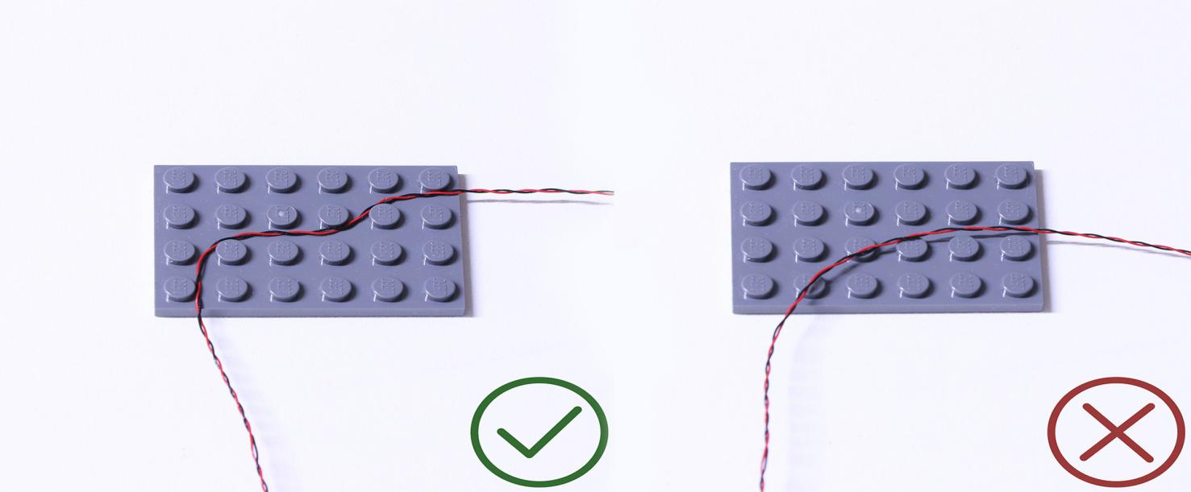
Insert the connectors to the ports.
Be careful when you are operating, there’s only one correct way to insert, make sure the expansion board is upward, find the soldered “=” sign on the left of the port. When you are inserting, the side which the wires can be seen should be faced to the “=” sign and if you feel hard to insert, please stop, and don’t force it, for that may result in bent pins inside the port or overheating of the expansion board.
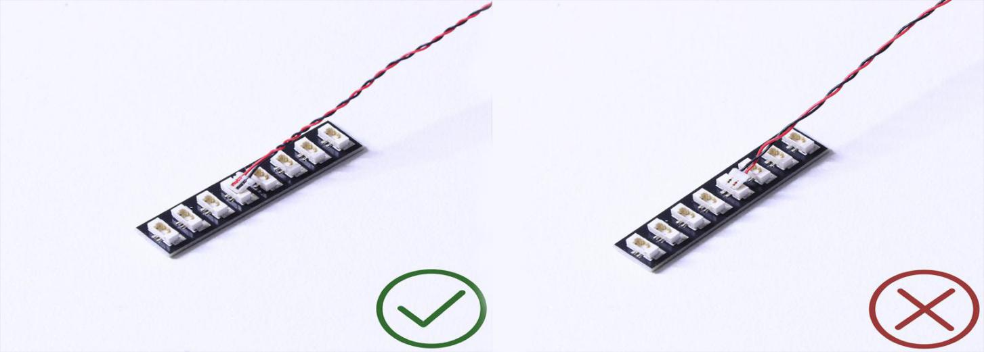

At this point, use the tweezers to straighten the bentpins.

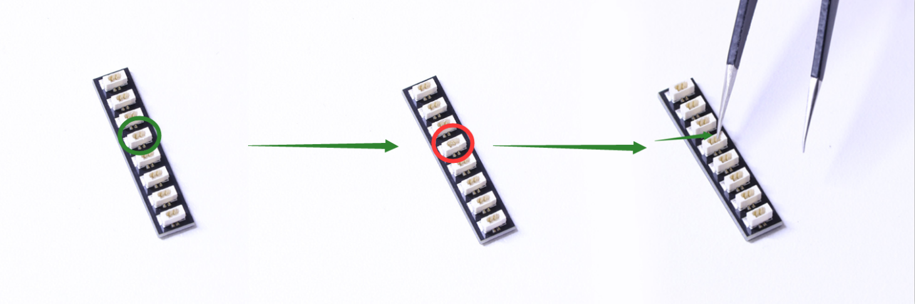

When installing dot lights, make sure they are correctly placed (Yellow LED package is exposed). You can put they either on the top of the studs or between studs.

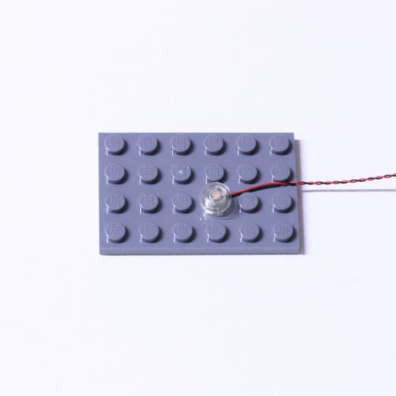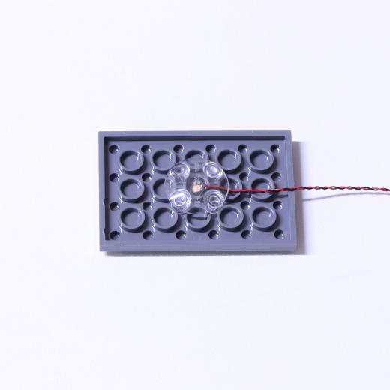

Connecting cable connectors to Strip Lights

Take extra care when inserting connectors to ports on the Strip Lights. Connectors can be inserted only one way. With the Strip Light facing up, ensure the side of the connector with the wires exposed is facing down. If a plug won’t fit easily into a port connector, don’t force it. Doing so will damage the plug and the connector.
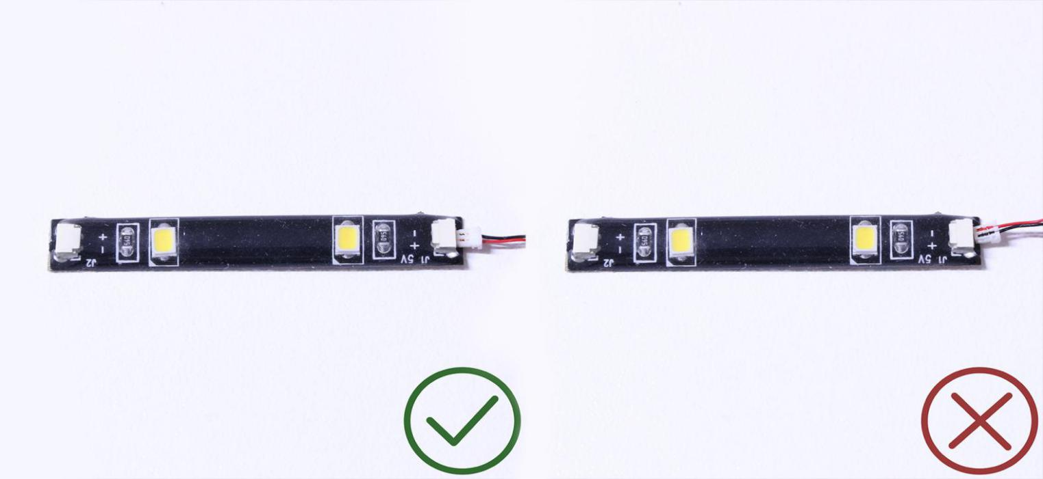
Finally, please pay attention to the positive and negative terminals of the battery when installing the battery case.
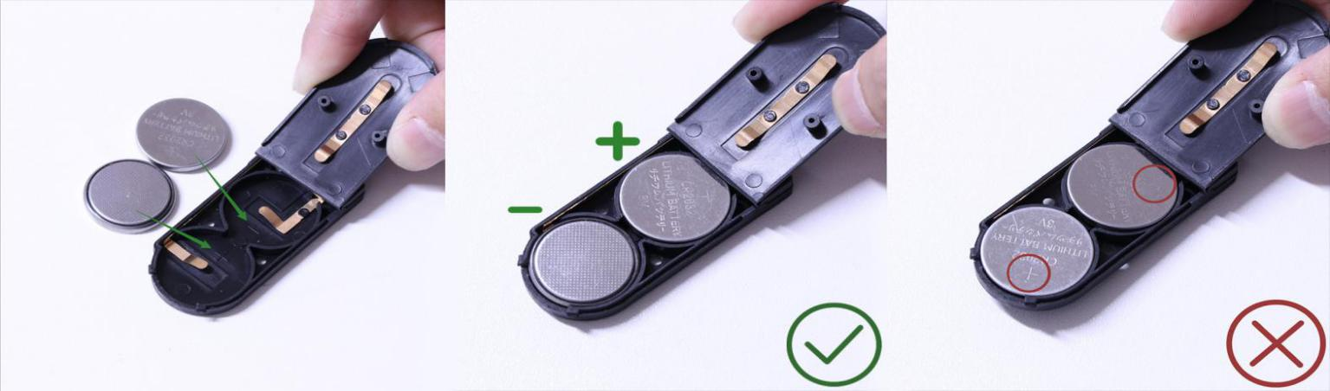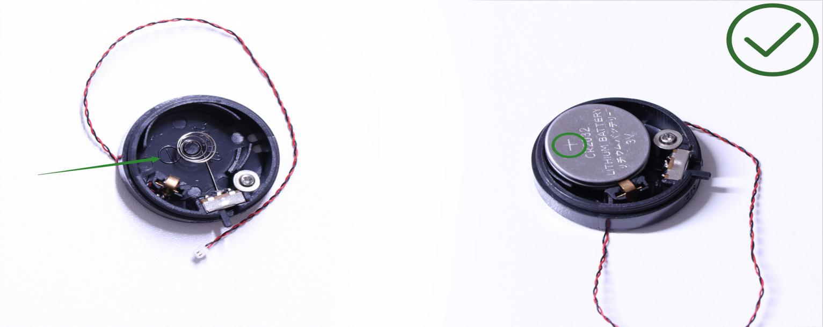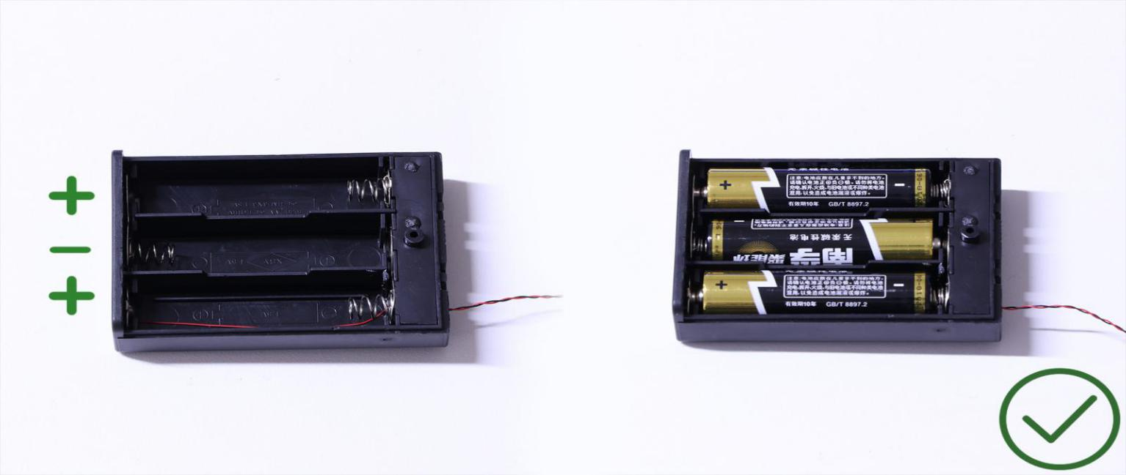
OK, Let’s Begin!
1.) Start by disconnecting the front window section as well as sections from the right side using the removal tool as per below:
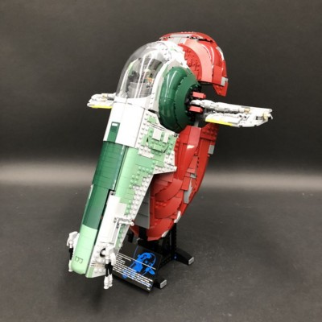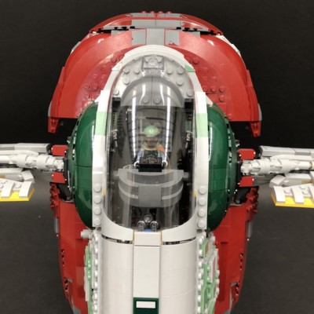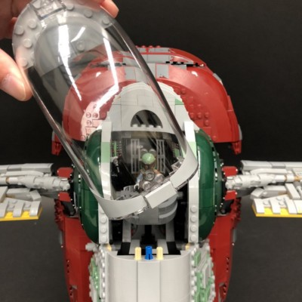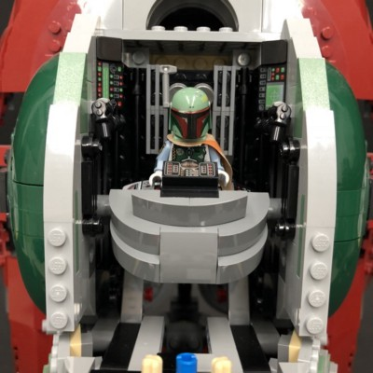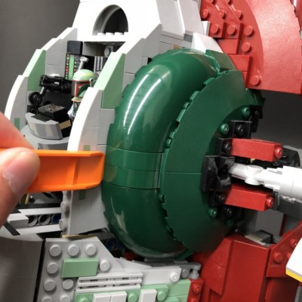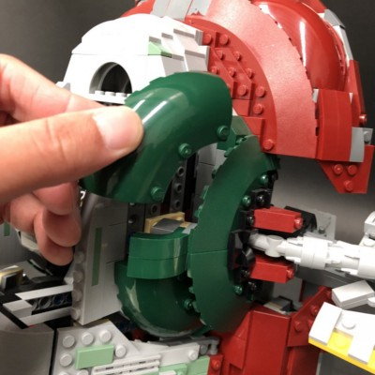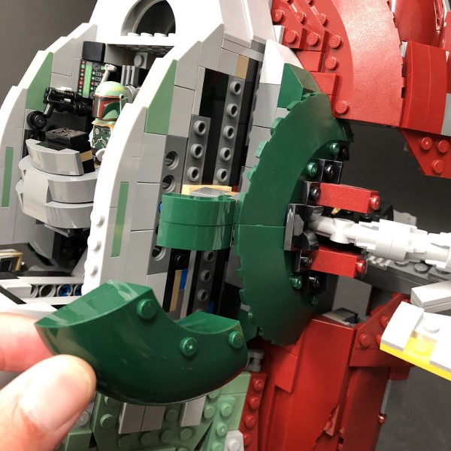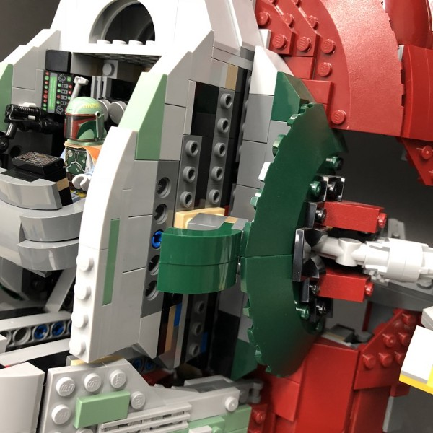
2.) Take a Flashing Red 30cm Dot Light and bend the component part slightly on a 90 degree angle so that it is facing upward.
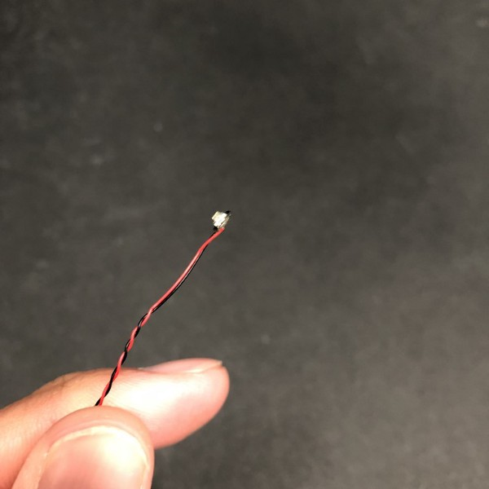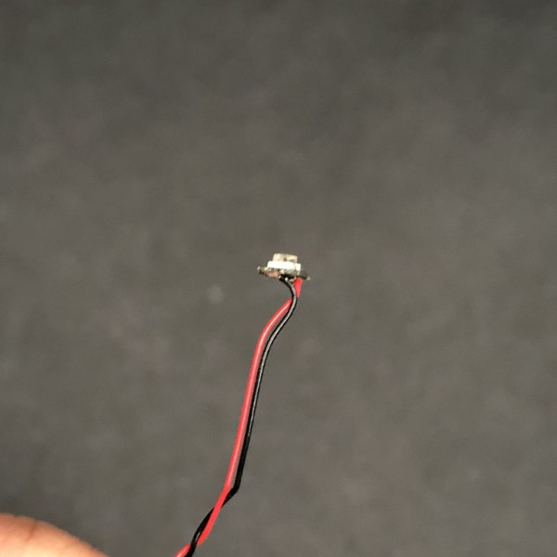

Thread the Dot Light through the upper hole on the right side of cockpit. Pull the cable out slightly from the inside as per below:
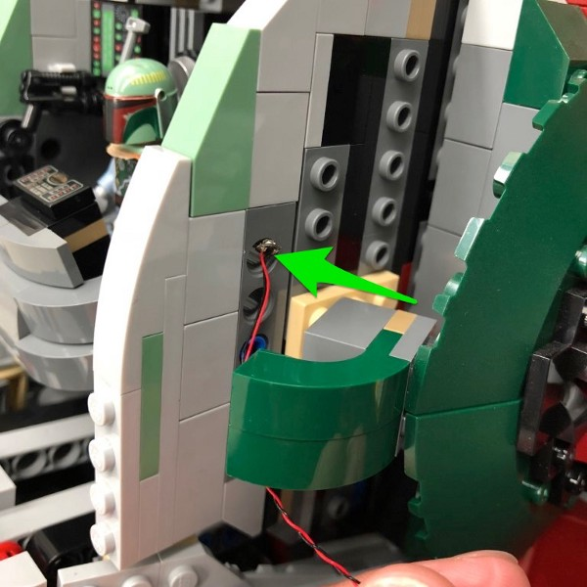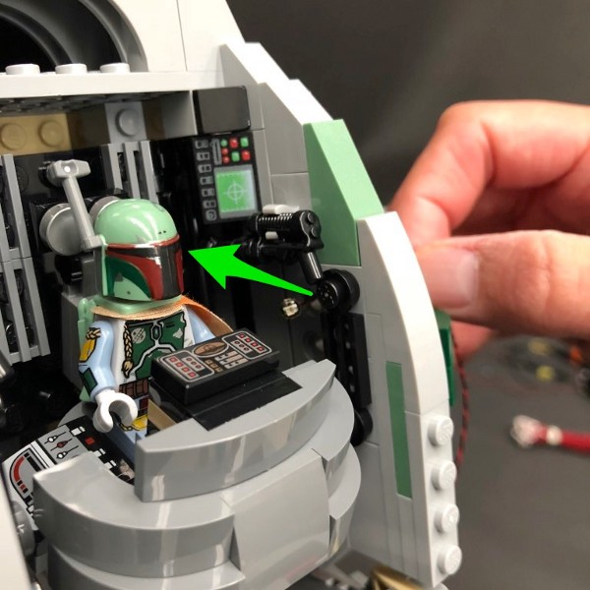

Lay the cable in between studs of the outside and then reconnect the middle part of the right section.
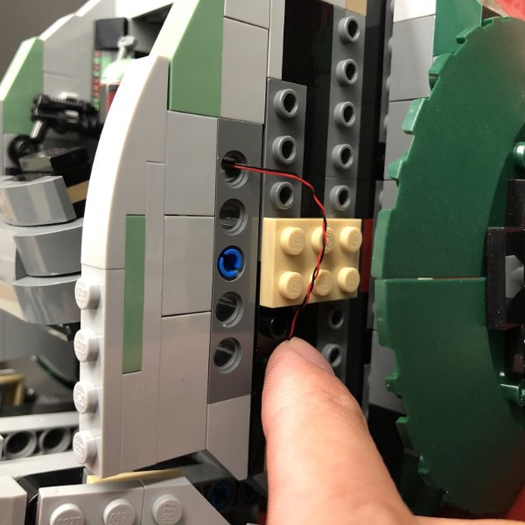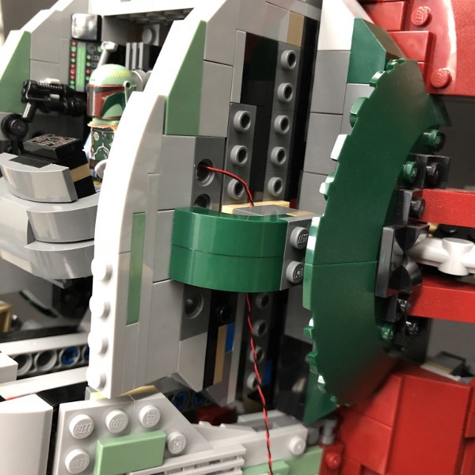

From the inside of Slave 1, push the Flashing Red Dot Light toward the inside of the hole.
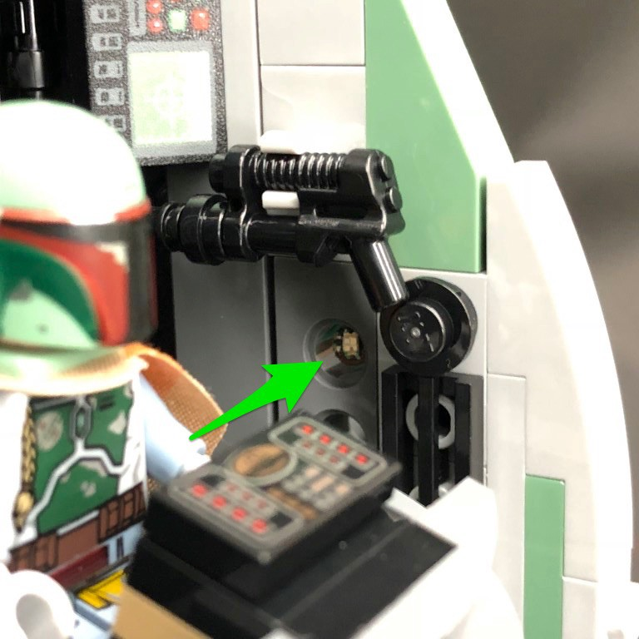

3.) Thread the connector side of the cable down behind the side of the ship and then reconnect sections of the right side which we removed earlier.
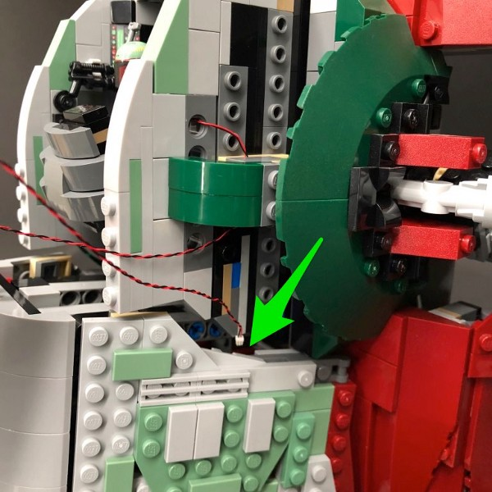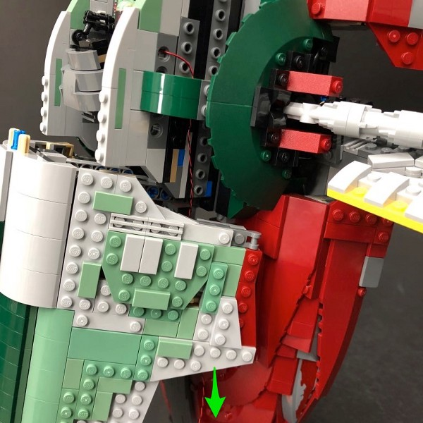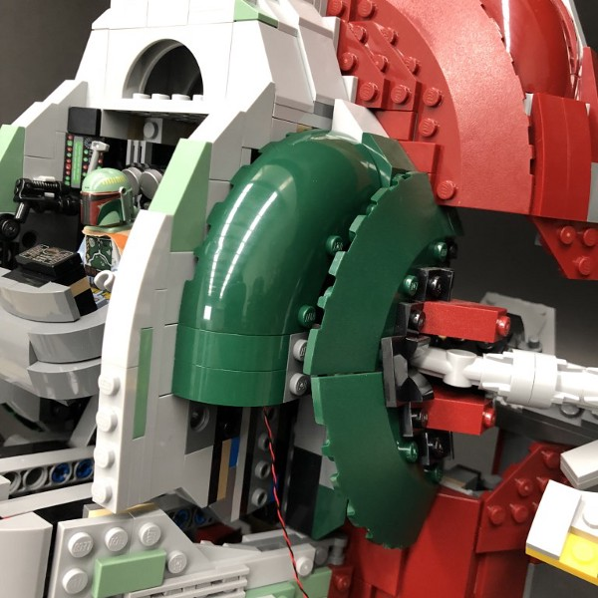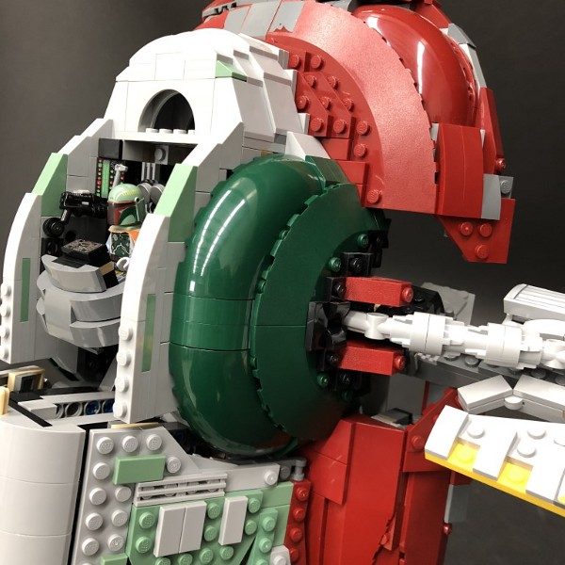
4.) Repeat previous steps to install another Flashing Red 30cm Dot Light to the left side of the cockpit.
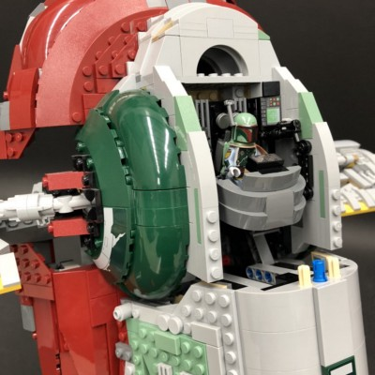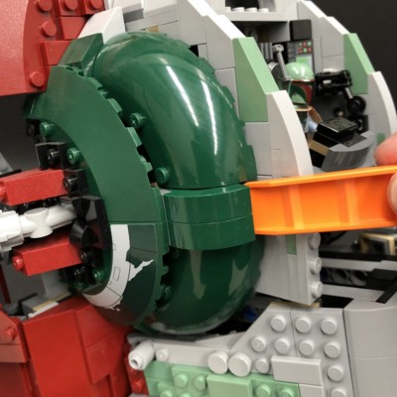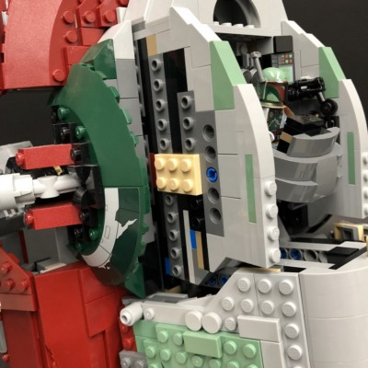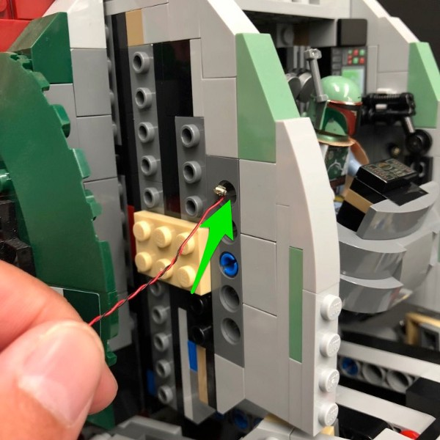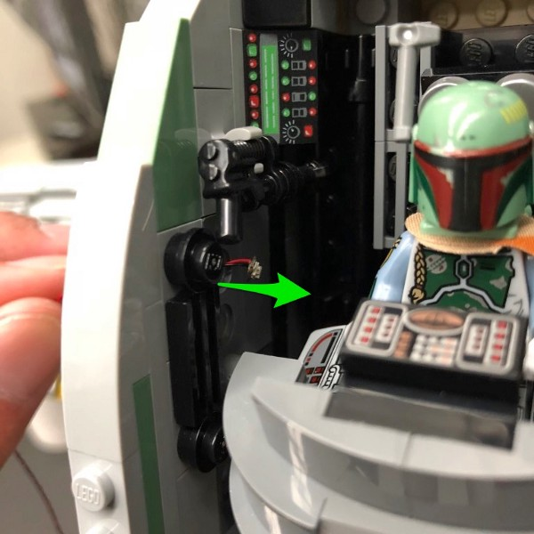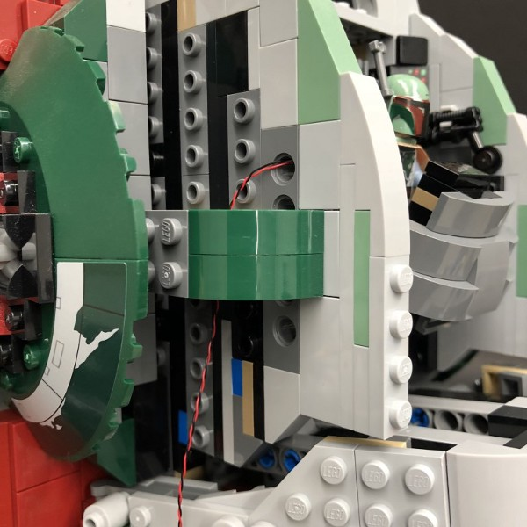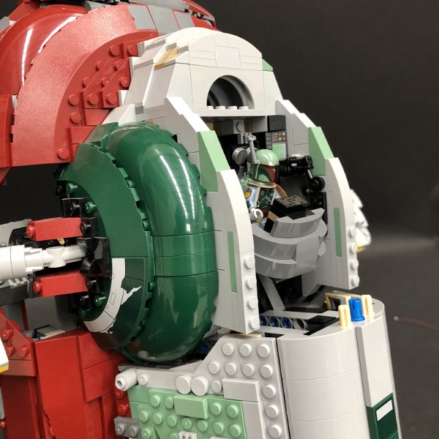

5.) Remove the middle and the left and right side sections of Slave 1 as per below:
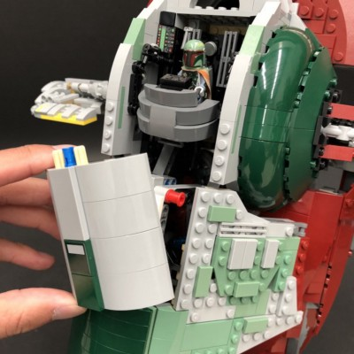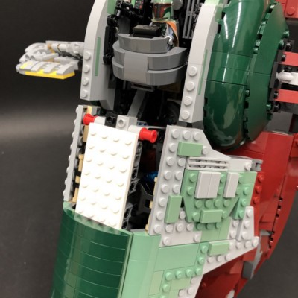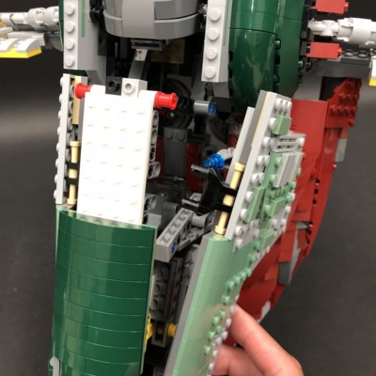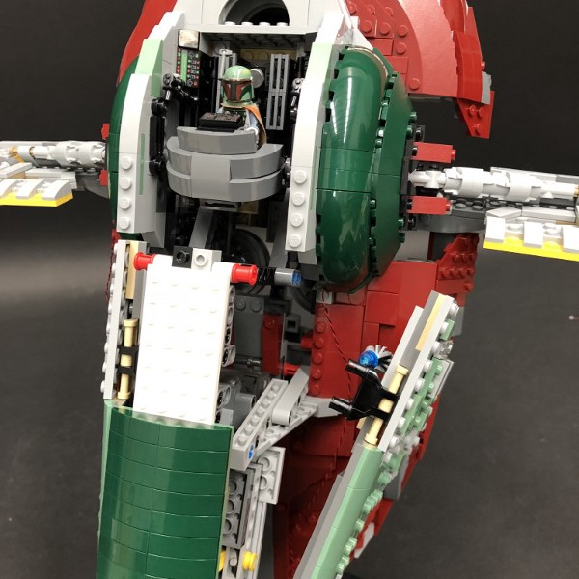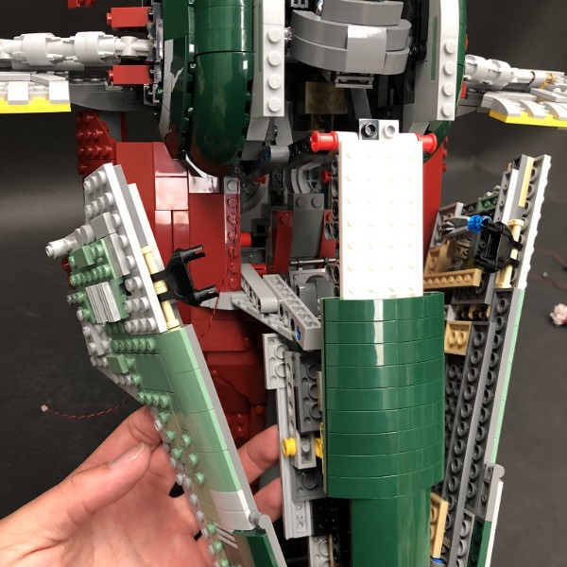
Take the cable from the left Flashing Red Dot Light and then thread it through the middle and pull it out from the right side so that both cables are together
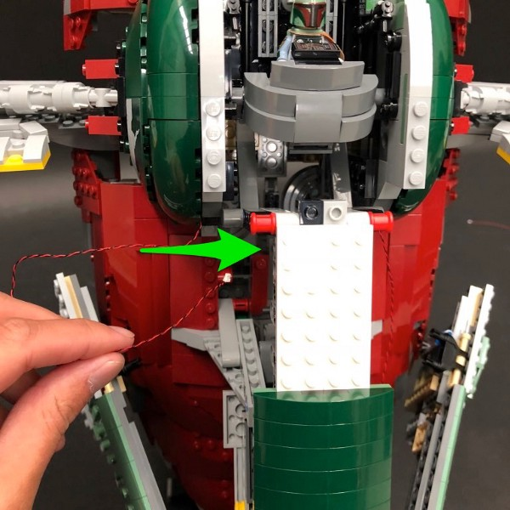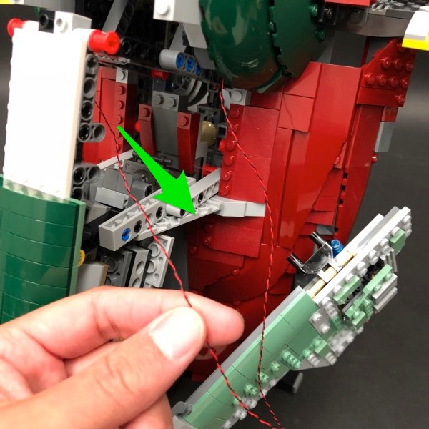
6.) Remove Slave 1 from the stand and then place it down.
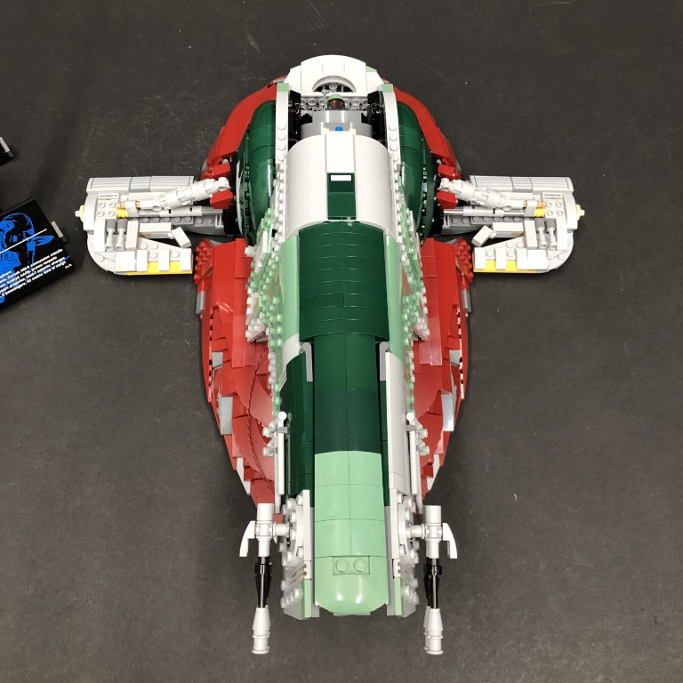

Bring Boba Fett’s seat forward and then take a White 30cm Dot Light and thread the connector side down behind his seat.
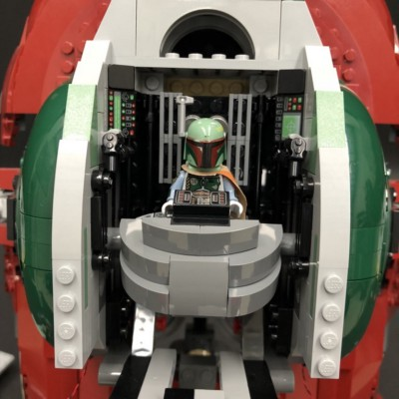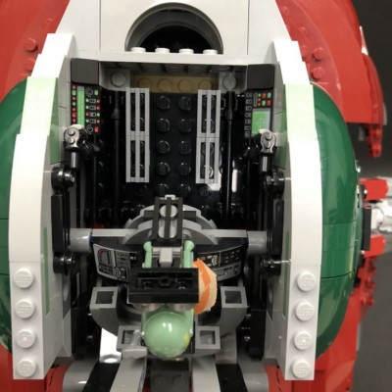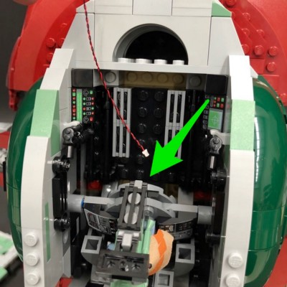

Place the Dot Light in between the following studs and then secure it in place by connecting a provided Trans Clear Round Plate 1x1 over the top.
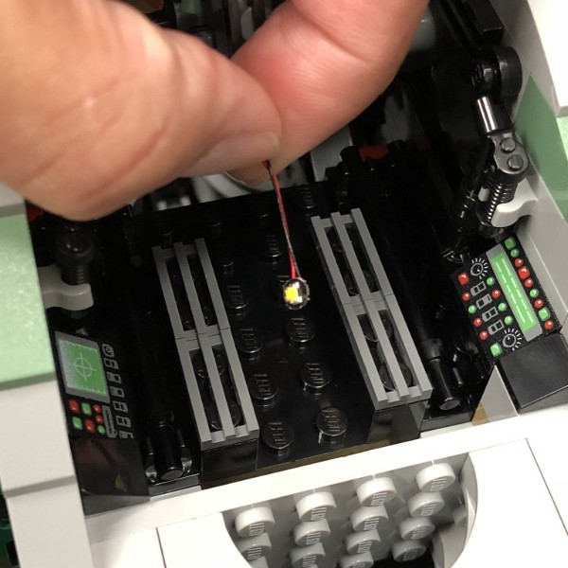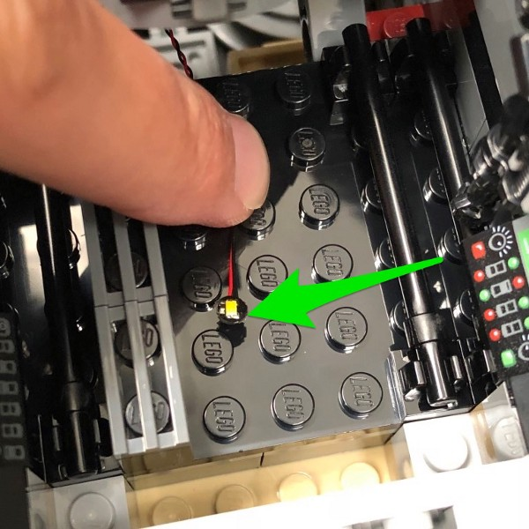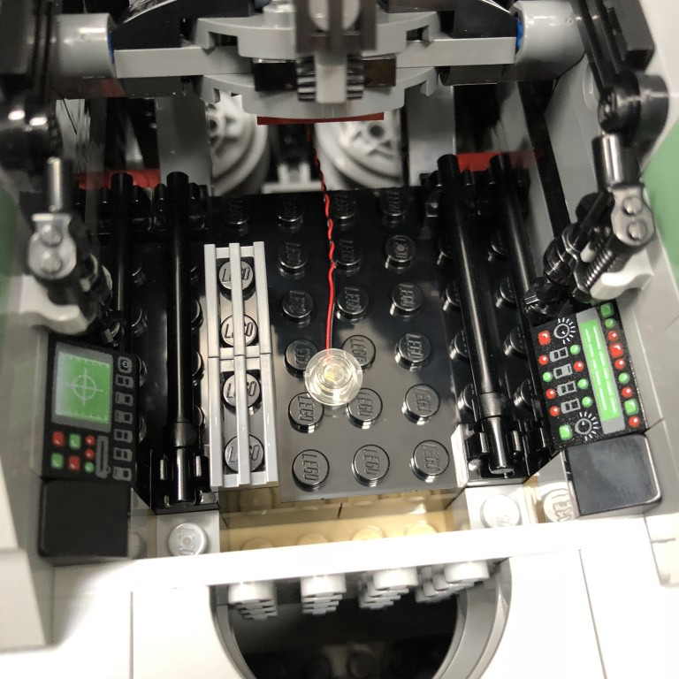
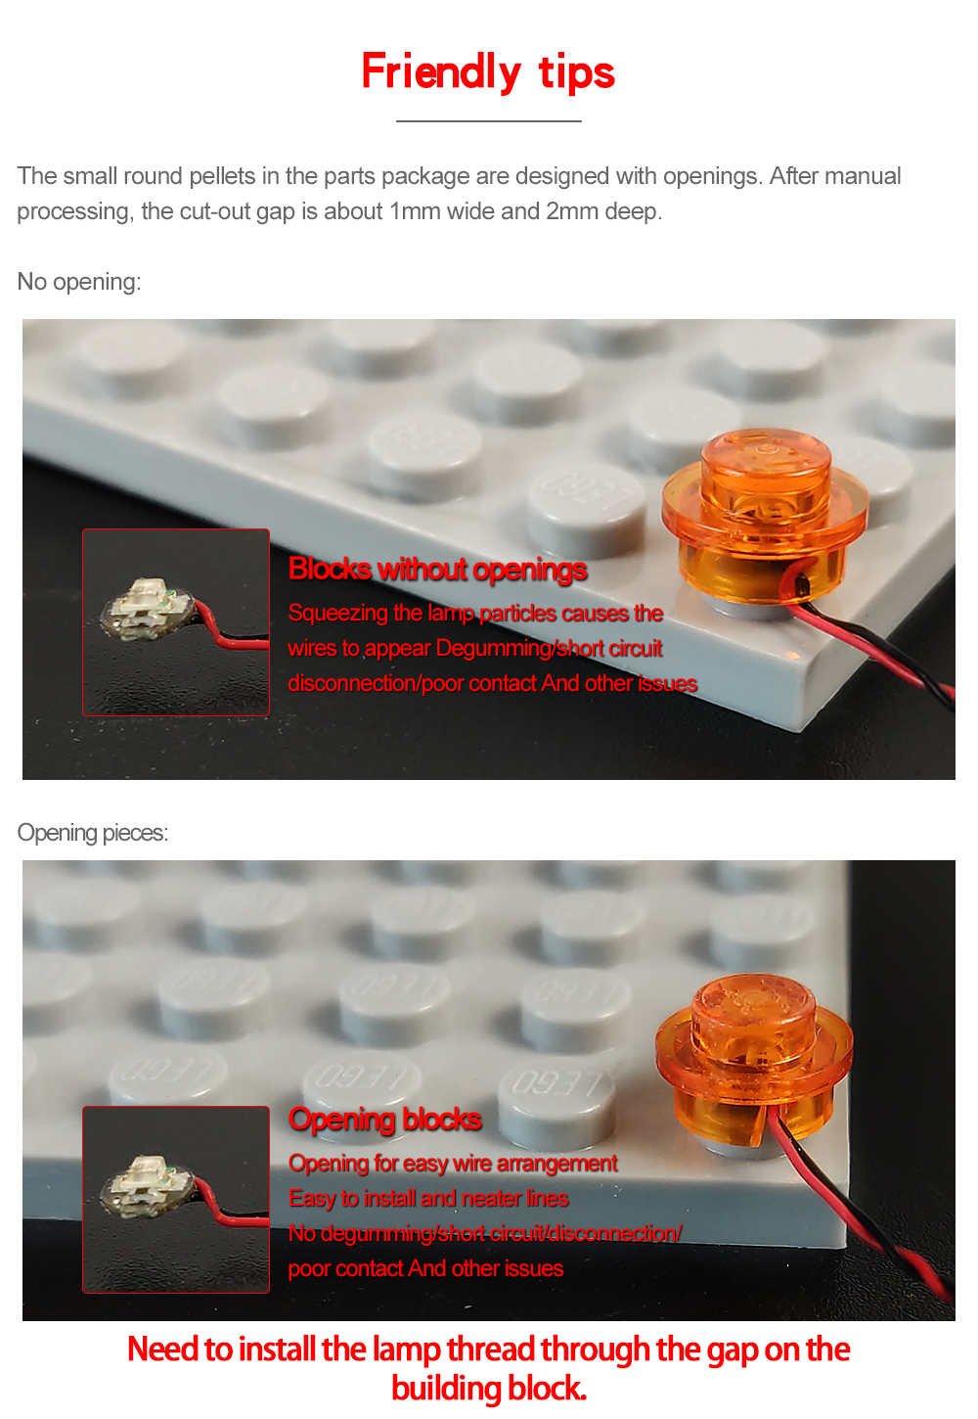

Bring back Boba Fett’s seat and then reconnect Slave 1 back to it’s stand in upright position.
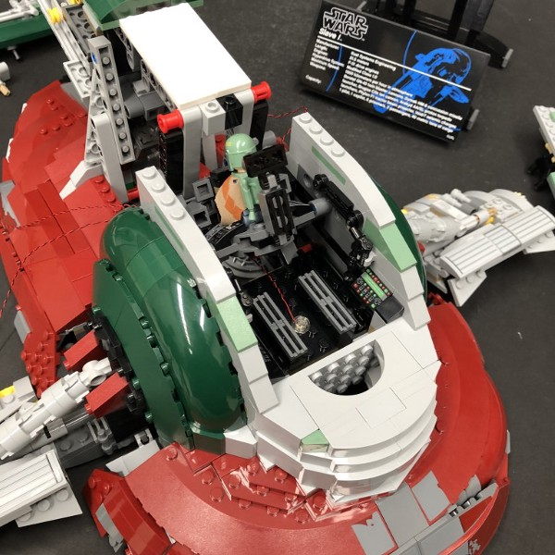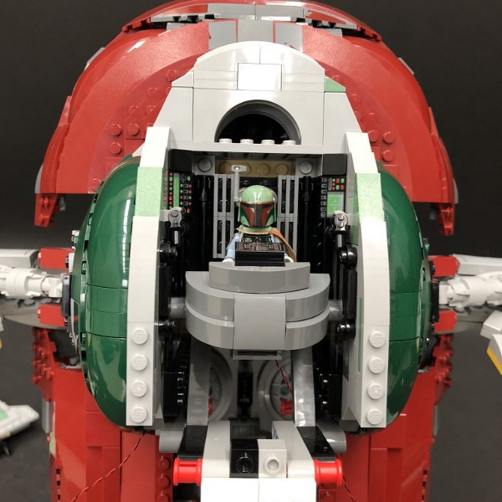

7.) Pull the cable from the White Dot Light down the right side so that it is together with the two Flashing Red Dot Light cables. Take a 8-Port Expansion Board and connect all three cables to it.
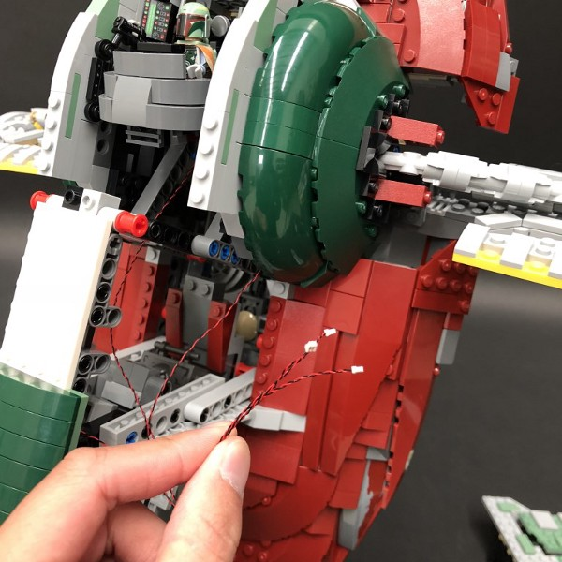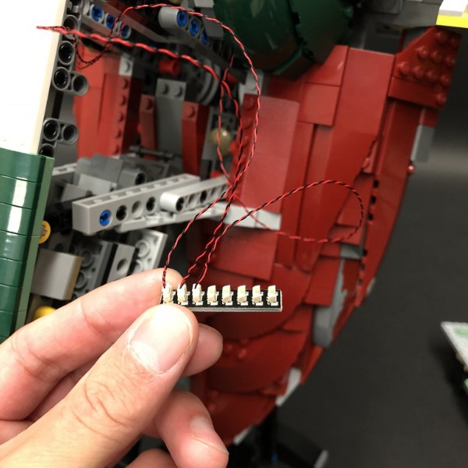

Take this time to test the lights we have installed so far by inserting 3x AA Batteries to the AA Battery Pack and then connect the battery pack cable to a spare port on the expansion board. Turn ‘ON’ to verify all is working OK.
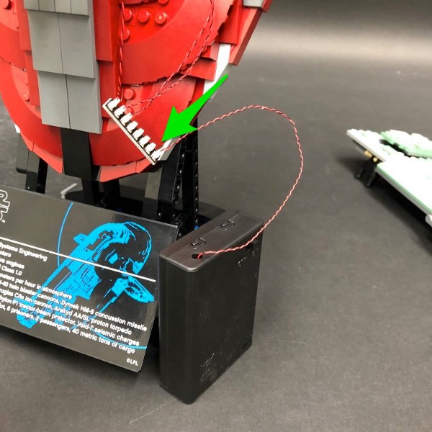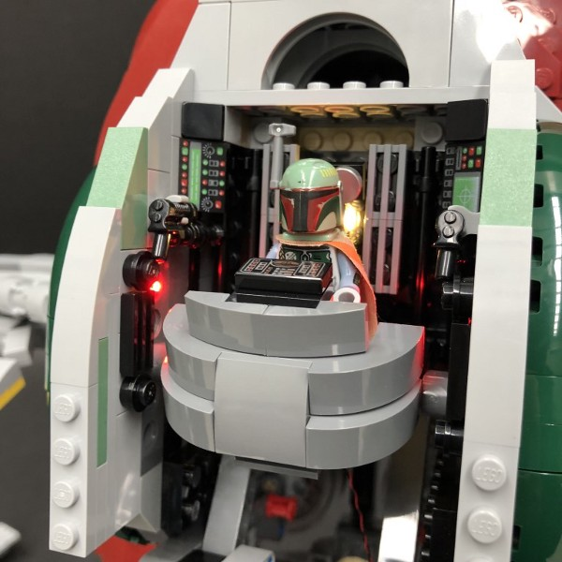

8.) Disconnect the AA Battery Pack from the expansion board and then turn Slave 1 over and disconnect the following section.
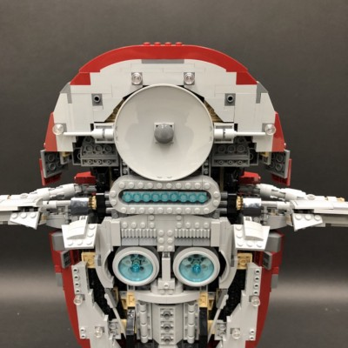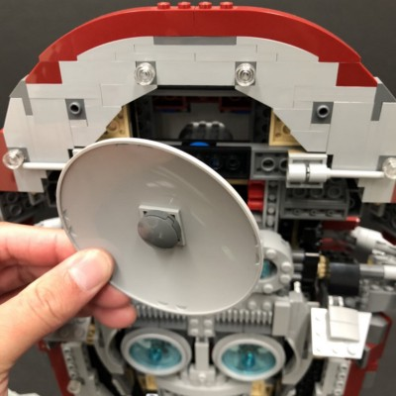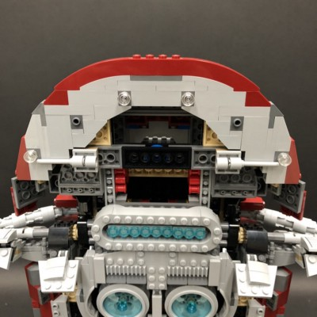

Place Slave 1 upside down and then disconnect the following sections from the bottom using the removal tool.
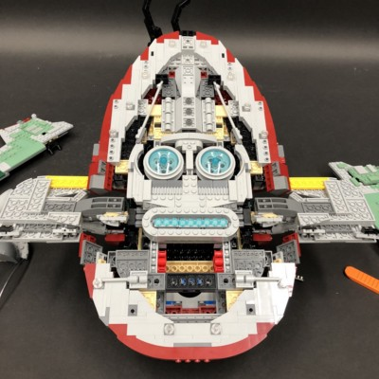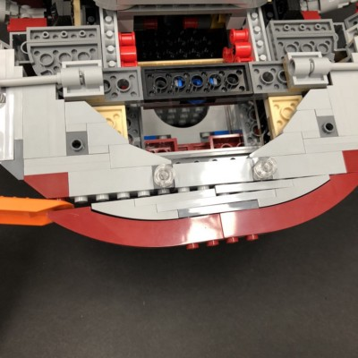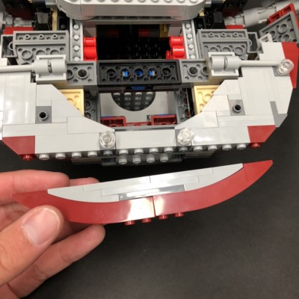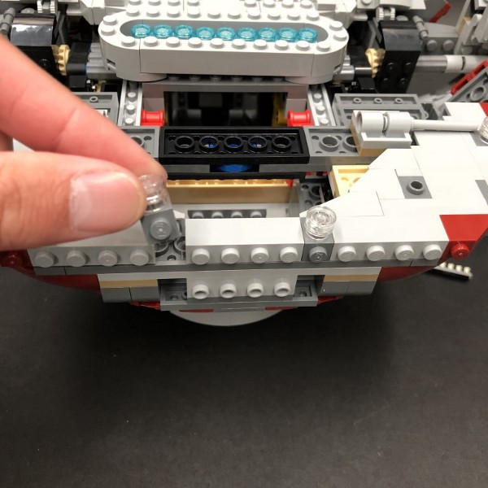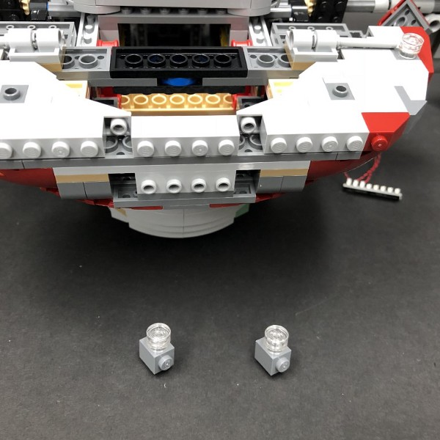

Disassemble pieces as per below
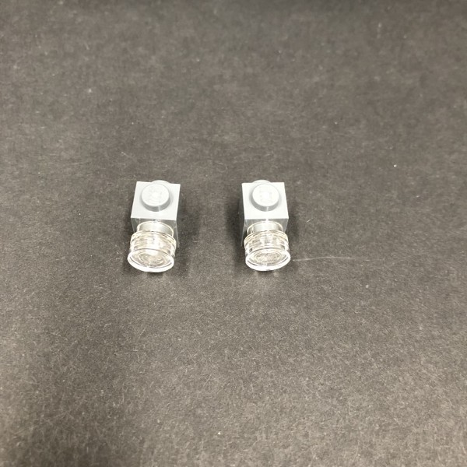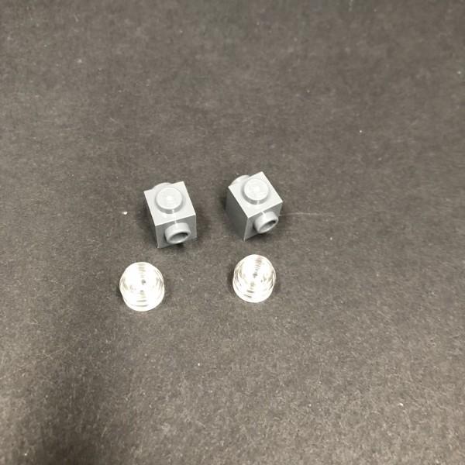

9.) Take a White 30cm Dot Light and thread the connector side of the cable through the front hole of the grey brick. Thread it down and out the bottom of the brick and then pull the cable all the way down until the Dot Light is sitting flat against the edge of the hole. Secure the Dot Light in place by reconnecting the two trans clear pieces over the top.
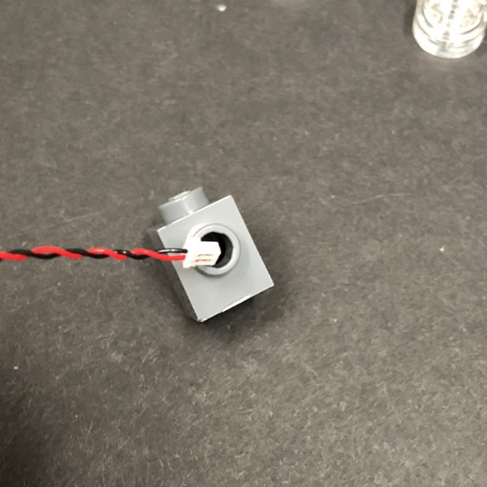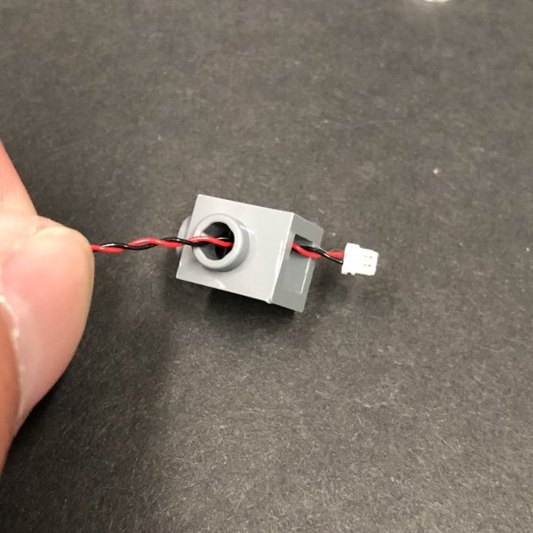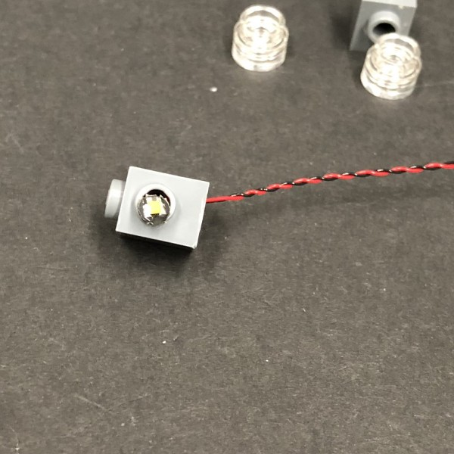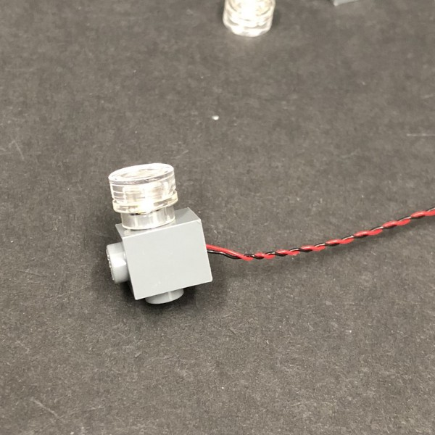

Repeat this step to install another White 30cm Dot Light to the other section.
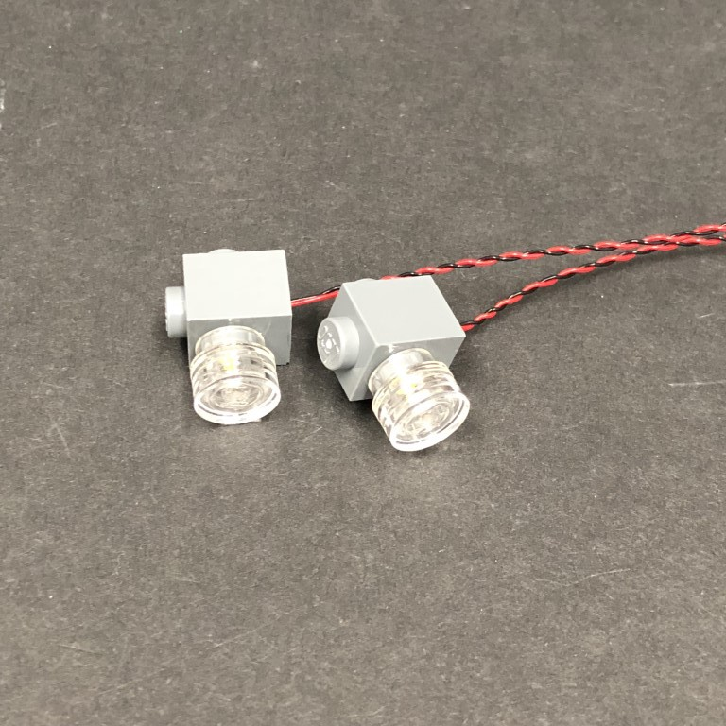

Before reconnecting these two sections, disconnect the following brick. After reconnecting both sections, reconnect the brick as well as larger section to we removed earlier to the bottom.
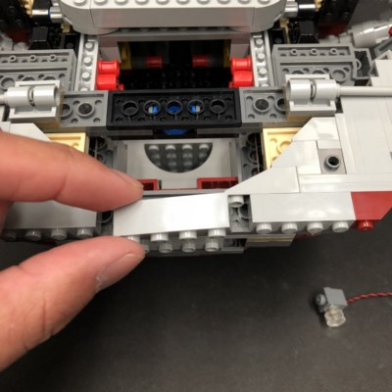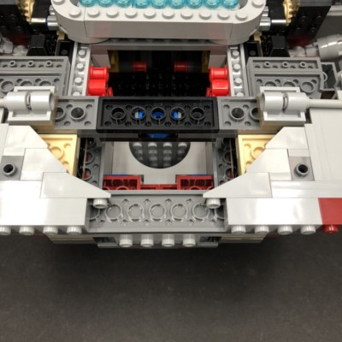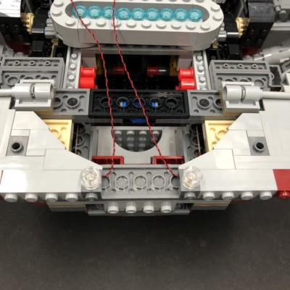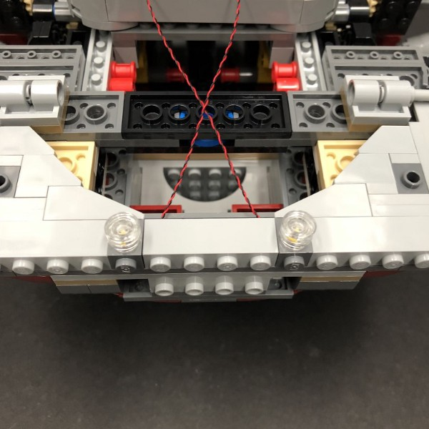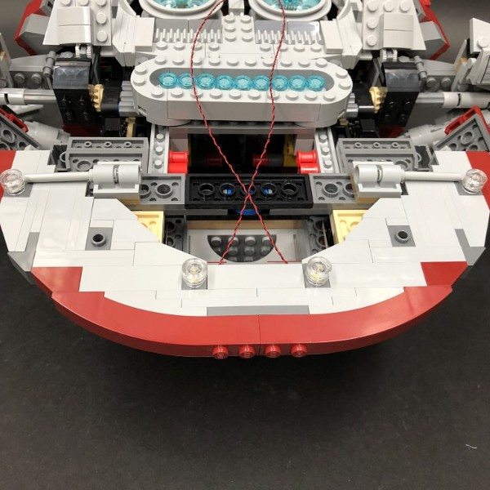

10.) Disconnect the left sections using the removal tool.
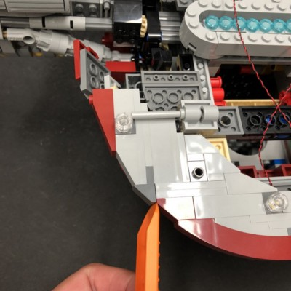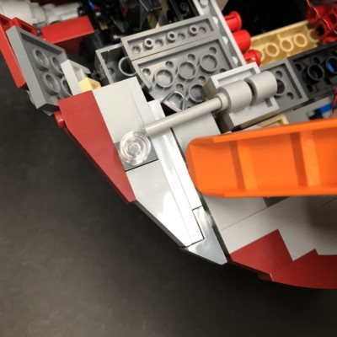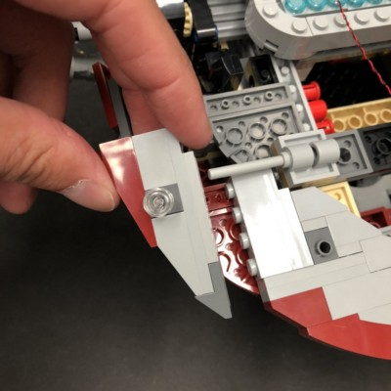

Disassemble the following pieces as per below
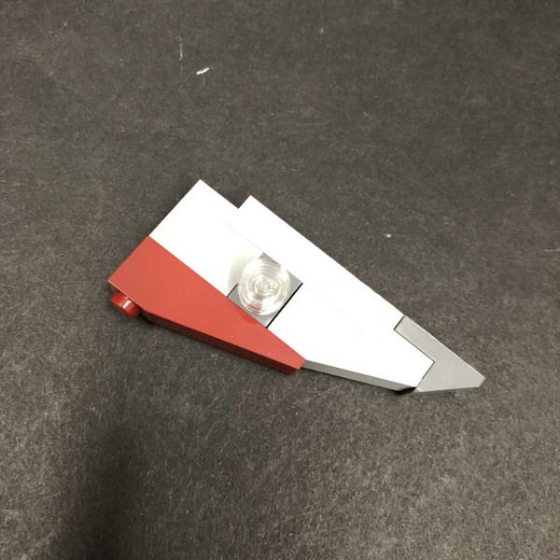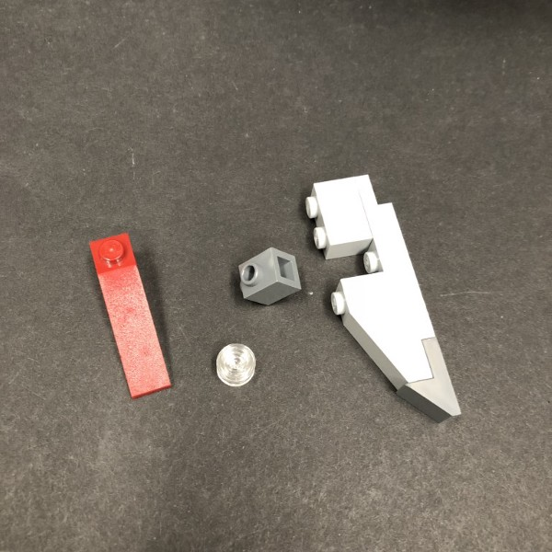

Take another White 30cm Dot Light and install it to the below using the same method we did for the previous two lights.

Reconnect this section back and then reconnect back to Slave 1
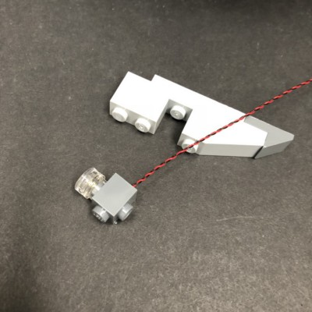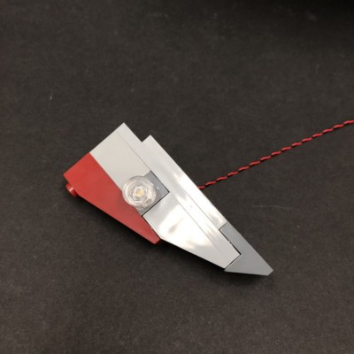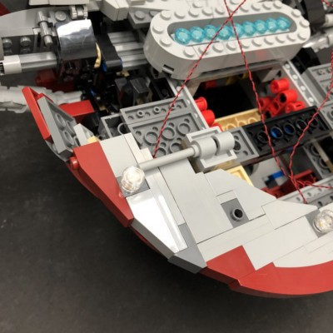

11.) Repeat previous steps to install another White 30cm Dot Light to the right side.
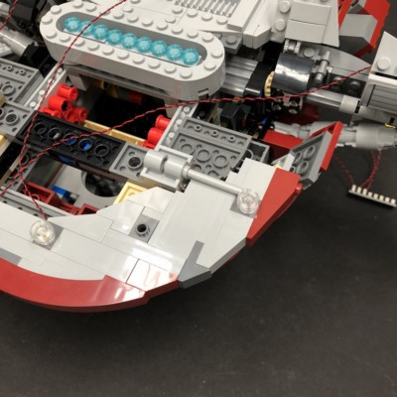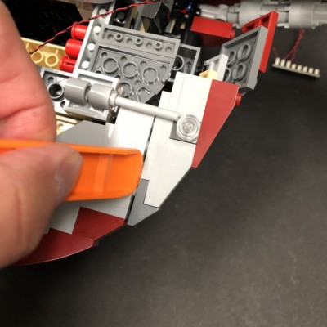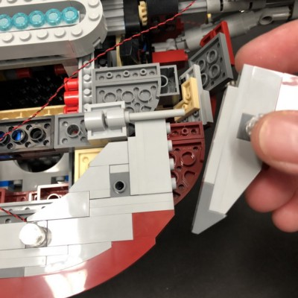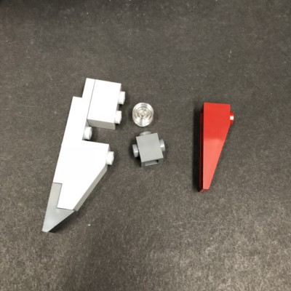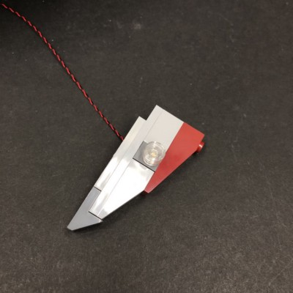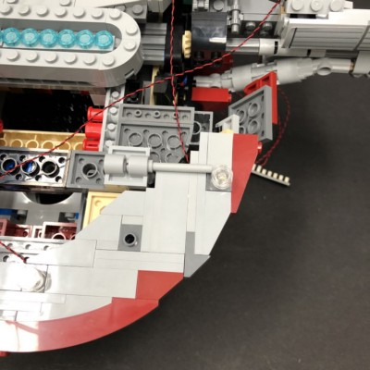

12.) Disconnect the following section which connects across then take all four cables from the lights we just installed and twist them around each other to form one larger cable.
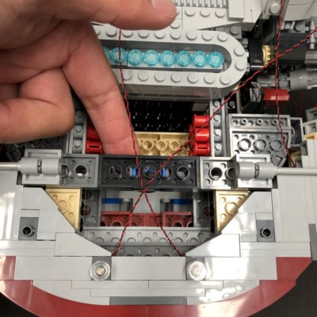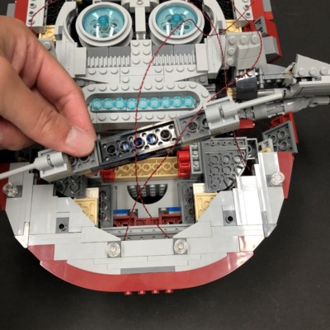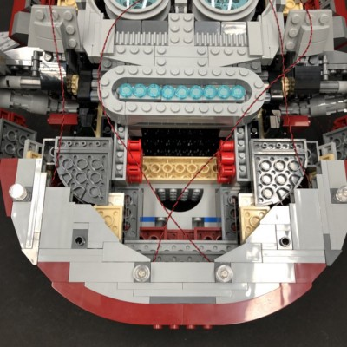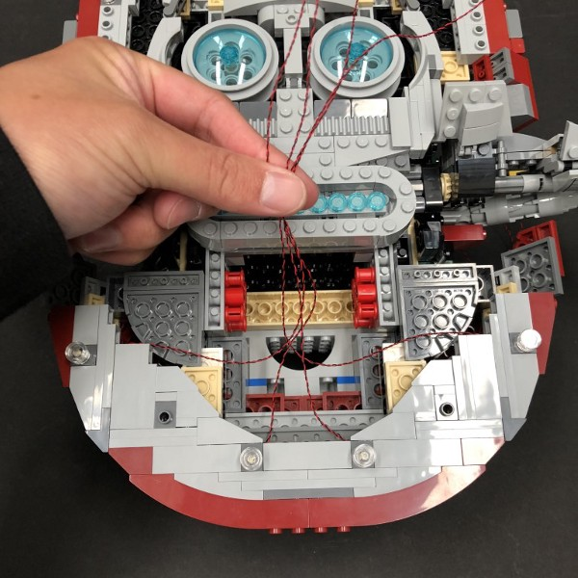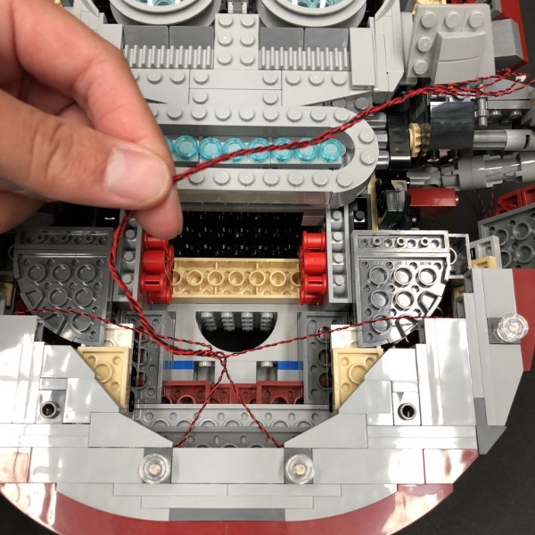

Reconnect the section that connects across ensuring cables are laid underneath and then thread all four cables underneath the section with the nine trans light blue round tiles.
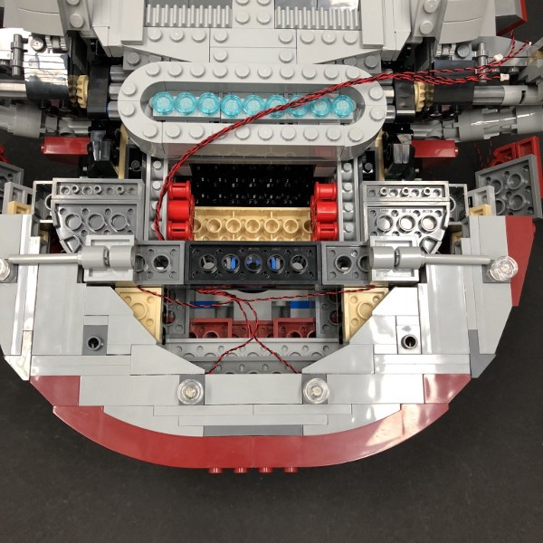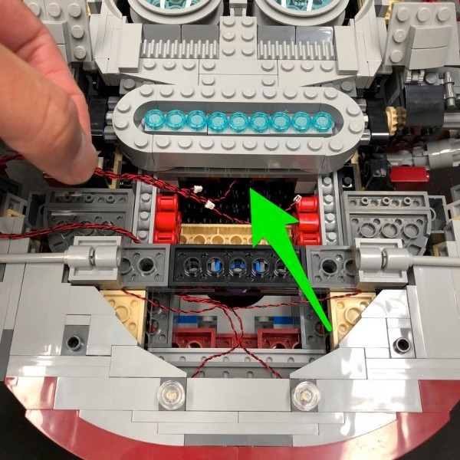

Pull the four cables out from the front side of Slave 1and then connect them to the 8-port expansion board from step 7.
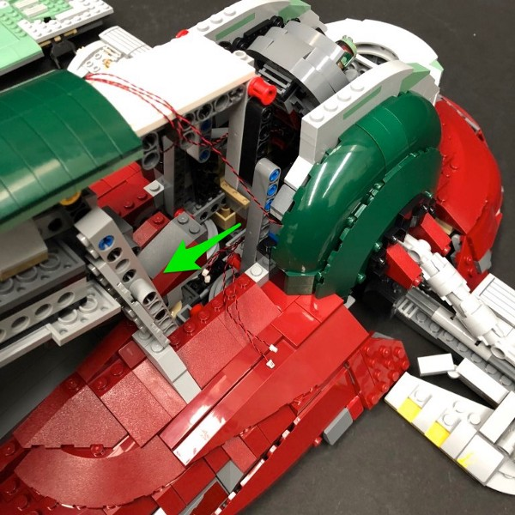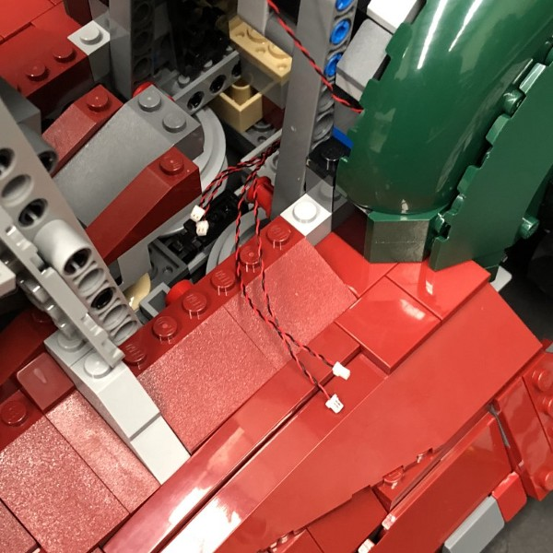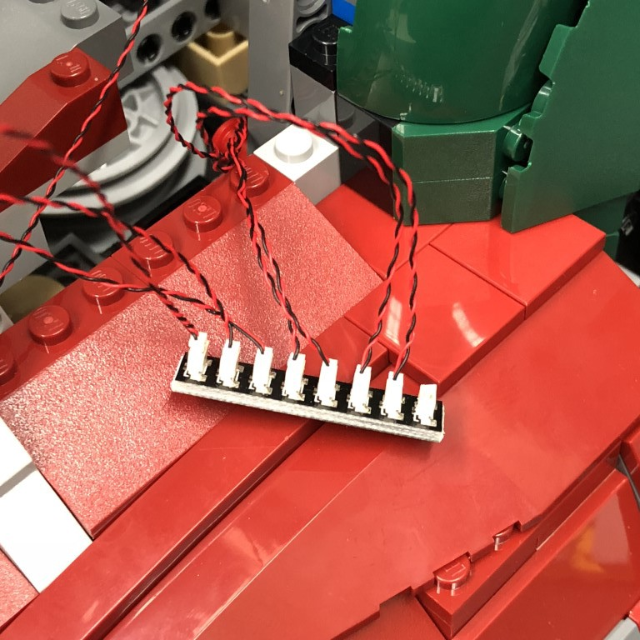

Test the lights we have installed so far by reconnecting the AA Battery Pack to the expansion board and turning ‘ON’ to verify all is OK.
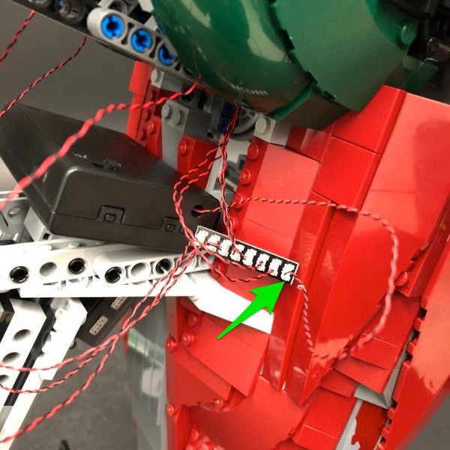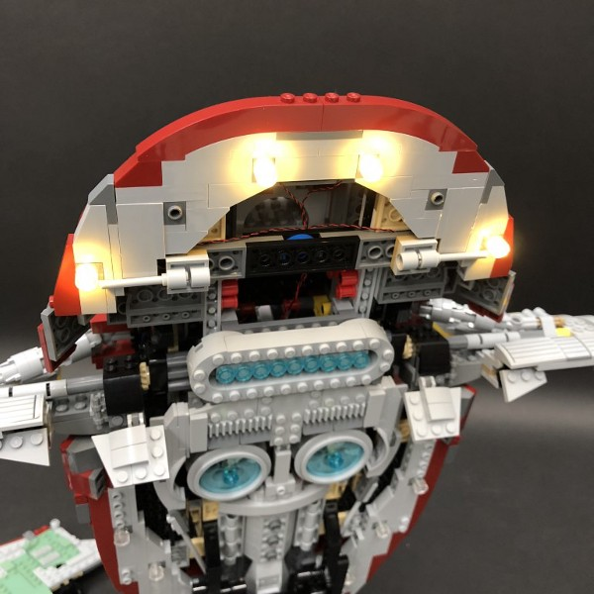

13.) Disconnect the AA Battery Pack and connect a 5cm Connecting Cableinto the expansion board.
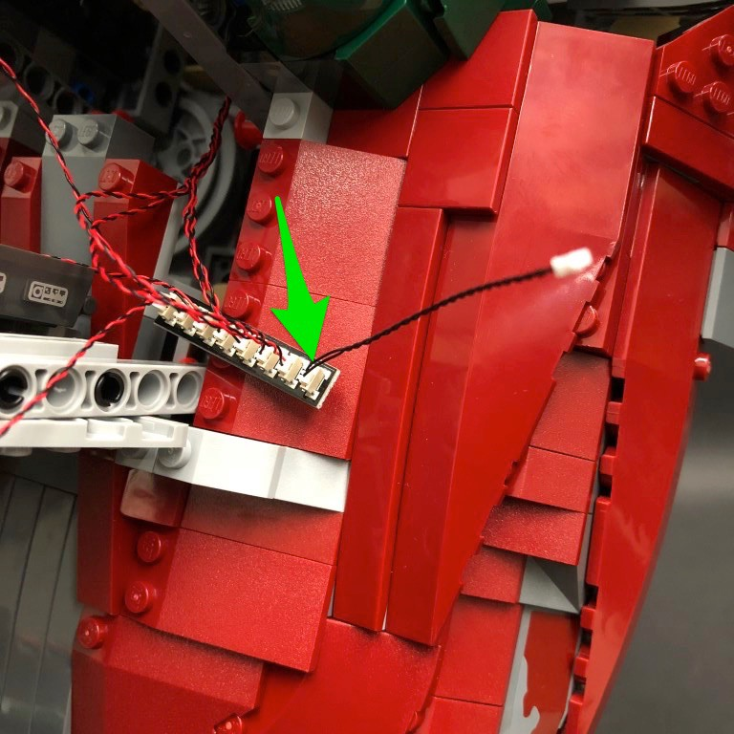

Neaten up cabling by pulling down the three cables from the the cockpit and then twisting them all around each other.
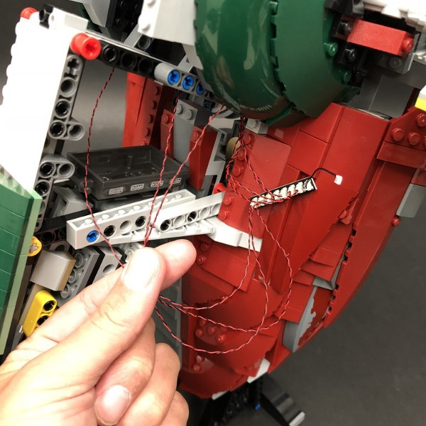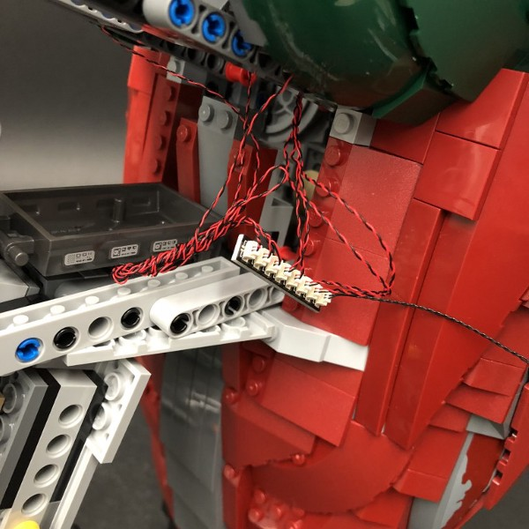

14.) Turn Slave 1 over again and then disconnect the following sections:
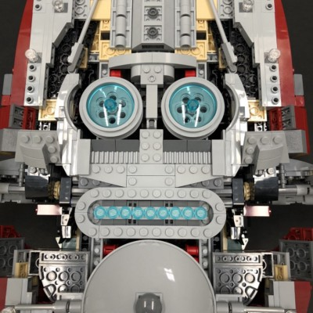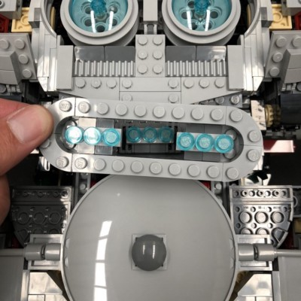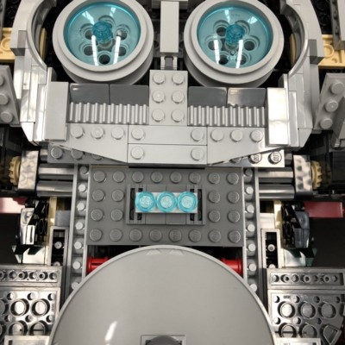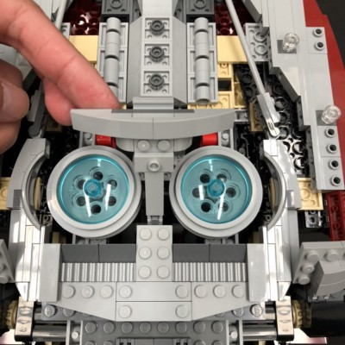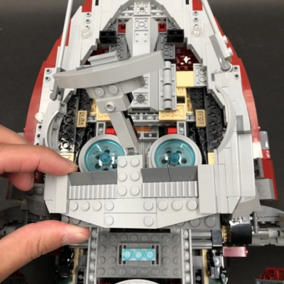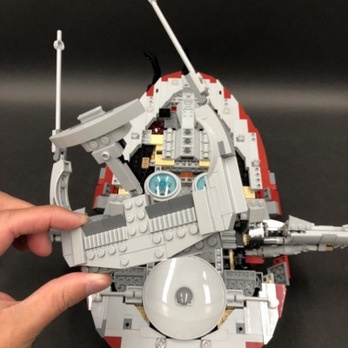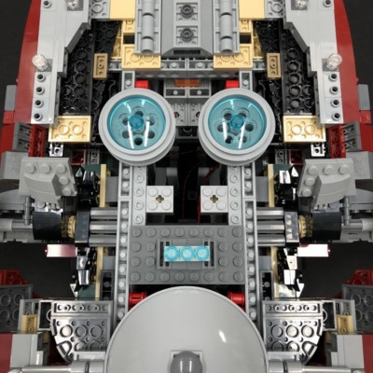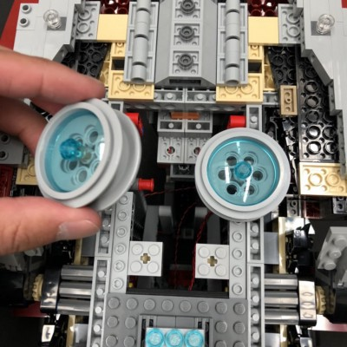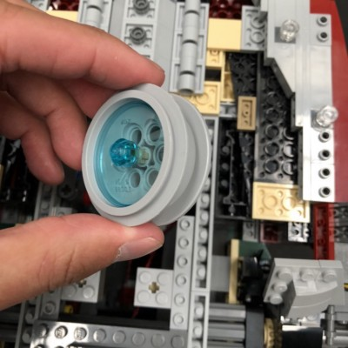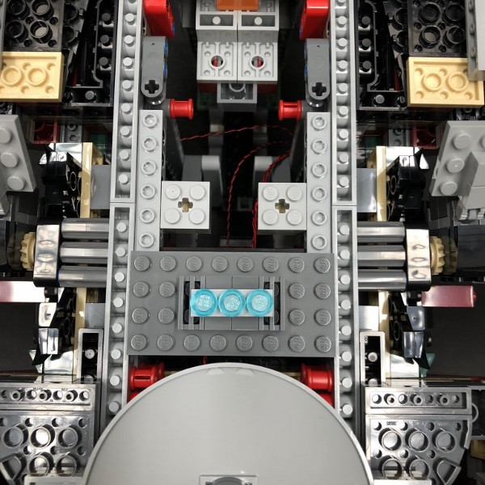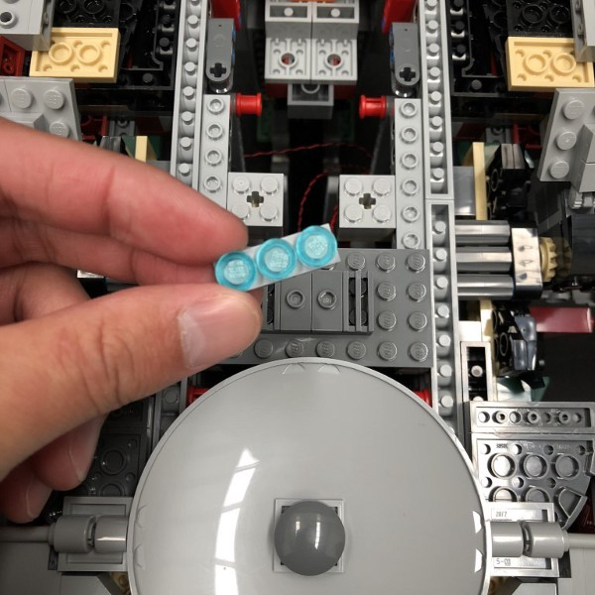

15.) Take the below sections and disconnect the two outer 1x3 plates and then disconnect all nine trans light blue round tiles.
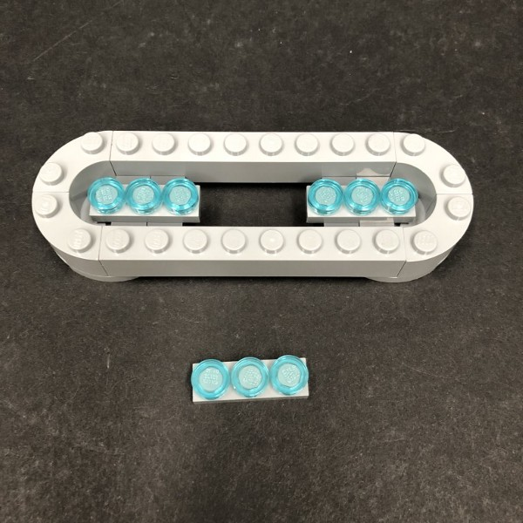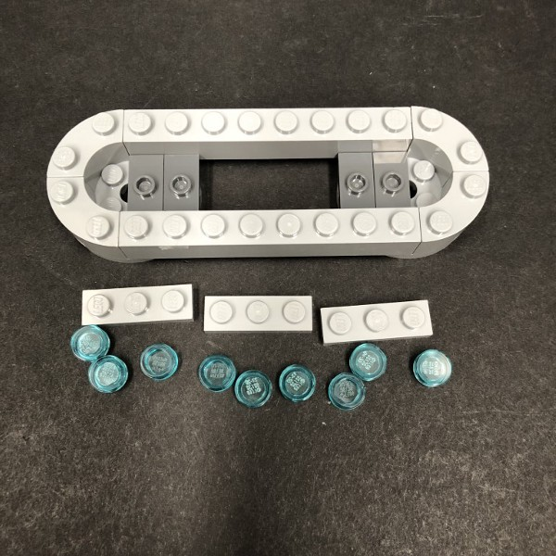

Starting with the left 1x3 plate, take a Blue 30cm Dot Light and place it over the stud furthest to the left. Secure it in place by connecting one of the provided Trans Light Blue Round Plate 1x1 directly over the top. Discard the original trans light blue round tile.
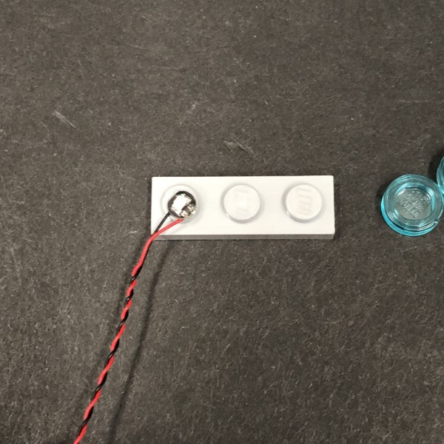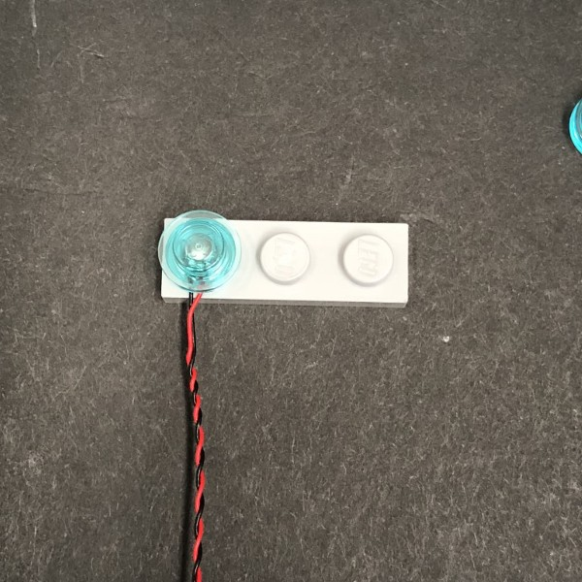

Take another Blue 30cm Dot Light and place it over the next stud along. Secure it in place by connecting another Trans Light Blue Round Plate 1x1directly over the top. Repeat this step to install another Blue 30cm Dot Lightusing another Trans Light Blue Round Plate 1x1
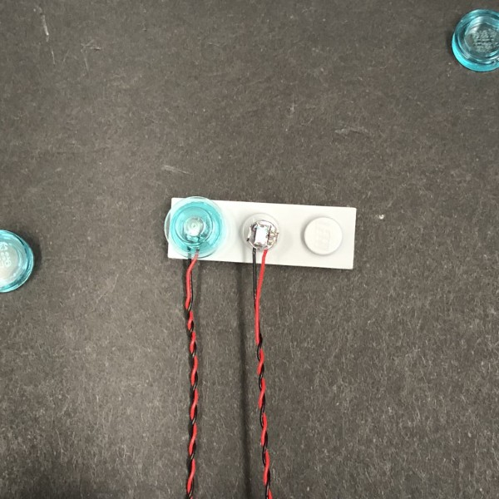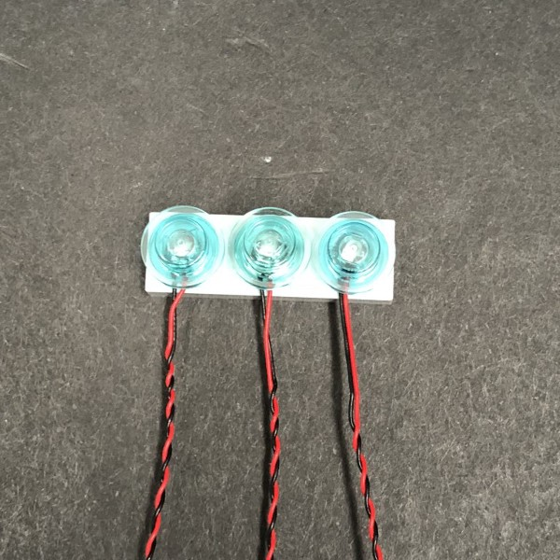
16.) Repeat previous step to install another 6x Blue 30cm Dot Lights to the remaining two 1x3 plates.
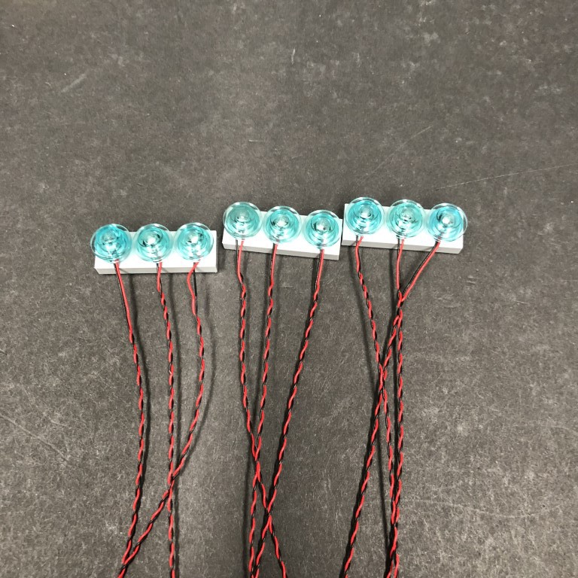
Reconnect the two outer plates to the main section ensuring all cables are threaded through the centre.
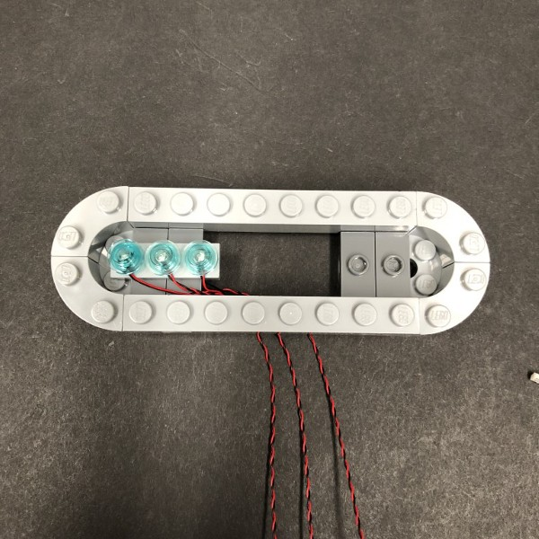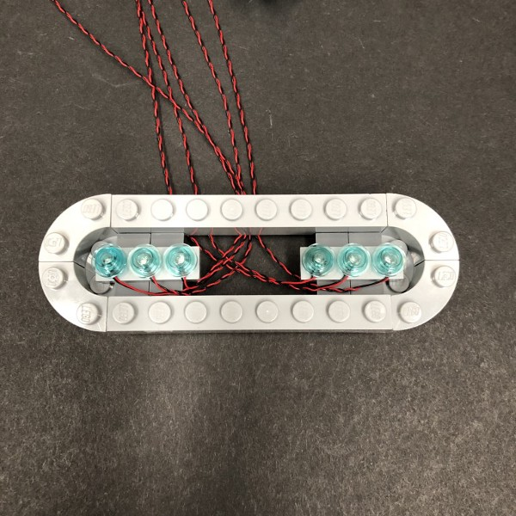

Group the three cables from each side and then reconnect this section back to Slave 1. Ensure that the cables from each side are neatly laid facing down as per below:
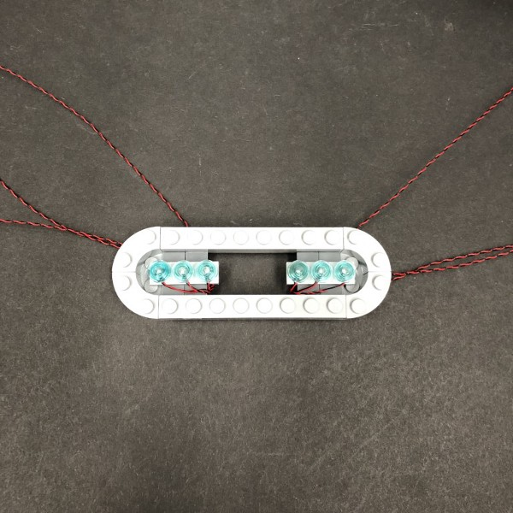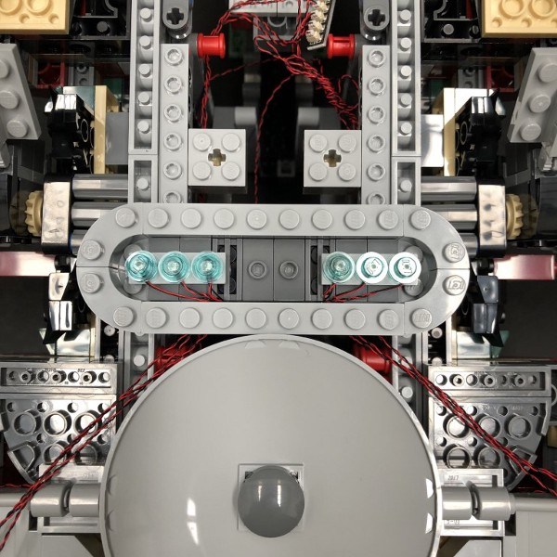

17.) Disconnect the lower 1x8 Brick and then reconnect the remaining 1x3 plate with Blue Dot Lights installed. Ensure all cables are laid in between studs before reconnecting the 1x8 brick over the top.
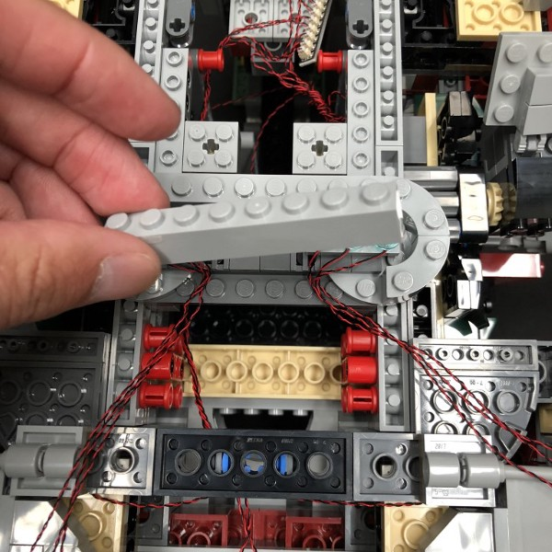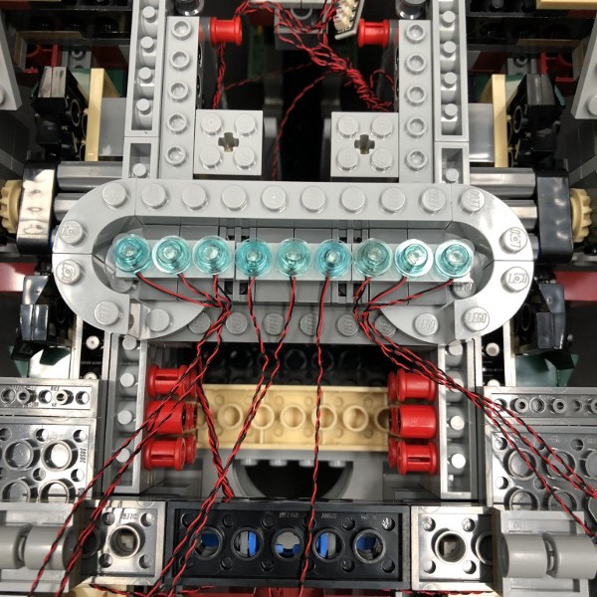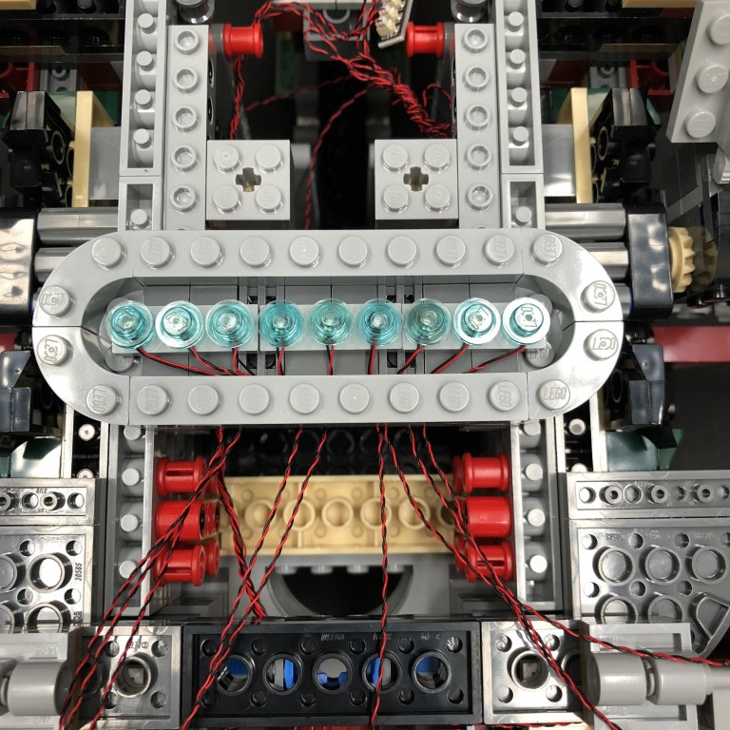

18.) Group all the Blue Dot Light cables together and then twist them around each other to form one larger cable.
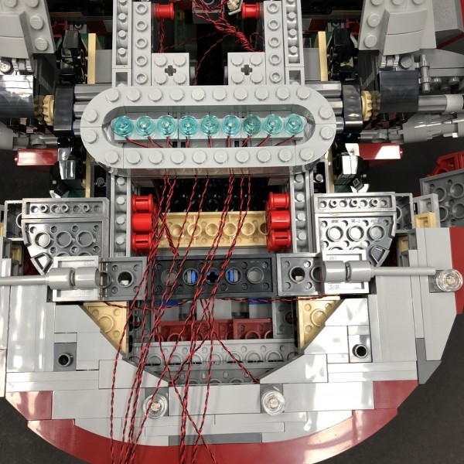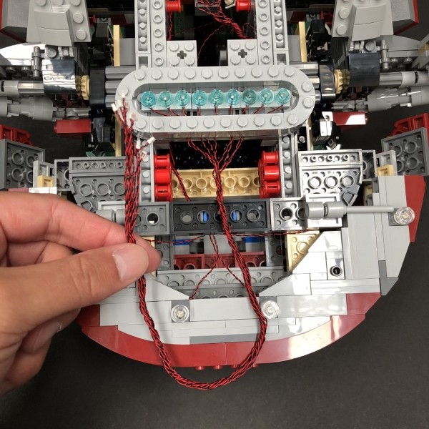
Thread the group of cables underneath the following section and then pull it out from the other side.
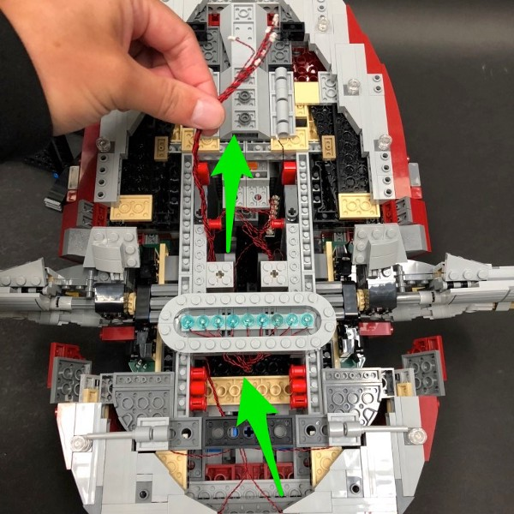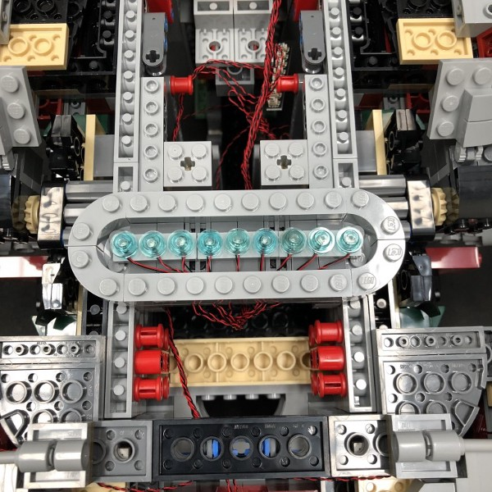
Reconnect the round dish section
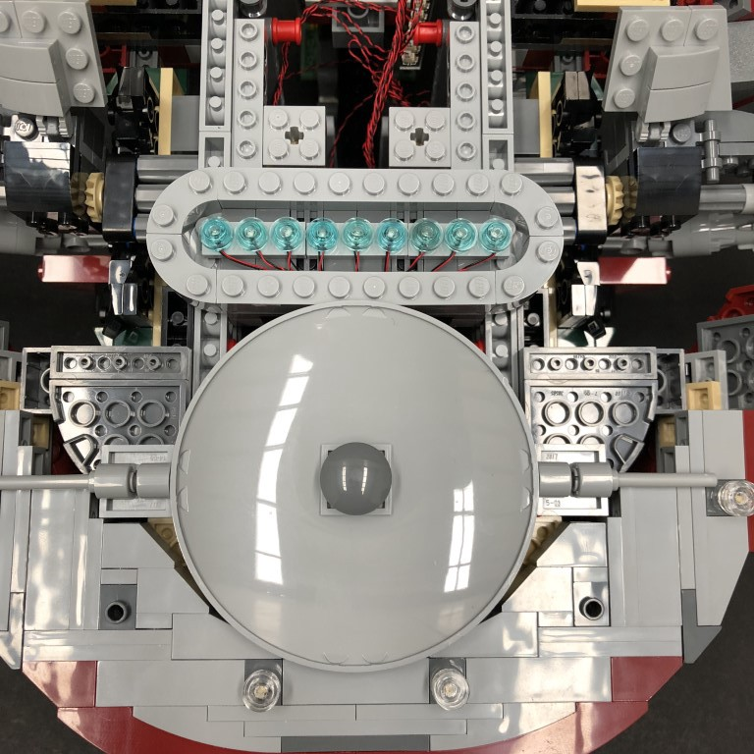

19.) Take a 12-Port Expansion Board and then connect all nine Blue Dot Light cables to it.
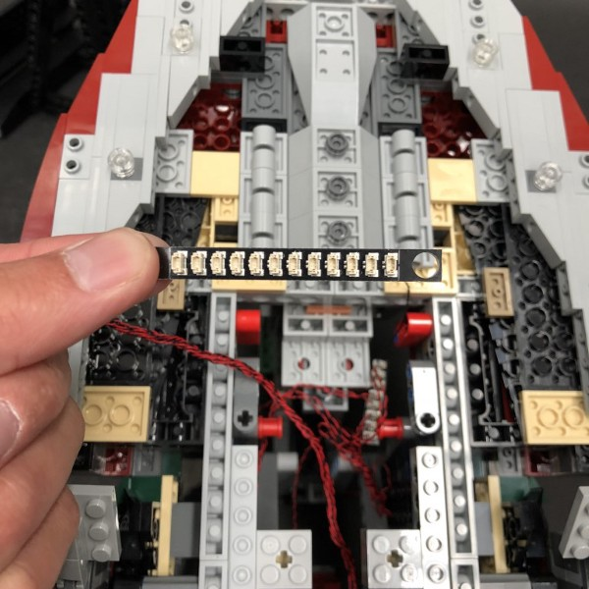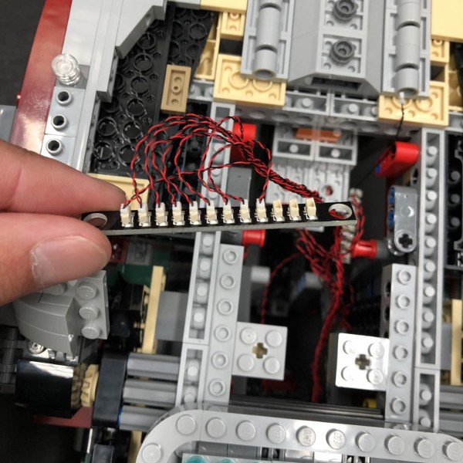

20.) Take the two blue jet sections and then push out the tan coloured technic bars to disconnect the trans light blue dish pieces.
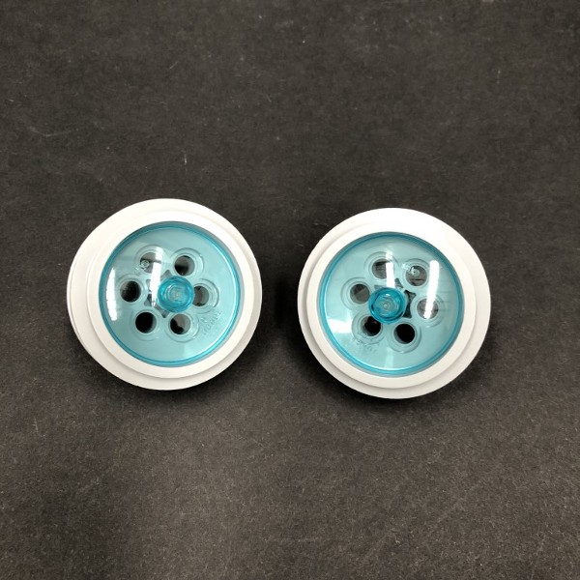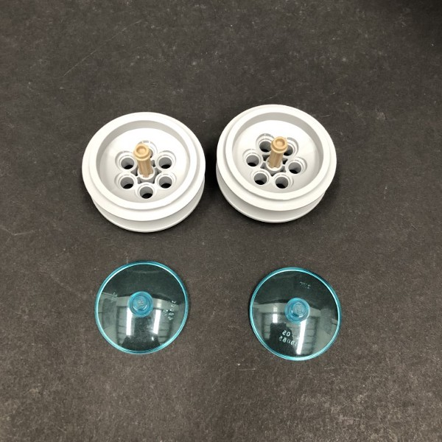

Take a Blue 30cm Dot Light and thread the connector side of the cable through one of the holes of the grey piece. Thread all the way through and then place the Dot Light directly over the technic bar.
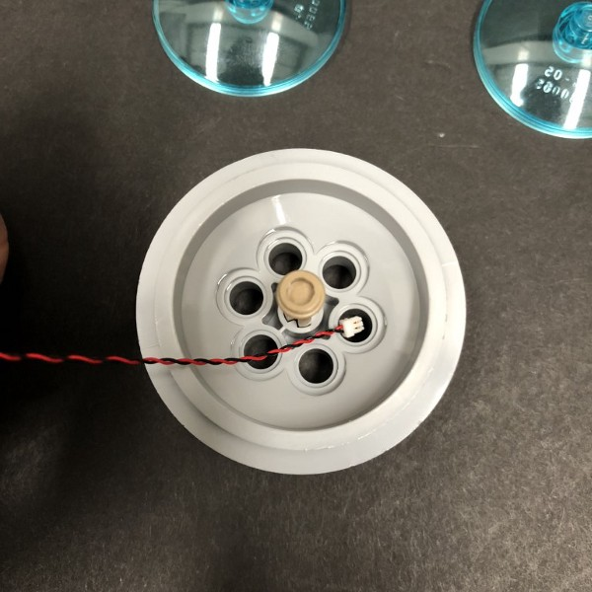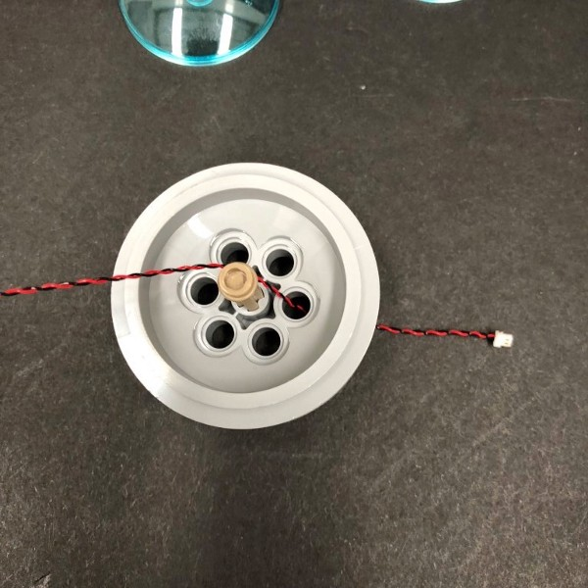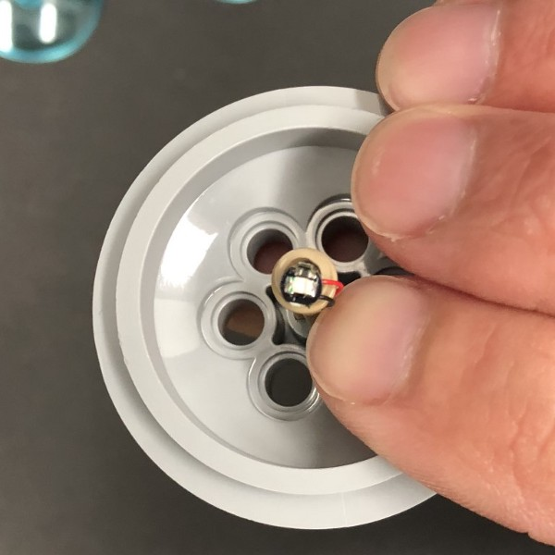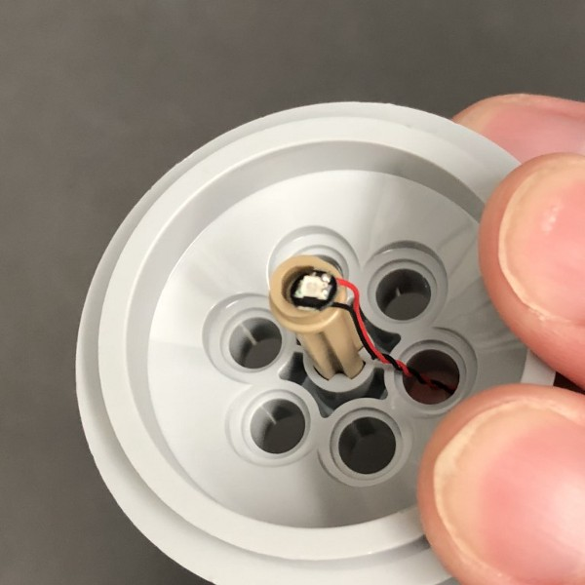

Secure the Dot Light in place by reconnecting the trans light blue dish over the top ensuring the Dot Light is directly underneath the stud.
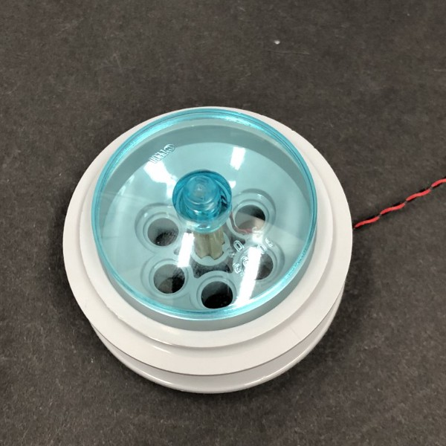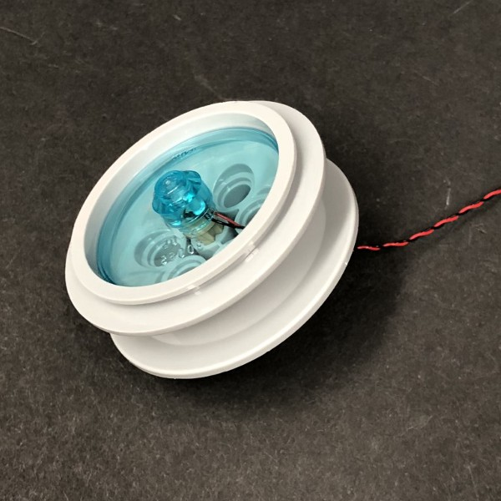

Repeat this step to install the remaining Blue 30cm Dot Light to the other section
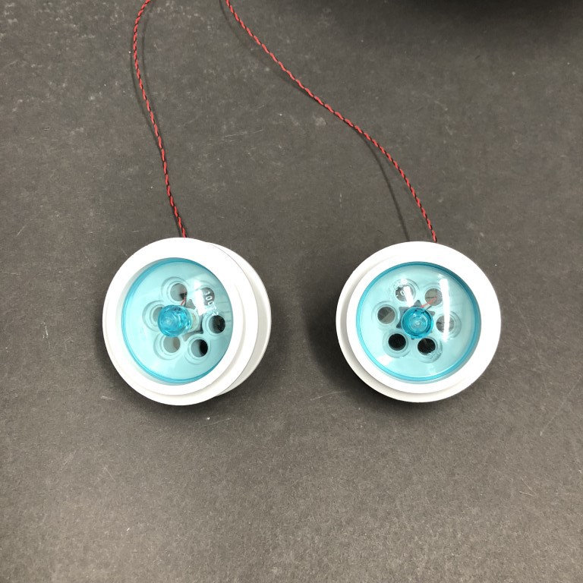

21.) Connect the two Blue Dot Light cables to the spare ports on the 12-Port Expansion Board from step 19.
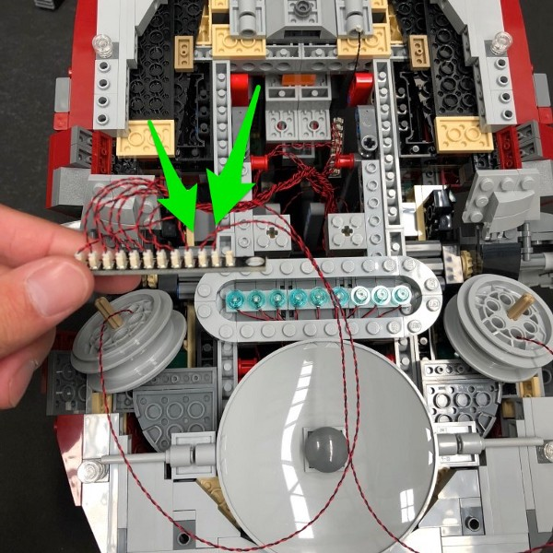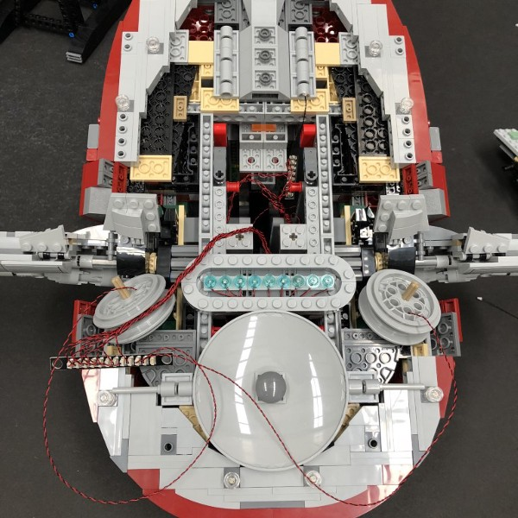

22.) Take a 5cm Connecting Cable and connect one side to the remaining port on the 12-port Expansion Board. Connect the other side to one of the OUT ports on the Multi Effects Board (side with 2 ports)
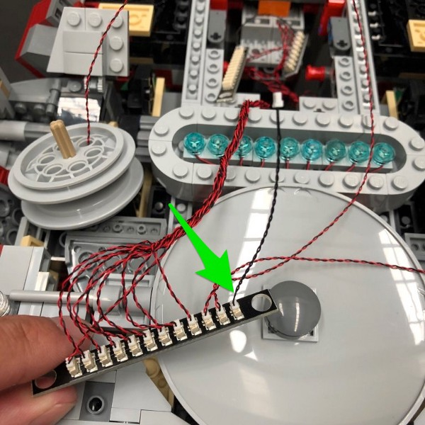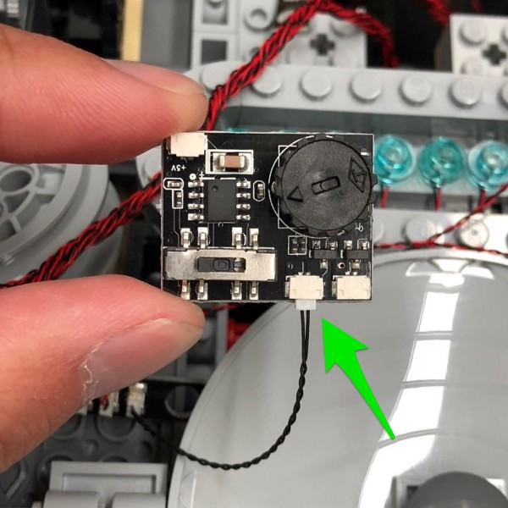

Setup and test the effects of the Multi Effects Board by connecting the AA Battery Pack to the IN port (side with 1 port). Turn ‘ON’ the battery pack and then set the switch to the left for the “Pulse” effect. Turn the wheel to adjust to the slowest speed. Alternatively, set the switch and adjust the speed to your desired effect.
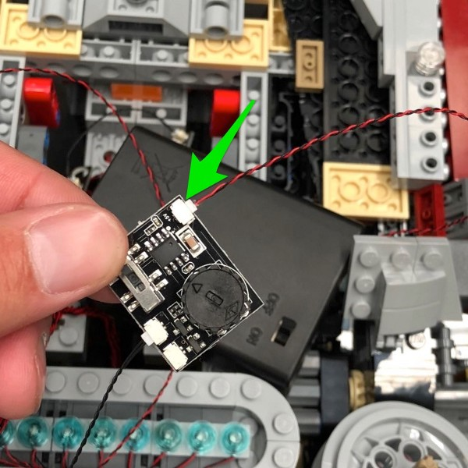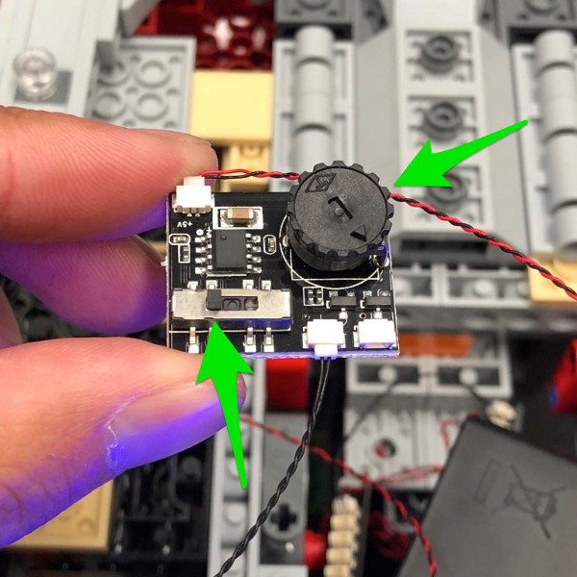
23.) Disconnect the Battery Pack and replace it with the remaining 5cm Connecting Cable.
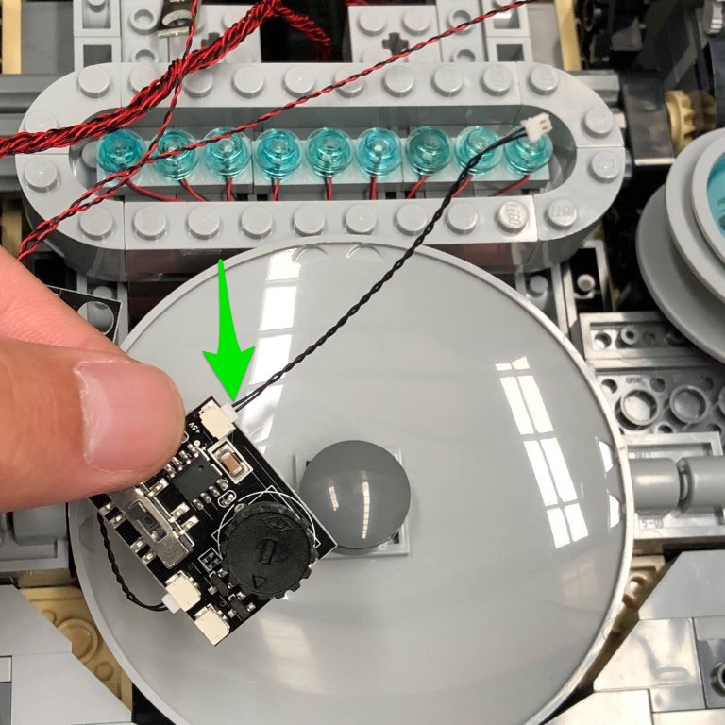

24.) Take the remaining 12-Port Expansion Board and then connect to the far right port, the other end of the 5cm cable from the 8-port expansion board from step 7.
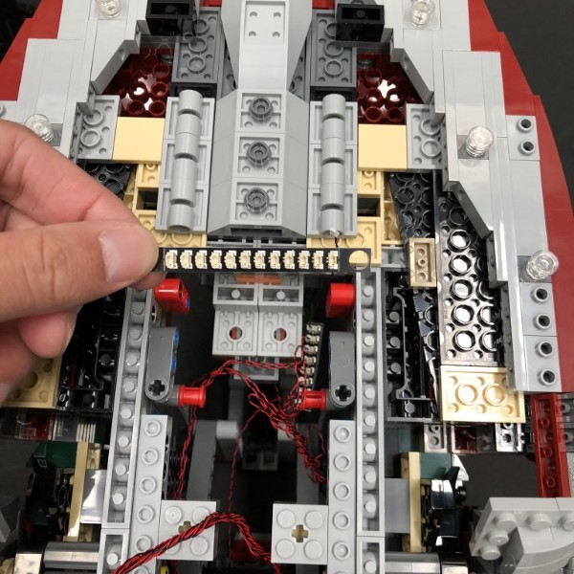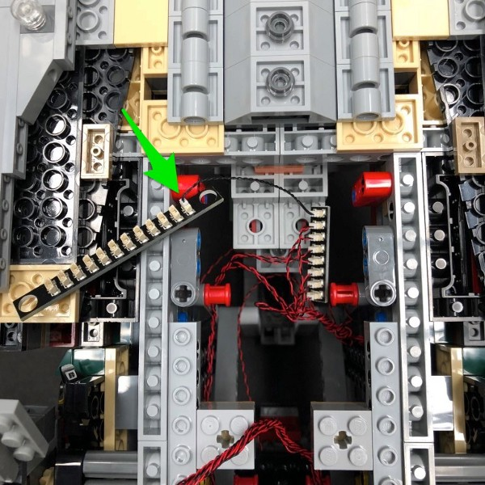

25.) Connect the other side of the 5cm connecting cable from the multi effects board to the far left port on the new 12-Port Expansion Board
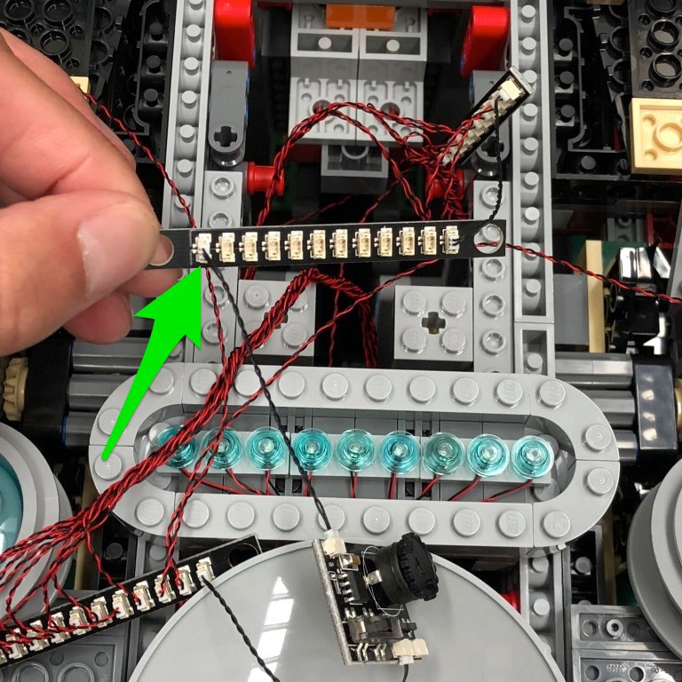

Set everything aside for now and proceed to the next step.

26.) We will now install the remaining lights to the top of Slave 1. Start by disconnecting the outer left and right sections using the removal tool
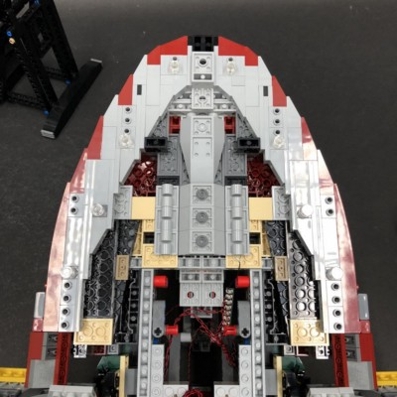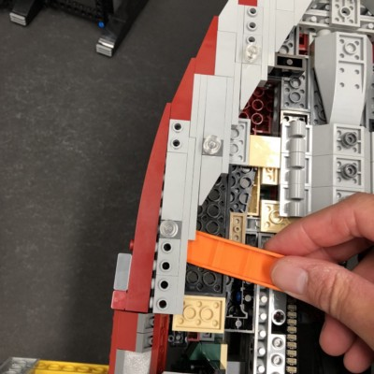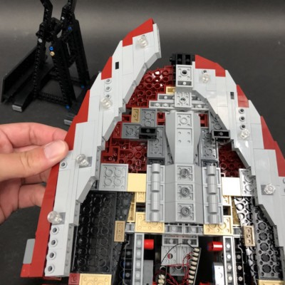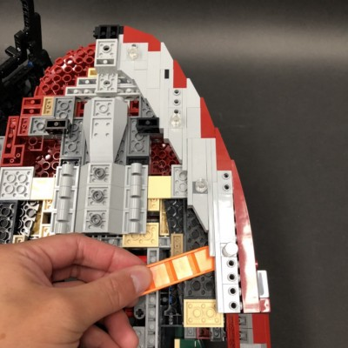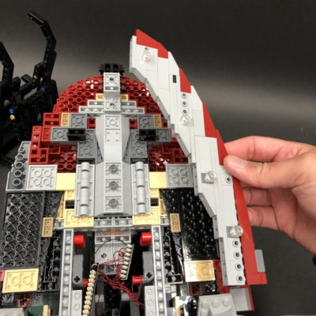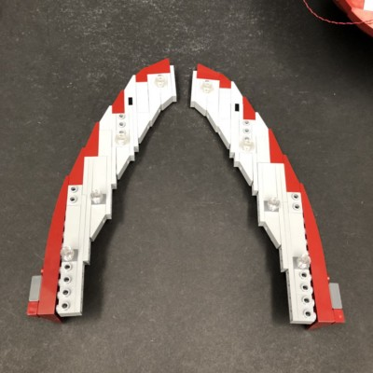
27.) Take the left section and then disassemble the following section:

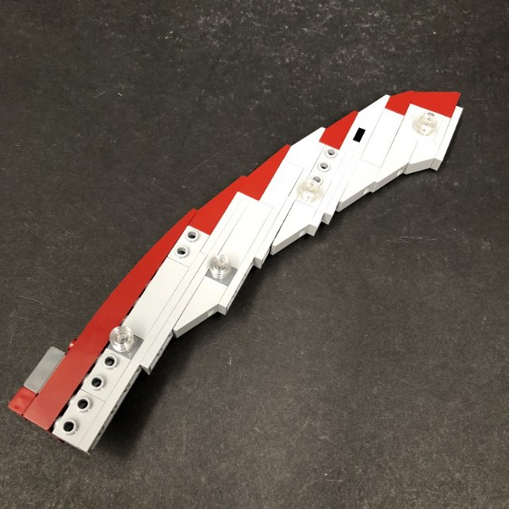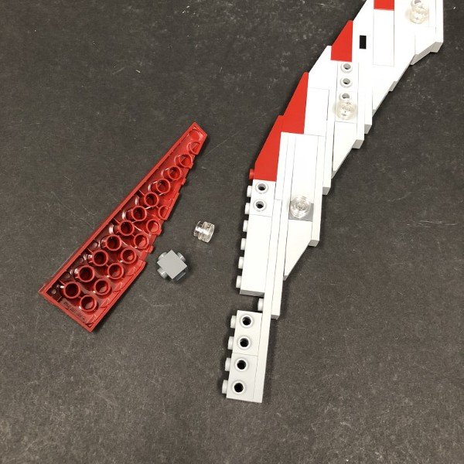

Install a White 30cm Dot Light to the dark grey brick using the same method as previously used for the lower lights then reconnect this section to the rest of the left section
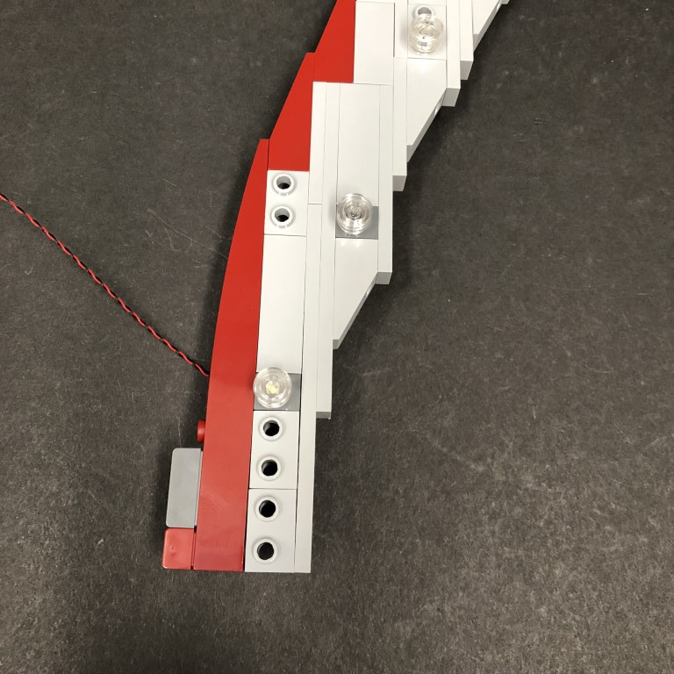

28.) Move onto the next section by disconnecting and disassembling pieces. Install another White 30cm Dot Light using the same method again.
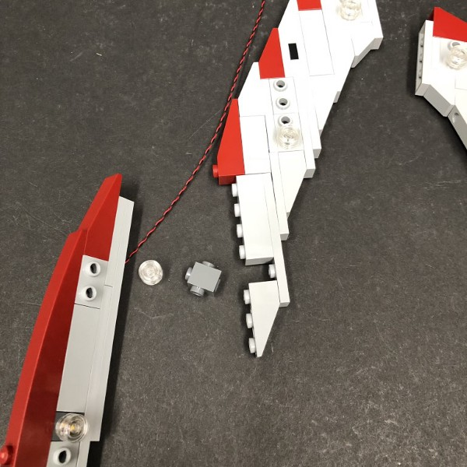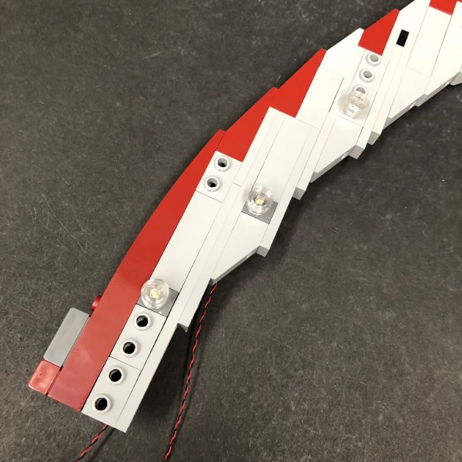

29.) Repeat this process again to install another 2x White 30cm Dot Lights to the remaining two lights in this left section.
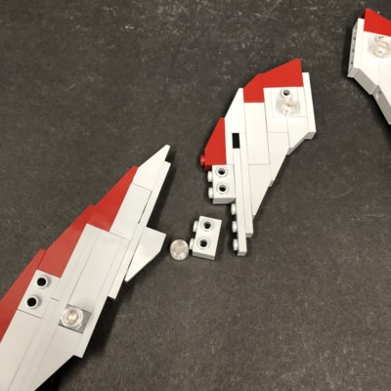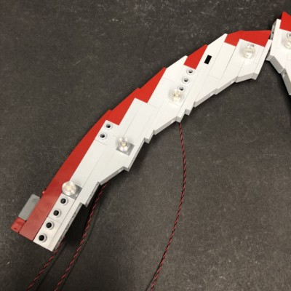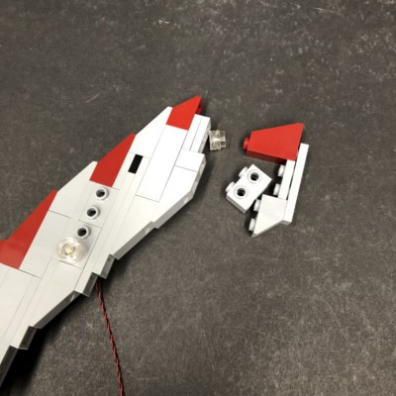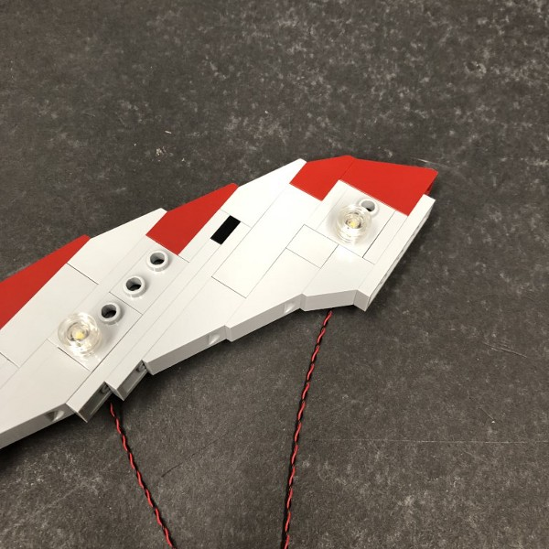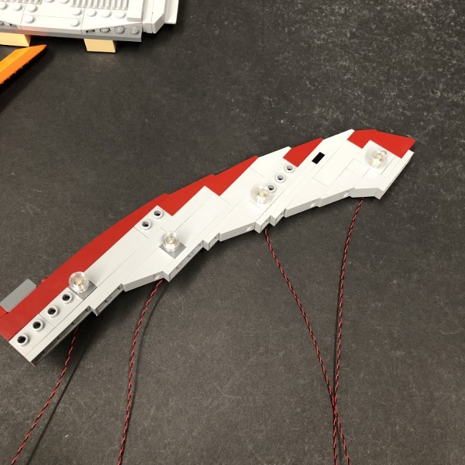
30.) Reconnect this main left section back to Slave 1 and then connect all four Dot Light cables to the 12-Port Expansion Board below
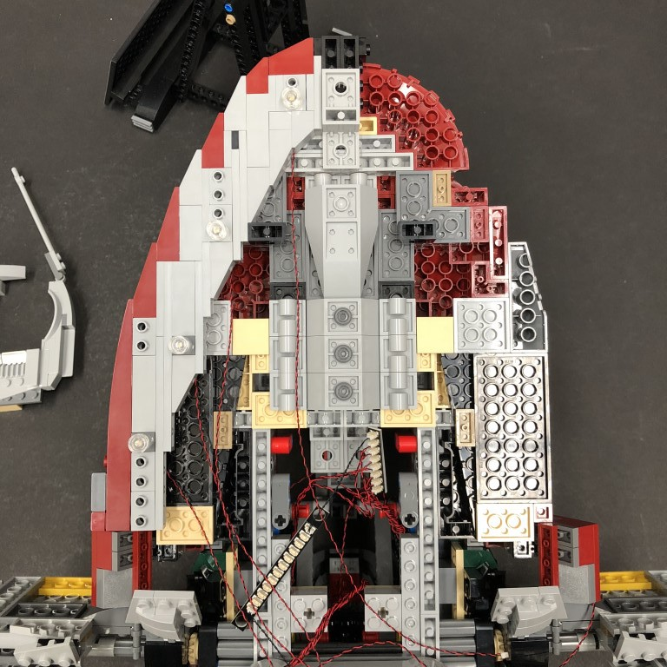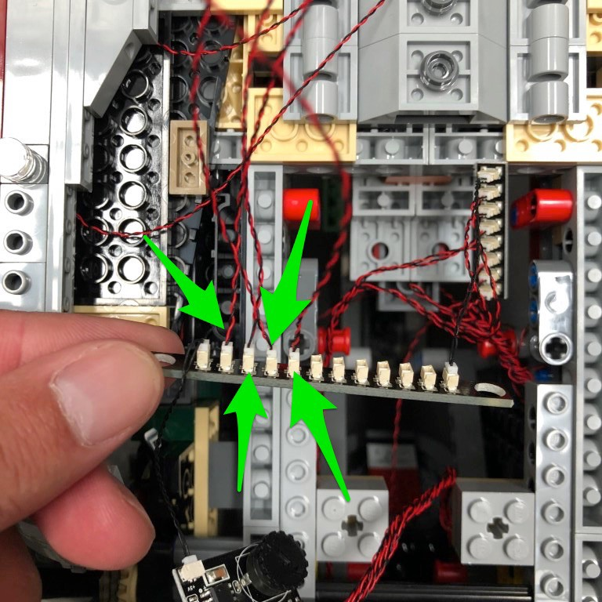

Lay the two right cables underneath the following pieces ensuring they are laid in between studs
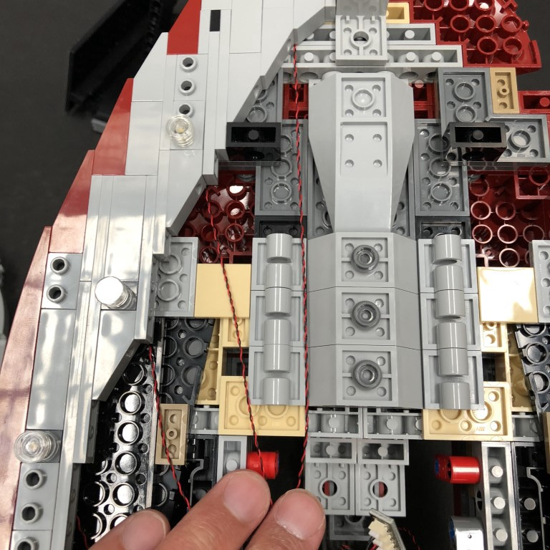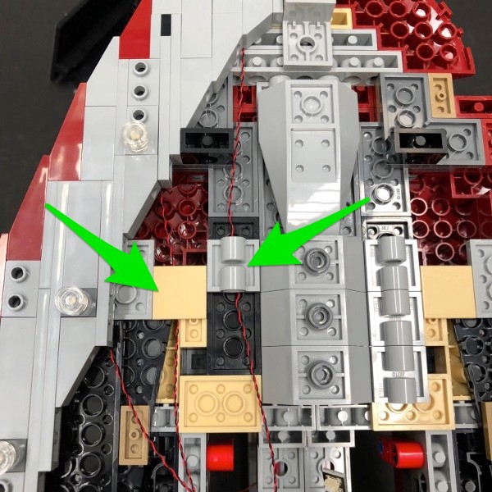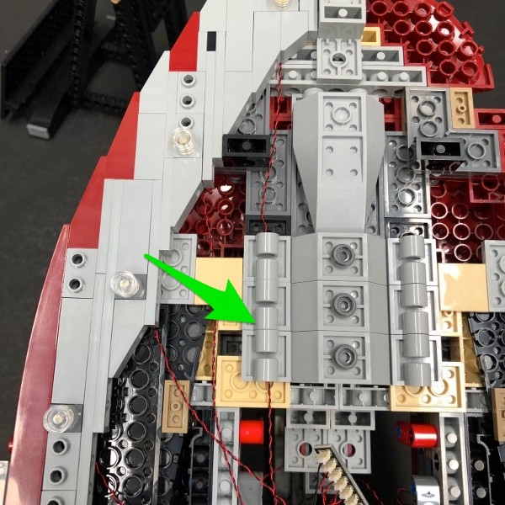

Neaten up cabling by grouping all four cables together and twisting them around each other as per below.
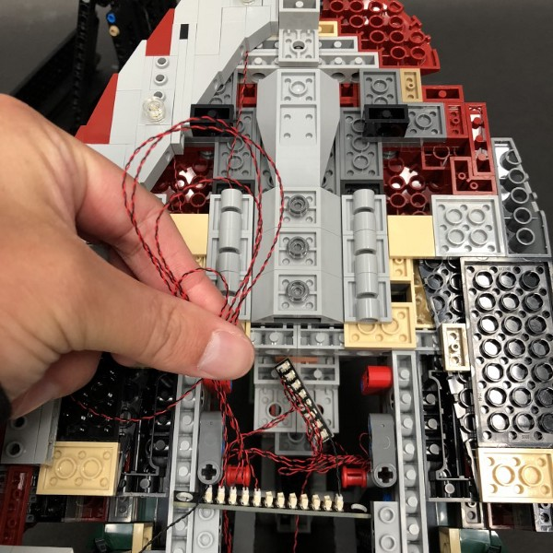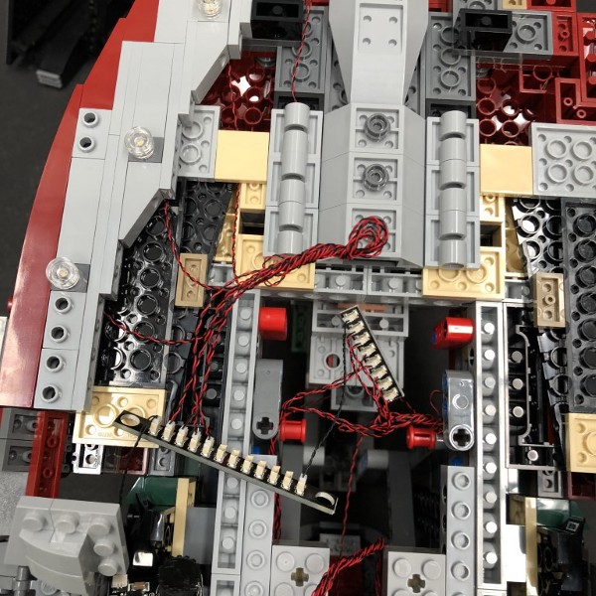

31.) Repeat steps 27–29 to install the remaining 4x White 30cm Dot Lights to the right side.
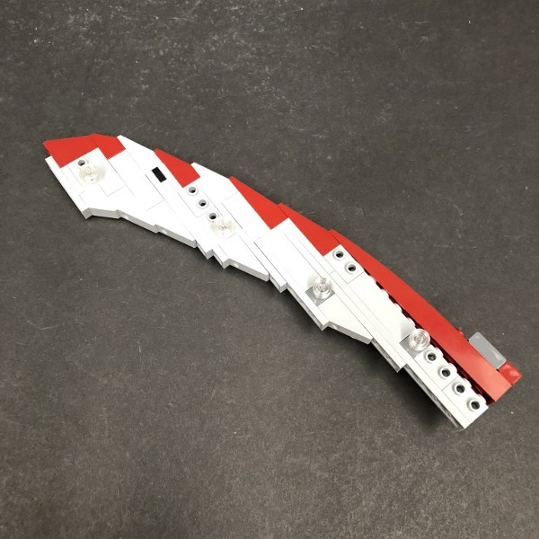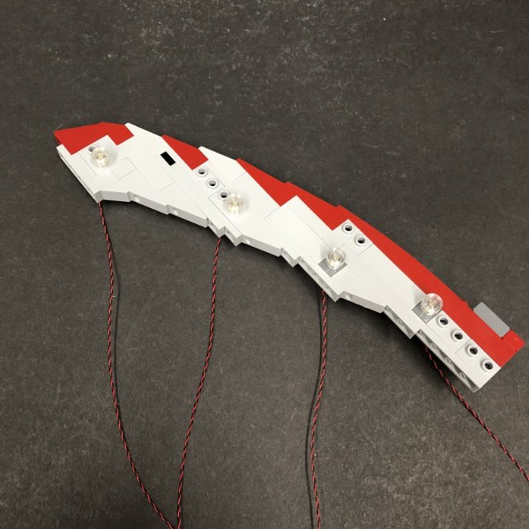

Reconnect the right section back to Save 1 and then lay cables underneath the following pieces again.
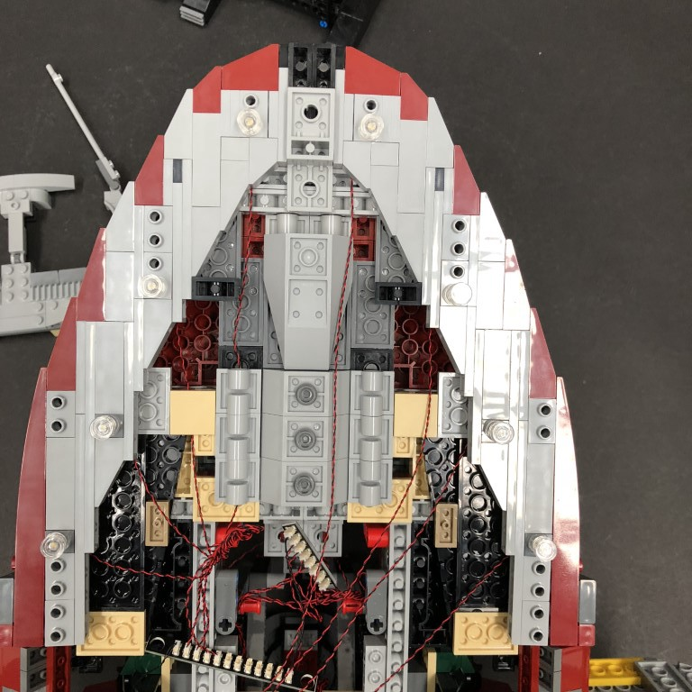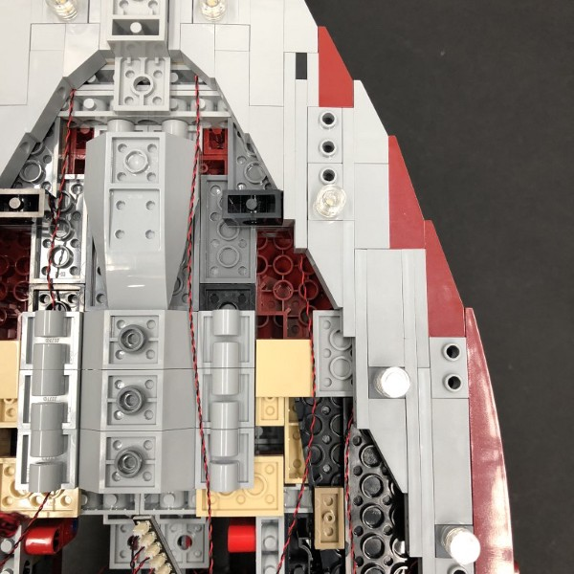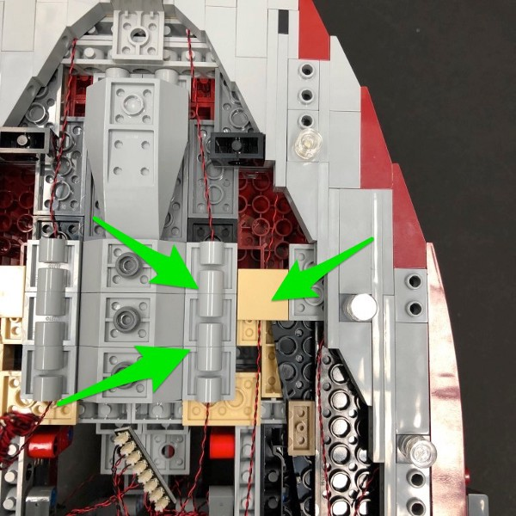

32.) Connect the four Dot Light cables from the right side to the next available ports on the 12-port expansion board then neaten up cabling by grouping and twisting the cables together.
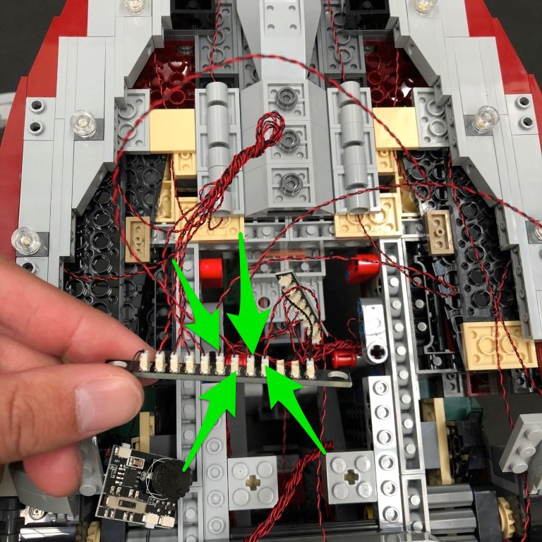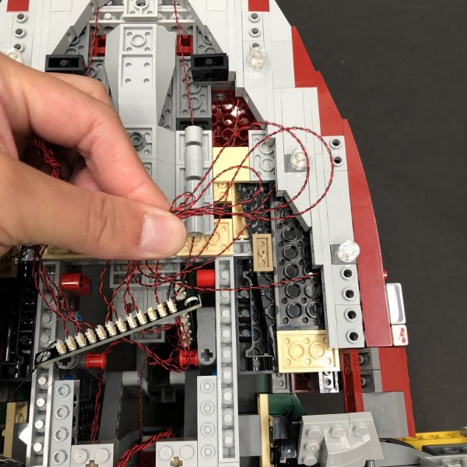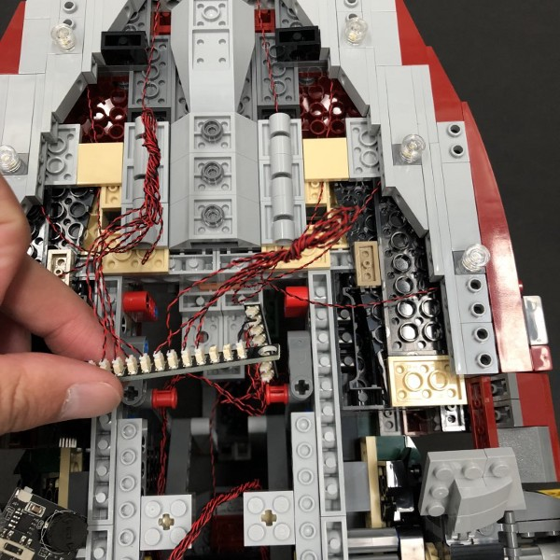

33.) Take the AA Battery Pack and connect the cable to one of the ports on the 12-port Expansion Board. Turn the power ‘ON’ to verify all lights are working OK
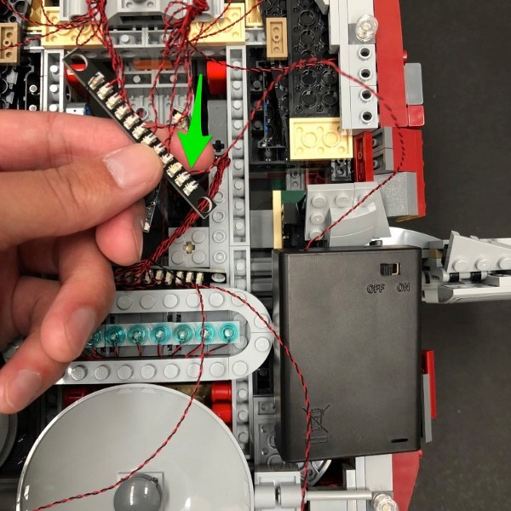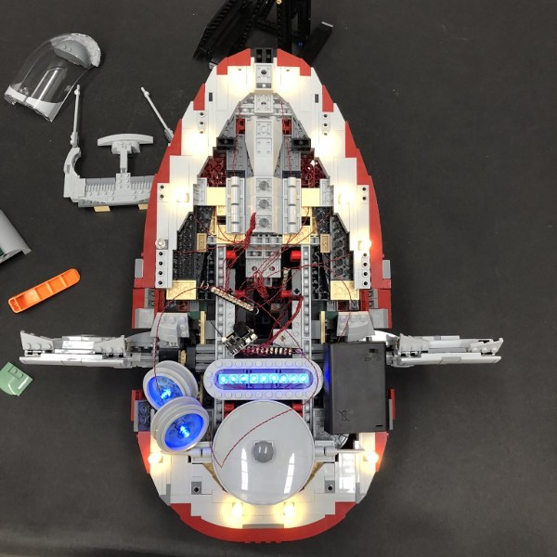

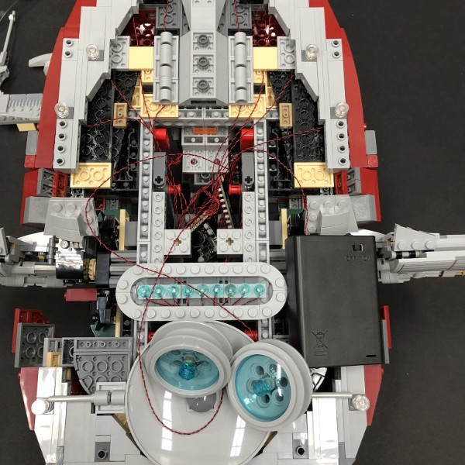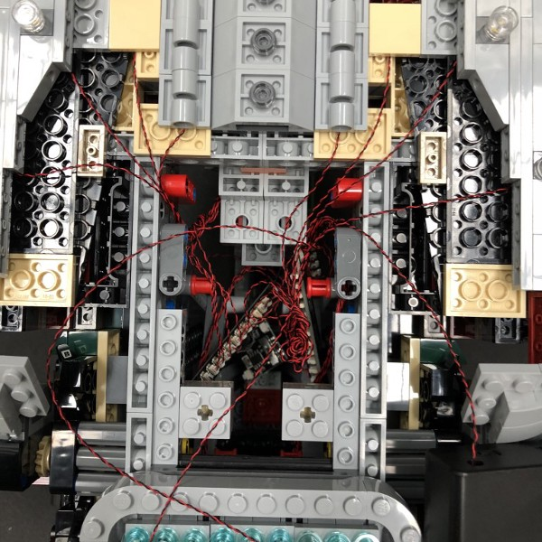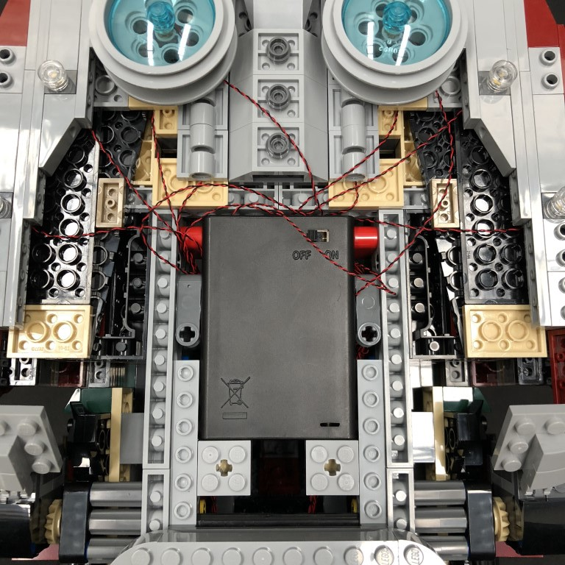

35.) Reconnect the remaining middle section and then neatly tuck in the cables from the two outer blue jet sections before reconnecting them back into place.
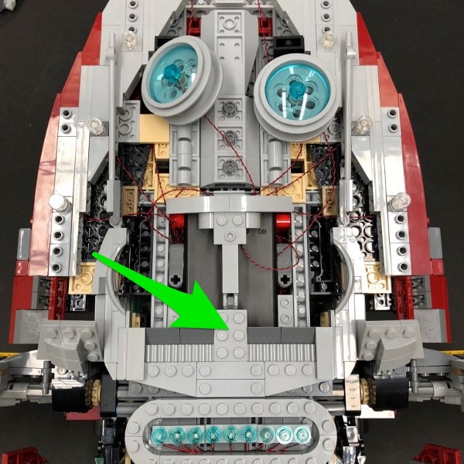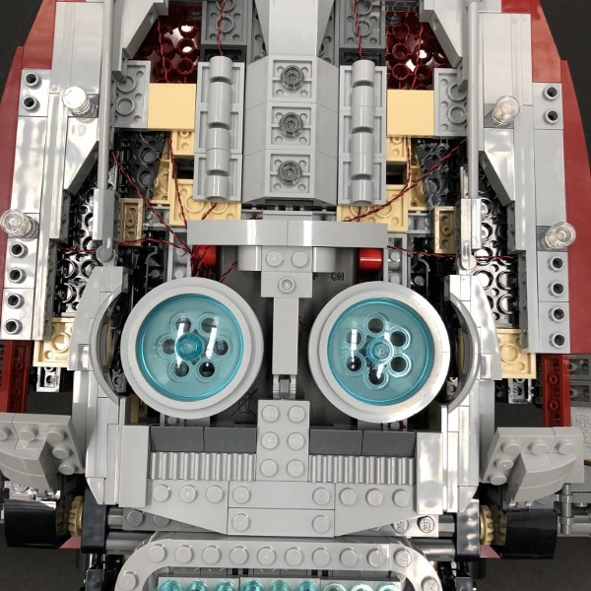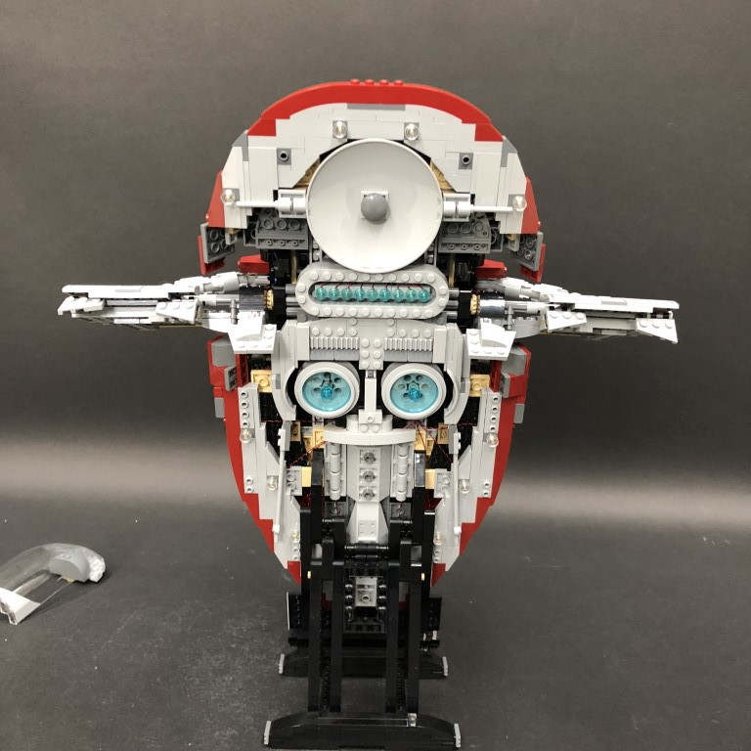

36.) Turn Slave 1 around and then reconnect all the remaining external sections starting with the right and left sides, followed by the middle, then the window section.
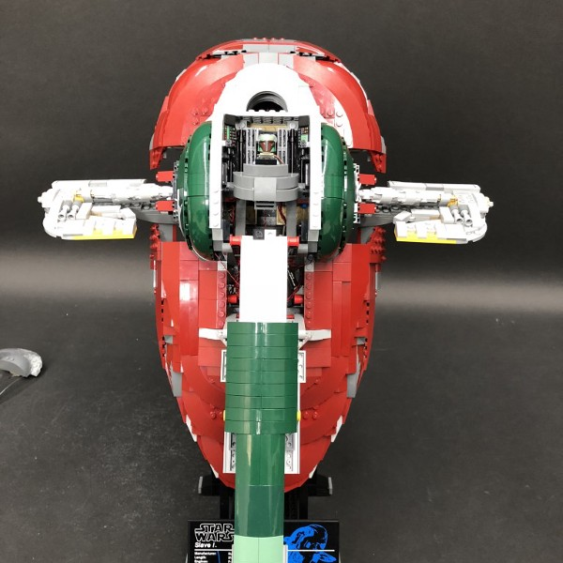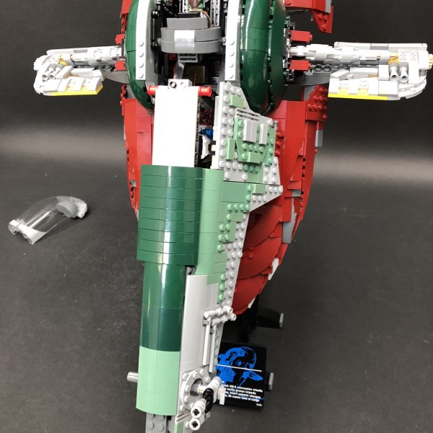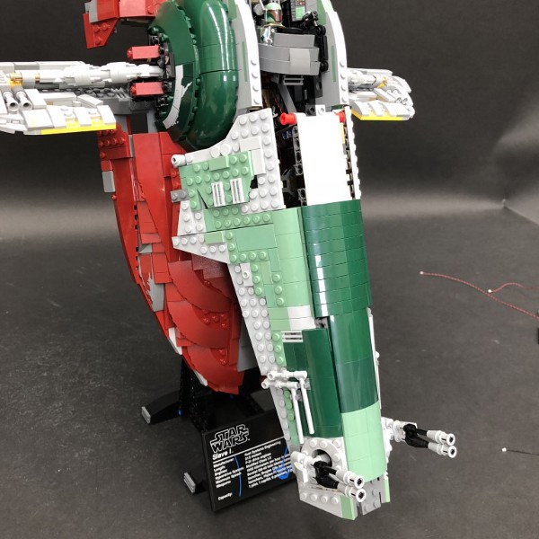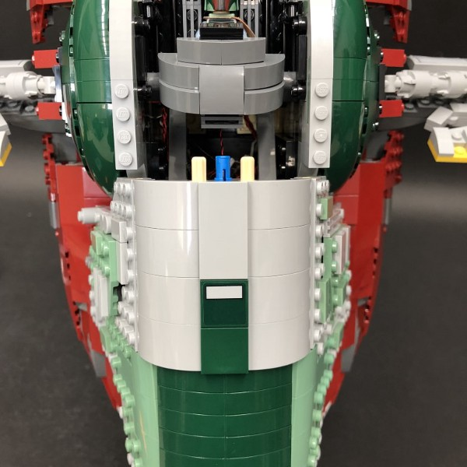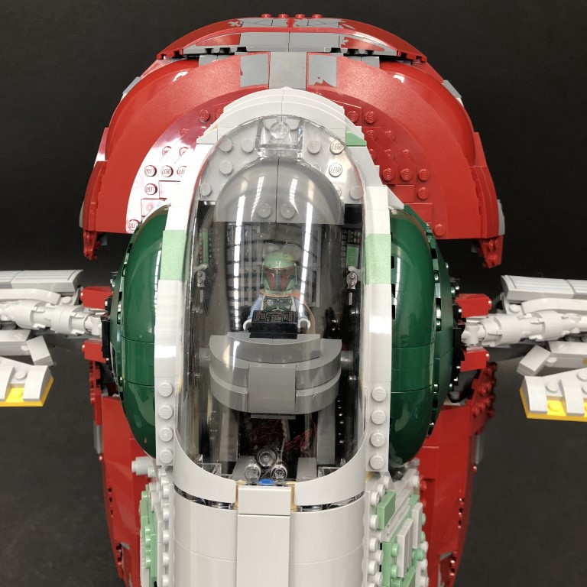

To access the battery pack, simply lift up the following section underneath Slave 1.
