Aston_Martin_DB5_10262 Basic Version LED Lighting Kit

Package contents:
- 1 X Round Button Battery pack
- 8 X 30cm White Dot Lights
- 2 X 30cm Warm White Dot Lights
- 1 X 12-Port Expansion Boards
Others：
- 2X Adhesive Squares
- pieces

Note:
Place wires on the surface or under the building blocks.
The wire can be place between the building blocks or under the block, but they should be placed between the studs correctly.
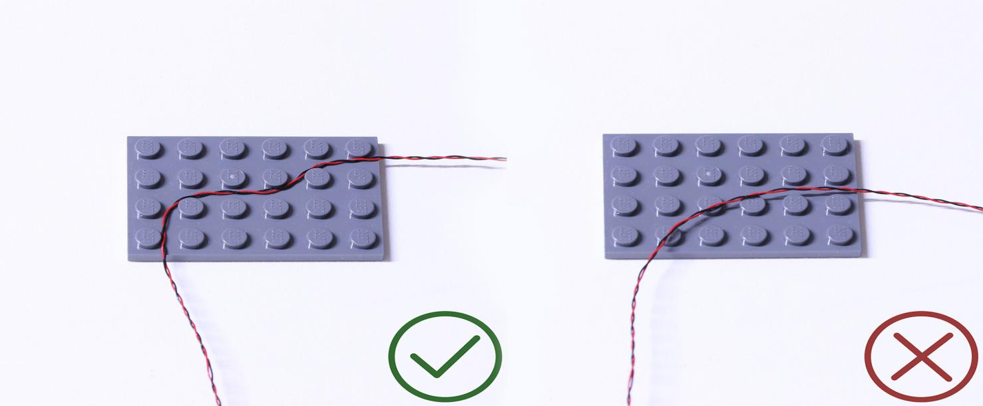
Insert the connectors to the ports.
Be careful when you are operating, there’s only one correct way to insert, make sure the expansion board is upward, find the soldered “=” sign on the left of the port. When you are inserting, the side which the wires can be seen should be faced to the “=” sign and if you feel hard to insert, please stop, and don’t force it, for that may result in bent pins inside the port or overheating of the expansion board.
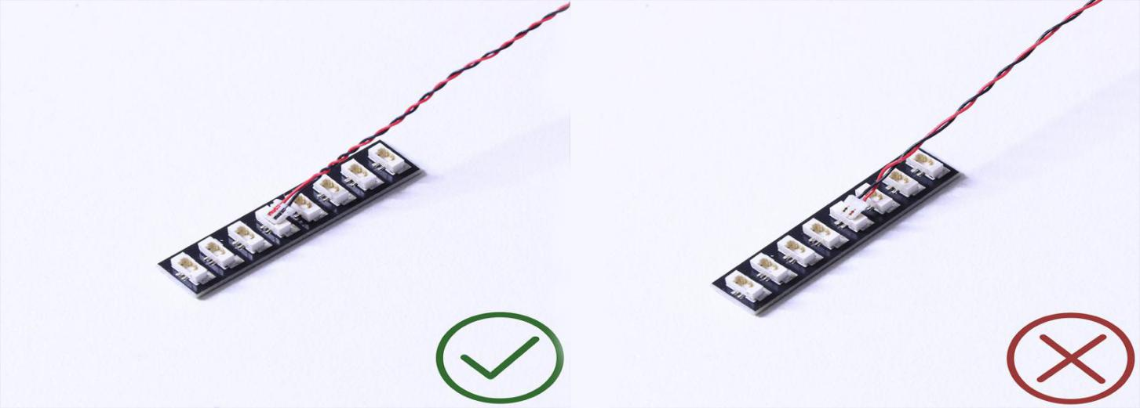

At this point, use the tweezers to straighten the bentpins.

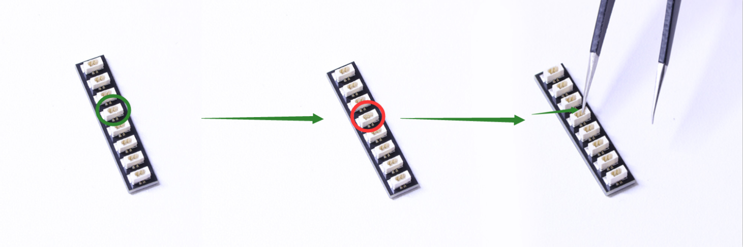

When installing dot lights, make sure they are correctly placed (Yellow LED package is exposed). You can put they either on the top of the studs or between studs.

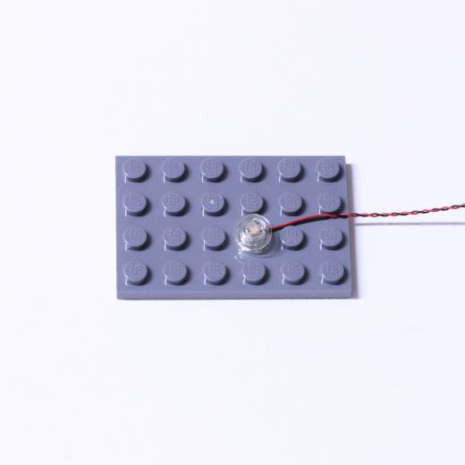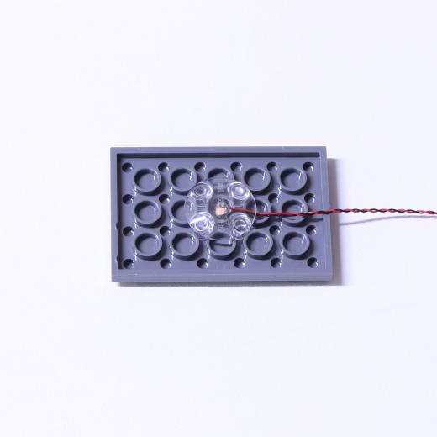

Connecting cable connectors to Strip Lights

Take extra care when inserting connectors to ports on the Strip Lights. Connectors can be inserted only one way. With the Strip Light facing up, ensure the side of the connector with the wires exposed is facing down. If a plug won’t fit easily into a port connector, don’t force it. Doing so will damage the plug and the connector.
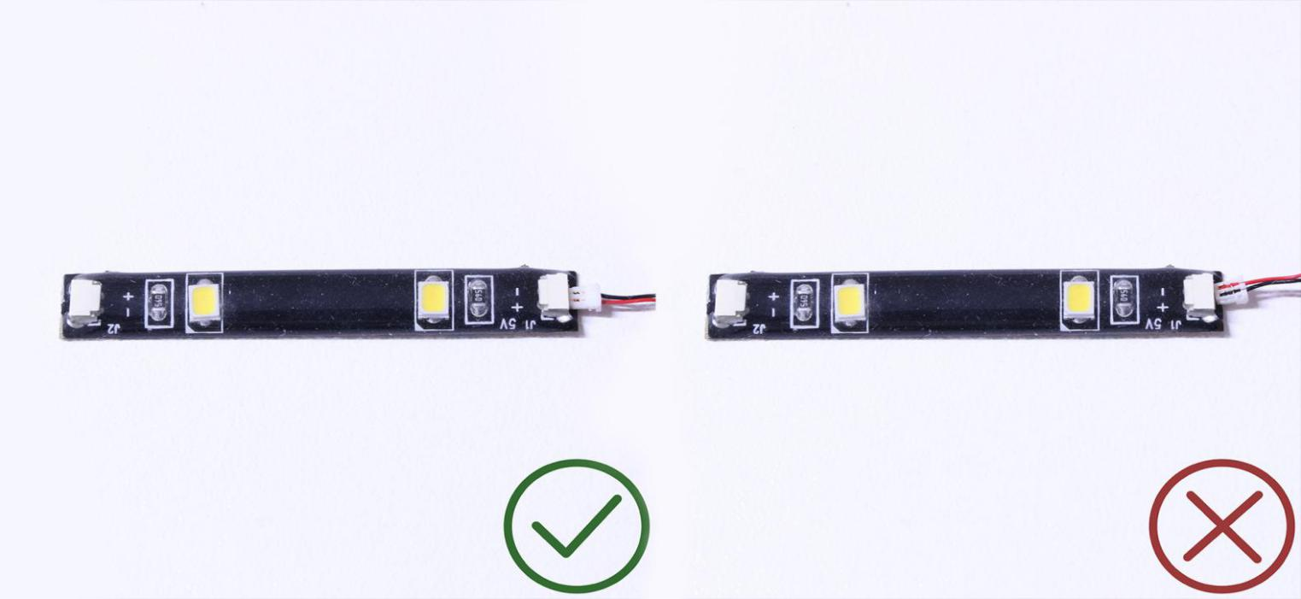
Finally, please pay attention to the positive and negative terminals of the battery when installing the battery case.
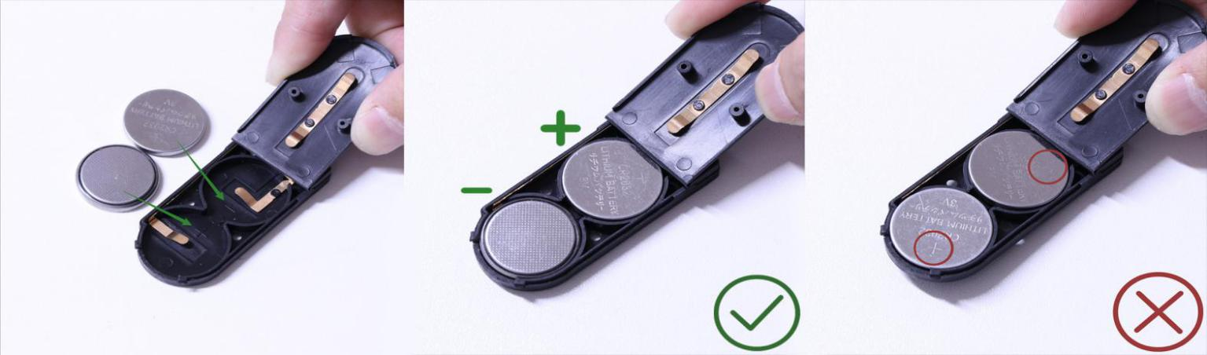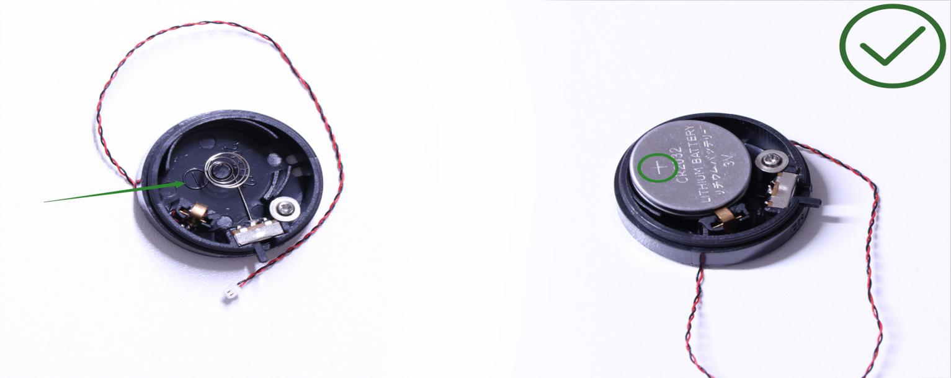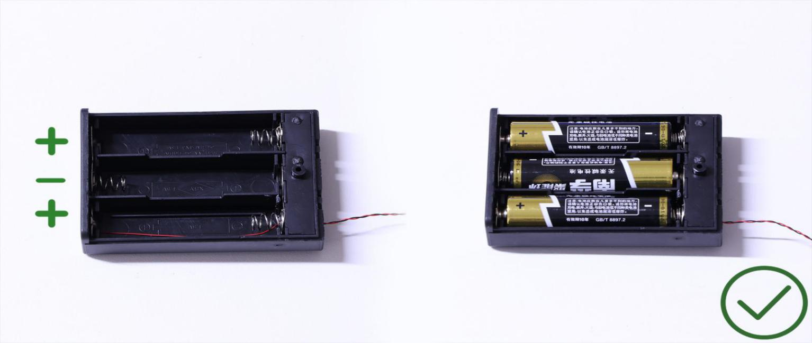
OK, Let’s Begin!

Instructions for installing this kit

1. First install the headlights. Remove a headlight, uncover the transparent part above, take out a 30cm warm white Dot Light, let the LED in the center of the headlight, and cover the transparent part.
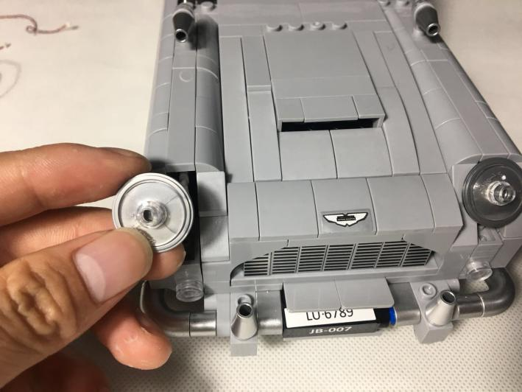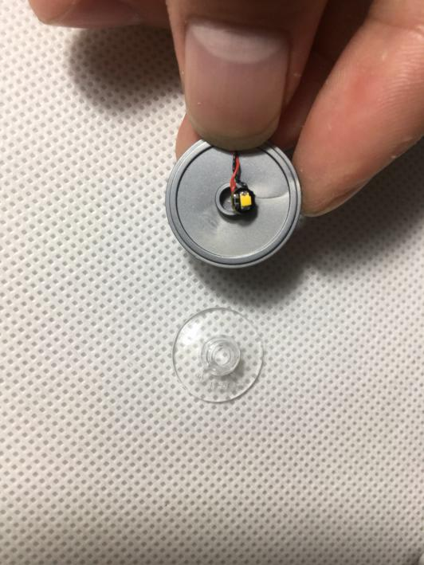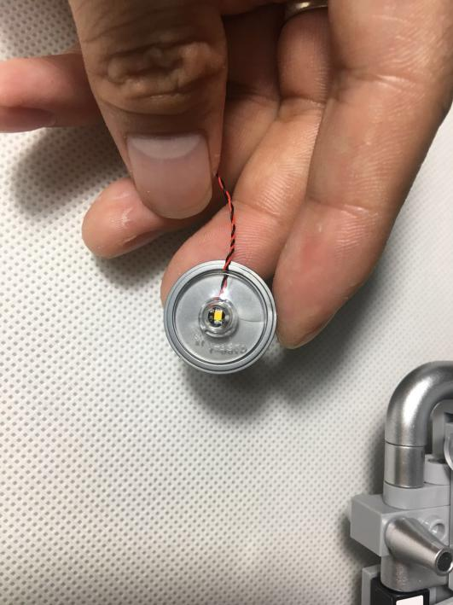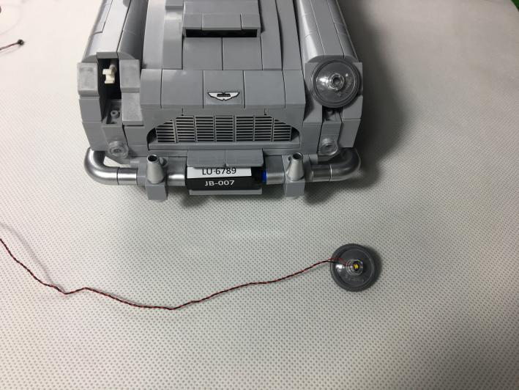

Put the car up on the table and remove the tire
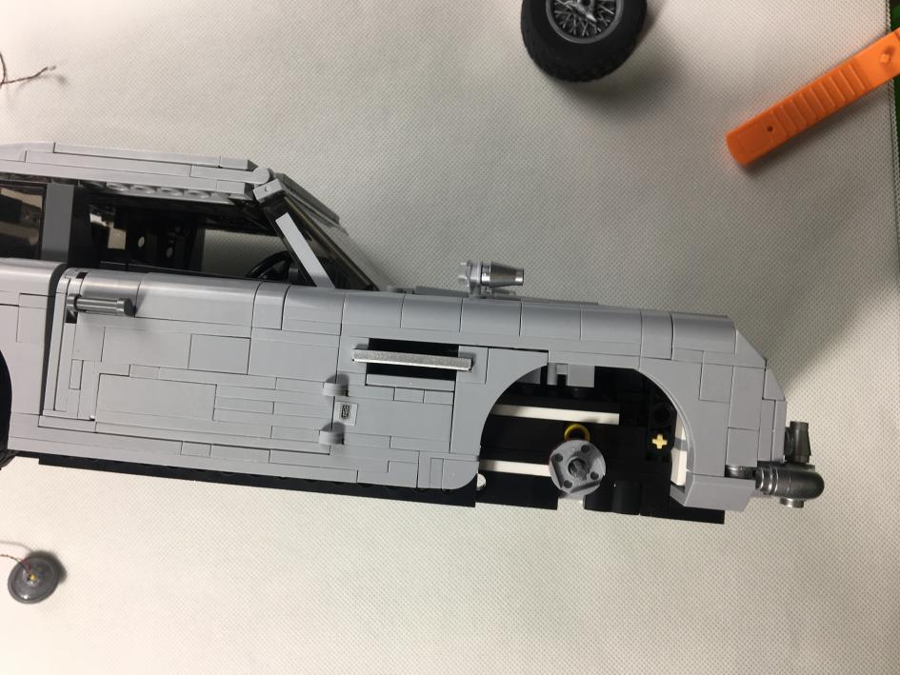

Remove the pieces as shown below
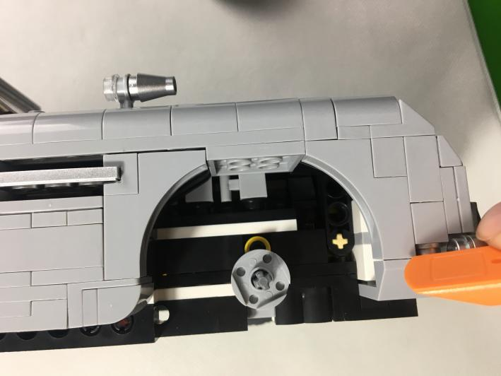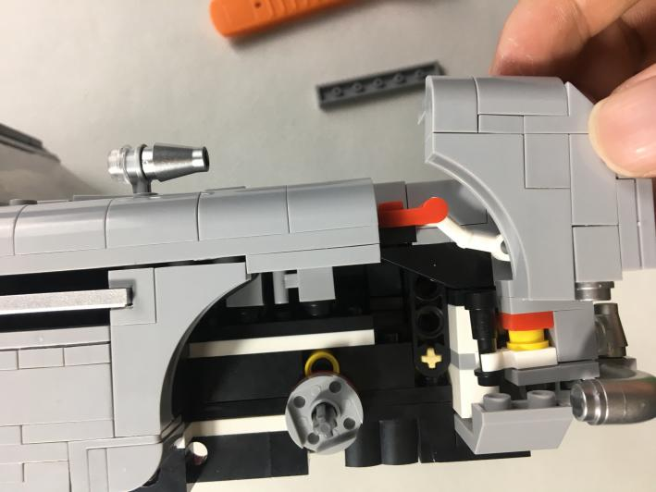

Pull out the piece where the lampshade is located, as shown below
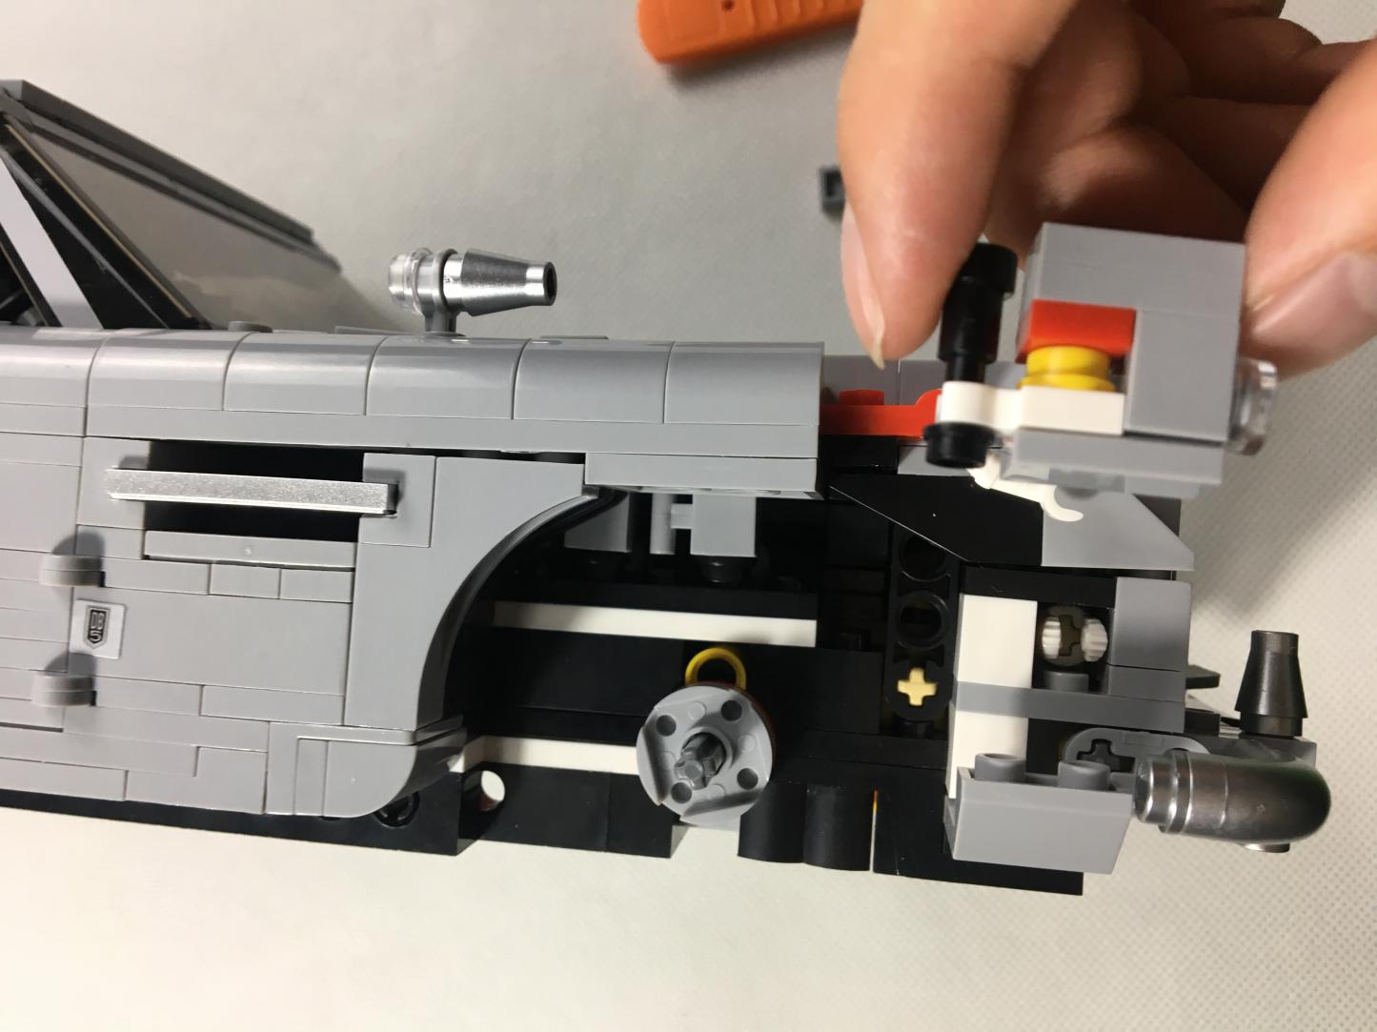

Take a 30cm white Dot Light and let the interface pass through the pieces as shown blew . Note that the cable is on the side of the red claw for easy wiring.
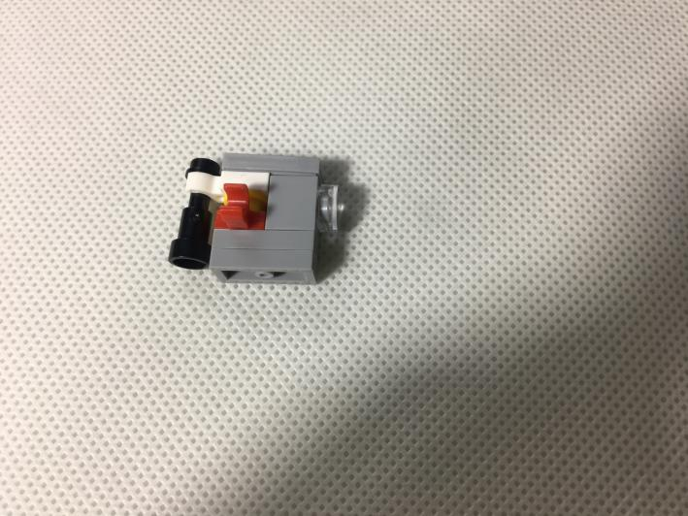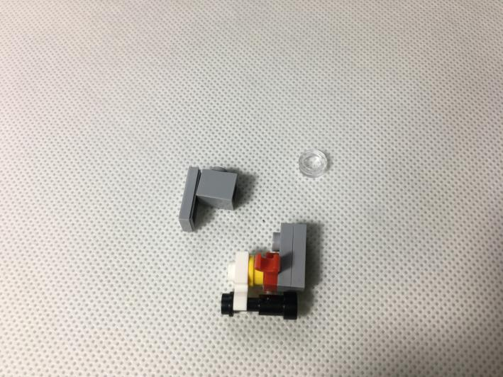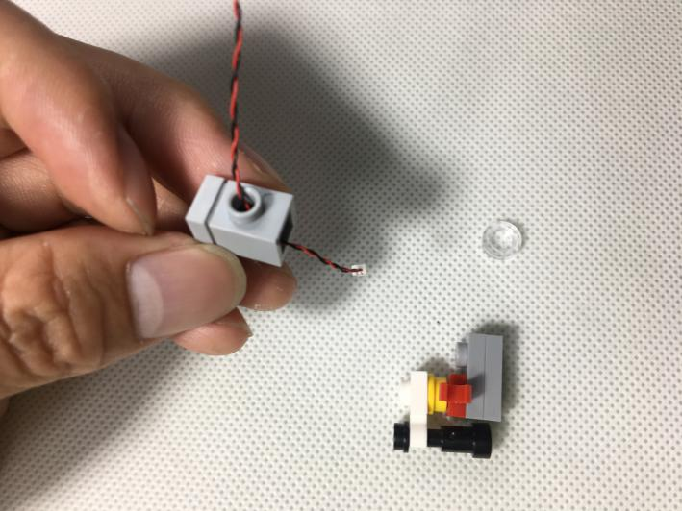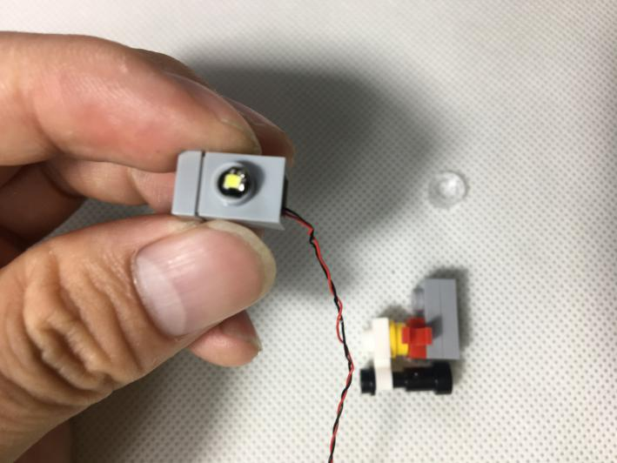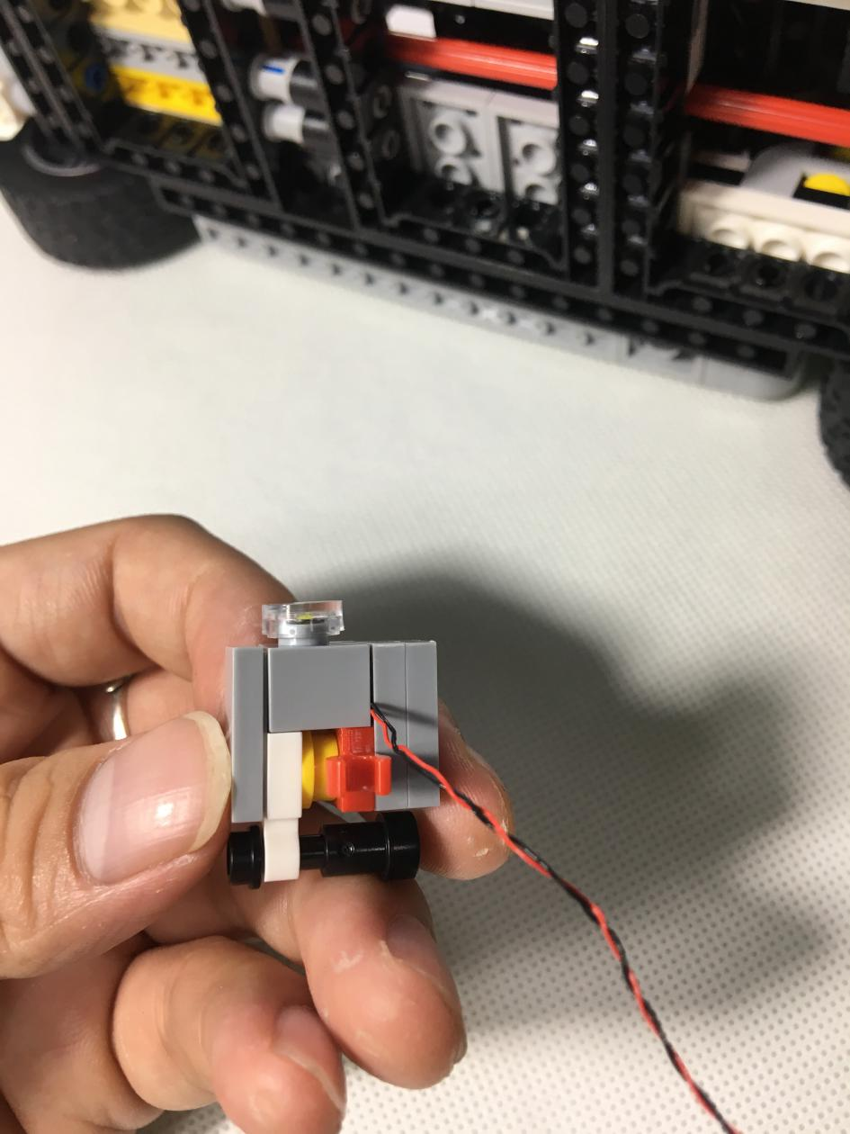
Reconnect the piece
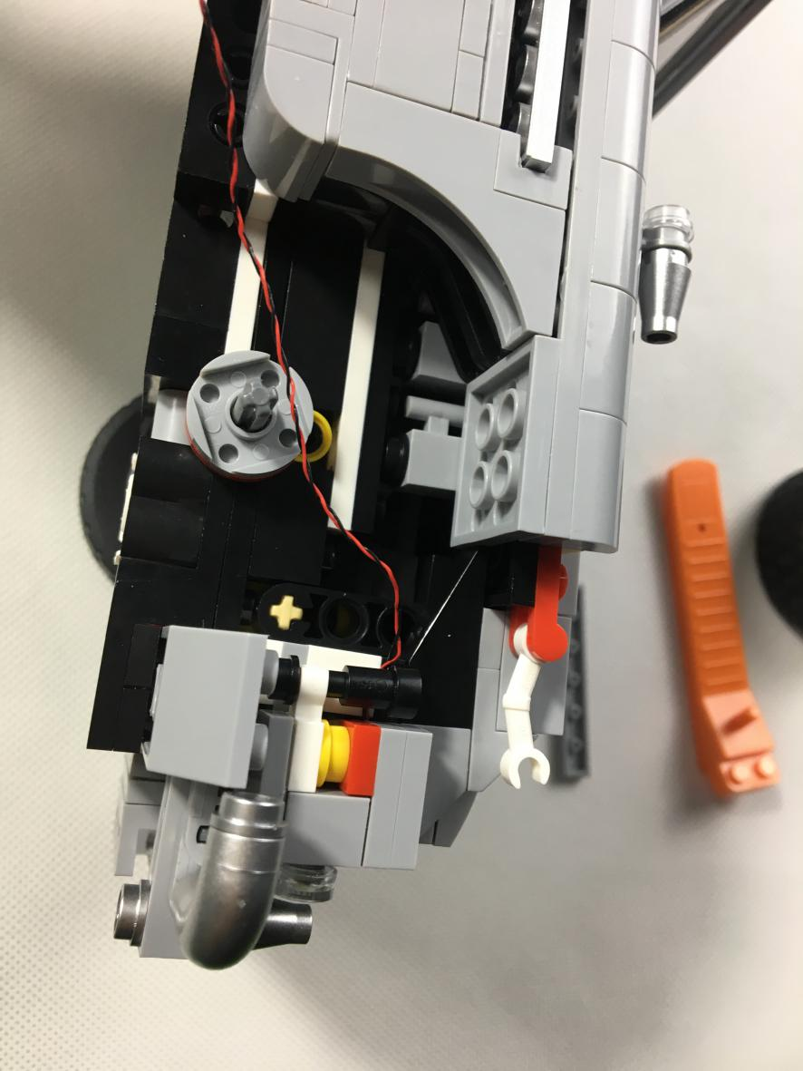

Reconnect the headlights and the pieces that were previously removed
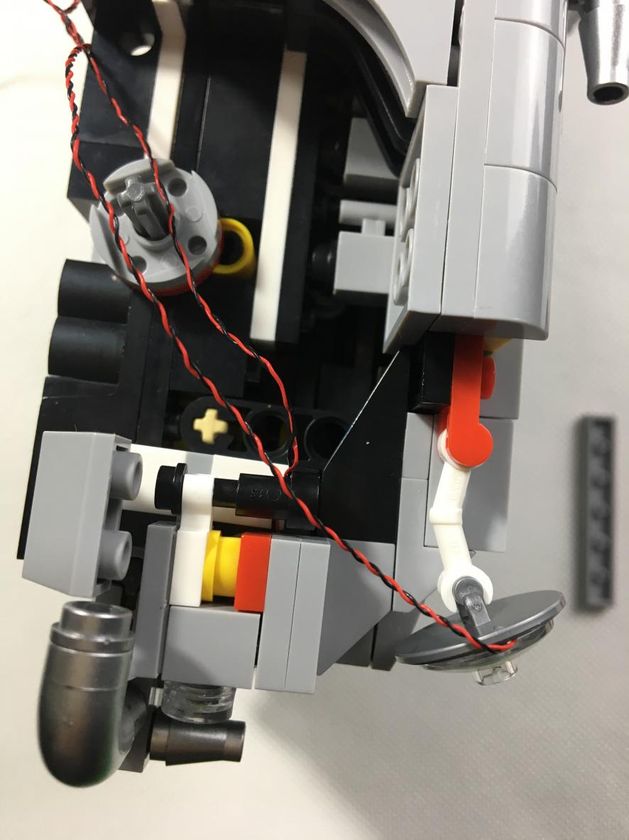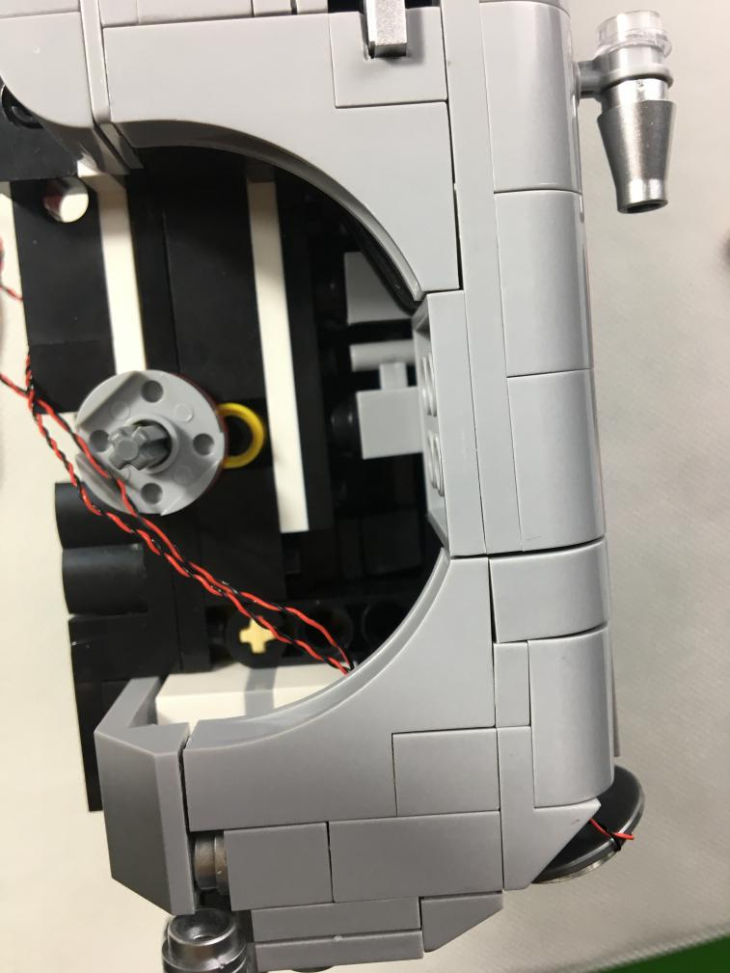

Remove the pieces as shown blew
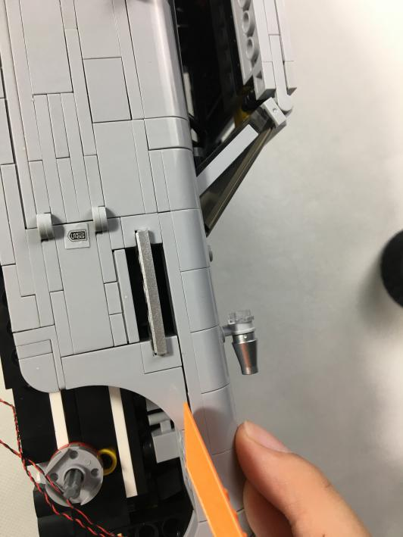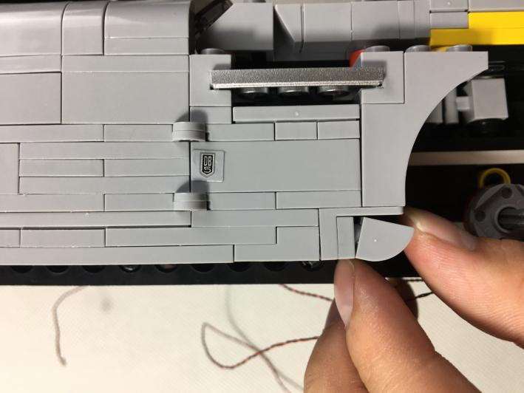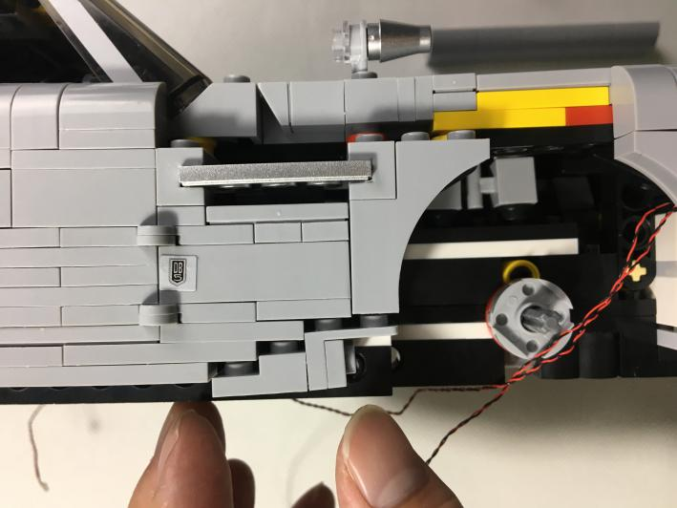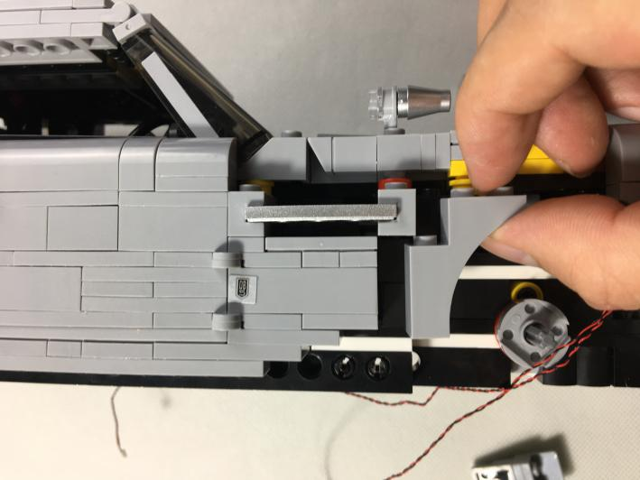

Press 3*3 piece. Note that the cable is above and between the bumps
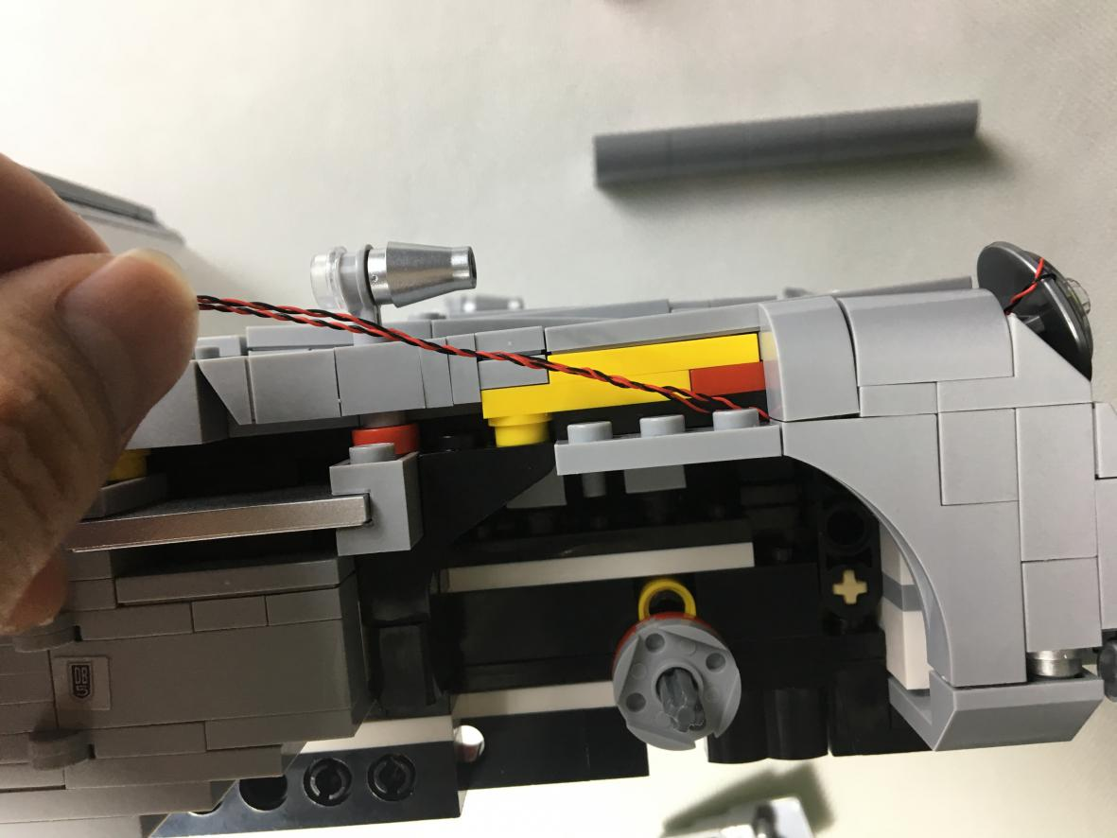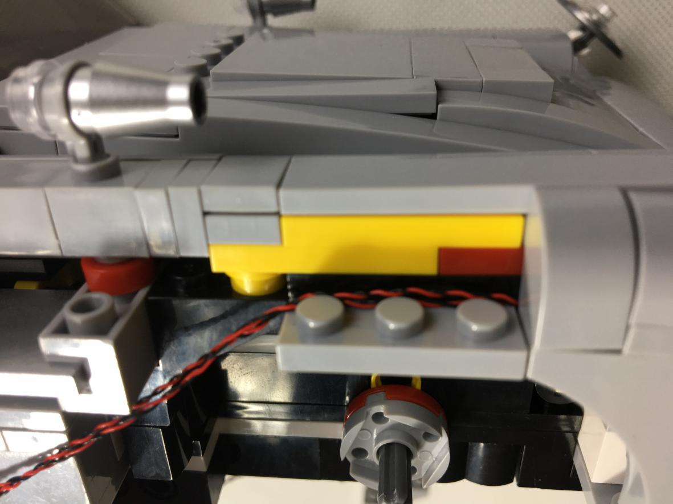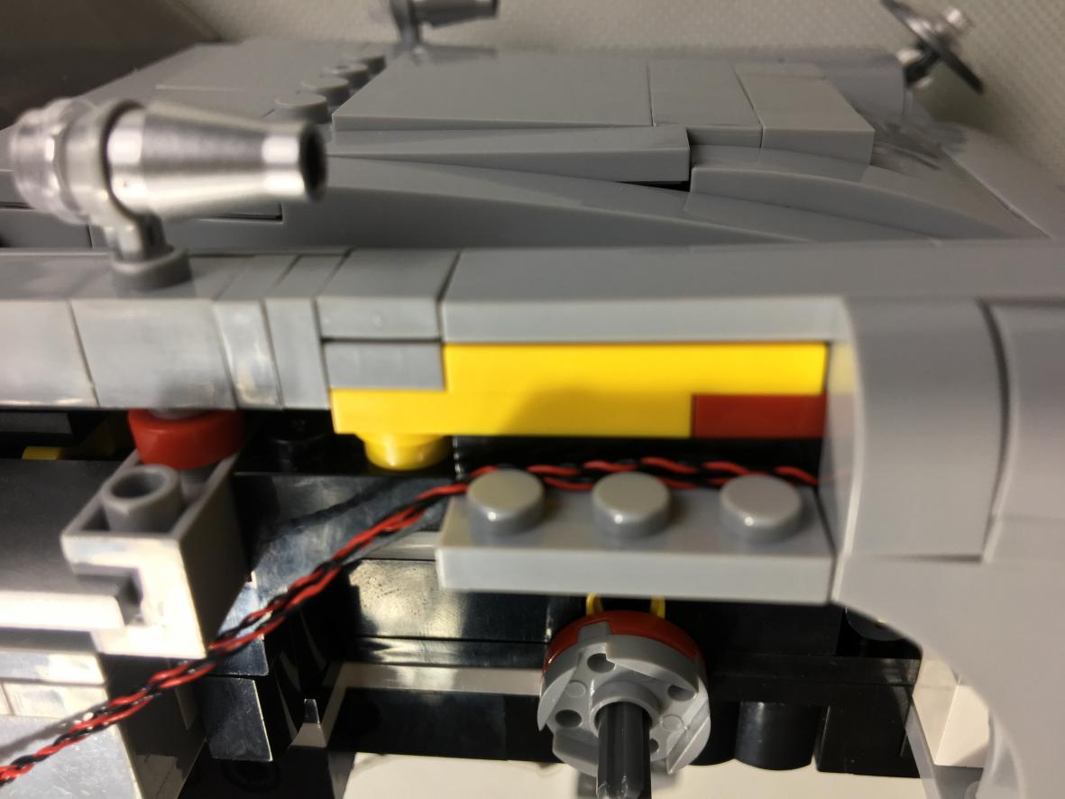

Reconnect the removed pieces, pay attention to the position of the cable, and place it on the black piece.
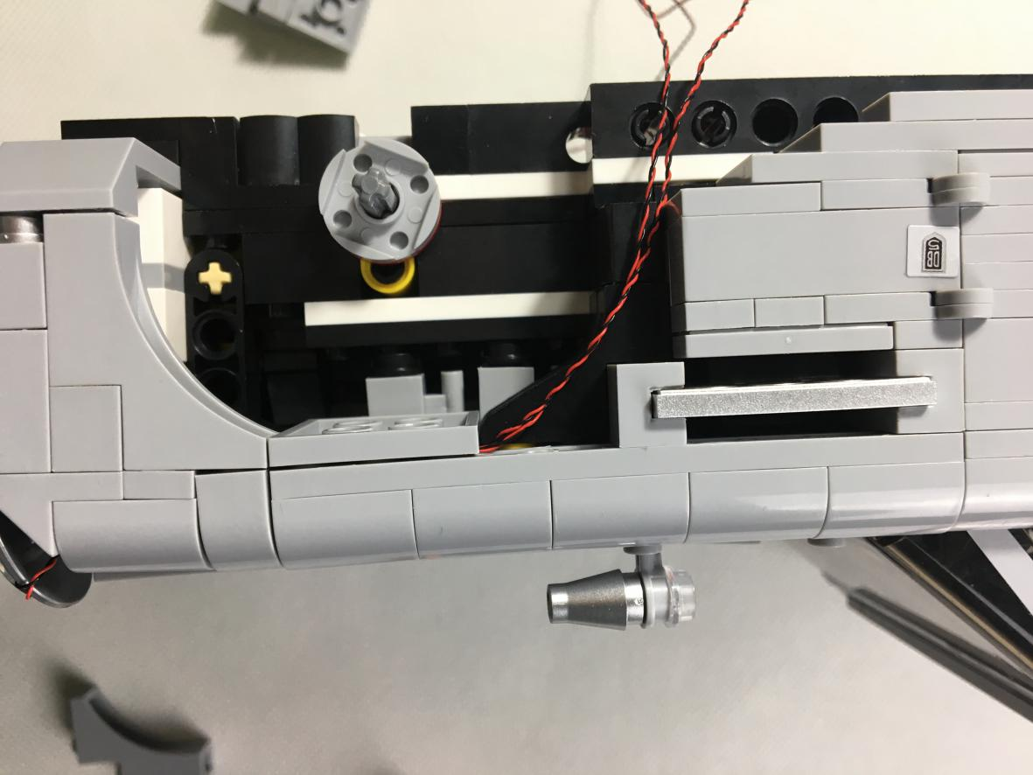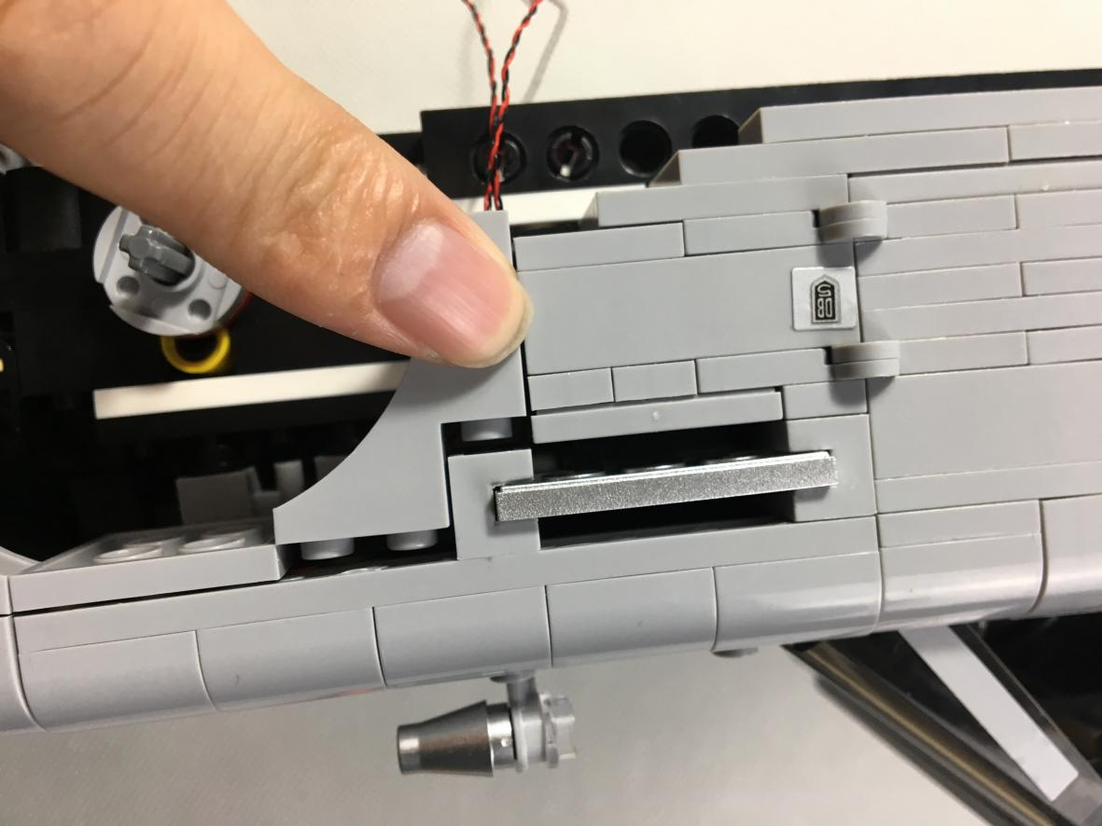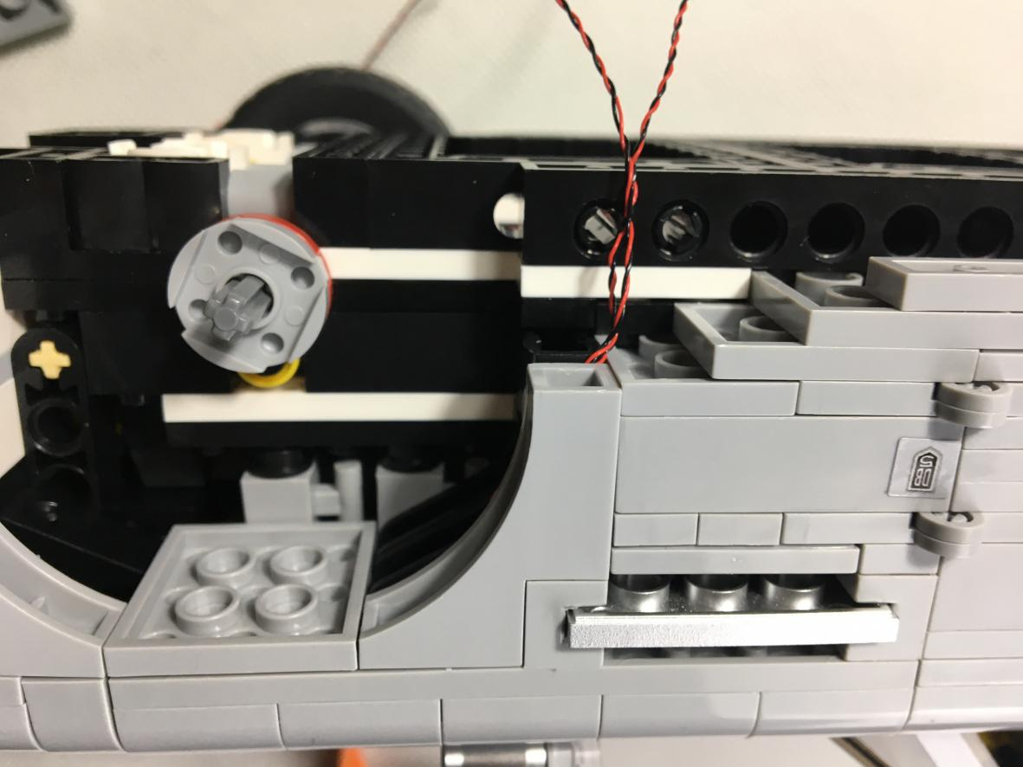

Note that the position of the cable must be between the bumps to avoid pinching off the thin cables.
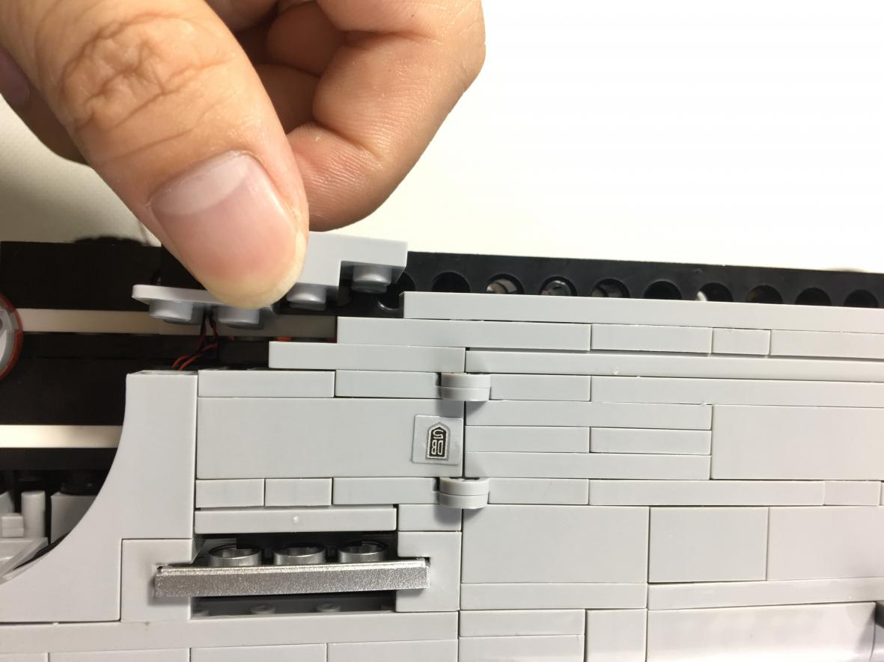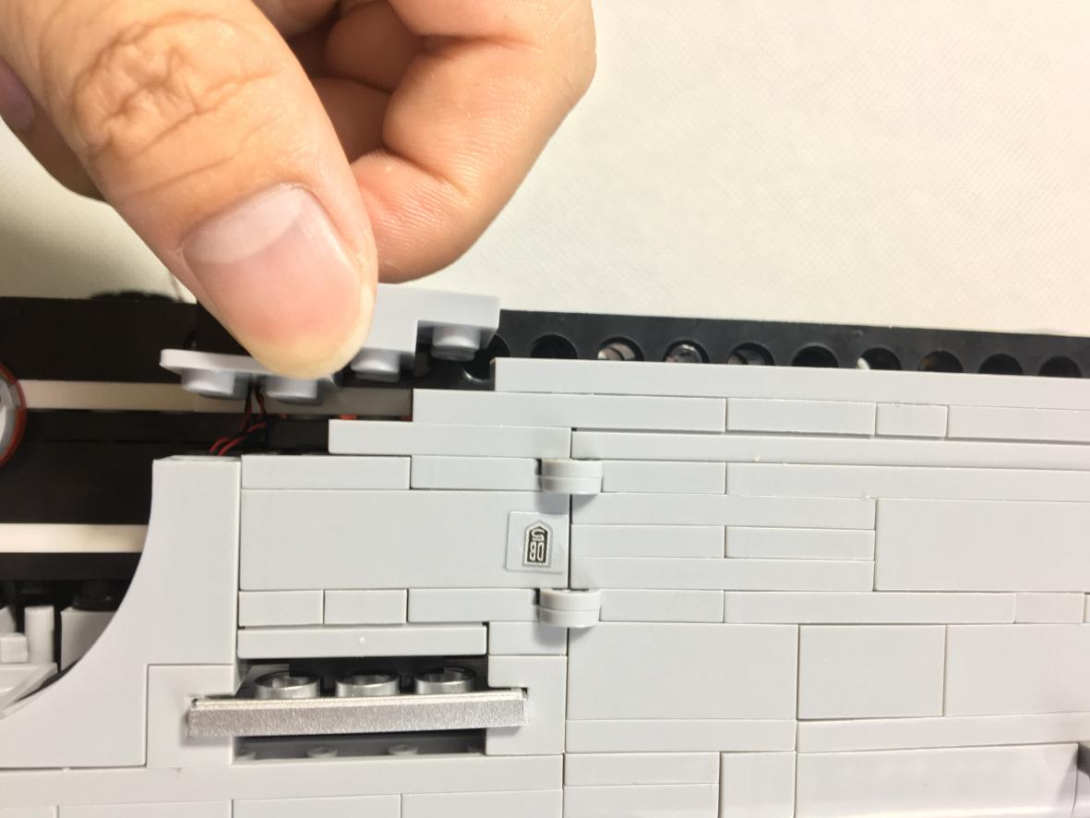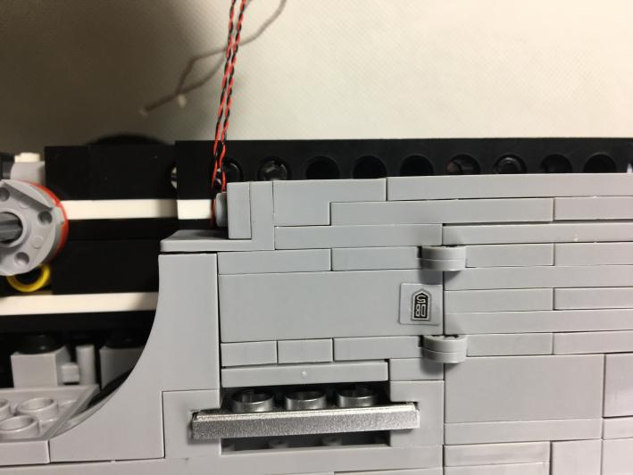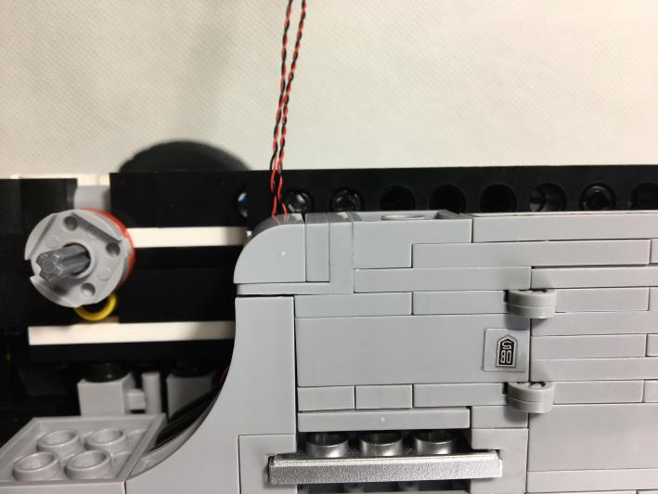

The cable passes through the hole as shown blew.
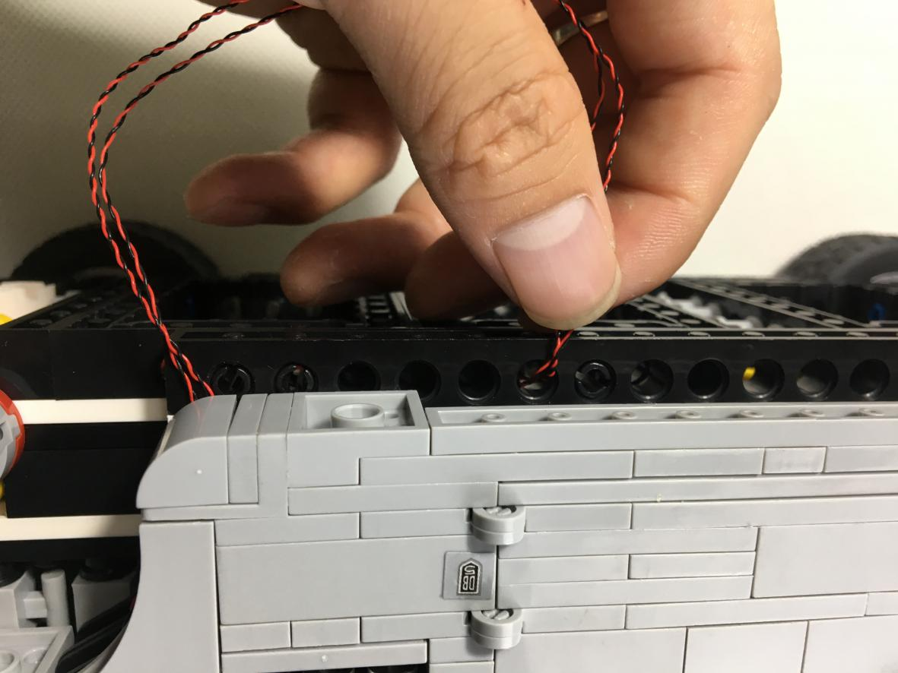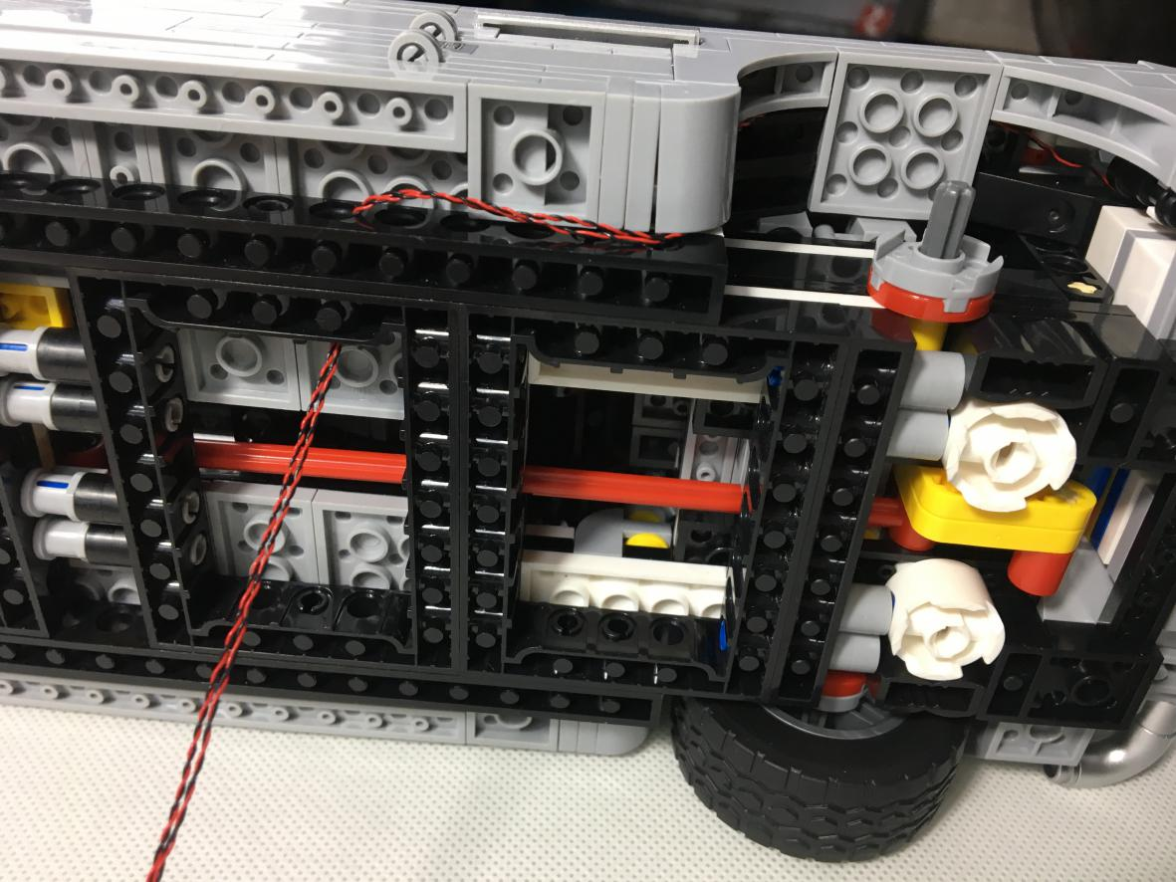

Reconnect the tire
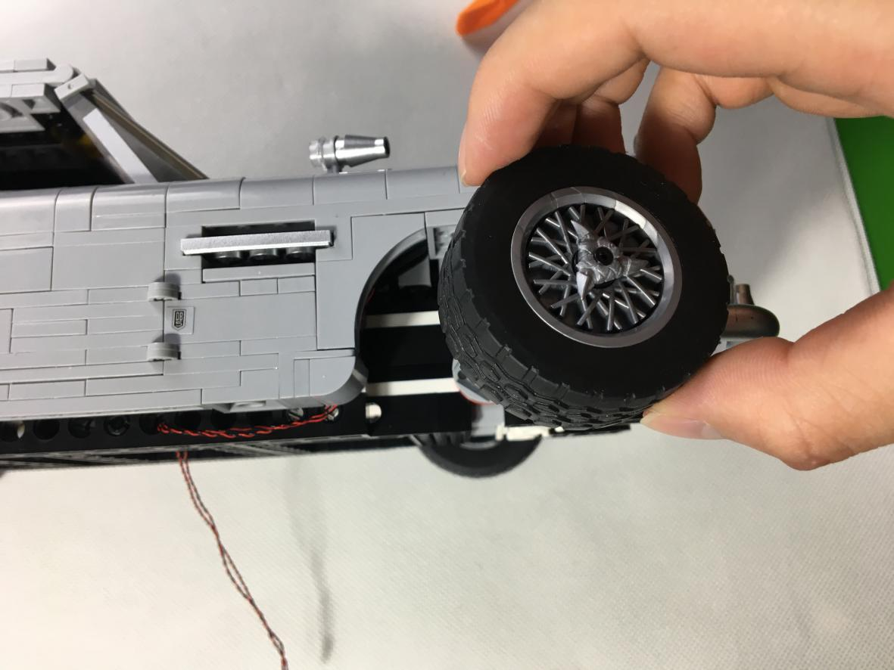

Repeat this process on the other headlight.
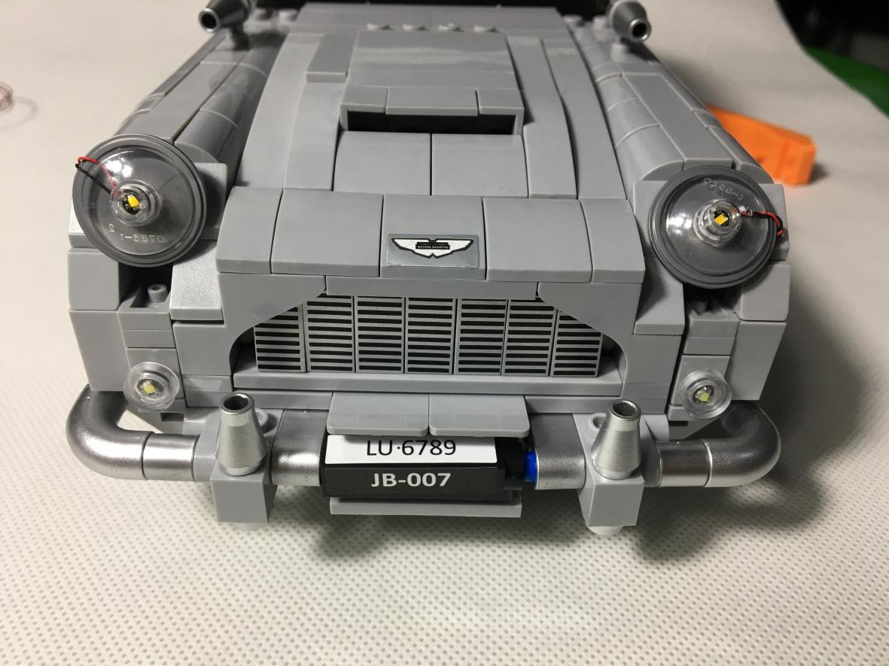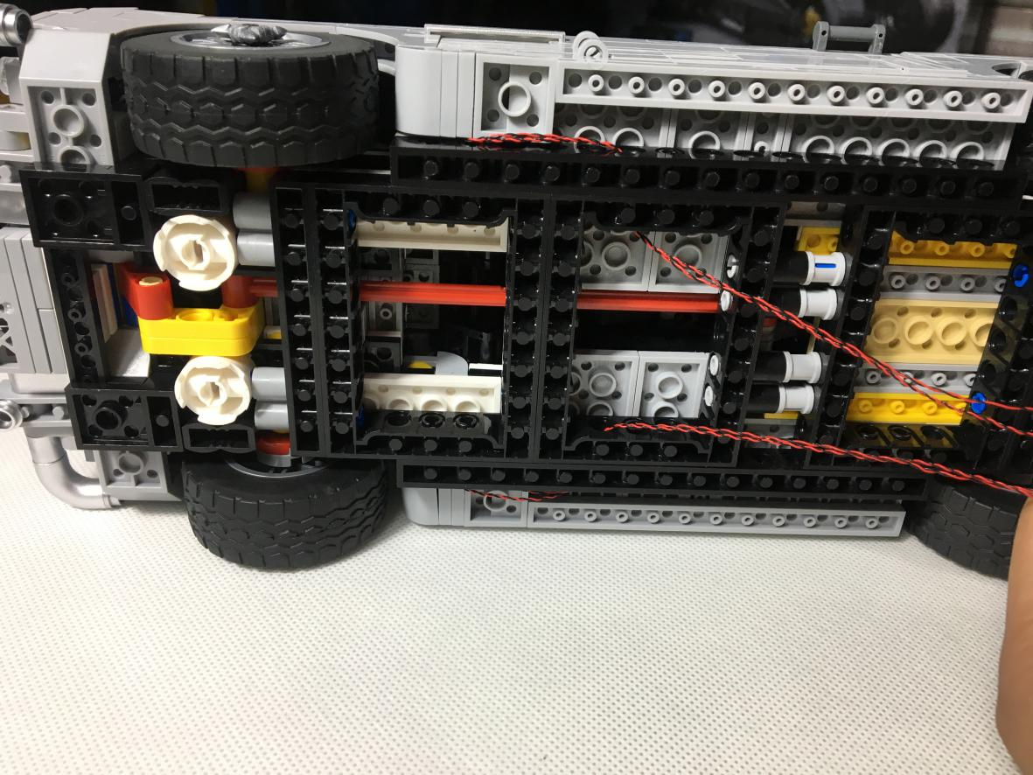

Test the effect of the headlights.
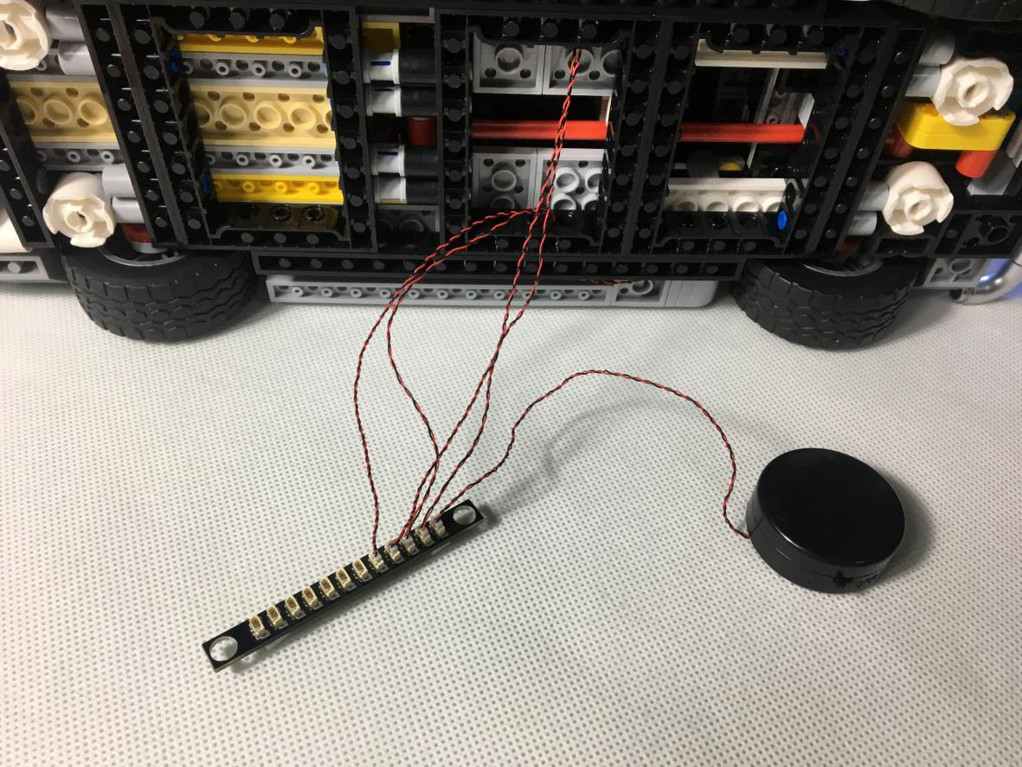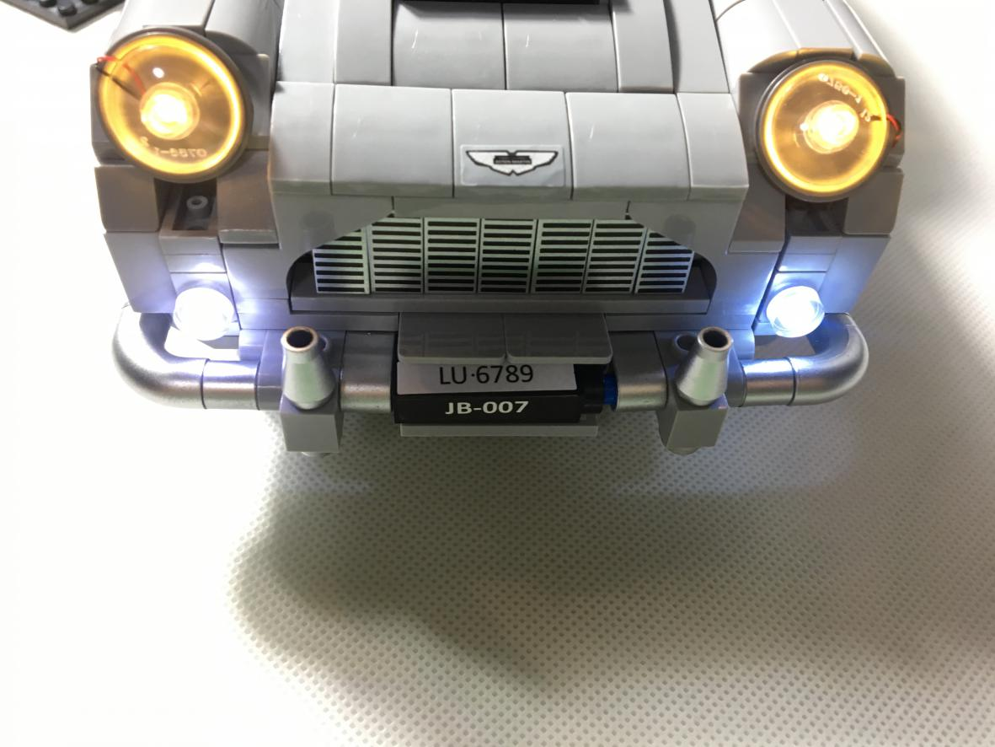

2. Install the taillights. Put the car upright on the table and remove the pieces as shown blew.
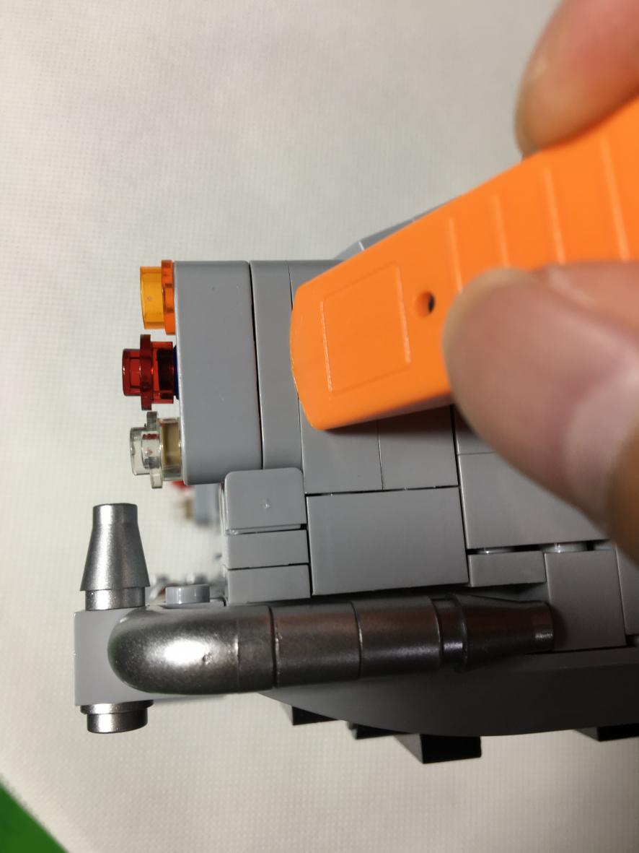
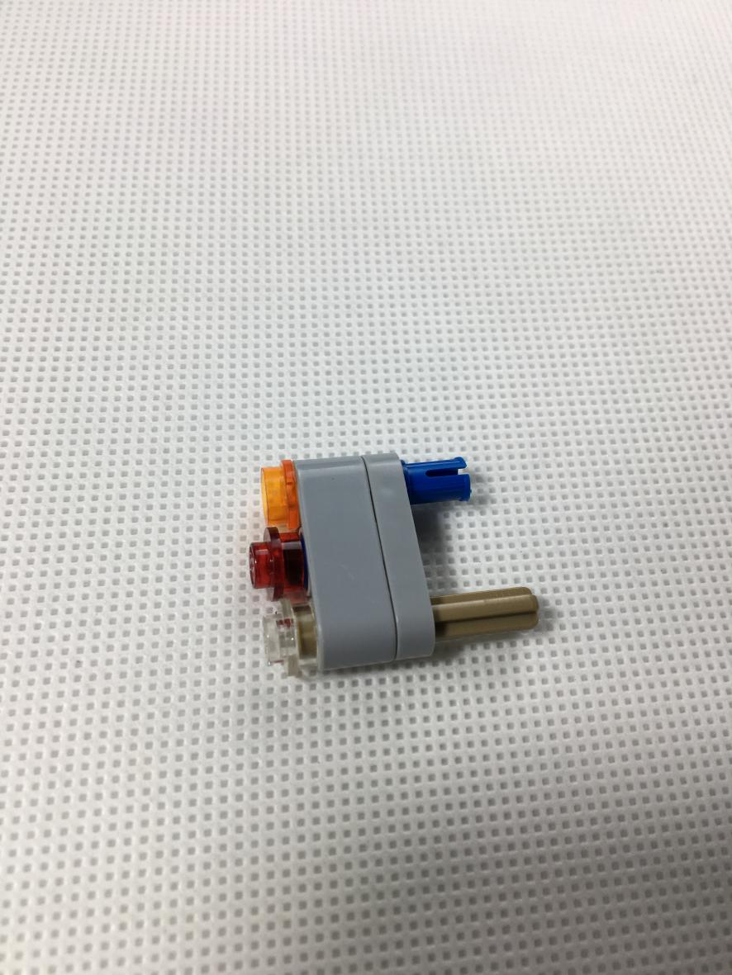

Take out three 30cm white Dot Lights and install them on the three taillights. First install the trans orange round plate. Place one end of the Dot Lights in the hole. Note that the side of the LED Dot Lights is facing outward, and the thin cable of the exit is placed next to the hole.
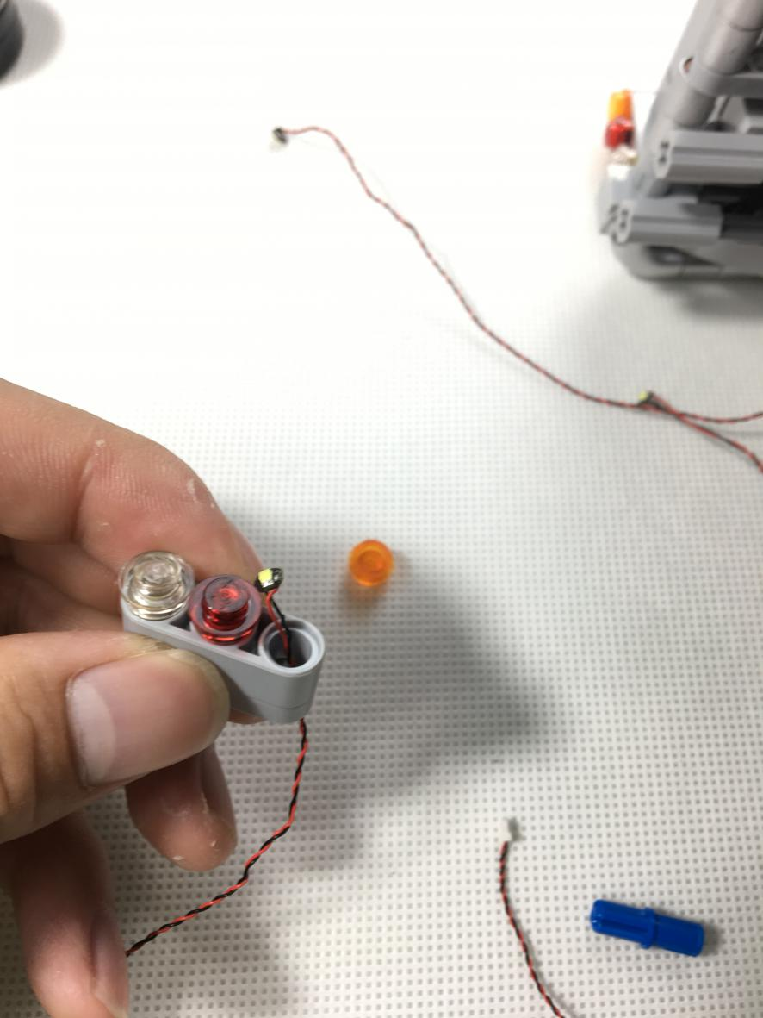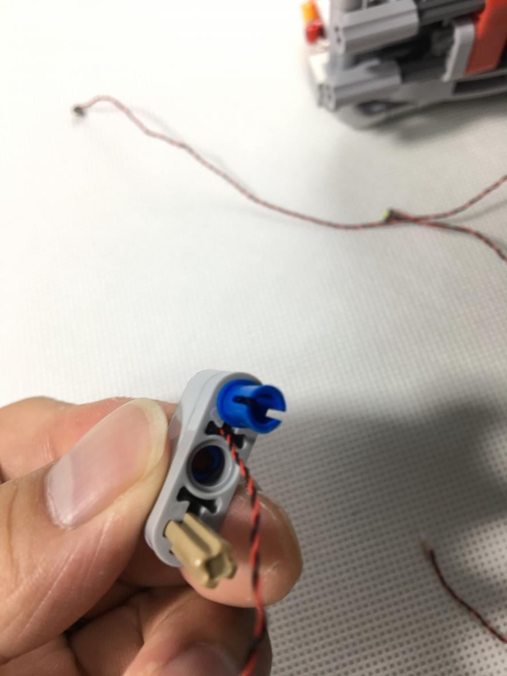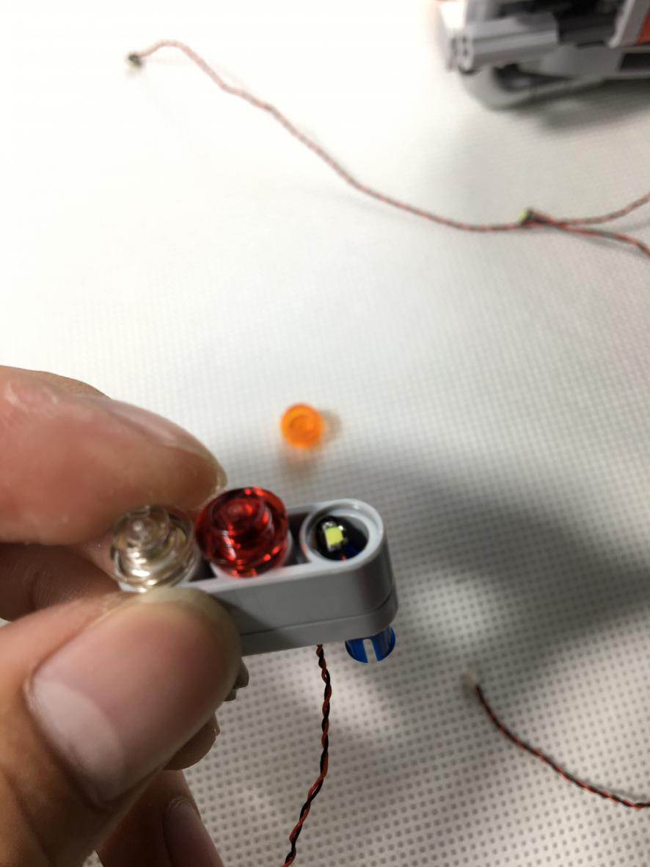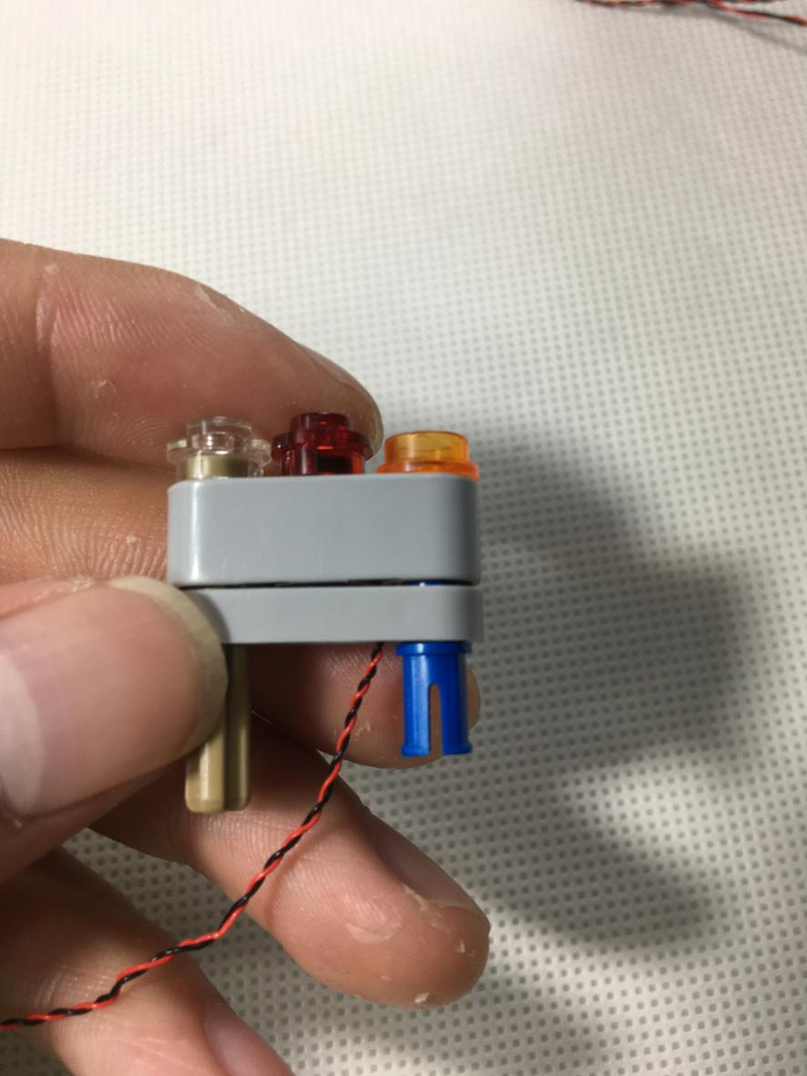

Install the red taillight. Remove the red piece, one end of the Dot Light passes through the hole, pulls it to the end then reconnect the red piece
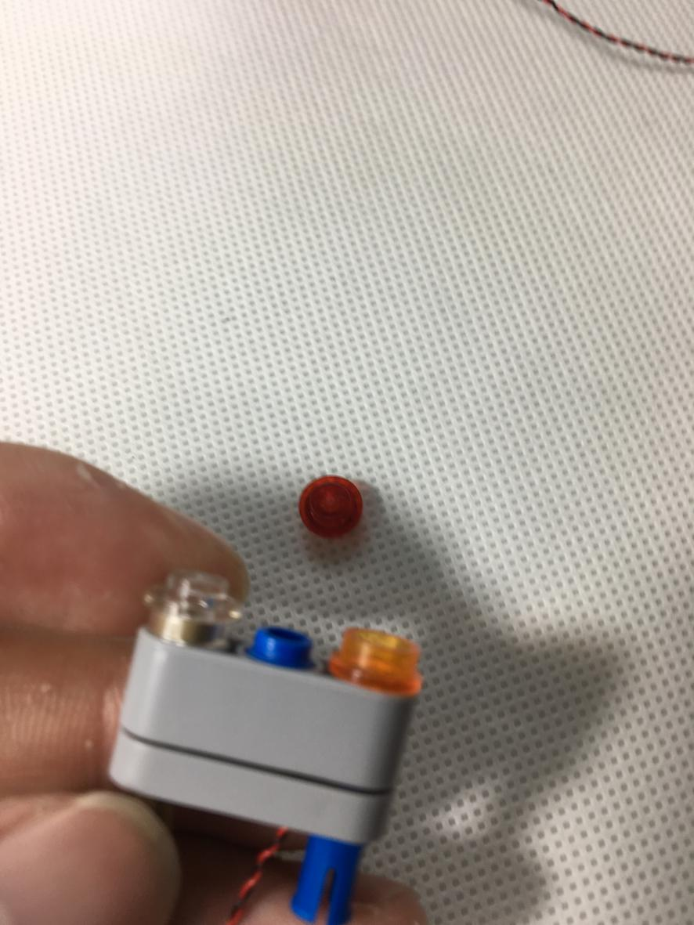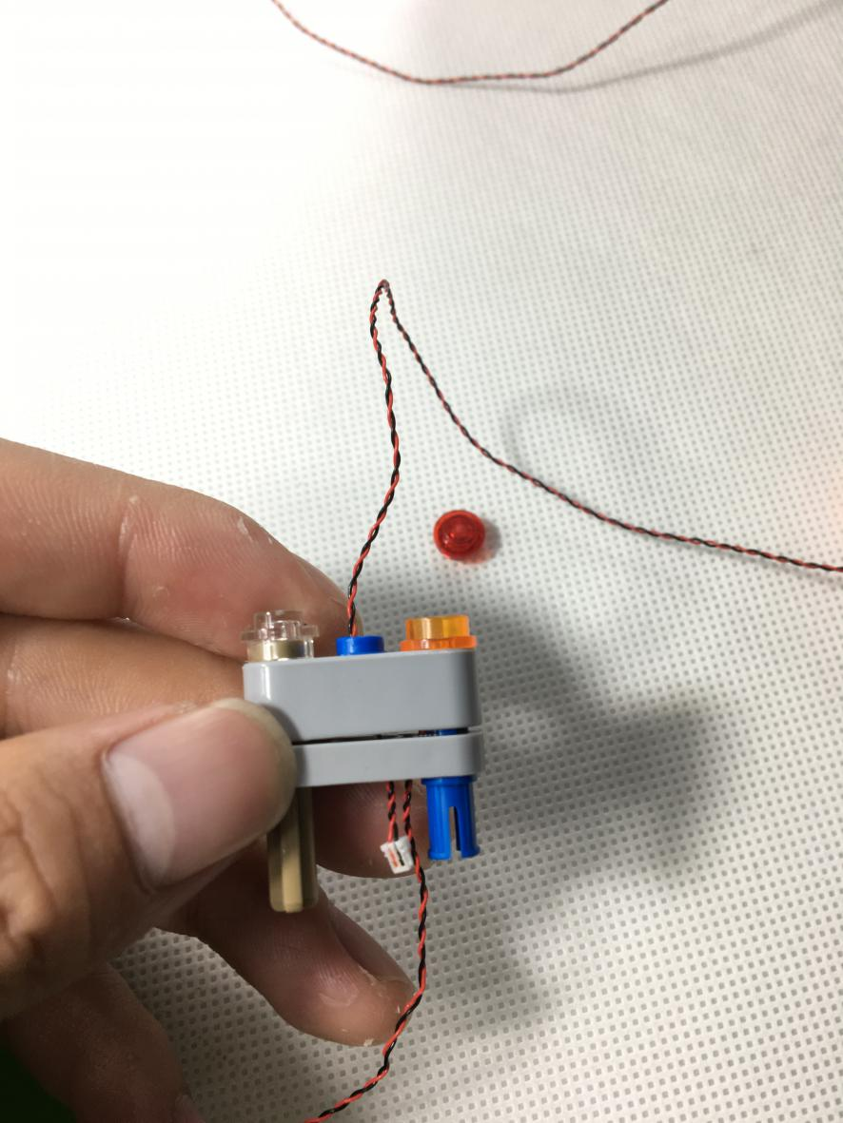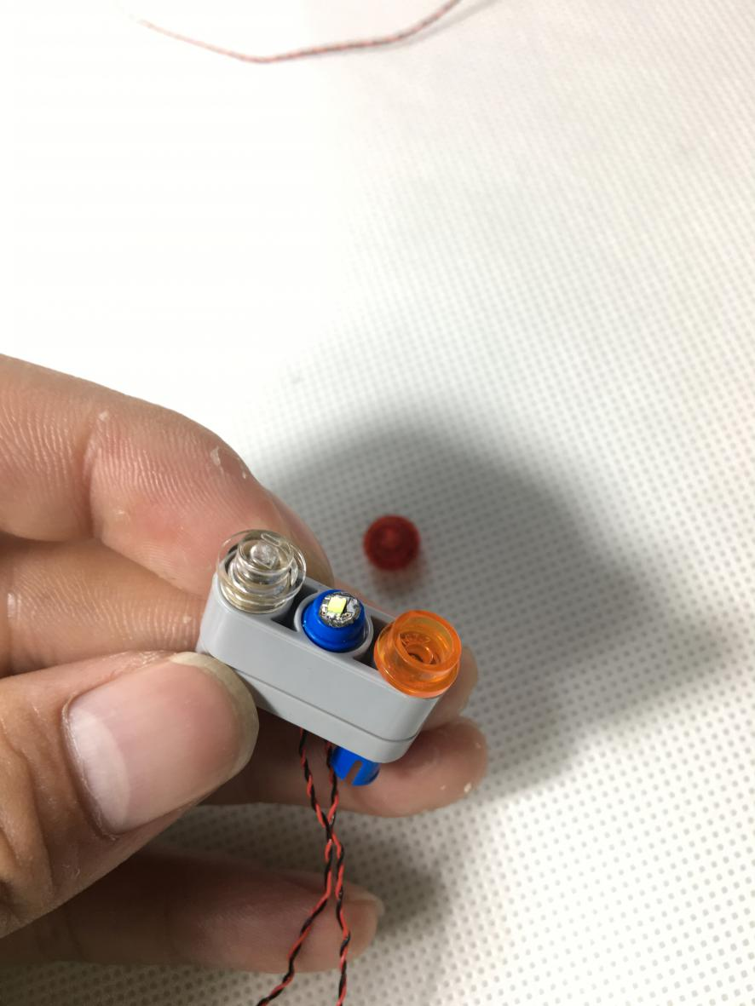

Install white taillight. Remove the pieces as shown blew, pay attention to the gap of the cable entrance in the "+piece”, and the exit of the cable should be next to the "-" hole
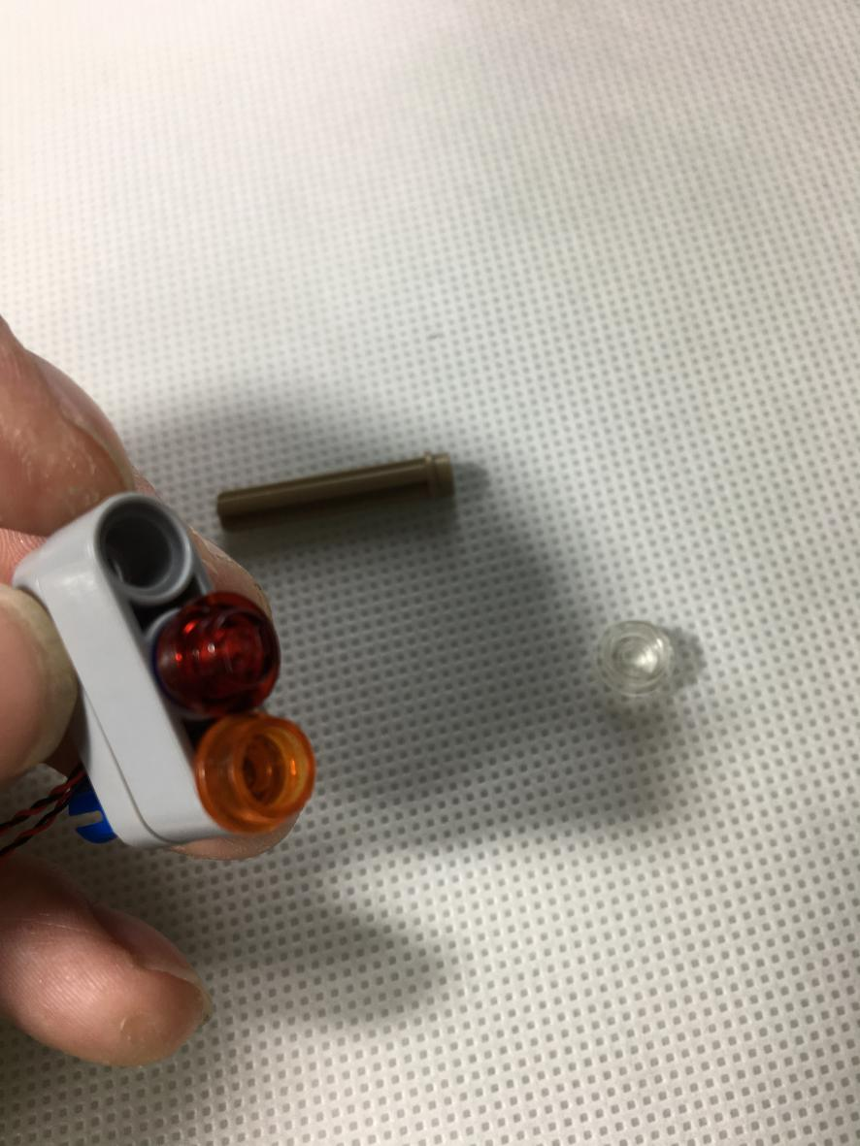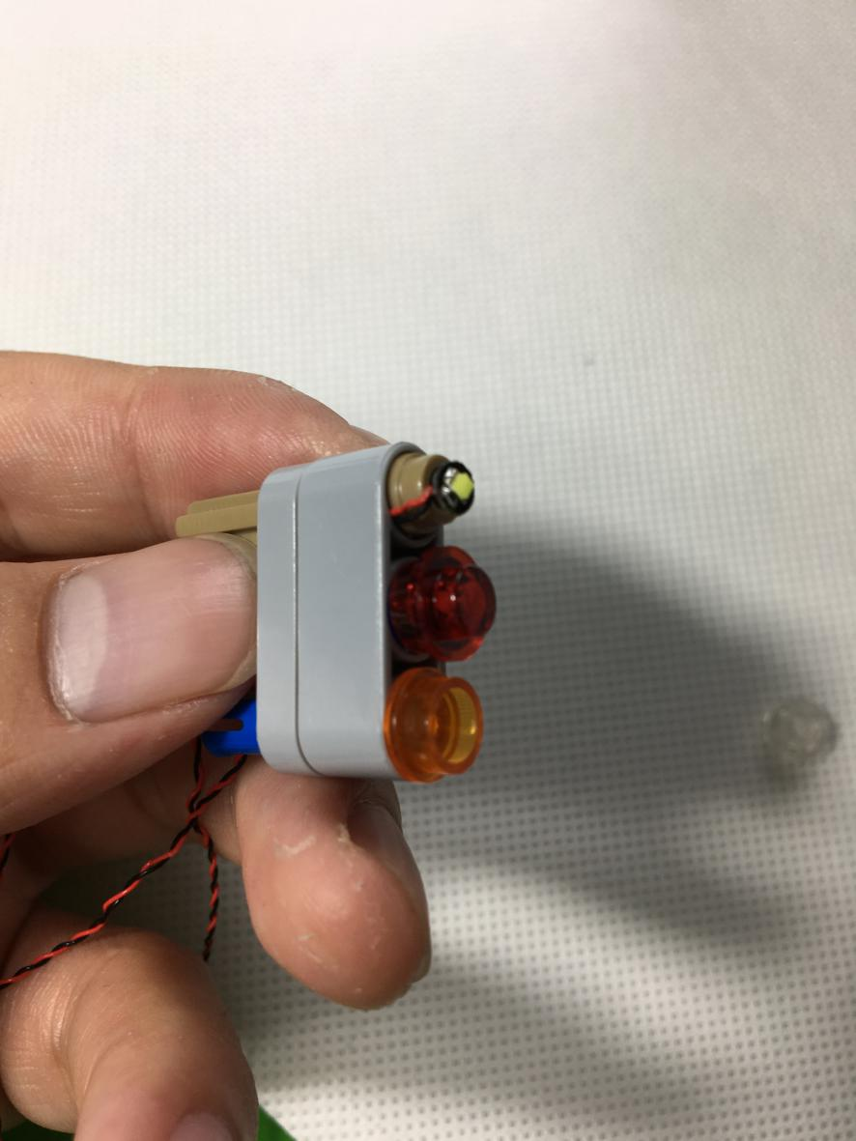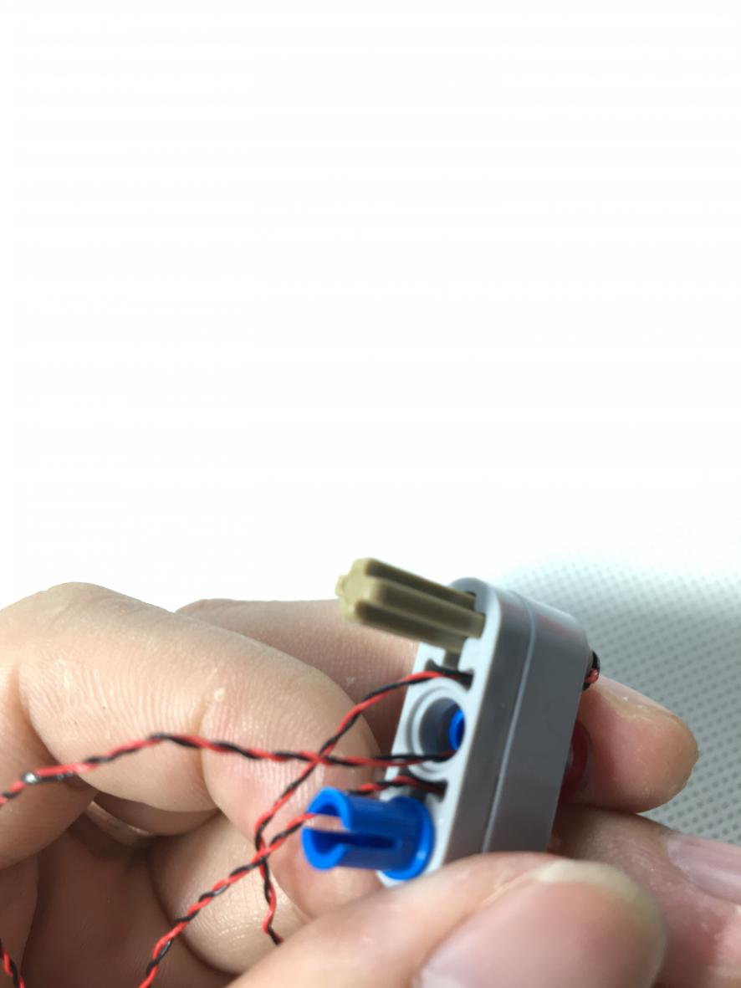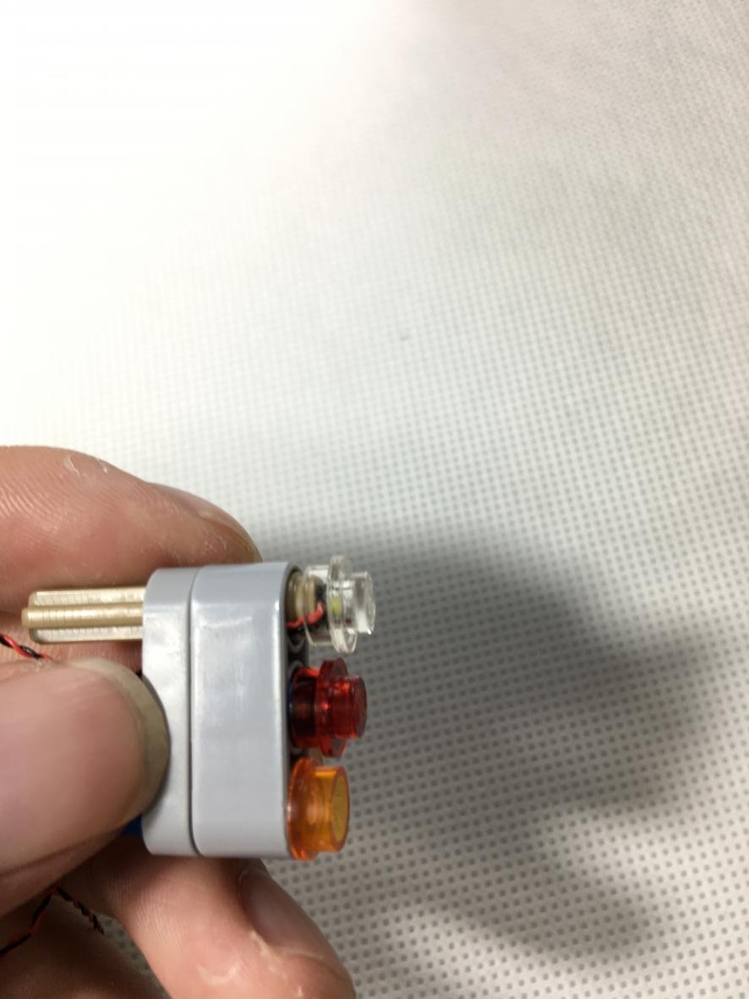

Remove the pieces as shown
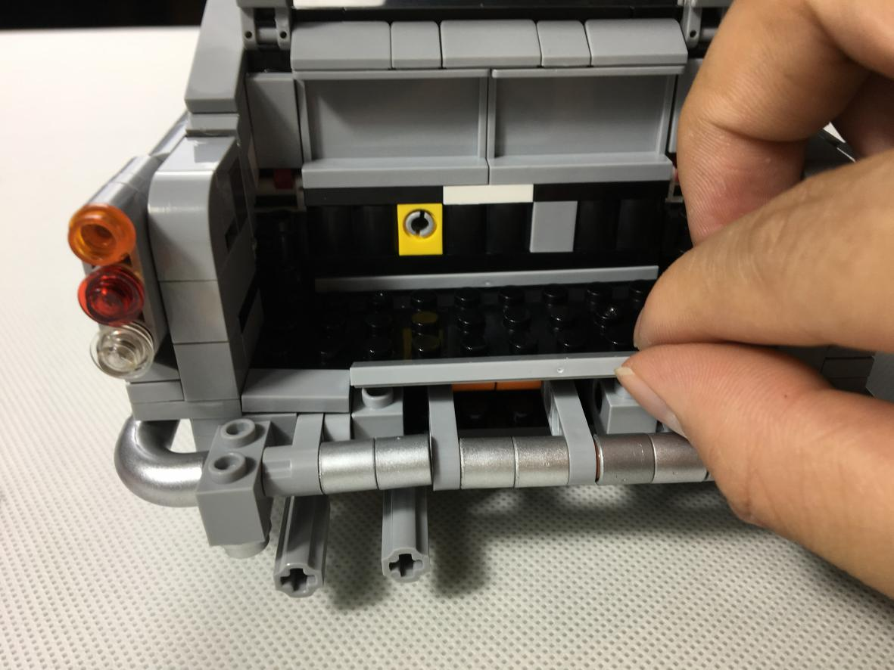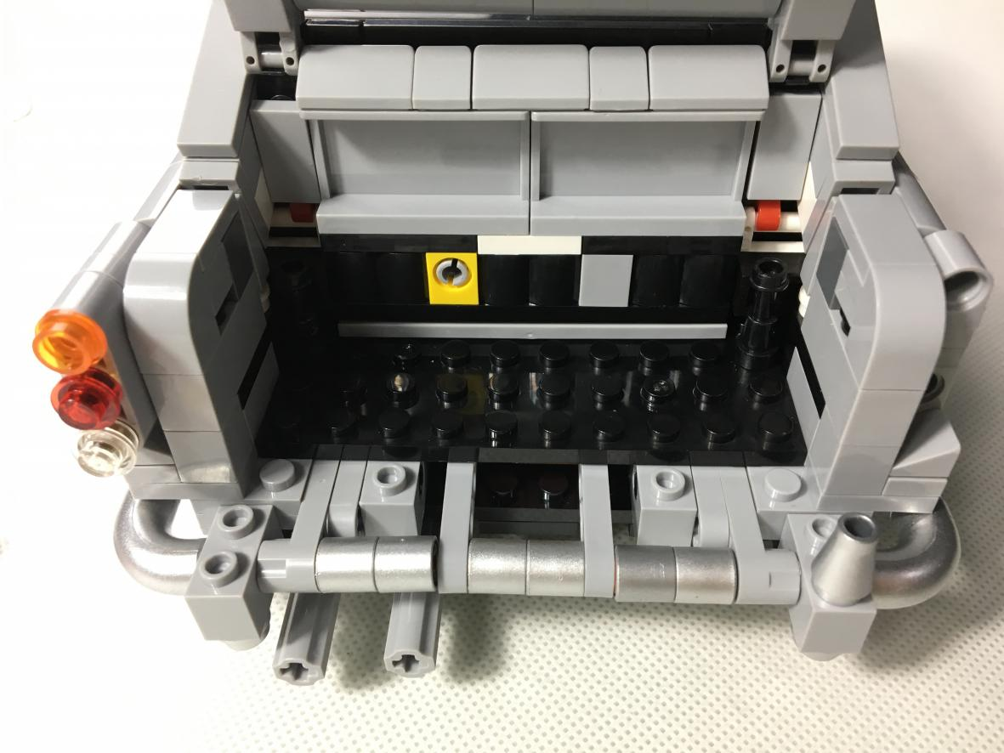

Remove 4X10 piece
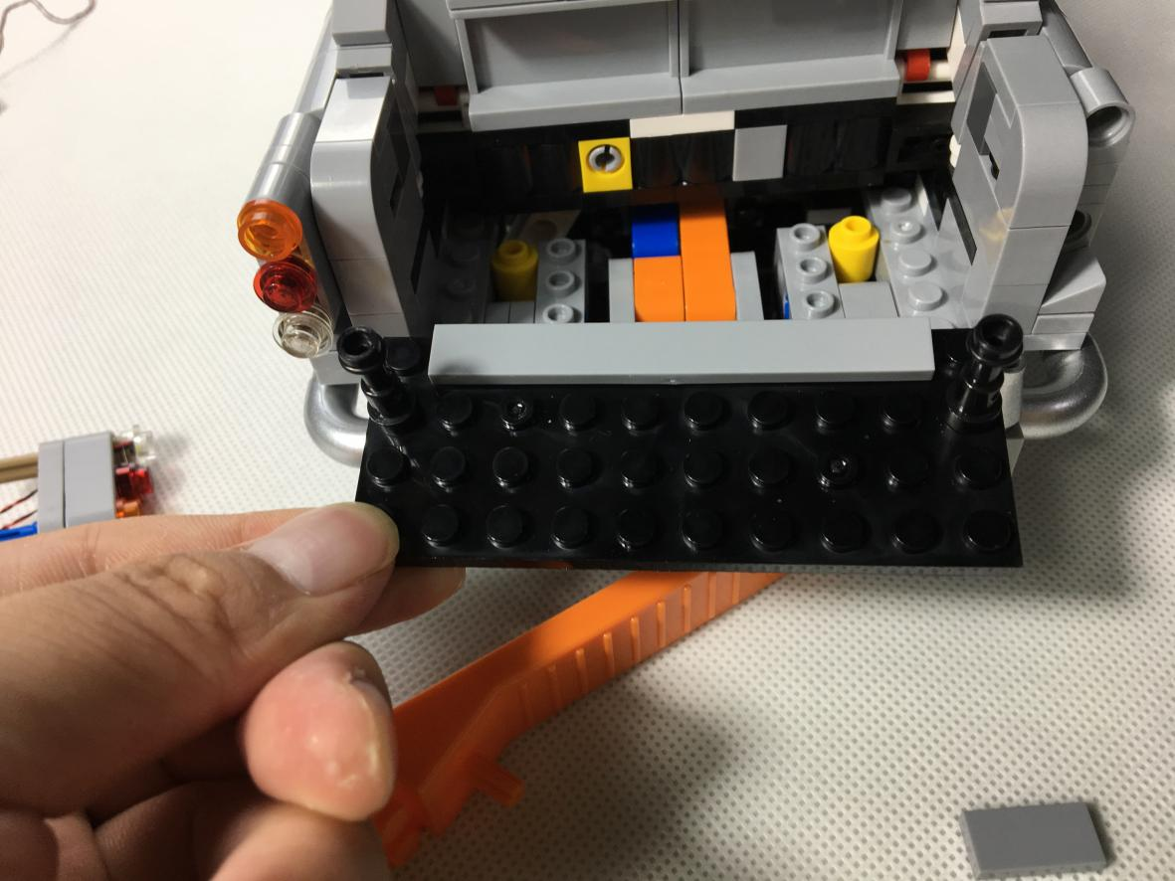

Remove the pieces as shown blew
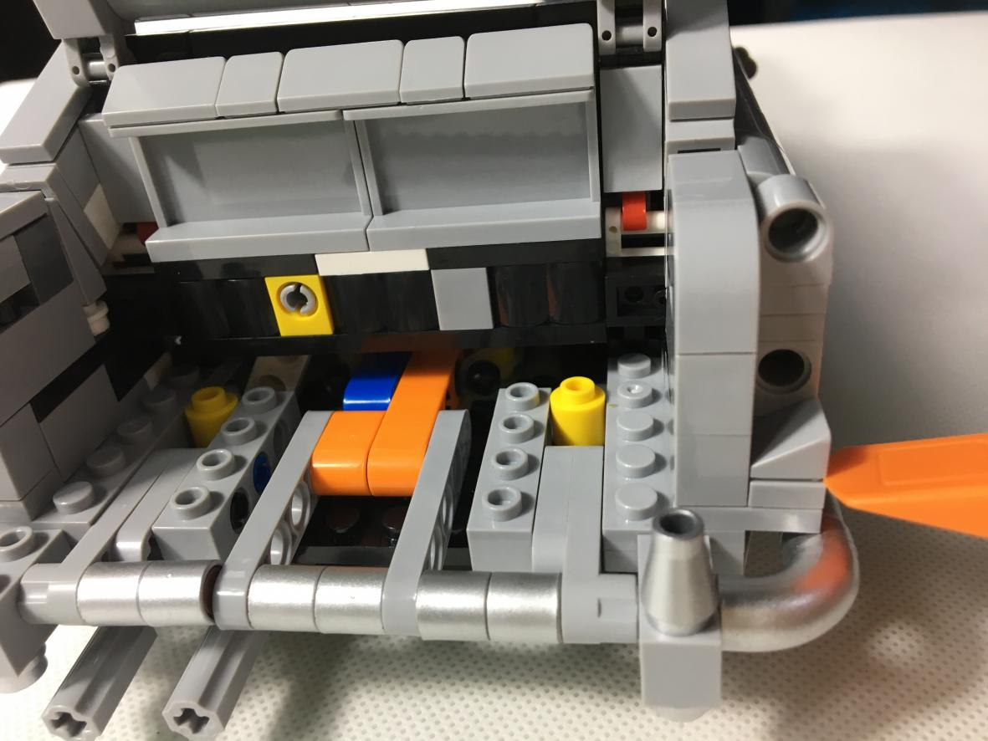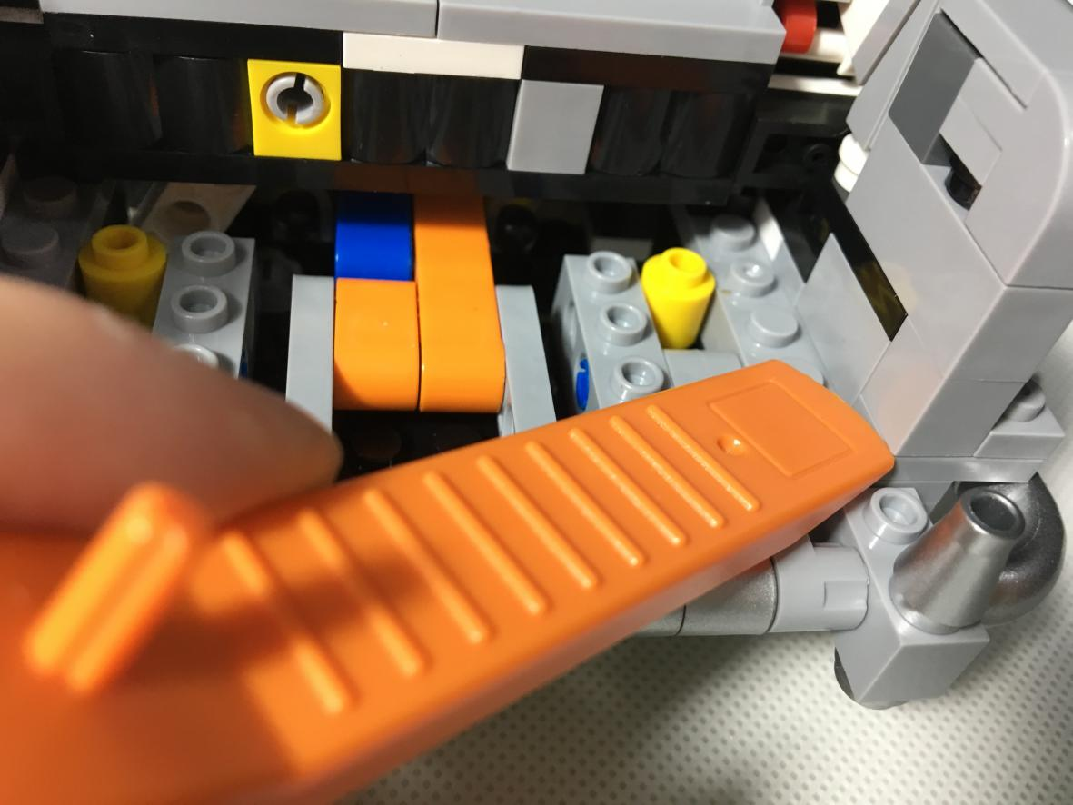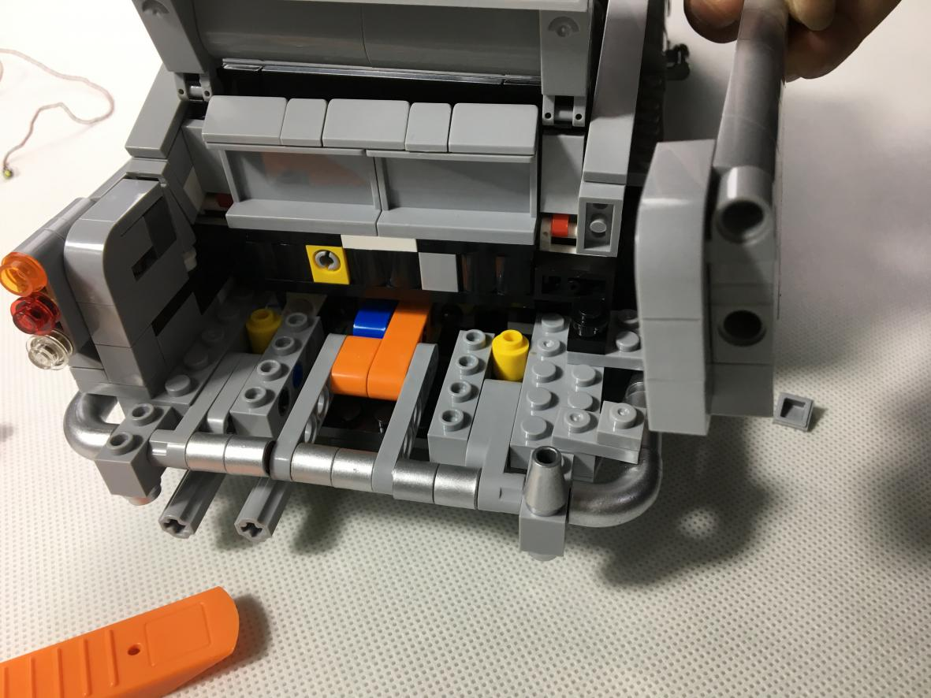

Install the taillight, pay attention to the cables location
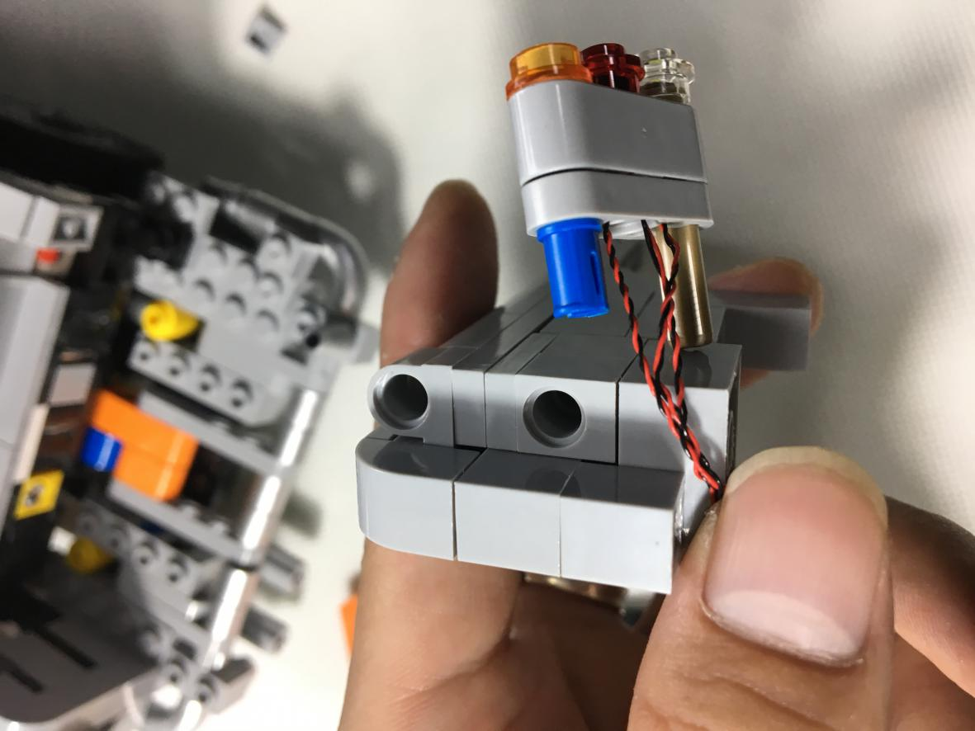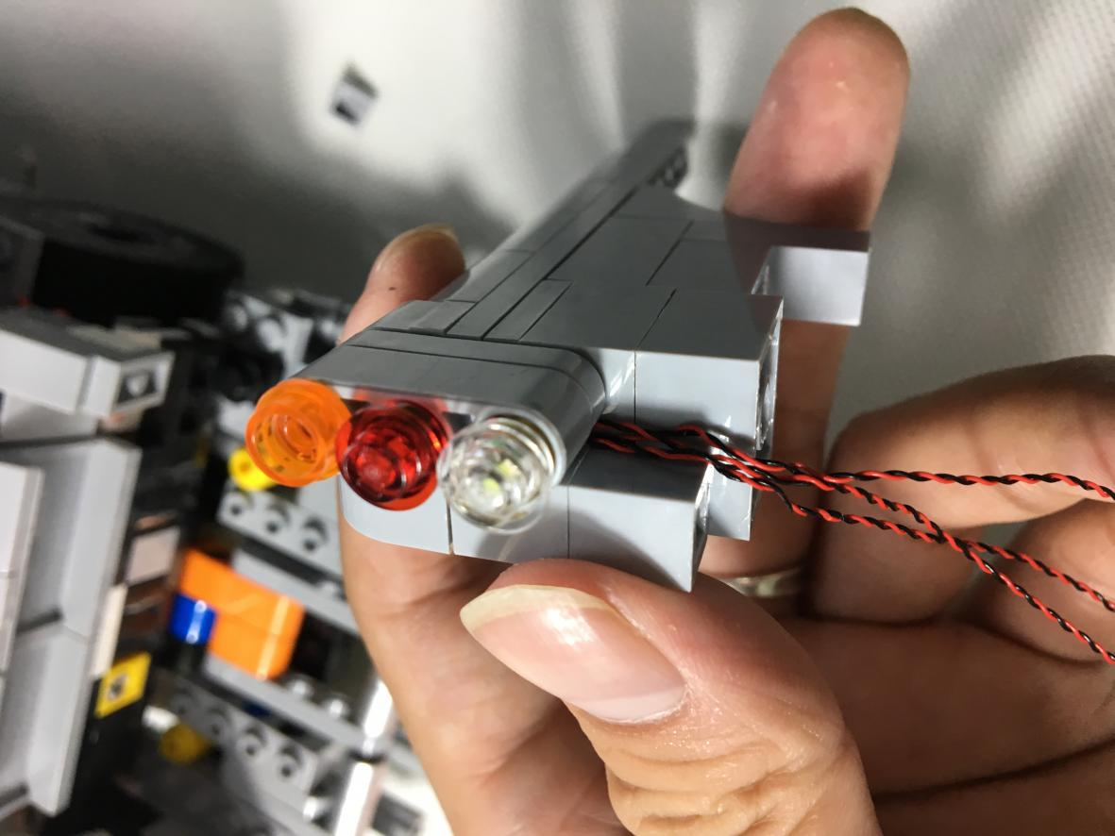

Reconnect the pieces that were removed. Note that the thin cables should be placed between the bumps to avoid pinching off them.
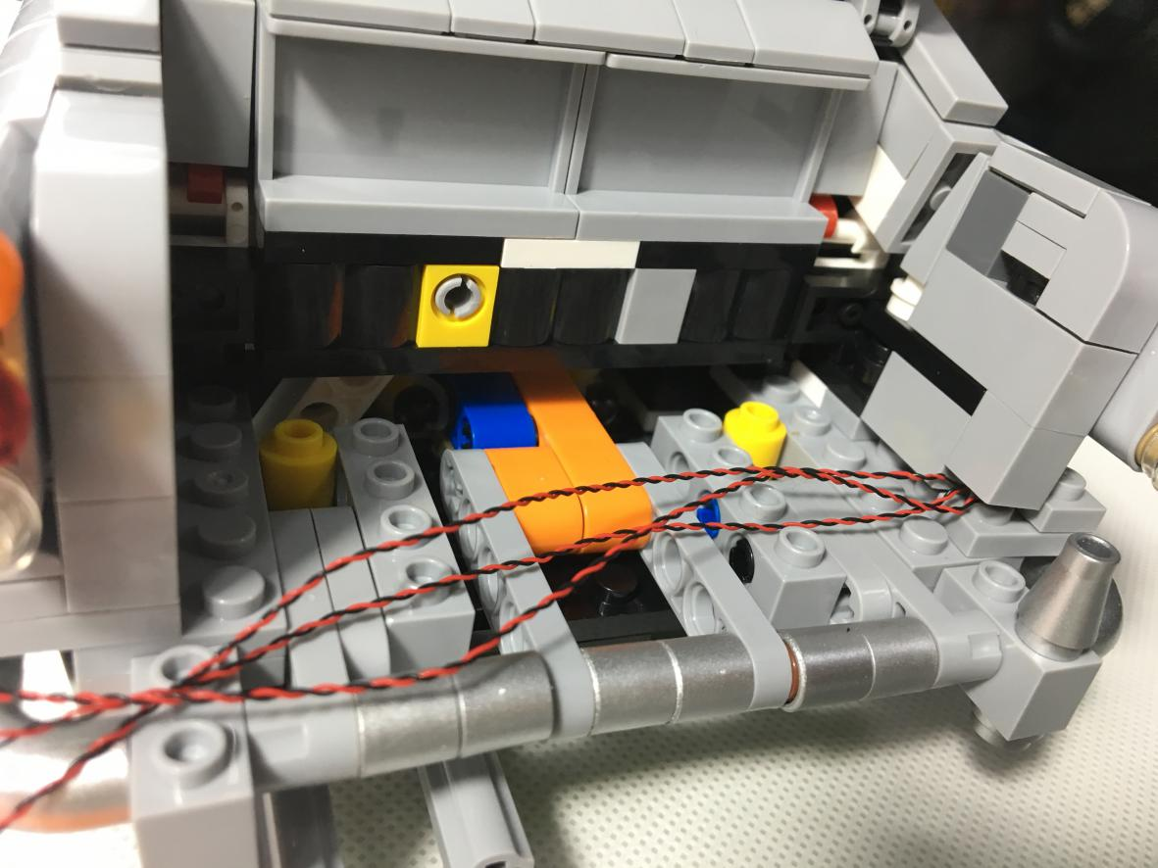

Repeat the above operation on the other taillight
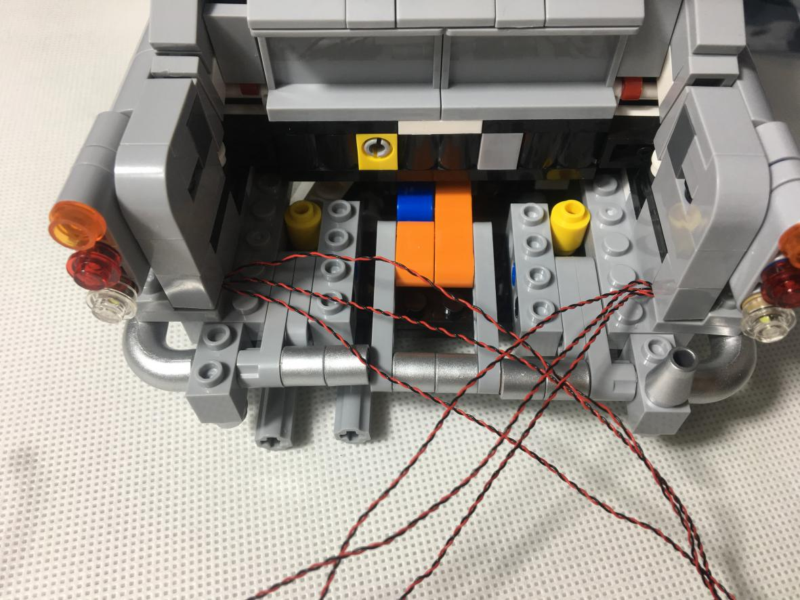

Twist the cable with each other and become a big strand of cable and then threads into the place shown below. Note that the cable should be placed between the bumps.
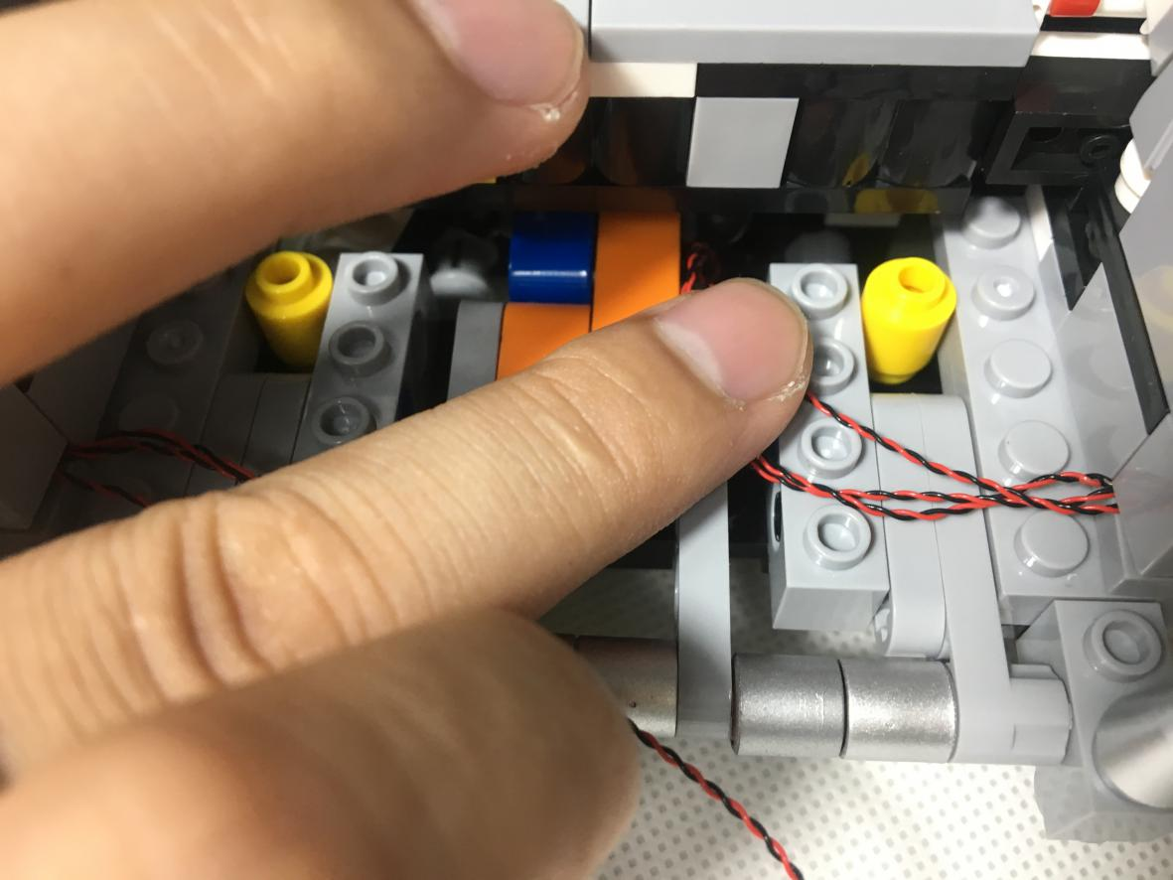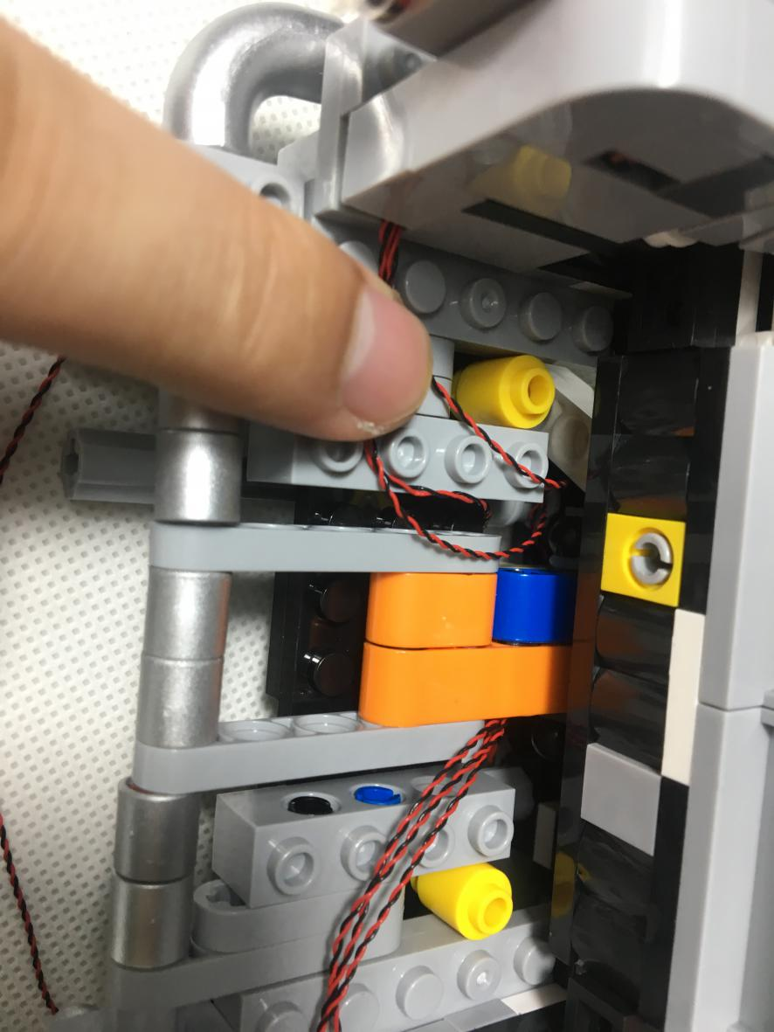

Reconnect 4X10 piece
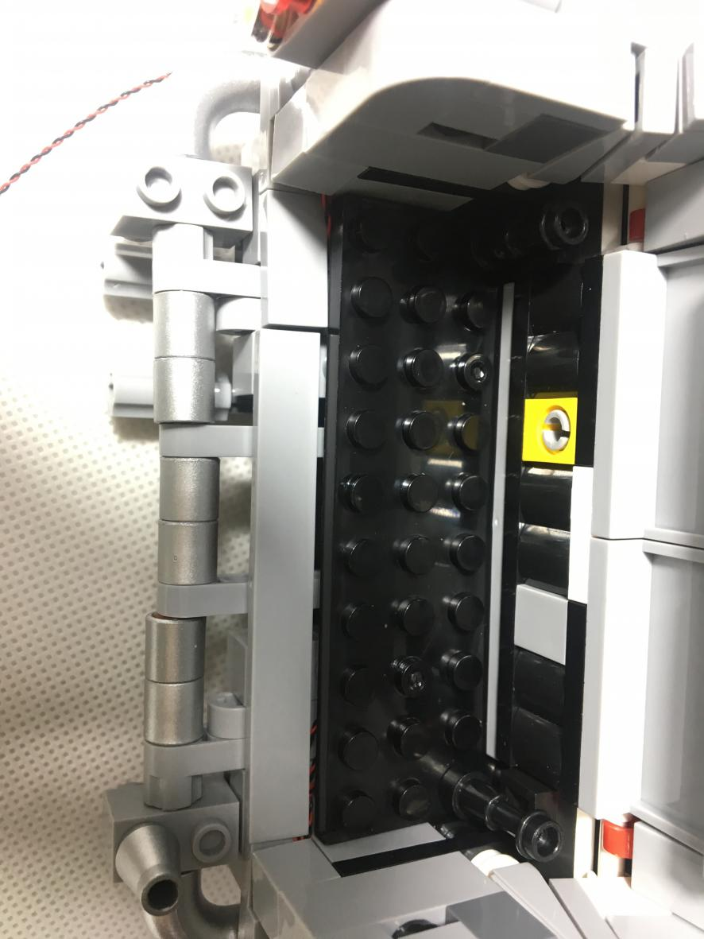

The place to pass through as shown blew
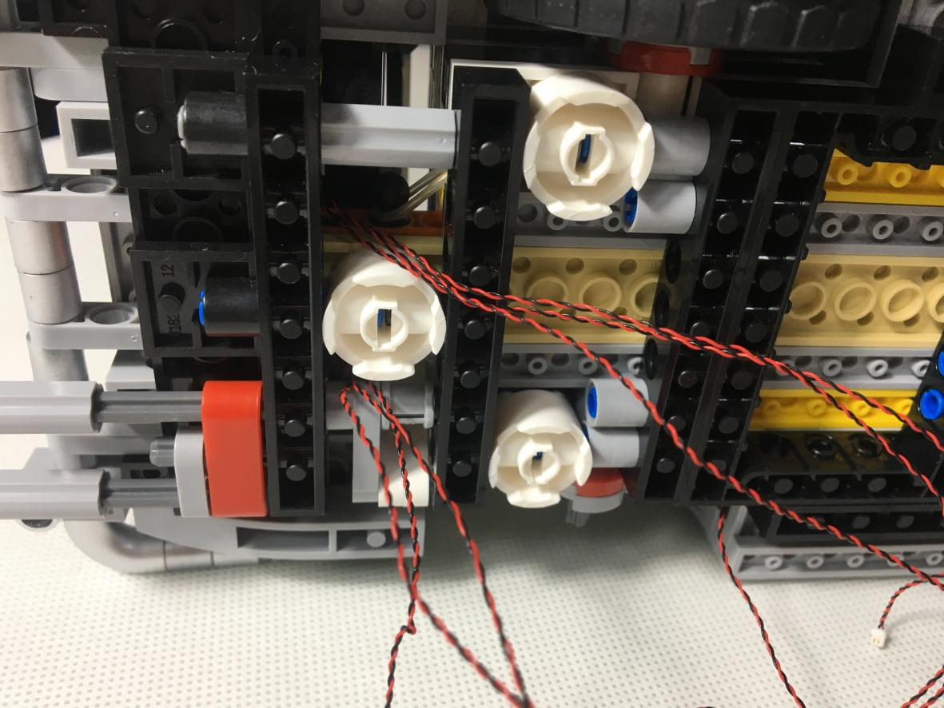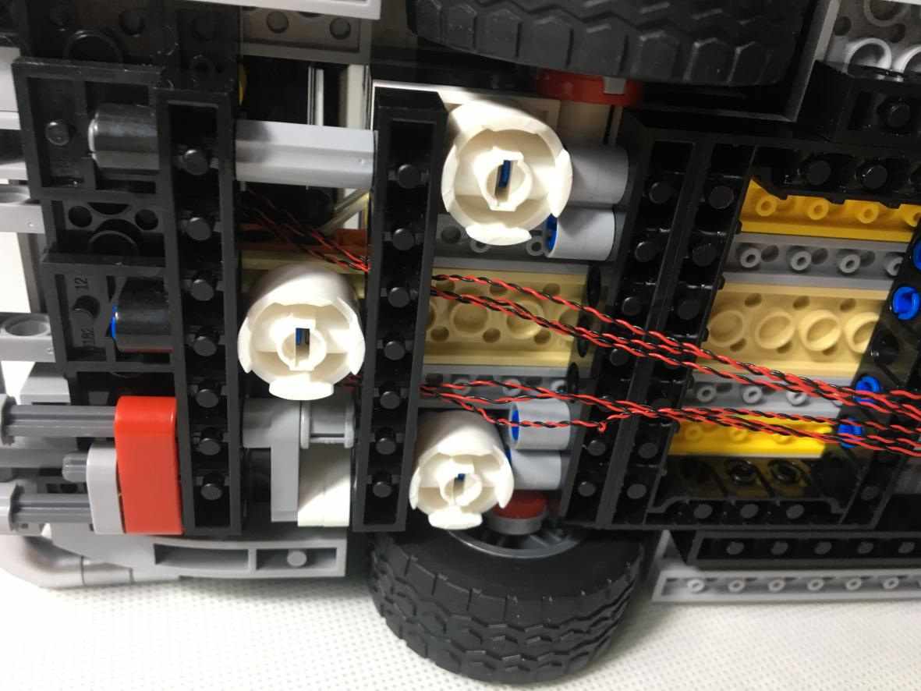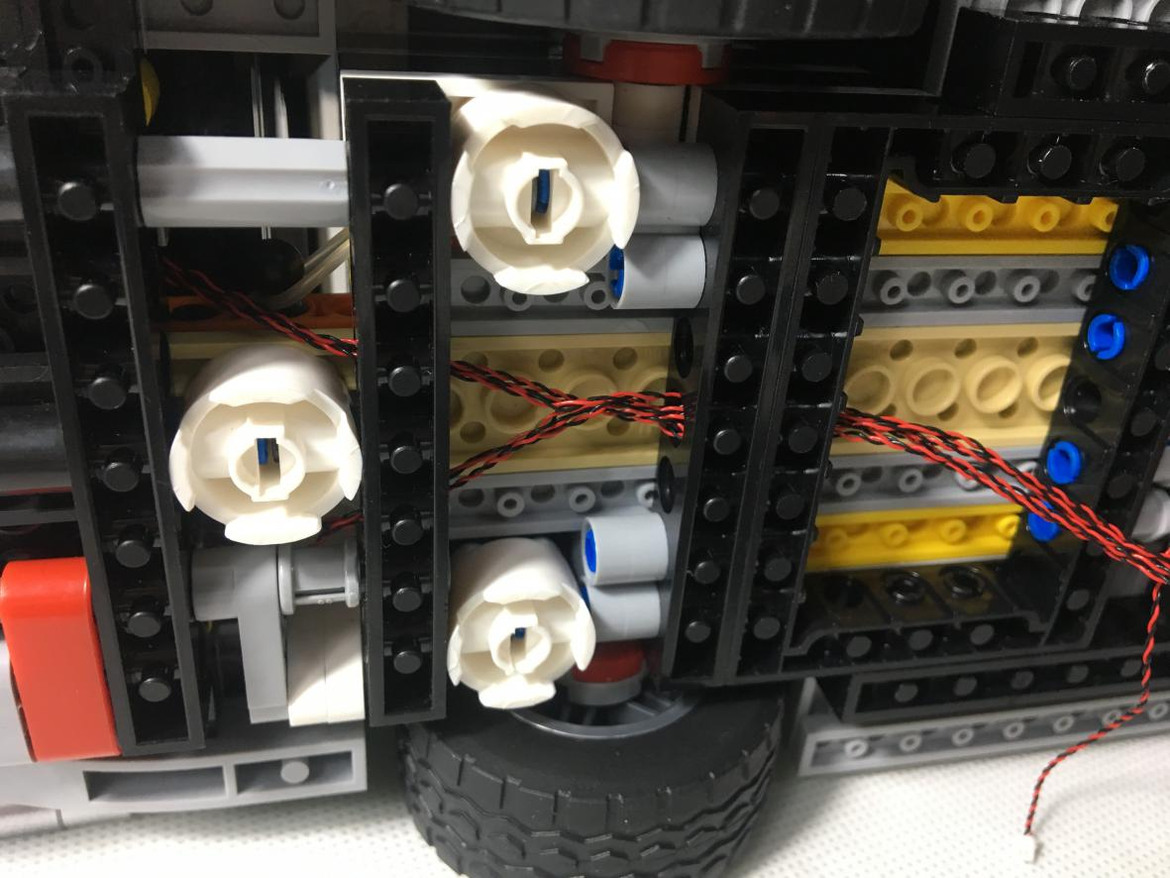

Connect the 12-Port Expansion Boards. The taillight cable is slightly longer than the headlight cable so circle the socket first.
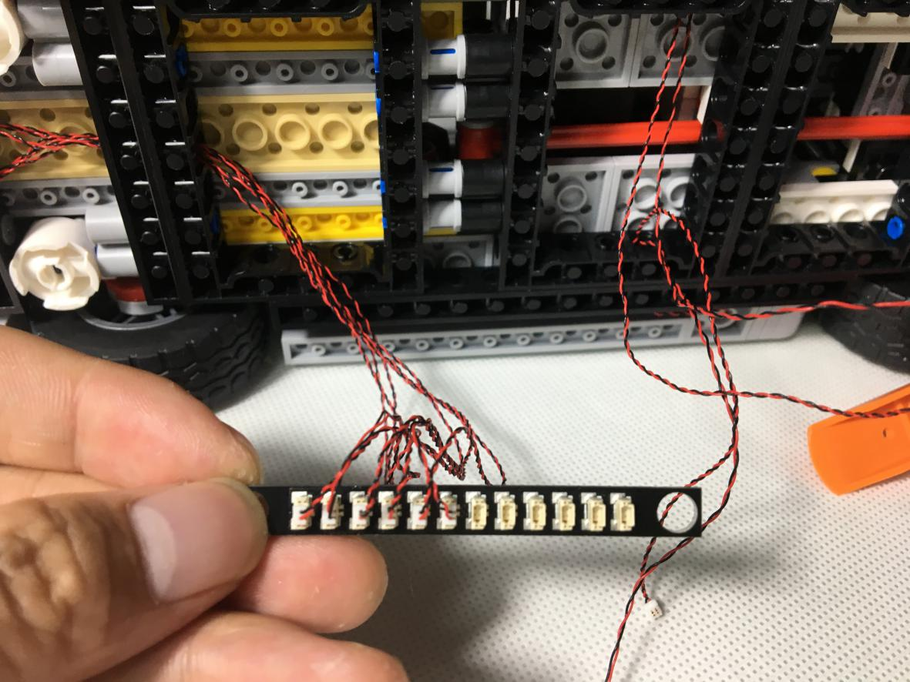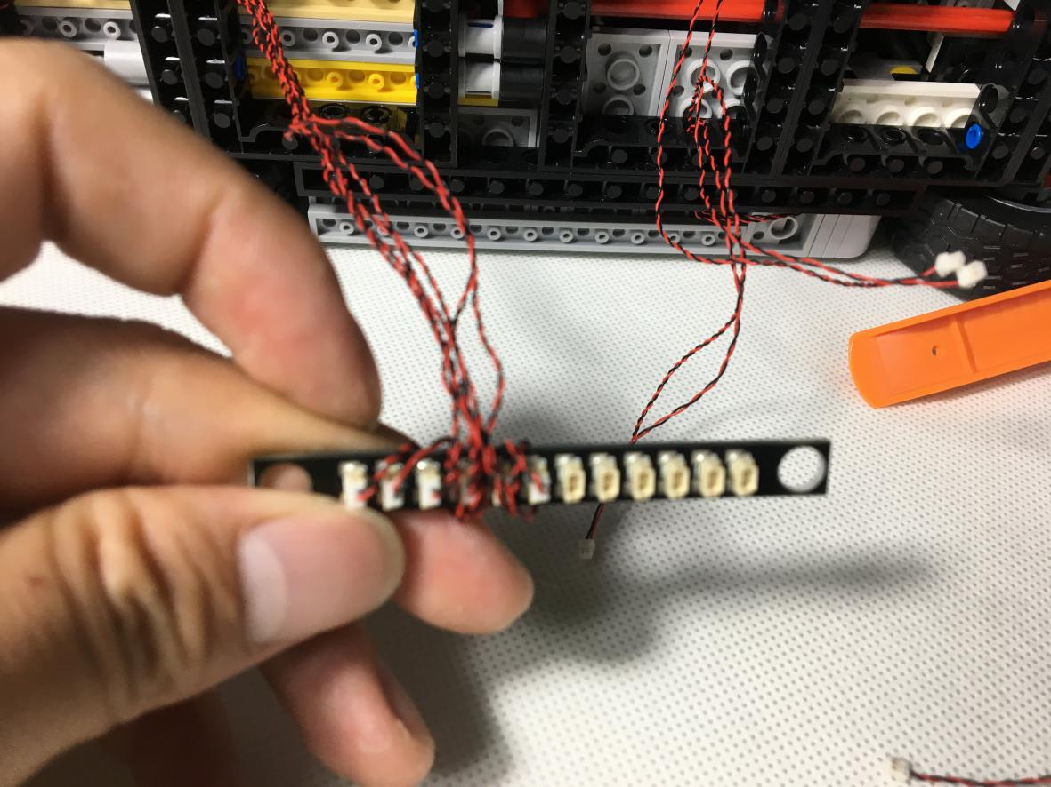

The Dot Light of the headlight is connected to the Expansion Boards.
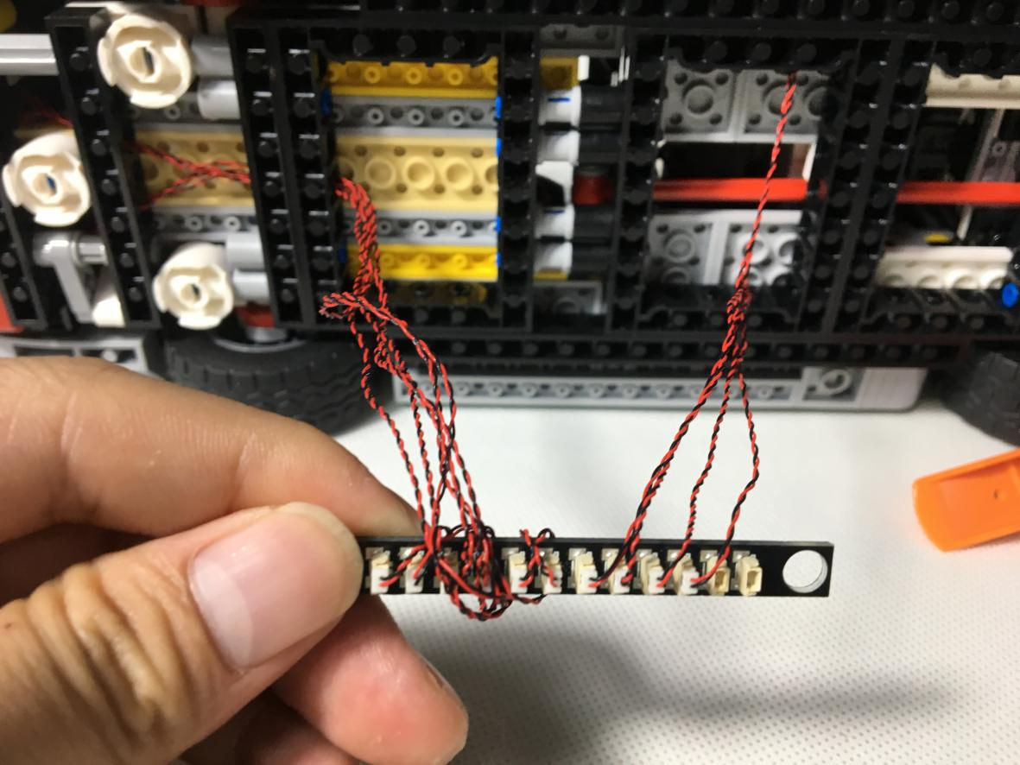

Take out two Adhesive Squares and stick them to the places as shown blew.
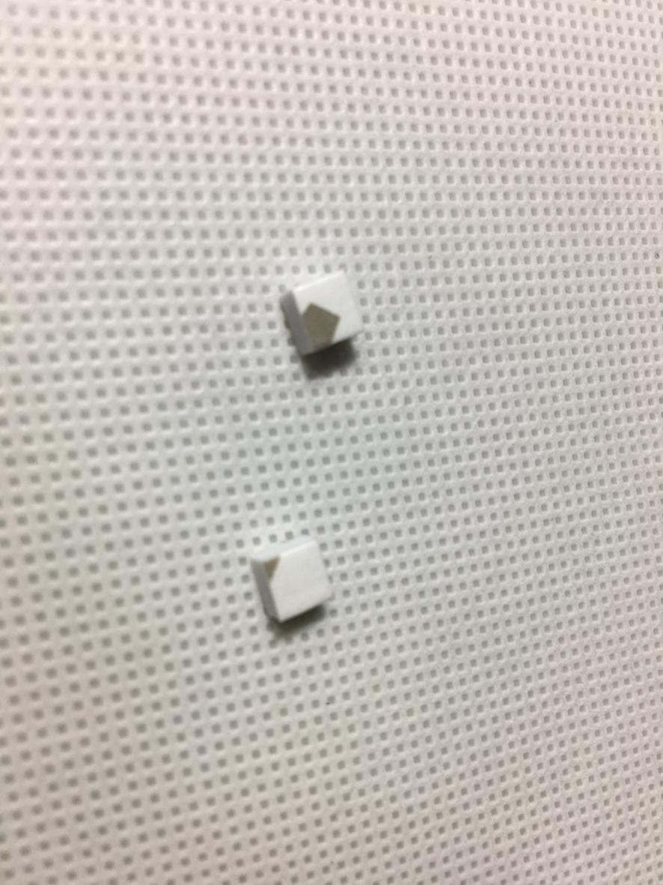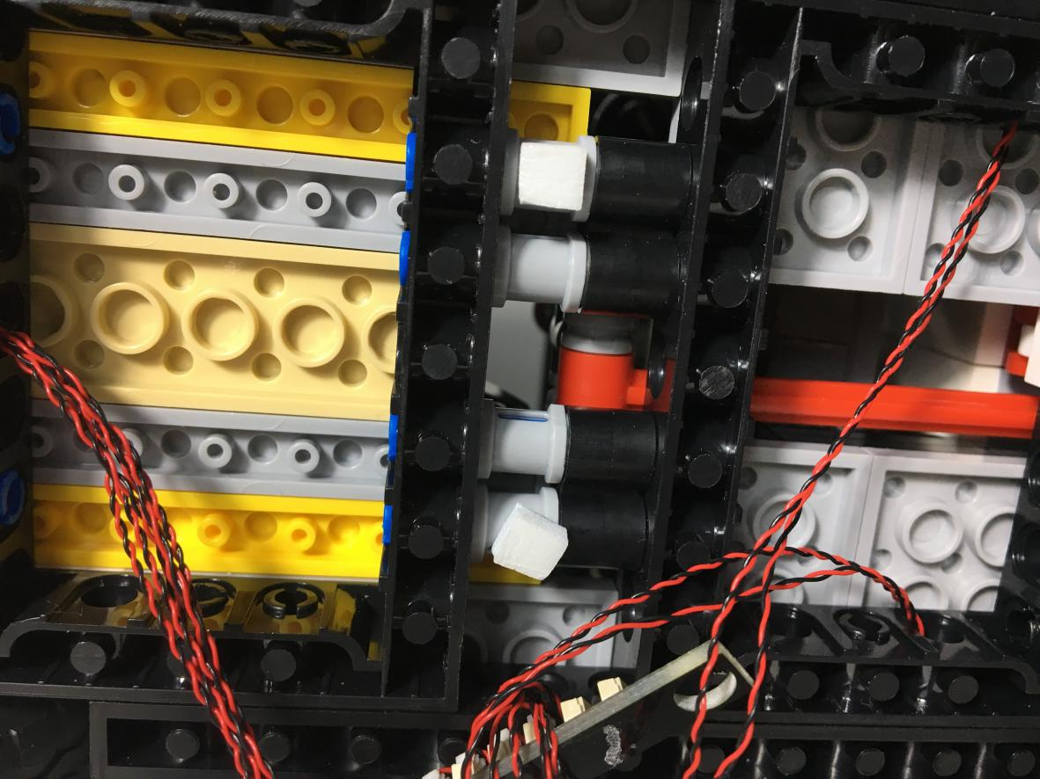

The extra cables is wrapped around the Expansion Boards then stick them to Adhesive Squares.
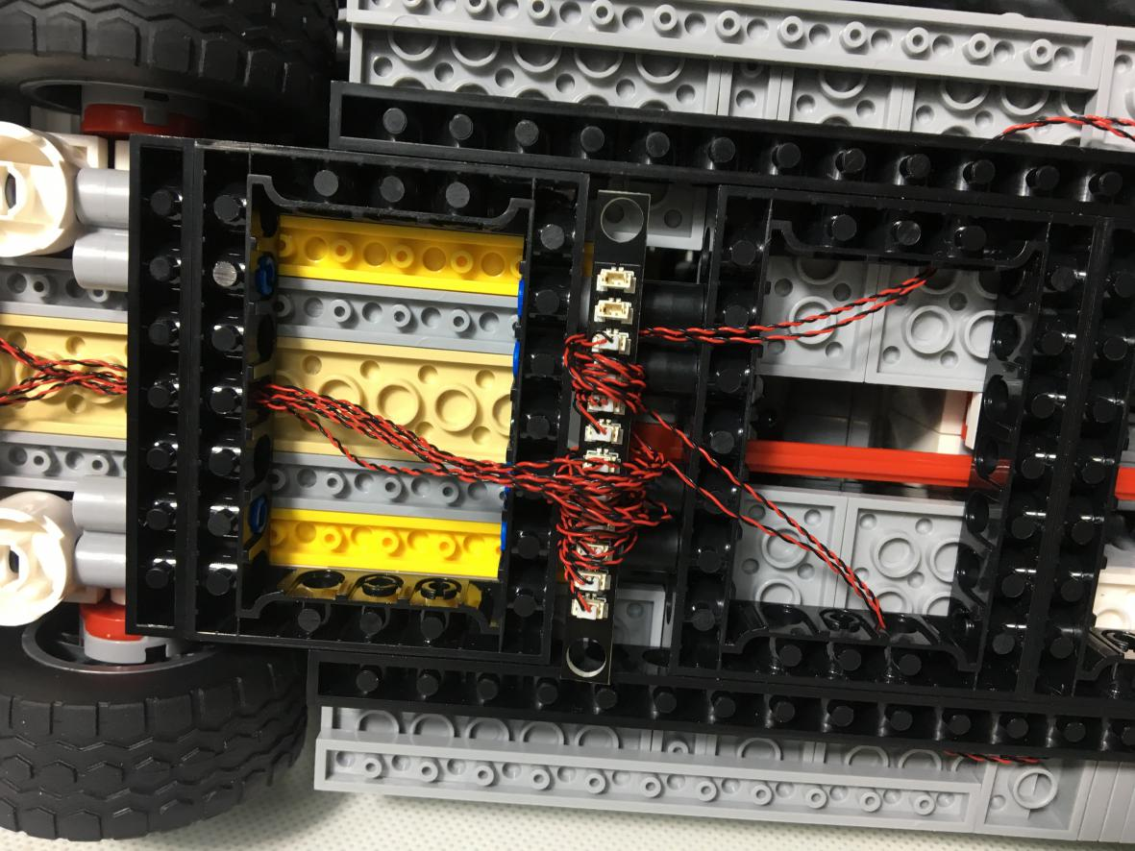

Remove the Button Battery Pack and click it in the picture below. Note that the switch position is placed in the gap to facilitate the switching power supply.
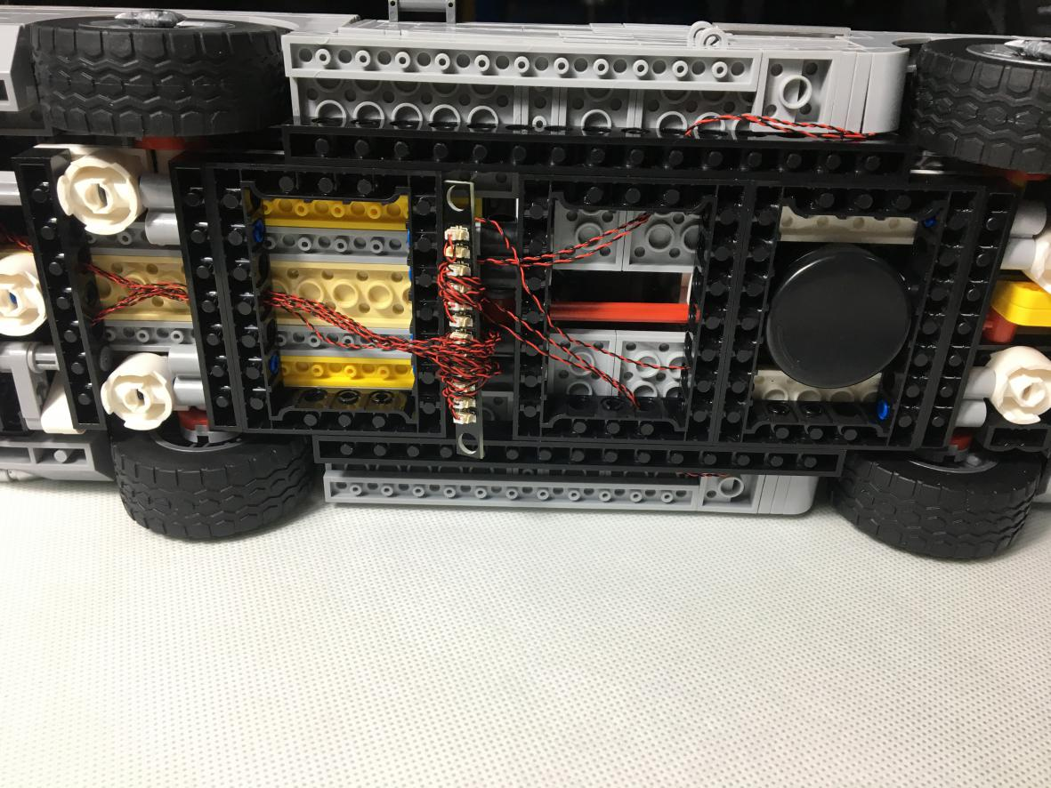

The lighting is installed, then open the switch, and the effect is as shown
