DETECTIVE'S OFFICE #10246

Package contents:
- 6x Warm White Strip Lights
- 5x Warm White 30cm Dot Lights
- 11x Flashing Warm White 30cm Dot Lights
- 1x 12-port Expansion board
- 1x 8-port Expansion board
- 1x 6-port Expansion board
- 1x Lamp Post with LED and cable attached
- 1x AA Battery Pack (requires 3x AA batteries)
- 6x Adhesive squares
- 2x Transparent Red 1x1 Round Plates
- 1x Transparent Blue1x1 Round Plate
- 6x 1x6 Plates (for mounting Strip Lights)

Connecting Cables
- 6x 15cm connecting cables
- 2x 5cm connecting cables

Note:
Place wires on the surface or under the building blocks.
The wire can be place between the building blocks or under the block, but they should be placed between the studs correctly.
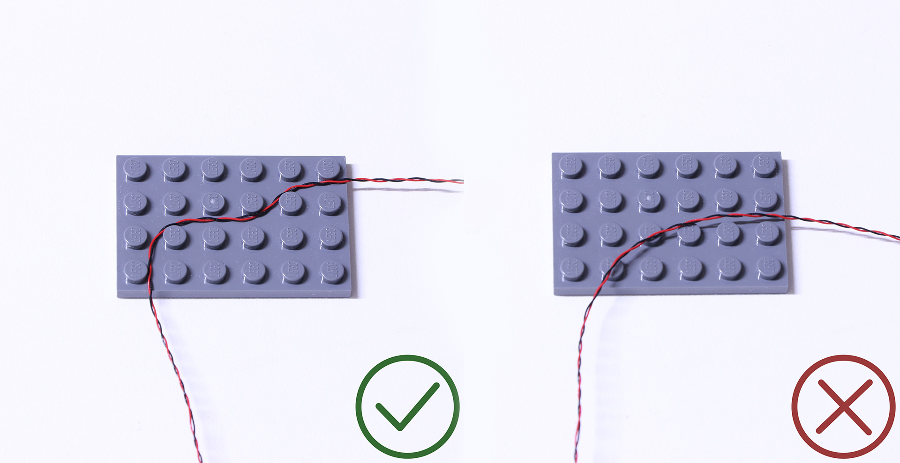
Insert the connectors to the ports.

Be careful when you are operating, there’s only one correct way to insert, make sure the expansion board is upward, find the soldered “=” sign on the left of the port. When you are inserting, the side which the wires can be seen should be faced to the “=” sign and if you feel hard to insert, please stop, and don’t force it, for that may result in bent pins inside the port or overheating of the expansion board.
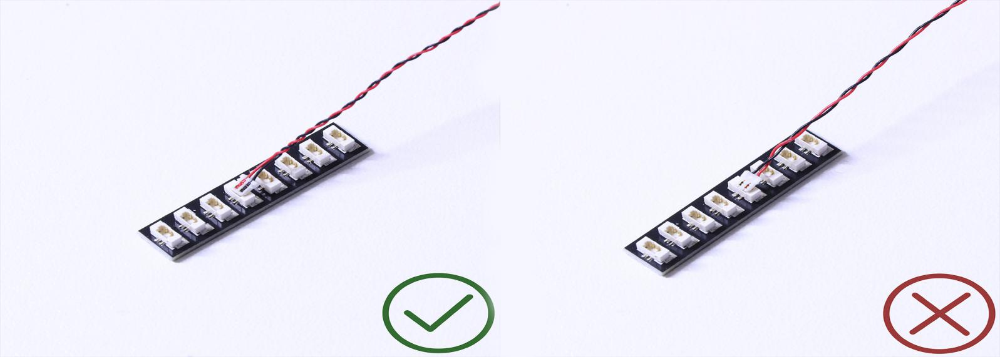

At this point, use the tweezers to straighten the bent pins.

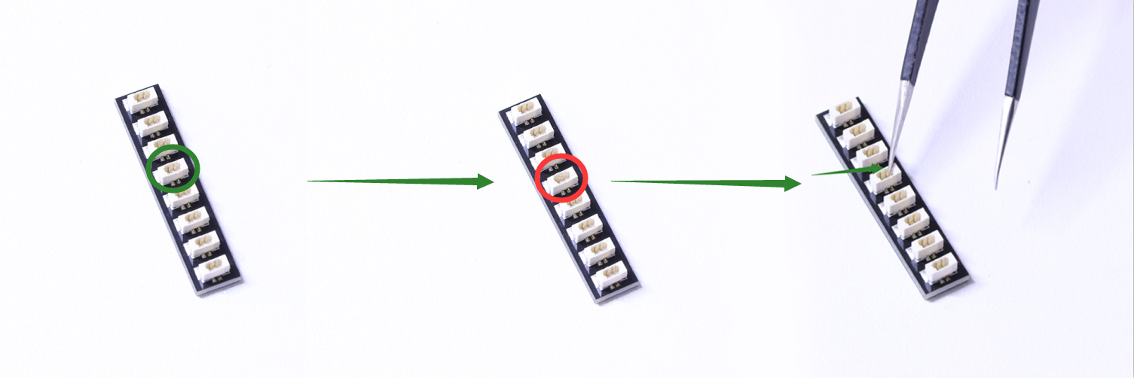

When installing dot lights, make sure they are correctly placed (Yellow LED package is exposed). You can put they either on the top of the studs or between studs.

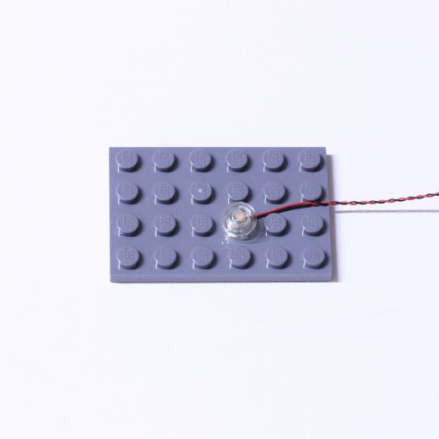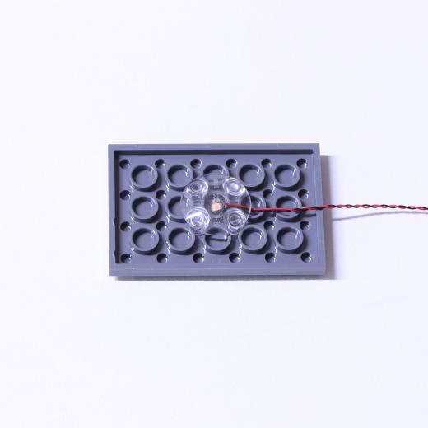

Connecting cable connectors to Strip Lights

Take extra care when inserting connectors to ports on the Strip Lights. Connectors can be inserted only one way. With the Strip Light facing up, ensure the side of the connector with the wires exposed is facing down. If a plug won’t fit easily into a port connector, don’t force it. Doing so will damage the plug and the connector.
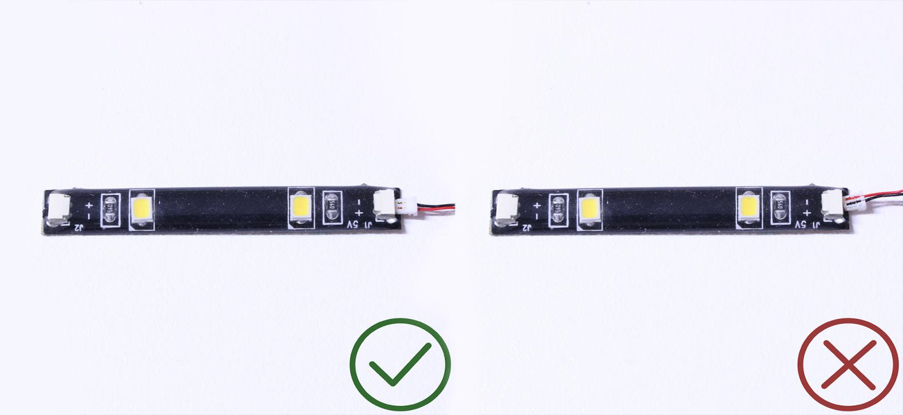

Finally, please pay attention to the positive and negative terminals of the battery when installing the battery case.

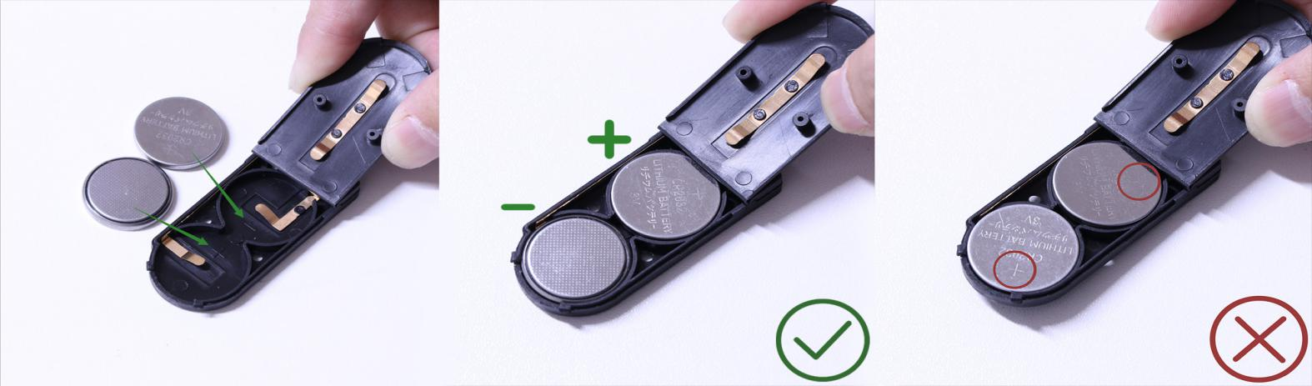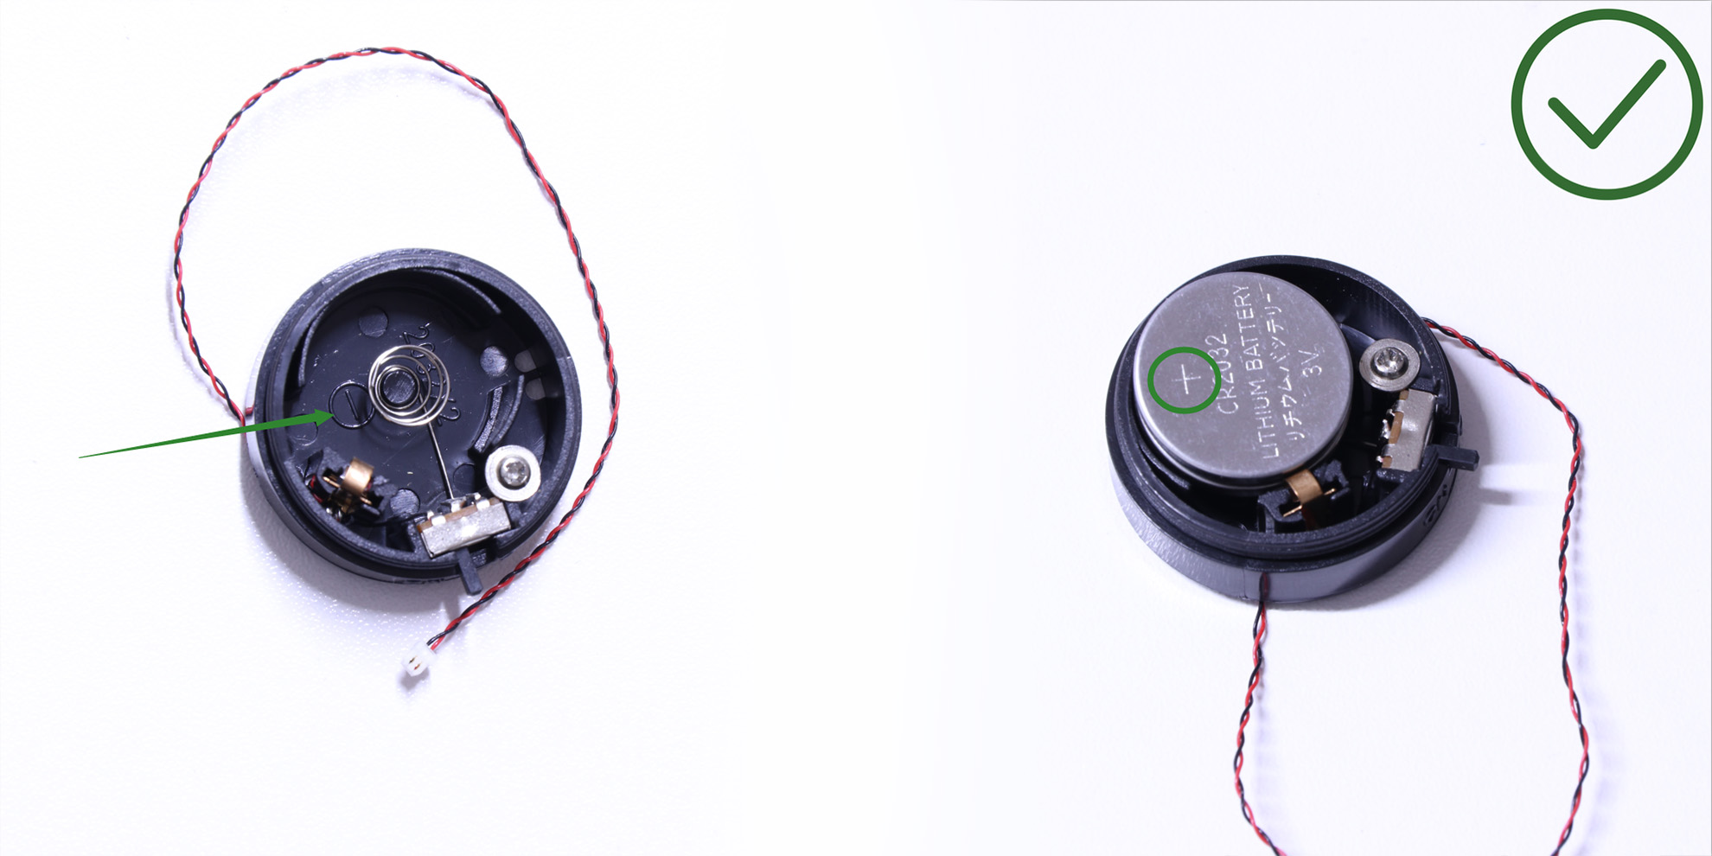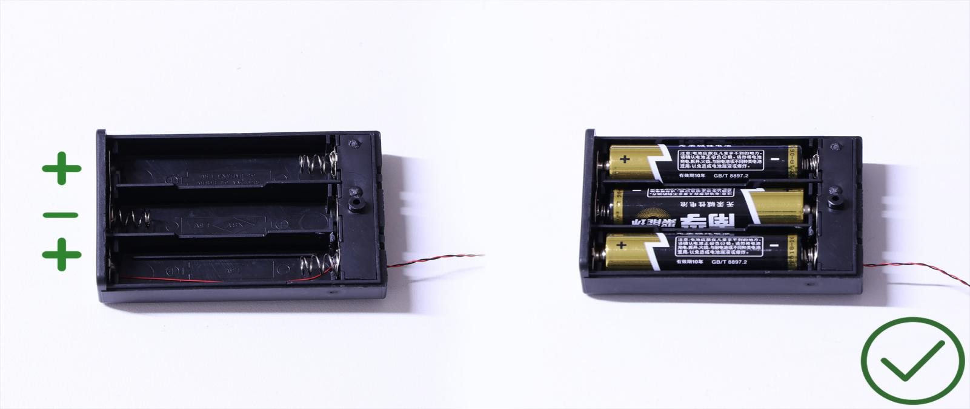
OK, Let’s Begin!

Instructions for installing this kit
1.) This lighting kit is installed from the bottom up. Start by removing the 2nd and top levels of the modular building. To enable us to lay the cable for the lamp post underneath the brick tiles, remove the following tiles as per below.
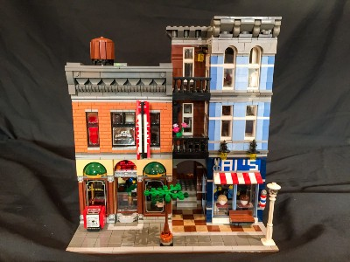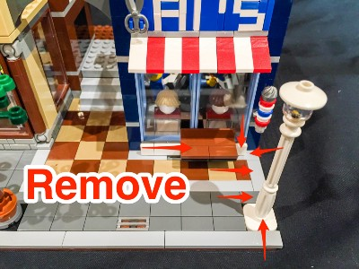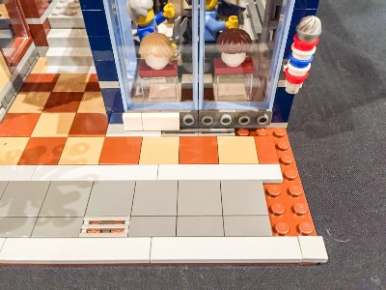

2.) Replace the original lamp post with the Vonado lamp post ensuring that the cable is laid in the middle the 2 studs.
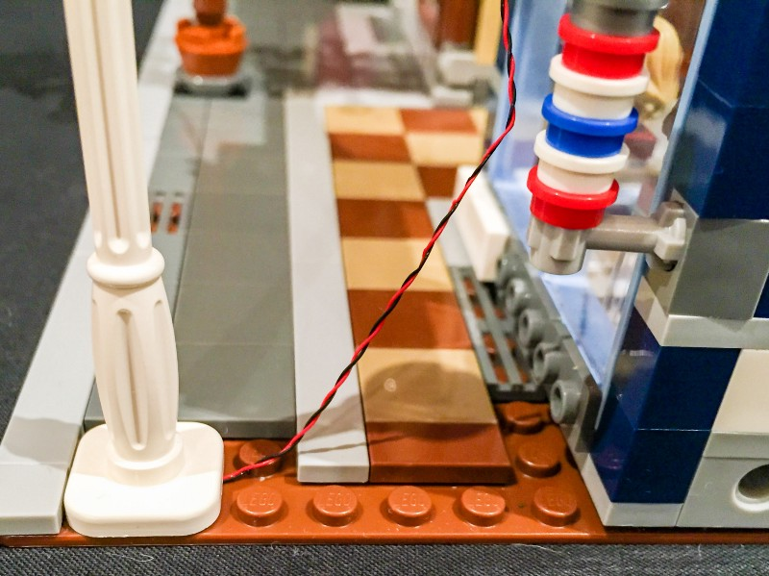

3.) Gently bend the base plate down and lift the building of the ground floor up and thread the cable for the lamp post underneath the brick wall. Ensure that the cable is laid in between the brick studs.
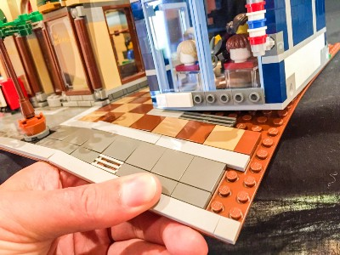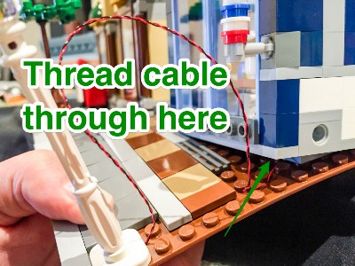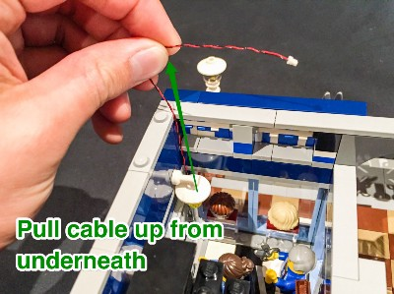

4.) Pull the cable up from underneath the wall and then connect this to the first available port of the 8-port expansion board.
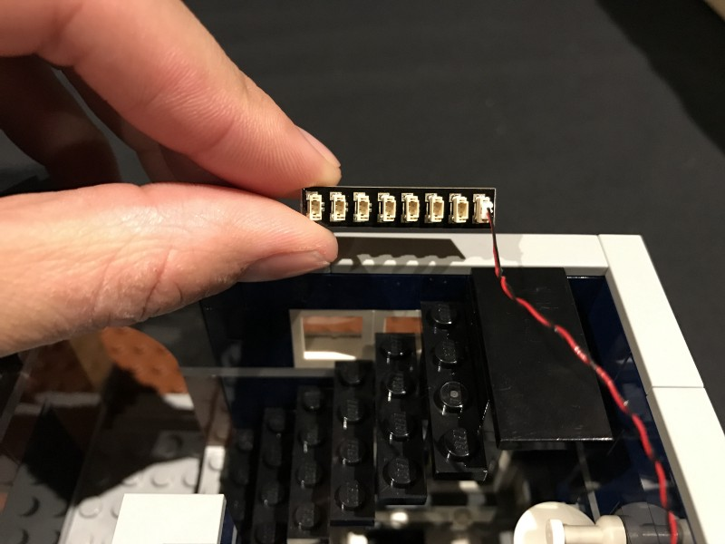

) We will now connect flashing lights to the barber pole. Start by removing the pieces in the following order.
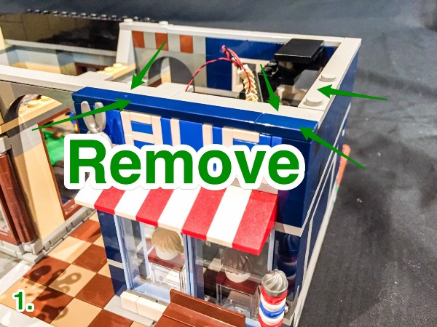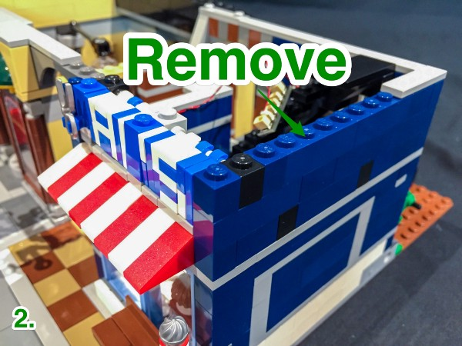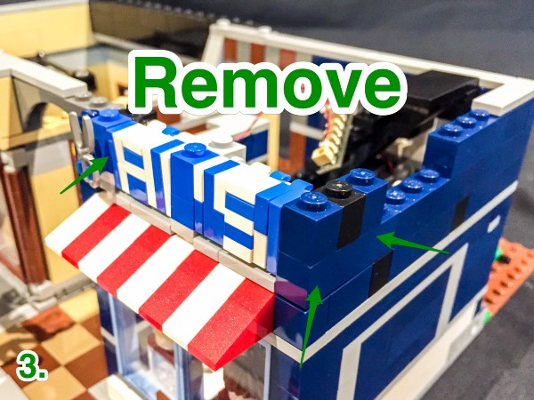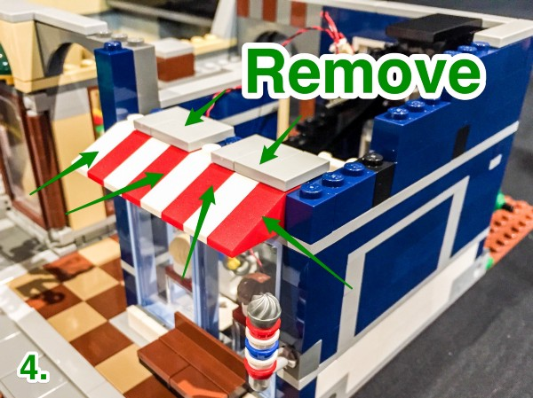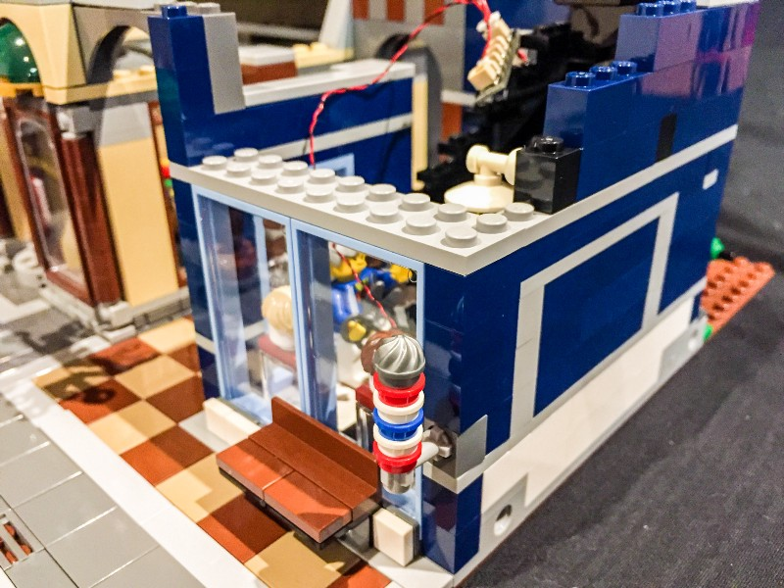

6.) Slightly lift up the grey 2x10 piece, and then remove the barber pole section from underneath.
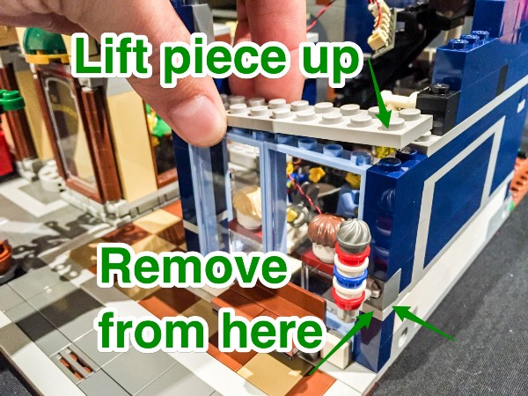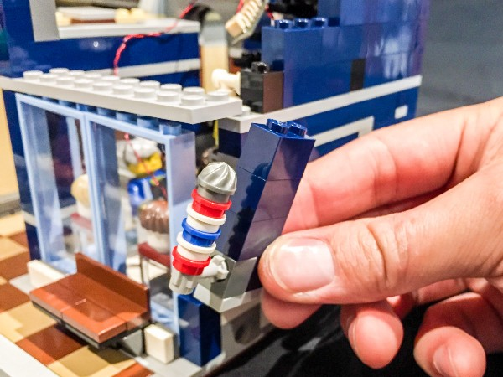
7.) Disassemble the round pieces which make up the barber pole and then replace them with the Transparent Blue and Red pieces which came with this kit.
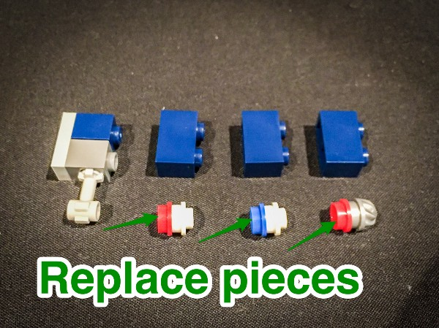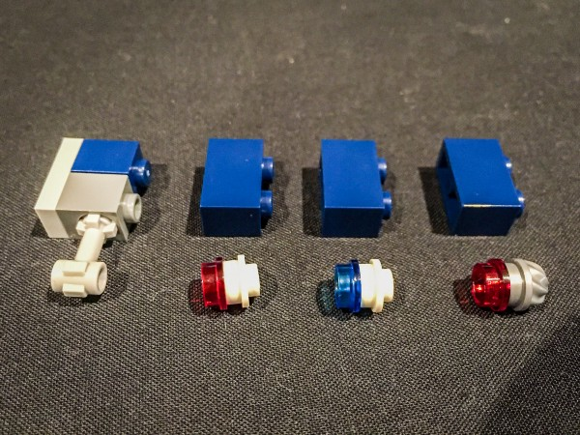
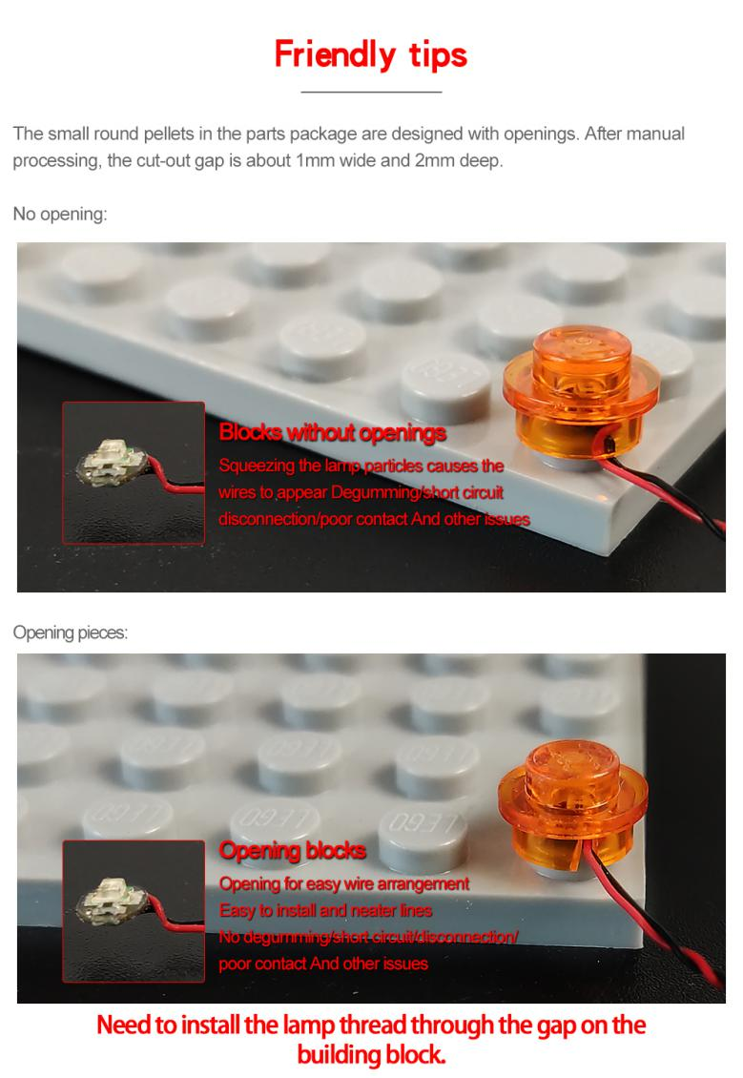
8.) Take one of the flashing dot lights and then starting from the bottom sections up, lay it down (LED component facing up) and then connect the first transparent red light piece on top.
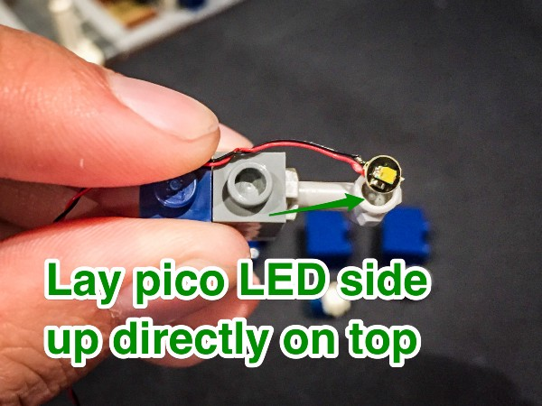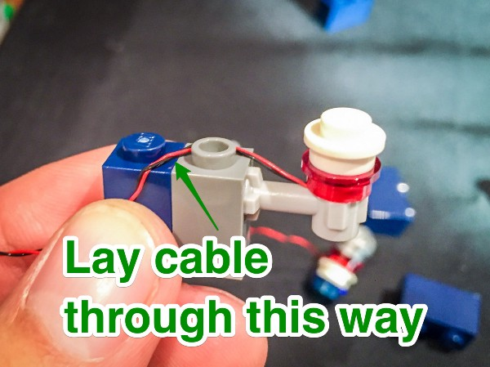

9.) Continue this process with 2 more flashing dot lights for another blue and red light, ensuring you lay the cable the exact way as shown in the photo examples. There will be a slight gap between each brick, this is because of the cables and this is OK as this whole section will connect securely under the grey 2x10 brick.
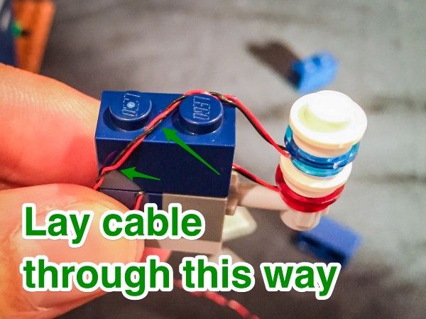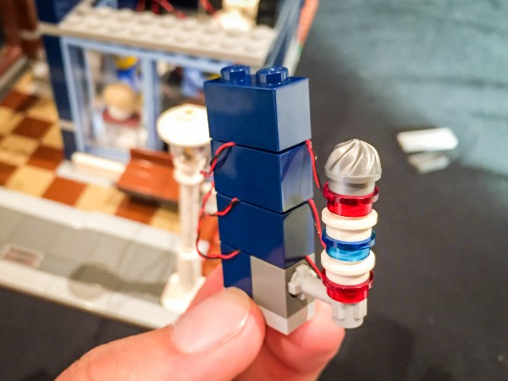
Use the blue 2:1 bricks to secure cables.

10.) Group together the cables for the 3 flashing lights and thread them through the spacing where you removed the barber pole section from and then reconnect this section back to its original position.
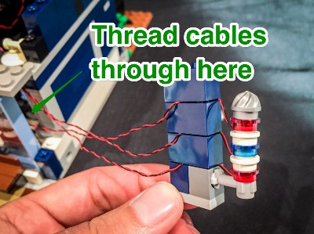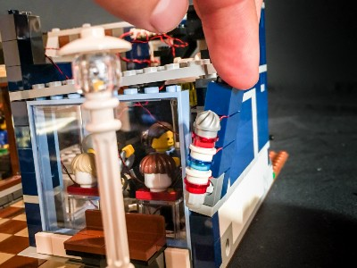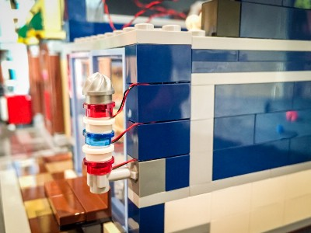

11.) Reconnect the pieces we removed on top of this section and then plug the 3 cables of the flashing lights into the spare ports on 8-port expansion board. Secure the expansion board to the top of the back wall using one of the provided double sided adhesive squares.
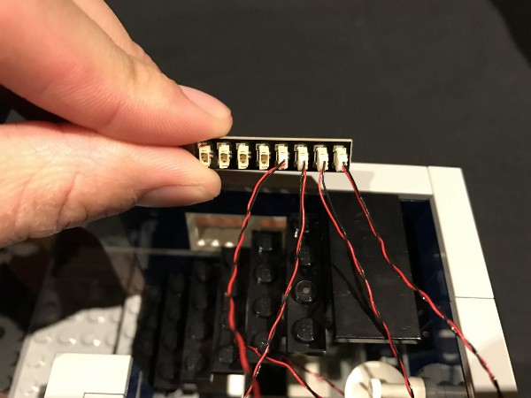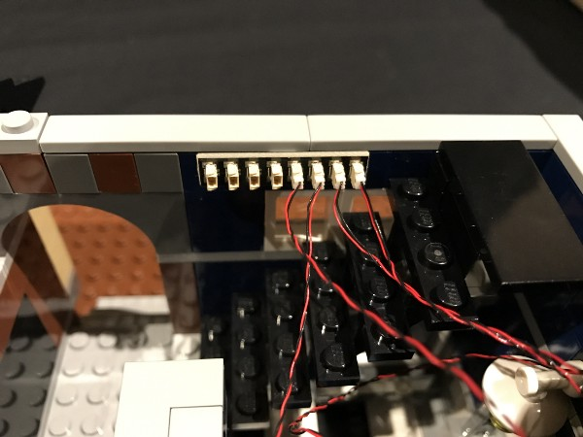

Remember: You can test out the lighting we have connected so far by simply plugging in the battery pack cable into a spare port of the expansion board and then turning it on.
12.) Neaten up the cables by laying them in between studs underneath tiles.
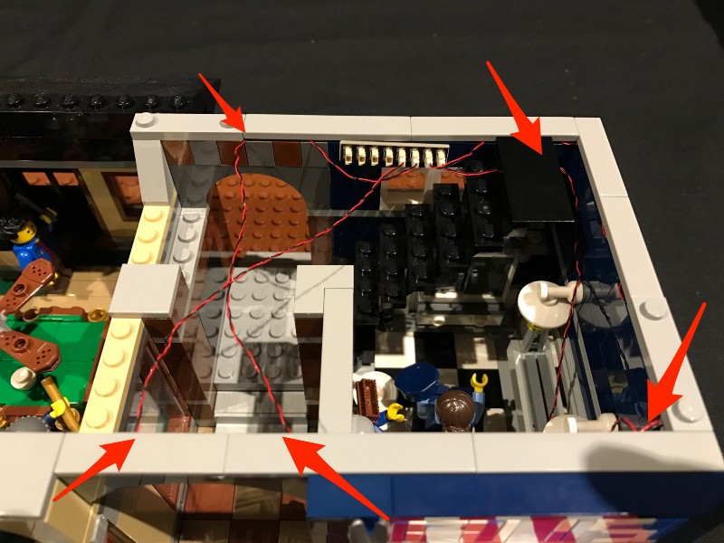
13.) We will now move onto installing the “down lights” for the front of the pool hall. Start by removing the following pieces.
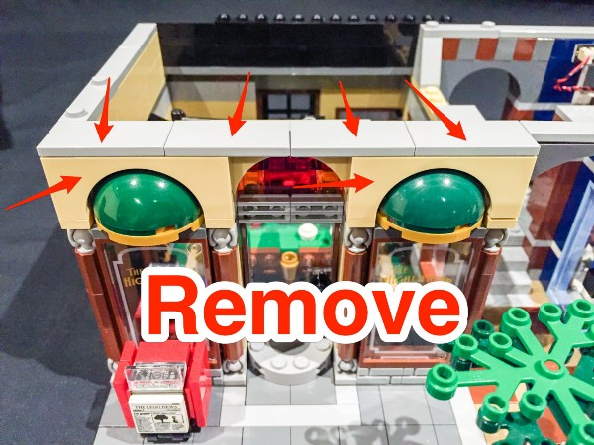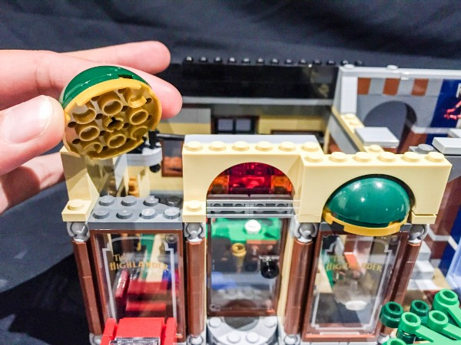
14.) Take a standard dot light (non flashing) and lay it down at the bottom of one of the lighting sections in the following position pictured below. Then connect this back into its original position ensuring that the LED light component is clearly visible from underneath.
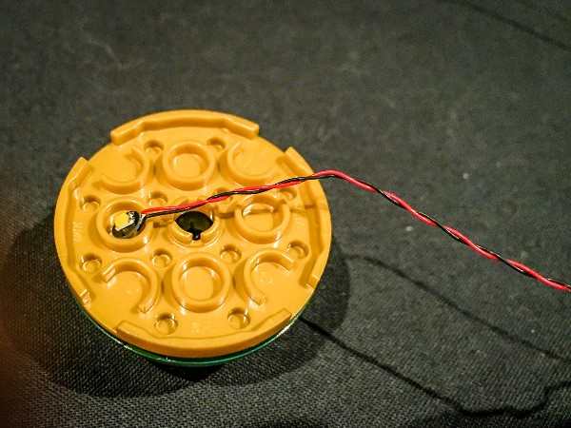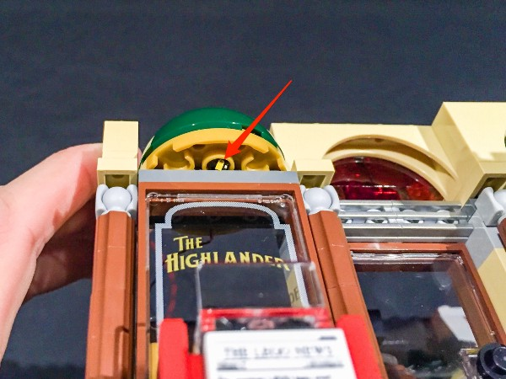
Repeat this process for the 2nd lighting section using another standard dot light then reconnect the pieces we removed in step 15 to their original positions.
15.) Connect the other end of the cables from the 2 LED lights we just installed into the spare ports of the 8-port expansion board.
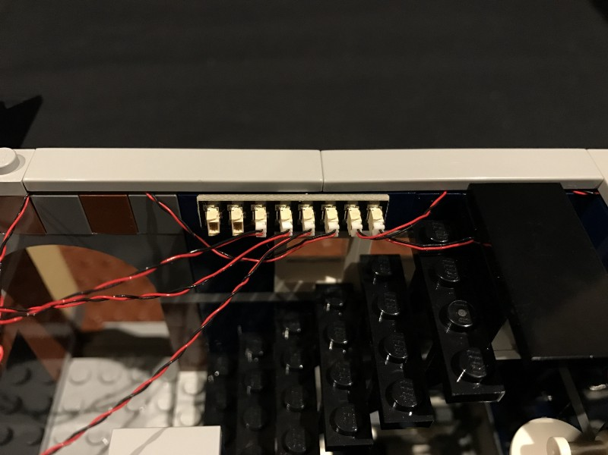
Neaten the cabling by hiding them underneath the flat tiles.
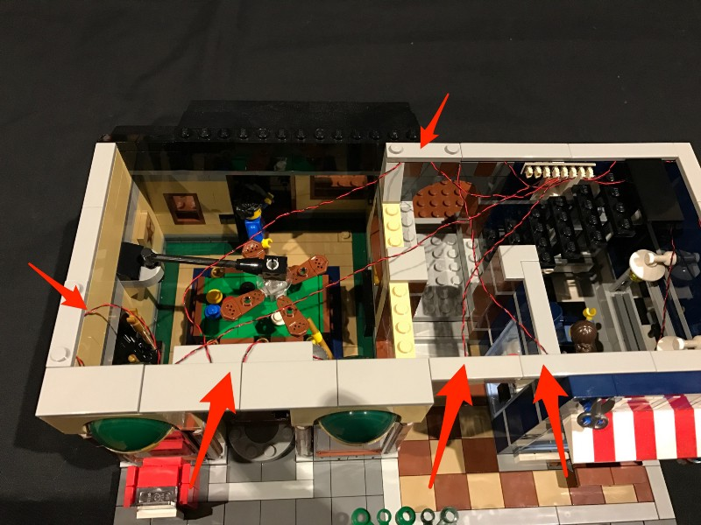
16.) Take a 15cm cable and connect it into a spare port of the expansion board. We will use this to connect to the strip lights.
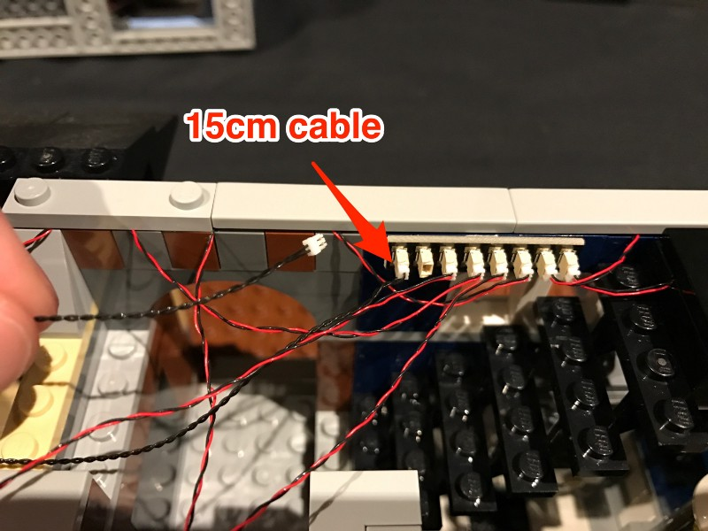

17.) Take the entire section of the second floor and flip it over so we can install lights to the ceiling.
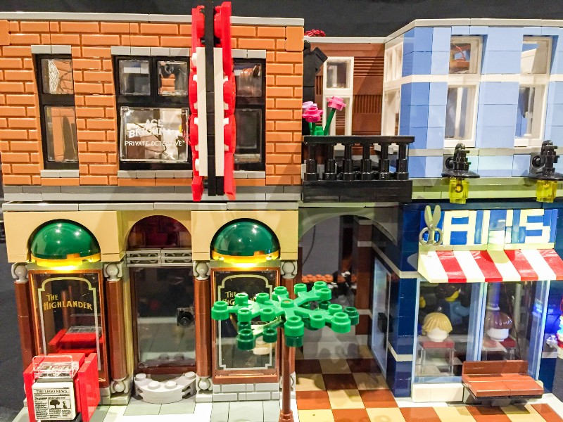

Take 3 LED strip lights and connect them together using 2x 5cm connecting cables. Stick/connect the lights in the following positions below. We will identify them as striplight#1, striplight#2, and striplight#3.
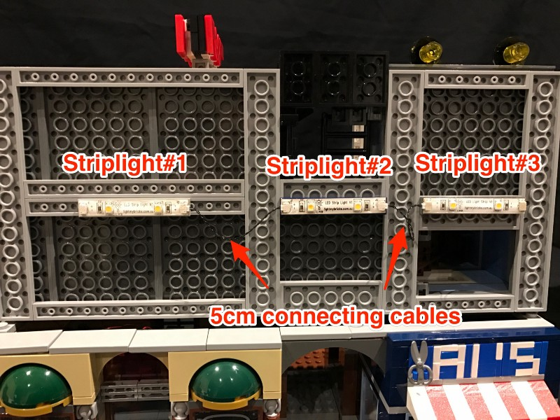
18.) Take a 15cm cable that we connected earlier to the expansion board and connect the other end of this to the left port of striplight#1.
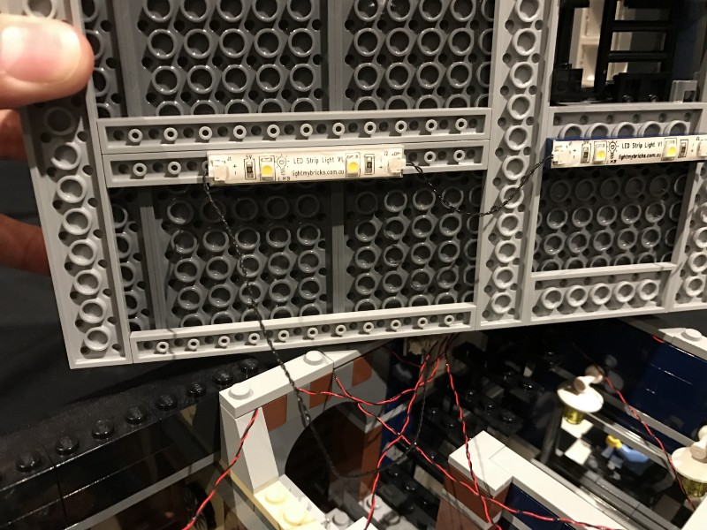

19.) Take another 15cm cable and connect this to striplight#3 and thread the other end of this cable up through the spacing which leads to the second floor.
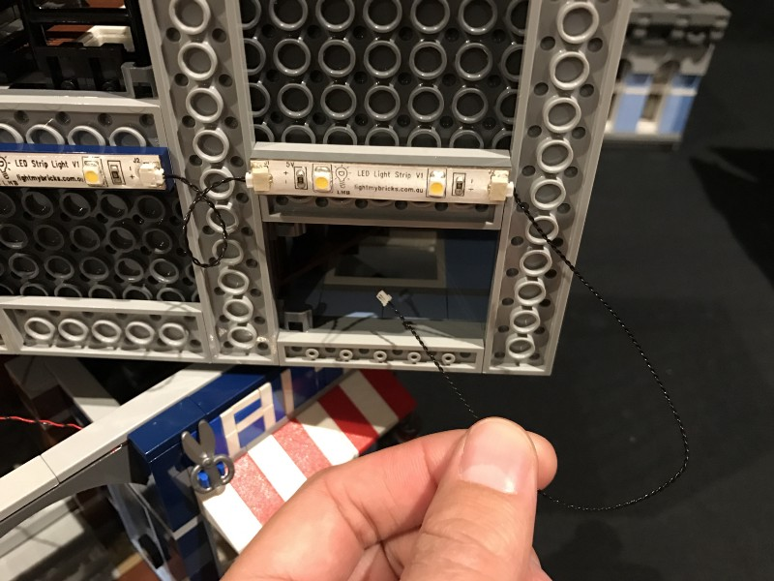

20.) Reconnect the entire second floor on top of the first floor and then pull the 30cm cable up from the first floor. Connect this end into a spare port of a new 6-port expansion board.
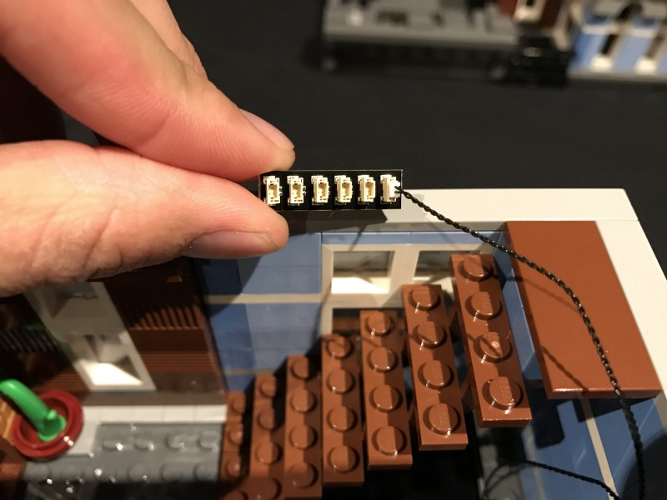
21.) We will now light up the lamps above the “Al’s” barber sign.
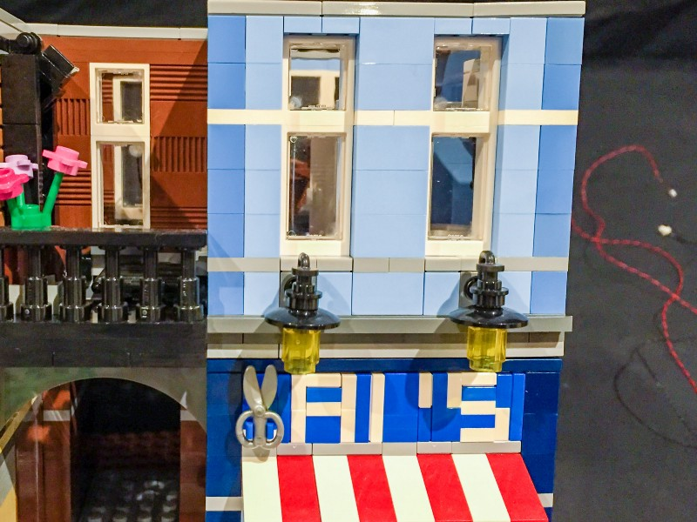

Start by removing the following pieces to then allow us to remove the 2 individual lamp sections.
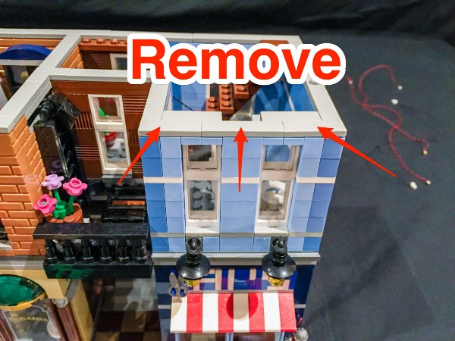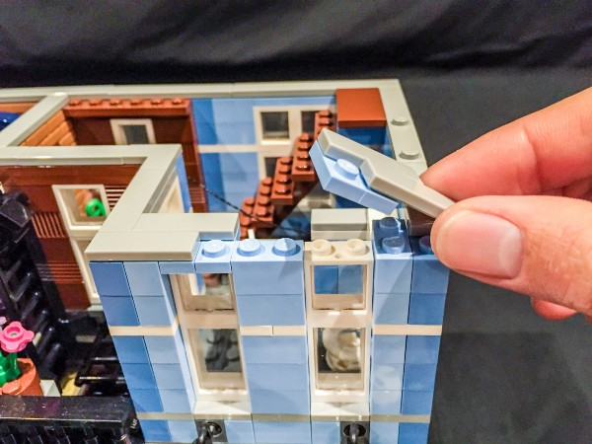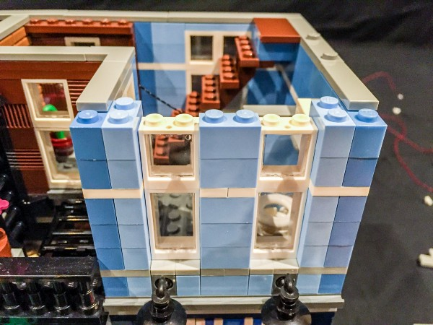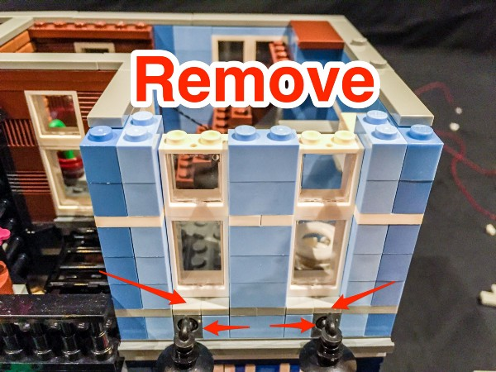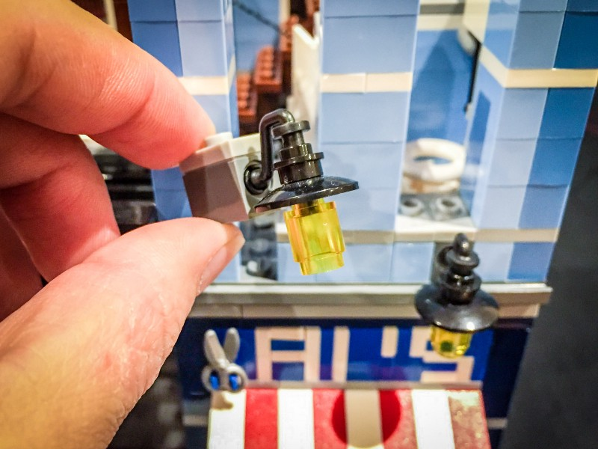

22.) Disconnect the 2 transparent yellow pieces from the lamp sections
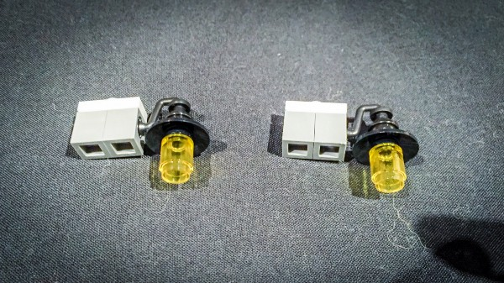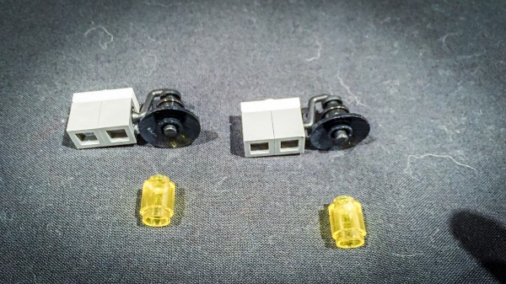

Take one of the dot lights and thread the cable from the connector side up through the smaller hole of the transparent yellow piece. Thread this all the way until the dot light part is up against the piece.
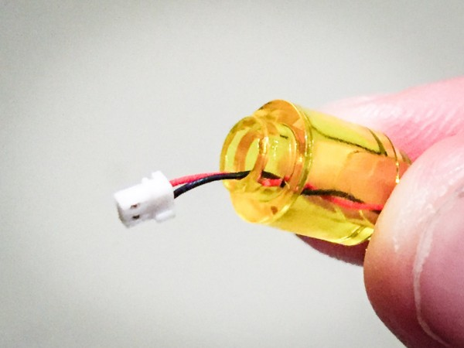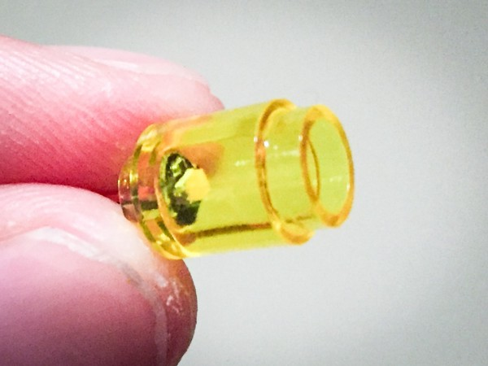

Reconnect this piece with LED back to the lamp shade
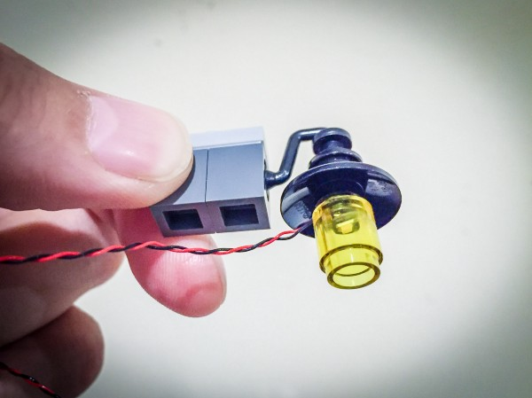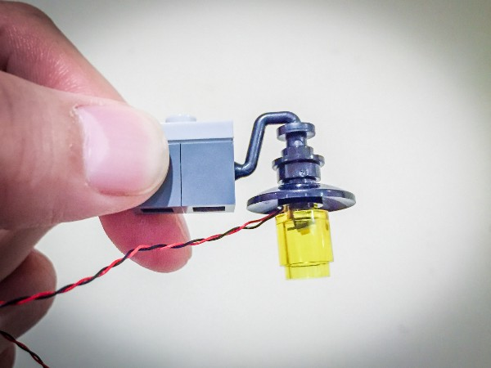
ensure cable is facing toward the back and the LED component is facing the correct way down

Repeat this process for the 2nd lamp shade.

23.) Reconnect the 2 wired lamp sections back to its original positions ensuring the cables for the LEDs are laid between studs. Then reconnect the pieces which make up the windows and the rest of the wall.
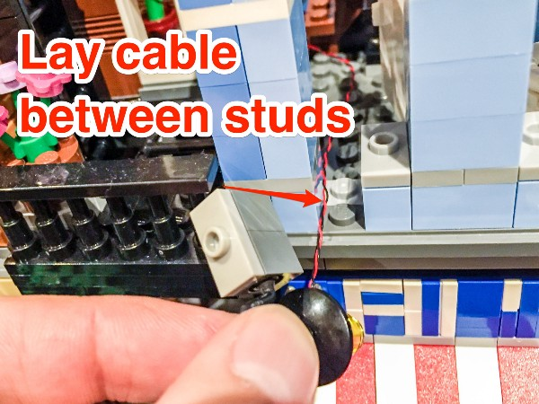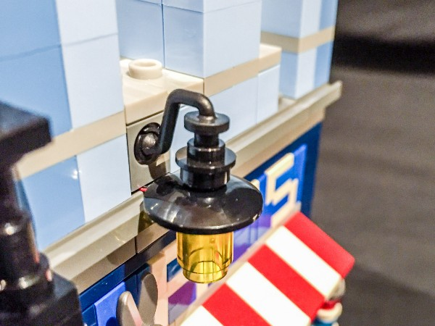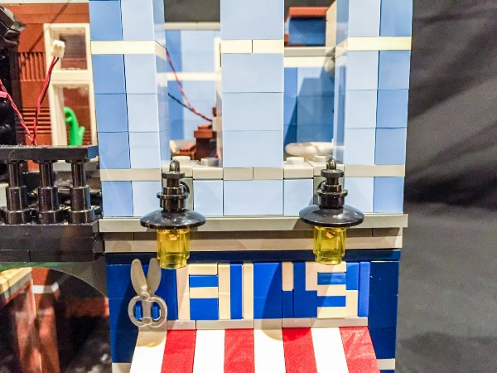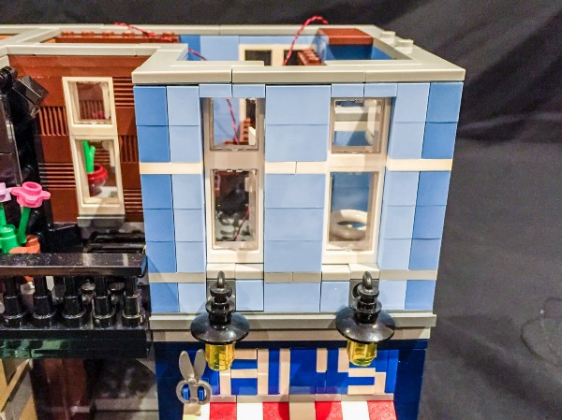

24.) Take the 2 wires from the lamps and connect them to the 6-port expansion board we used previously.
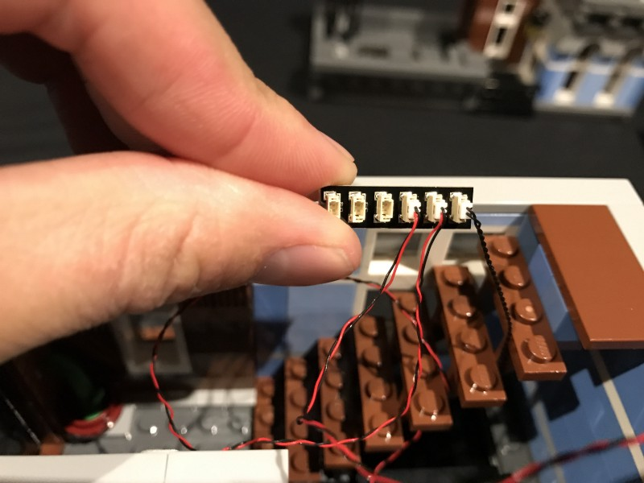

25.) Take another 15cm cable and connect it to the next available port of the 6-port expansion board.
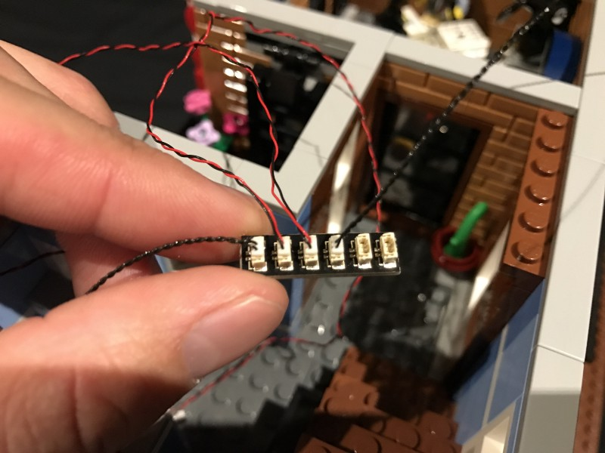

26.) Turn the building around to the back side and then use one of the provided adhesive squares to stick the expansion board on the top of the wall in the following position.
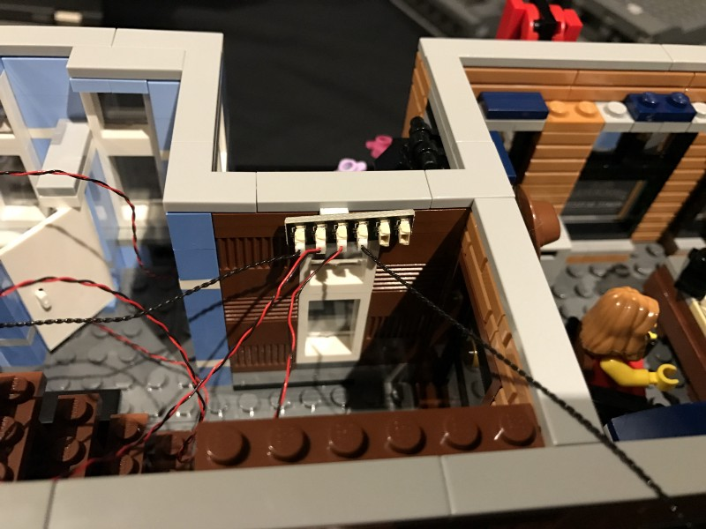

27.) Lay any excess cables from the lamp LEDs underneath tiles on the roof of level 2. When doing so ensure that cables are hidden so they are not obviously visible when looking in from the outside through the windows.
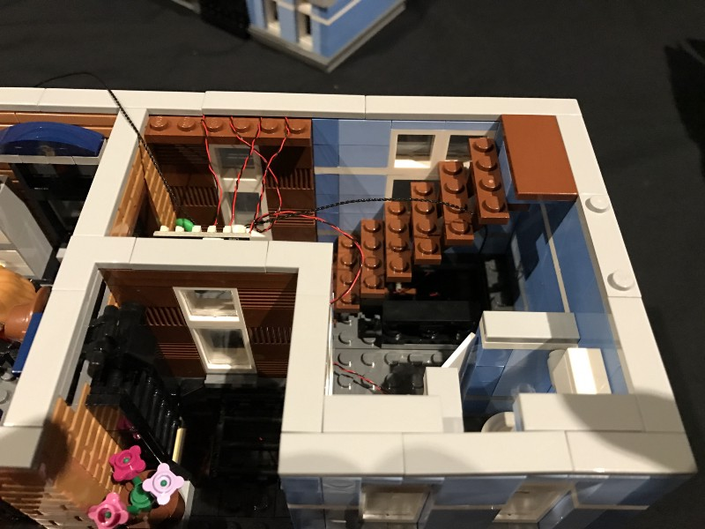

28.) We will now connect flashing LED lights to the “Pool” sign. Start by removing the entire Pool sign section from the “arm” as per below.
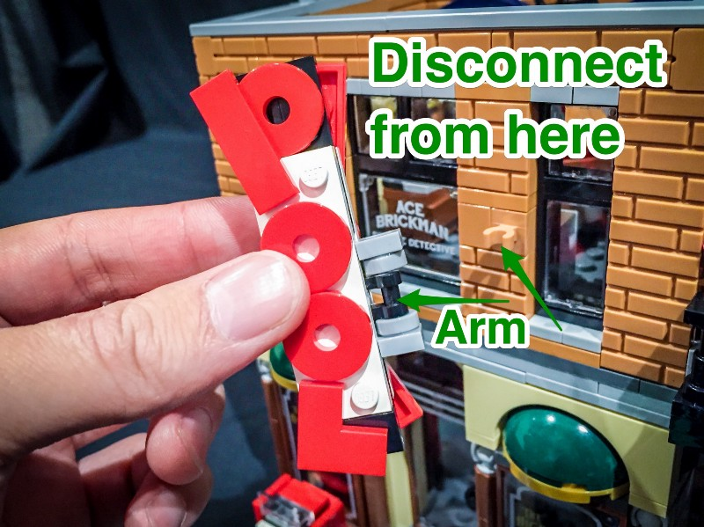

29.) Lay this section down with the arm facing up then remove the 2 red pieces which make up the letter “P”.
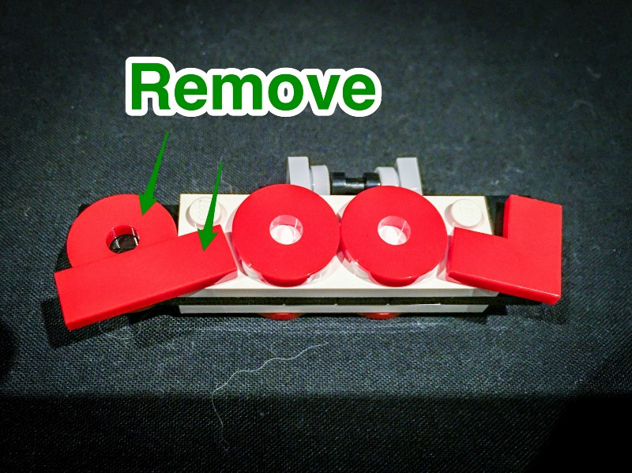

30.) Take 1 of the flashing dot lights and lay the LED component part down in the center of where the “O” shaped piece will connect to. Ensure that the LED component is facing the correct way up and that the cable is also facing toward the handle. Reconnect the “P” letter directly on top ensuring the LED component is visible in the center.
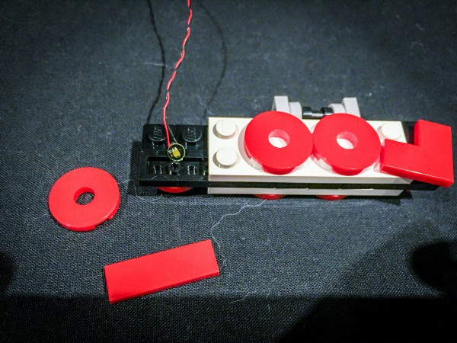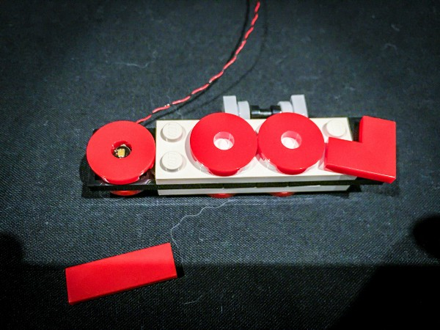

Take another 2 flashing dot lights and repeat the same step for the 2x letter “O”’s ensuring the LED component part is laid in between the 4x studs and visible in the center.
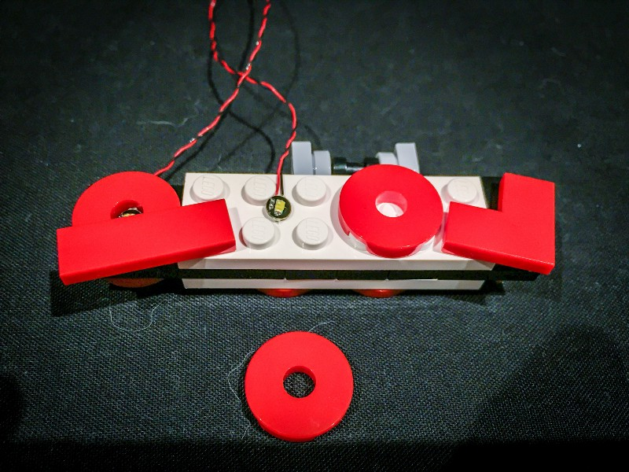
For the letter “L” section, lay the 4th flashing dot light in the top section of the black part closest to the top. Then connect the “L” piece directly on top.
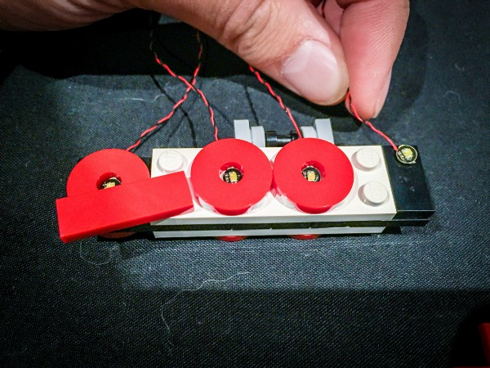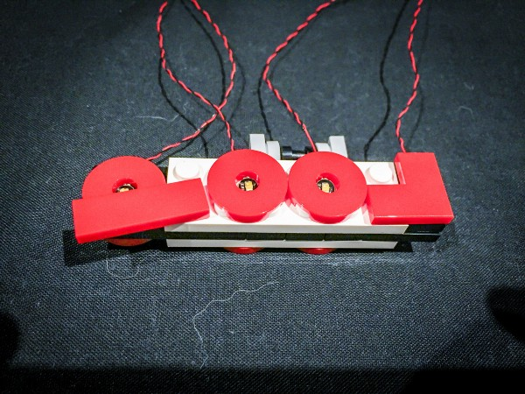
Ensure all cables for the flashing LEDs are facing up toward the handle

31.) Flip the “Pool” sign over as we will now have to lay another 4 flashing dot lights on this side.
Take another 4 flashing dot lights and connect them to the sign by laying them in the same positions as we did for the other side of the sign.
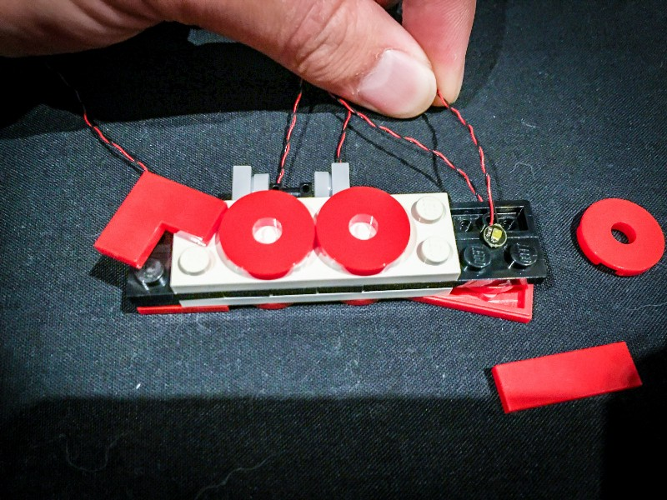

For the “L” piece on this side, we will have to lay the cable for the flashing LED over and in between the white stud as per below. Then connect the “L” piece over it.
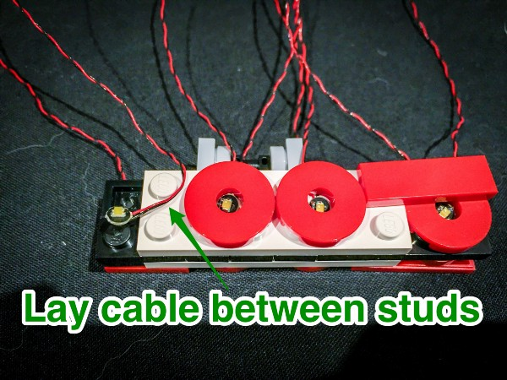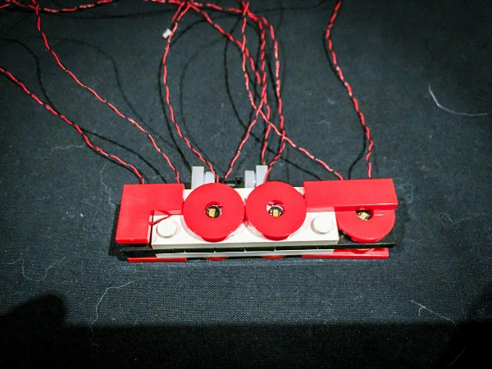
32.) We now have a lot of messy cables. Let’s neaten this all up by grouping them all together which will then allow us to neatly thread this through the window of the Ace Brickman Detective’s Office.
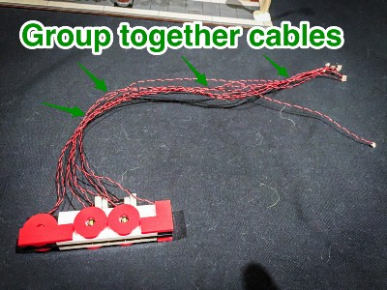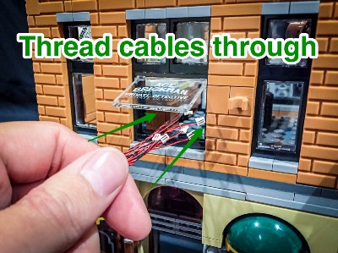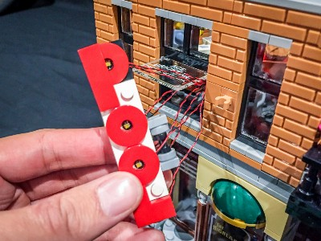
Group the cables and thread them all the way through the window
33.) Connect back the “Pool” sign and then twist all the cables around each other so they form 1 thicker cable. Connect all 8 individual cables from the flashing LEDs into the 12-port expansion board .
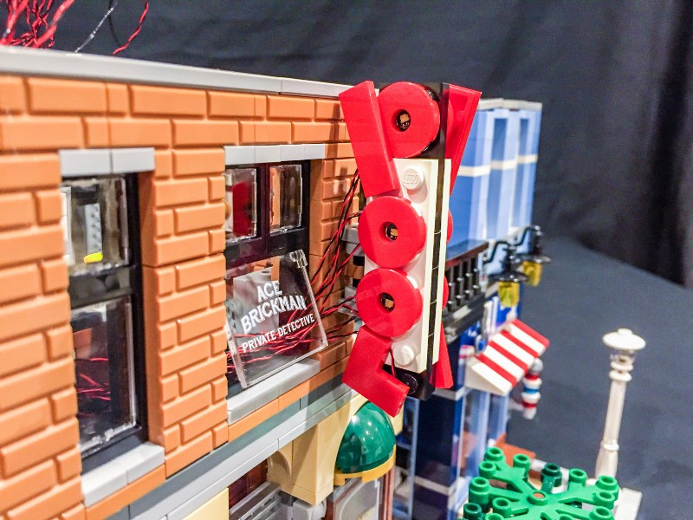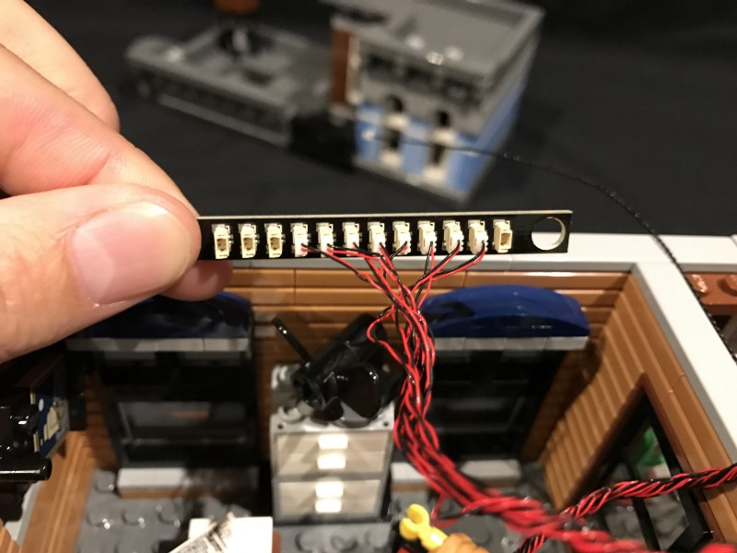

34.) Turn the building around and then remove the following piece as we will be placing the 12-port expansion board here.
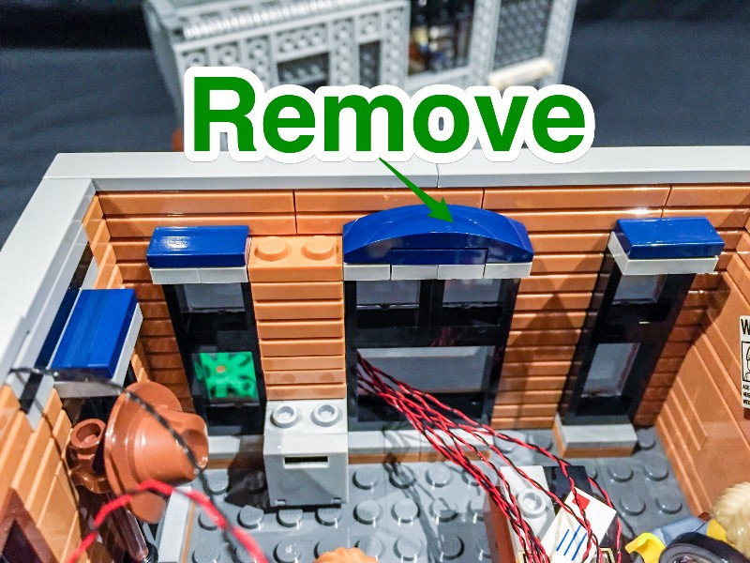

35.) Place the expansion board in the following position and secure it by using a self adhesive square.
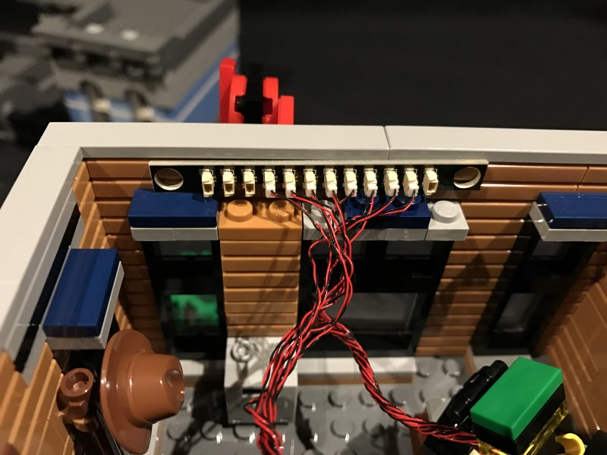
36.) Connect the other end of the 15cm cable from the 6-port expansion board to a 12-port expansion board.
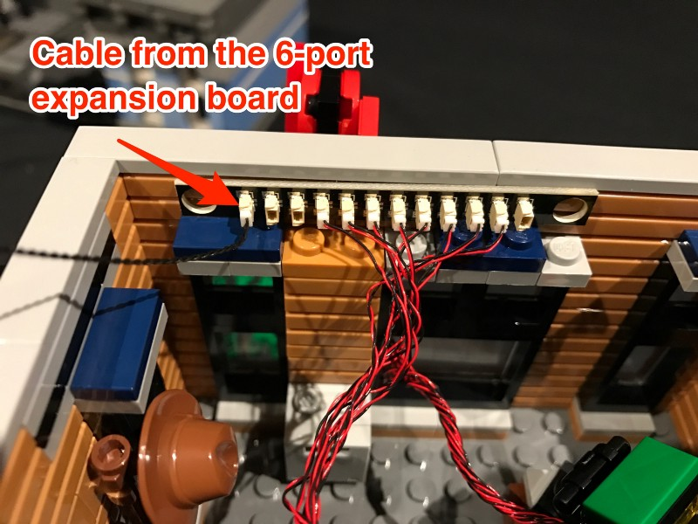

37.) We need to hide all the cables from the pool sign. Do this by pulling the lot of cables underneath the middle window and then up in between this window and the right window, then up above the expansion board. Use some tape to secure the cables as per below.
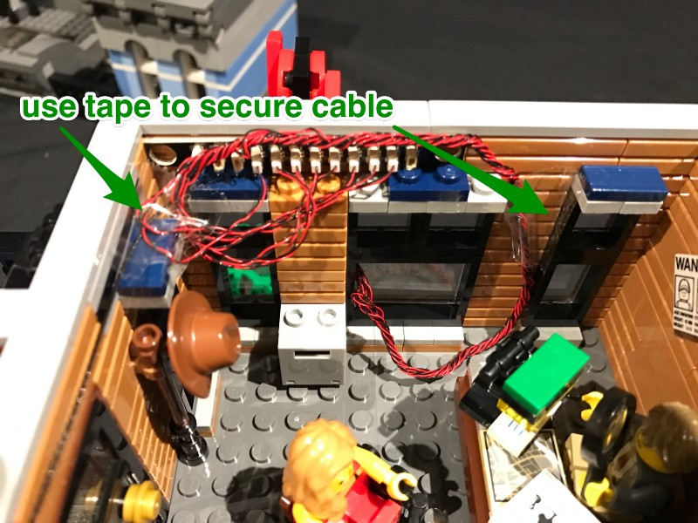

38.) Take another 15cm cable and then connect it to a spare port of the 12-port expansion board.
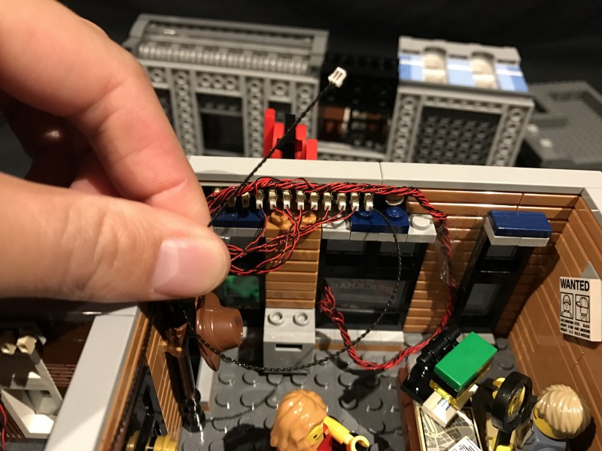

39.) Take 2x LED strip lights and then stick/connect them on the ceiling of level 2 (underneath the top level) in the following position. We will refer to them as striplight#4 and striplight#5.
Connect striplight#4 and 5 together using another 15cm connecting cable.
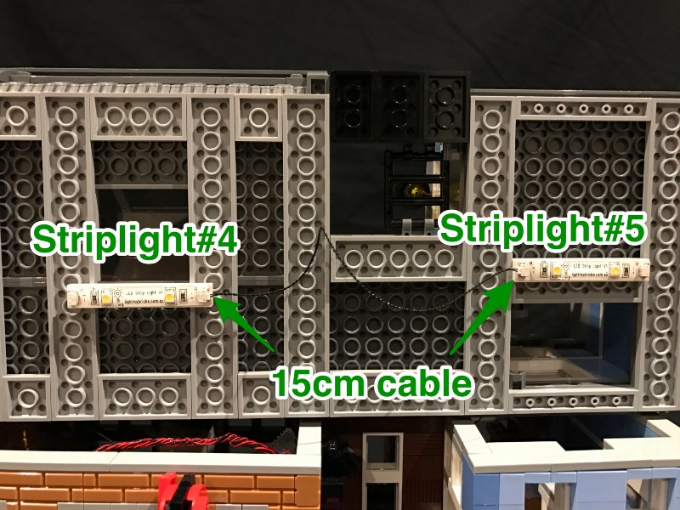
40.) Connect the 2 strip lights we just installed to the rest of the lighting circuit by connecting the other end of the 15cm cable from the 12-port expansion board to striplight#4
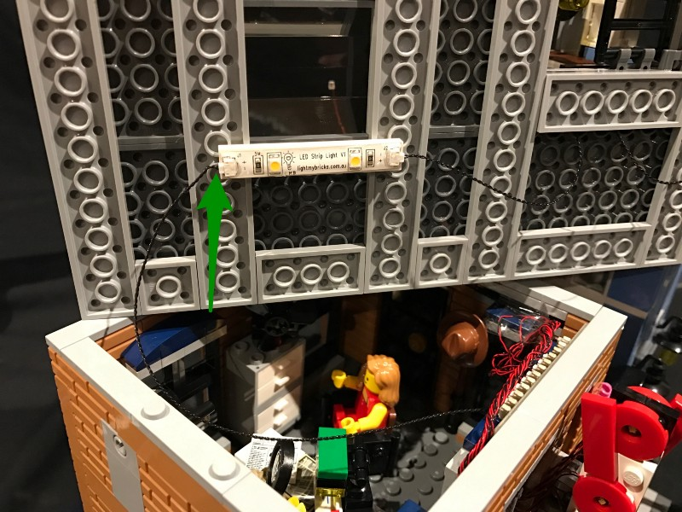
41.) Take another 15cm cable and connect this to the other end of striplight#5. Thread the other end of the cable up through spacing which leads to the top level. Connect the entire top level on top of level 2 in original position, then pull the 15cm cable up from the lower level.
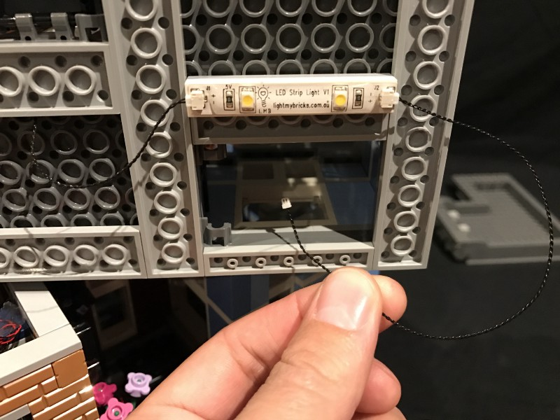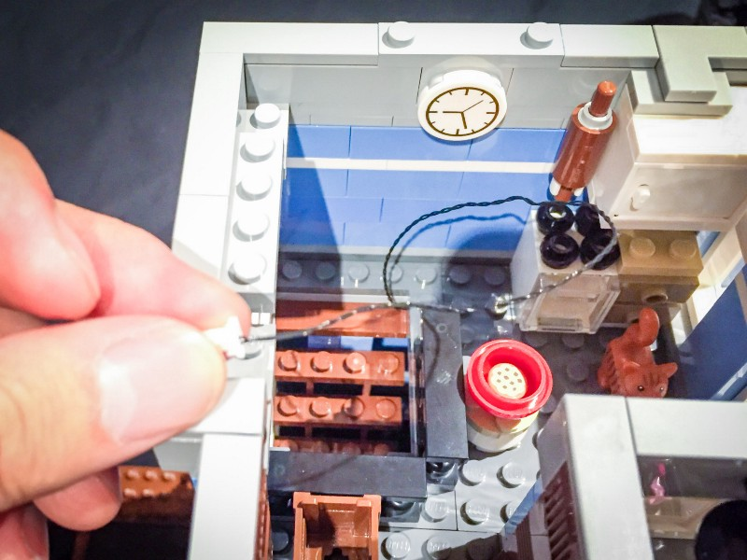
42.) We will now connect the lamp for the top floor window. Remove the following pieces so that we can remove the lamp section.
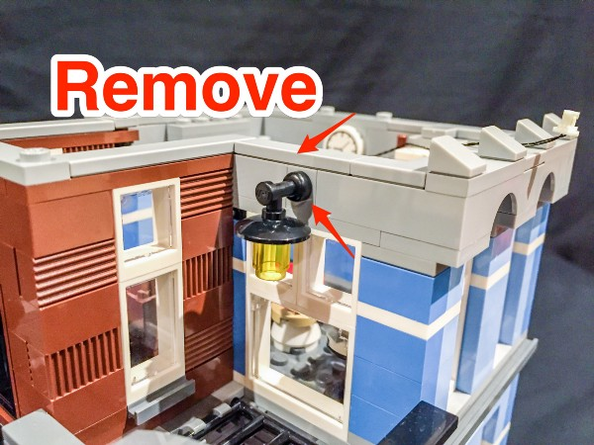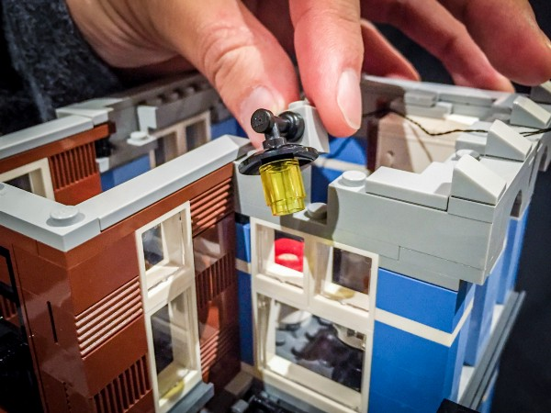

43.) Disassemble the lamp section and then using dot light, thread the connecting end through the small hole on the top of the grey piece.
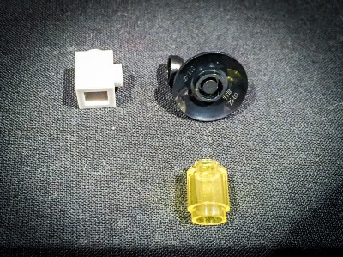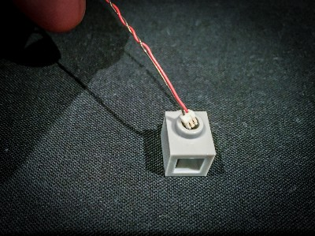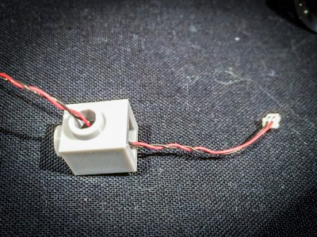

Then thread the cable from the connector side up through the smaller hole of the transparent yellow piece. Thread this all the way until the dot light part is up against the piece.

Reconnect the black lamp shade piece on top of the transparent yellow piece and then connect the black lamp shade piece back to the grey piece.
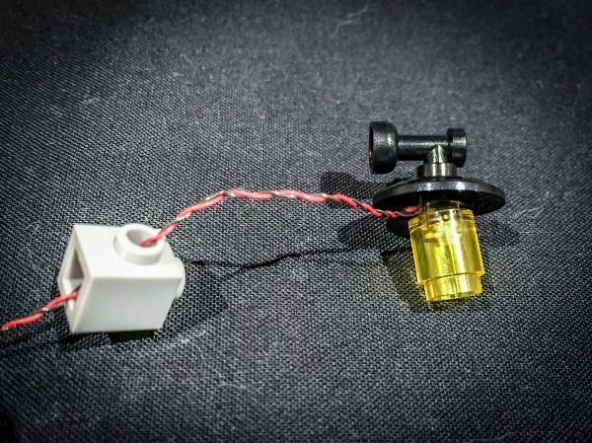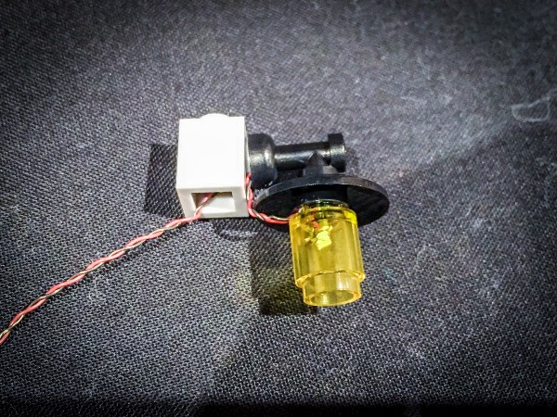

44.) Reconnect the lamp section back to its original position and then thread the cable from the lamp down the staircase section as we will need to connect this to the 6-port expansion board on level 2.
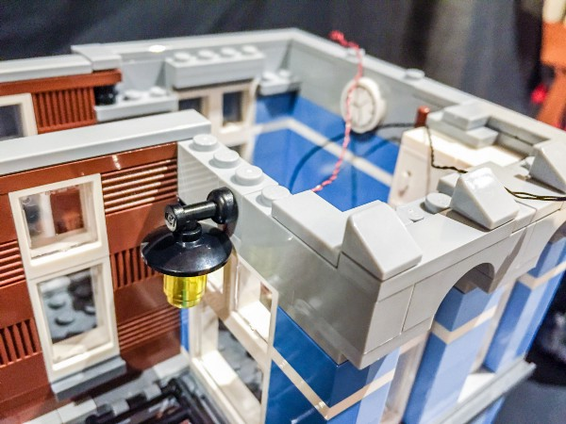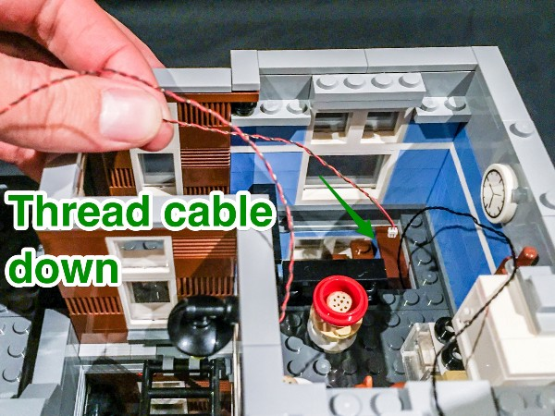

45.) Lift and flip over the entire 3rd level on it’s side so that we can pull the cable from the lamp down from the spacing and then connect this to a spare port on the 6-port expansion board.
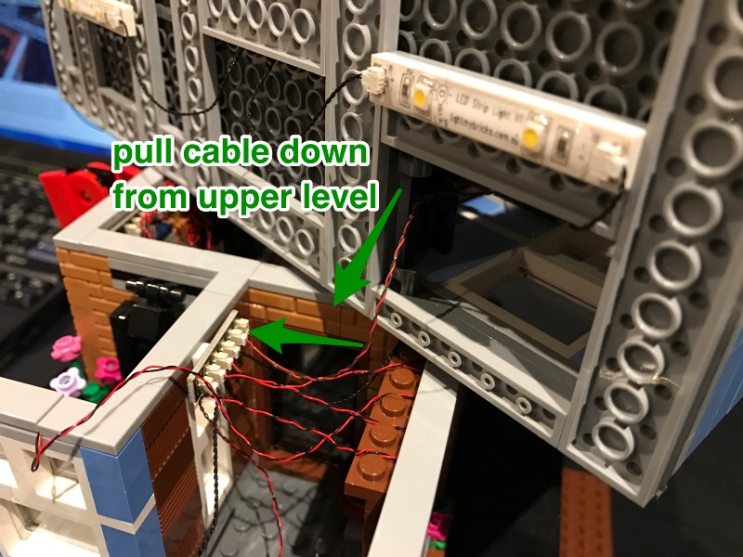

46.) Reconnect the 3rd floor on top of the 2nd floor and then lay any excess cable underneath the tiles on the roof. Ensure that you give the cabling enough slack so we are still able to comfortably lift up the 3rd level section if we ever need to.
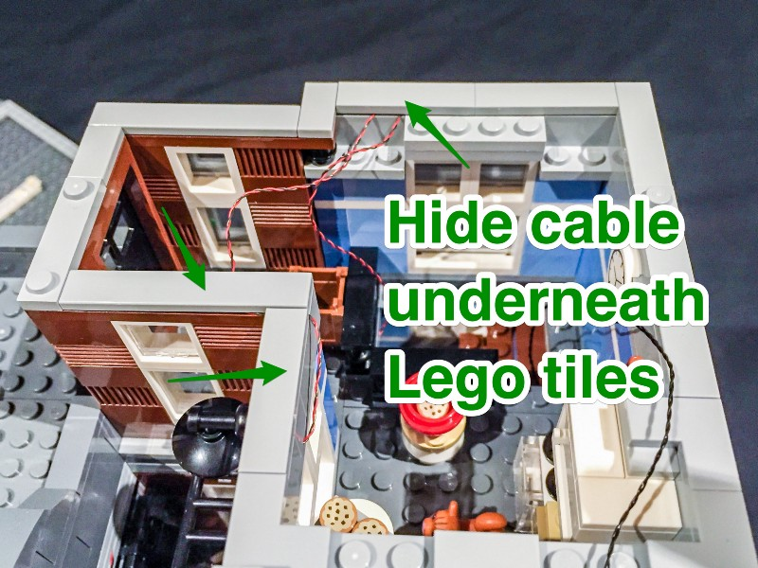

47.) Take the roof section of this building and flip it on its side. Stick/connect the final strip light (striplight#6) in the following position and then connect to it the 15cm cable that we pulled up from the lower level (striplight#5) .
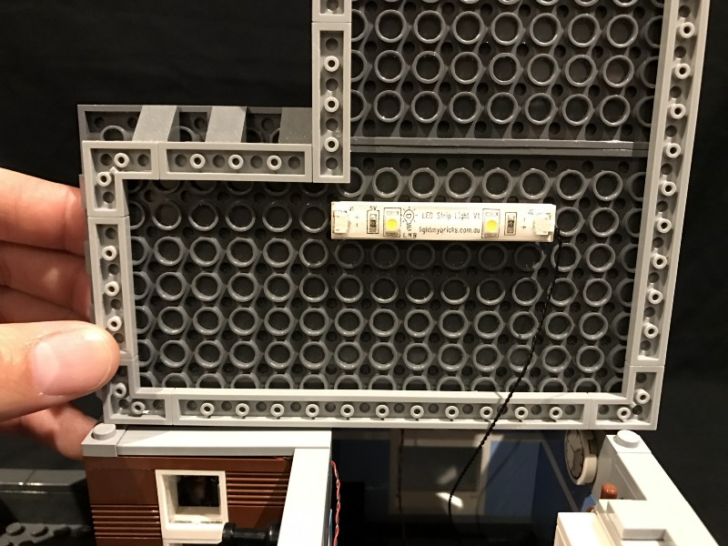

48.) Take the AA Battery pack and insert the attached cable into the left port of striplight#5.
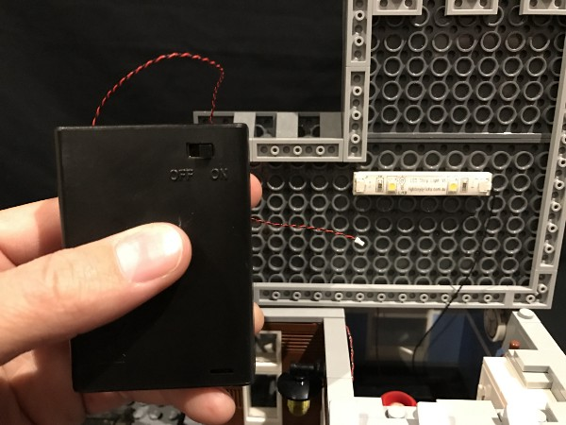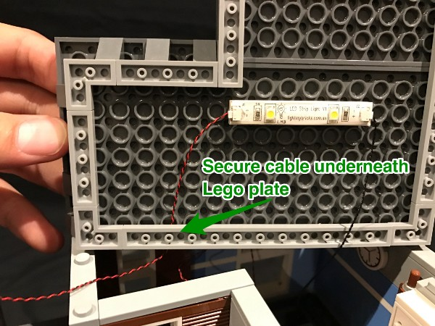
Reconnect the roof back to it’s original position and place the battery pack on the roof top in the following position.
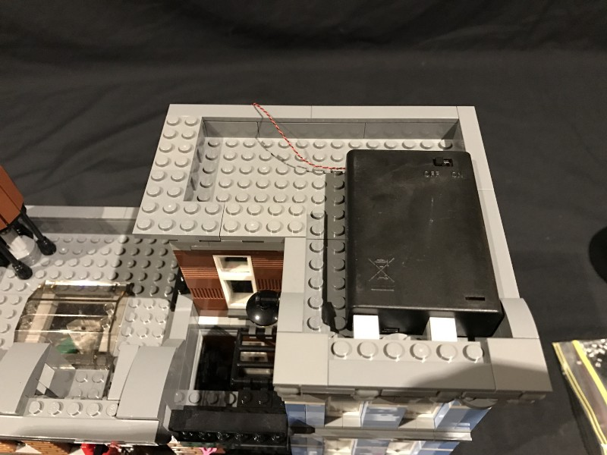

49.) Turn the building around to the back and hide/secure the battery cable underneath the following bricks.
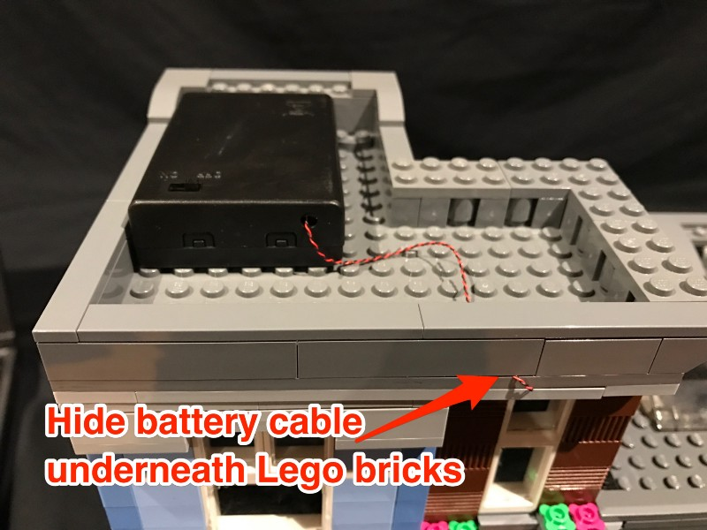

This finally completes the LED lighting circuit. Your kit is now ready to be turned “ON”.
Now turn off your lights, turn on the lighting kit, and enjoy!

