Package contents：

8 X 15cm Multi Colour Flashing Lights
4 X 30cm Multi Colour Flashing Lights
1 X 12-port Expansion Boards
1 X 6-port Expansion Boards
6 X Warm White Strip Lights
6 X 5cm Connecting Cables
1 X 15cm Connecting Cable
1 X AA Battery Pack

Note:
Place wires on the surface or under the building blocks.
The wire can be place between the building blocks or under the block, but they should be placed between the studs correctly.
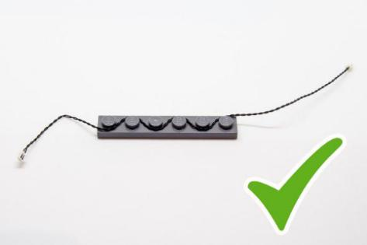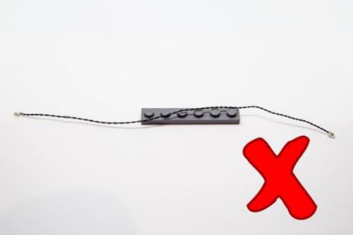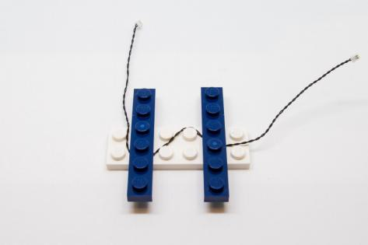
Insert the connectors to the ports.
Be careful when you are operating, there’s only one correct way to insert, make sure the expansion board is upward, find the soldered “=” sign on the left of the port. When you are inserting, the side which the wires can be seen should be faced to the “=” sign and if you feel hard to insert, please stop, and don’t force it, for that may result in bent pins inside the port or overheating of the expansion board.
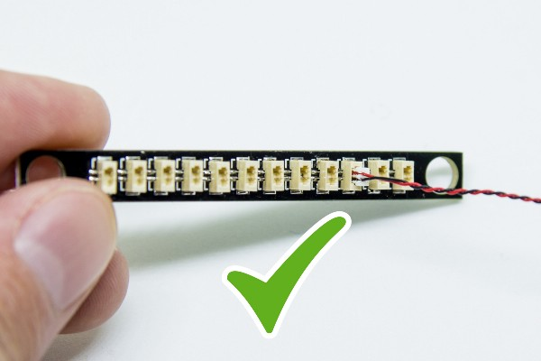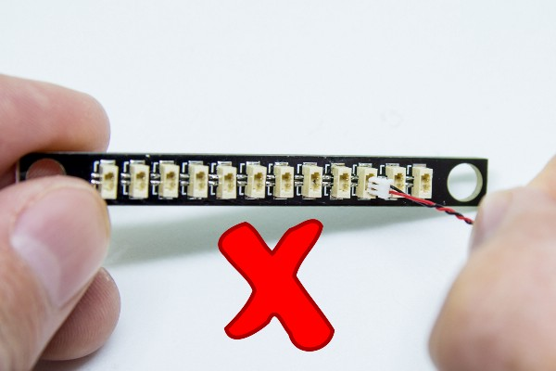
When installing bit lights, make sure they are correctly placed (Yellow LED package is exposed). You can put they either on the top of the studs or between studs.
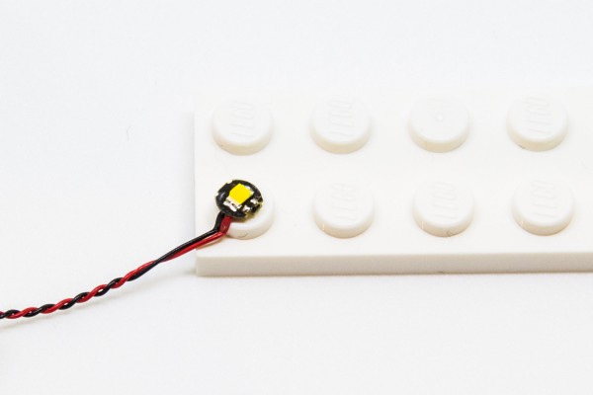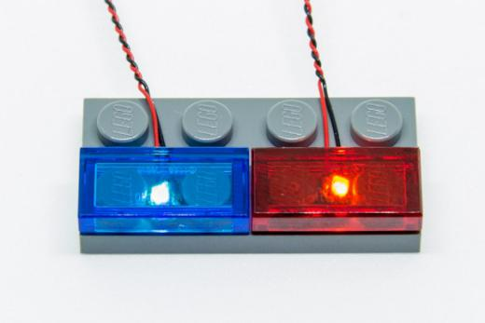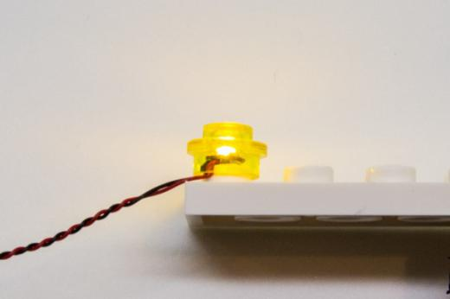

OK, Let’s Begin!
Instructions for installing this kit
1.）Install all lights to the top of the merry-go-round. Remove the roof as per below
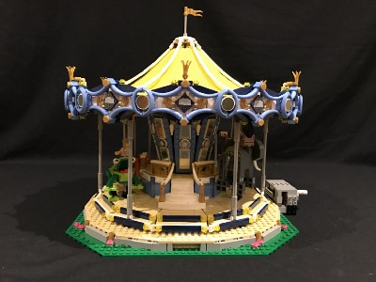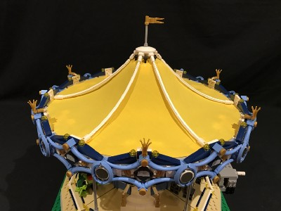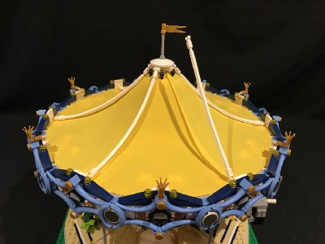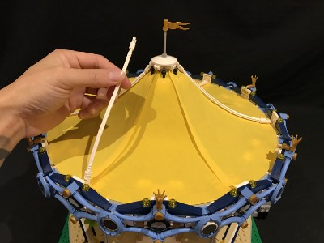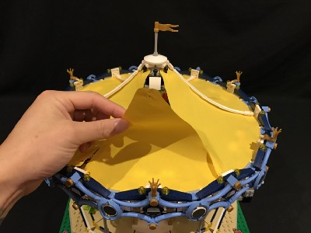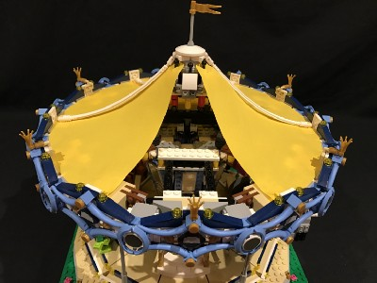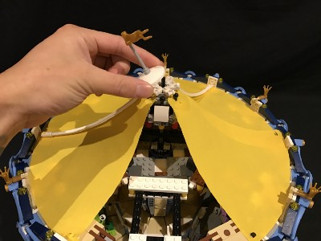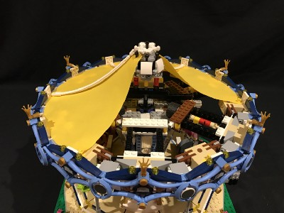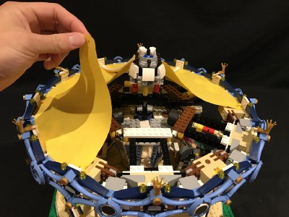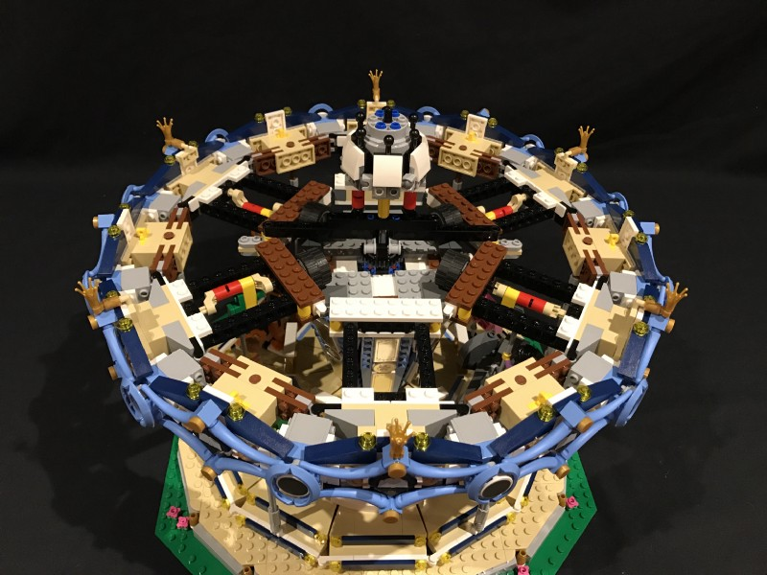
7.）Take a warm white strip light, stick it to a 1x6 plate from the kit, connect a 5cm connecting cable to its right port
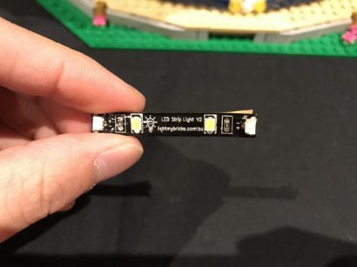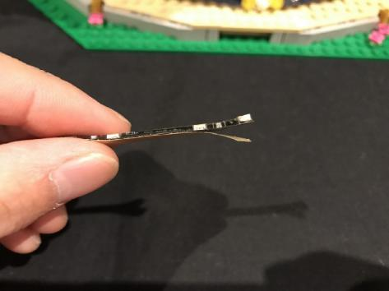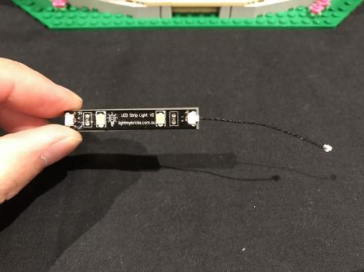
Connect the other side of the connecting cable to another warm white strip light
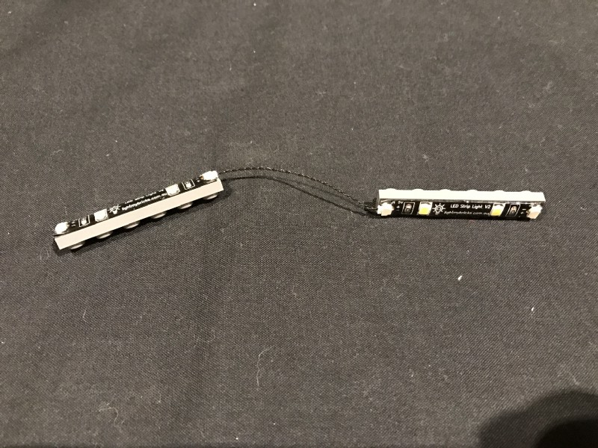
Assemble all 6 strip lights together by repeating the previous steps.
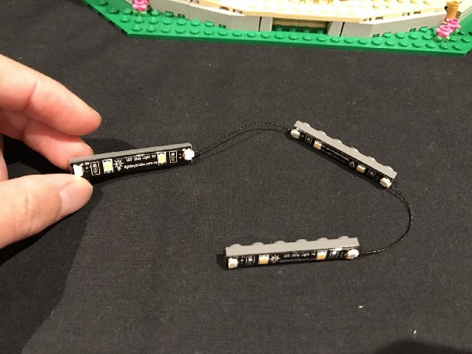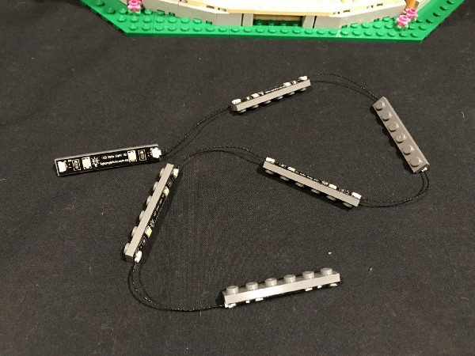
Take another 5cm connecting cable, connect it to the end of the white strip light
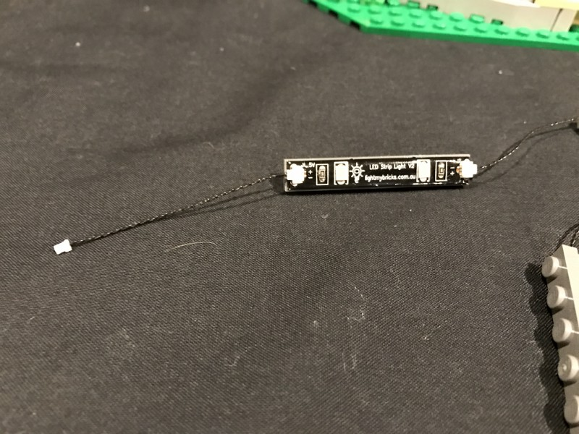
8.）Place all 6 strip lights to the top of the merry-go-round before connecting the other end of the 5cm connecting cable to the 12-port expansion board
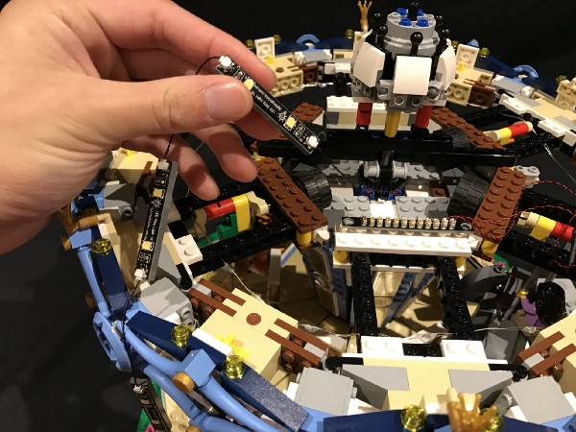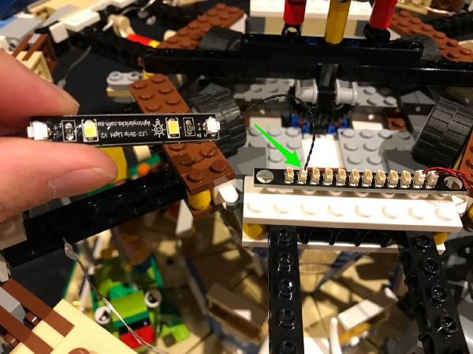
Thread the strip lights through the following gaps
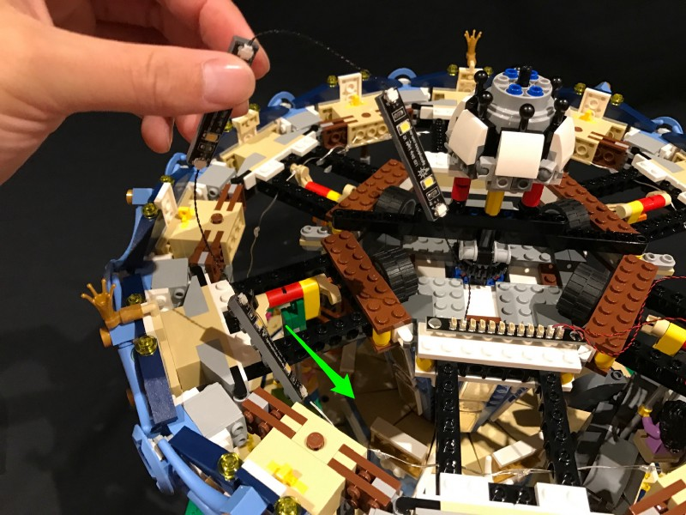
9.）connect the first strip light to the following position
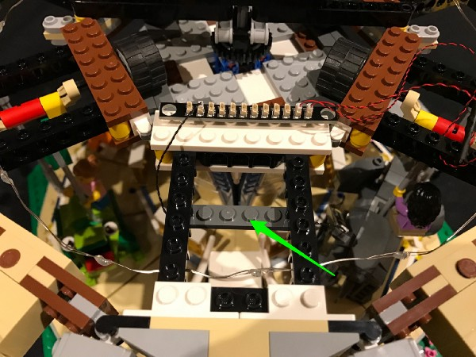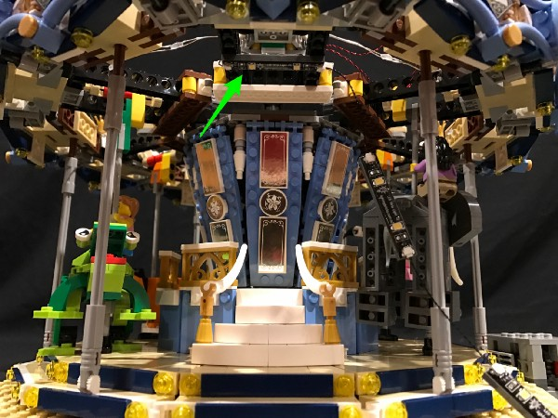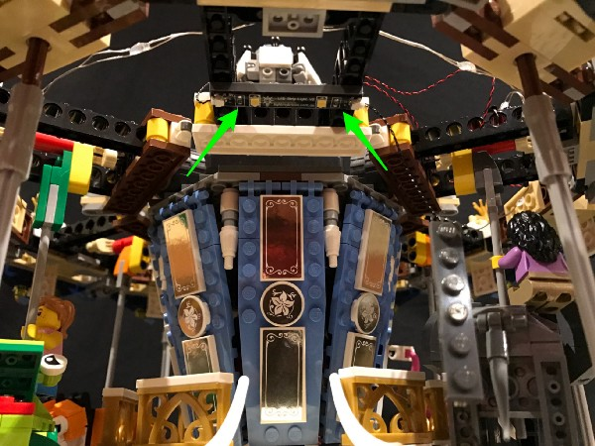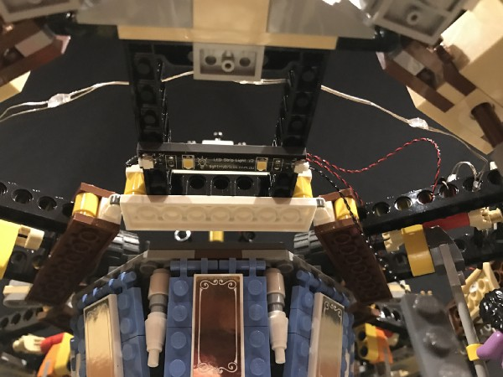
Connect the second strip light to the place at the lower right.
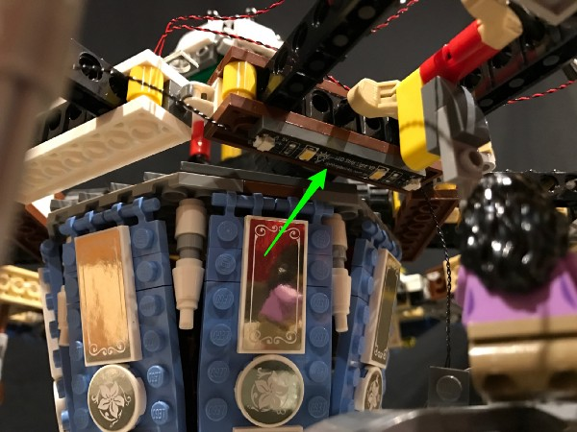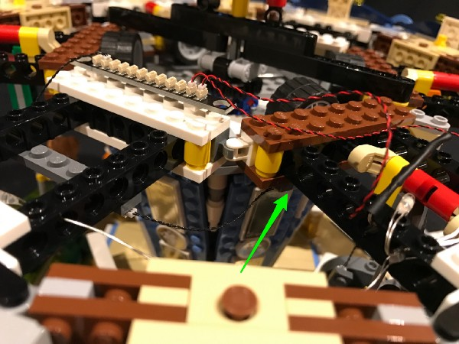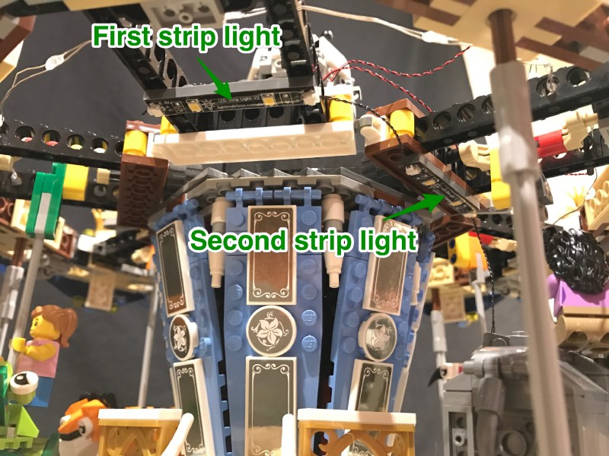
Make sure you place the strip lights to the correct places on the picture
Continue to install the other 4 strip lights as per below 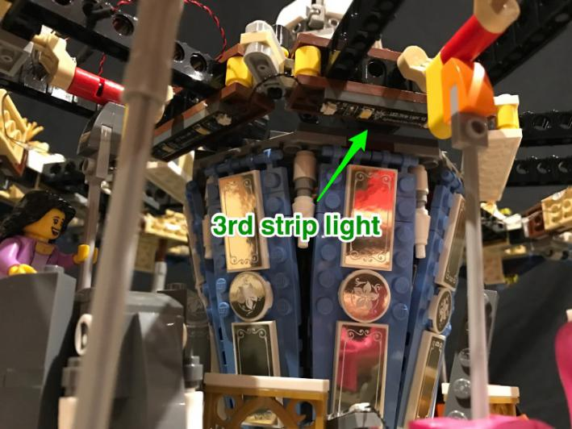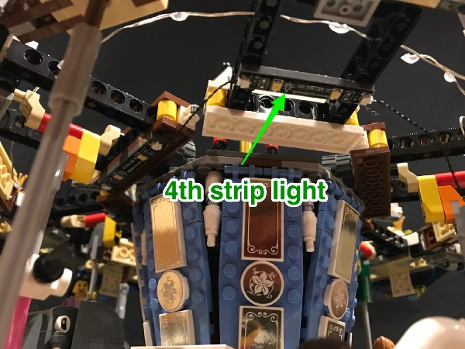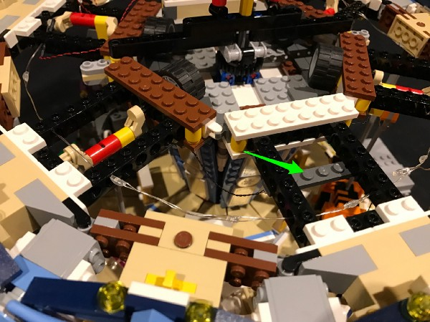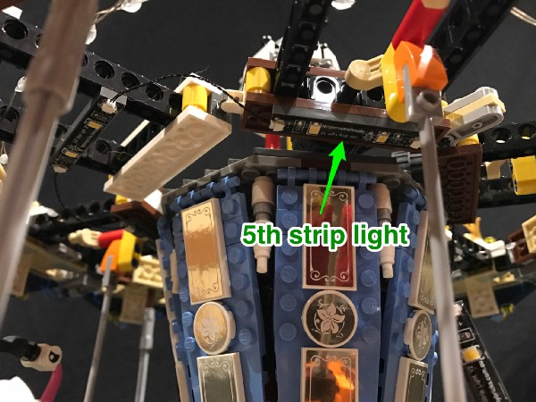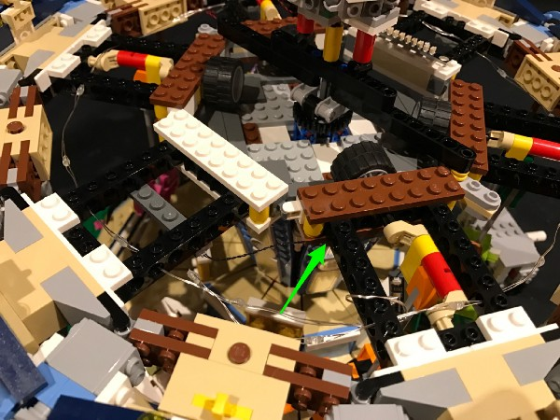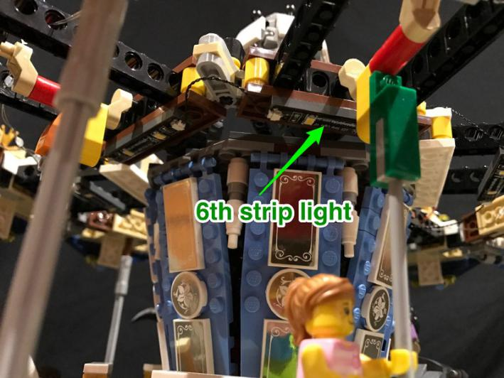
After finishing installing all 6 strip lights, connect the cable of the battery pack to the expansion board, then turn on the power to test if all the lights are working OK 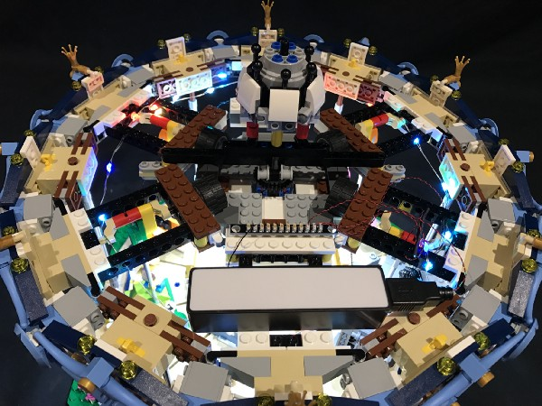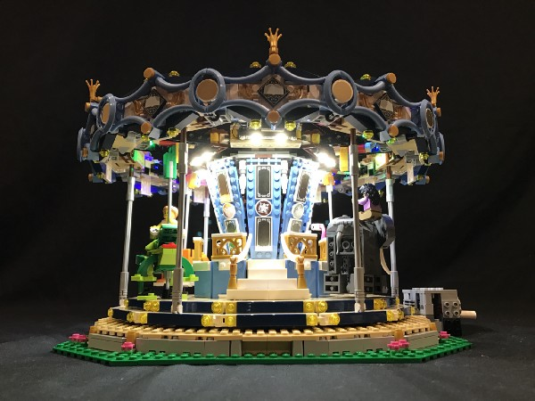
- ）we’ll move onto installing lights for the outside of the merry-go-round. Remove the following pieces
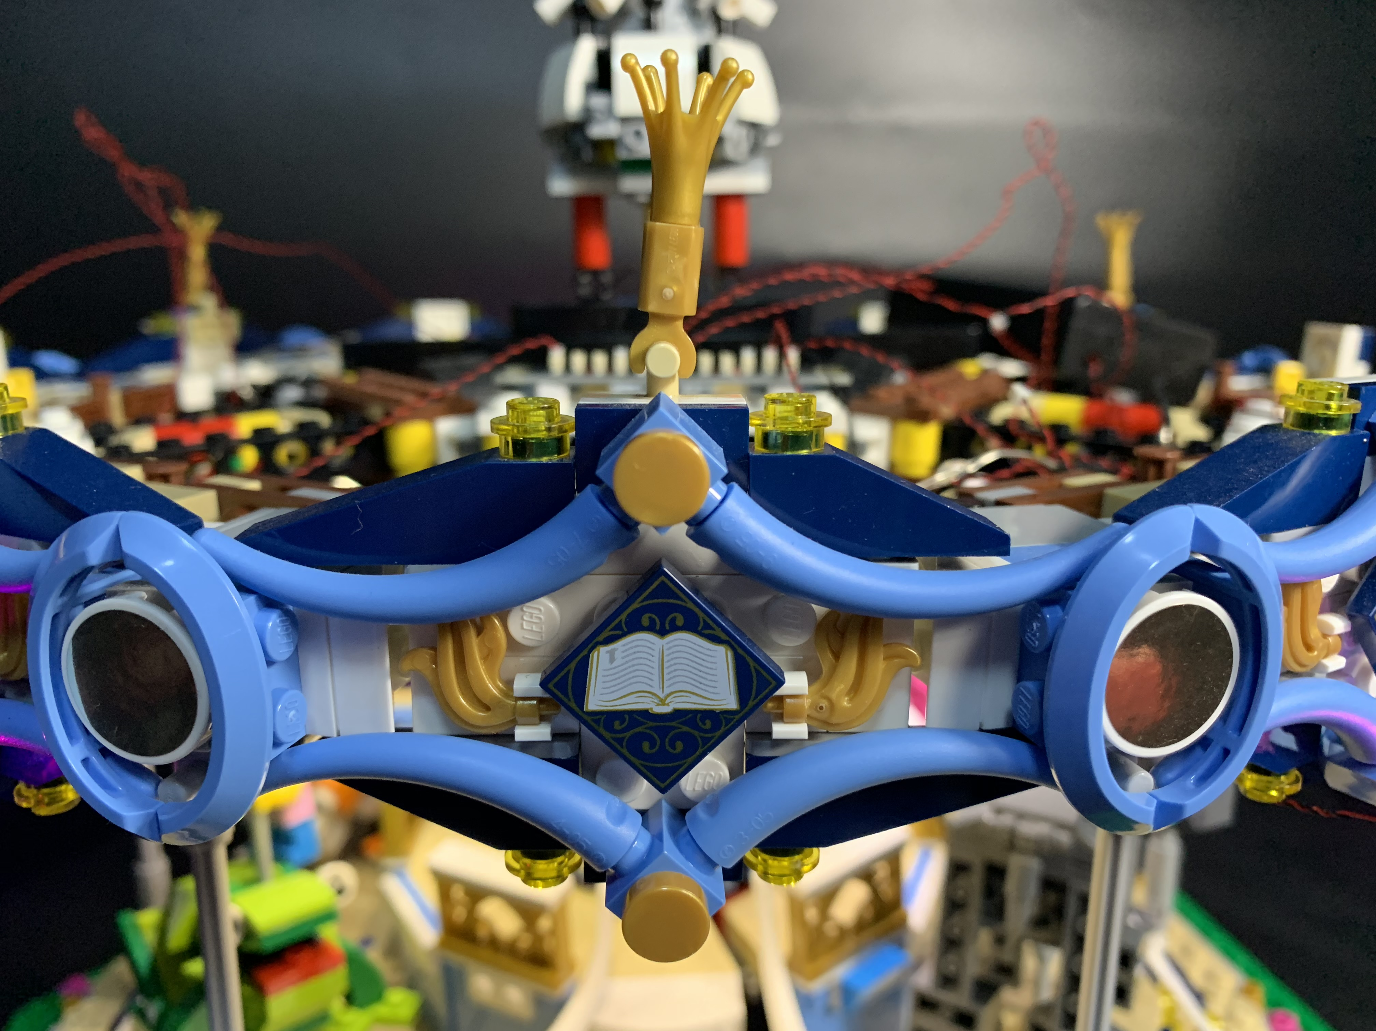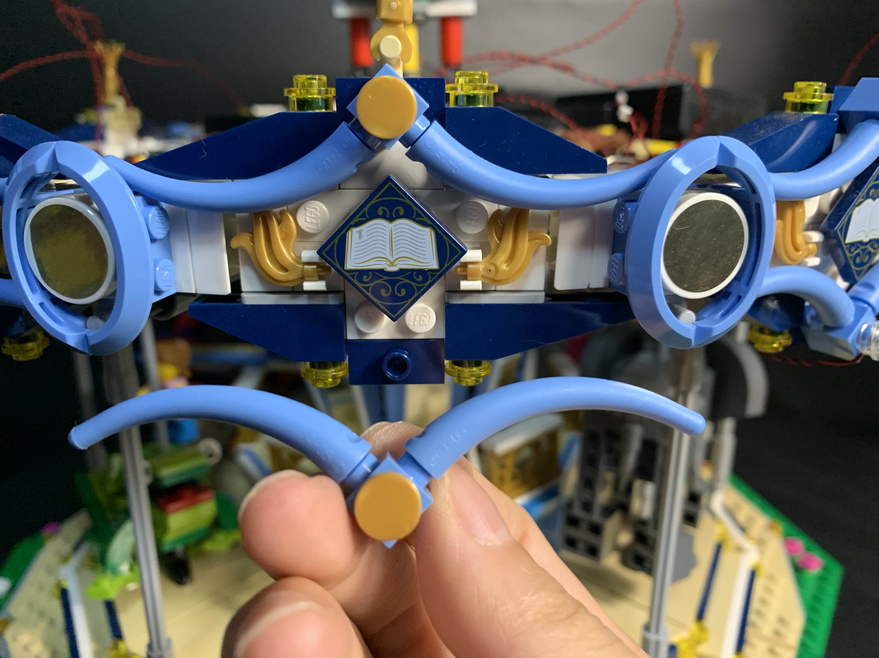
Take a 15cm Multi Colour Flashing Light, a trans 1x1 round plate
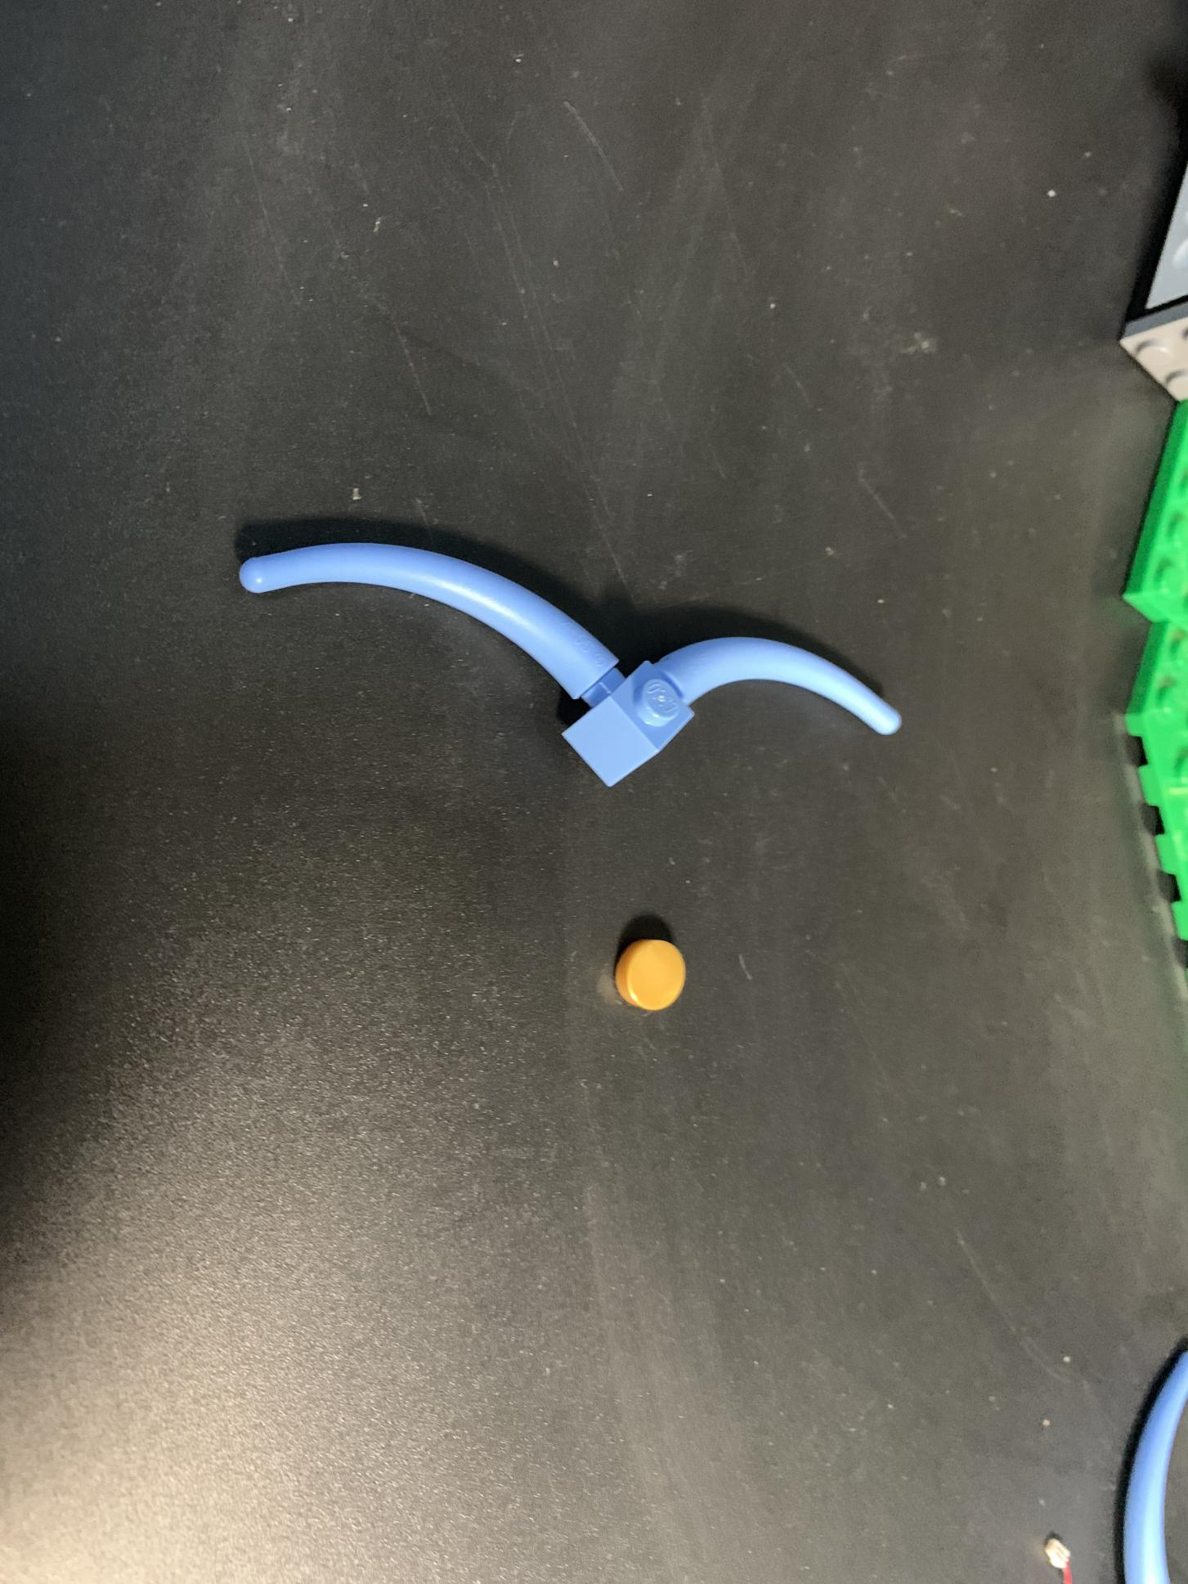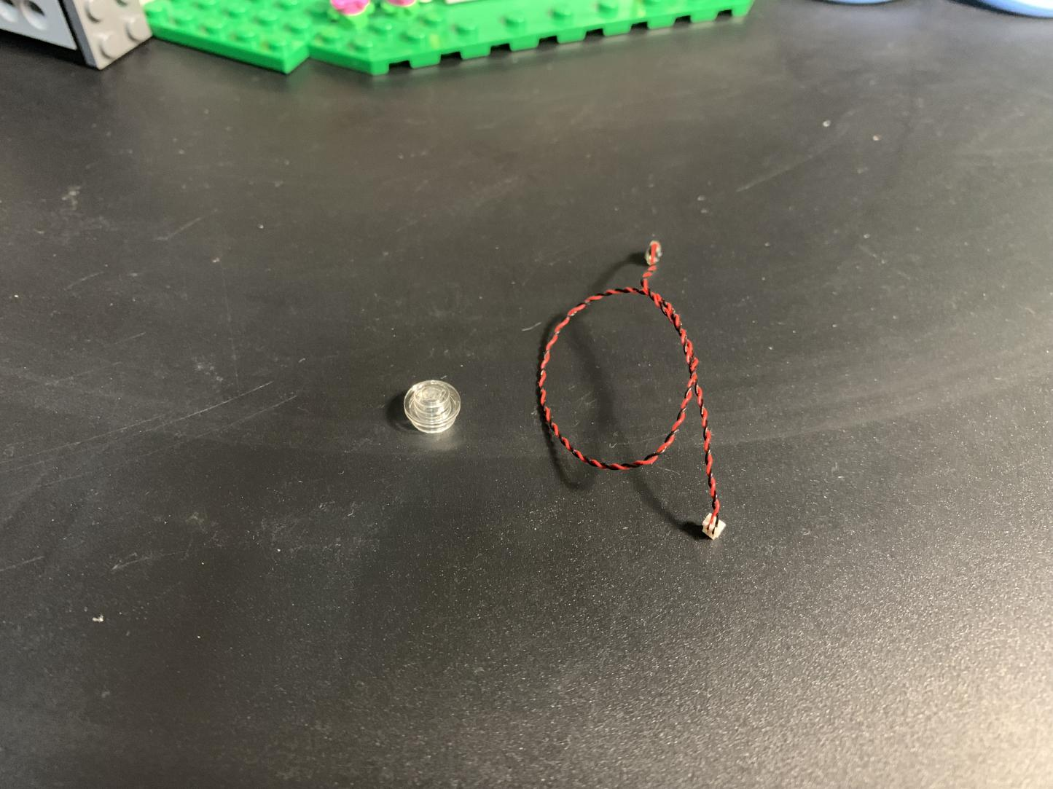
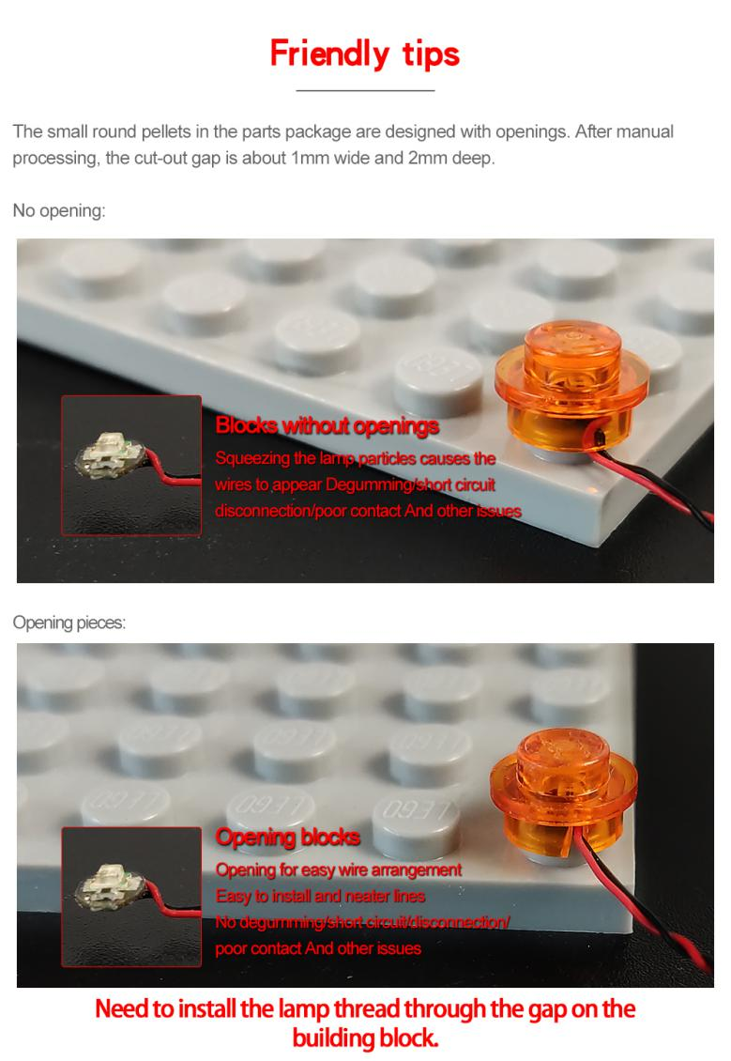
With lighting part facing up，secure the light, leave the cable as per below
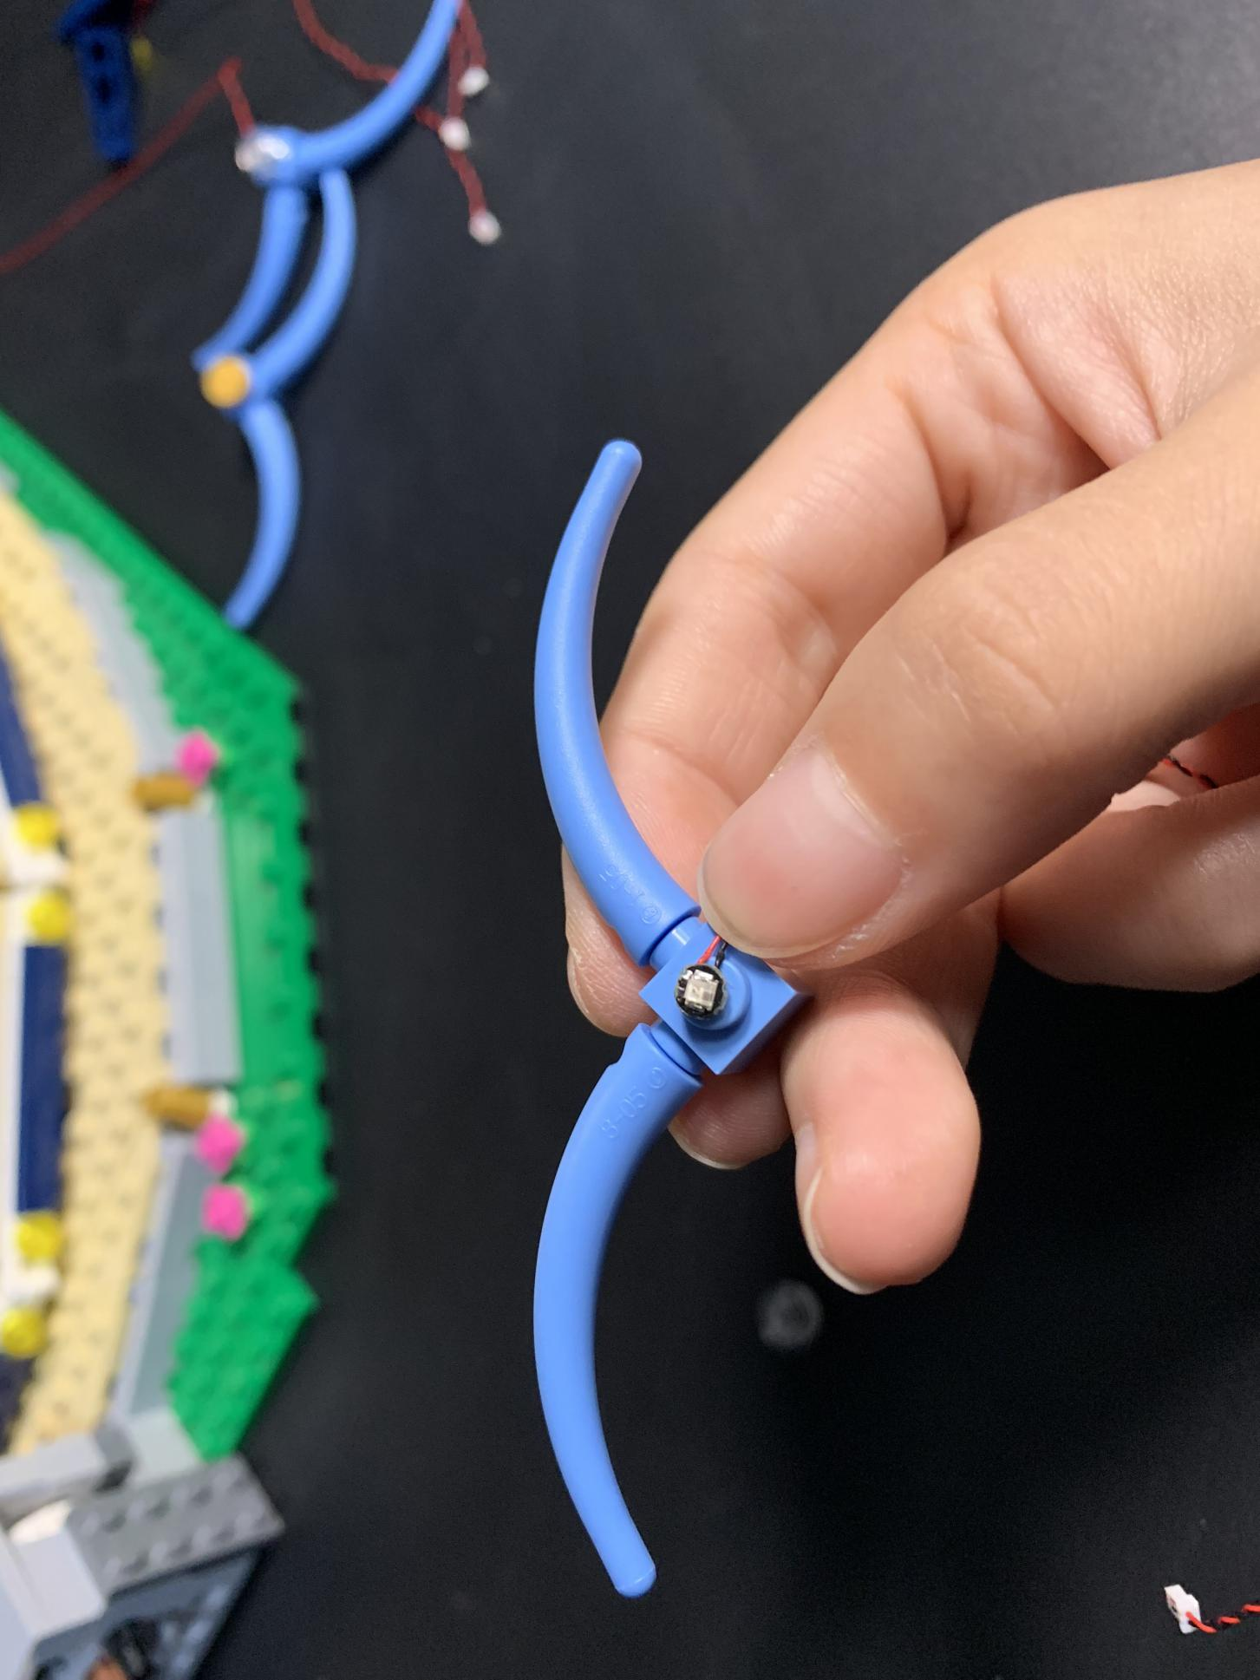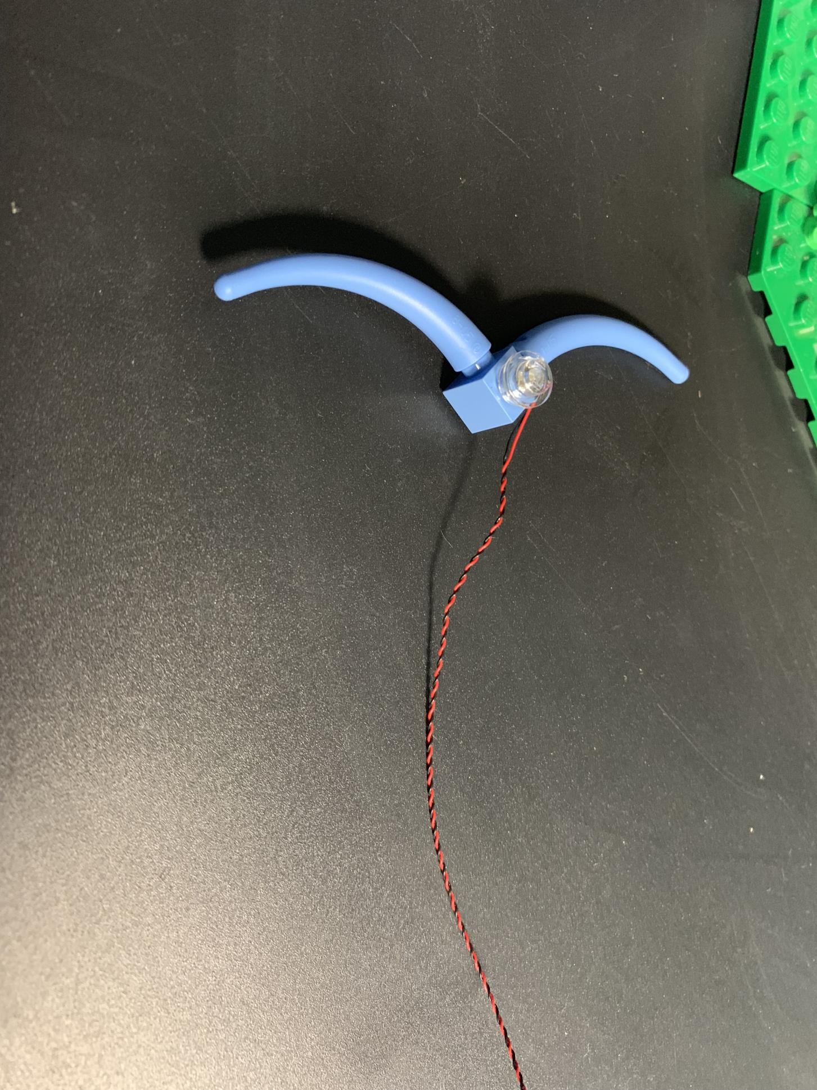
Reconnect the pieces back. Thread the cable up to the roof, connect it to the 12-port expansion board.
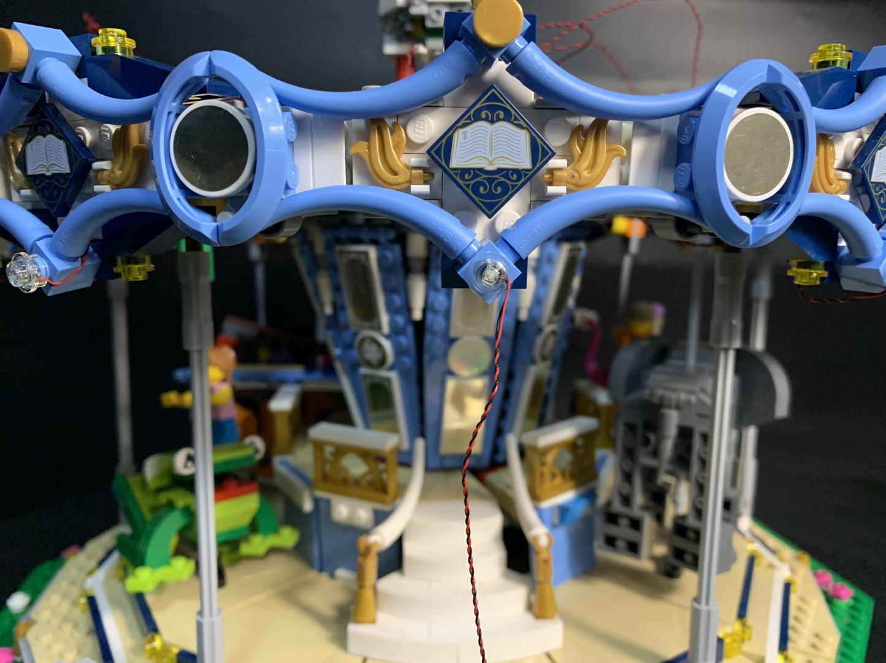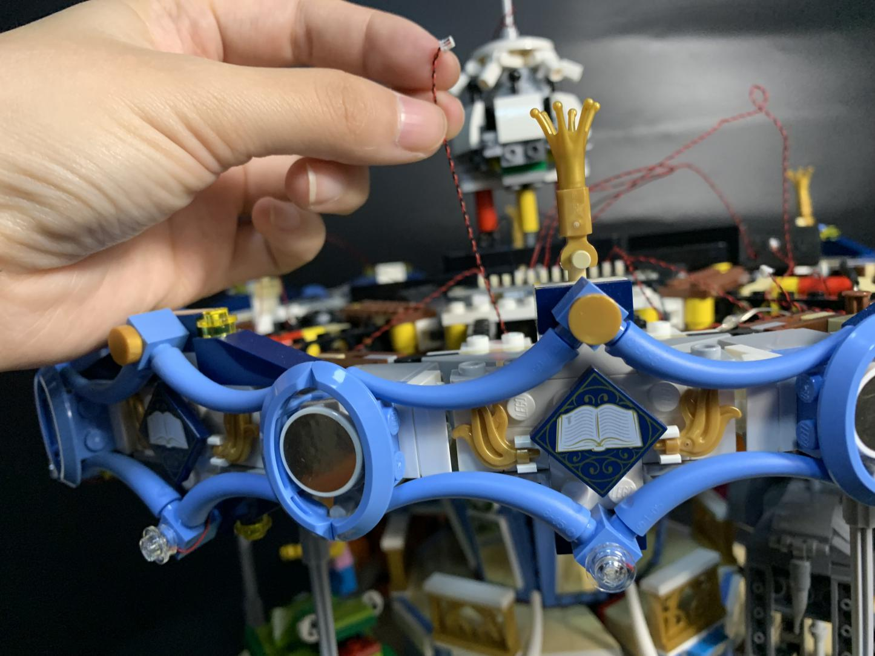
Similarly, take another 3 Multi Colour Flashing Lights, 3 trans 1x1 round plates，install them to the following pieces close to the 12-port expansion board
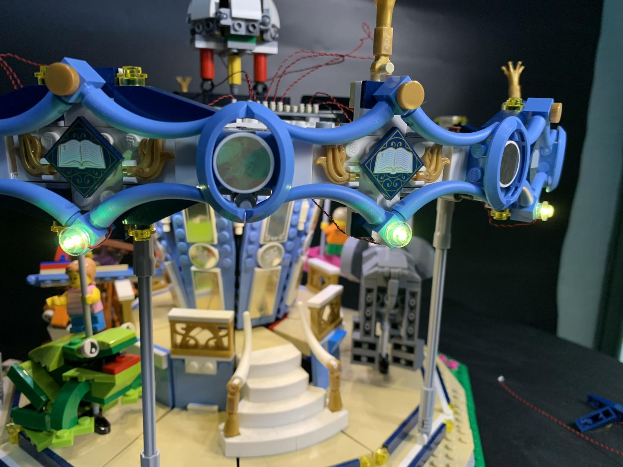
Take four 30cm Multi Colour Flashing Lights, 4 trans 1x1 round plates
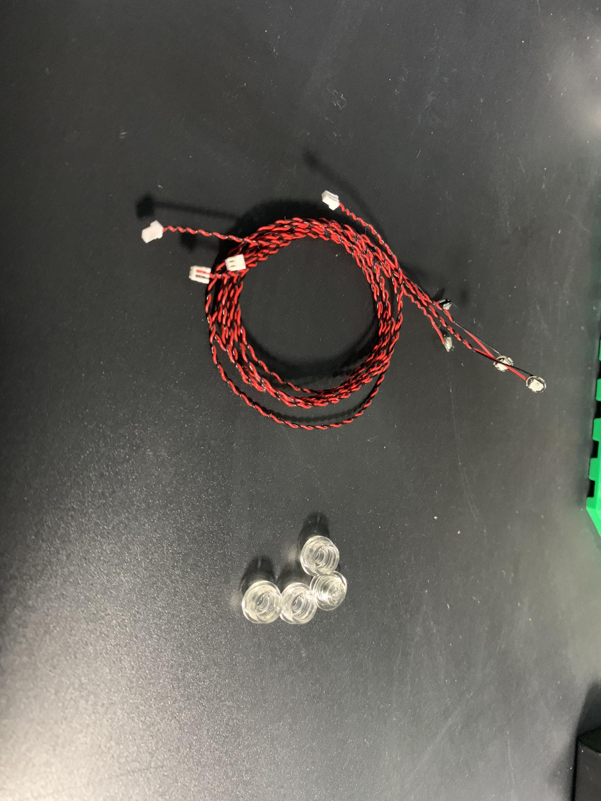
Continue to install them to the following pieces before connecting them to the 12-port expansion board. Group all cables into a larger one
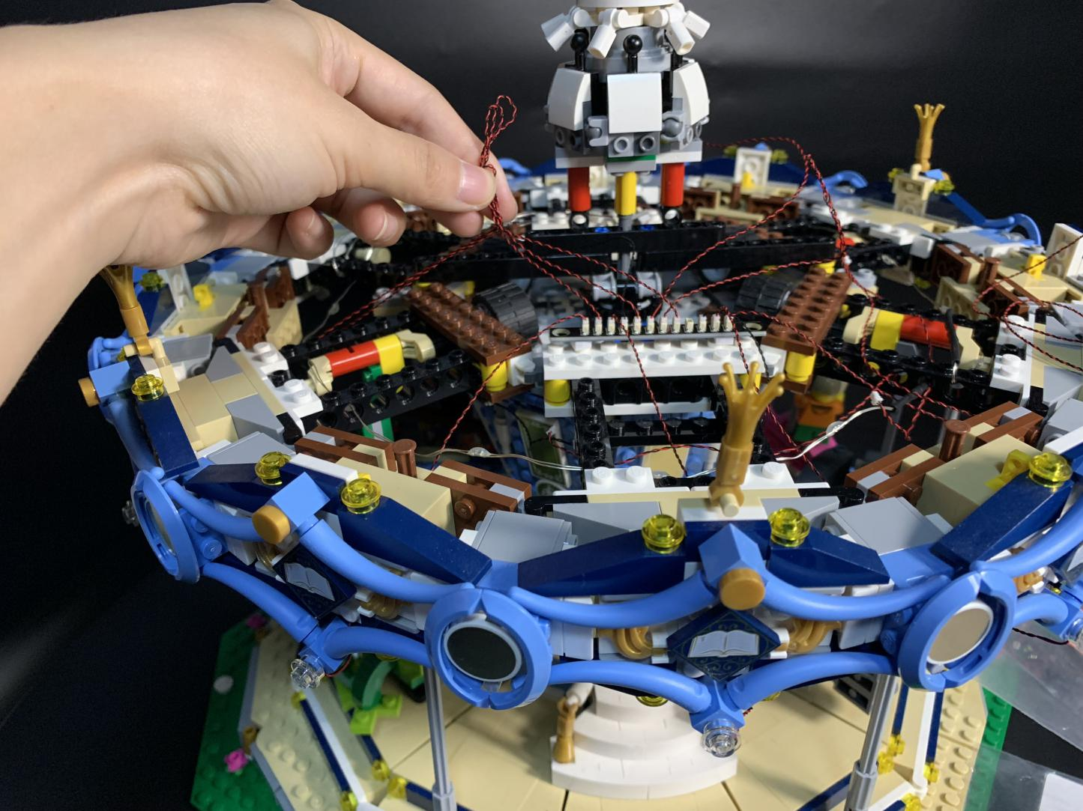
Take a 15cm connecting cable, a 6-port expansion board, assemble the 2 expansion boards together by using the connecting cable. Place the 6-port expansion board to the following place
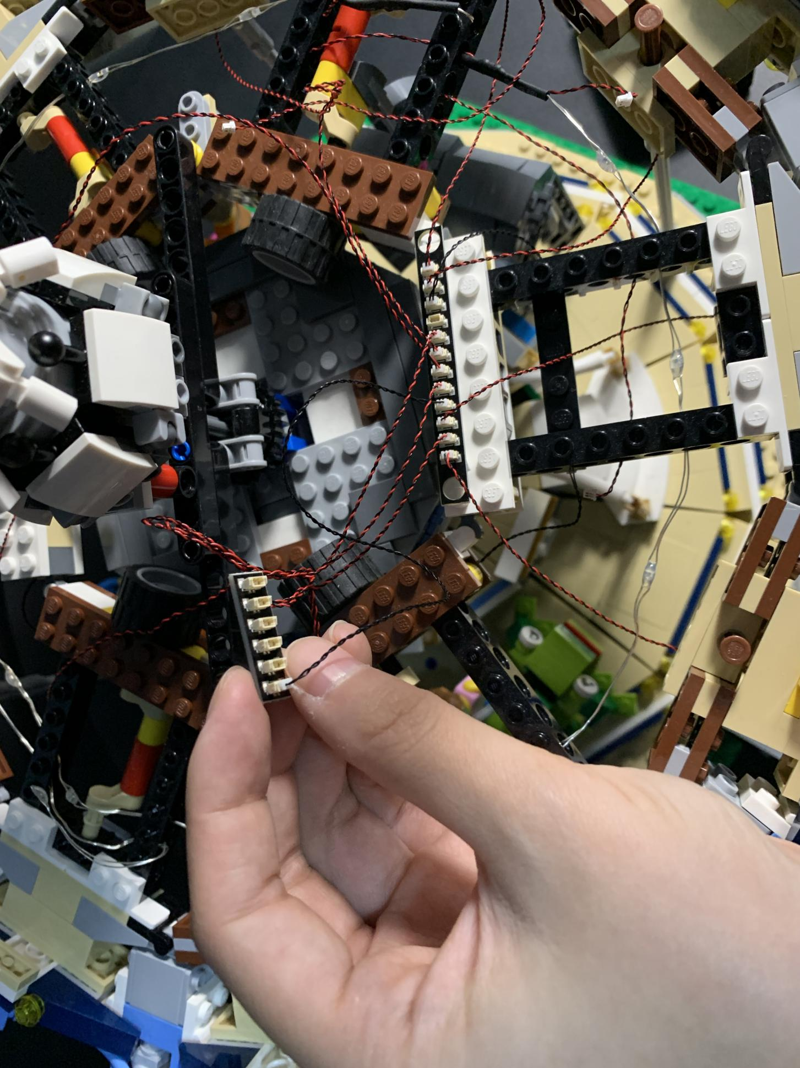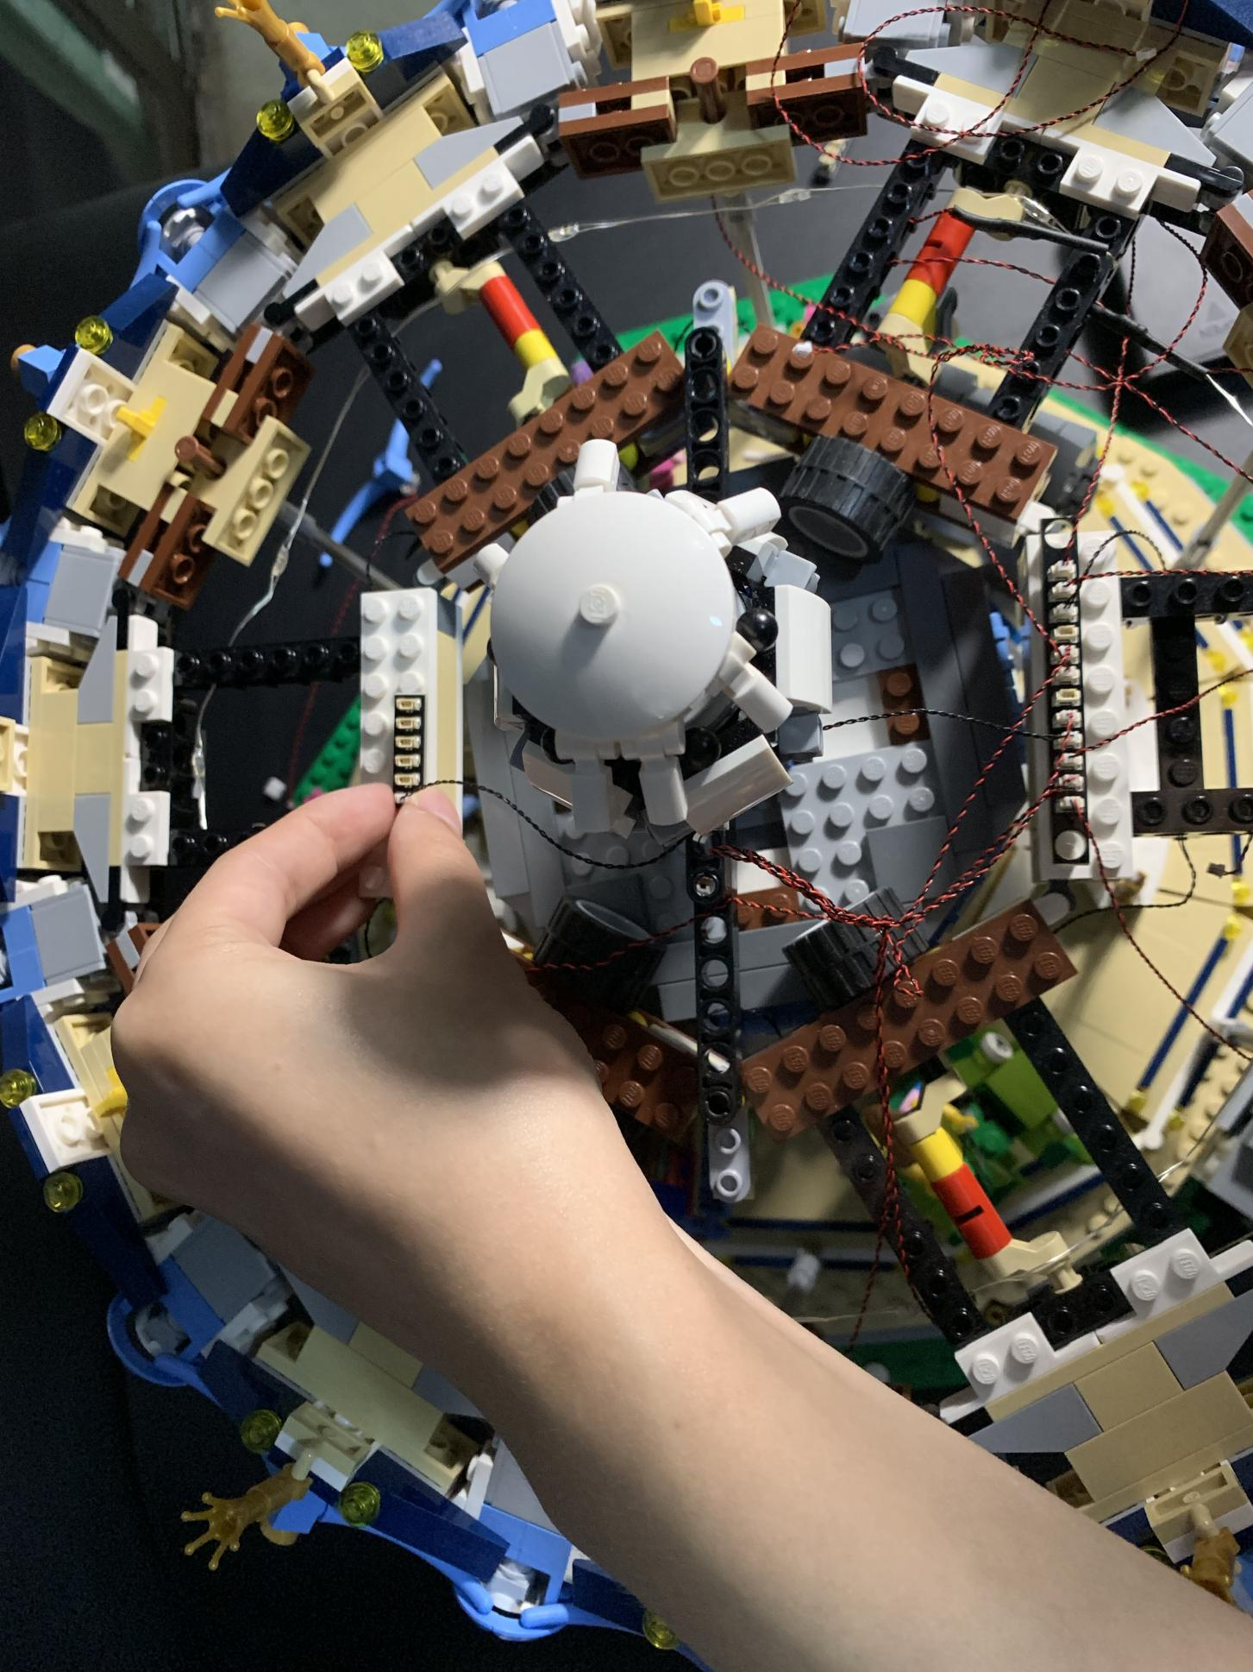
Take four 15cm Multi Colour Flashing Lights, 4 trans 1x1 round plates, install the lights to the following pieces
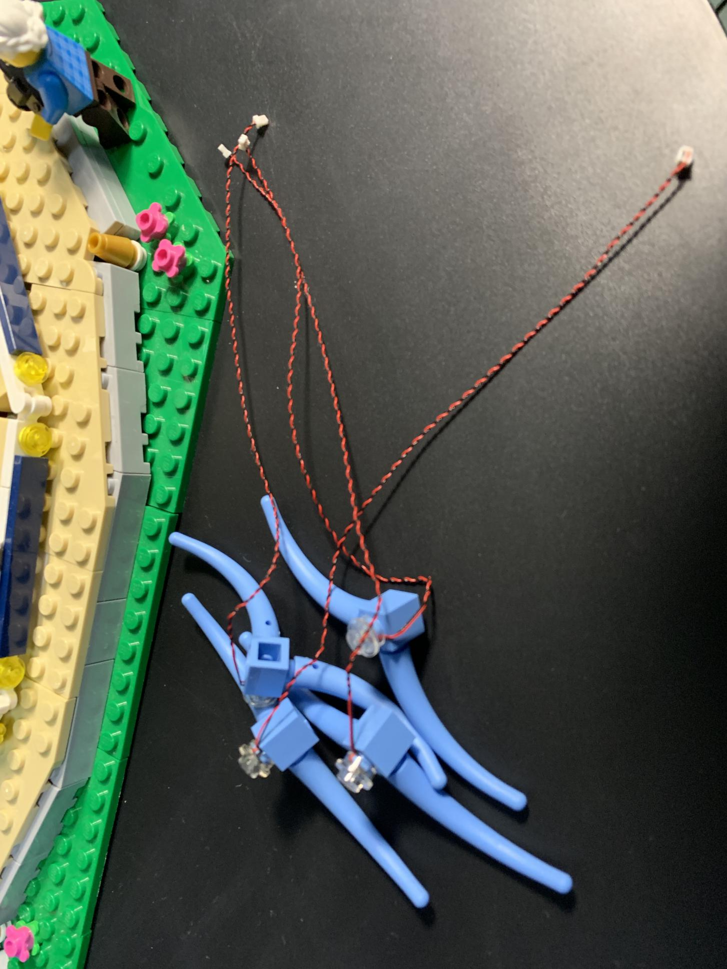
Thread the cables up, then connect them to the 6-port expansion board
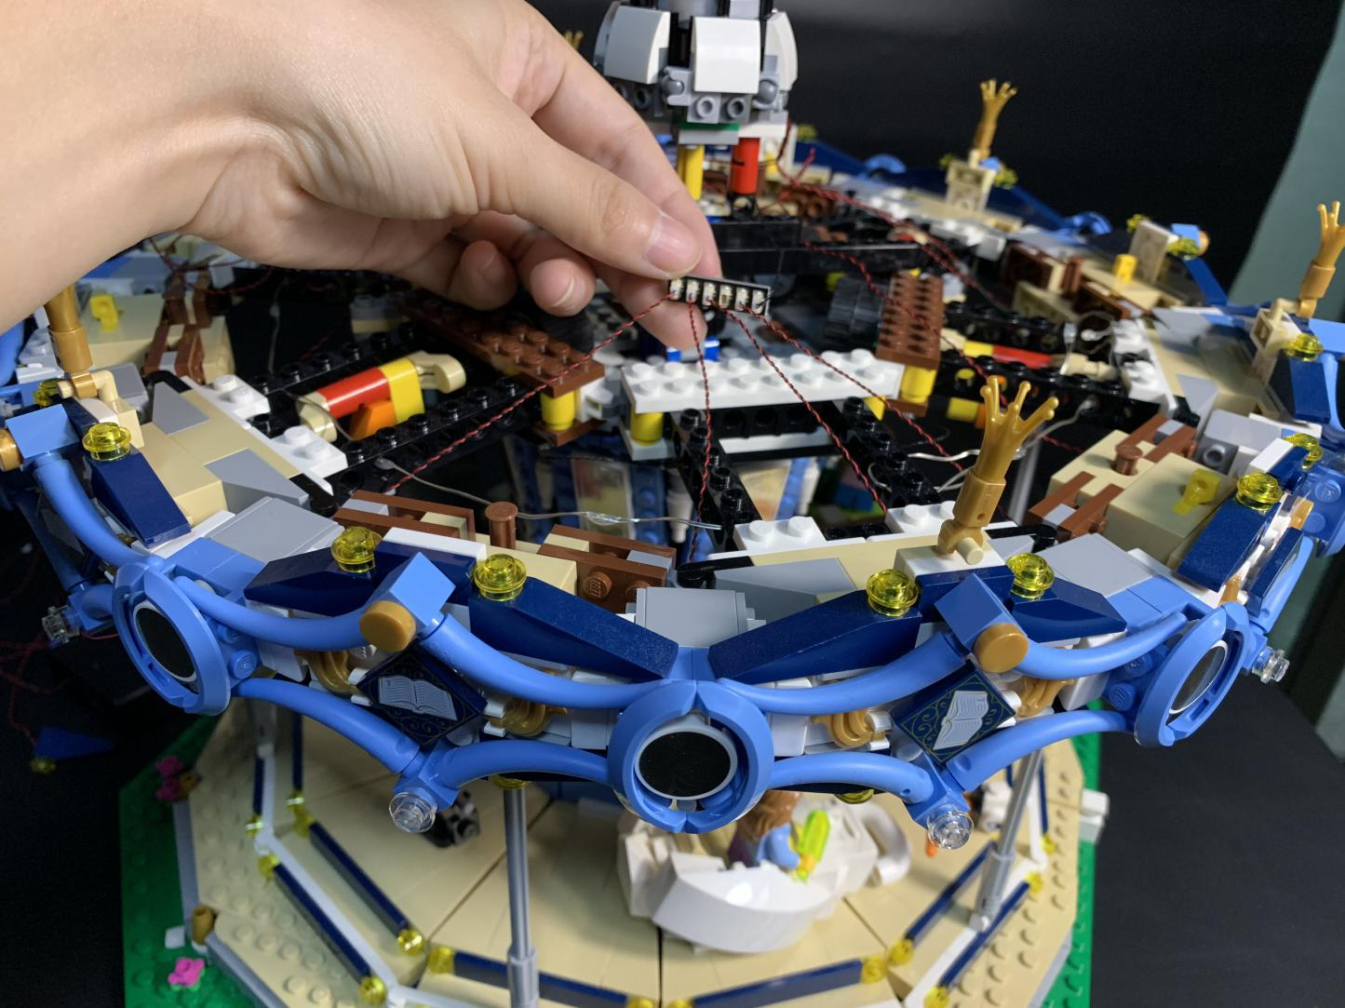
Now, you can turn the power on to verify the current
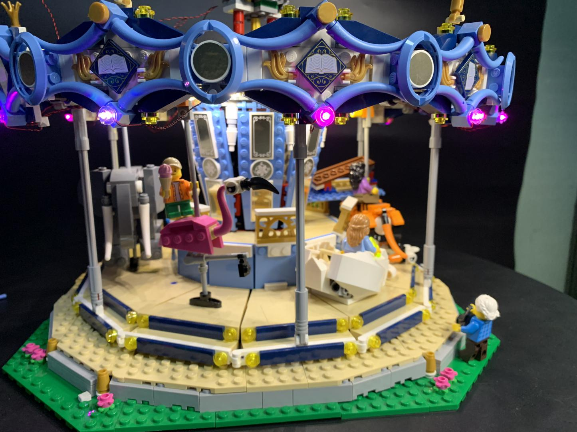
With switch facing down, place the battery pack to the top of the merry-go-round.
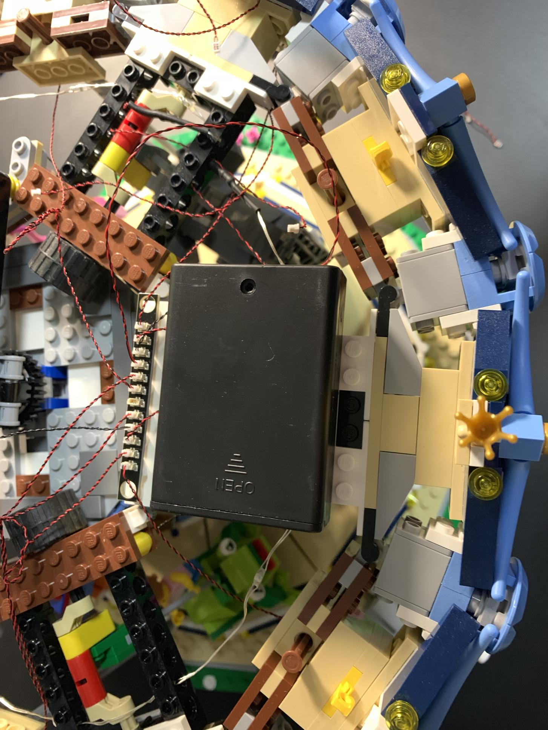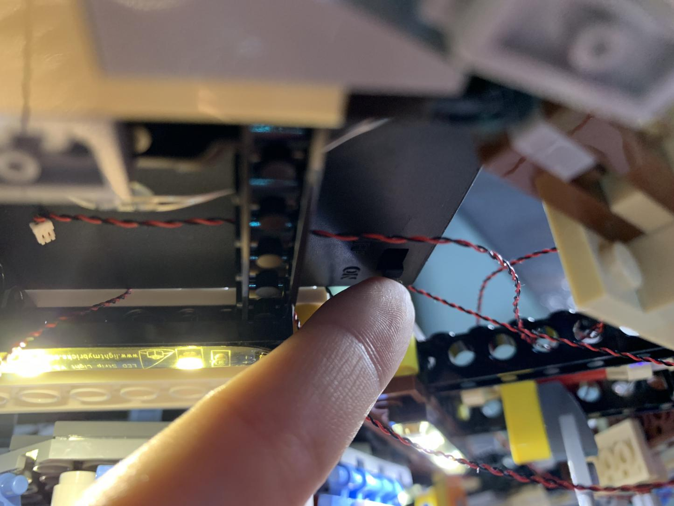
You can tuck excess cables by sticking them to the pieces
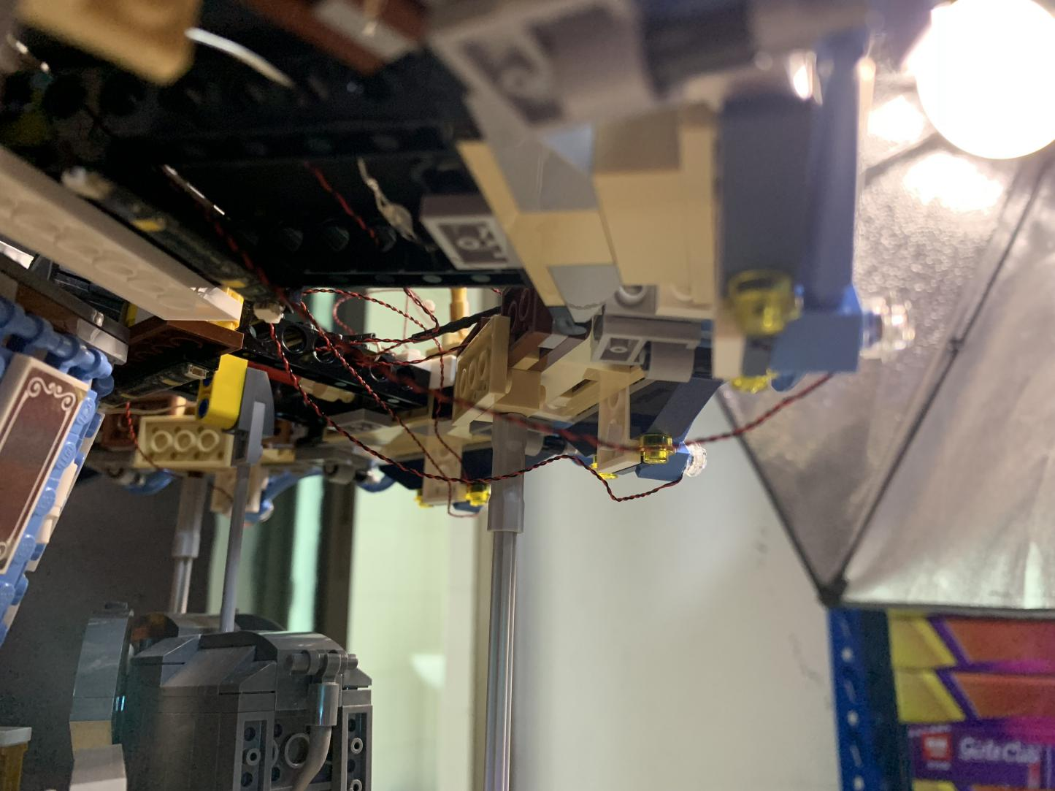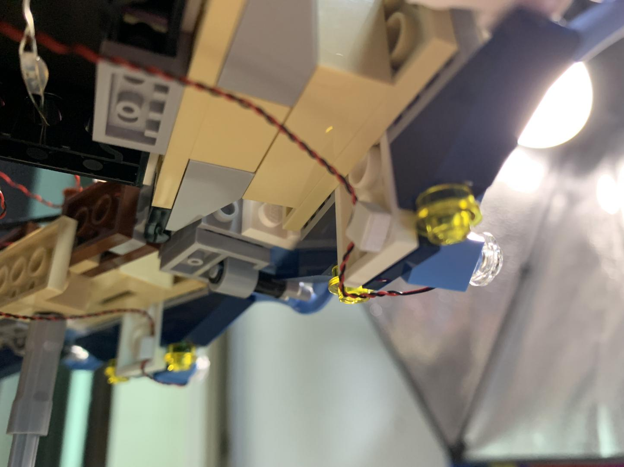
This completes installation of this LED Lighting Kit. ENJOY!
