# **AMBULANCE #4431**

# **Package contents:**

6x Flashing Warm White 15cm Dot Lights

10x Warm White 15cm Dot Lights

1x Multi Effects Board

1x 8-Port Expansion Board

3x 6-Port Expansion Boards

4x 5cm Connecting Cables

1x Flat Battery Pack (Requires 2x CR2032)

**Plate Pieces**

1x White Plate 1x6

**Note:**

**Place wires on the surface or under the building blocks.**

**The wire can be place between the building blocks or under the block, but they should be placed between the studs correctly.**

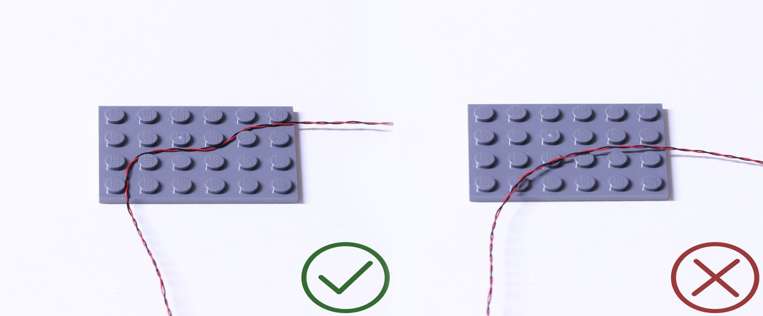

**Insert the connectors to the ports.**

**Be careful when you are operating, there’s only one correct way to insert, make sure the expansion board is upward, find the soldered “=” sign on the left of the port. When you are inserting, the side which the wires can be seen should be faced to the “=” sign and if you feel hard to insert, please stop, and don’t force it, for that may result in bent pins inside the port or overheating of the expansion board.**

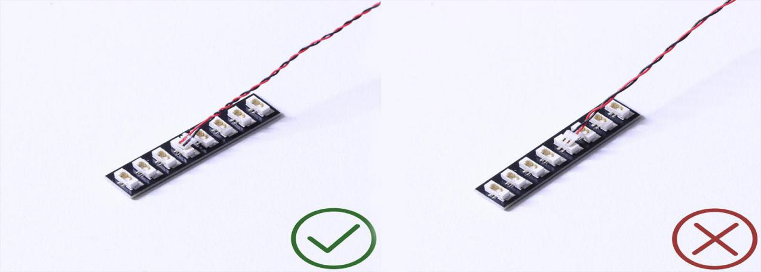

**At this point, use the tweezers to straighten the bent pins.**

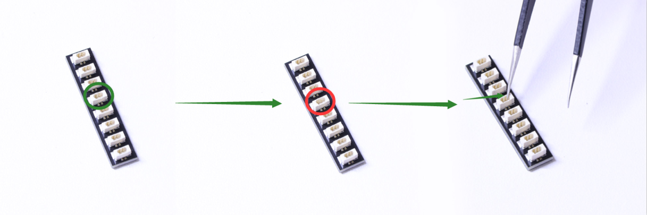

**When installing dot lights, make sure they are correctly placed (Yellow LED package is exposed). You can put they either on the top of the studs or between studs.**

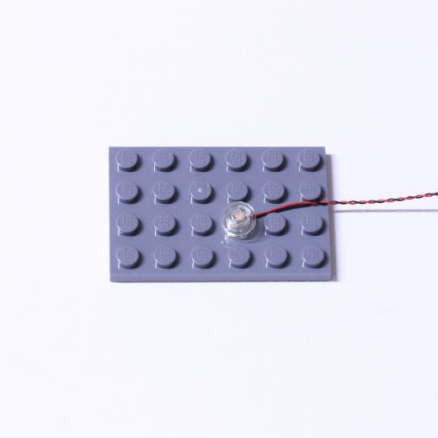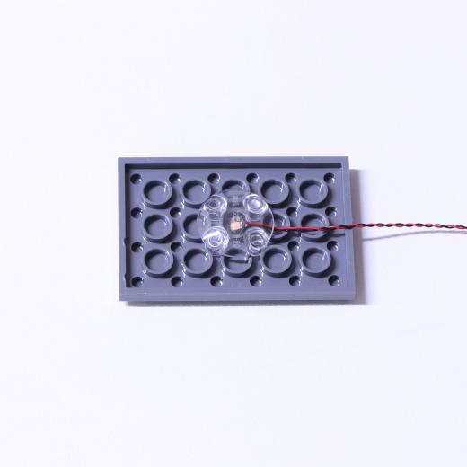

**Connecting cable connectors to Strip Lights**

**Take extra care when inserting connectors to ports on the Strip Lights. Connectors can be inserted only one way. With the Strip Light facing up, ensure the side of the connector with the wires exposed is facing down. If a plug won’t fit easily into a port connector, don’t force it. Doing so will damage the plug and the connector.**

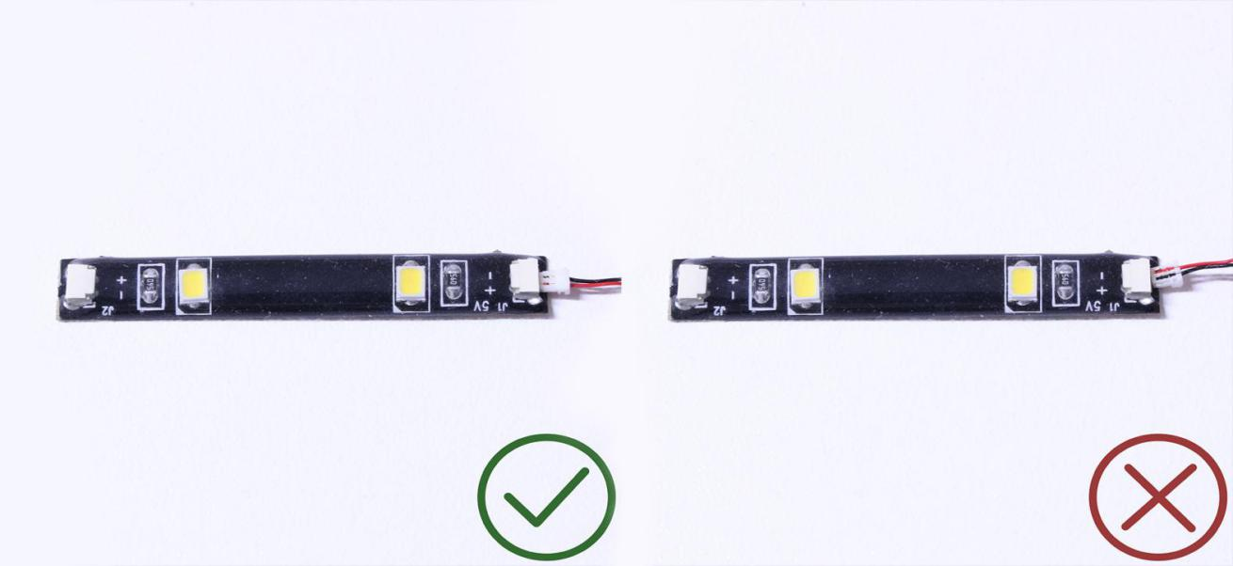

**Finally, please pay attention to the positive and negative terminals of the battery when installing the battery case.**

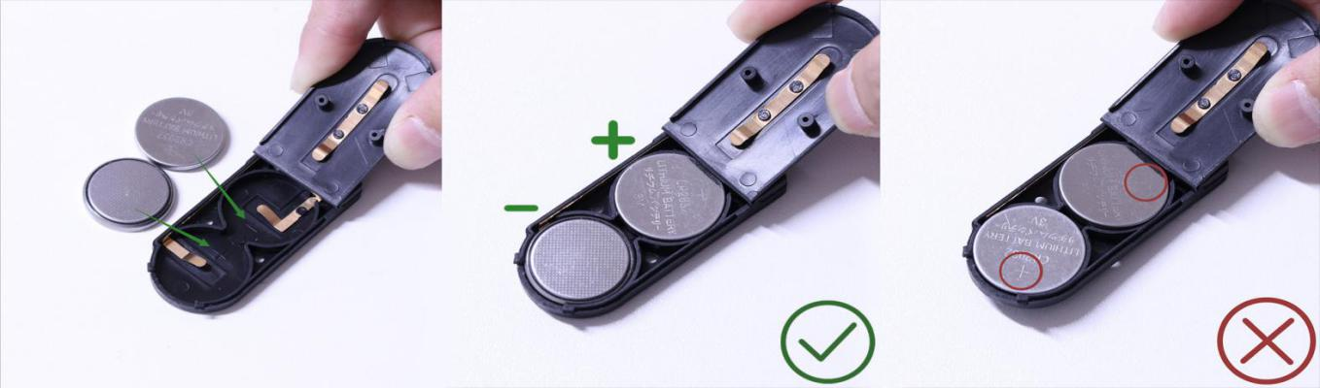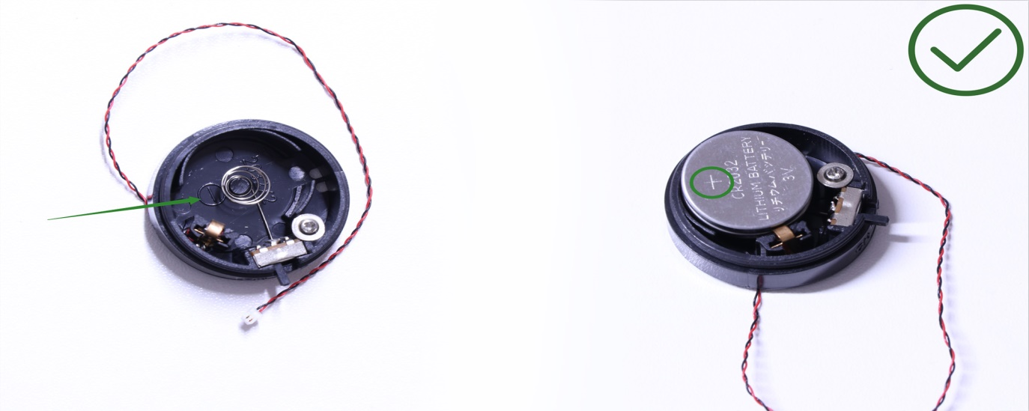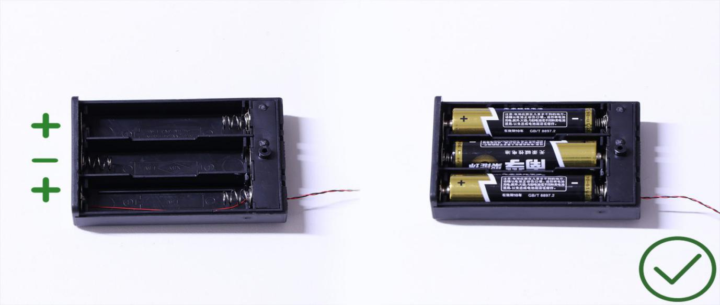

**OK, Let’s Begin!**

# **Instructions for this Kit**

1.) Start by disconnecting the following pieces from the front of the vehicle

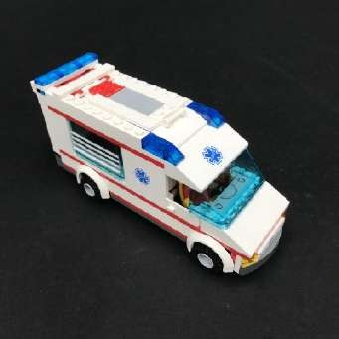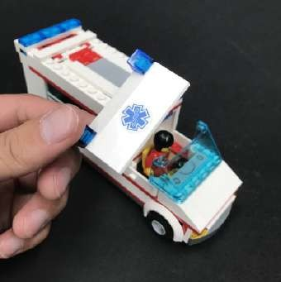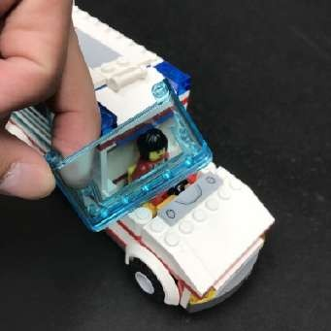

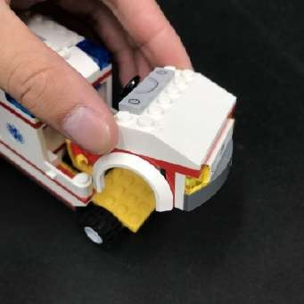 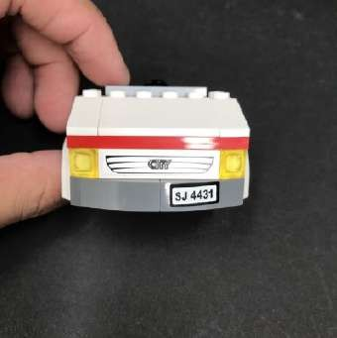 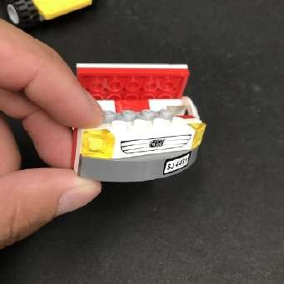

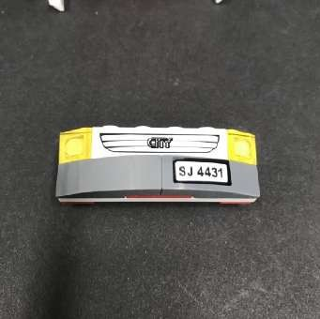 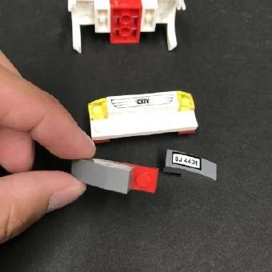 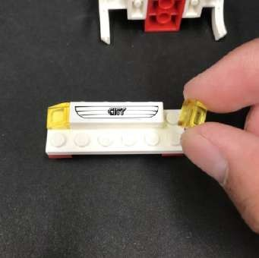

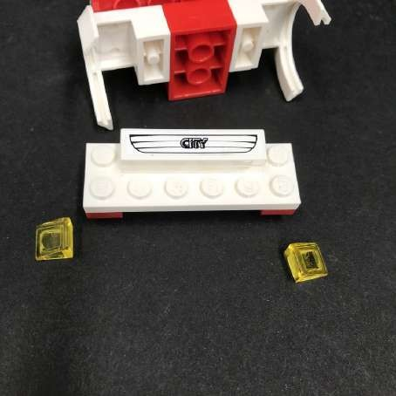

2.) Take 1x White 15cm Dot Light and place it over the top corner stud ensuring the cable is facing down as per below. Reconnect the trans yellow plate over the top to secure the light in place.

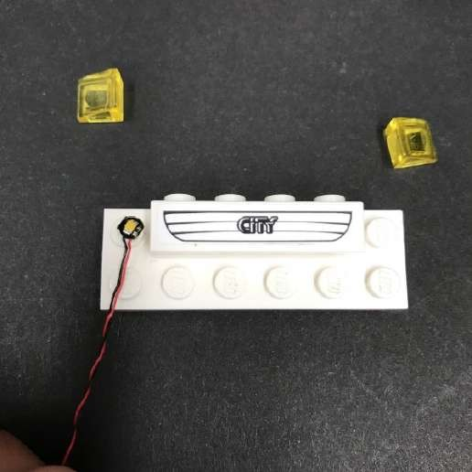 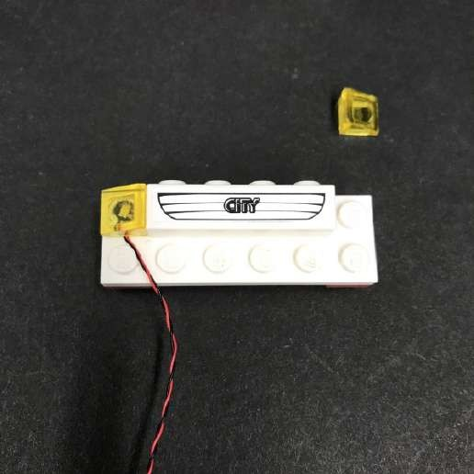

Repeat this step to install another 1x White 15cm Dot Light to the other headlight.

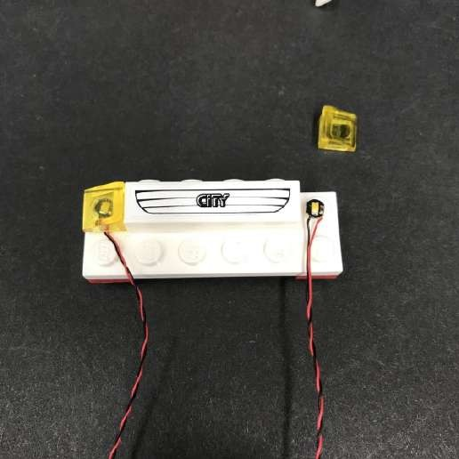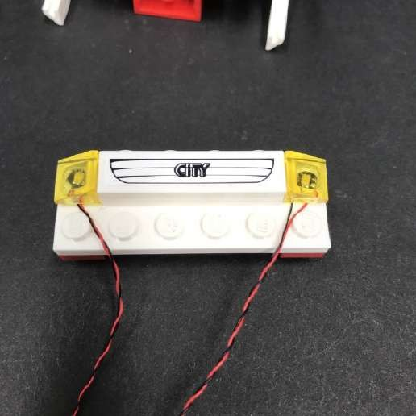

3.) Reconnect pieces we removed earlier ensuring the cables underneath are laid in between studs.

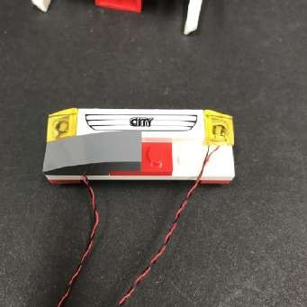 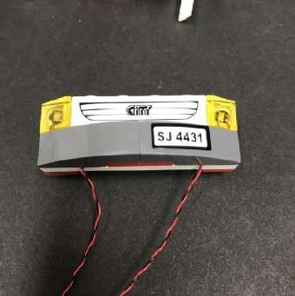 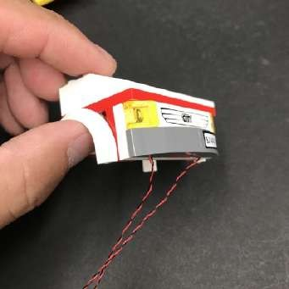

Reconnect this front section back to the vehicle.

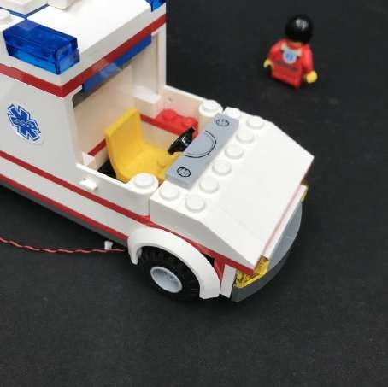

4.) Thread each cable up the space behind the front wheels. Pull the cables up from the top and then tuck the cable in over the wheel.

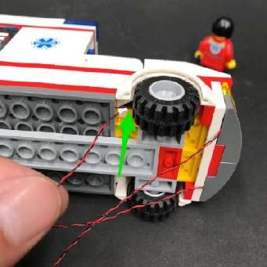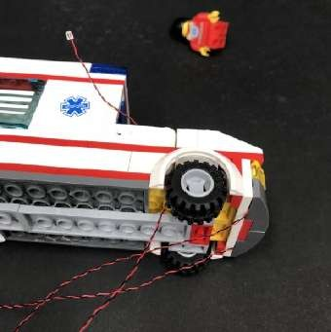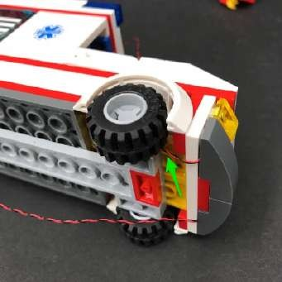

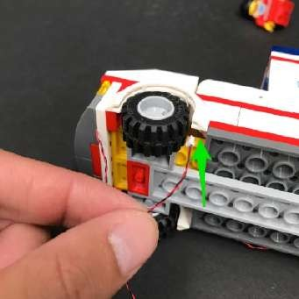 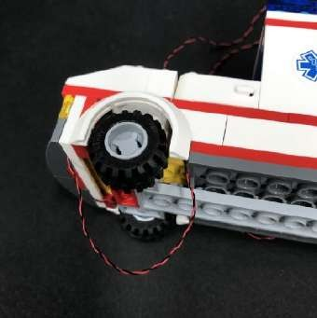 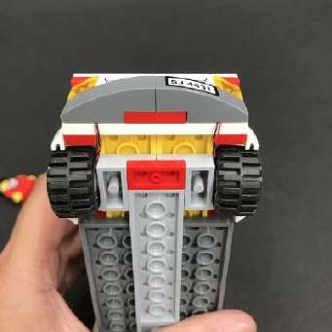

5.) Open up the roof door and then disconnect the following pieces behind the front seat.

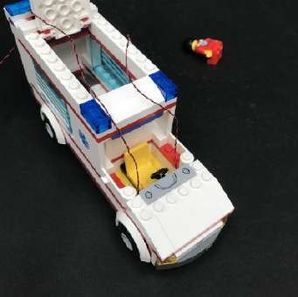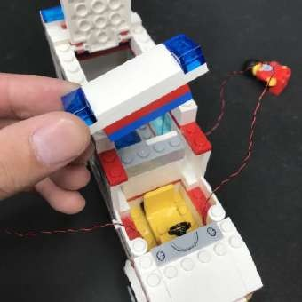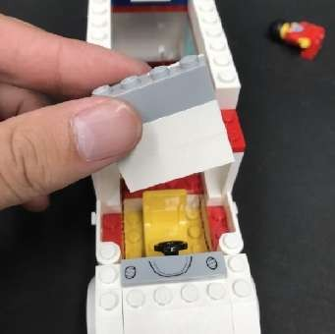

6.) Lay the front Dot Light cables along each side (in between studs) before reconnecting the middle wall section over the top.

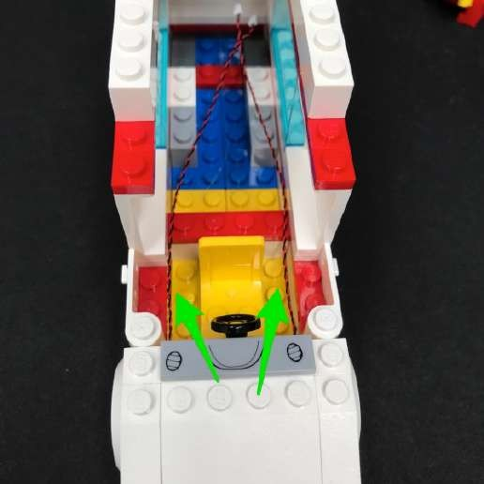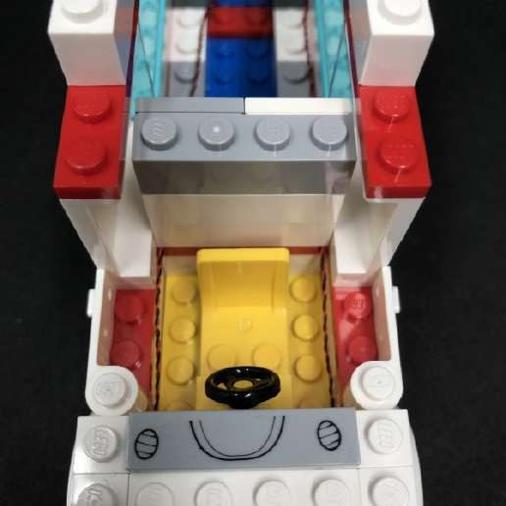

7.) Take one of the 6-port Expansion Boards and connect the Dot Light cables to spare ports.

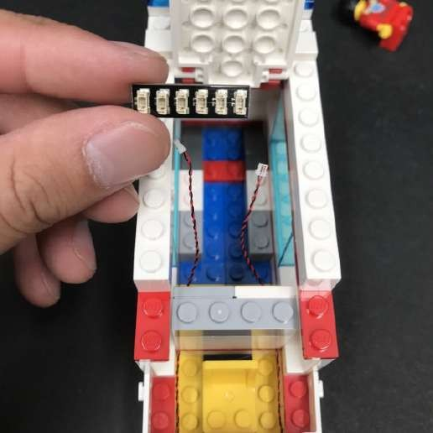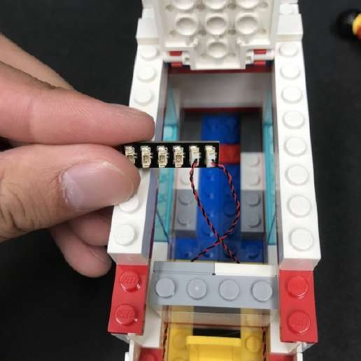

8.) Reconnect the window.

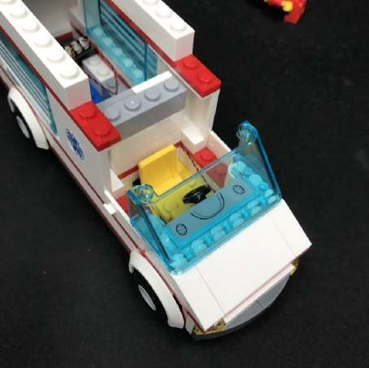

9.) Disconnect the red and blue plates from underneath the top roof section and then reconnect them on top of the middle wall.

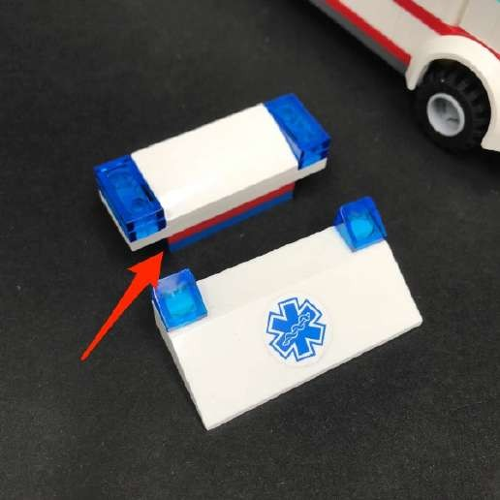 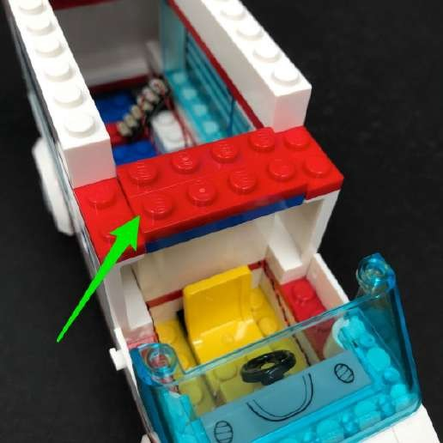

10.) Take the top roof section and disconnect the trans blue 1x2 tiles from each side.

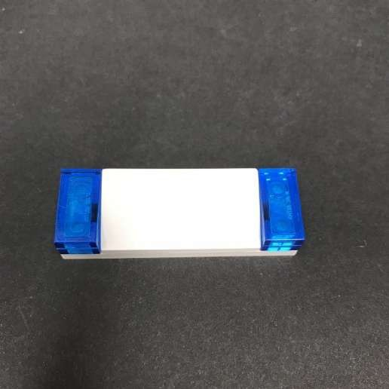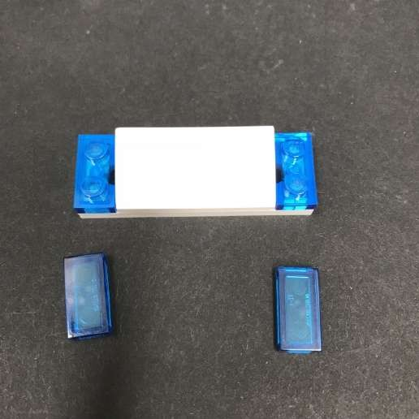

Take a 1x White 15cm Dot Light and with the cable facing up, place the Dot Light in between studs on one side. Reconnect the trans blue 1x2 tile over the top to secure it in place.

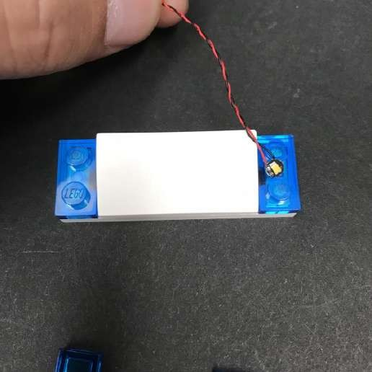 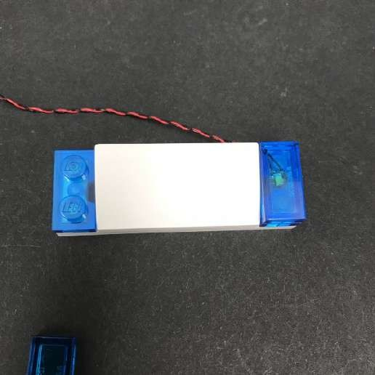

Repeat this step to install another White 15cm Dot Light to the other side.

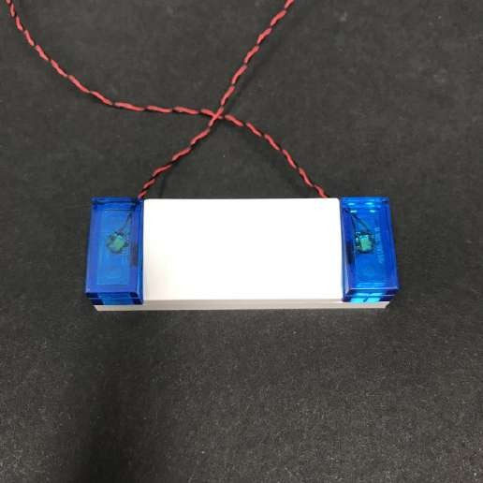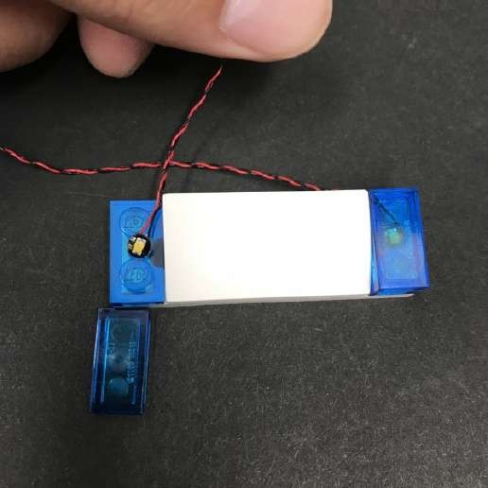

11.) Take the front roof section and disconnect the trans blue plates from each side.

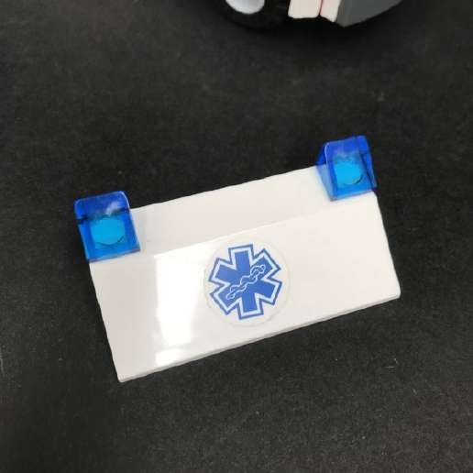 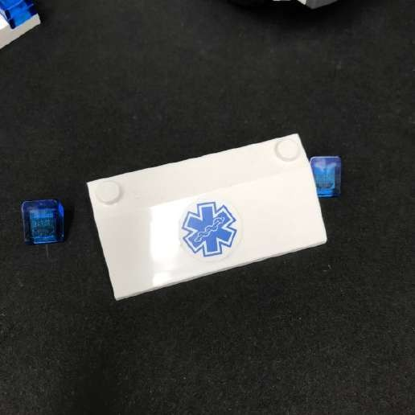

Install another 2x White 15cm Dot Lights using the same method as above ensuring the cables are facing up.

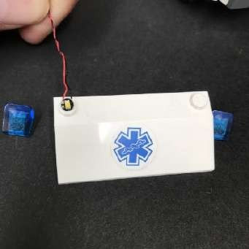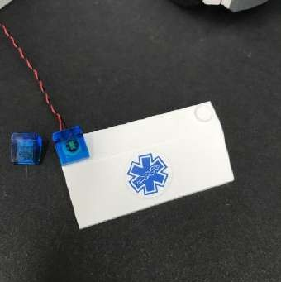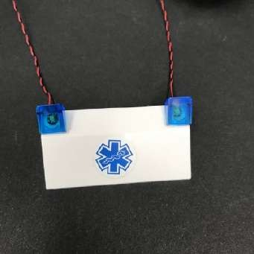

12.) Reconnect the front roof section back to the vehicle.

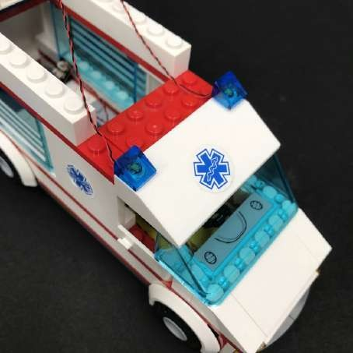

Lay each dot light cable in between studs before reconnecting the top roof section.

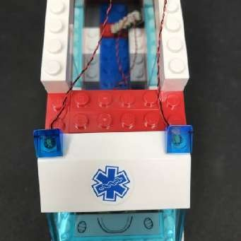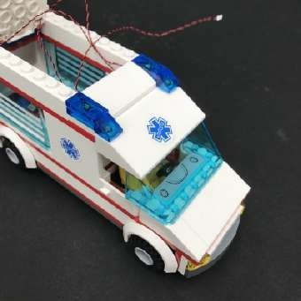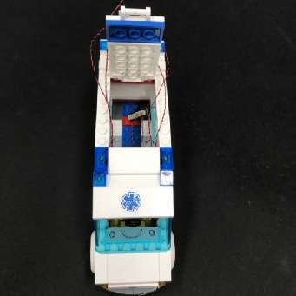

13.) Connect the two cable from the left into a 6-port Expansion Board and then connect the two cables from the right into another 6- port Expansion Board.

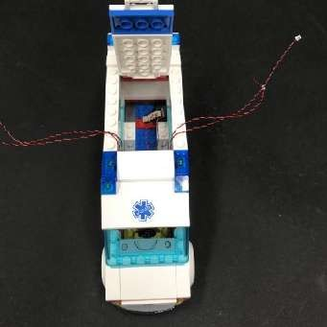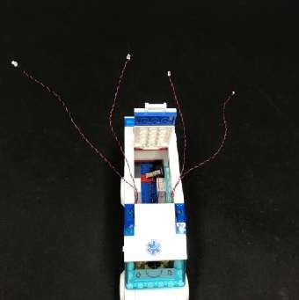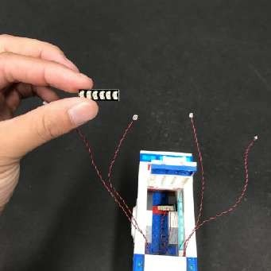

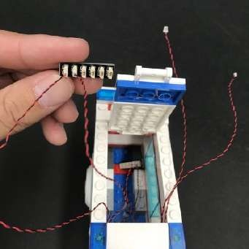 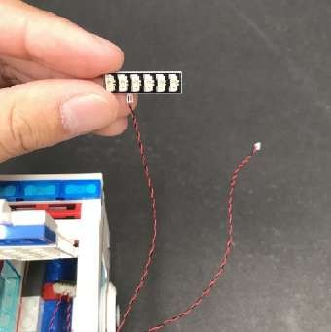 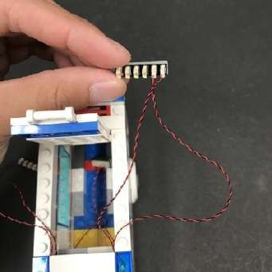

14.) Turn the Ambulance to the back and then disconnect the back door.

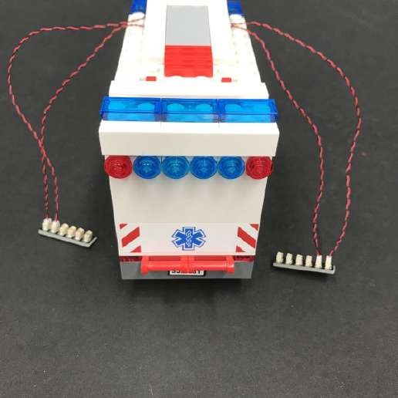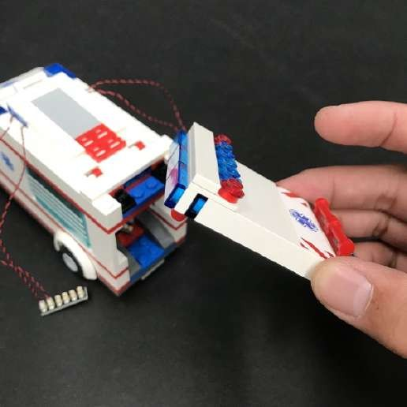

Disconnect the bottom section of the door and disconnect the two trans red pieces as per below

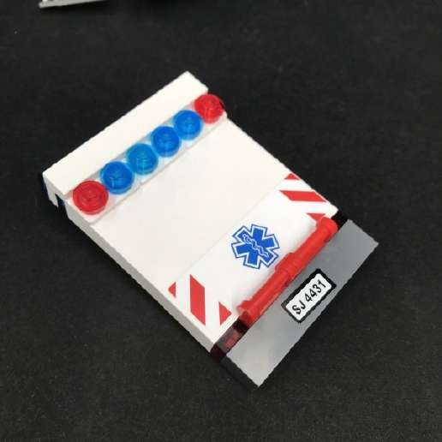 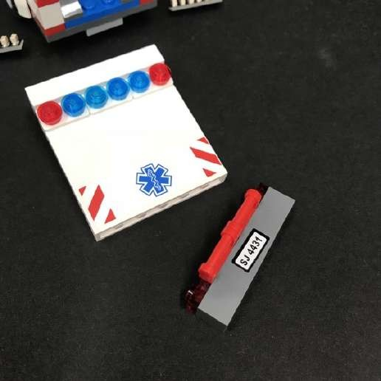

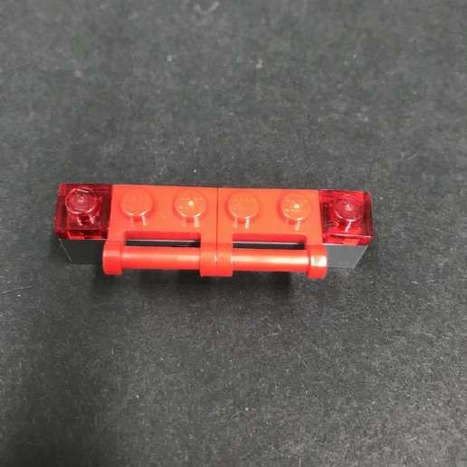 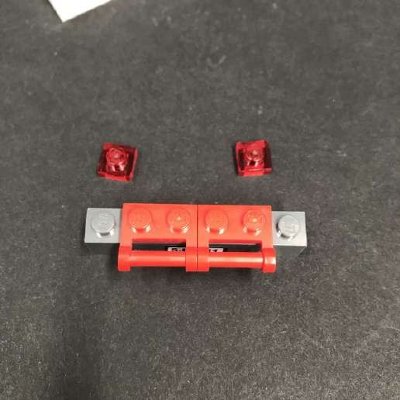

15.) Install another 2x White 15cm Dot Lights to the bottom section ensuring the cables for each light is facing up. Secure the lights in place by reconnecting the trans red plates over the top.

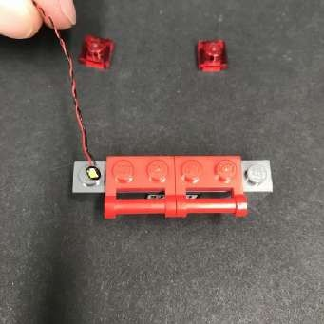 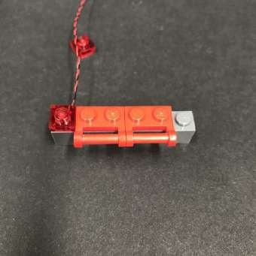 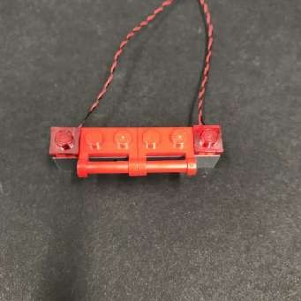

Reconnect the bottom section back to the door.

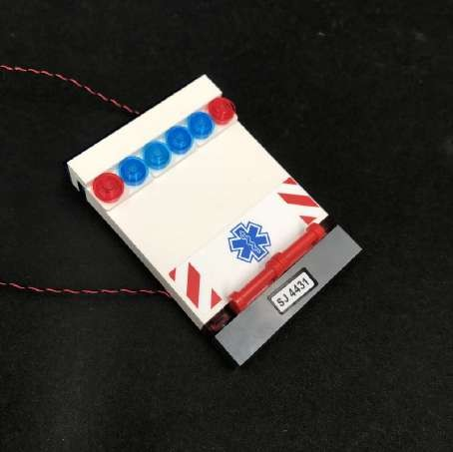

16.) Disconnect the following sections from the top of the door and then disassemble pieces underneath

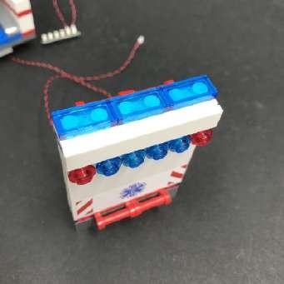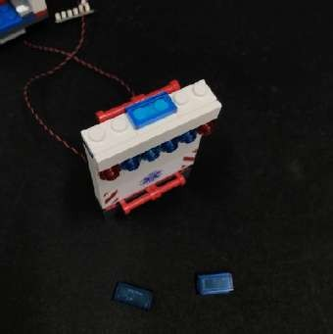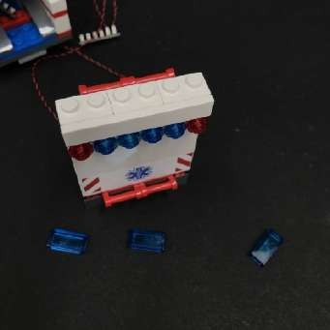

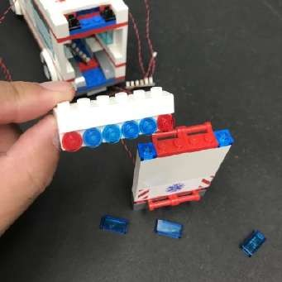 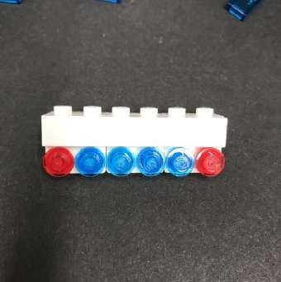 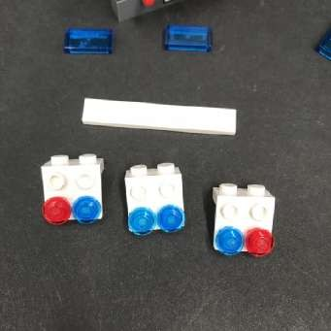

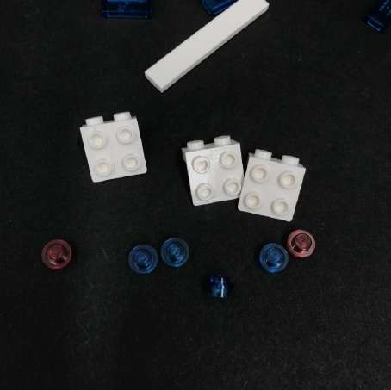

17.) Take 1x Flashing White 15cm Dot Light and place it on top of the first stud on the the first white plate as per below.

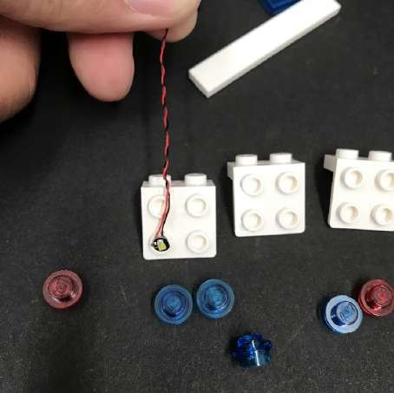

Secure the light in place by reconnecting the trans red plate over the top.

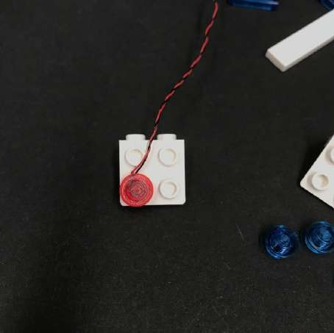

Repeat this step to install the remaining 5x Flashing White 15cm Dot Lights ensuring you follow the correct order of colours.

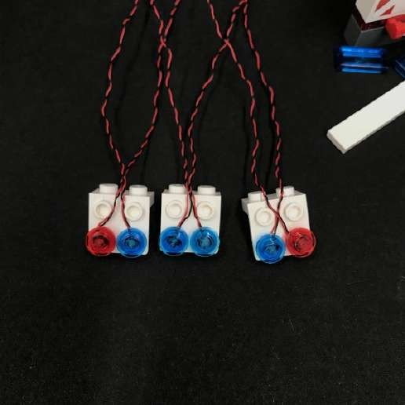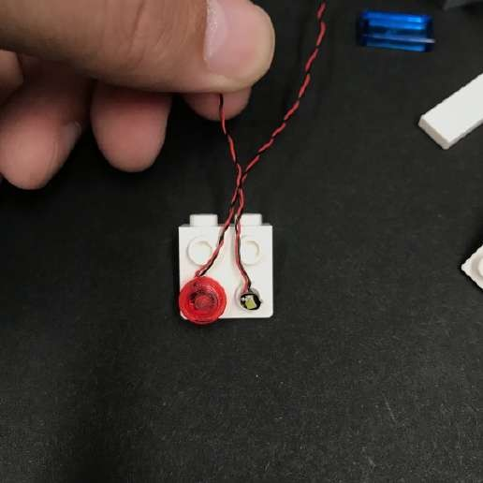

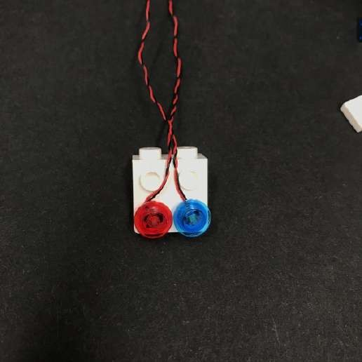 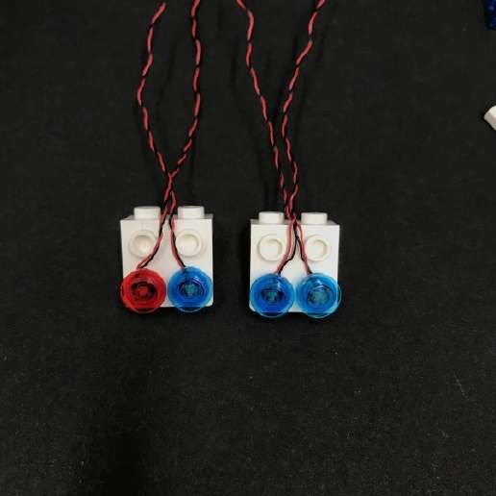

19.) Reconnect the 3x White Plates back to the top of the door and then lay the cables in between studs (2 cables between each of the studs) as shown below.

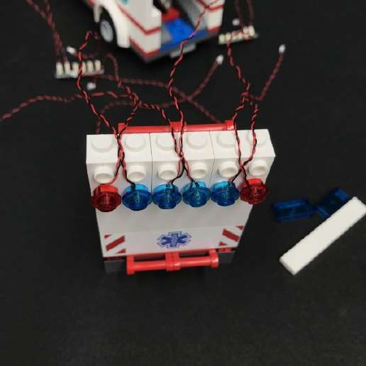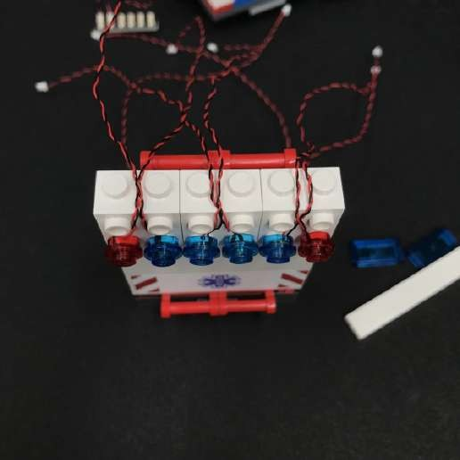

20.) Take the provided Plate 1x6 and connect it over the top of the cables then reconnect the white 1x6 tile at the front.

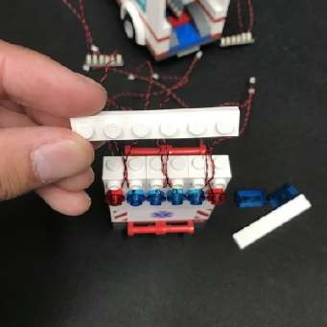 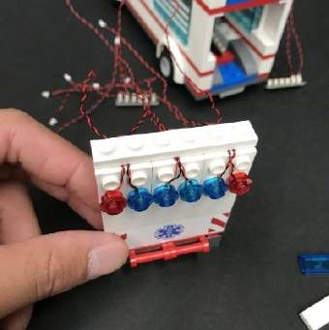 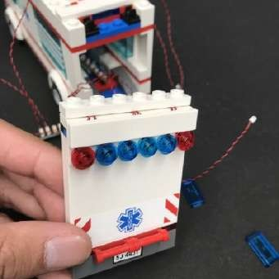

21.) From the other side of the door, Take the two Dot Light cables from the bottom and thread each cable up the space of each red 1x2 plate with handle, as shown below.

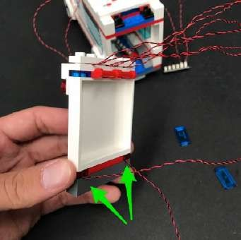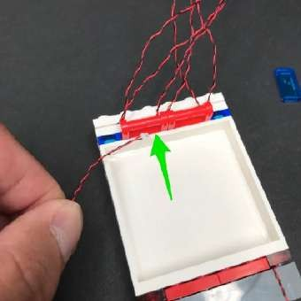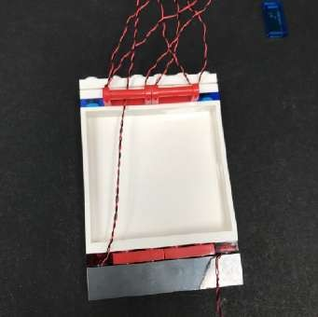

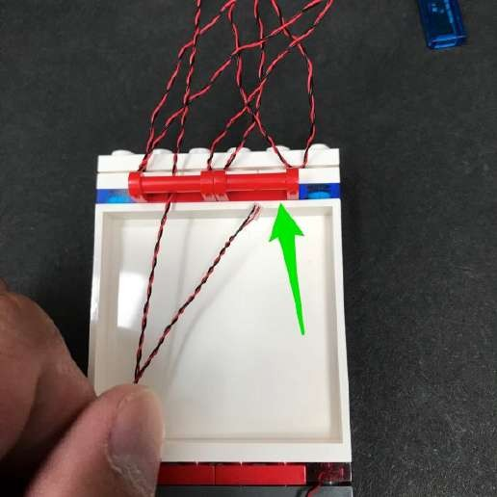 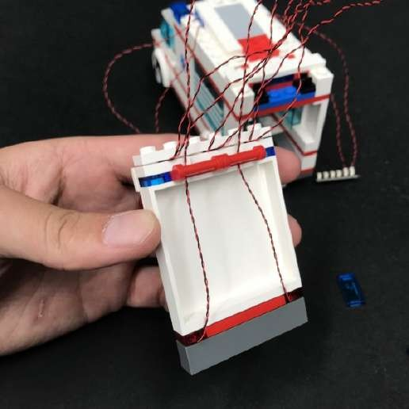

22.) From the top of the door, take the three cables toward the right and thread them down the space of the red 1x2 plate with handle.

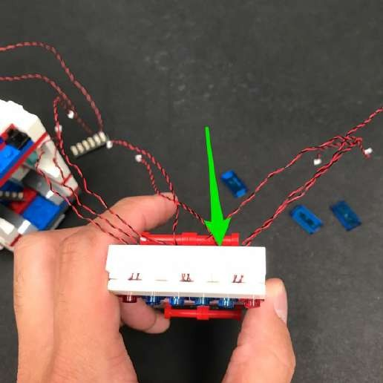 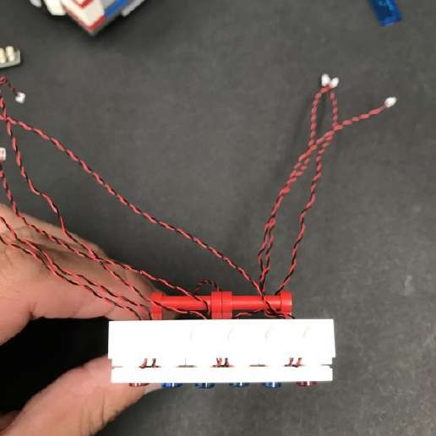

Repeat this step to thread down the three cables on the left, down the space of the other red 1x2 plate with handle.

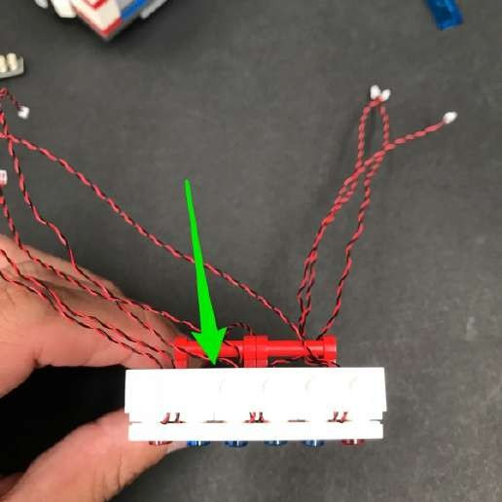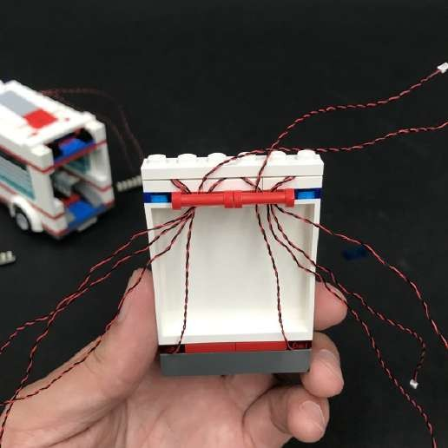

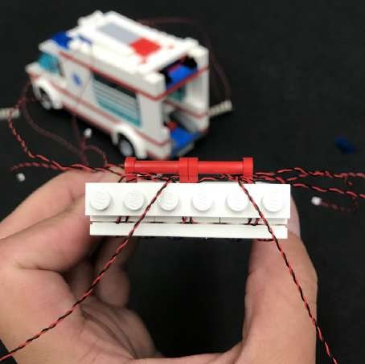

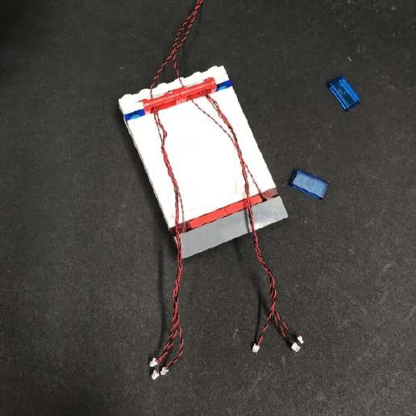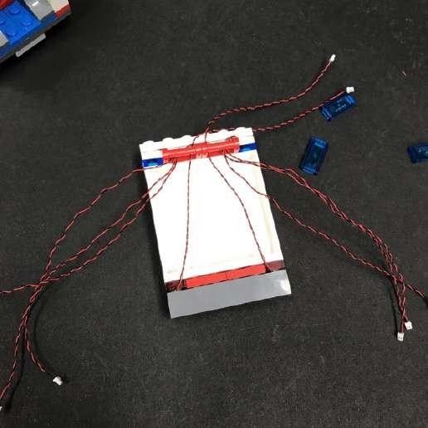23.) Take each group of three cables which have been threaded down from the top and then twist them

around each other forming one thicker cable for each side.

24.) Take the 8-port Expansion Board and connect both groups of cables (Total of 6) to the spare ports.

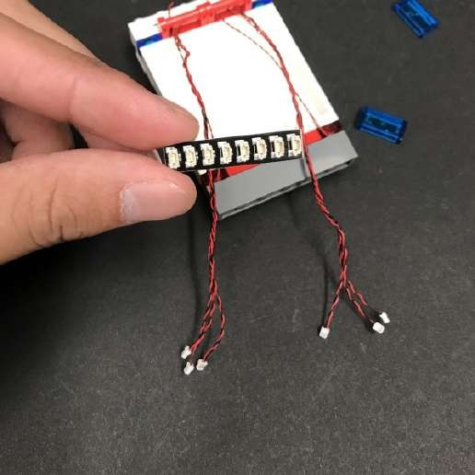 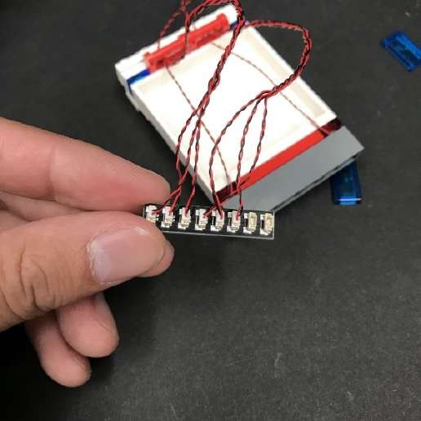

25.) Take 1x 5cm Connecting Cable and connect it to the next port along the 8-port expansion board.

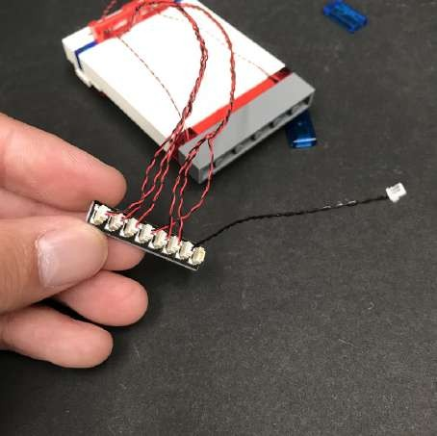

26.) Take this time to test the flashing lights we have just installed. To do this take the Flat Battery Pack and insert 2x CR2032 batteries to it. Connect the battery pack to the spare port on the expansion board and then turn it on to ensure flashing lights are working OK.

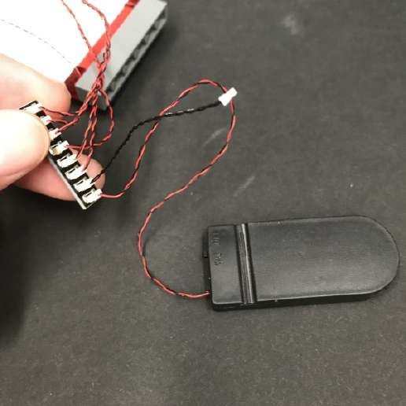 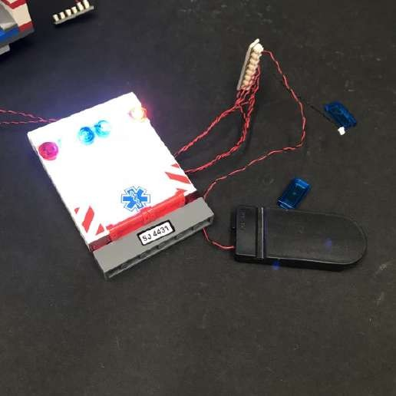

27.) Disconnect the following sections and pieces from the back of the vehicle.

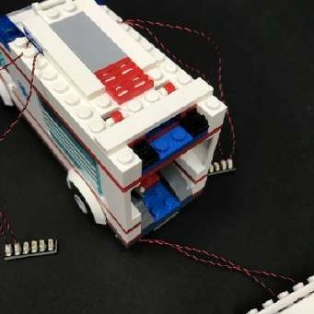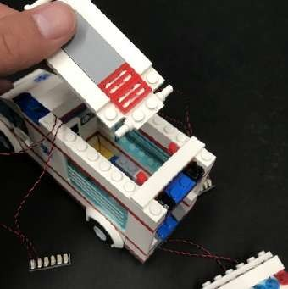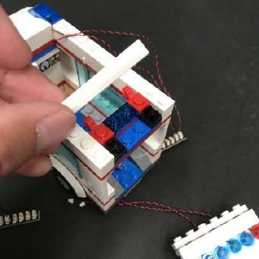

Remove the red 1x2 plate and the trans blue 1x2 plate attached to it. We will be threading the light cables from the back door through the space these pieces were originally connected to therefor, we will not be reconnecting these pieces.

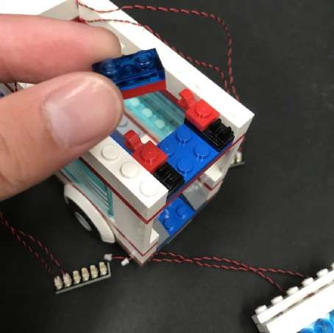

1. ) We will now install the remaining two lights to the top of the back door. First reconnect the middle trans blue 1x2 tile.

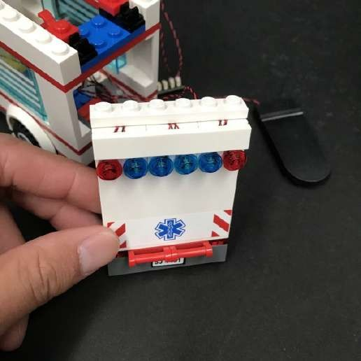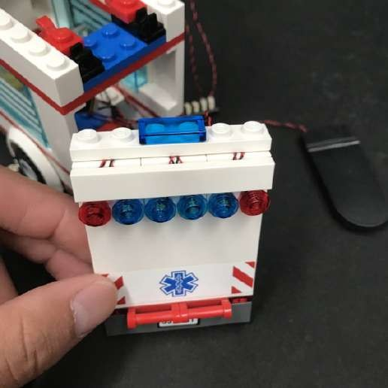

29.) Install the remaining 2x White 15cm Dot Lights to the top of the back door ensuring the cables are facing up. Secure them in place by reconnecting the trans blue 1x2 tiles on either side.

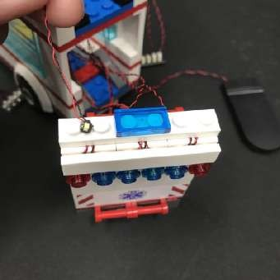 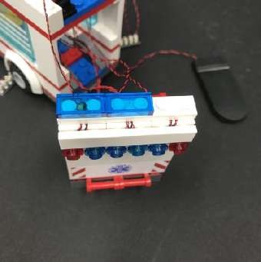 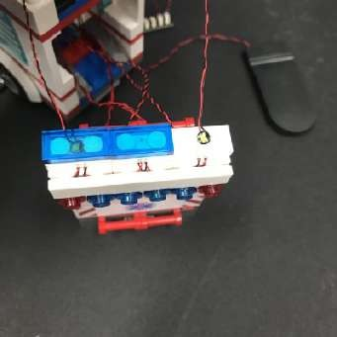

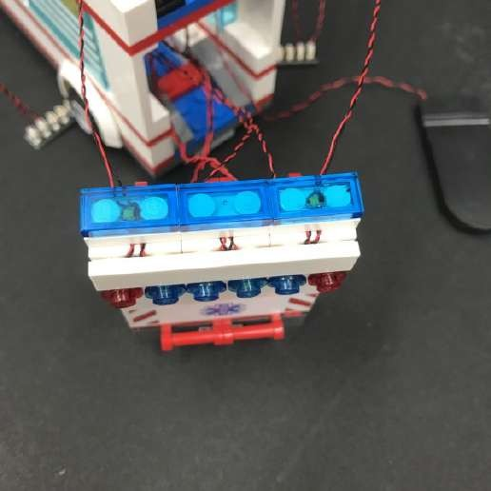 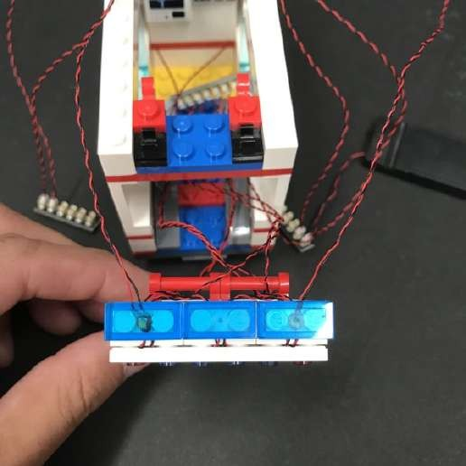

30.) Thread one of the dot light cables we just installed down the space of the red 1x2 plate with handle closest to it, then thread the other dot light cable down the space of the other red 1x2 plate with handle.

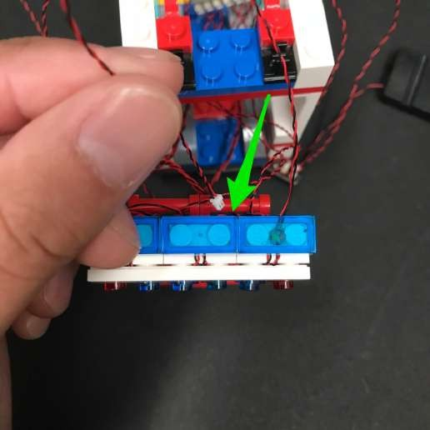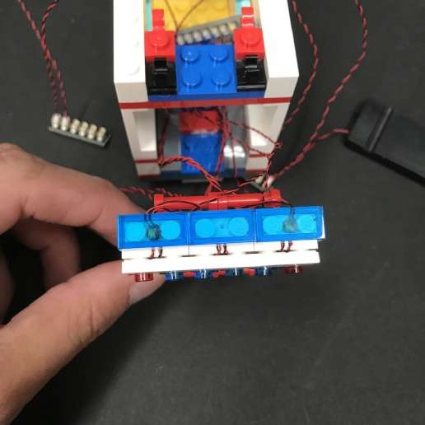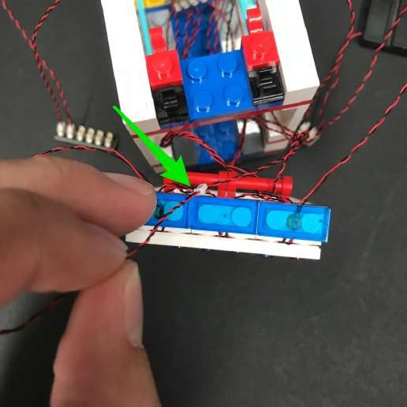 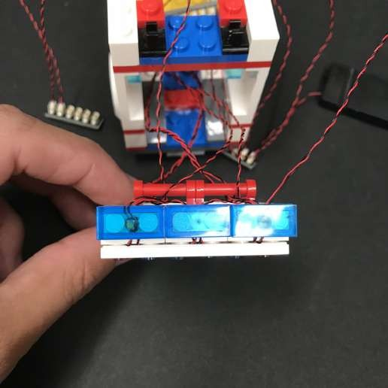

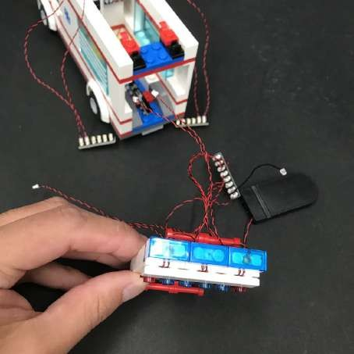

31.) Take the door and all the cables, expansion board, and connected battery pack and place them inside the top of the ambulance before reconnecting the back door.

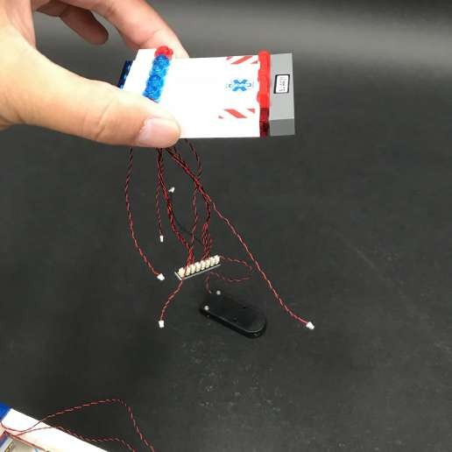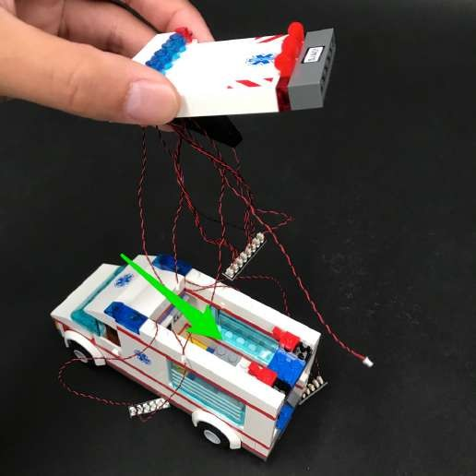

Pull the cables, expansion board, and connected battery pack out the back door way.

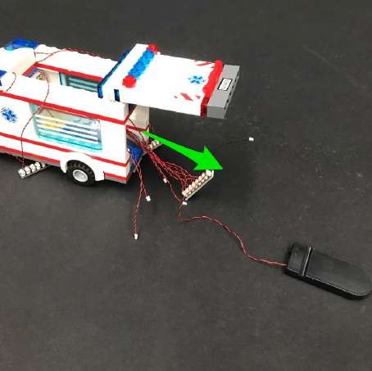

32.) Locate the 6-port expansion board with the headlights connected to it and then bring the tail lights back in from the back of the ambulance and connect them to it.

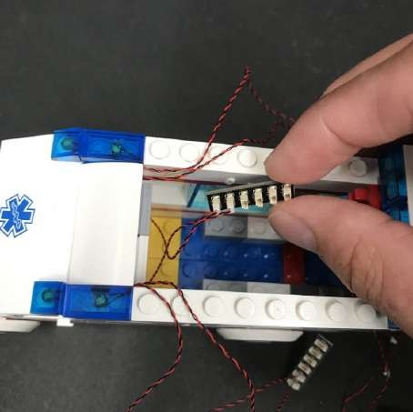

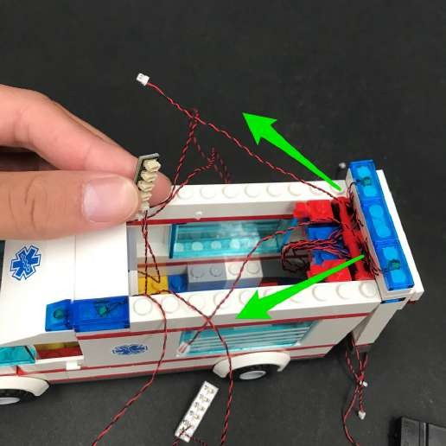 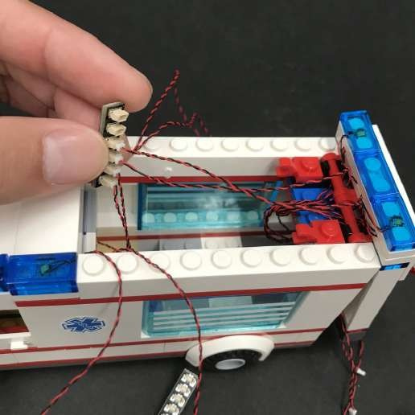

Locate the other end of the 5cm connecting cable from the 8-port expansion board and bring this back in and connect it to the 6-port expansion board inside (where the head and tail lights are connected to)

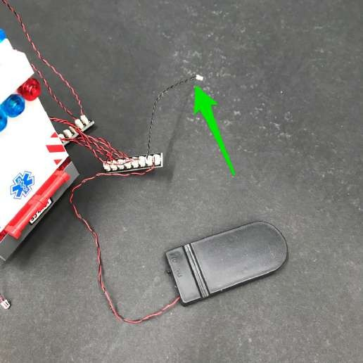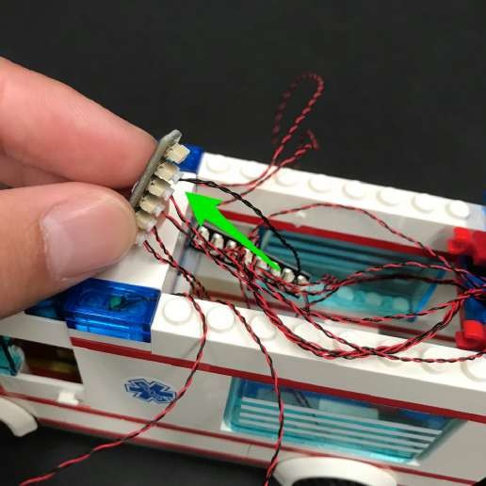

33.) Turn on the battery pack to verify the head lights, tail lights, and flashing lights on the back door are all working OK.

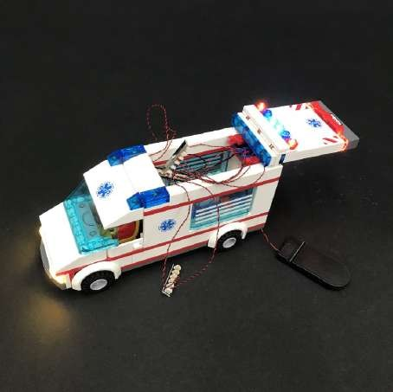

34.) We will now connect the 2 remaining lights from the top of the back door to the expansion boards where the front roof lights are connected to. Turn the ambulance to the backside and then take the dot light on the right side and connect it to the 6-port expansion board on the left side.

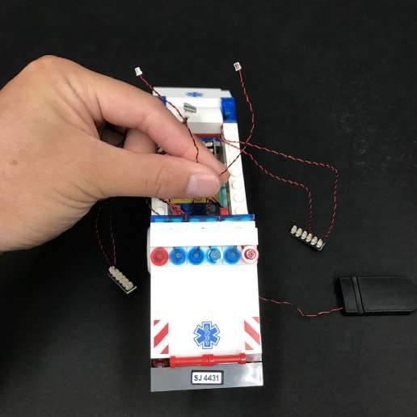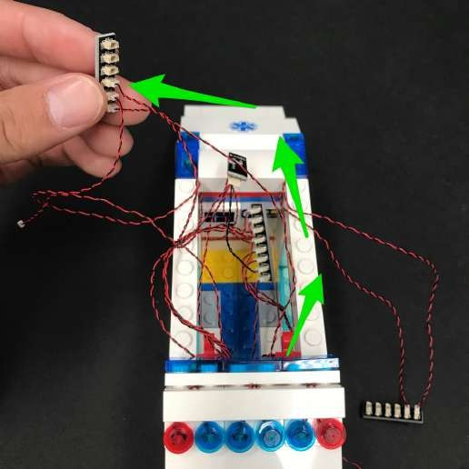

Take the dot light on the left side and connect it to the 6-port expansion board on the right side.

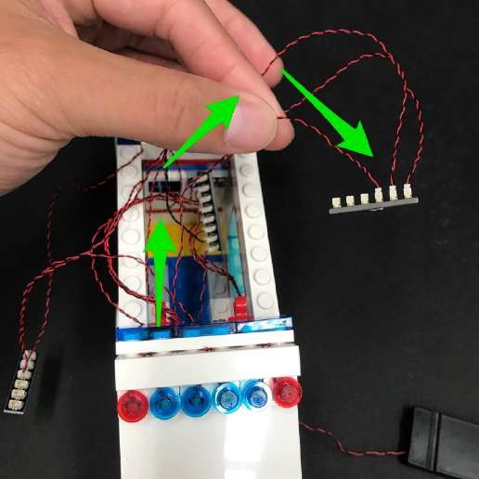 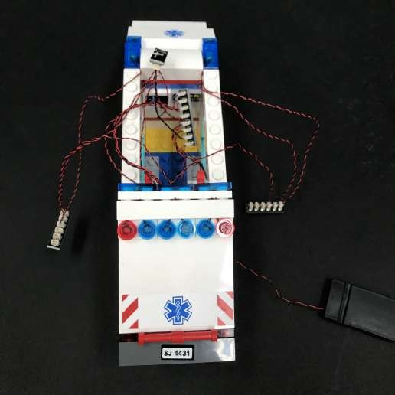

35.) Take the 2x 5cm Connecting Cables and connect each one to each of the 6-port expansion boards on each side.

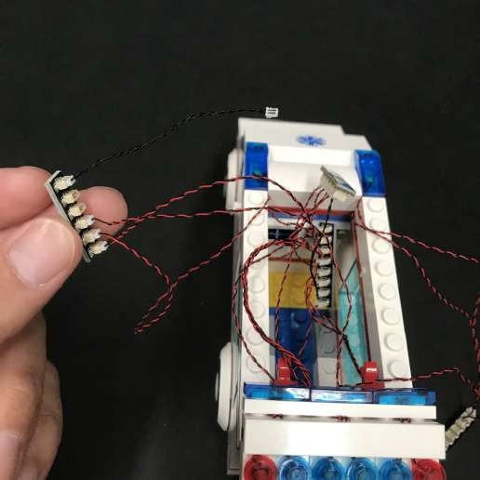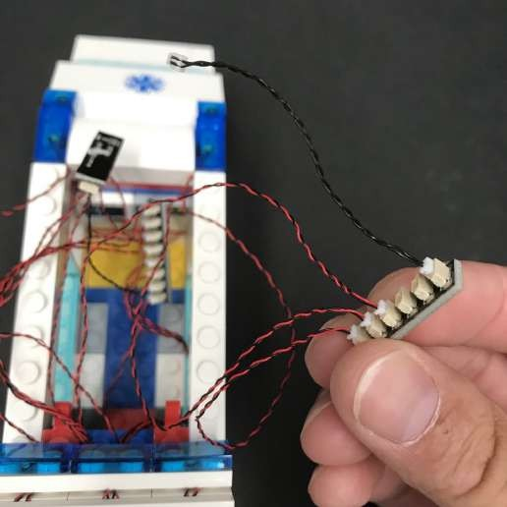

36.) Take the Multi Effects Board and then connect the remaining 5cm Connecting Cable to the input port of the effects board (side with 1 port).

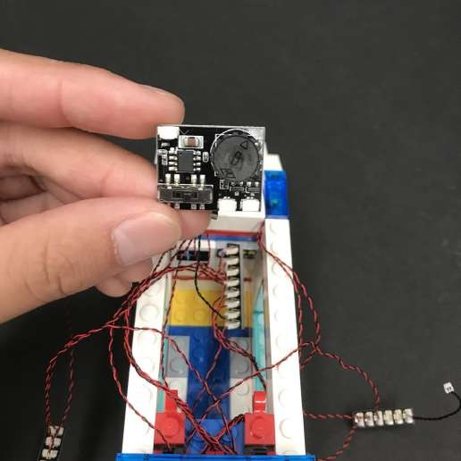 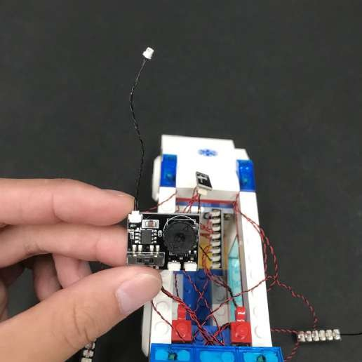

Connect the other end of the 5cm connecting cable from the effects board to the remaining port on the 6-port expansion board (where the head and tail lights are connected to)

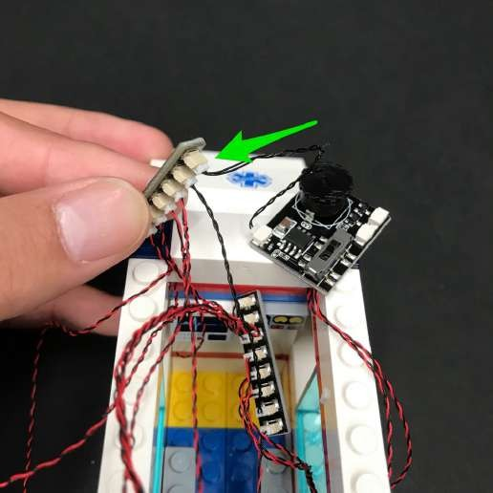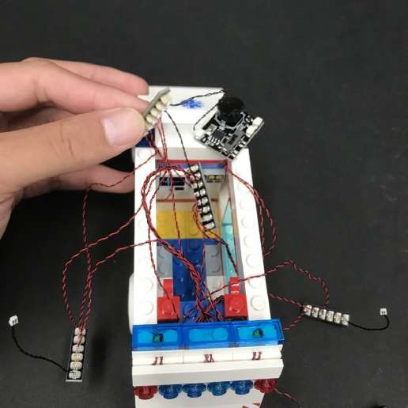

37.) Take the spare ends of the 2x 5cm Connecting Cables from the expansion boards (where the roof lights are connected to) and connect each one to the output ports of the multi effects board (side with 2 ports)

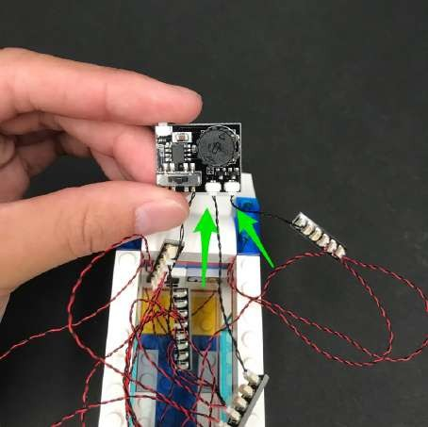

38.) Program the effects board by flicking the switch to the middle (emergency effect) and then turn the battery pack on to verify the effect of the roof lights.Turn the wheel on the effects board to adjust the speed of the flashing effect.

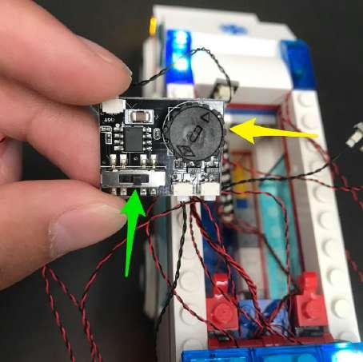

39.) Once you have configured the effect to your desired speed, neatly tuck all the components inside the back of the ambulance.

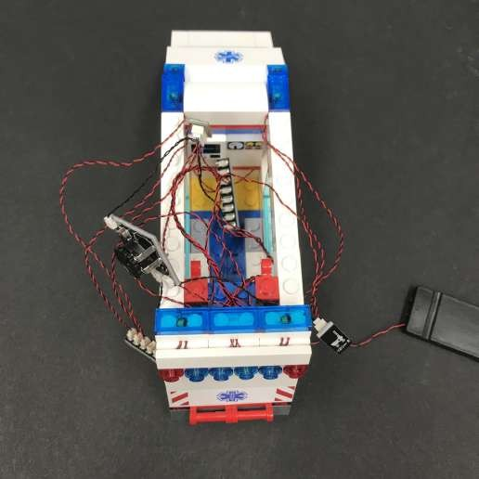 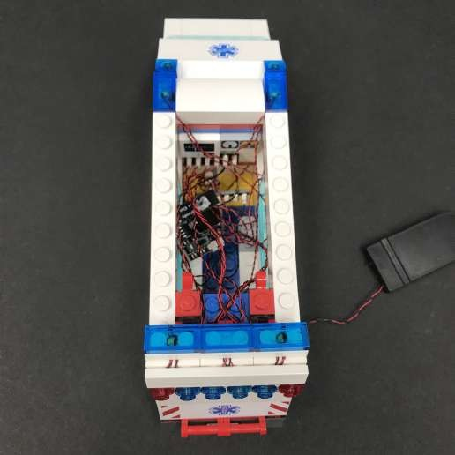

40.) Reconnect the roof of the ambulance and then reconnect the white 1x6 plate to cover the wires.

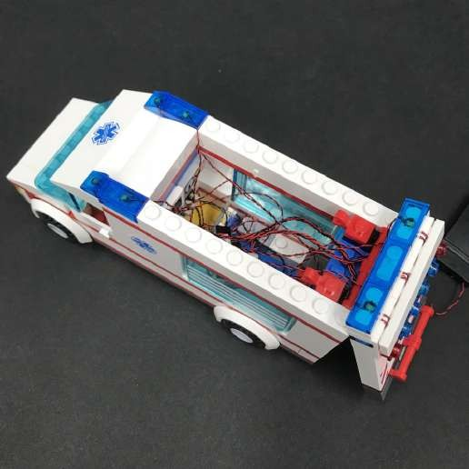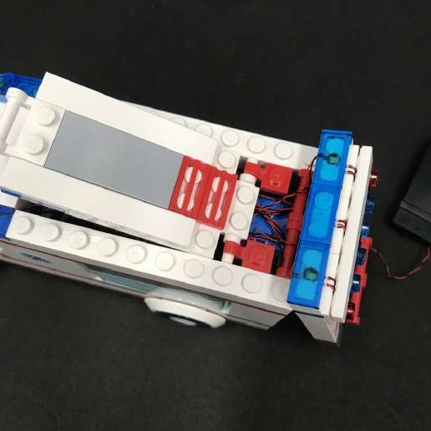

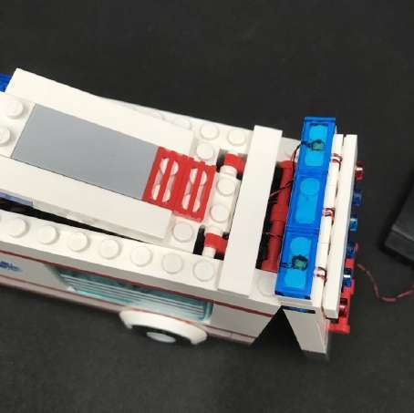

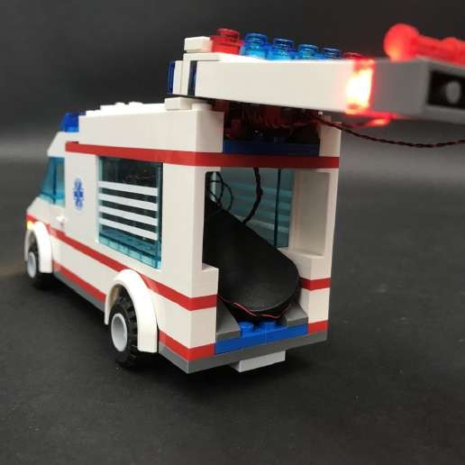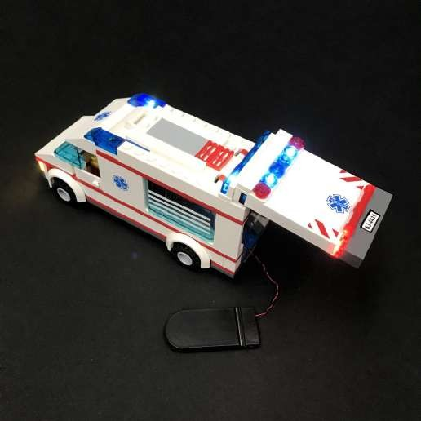Neatly tuck in the battery pack and then close the back door.

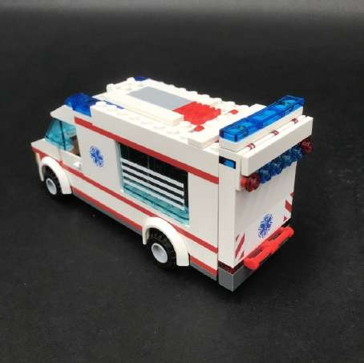

This finally completes installation of your City Ambulance lighting kit. Now turn on the light kit and ENJOY!