Mini Cooper #10242

Package contents:
- 9x White 30cm Dot Lights
- 1x 12 Port Expansion board
- 1x Flat Battery Pack (requires two CR2032 batteries)
- 2x 1 x 1 trans orange round plates
- 1x 1 x 2 trans red tile
- 2x 1/2L technic pins
- 1x 6 x 10 plate
Note:
Place wires on the surface or under the building blocks.
The wire can be place between the building blocks or under the block, but they should be placed between the studs correctly.
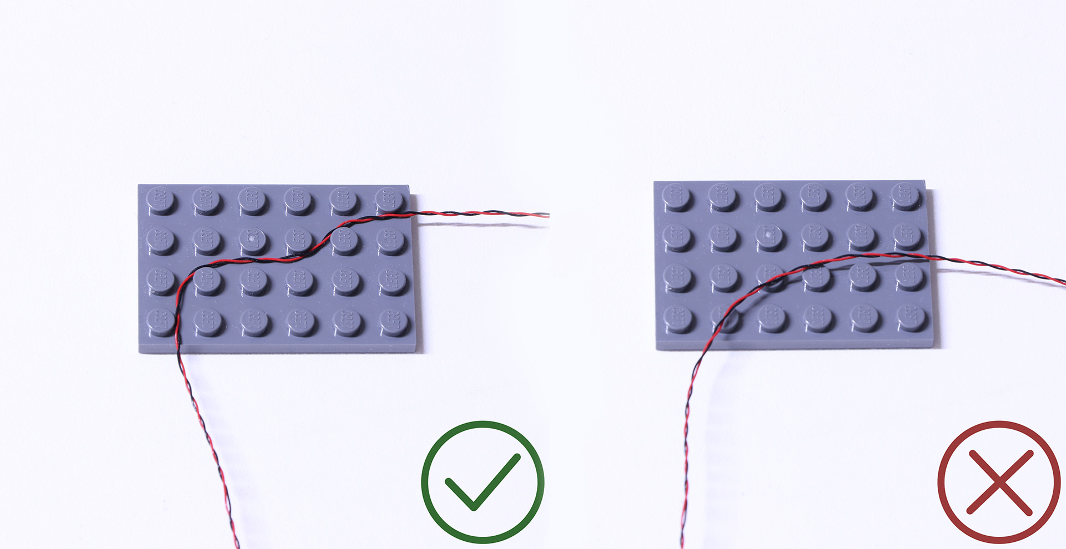
Insert the connectors to the ports.

Be careful when you are operating, there’s only one correct way to insert, make sure the expansion board is upward, find the soldered “=” sign on the left of the port. When you are inserting, the side which the wires can be seen should be faced to the “=” sign and if you feel hard to insert, please stop, and don’t force it, for that may result in bent pins inside the port or overheating of the expansion board.
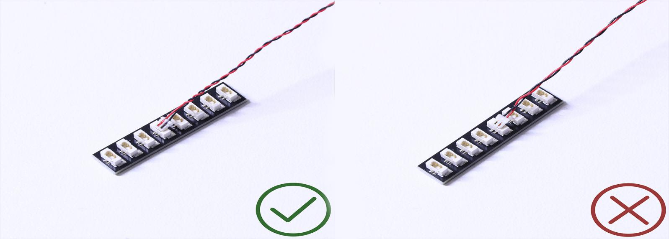

At this point, use the tweezers to straighten the bent pins.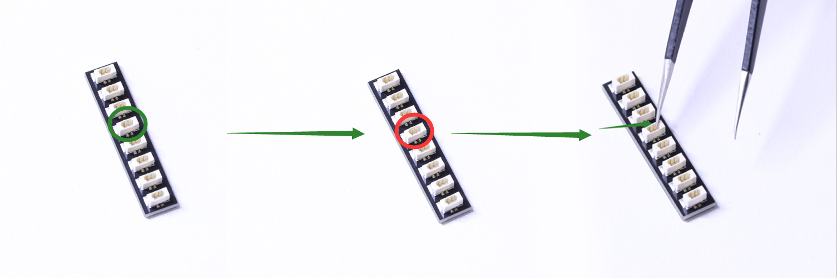
When installing dot lights, make sure they are correctly placed (Yellow LED package is exposed). You can put they either on the top of the studs or between studs.

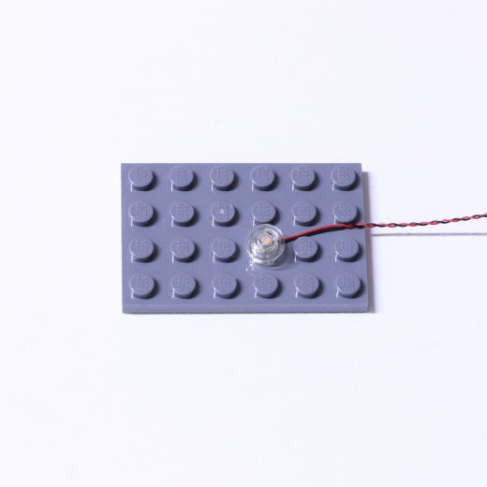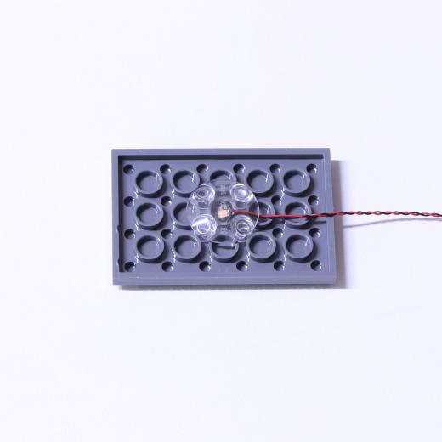

Connecting cable connectors to Strip Lights

Take extra care when inserting connectors to ports on the Strip Lights. Connectors can be inserted only one way. With the Strip Light facing up, ensure the side of the connector with the wires exposed is facing down. If a plug won’t fit easily into a port connector, don’t force it. Doing so will damage the plug and the connector.
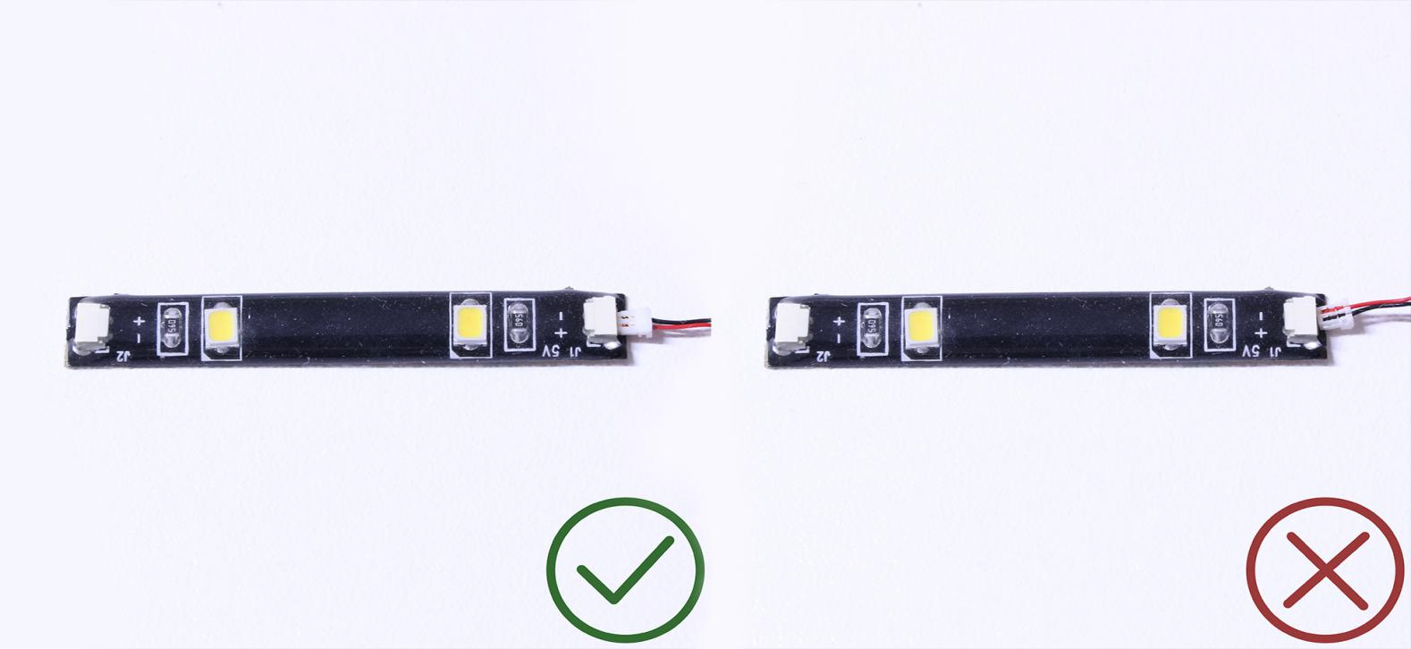
Finally, please pay attention to the positive and negative terminals of the battery when installing the battery case.
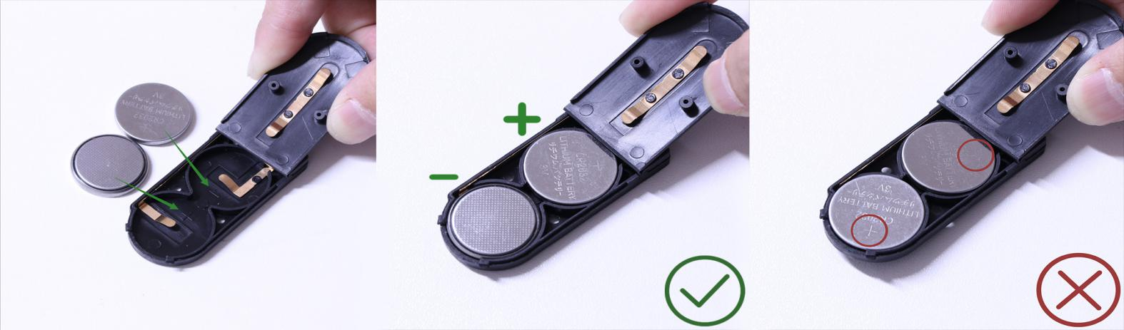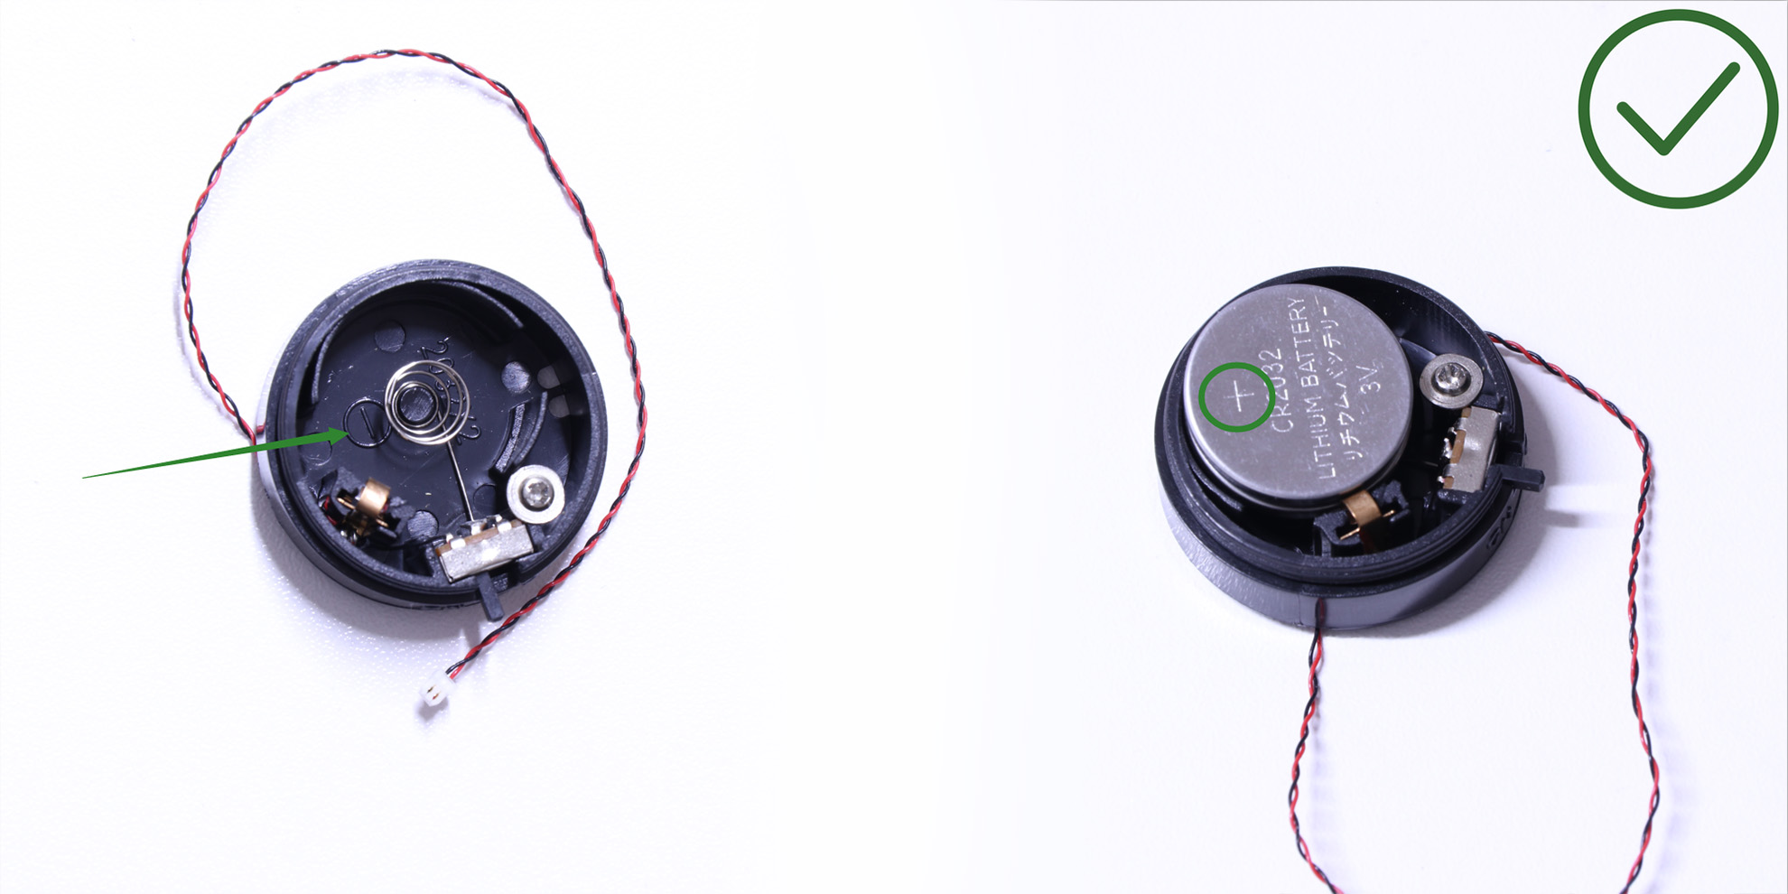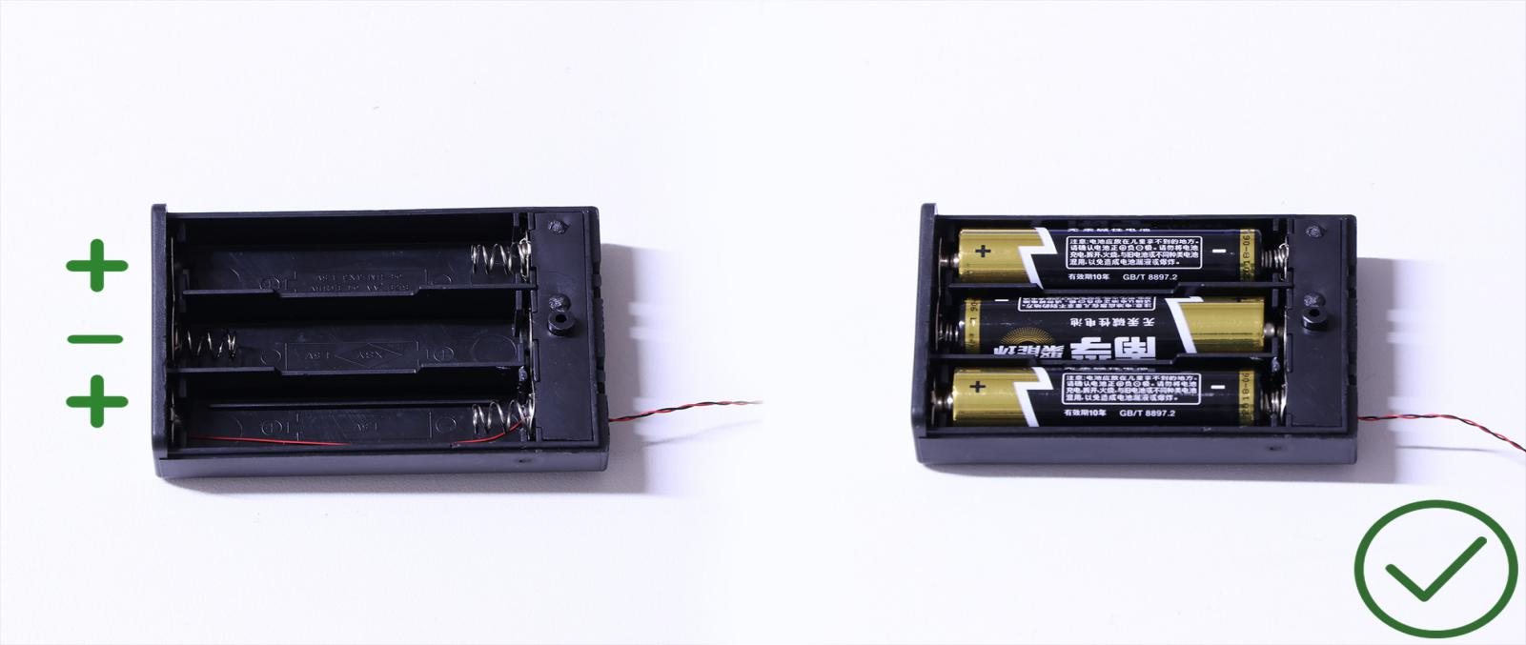
OK, Let’s Begin!

Instructions for installing this kit

This model has 6 lights on the front and three lights on the back. As we install the lights, we are going to run the wires to a central point underneath the vehicle. This is where we will connect them up as seen in the picture below.
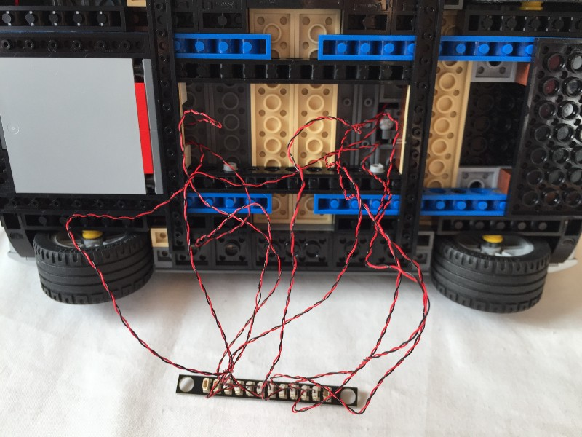
Start by taking the roof off and opening the bonnet.
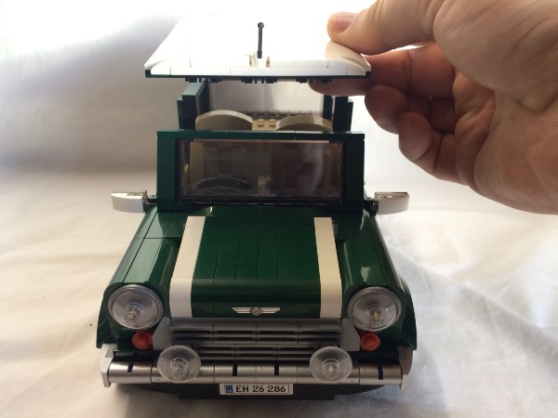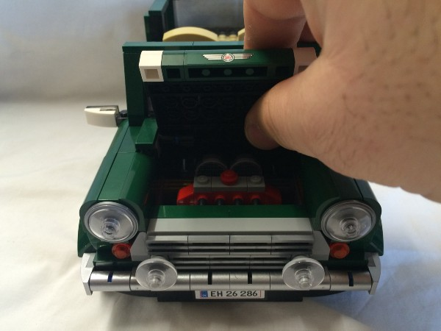
Hold on to the bonnet and pull it up to remove it. Sometimes the side pieces will come out as well and other times they won’t. If they don’t, remove them manually and attach them to the sides of the bonnet.
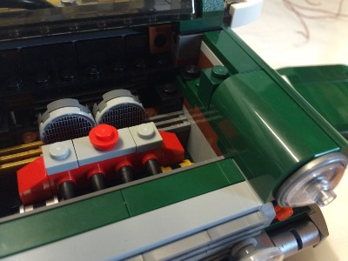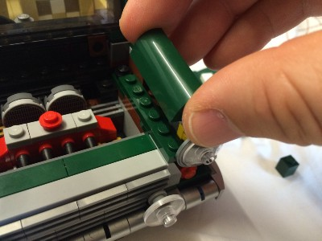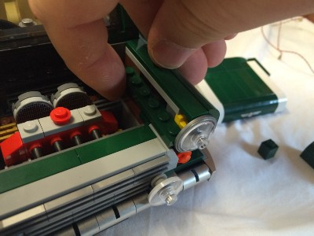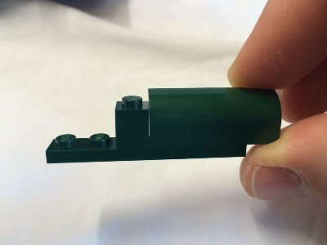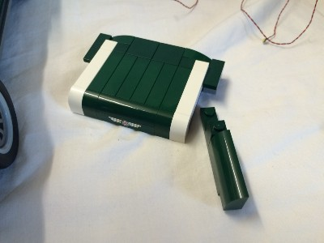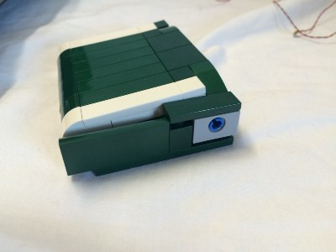
Above the front grille, there is a 1 x 8 light grey tile and two 1 x 4 green tiles behind it. Remove the 1 x 4 tiles and the piece they are sitting on.
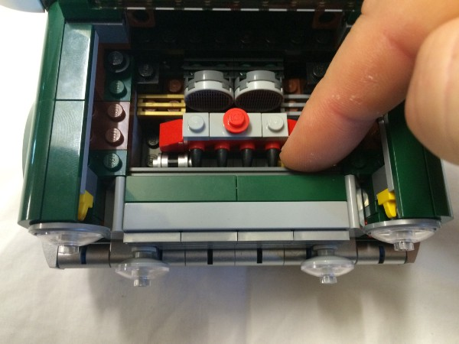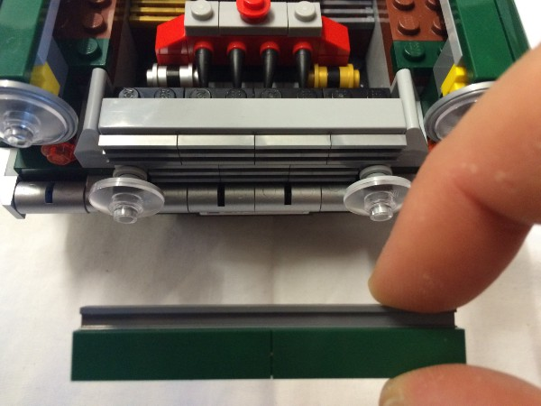
Remove the transparent clear dish pieces from both front fog lights.
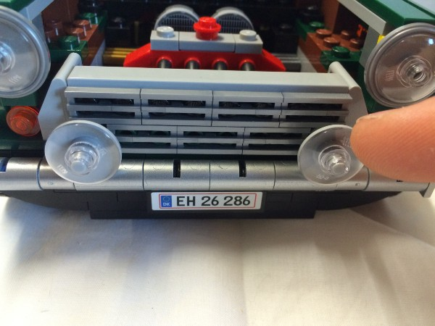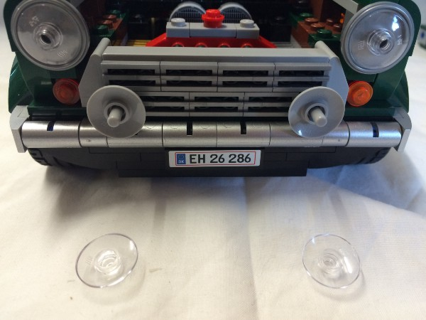
Grab a White Dot Light and hold it in the bottom section of the light grey dish piece that is still on the car. hold it near the middle with the wires coming away from the centre of the car.
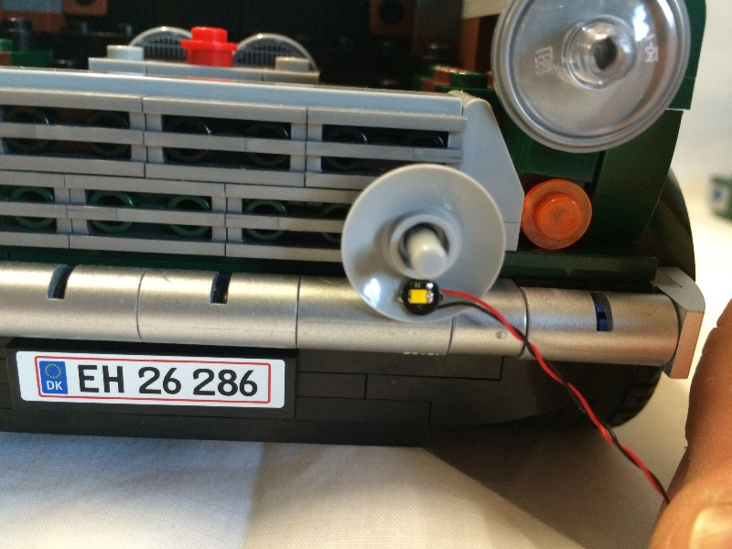

Replace the transparent clear dish pieces.
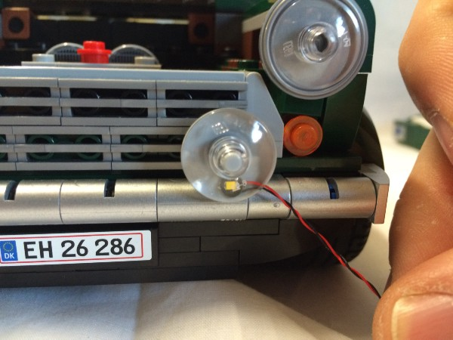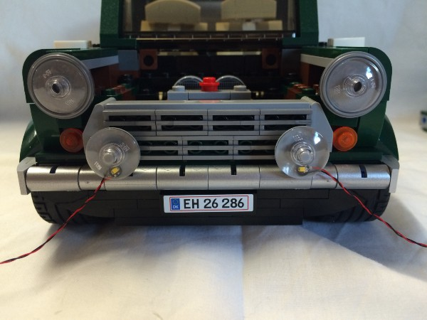

Remove the headlights by placing your thumb on the headlight and lifting it upwards, also removing the plate and tile on top of it.
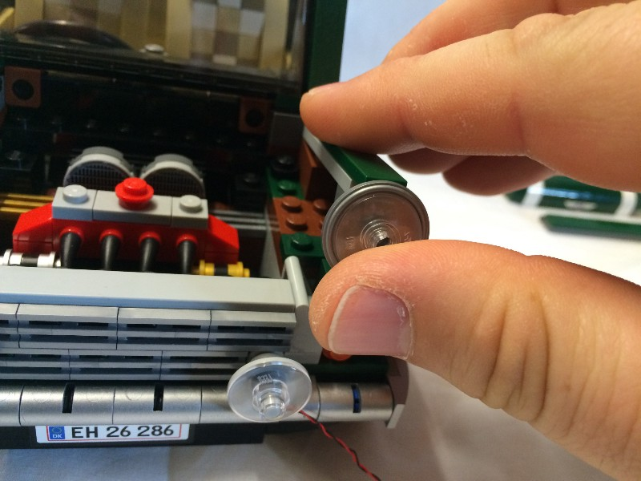
Remove the indicator and the bricks attached to it (if you pull the green brick behind the indicator forward, a few pieces should all come out together).
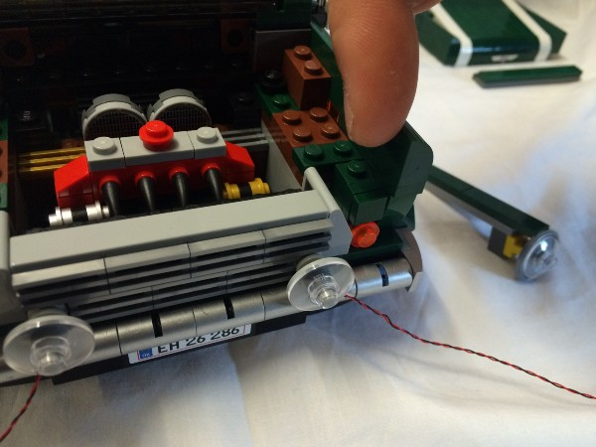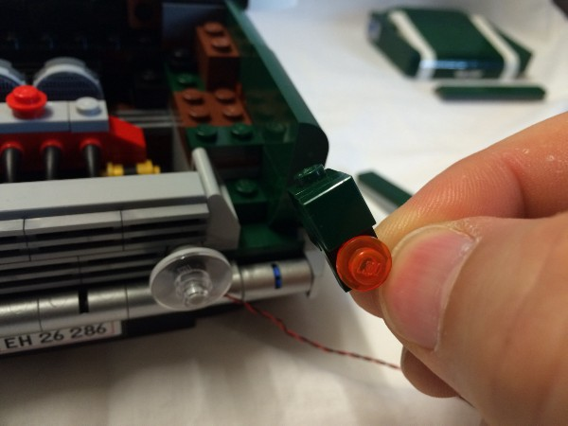
Remove the unusual looking grey piece from the place next to where the indicator was.
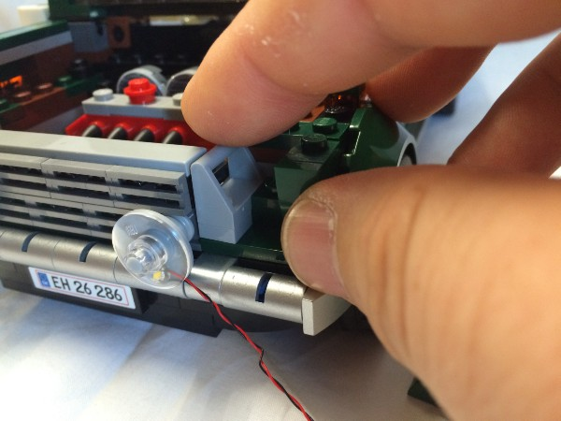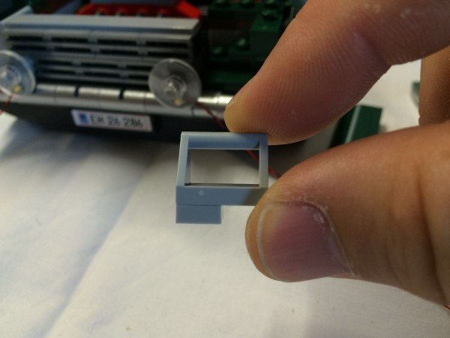
Look for the space underneath a black plate and above the green plate that is now visible. Feed the plug end of the fog lights through this gap.
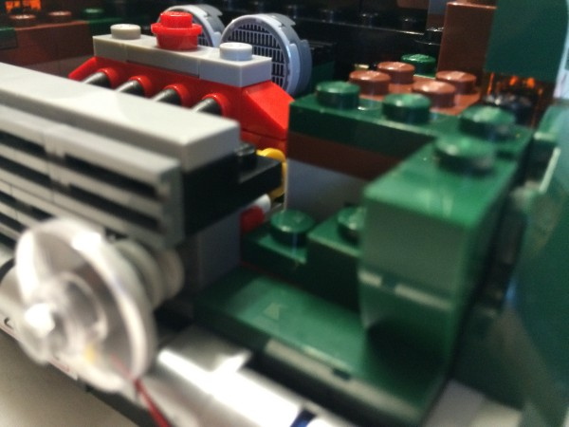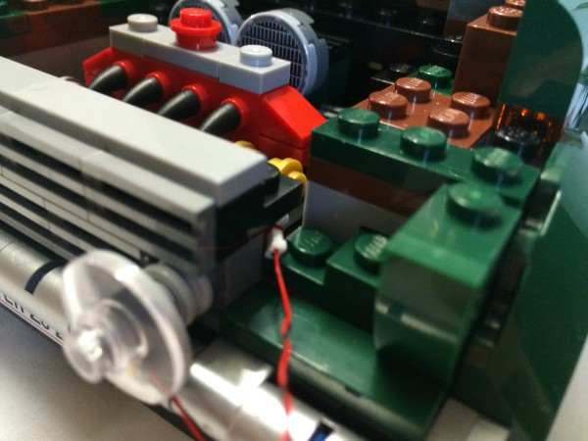
Pull the wire through and then replace the unusual looking grey piece.
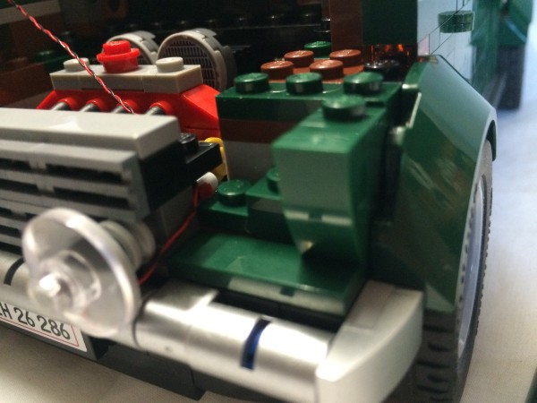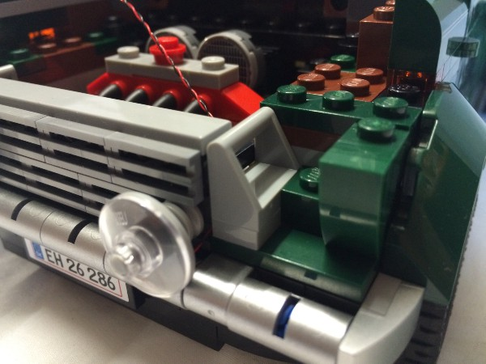
The transparent orange indicator lights that came with this model do not fit our lights underneath them. Get the transparent orange 1 x 1 round plates to use for the indicators.
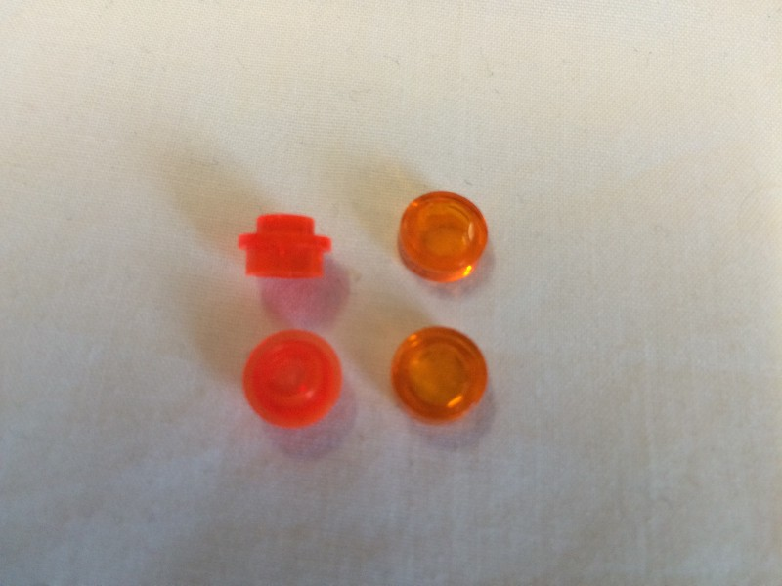
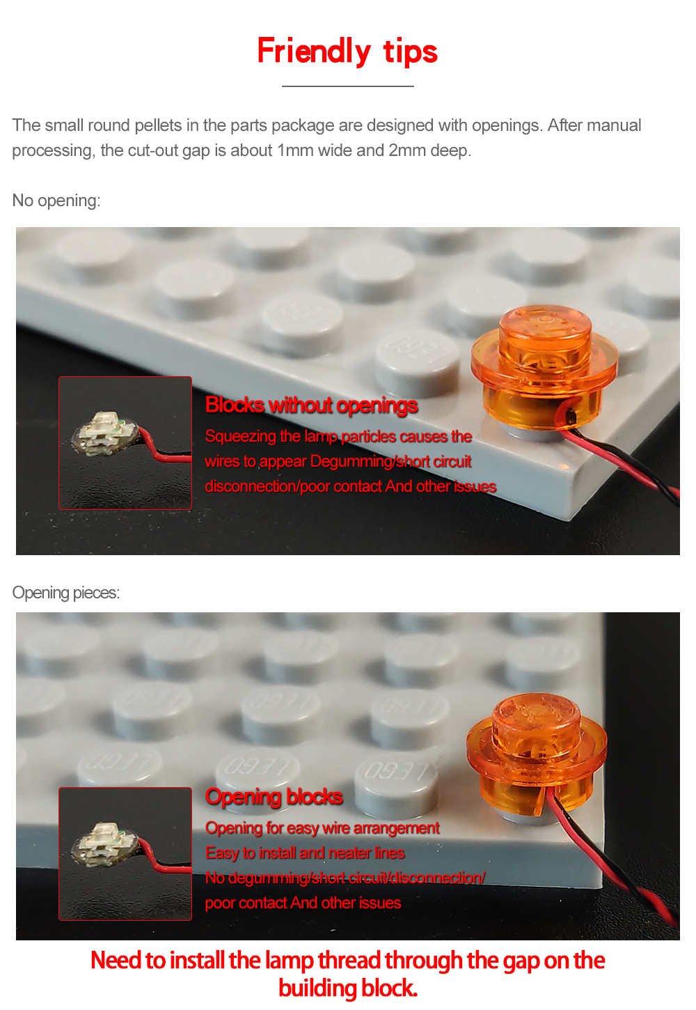

Pick up the indicator pieces the you removed earlier. Remove the transparent orange indicator plate.
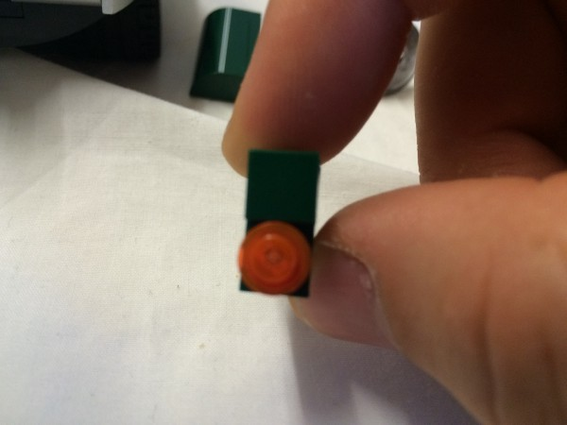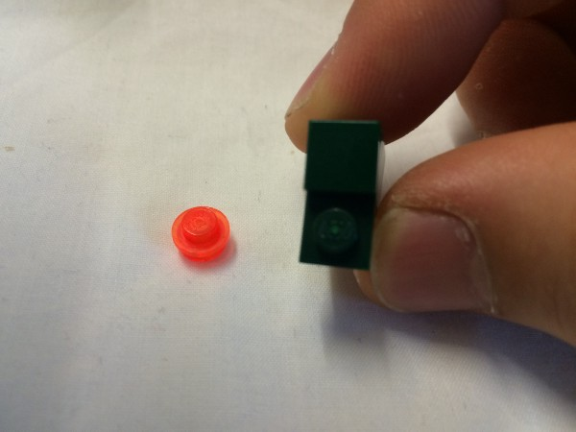

Grab a White Dot Light and hold it in place above the stud that is now exposed because the transparent orange piece was removed. Gently place a transparent orange 1 x 1 round plate over the White dot light.
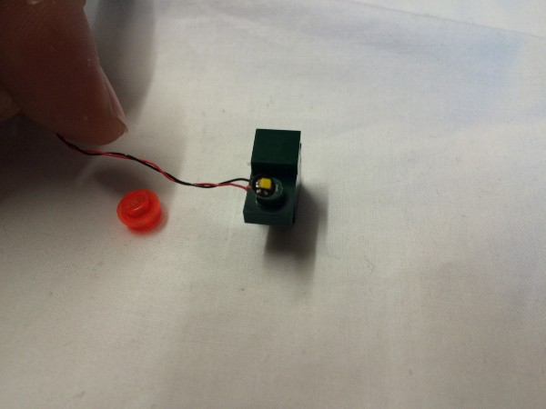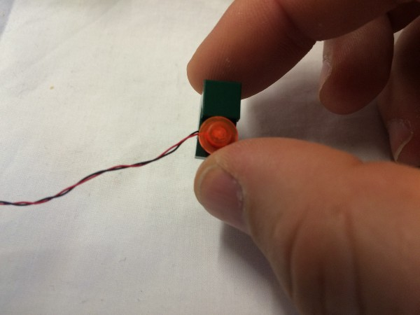
Feed the plug end of the White dot light through the unusual looking grey piece and pull it through as you return the indicator pieces to their position.
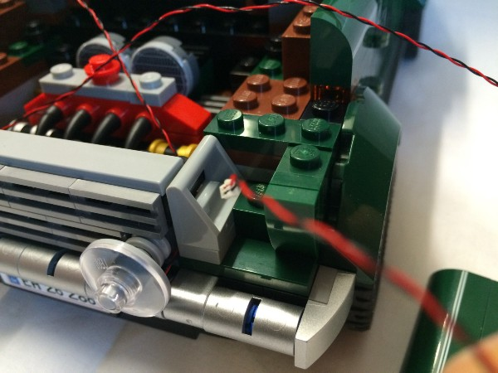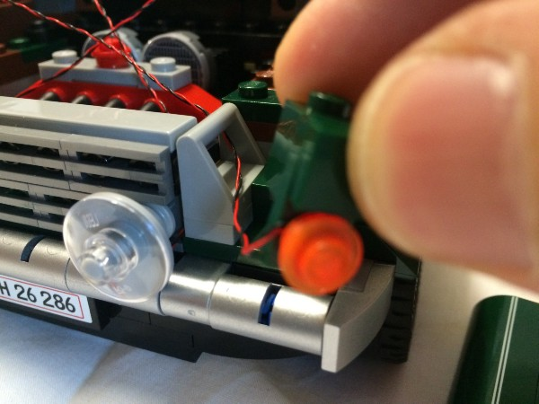
Fit the indicator pieces back in their position.
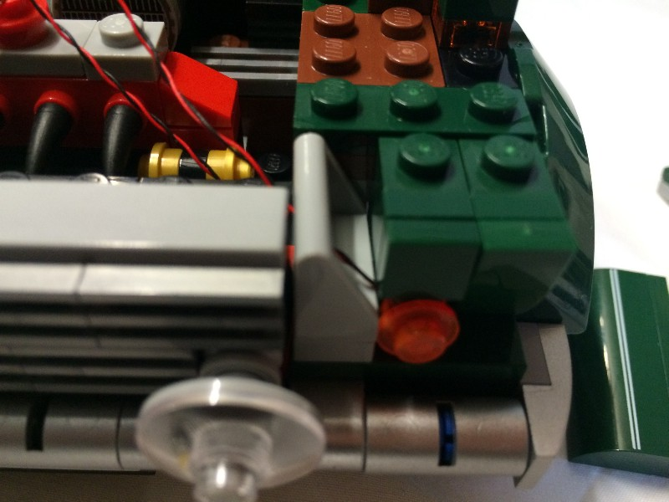

Replace the headlight and the plate and tile on top of it.
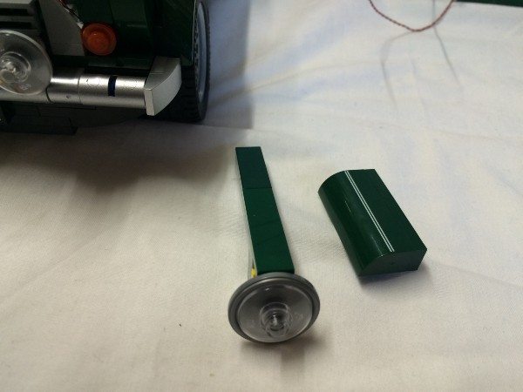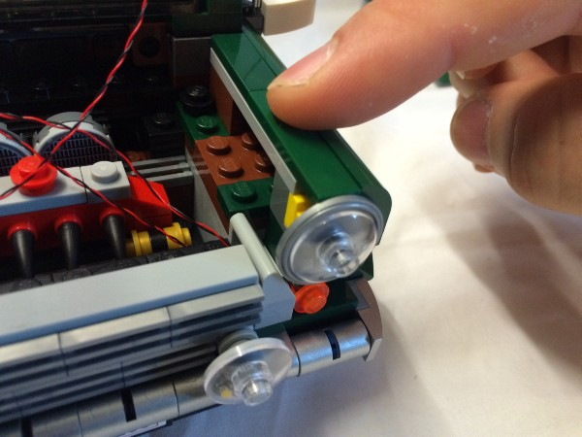
Remove the transparent clear dish pieces from both head lights.
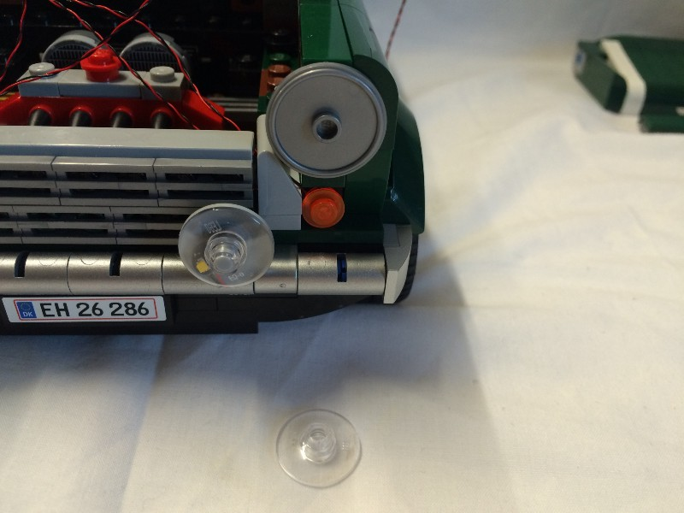

Grab a White dot light and hold it in the centre of the of the light grey shield piece that is still on the car. Hold it so that the wires coming vertically down.
Replace the transparent clear dish piece.
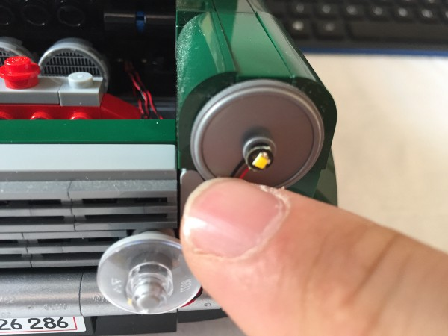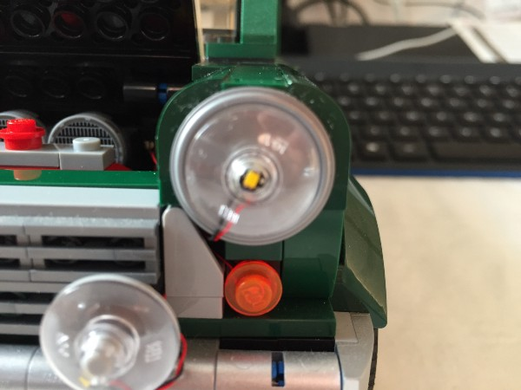

There is a small gap above the indicator where you can run the plug end of the headlight wire through the unusual looking grey piece.
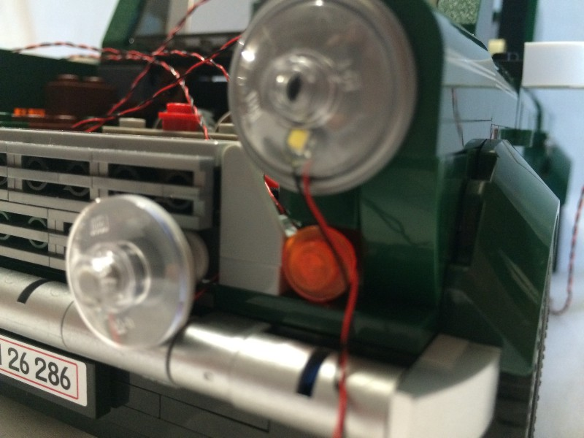
Run the wire through.
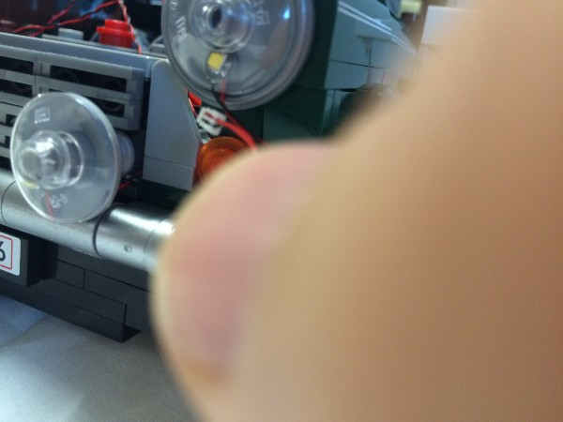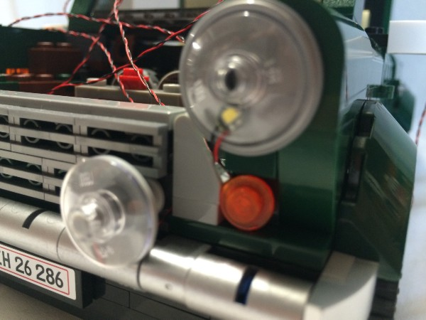
Now you should have 6 wires hanging out of the engine bay going all over the place!
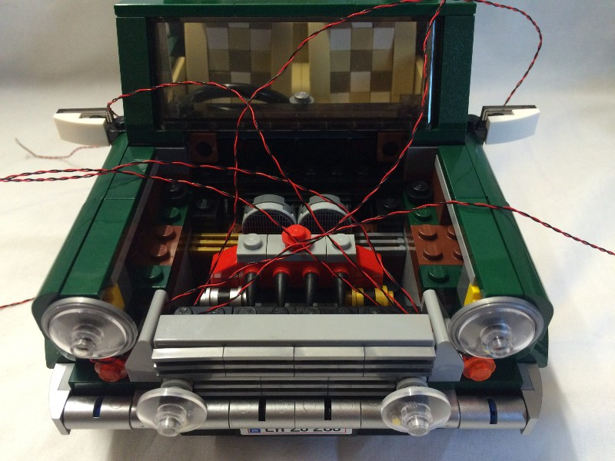

We are going to feed the wires through to the interior of the car. We are going to feed the three pairs of wires from lights on the right down the right hand side of the engine and into an existing gap in the “firewall”.
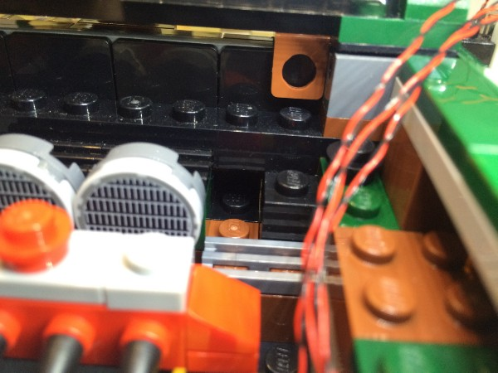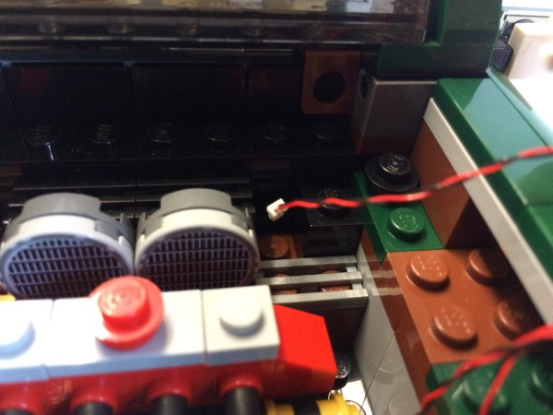

Look for the wire near the floor in the front of the car’s interior and pull it through when you can see it.
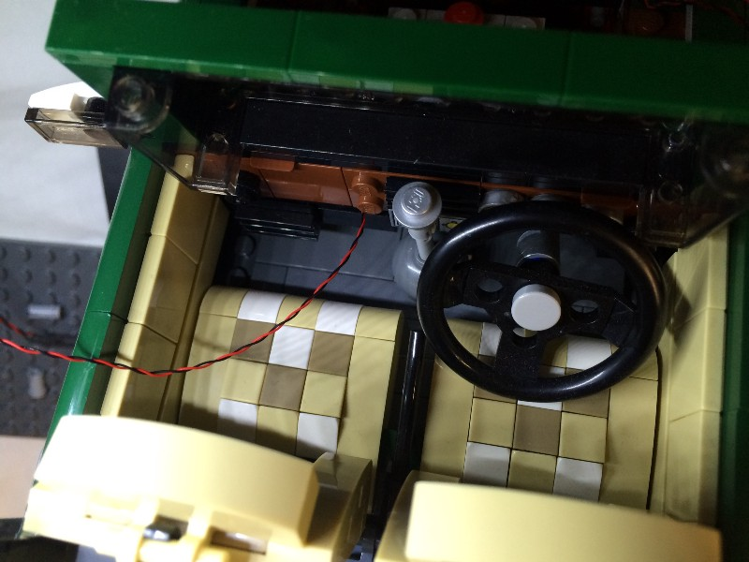
The left hand side looks a little different because the steering wheel is there. Look for the metallic silver technic piece that is part of the steering wheel assembly and feed the wires passed it.
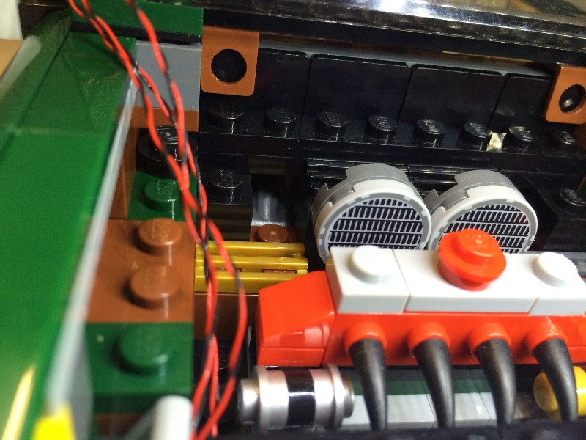
Once all the wires are pulled through, you should see that they all fit comfortably within the engine bay running down either side of the engine.
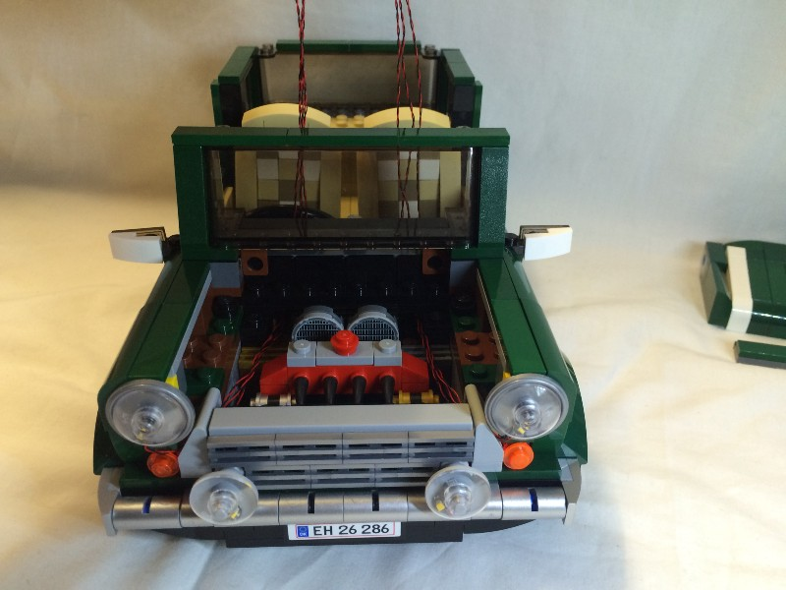
Replace the front piece with the two green 1 x 4 tiles on top then put the bonnet back on.
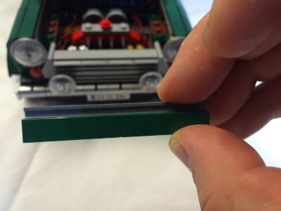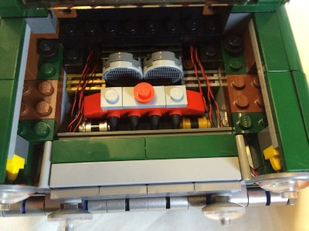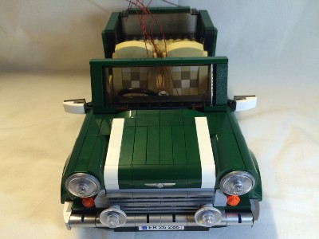
Now we want to run the wires to the underside of the car. We will do this by feeding them through the gaps on either side of the gear stick.
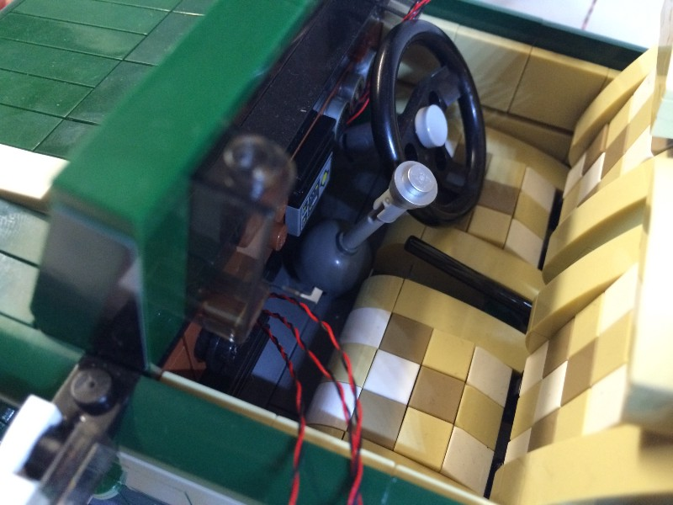
Remove the gear stick and feed the wires on the left hand side through the gap in the floor.
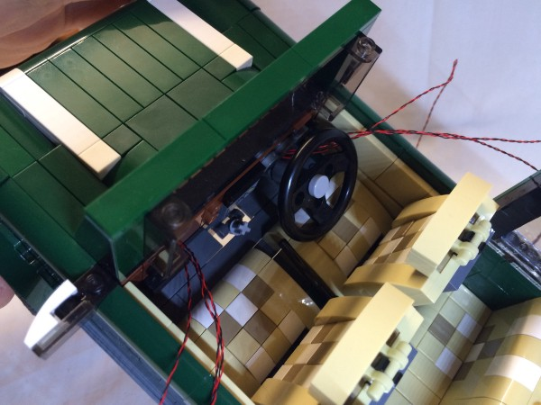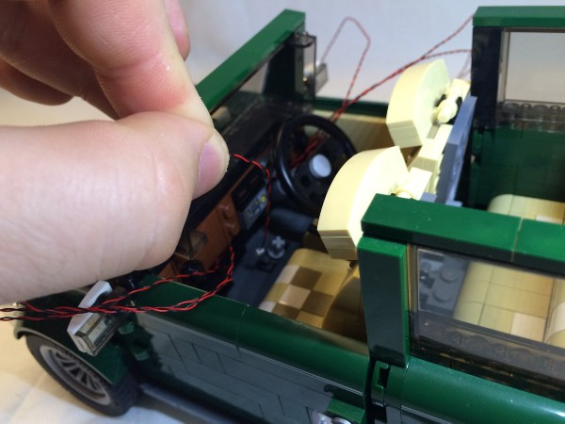
Pull them through the underside of the car.
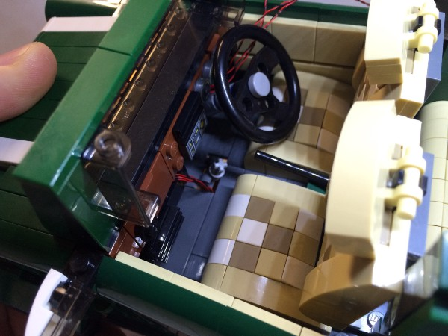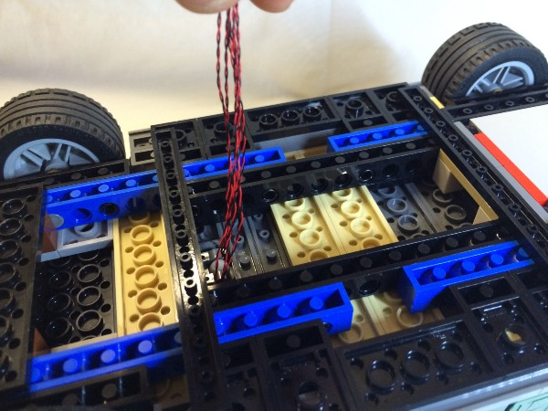
Remove the steering wheel and feed the wires on the right hand side of the car through the gap on the right hand side of the gear stick.
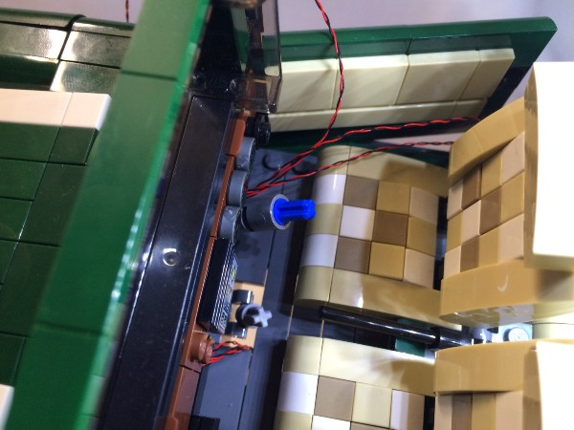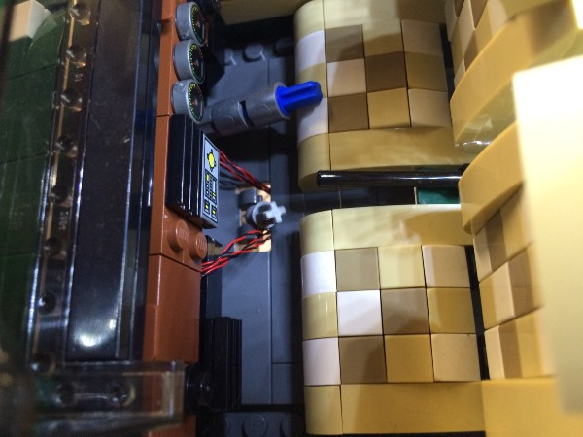
Replace the gear stick and the steering wheel.
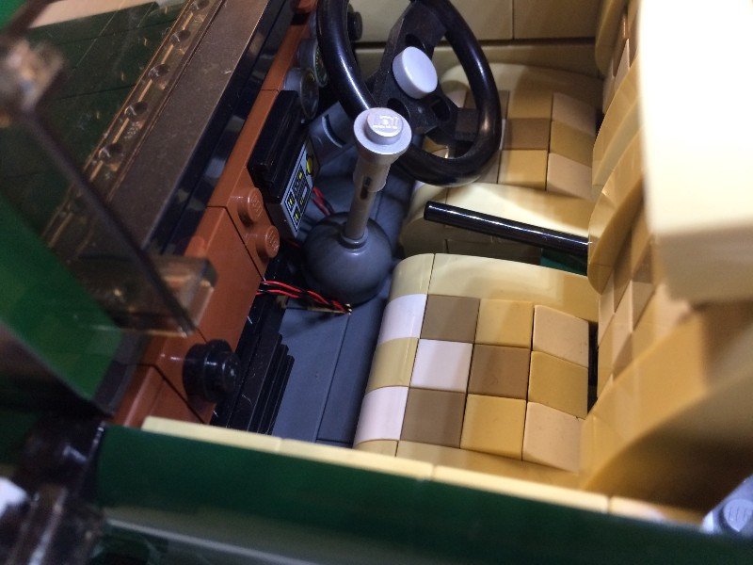

OK, let’s turn the vehicle around so that the back is facing you.
Open the boot and remove the contents (if you kept the picnic gear in the boot).
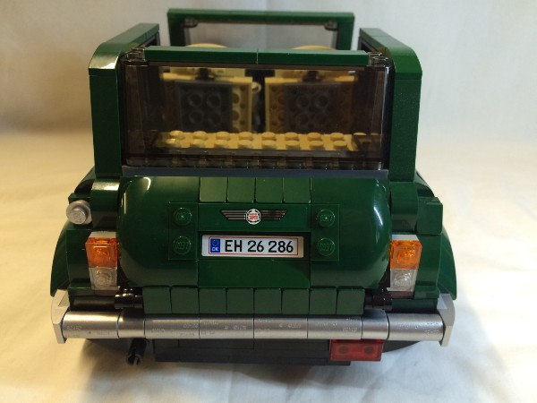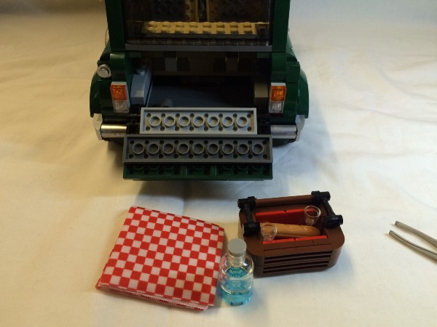
Now is the time to substitute the two 1 x 1 transparent red plates with the 1 x 2 transparent red plate.
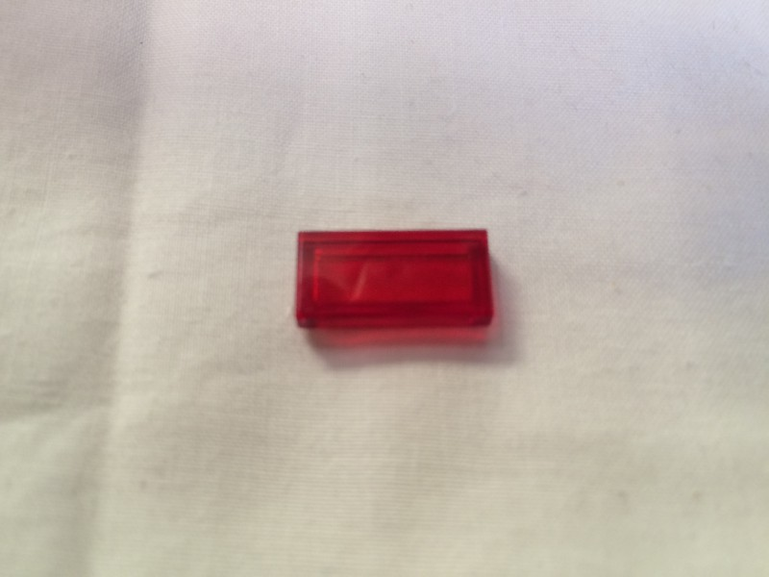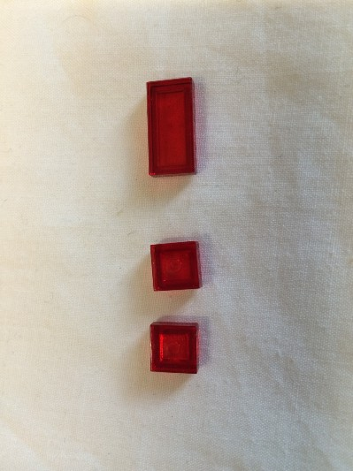
Remove the plate or plates that are representing the break light on the back of the car.
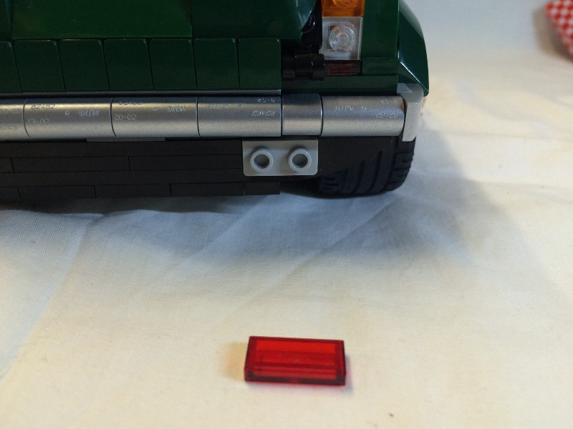

Grab a White dot light and feed the plug end up behind the bumper bar. The bumper bar has some flex and is easily bent out a dot to fit the plug through.
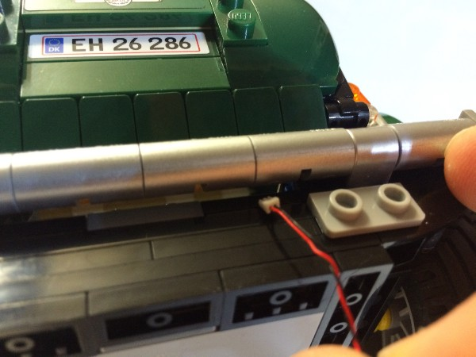
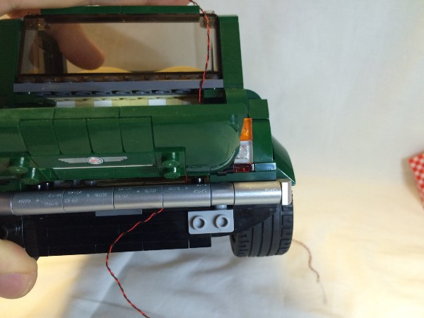

Hold the LED end of the White dot light in the centre of the two studs on the piece that the brake light came off. The White dot light will not sit flush and will be in a slight angle.
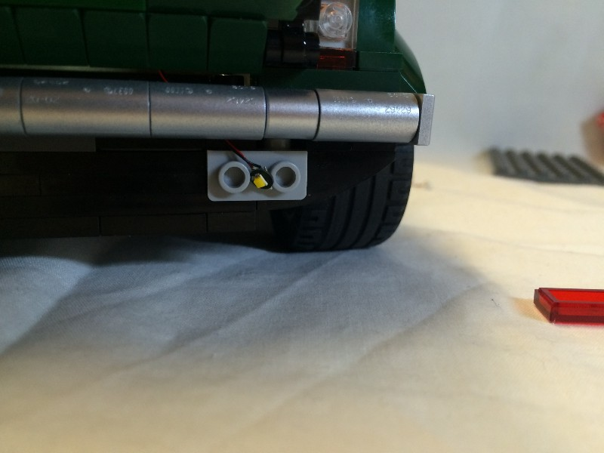
When you replace the transparent red brake light piece, it will only close over about half of the stud leaving an obvious gap if you look closely. Carefully replace the transparent red piece brake light piece.
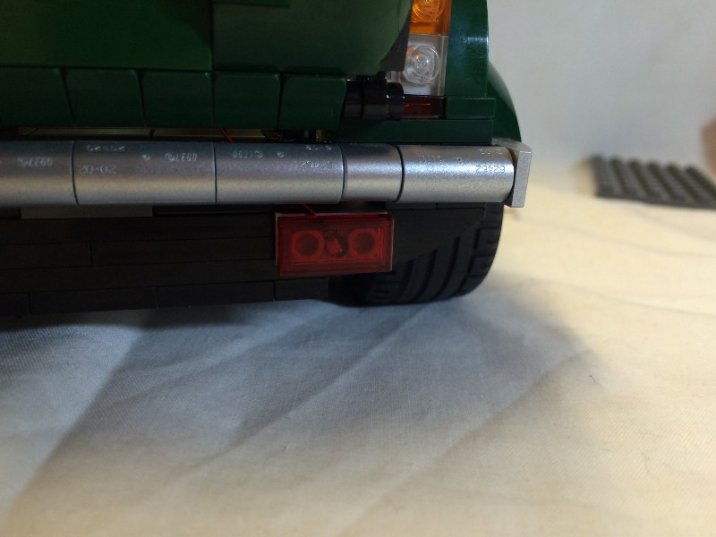
Let the wire from the brake light run out the back of the boot. Remove the transparent orange 1 x 1 plates that represent indicator pieces from the back of the car.
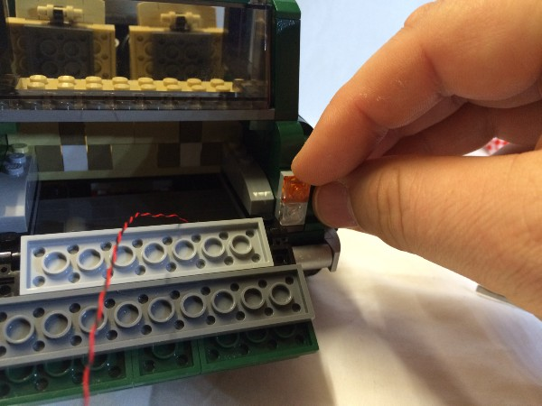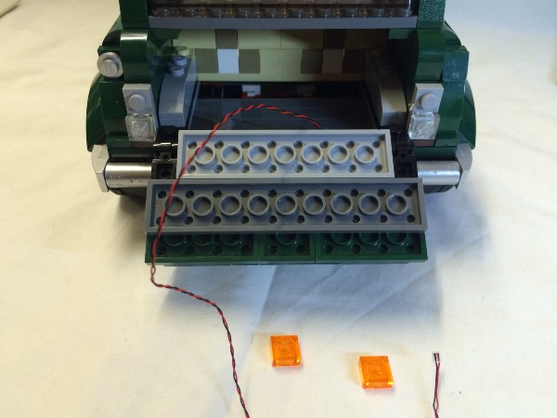

For each indicator, grab a White dot light and hold it in the centre of the stud that the transparent orange plate was removed from. The gently replace the transparent orange brick over the White dot light.
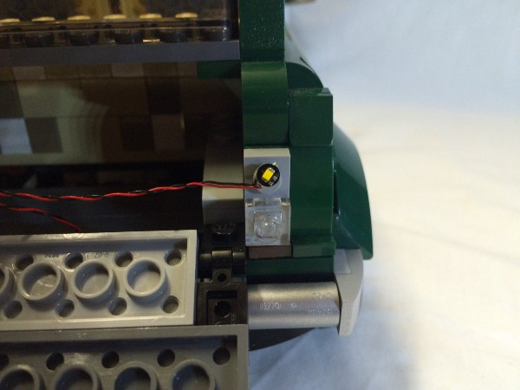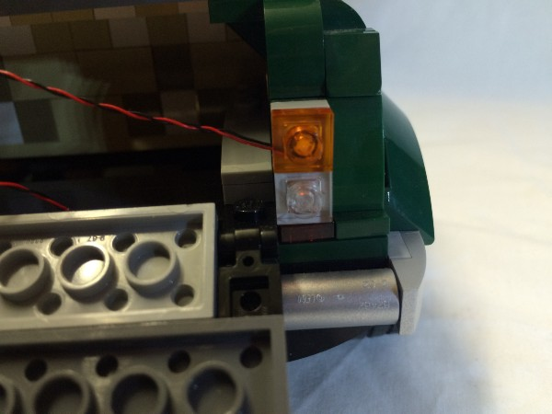

Now you will have three sets of White dot light wires hanging out the back of the car.
Lift up the grey floor of the boot (the dot that covers the spare wheel) until you have enough of it to hold on to. Twist it and pull it out.
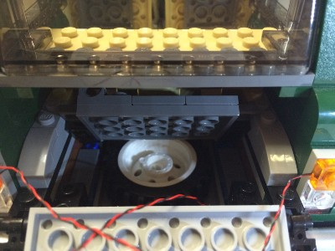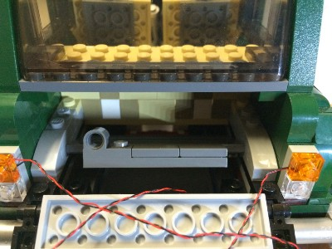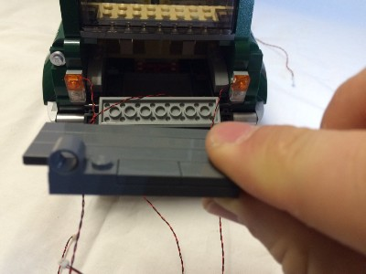
Take the spare wheel out.
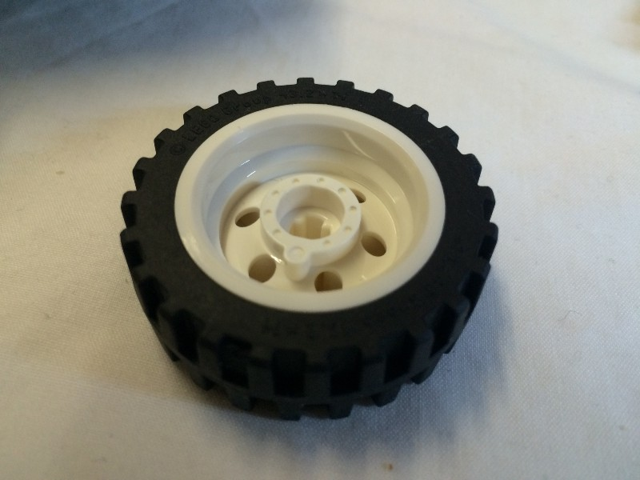
Looking inside the boot and under the back seat, you will see some white clip pieces holding a couple of red hinge pieces. Immediately behind that is a hole where you might see some light come through if you lift the car a dot. Feed the White dot light wires through the hole and look for them on the underside of the car.
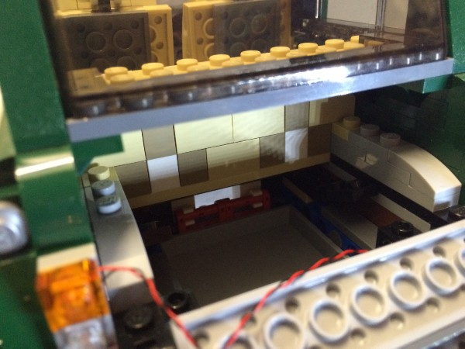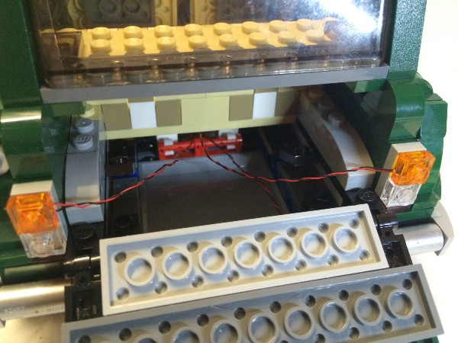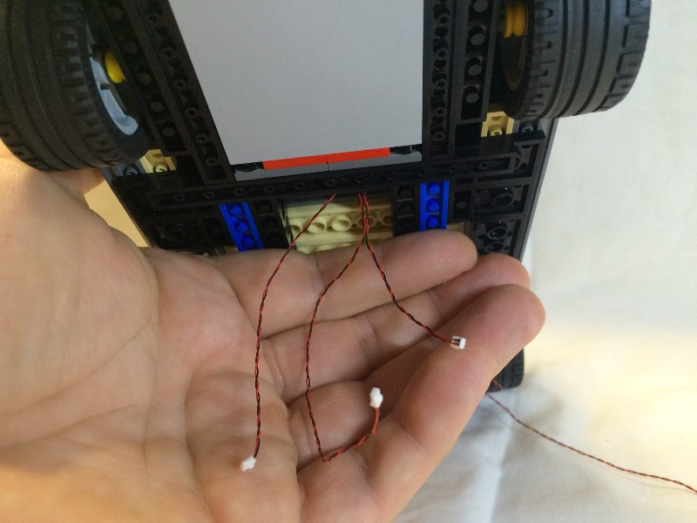
Grab the Coin Cell Battery Pack and feed the plug end of the wires through the same gap.
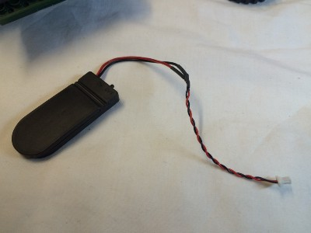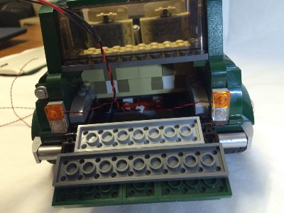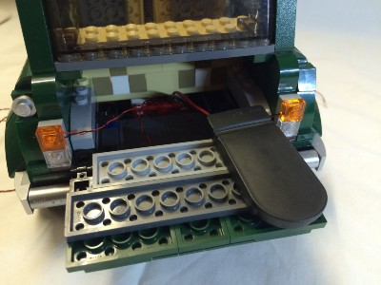
Let the Coin Cell Battery Pack rest in the boot. Close the boot and rest the car on its side so you can access the bottom of the car.
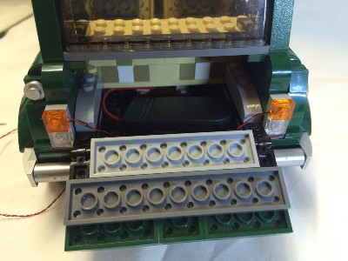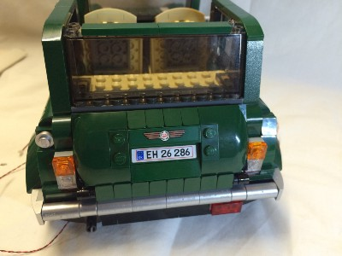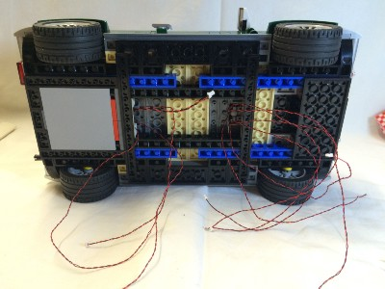
Grab the 12 Port Expansion Board and connect each of the nine wires anf the battery pack to the board.
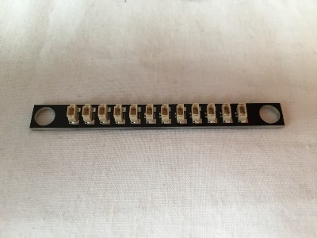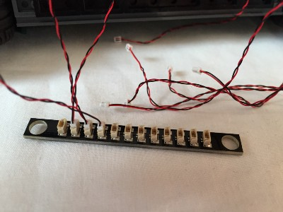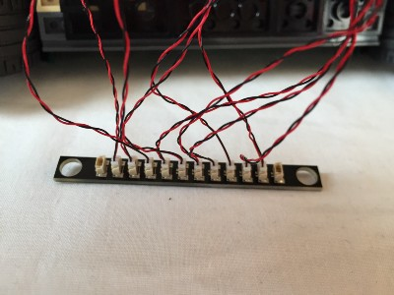
Grab the two 1/2L Technic pins, get them now and working from the bottom of the 1:9 Expansion Board place the short end up through the holes on either side of the 1:9 Expansion Board.
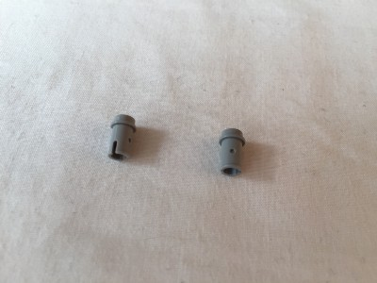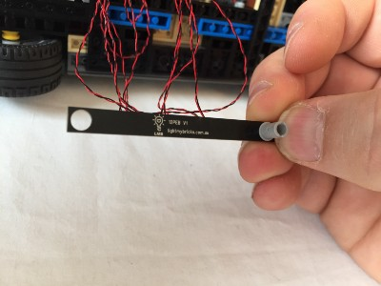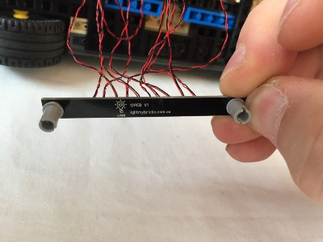

Now fix the 12 Port Expansion Board to the black technic brick running along the side of the exposed centre section underneath the car.
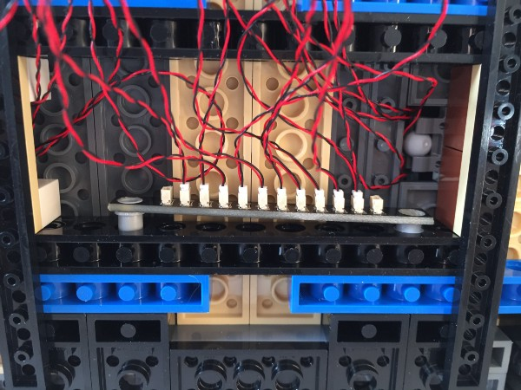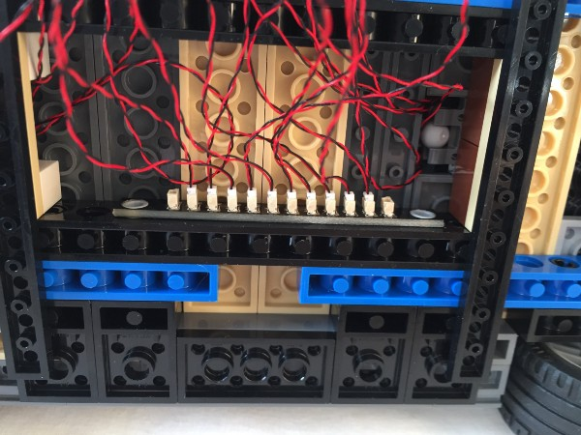

Gather the wires together and work them until they are contained within the exposed centre section underneath the car, between the two black technic bricks. Have your 6 x 10 plate ready.
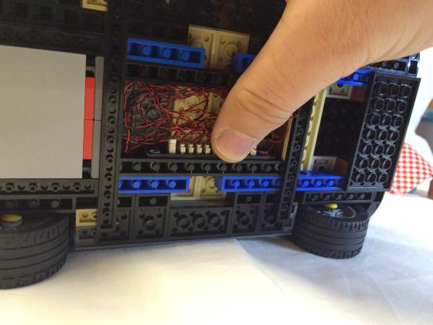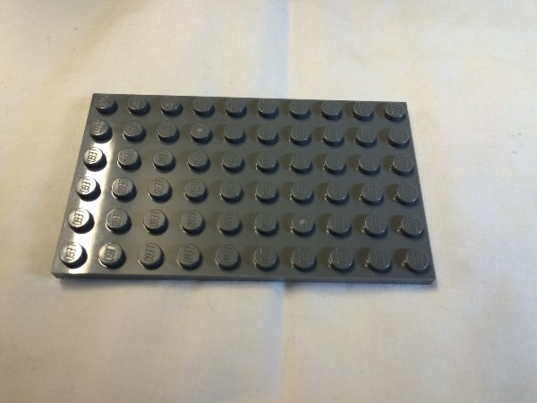

With the wires contained as seen above, the 6 x 10 plate will cover the exposed centre section and keep the wires inside.
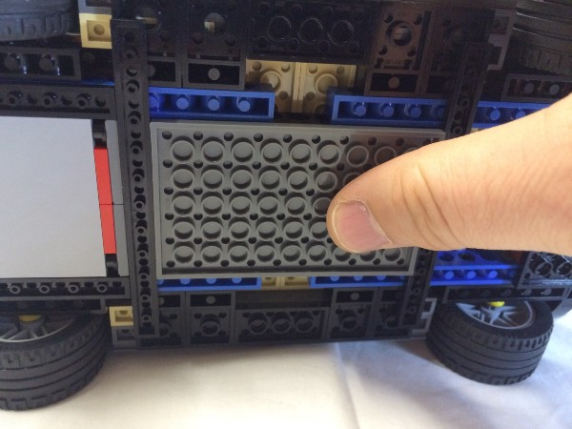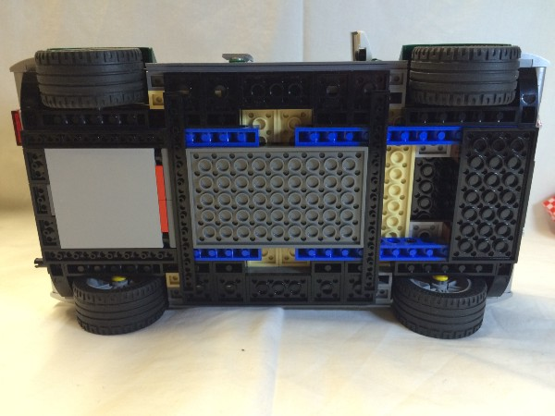

Turn the car upright again and have the back of the car facing you. Open the boot to reveal the battery pack.
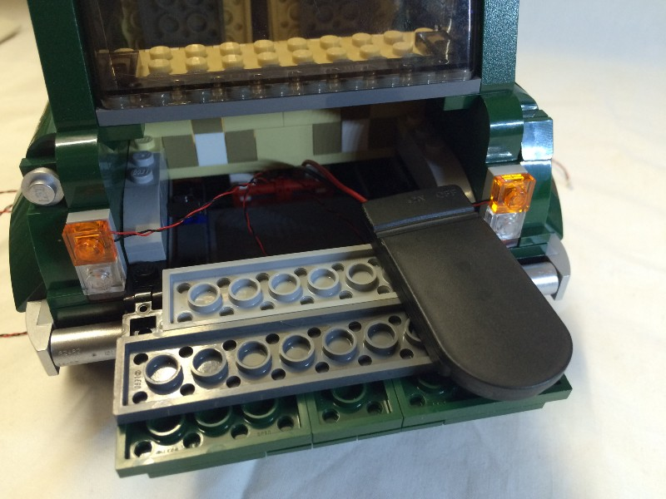
Holding the Coin Cell Battery Pack up and out of the way, replace the spare wheel. If you want to keep things as neat as possible, pull the wires from the lights back towards you a little dot so there is a good dot of slack. Place the spare wheel down on top of the wires from the lights.
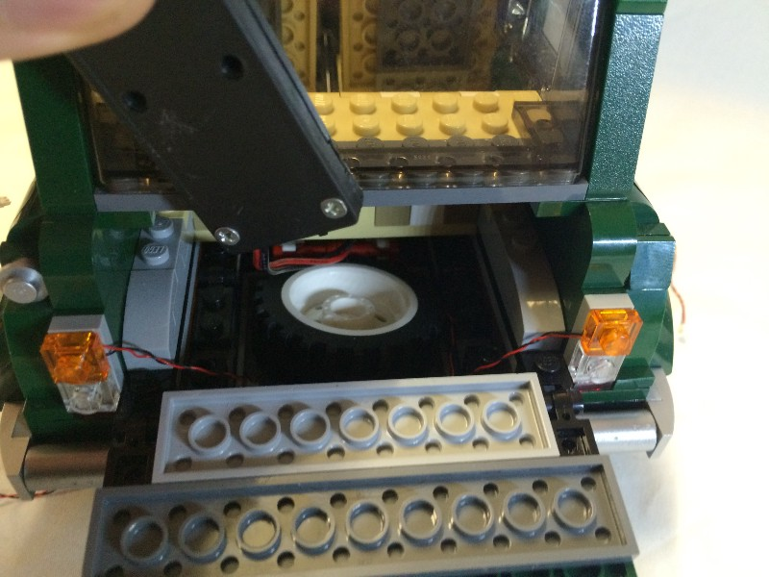
Still holding the Coin Cell Battery Pack up and out of the way, refit the floor section of the boot.
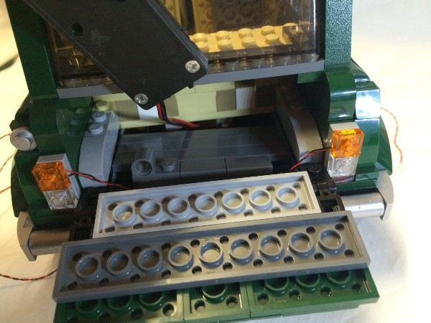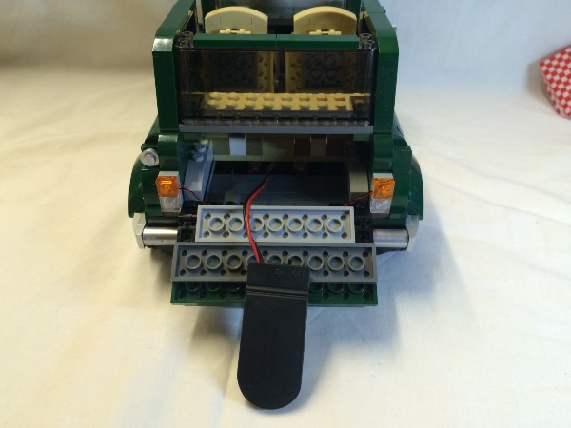

Flick the switch on the Coin Cell Battery Pack and light her up!
The picnic basket, blanket and drink can all still fit in the boot!
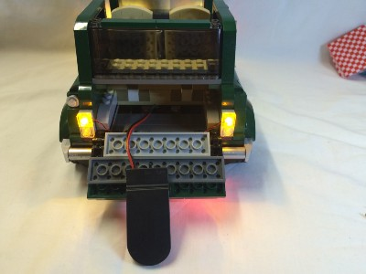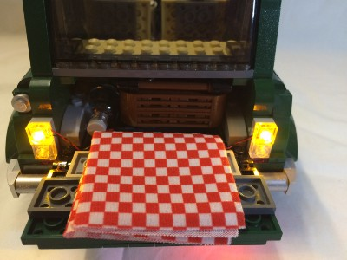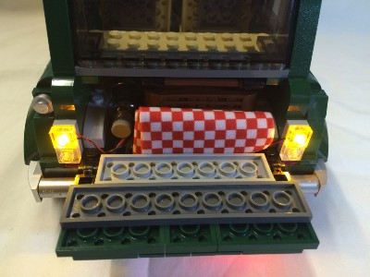
Just pop the roof back on and you are done……enjoy!
