Ferrari F40 LED Lighting Kit

Package contents:
- 10x White 15cm Dot Lights
- 1x 6-port Expansion Board
- 1x 8-port Expansion Board
- 1x 30cm Connecting Cable
- 1 x Round Battery Pack (2x CR2032 Batteries Required)
- 6x Adhesive Squares
Extra Plate Pieces
- 2x Plate 1x2 Red
- 4x Plate 1x1 Trans Clear
- 2x Round Tile 1x1 Trans Red
- 2x Round Tile 1x1 Trans Orange
Note:
Place wires on the surface or under the building blocks.
The wire can be place between the building blocks or under the block, but they should be placed between the studs correctly.
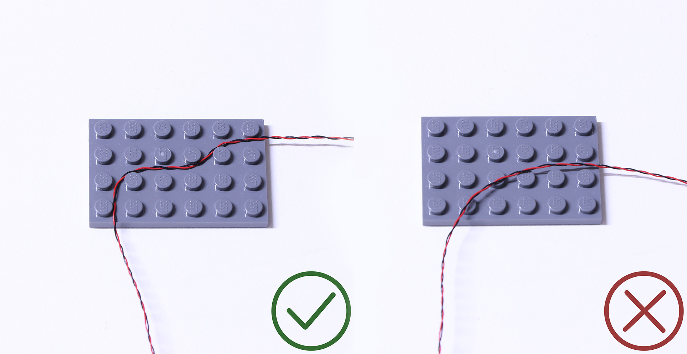
Insert the connectors to the ports.

Be careful when you are operating, there’s only one correct way to insert, make sure the expansion board is upward, find the soldered “=” sign on the left of the port. When you are inserting, the side which the wires can be seen should be faced to the “=” sign and if you feel hard to insert, please stop, and don’t force it, for that may result in bent pins inside the port or overheating of the expansion board.
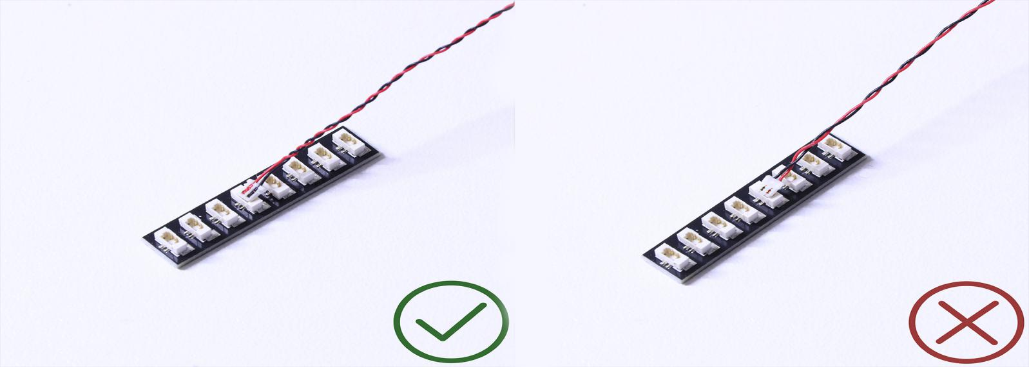

At this point, use the tweezers to straighten the bent pins.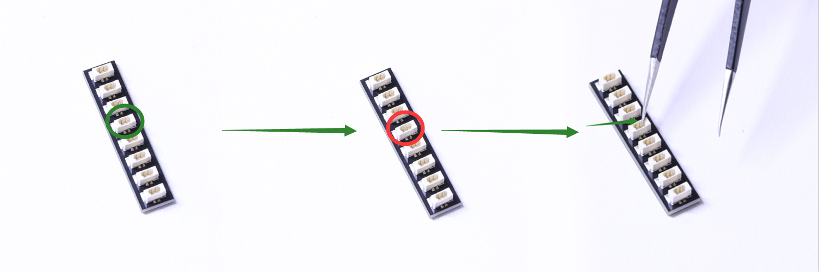
When installing dot lights, make sure they are correctly placed (Yellow LED package is exposed). You can put they either on the top of the studs or between studs.

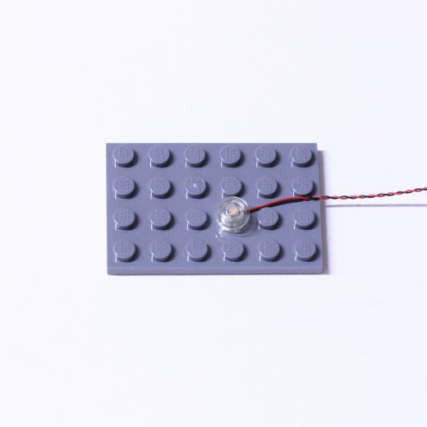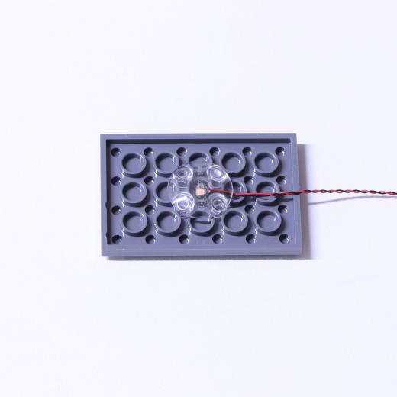

Connecting cable connectors to Strip Lights

Take extra care when inserting connectors to ports on the Strip Lights. Connectors can be inserted only one way. With the Strip Light facing up, ensure the side of the connector with the wires exposed is facing down. If a plug won’t fit easily into a port connector, don’t force it. Doing so will damage the plug and the connector.
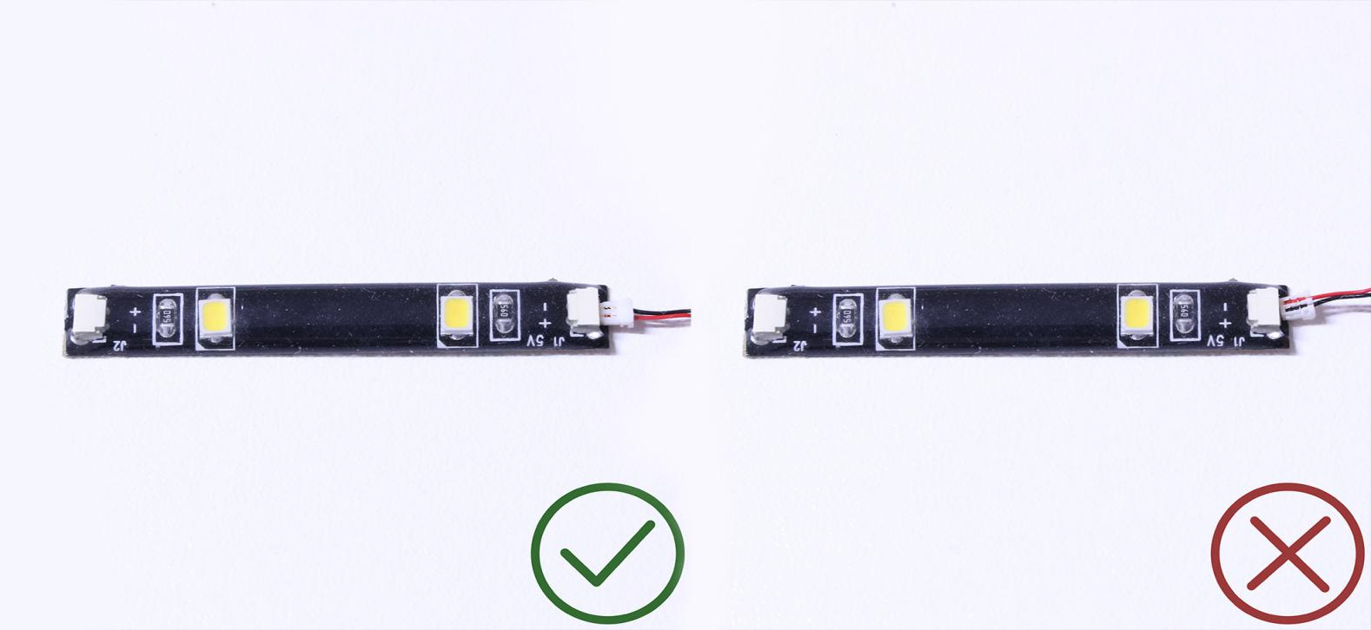
Finally, please pay attention to the positive and negative terminals of the battery when installing the battery case.
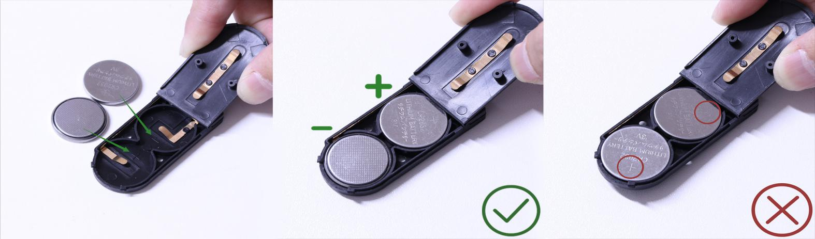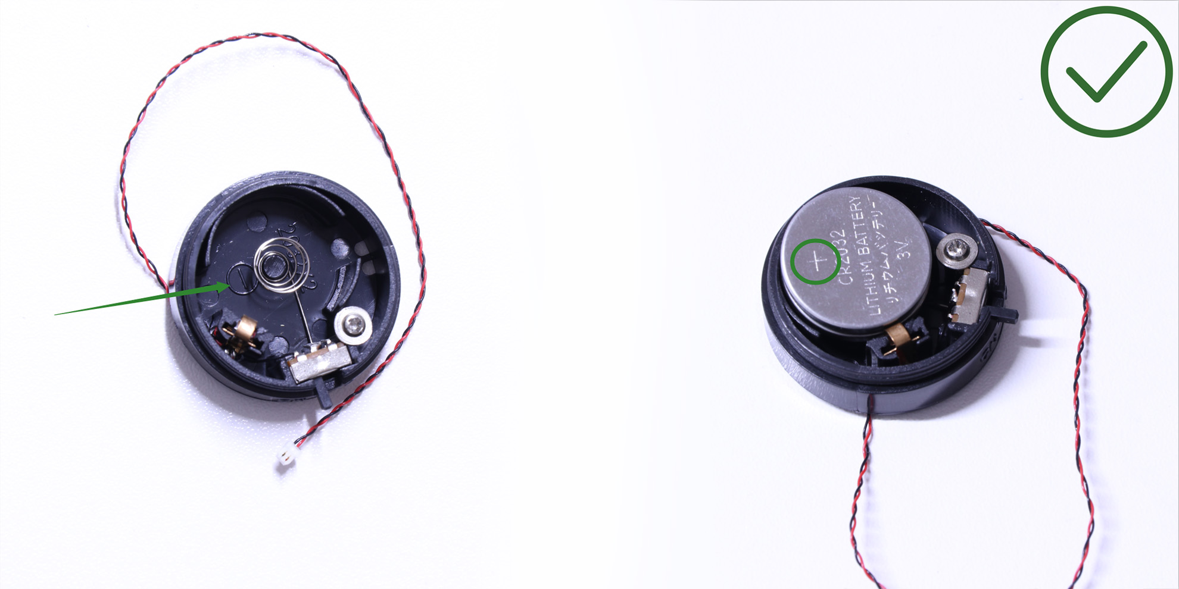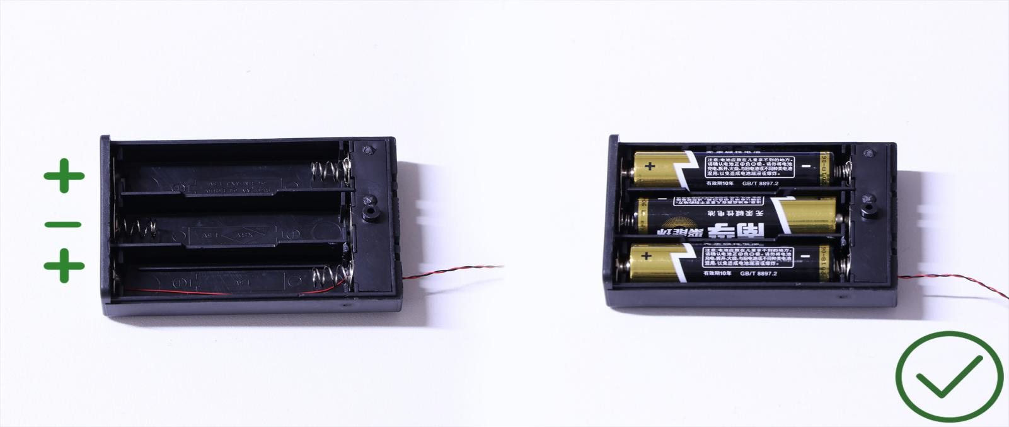OK, Let’s Begin!

Instructions for installing this kit
1.) We will start with installation of the headlights. Lift each section up and then remove the following pieces.
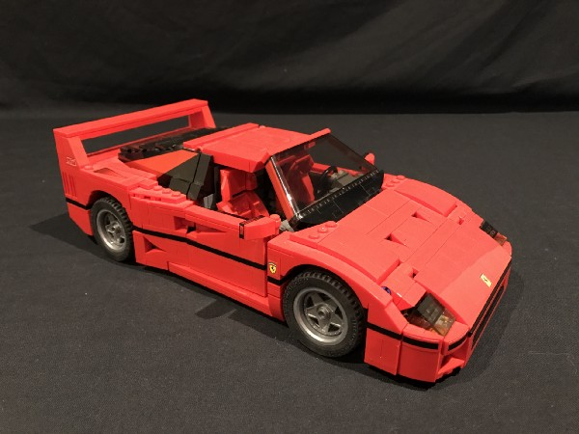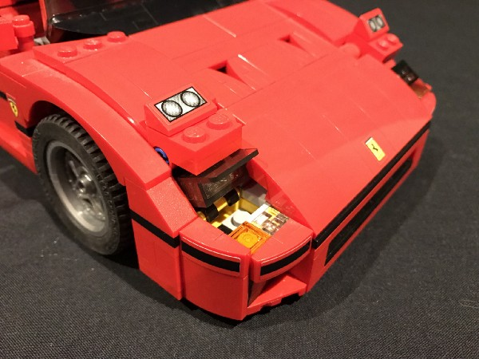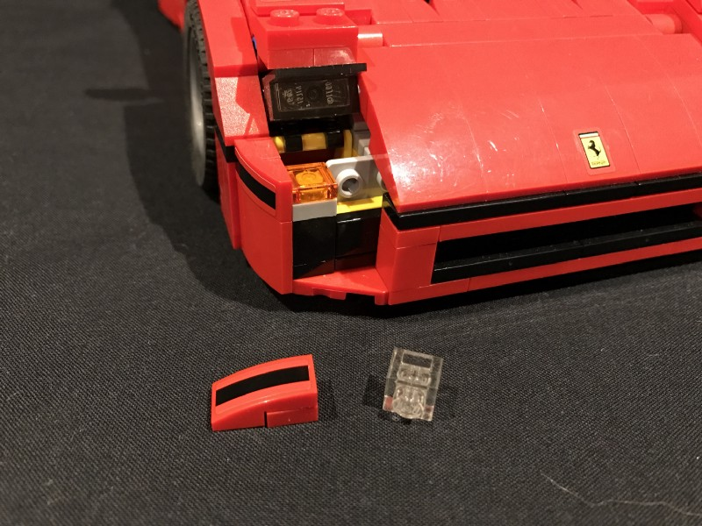

Take a White 15cm Dot Light and then place it directly over the light grey stud as per below. Ensure the cable is facing behind before reconnectong the trans clear plates over the top to secure the Dot Light in place.
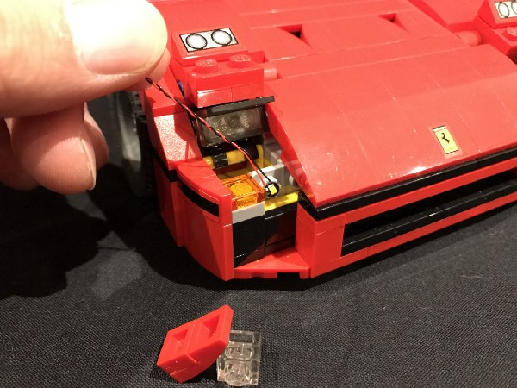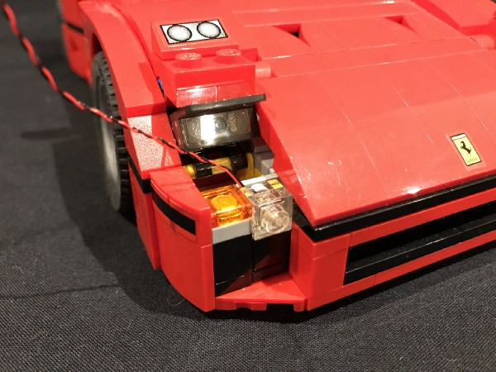
Thread the other end of the cable through to behind and then lift up the bonnet to pull the cable through.
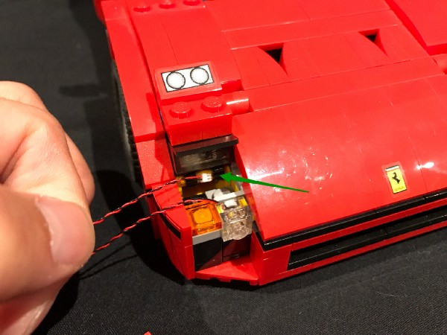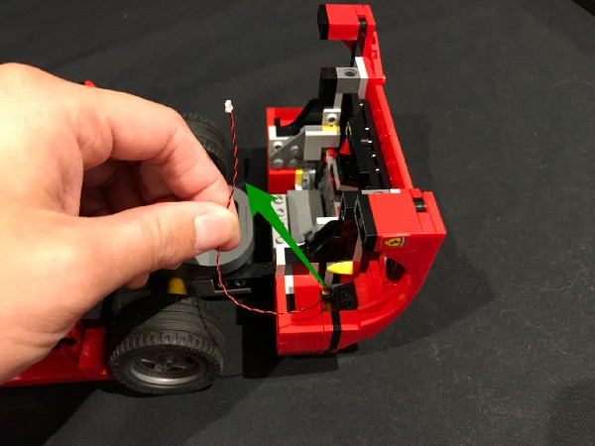

Close the bonnet and ensure cable is neatly placed as per below.
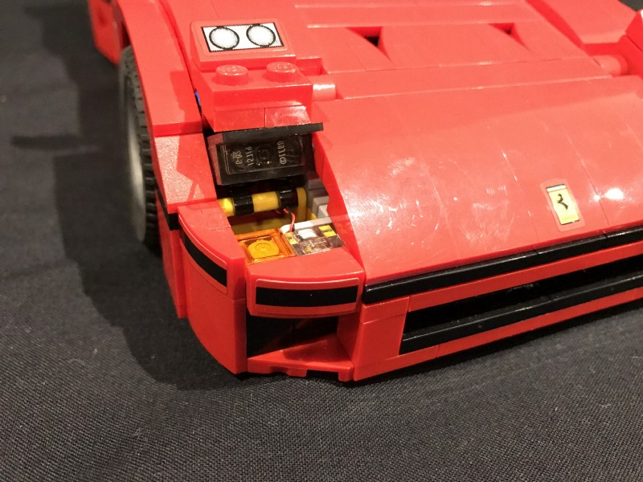
- ) Use the above method to install another White 15cm Dot Light to the right side.
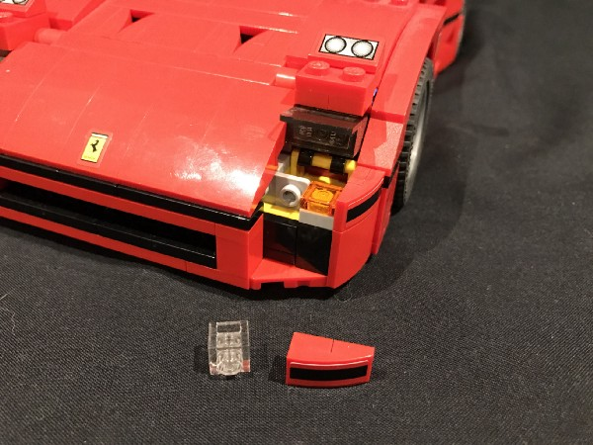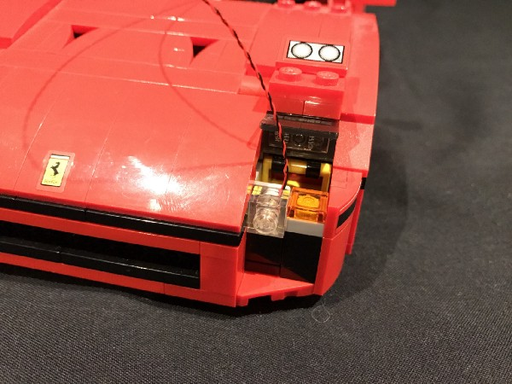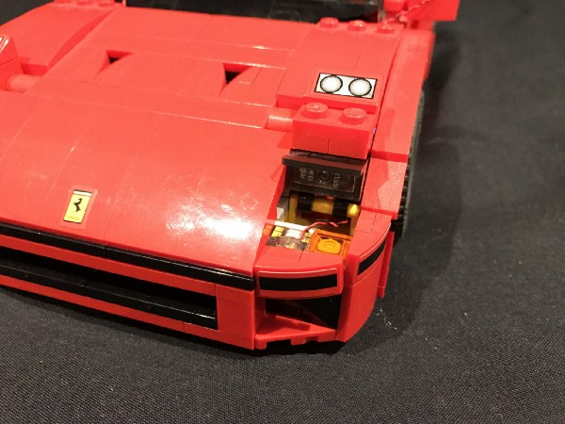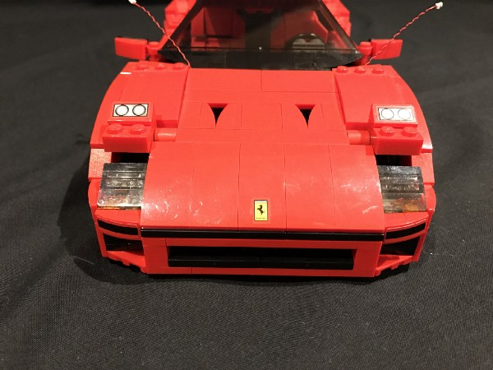
- ) We will now install the main headlights. Remove the following pieces from the left side to allow you to remove the head light section:
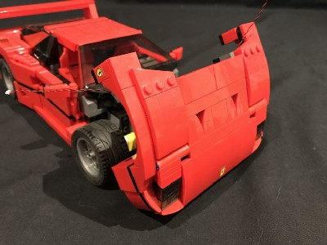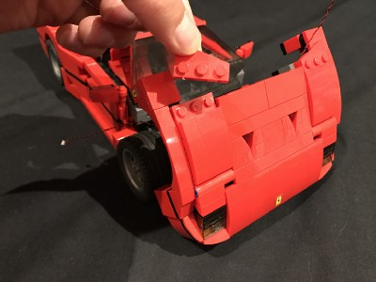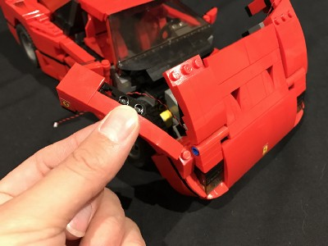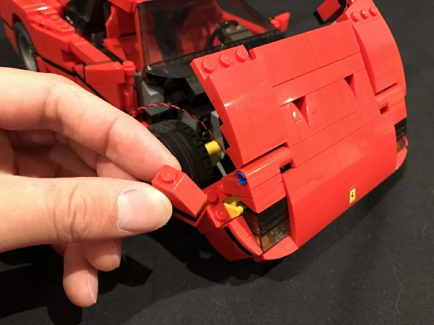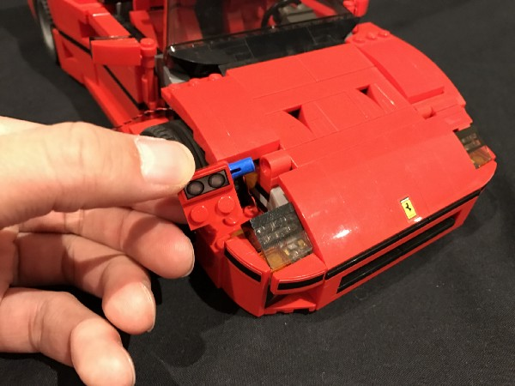

Remove the same pieces from the right side to allow you to remove the 2nd headlight section.
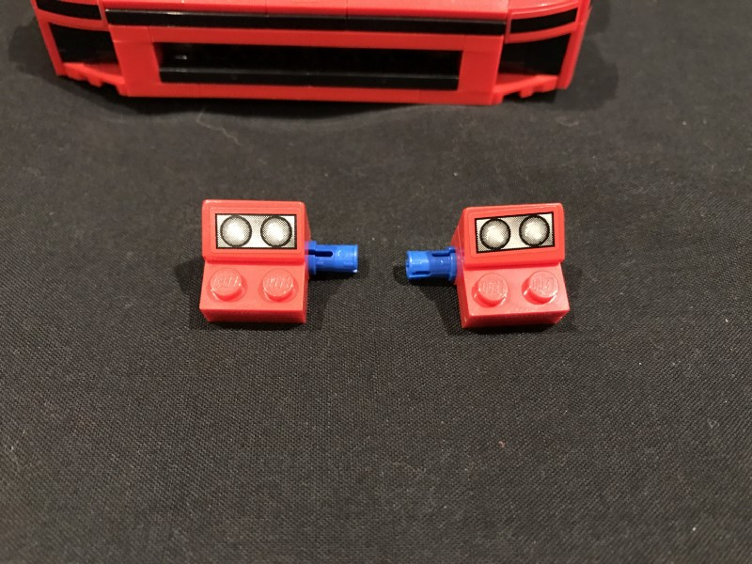
Disassemble pieces and have the following pieces from this light kit ready:
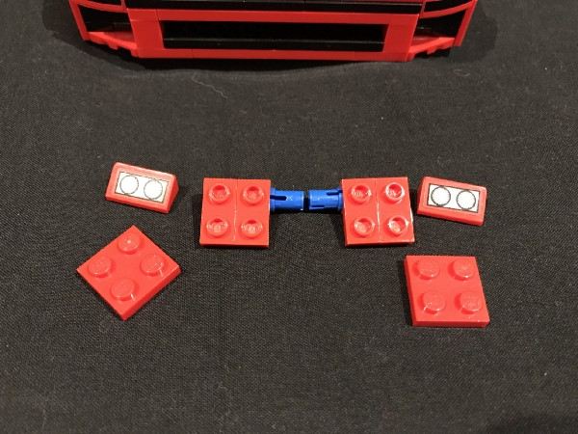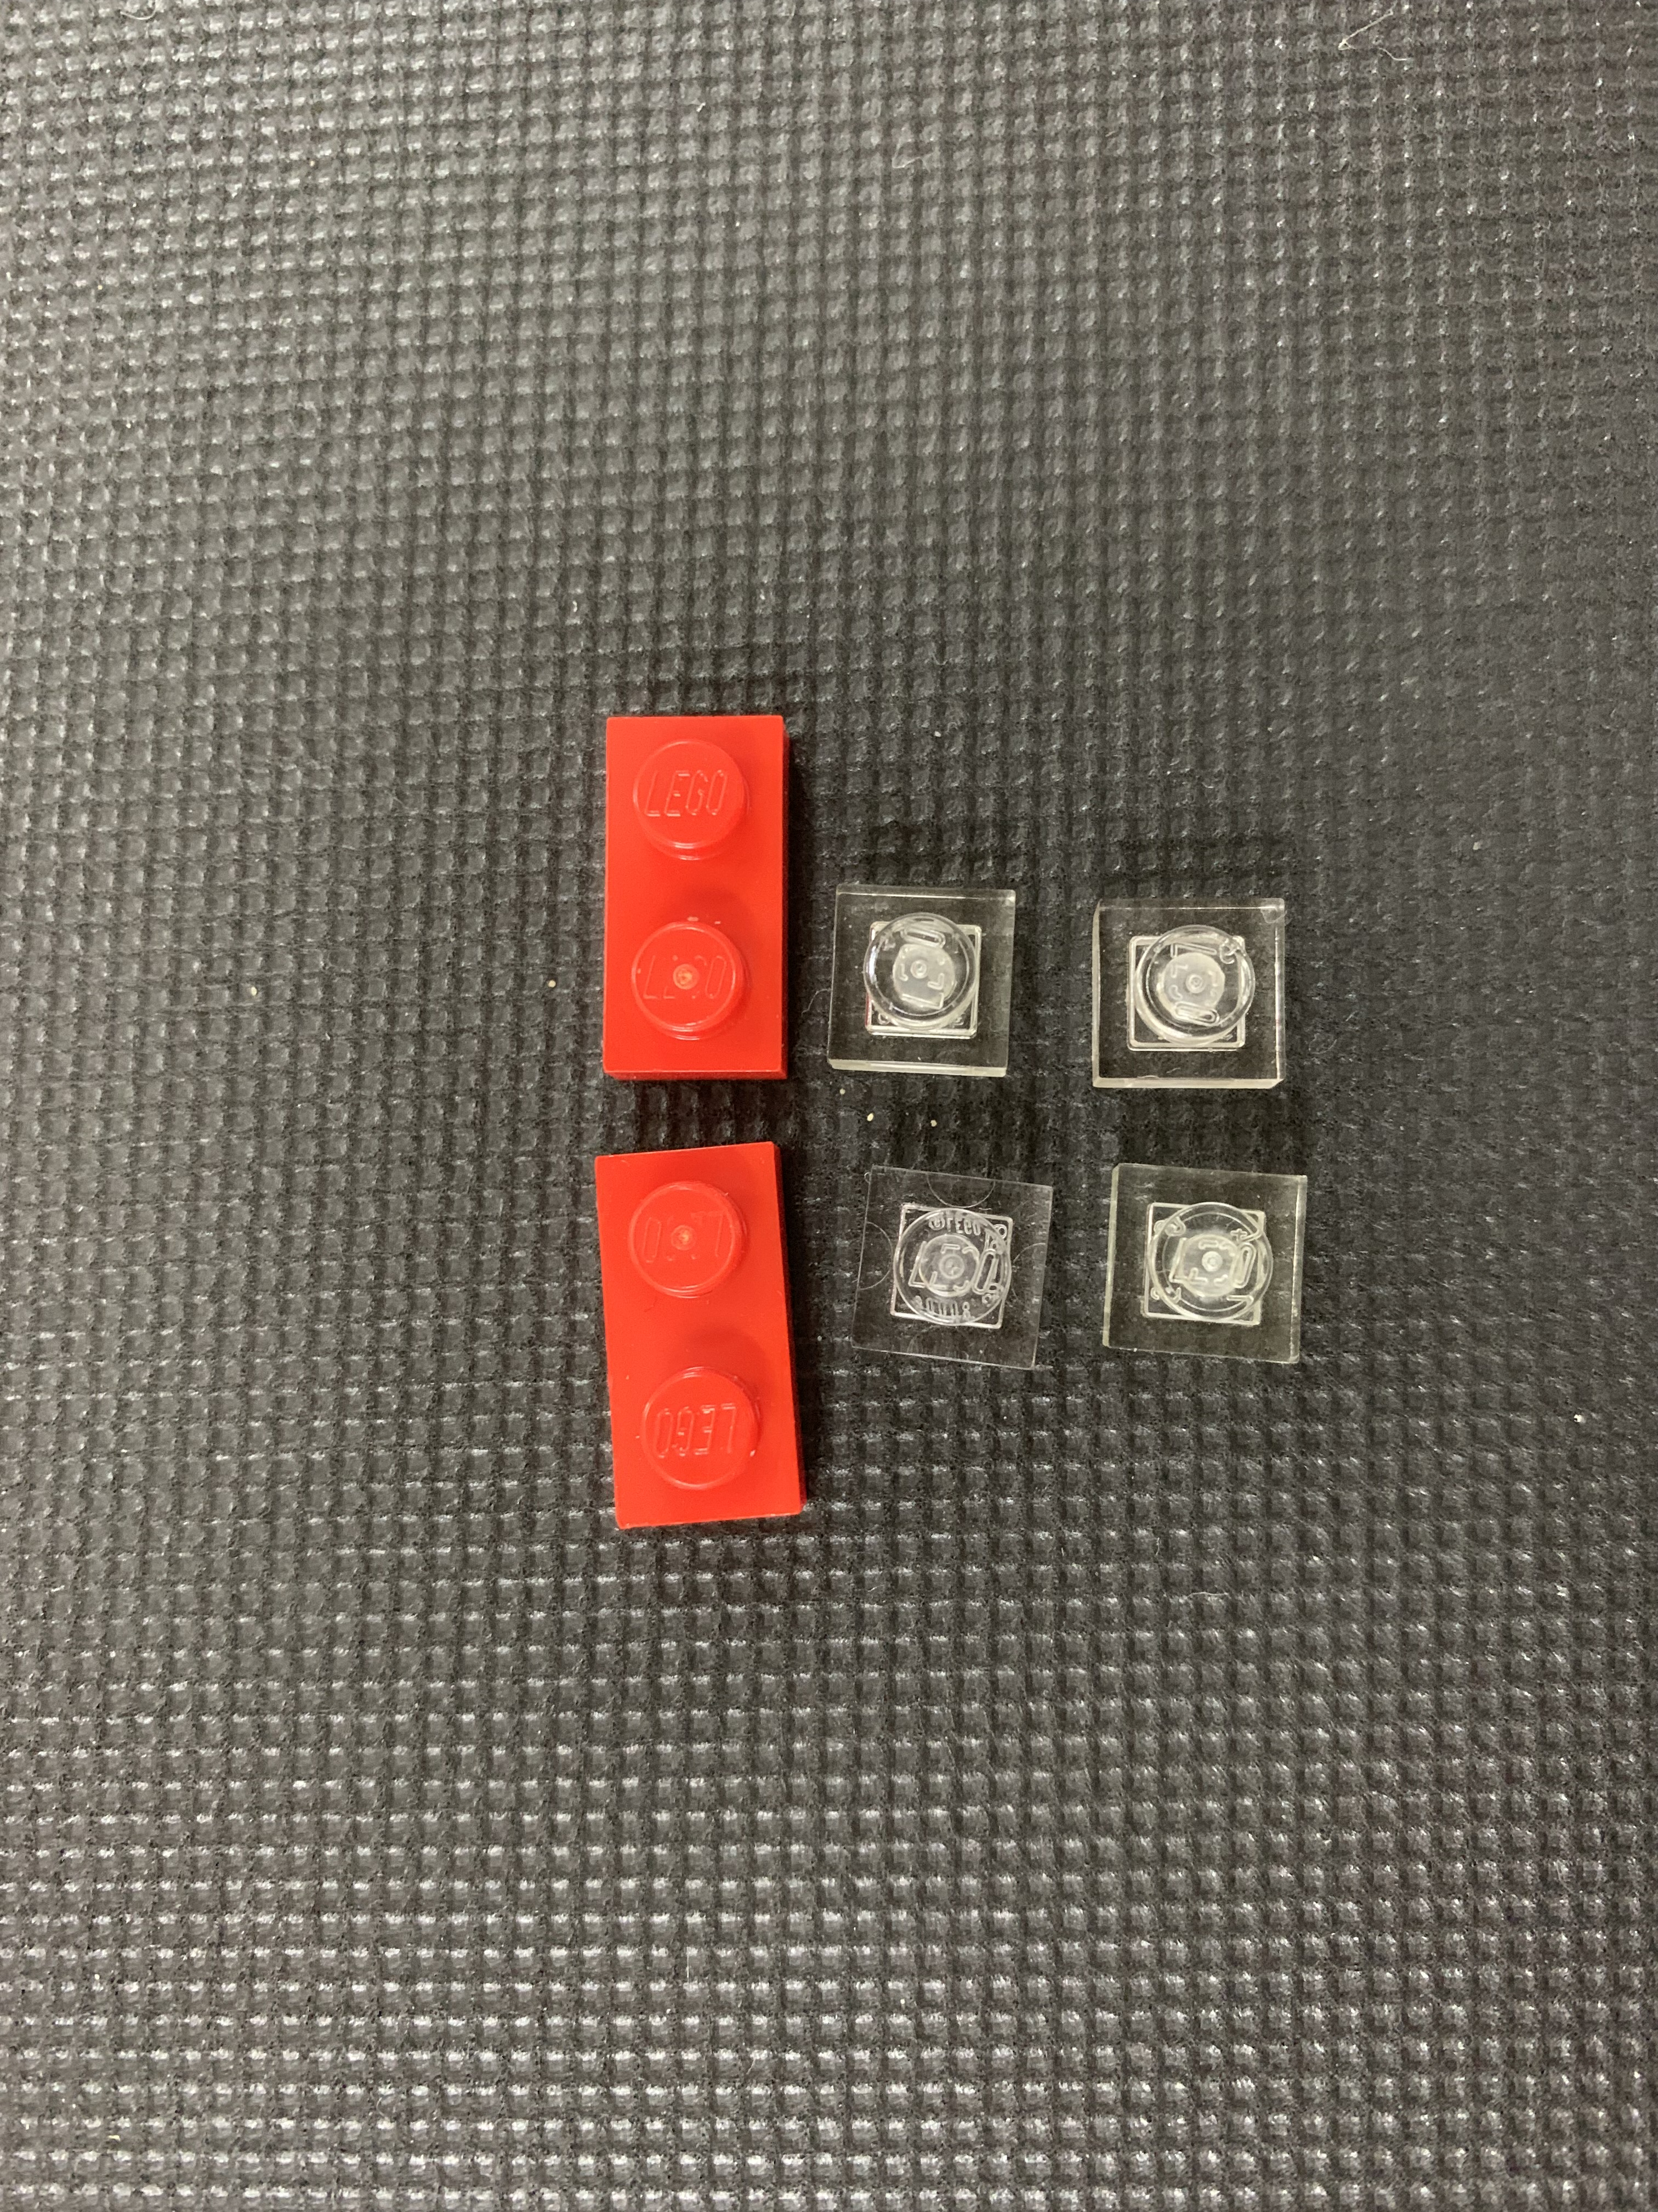
Connect the 2x Red 1x2 plates to replace the original 2x2 plates and then Connect the 2x headlight pieces over the top.
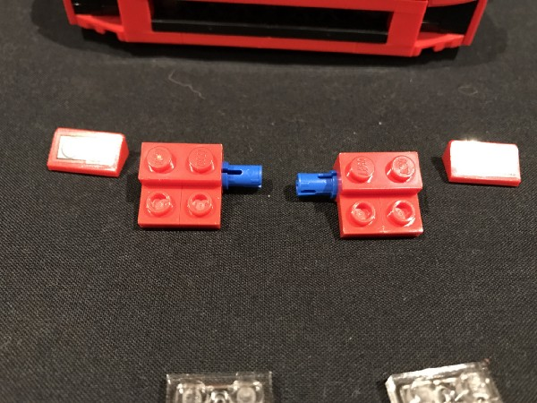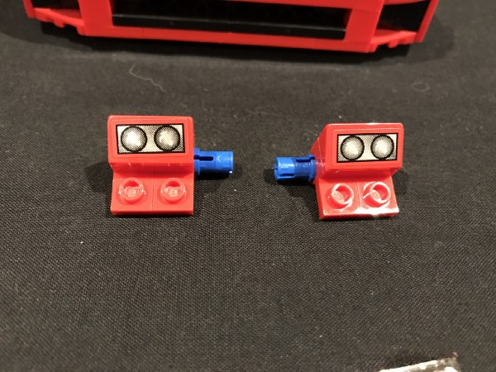

- ) Take 2x White 15cm Dot Lights and place them directly over the red studs with the cables facing down. Secure the 2 dot lights in place by connecting two of the Trans Clear 1x1 plates over the top.
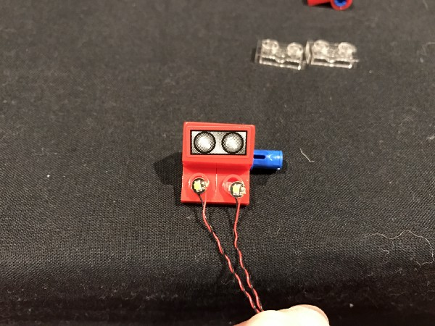
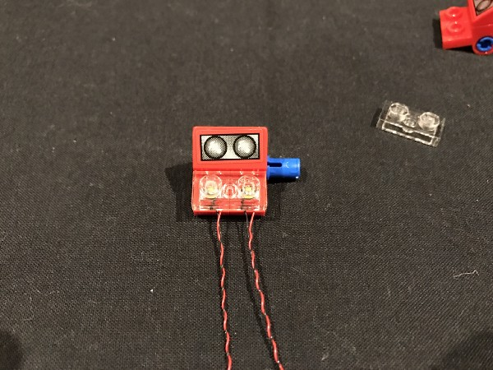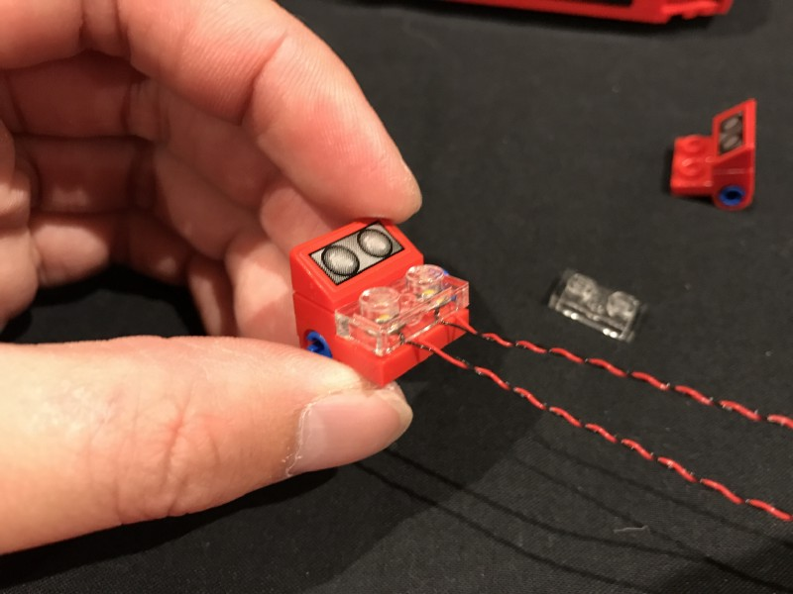

Repeat this step to install another 2x White 15cm Dot Lights to the other main headlight.
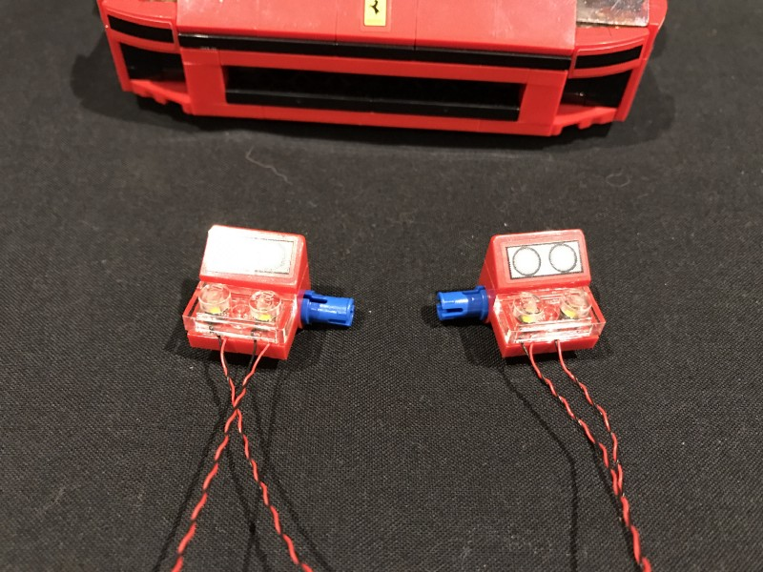
- ) Take the left main headlight and then tuck dot light cables underneath before reconnecting it to the car.
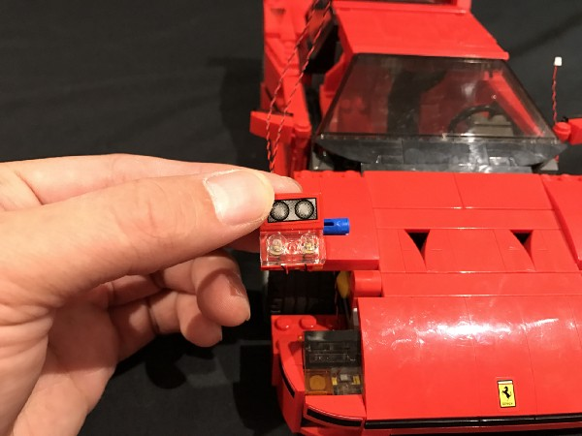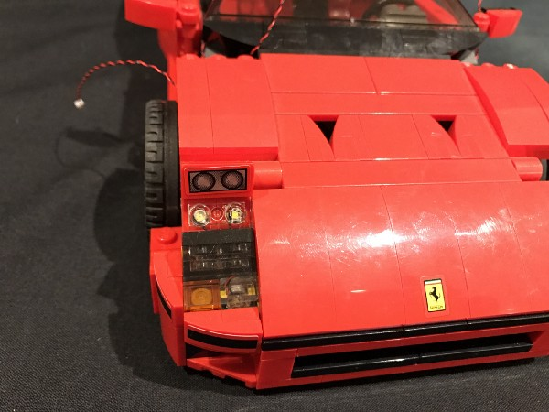
Repeat this step to reconnect the right main headlight.
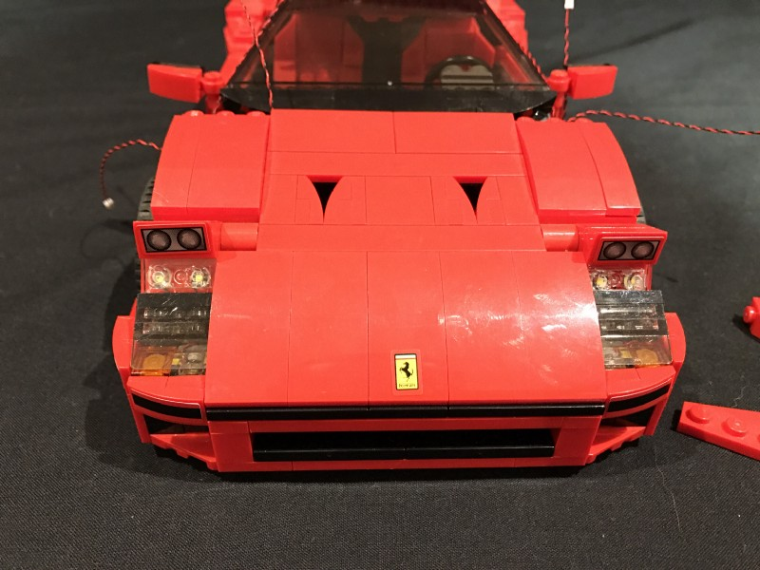

Reconnect pieces we removed from the side and top of the bonnet.
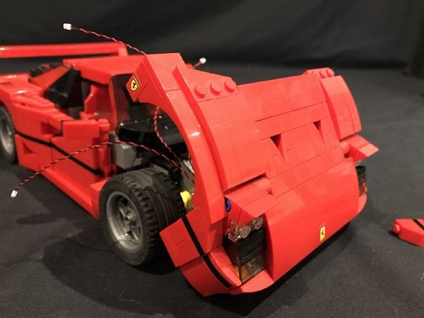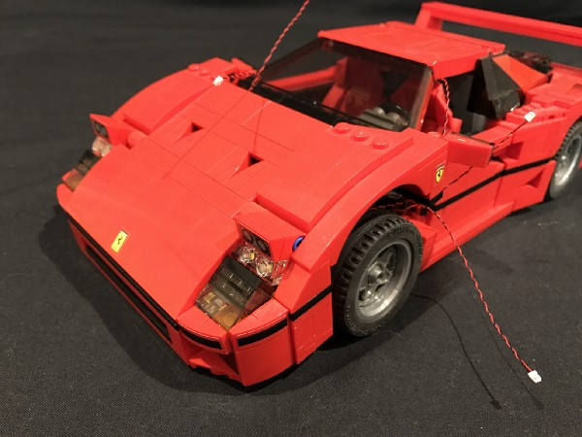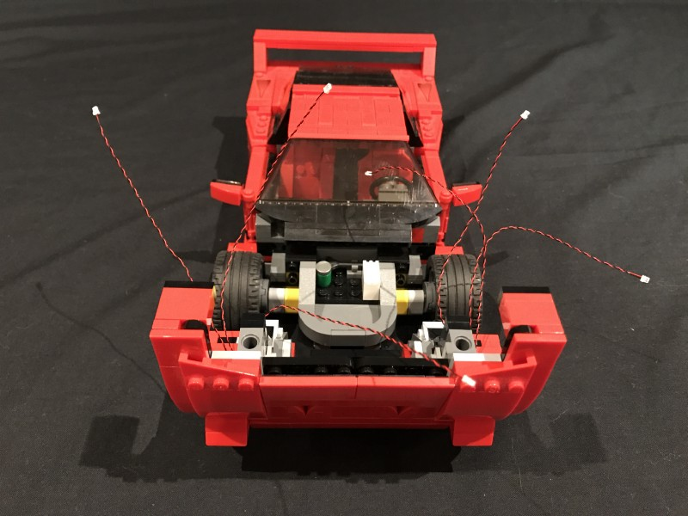
- ) Take the 8-port Expansion Board and then connect all the Dot Light cables to the available ports.
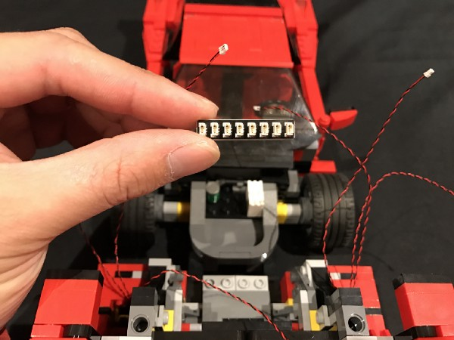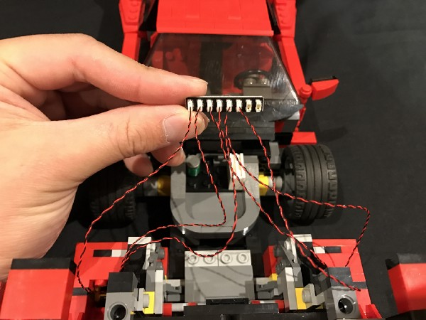
We can now test the lights we have installed so far. To do so, take the Round Battery Pack and insert 2x CR2032 batteries to it. Please ensure batteries are connected correctly (with ‘-’ side facing down toward the battery pack springs). Connect the battery pack cable to the spare port of the expansion board, turn on and verify lights are working.
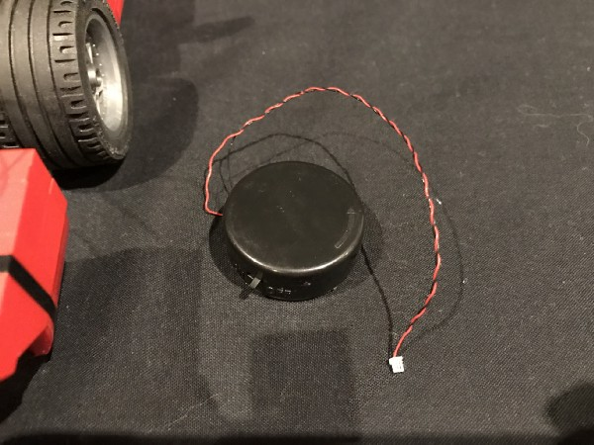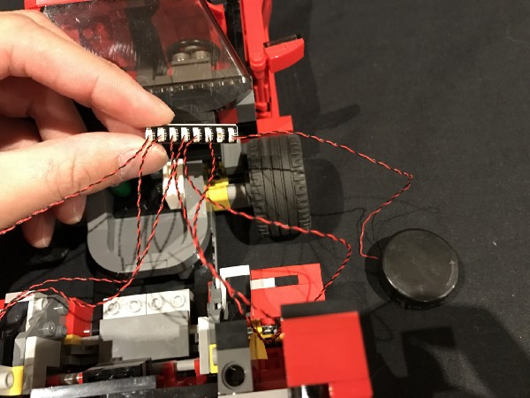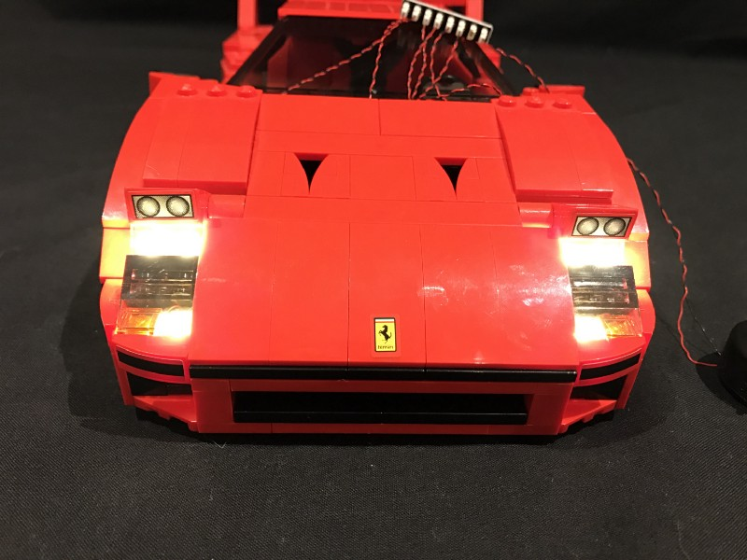
Disconnect battery pack and proceed to the next step.
8.) We now need to eliminate excess cable before placing the expansion board underneath. To do this, wind cables around the expansion board 2–3 times as shown below.
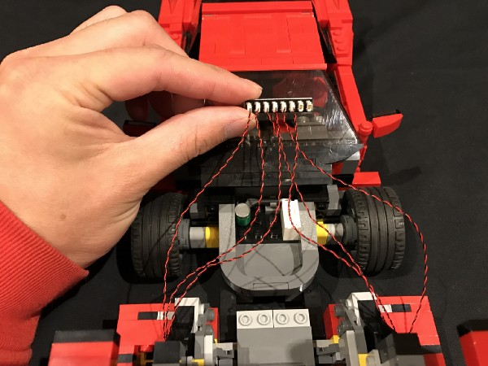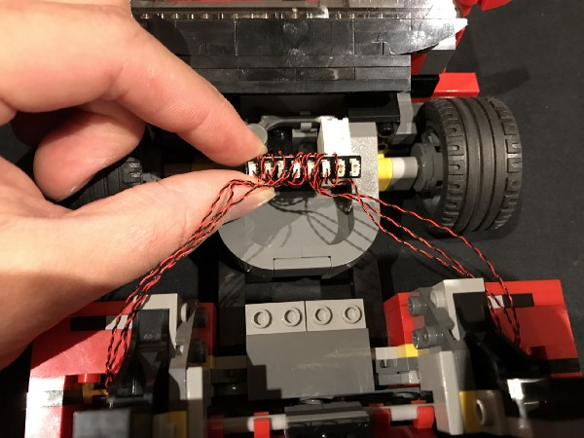

Take 4x Adhesive squares and then stick 2 of them directly on top of each other and then stick them underneath the expansion board on each side.
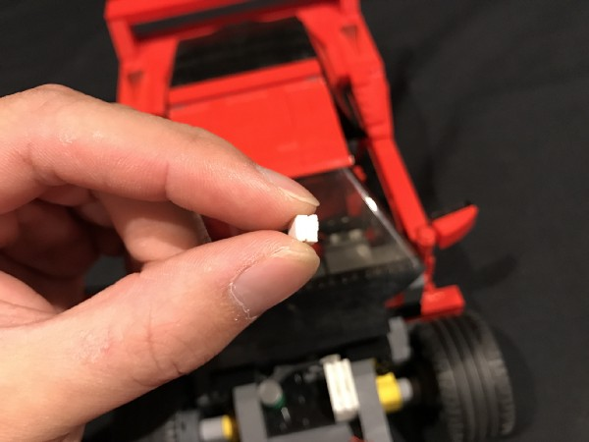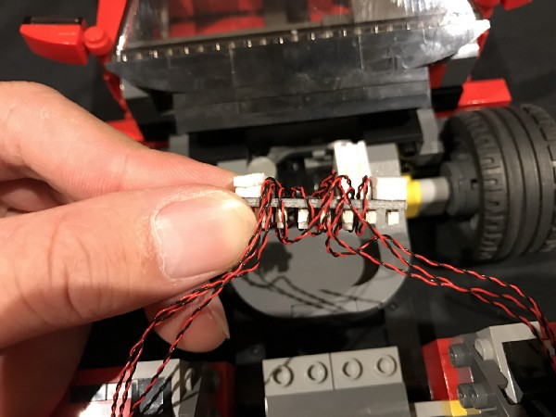

Mount the expansion board to the section underneath the bonnet as per below.
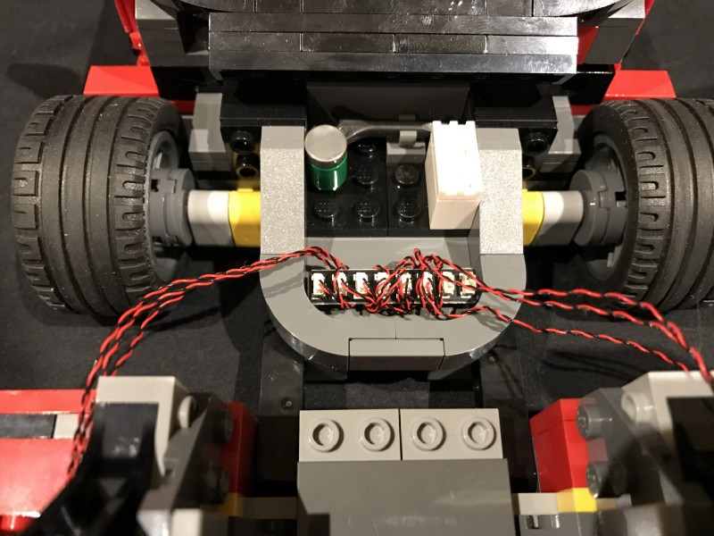
- ) Take a 30cm connecting cable and connect it to the spare port on the expansion board and then thread the other end of the cable through the hole of the brick which leads to the inside of the car.
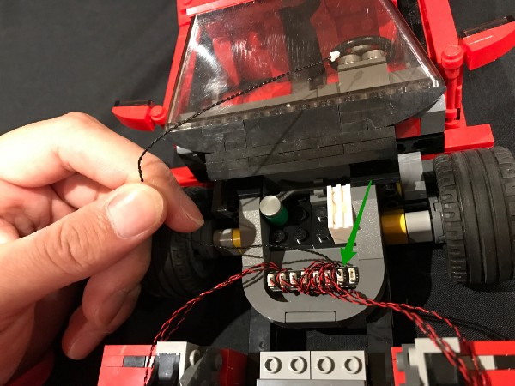
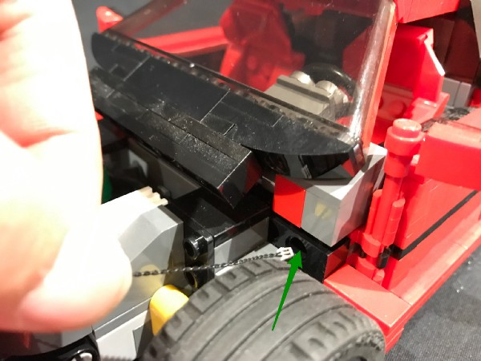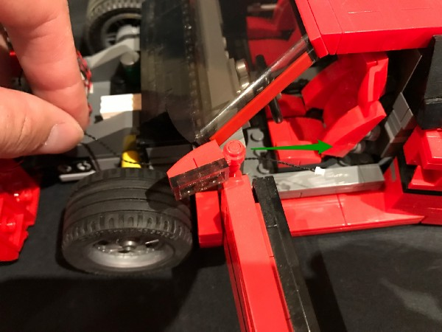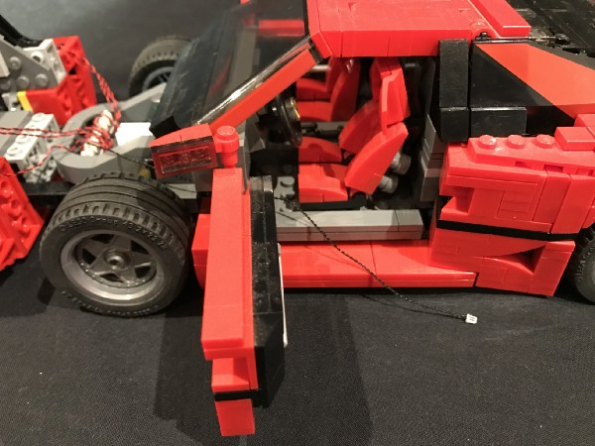
We can now close the bonnet and move onto installing tail lights.
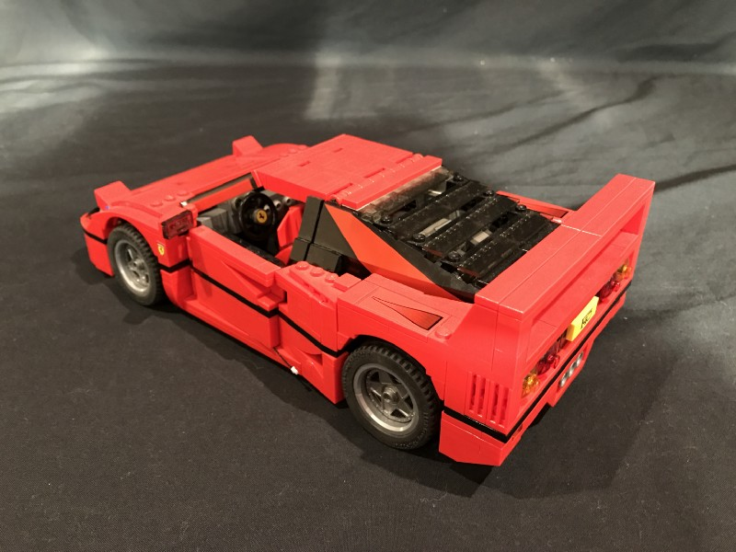

- ) Remove the following sections from the back of the car, followed by the 4x trans coloured dishes.
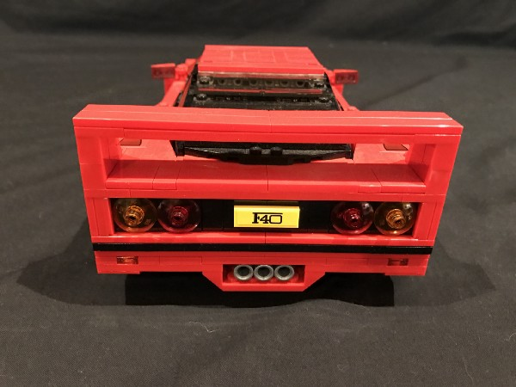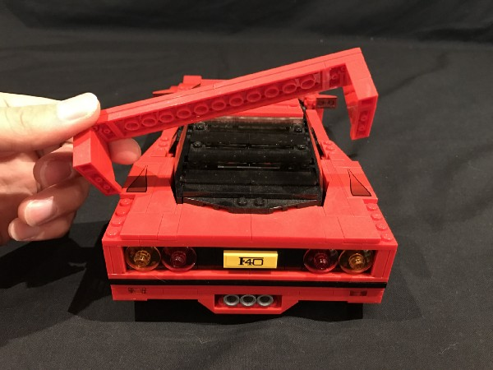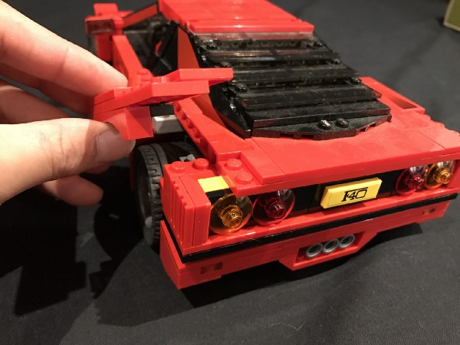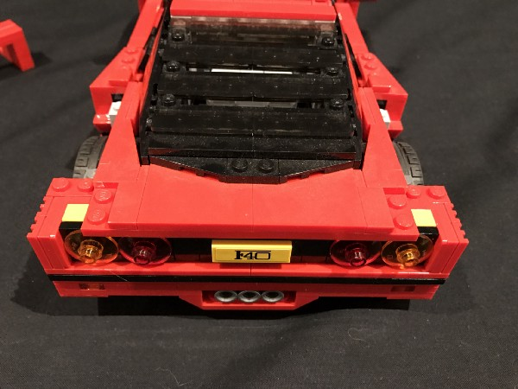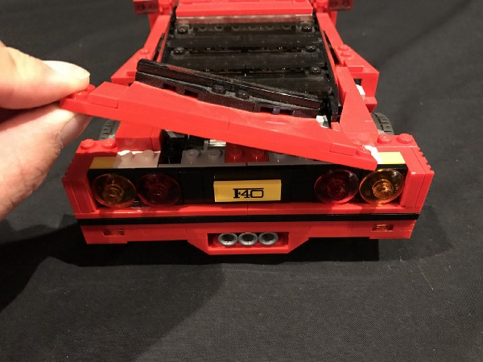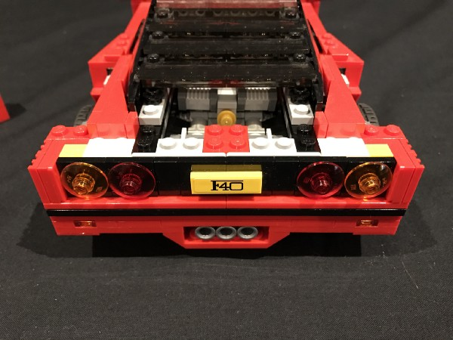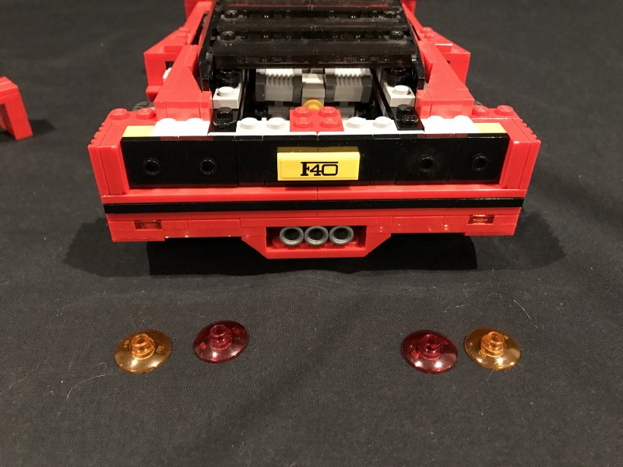
- ) Take a White 15cm Dot Light and place it directly over the the black stud on the far left. Secure the Dot Light in place by reconnecting the trans-orange coloured dish directly over the top.
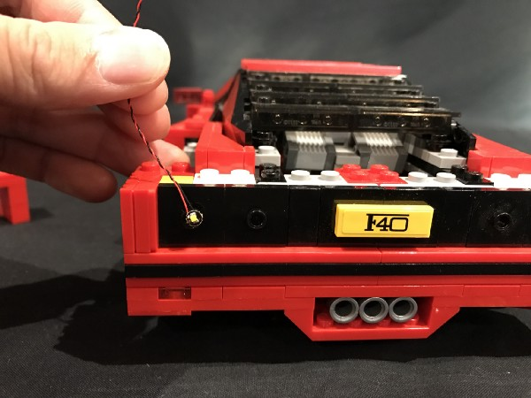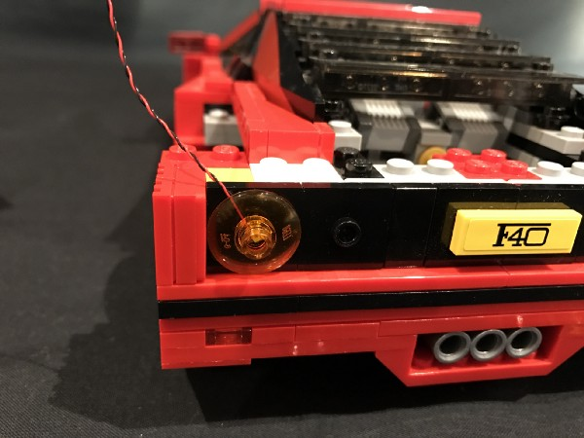
Repeat this step to install another White 15cm Dot Light to the next tail light along, securing it in place by reconnecting the trans-red coloured dish over the top.
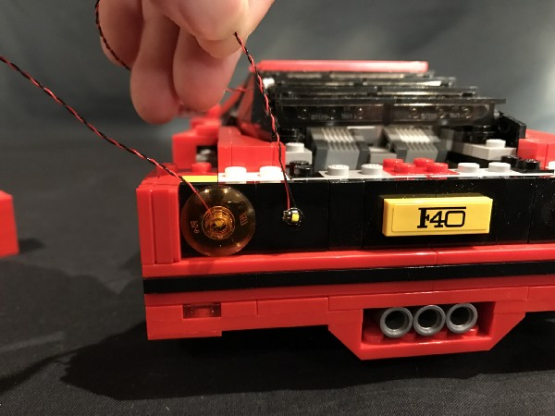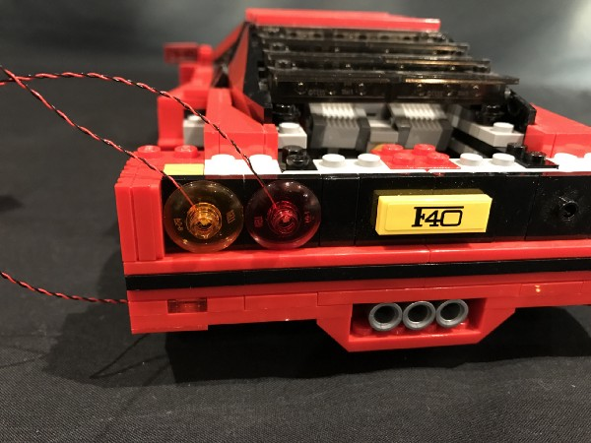
Locate the provided round tiles (2x trans orange and 2x trans red). Take 1 of each colour and connect them over dishes we have just installed dot lights to.
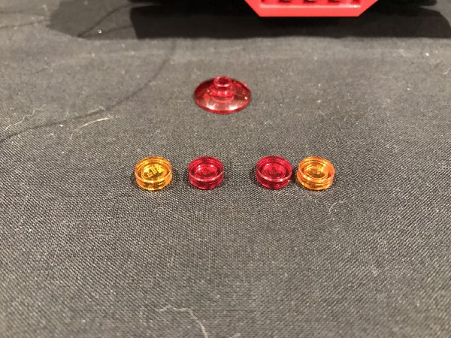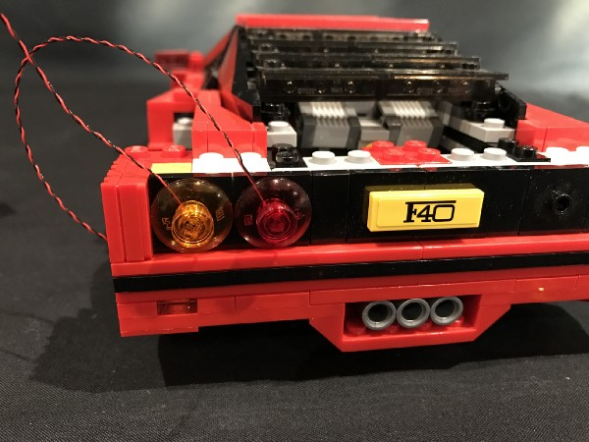
Install another 2x White 15cm Dot Lights to the right section and then connect the remaining 2 round tiles.
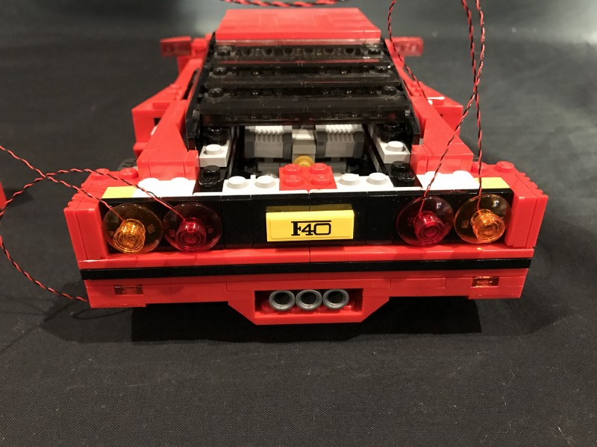

- ) Lift up the trunk of the car and then take the cables from each side and then pull them behind before connecting them to a 6-port Expansion Board
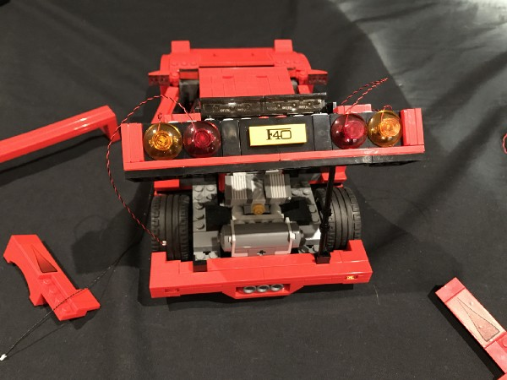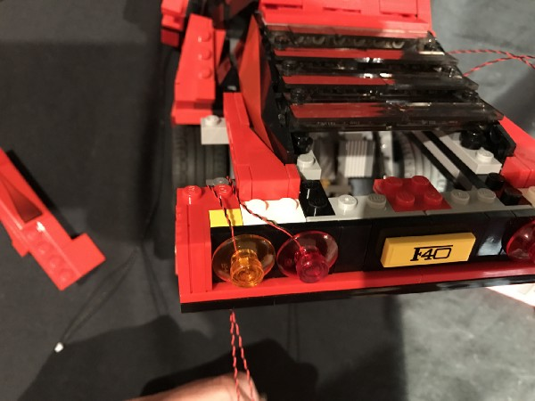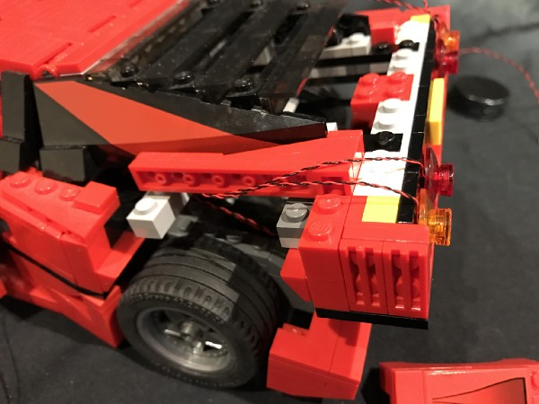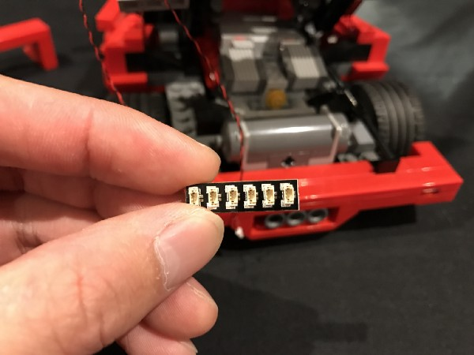

Loop the cables behind the light grey plates
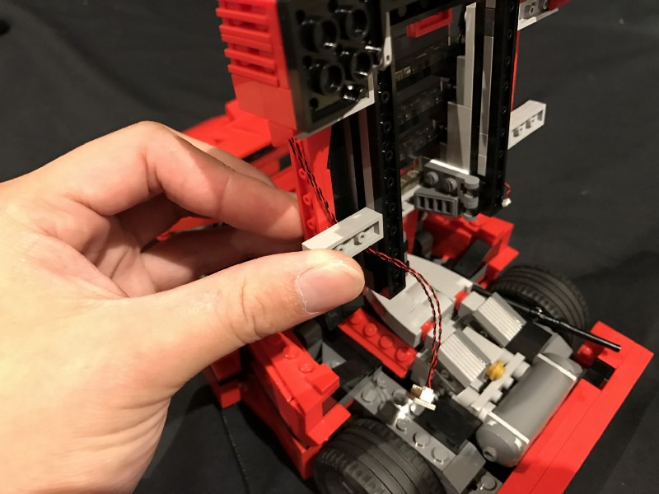
Repeat this step to lay cables from the right side behind and loop them underneath the light grey plates on the right side before connecting them to the 6-port Expansion Board.
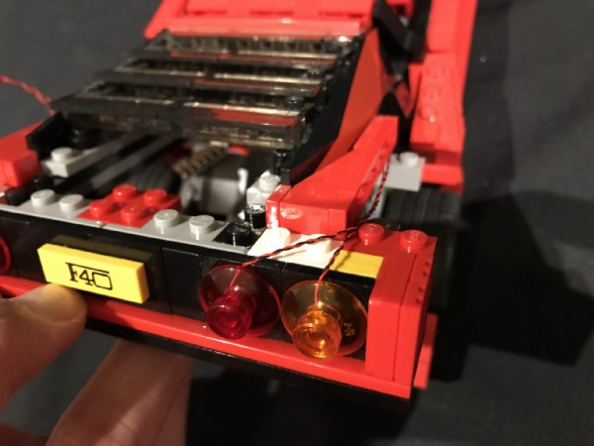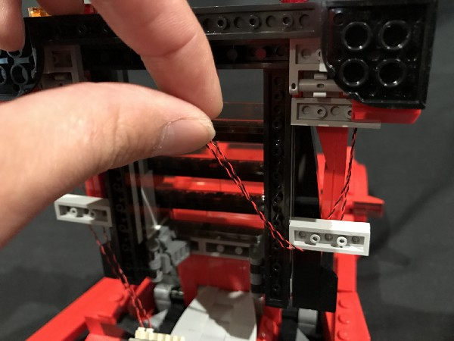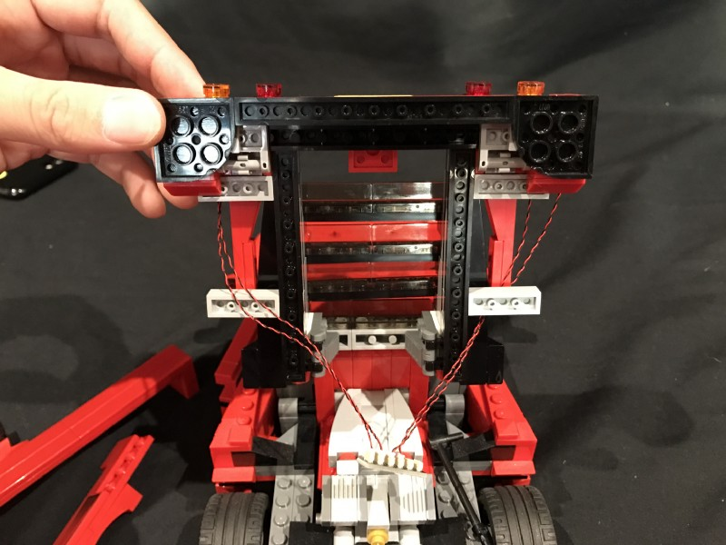

- ) Take 2x Adhesive Squares and stick them underneath the expansion board. Mount the expansion board underneath the trunk of the car in the following position.
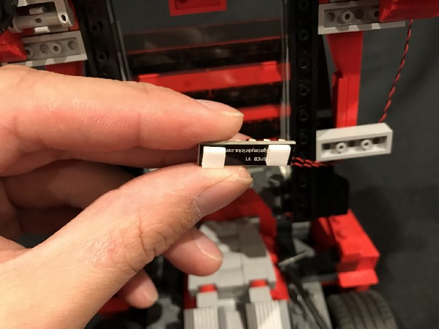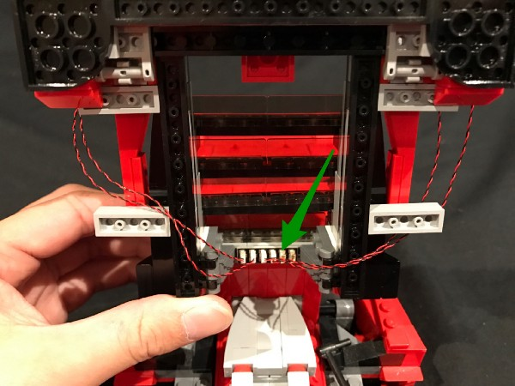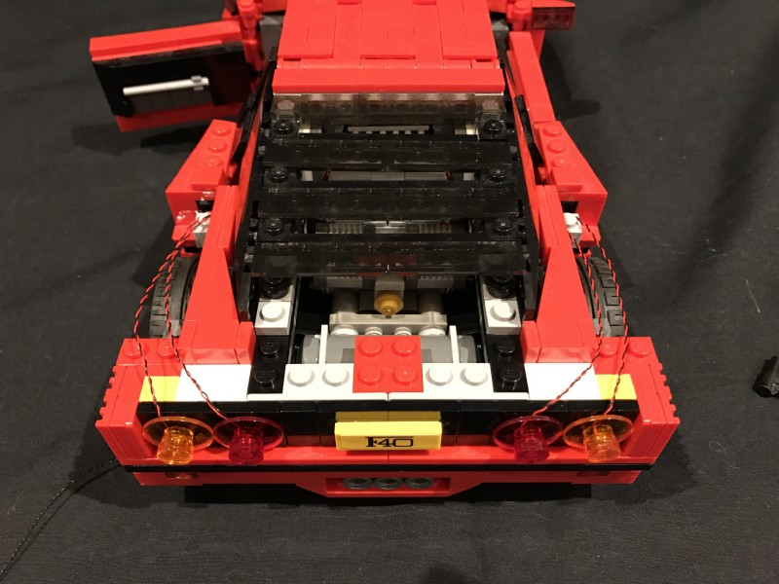
- ) Neatly lay cables to the side and in between studs before reconnecting the sections removed earlier over the top.
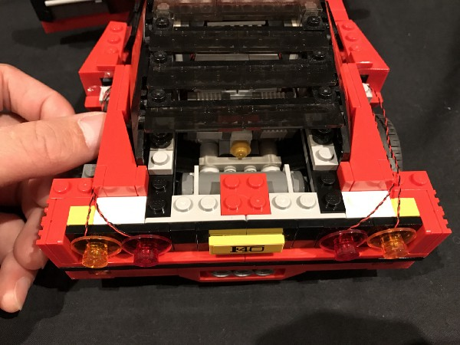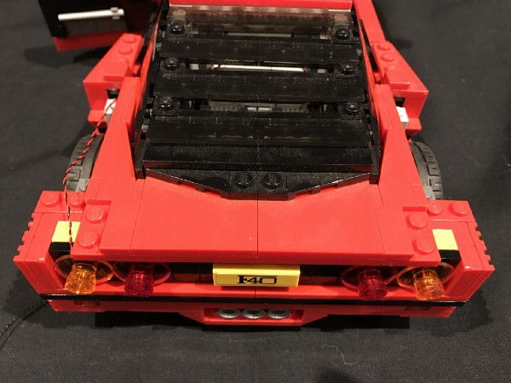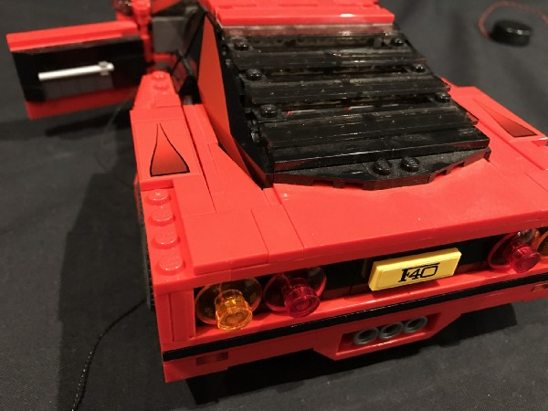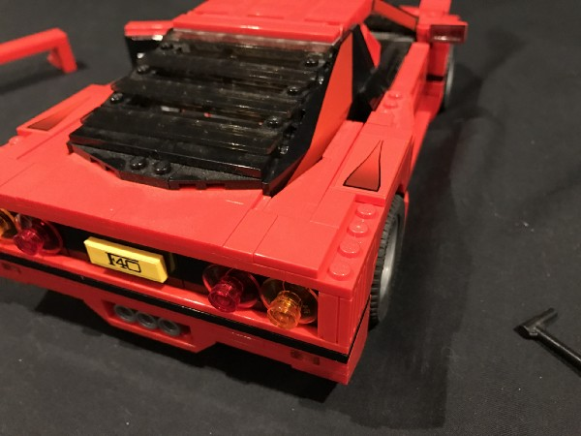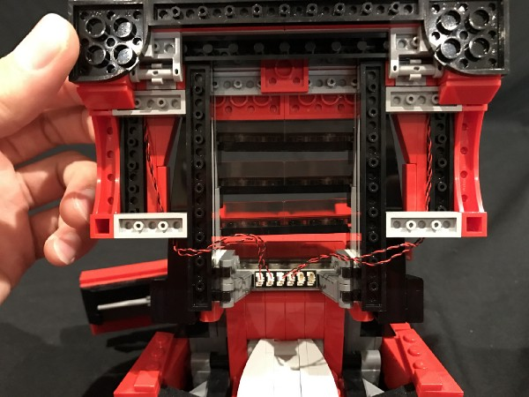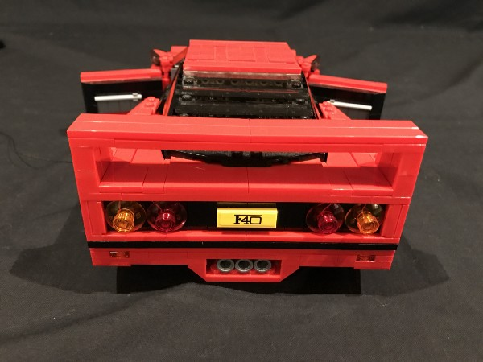
- ) Take the round battery pack and then place it in the passenger side of the car. Thread the battery pack cable through the spacing behind which leads to the back of the car and then connect the cable to a spare port on the 6-port expansion board.
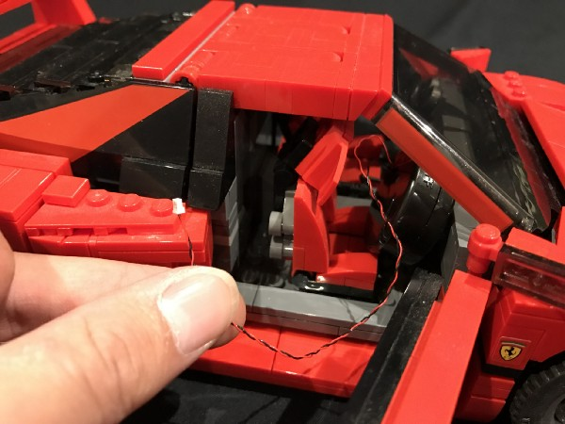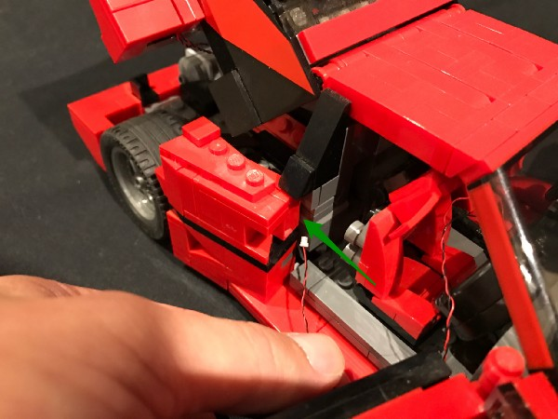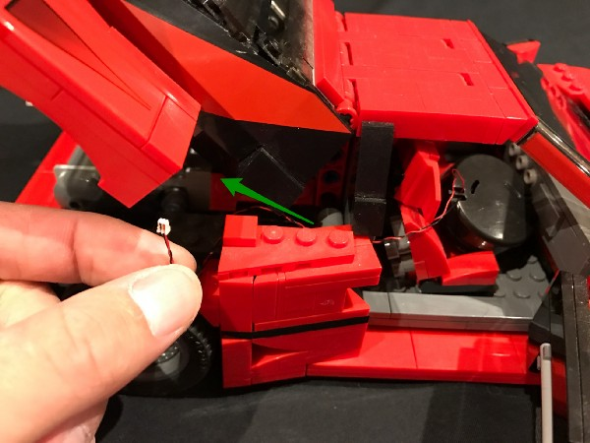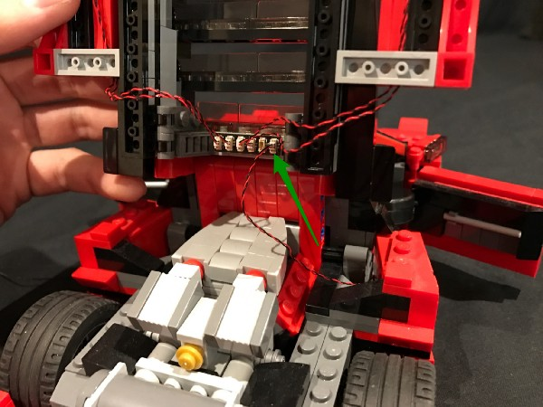
- ) Take the other end of the 30cm connecting cable we threaded through from the front bonet and then thread it through to the back of the car in between black and red sections.
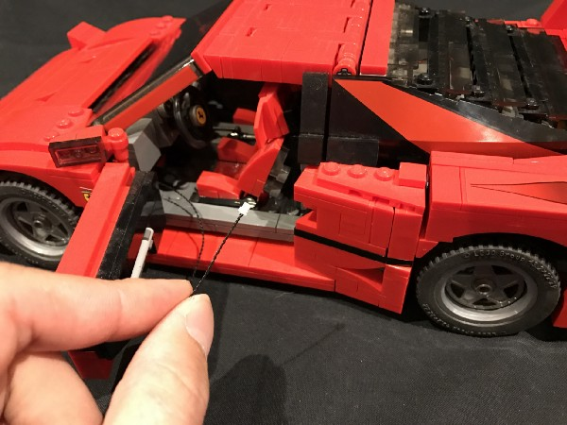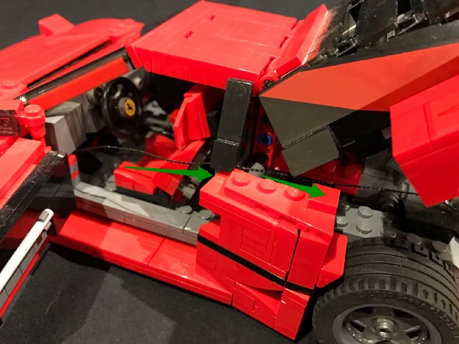
Pull cable all the way through and then connect to the last available port on the 6-port expansion board.
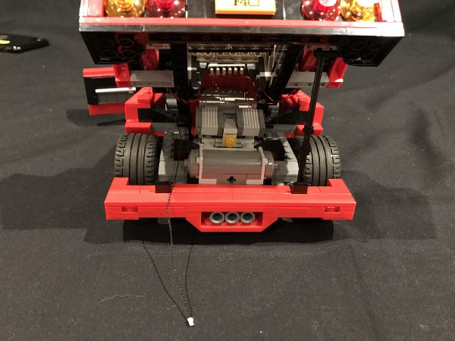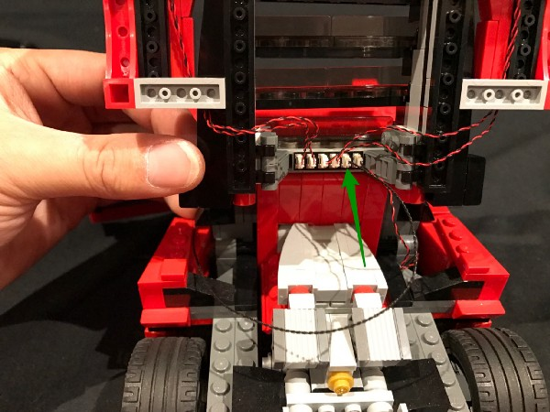
Pull the excess cable back so that it does not get caught when opening and closing the trunk.
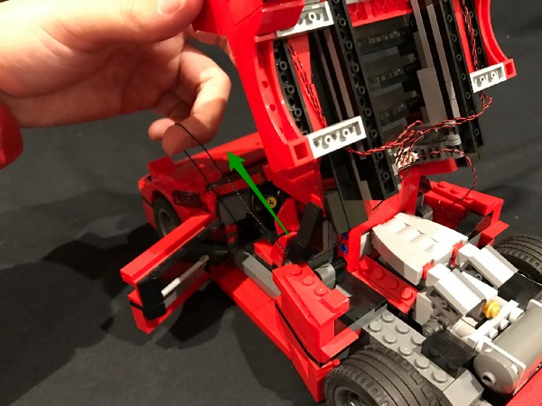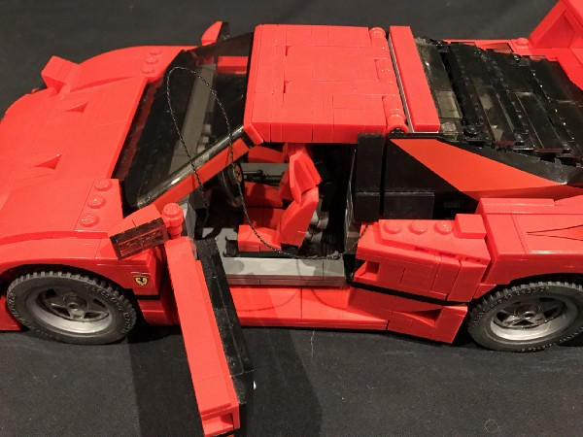
Tuck the excess cable in between the side of the car as per below.
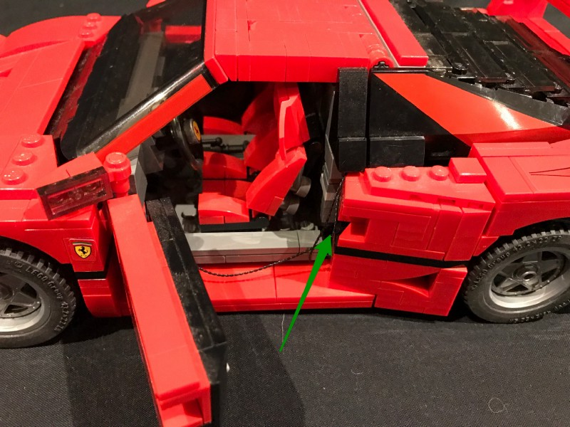

This finally completes installation of the Ferrari F40 Lighting Kit. Turn your lighting kit on via the battery pack and ENJOY!
