Lighting Kit LEGO 75810

Thank you for choosing our lighting products. We are committed to LEGO product study and lighting development, we're always trying our best to provide LEGO fans with the best products and the best installation ideas.
Must be careful observation, imagination can be infinite.
We provide basic parts to support your imagination.
DO IT YOURSELF .that's what LEGO is .

As always, Lego has been adhering to the DIY philosophy from product selection, research and development to sales. Consumers buy the parts, you will assemble them by yourself, and you can experience every step from picking up the first piece to installing the last one. Besides, LEGO has different answers for the installation form and method of each part. Vonado lighting also does not want to kill your unlimited creativity, we will try our best to make products with high variability, high playability and unlimited play. If you have any dissatisfaction or your own ideas on the parts such as the color of the lights, the length of the cables, the installation position of the product, and the final effects of each module, you can make your own arrangement, and we will cooperate with you to replace or repurchase.
LETS MOVE!

Package contents：
- 6 x 30cm Red Dot Lights
- 3 x 30cm Warm White Dot Lights
- 6 x 30cm Blue Dot Lights
- 1 x 30cm Green Dot Light
- 4 x 15cm Warm White Dot Lights
- 2 x 15cm Green Dot Lights
- 3 x 15cm Blue Dot Light
- 4 x 15cm Red Dot Light
- 3 x 15cm Flashing Warm White Dot Lights
- 3 x 15cm Flashing Blue Dot Lights
- 1 x 15cm Flashing White Dot Light
- 1 x 15cm Connecting Cable
- 4 x 30cm Connecting Cables
- 1 x 4-port Expansion Board
- 2 x 6-port Expansion Boards
- 1 x 8-port Expansion Board
- 2 x 12-port Expansion Boards
- 1 x USB Cable
Extra pieces
Note:
Place wires on the surface or under the building blocks.
The wire can be place between the building blocks or under the block, but they should be placed between the studs correctly.
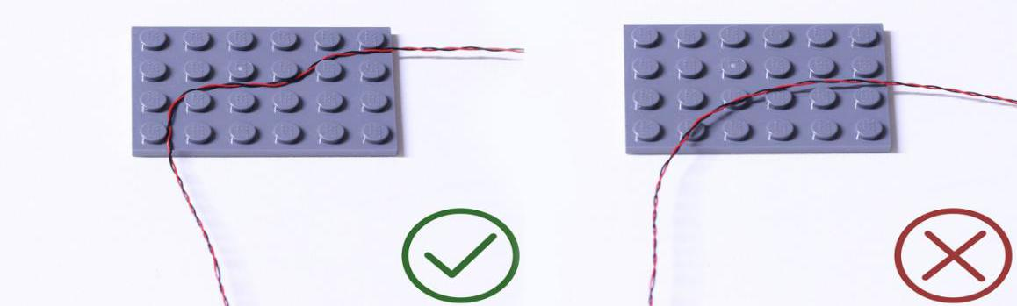

Insert the connectors to the ports.
Be careful when you are operating, there’s only one correct way to insert, make sure the expansion board is upward, find the soldered “=” sign on the left of the port. When you are inserting, the side which the wires can be seen should be faced to the “=” sign and if you feel hard to insert, please stop, and don’t force it, for that may result in bent pins inside the port or overheating of the expansion board.
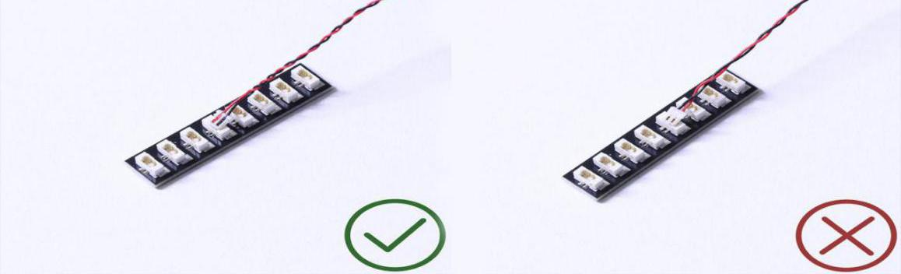

At this point, use the tweezers to straighten the bent pins.
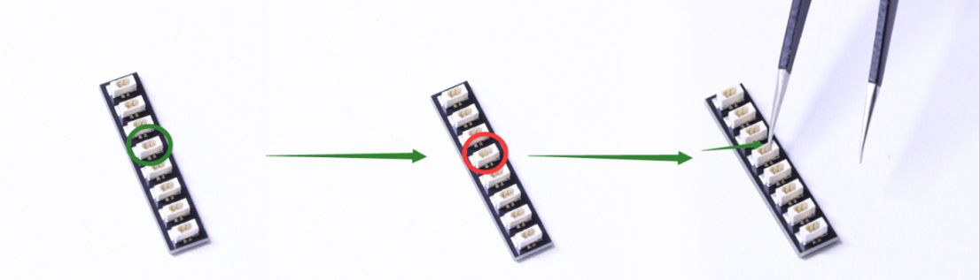

When installing dot lights, make sure they are correctly placed (Yellow LED package is exposed). You can put they either on the top of the studs or between studs.

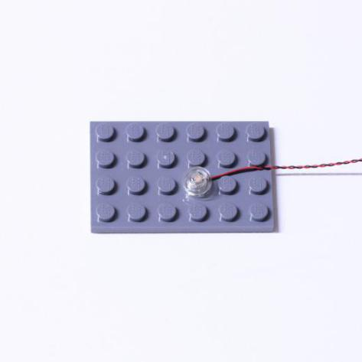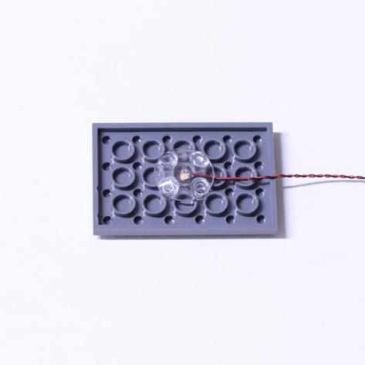

Connecting cable connectors to Strip Lights
Take extra care when inserting connectors to ports on the Strip Lights. Connectors can be inserted only one way. With the Strip Light facing up, ensure the side of the connector with the wires exposed is facing down. If a plug won’t fit easily into a port connector, don’t force it. Doing so will damage the plug and the connector.
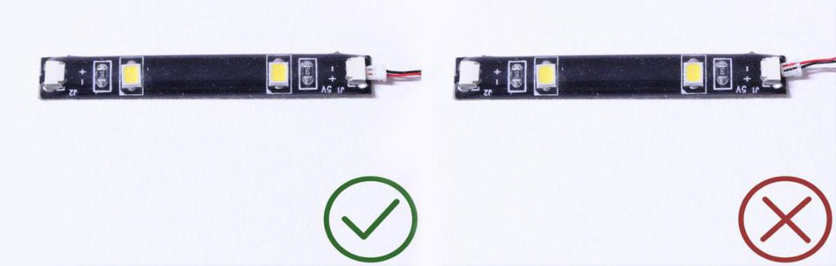

Finally, please pay attention to the positive and negative terminals of the battery when installing the battery case.
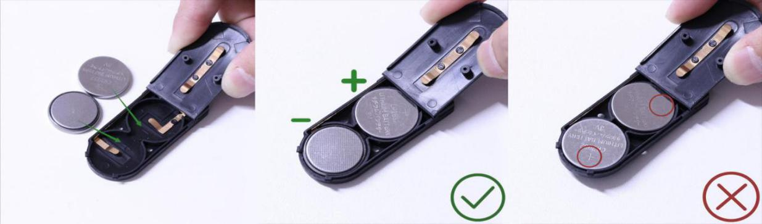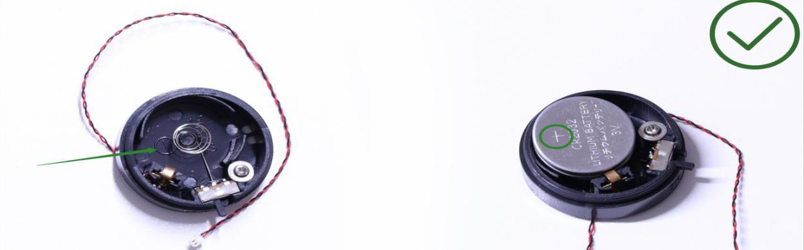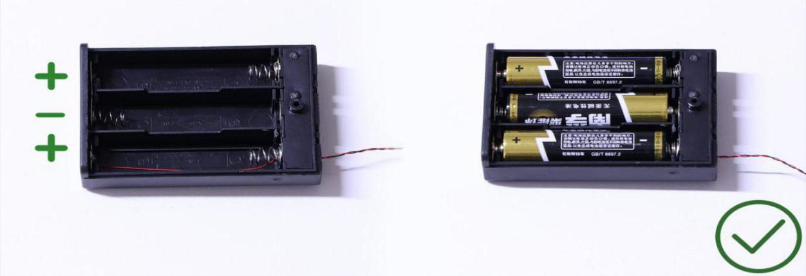

Instructions for installing this kit：
Stranger Things, Lighting Kit, 16 bags in total.
Power supply： USB cable (self-contained power bank or mobile phone charger).
Firstly, take the power source (power bank or mobile phone charger), connect it to the USB cable, connect the other end of the USB cable to the expansion board to verify all the lights one by one.
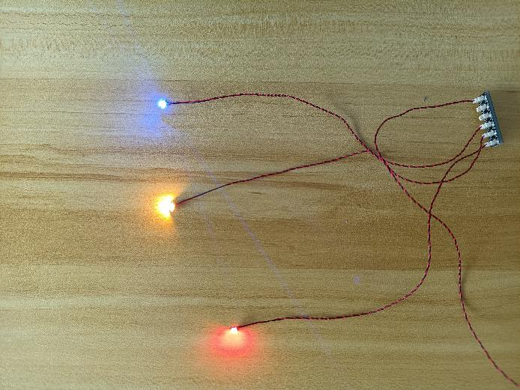
After the verification, disconnect the lights and put them back to the bags.
（note: put the lights back to the bags when verification of the lights from the same bag is done, then, continue to verify the lights in another bag.）
OK, Let’s Begin! （you can use the tweezer if necessary.）
（Tips: the tweezer is sharp, you should be careful when using it, do not hurt yourself or scratch the pieces; be gentle and do not wear the cables.）

Instructions for installing this kit：
Firstly, take the Stranger Things.
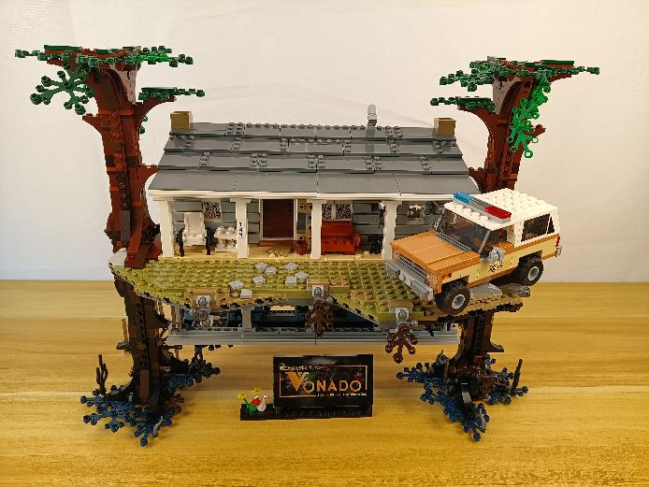

Turn to the following place.
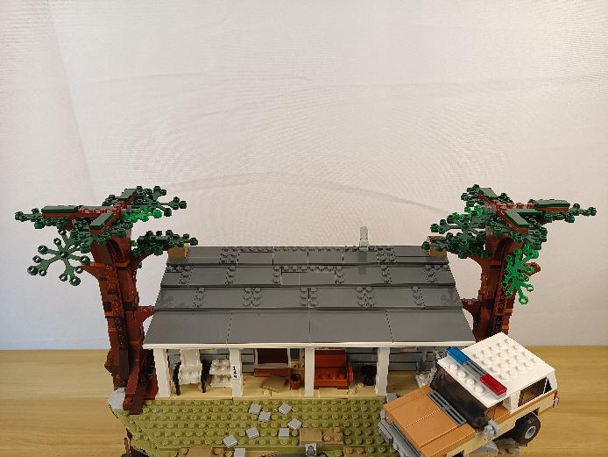

Start from installing lights for the tree at the left.
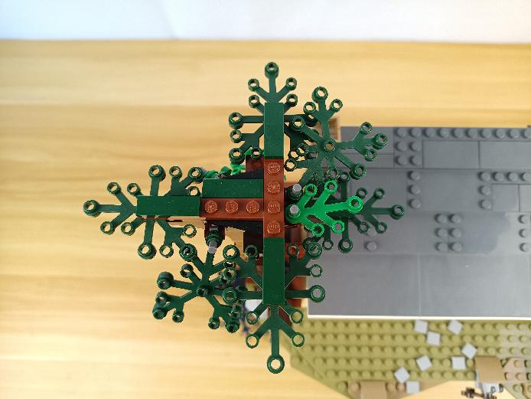

Take 3 red 30cm dot lights, 3 trans red 1x1 round plates.
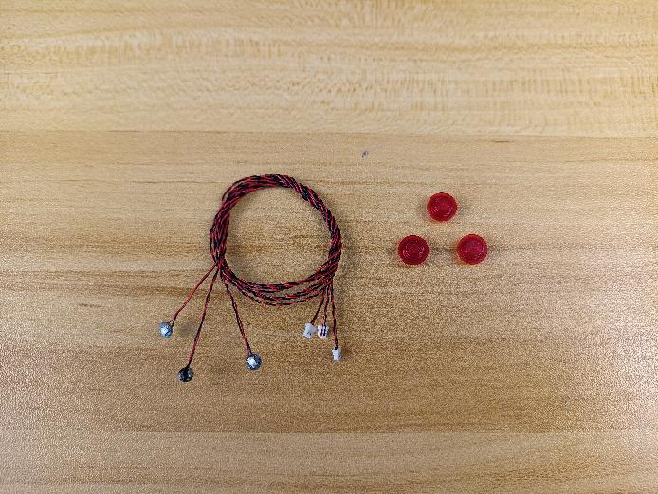

With lighting part facing up, thread the cables through the following holes on the leaves.
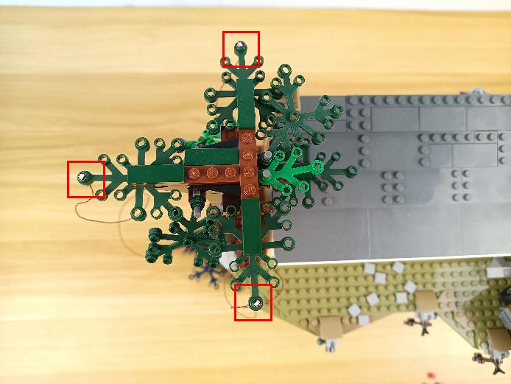

Connect the trans red round plates over.
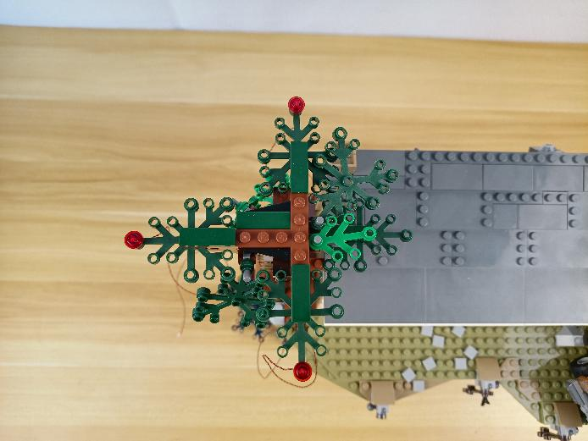

Take the following cable, threat it through the space underneath the leaf, pull it to the middle, and continue to pull it down.
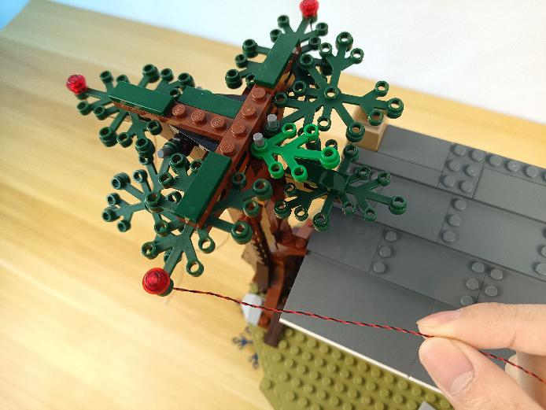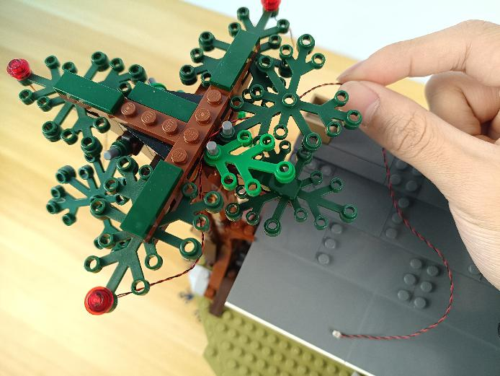
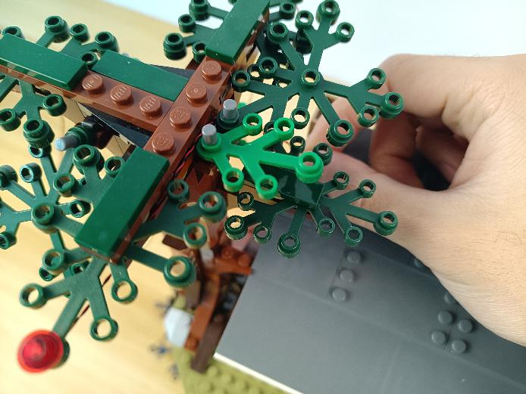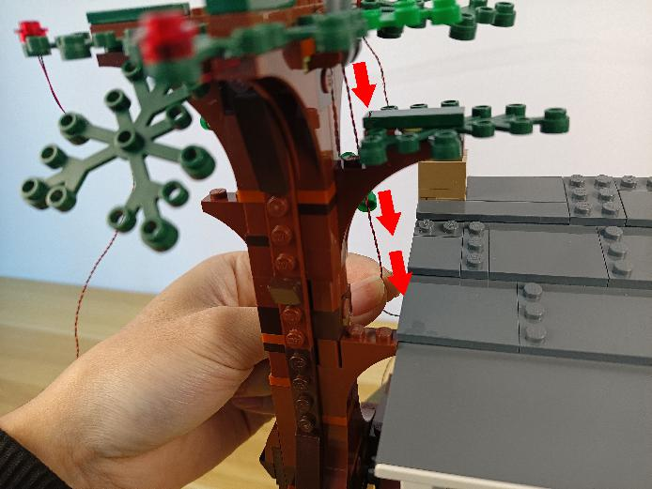

Take the following cable, threat it through the space underneath the leaf, pull it to the middle.
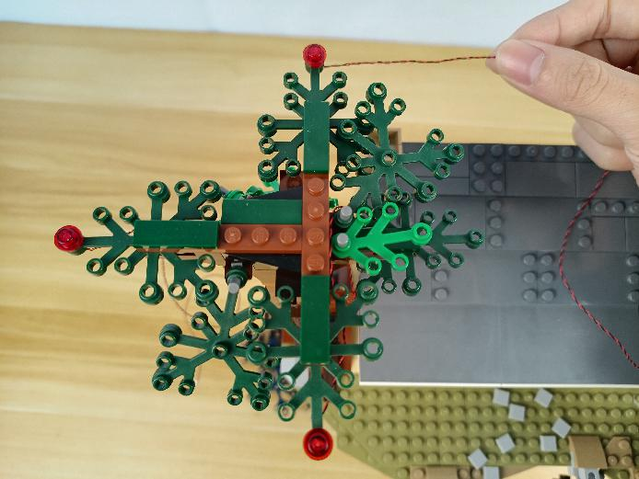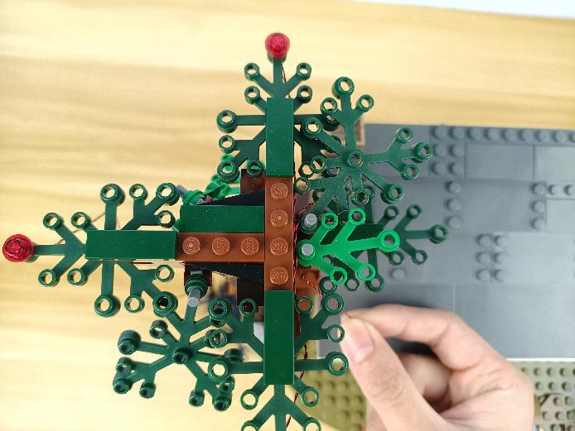

Take the following cable, place it as per below and tighten it up.
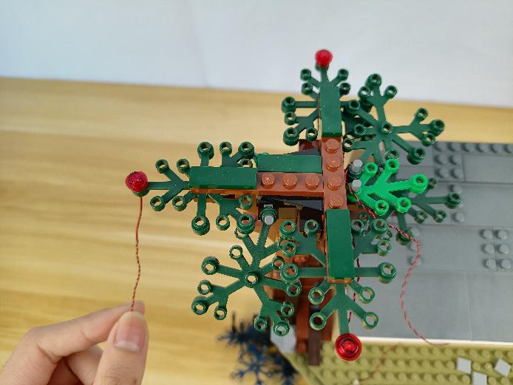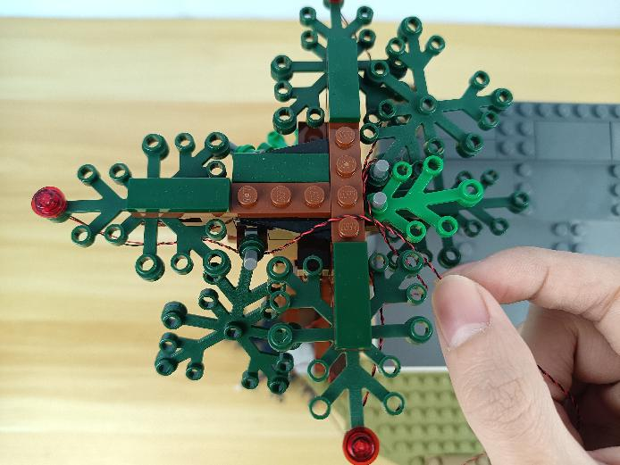

Group the 3 cables together.
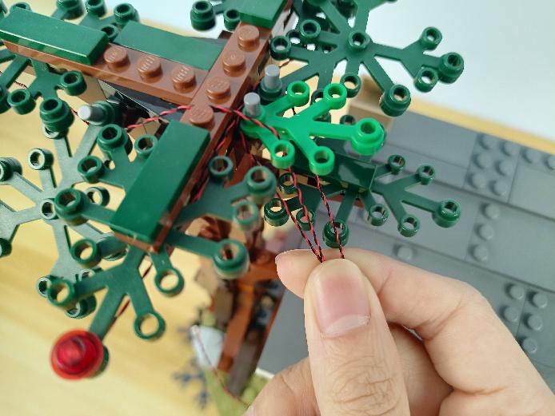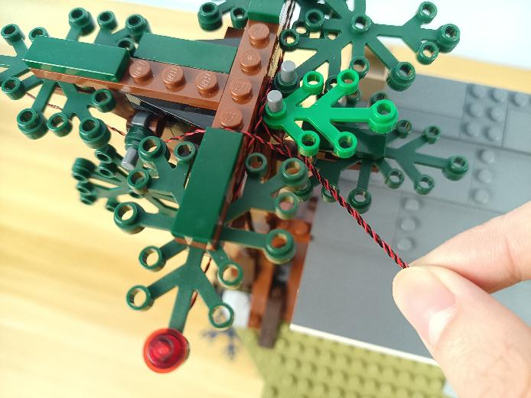

Pull them all the way down.
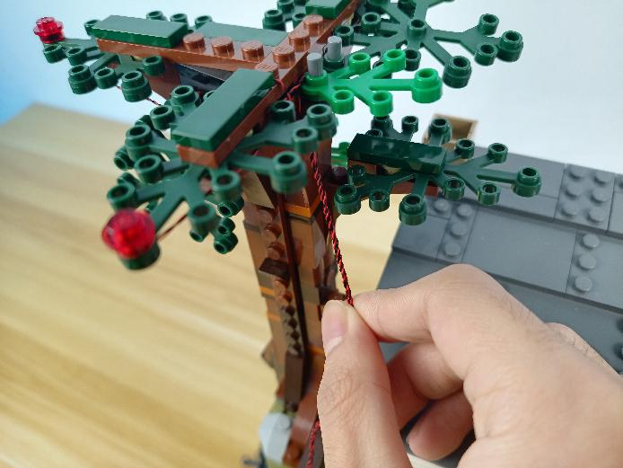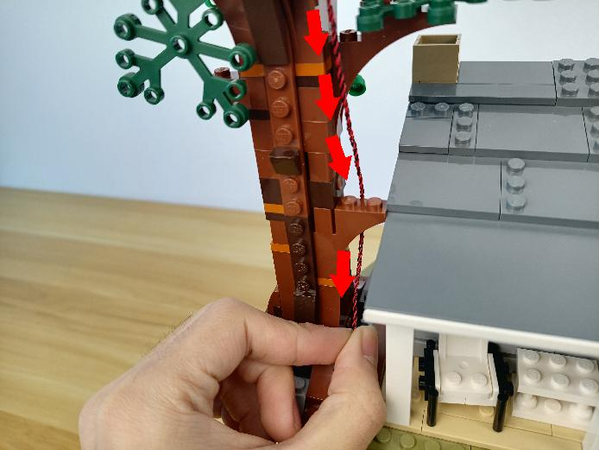

Thread them through the following space and pull them down.
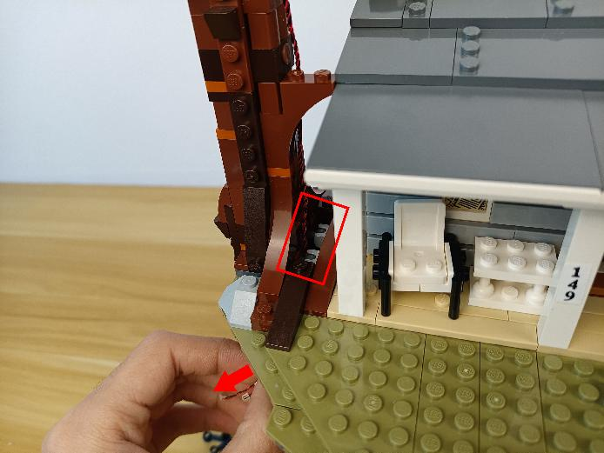

Continue to install lights for the tree at the right.
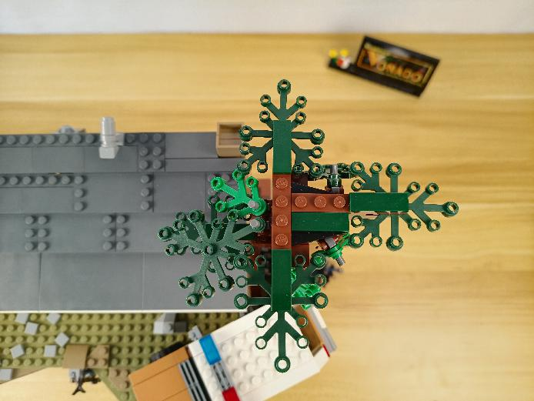

Take 3 red 30cm dot lights, 3 trans red 1x1 round plates.

With lighting part facing up, thread the cables through the following holes on the leaves.
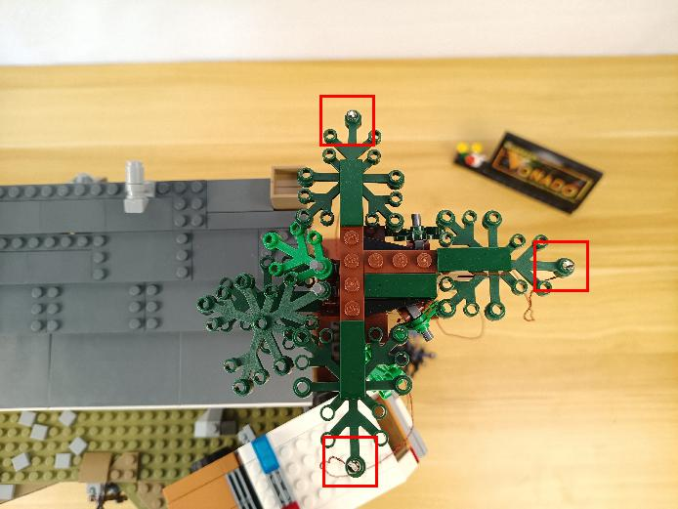

Connect the trans red round plates over.
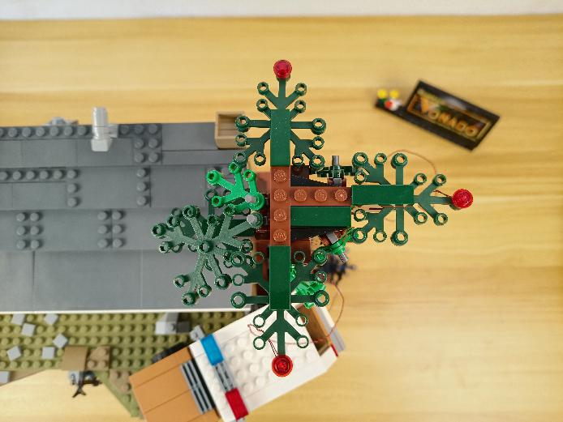

Take the following cable, threat it through the space underneath the leaf, pull it to the middle.
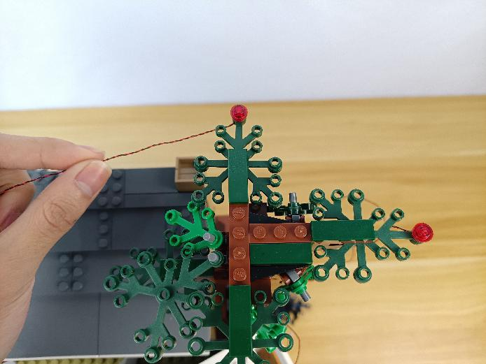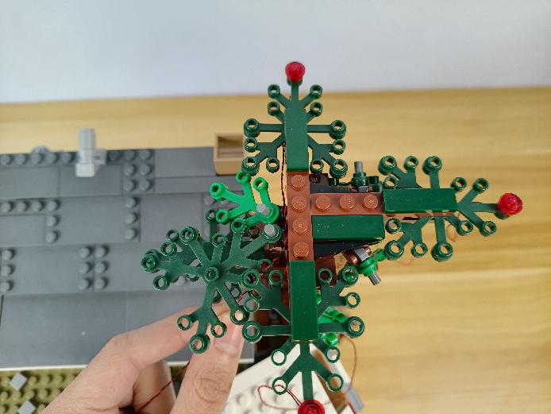

Take the following cable, threat it through the space underneath the leaf, pull it to the middle.
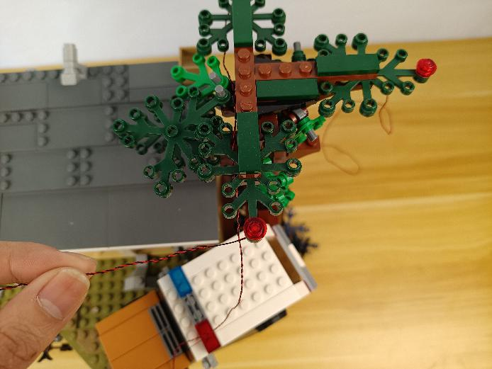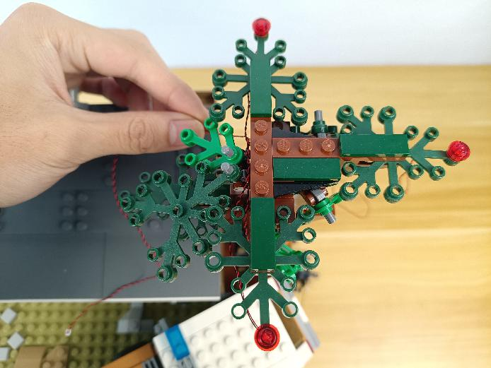

Take the following cable, threat it through the space underneath the leaf, and tighten it up.
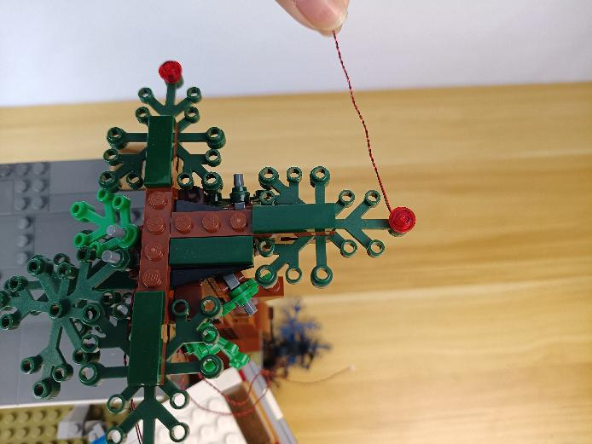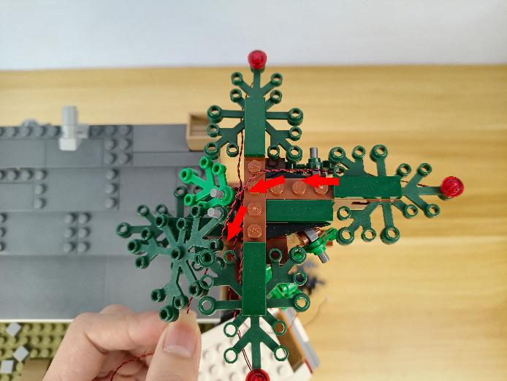

Group the 3 cables together.
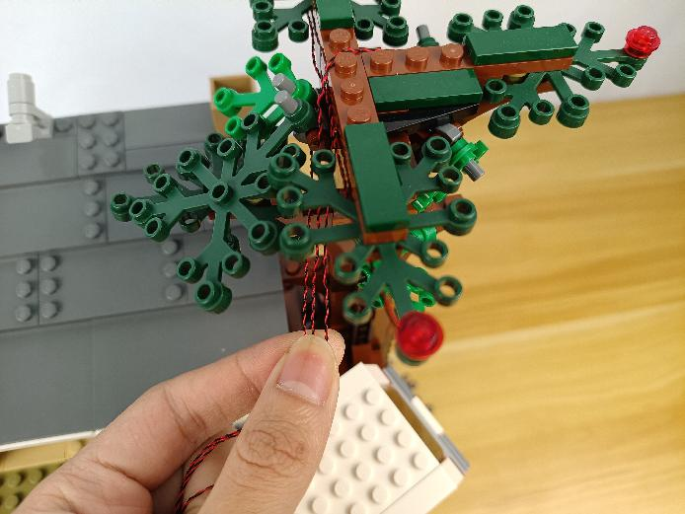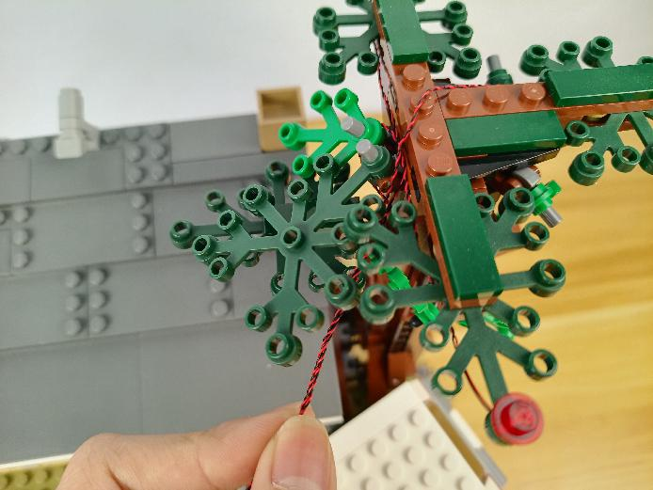

Pull them all the way down.
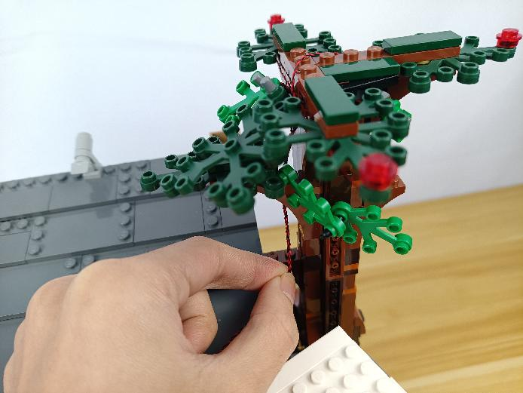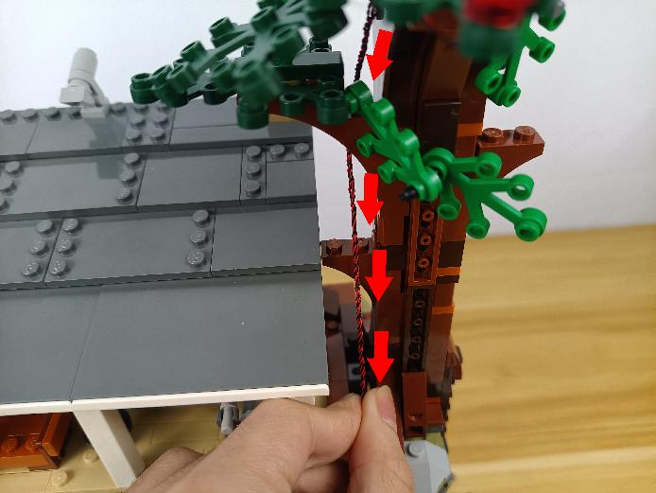

Thread them through the following space and pull them down.
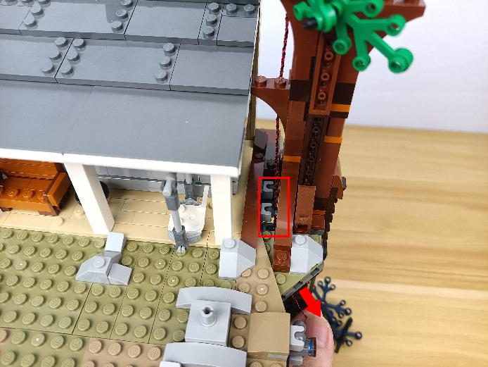

Remove the car.
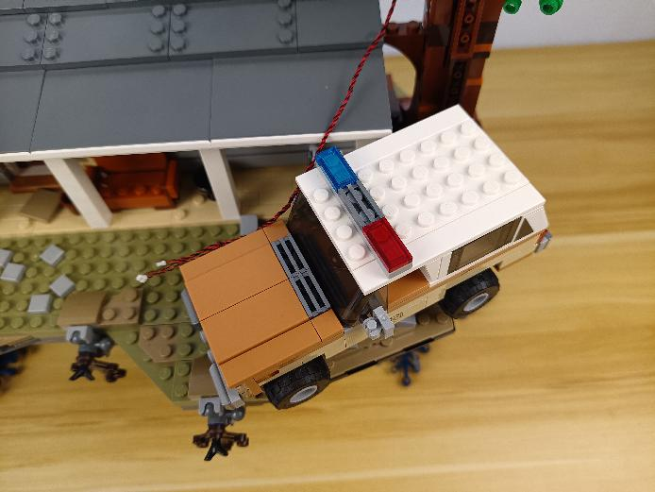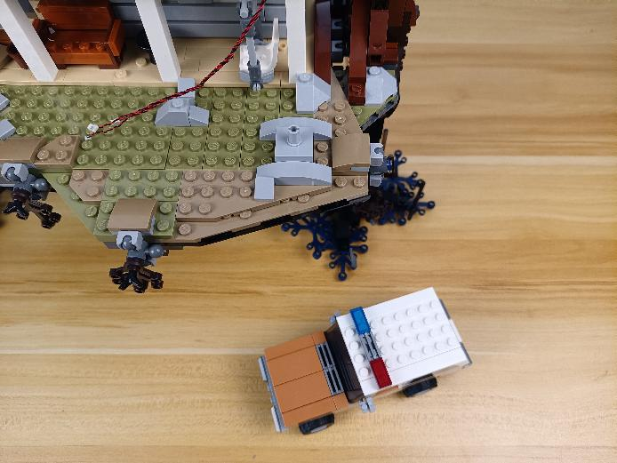

Turn to the front, remove the following pieces.
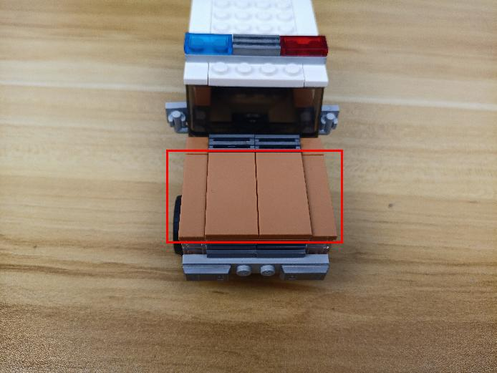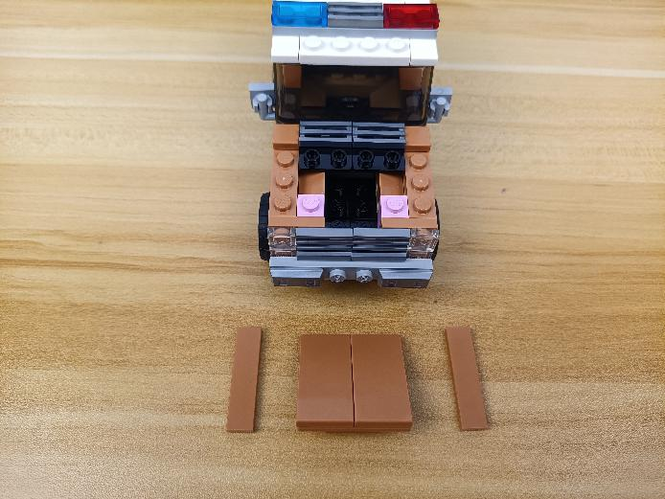

Continue to remove the following trans pieces from both sides.
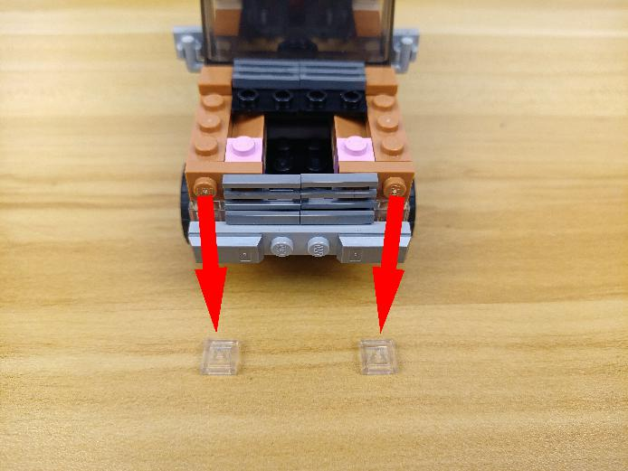

Take 2 warm white 15cm dot lights, 2 trans white 1x1 bricks.
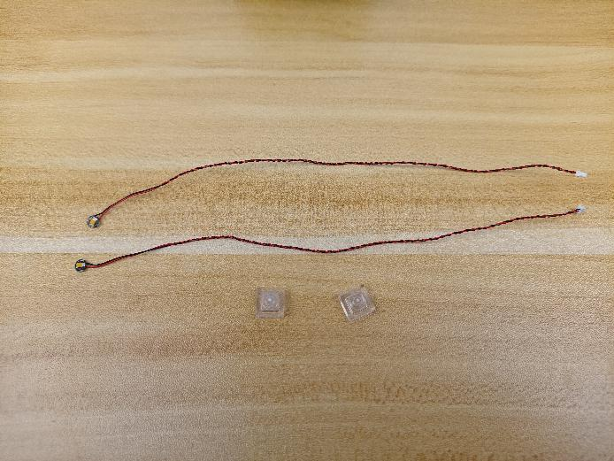

With lighting part facing up, place the light as per below, connect the trans white brick over.
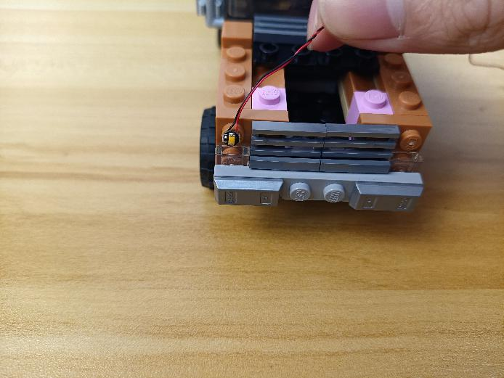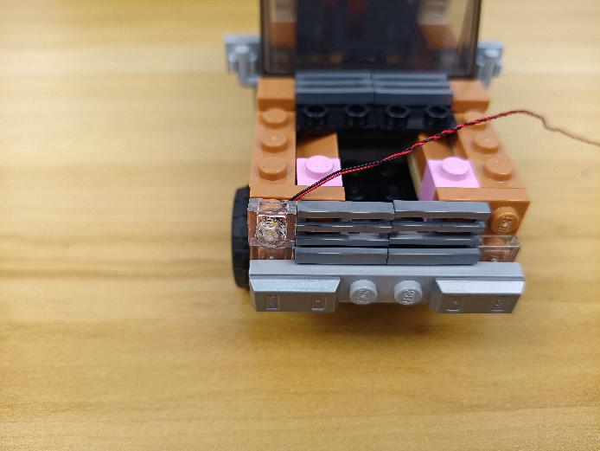

Install the other light in the same way.
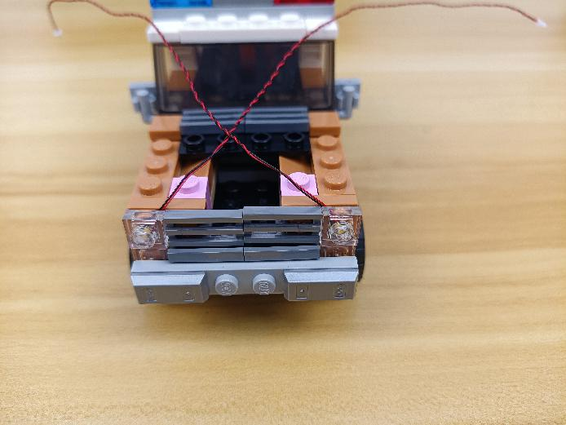

Remove the following roof.
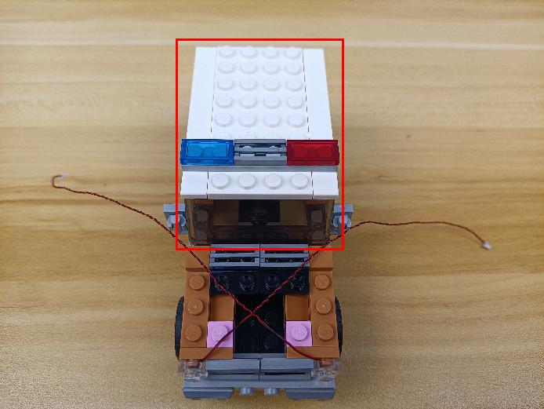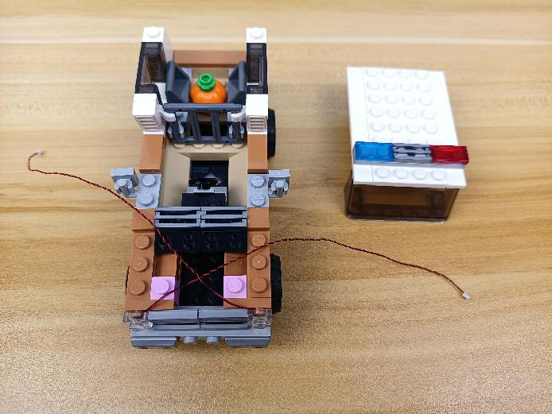

Continue to remove the following piece.
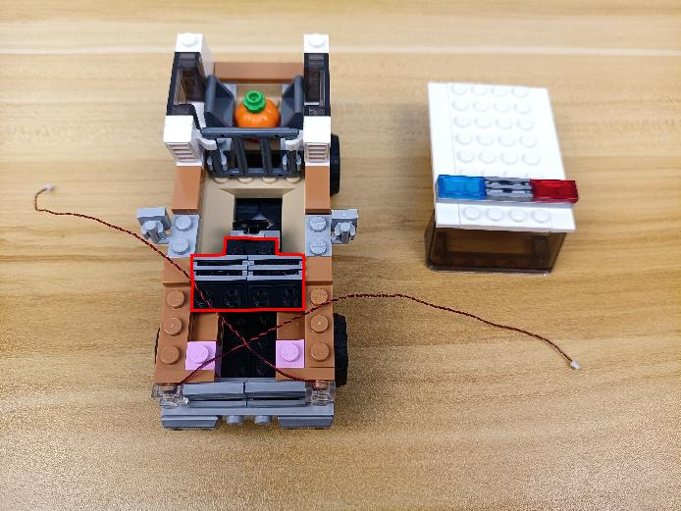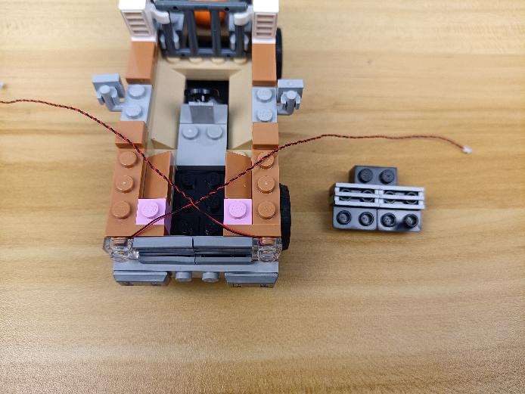

Take a 15cm connecting cable, a 30cm connecting cable, a 4-port expansion board.
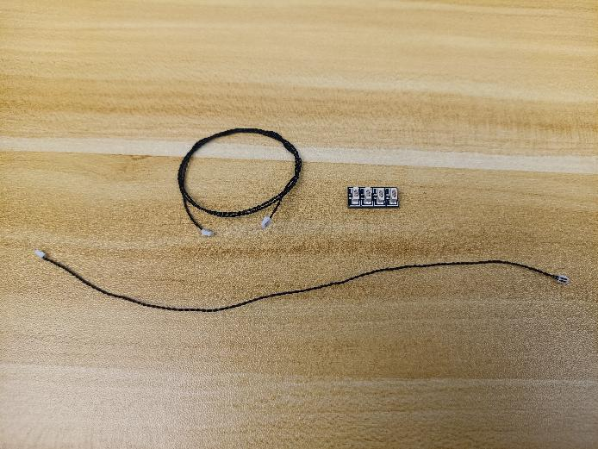

Connect the 2 connecting cables to the expansion board.
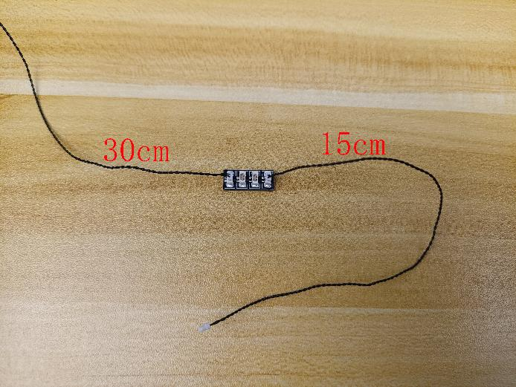

Connect the following 2 cables to the expansion board.
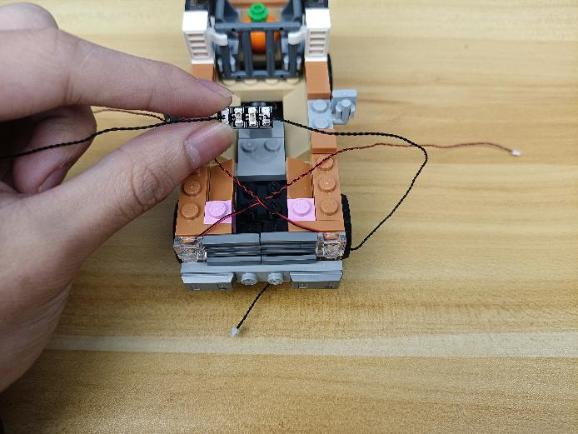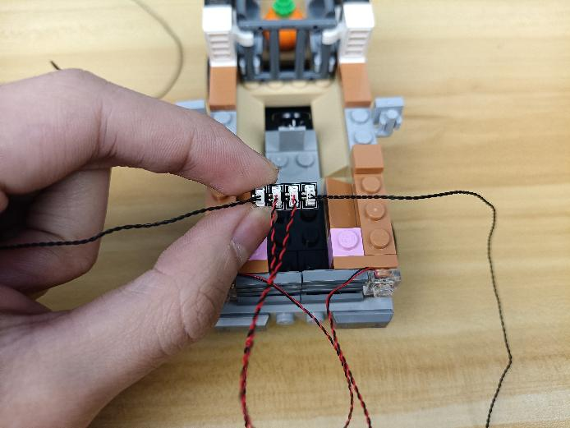

Take 2 adhesive squares.
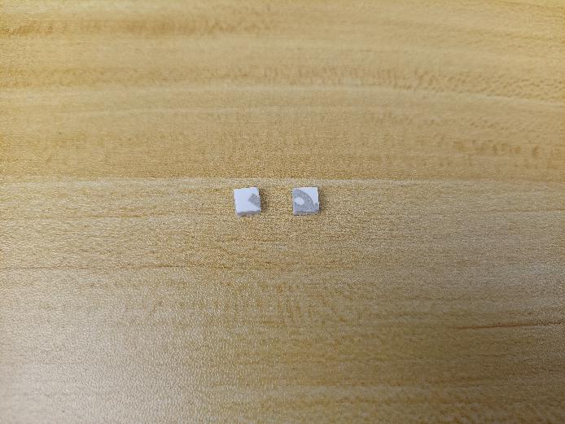

Stick them to the back of the expansion board, and stick the expansion board to the following place.
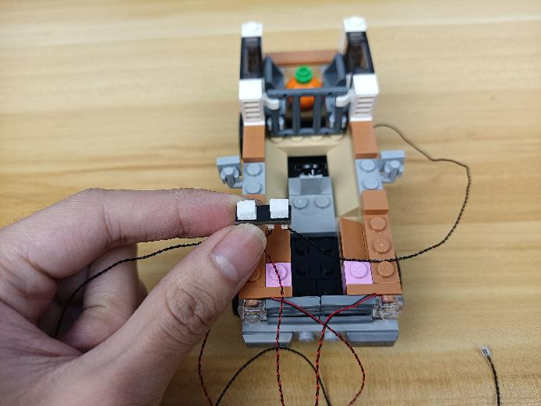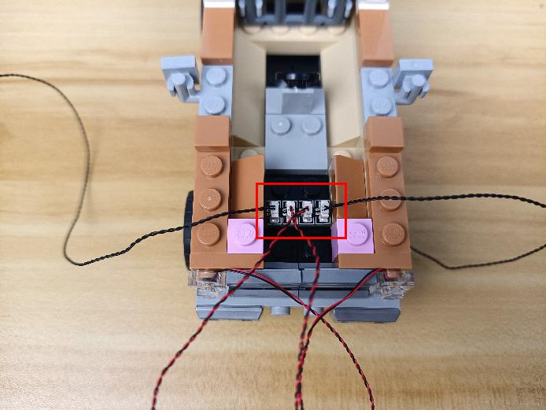

Pull the cables backward, reconnect the following piece.
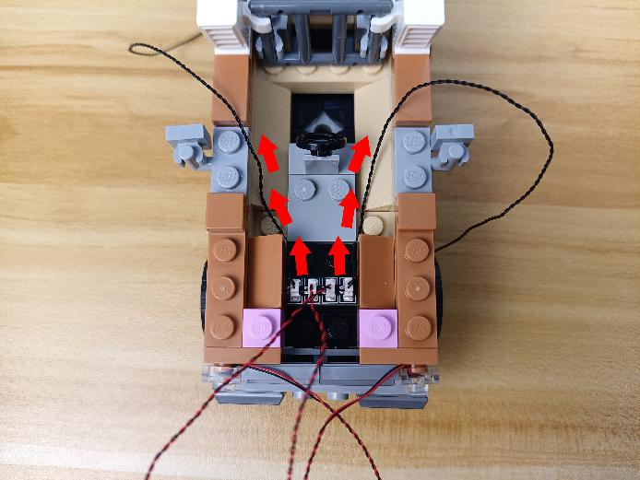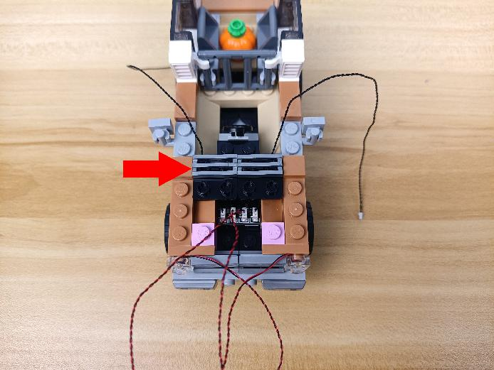

Tuck excess cables at the following space with the tweezer.
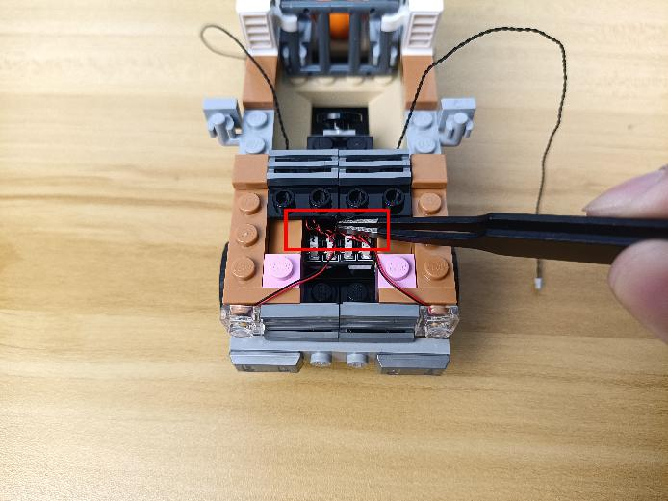

Reconnect the following piece.
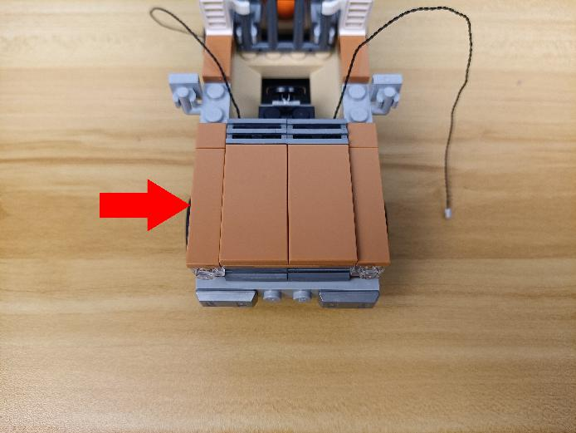

Remove the following gray piece.
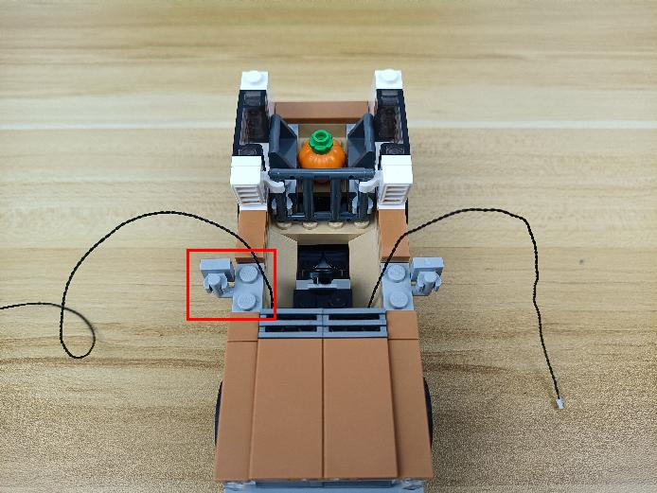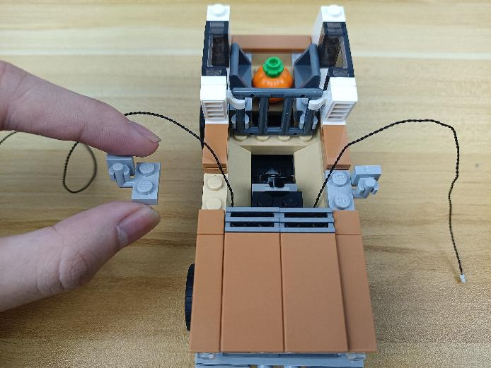

Place the 30cm connecting cable as per below, reconnect the following gray piece.
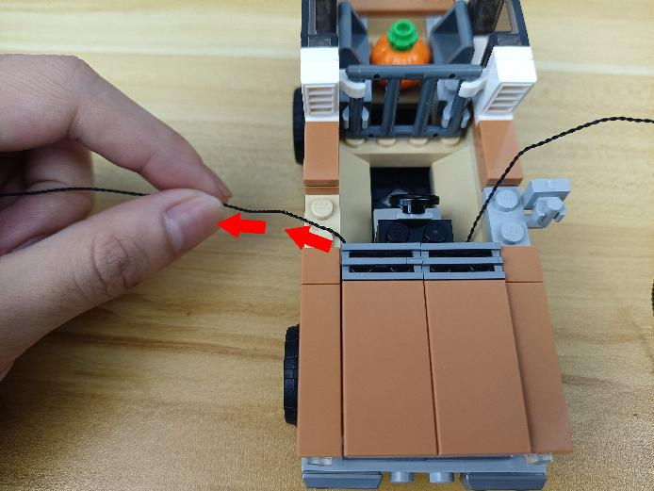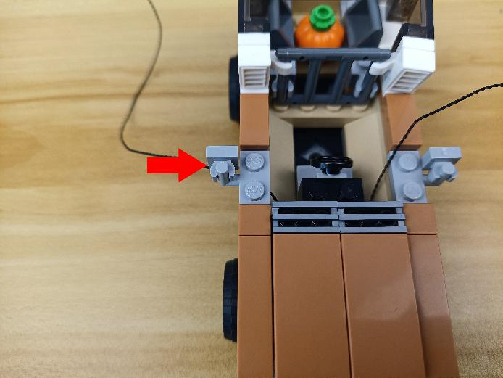

Continue to remove the following piece.
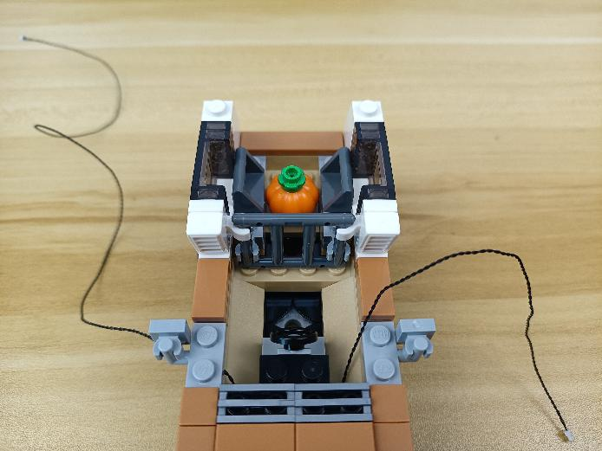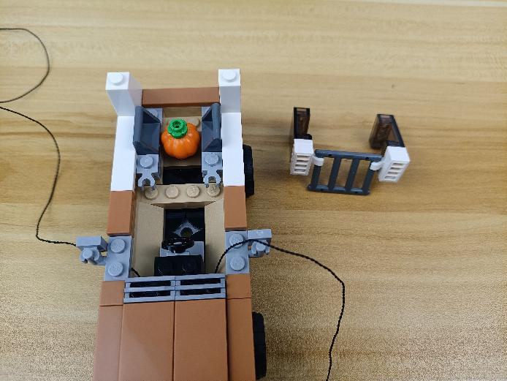

Place the 15cm connecting cable as per below.
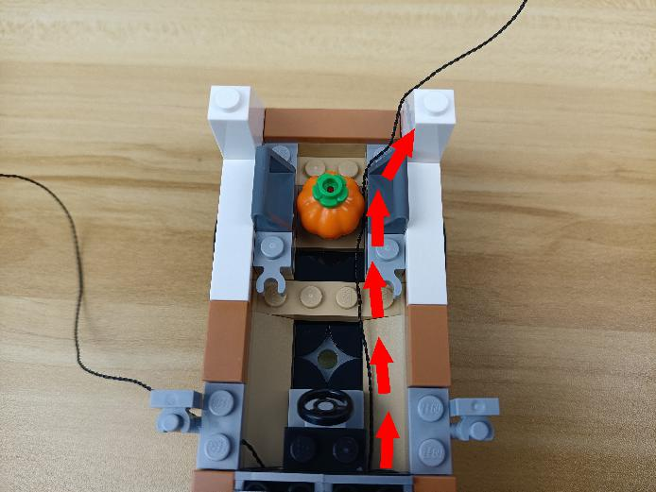

Remove the following piece from the roof.
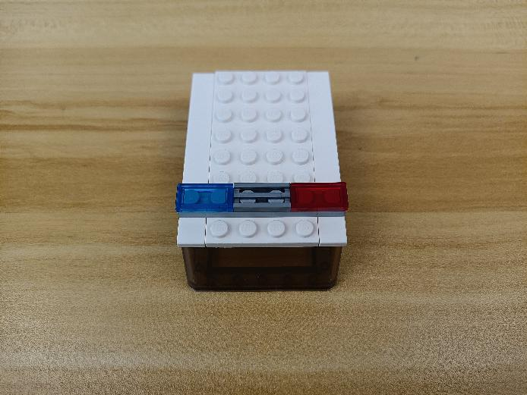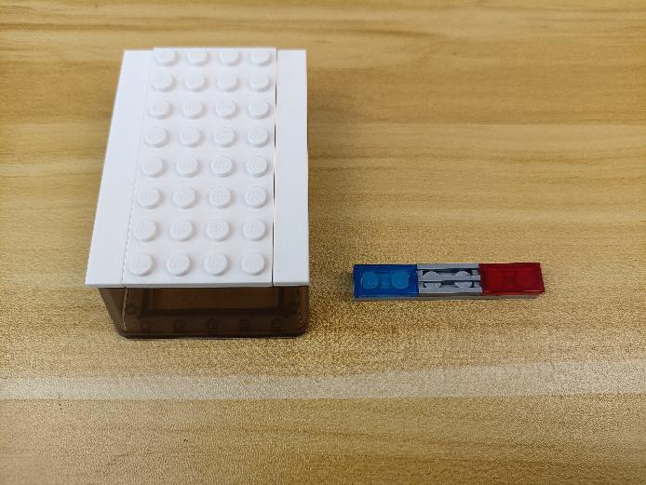

Disconnect the blue plate and the red plate.
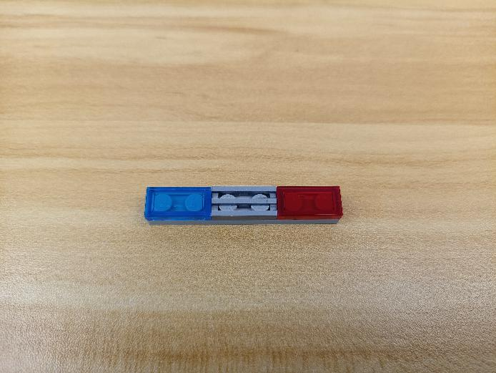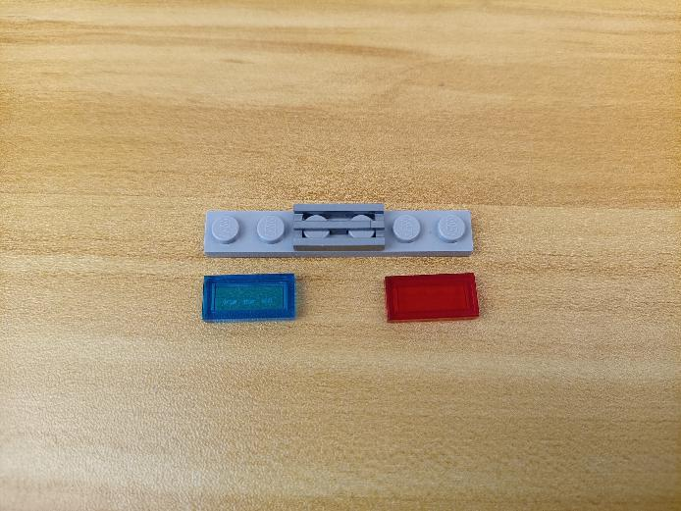

Take 2 flashing blue 15cm dot lights, 2 trans blue 1x2 bricks.
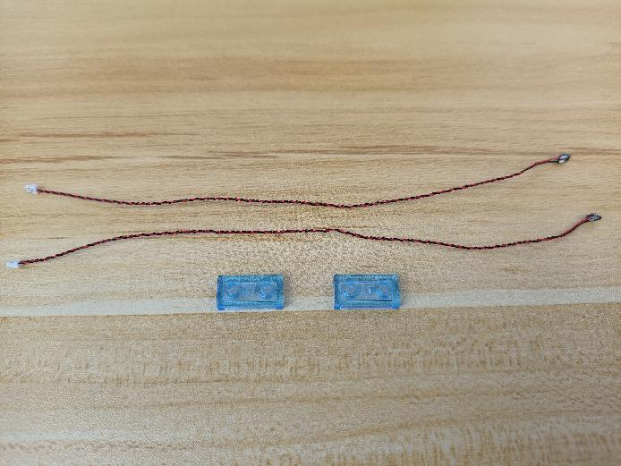

With lighting part facing up, place the light as per below, connect the trans blue 1x2 brick over.
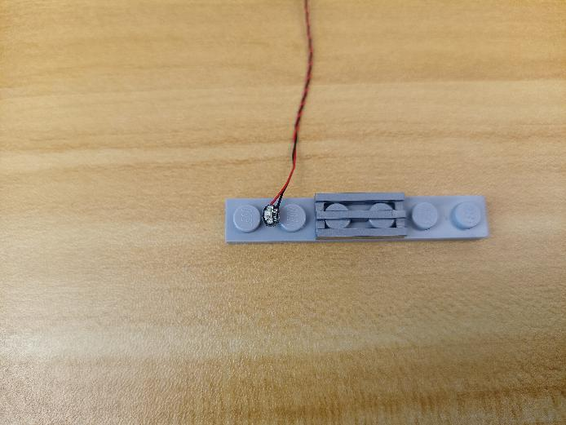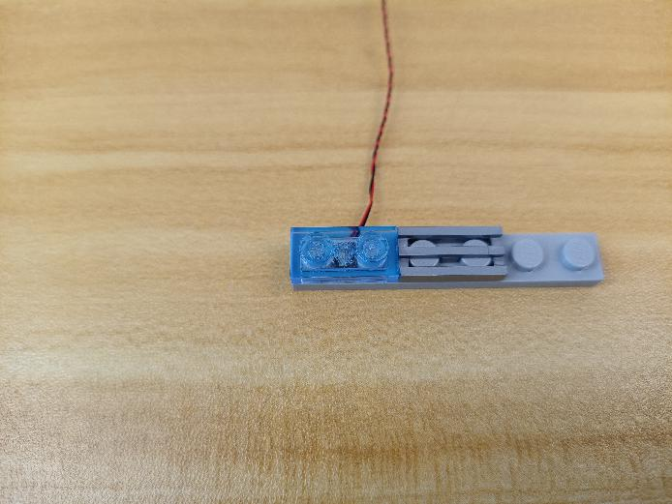

Install the light at the other side in the same way.
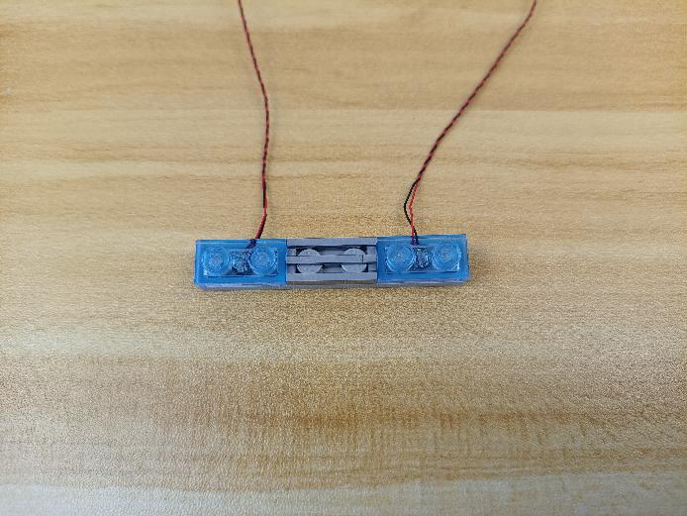

Reconnect the following piece.
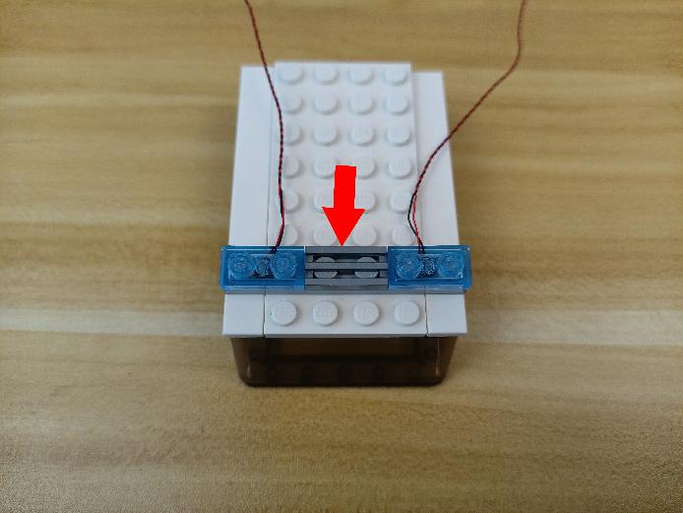

Create gaps at the following places on the roof.
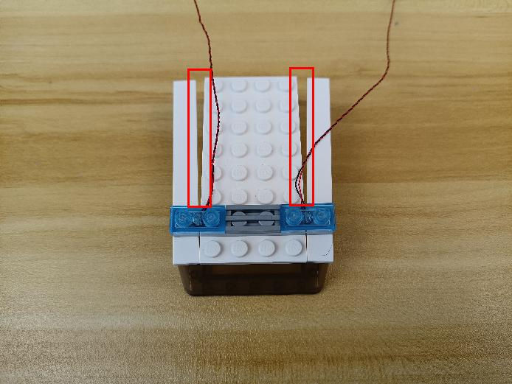

Place the cables at the following places, close the gaps.
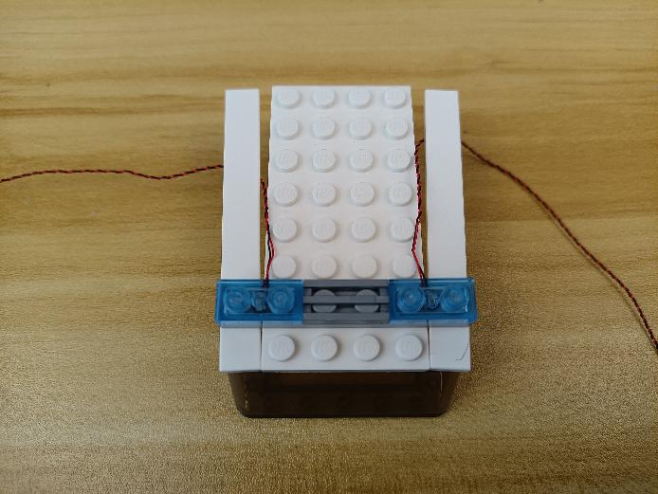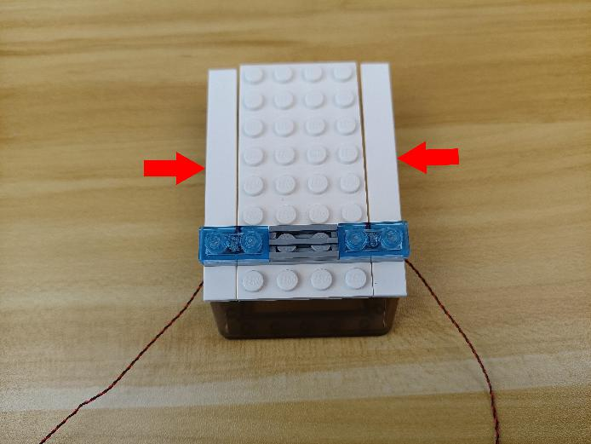

Turn it over and turn to the side.
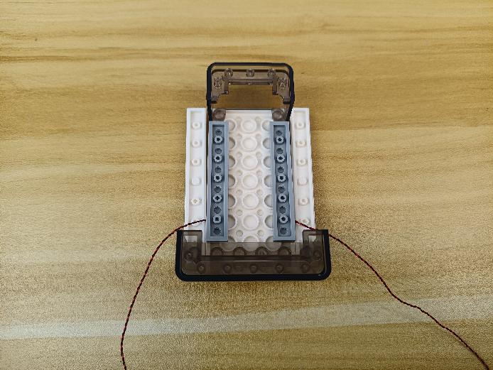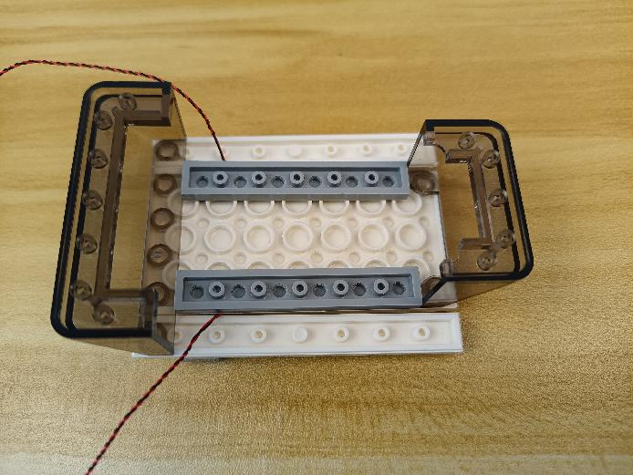

Take a warm white 15cm dot light, an adhesive square.
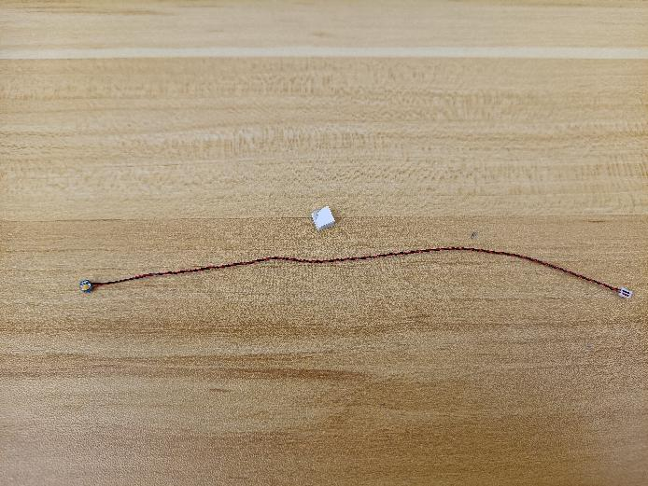

Stick the adhesive square to the following place.
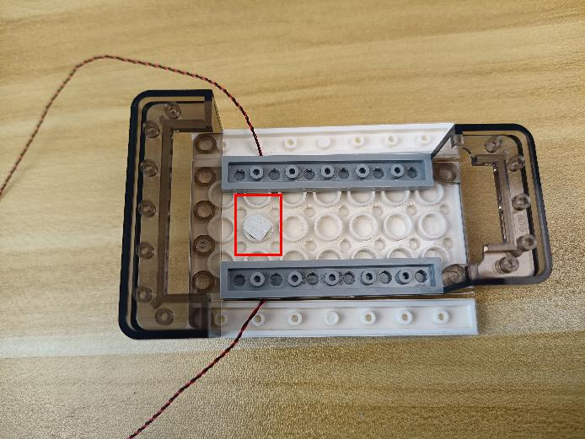

Remove the following pieces.
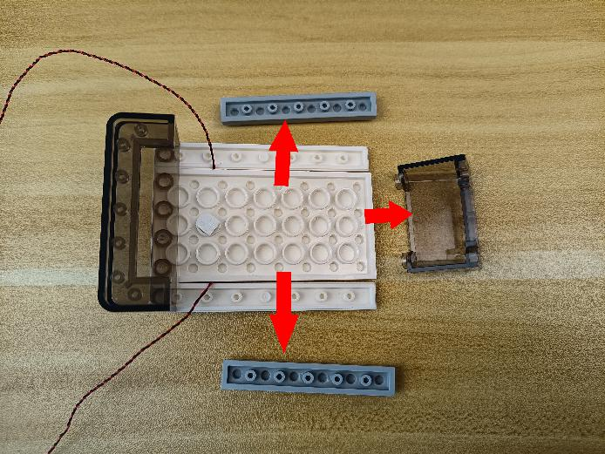

Stick the light to the adhesive square.
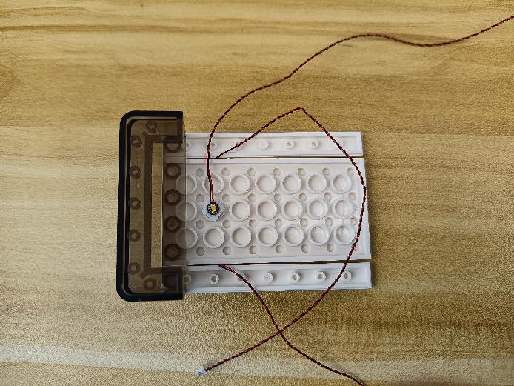

Place the cables as per below, reconnect the following pieces
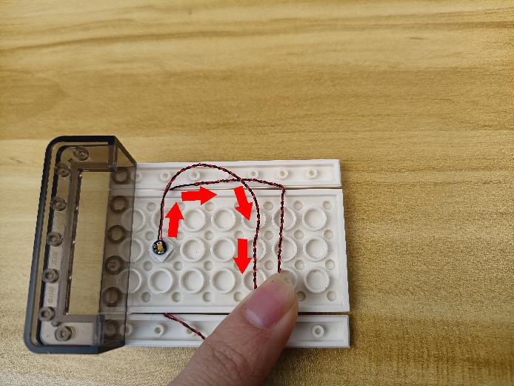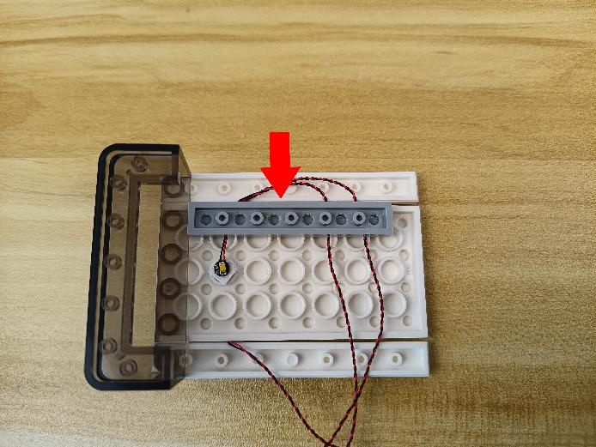

Place the cables as per below.
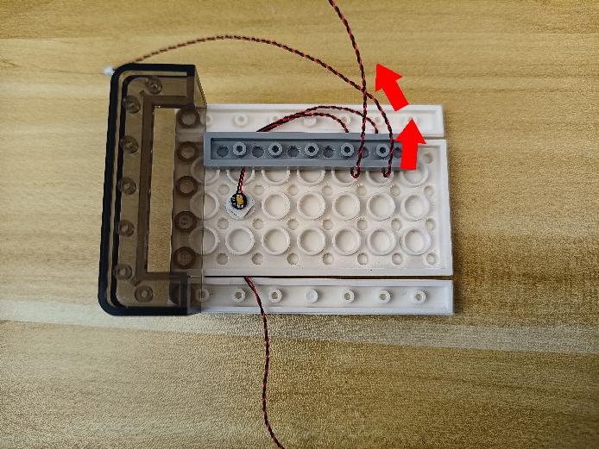

Place the other cable as per below, reconnect the following piece.
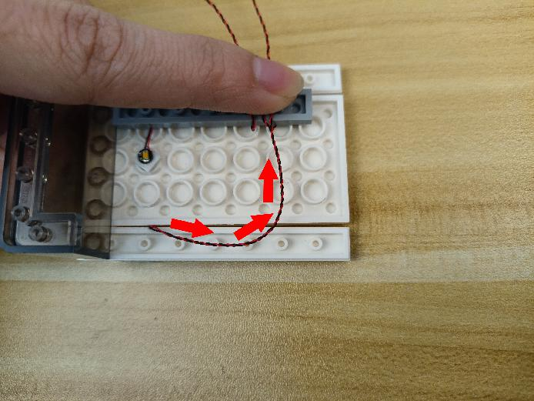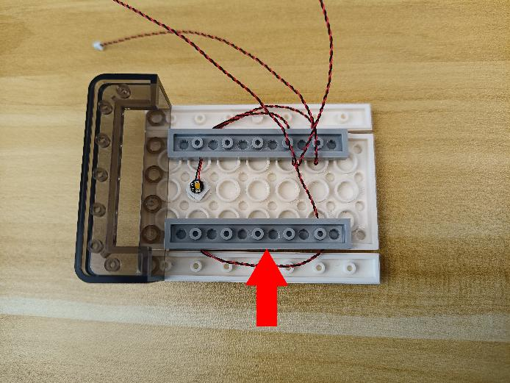

Turn to the car, remove the following pieces from both sides.
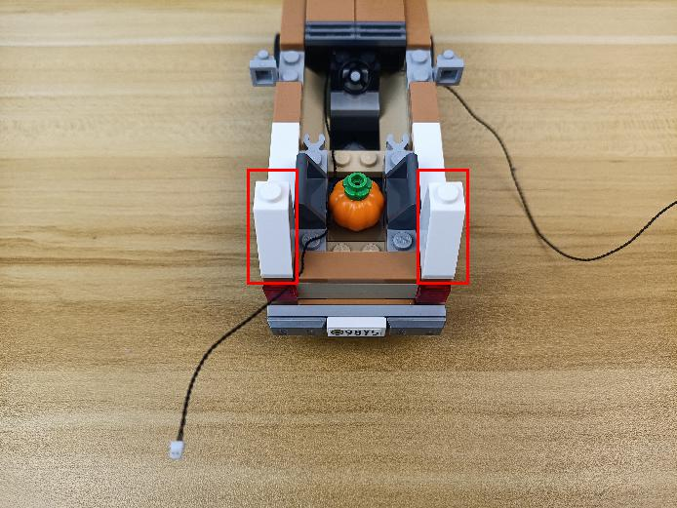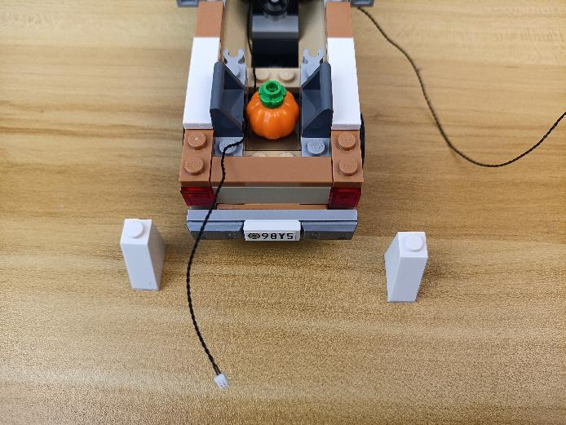

Continue to remove the following pieces.
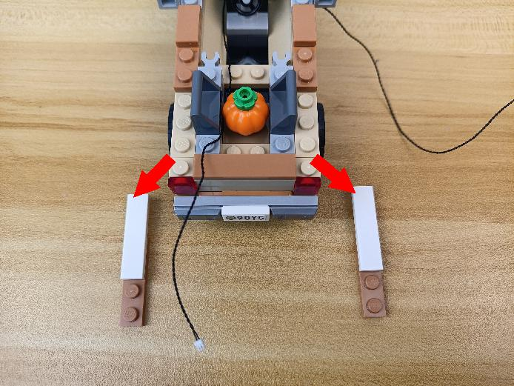

Disconnect the following pieces.
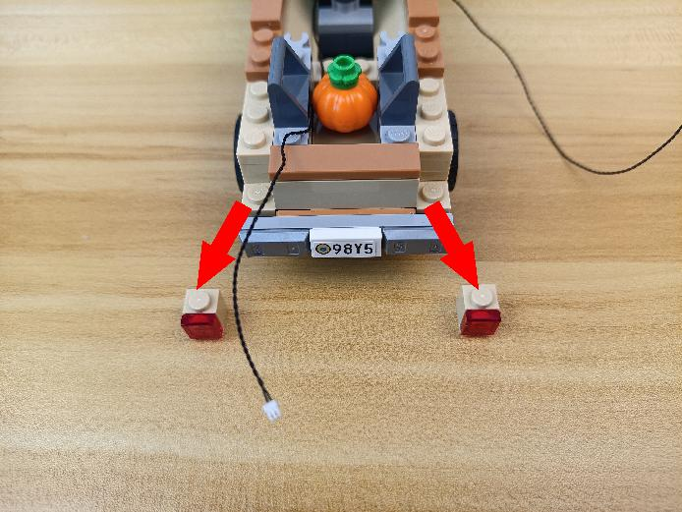

Disassemble them as per below.
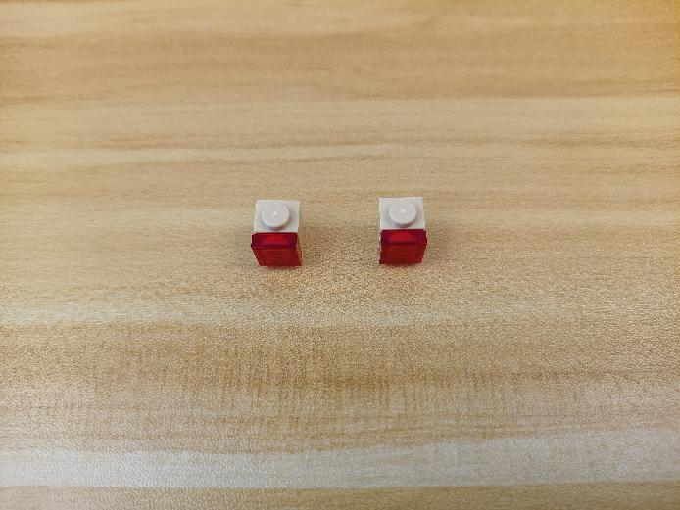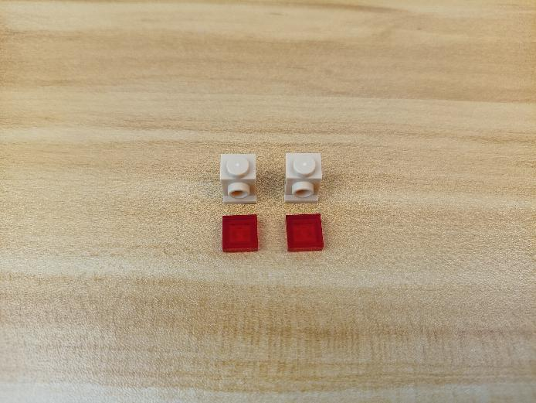

Take 2 red 15cm dot lights.
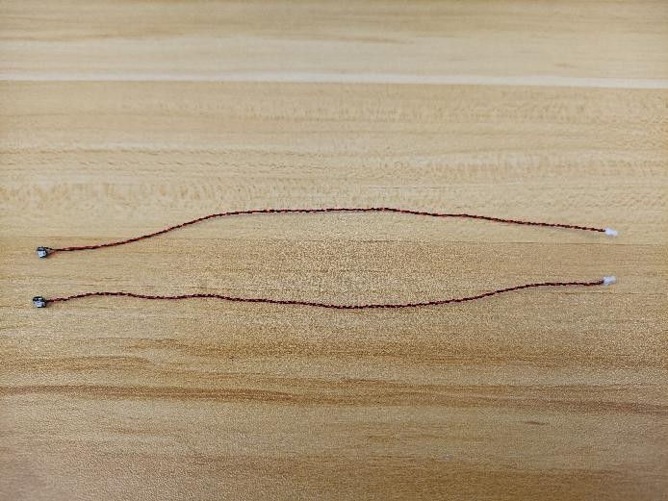

With lighting part facing up, thread the cables through the holes, and tighten them up.
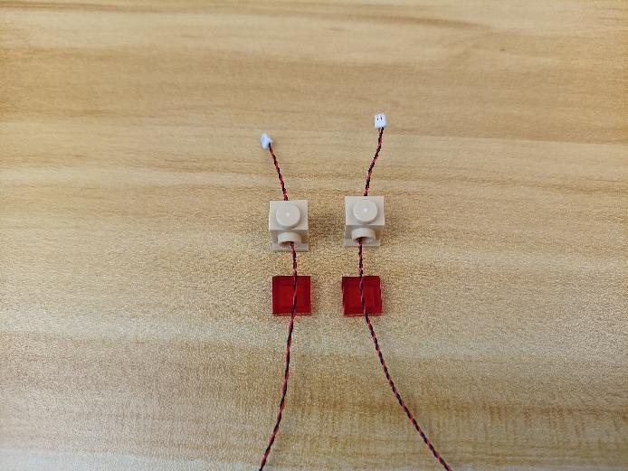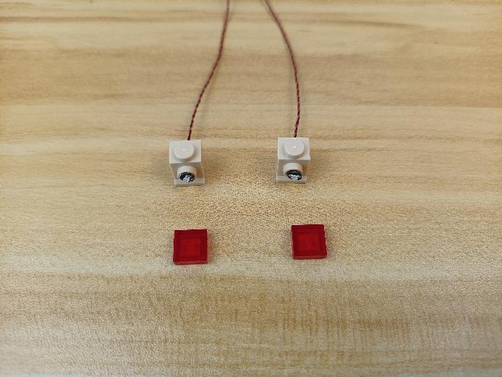

Reconnect the following red pieces.
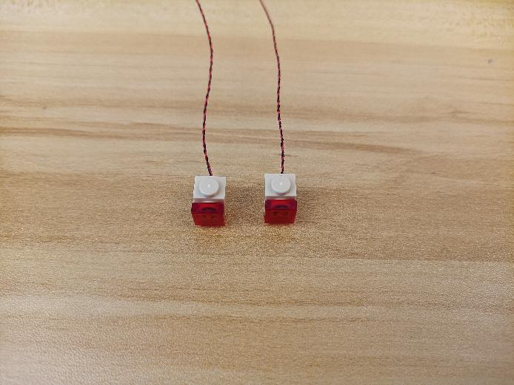

Reconnect the following pieces.
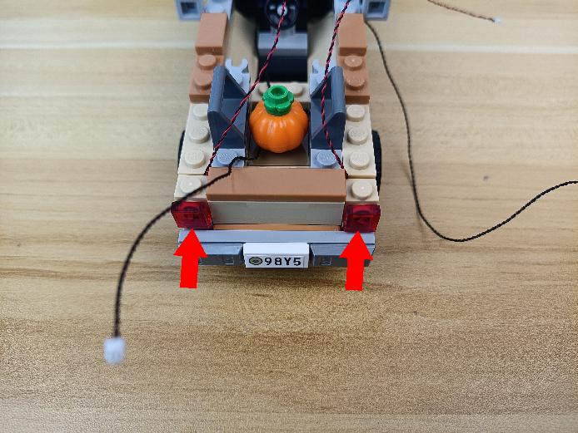

Wind the 2 cables around the pumpkin.
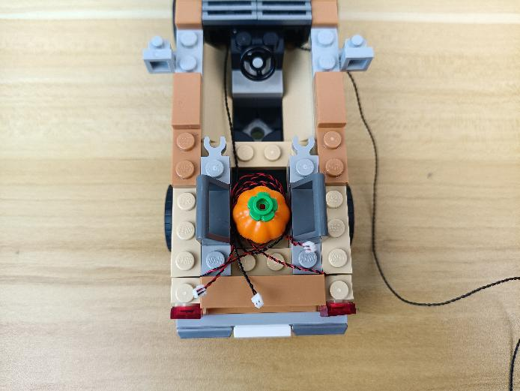

Reconnect the following pieces.
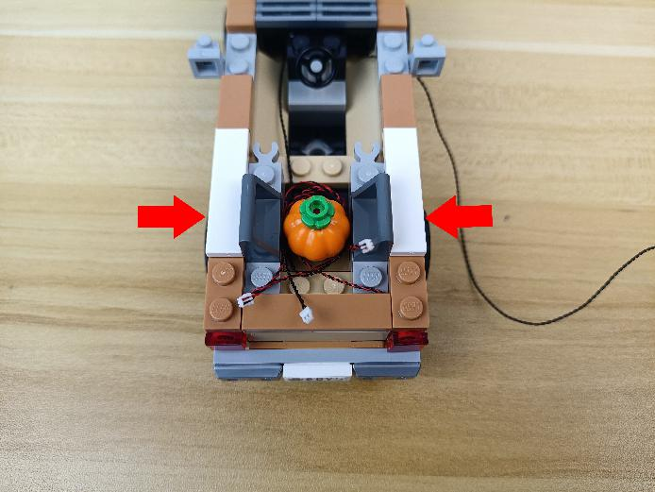

Continue to reconnect the following pieces.
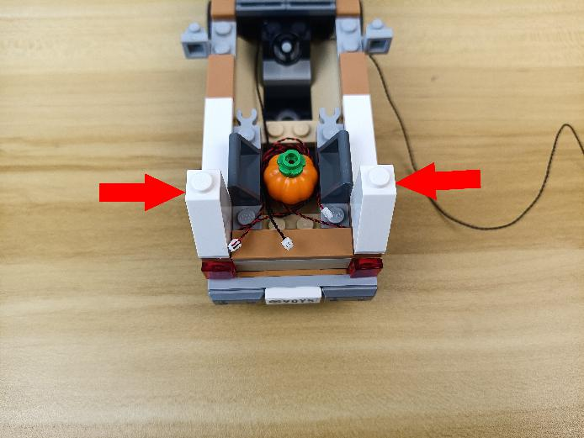

Take a 6-port expansion board.
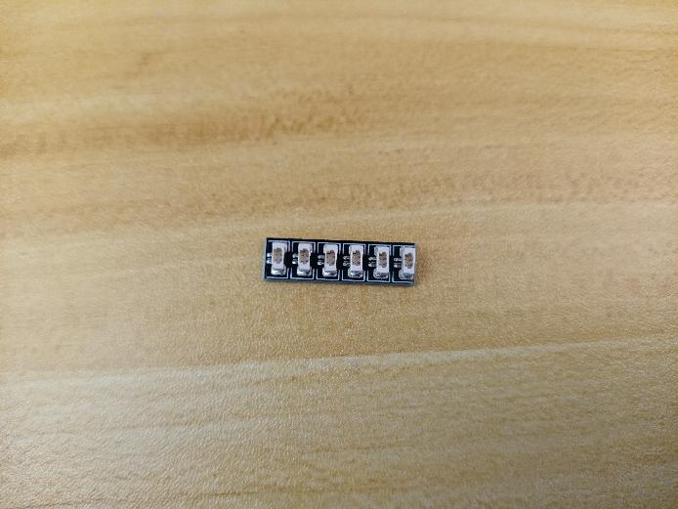

Connect the following cables from the roof to the expansion board.
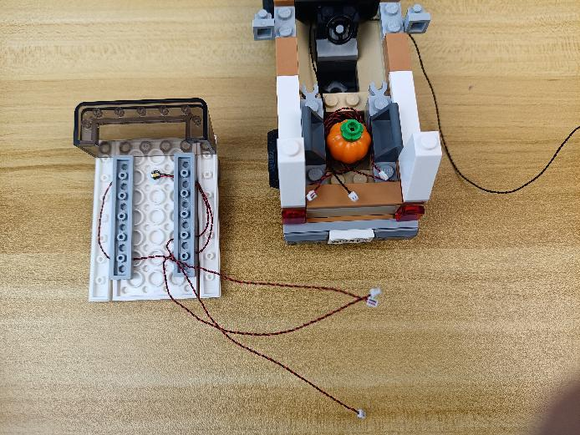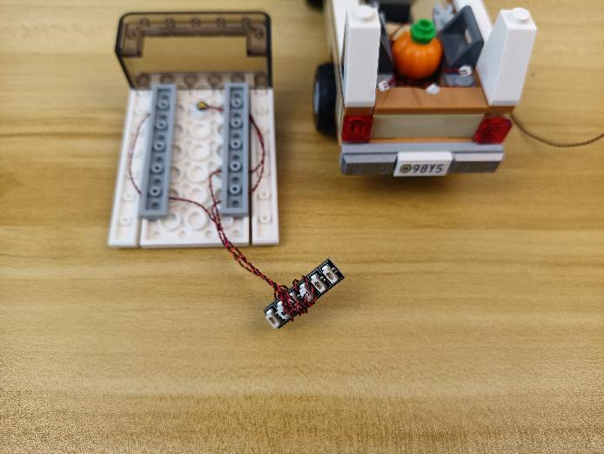

Continue to connect the following cables from the car to the expansion board.
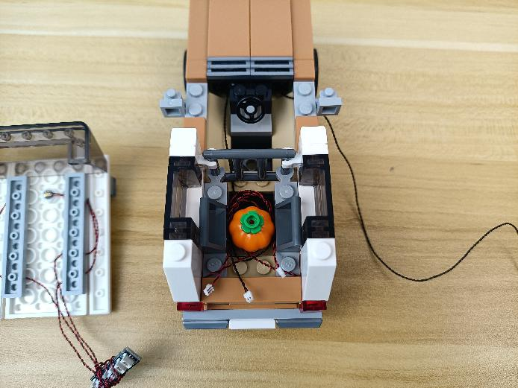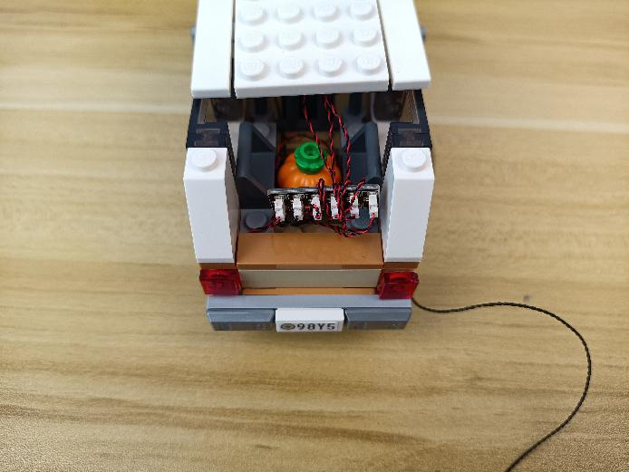

Reconnect the following piece, and reconnect the roof.
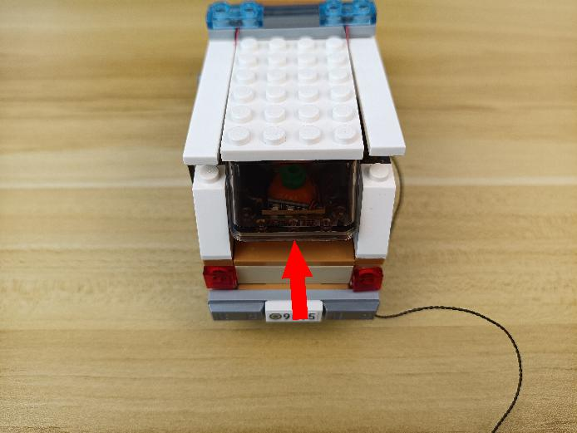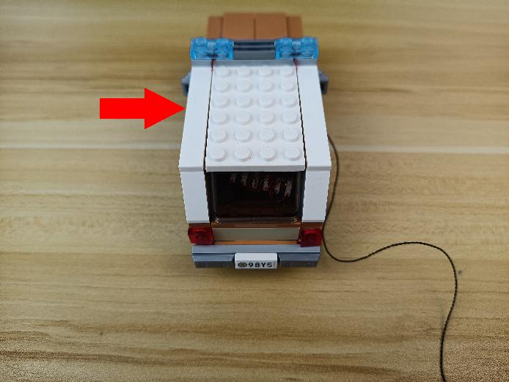

Turn to the house, remove the roof.
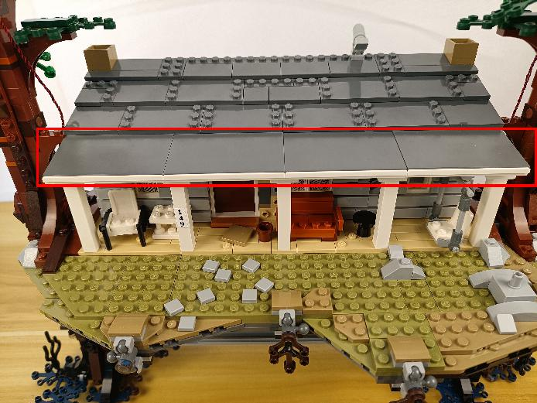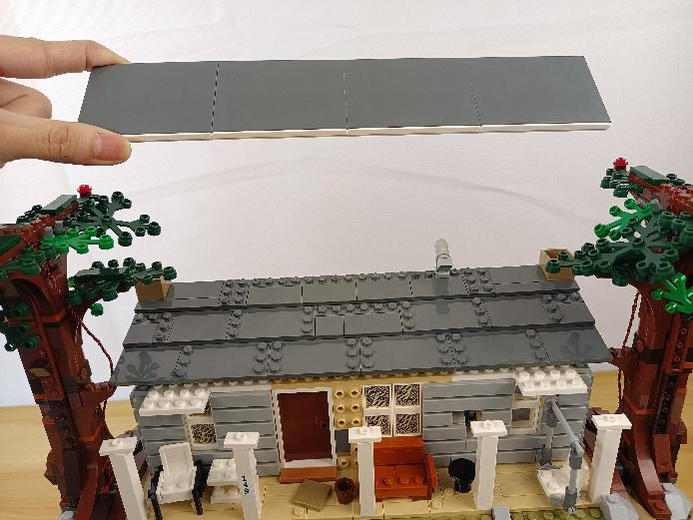

Turn the roof piece over.
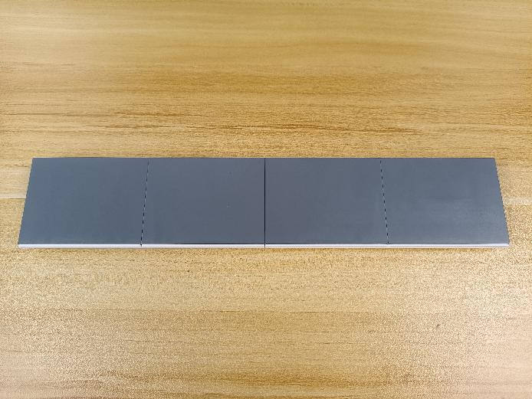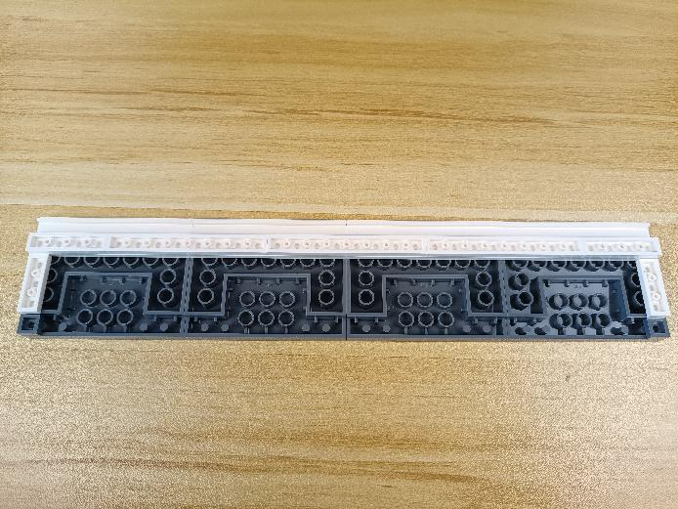

Disconnect the following 3 pieces.
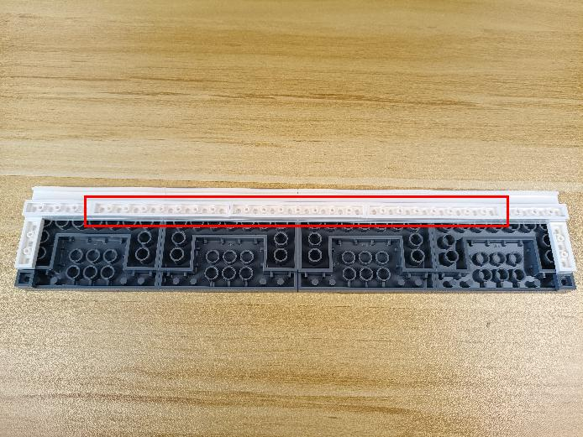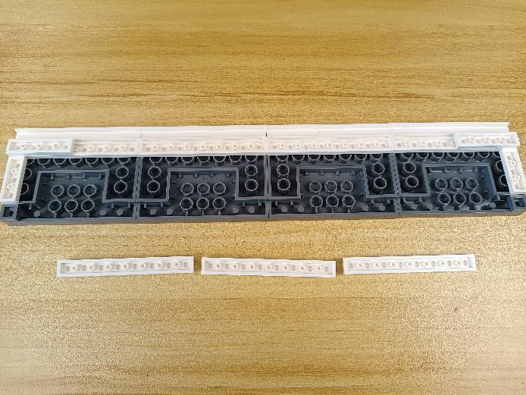

Take 3 warm white 30cm dot lights, 3 adhesive squares.
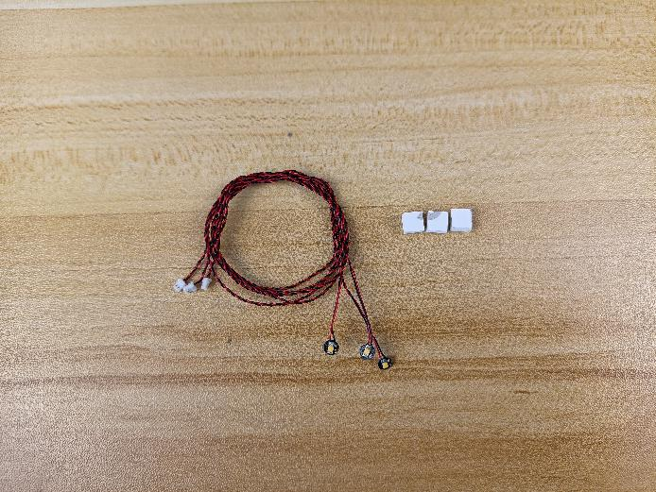

Stick the adhesive squares to the following places.
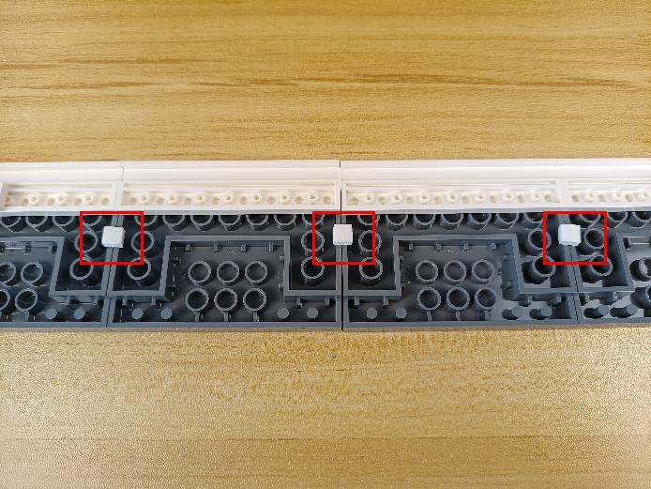

With lighting part facing up, stick the lights to the adhesive squares.
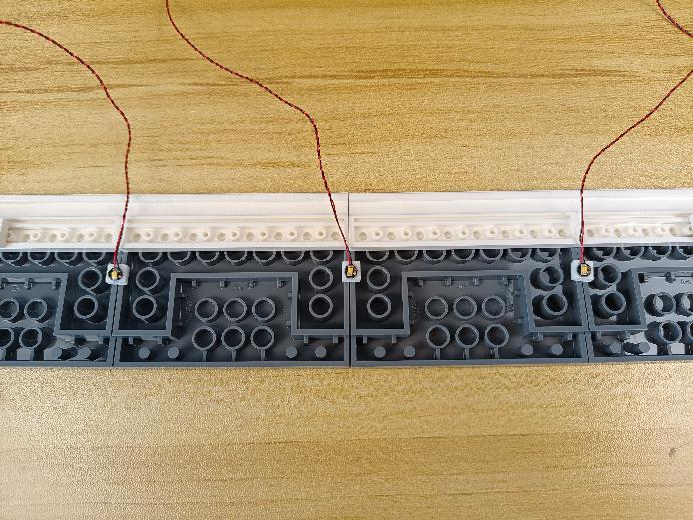

Place the cables as per below, reconnect the following pieces.
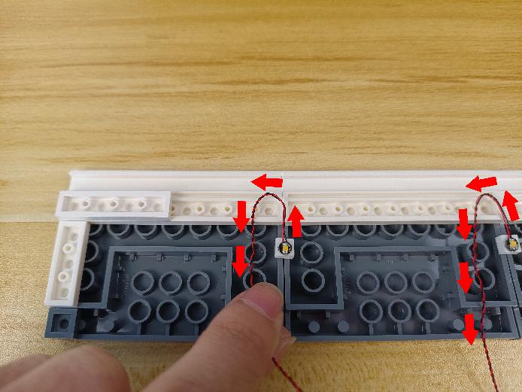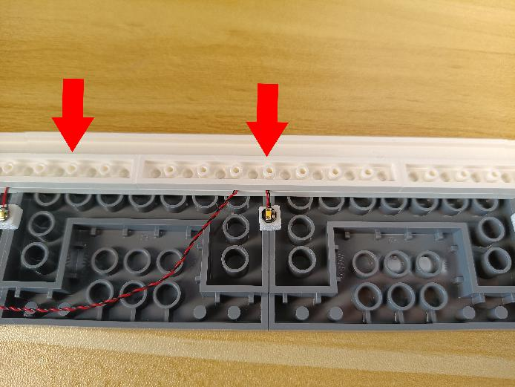
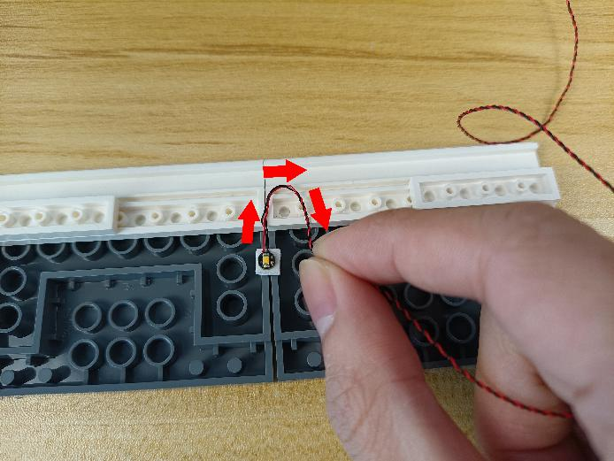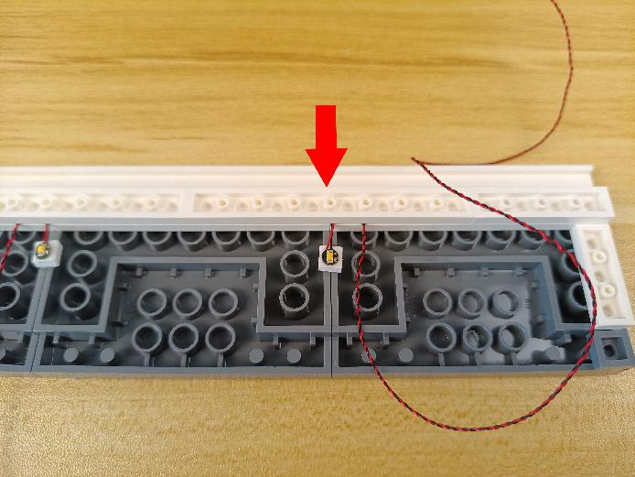

Disconnect the following piece.
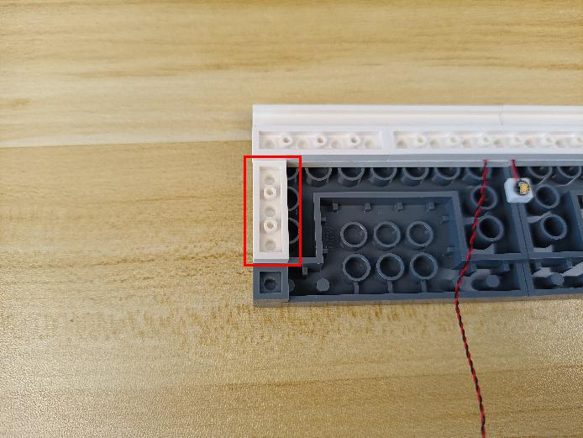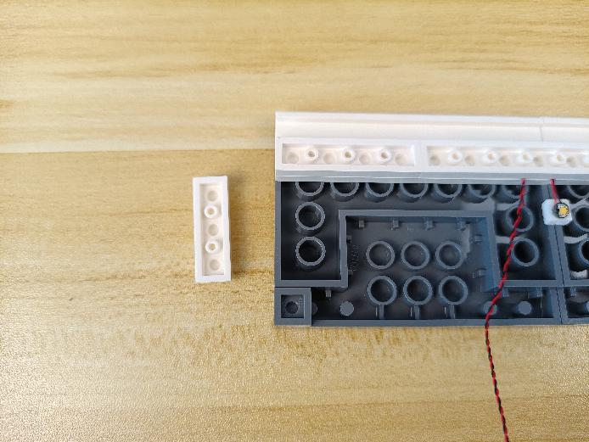

Place the following 2 cables as per below.
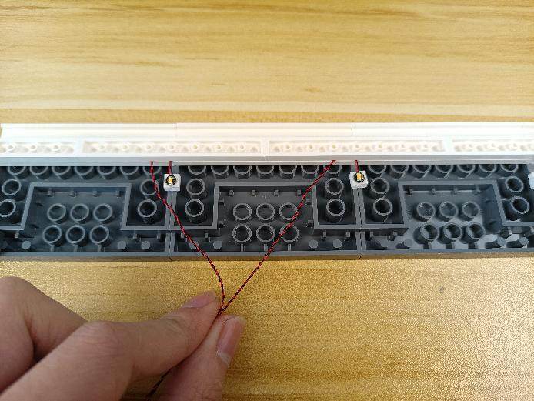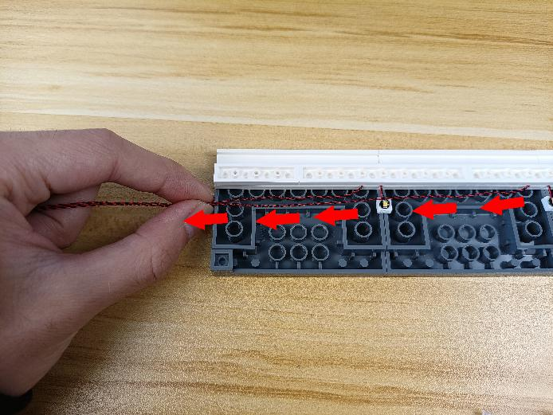

Reconnect the following piece.
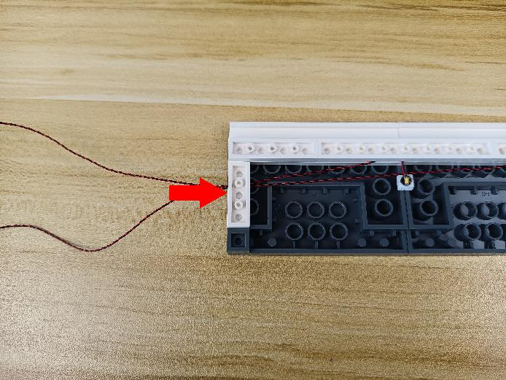

Place the cable at the left as we did before.
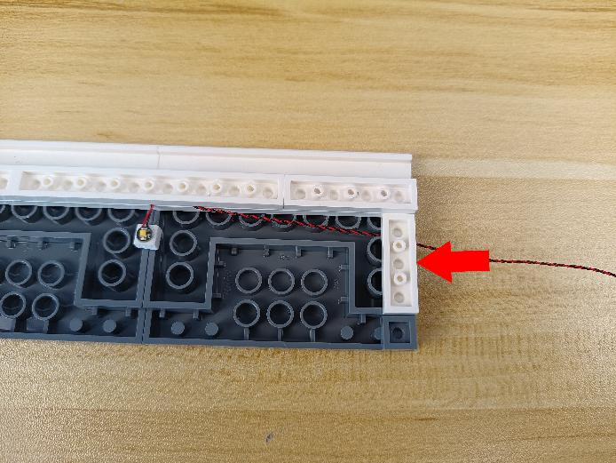

Turn to the house, reconnect the roof.
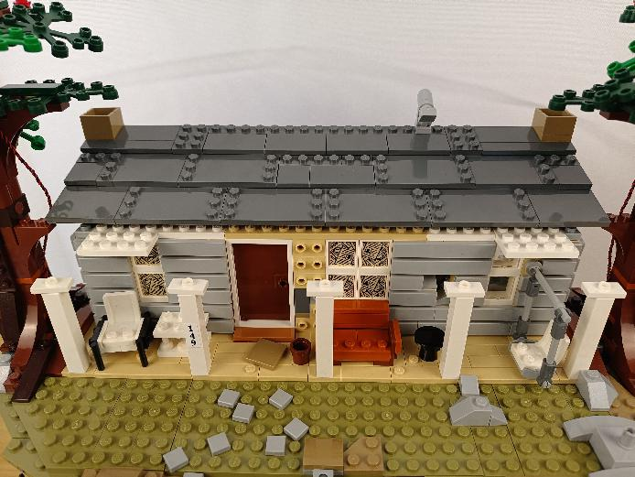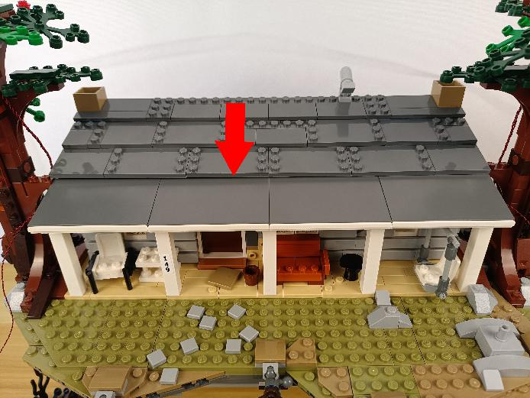

Thread the cables from the left roof through the following space down.
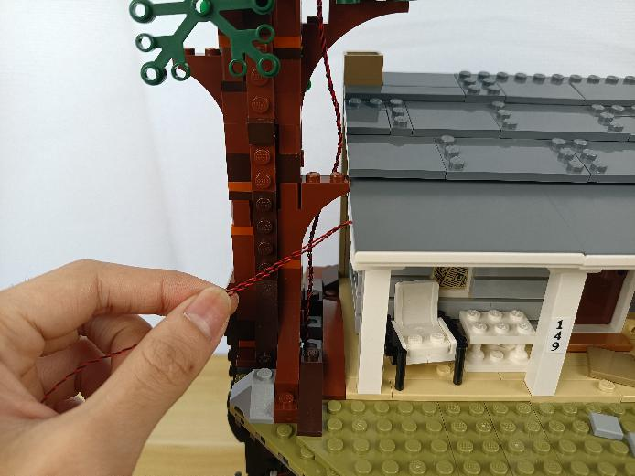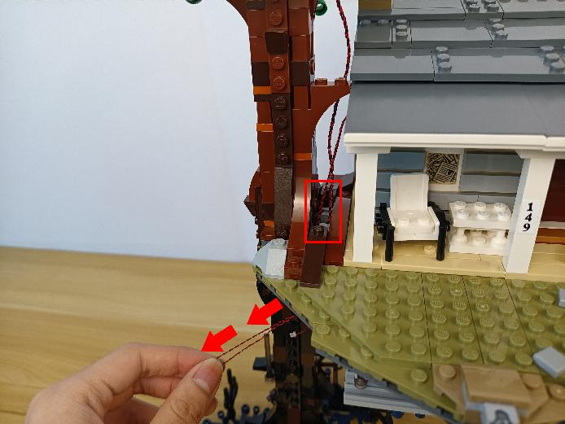

Thread the cables from the right roof through the following space down.
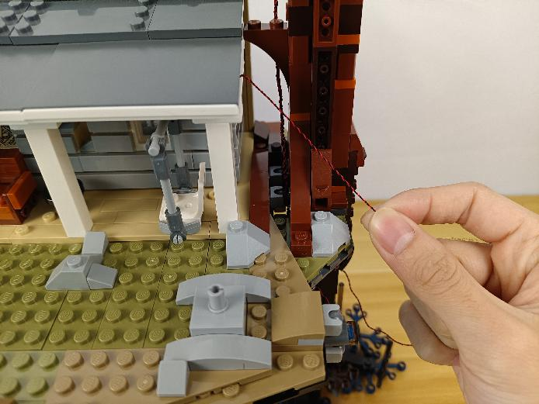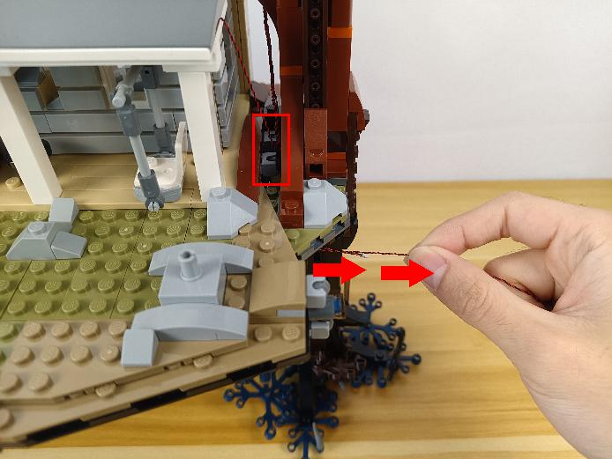

Turn to the side.
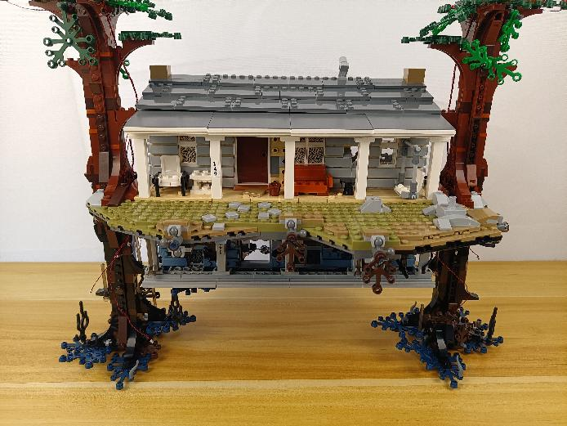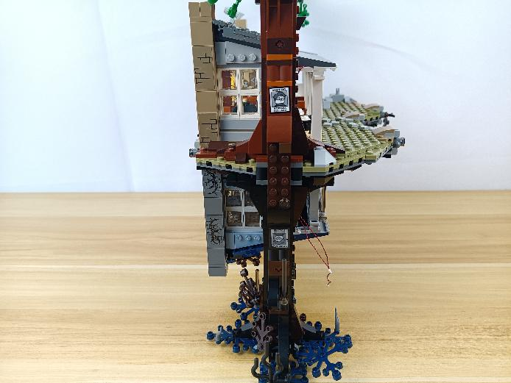

Turn to the following place.
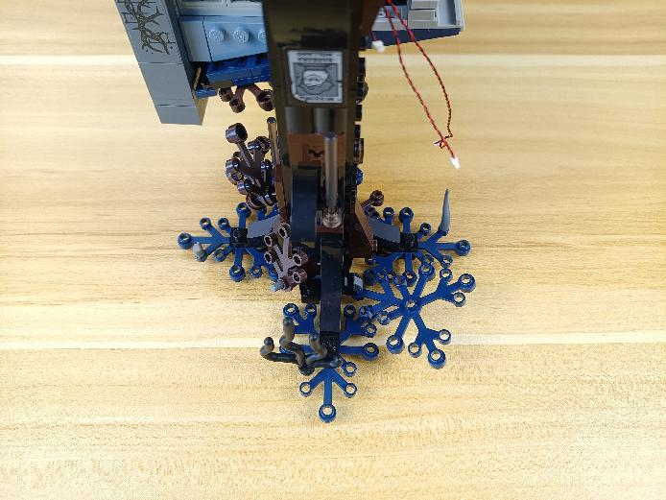

Take 3 blue 30cm dot lights, 3 trans blue 1x1 round plates.
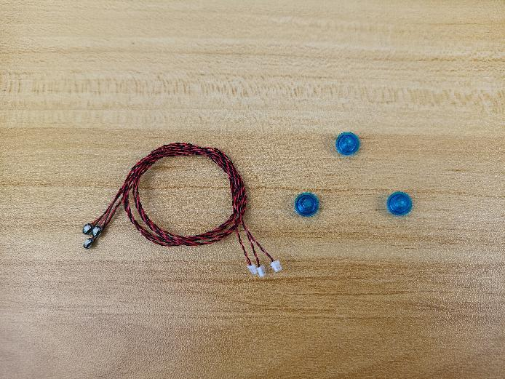

With lighting part facing up, thread the cables through the following holes on the leaves.
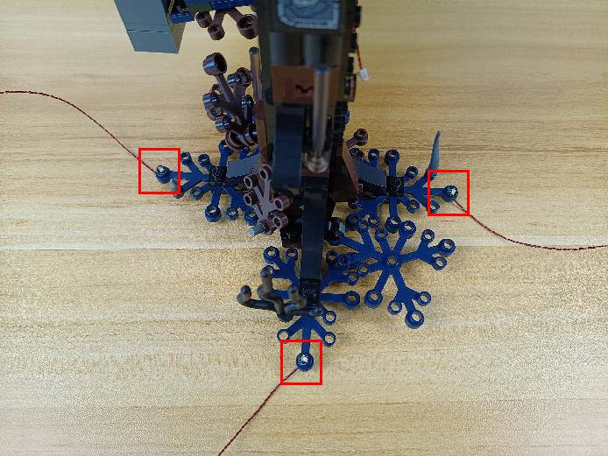

Connect the trans blue round plates over.
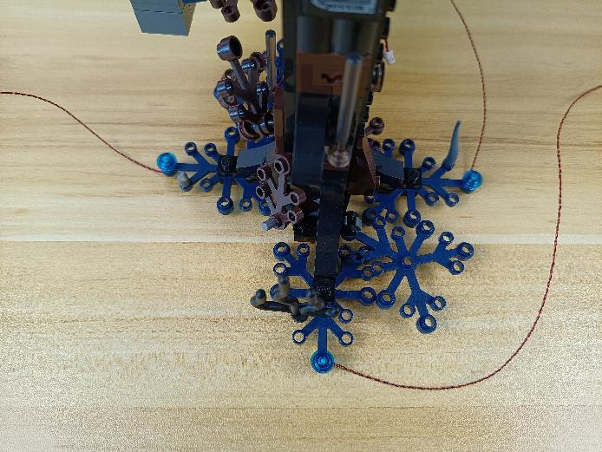

Take the following cable, thread it through the space underneath the leaves, and pull it out as per below.
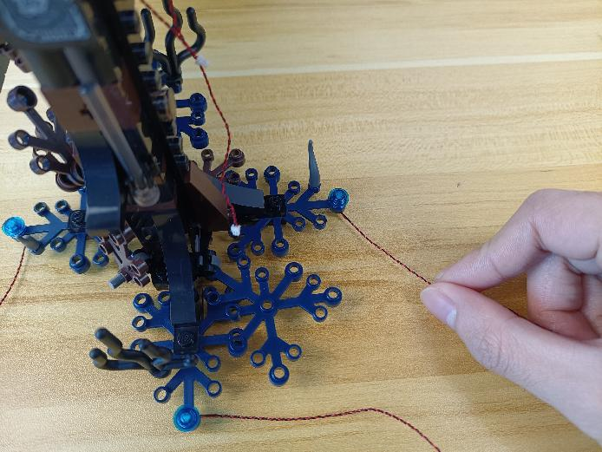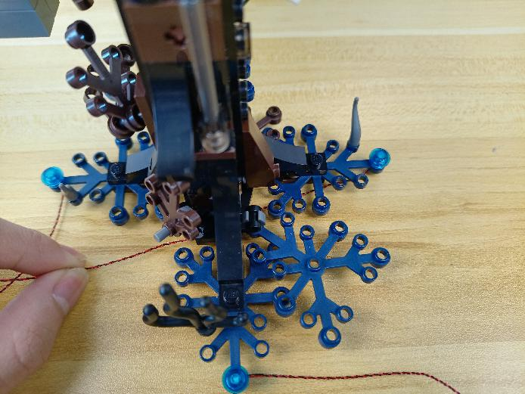

Continue to thread it through the following hole.
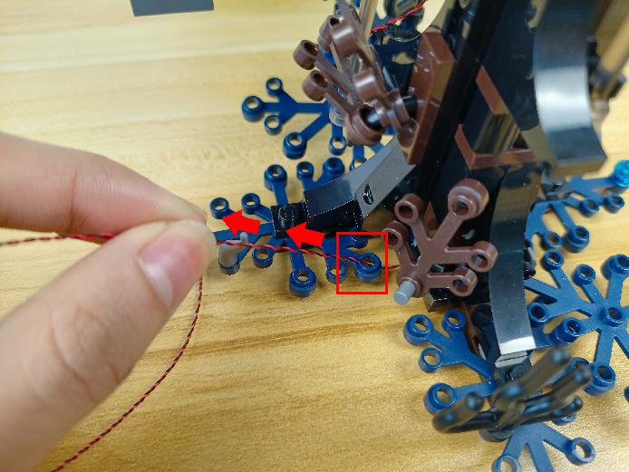

Take the following cable, thread it through the hole, and pull it out as per below.
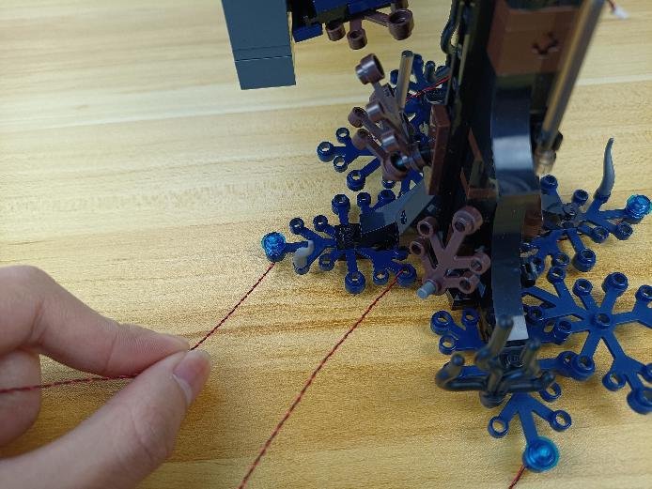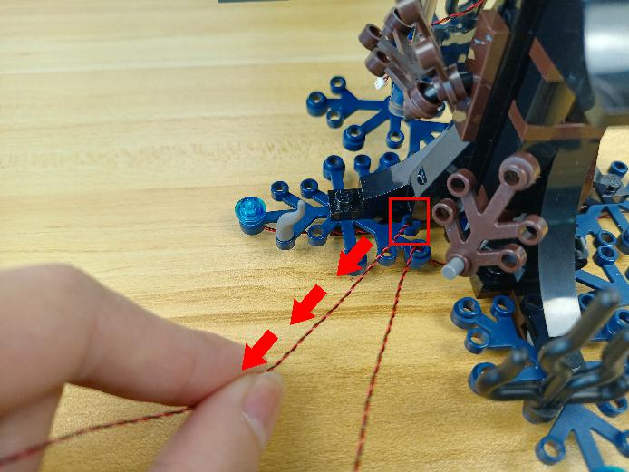

Take the following cable, thread it through the hole, and pull it out as per below.
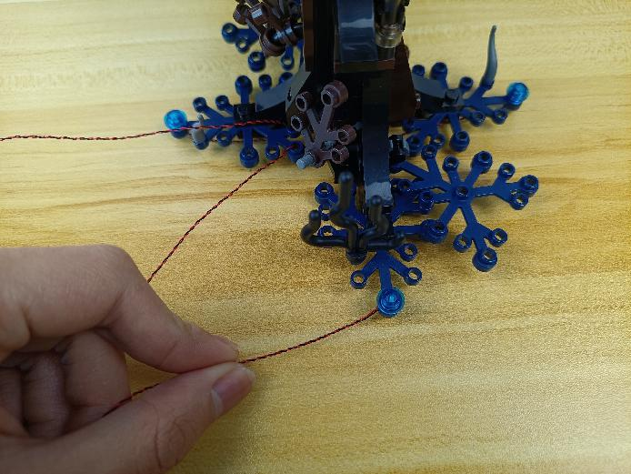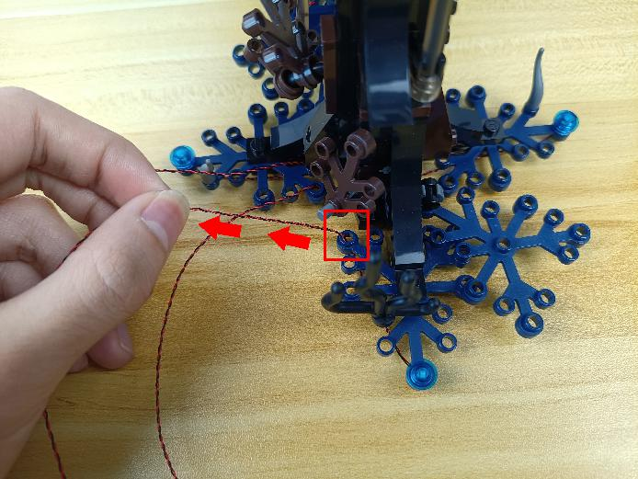

Group the 3 cables together.
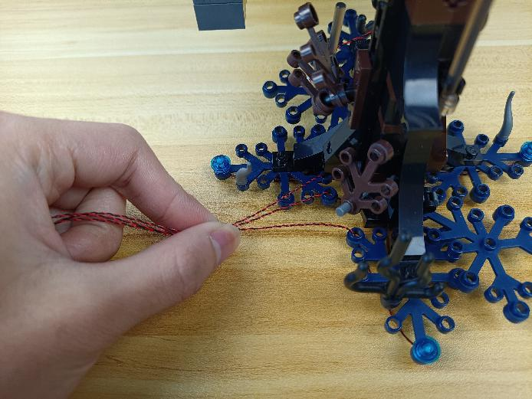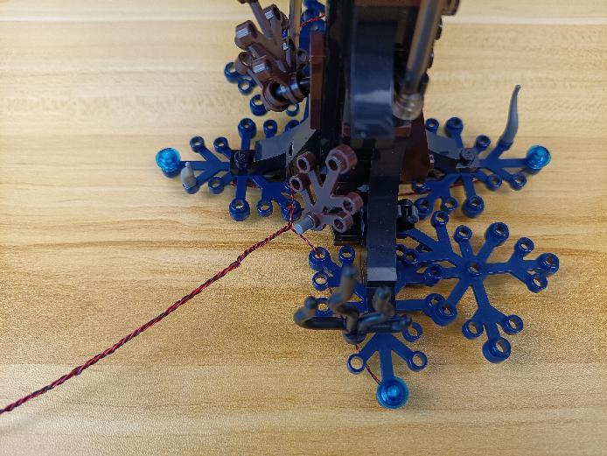

Wind them around the following piece.
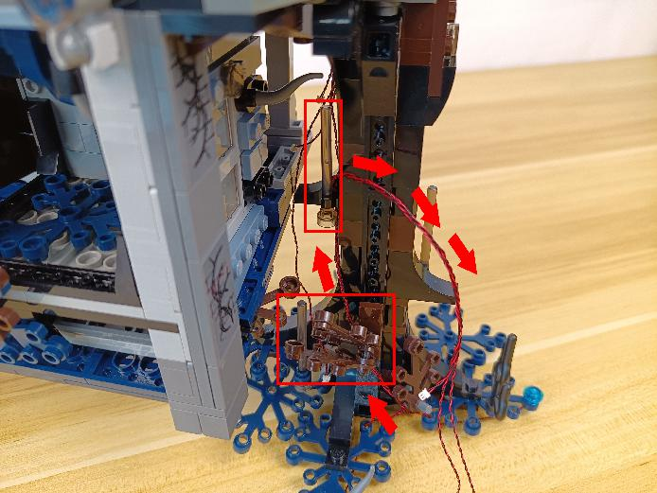

Turn to the other side.
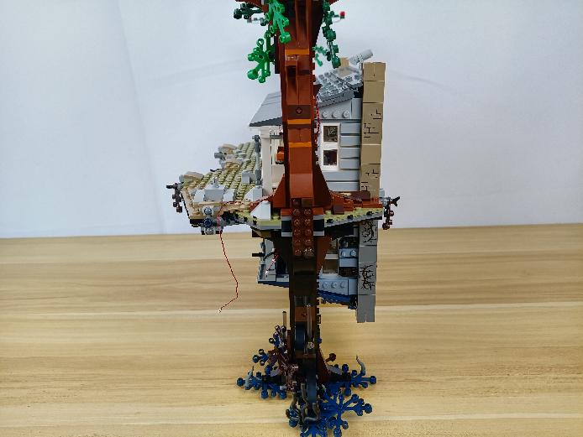

Turn to the following place.
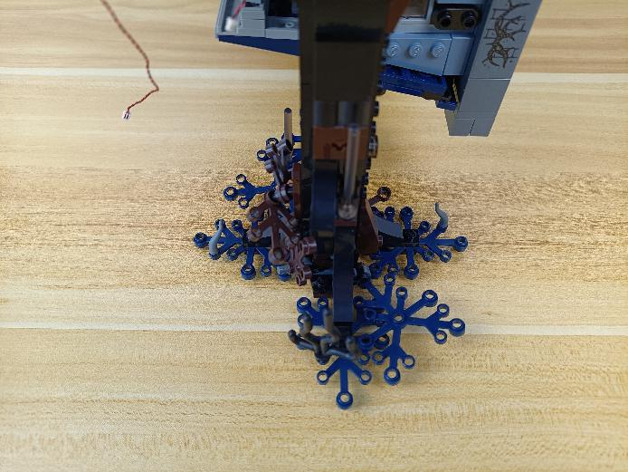

Take 3 blue 30cm dot lights, 3 trans blue 1x1 round plates.

With lighting part facing up, thread the cables through the following holes on the leaves.
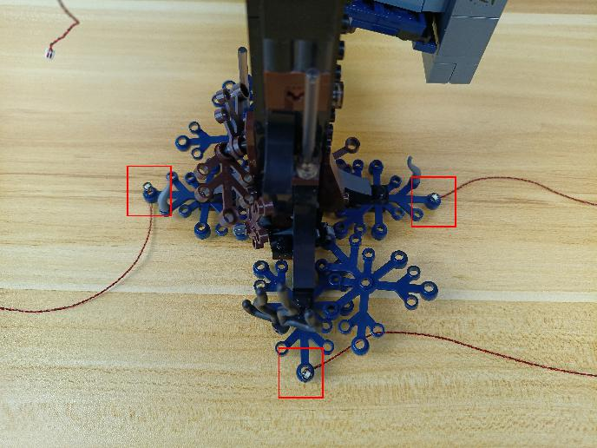

Connect the trans blue round plates over.
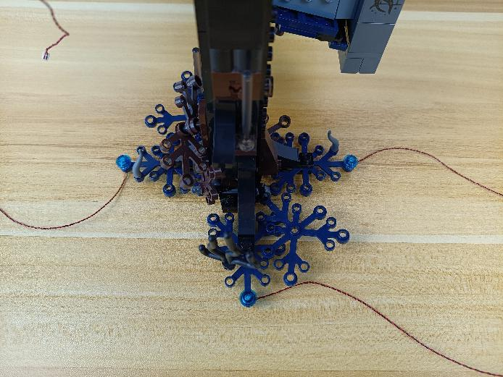

Take the following cable, thread it through the hole, and pull it out as per below.
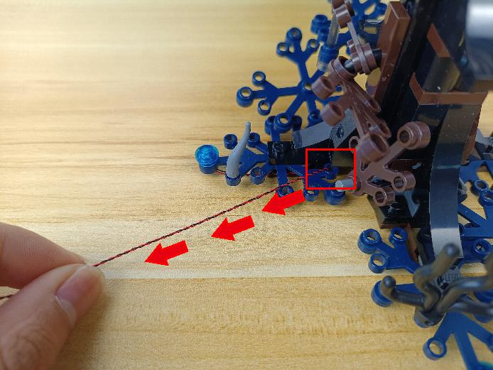

Take the following cable, thread it through the hole, and pull it out as per below.
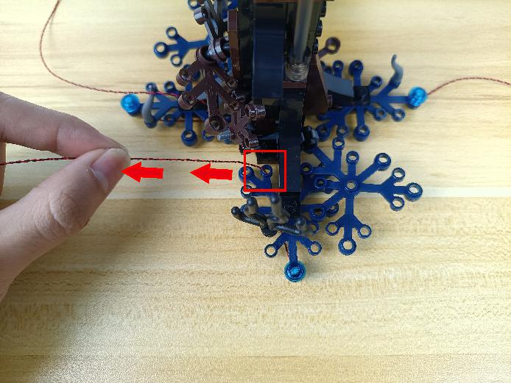

Take the following cable, thread it through the space underneath the leaves.
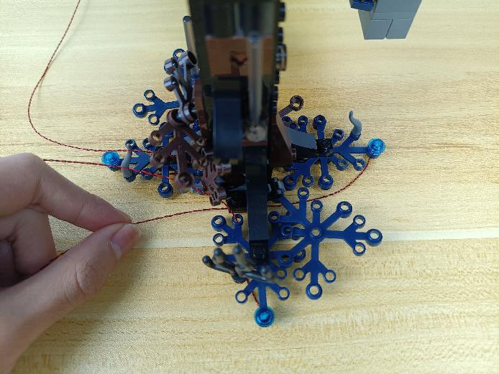

Continue to thread it through the hole, and pull it out as per below.
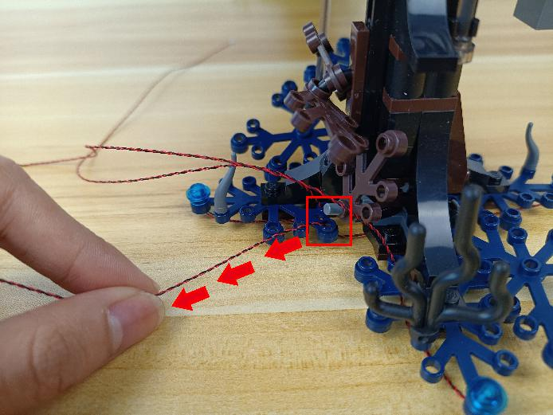

Group the 3 cables together.
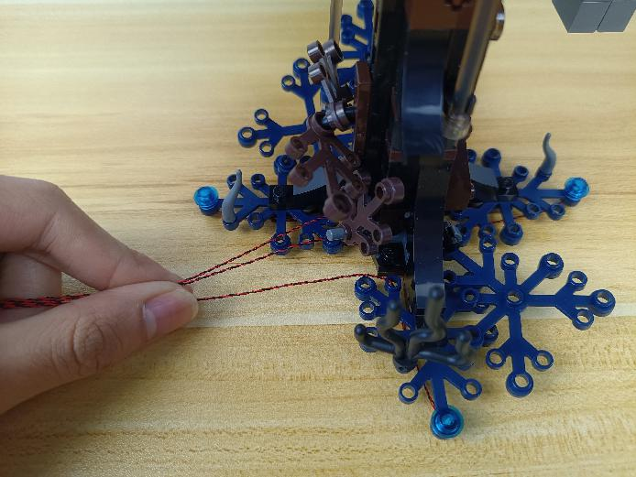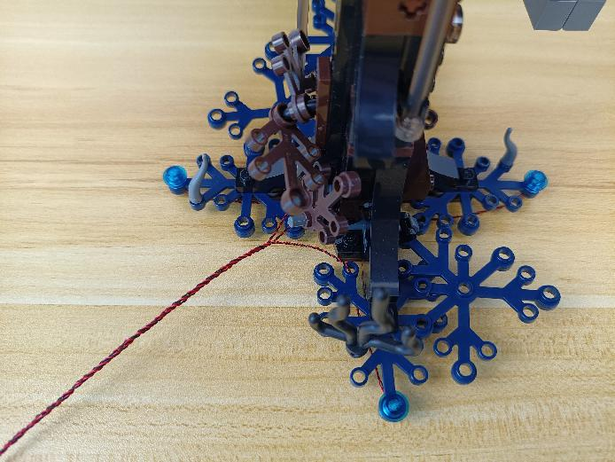

Wind them around the following piece.
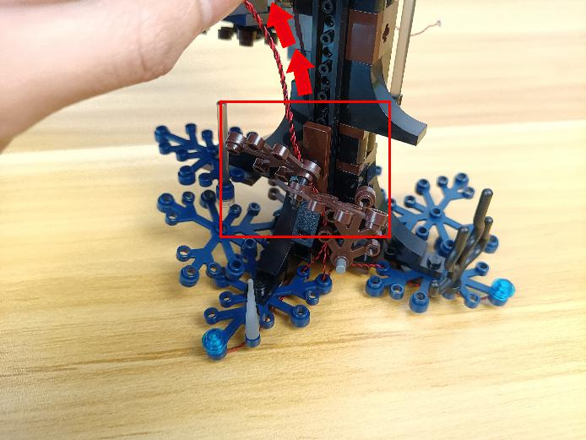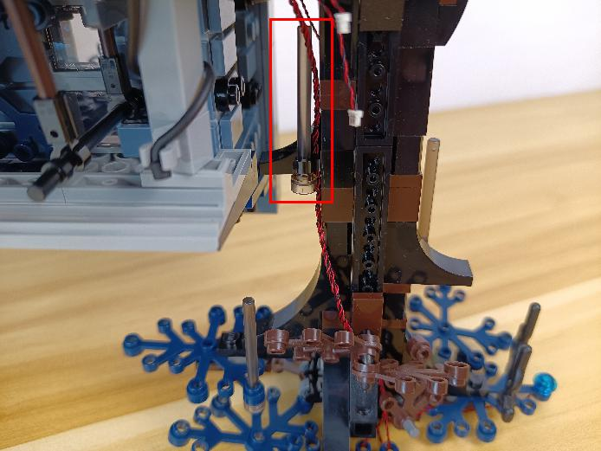

Turn to the following place，remove the base.
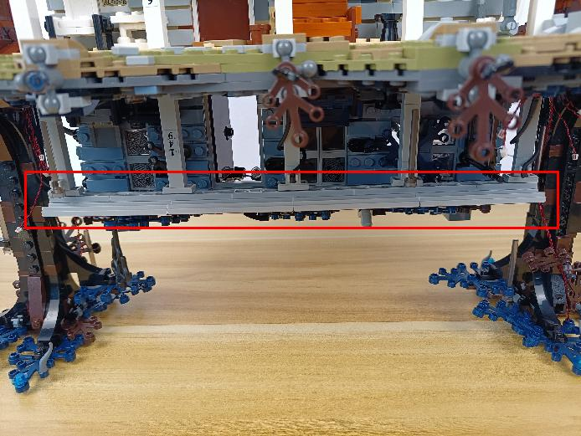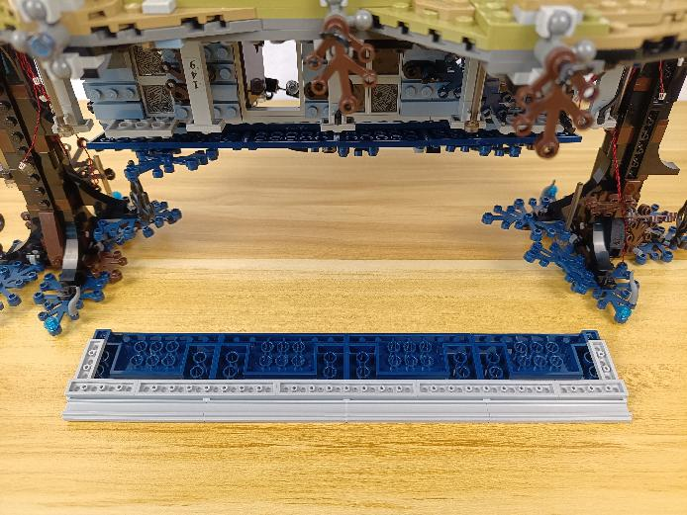

Disconnect the following 3 pieces.
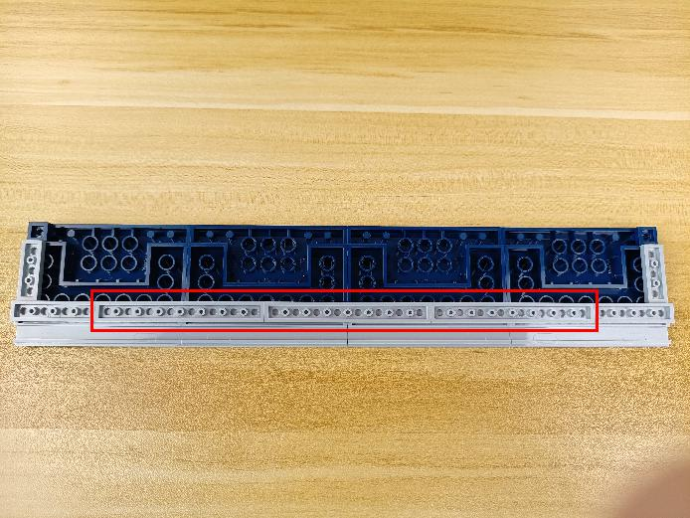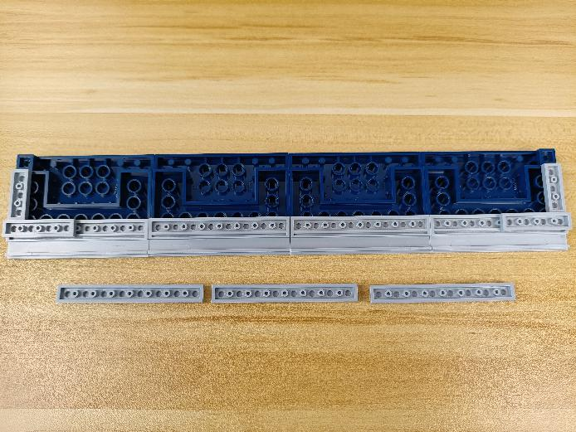

Take 2 green 15cm dot lights, 3 adhesive squares.
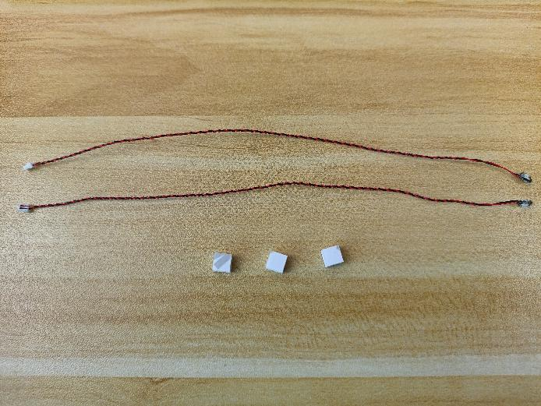

Stick the adhesive squares to the following places.
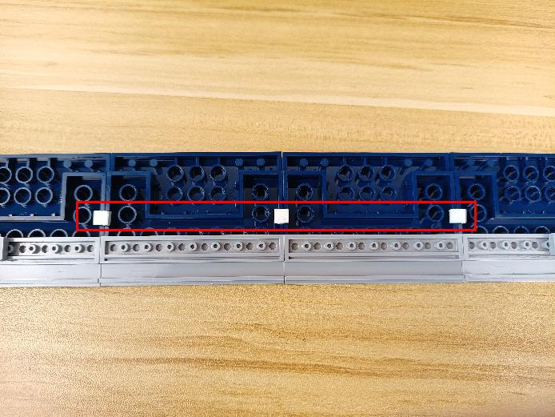

With lighting part facing up, stick the lights to the adhesive squares.
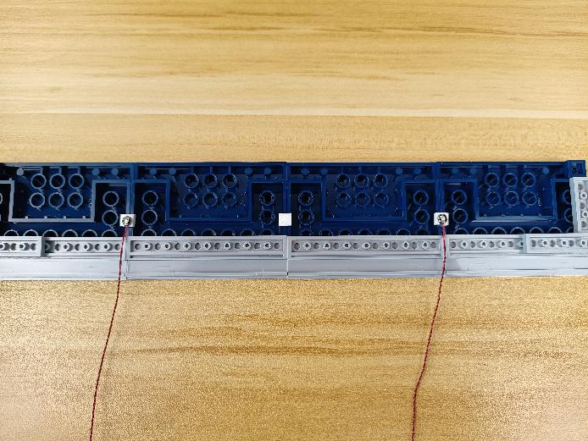

Place the cables as per below, reconnect the following pieces.
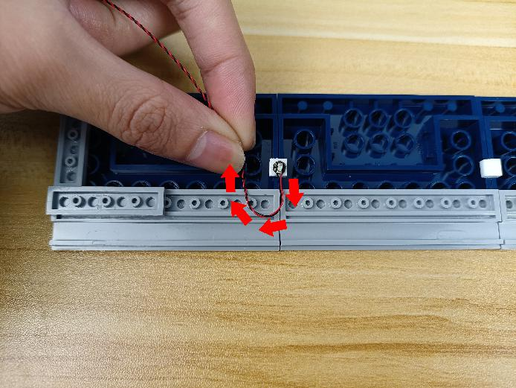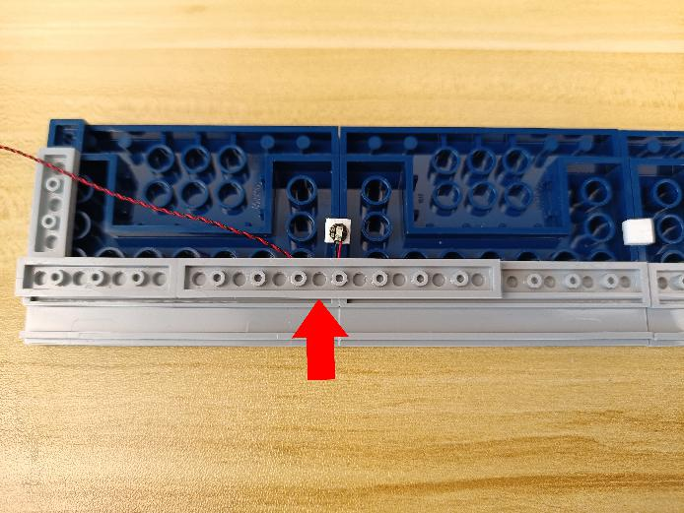
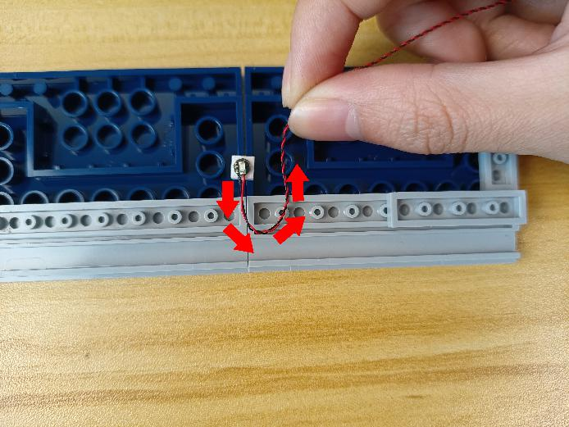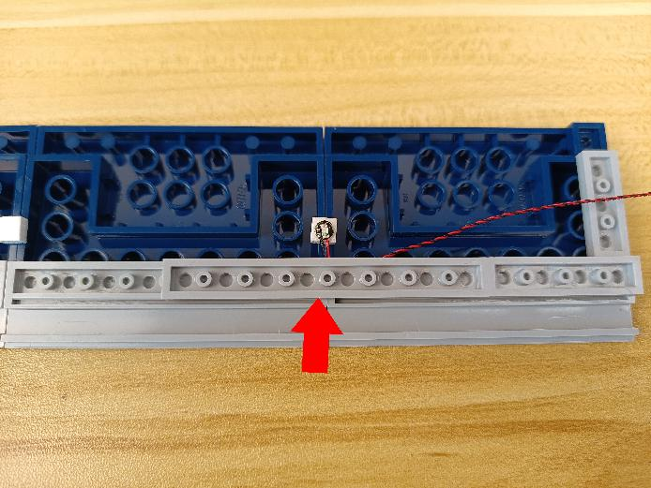

Take a green 30cm dot light.
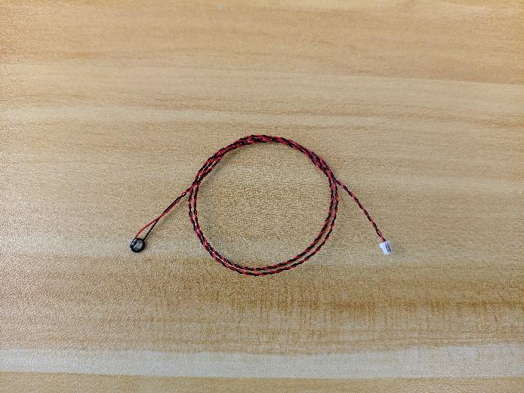

With lighting part facing up, stick the light to the adhesive square, place the cable as per below.
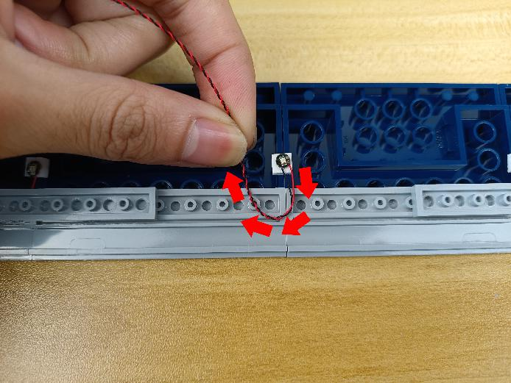

Reconnect the following piece.
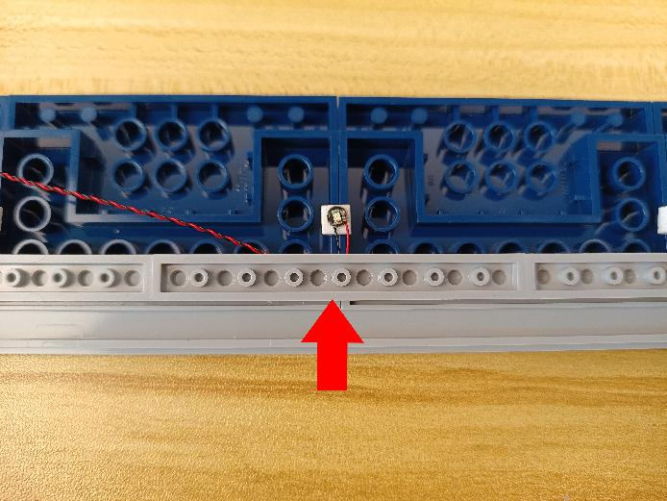

Remove the following piece at the left.
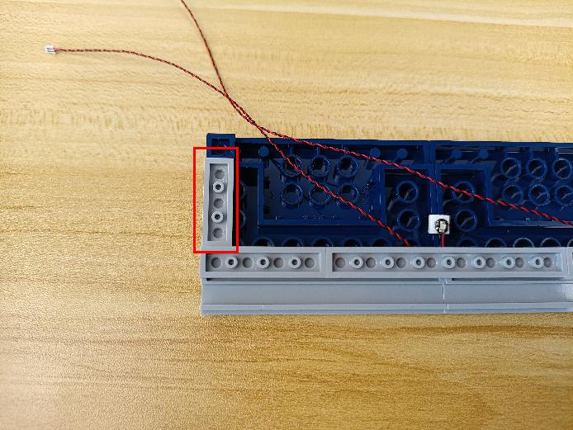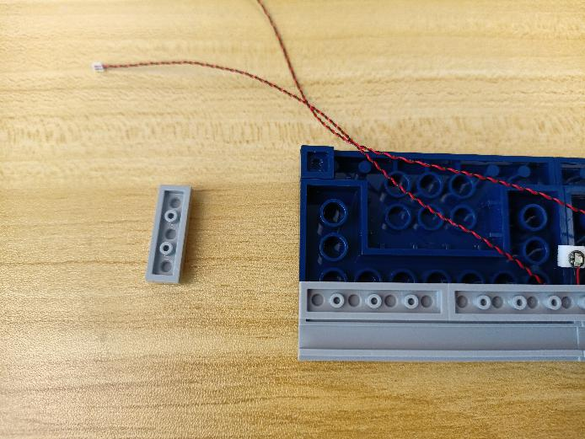

Place the cables as per below, reconnect the following piece.
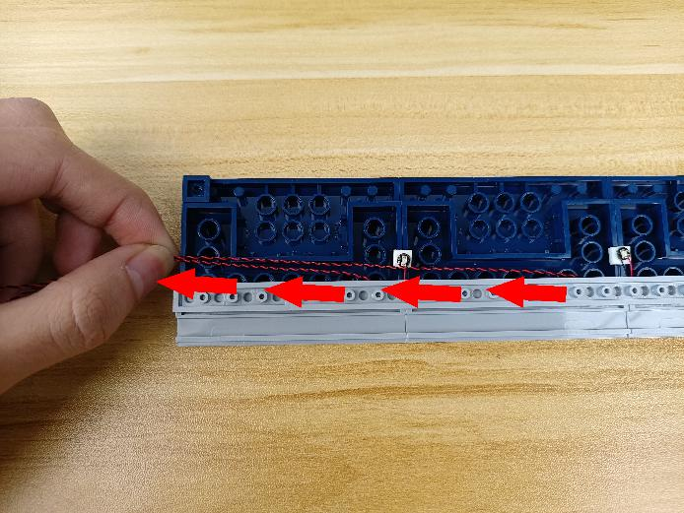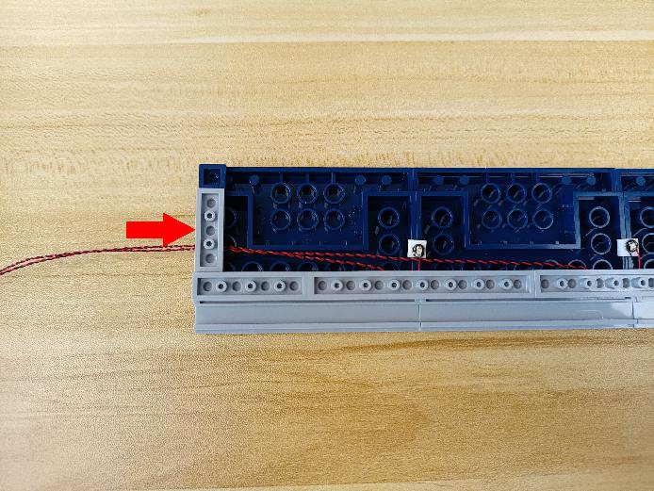

Place the cable at the left as we did before.
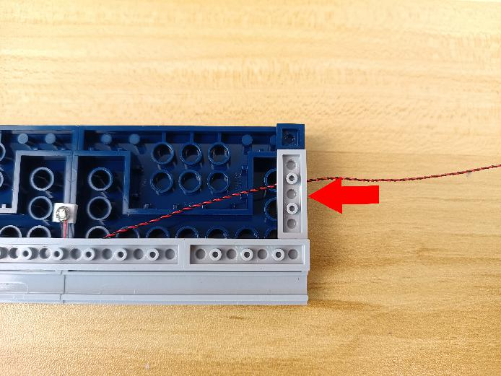

Turn to the following place, reconnect the bottom.
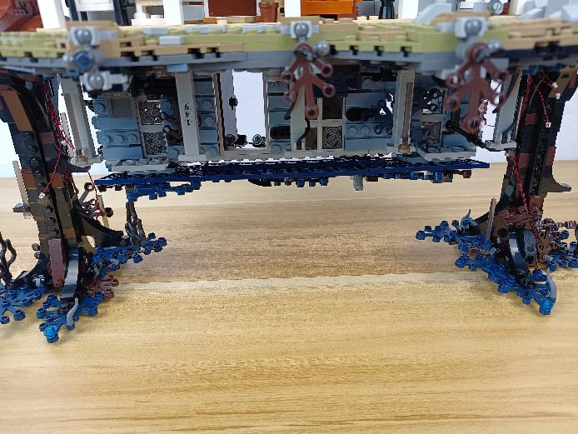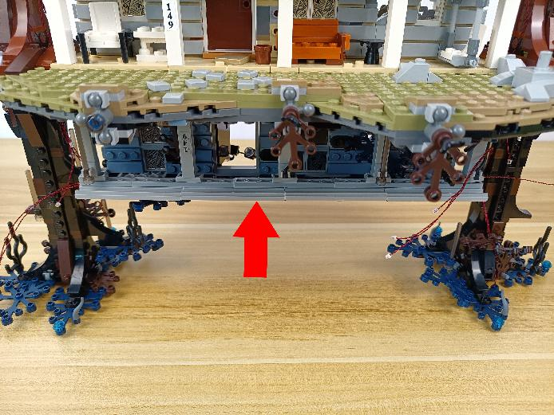

Turn to the left.
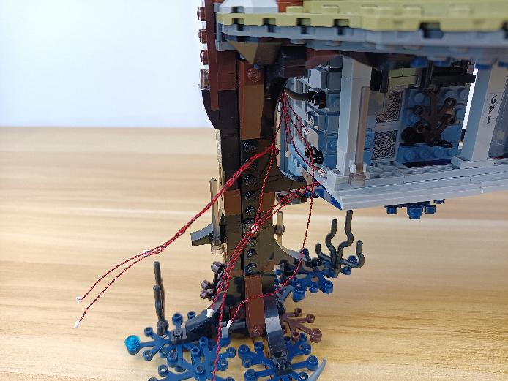

Take a 30cm connecting cable, a 12-port expansion board, assemble the as per below.
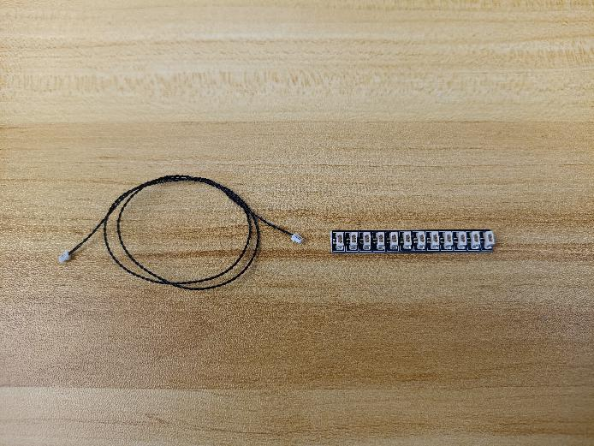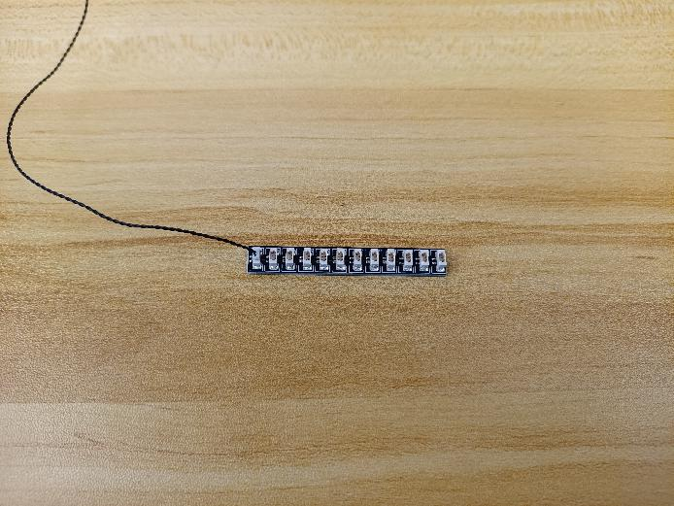

Connect all the following cables to the expansion board, and tuck excess cables around the expansion board.
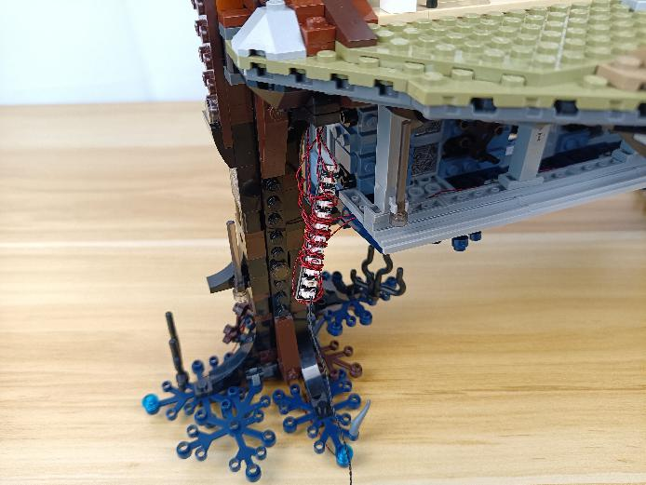

Take 2 adhesive squares.
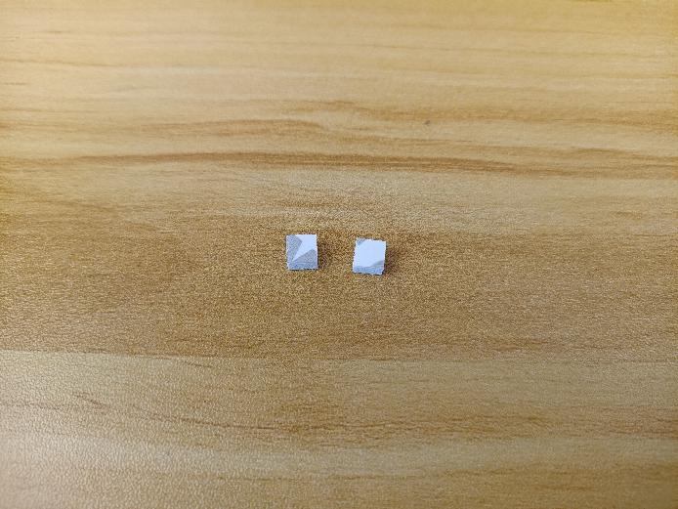

Stick them to the back of the expansion board, and stick the expansion board to the following place.
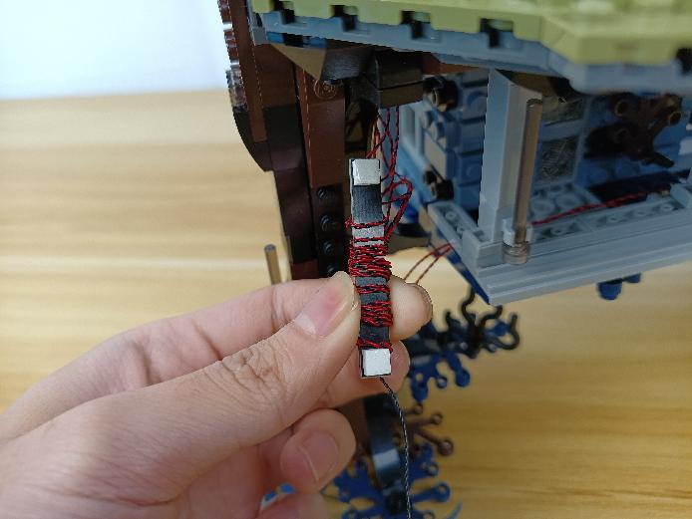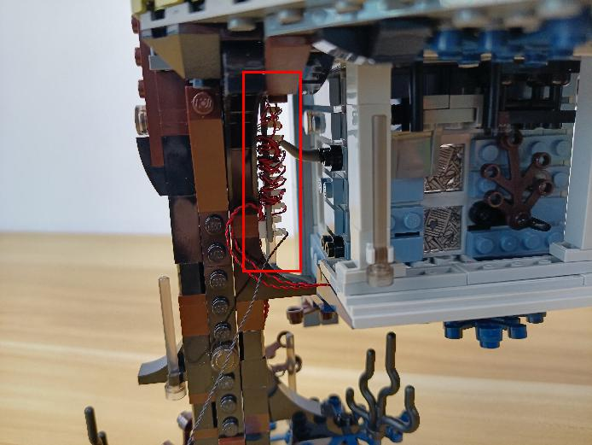

Turn to the back.
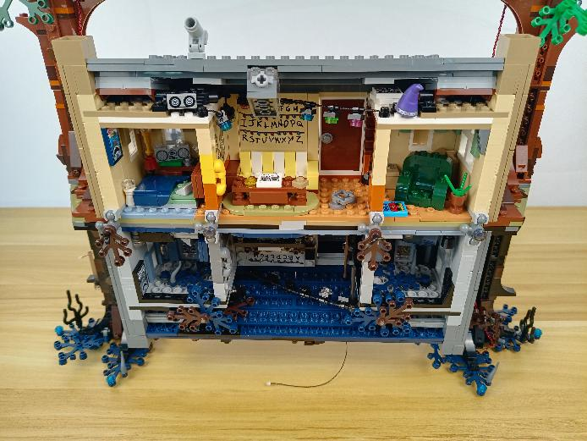

Turn to the following place.
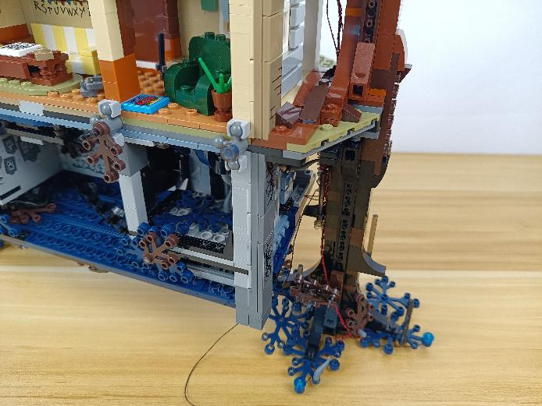

Remove the following piece.
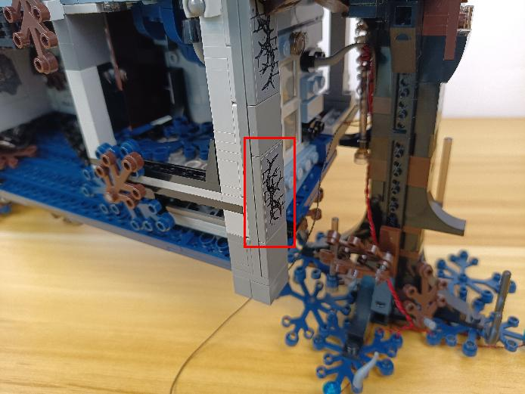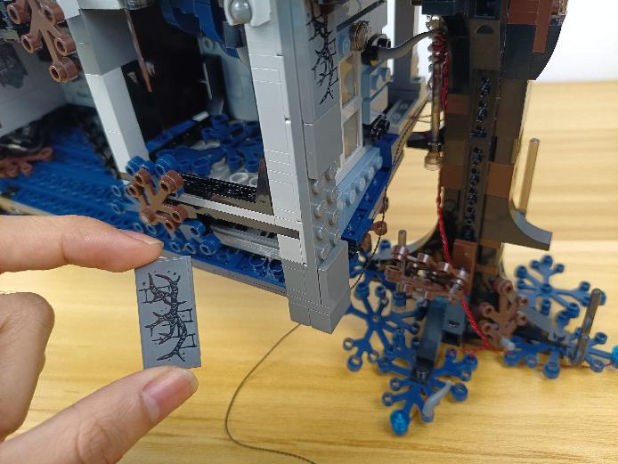

Place the cable as per below, reconnect the following piece.
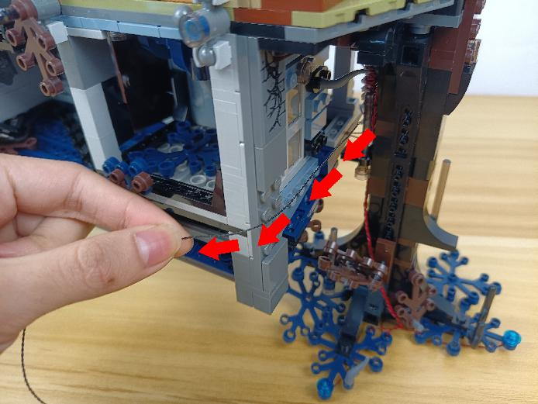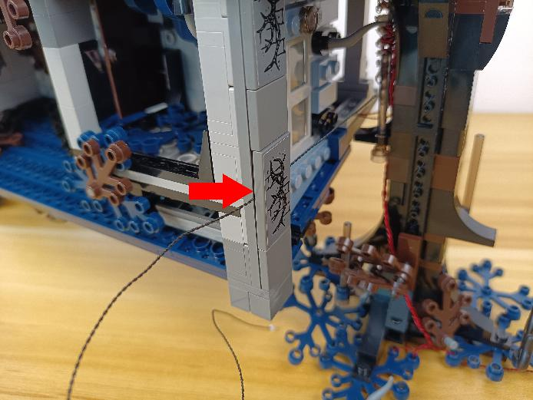

Thread the connecting cable through the space underneath the leaves, and pull it to the middle.
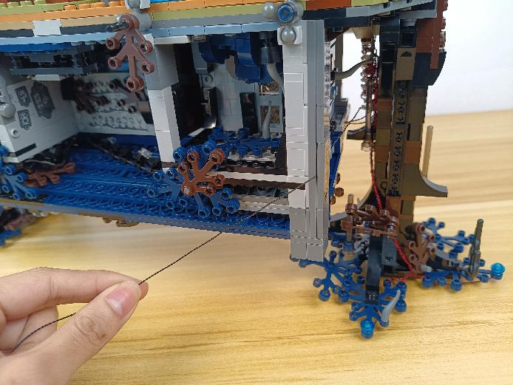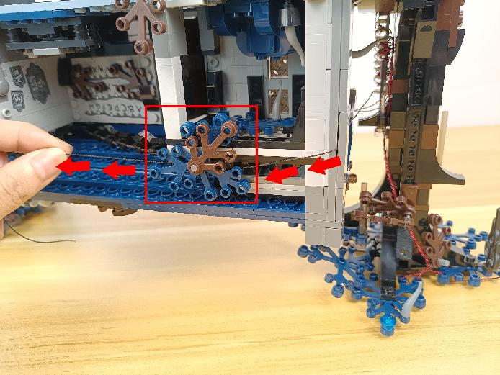

Remove the following piece.
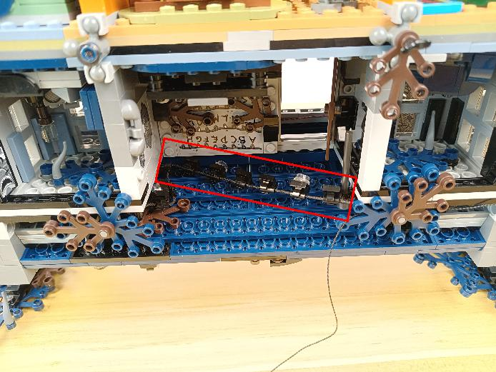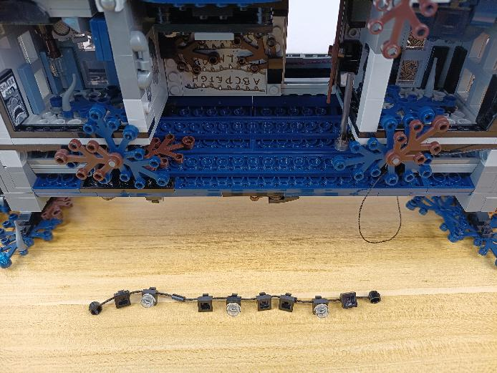

Disconnect the 3 white round plates.
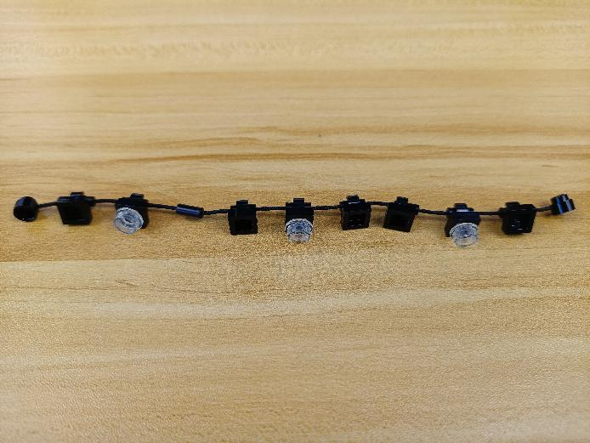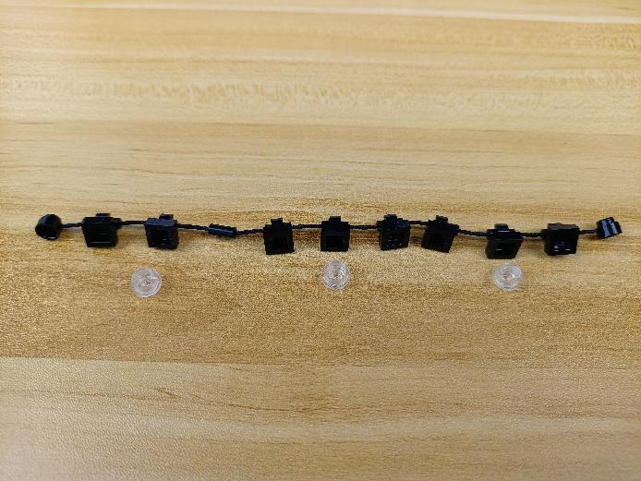

Take 3 flashing warm white 15cm dot lights.
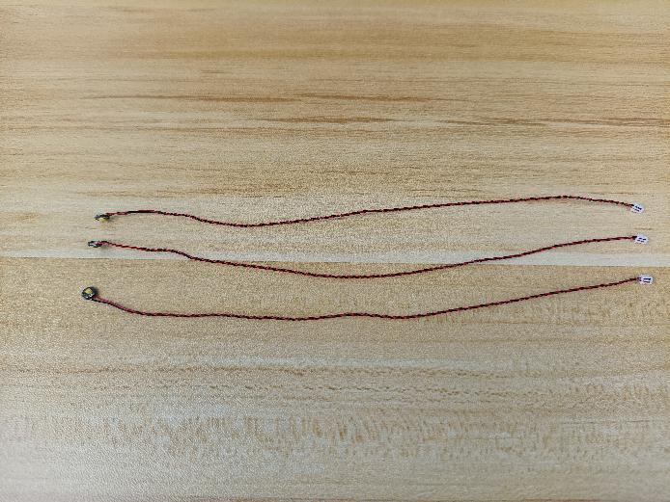

With lighting part facing down, wind the cable around the round plate as per below.
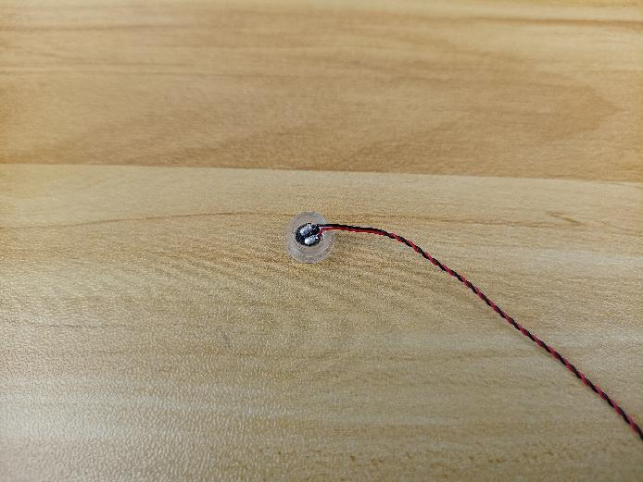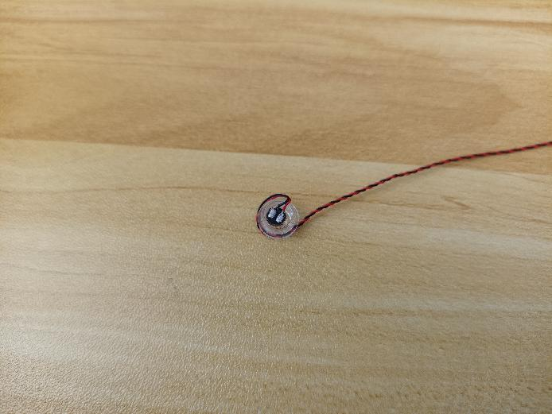

Reconnect the light.
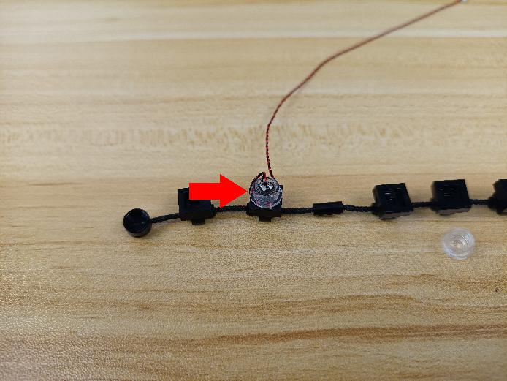

Install the other 2 lights in the same way.
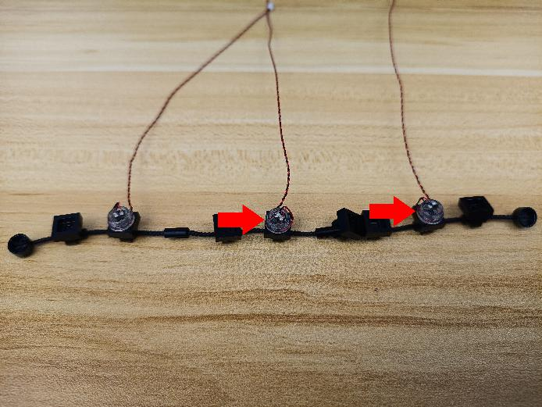

Reconnect the following piece.
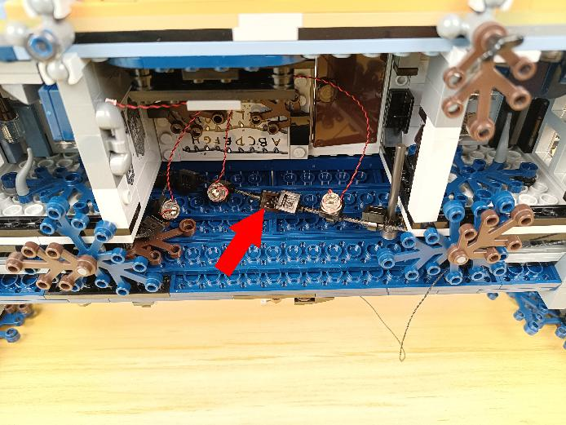

Turn to the following place at the left, remove the following leaf.
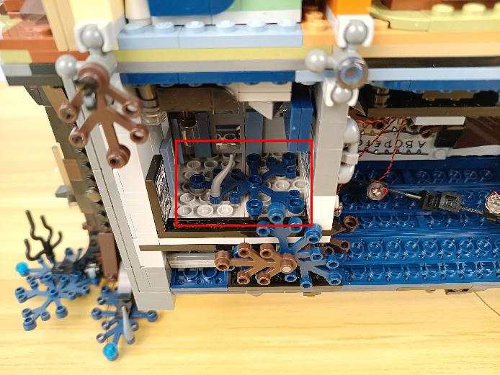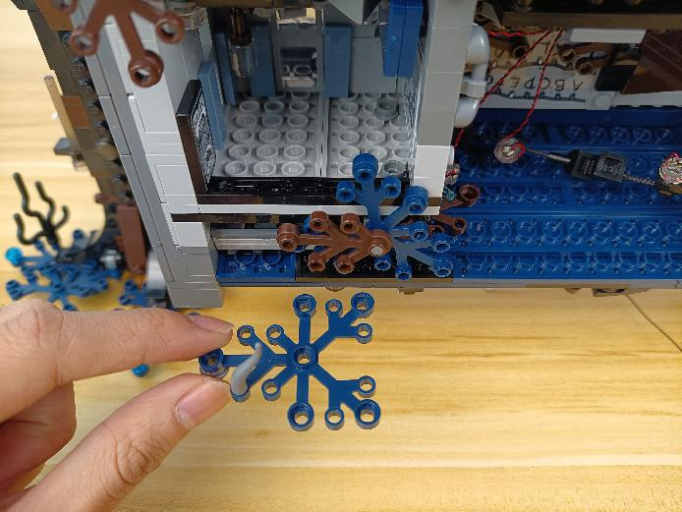

Take a blue 15cm dot light.
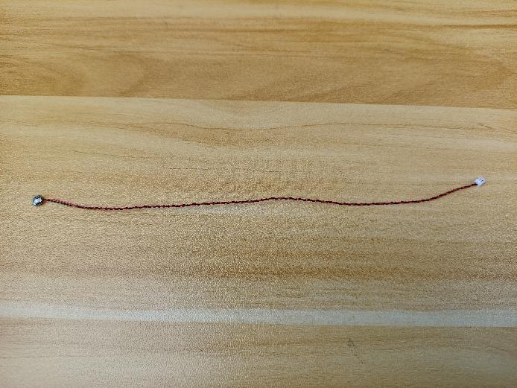

With lighting part facing up, thread the cable through the hole, and tighten it up.
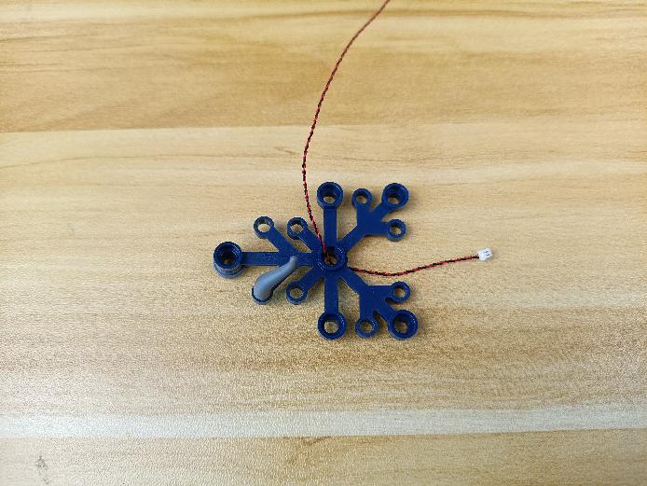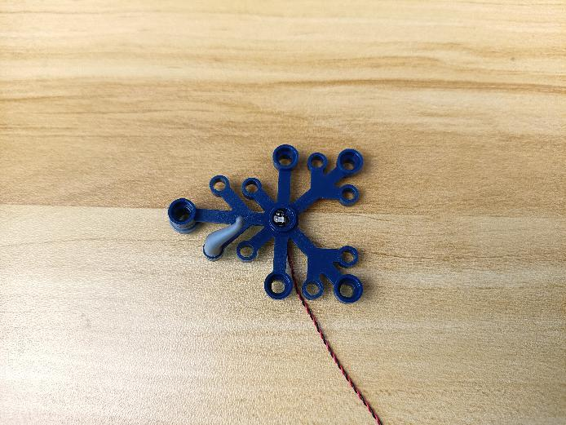

Reconnect the leaf.
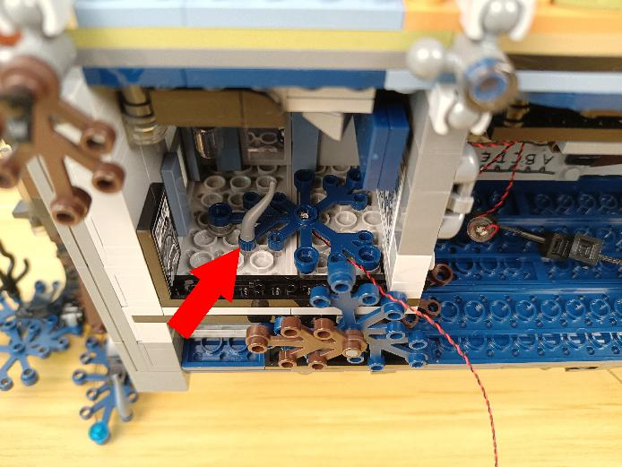

Pull the following cable to the middle.
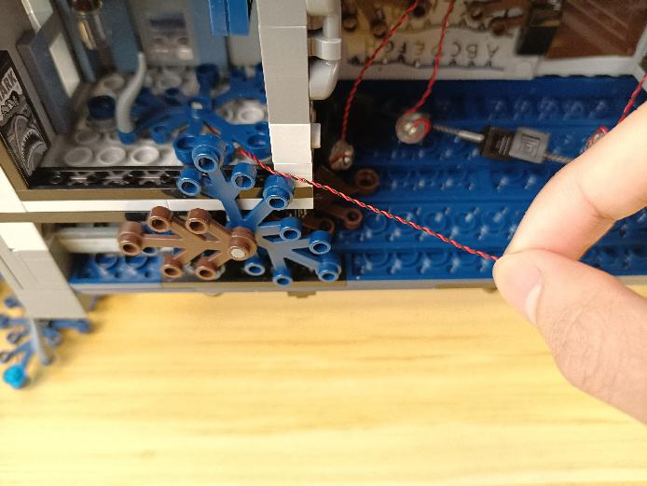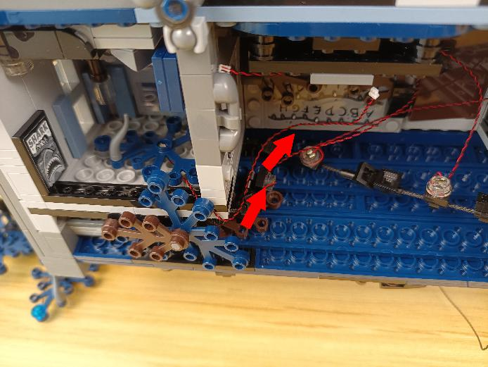

Turn to the following place at the right, remove the following leaf.
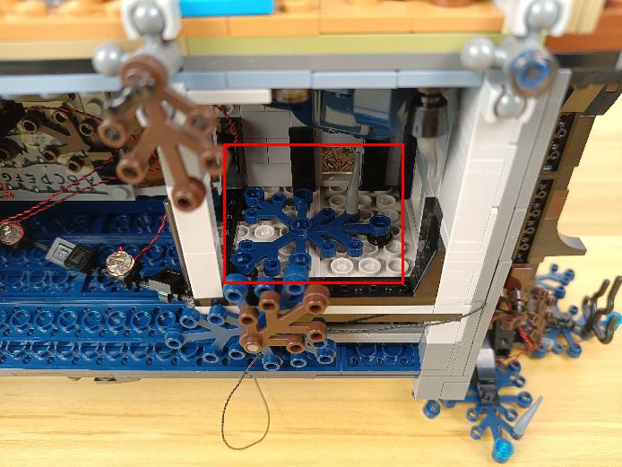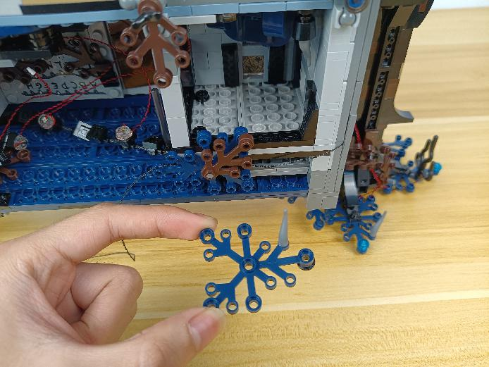

Take a blue 15cm dot light.
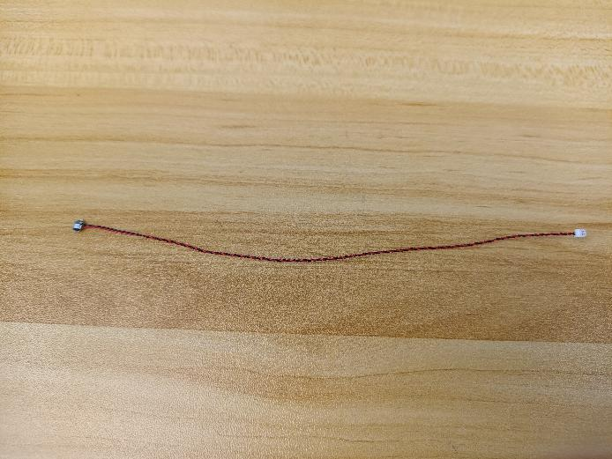

With lighting part facing up, thread the cable through the hole, and tighten it up.
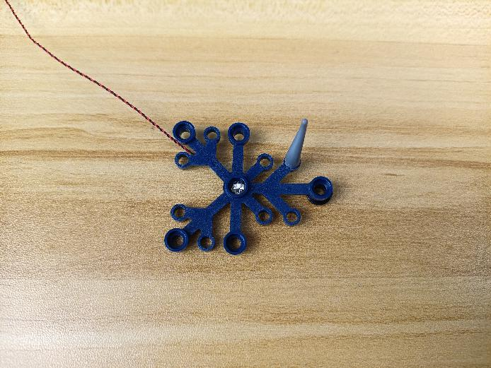

Reconnect the leaf.
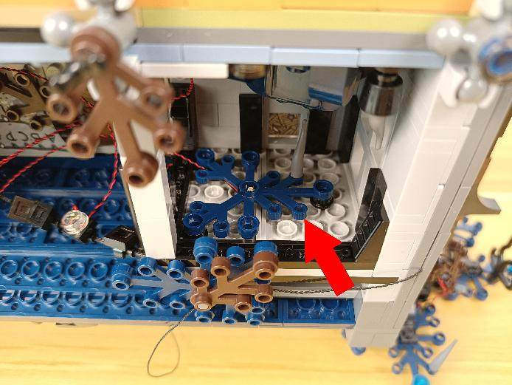

Pull the following cable to the middle.
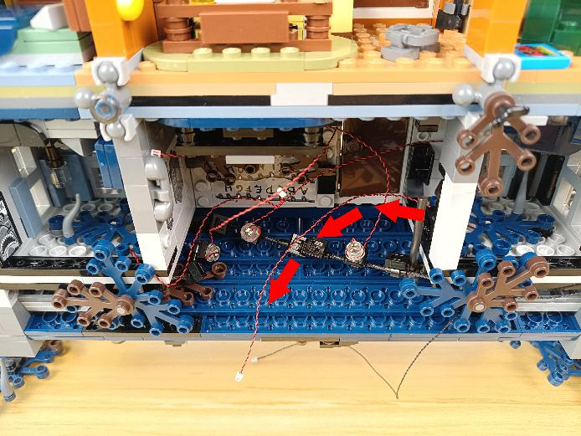

Take a blue 15cm dot light, an adhesive square.
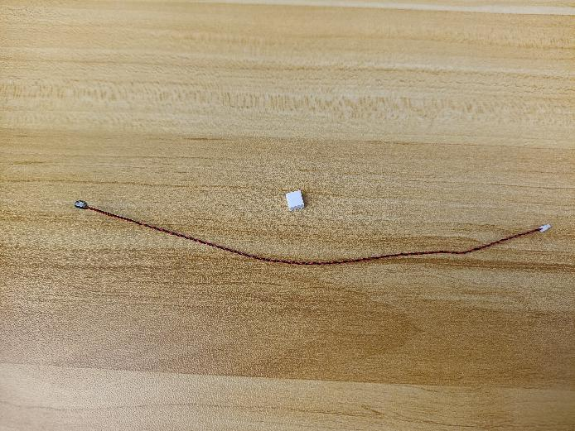

Stick the adhesive square to the following place.
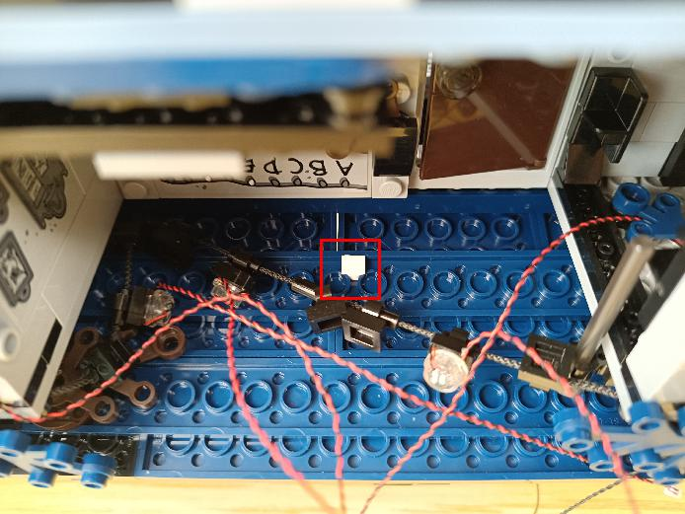

With lighting part facing up, stick the light to the adhesive square.
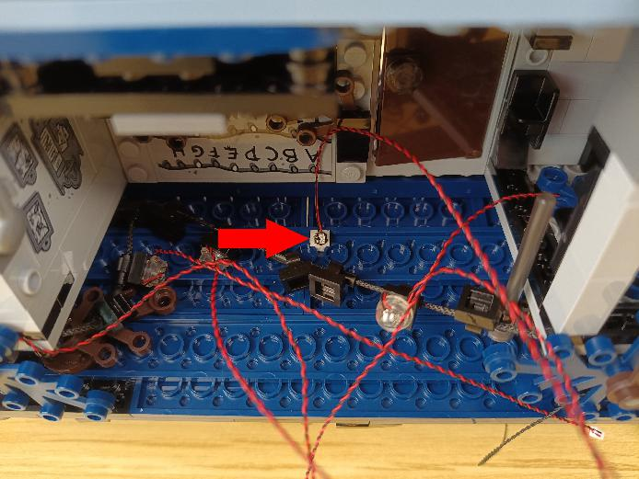

Take a 30cm connecting cable, an 8-port expansion board, assemble the as per below.
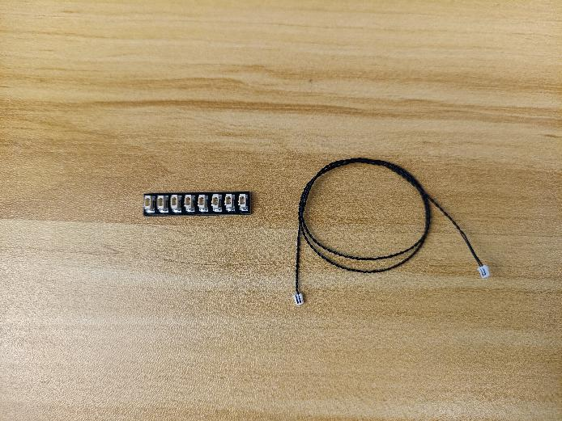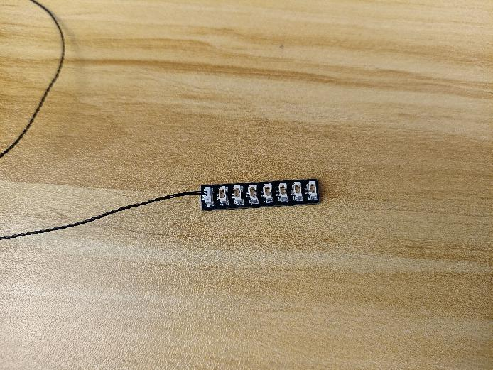

Connect all the following cables to the expansion board, and tuck excess cables around the expansion board.
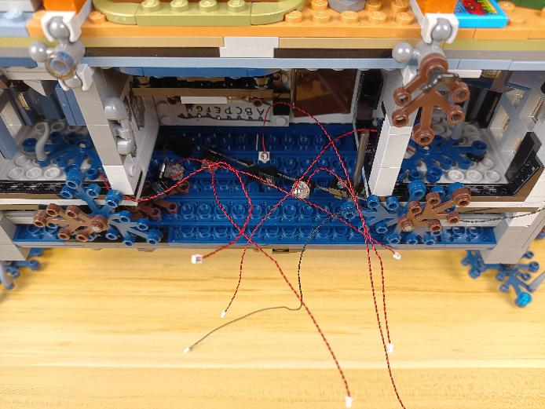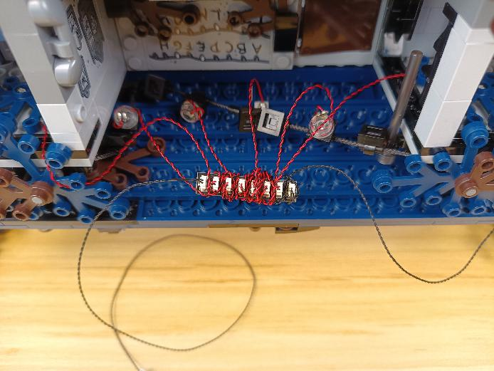

Take 2 adhesive squares.
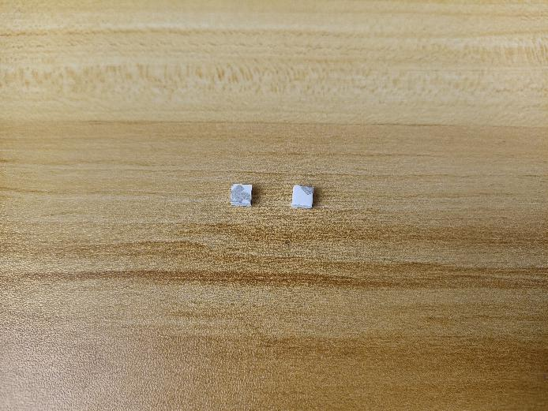

Stick them to the back of the expansion board, and stick the expansion board to the following place.
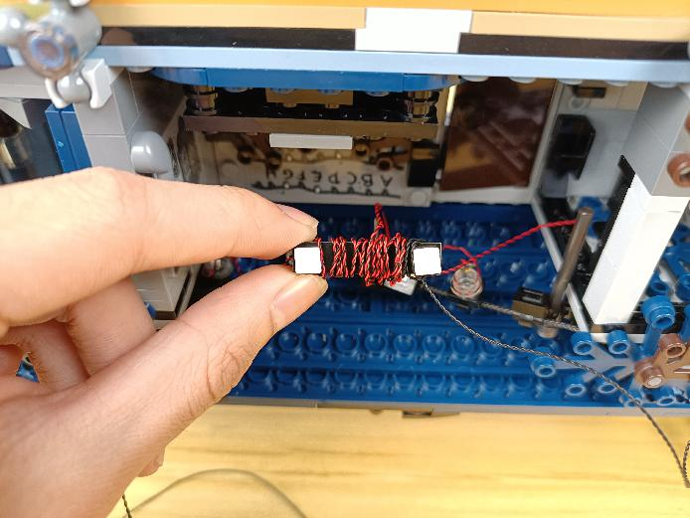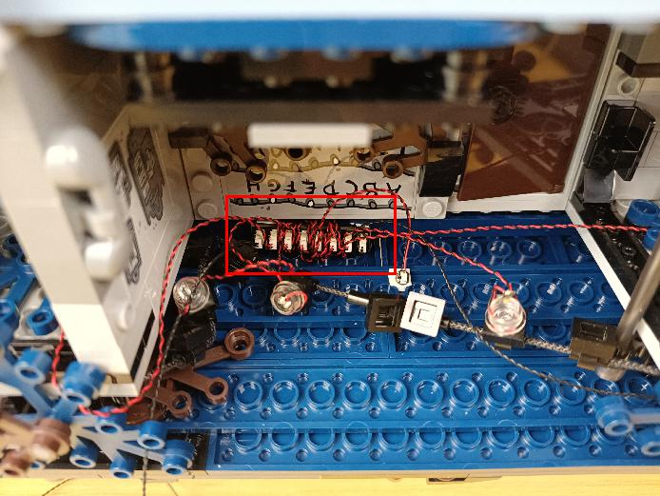

Thread the connecting cable from the expansion board through the following place underneath the leaf, and pull it to the left.
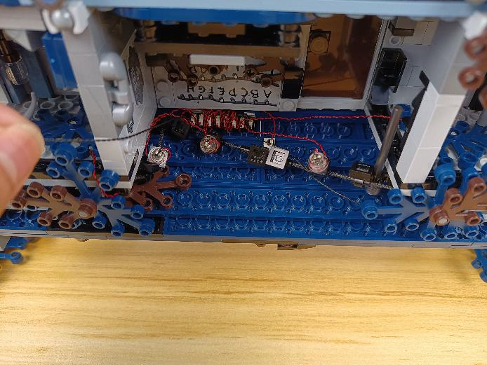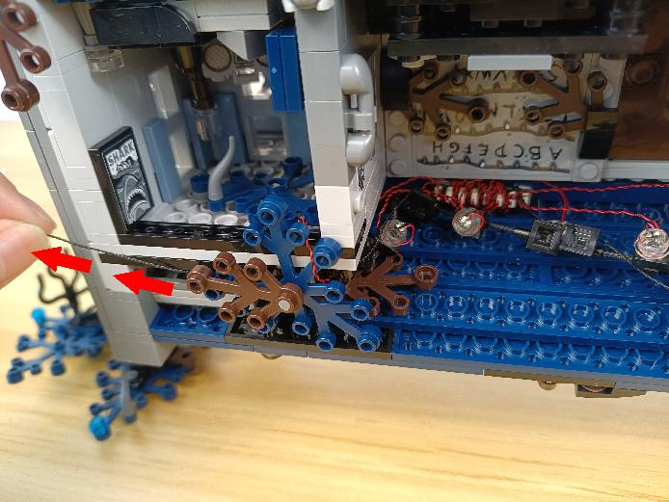

Remove the following piece.
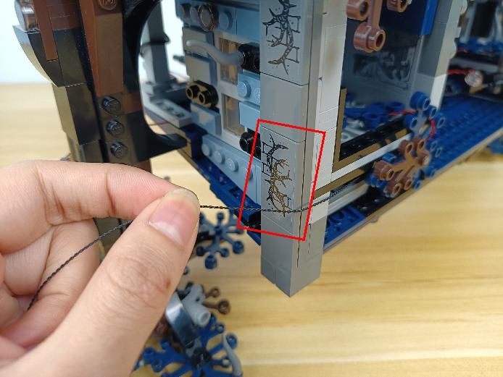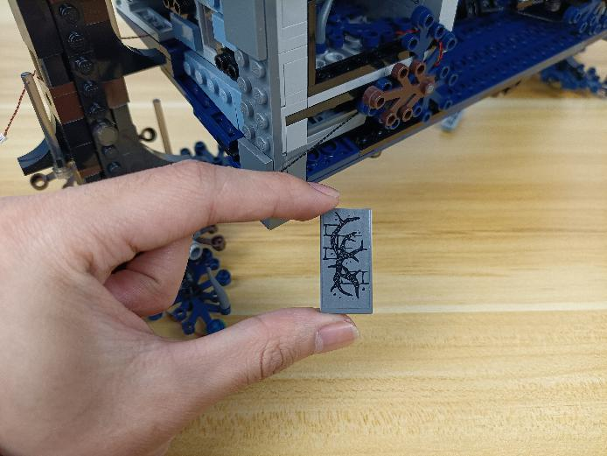

Place the cable as per below, reconnect the following piece.
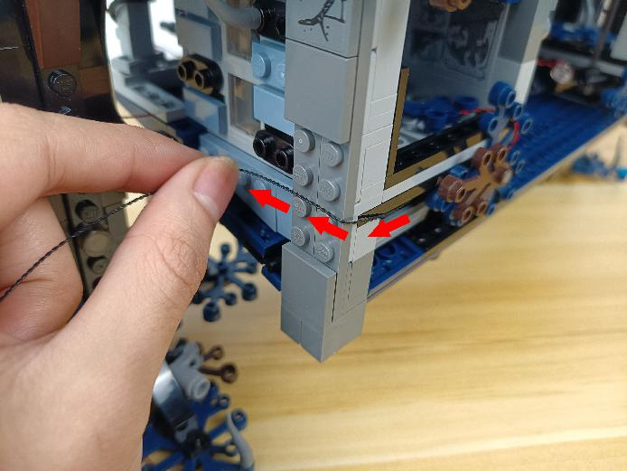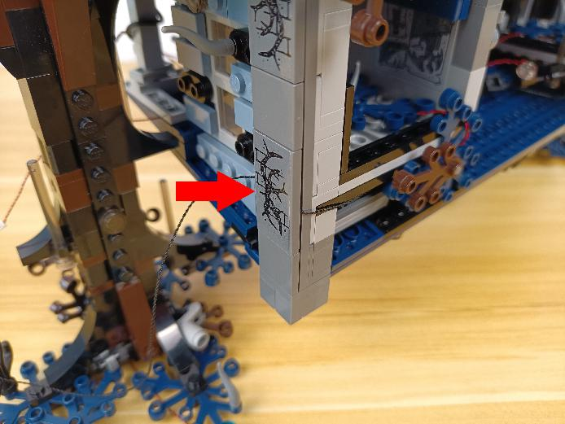

Pull the cable to the following place.
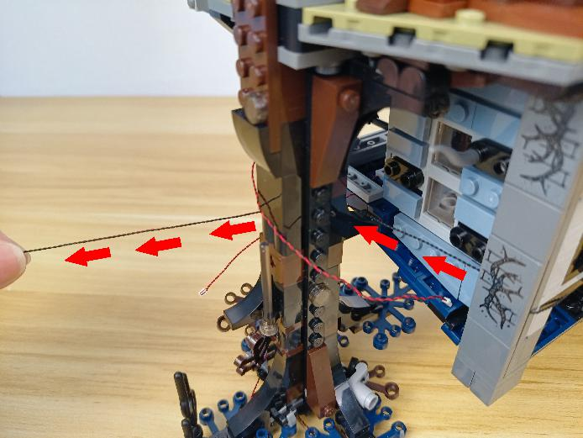

Turn to the following place.，remove the following piece.
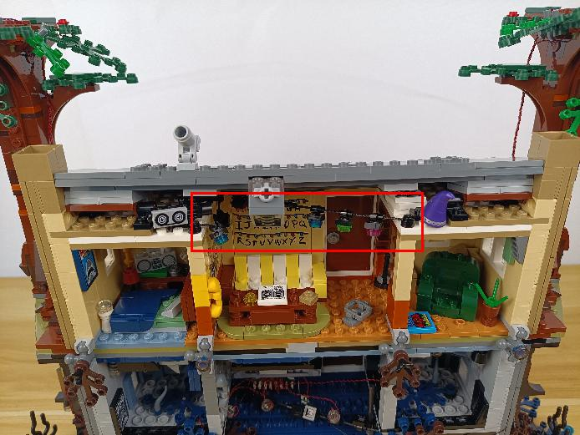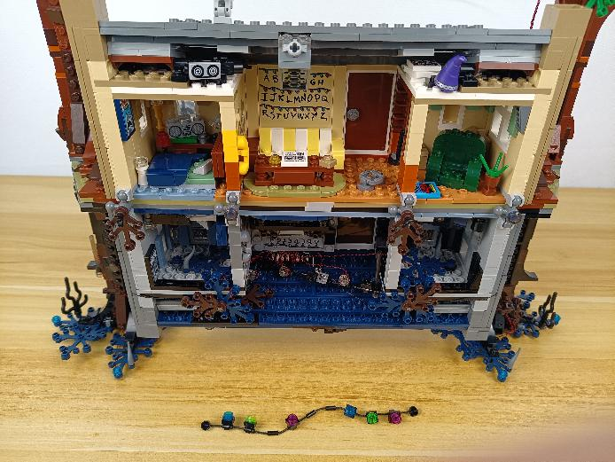

Disconnect the following 2 round plates.
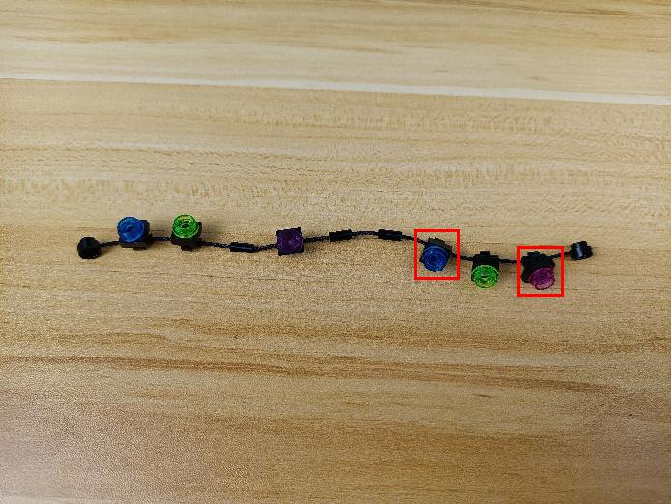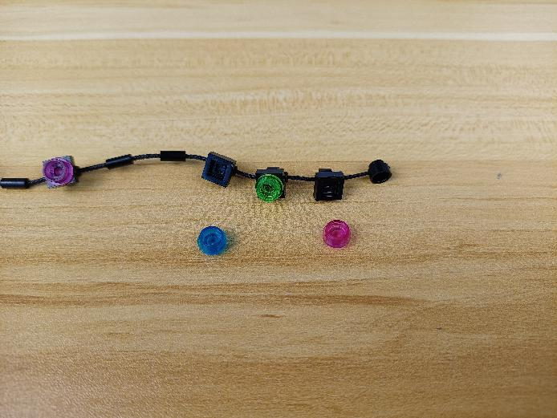

Take a flashing blue 15cm dot light.
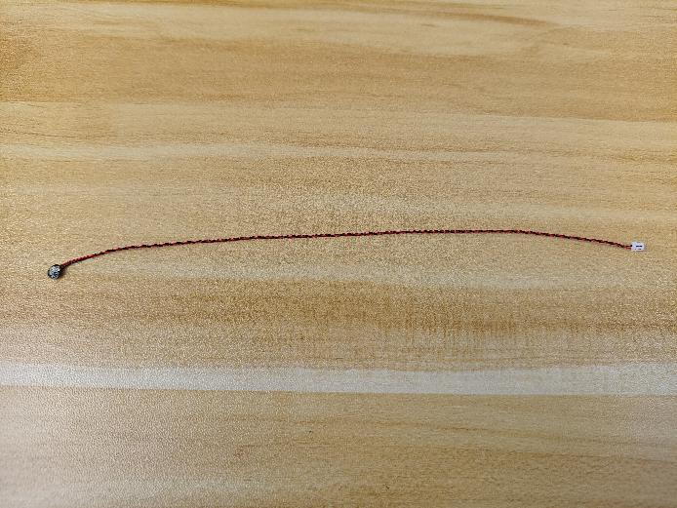

With lighting part facing down, wind the cable around the round plate as per below.
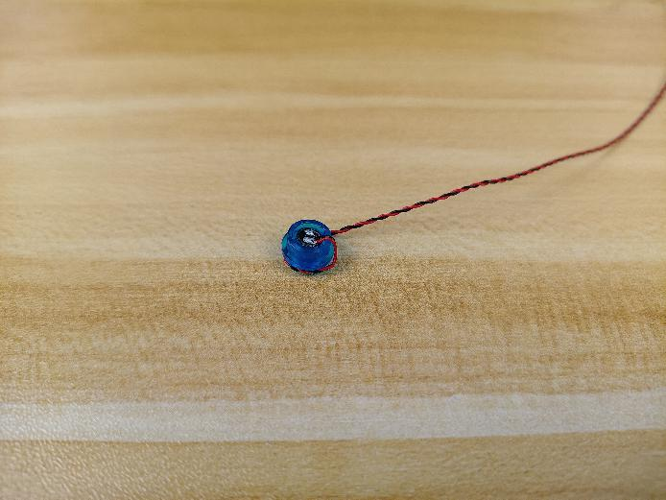

Reconnect the light.
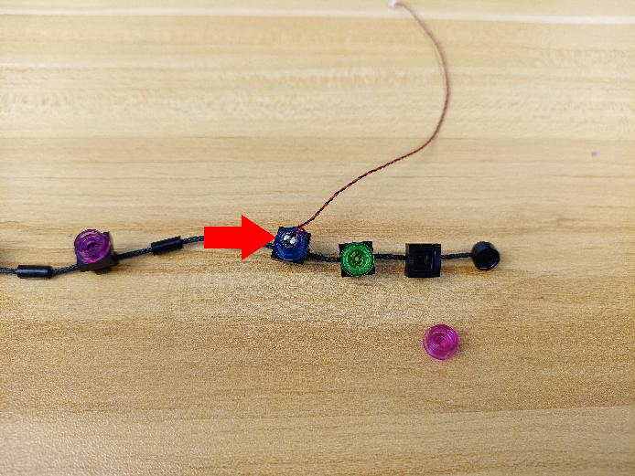

Take a flashing white 15cm dot light.
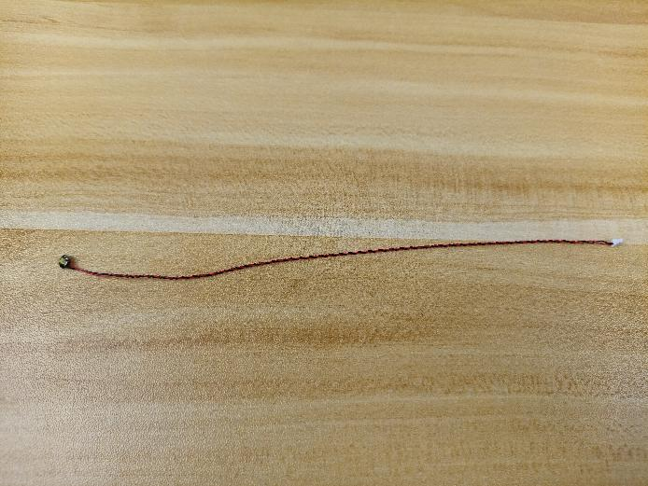

Install the other light in the same way.
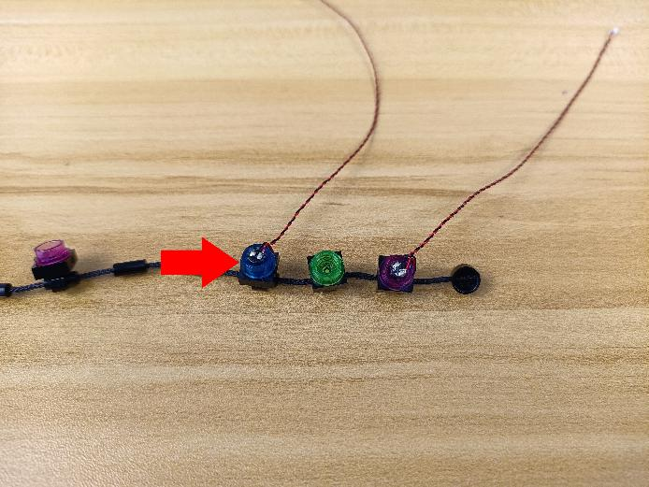

Take a warm white 15cm dot light, an adhesive square.
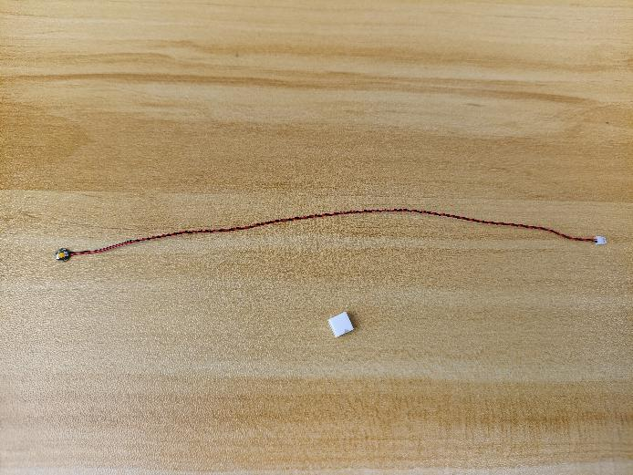

With lighting part facing up, stick the light to the adhesive square.
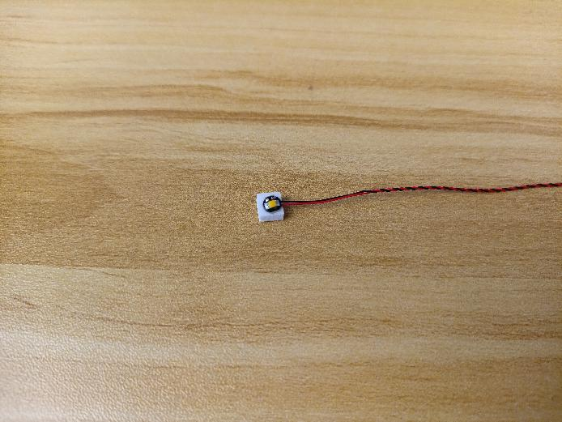

Secure the light at the following place.
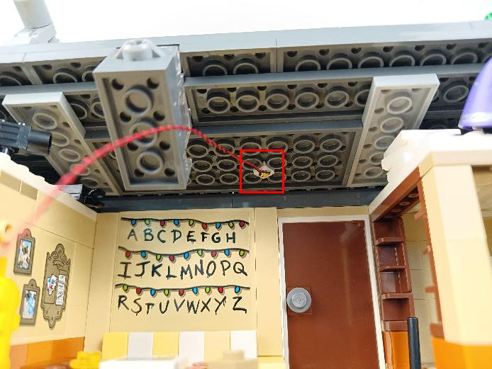

Reconnect the following piece.
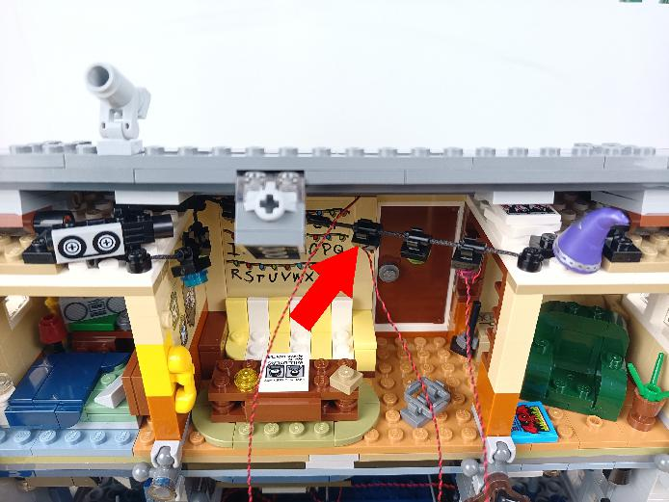

Take 2 red 15cm dot lights, 2 adhesive squares.
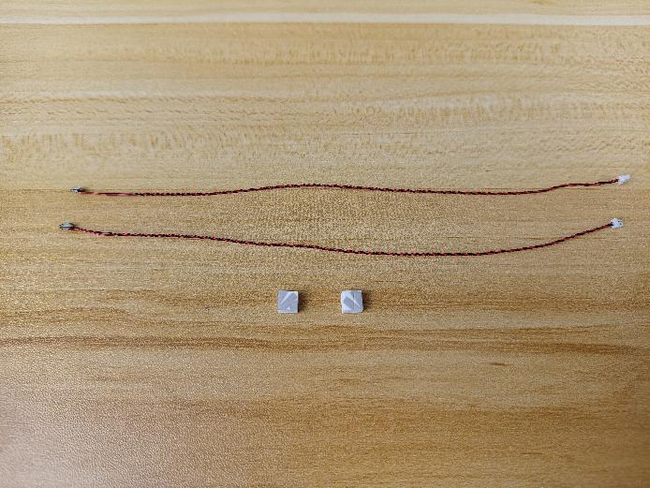

With lighting part facing up, stick the lights to the adhesive squares.
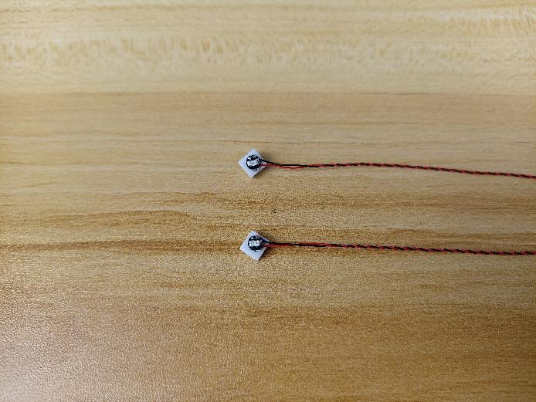

Turn to the room at the left.
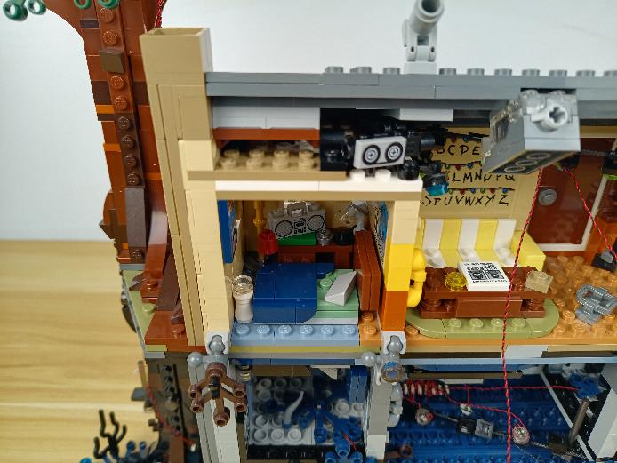

Secure the light to the ceiling as per below.
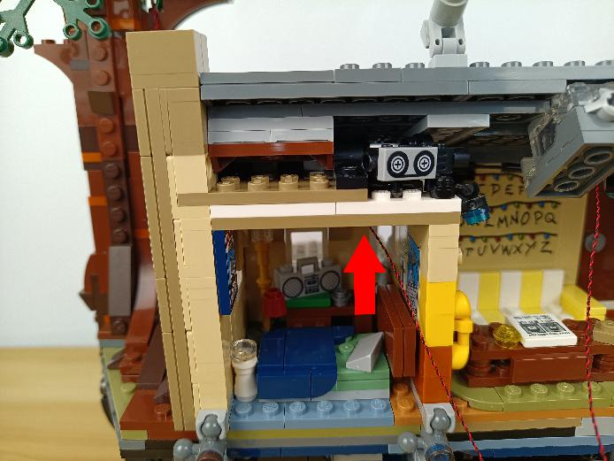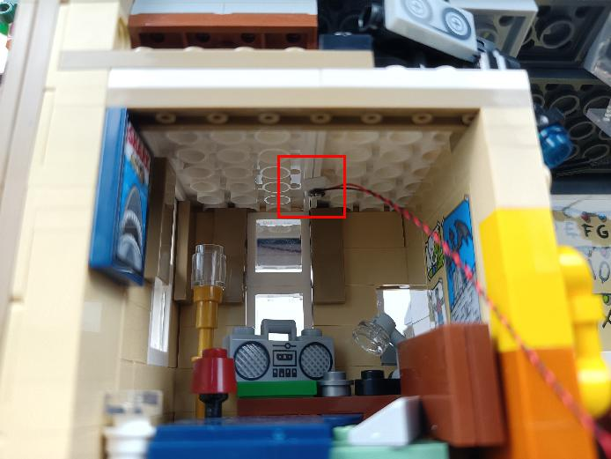

Wind the cable around the following black piece and pull it to the middle.
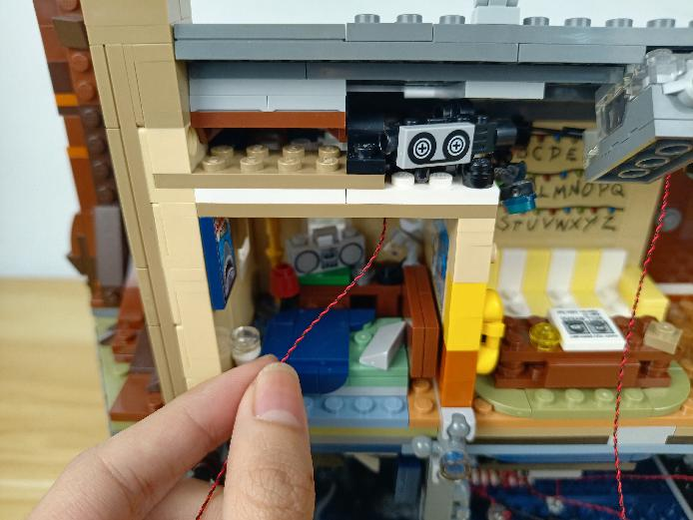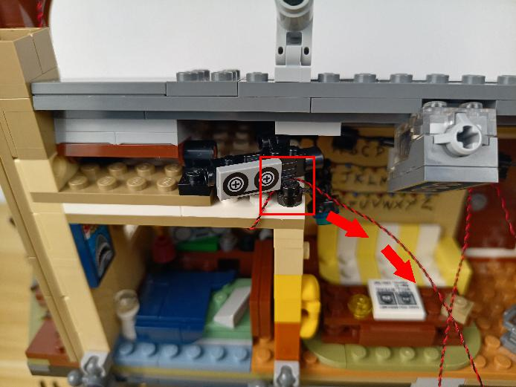

Turn to the room at the right.
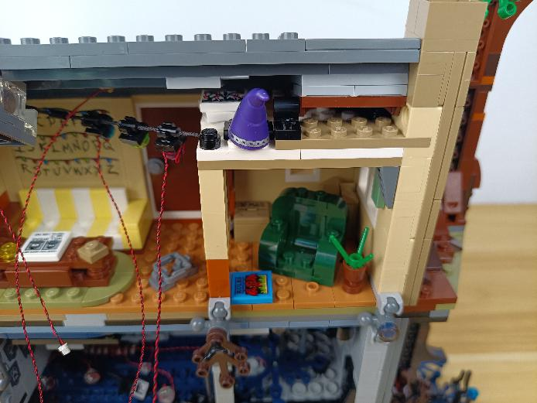

Secure the light to the ceiling as per below.
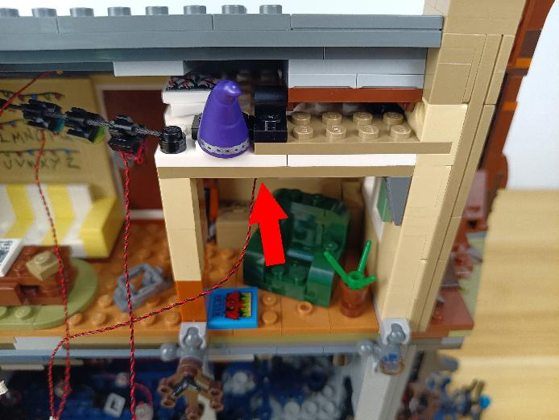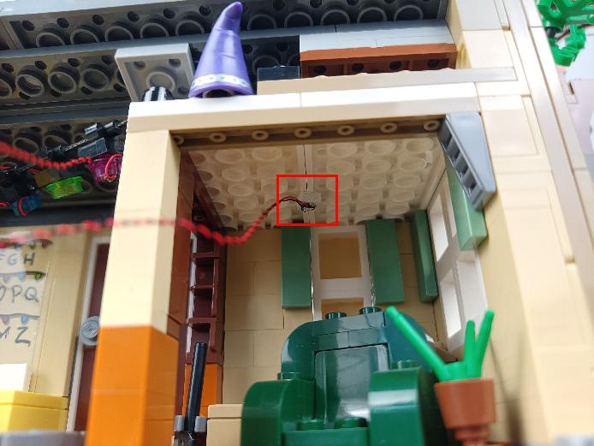

Wind the cable around the following black piece and pull it to the middle.
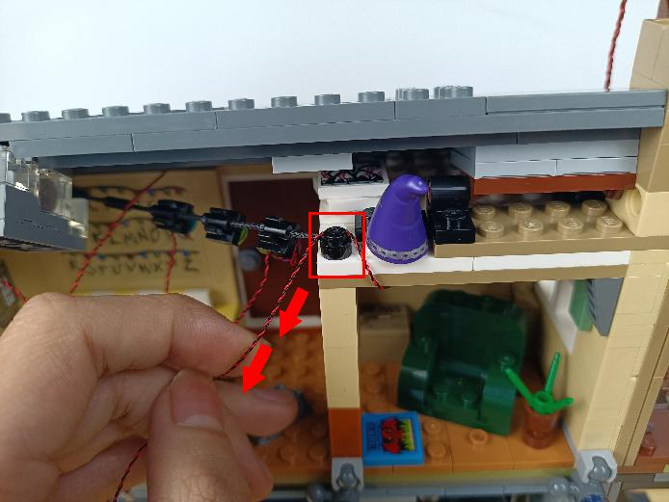

Take a 30cm connecting cable, a 6-port expansion board, assemble the as per below.
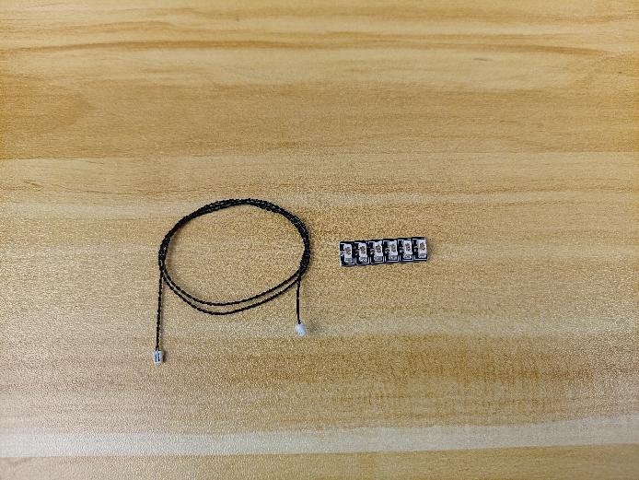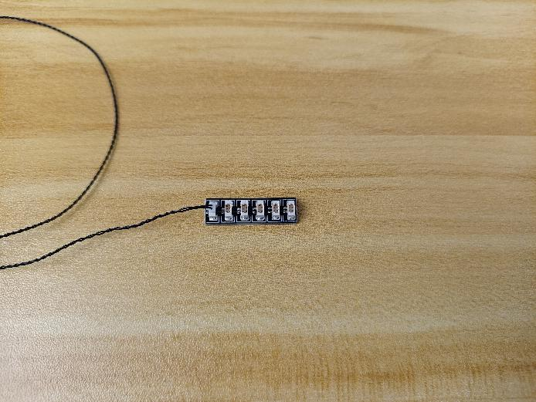

Connect all the following cables to the expansion board, and tuck excess cables around the expansion board.
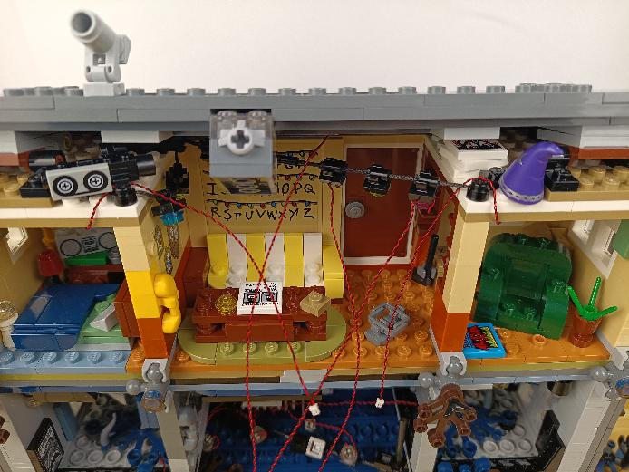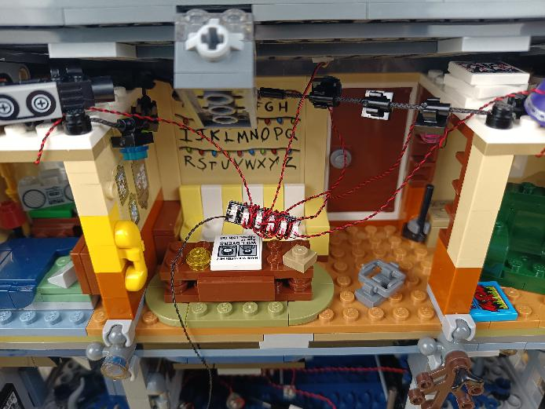

Take 2 adhesive squares.
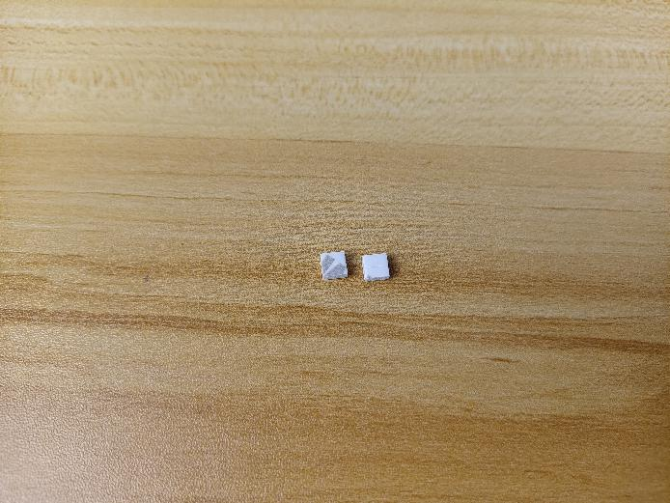

Stick them to the back of the expansion board, and stick the expansion board to the following place.
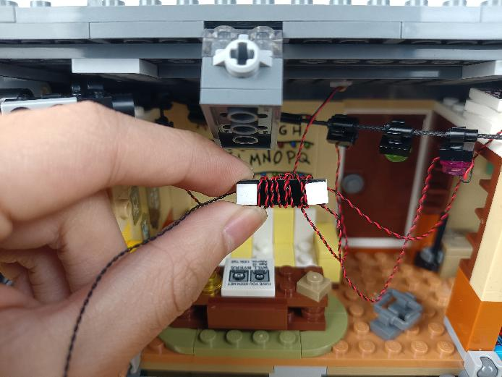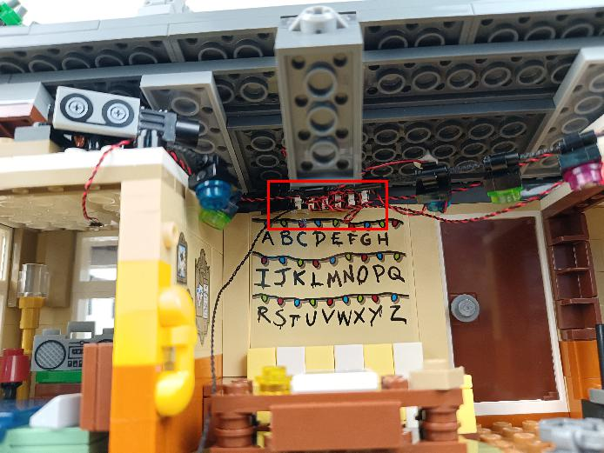

Pull the connecting cable from the expansion board to the left.
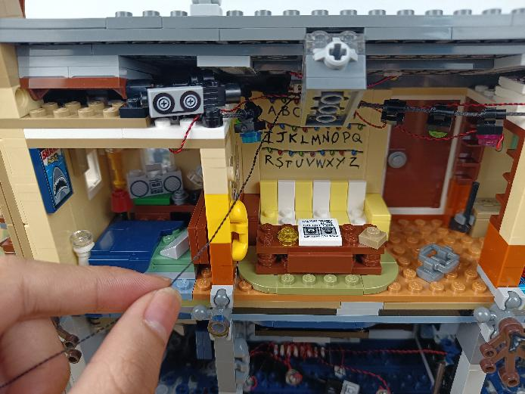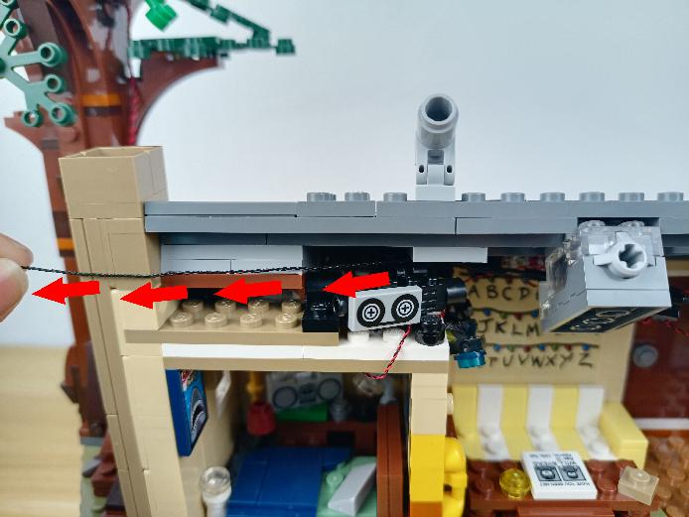

Disconnect the following piece, place the cable as per below.
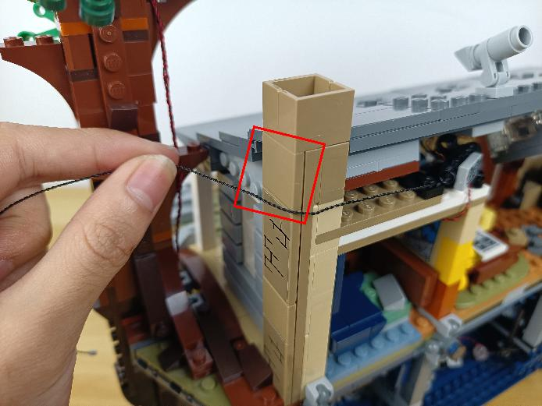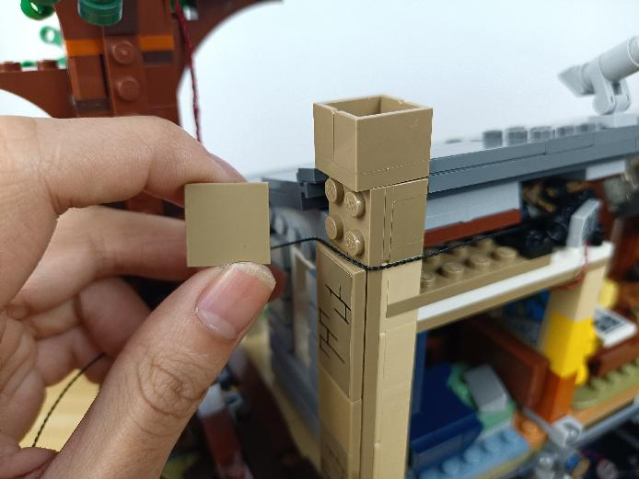

Reconnect the following piece to secure the cable.
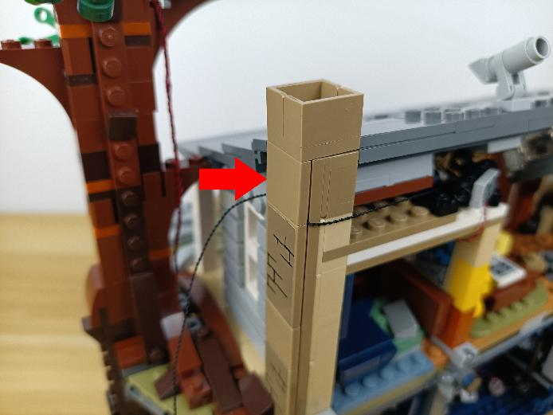

Pull the cable to the following place, thread it through the space and pull it out from the bottom.
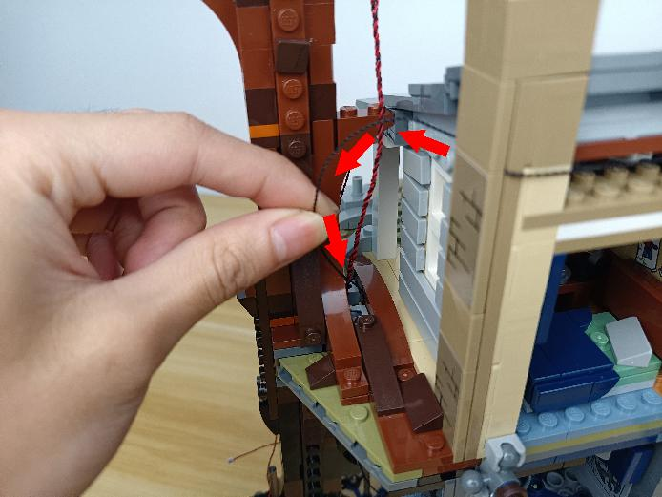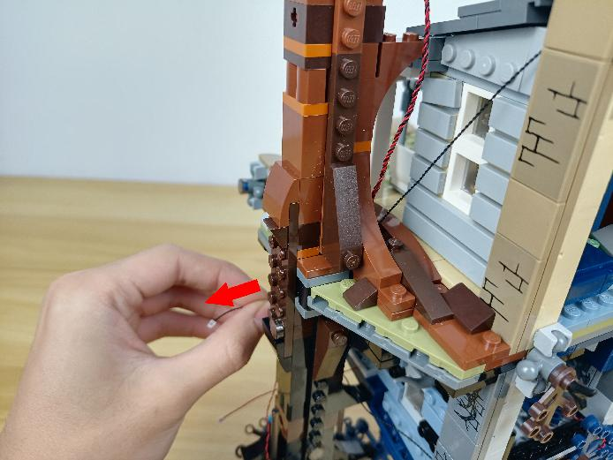

Turn to the following place.
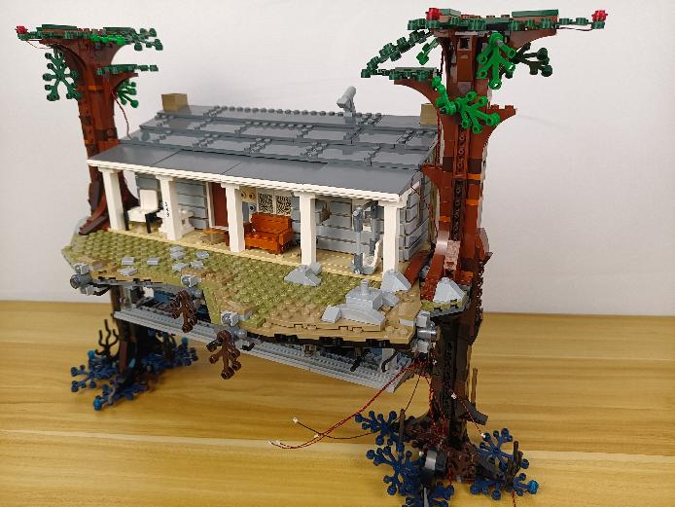

Turn to the following place at the right.
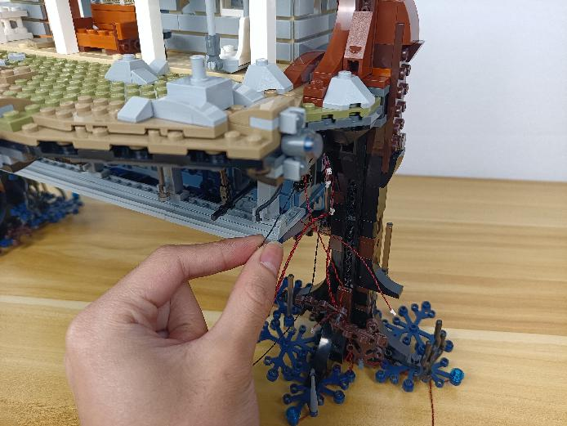

Take a USB cable, a 12-port expansion board, assemble the as per below.
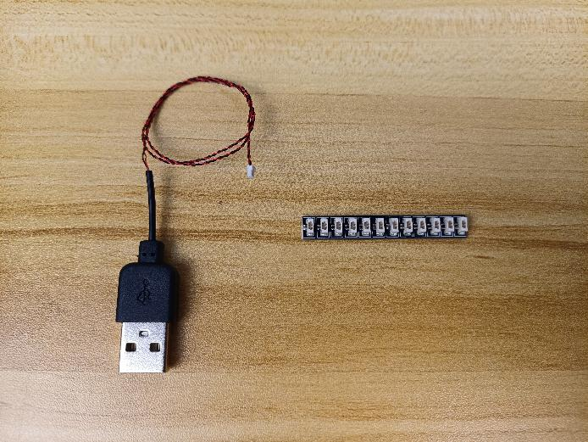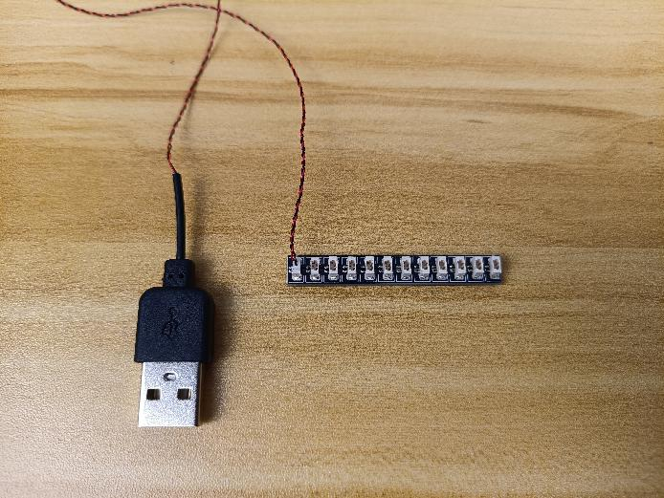

Connect all the following cables to the expansion board, and tuck excess cables around the expansion board.
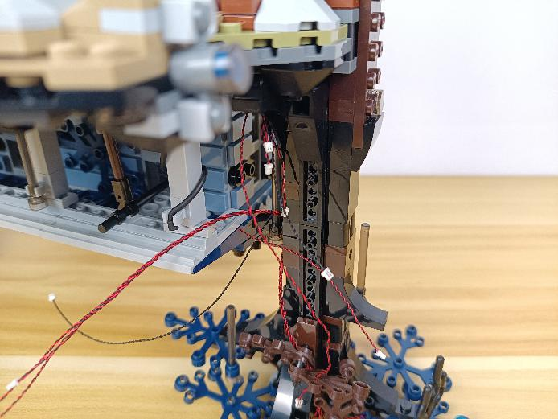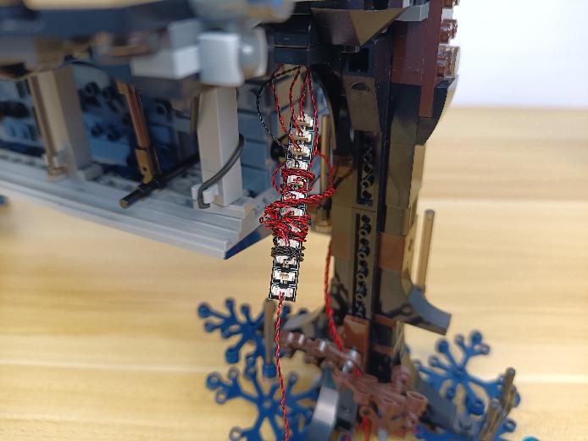

Turn to the following place, reconnect the car.
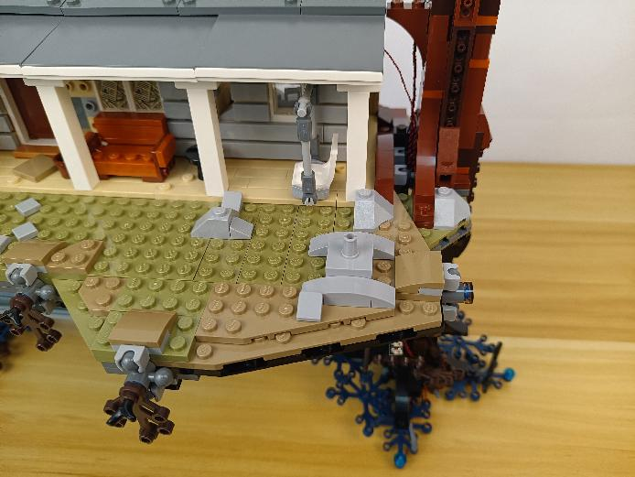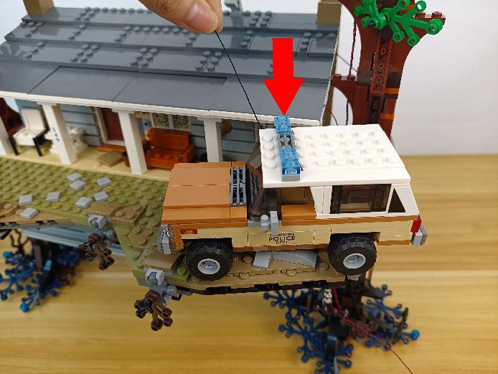

Pull the following connecting cable from the car to the right and connect it to the expansion board.
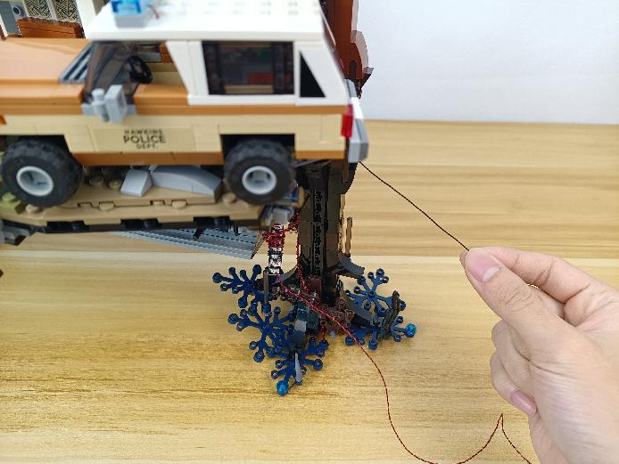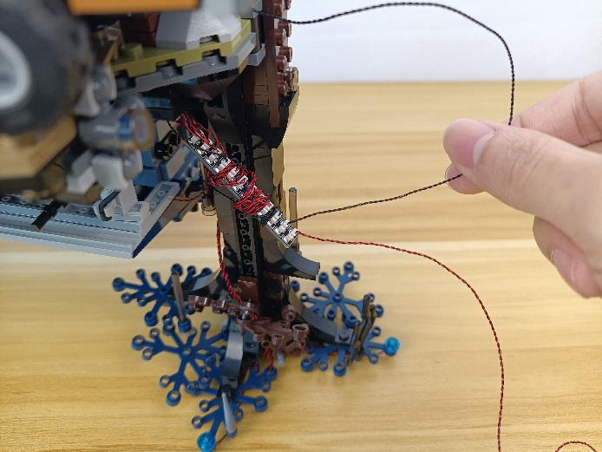

Take 2 adhesive squares.
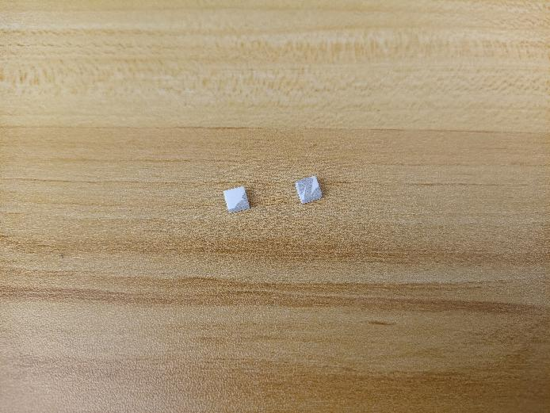

Stick them to the back of the expansion board, and stick the expansion board to the following place.
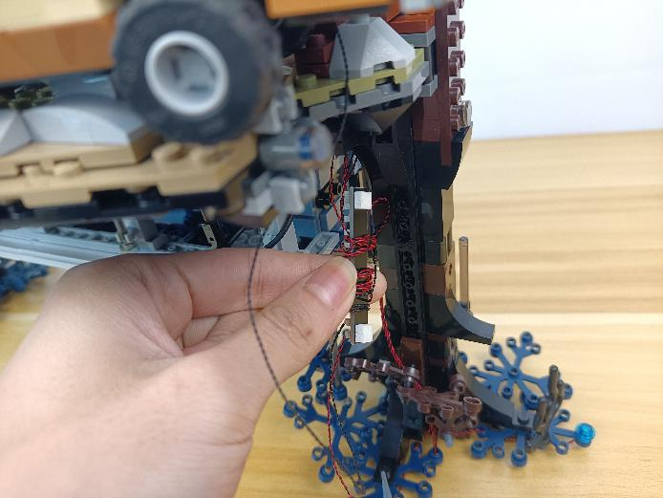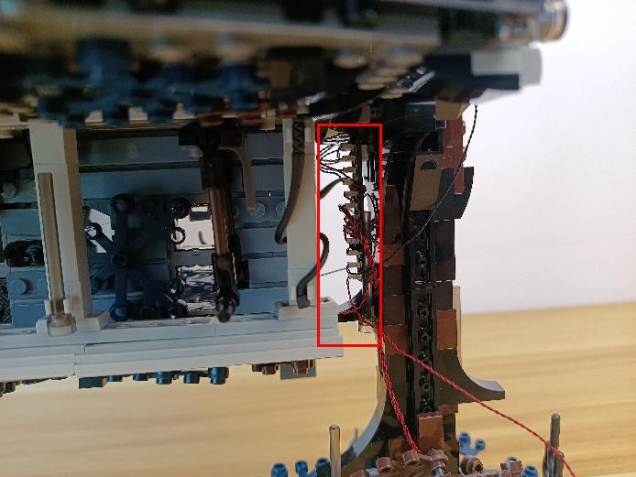

This completes installation of this LED Lighting Kit. ENJOY!

The above are ideas and instructions provided by our designers. Please move on:
1: Do you have any suggestions about the material and quality of our products?
2: Do you have any suggestions on the installation instructions and the degree of difficulty of the installation?
3: If you have better installation method and ideas, please contact us in time.

