Lighting Kit LEGO 42098

Thank you for choosing our lighting products. We are committed to LEGO product study and lighting development, we're always trying our best to provide LEGO fans with the best products and the best installation ideas.
Must be careful observation, imagination can be infinite.
We provide basic parts to support your imagination.
DO IT YOURSELF .that's what LEGO is .

As always, Lego has been adhering to the DIY philosophy from product selection, research and development to sales. Consumers buy the parts, you will assemble them by yourself, and you can experience every step from picking up the first piece to installing the last one. Besides, LEGO has different answers for the installation form and method of each part. Vonado lighting also does not want to kill your unlimited creativity, we will try our best to make products with high variability, high playability and unlimited play. If you have any dissatisfaction or your own ideas on the parts such as the color of the lights, the length of the cables, the installation position of the product, and the final effects of each module, you can make your own arrangement, and we will cooperate with you to replace or repurchase.
LETS MOVE!

Package contents：
- 12 x 15cm White Dot Lights
- 27 x 15cm Warm White Dot Lights
- 8 x 15cm Red Dot Lights
- 1 x Warm White Strip Light
- 1 x AAA Battery Pack
- 1 x 4-port Expansion Board
- 5 x 6-port Expansion Boards
- 3 x 8-port Expansion Boards
- 1 x 12-port Expansion Board
- 4 x 15cm Connecting Cables
- 2 x 30cm Connecting Cables
- 4 x 50cm Connecting Cables
- 1 x USB Cable
Extra pieces
Note:
Place wires on the surface or under the building blocks.
The wire can be place between the building blocks or under the block, but they should be placed between the studs correctly.
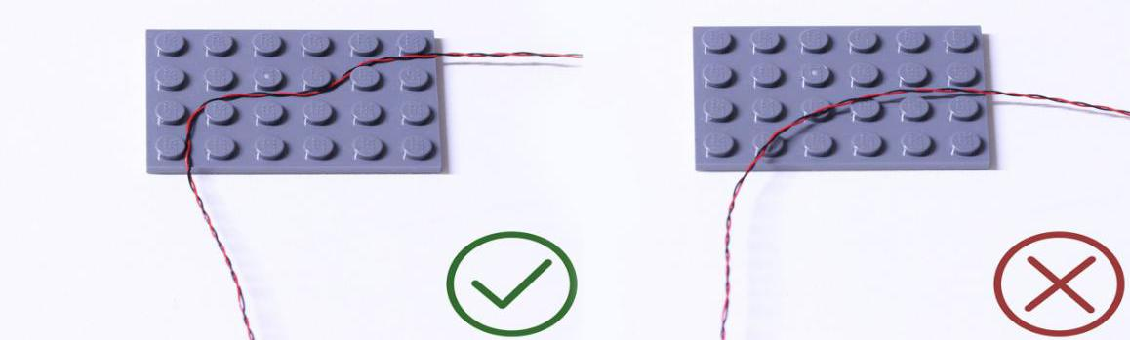

Insert the connectors to the ports.
Be careful when you are operating, there’s only one correct way to insert, make sure the expansion board is upward, find the soldered “=” sign on the left of the port. When you are inserting, the side which the wires can be seen should be faced to the “=” sign and if you feel hard to insert, please stop, and don’t force it, for that may result in bent pins inside the port or overheating of the expansion board.
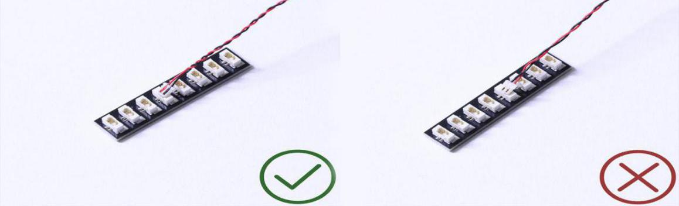

At this point, use the tweezers to straighten the bent pins.
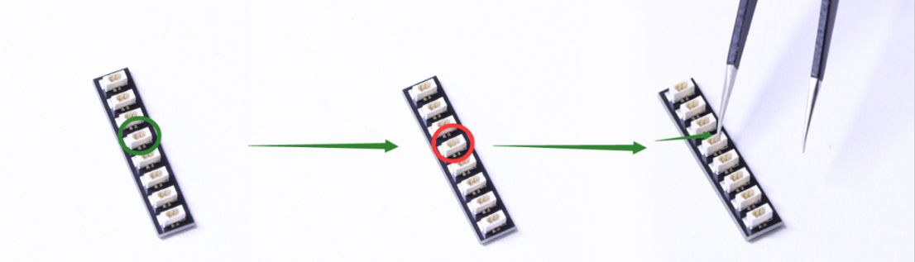

When installing dot lights, make sure they are correctly placed (Yellow LED package is exposed). You can put they either on the top of the studs or between studs.

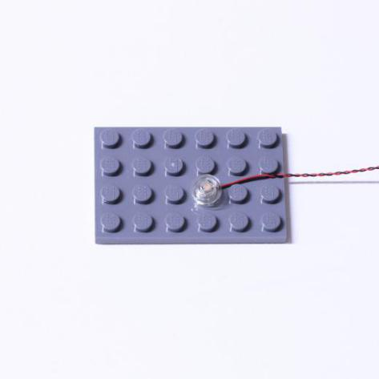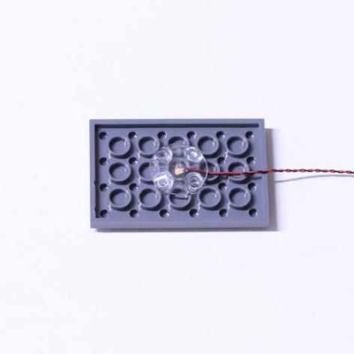

Connecting cable connectors to Strip Lights
Take extra care when inserting connectors to ports on the Strip Lights. Connectors can be inserted only one way. With the Strip Light facing up, ensure the side of the connector with the wires exposed is facing down. If a plug won’t fit easily into a port connector, don’t force it. Doing so will damage the plug and the connector.
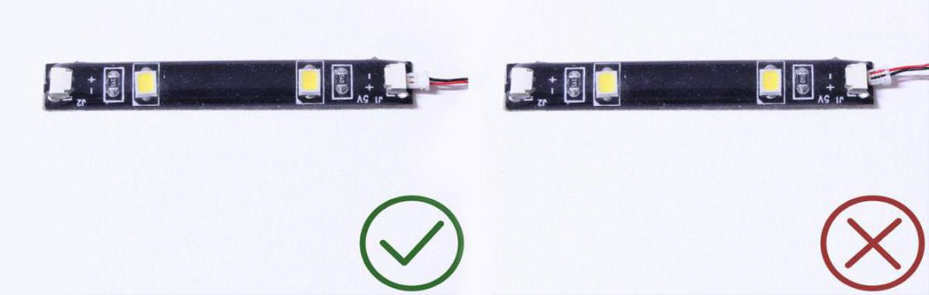

Finally, please pay attention to the positive and negative terminals of the battery when installing the battery case.
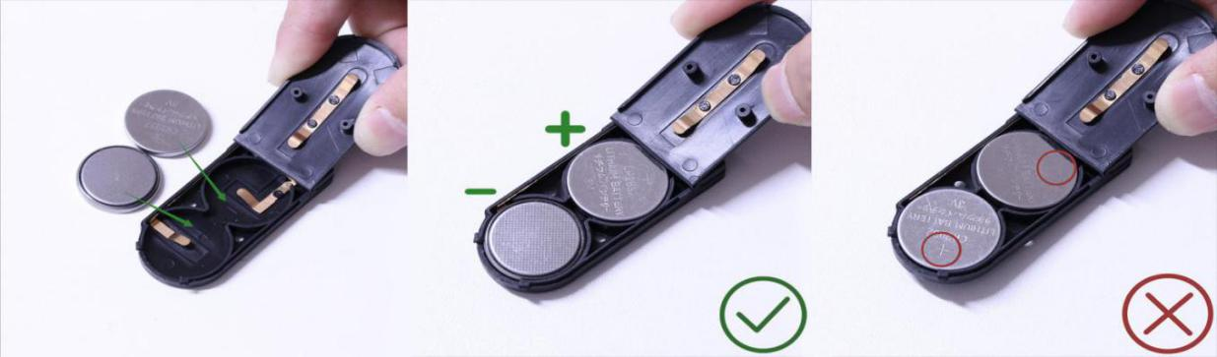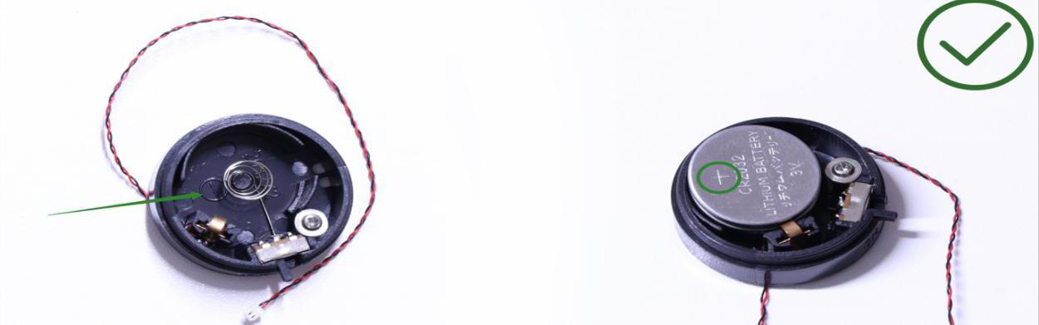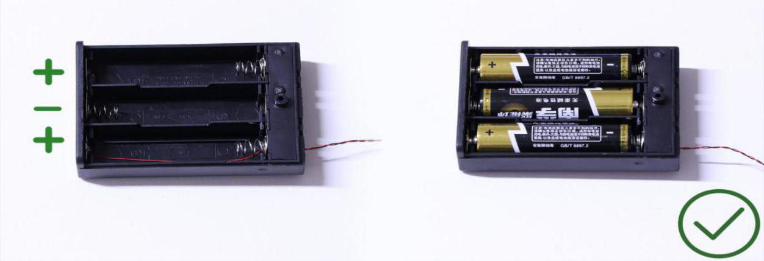
Instructions for installing this kit：
Transport Vehicle, Lighting Kit, 11 bags in total.
Power supply： USB cable (self-contained power bank or mobile phone charger).
Firstly, take the power source (power bank or mobile phone charger), connect it to the USB cable, connect the other end of the USB cable to the expansion board to verify all the lights one by one.
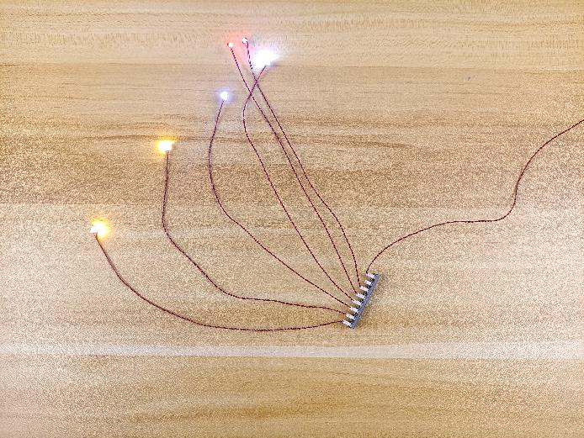
After the verification, disconnect the lights and put them back to the bags.
（note: put the lights back to the bags when verification of the lights from the same bag is done, then, continue to verify the lights in another bag.）
OK, Let’s Begin! （you can use the tweezer if necessary.）
（Tips: the tweezer is sharp, you should be careful when using it, do not hurt yourself or scratch the pieces; be gentle and do not wear the cables.）
Instructions for installing this kit：
Take the transport vehicle at first.
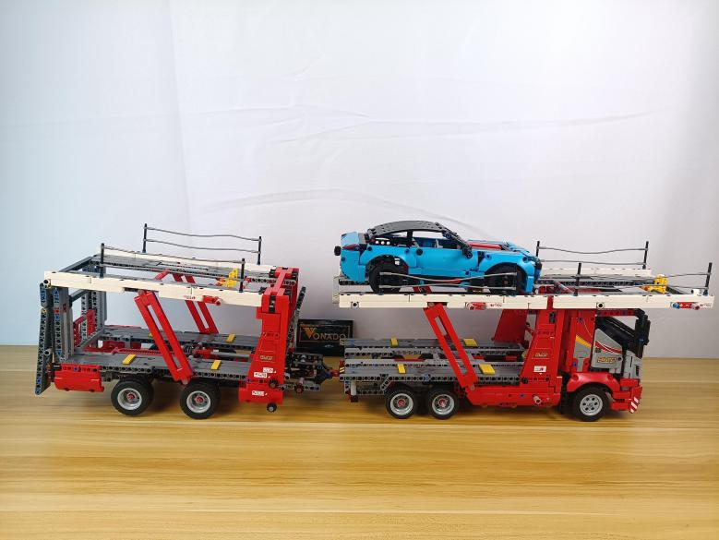

Remove the joint pin.
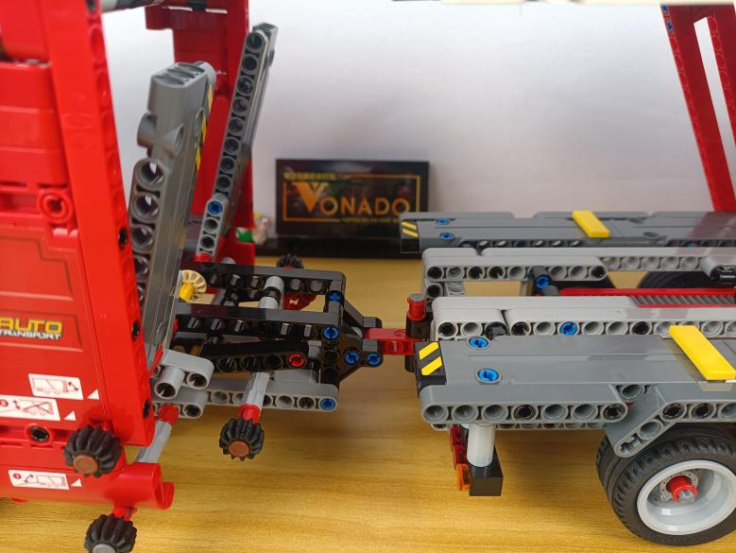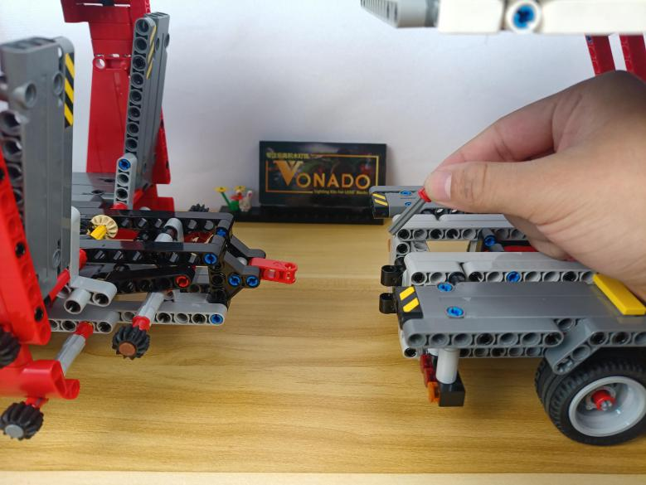

Divide the piece into A part、B part and C part.
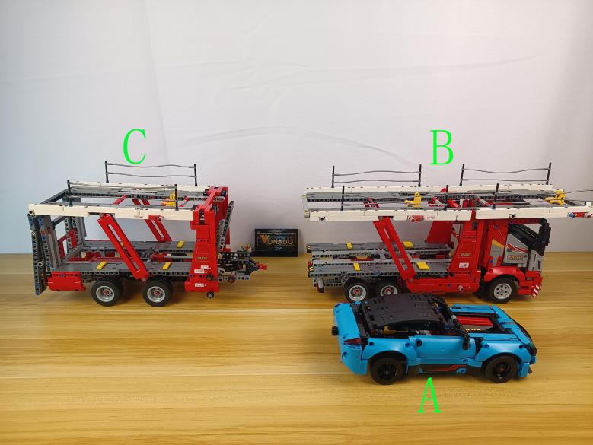

Start from installing lights for the A part.
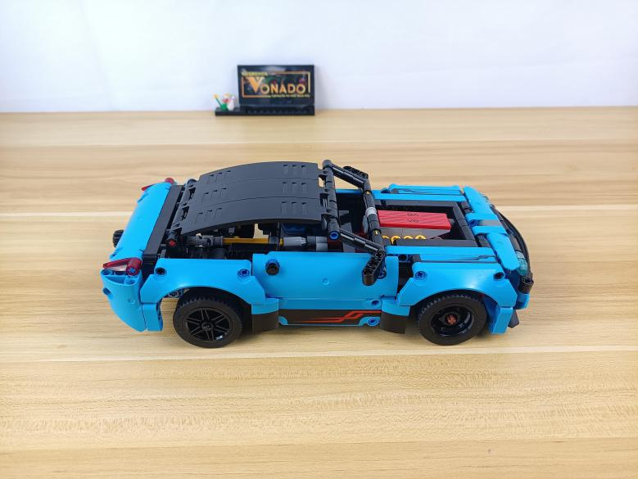

Turn to the head.
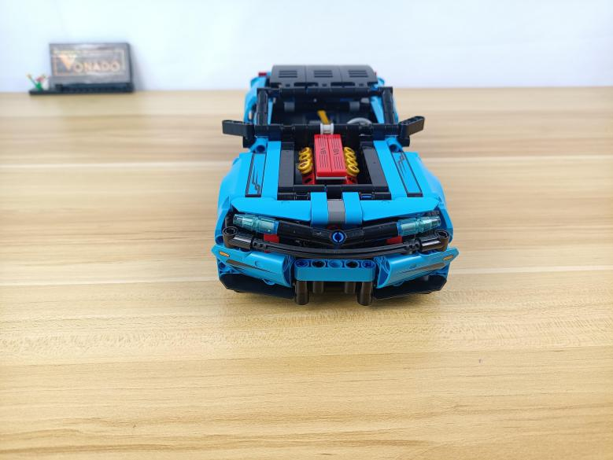

Remove the following blue pieces from both sides.
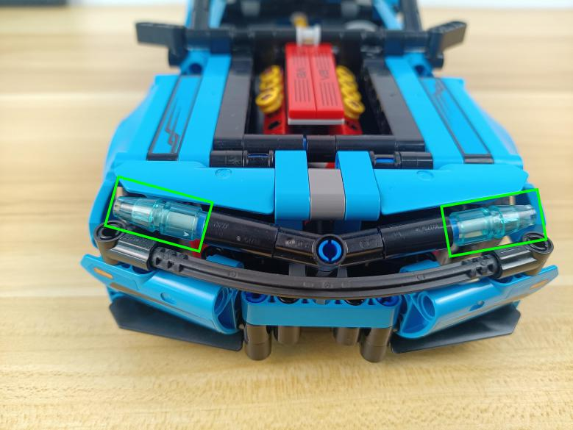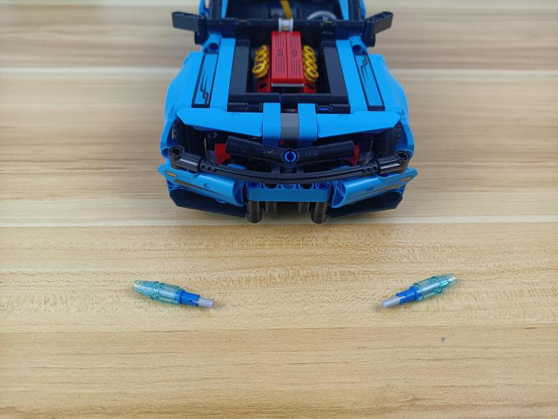

Continue to disconnect the following blue pieces.
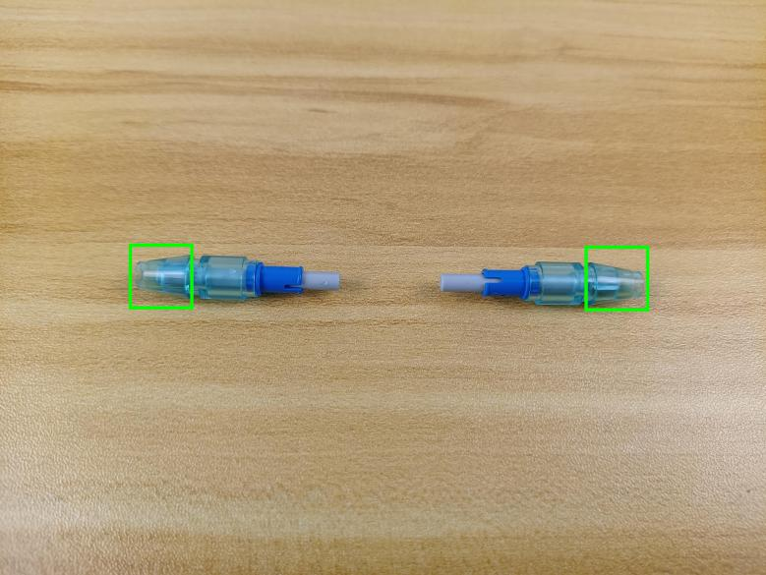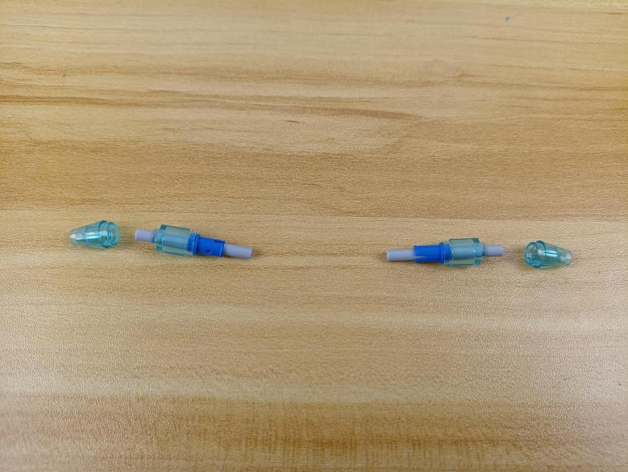

Take 2 white 15cm dot lights.
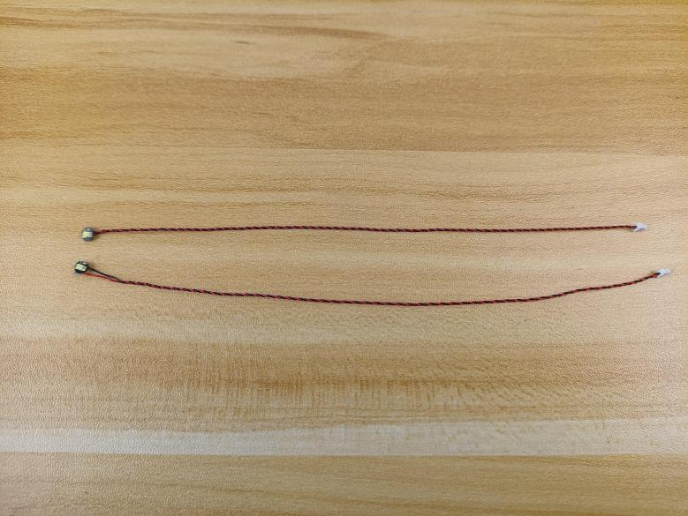

Thread the cable through the hole and tighten it up.
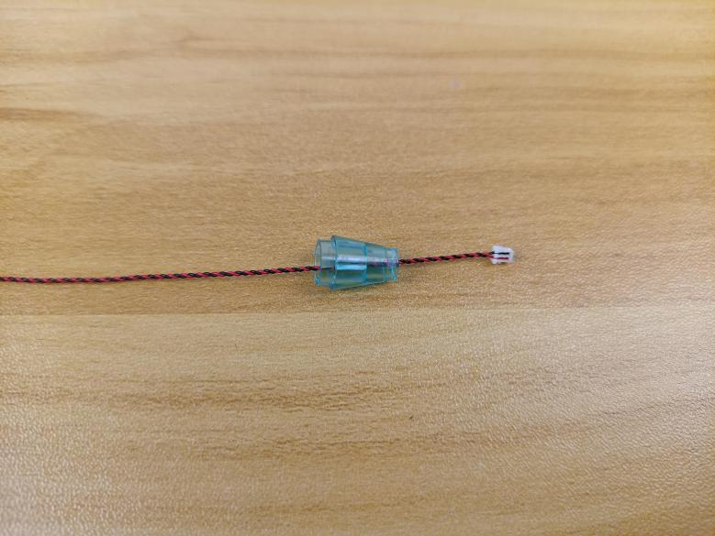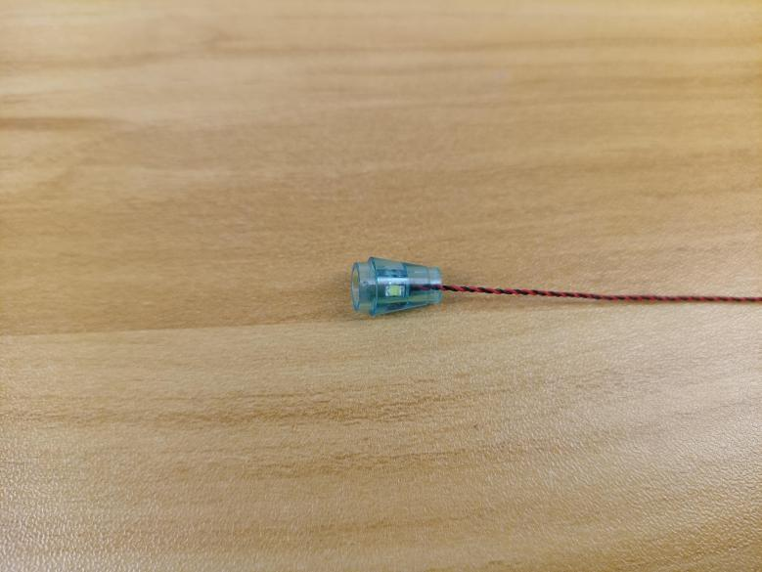

Reconnect the blue piece.
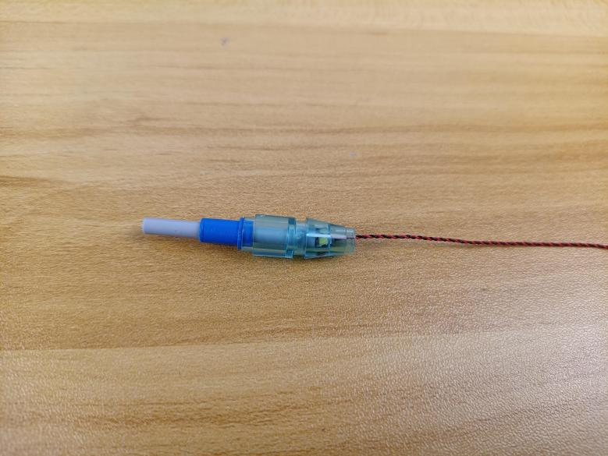

Install the other light in the same way.
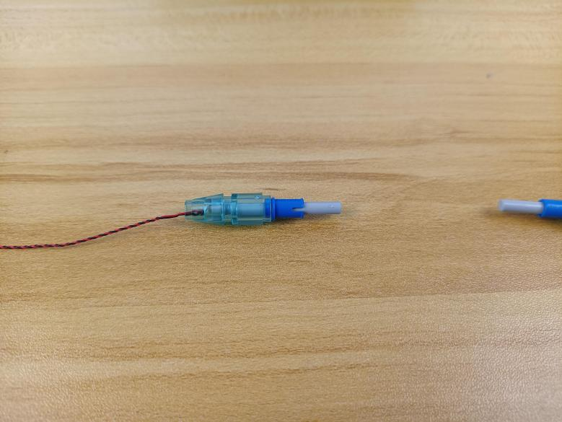

Reconnect the blue pieces.
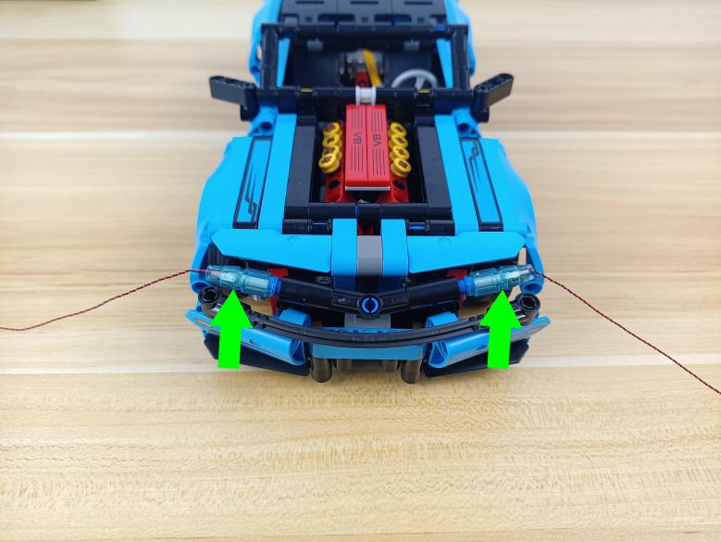

Thread the cable through the following space, and pull it out from the bottom.
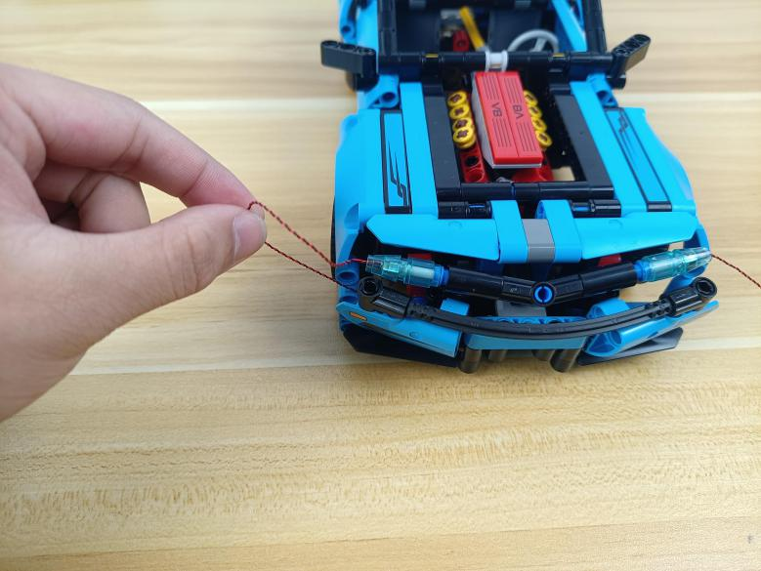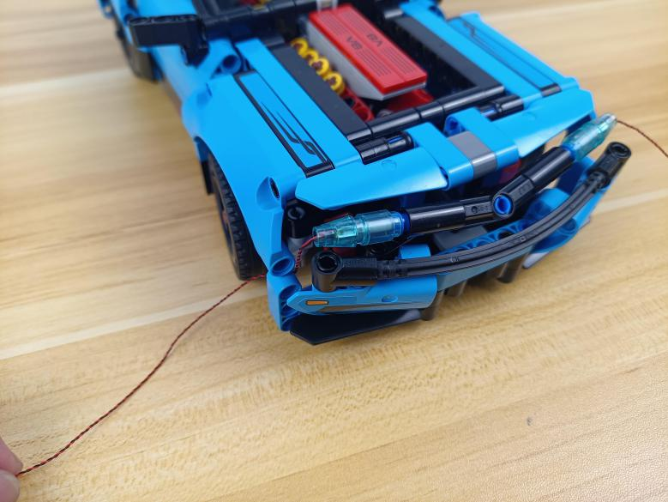

Place the cable at the other side in the same way.
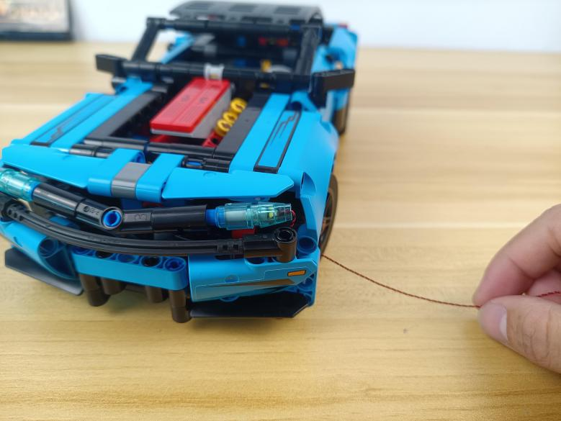

Turn to the side.
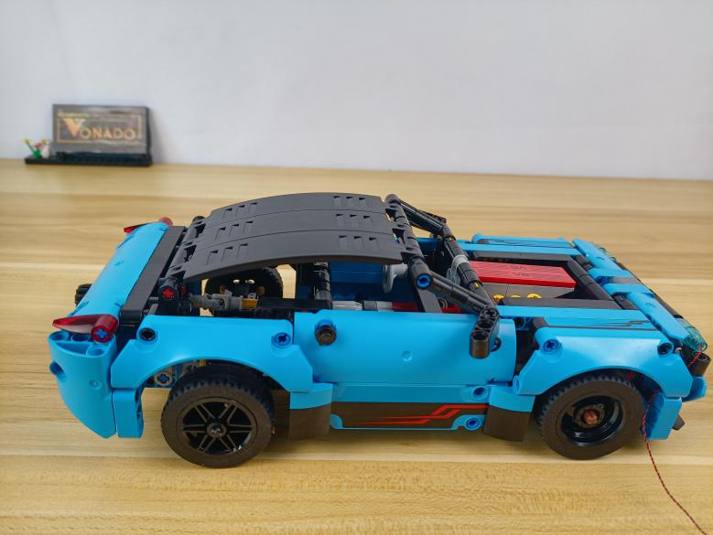

Take a warm white 15cm dot light, an adhesive square.
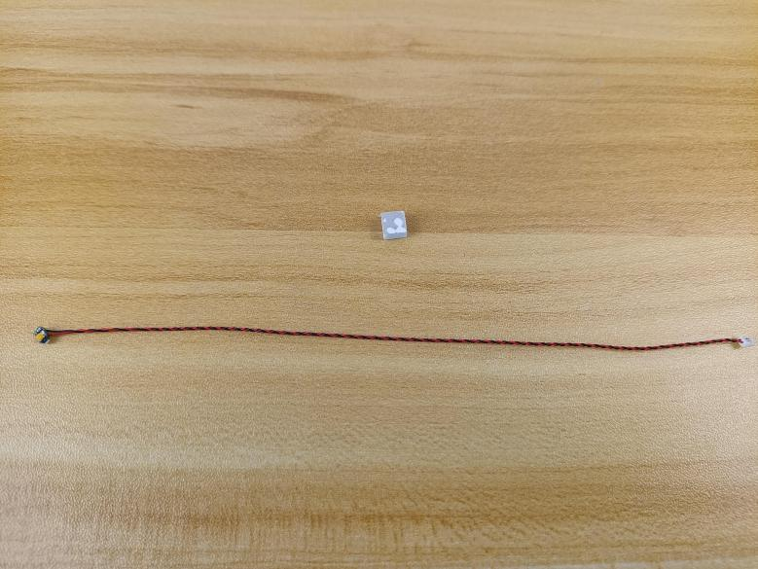

Stick the adhesive square to the back of the light.
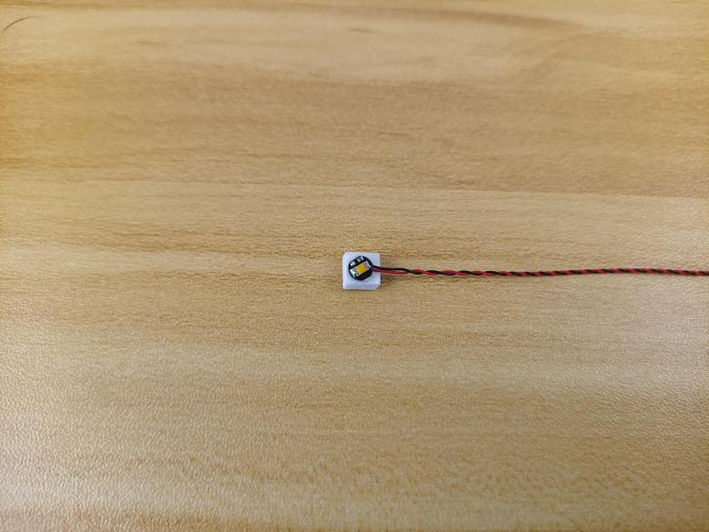

Stick the light to the roof inside as per below.
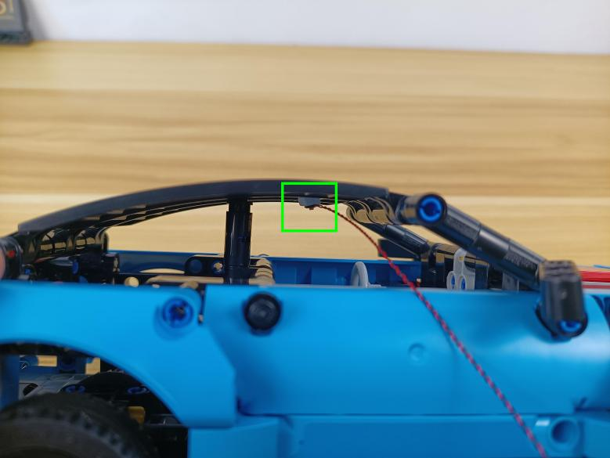

Thread the cable through the following space, and pull it out from the bottom.
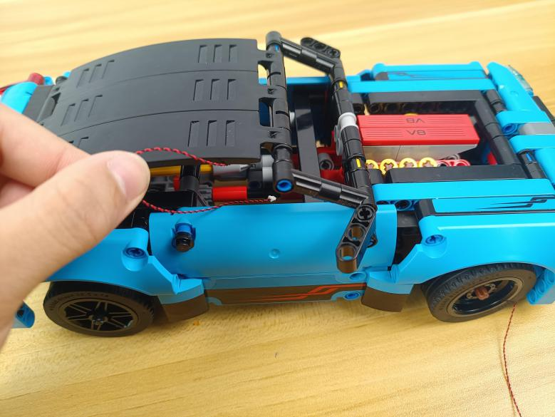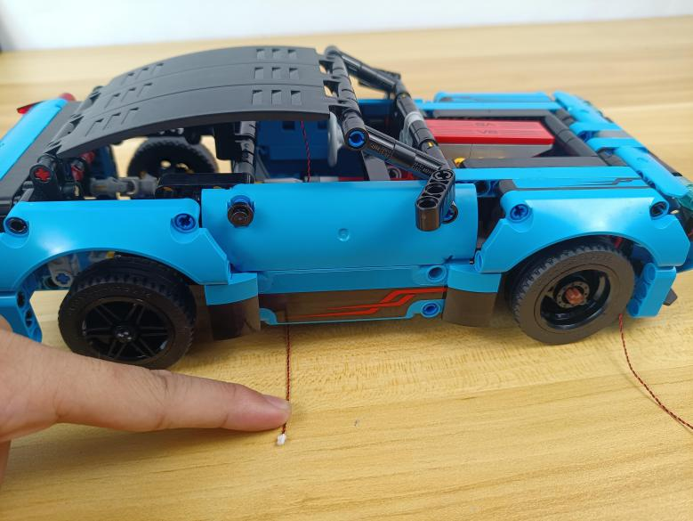

Turn to the tail.
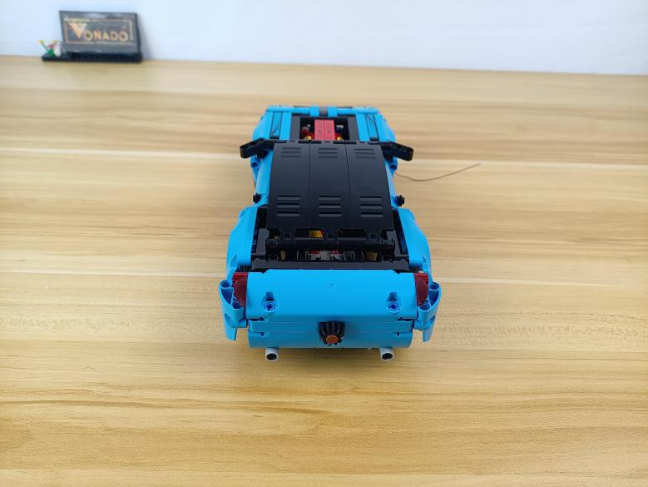

Remove the following red pieces from both sides.
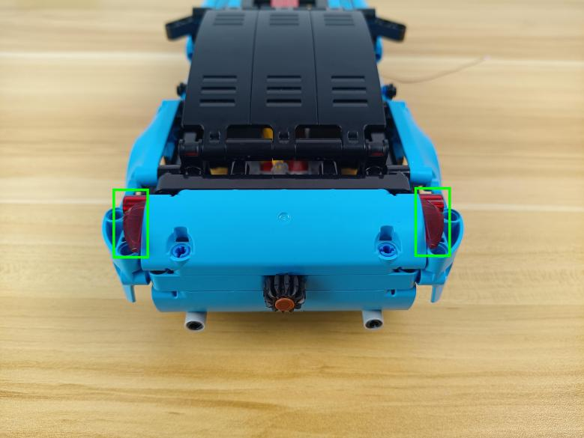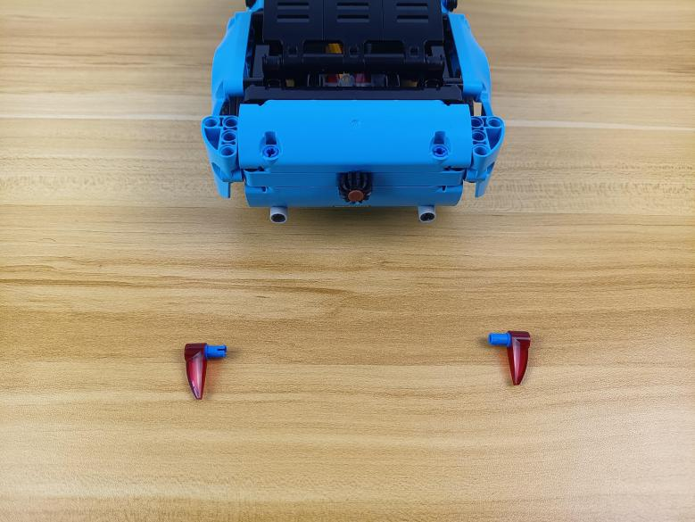

Take 2 white 15cm dot lights.
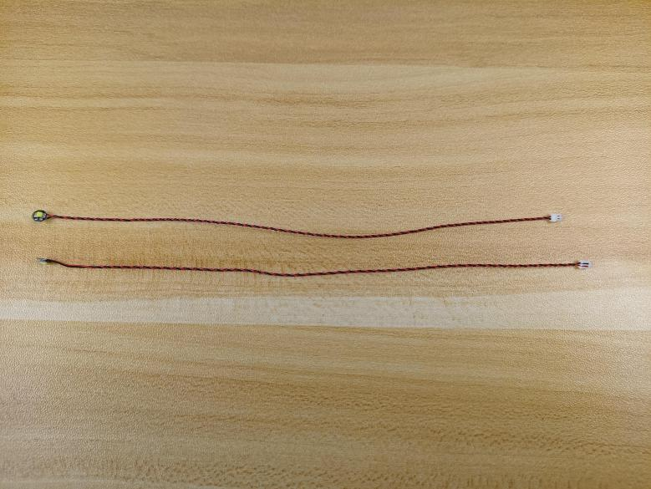

Split the cables as per below.
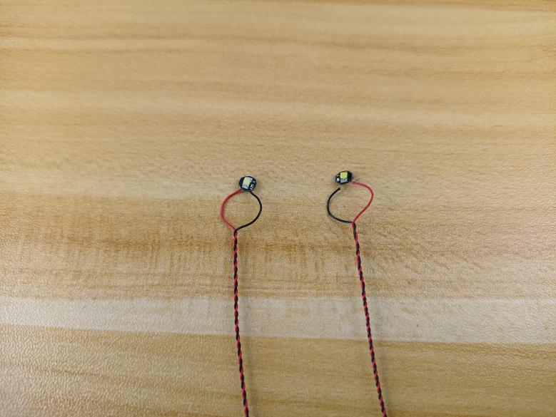

With lighting part facing outside, connect the lights at the blue pieces.
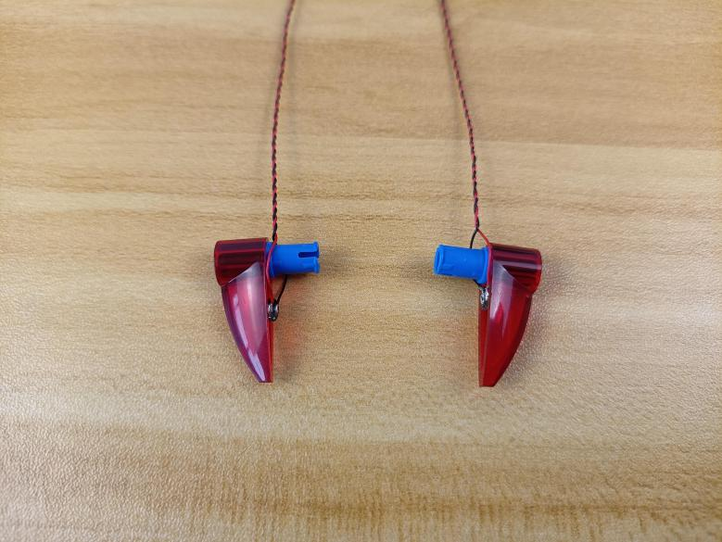

Tighten the cables up.
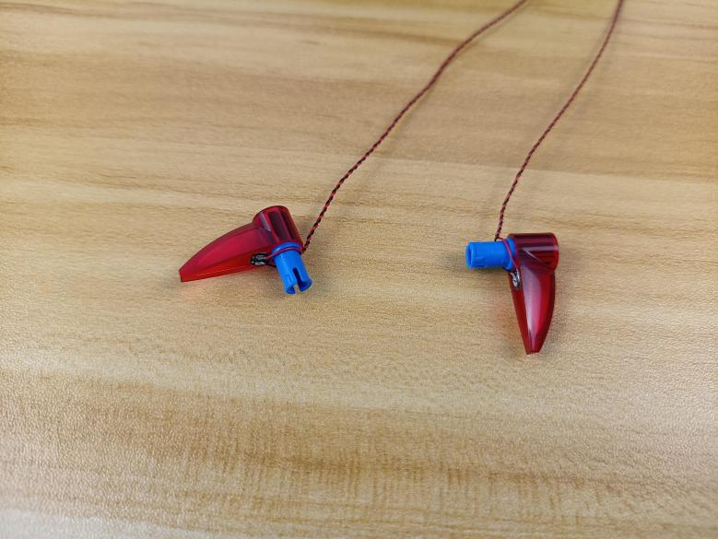

Reconnect the red pieces.
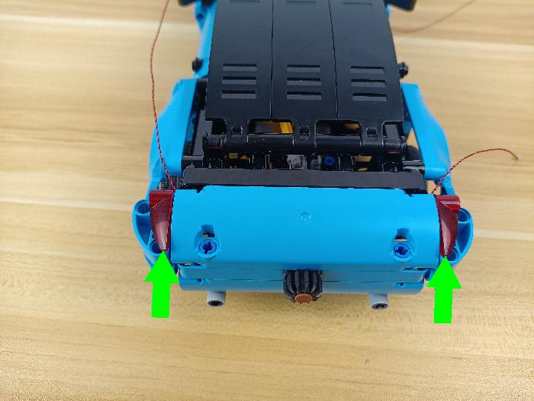

Thread the cable through the following space, and pull it out from the bottom.
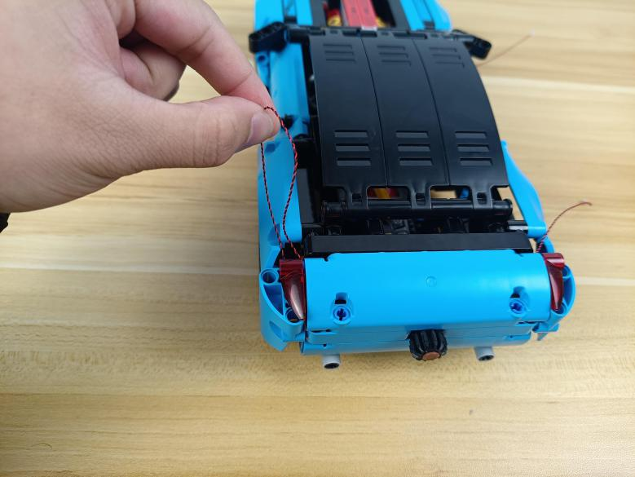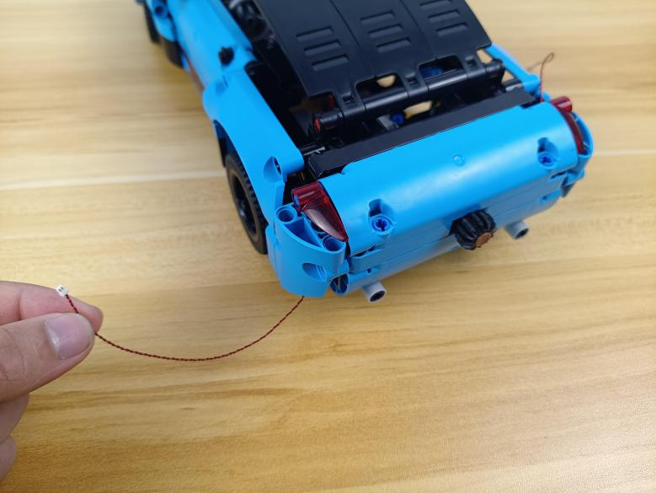

Place the cable at the other side in the same way.
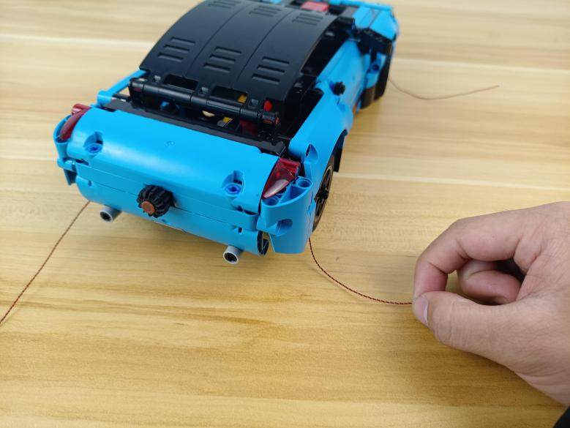

Turn the car over.
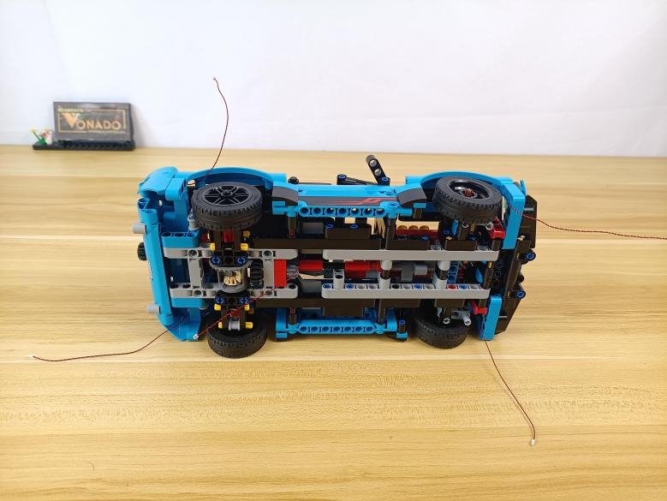

Turn to the head.
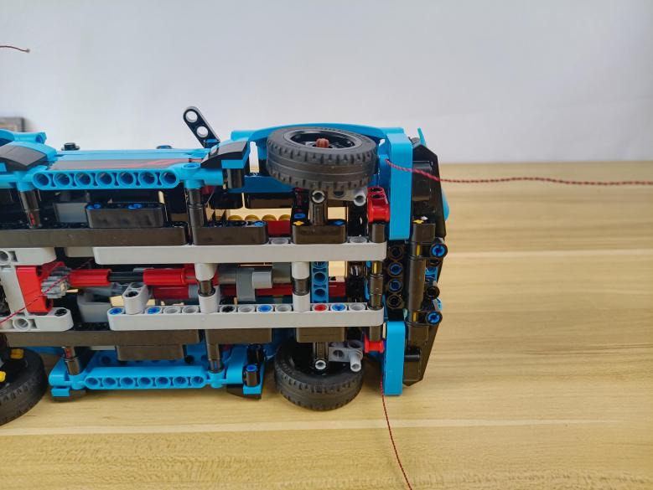

Thread the following cable through the following space, and pull it out.
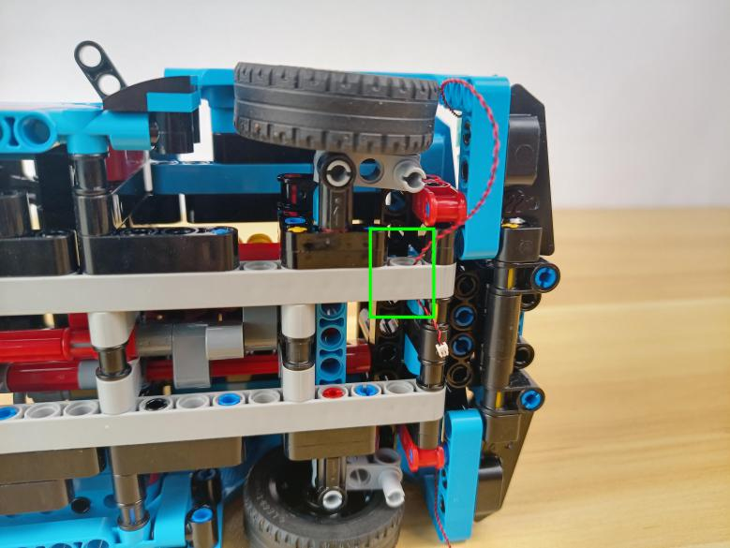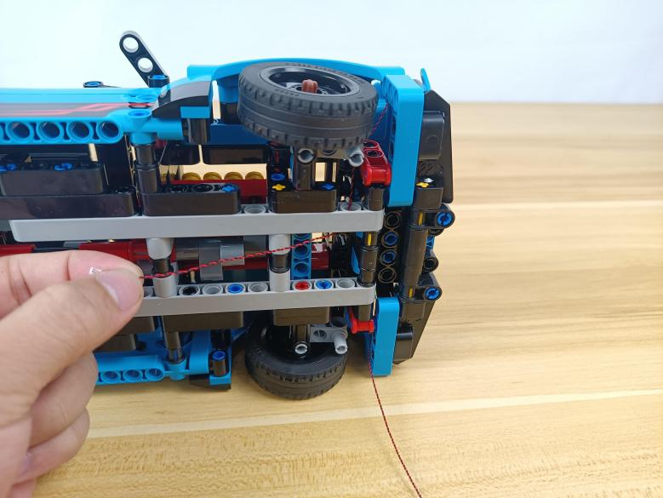

Continue to thread the following cable through the hole and pull it out.
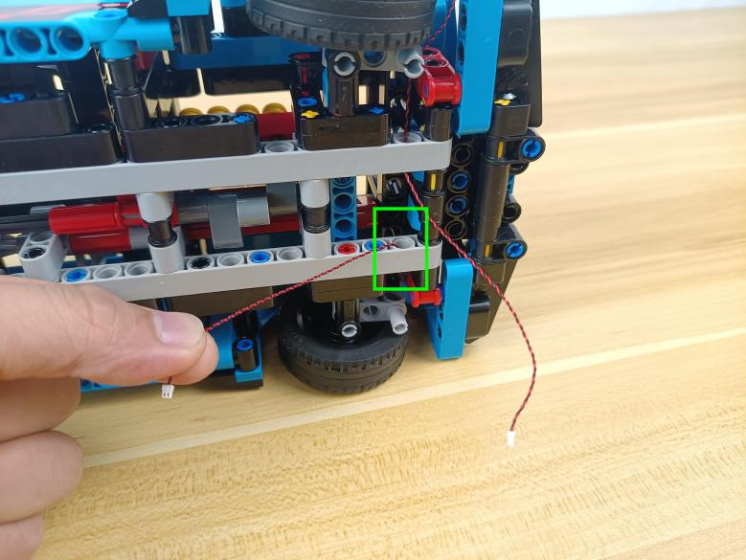

Take a 15cm connecting cable, a 4-port expansion board, assemble the as per below.
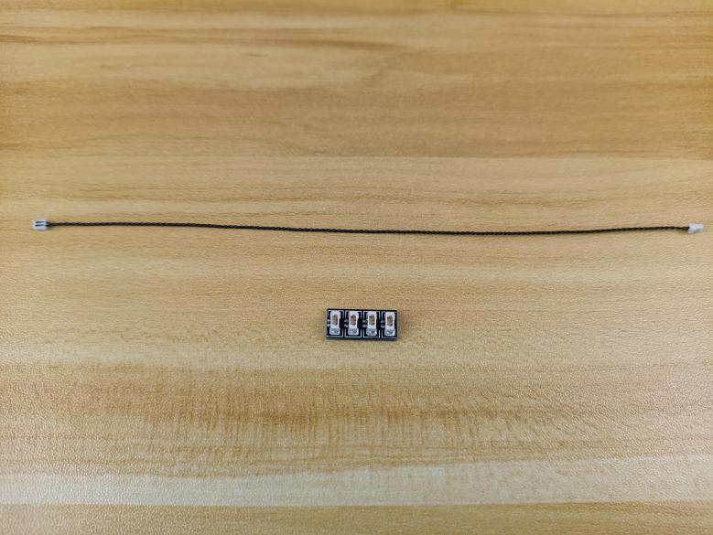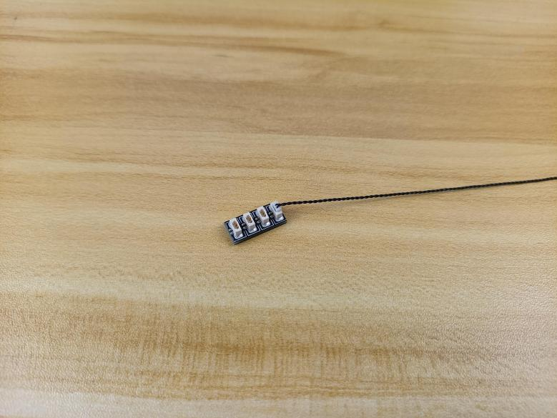

Connect the following 2 cables to the expansion board, you can tuck excess cables around the expansion board.
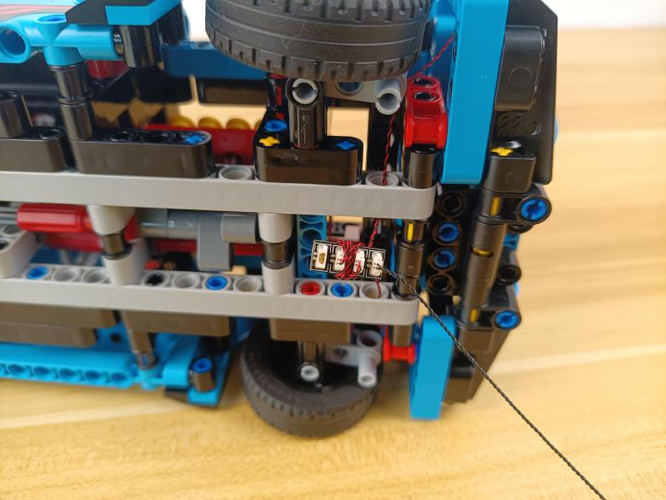

Take 2 adhesive squares.
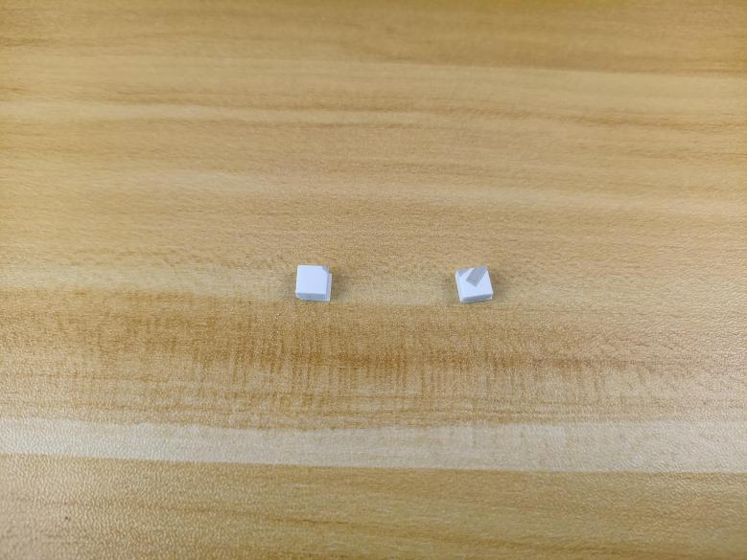

Stick them to the back of the expansion board, and stick the expansion board to the following place.
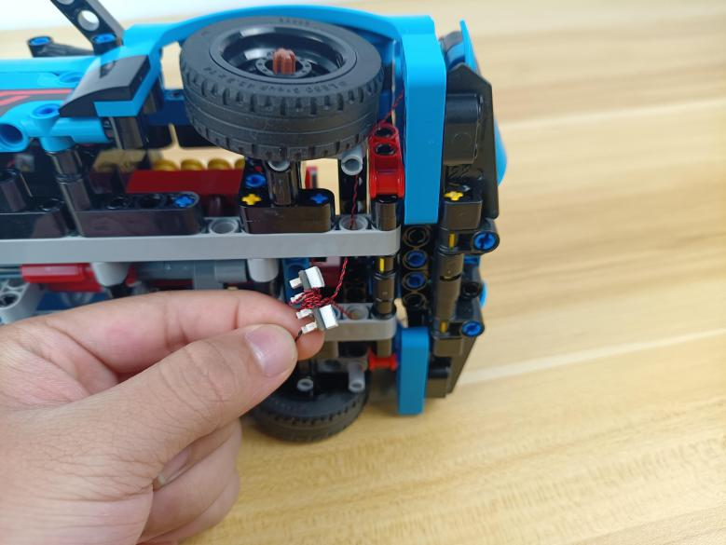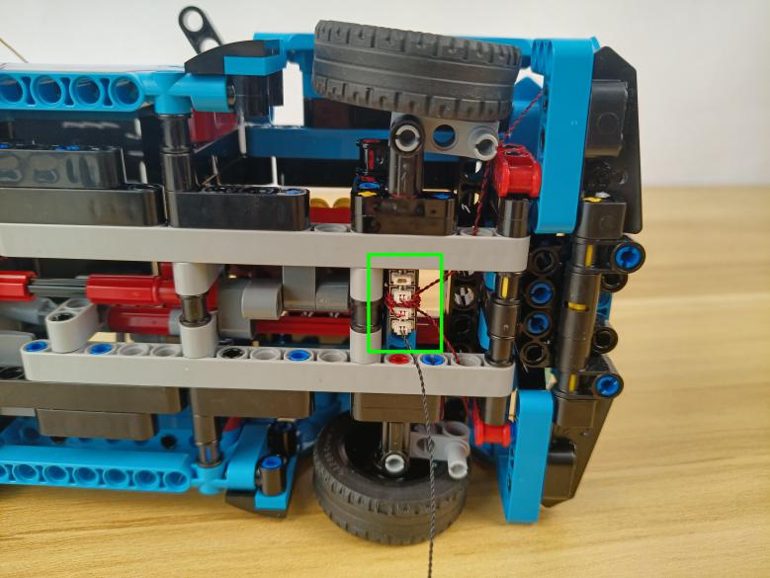

Turn to the tail.
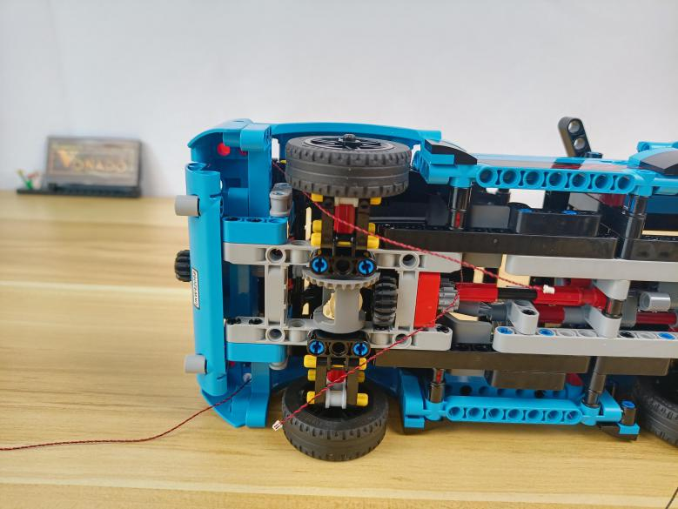

Thread the following cable through the black piece.
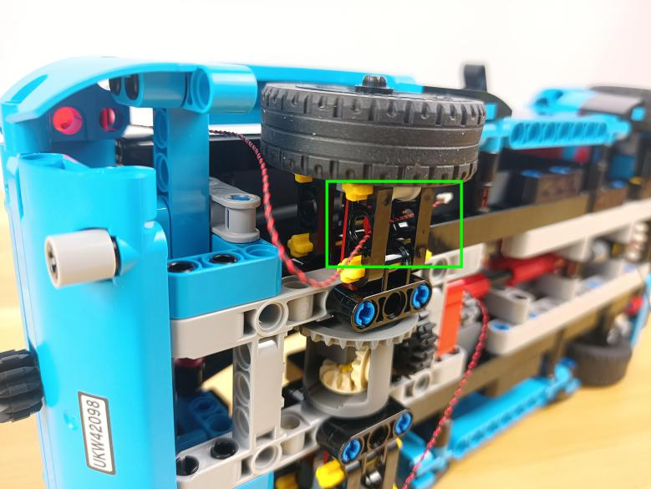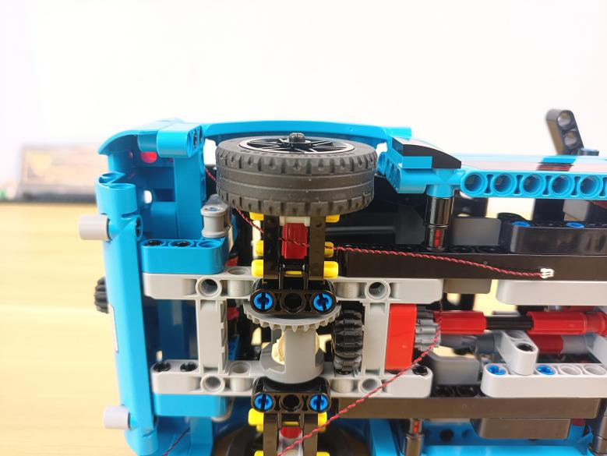

Place the following cable similarly.
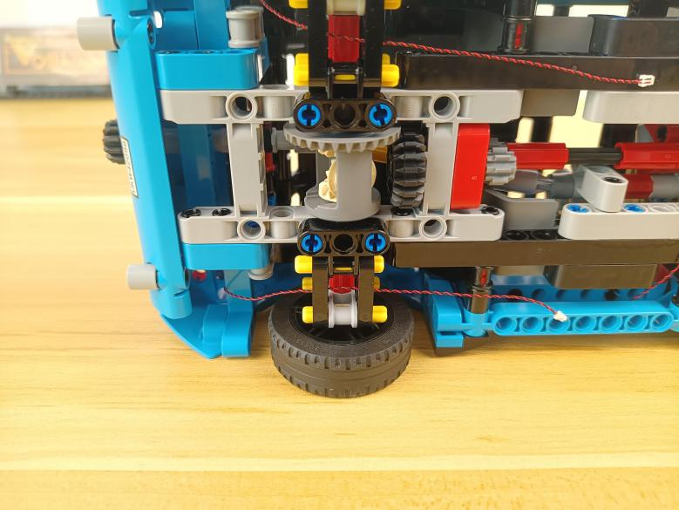

Take a 6-port expansion board.
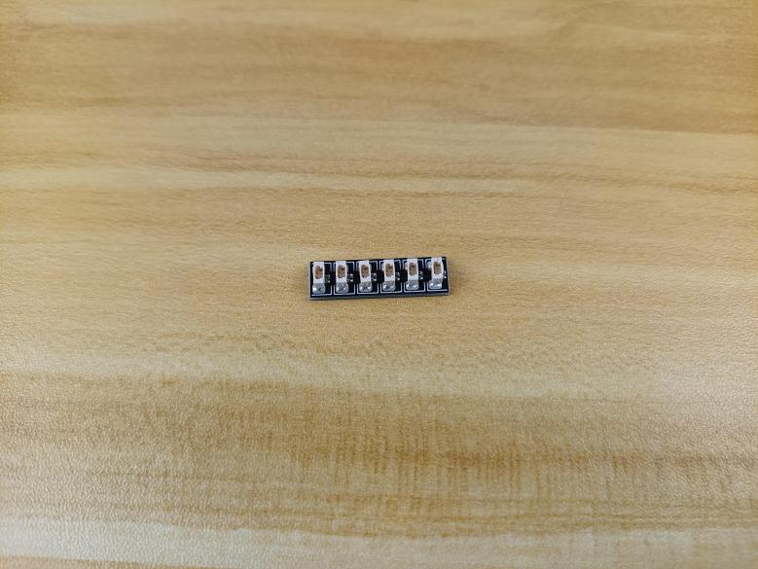

Connect the follwoing 2 cables to the expansion board.
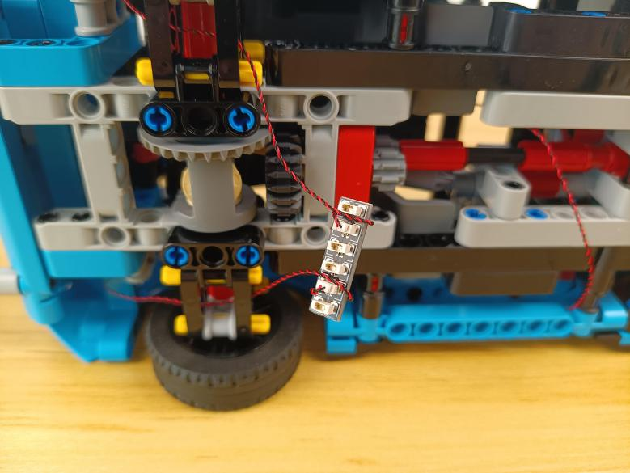

Thread the cable from the roof inside through the following space.
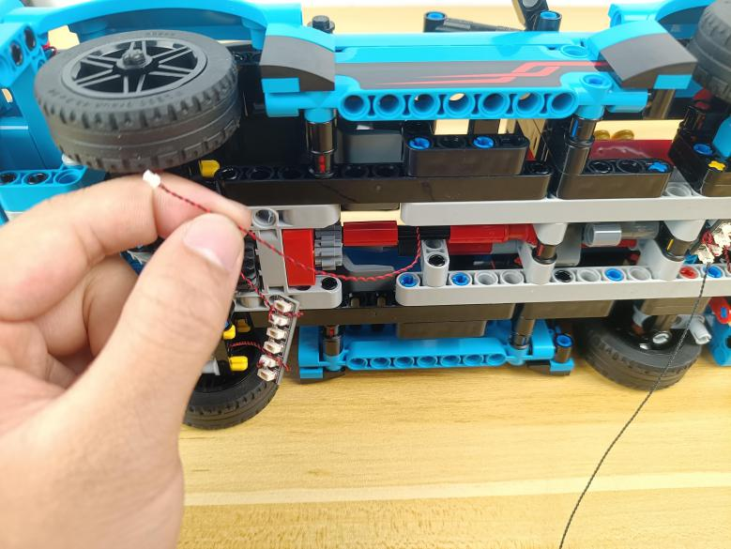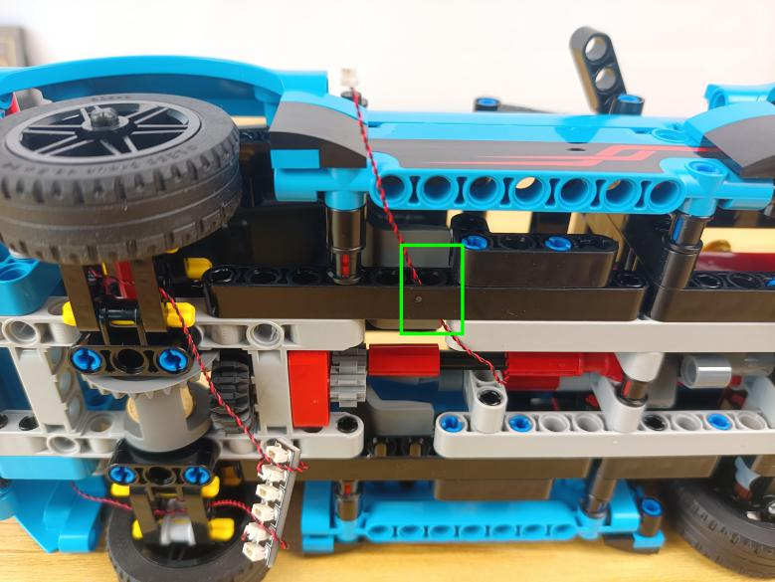

Wind it around the black piece before connecting it to the expansion board.
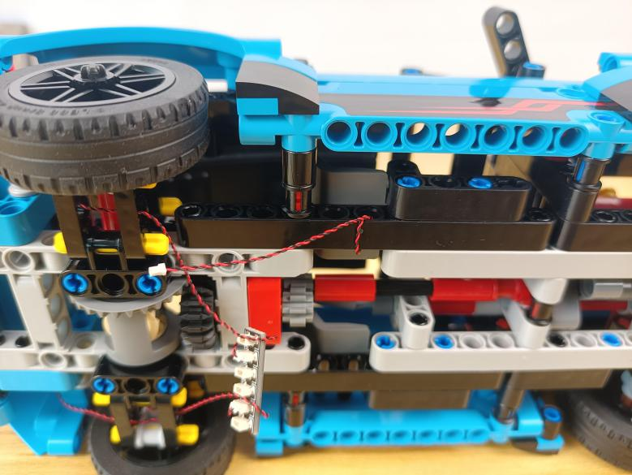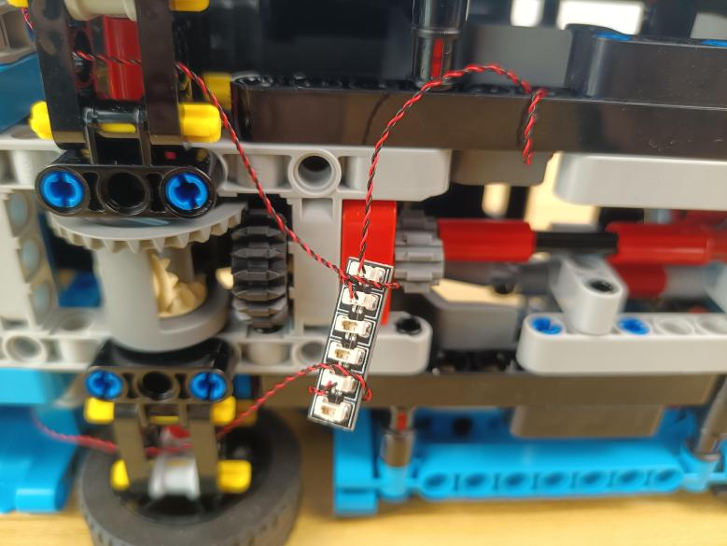

Connect the cable from the 4-port expansion board to the 6-port expansion board.
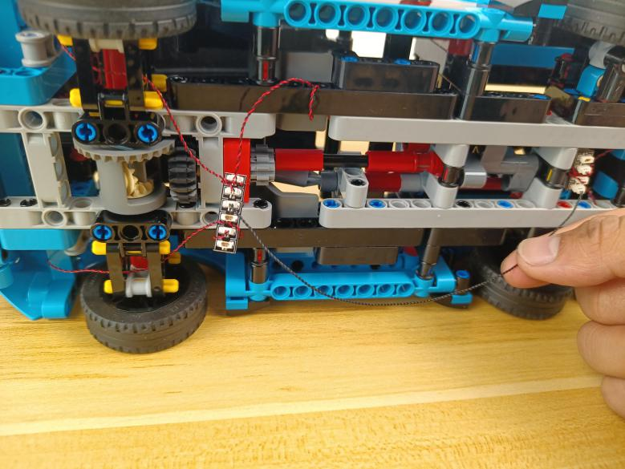

Take an AAA battery pack.
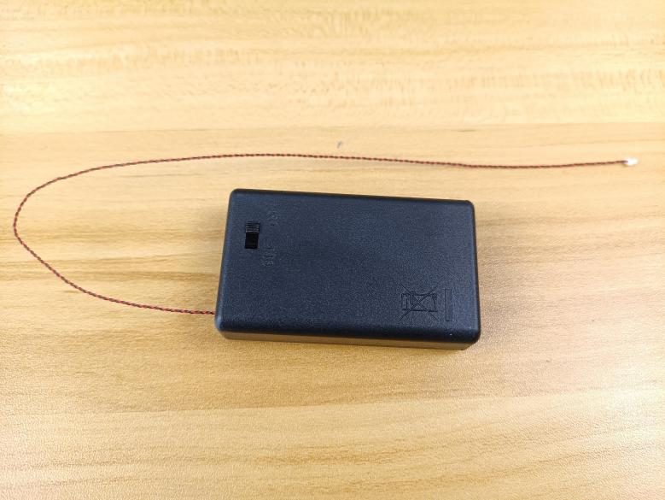

Thread the cable from the battery pack through the car to the bottom.
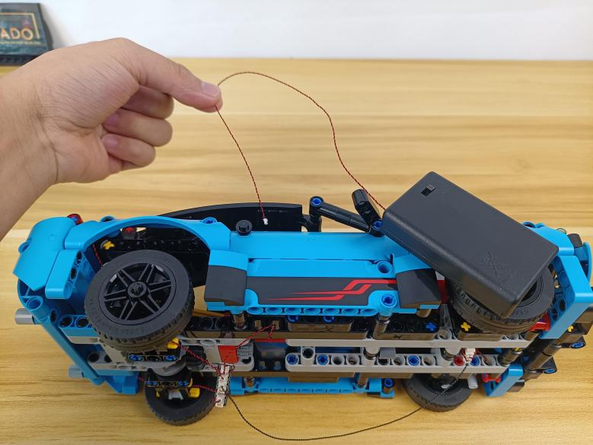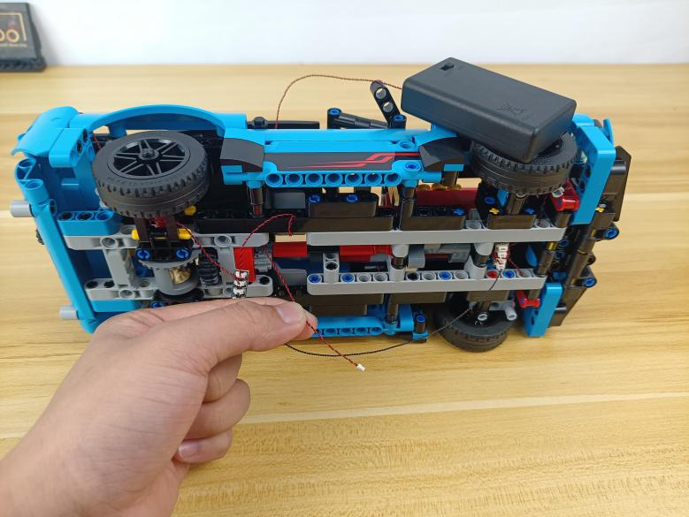

Connect the cable from the battery pack to the 6-port expansion board.
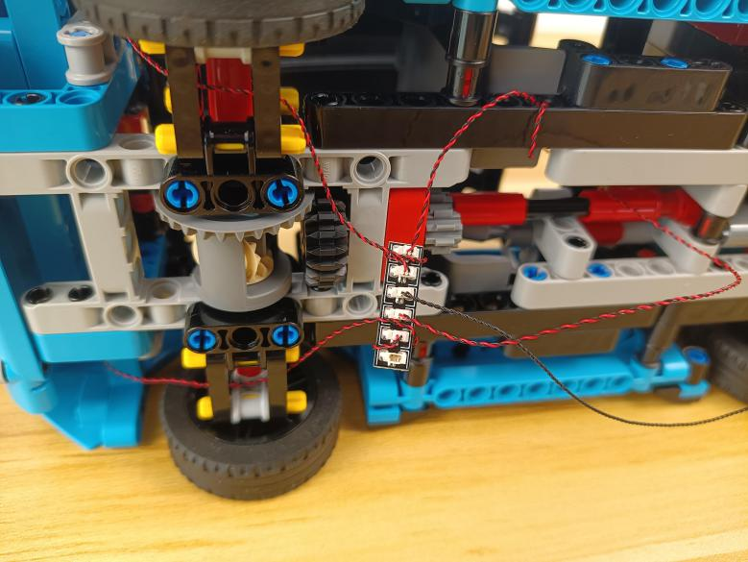

Take 2 adhesive squares.
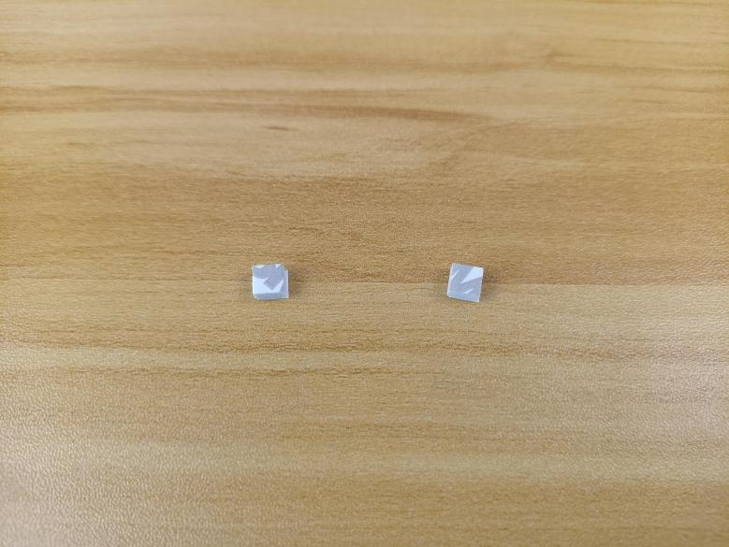

Stick them to the back of the expansion board, and stick the expansion board to the following place.
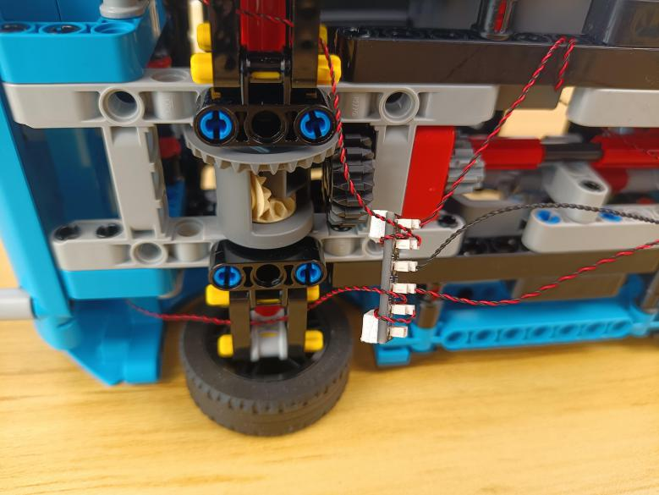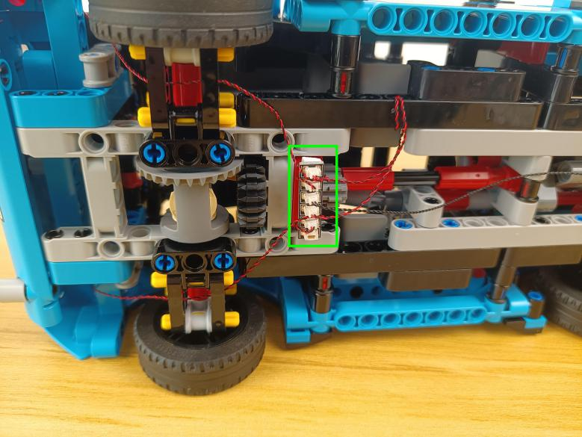

Tighten excess cables up as per below.
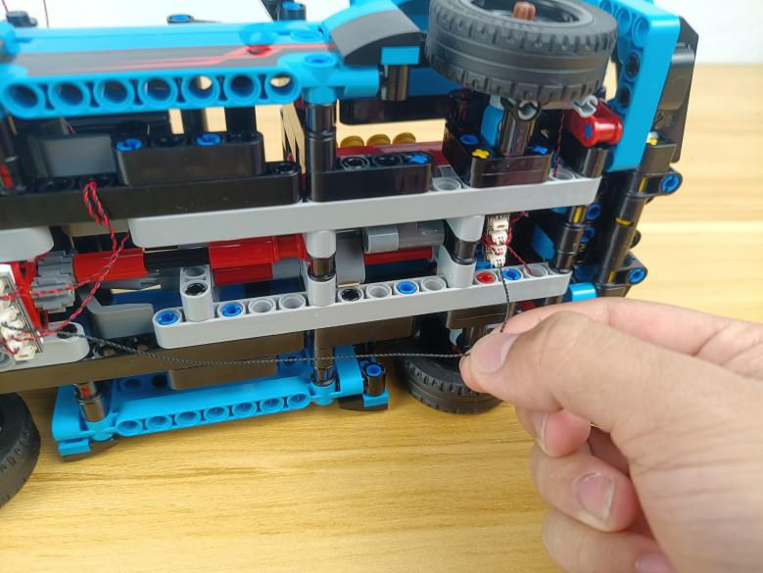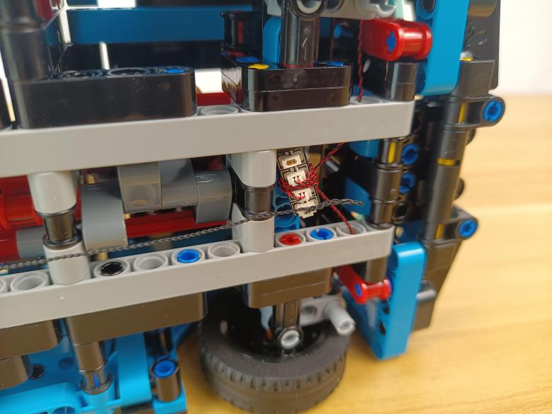

Turn the car to the side.
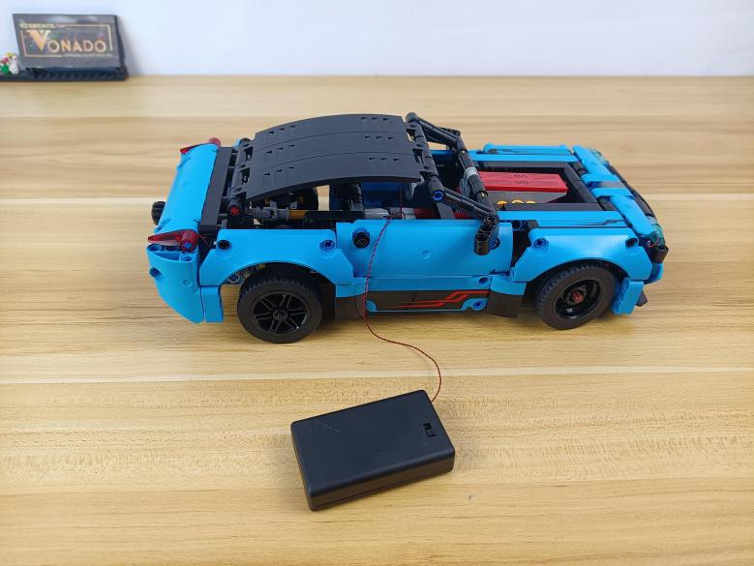

Tuck the battery pack inside the driver’s room.
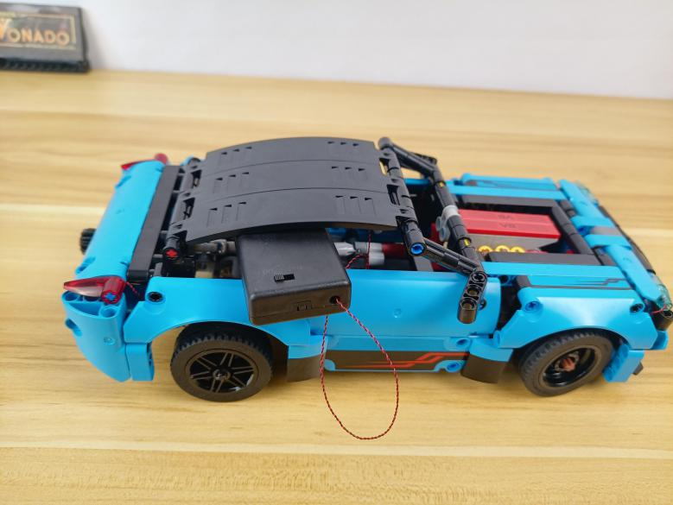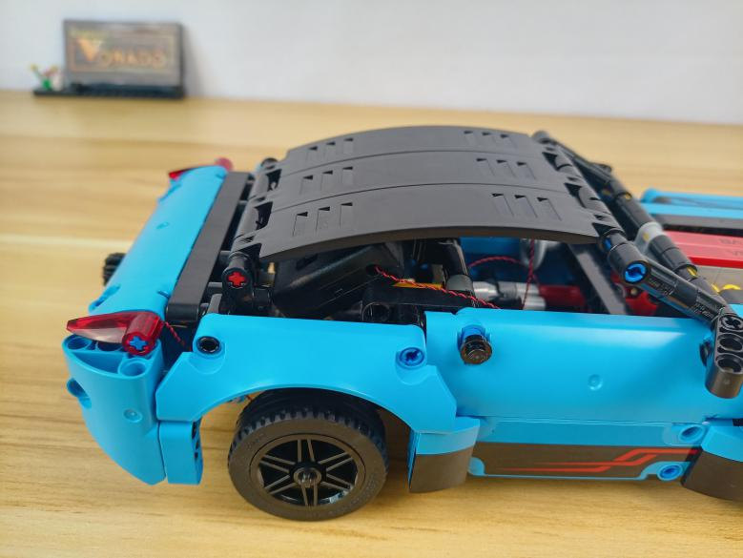

Continue to install lights for the B part.
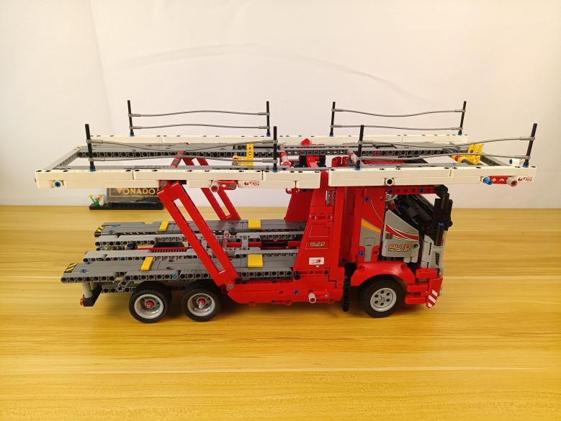

Turn to the head.
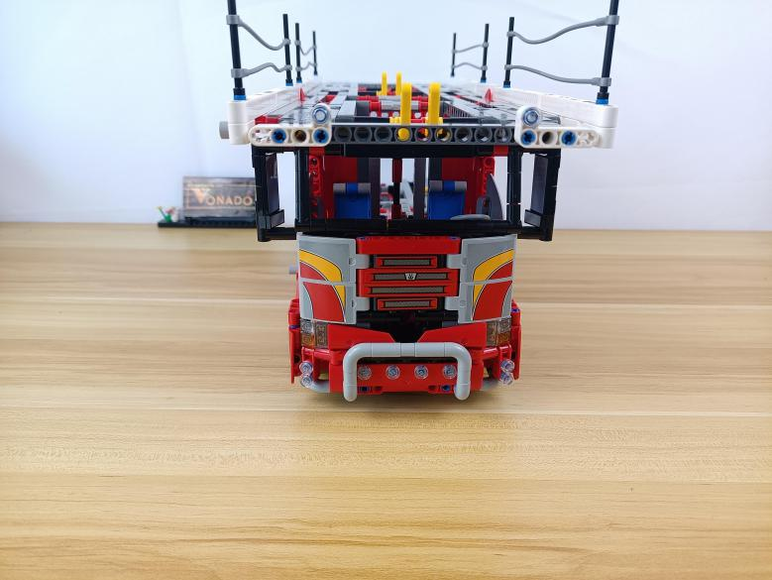

Remove the following piece from the left.
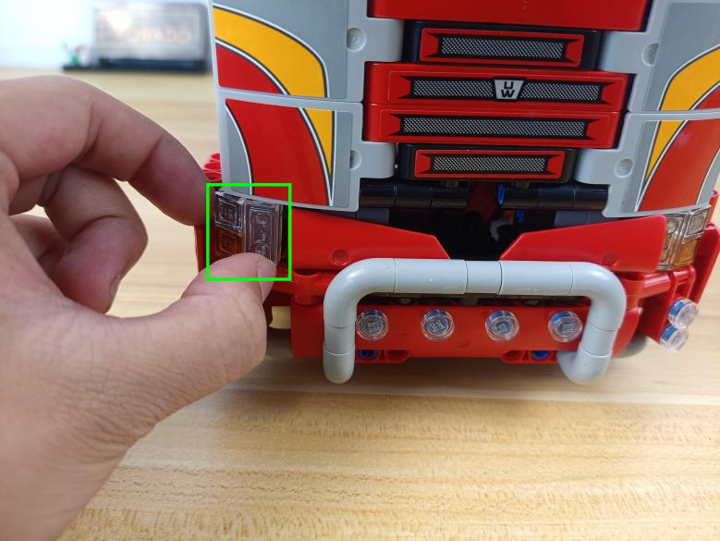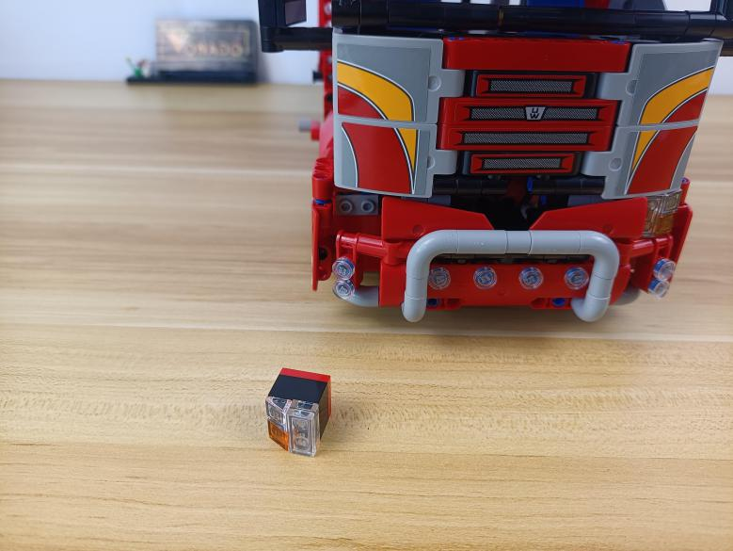

Remove the following piece from the right.
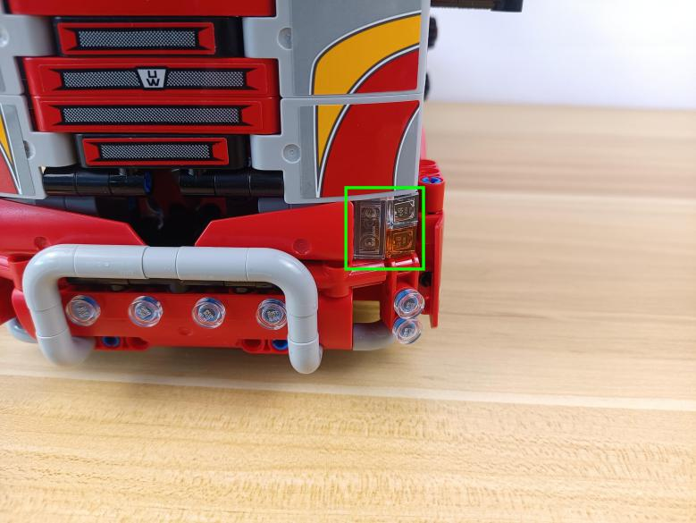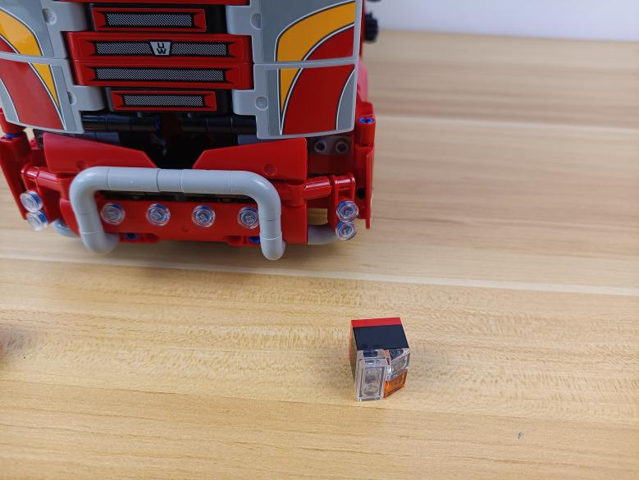

Remove the following white plates.
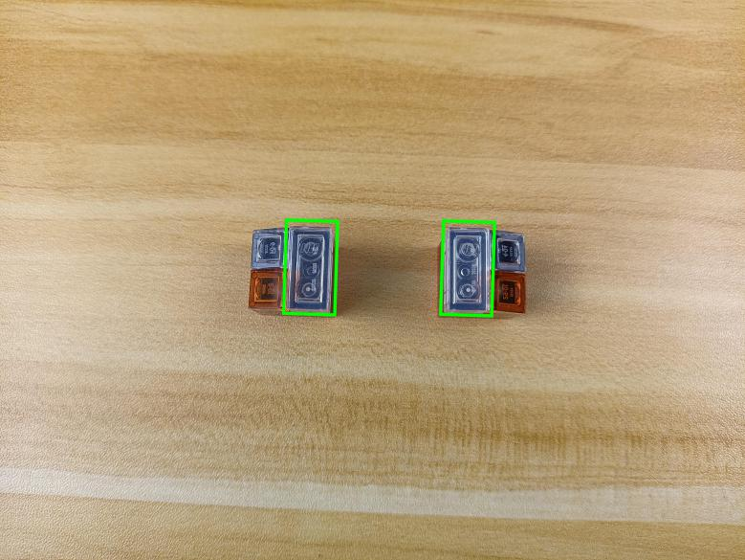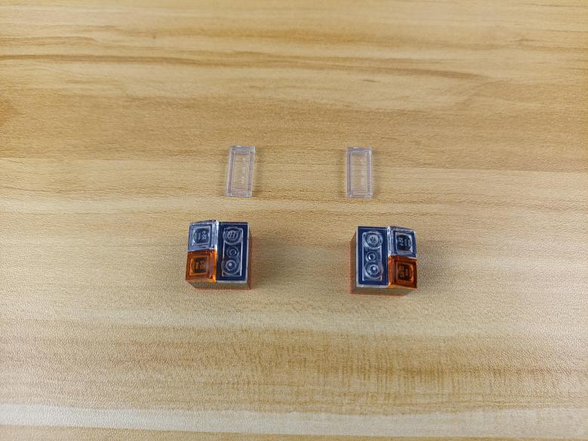

Take 2 white 15cm dot lights.
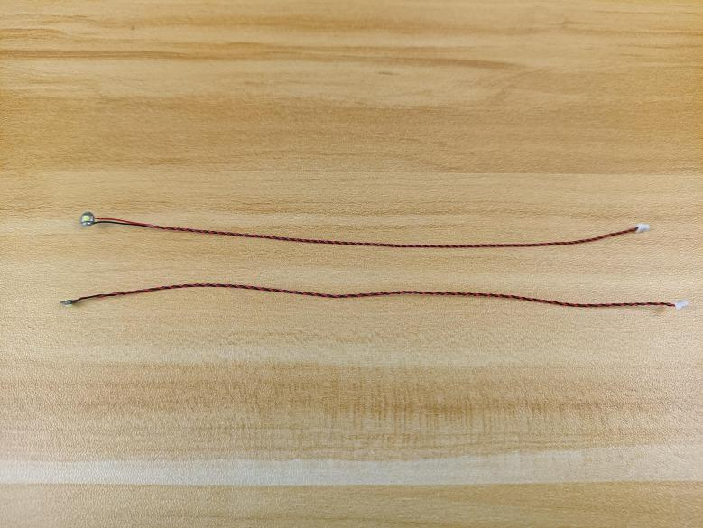

With lighting part facing up, reconnect the white plate.
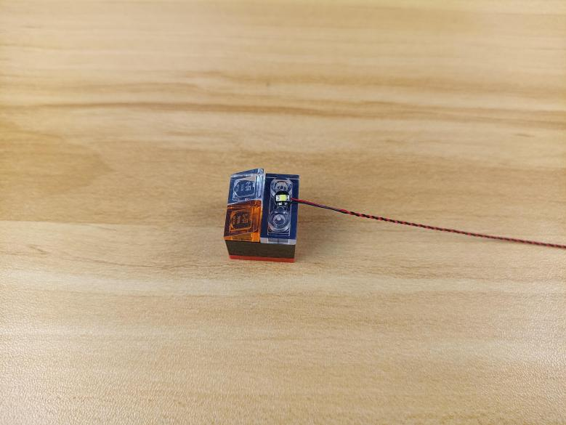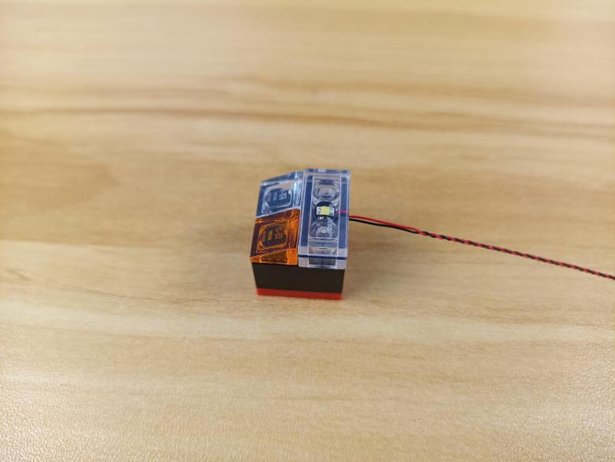

Install the other light in the same way.
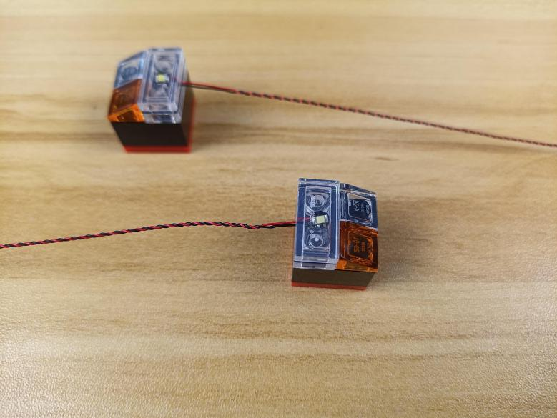

Thread the cable through the folloiwng space to the bottom, reconnect the piece.
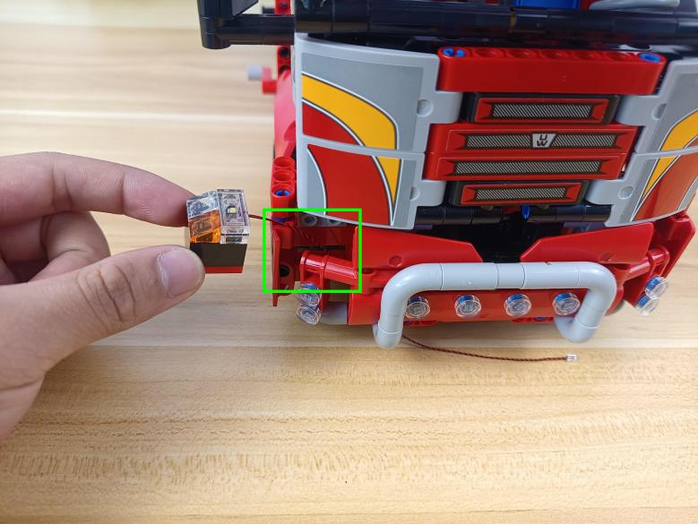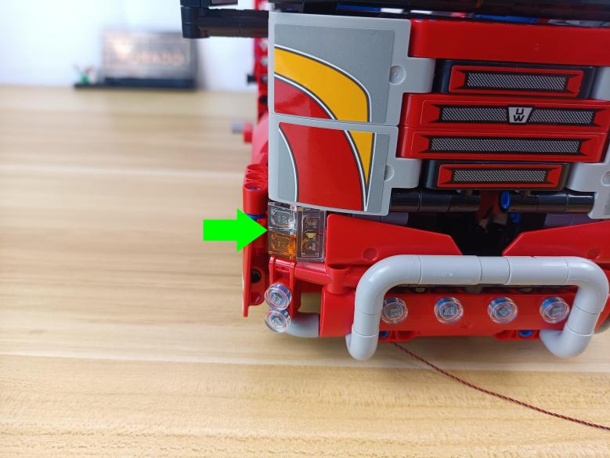

Install the other light in the same way, reconnect the piece.
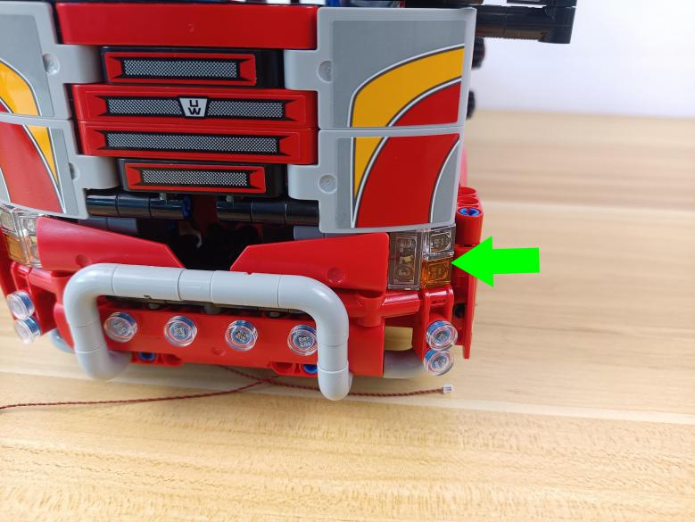

Remove the following 2 white round plates.
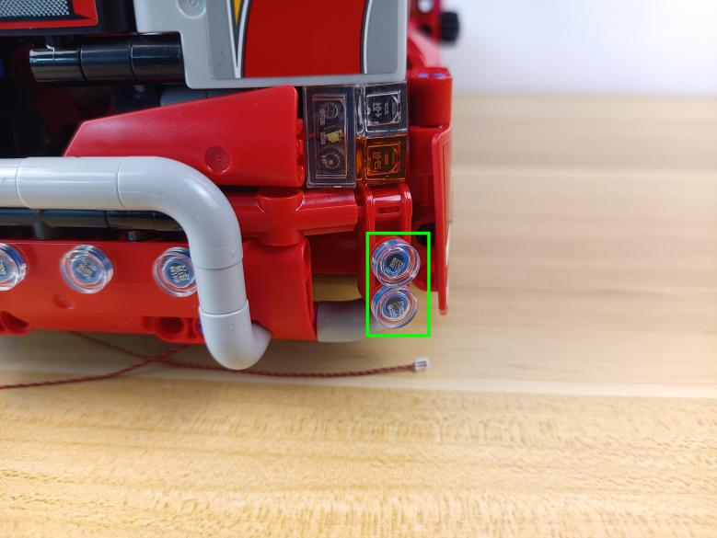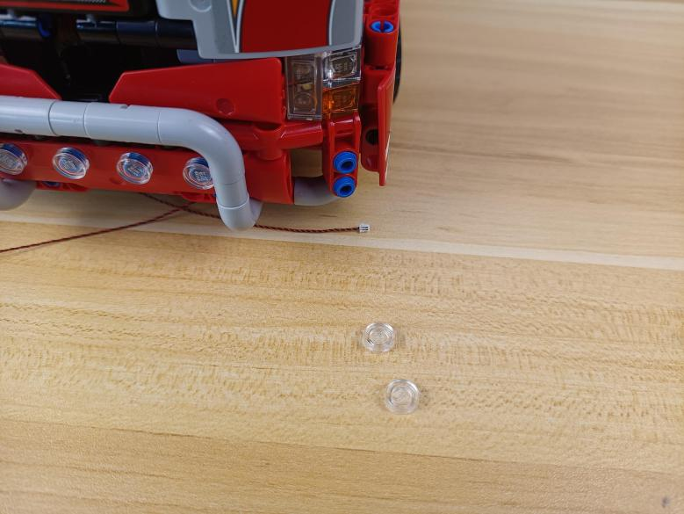

Turn to the left, continue to remove the following 2 white round plates.
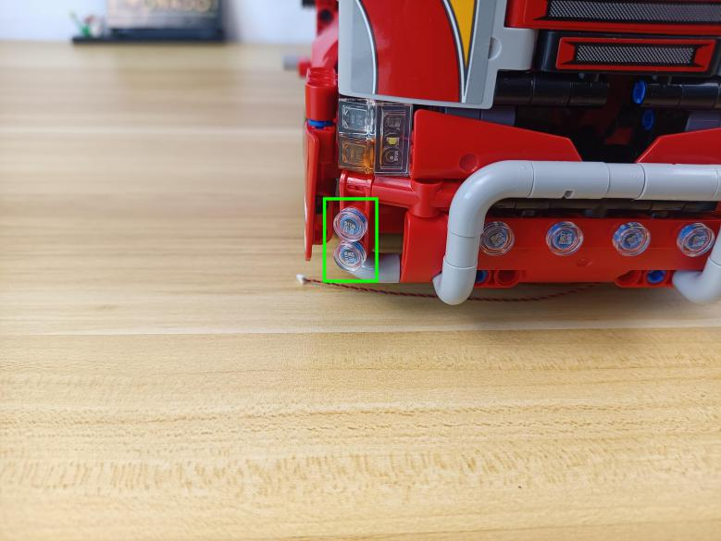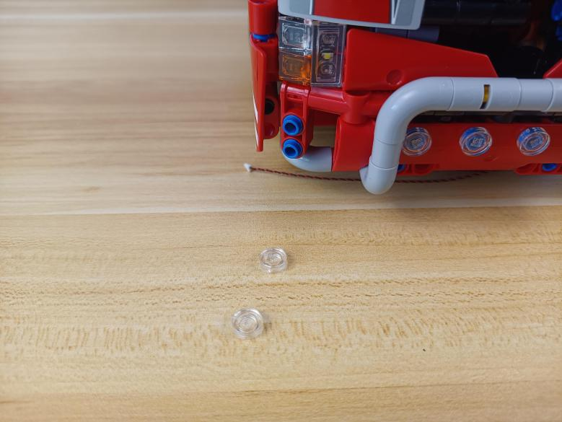

Take 4 white 15cm dot lights,4 trans white 1x1 round plates.
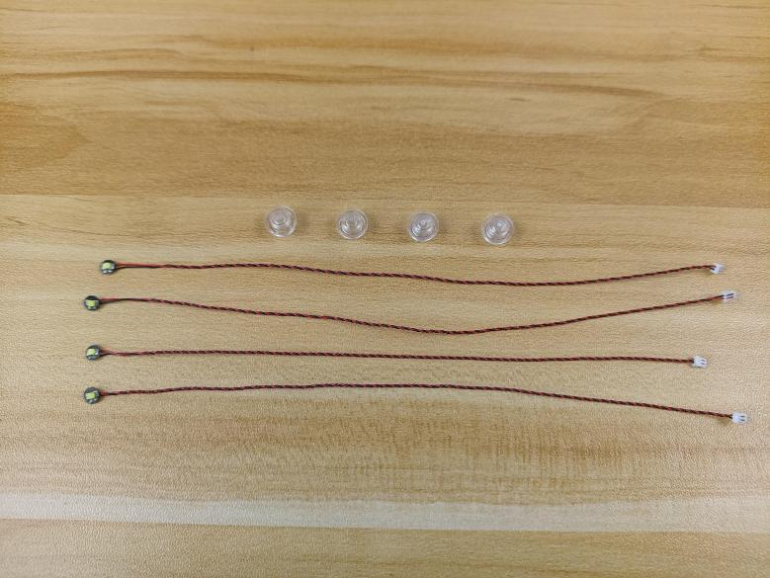

With lighting part facing up,thread the cable through the following space to the bottom.
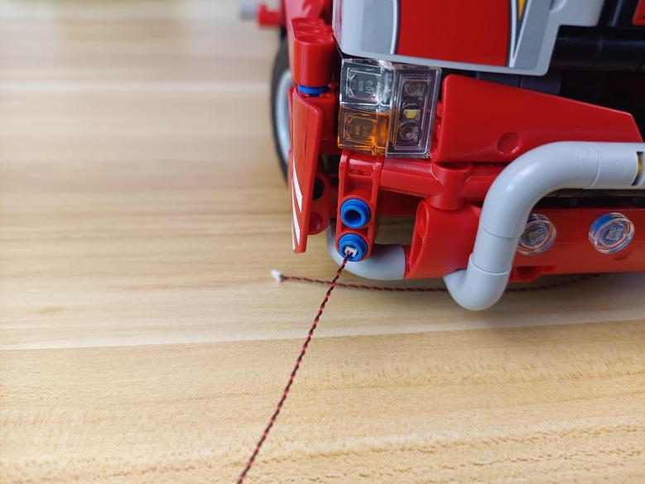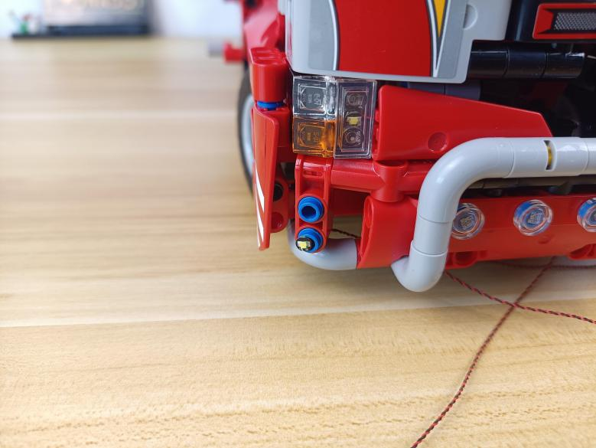

Connect the white round plate over.
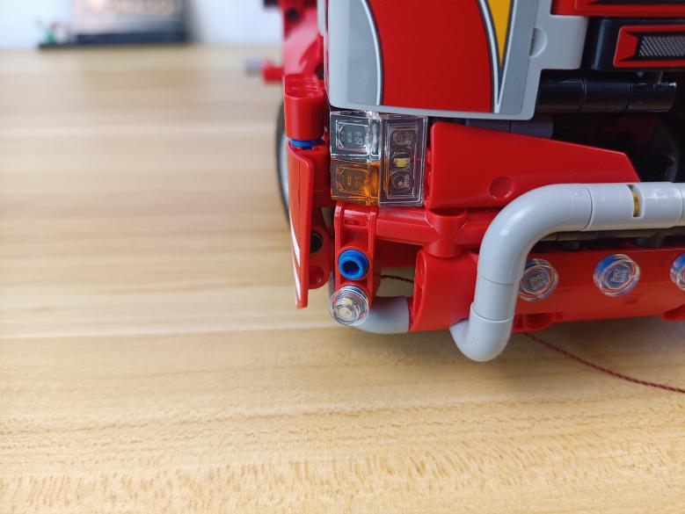

Install the other light in the same way.
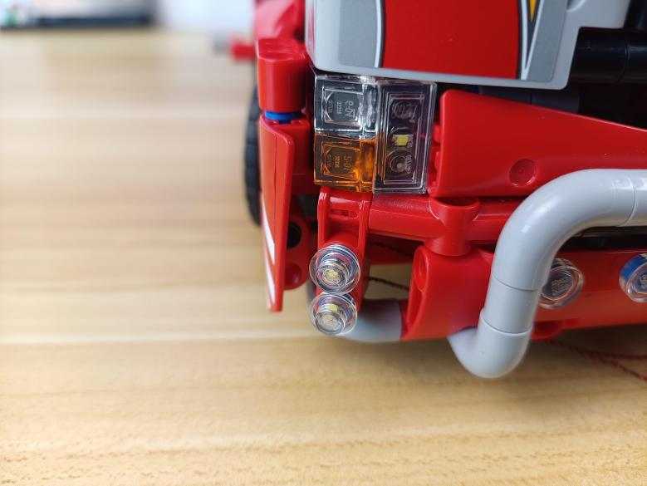

Turn to the right, install the other 2 lights in the same way.
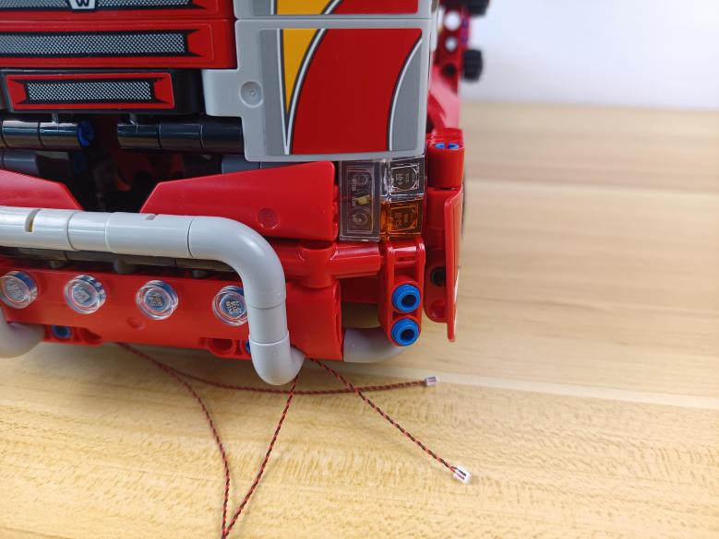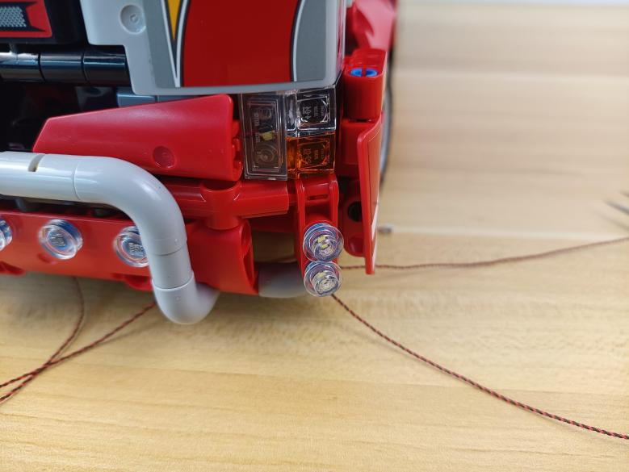

Turn the B part to the other side.
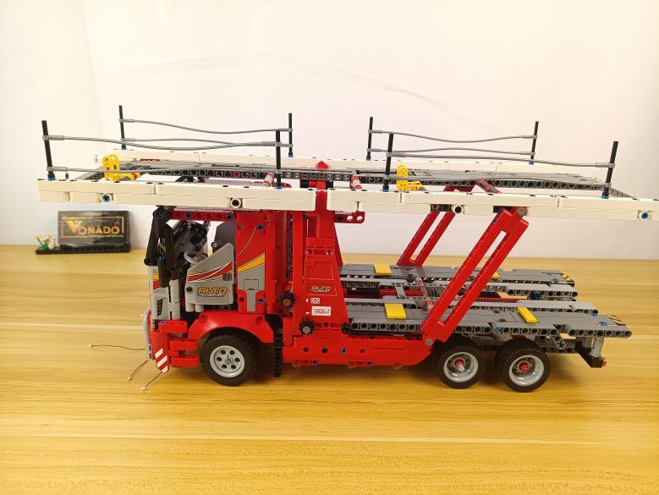

Take a 50cm connecting cable, a 30cm connecting cable, a warm white strip light.
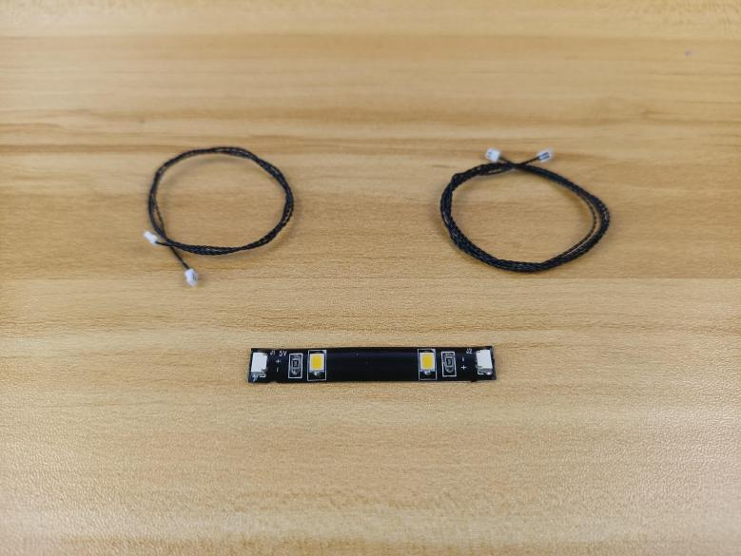

Assemble them as per below.
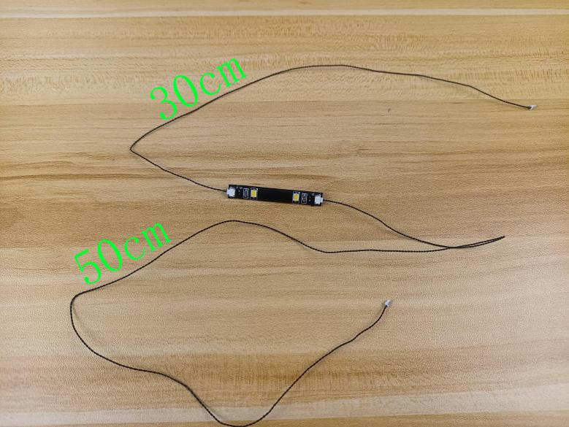

Pull the 50cm connecting cable out from the roof as per below.
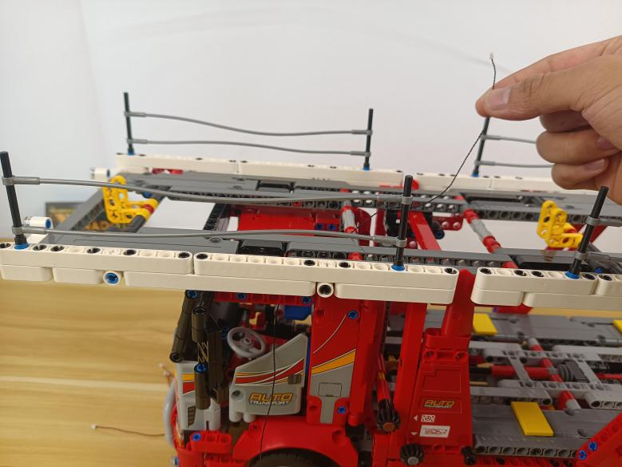

Stick the strip light inside the driver’s room.
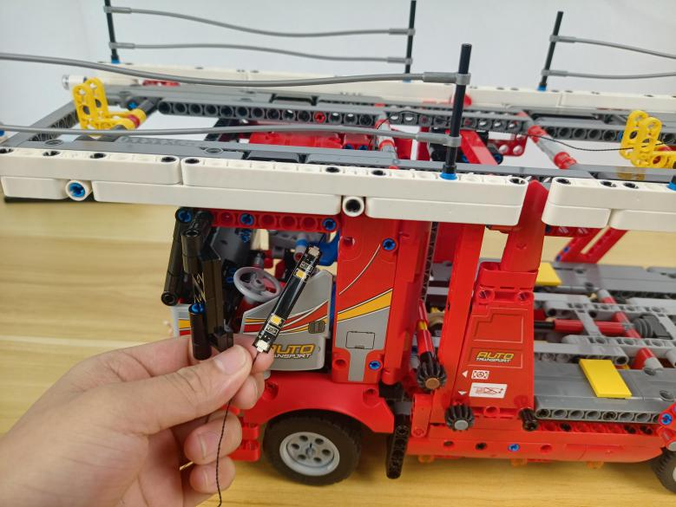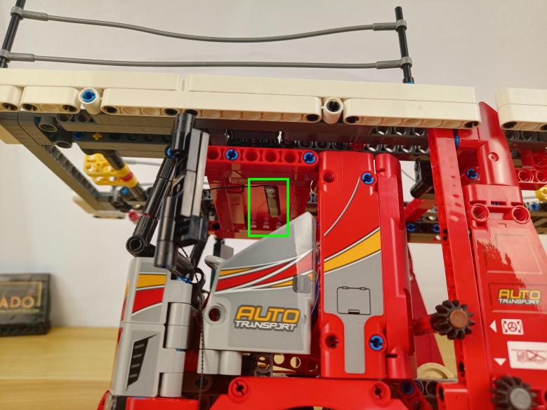

Open the door.
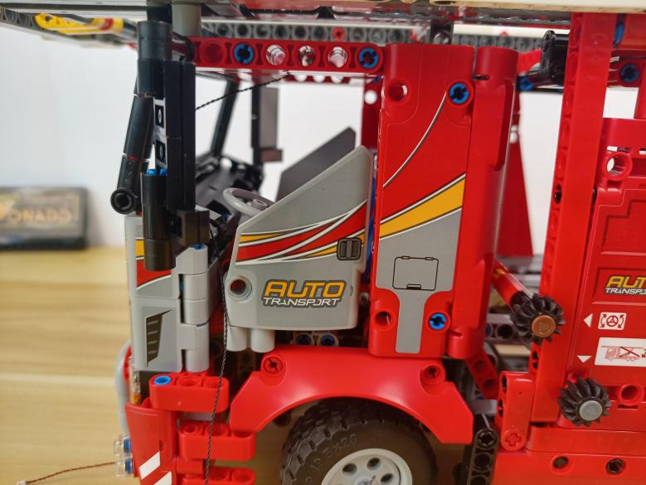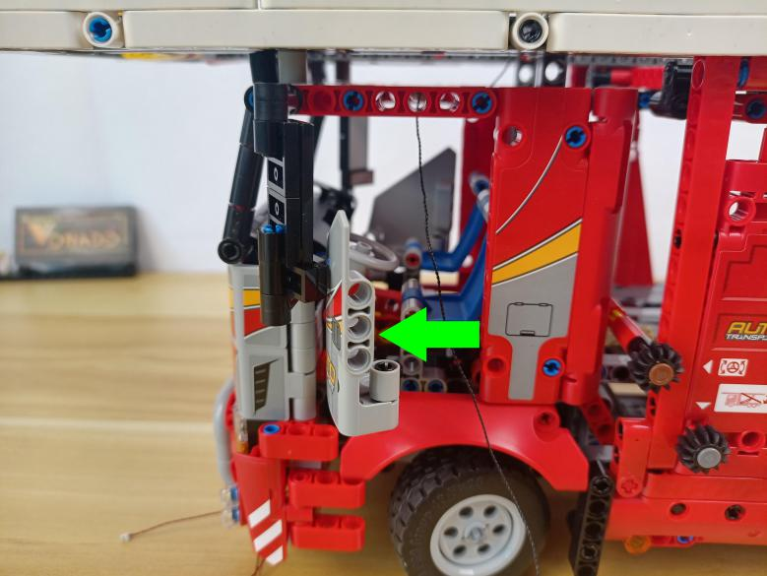

Take a 30cm connecting cable, thread it through the following hole.
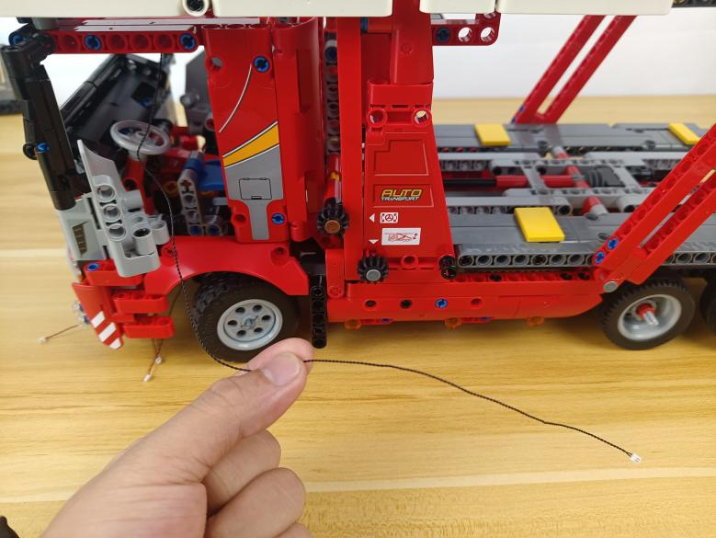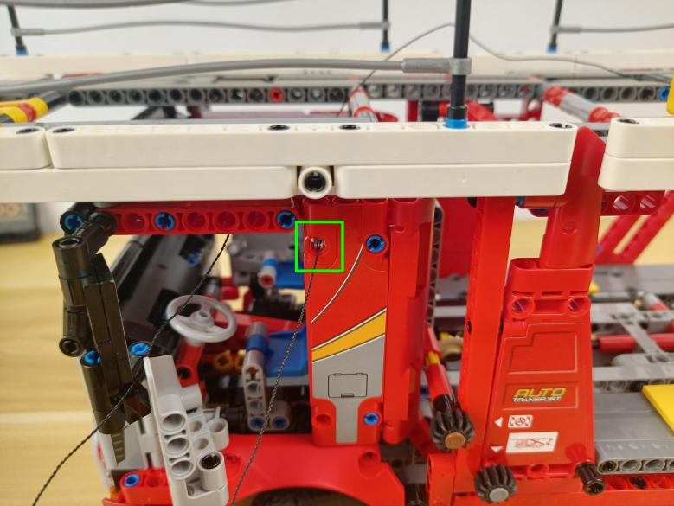

Pull it out.
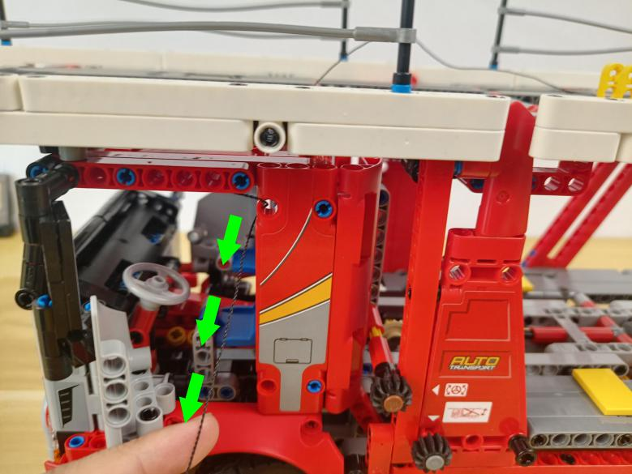

Continue to thread it through the following hole, and pull it out.
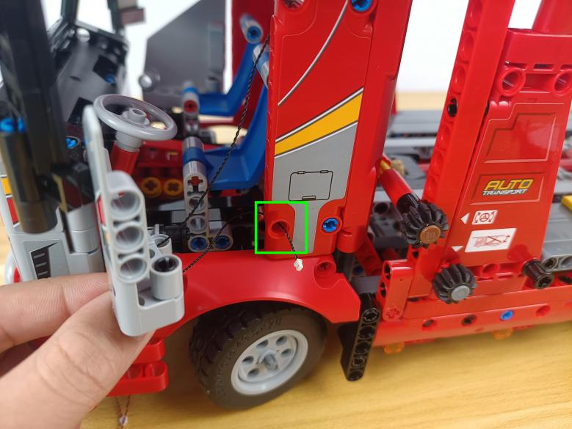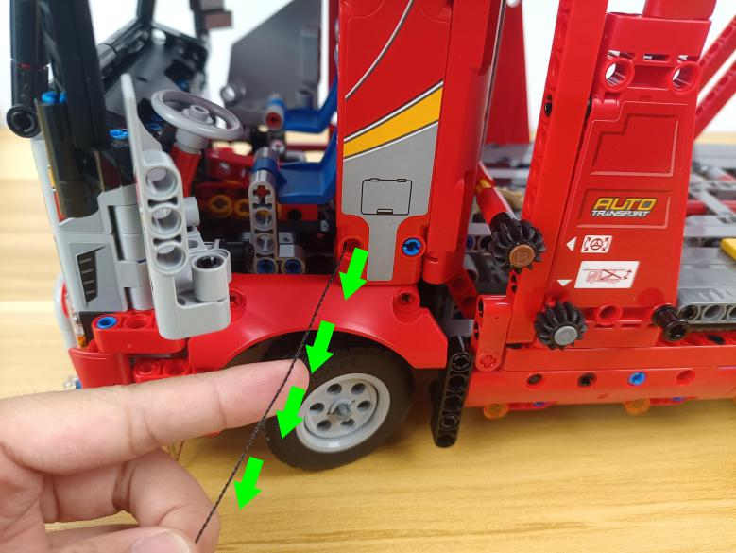

Thread the cable through the follwoing space to the bottom.
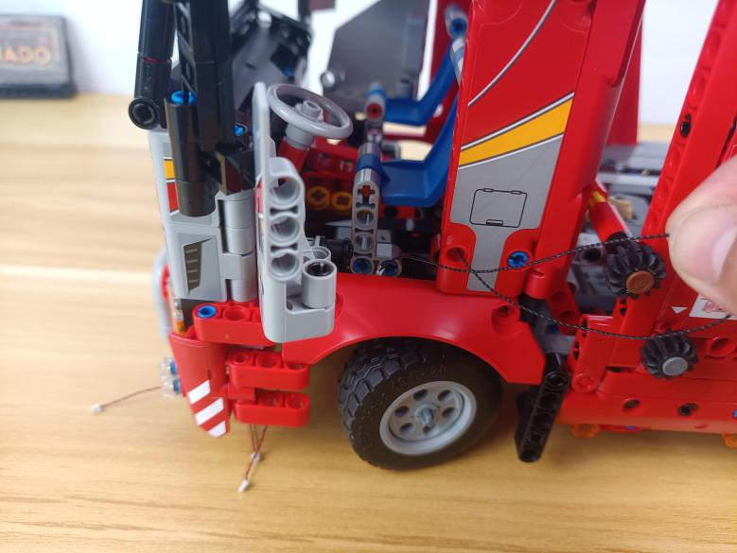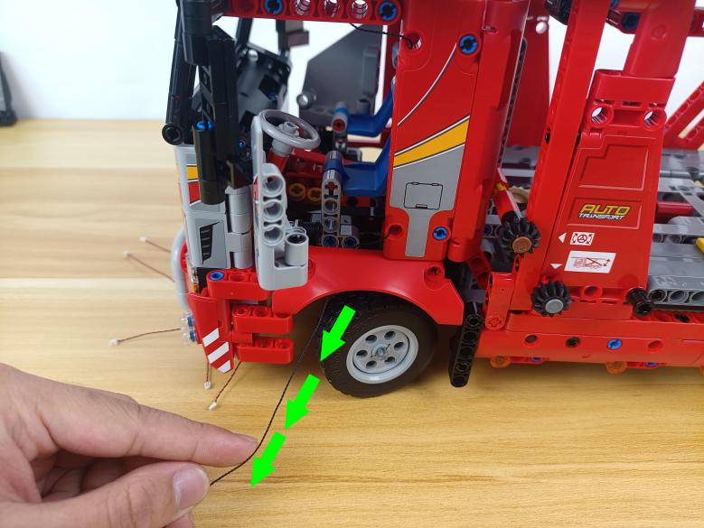

Close the door.
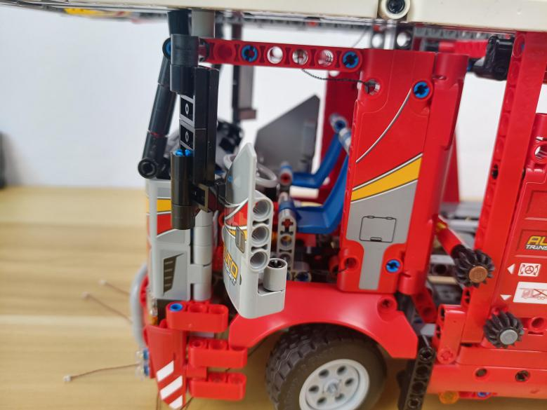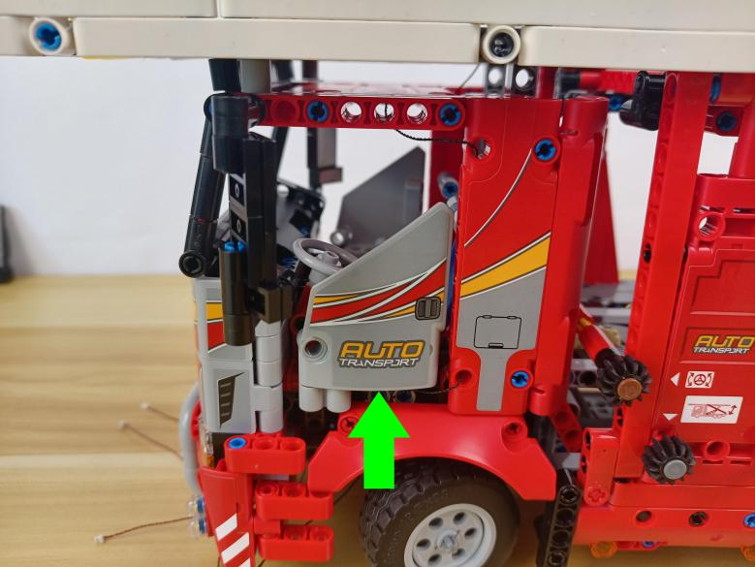

Turn the B part over.
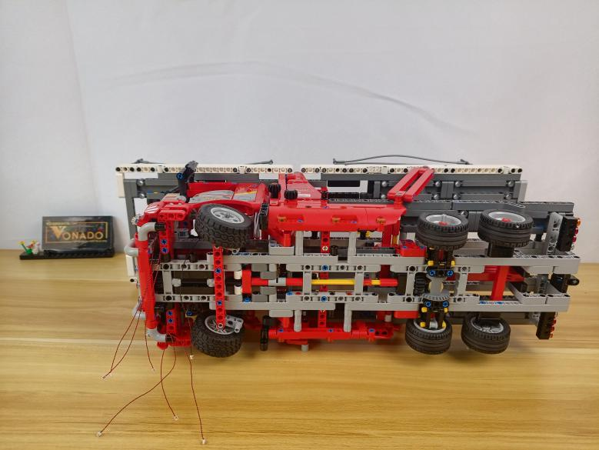

Take a 15cm connecting cable, an 8-port expansion board, assemble the as per below.
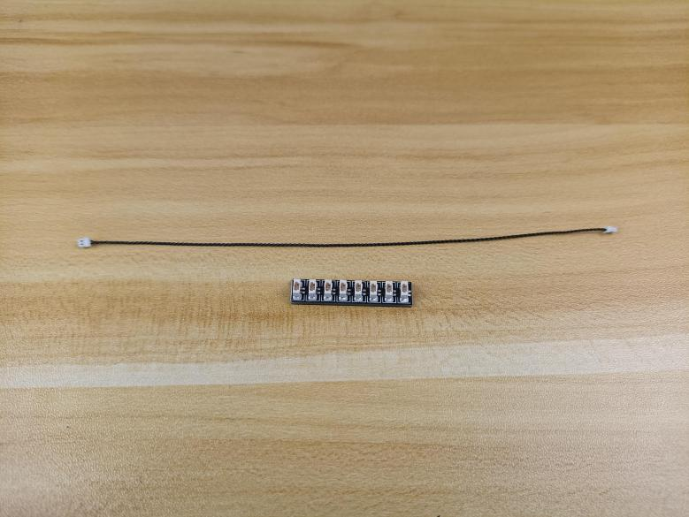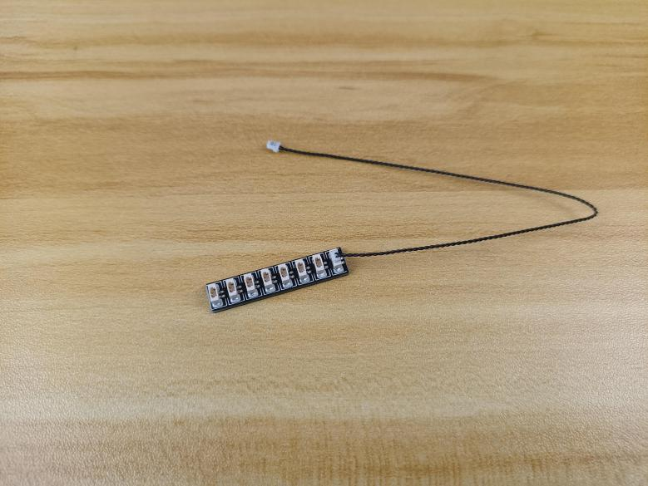

Group the follwoing 3 cables at the head together.
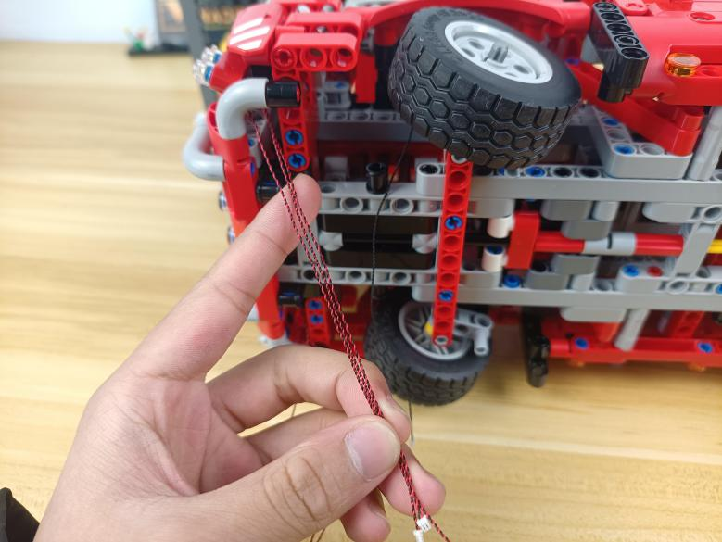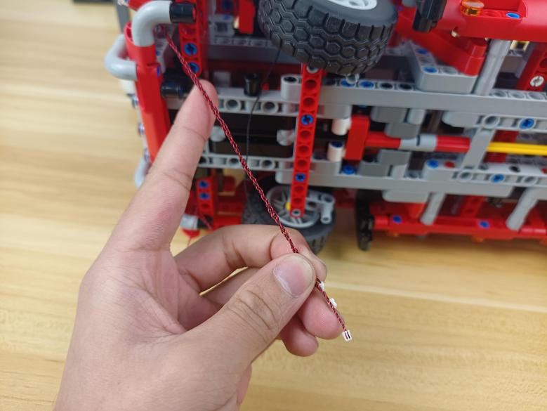

Thread them through the following hole, and wind them around the following piece.
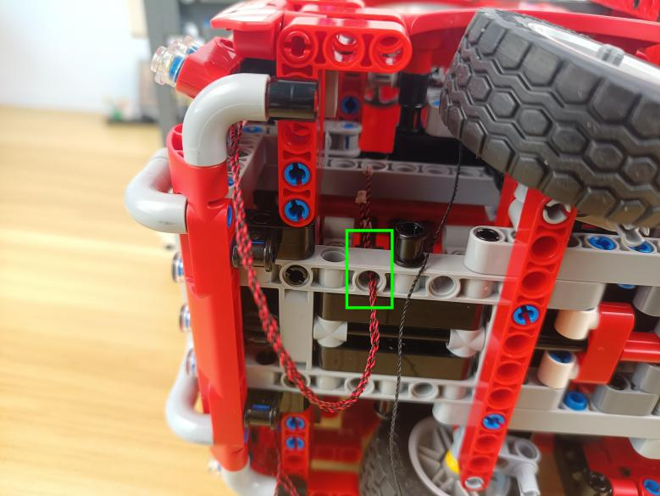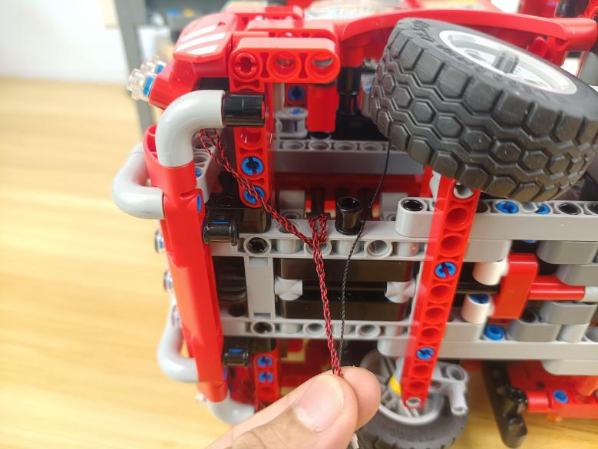

Group the follwoing 3 cables together, thread them through the following hole, and wind them around the following piece
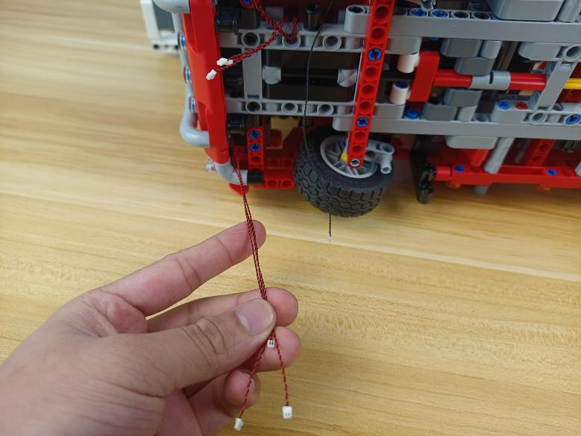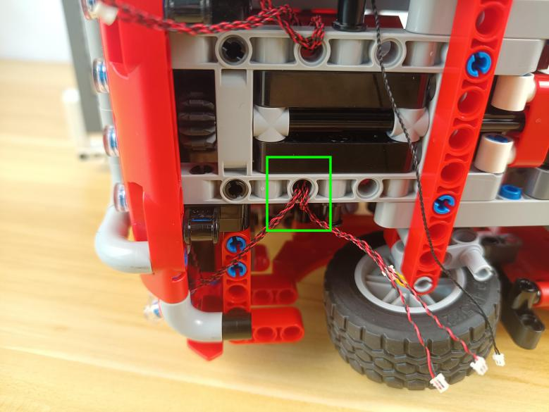

Thread the 30cm connecting cable through the following hole, and wind it around piece twice.
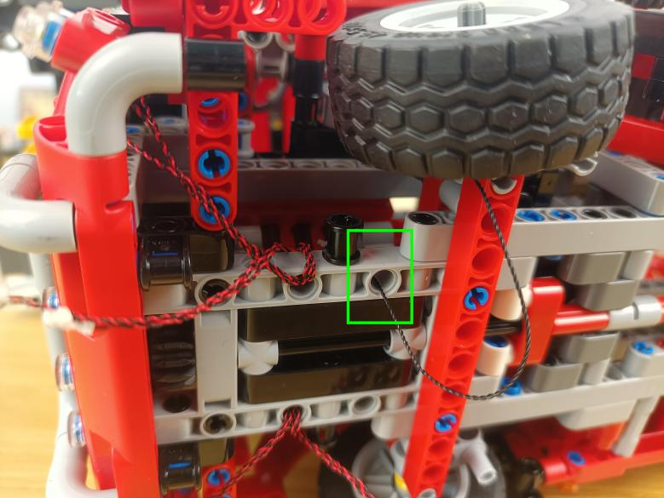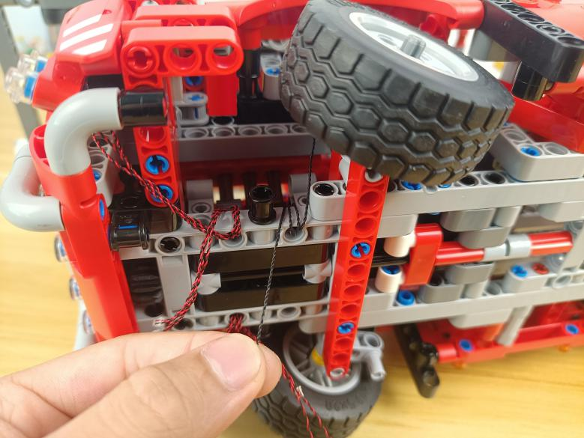

Connect all the cables from the head to the expansion board.
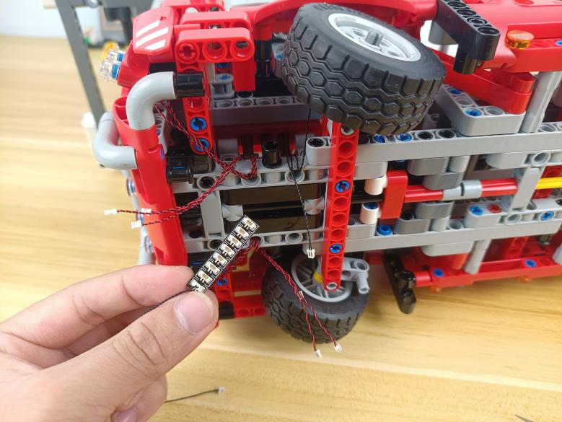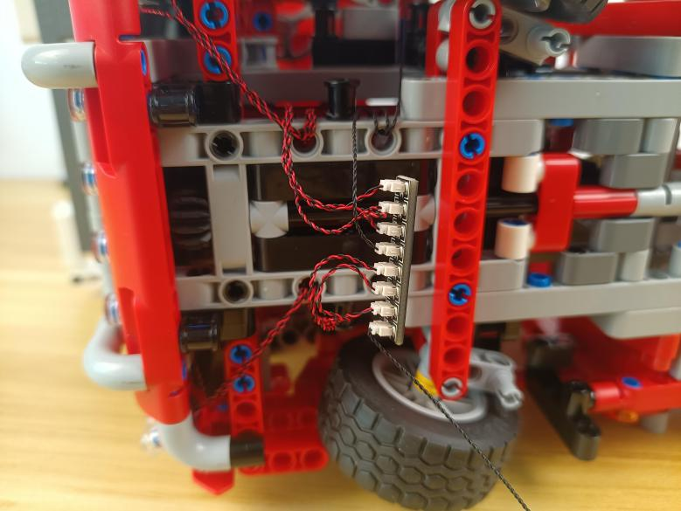

Take 2 adhesive squares.
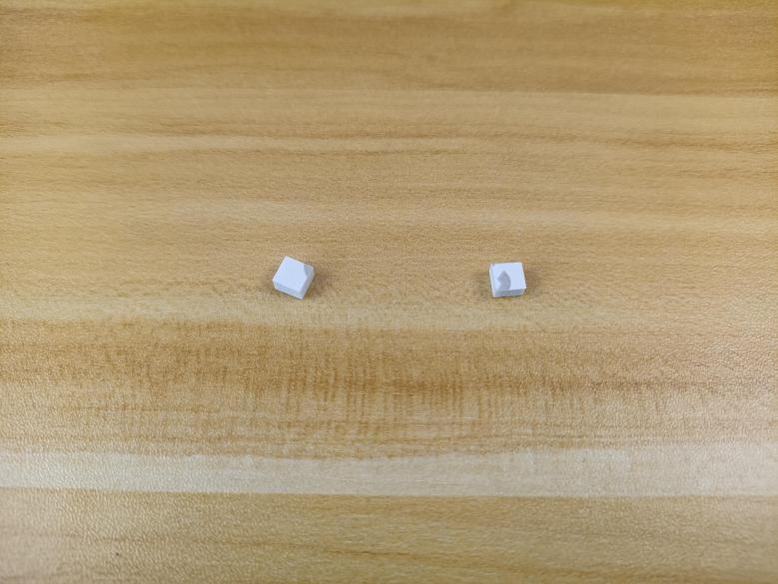

Stick them to the back of the expansion board, and stick the expansion board to the following place.
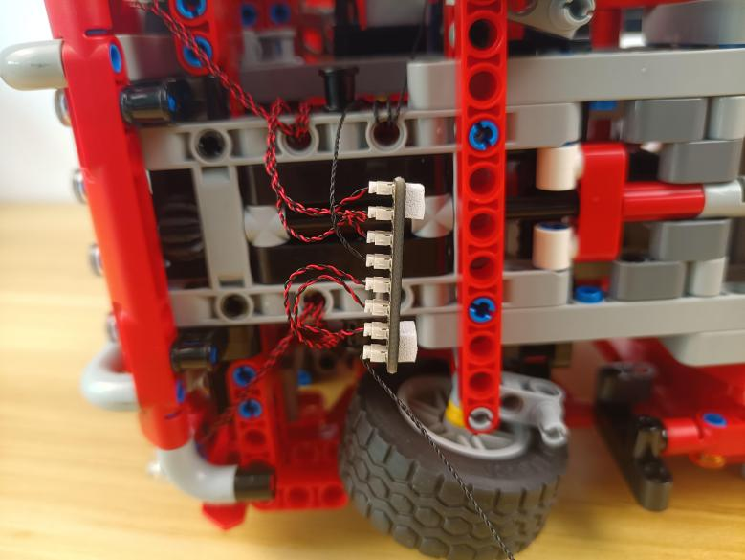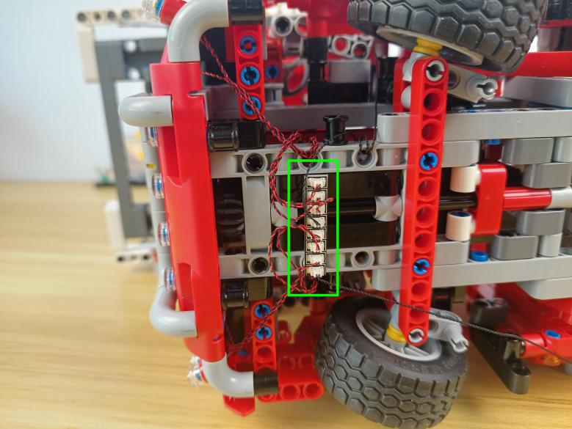

Turn to the center, remove the following 3 orange round plates.
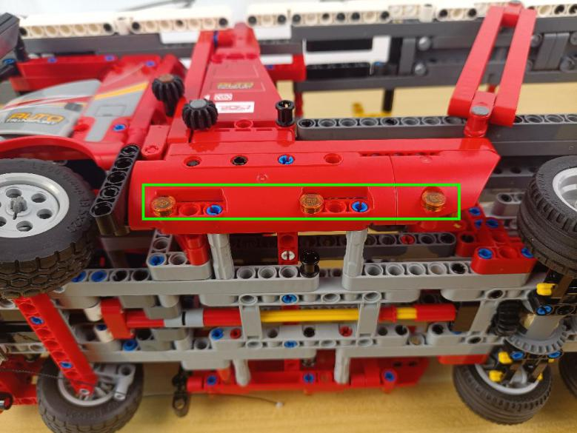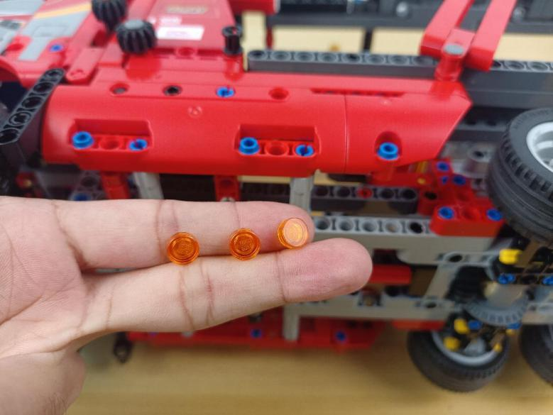

Take 3 warm white 15cm dot lights, 3 trans orange 1x1 rouns plates.
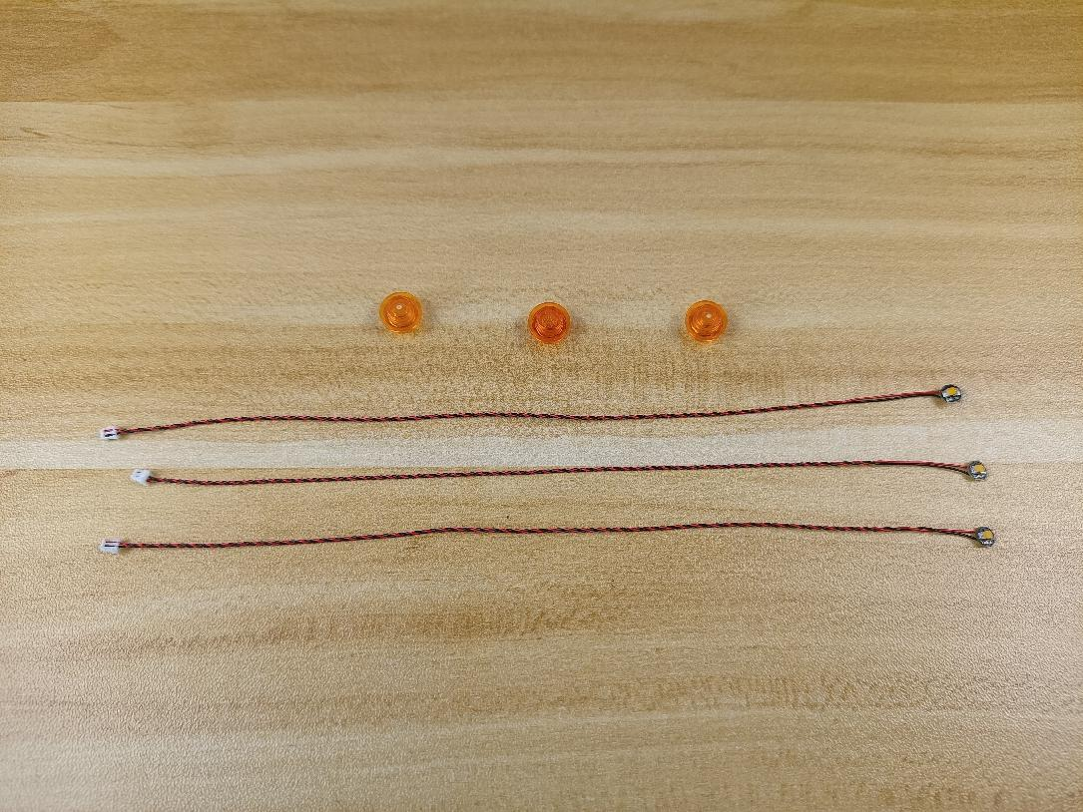

With lighting part facing up, thread the cable through following space.
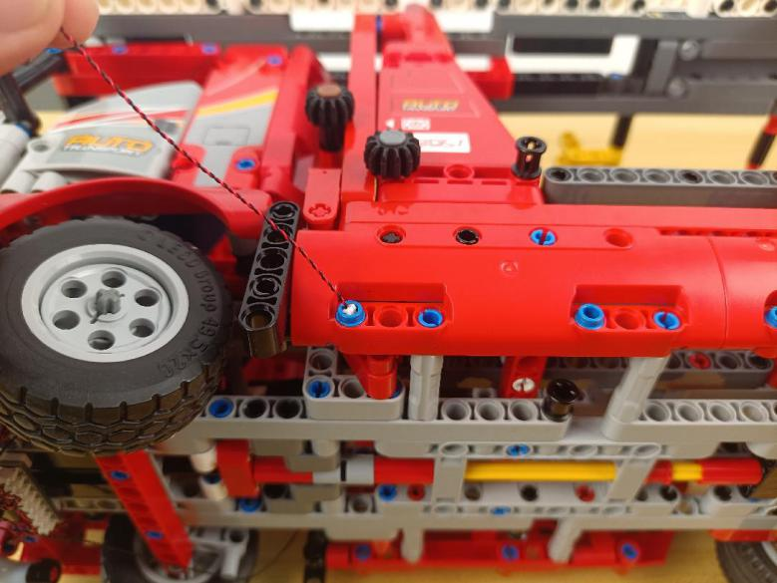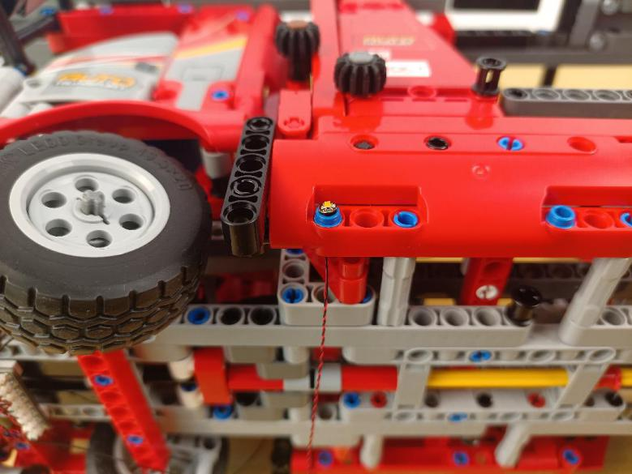

Connect the orange round plate over.
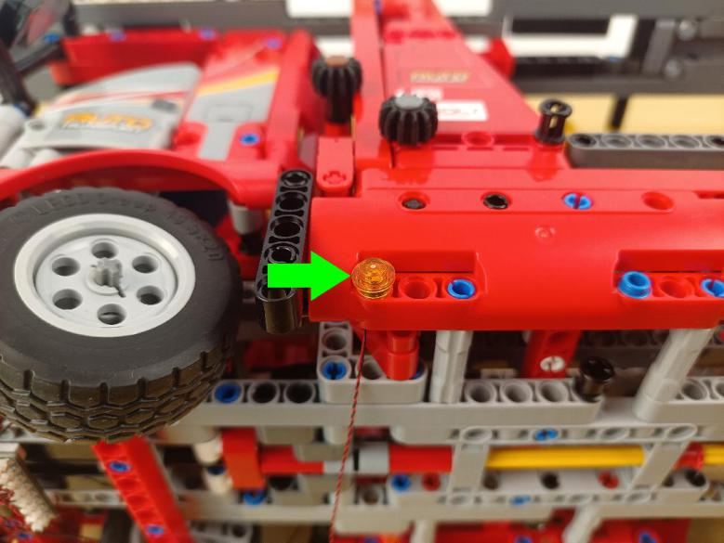

Install the other 2 lights in the same way.
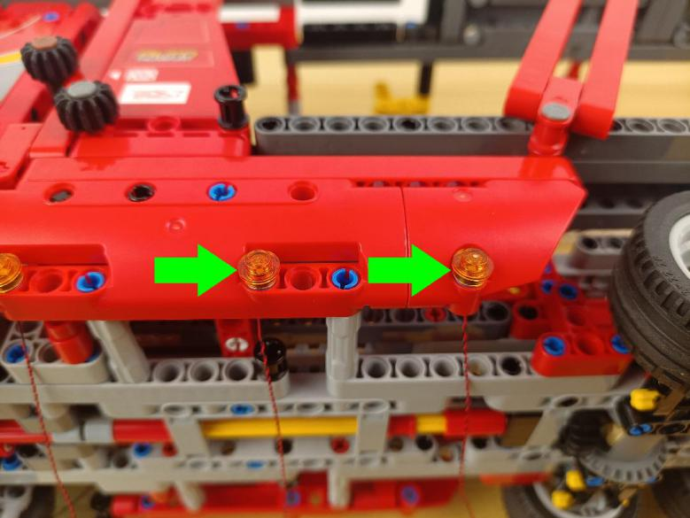

Turn to the following place.
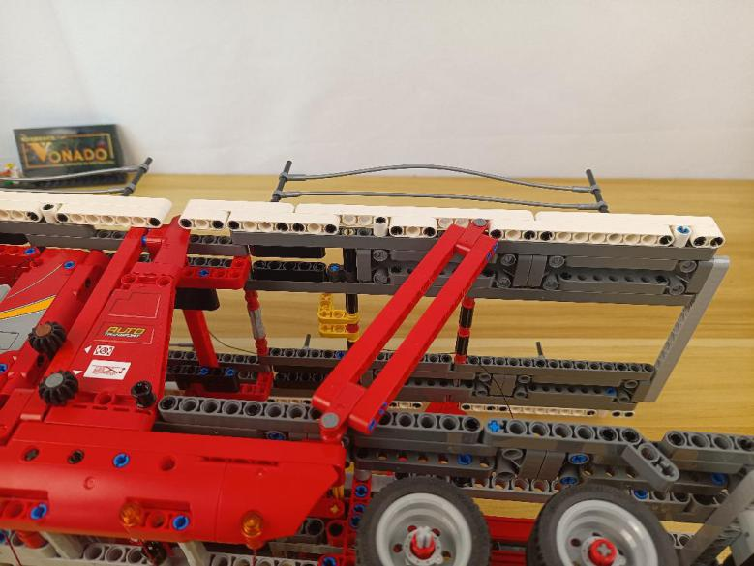

Take 4 warm white 15cm dot lights, 4 light gray half pins, 4 trans yellow 1x1 round plates.
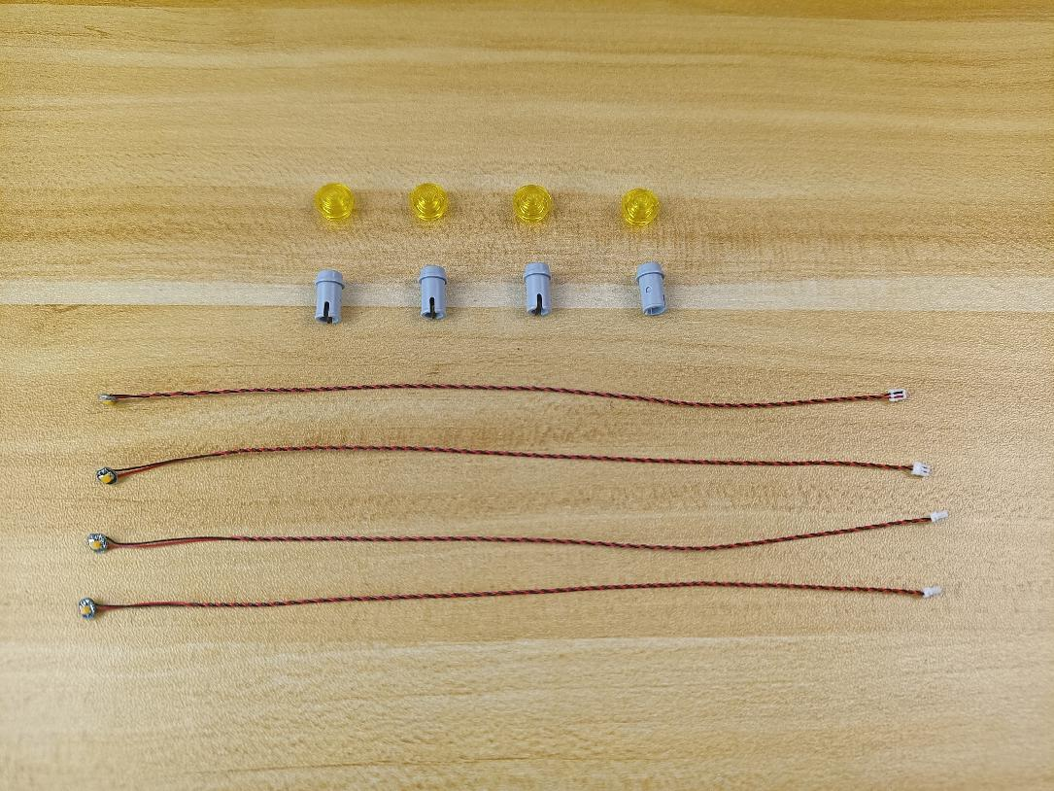

With lighting part facing up, thread the light through the half pin.
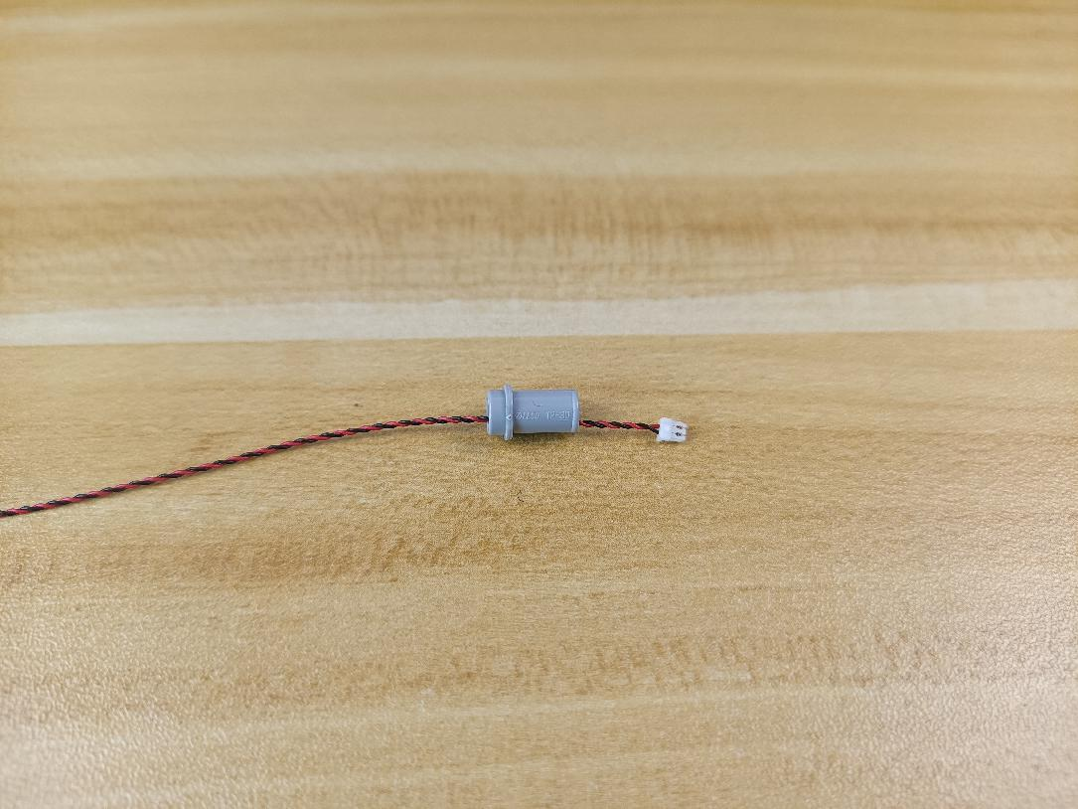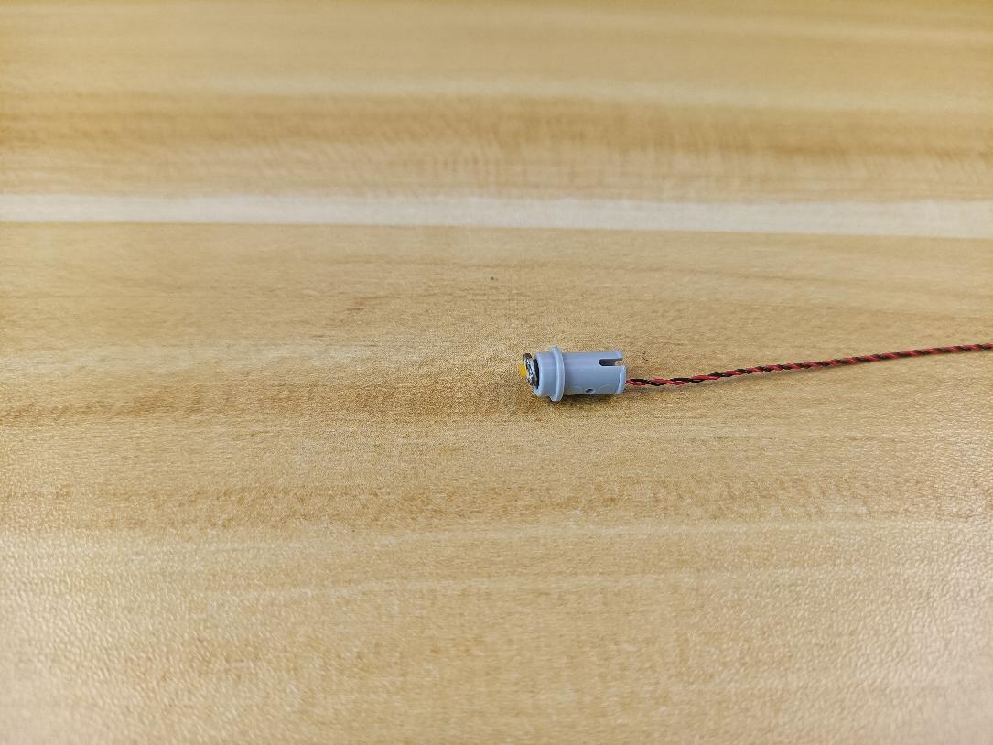

Connect the yellow round plate over.
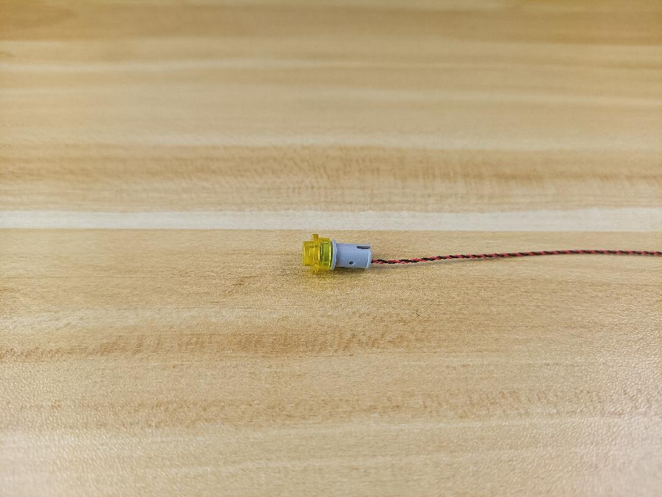

Install the other 3 lights in the same way.
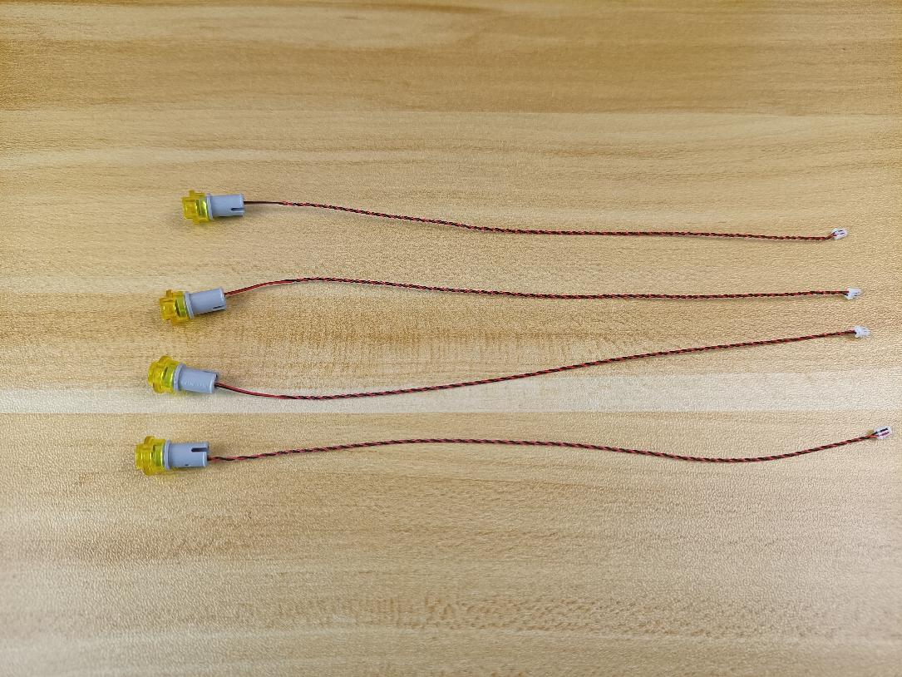

Thread the cable through the following hole, reconnect the light.
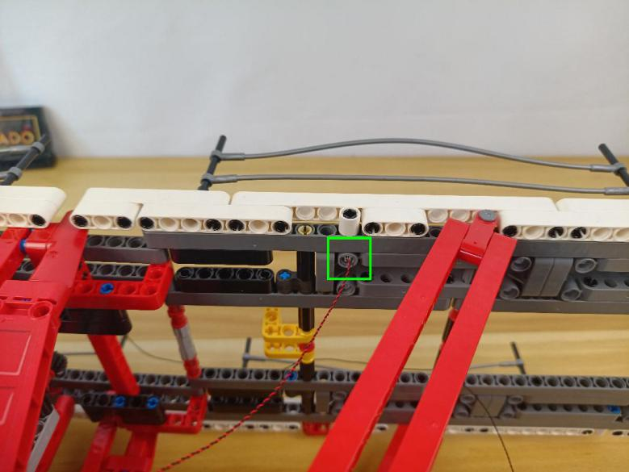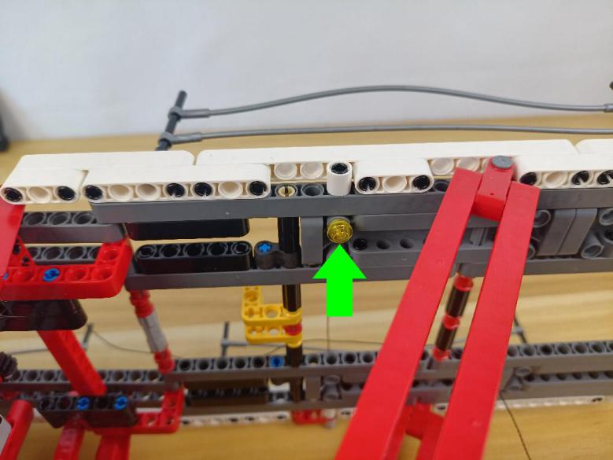

Install the other 3 lights in the same way.
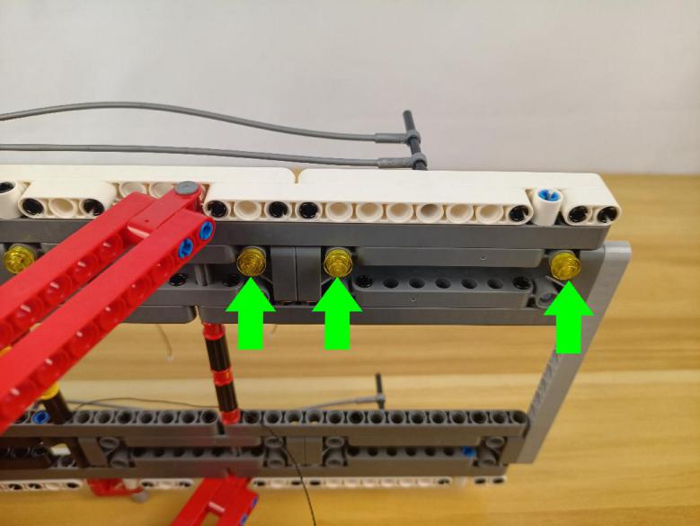

Turn to the following place.
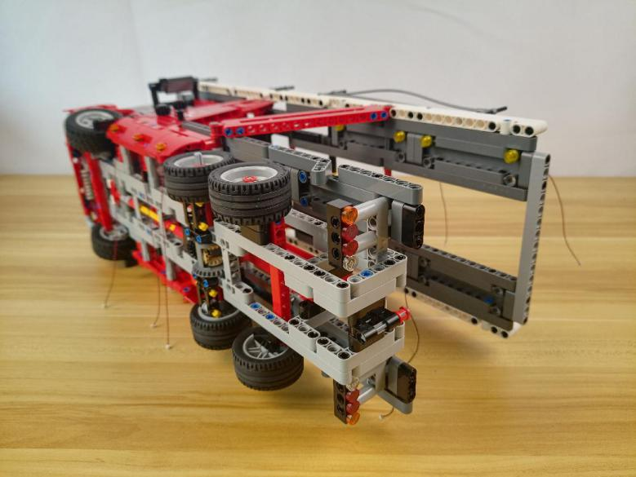

Remove the following piece.
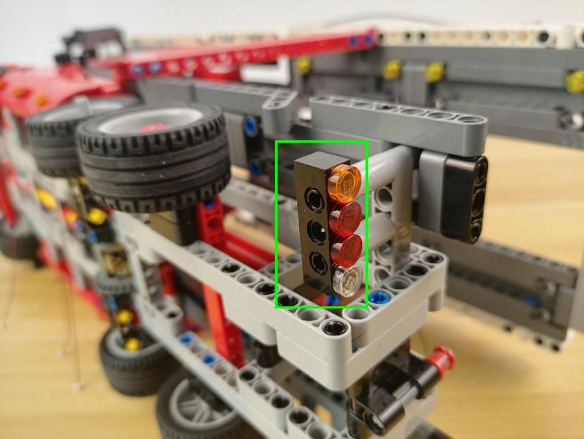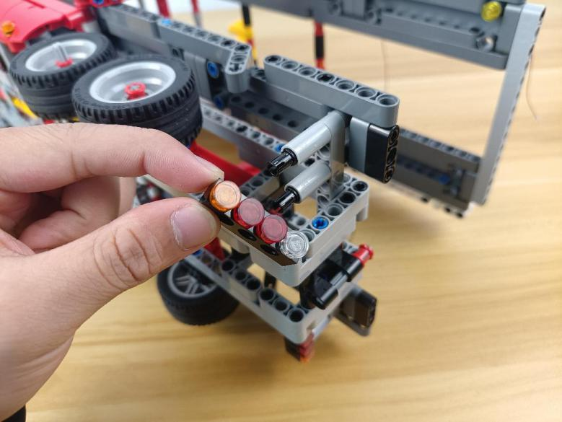

Continue to remove the following piece.
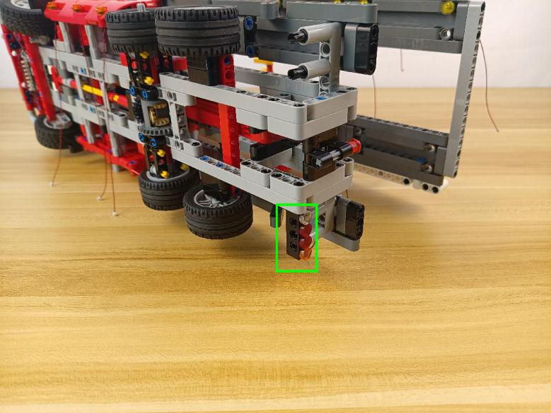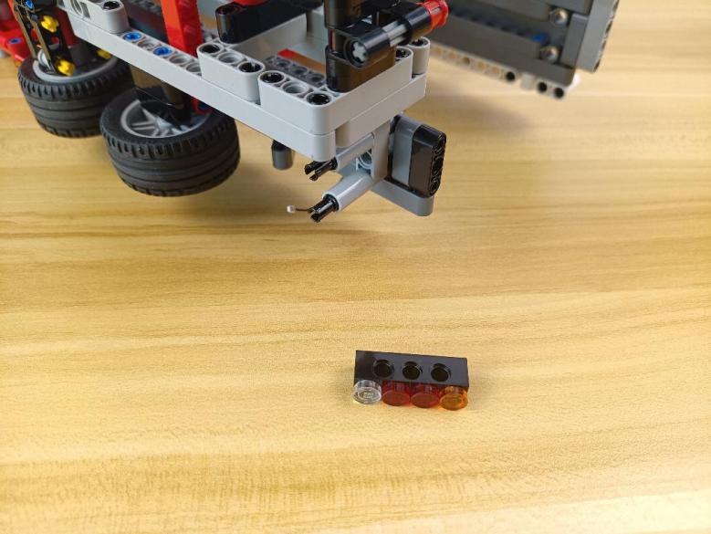

Disconnect all the round plates from the pieces.
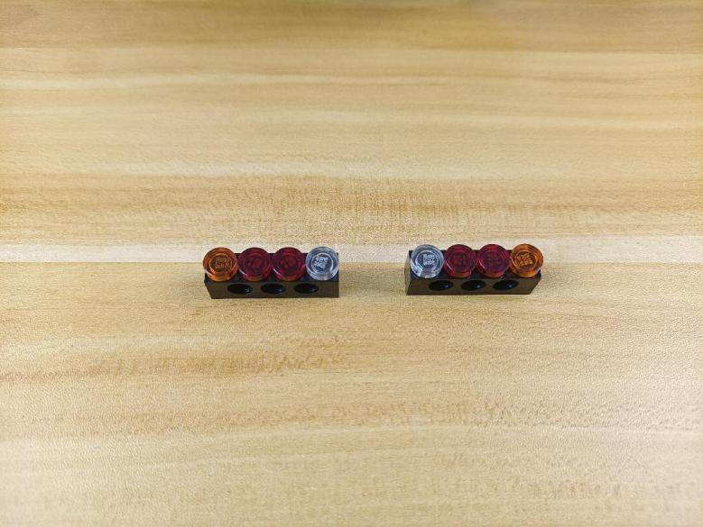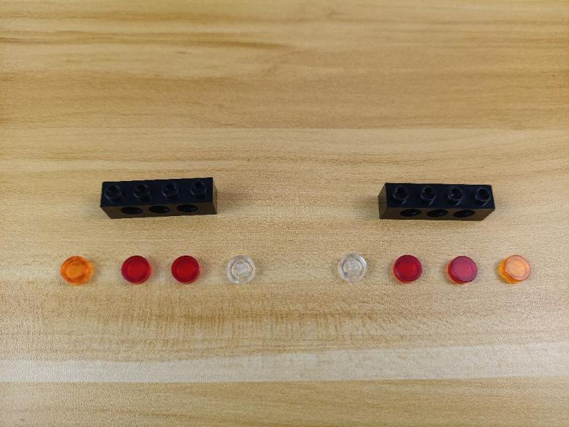

Take 2 warm white 15cm dot lights, 2 trans orange 1x1 round plates with opening.
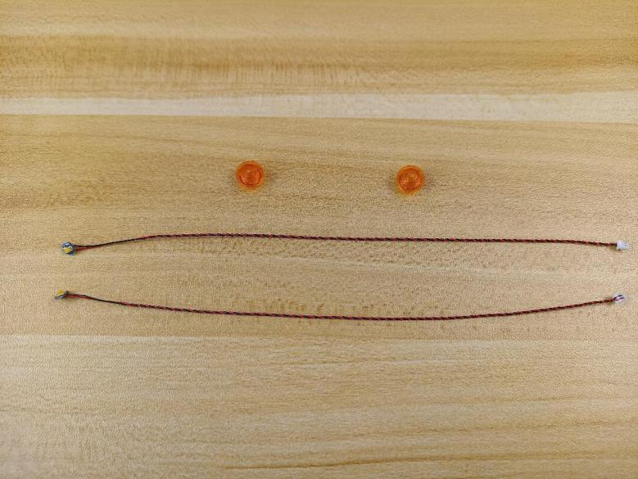
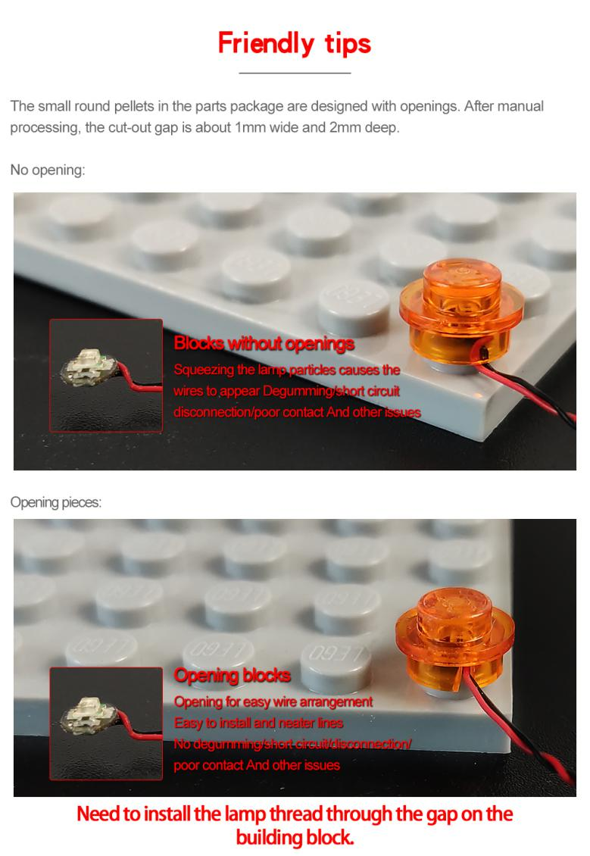

With lighting part facing up, connect the orange round plate over.
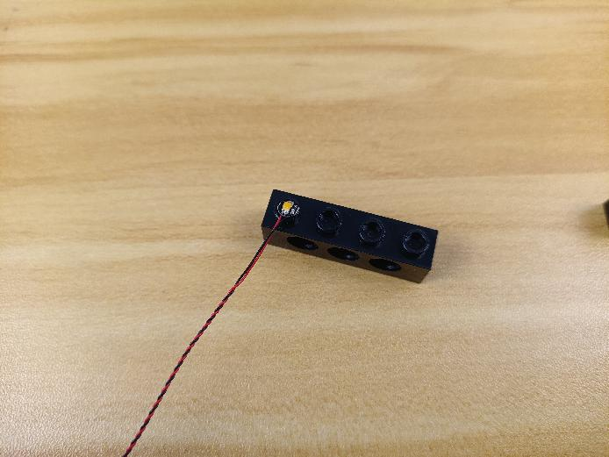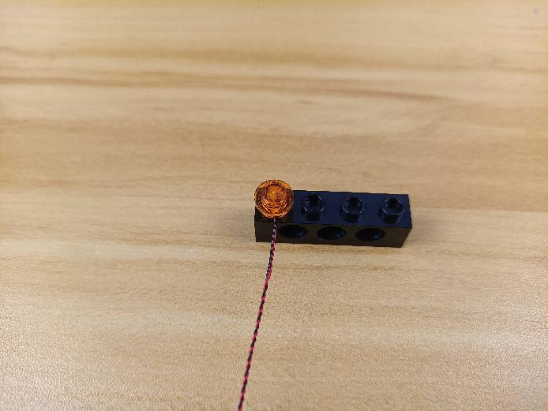

Install the other light in the same way.
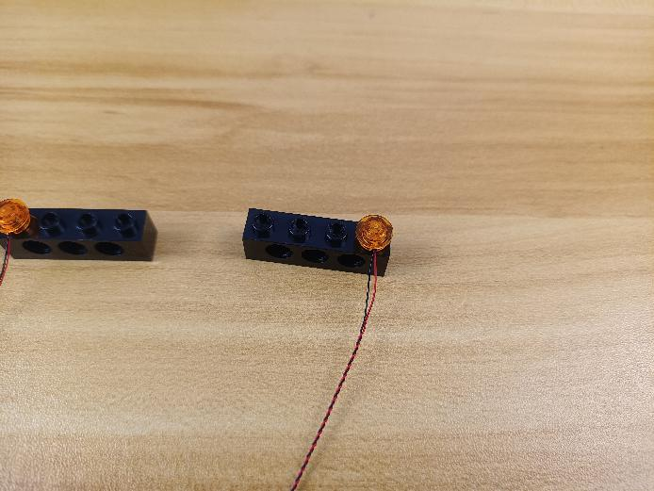

Take 4 red 15cm dot lights, 4 trans red 1x1 round plates with opening.
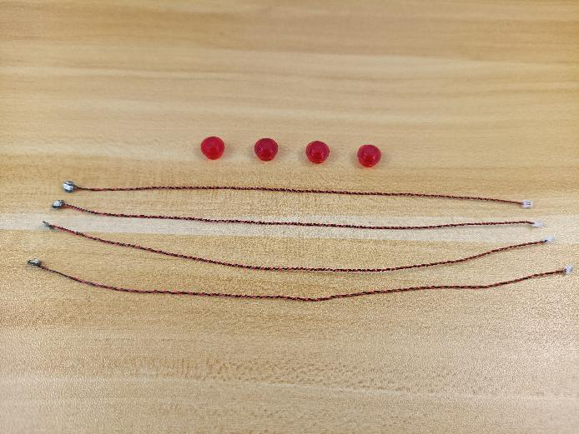

Install the lights as we did before.
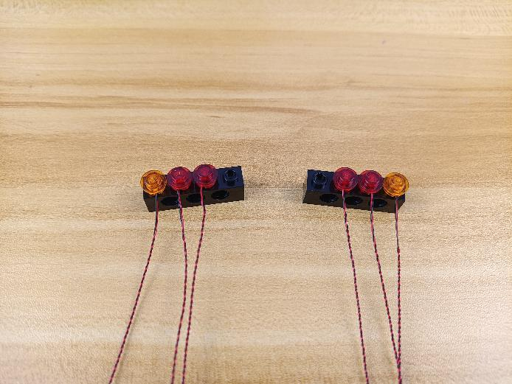

Take 2 white 15cm dot lights, 2 trans white 1x1 round plates with opening.
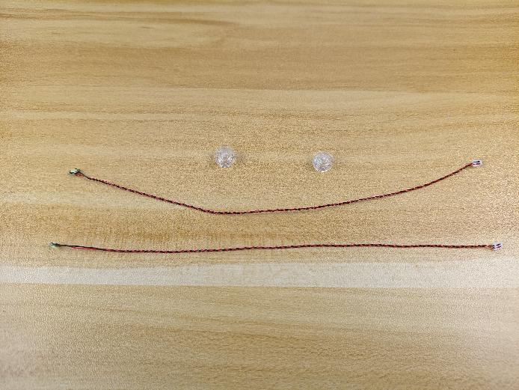

Install the following lights in the same way.
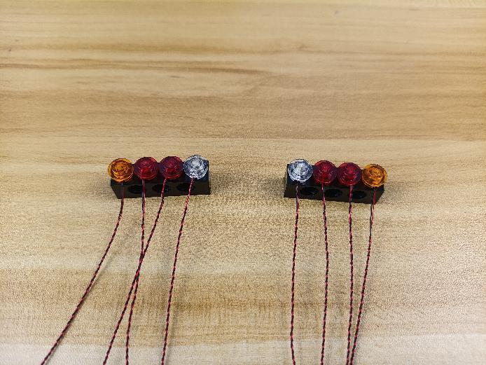

Group the cables together respectively.
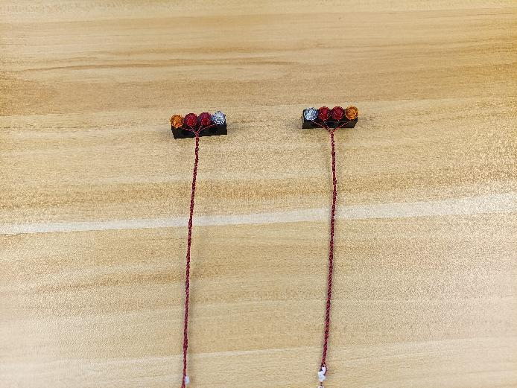

Reconnect the follwoing pieces.
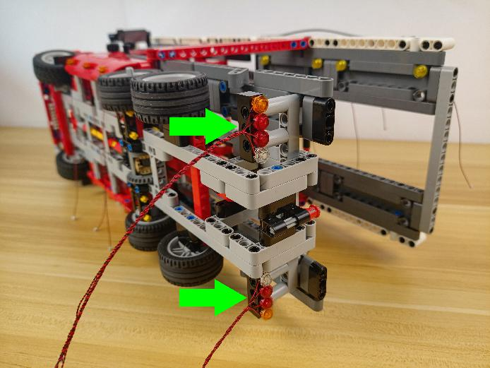

Turn the B part to the other side.
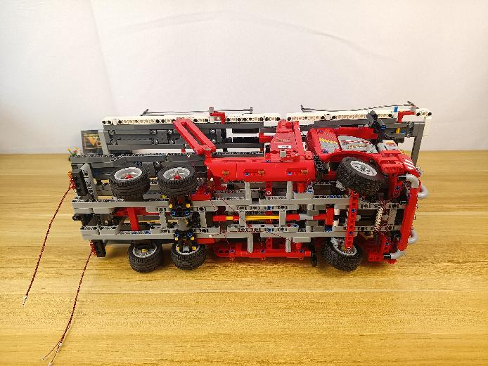

Turn to the middle, remove the 3 orange round plates.
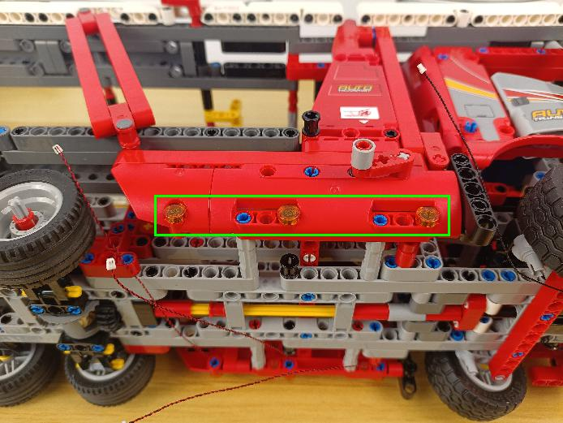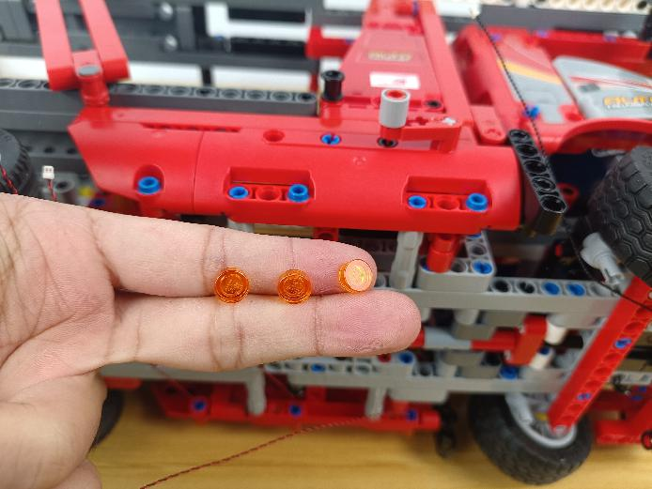

Take 3 warm white 15cm dot lights, 3 trans orange 1x1 round plates.

With lighting part facing up, thread the cable through following space.
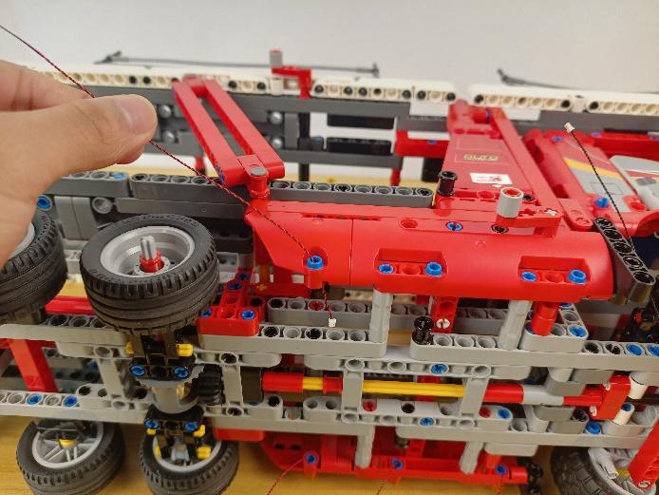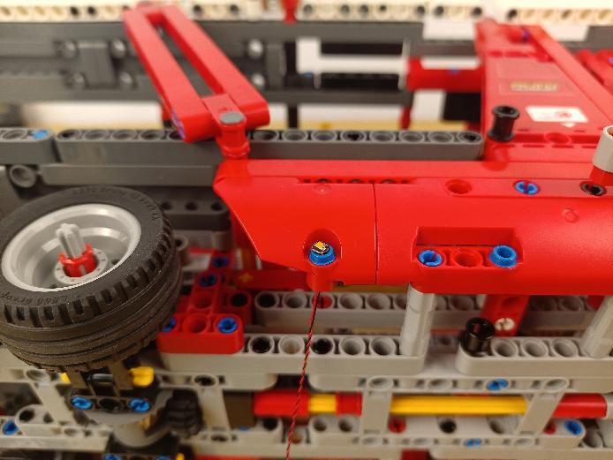

Connect the orange round plate over.
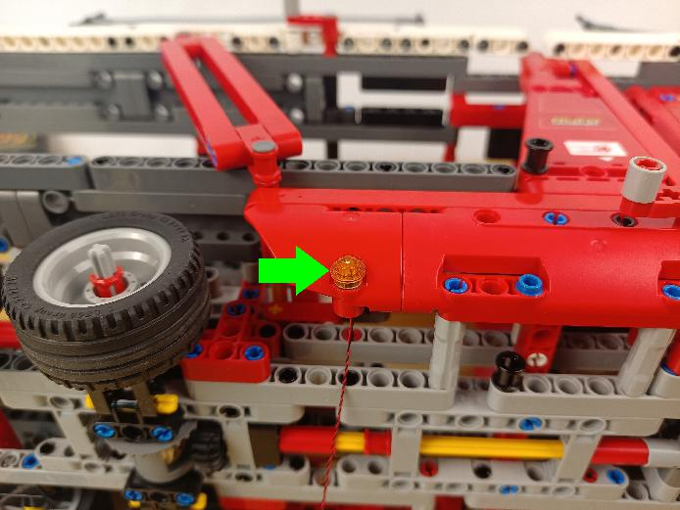

Install the other 2 lights in the same way.
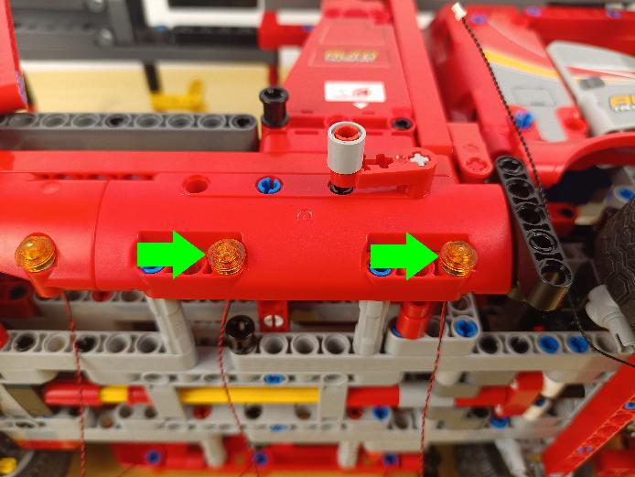

Turn to the following place.
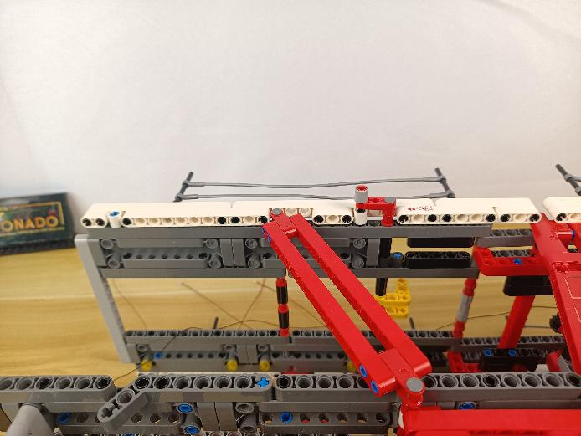

Take 4 warm white 15cm dot lights, 4 light gray half pins, 4 trans yellow 1x1 round plates.

With lighting part facing up, thread the light through the half pin.

Connect the yellow round plate over.

Install the other 3 lights in the same way.

Thread the cable through the following hole, reconnect the light.
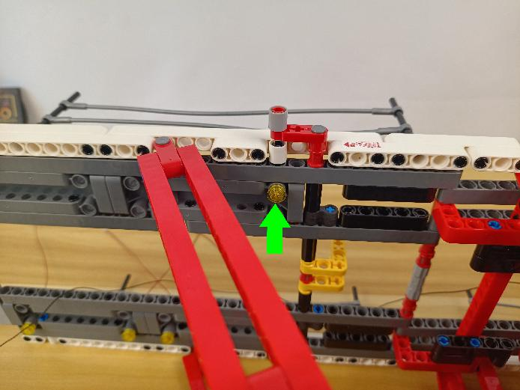

Install the other 3 lights in the same way.
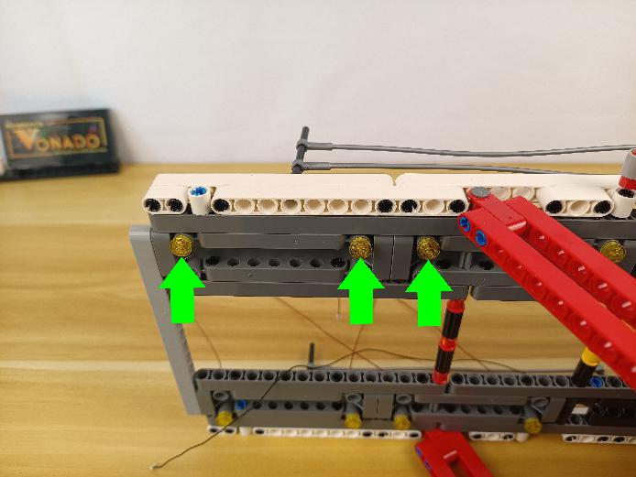

Take a 30cm connecting cable, an 8-port expansion board, assemble the as per below.
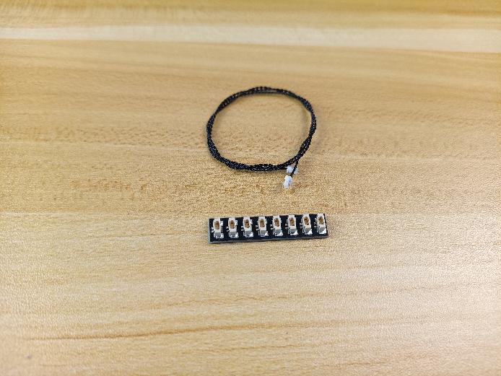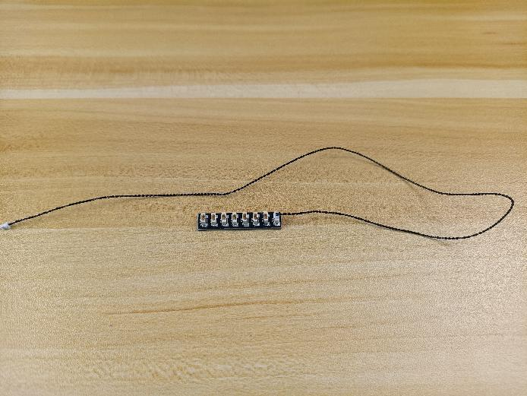

Group the 3 cables above together.
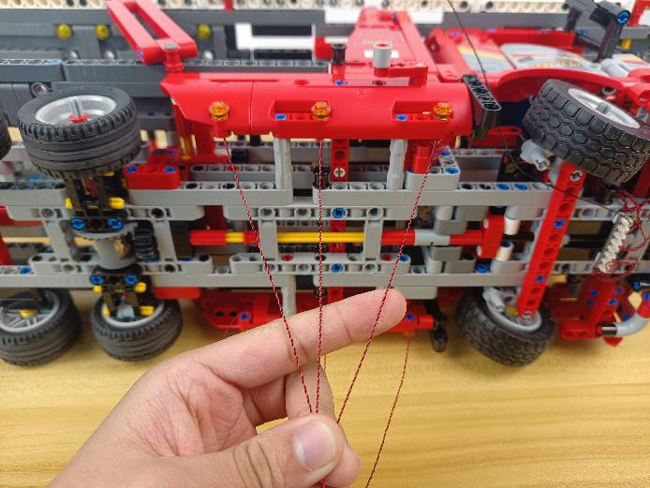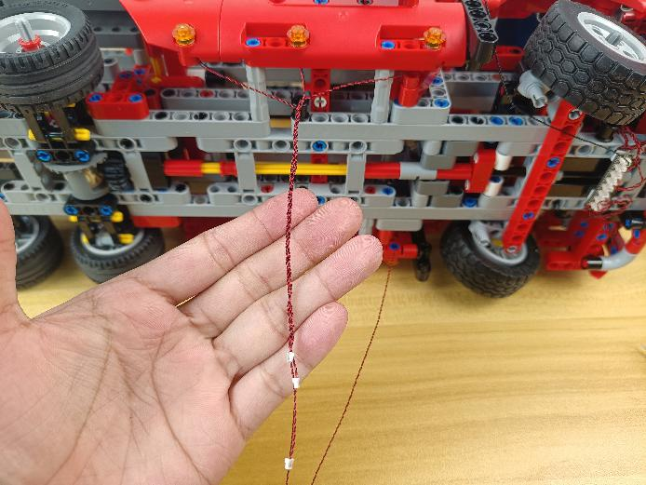

Thread them through the following space, and wind them around the piece.
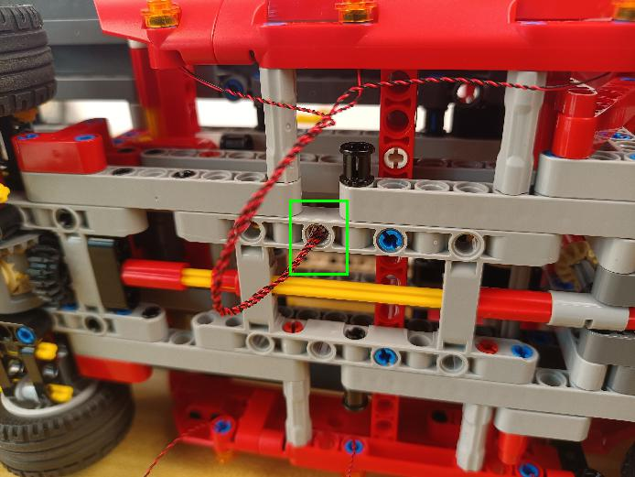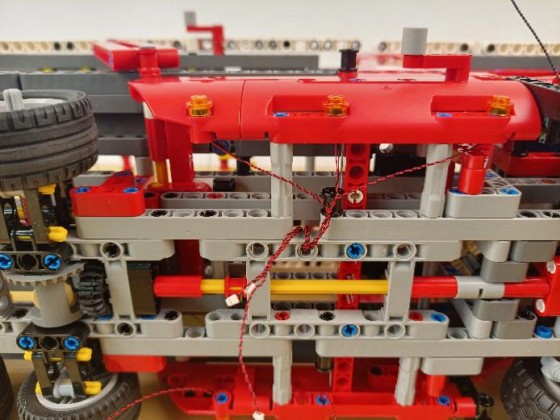

Group the 3 cables below together.
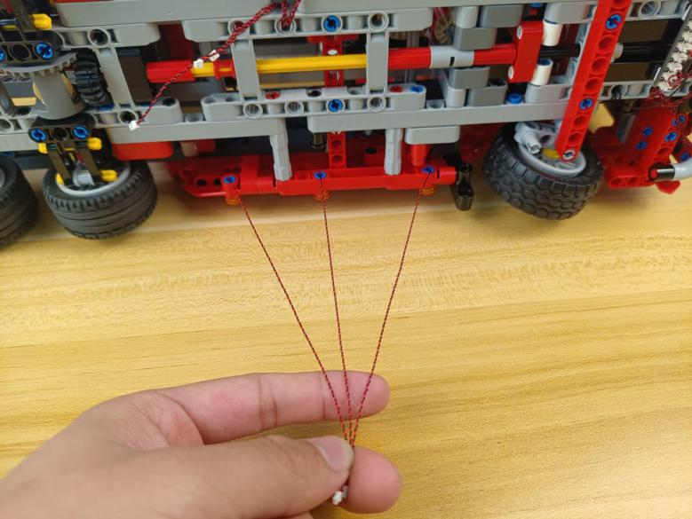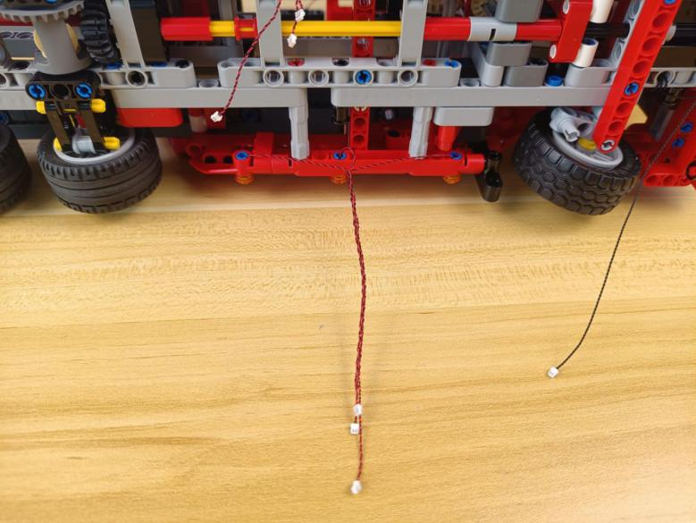

Thread them through the following space, and wind them around the piece.
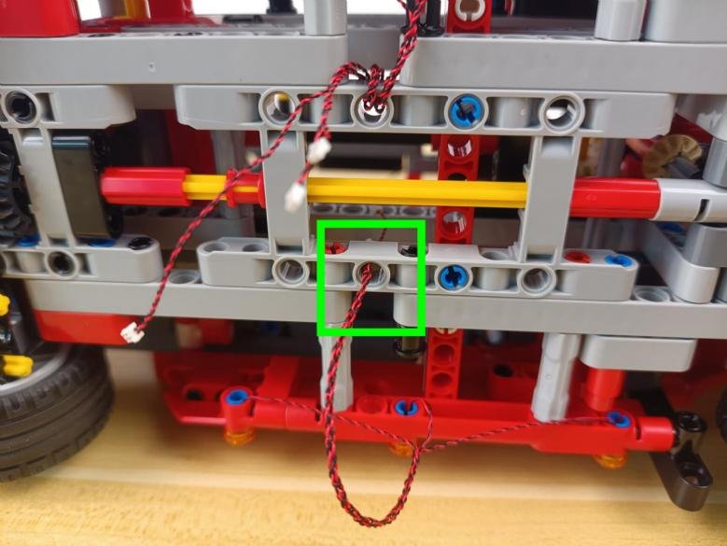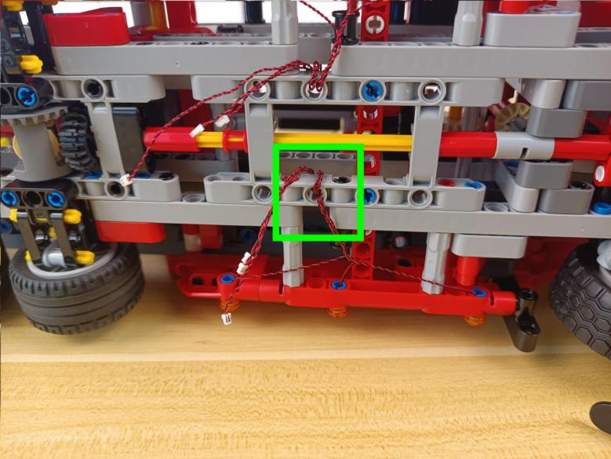

Connect the following 6 cables to the expansion board, you can tuck excess cables around the expansion board.
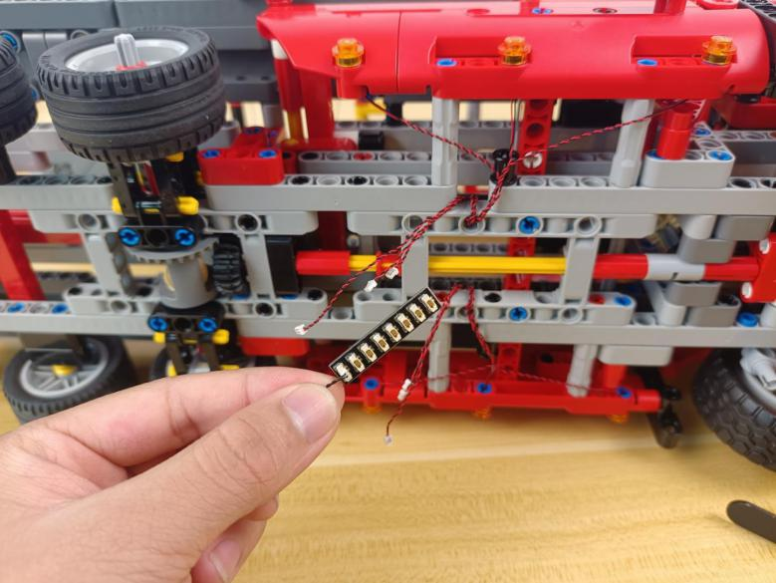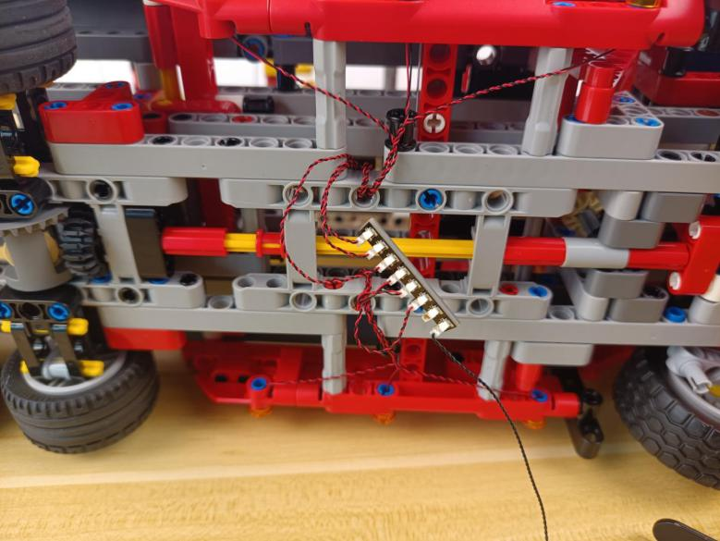

Connect the following cable to the expansion board.
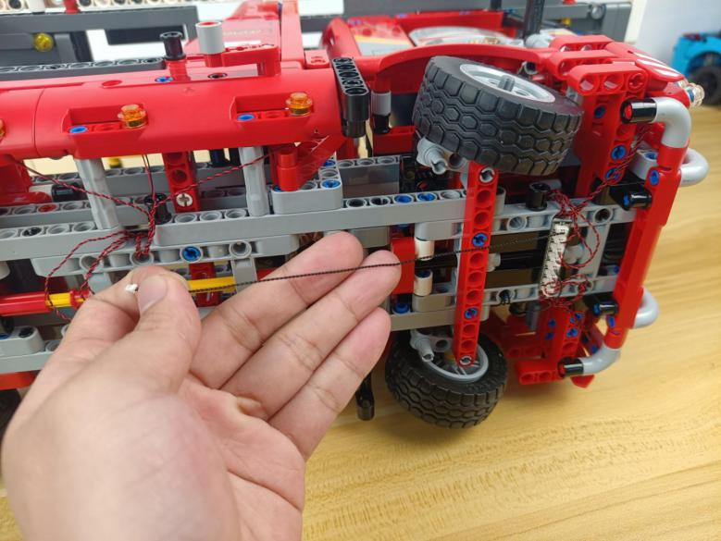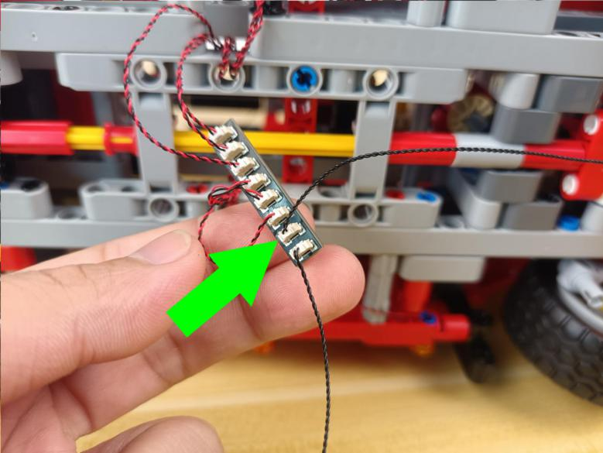

Take 2 adhesive squares.
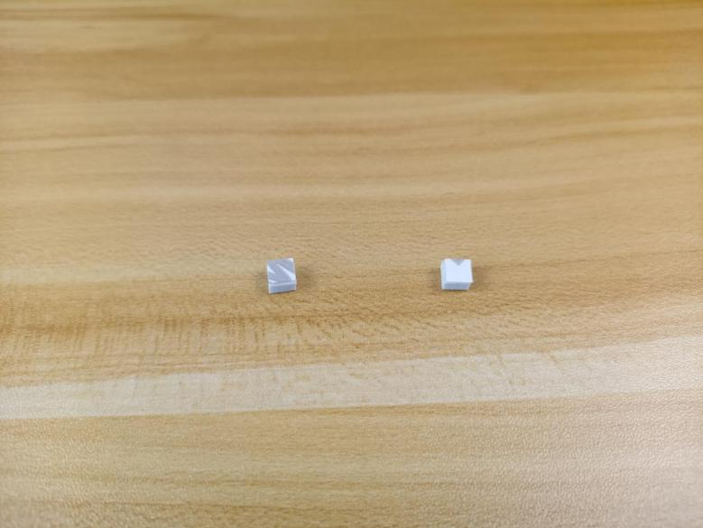

Stick them to the back of the expansion board, and stick the expansion board to the following place.
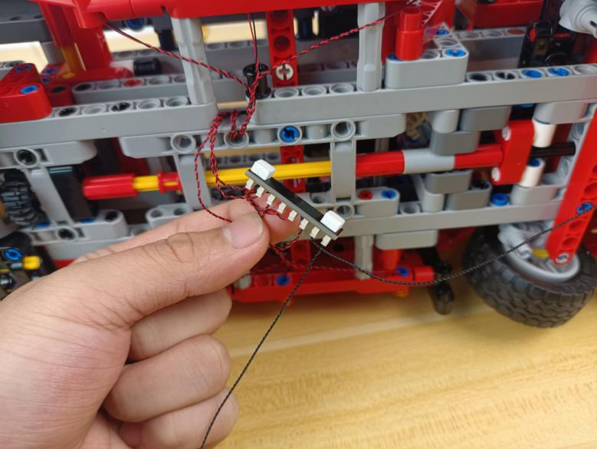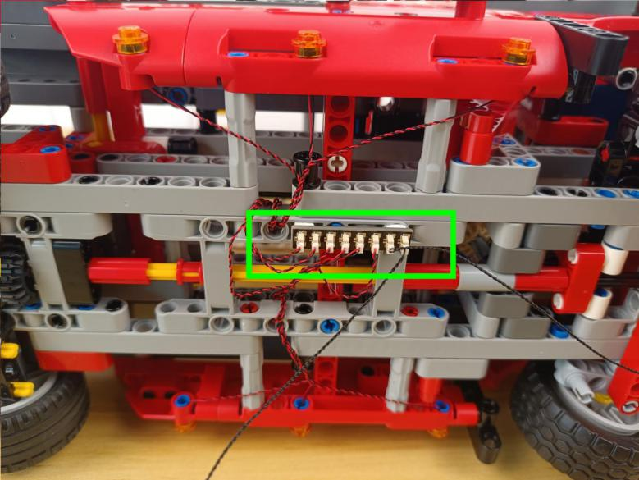

Tighten excess cables up.
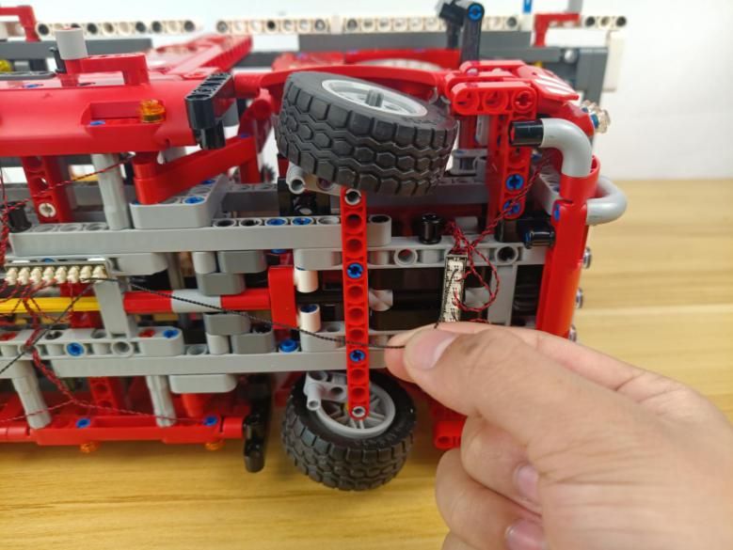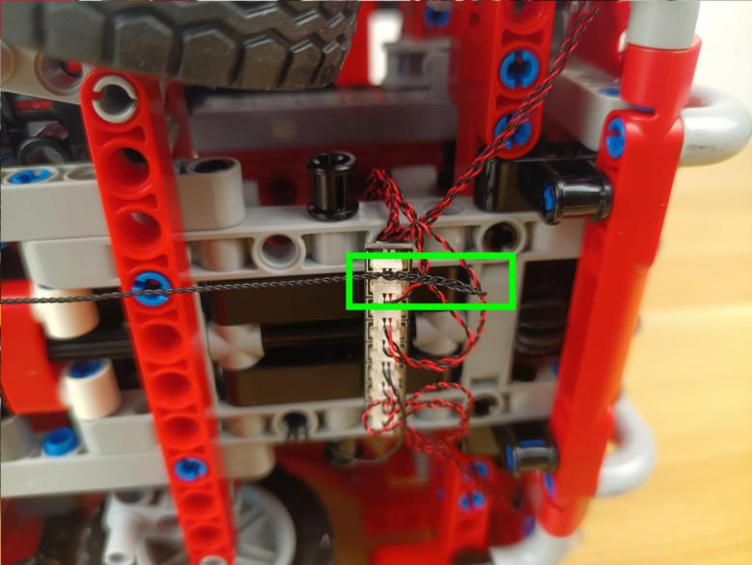

Turn to the tail.
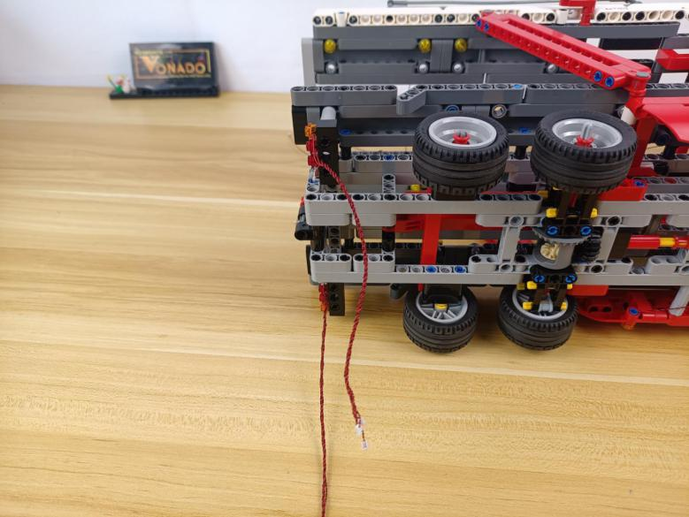

Wind the 2 groups of cables around the following pieces.
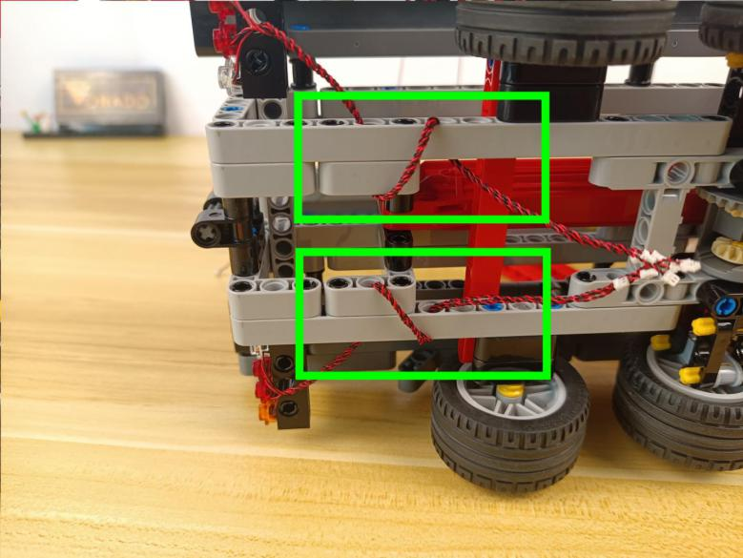

Take a 12-port expansion board.
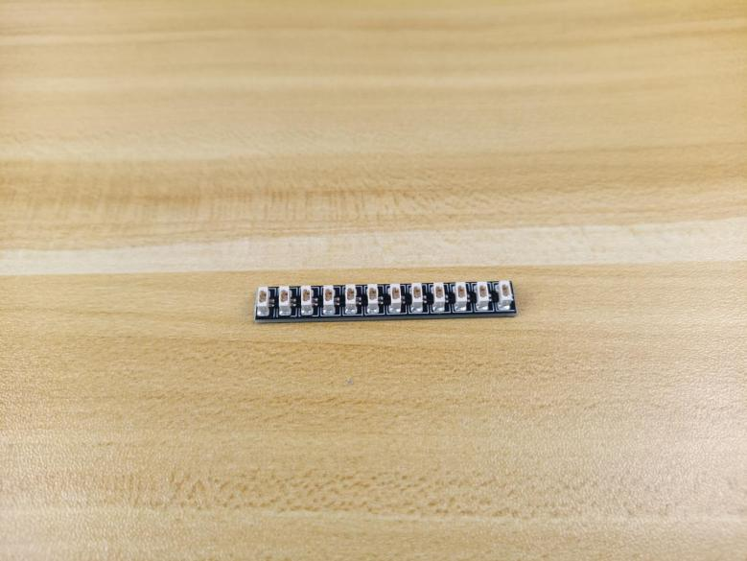

Connect the following cables to the expansion board.
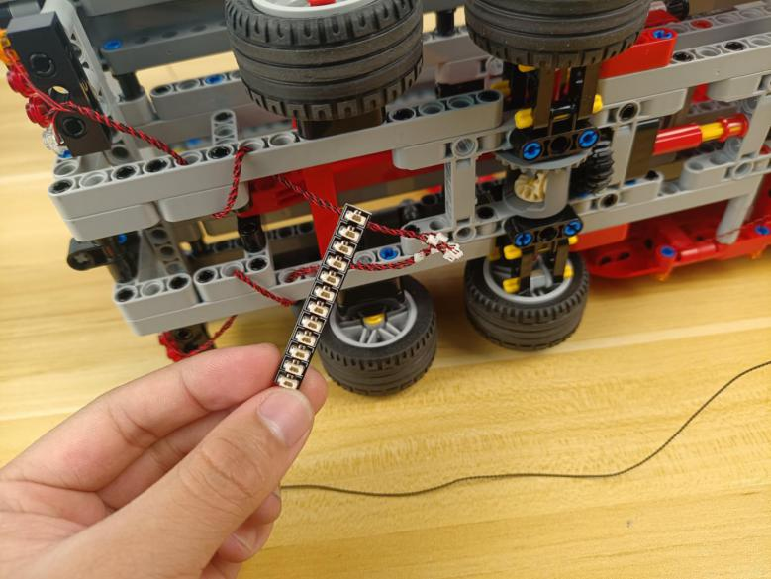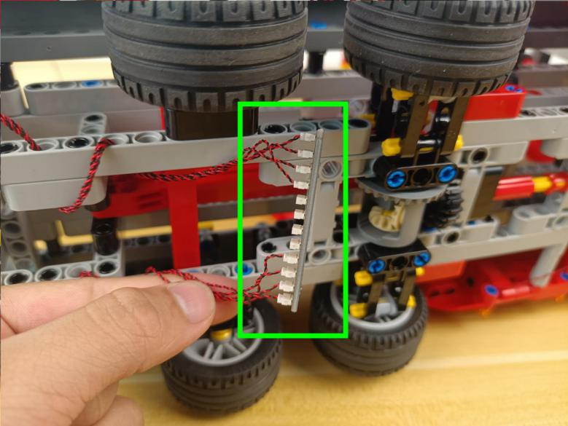

Thread the 30cm connecting cable from the 8-port expansion board through the following hole, and pull it to the back.
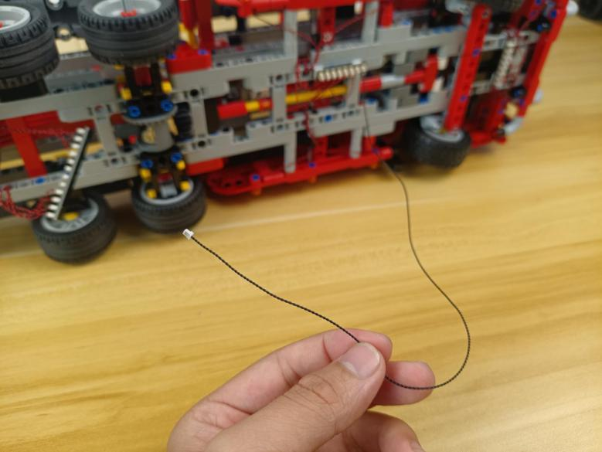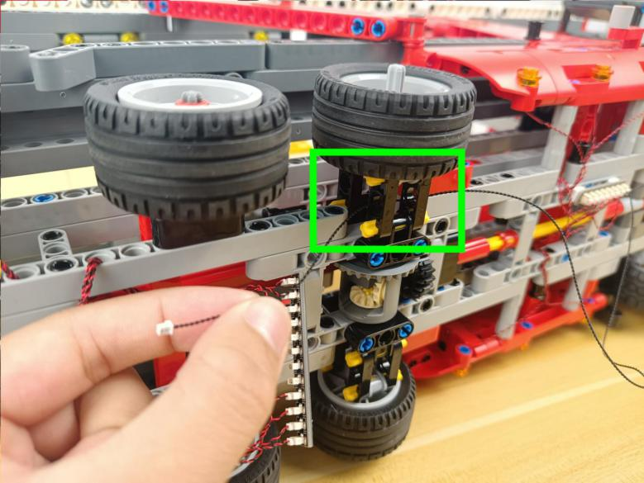

Connect it to the 12-port expansion board.
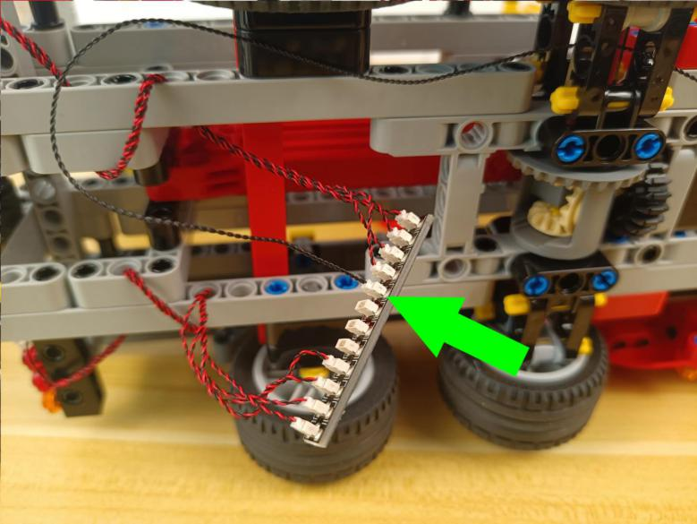

Take 2 adhesive squares.
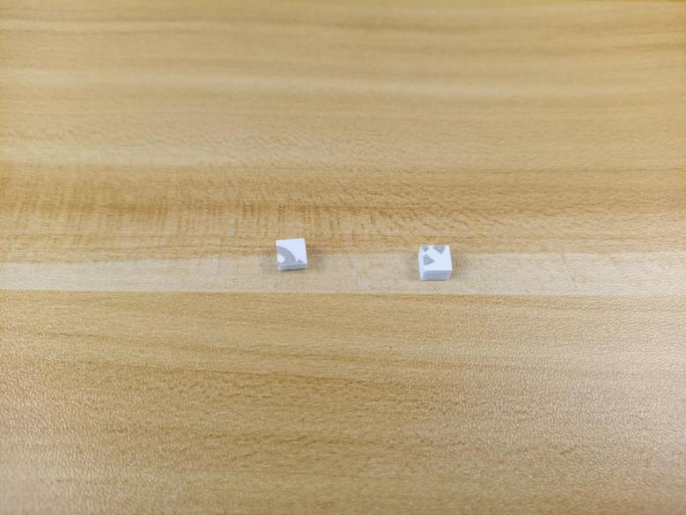

Stick them to the back of the expansion board, and stick the expansion board to the following place.
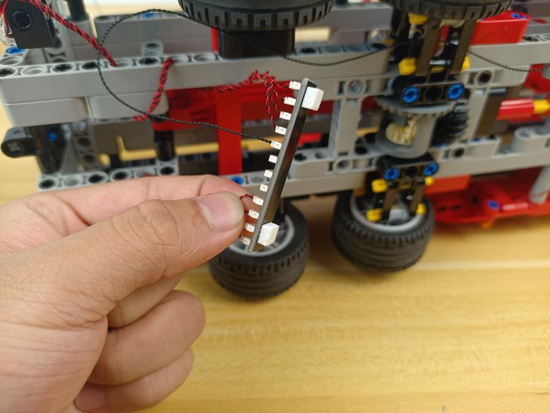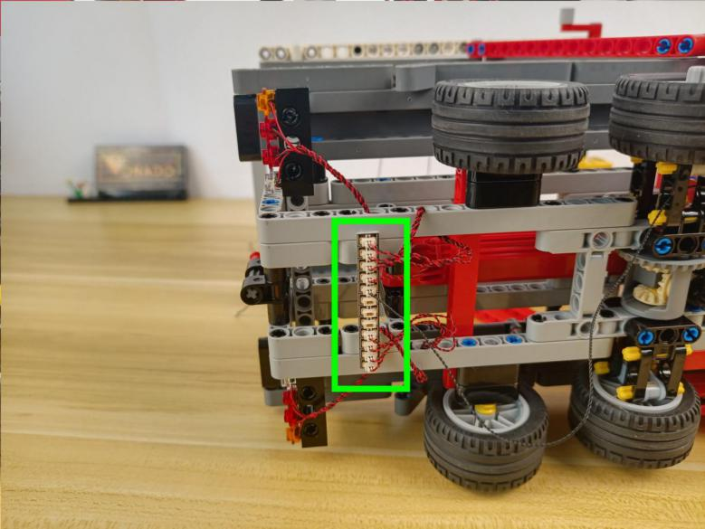

Tighten excess cables up.
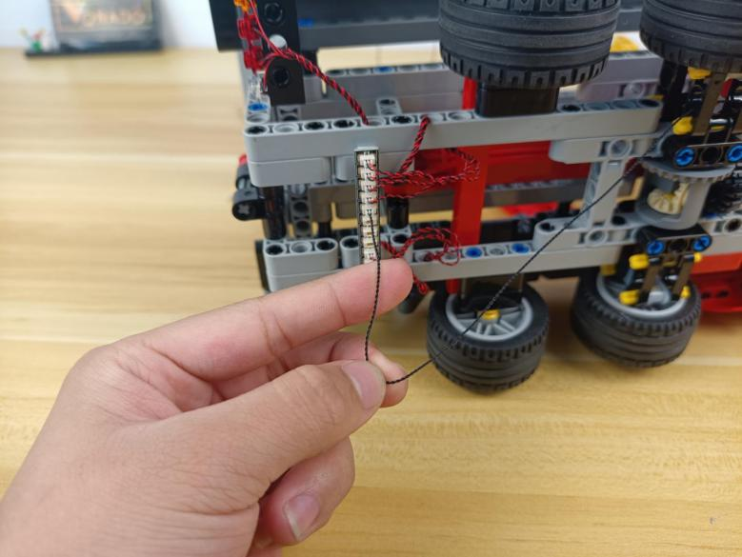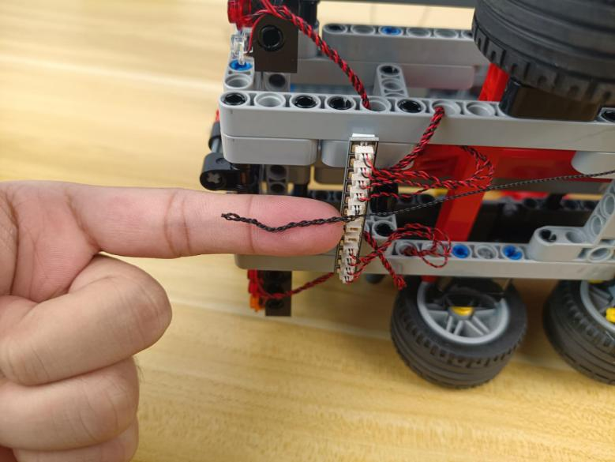

Turn to the side
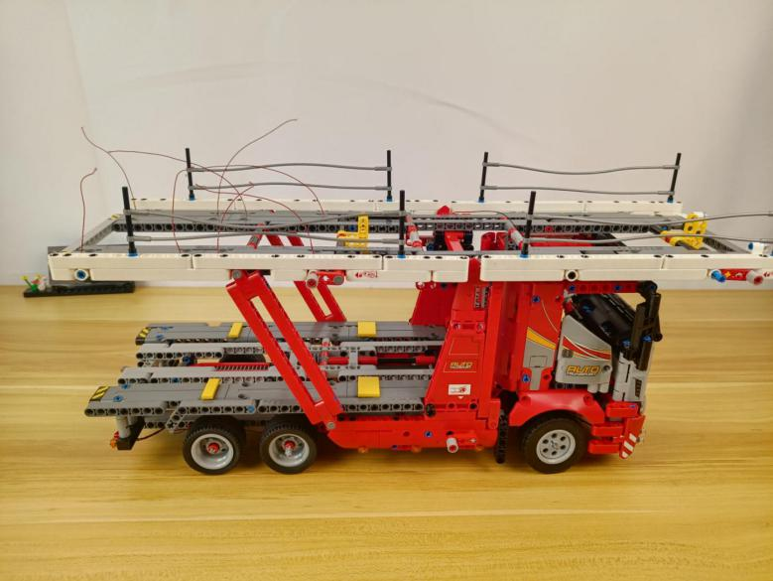

Thread the following cable down.
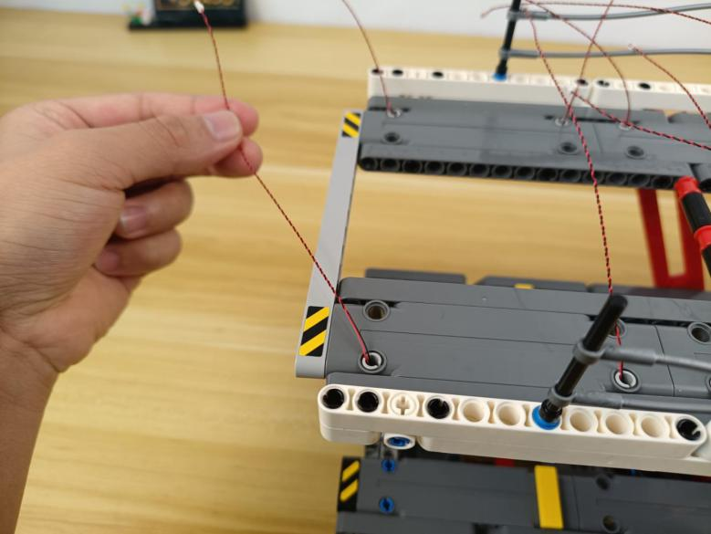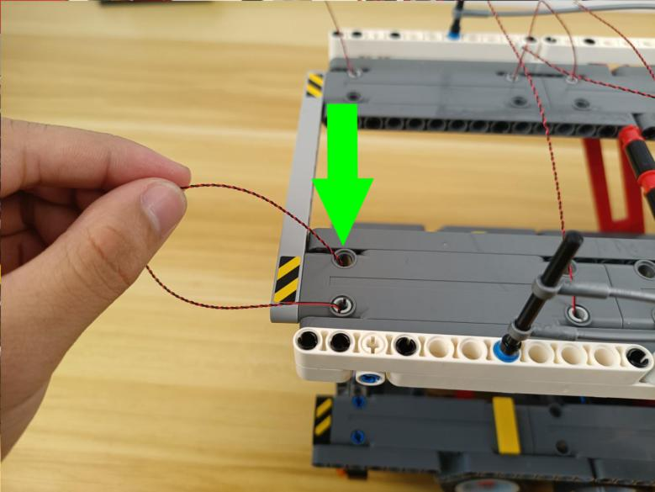

Tighten the cable up.
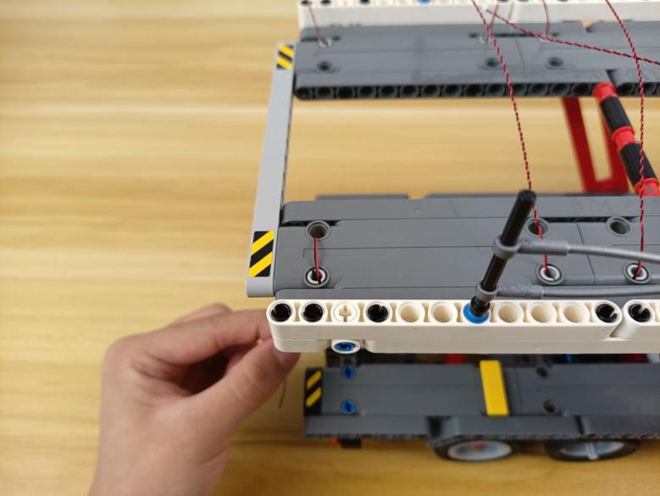

Place the other cables in the same way as per below.
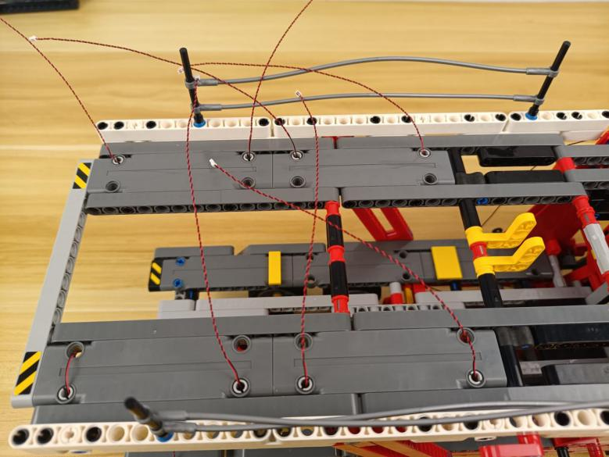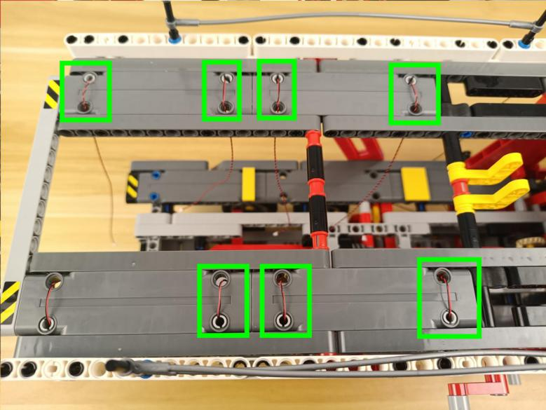

Take two 6-port expansion boards.
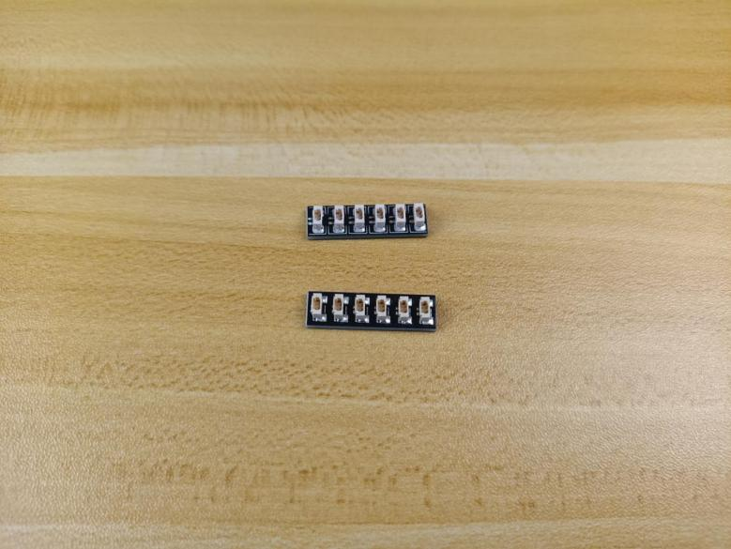

Connect the following 4 cables to the a 6-port expansion board.
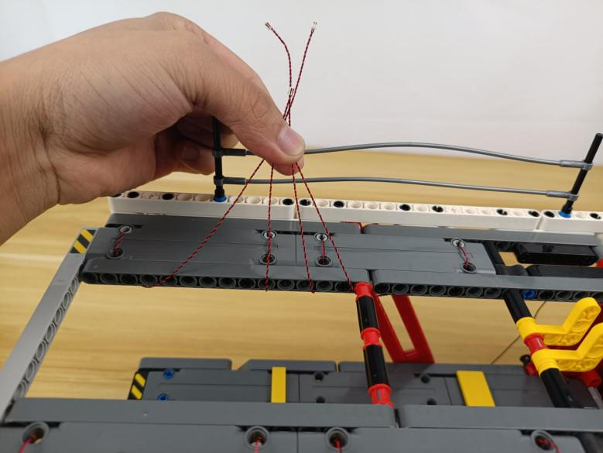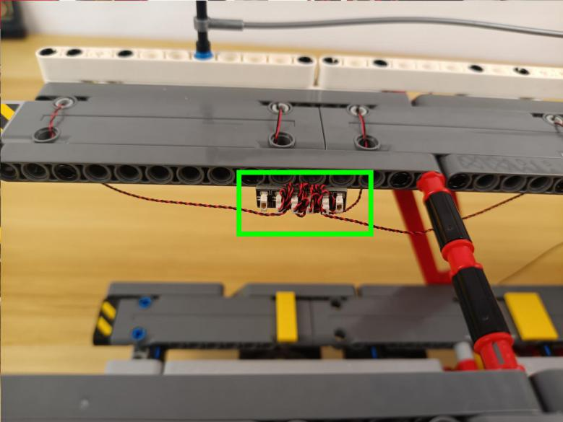

Connect the other 4 cables to the 6-port expansion board.
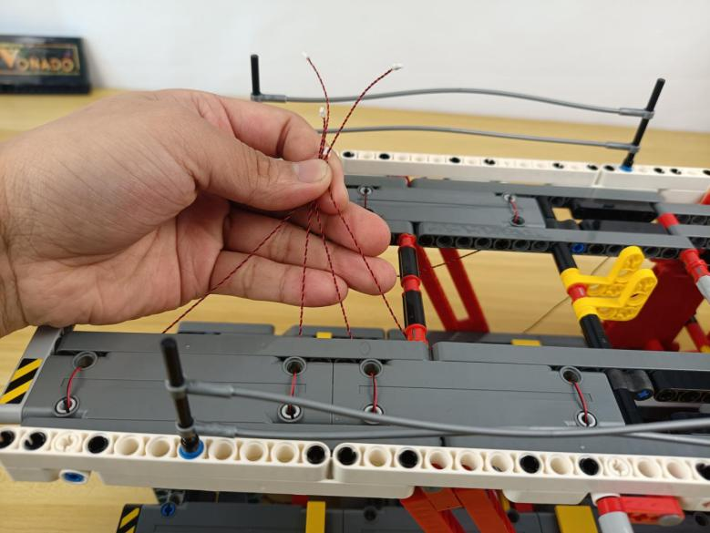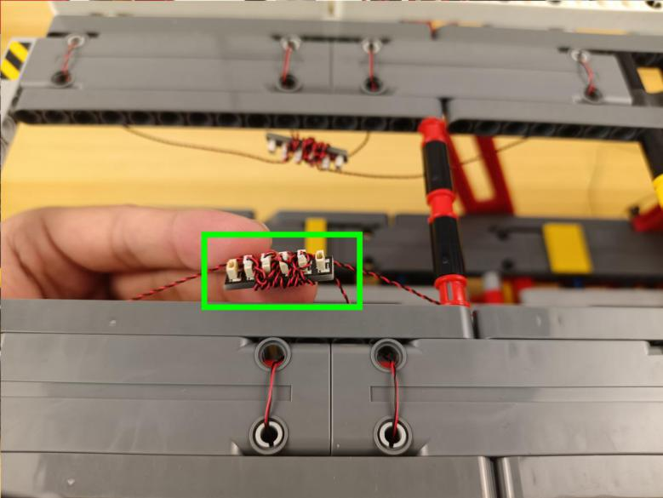

Take a 15cm connecting cable.
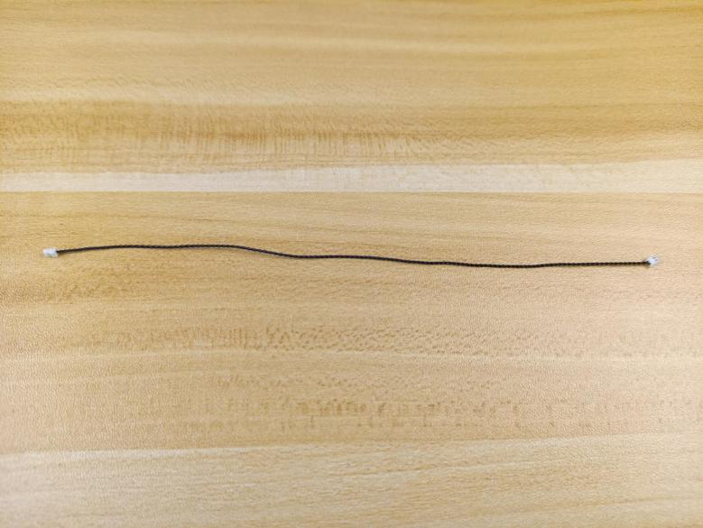

Connect the two 6-port expansion boards together.
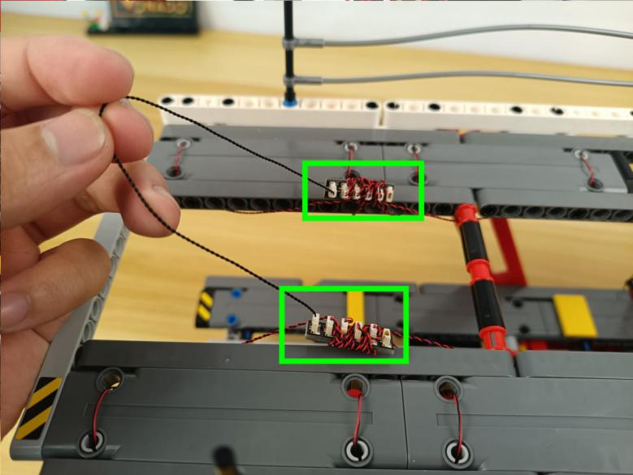

Pull the 50cm conencting cable from the warm white strip light at the head to the back.
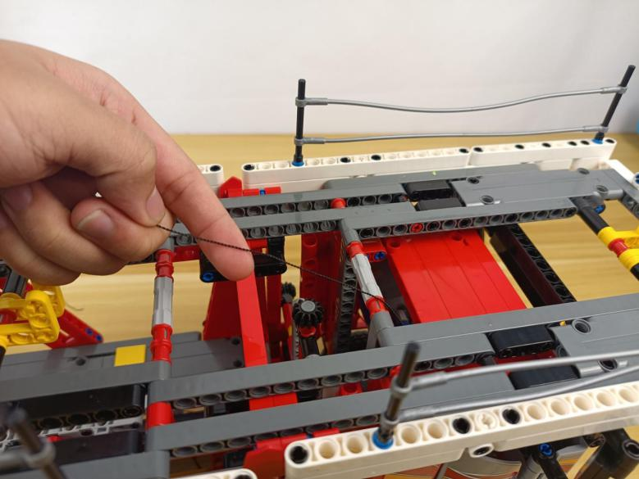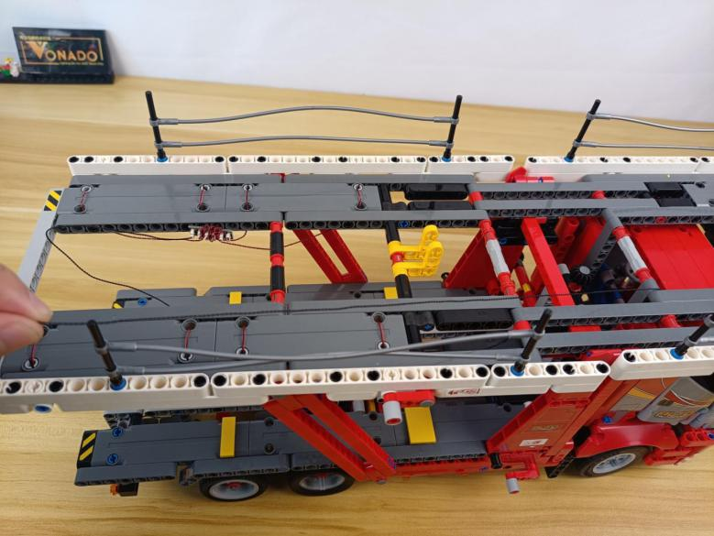

Wind it around the follwoing piece several times.
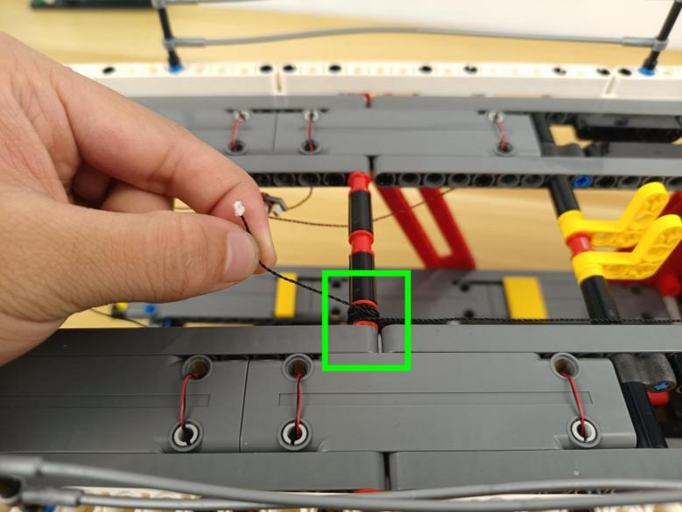

Connect it to the following expansion board.
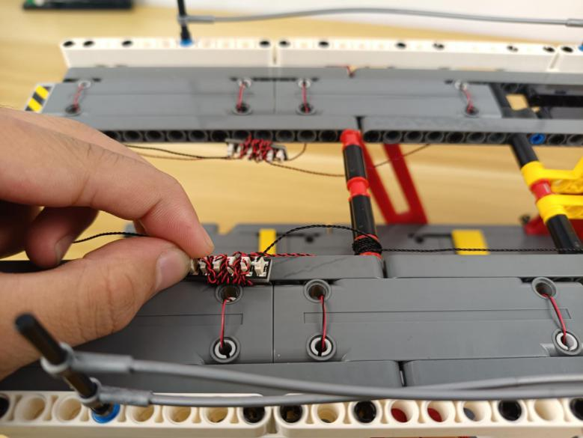

Take 4 adhesive squares.
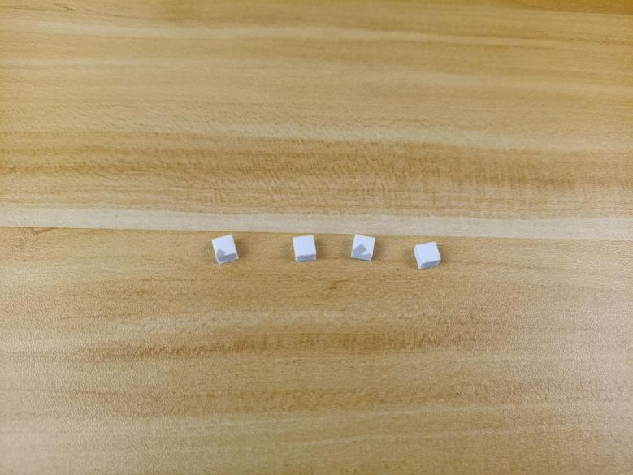

Stick them to the backs of the expansion boards, and stick the expansion boards to the following places.
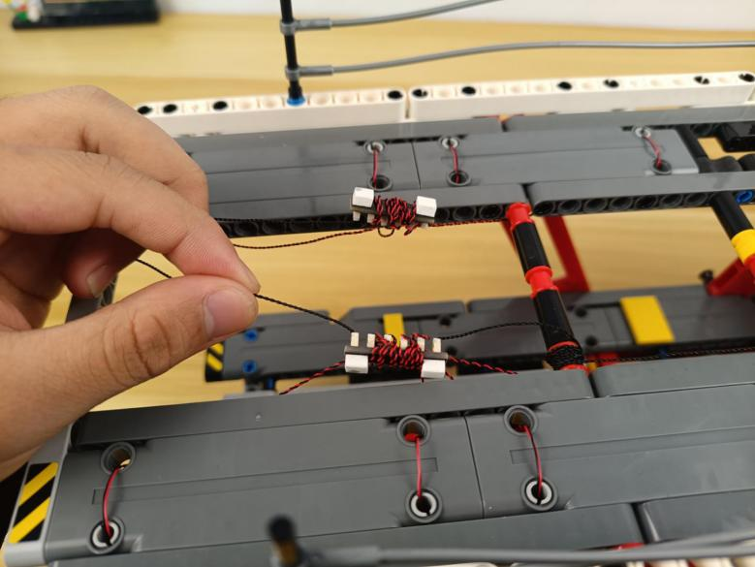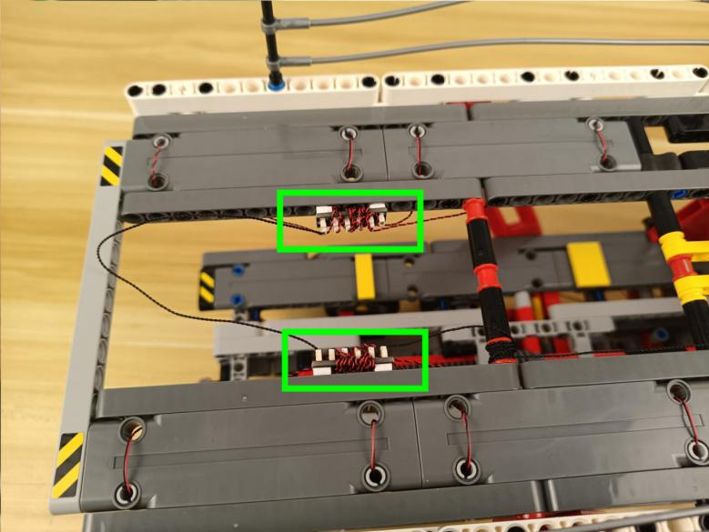

Tighten excess cables up.
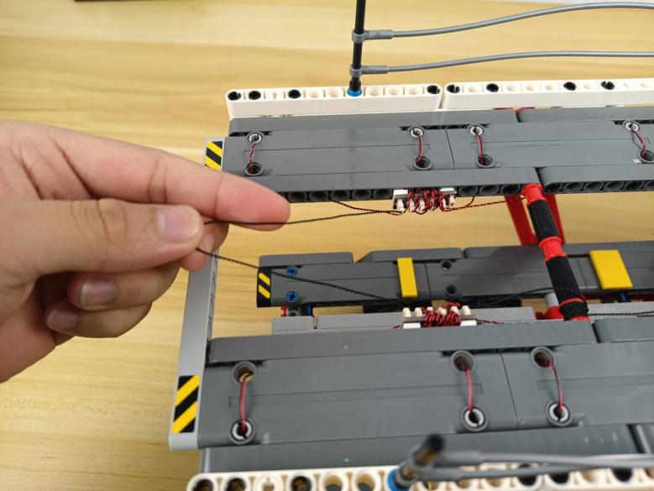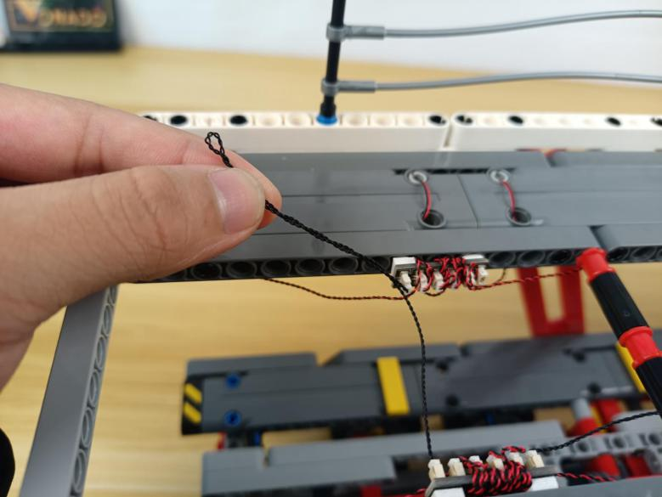

Tuck it inside the following space.
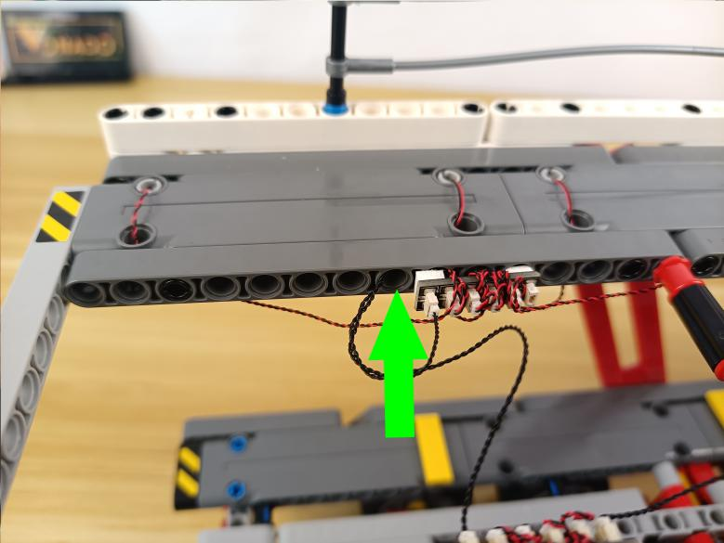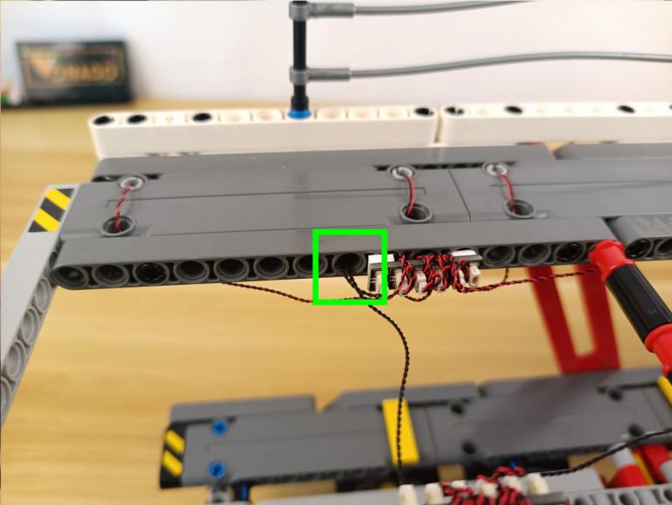

Start to install lights for the C part.
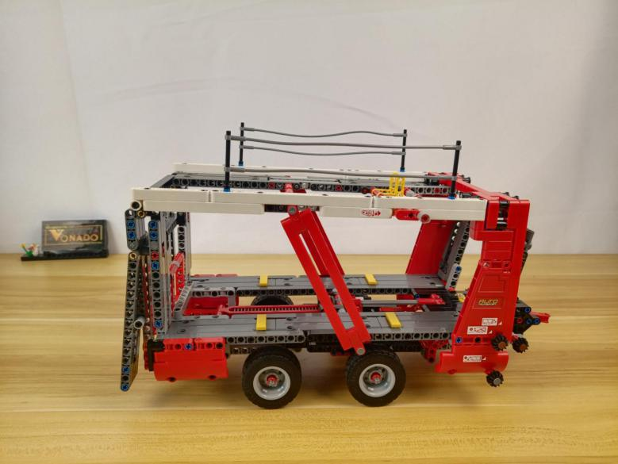

Turn it over.
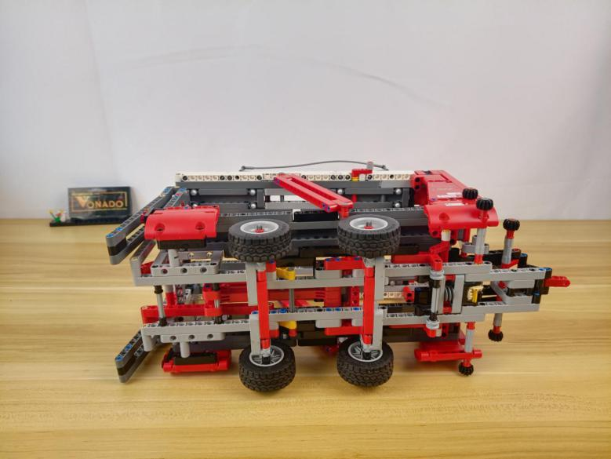

Turn to the following place.
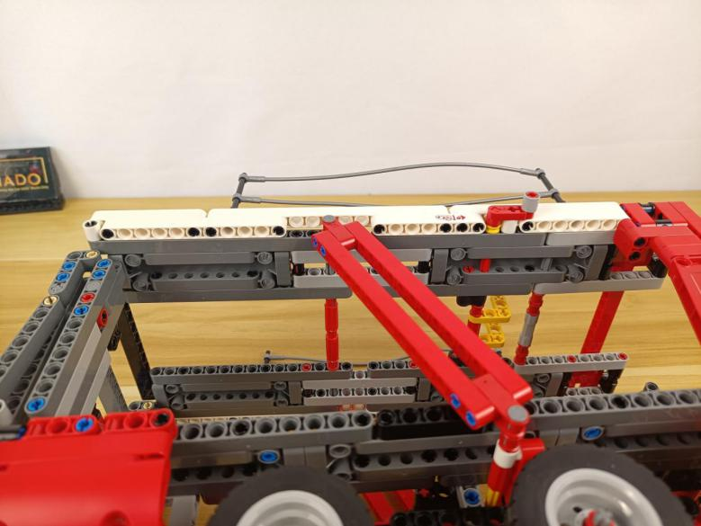

Take 8 warm white 15cm dot lights, 8 light gray half pins, 8 trans yellow 1x1 round plates without opening.
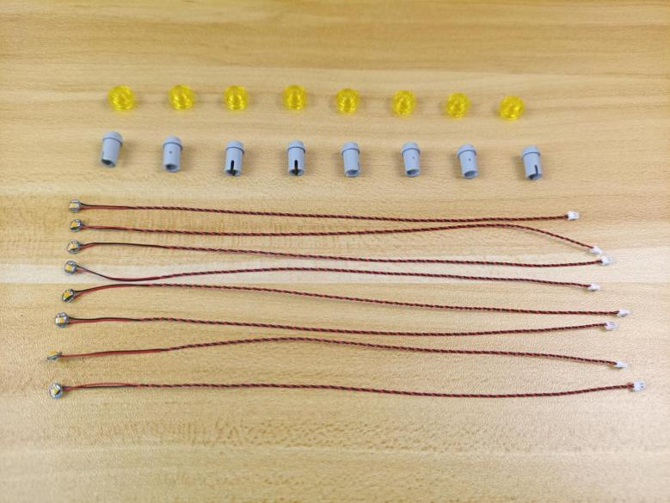
Thread the light through the half pin.
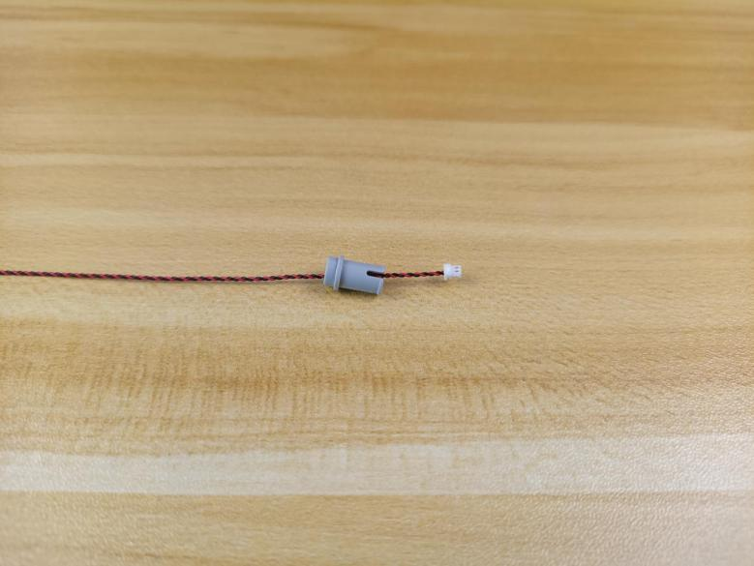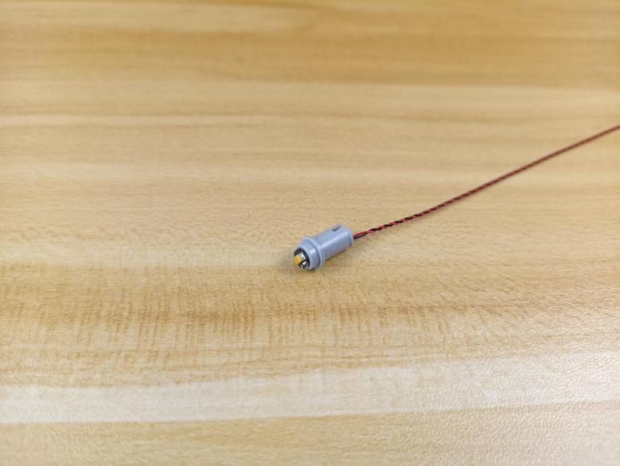

Connect the round plate over.
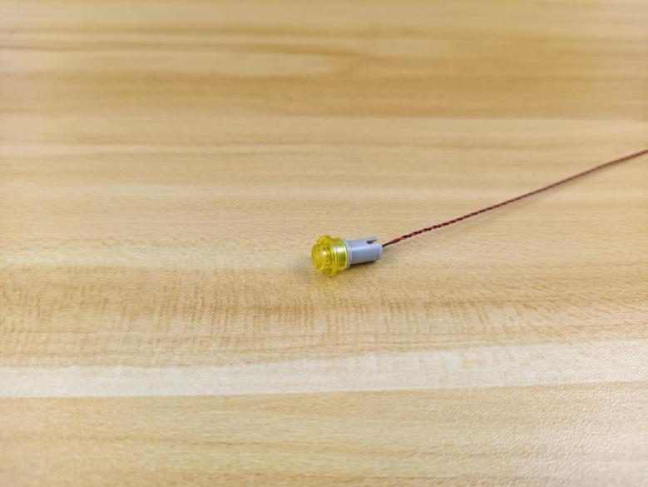

Install the other lights in the same way.
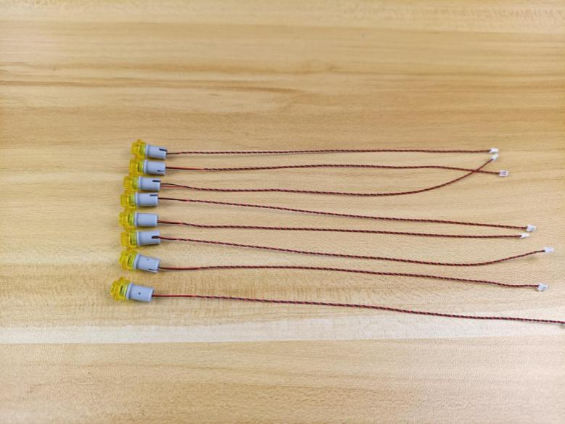

Thread the cable through the following hole, reconnect the half pin.
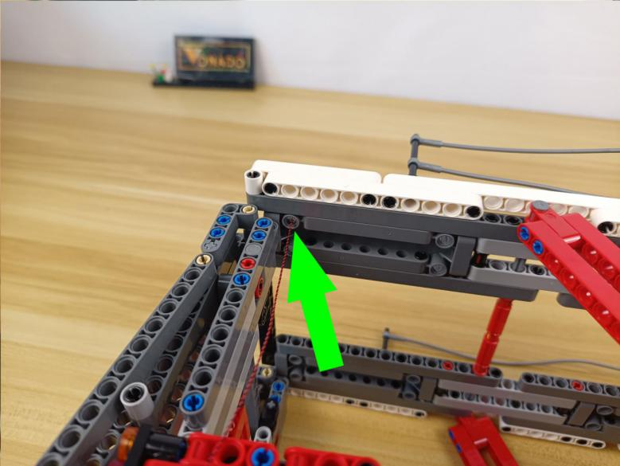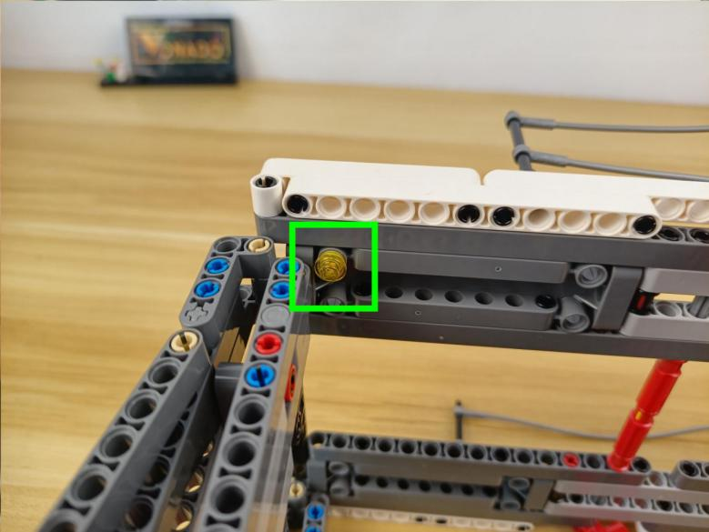

Install the following 3 lights in the same way.
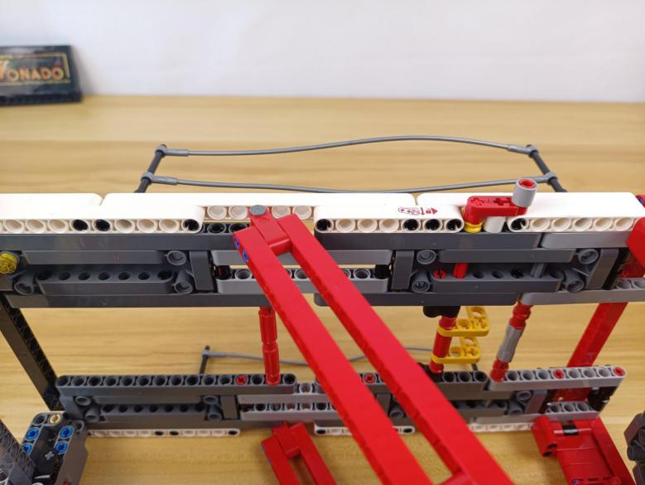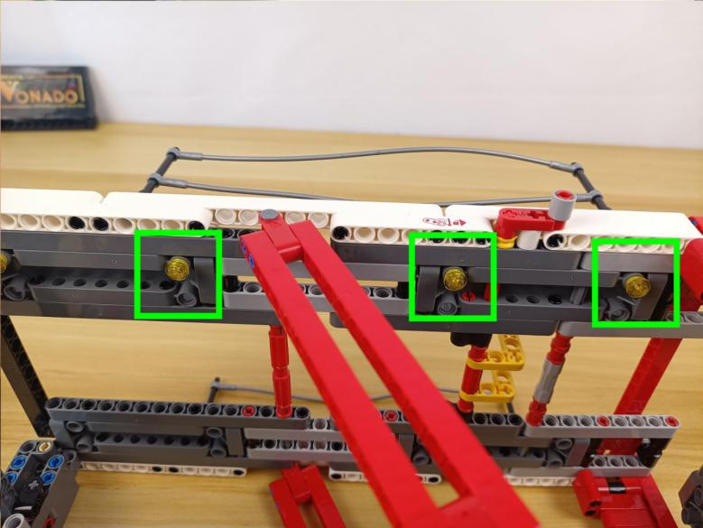

Turn the C part to the following place.
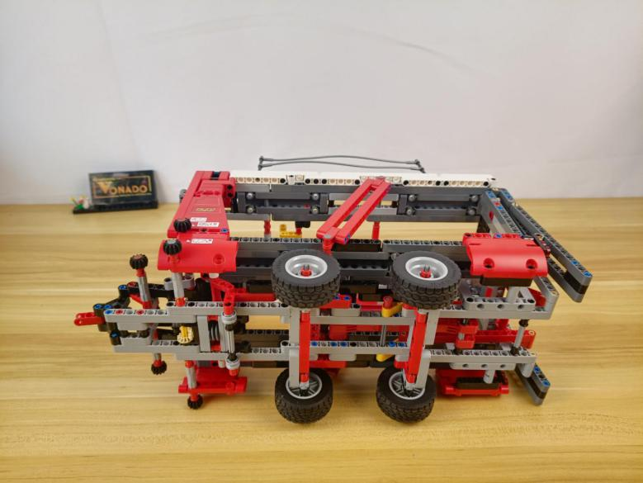

Install the other 4 lights at the follwoing places in the same way.
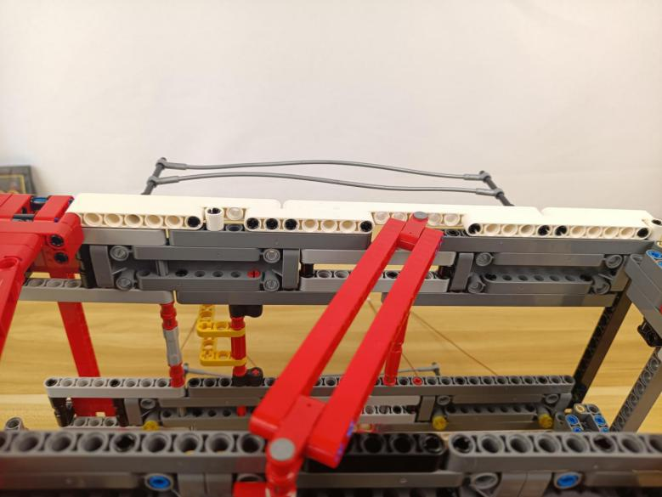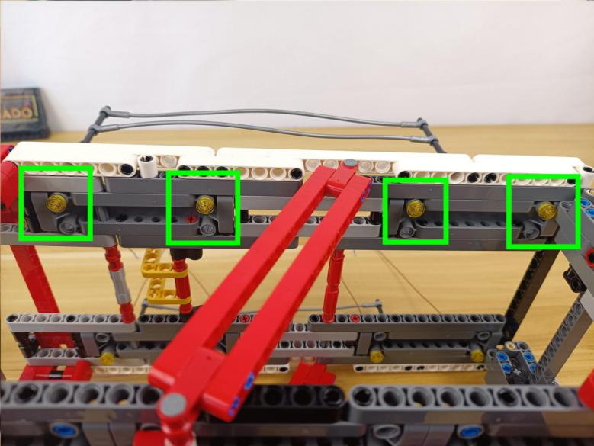

Turn the car back.
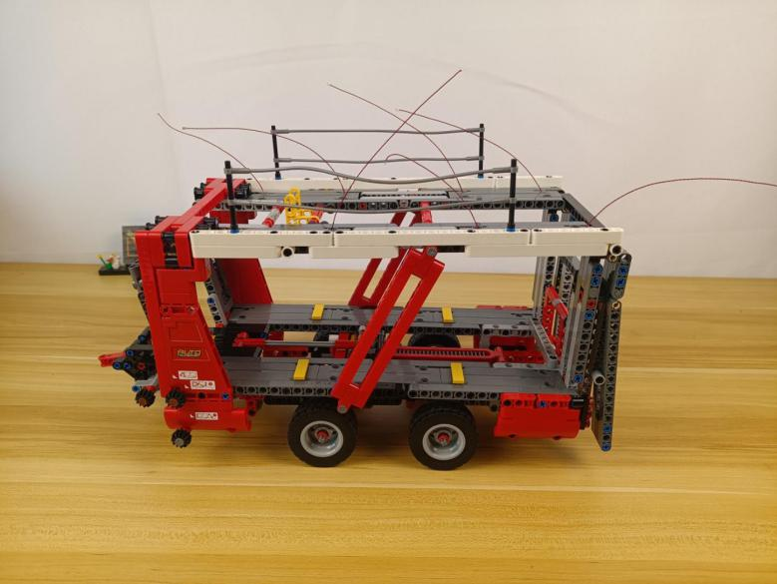

Thread the cable through the following hole to the bottom.
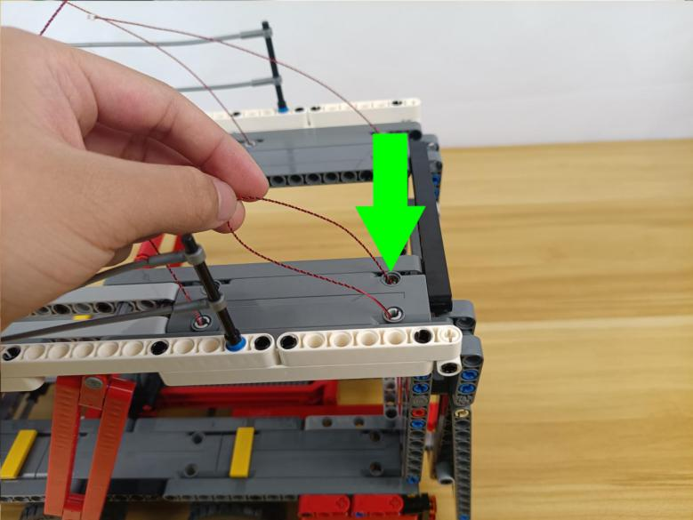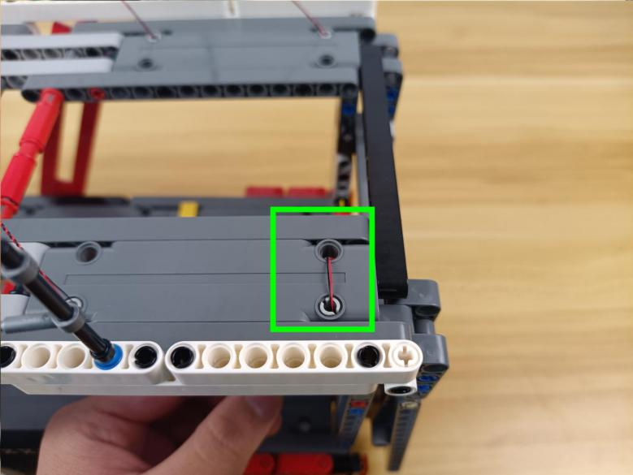

Place the other cables in the same way.
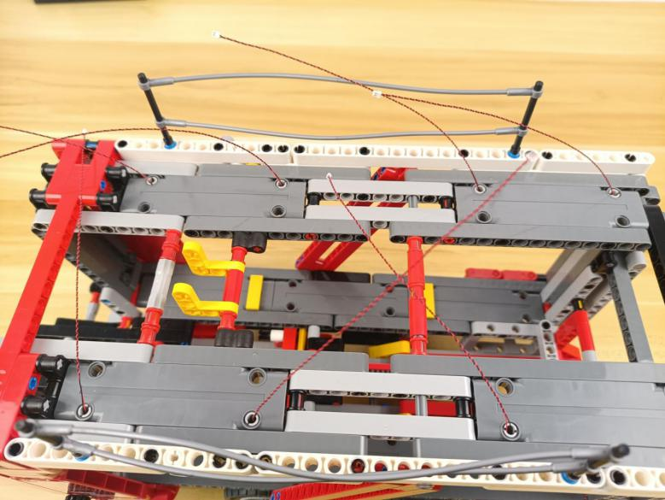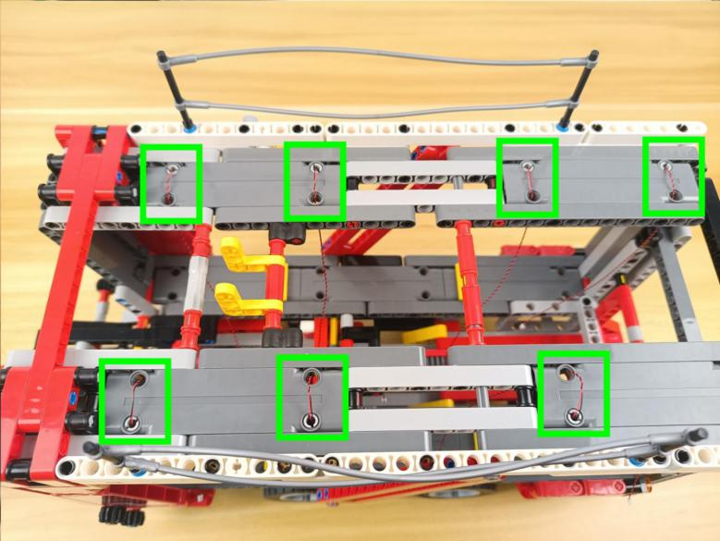

Take two 6-port expansion boards.
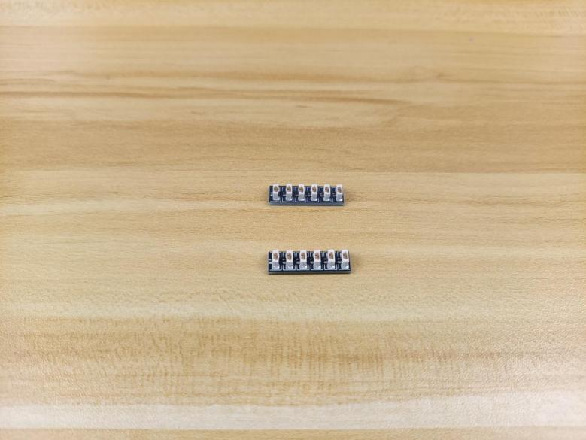

Connect the following cables to a 6-port expansion board.
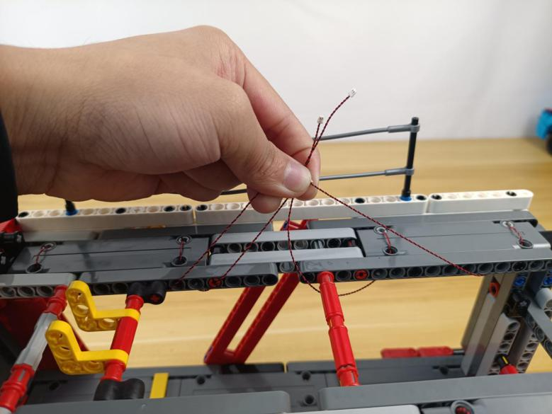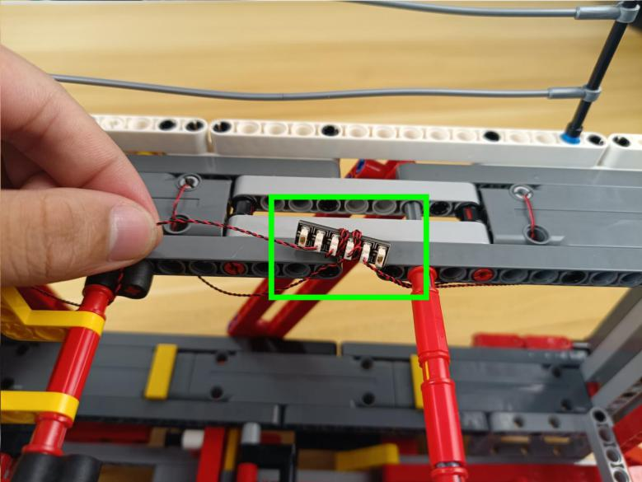

Connect the other 4 cables to the other 6-port expansion board.
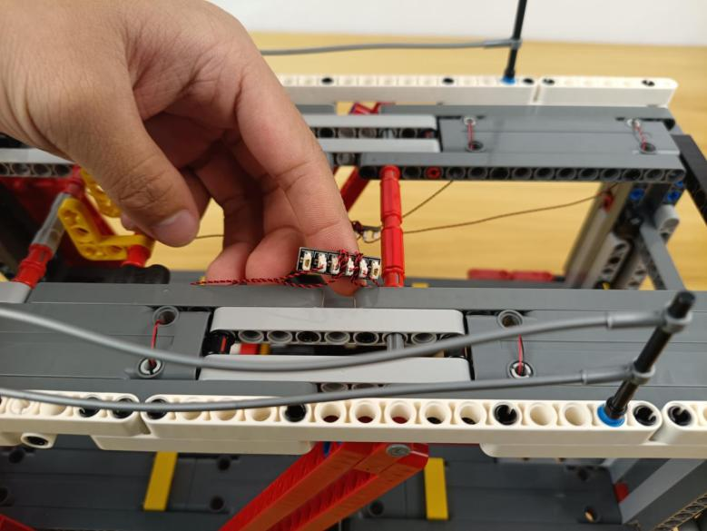

Take a 15cm connecting cable.
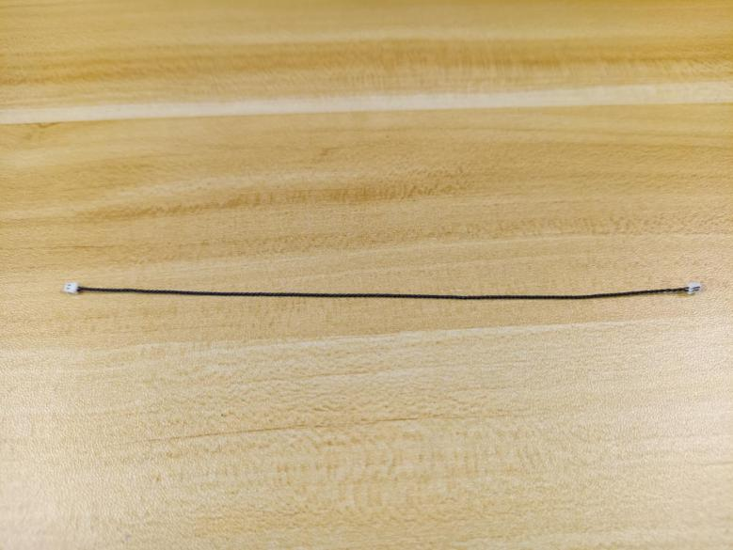

Connect the 2 expansion boards together.
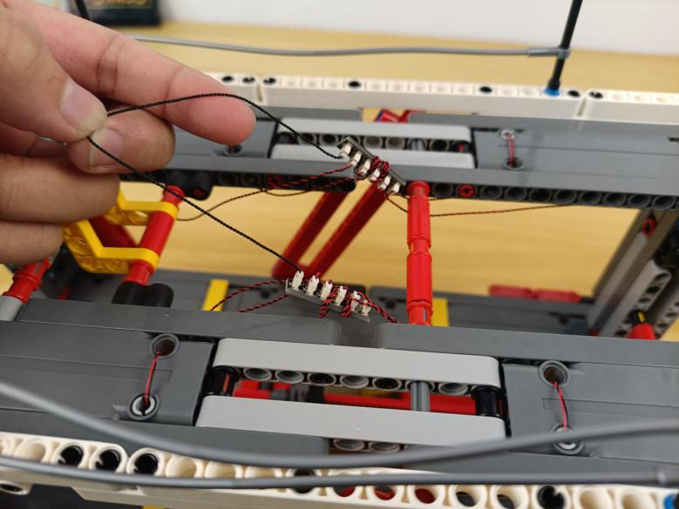

Take a 50cm connecting cable.
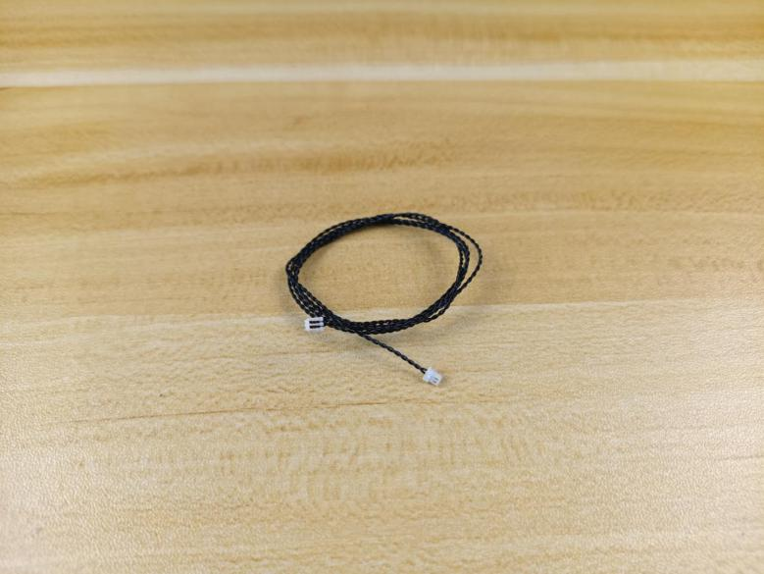

Connect it to the following expansion board.
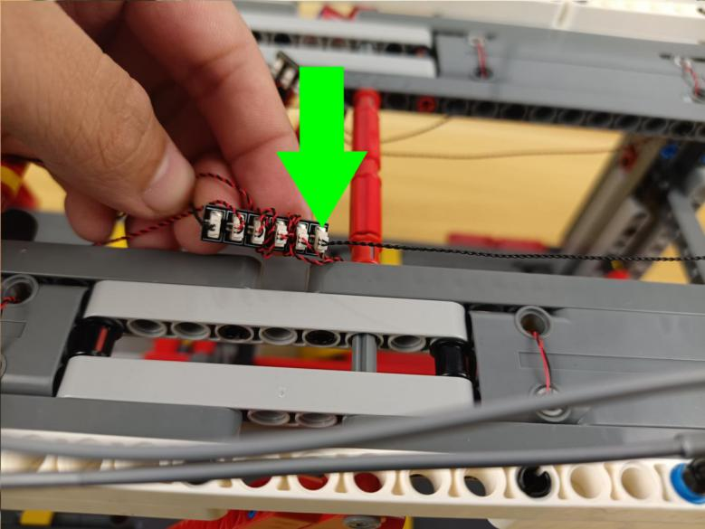

Thread the cable through the follwoing hole to the outside.
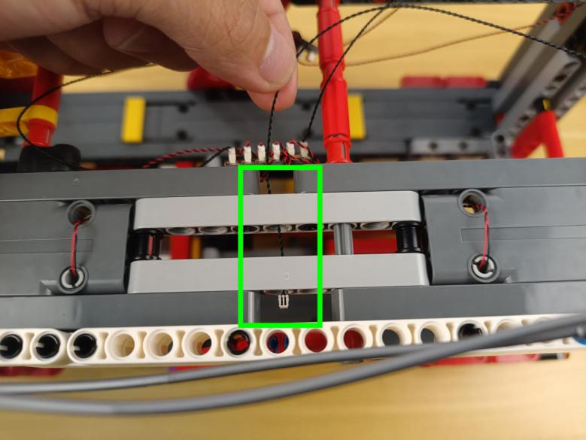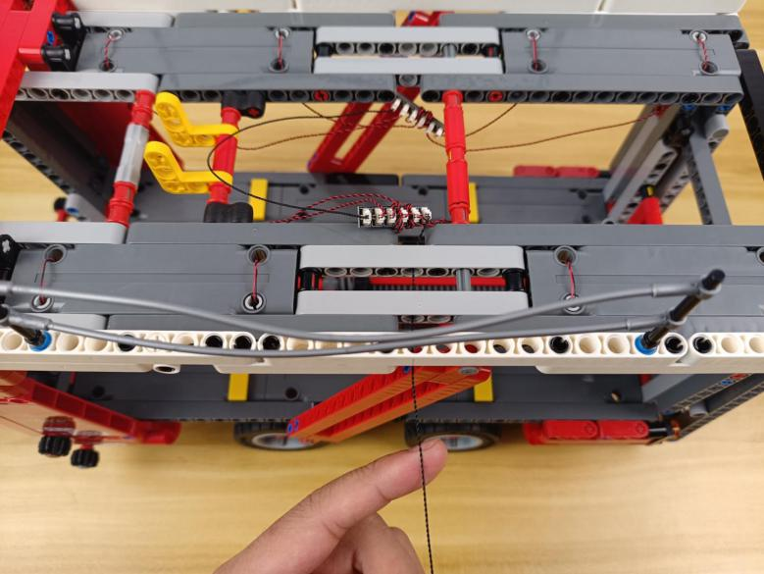

Take 4 adhesive squares.
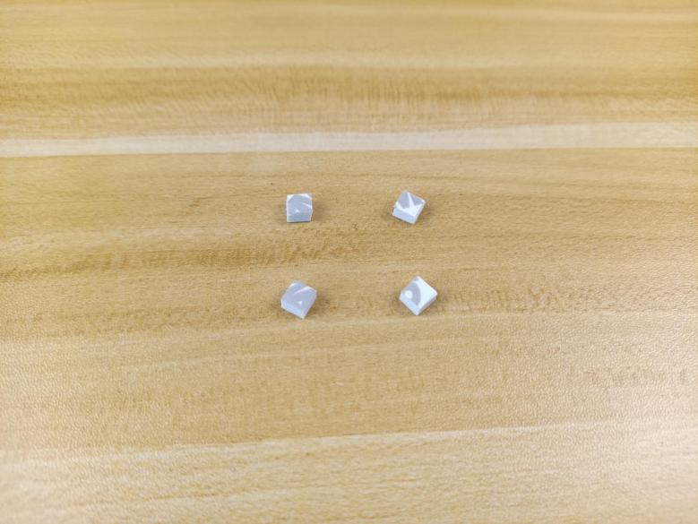

Stick them to the backs of the expansion boards, and stick the expansion boards to the following places.
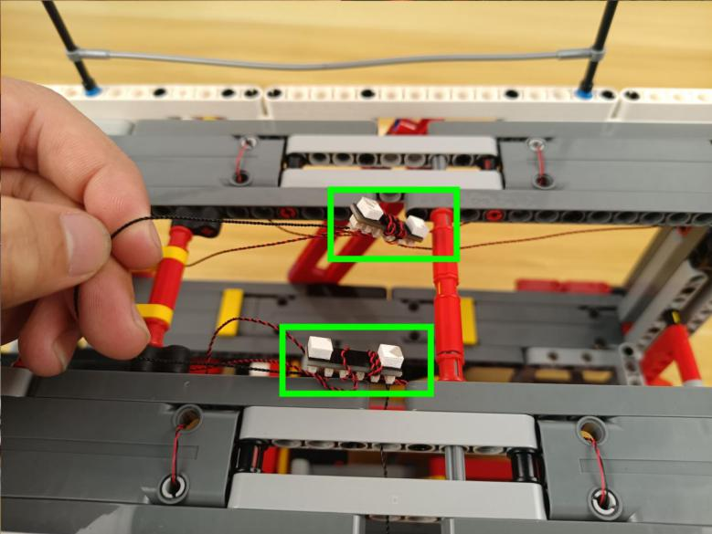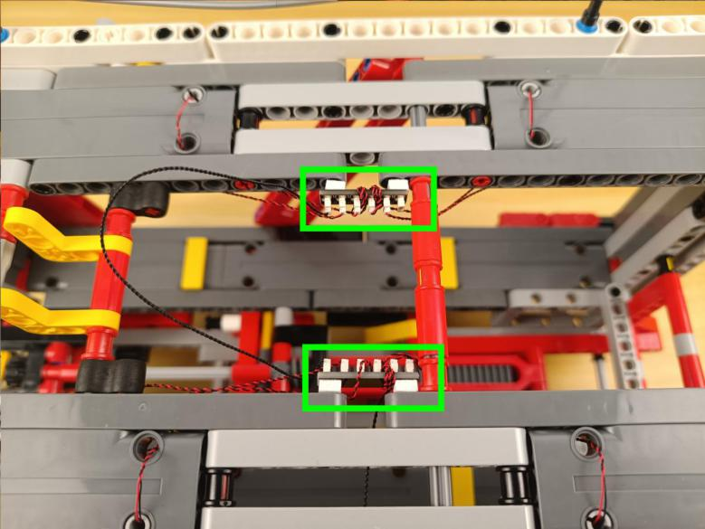

Tighten excess cables up.
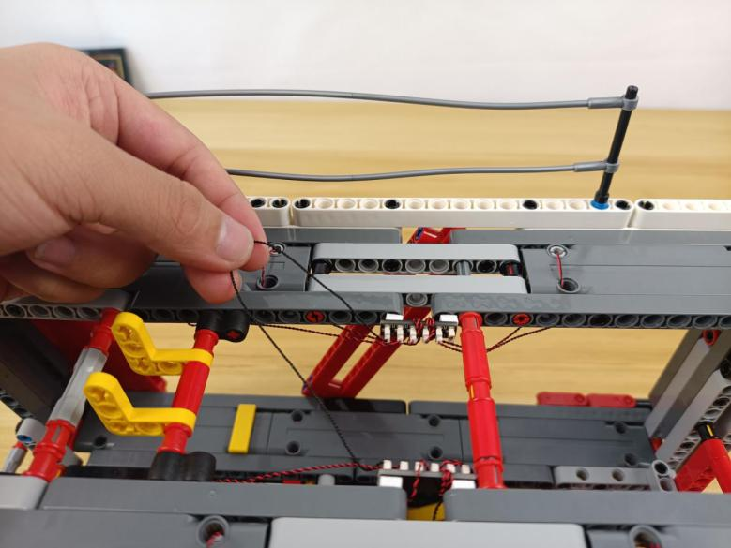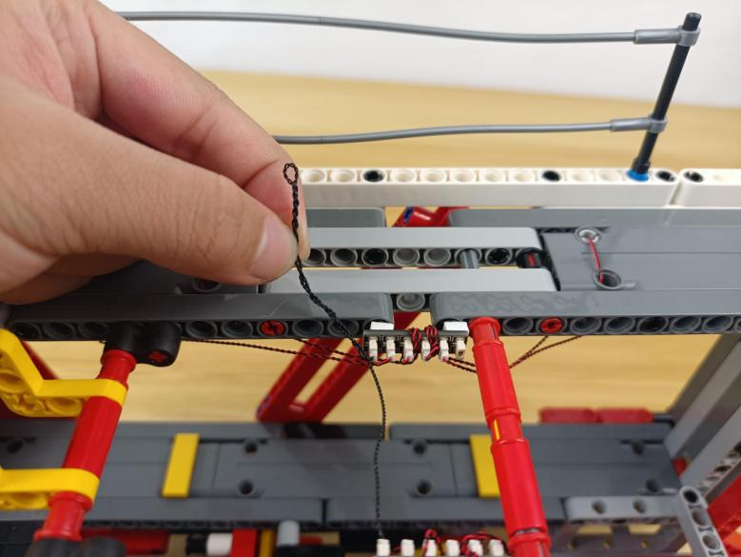

Tuck the cable as per below.
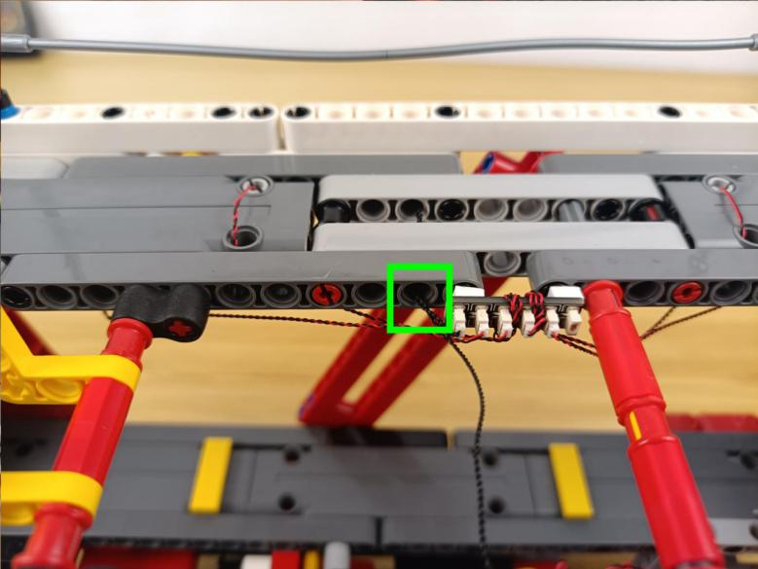

Thread the following 50cm connecting cable through the folloiwn space.
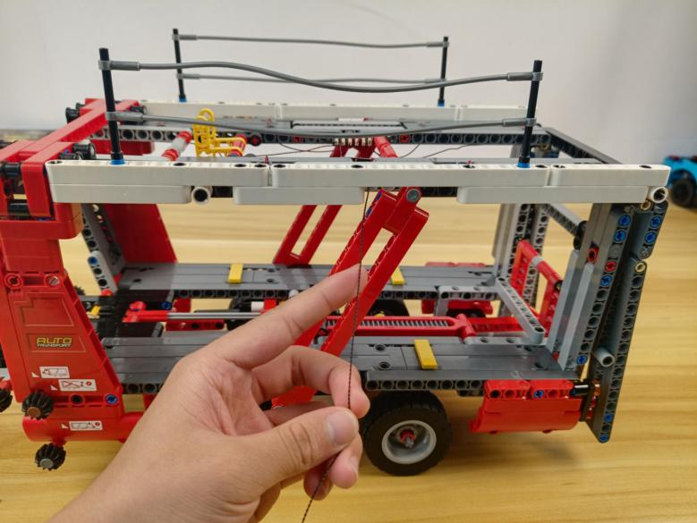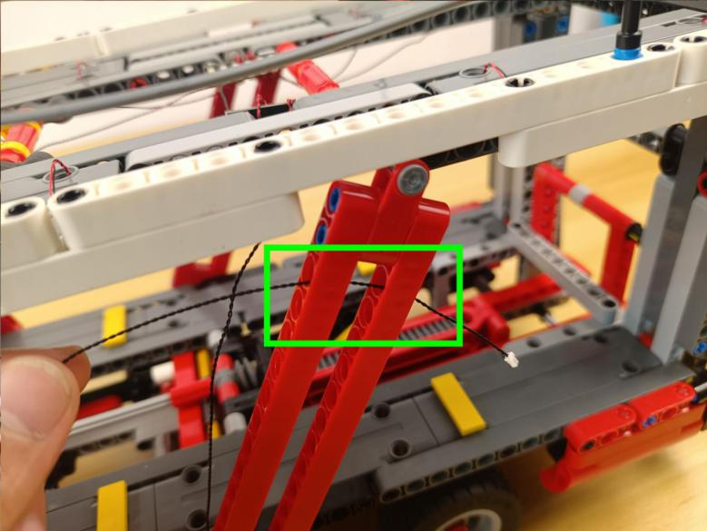

Tighten the cable up.
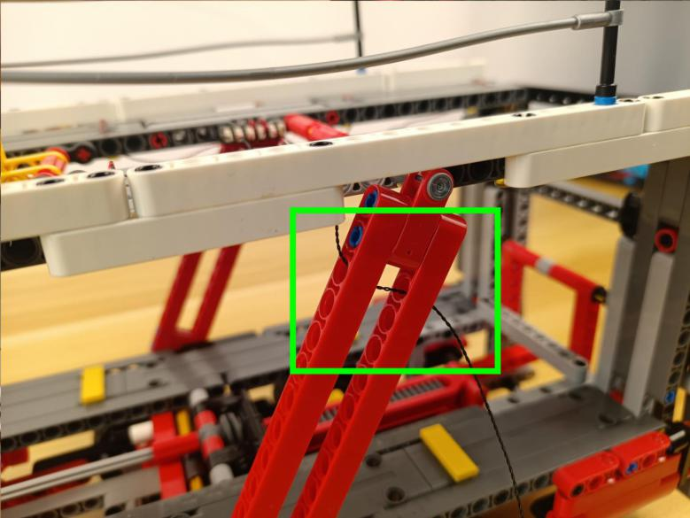

Continue to thead it through the following hole.
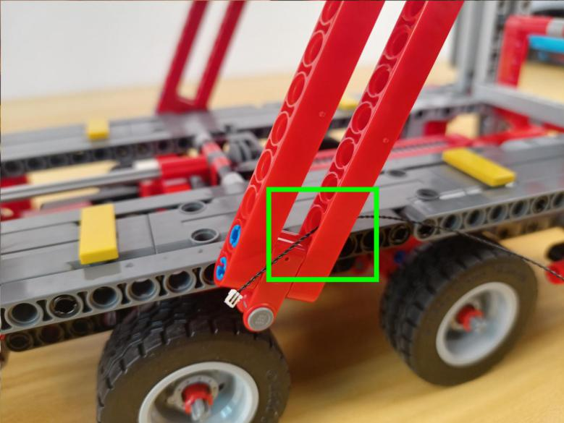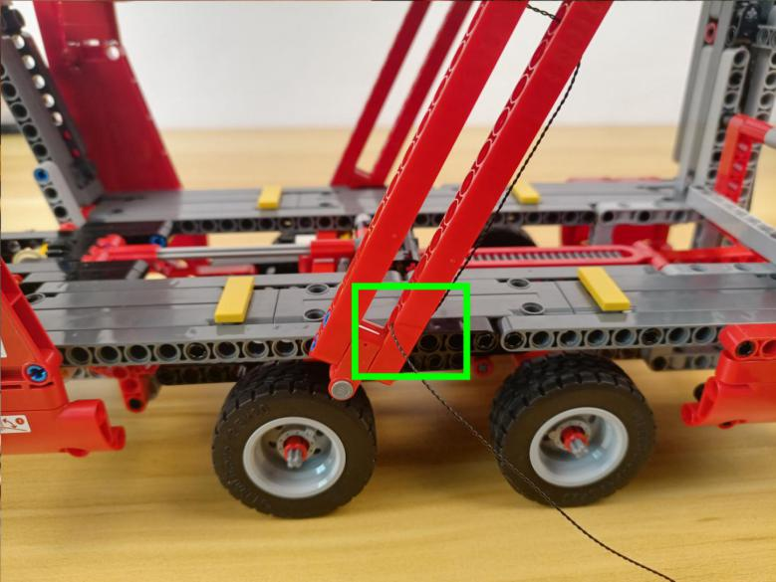

Thread it to the inside.
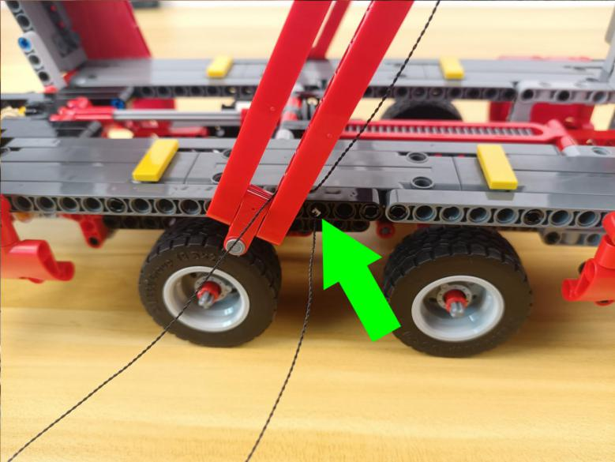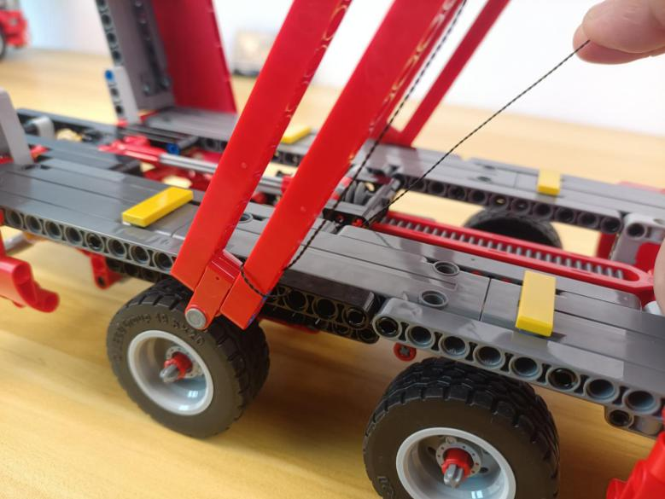

Continue to thread it down to the bottom.
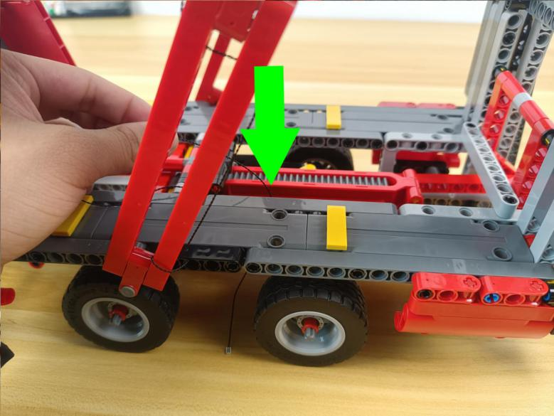

Turn to the tail.
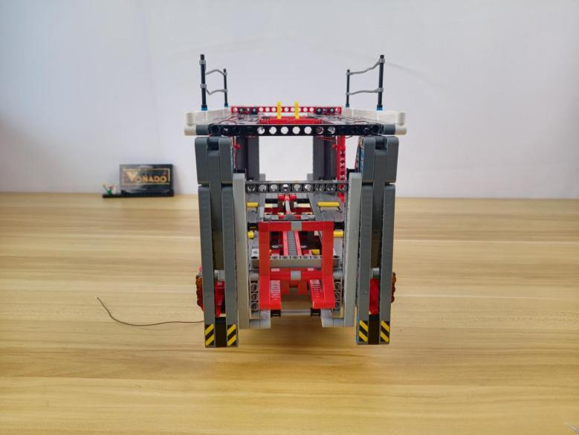

Remove the left taillight piece.
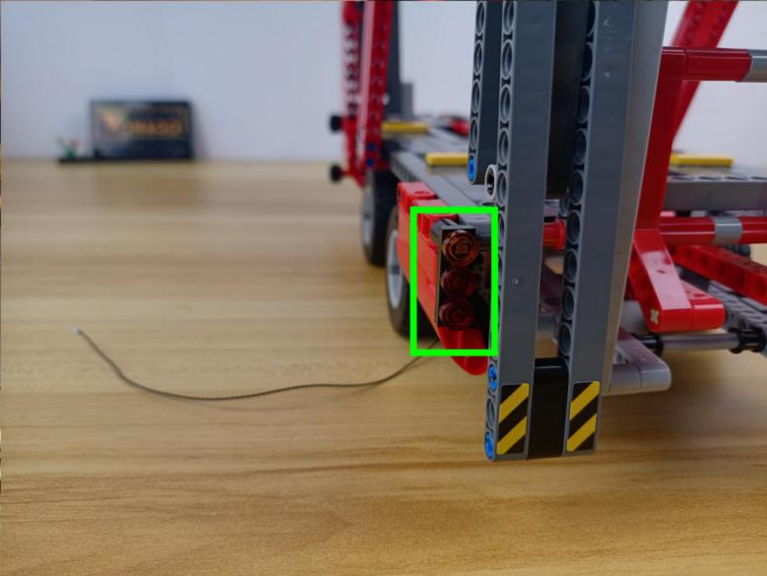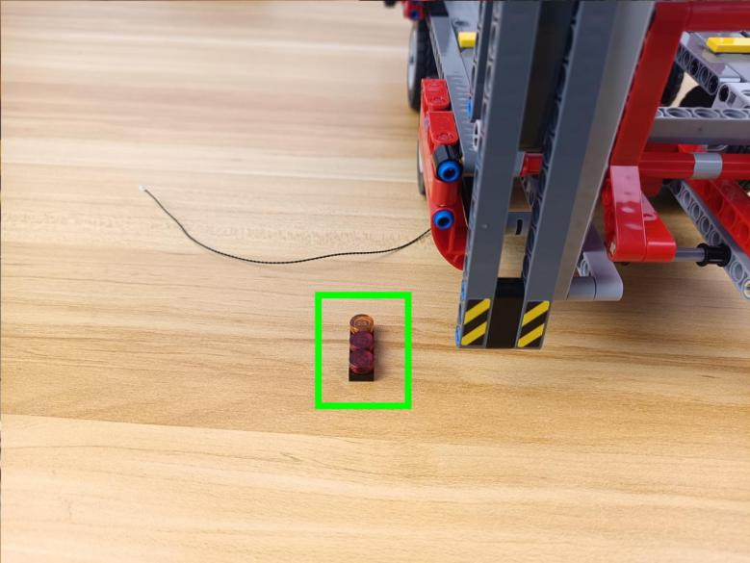

Remove the right taillight piece.
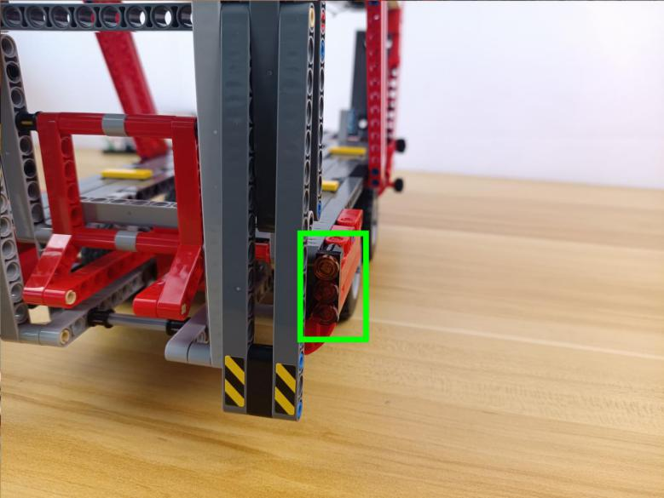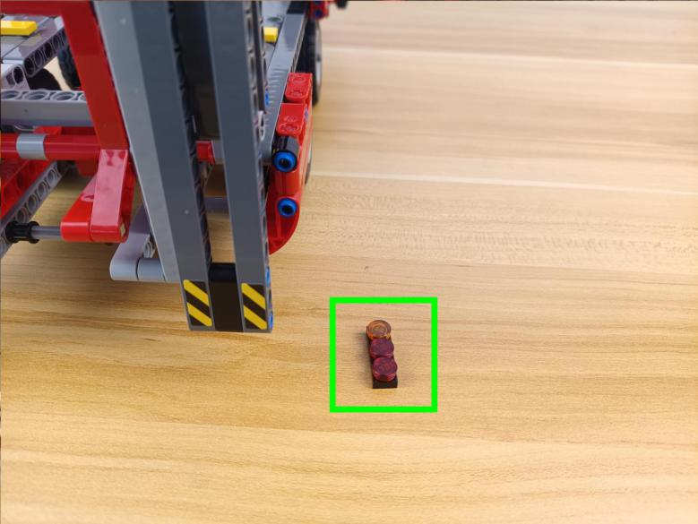

Disassemble them.
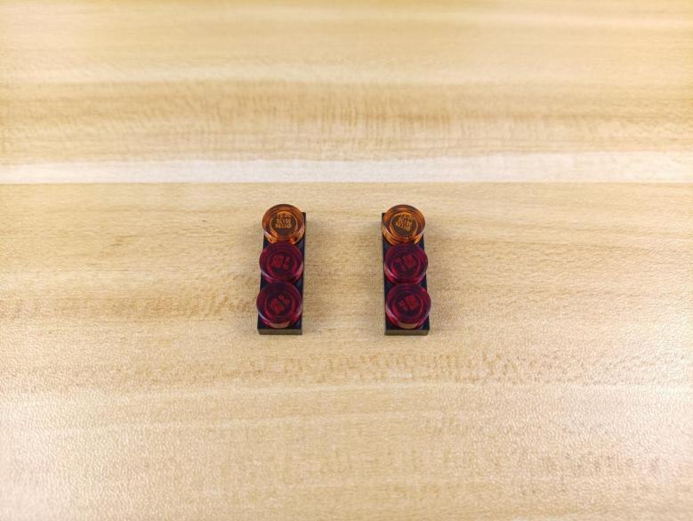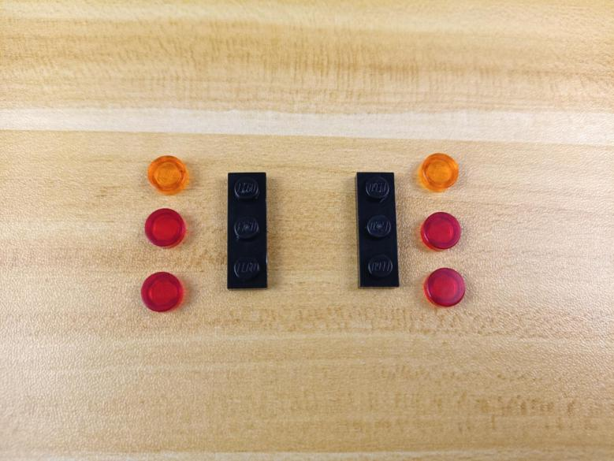

Take 2 warm white 15cm dot lights, 2 trans orange 1x1 round plates with opening.
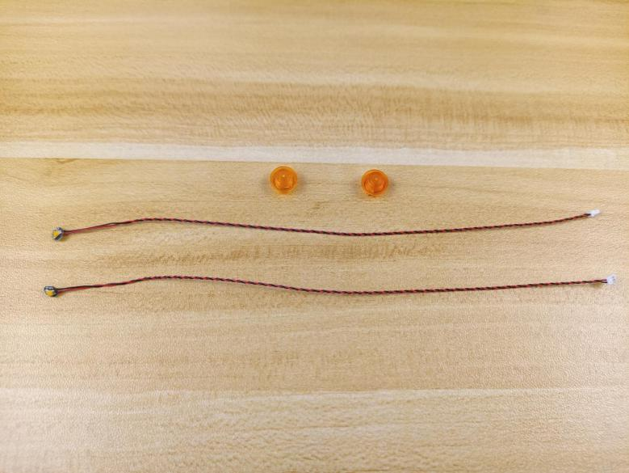

Place the light as per below, connect the round plate over.
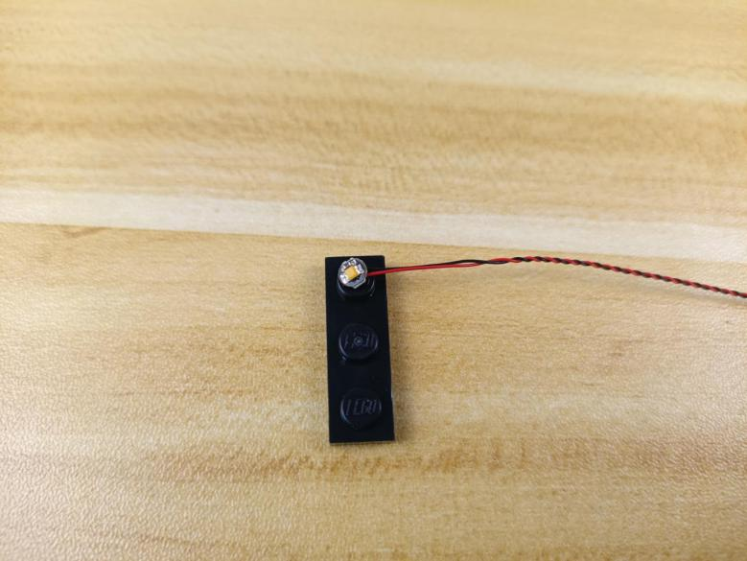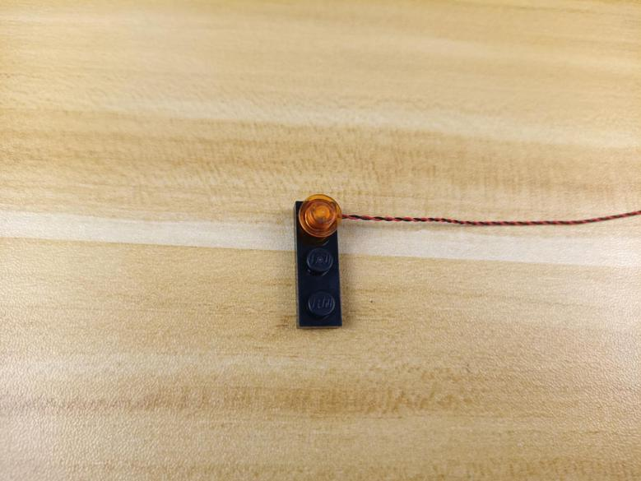

Stuck the cable at the opening.
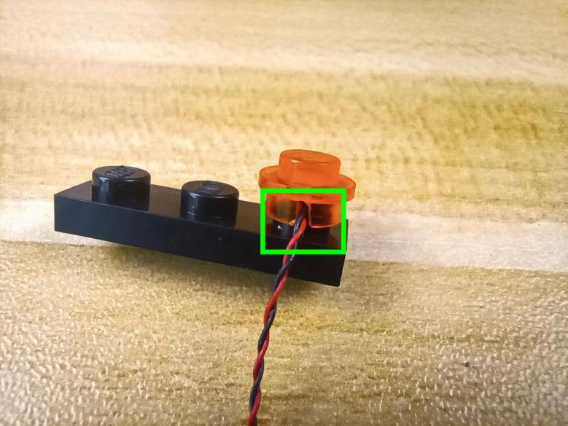

Install the other light in the same way.
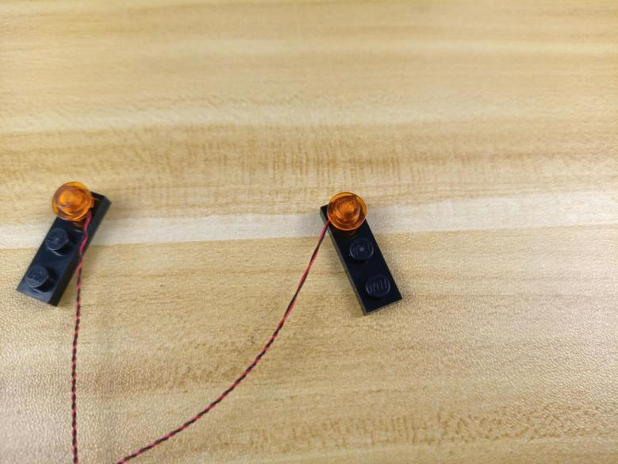

Take 4 red 15cm dot lights, 4 trans red 1x1 round plates with opening.
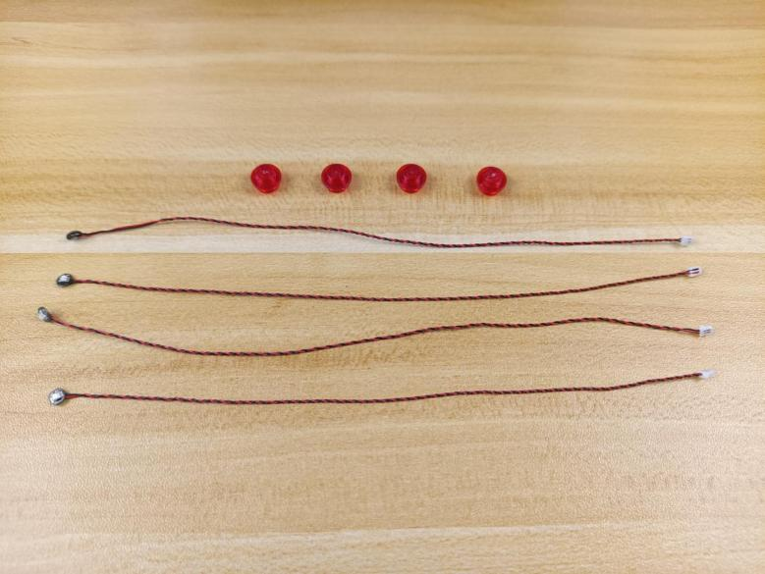

Install the lights at the follwoing places as we did before.
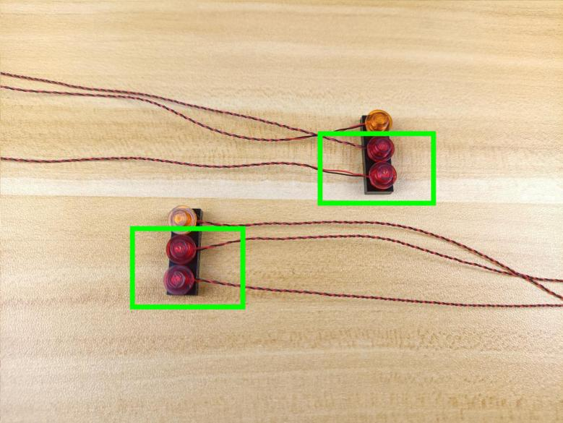

Group the cables together respectively.
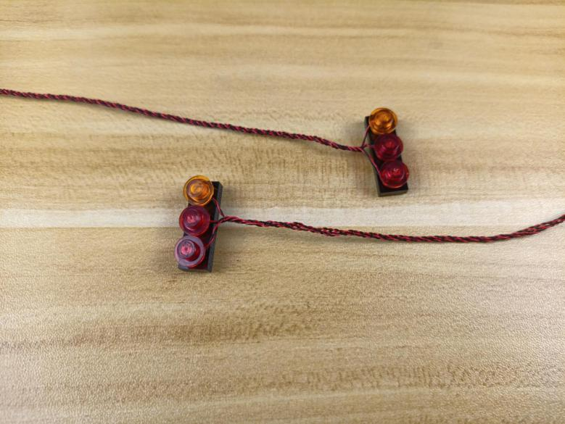

Reconnect them.
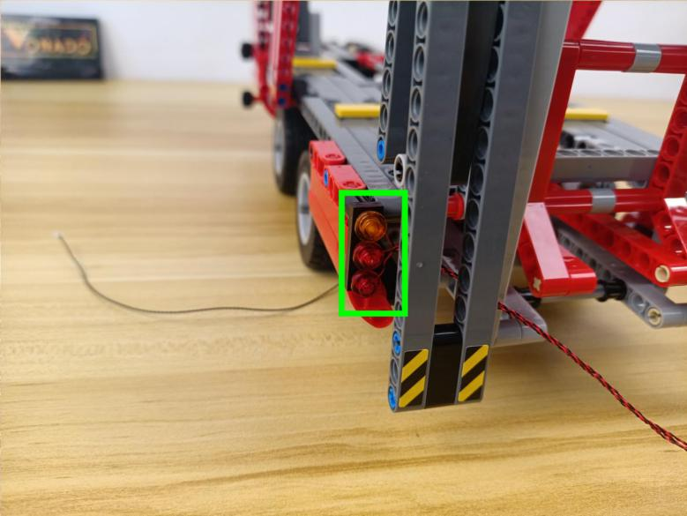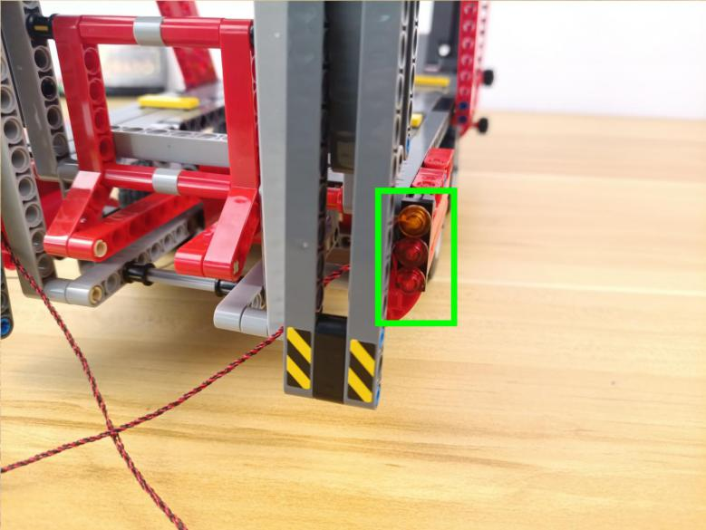

Turn the car over.
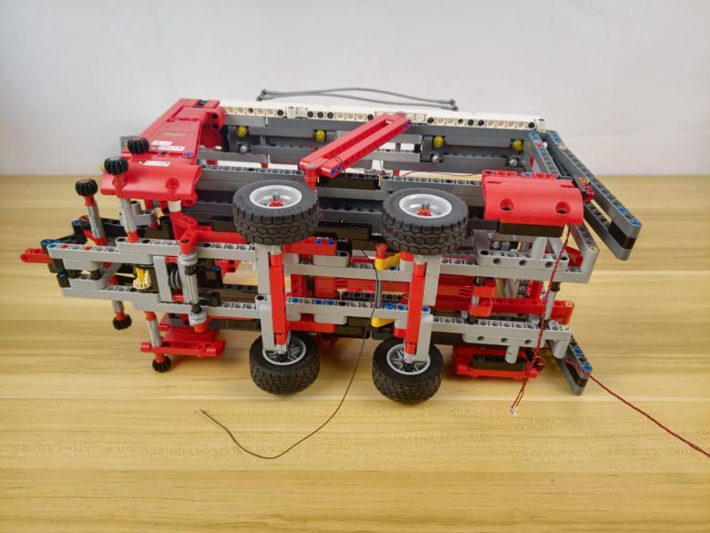

Thread the cables of the taillights through the follwoing hole.
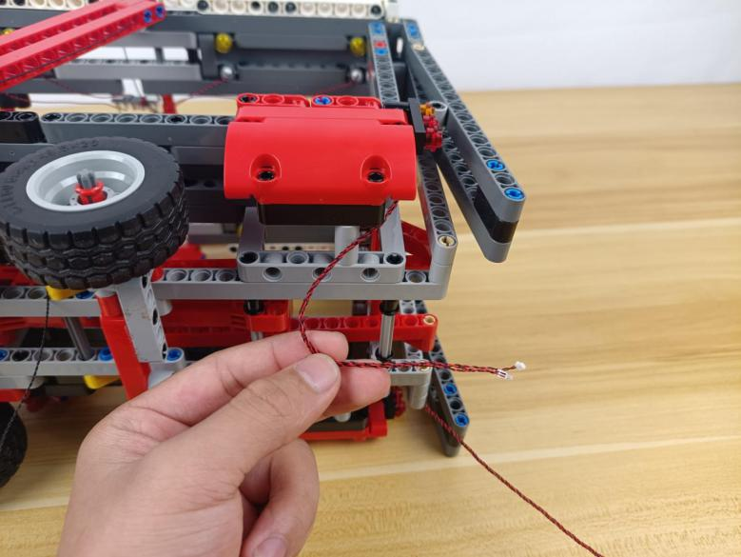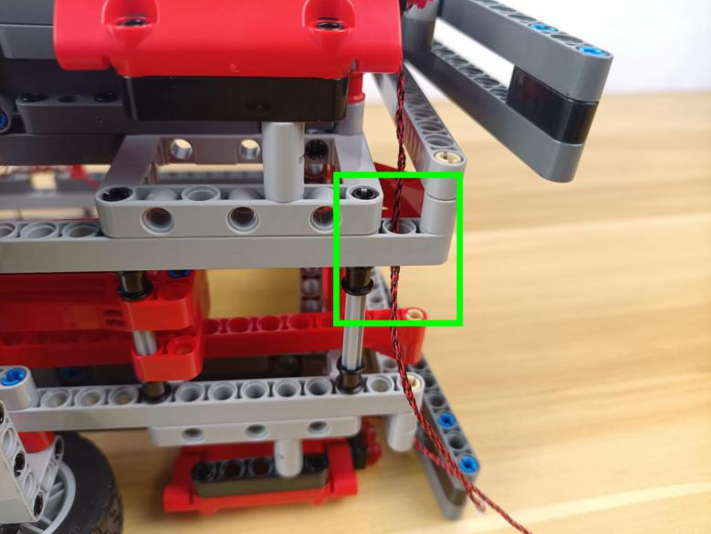

Wind them around the following piece.
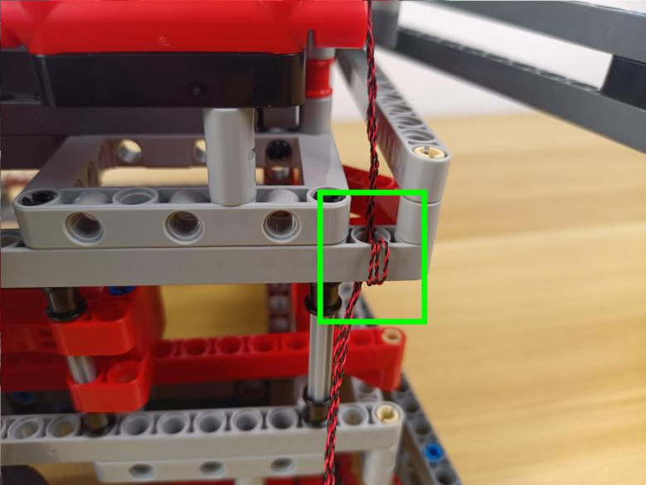

Place the following cables similarly.
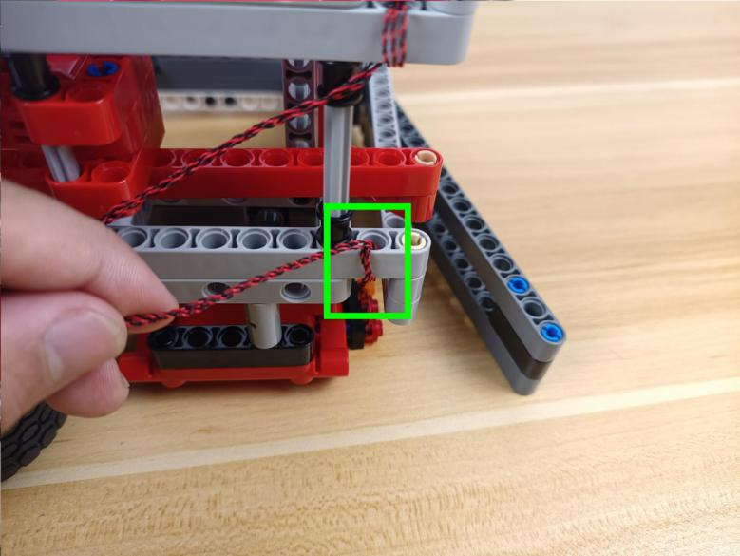

Take an 8-port expansion board.
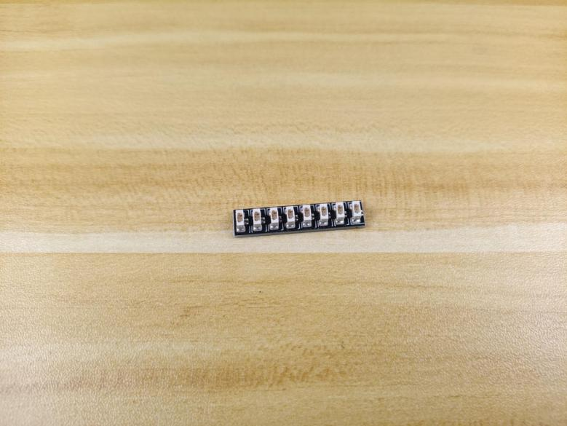

Connect the cables of the taillights to it.
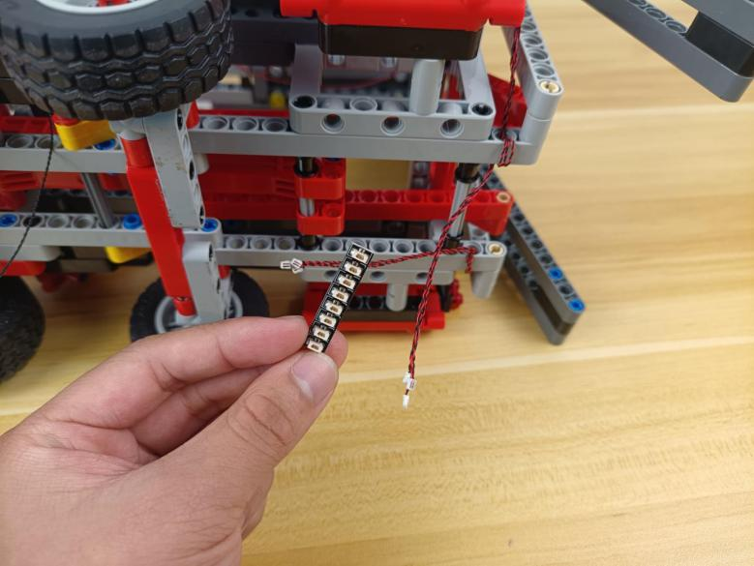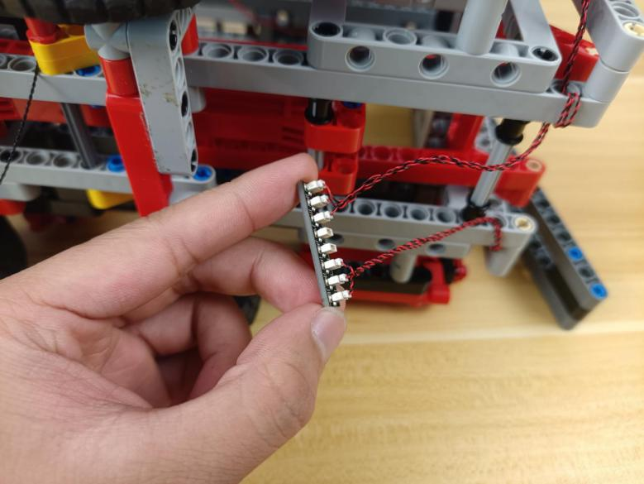

Take the following cable from the bottom.
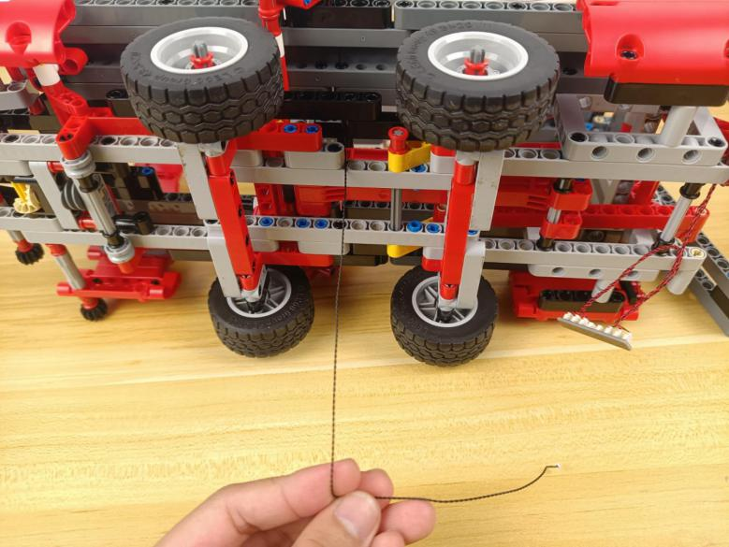

Thread it through the following space and wind it aroud the piece.
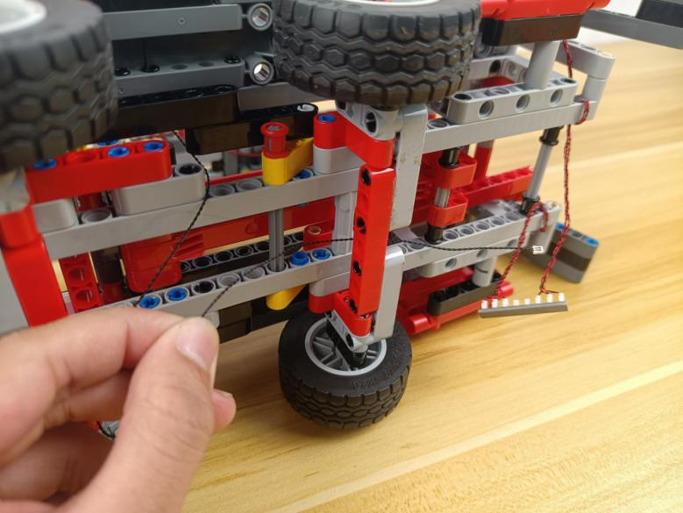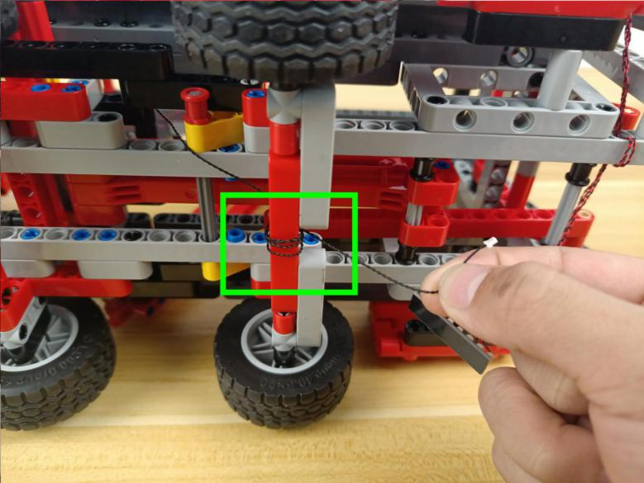

Connect it to the following expansion board.
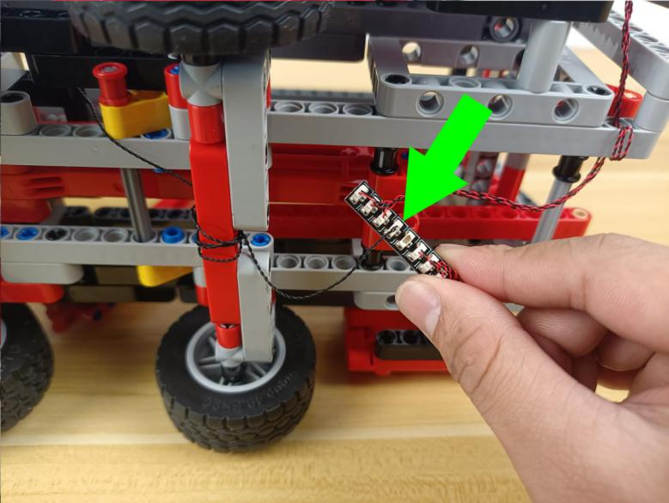

Take a 50cm connecting cable.
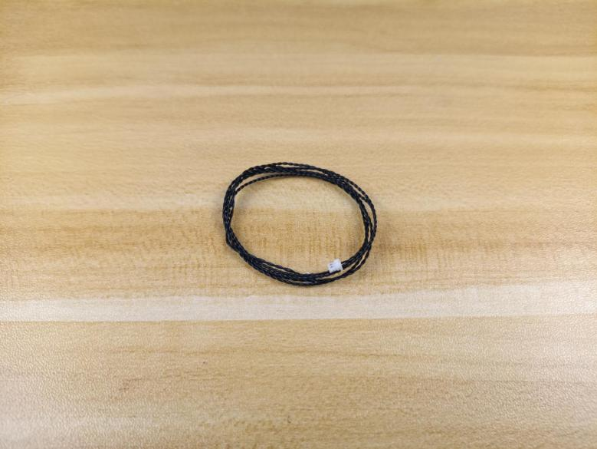

Connect it to the following expansion board.
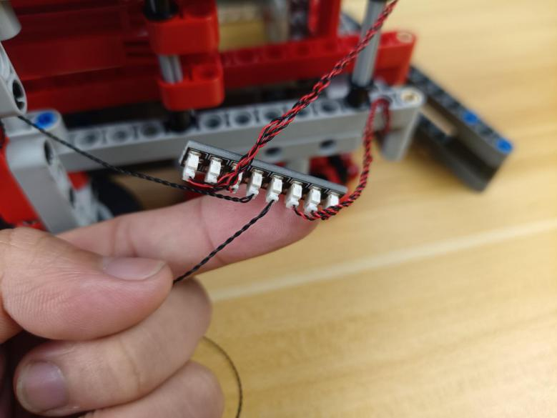

Take 2 adhesive squares.
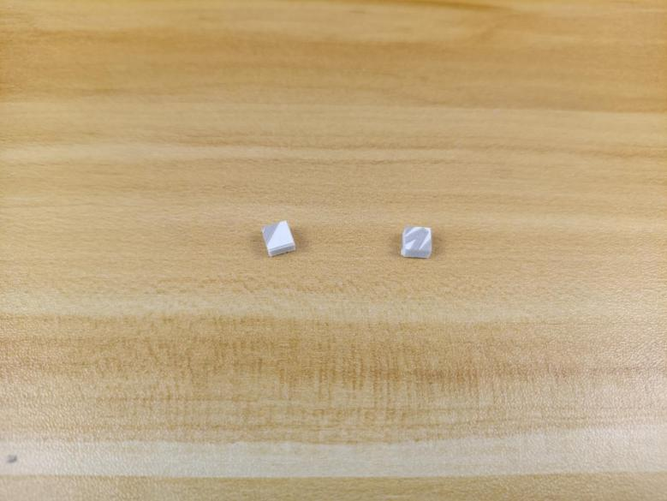

Stick them to the following places, and stick the expansion board to them.
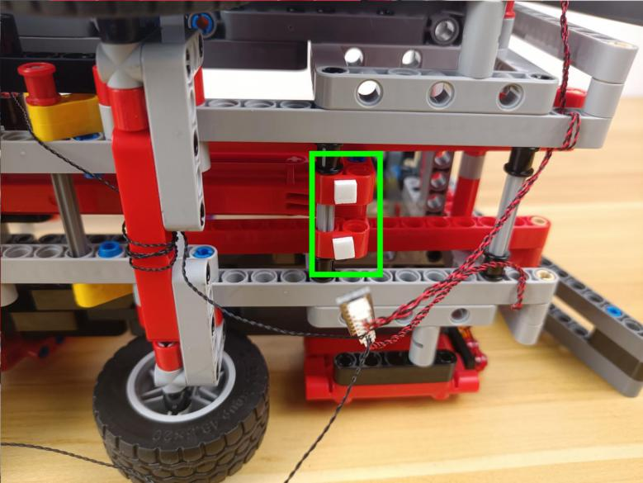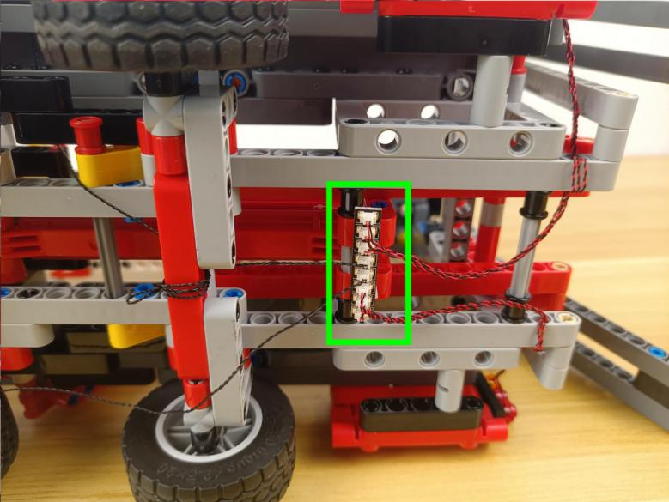

Pull the 50cm connecting cable from the expansion board to the front.
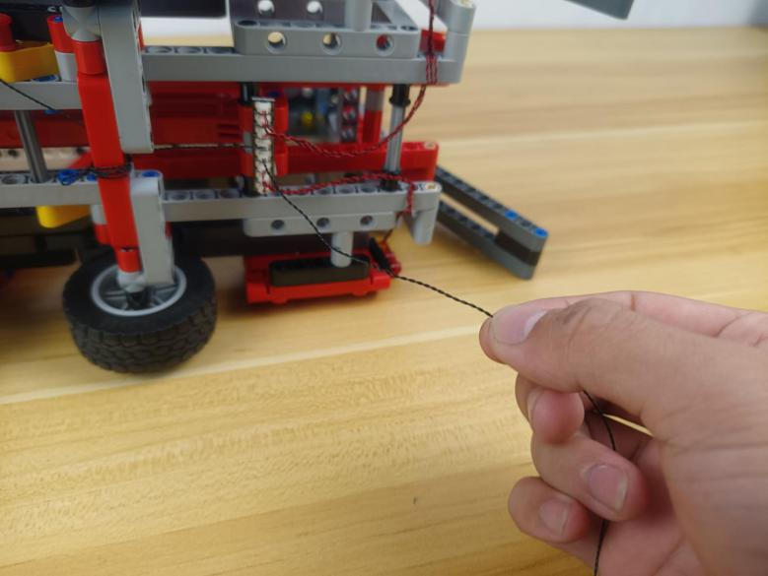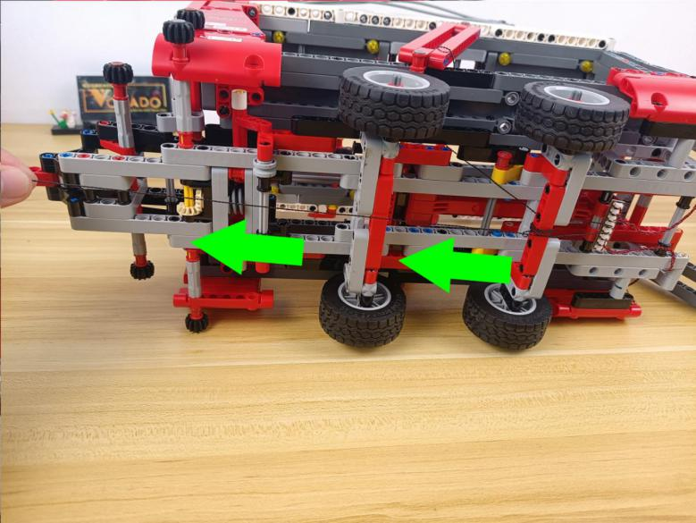

Wind it around the following piece several times.
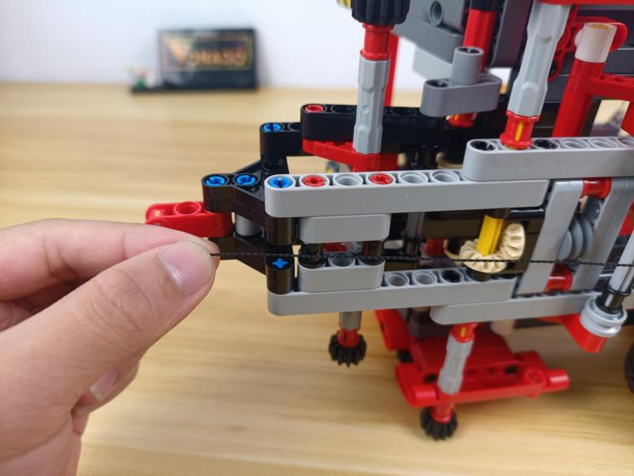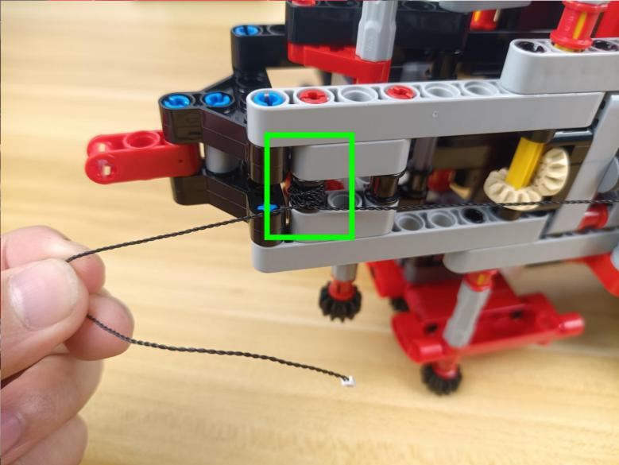

Take the B part.
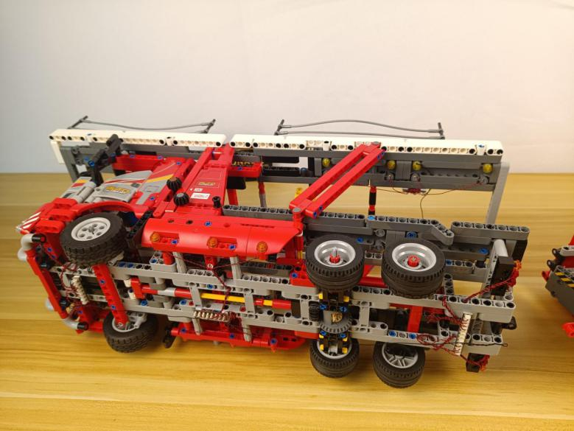

Connect the 2 parts together.
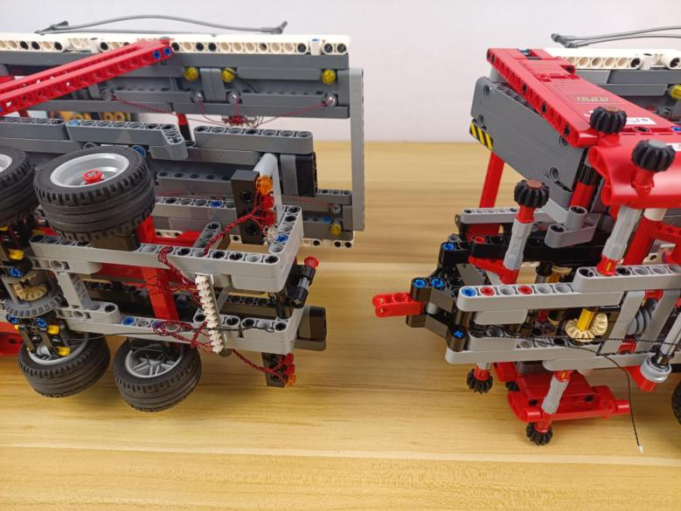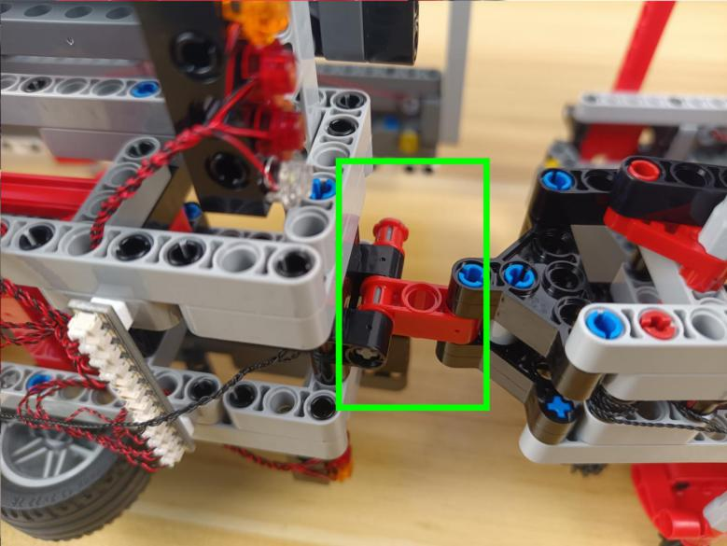

Connect the following cable from the C part to the 12-port expansion board at the B part.
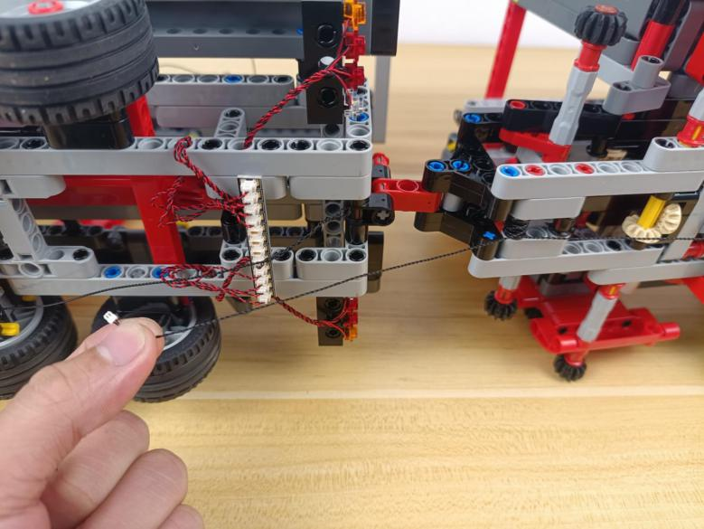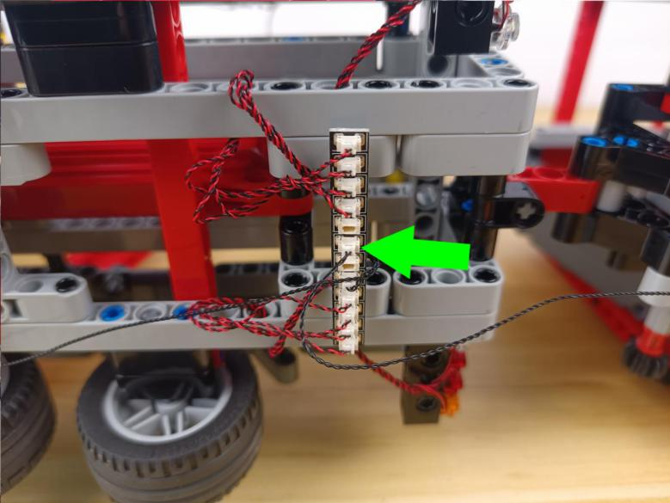

Take a USB cable.
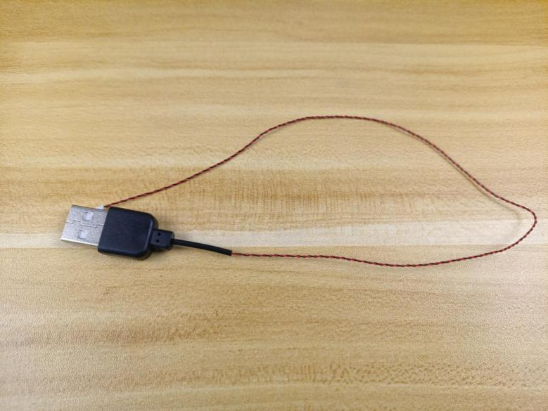

Connect the USB cable to the expansion board.
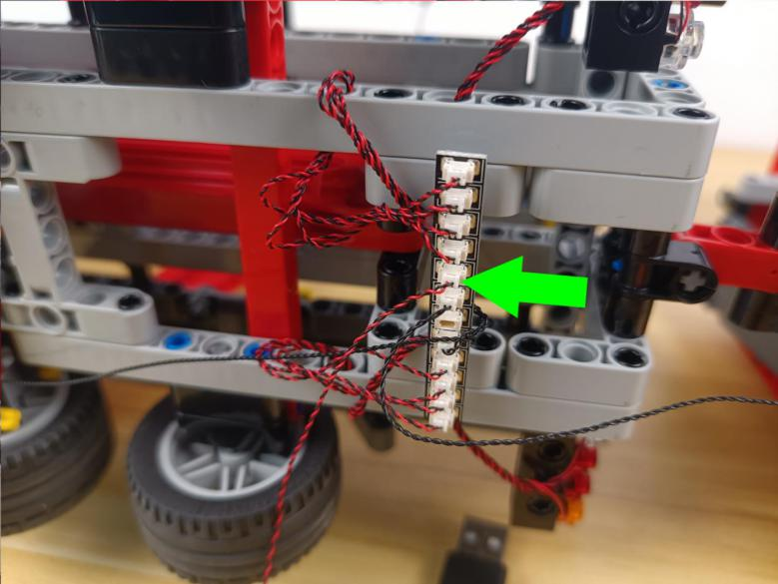

This completes installation of this LED Lighting Kit. ENJOY!
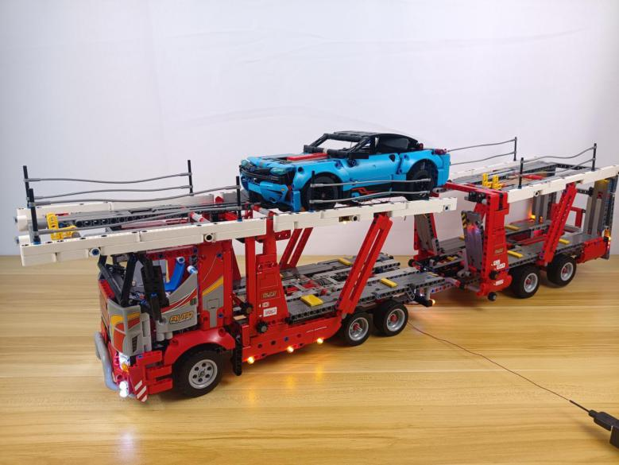

The above are ideas and instructions provided by our designers. Please move on:
1: Do you have any suggestions about the material and quality of our products?
2: Do you have any suggestions on the installation instructions and the degree of difficulty of the installation?
3: If you have better installation method and ideas, please contact us in time.

