Lighting Kit LEGO 10276

Thank you for choosing our lighting products. We are committed to LEGO product study and lighting development, we're always trying our best to provide LEGO fans with the best products and the best installation ideas.
Must be careful observation, imagination can be infinite.
We provide basic parts to support your imagination.
DO IT YOURSELF .that's what LEGO is .

As always, Lego has been adhering to the DIY philosophy from product selection, research and development to sales. Consumers buy the parts, you will assemble them by yourself, and you can experience every step from picking up the first piece to installing the last one. Besides, LEGO has different answers for the installation form and method of each part. Vonado lighting also does not want to kill your unlimited creativity, we will try our best to make products with high variability, high playability and unlimited play. If you have any dissatisfaction or your own ideas on the parts such as the color of the lights, the length of the cables, the installation position of the product, and the final effects of each module, you can make your own arrangement, and we will cooperate with you to replace or repurchase.
LETS MOVE!

Package contents：
- 11 x 30cm Warm White Head Lights
- 5 x Multi Colour Background Lights
- 18 x 15cm Warm White Strip Lights（with 28 lights）
- 1 x 5cm Connecting Cable
- 1 x 15cm Connecting Cable
- 10 x 30cm Connecting Cables
- 7 x 50cm Connecting Cables
- 10 x 4-port Expansion Boards
- 4 x 6-port Expansion Boards
- 1 x Acousto-optic Control Switch Board
- 1 x USB Cable
Extra pieces
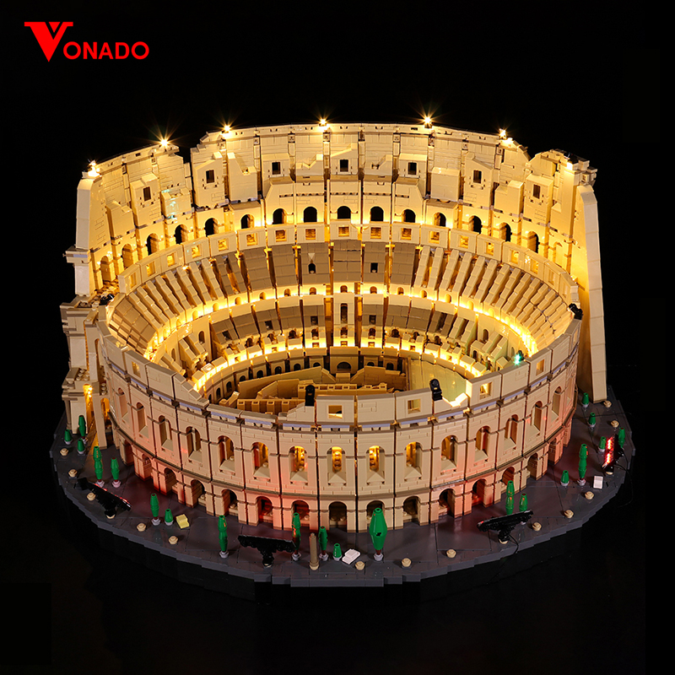
Note:
Place wires on the surface or under the building blocks.
The wire can be place between the building blocks or under the block, but they should be placed between the studs correctly.

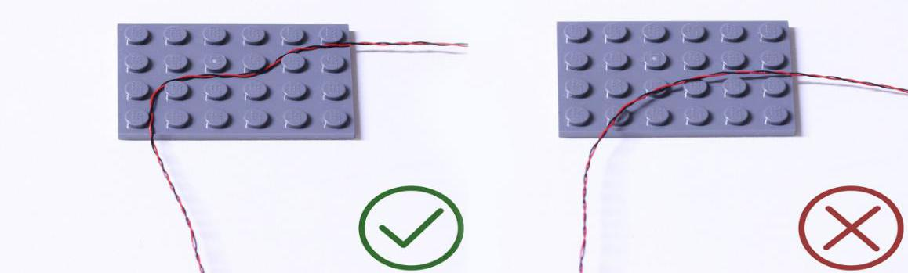

Insert the connectors to the ports.

Be careful when you are operating, there’s only one correct way to insert, make sure the expansion board is upward, find the soldered “=” sign on the left of the port. When you are inserting, the side which the wires can be seen should be faced to the “=” sign and if you feel hard to insert, please stop, and don’t force it, for that may result in bent pins inside the port or overheating of the expansion board.

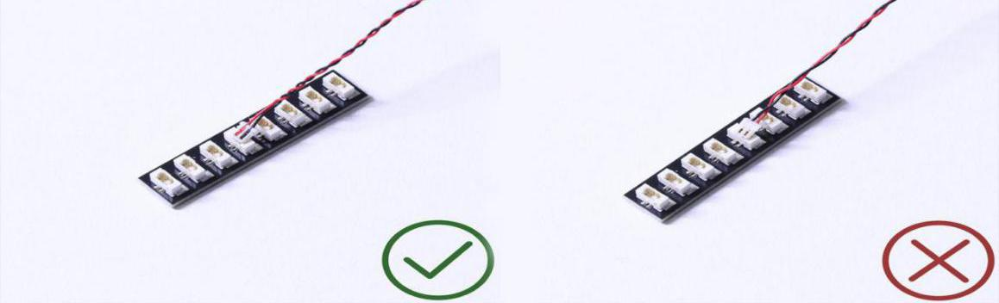

At this point, use the tweezers to straighten the bent pins.

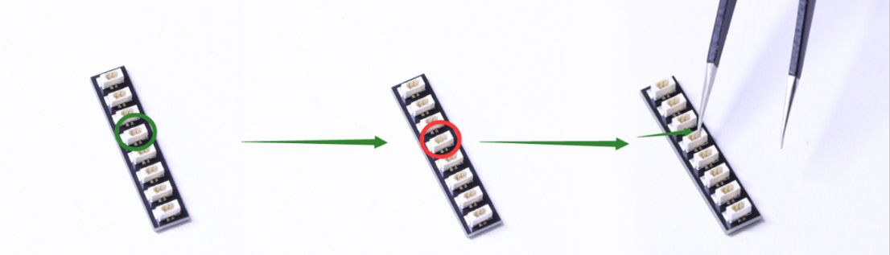

When installing dot lights, make sure they are correctly placed (Yellow LED package is exposed). You can put they either on the top of the studs or between studs.

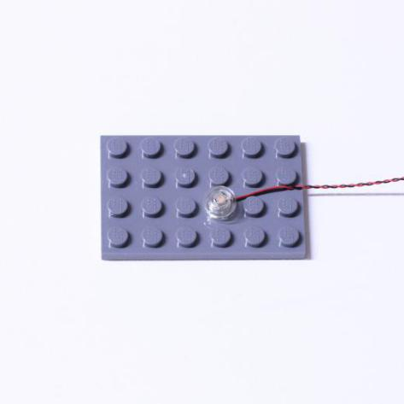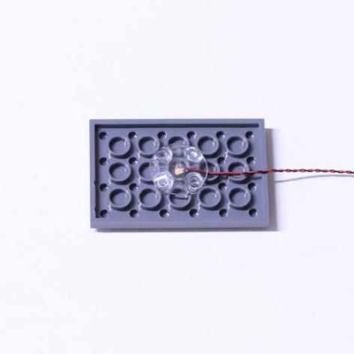

Connecting cable connectors to Strip Lights

Take extra care when inserting connectors to ports on the Strip Lights. Connectors can be inserted only one way. With the Strip Light facing up, ensure the side of the connector with the wires exposed is facing down. If a plug won’t fit easily into a port connector, don’t force it. Doing so will damage the plug and the connector.

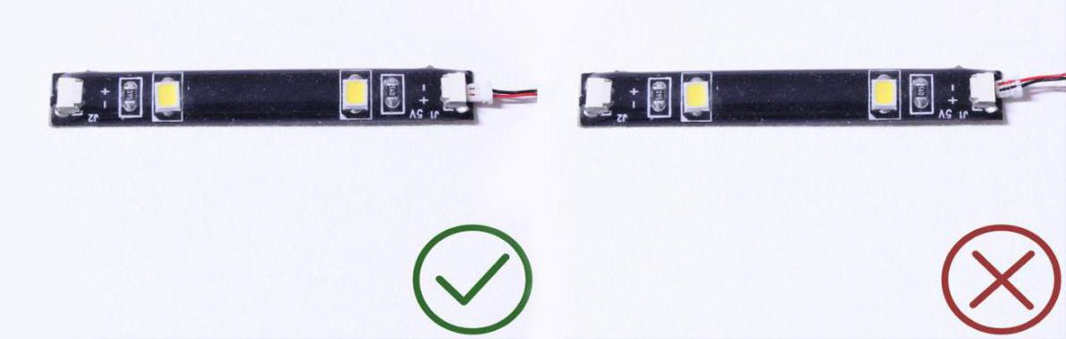

Finally, please pay attention to the positive and negative terminals of the battery when installing the battery case.

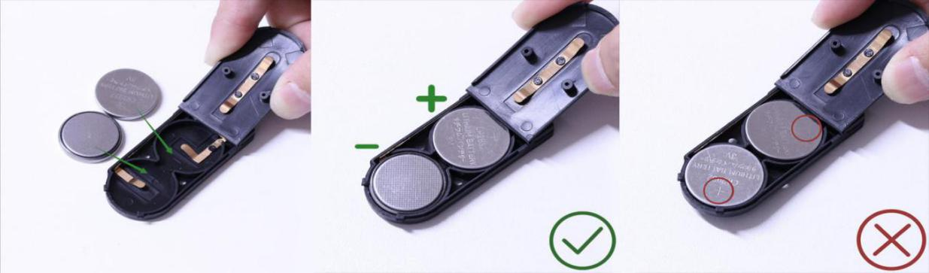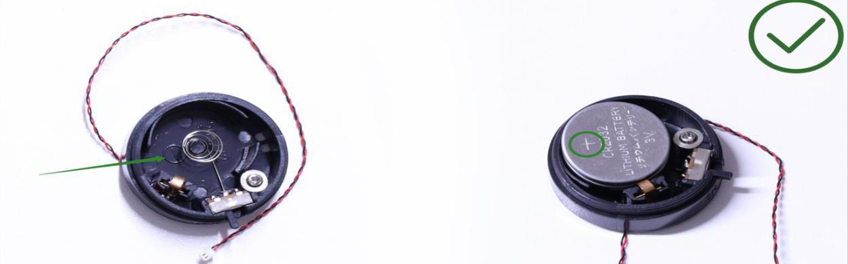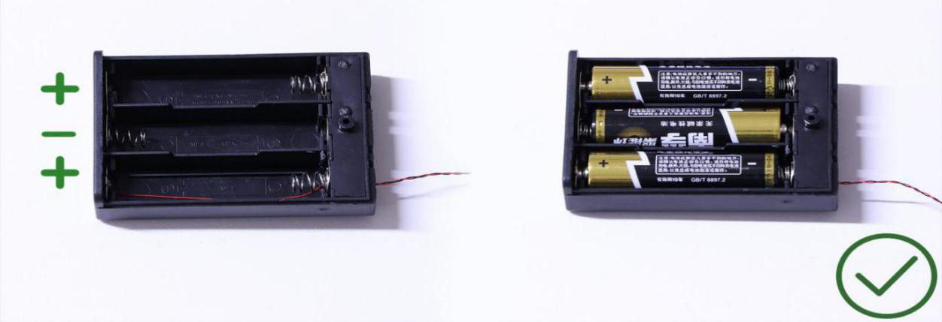
Instructions for installing this kit：
The Roman Colosseum, Acousto-optic Control Version, Lighting Kit, 12 bags in total.
Power supply： USB cable (self-contained power bank or mobile phone charger).
Firstly, take the power source (power bank or mobile phone charger), connect it to the USB cable, connect the other end of the USB cable to the expansion board to verify all the lights one by one.
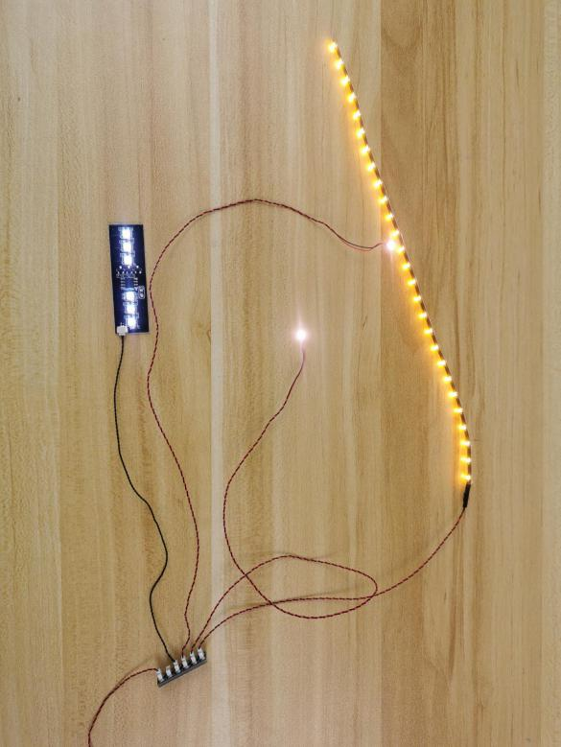
After the verification, disconnect the lights and put them back to the bags.
（note: put the lights back to the bags when verification of the lights from the same bag is done, then, continue to verify the lights in another bag.）
OK, Let’s Begin! （you can use the tweezer if necessary.）
（Tips: the tweezer is sharp, you should be careful when using it, do not hurt yourself or scratch the pieces; be gentle and do not wear the cables.）
Instructions for installing this kit：
Start to install.
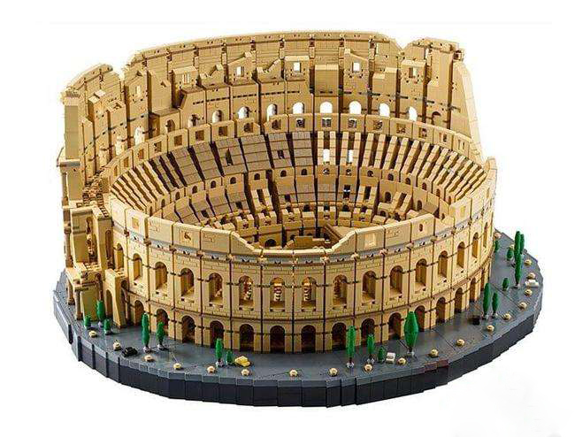

Take 11 black round hinge plate with handle, 11 black ladder vertical clamp plates.
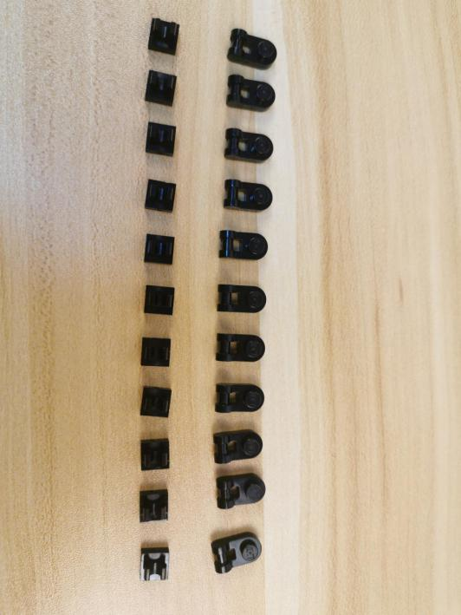

Assemble them respectively as per below.
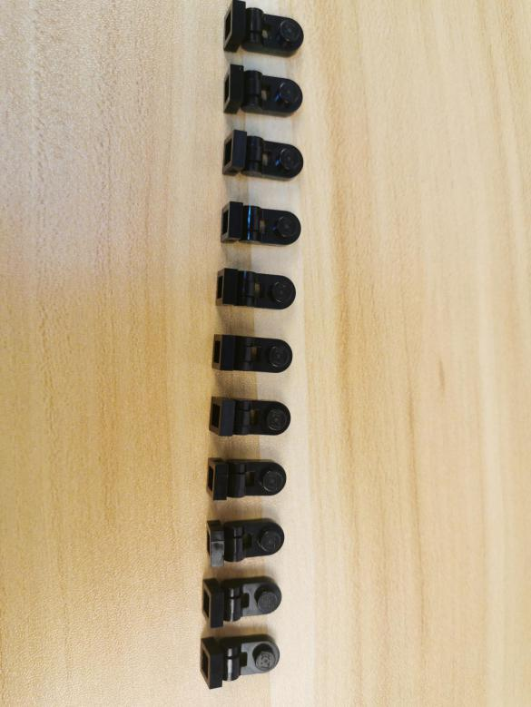

Take 11 head lights, 11 adhesive squares.
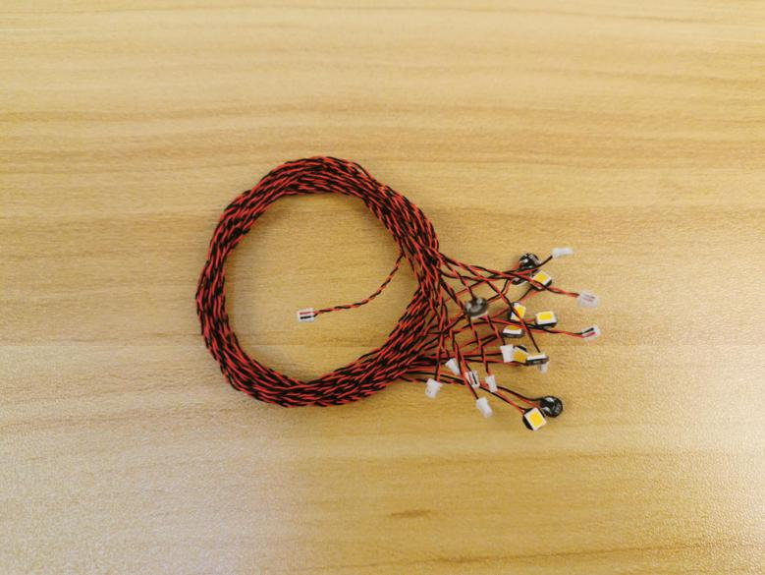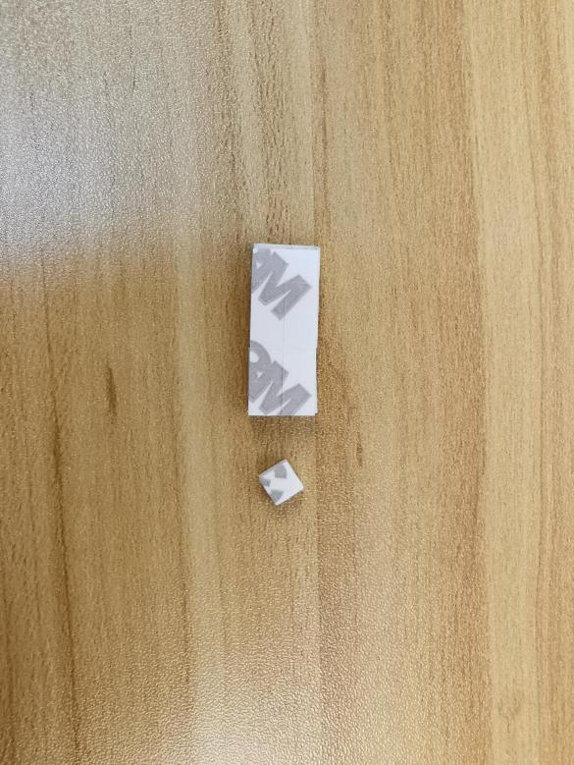

Take adhesive square to the back of the hinge plate.
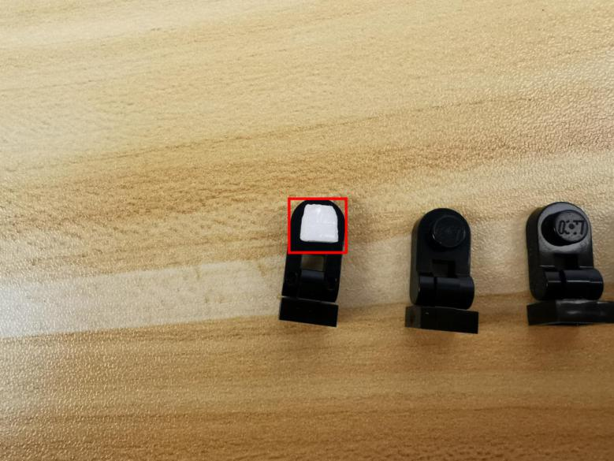

With lighting part facing up, stick the head light to it.
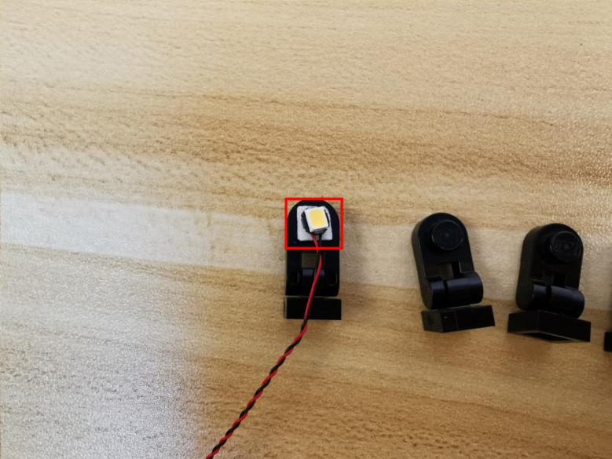

Thread the cable through the gap on the hinge plate.
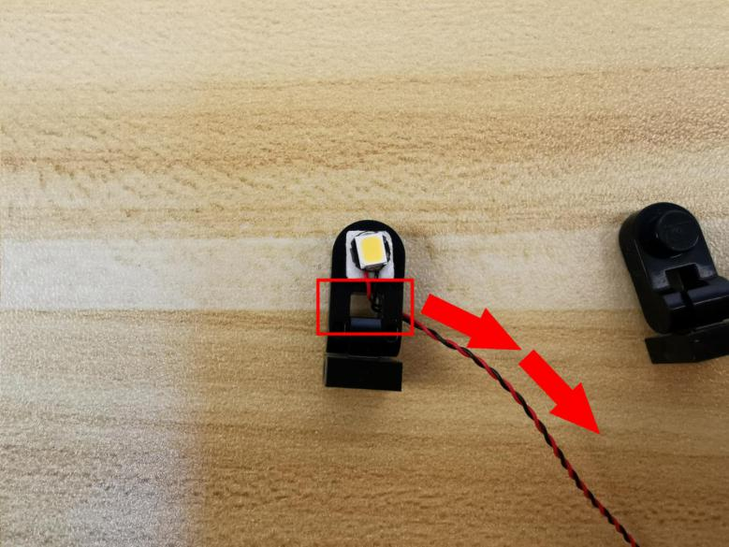

Install the other 10 lights in the same way.
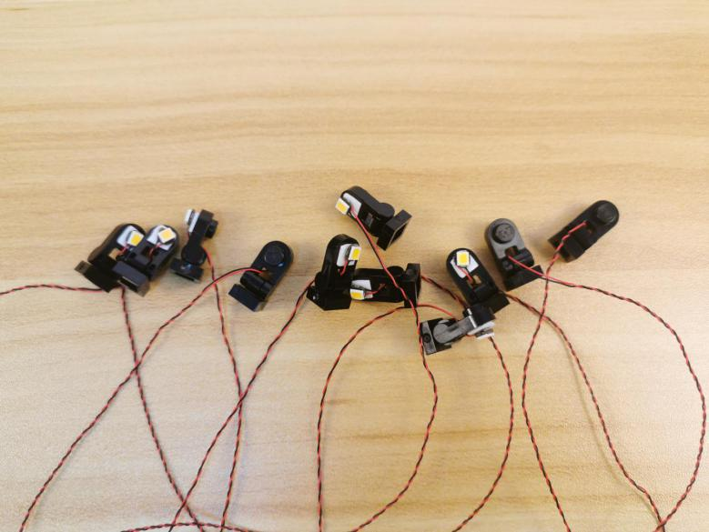

With lighting part facing the front, connect the 7 of them to the top of the Colosseum.
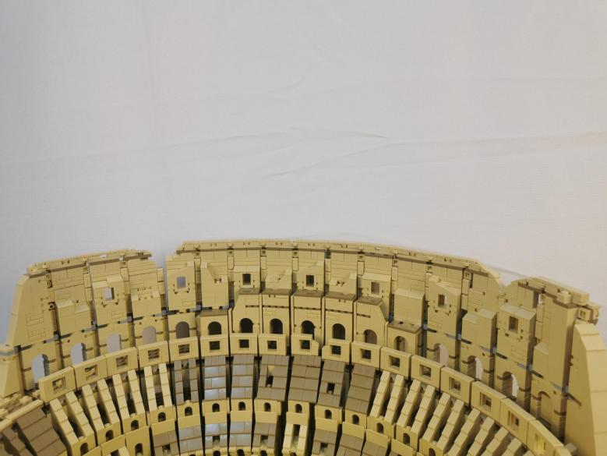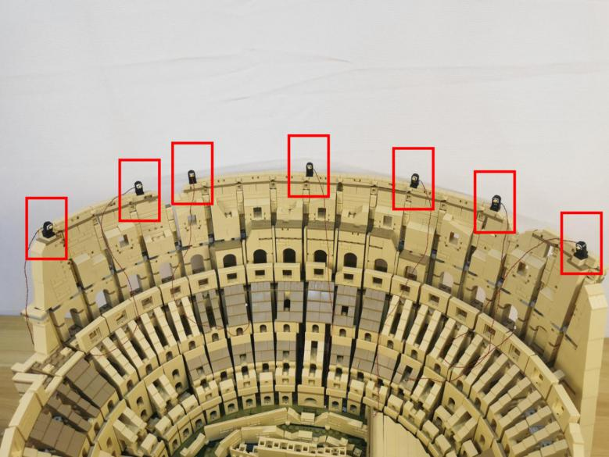

Connect the other 4 lights to the following places.
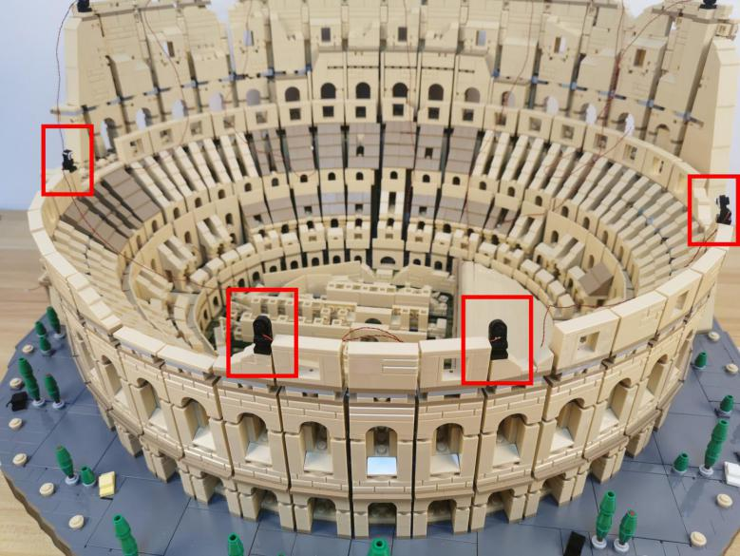

Take two 30cm connecting cables, two 4-port expansion boards assemble them as per below.
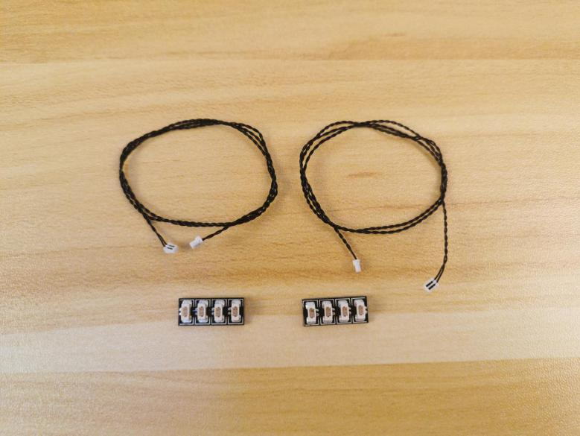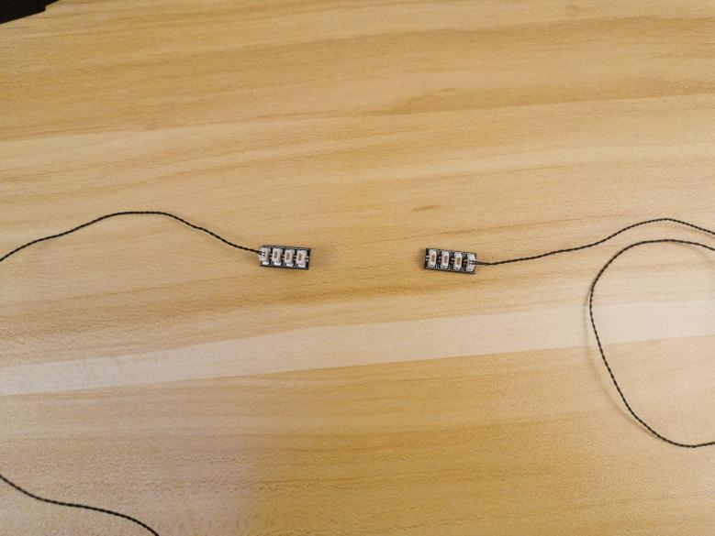

Connect the 3 cables from the left to the following expansion board.
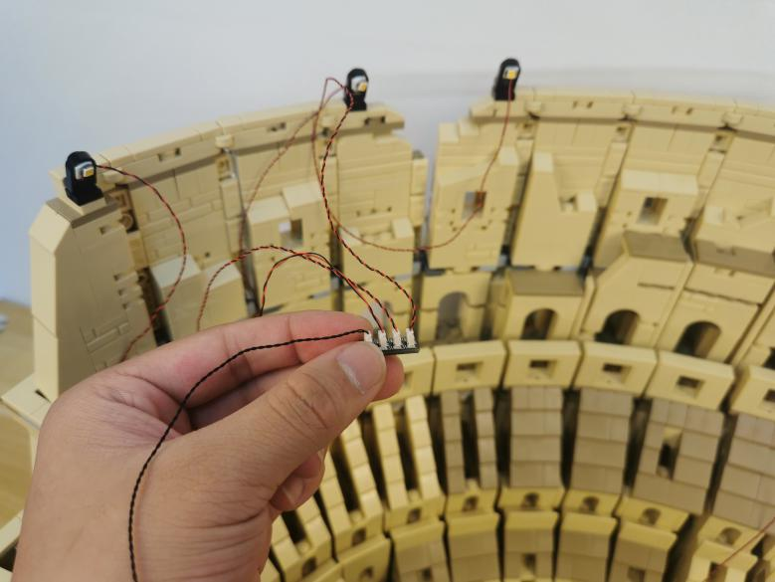

Take 2 adhesive squares.
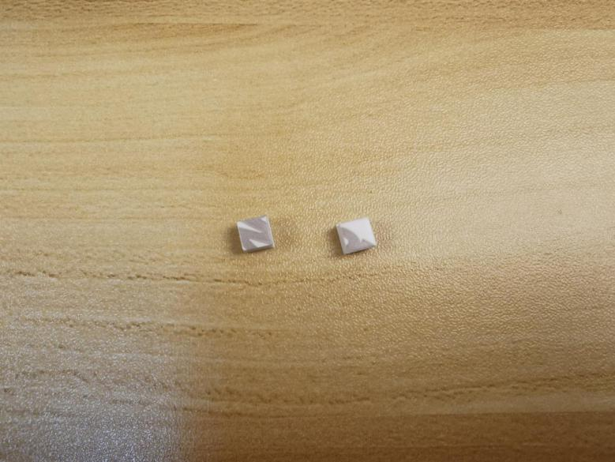

Stick them to the back of the expansion board, and stick the expansion board to the following place.
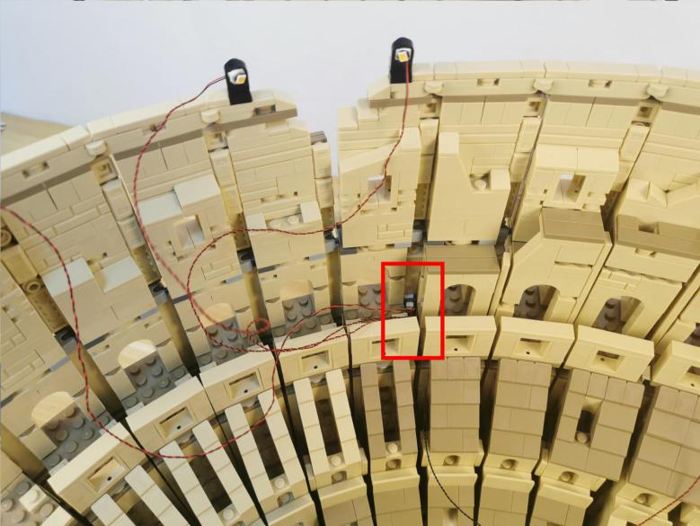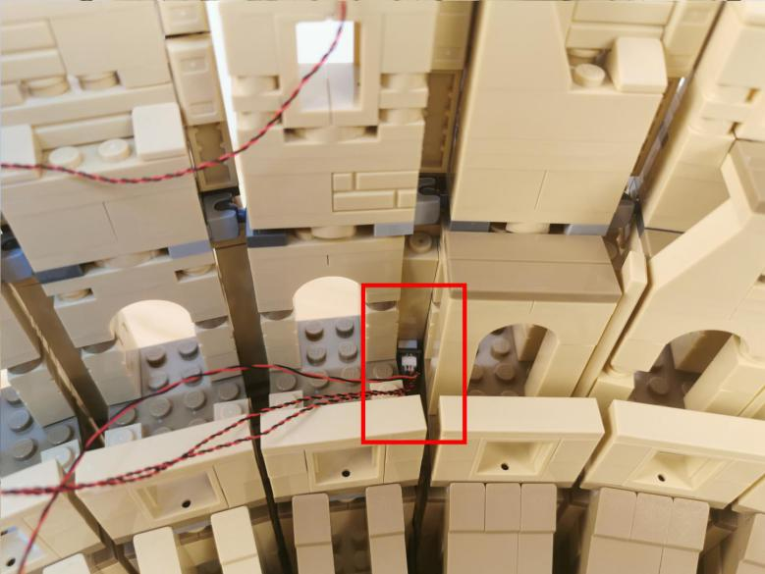

Take 3 adhesive squares.
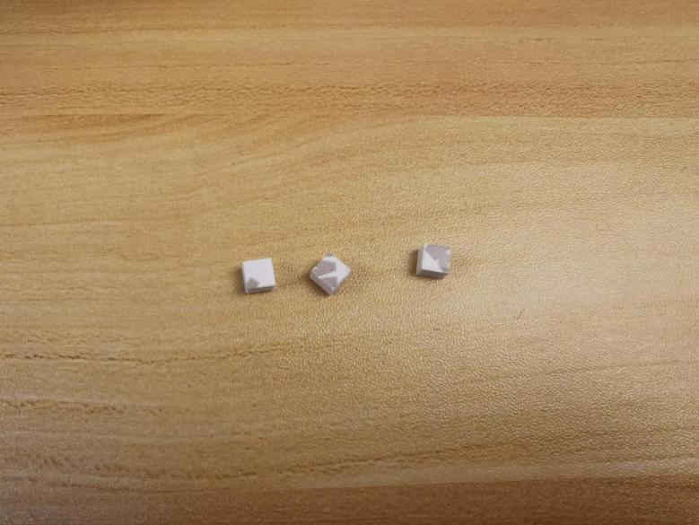

Tuck the cables as per below.
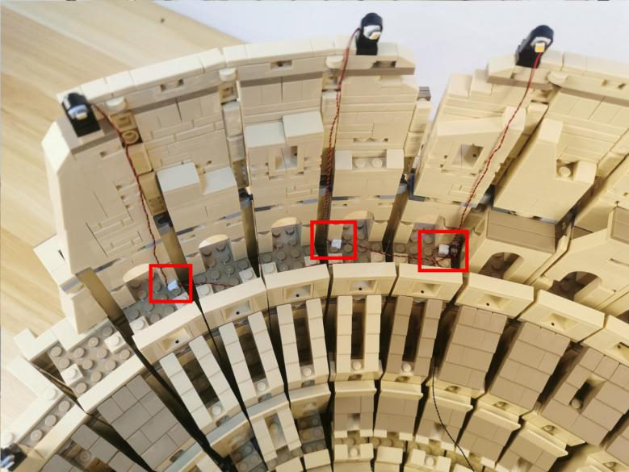

Connect the 3 cables from the right to anther 4-port expansion board.
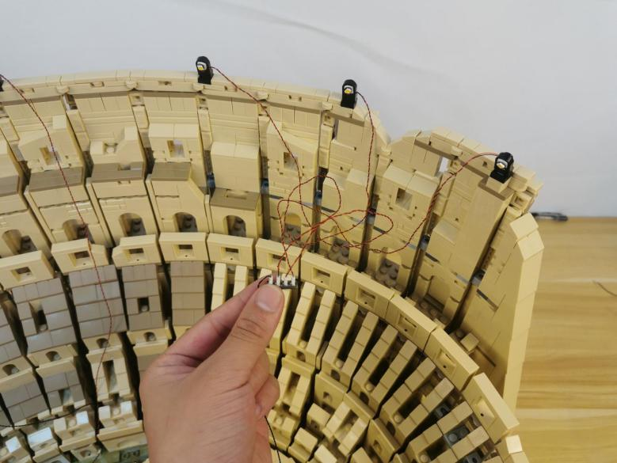

Take 2 adhesive squares.
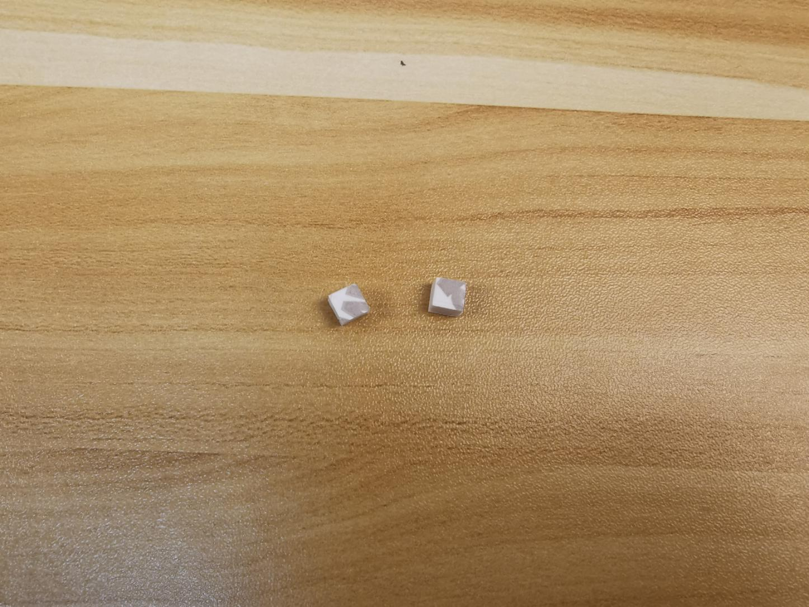

Stick them to the back of the expansion board, and stick the expansion board to the following place.
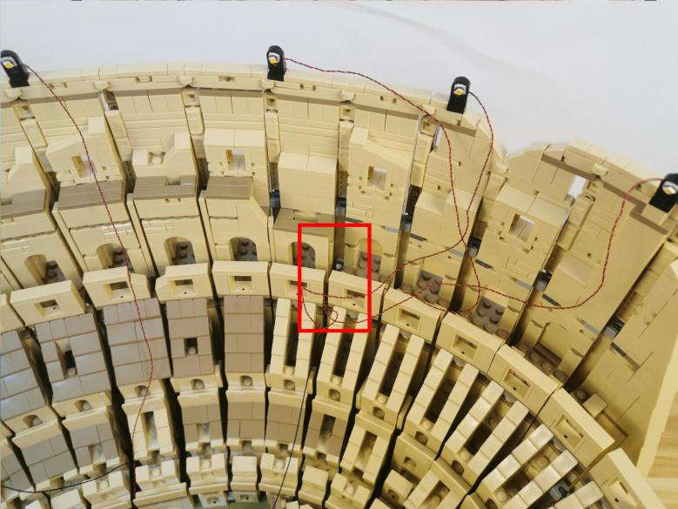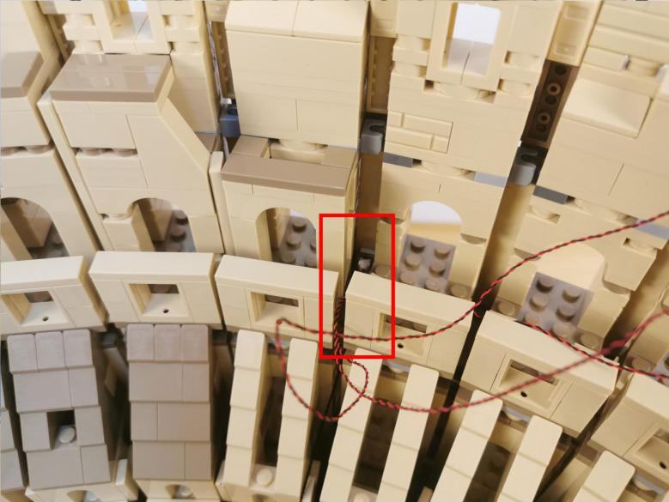

Take a 50cm connecting cable, a 4-port expansion board, assemble the as per below.
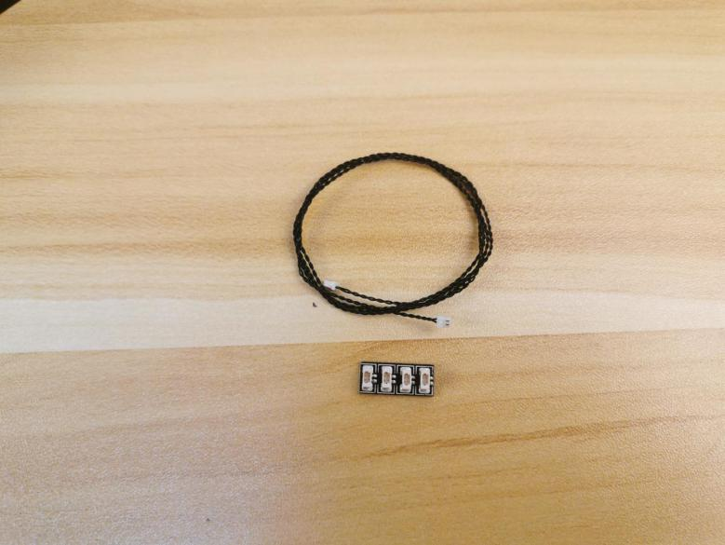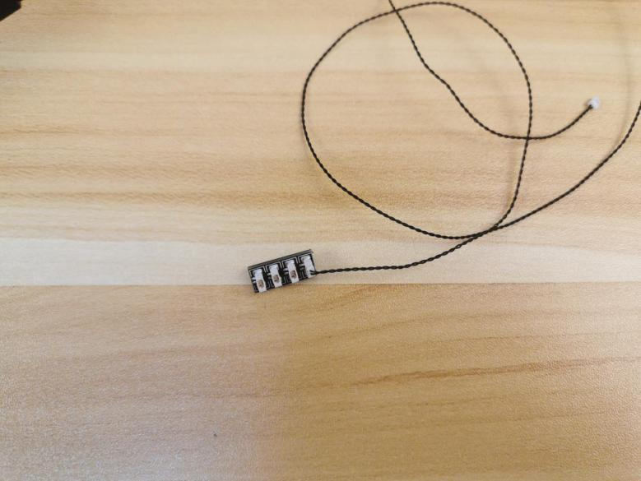

Connect the cables from the middle and both sides to the expansion board, group the cables together.
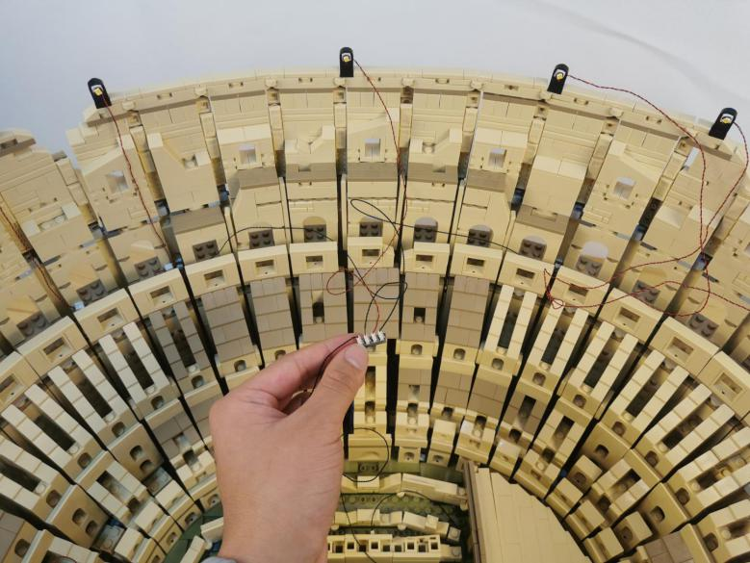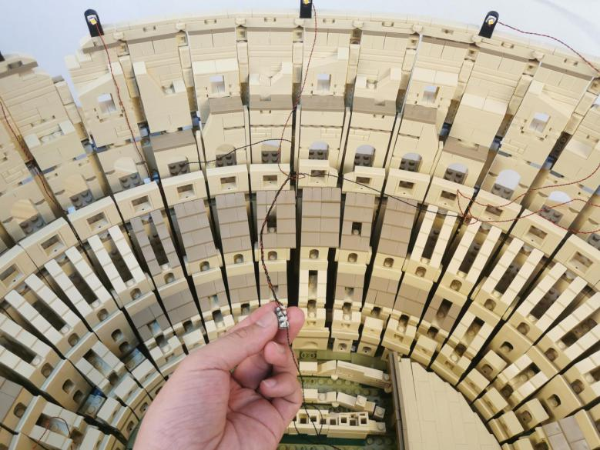

Tuck the expansion board at the following place, place the 50cm connecting cable underneath.
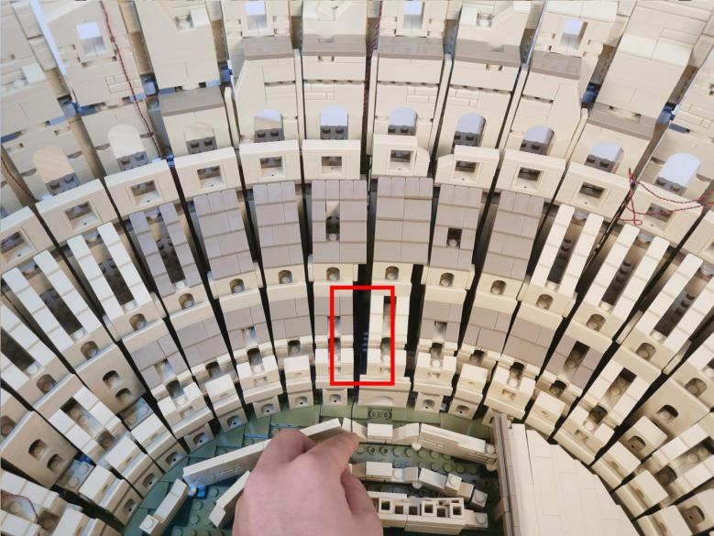

Take 3 adhesive squares.
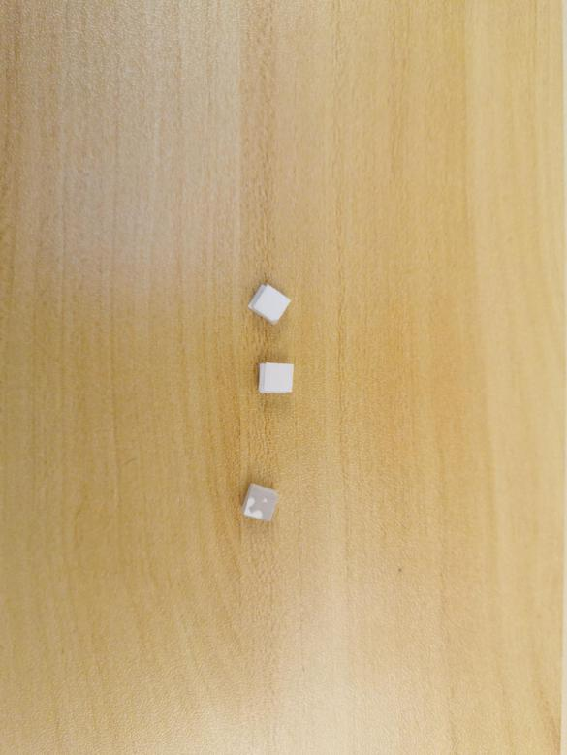

Tuck the cables at the right as per below.
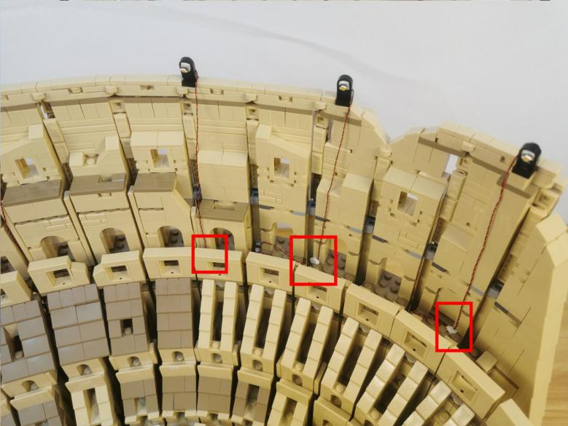

Take 3 warm white 15cm strip lights.
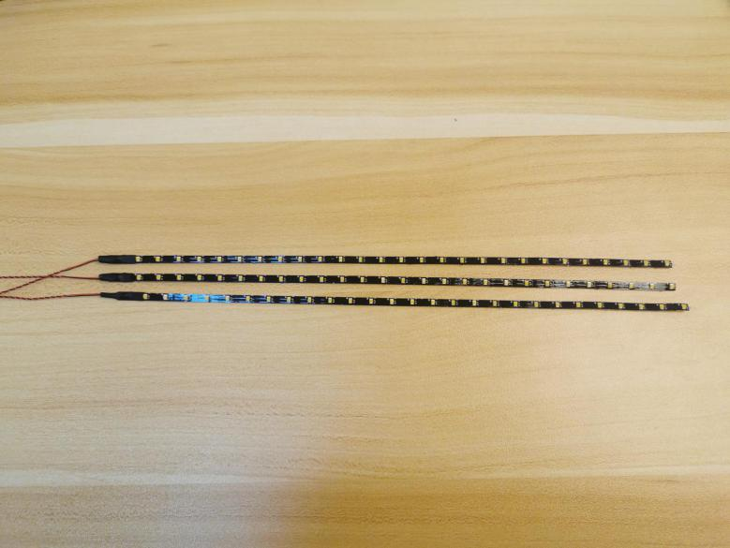

With lighting part facing outside, stick them to the following places, place the cables as per below.
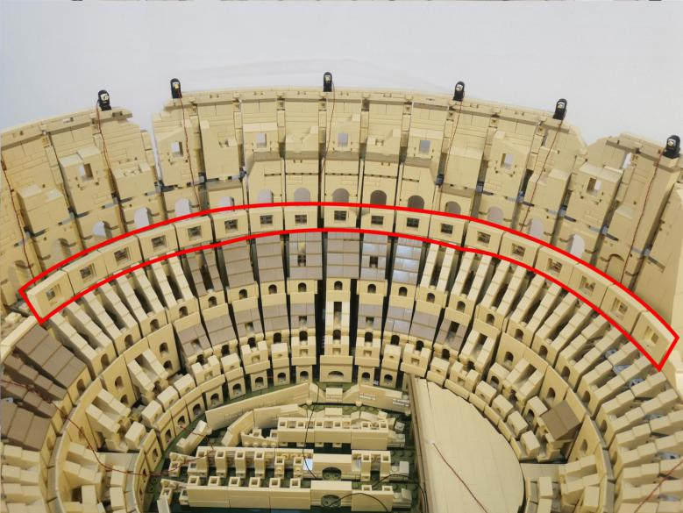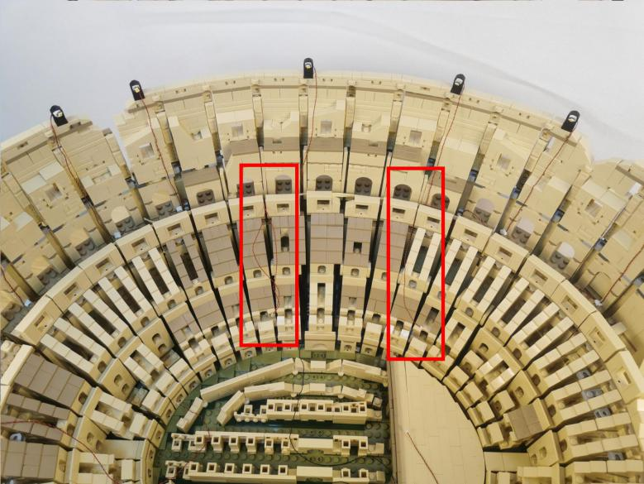

Take a 50cm connecting cable, a 4-port expansion board, assemble the as per below.
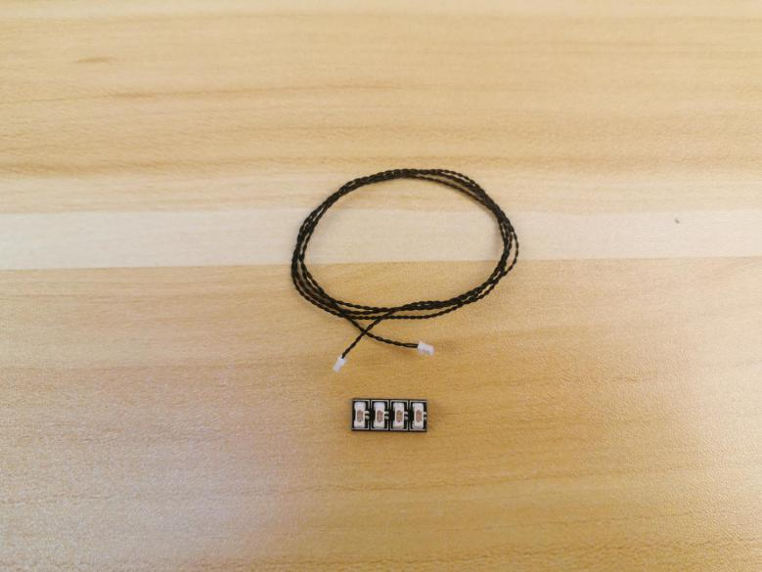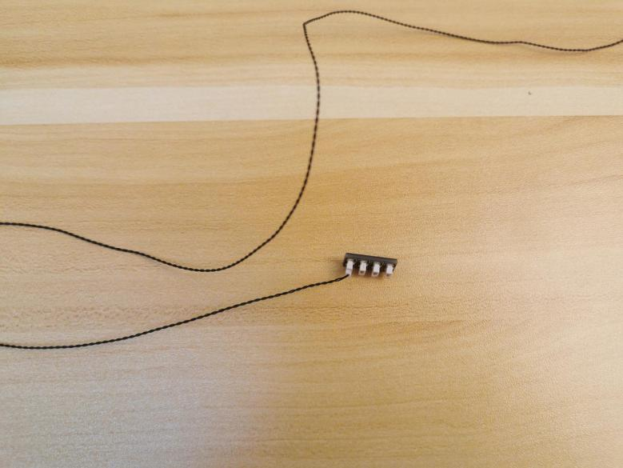

Connect the 3 cables of the strip lights to the expansion board.
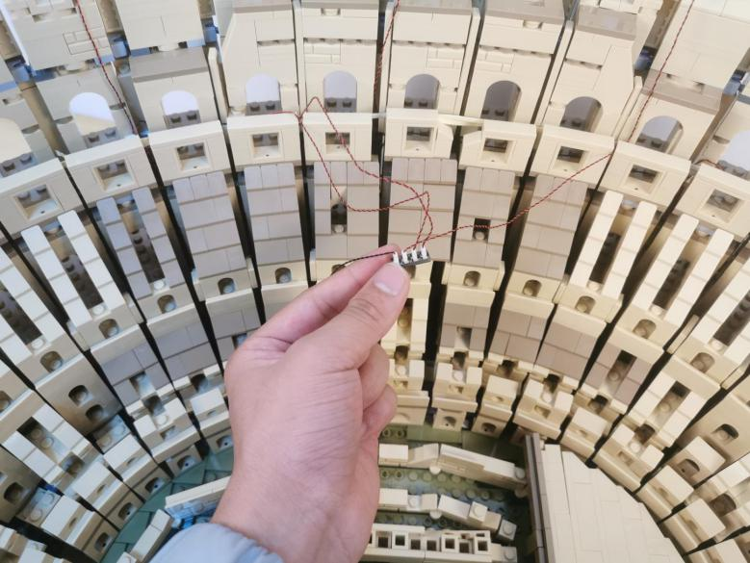

Take 2 adhesive squares.
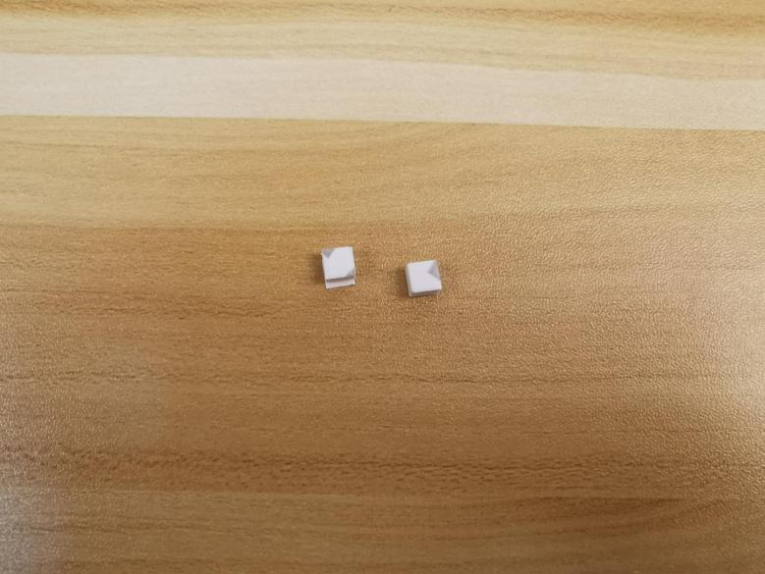

Stick them to the back of the expansion board, and stick the expansion board to the following place.
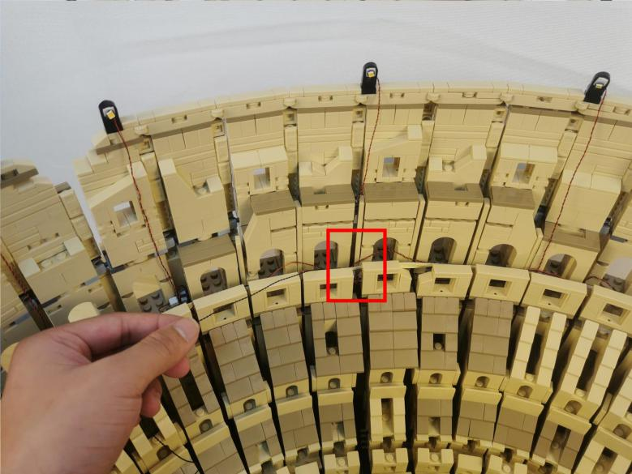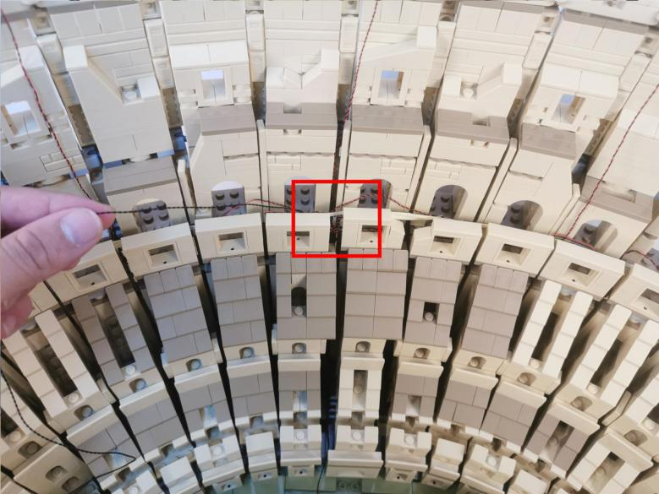

Pull the 50cm connecting cable to the left.
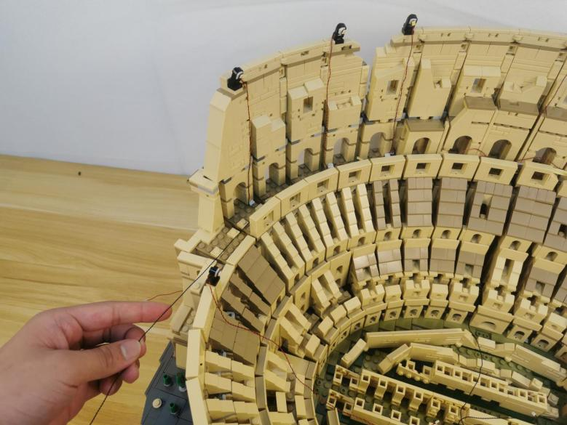

Secure it at the following place as per below.
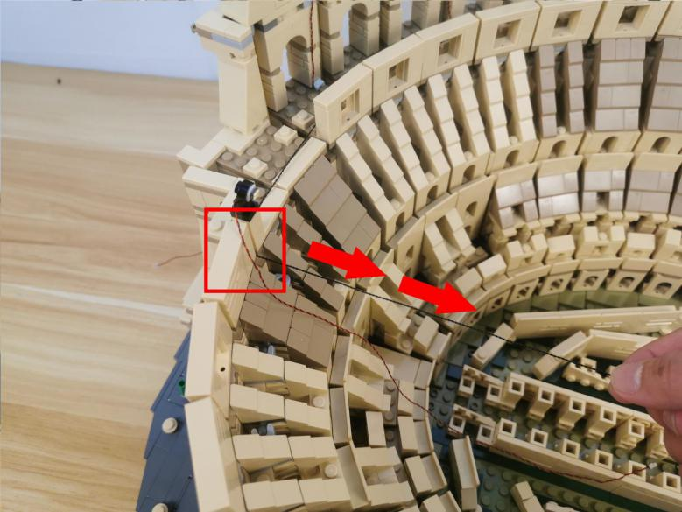

Take a 50cm connecting cable, a 4-port expansion board, assemble the as per below.
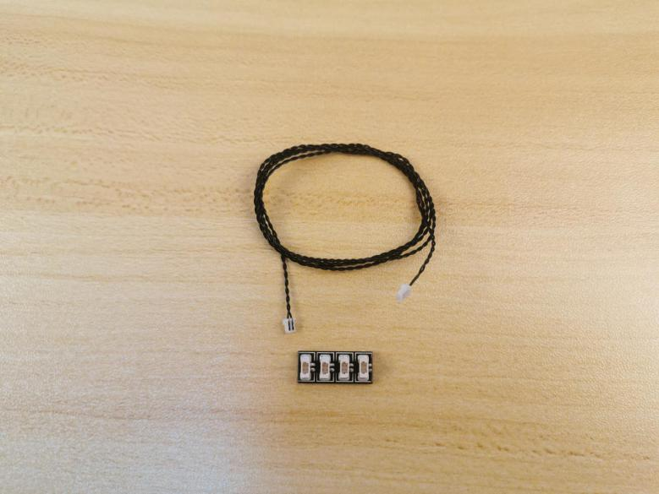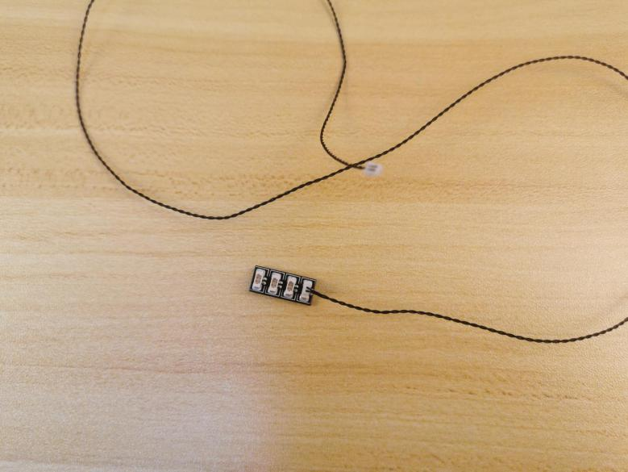

Connect the cable we pulled and the cable of the following light to the expansion board.
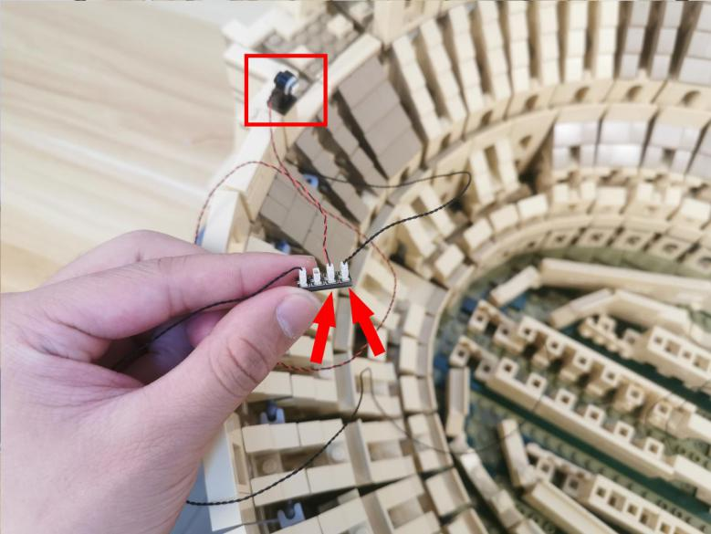

Tuck the expansion board as per below.
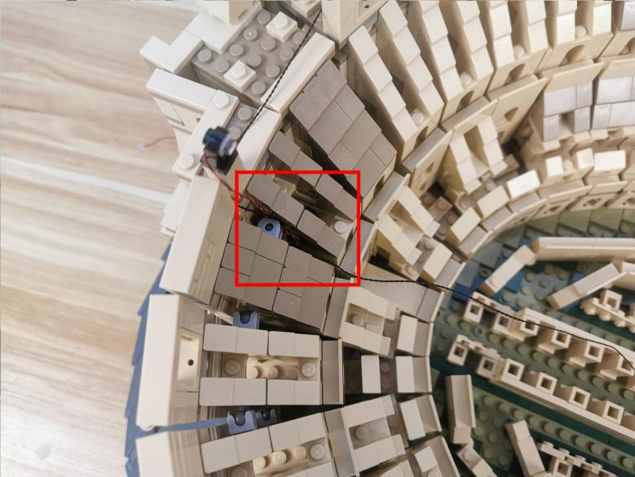

Take a 15cm connecting cable, a 6-port expansion board, assemble the as per below.
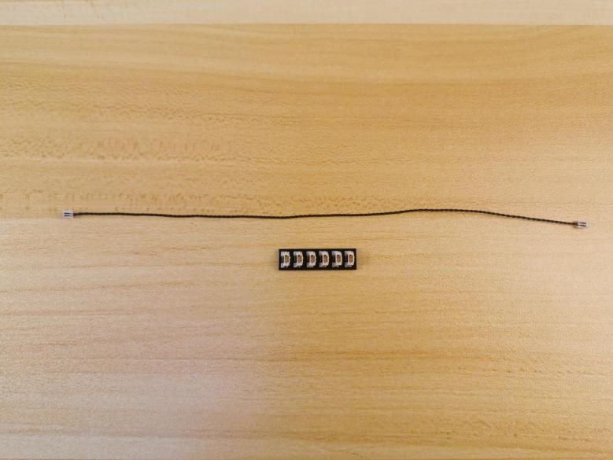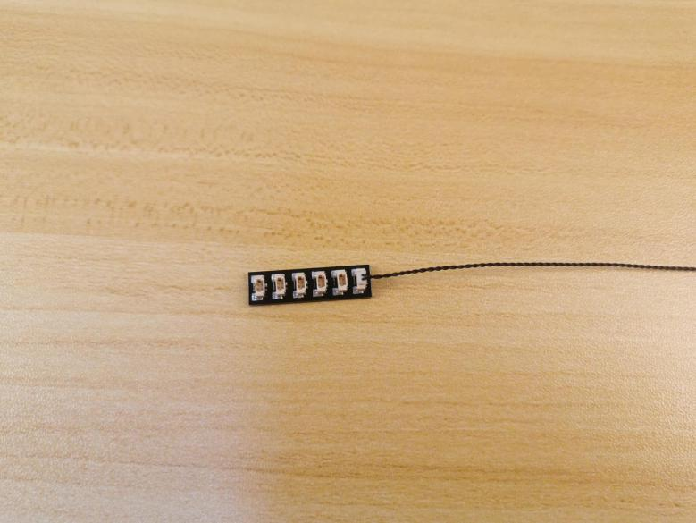

Connect the following cable from the left and the 3 cables to the following expansion board.
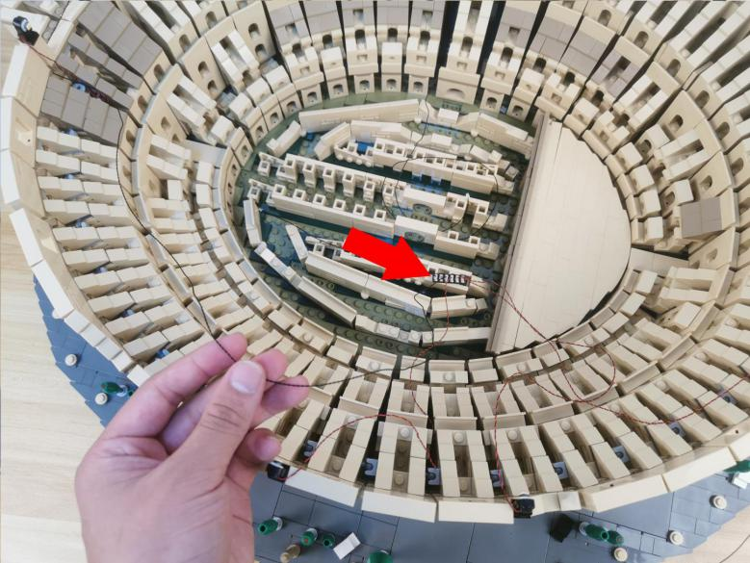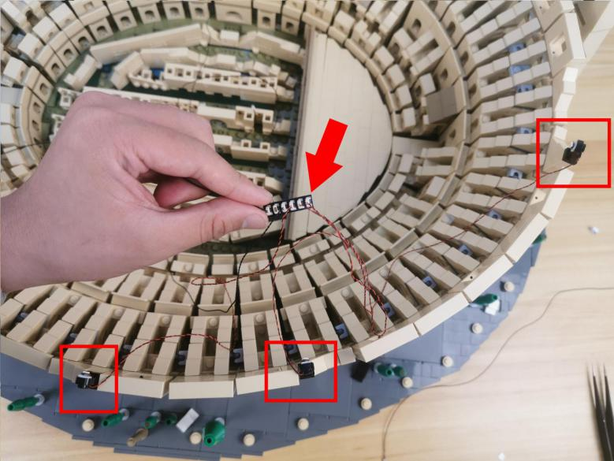

Place the expansion board at the following place, tuck the cables in between the spaces.
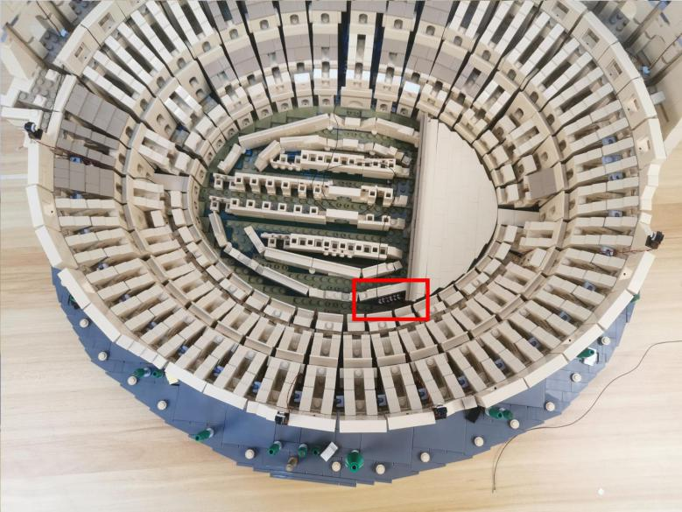

Take 5 warm white strip lights.
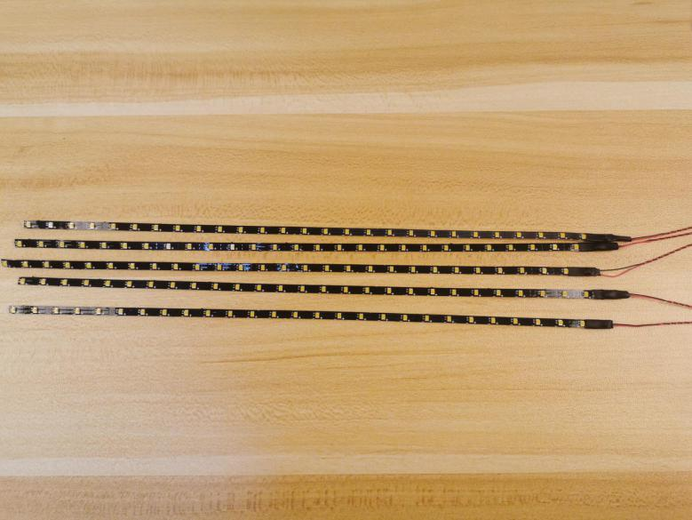

With lighting part facing outside, stick them to the following places, place the cables as per below.
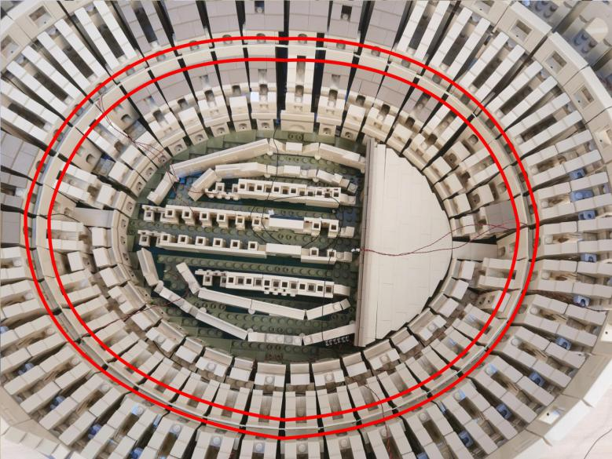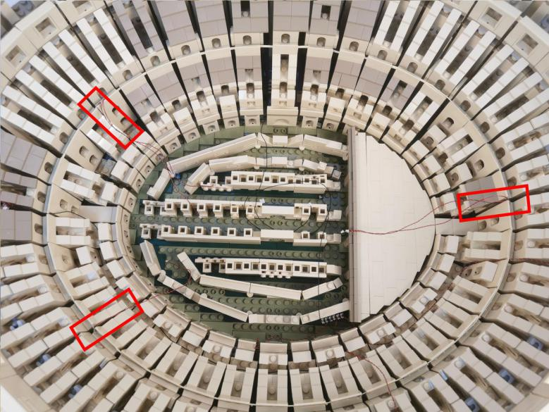

Turn the Colosseum to the back.
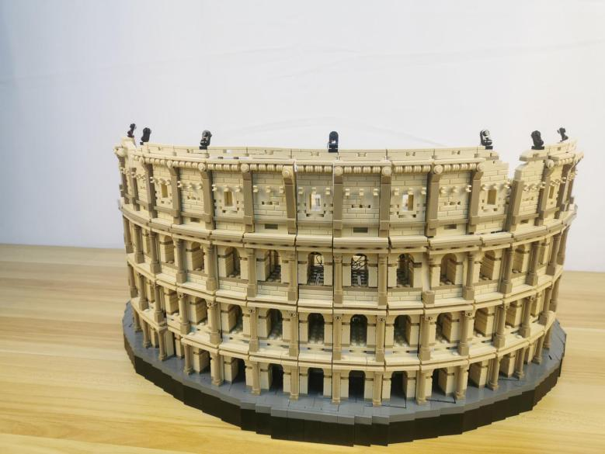

Turn to the left.
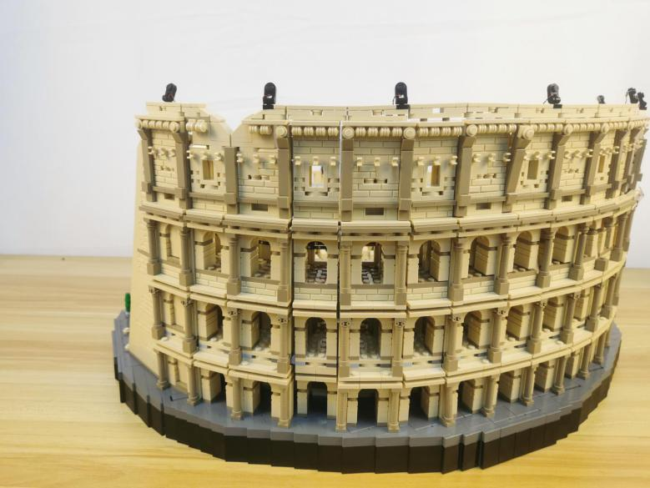

Take 6 warm white strip lights.
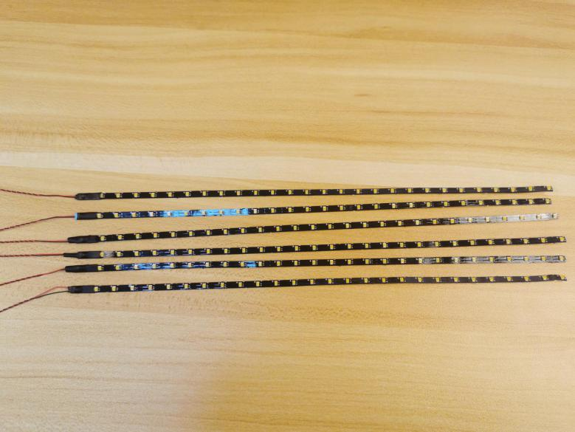

Take 4 strip lights, thread the cables through and stick the lights to the wall inside, you can use the tweezer to help.
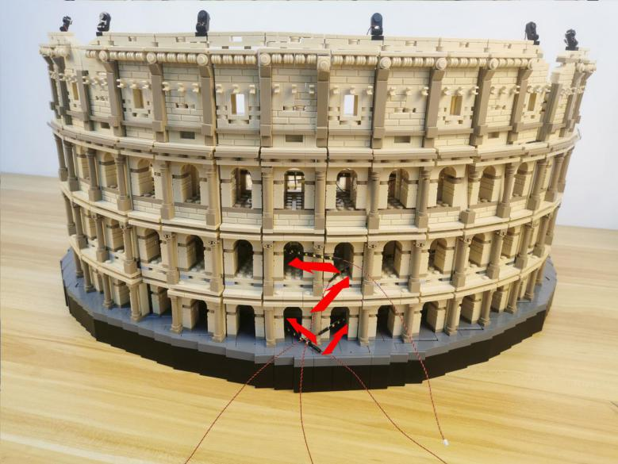

After secured the strip lights, thread the cables to the inside.
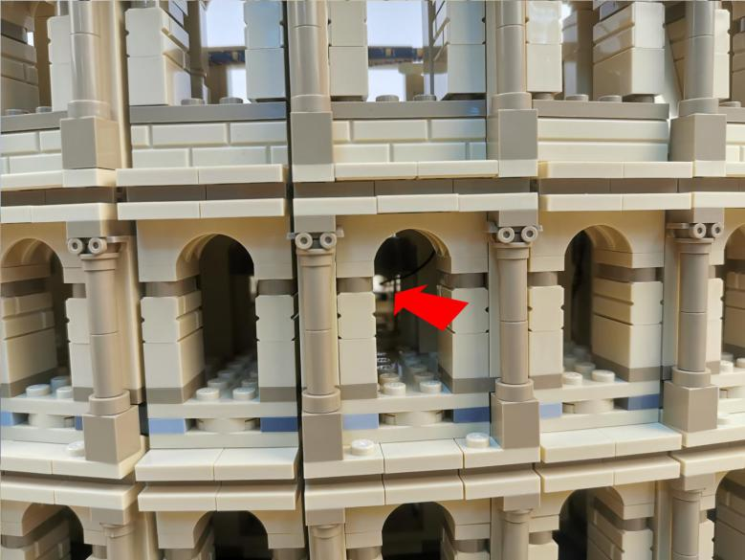

Pull the 4 cables to the inside.
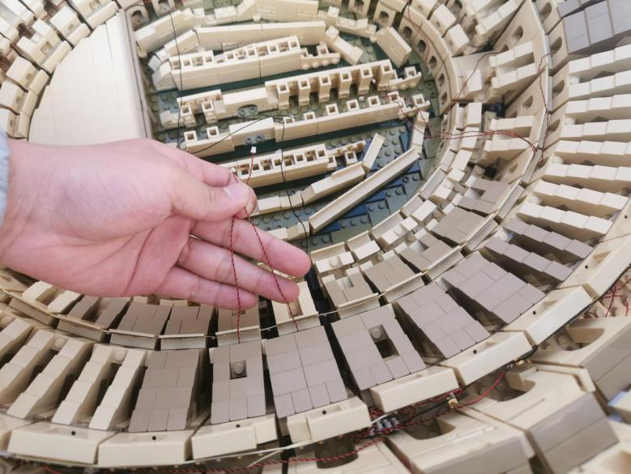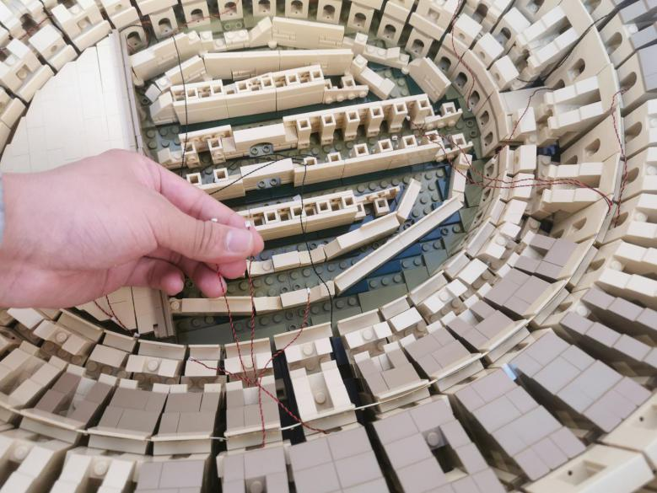

Turn to the right of the Colosseum.
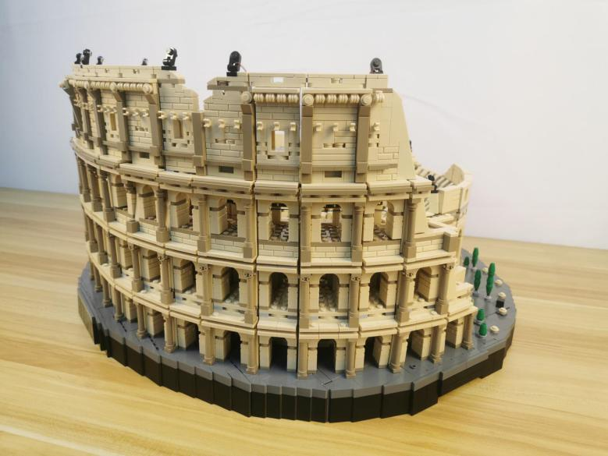

Thread the other 2 cables of the strip lights through the following spaces, and stick the strip lights to the wall inside.
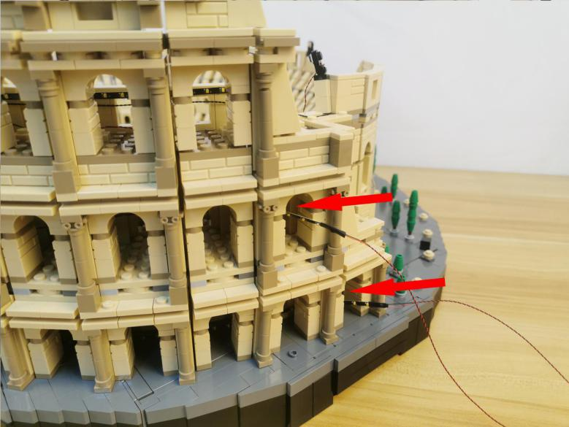

After secured the strip lights, thread the cables to the inside.
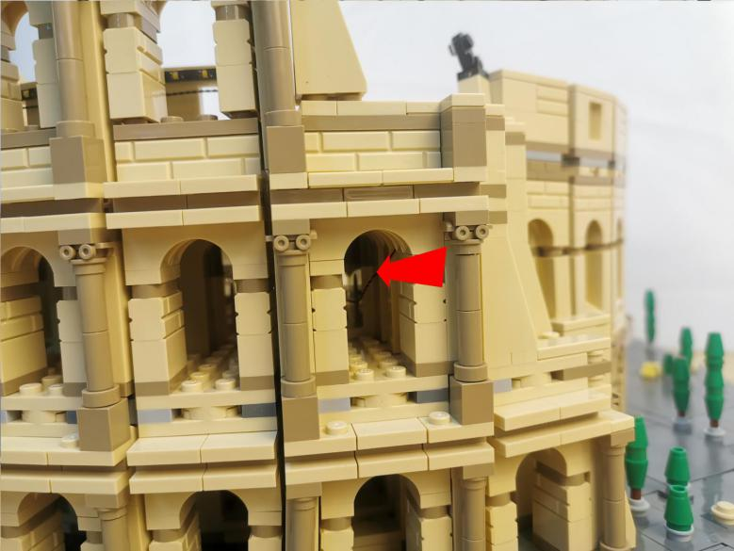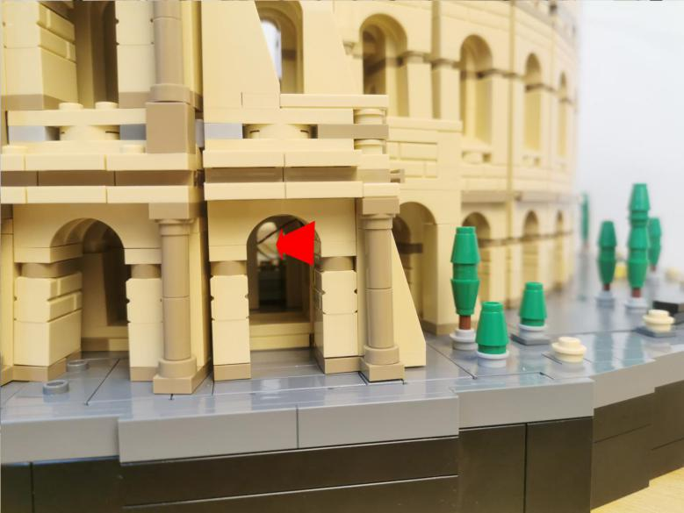

Pull the cables out.
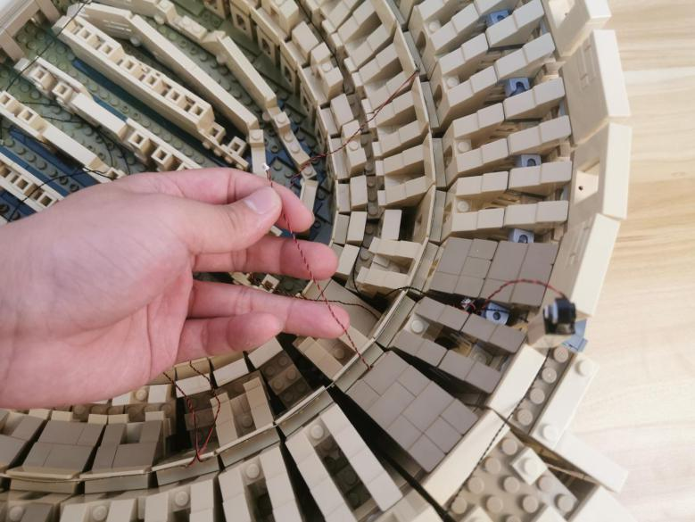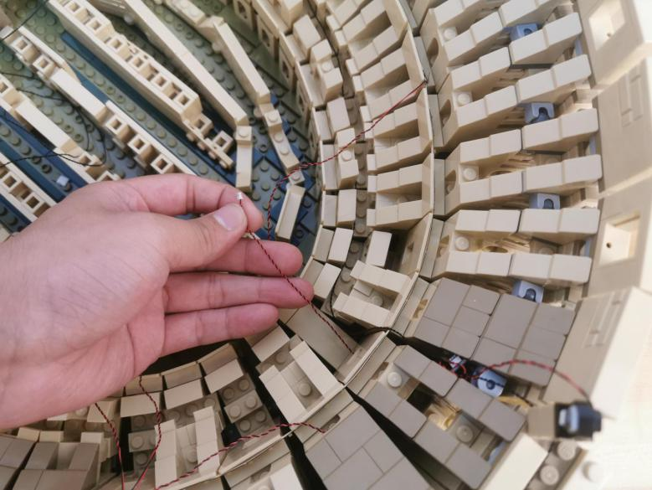

Turn to the front.
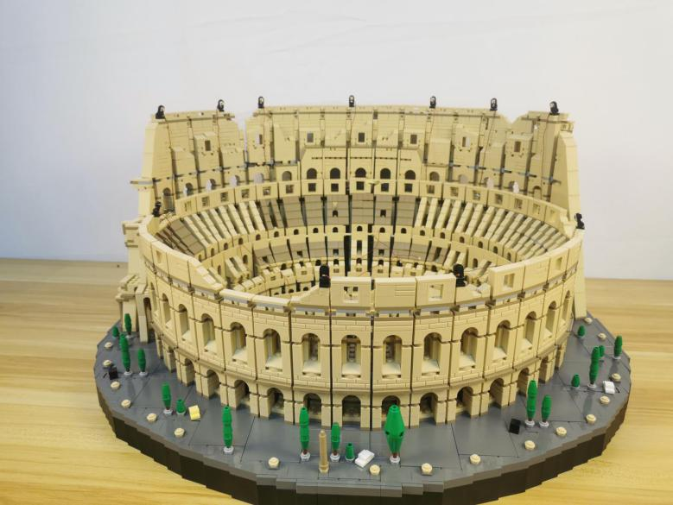

Take a 50cm connecting cable, a 6-port expansion board, assemble the as per below.
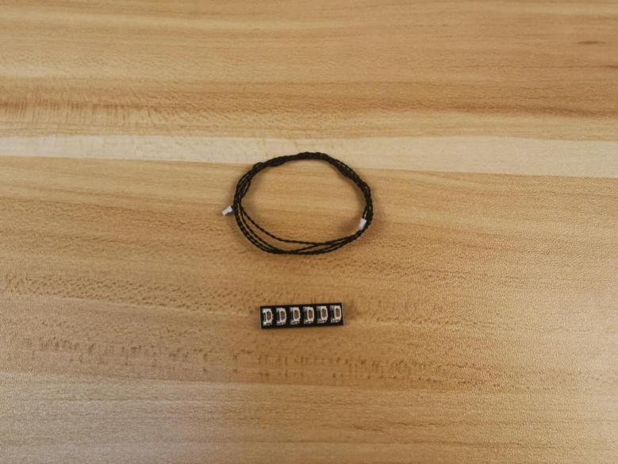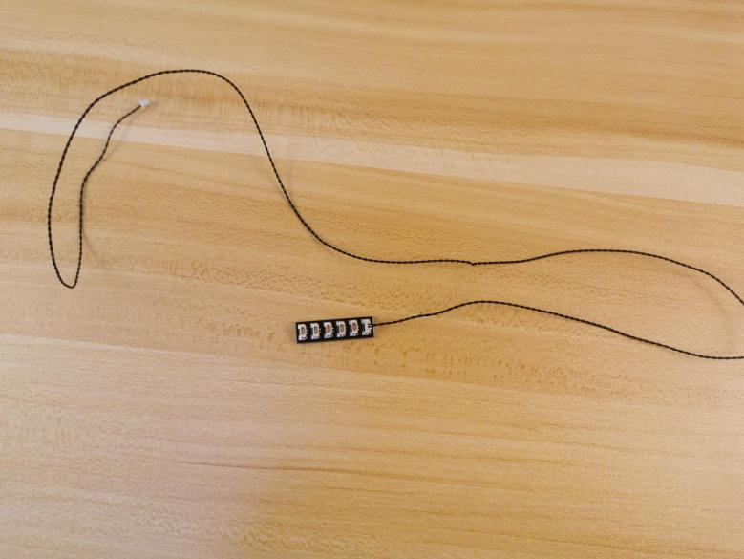

Connect the following 4 cables from the strip lights to the expansion board.
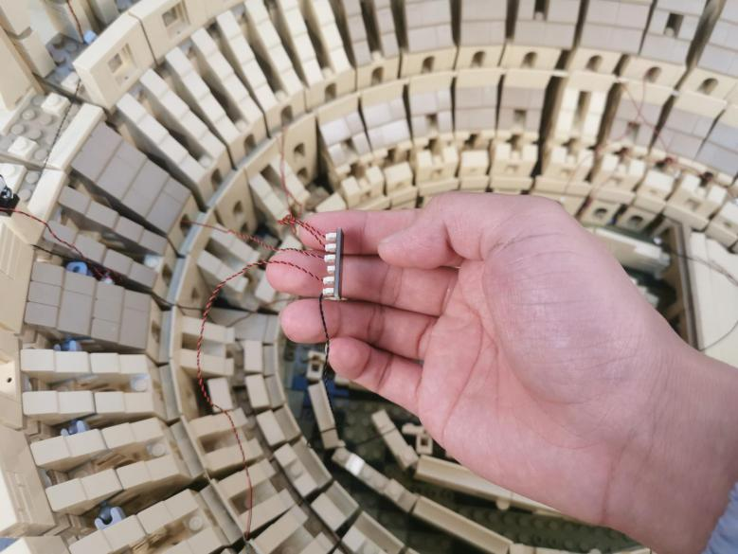

Tuck the expansion board inside as per below.
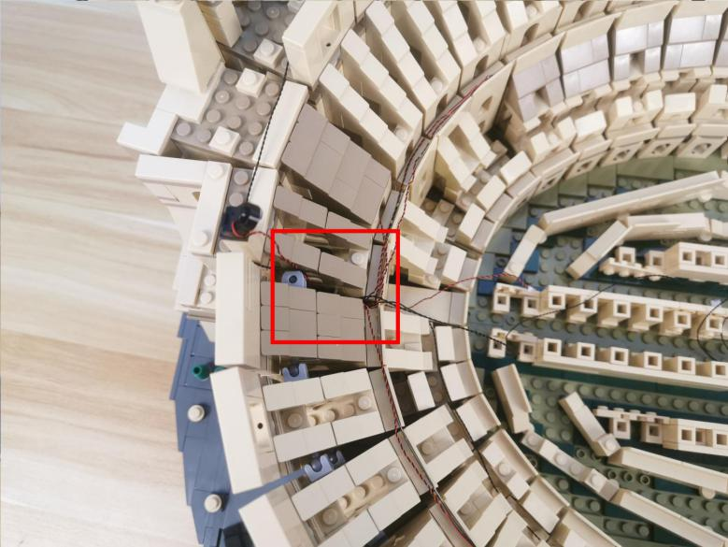

Take a 30cm connecting cable, a 4-port expansion board, assemble the as per below.
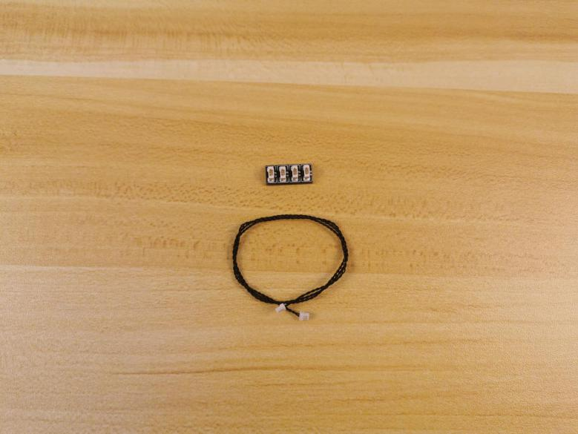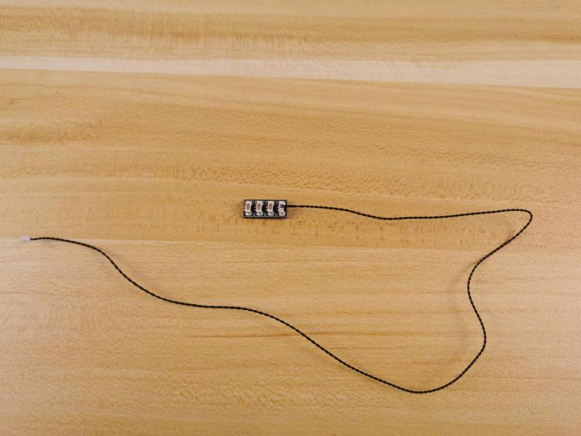

Connect the following 50cm connecting cable and the 2 cables of the strip lights to the expansion board.
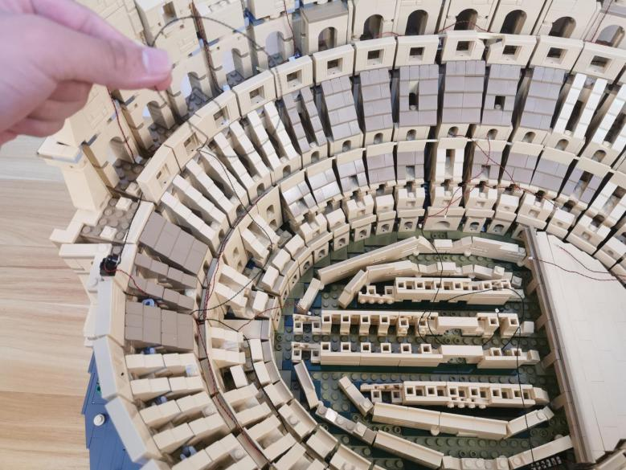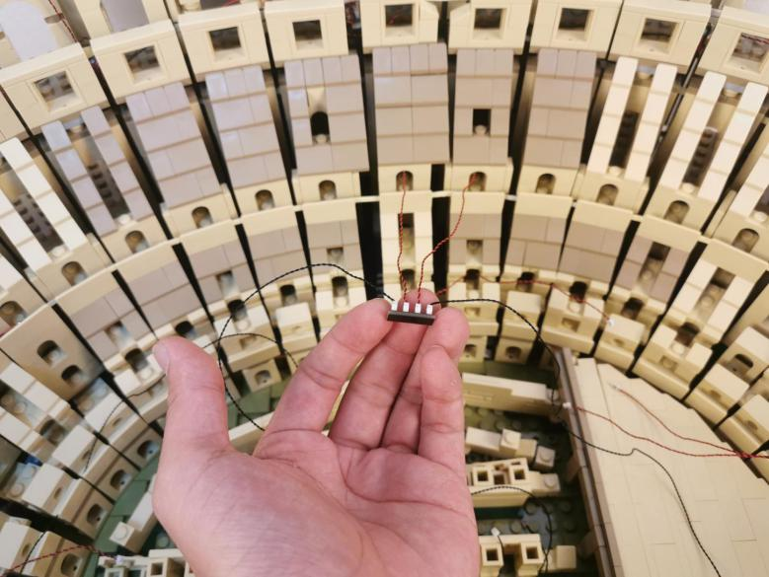

Tuck the expansion board inside as per below.
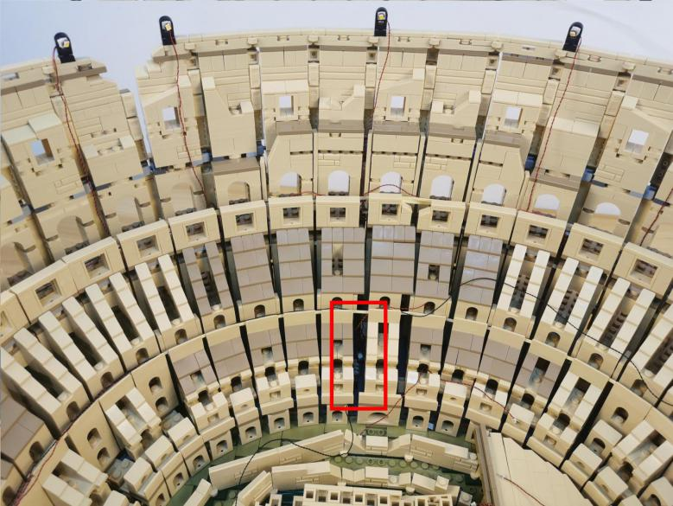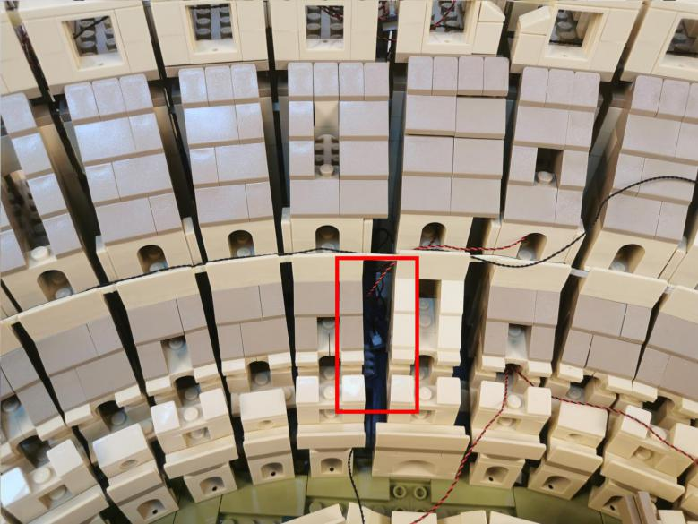

Take a 30cm connecting cable, a 4-port expansion board, assemble the as per below.
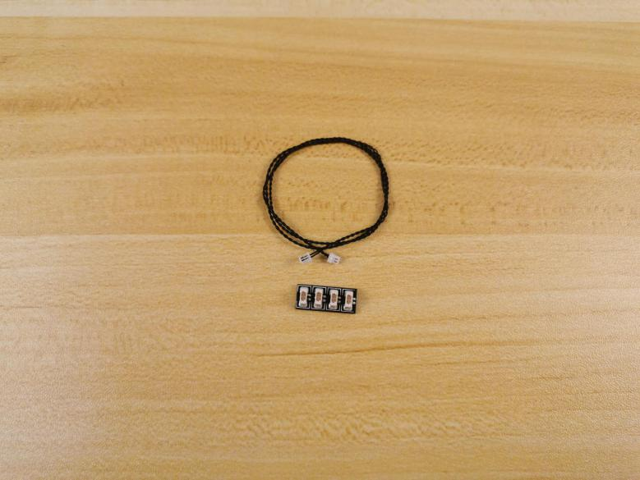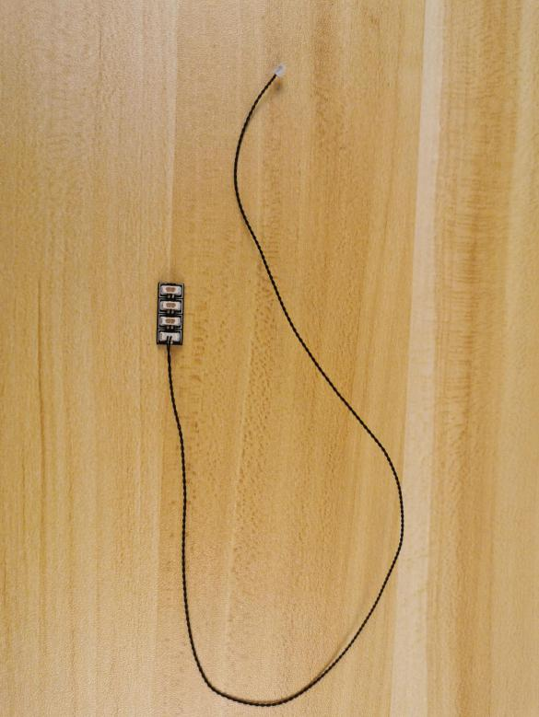

Connect the following 3 cables to the expansion board.
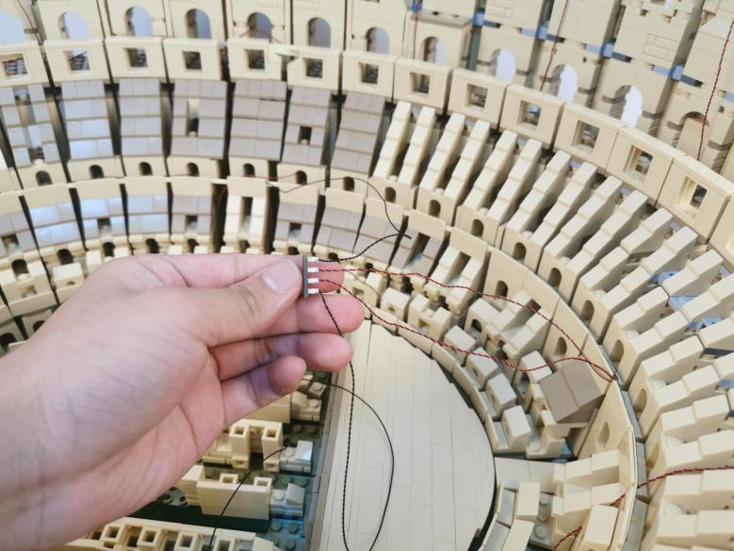

Tuck the expansion board inside as per below.
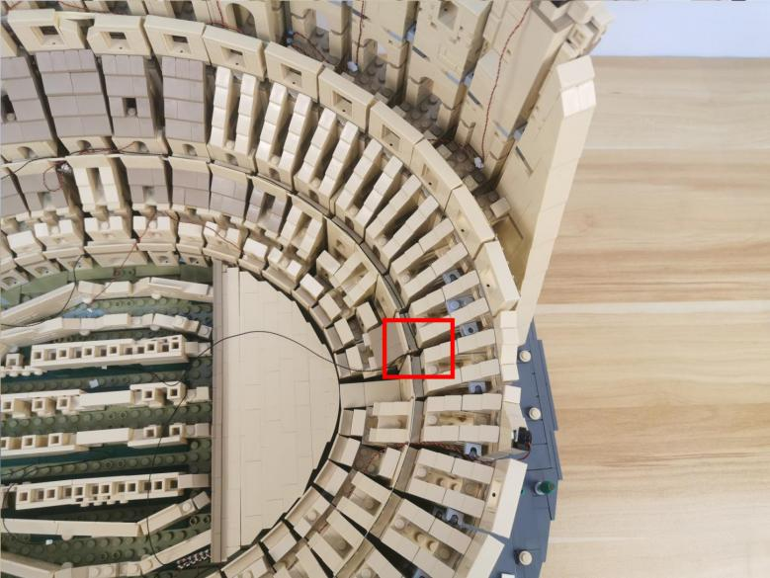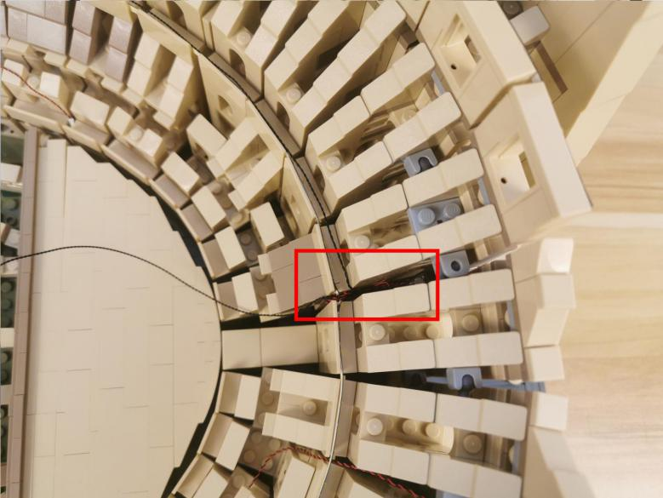

Remove the following piece.
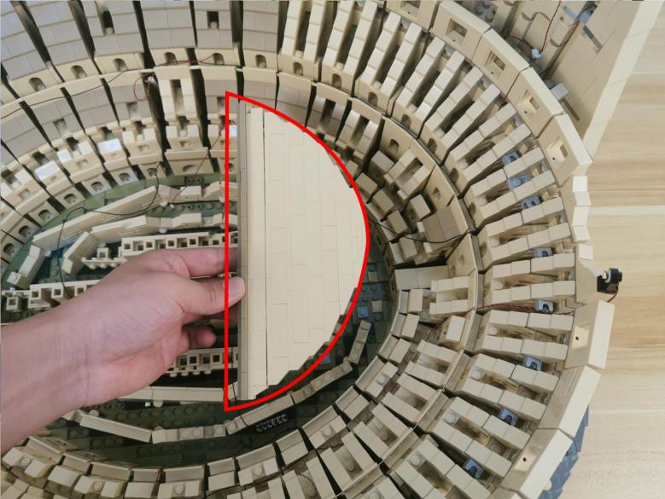

Take 4 warm white strip lights.
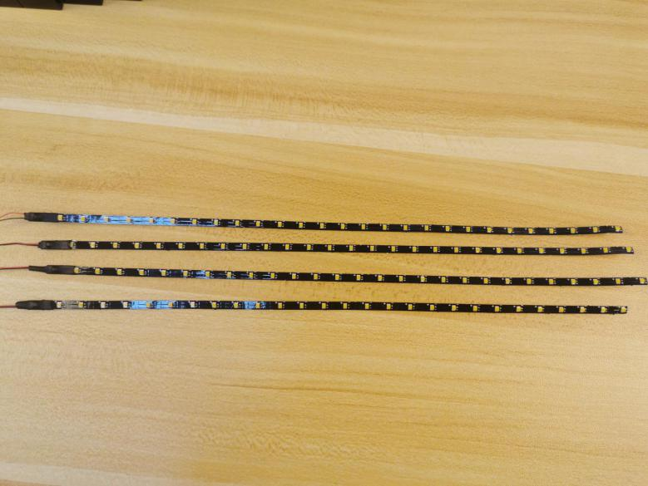

With lighting part facing outside, stick them to the following places, place the cables as per below.
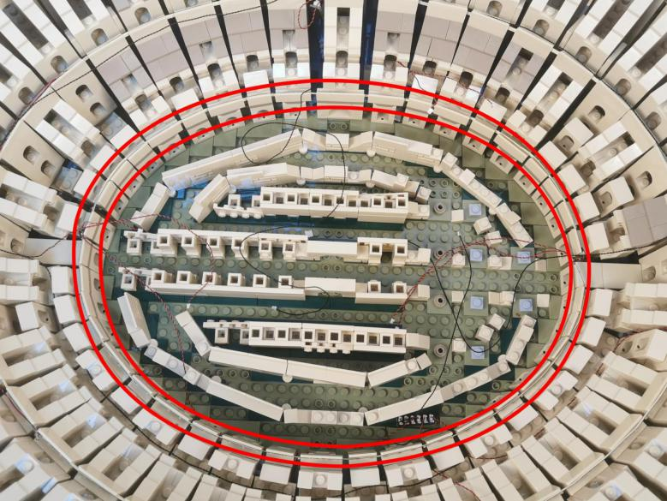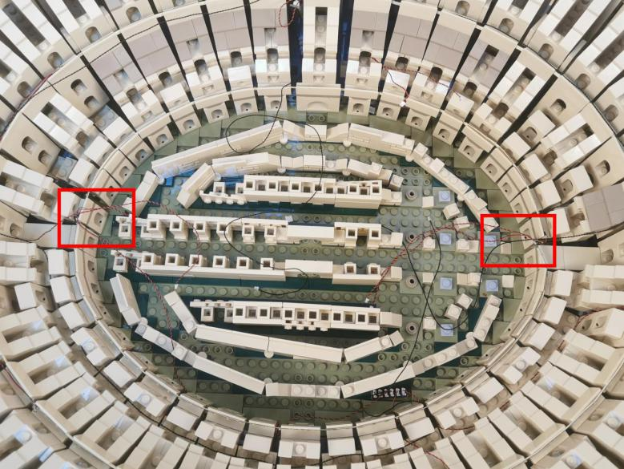

Take a 50cm connecting cable, a 4-port expansion board, assemble the as per below.
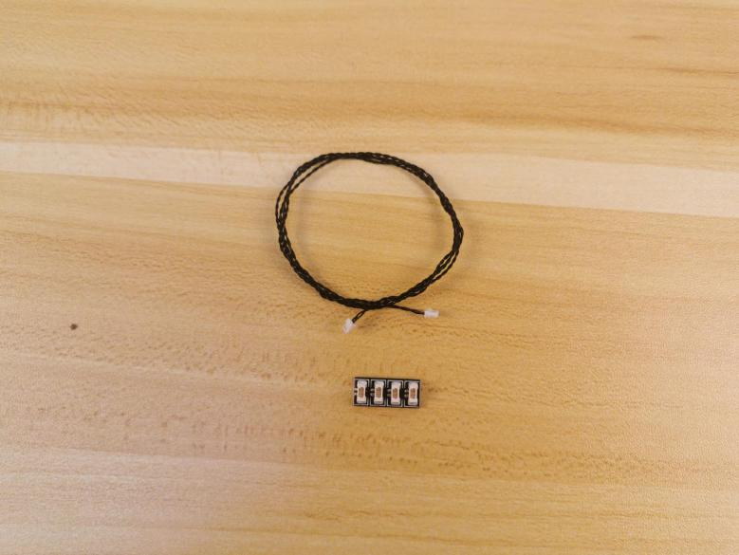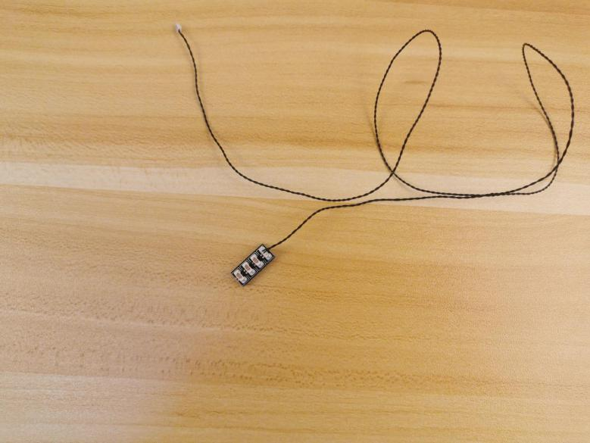

Connect the following 3 cables of the strip lights from the left to the expansion board.
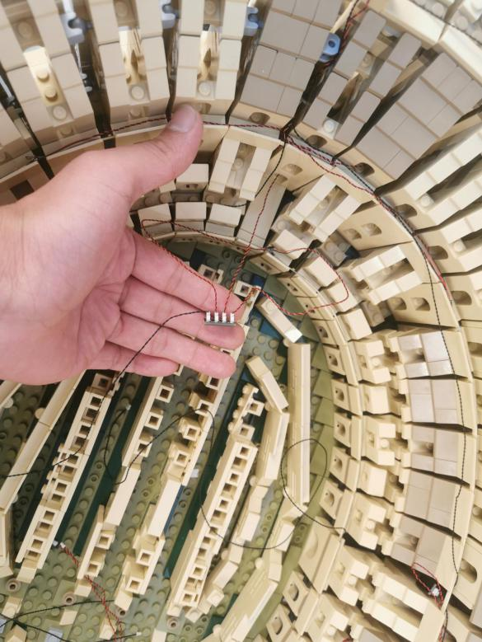

Tuck the expansion board at the following space.
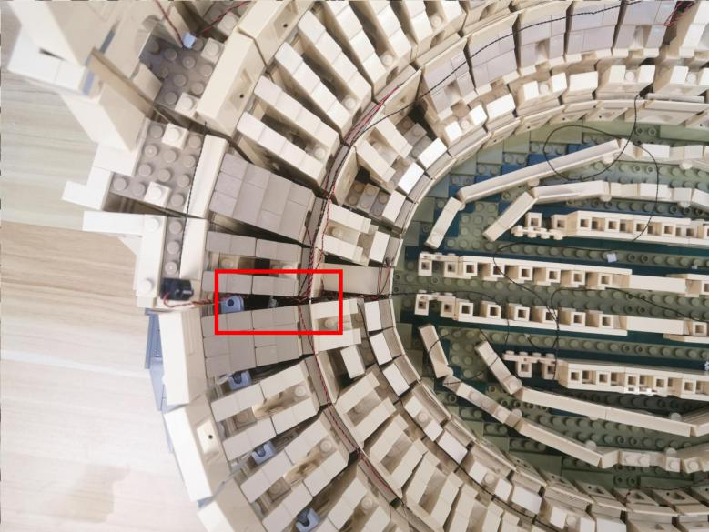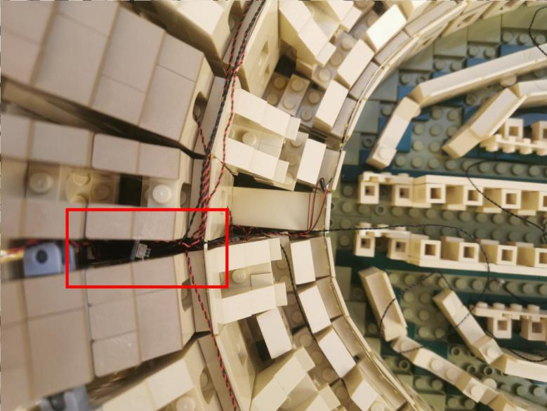

Take a 30cm connecting cable, a 6-port expansion board, assemble the as per below.
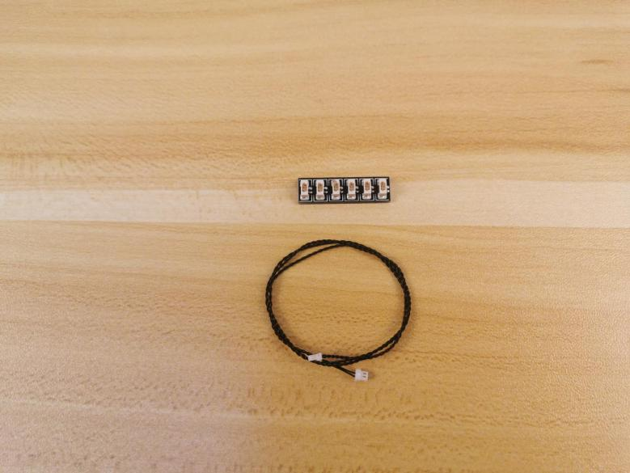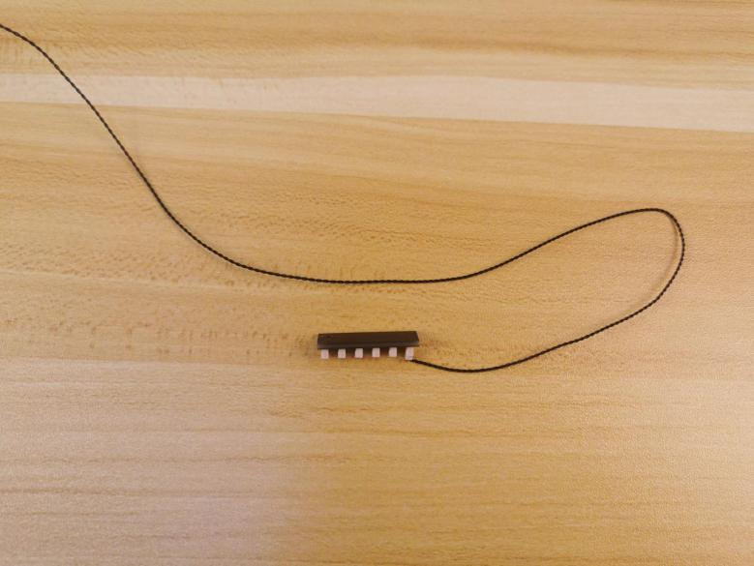

Connect the following 4 cables of the strip lights to the expansion board.
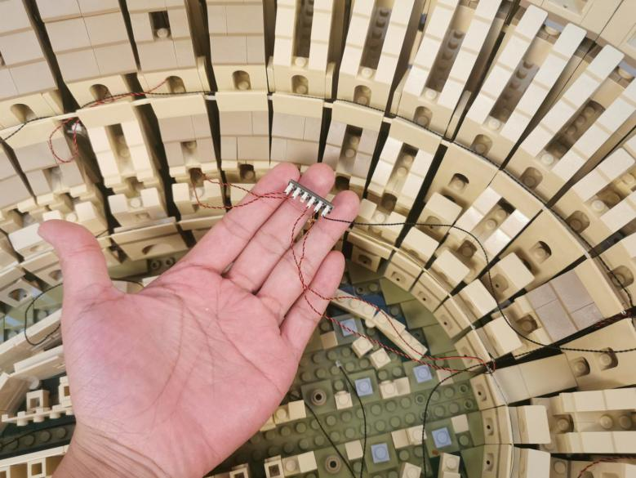

Connect the 50cm connecting cable from the left to the 6-port expansion board at the right.
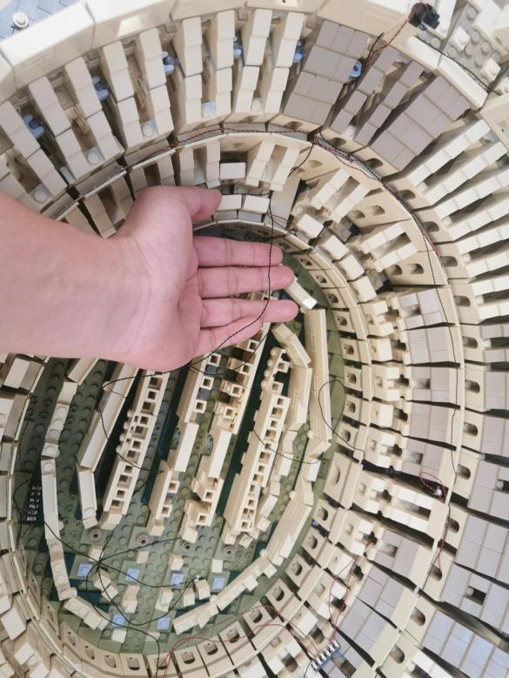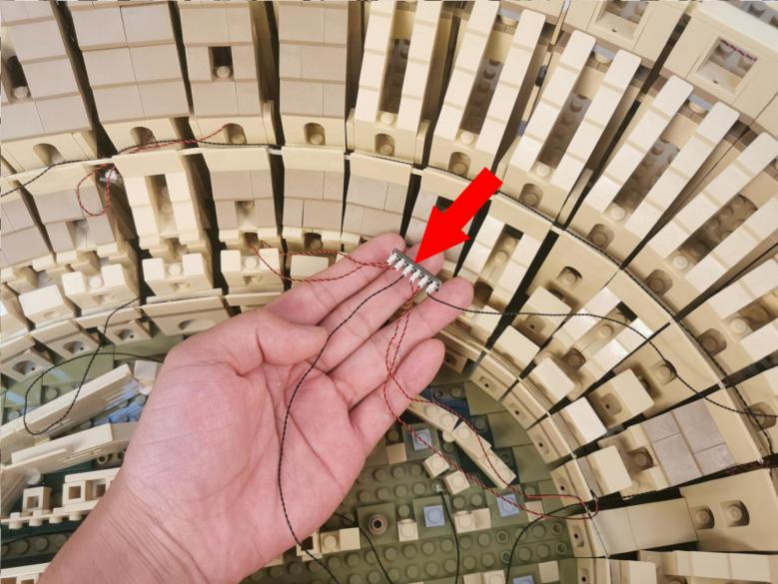

Remove the following piece.
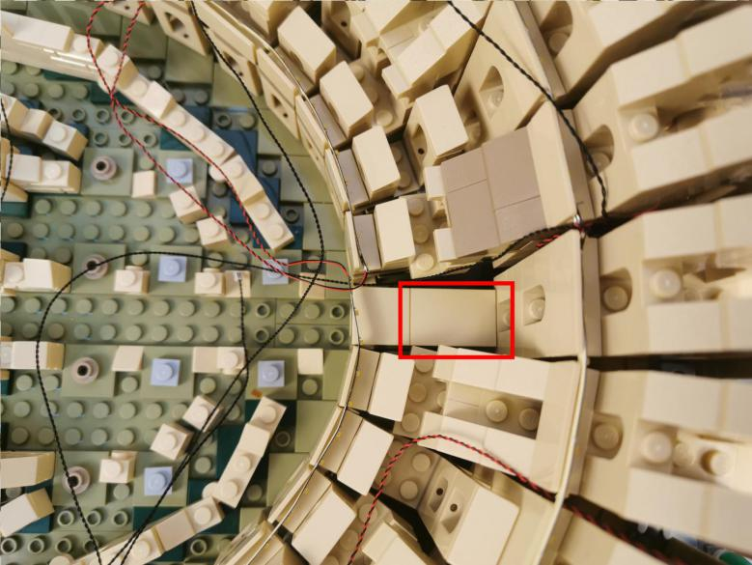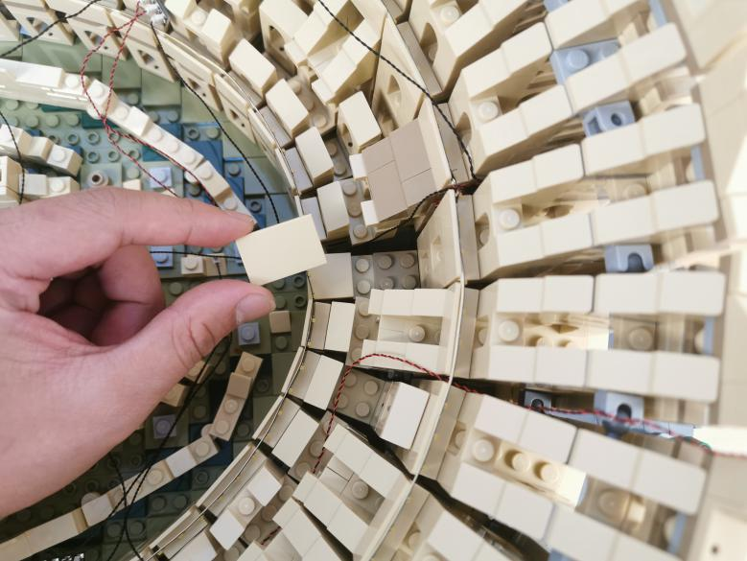

Take a 2x6 black plate, 3 black plates, a black ladder vertical clamp plate, a black hinge plate with handle.
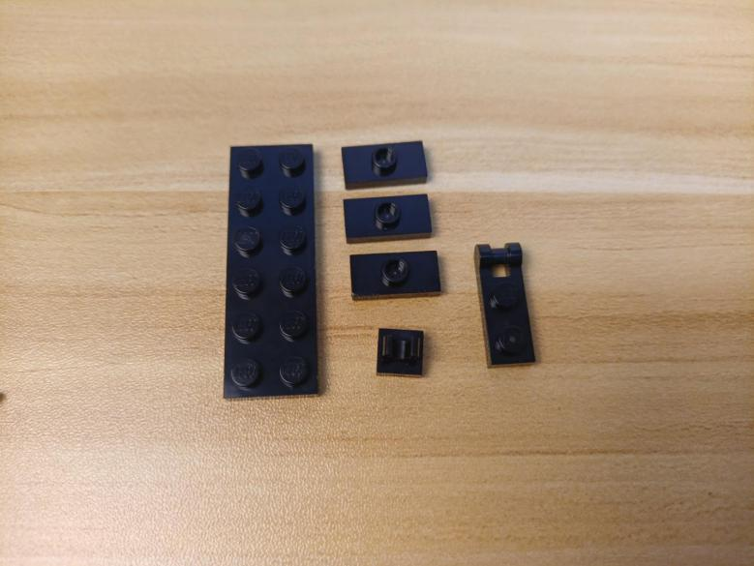

Assemble them as per below.
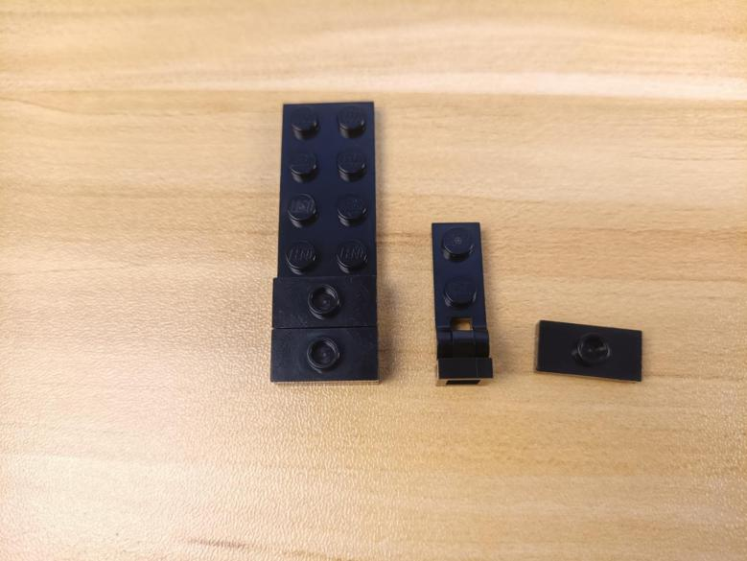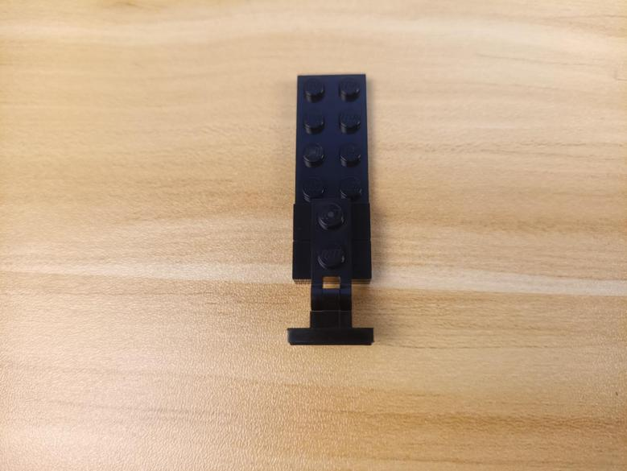

Turn the piece to the back.
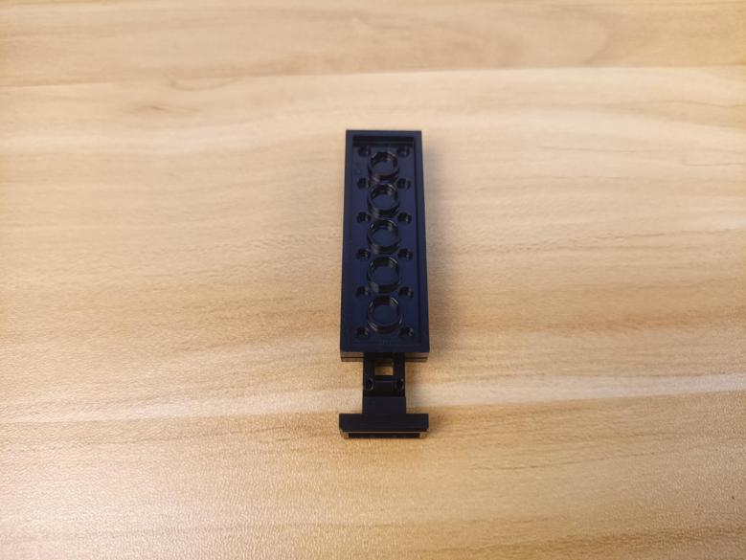

Take a Multi Colour Background Light, a 30cm connecting cable, assemble them as per below.
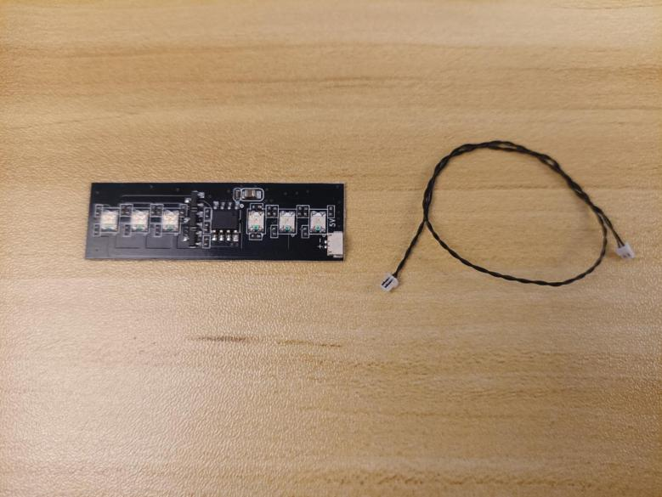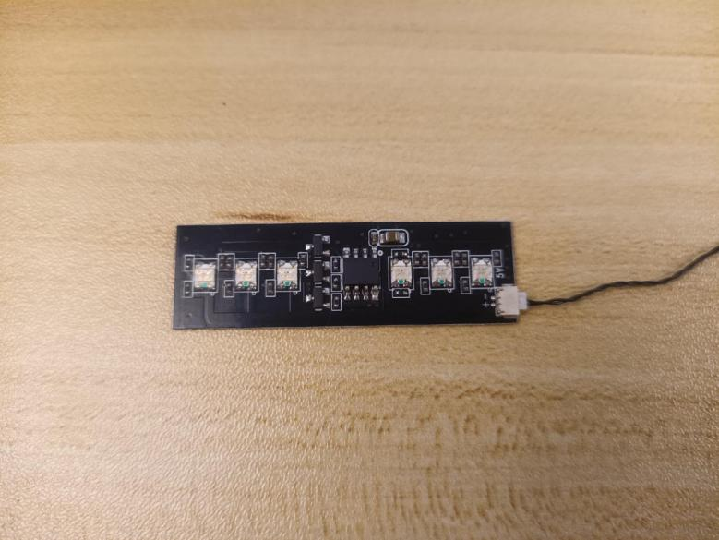

Stick it to the 2x6 plate.
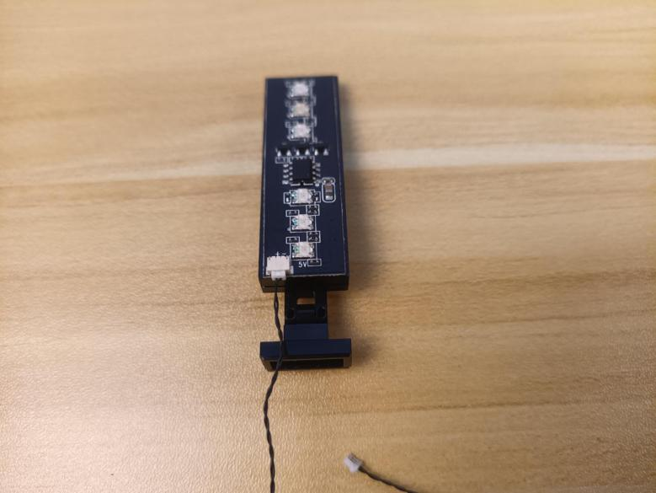

Connect it to the following place.
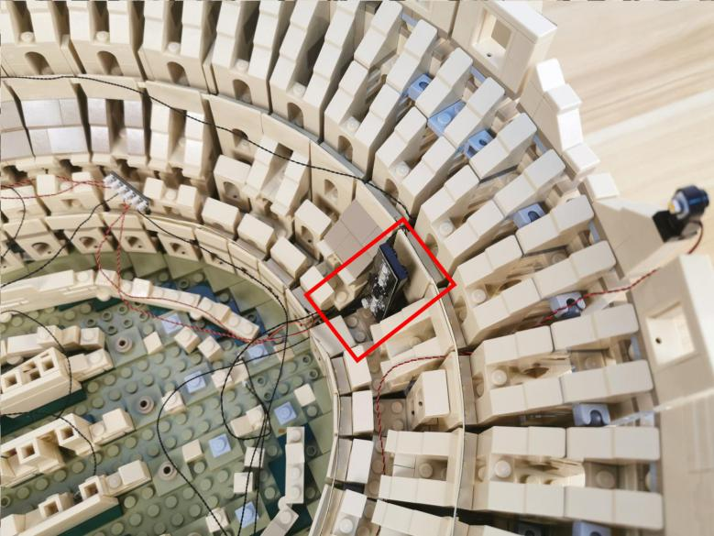

Take a 4-port expansion board, a 5cm connecting cable, assemble the as per below.
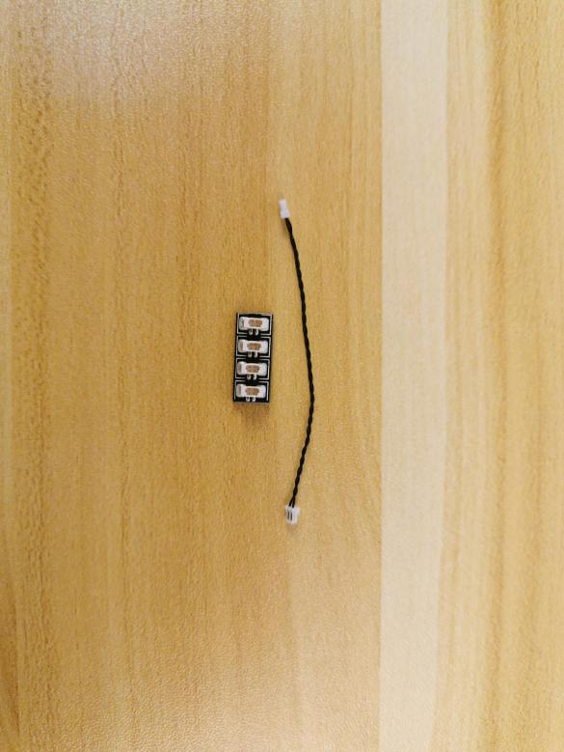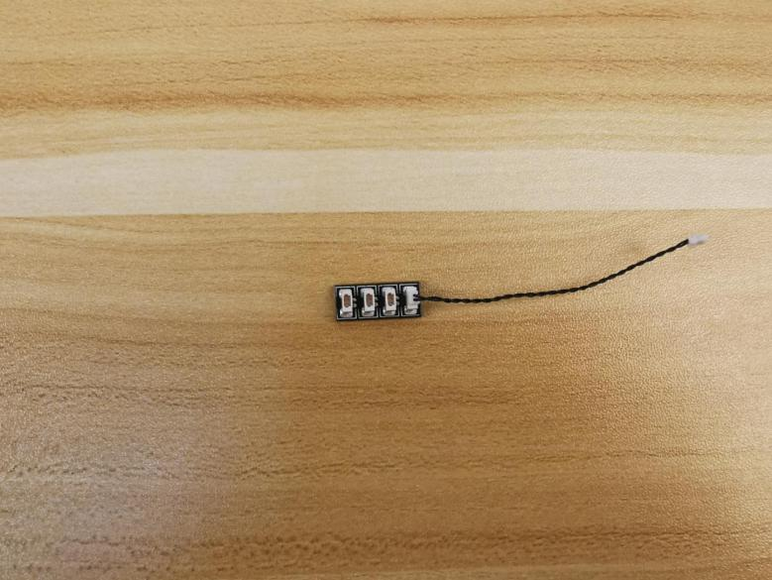

Connect the connecting cable from the 6-port expansion board to the 4-port expansion board.
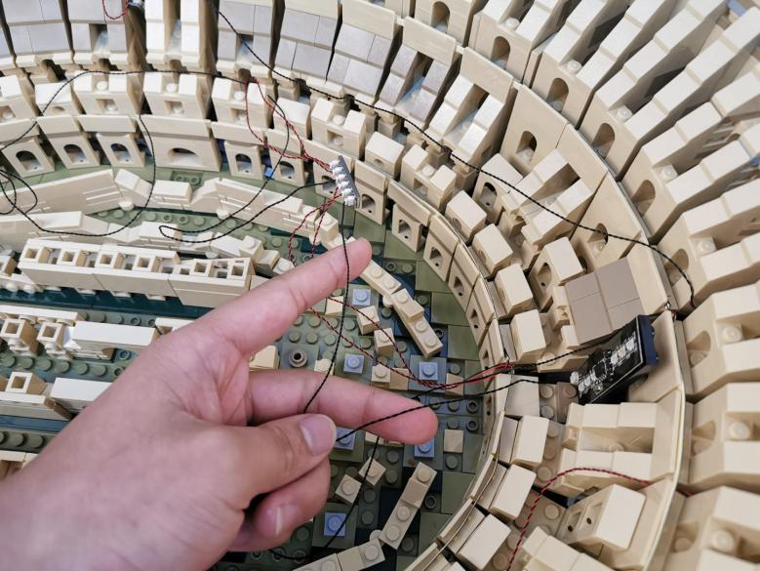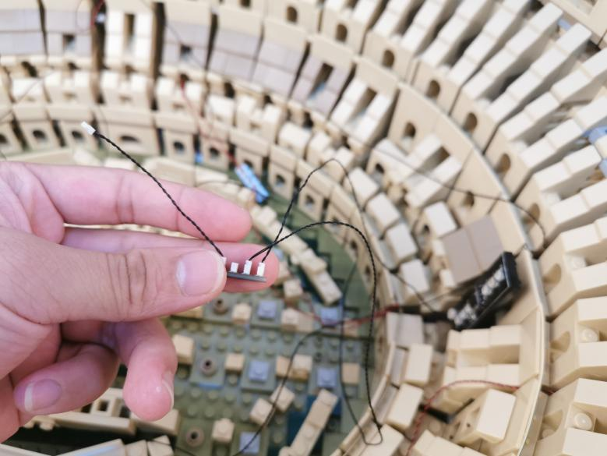

Take a Acousto-optic Control Switch Board.
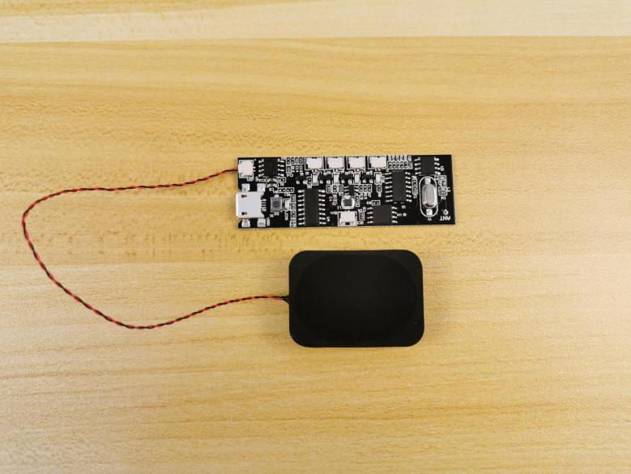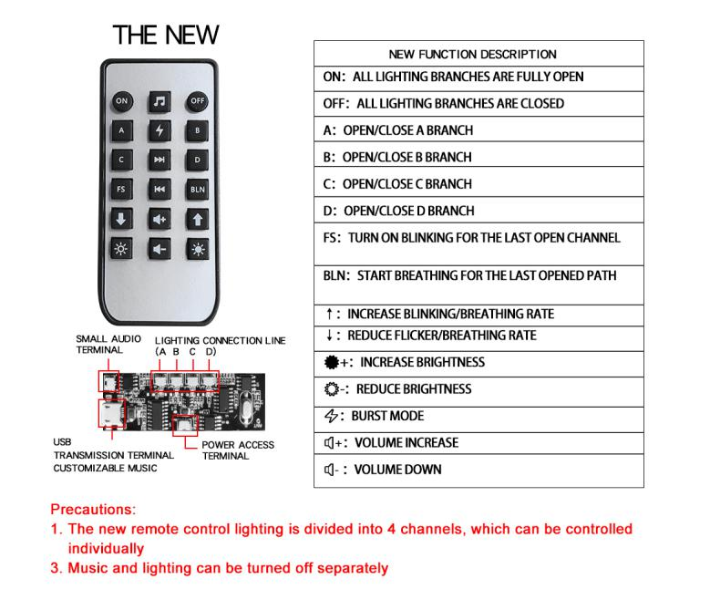

Connect the connecting cable from the 4-port expansion board to the A port on the Acousto-optic Control Switch Board.
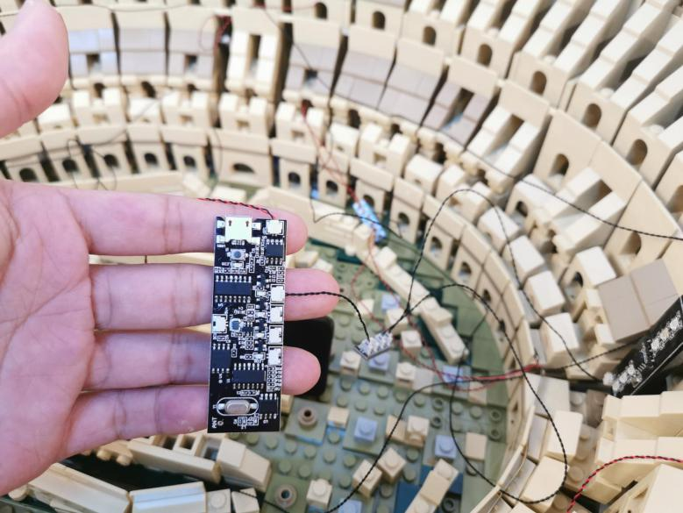

Connect the following cable from the right to the B port.
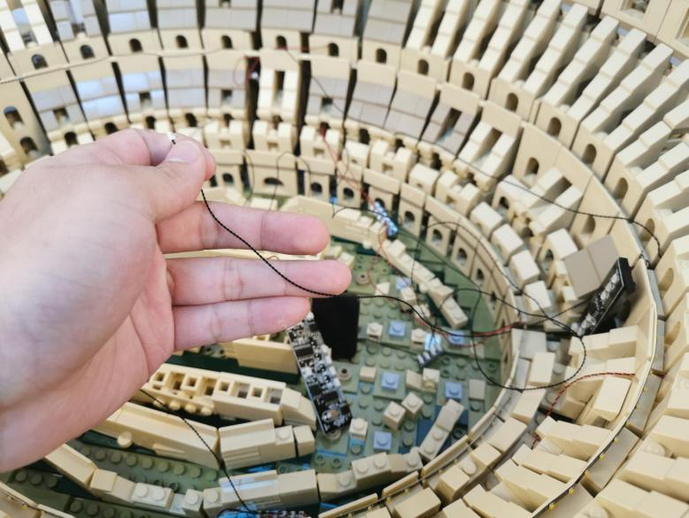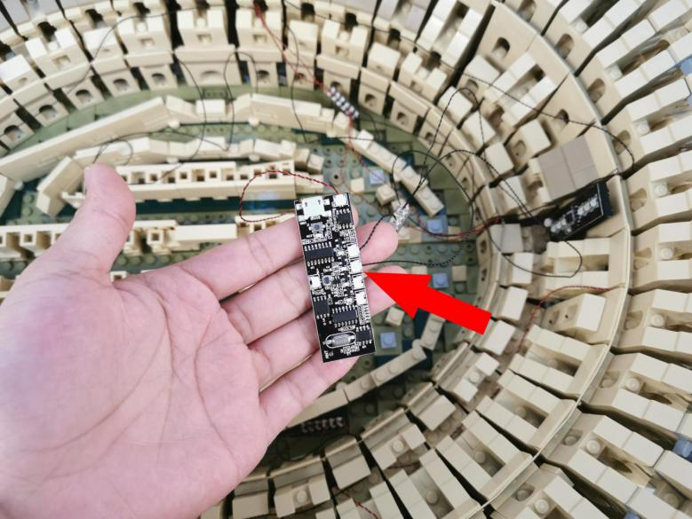

Connect the following cable below to the C port.
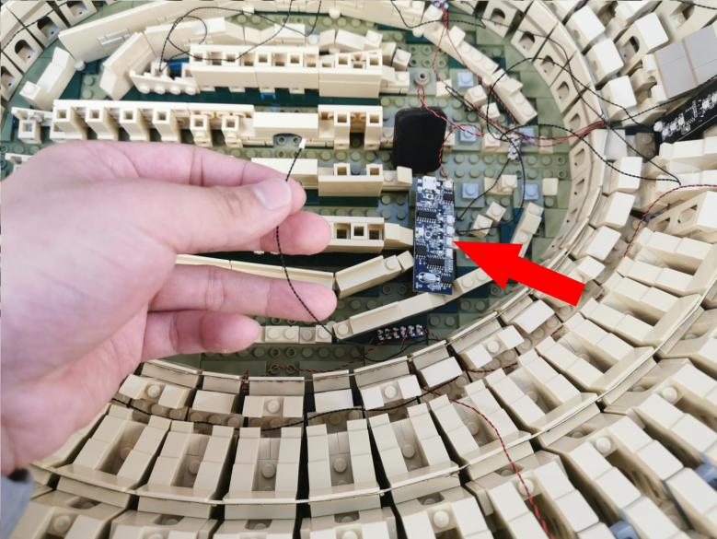

Connect the following cable above to the D port.
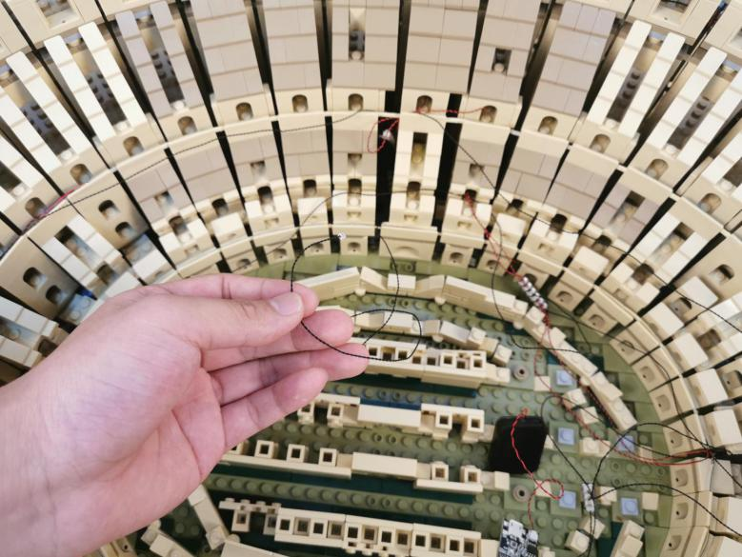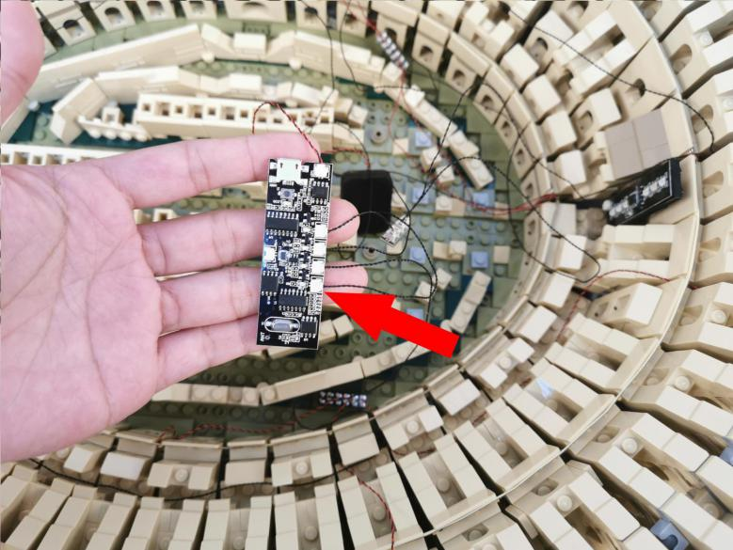

Take a 50cm connecting cable, 8 adhesive squares.
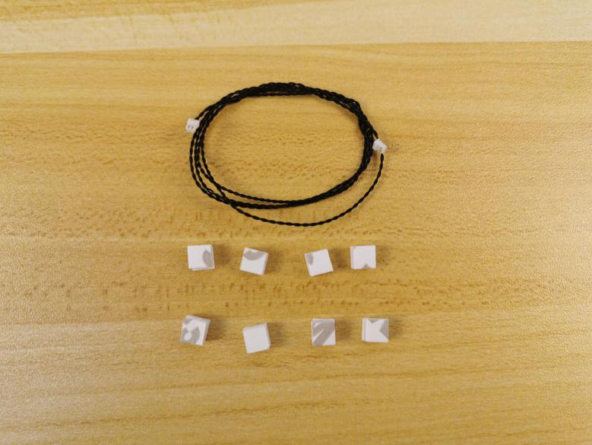

Connect the connecting cable to the input port on the Acousto-optic Control Switch Board.
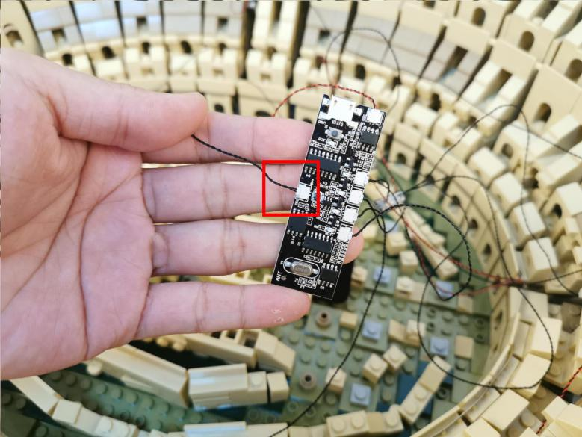

Stick the adhesive squares to the backs of the Acousto-optic Control Switch Board and the speaker.
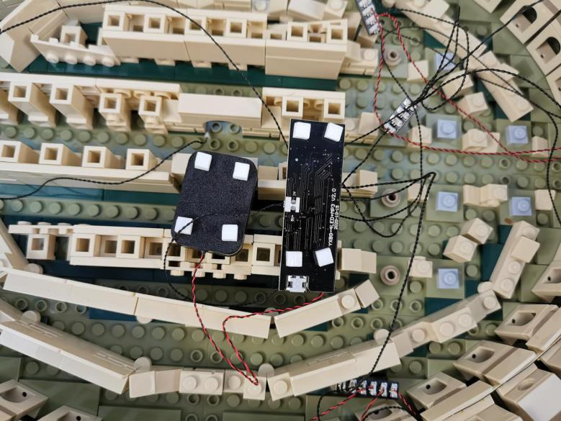

Stick them to the following spaces.
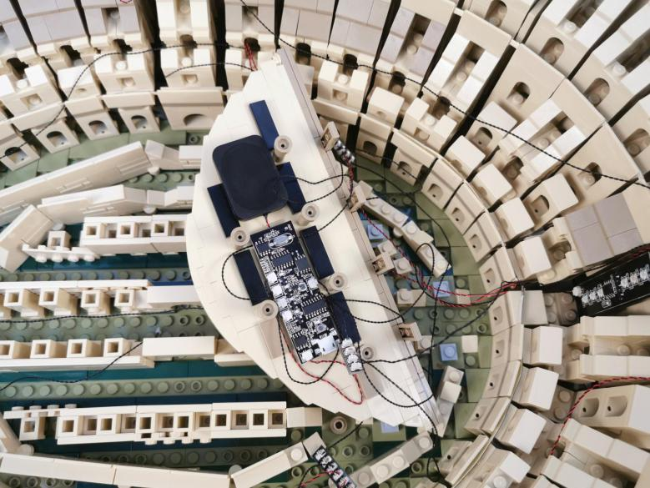

Reconnect the following piece.
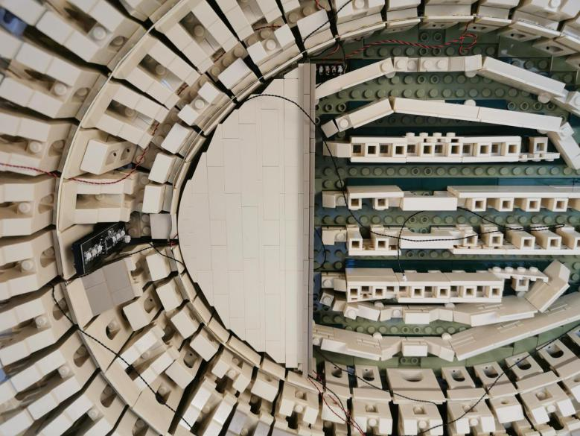

Thread the connecting cable from the Acousto-optic Control Switch Board to the outside.
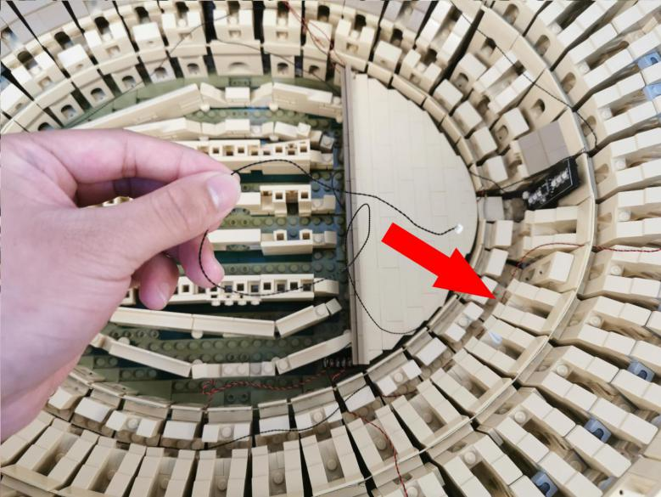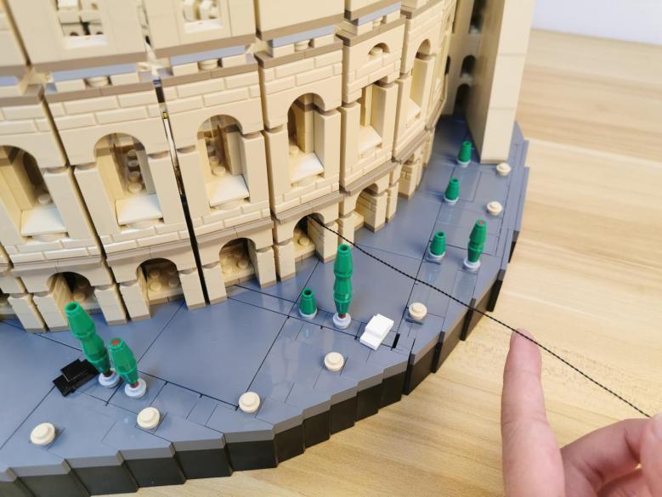

Take four 2x6 black plates, 8 black plates, 4 black hinge plates with handle, 4 black ladder vertical clamp plates.
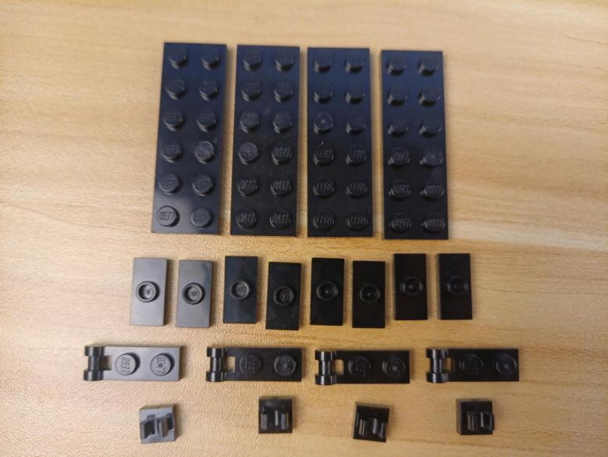

Assemble them as per below.
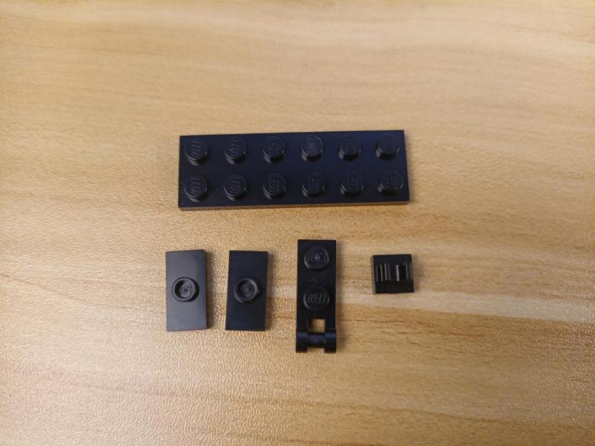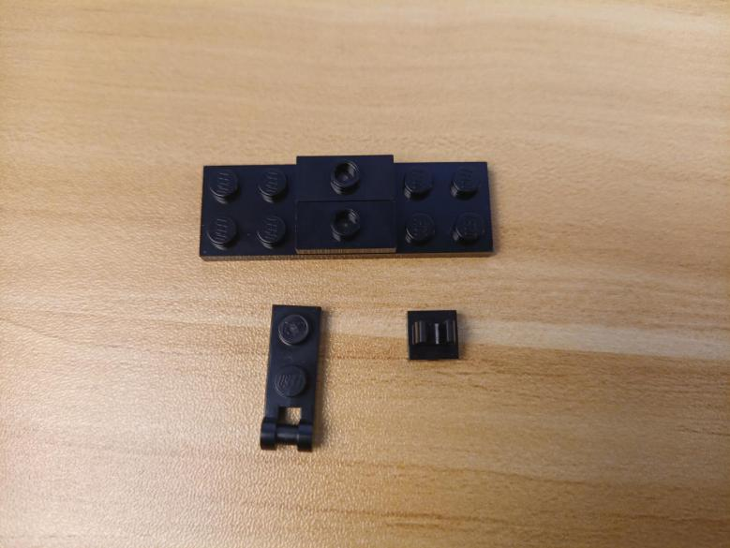
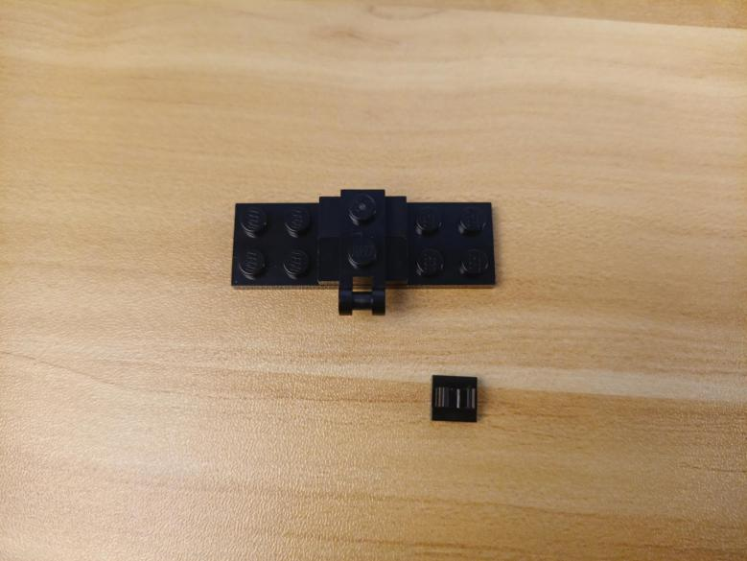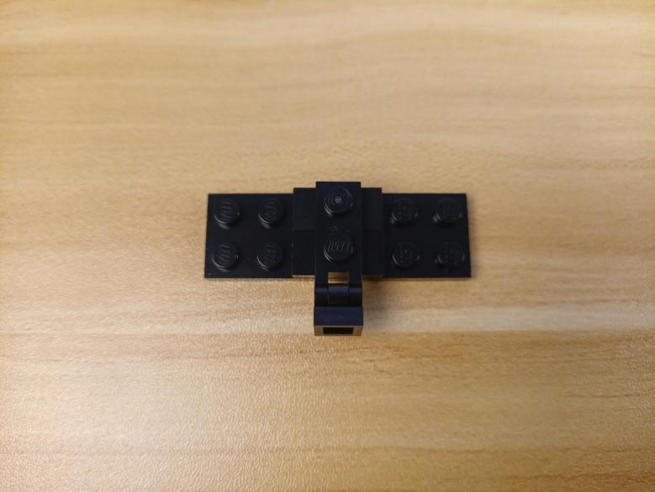

The 4 pieces assembled are as per below.
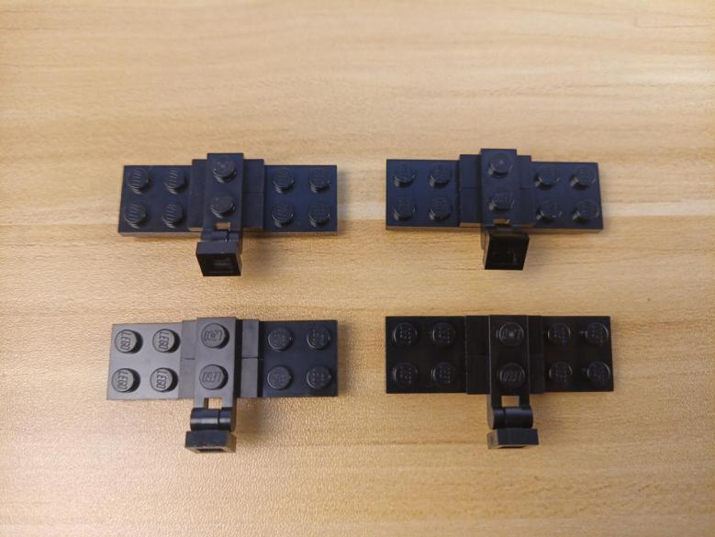

Take 4 Multi Colour Background Lights.
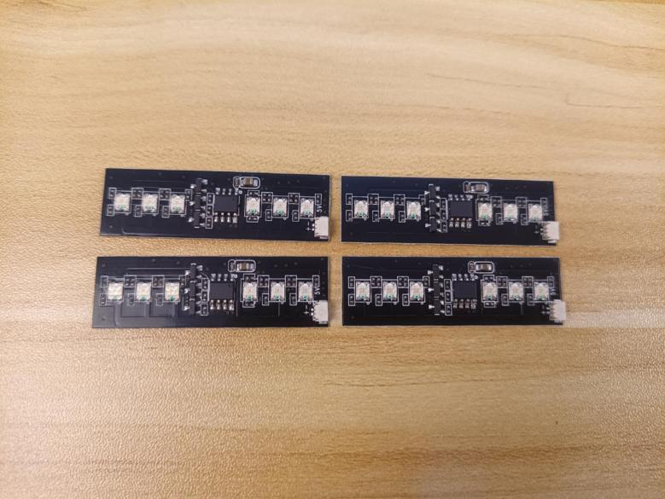

Turn the following piece to the back.
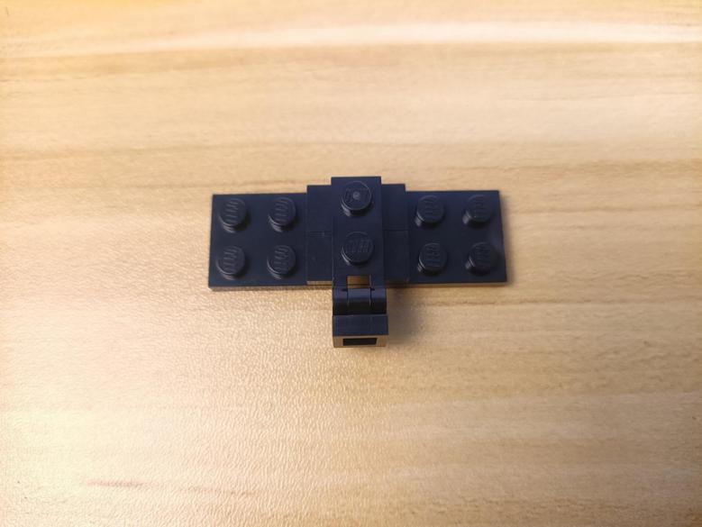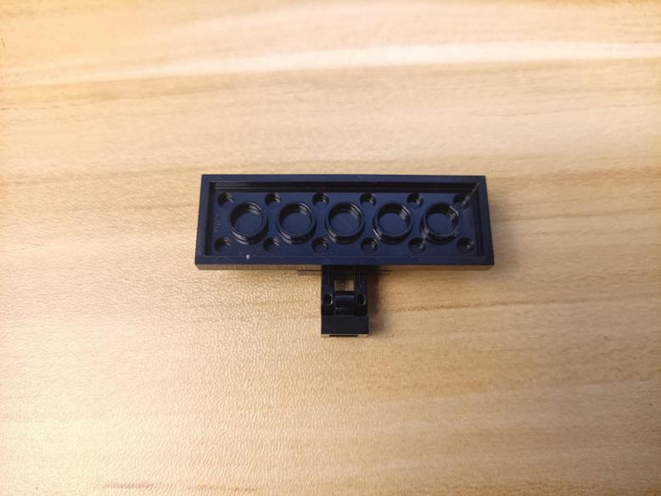

Stick the background lights to them.
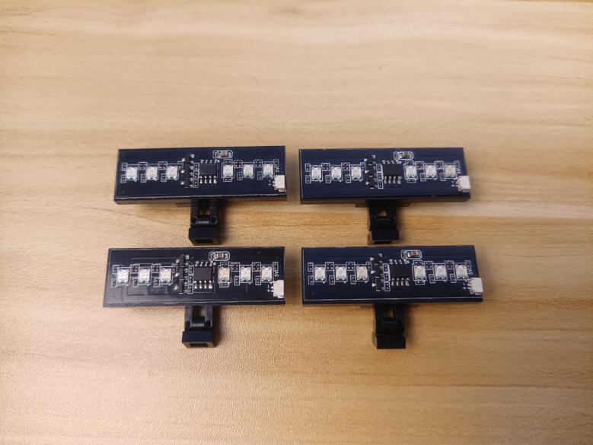

Take four 30cm connecting cables, a 6-port expansion board.
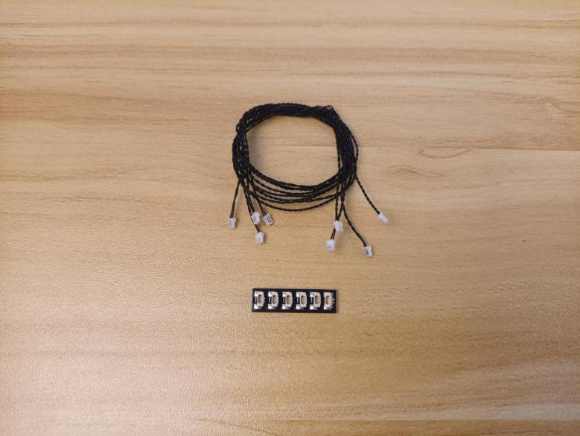

Connect the cables to the following ports.
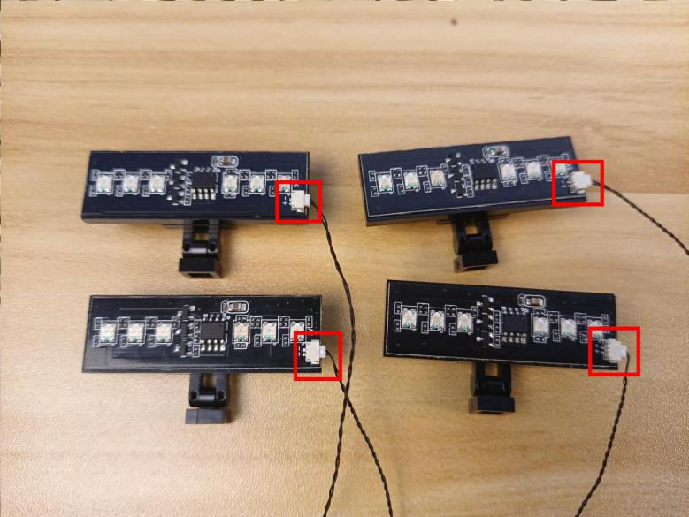

And connect them to the 6-port expansion board.
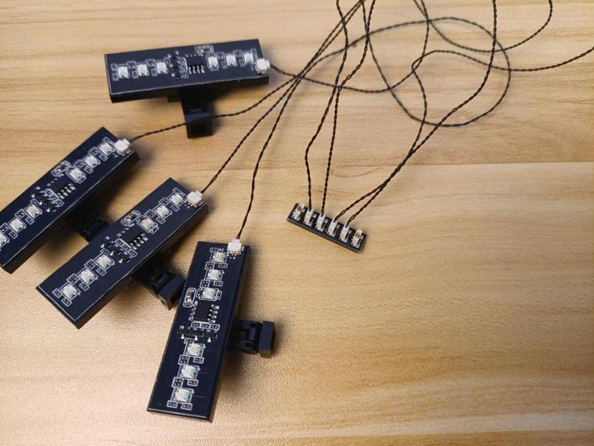

Take a 50cm connecting cable, connect it to the expansion board.
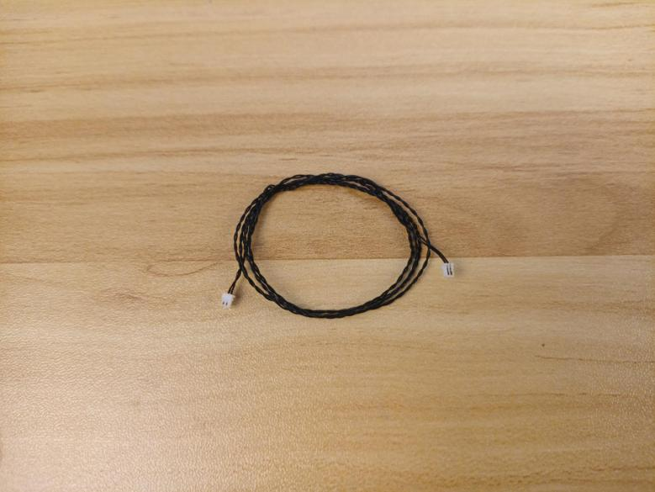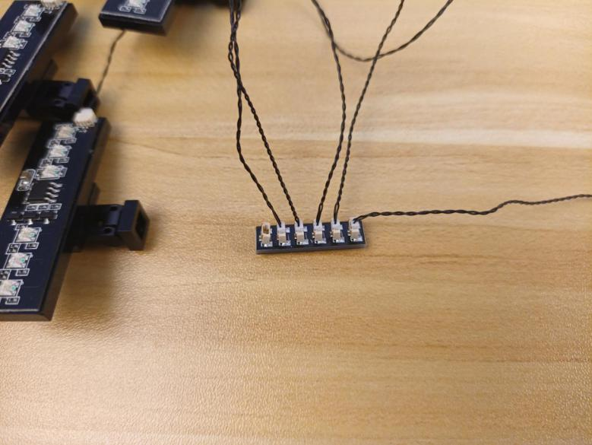

Continue to install lights for the outer ring.
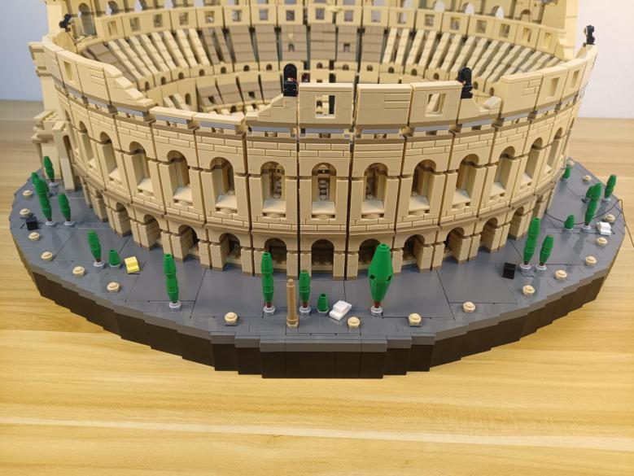

Turn to the left, install the 2 multi colour background lights to the following places.
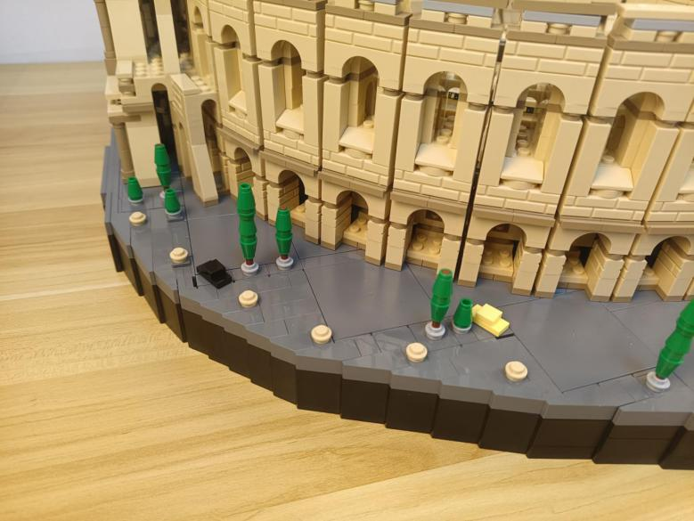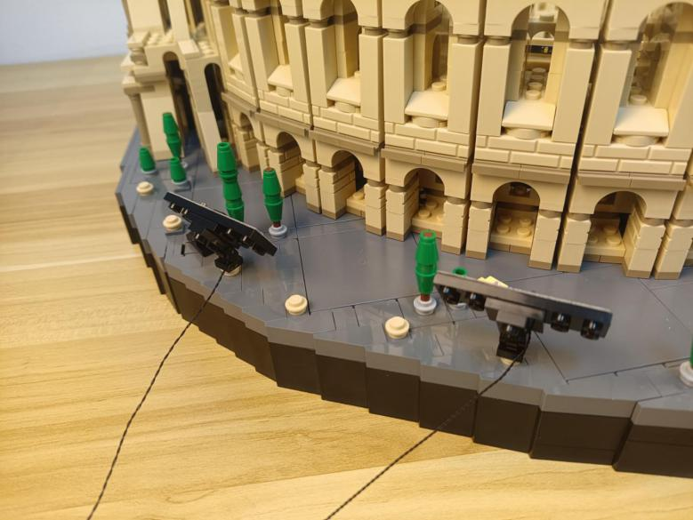

Turn to the right, install the other 2 multi colour background lights to the following places.
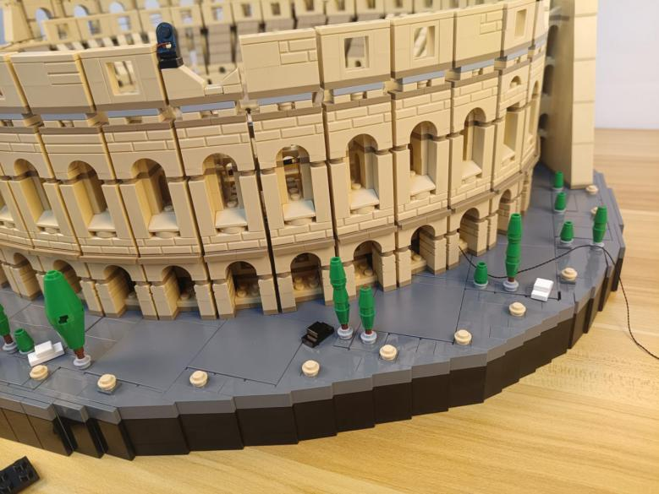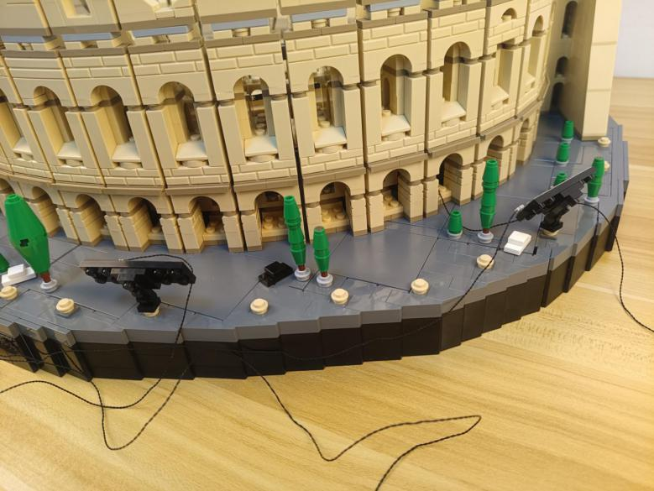

Turn to the middle.
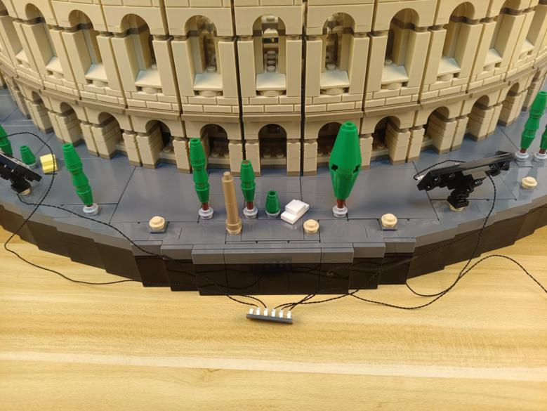

Take 2 adhesive squares.
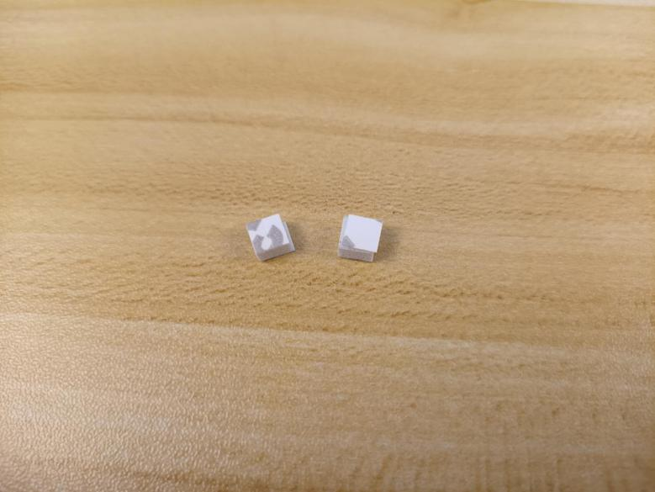

Stick them to the back of the expansion board, and stick the expansion board to the following place.
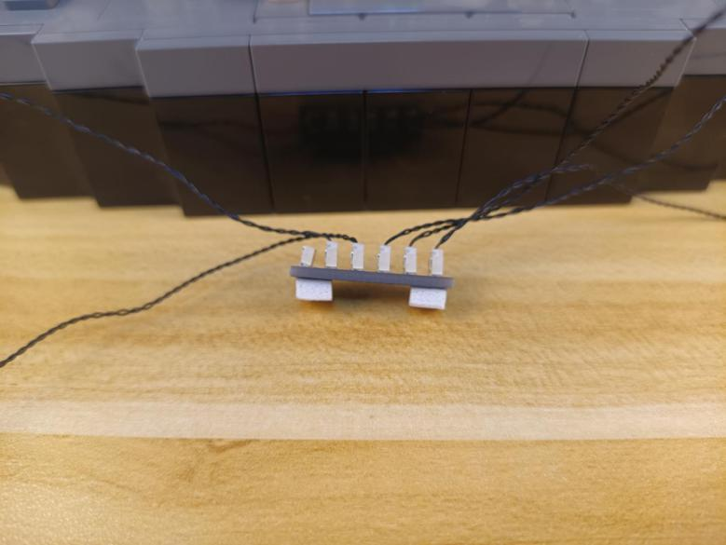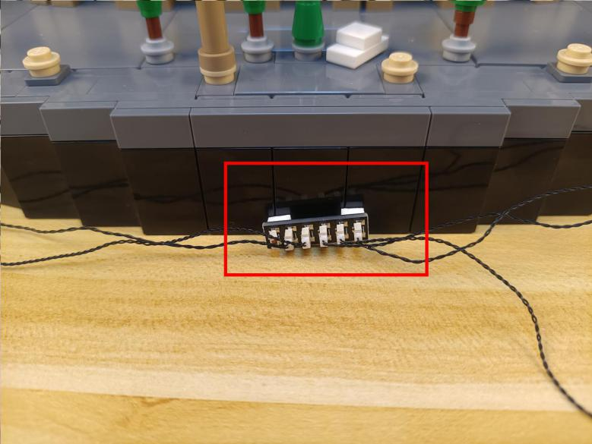

Pull the connecting cable from the expansion board to the right.
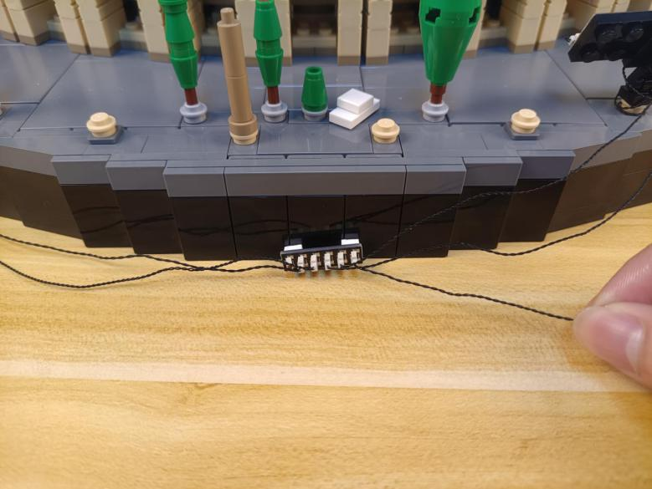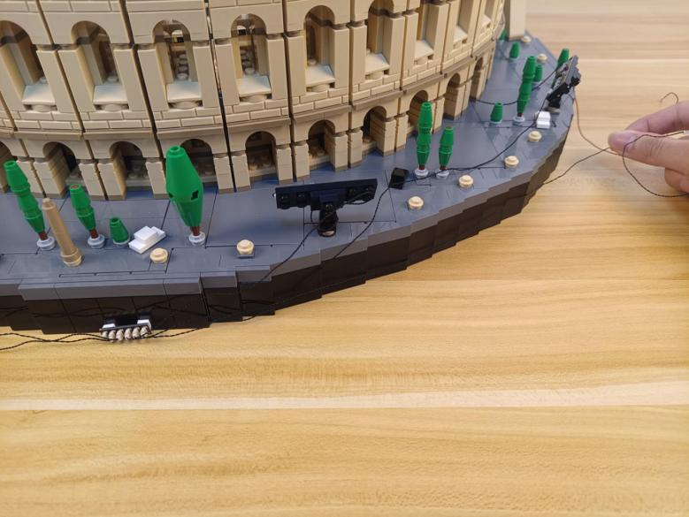

Take a USB cable, a 4-port expansion board, assemble the as per below.
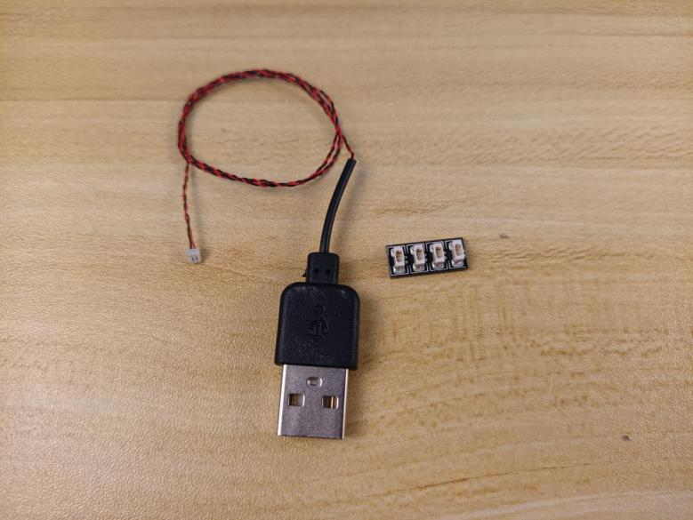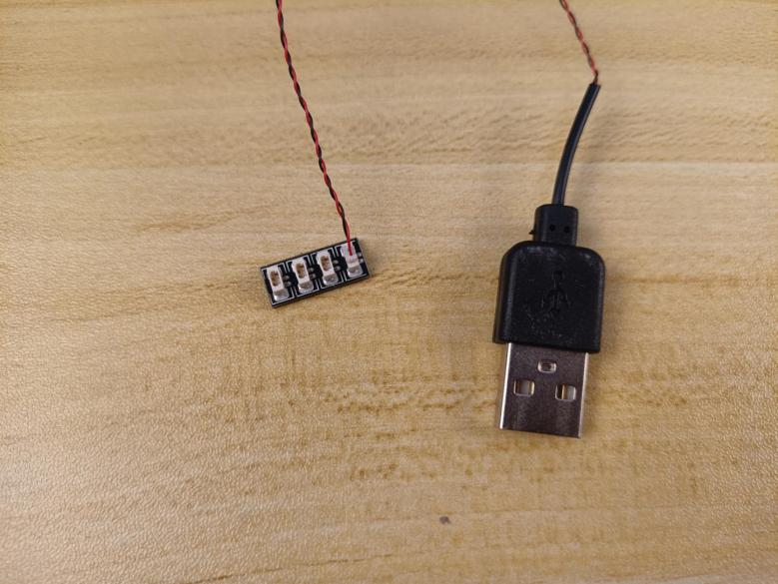

Connect the cable from the 6-port expansion board and the following cables from the Colosseum to the 4-port expansion board.
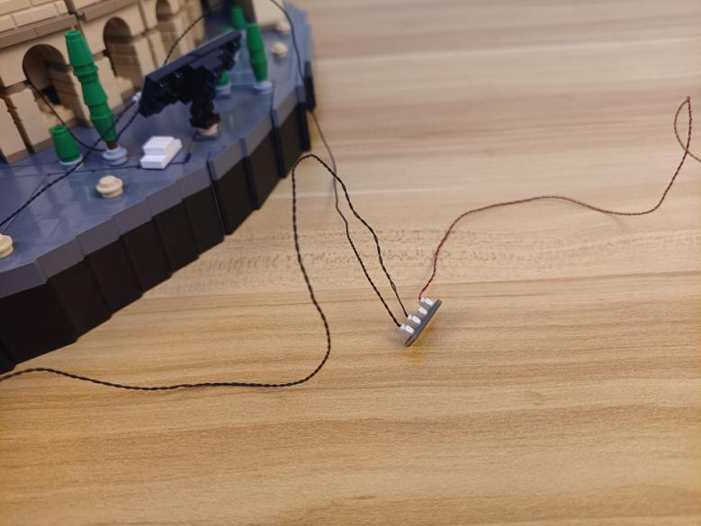

Take 2 adhesive squares.
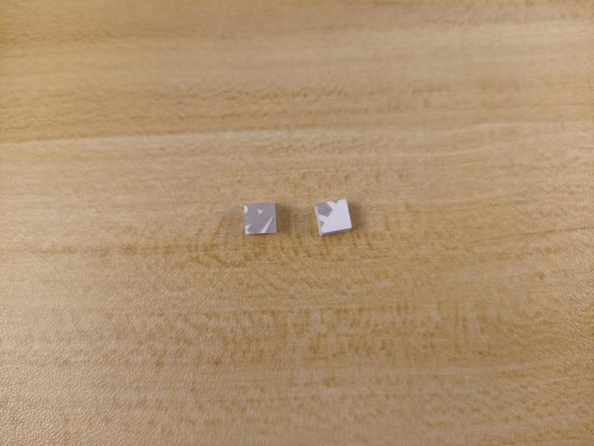

Stick them to the back of the expansion board, and stick the expansion board to the following place.
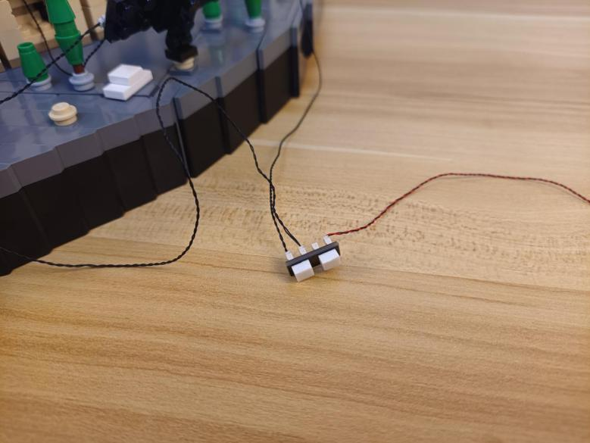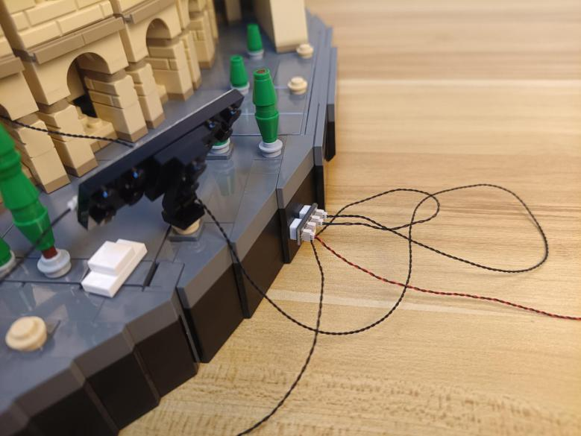

This completes installation of this LED Lighting Kit. ENJOY! （A port：lights from the 1st floor；B port：lights from the 2nd floor；C port：lights from the 3rd floor；D port：lights from the 4th floor.）

The above are ideas and instructions provided by our designers. Please move on:
1: Do you have any suggestions about the material and quality of our products?
2: Do you have any suggestions on the installation instructions and the degree of difficulty of the installation?
3: If you have better installation method and ideas, please contact us in time.

