Lighting Kit LEGO 21324

Thank you for choosing our lighting products. We are committed to LEGO product study and lighting development, we're always trying our best to provide LEGO fans with the best products and the best installation ideas.
Must be careful observation, imagination can be infinite.
We provide basic parts to support your imagination.
DO IT YOURSELF .that's what LEGO is .

As always, Lego has been adhering to the DIY philosophy from product selection, research and development to sales. Consumers buy the parts, you will assemble them by yourself, and you can experience every step from picking up the first piece to installing the last one. Besides, LEGO has different answers for the installation form and method of each part. Vonado lighting also does not want to kill your unlimited creativity, we will try our best to make products with high variability, high playability and unlimited play. If you have any dissatisfaction or your own ideas on the parts such as the color of the lights, the length of the cables, the installation position of the product, and the final effects of each module, you can make your own arrangement, and we will cooperate with you to replace or repurchase.
LETS MOVE!

Package contents：
- 1 x 15cm Blue Strip Light （with 21 lights）
- 2 x 15cm Blue Strip Lights（with 7 lights）
- 3 x 15cm Warm White Dot Lights
- 1 x 15cm Pink Dot Light
- 1 x 15cm Green Dot Light
- 1 x 15cm Red Dot Light
- 2 x 15cm Blue Dot Lights
- 1 x 30cm Blue Dot Light
- 1 x 30cm Warm White Dot Light
- 3 x 15cm Flashing Red Dot Lights
- 2 x 15cm Multi Colour Flashing Lights
- 1 x 15cm Head Light
- 1 x 15cm Connecting Cable
- 4 x 30cm Connecting Cables
- 3 x 4-port Expansion Boards
- 2 x 6-port Expansion Boards
- 1 x 12-port Expansion Boards
- 1 x USB Cable
Extra pieces
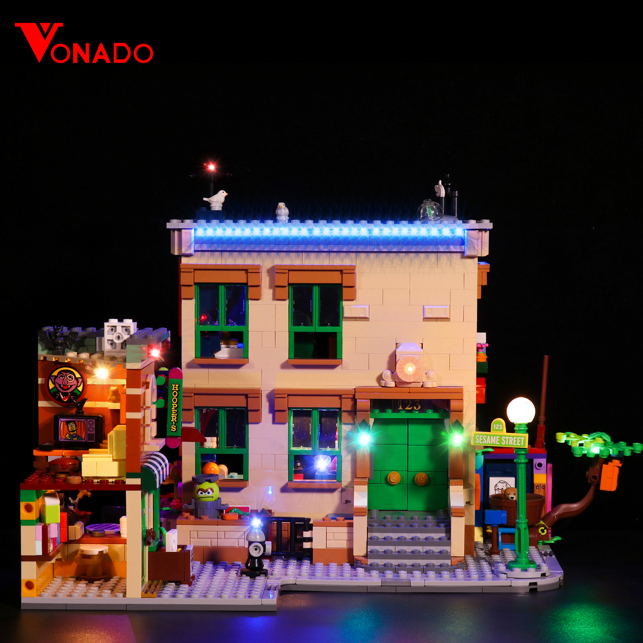
Note:
Place wires on the surface or under the building blocks.
The wire can be place between the building blocks or under the block, but they should be placed between the studs correctly.

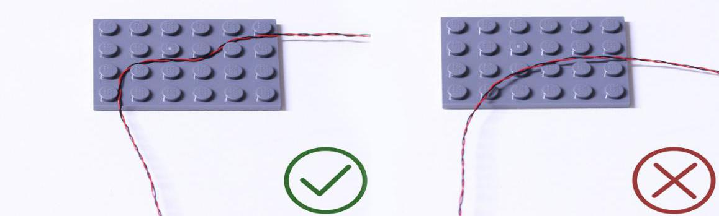

Insert the connectors to the ports.

Be careful when you are operating, there’s only one correct way to insert, make sure the expansion board is upward, find the soldered “=” sign on the left of the port. When you are inserting, the side which the wires can be seen should be faced to the “=” sign and if you feel hard to insert, please stop, and don’t force it, for that may result in bent pins inside the port or overheating of the expansion board.

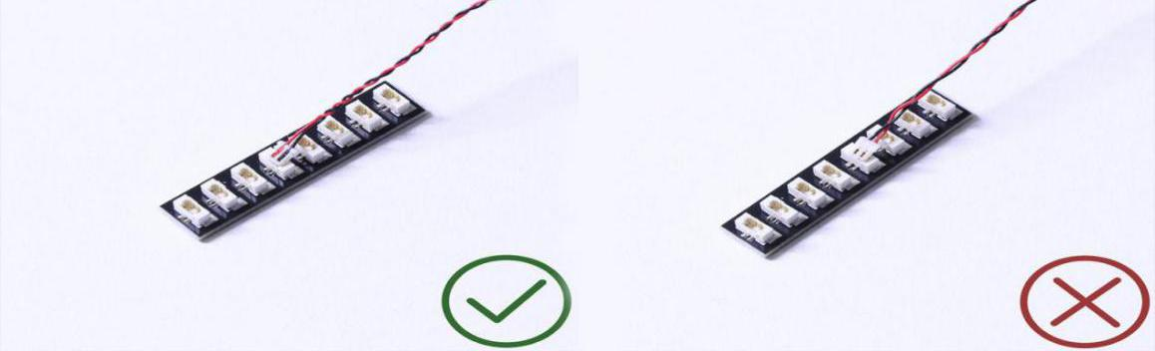

At this point, use the tweezers to straighten the bent pins.

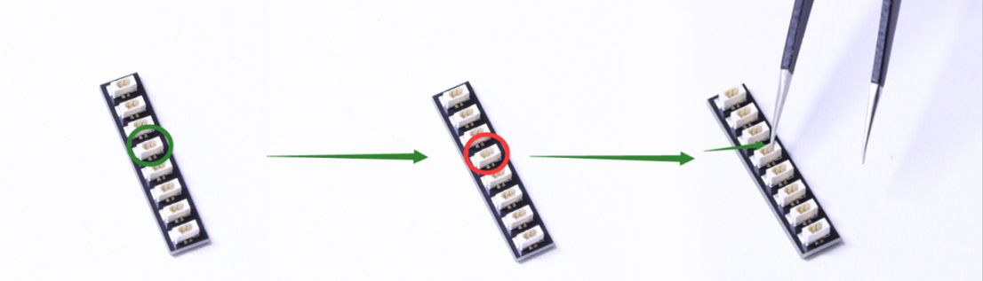

When installing dot lights, make sure they are correctly placed (Yellow LED package is exposed). You can put they either on the top of the studs or between studs.

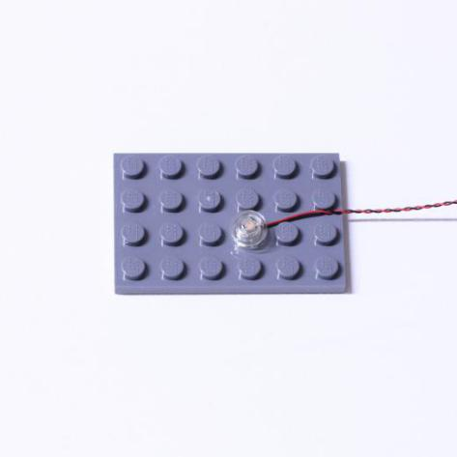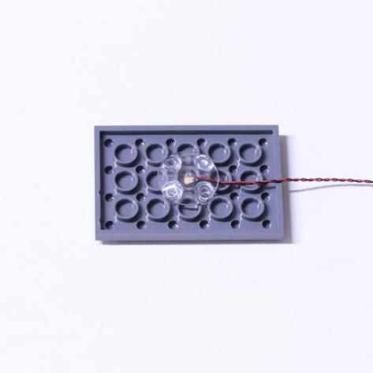

Connecting cable connectors to Strip Lights

Take extra care when inserting connectors to ports on the Strip Lights. Connectors can be inserted only one way. With the Strip Light facing up, ensure the side of the connector with the wires exposed is facing down. If a plug won’t fit easily into a port connector, don’t force it. Doing so will damage the plug and the connector.

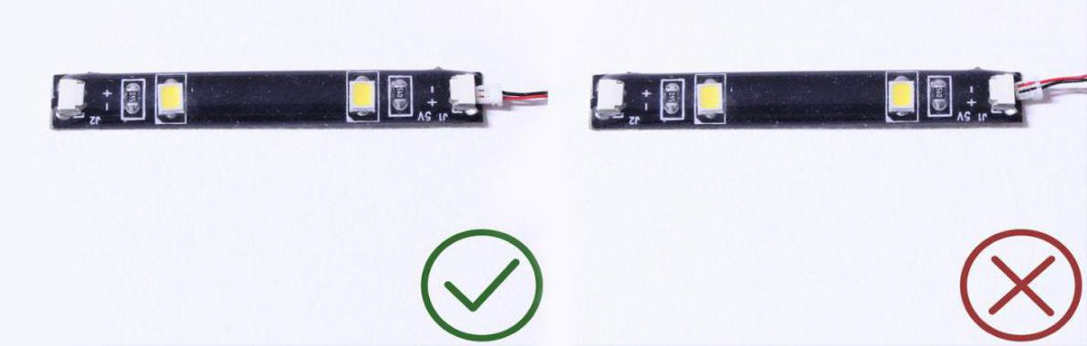

Finally, please pay attention to the positive and negative terminals of the battery when installing the battery case.

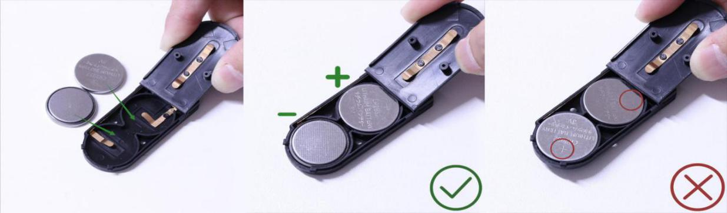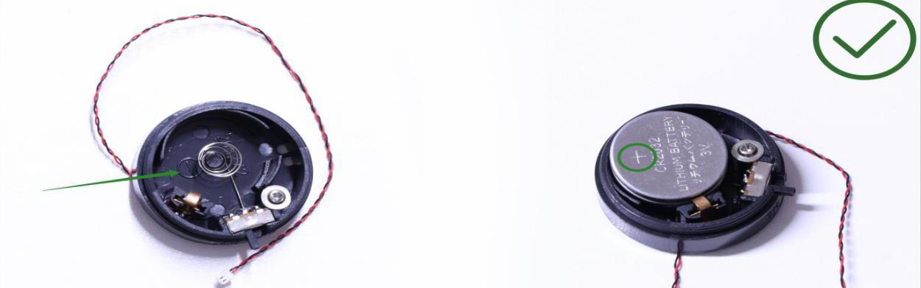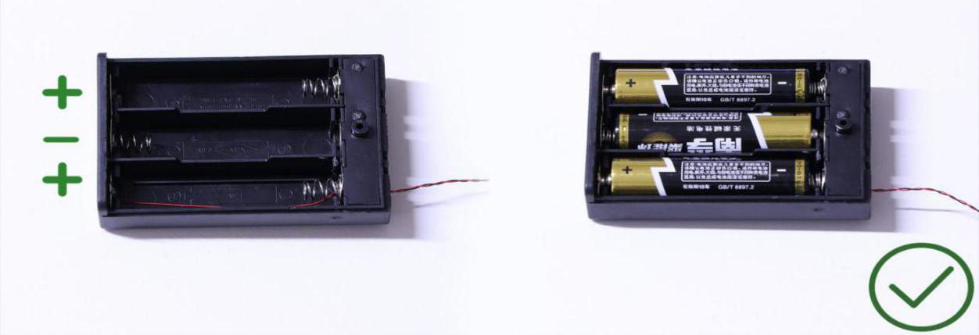
Instructions for installing this kit：
Sesame Street Deluxe Version, Lighting Kit, 17 bags in total.
Power supply： USB cable (self-contained power bank or mobile phone charger).
Firstly, take the power source (power bank or mobile phone charger), connect it to the USB cable, connect the other end of the USB cable to the expansion board to verify all the lights one by one.
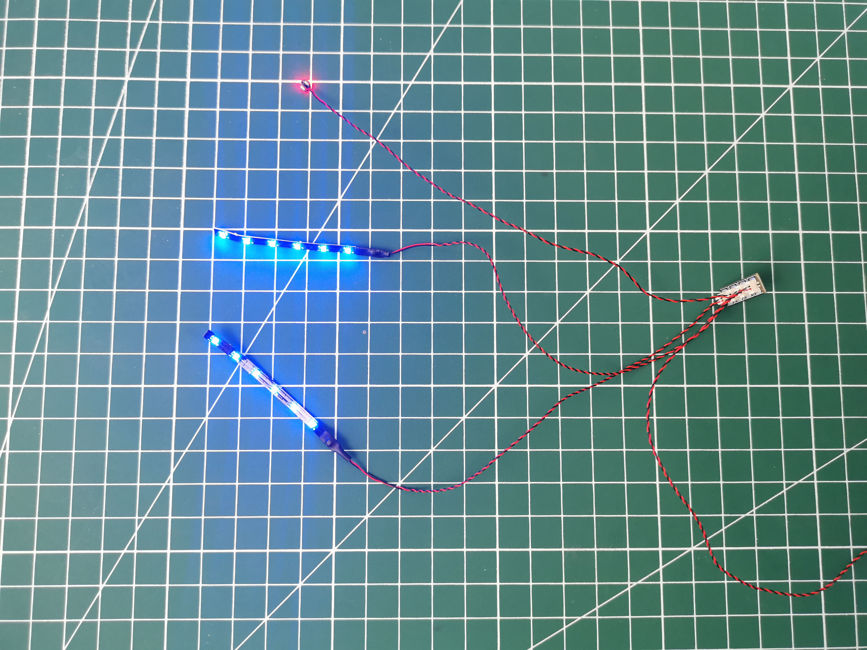
After the verification, disconnect the lights and put them back to the bags.
（note: put the lights back to the bags when verification of the lights from the same bag is done, then, continue to verify the lights in another bag.）
OK, Let’s Begin! （you can use the tweezer if necessary.）
（Tips: the tweezer is sharp, you should be careful when using it, do not hurt yourself or scratch the pieces; be gentle and do not wear the cables.）
Instructions for installing this kit：
Take the house.
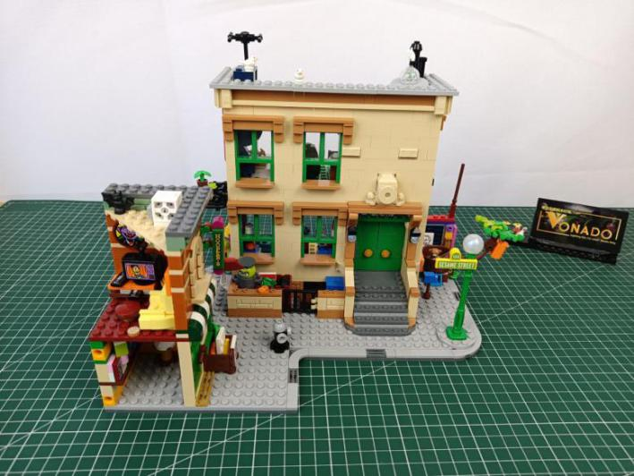

Turn to the cabin at the left.
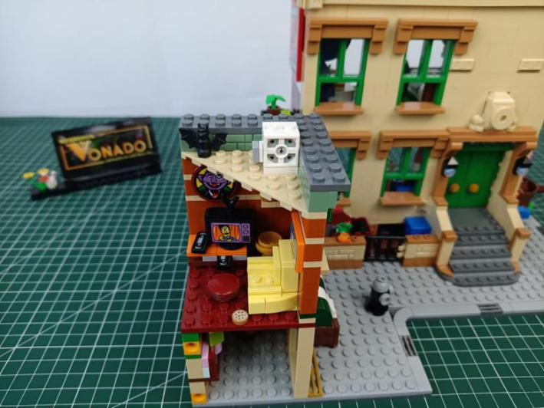

Remove the roof piece.
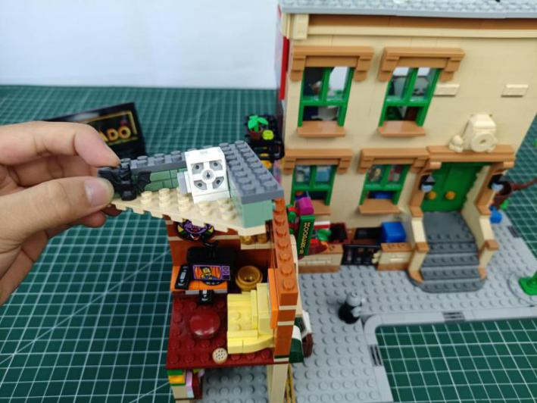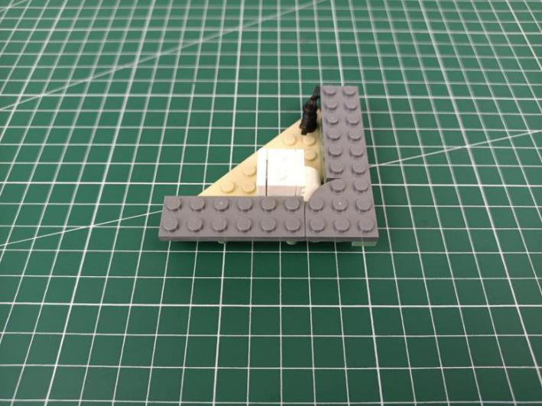

Take 2 flashing red 15cm dot lights, 2 trans red round plates.
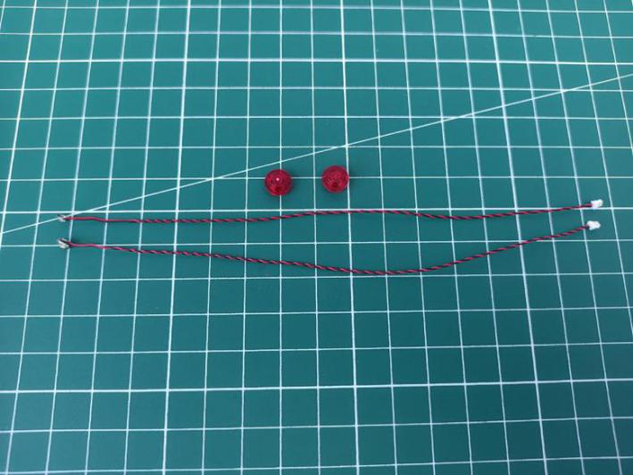
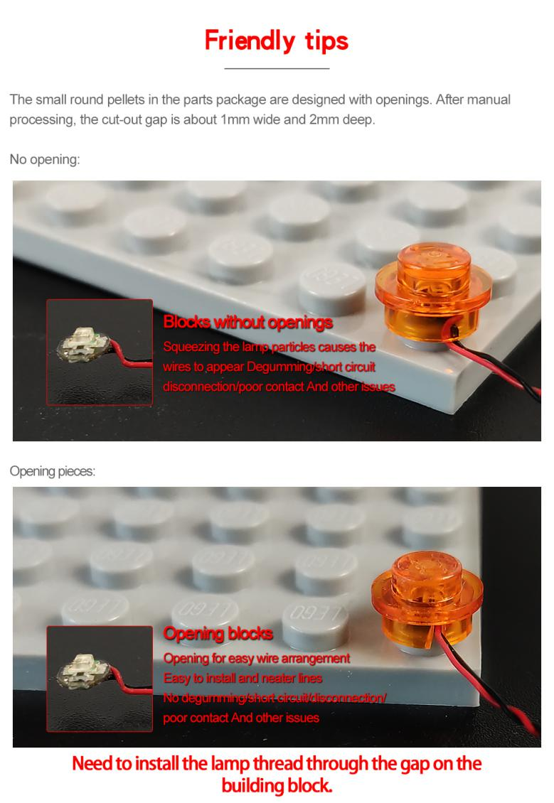

With lighting part facing down, place the light inside the round plate, stuck the cable at the opening.
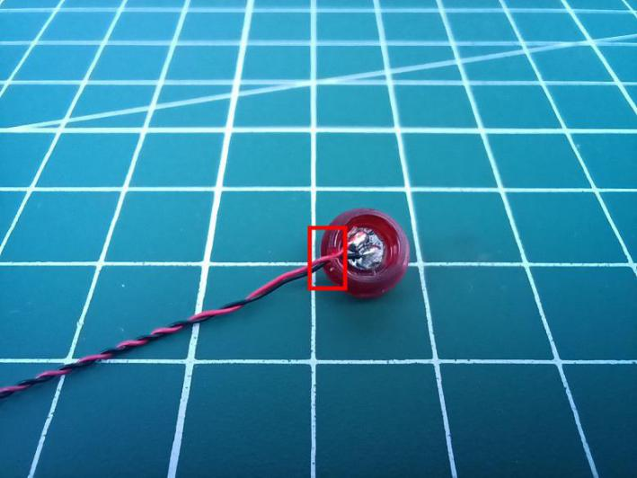

Connect the round plate to the roof piece as per below.
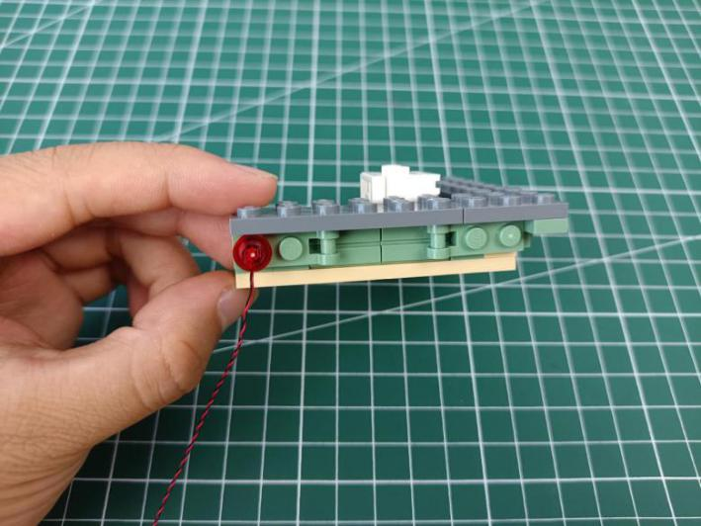

Install the other light in the same way.
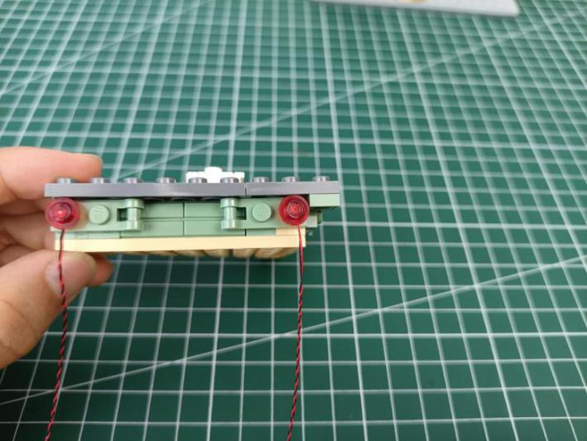

Straighten the cables as per below.
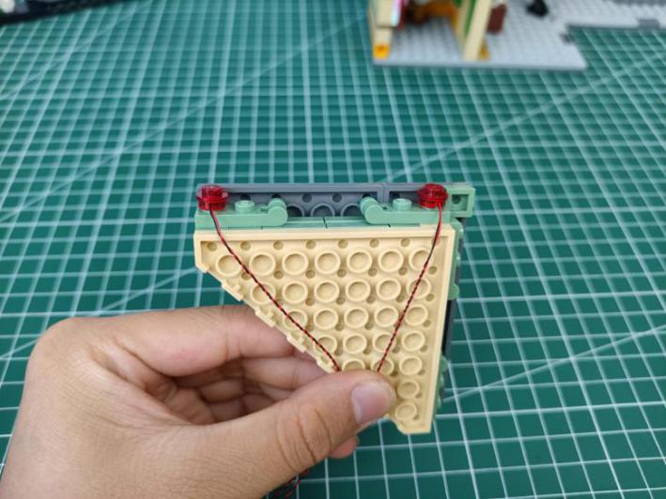

Reconnect the roof, stuck the cables as per below.
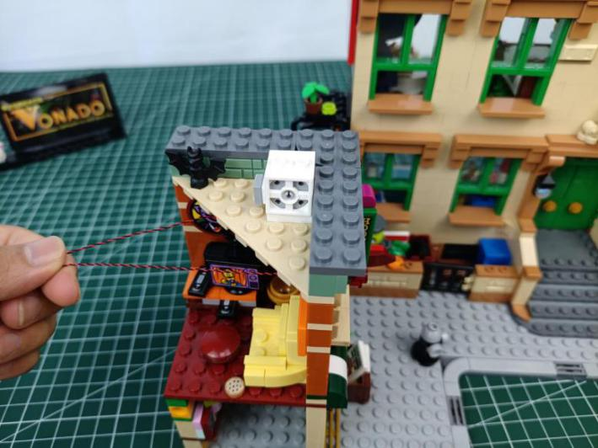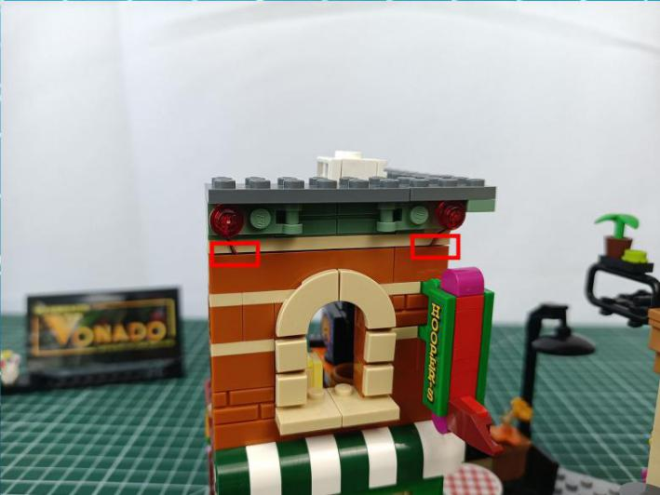

Remove the whole second floor from the side cabin.
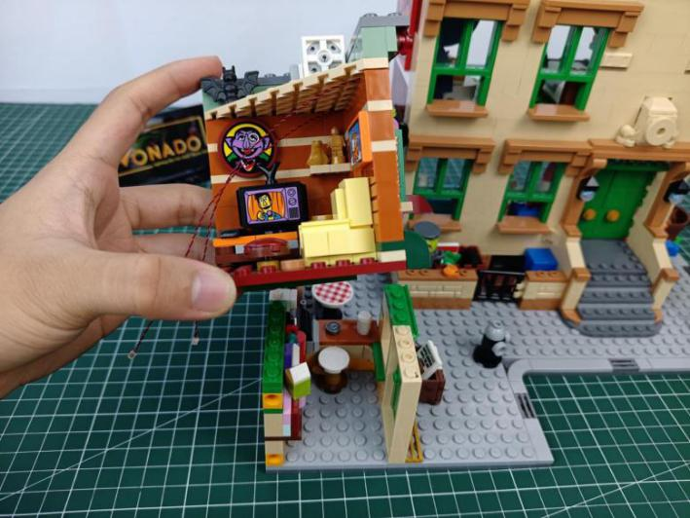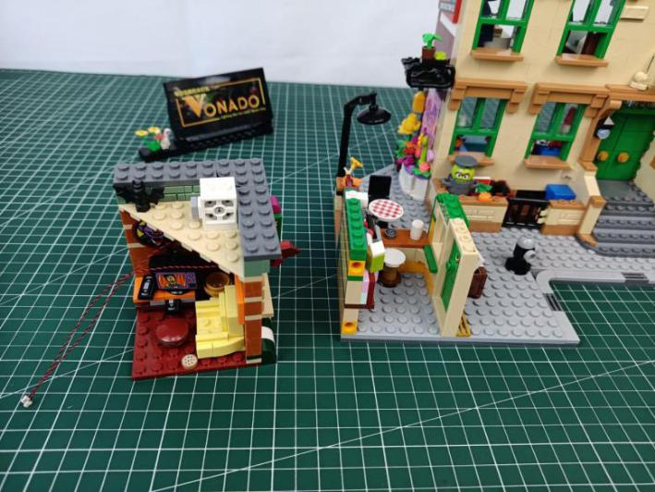

Turn the following piece over.
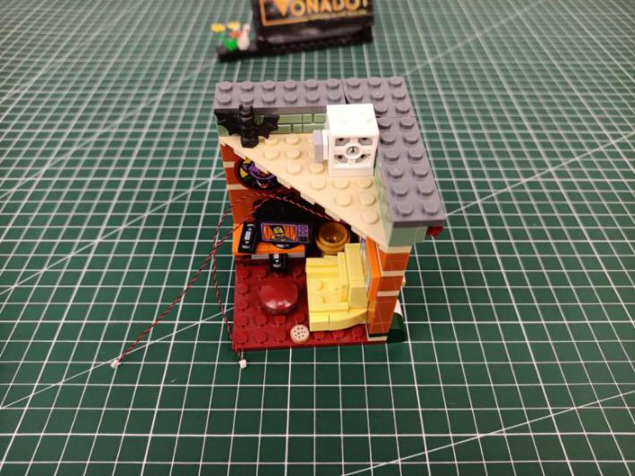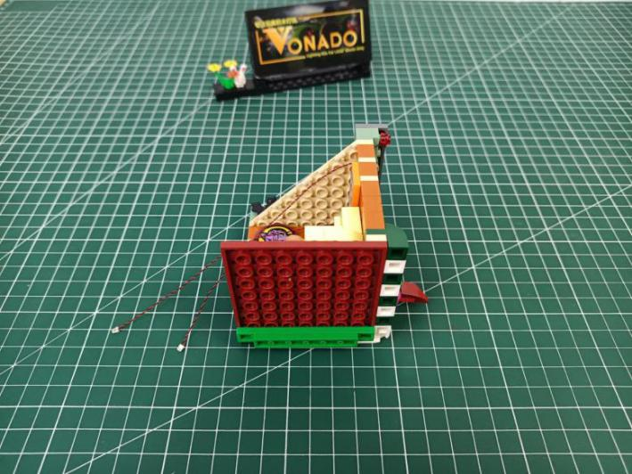

Take a warm white 15cm dot light, an adhesive square.
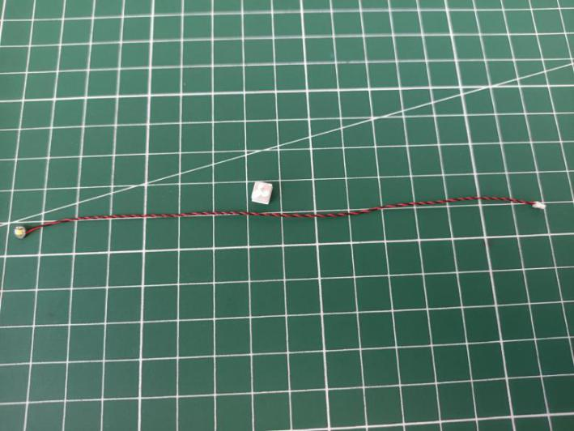

Stick the adhesive square to the back of the light, and stick the light to the following place.
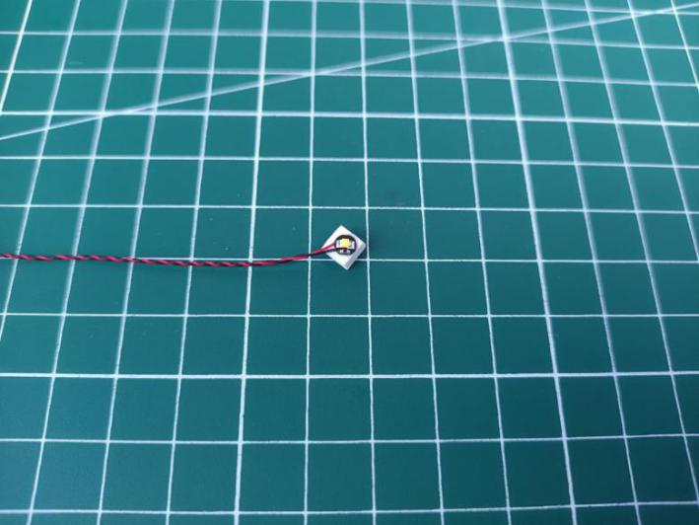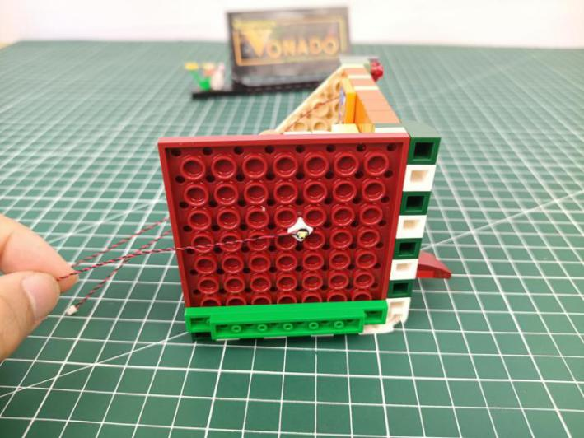

Reconnect the floor.
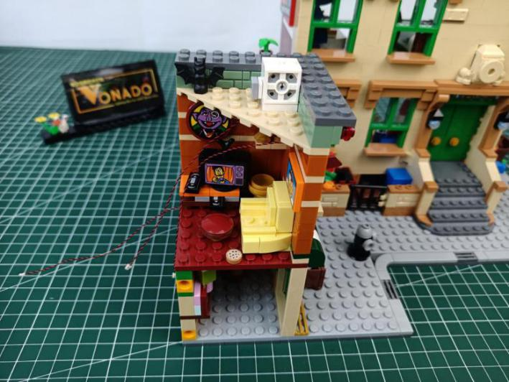

Turn to the side.
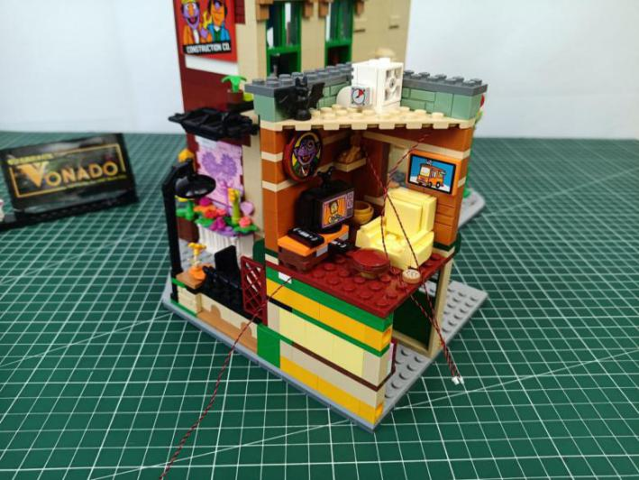

Remove the table piece.
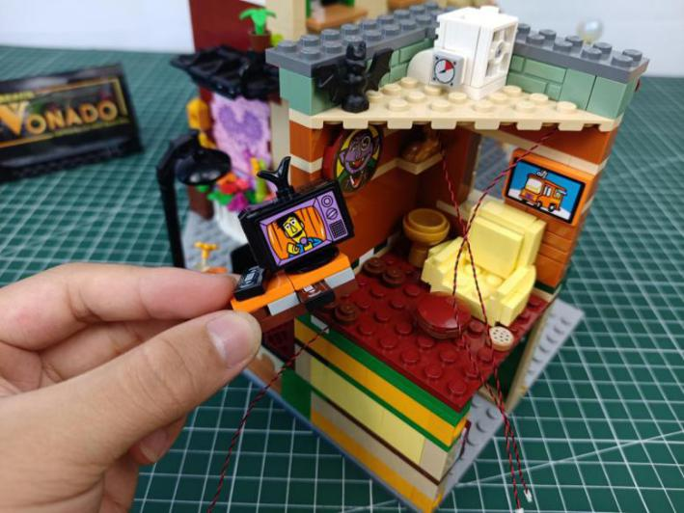

Remove the following 2 round plates.
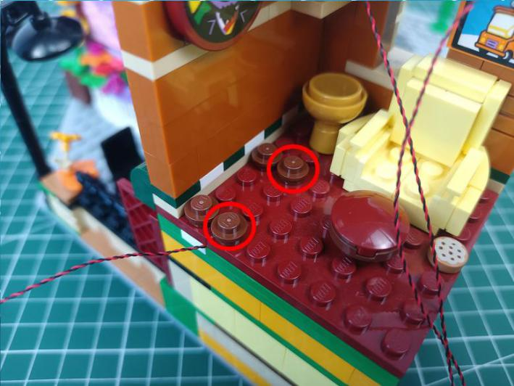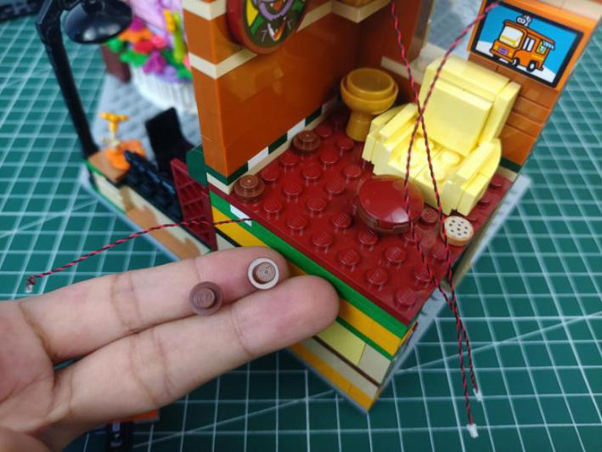

Place the cable as per below.
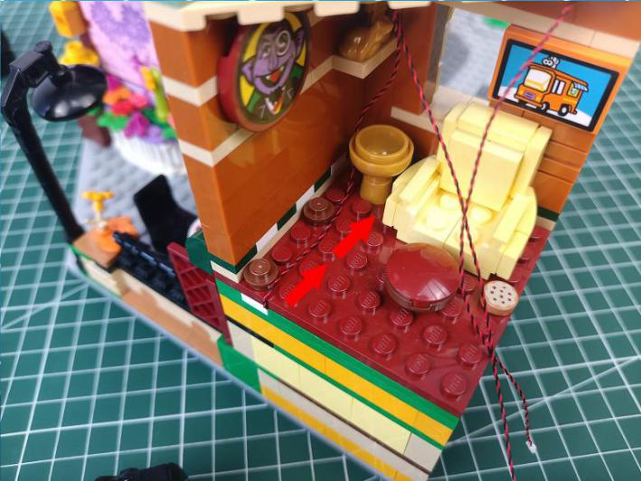

Reconnect the round plates.
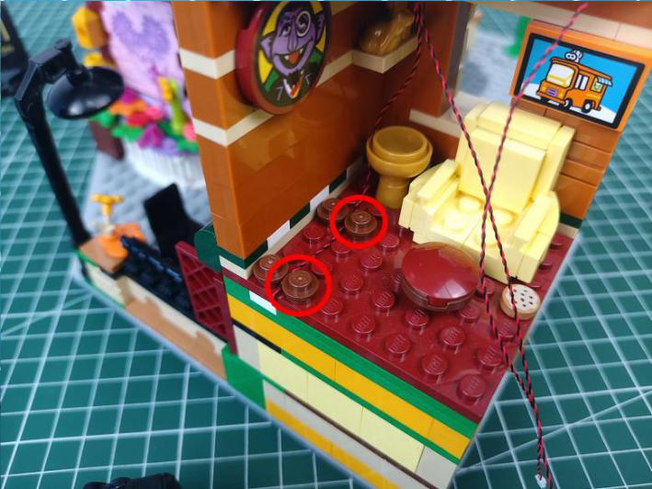

Reconnect the table piece.
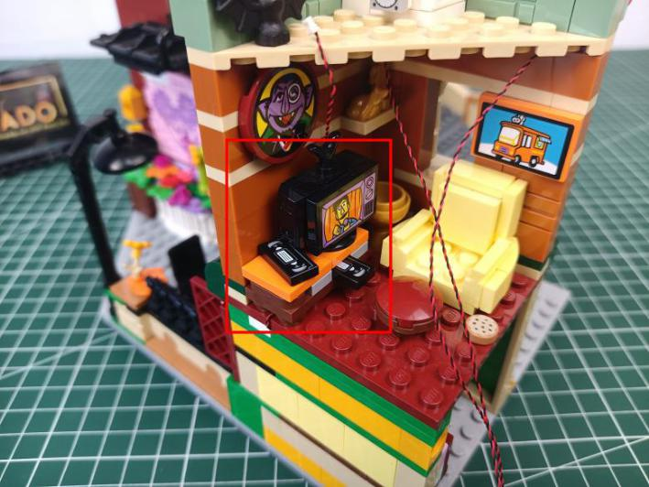

Take a 6-port expansion board, a 30cm connecting cable, assemble them as per below.
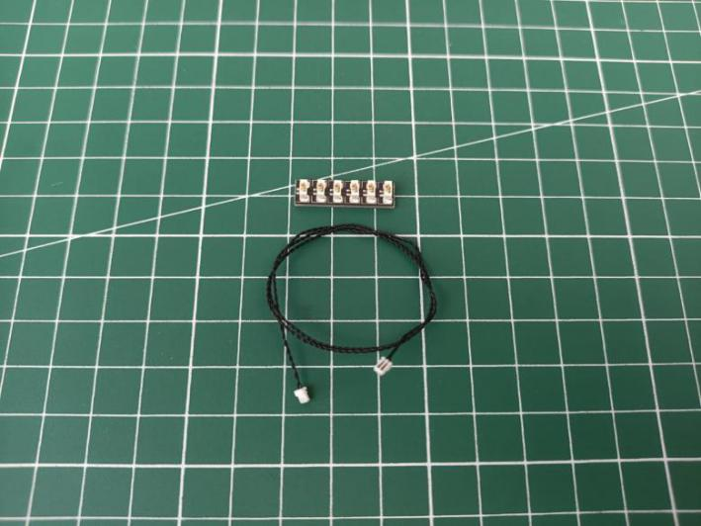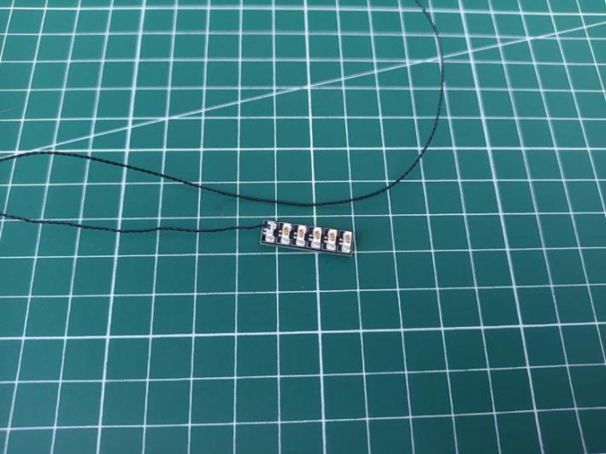

Take a warm white 15cm dot light, wind it around the expansion board before connecting it to the expansion board.
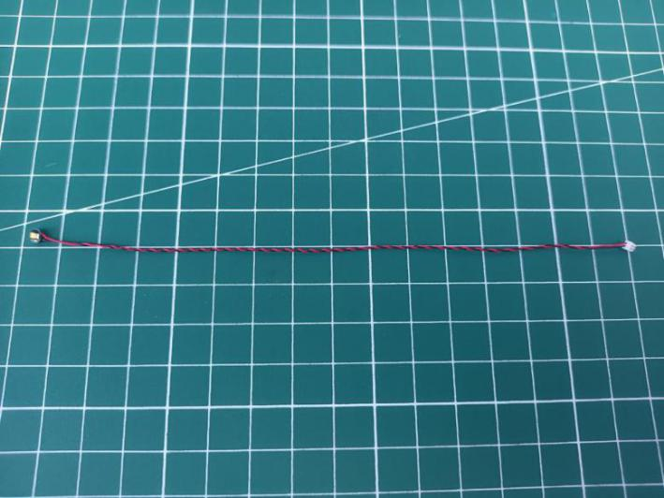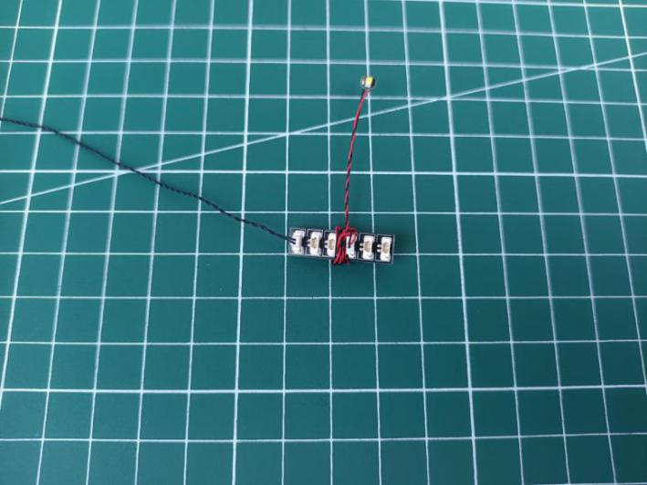

Connect the cables of the lights from the side cabin to the expansion board, and tuck excess cables around the expansion board.
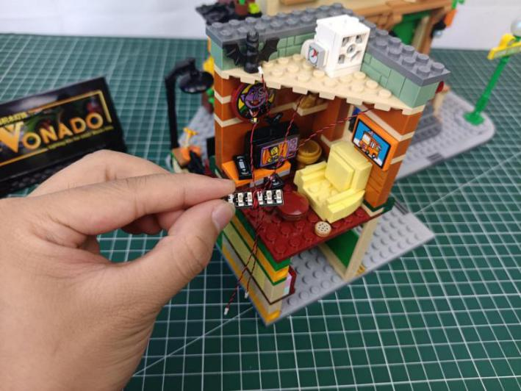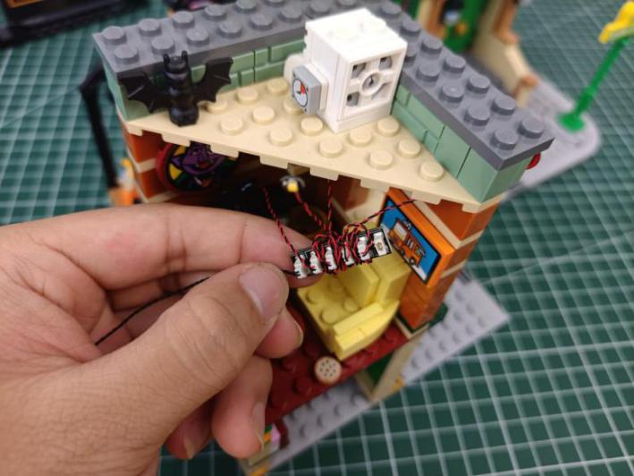

Take 3 adhesive squares, stick them to the backs of the expansion board and the light.
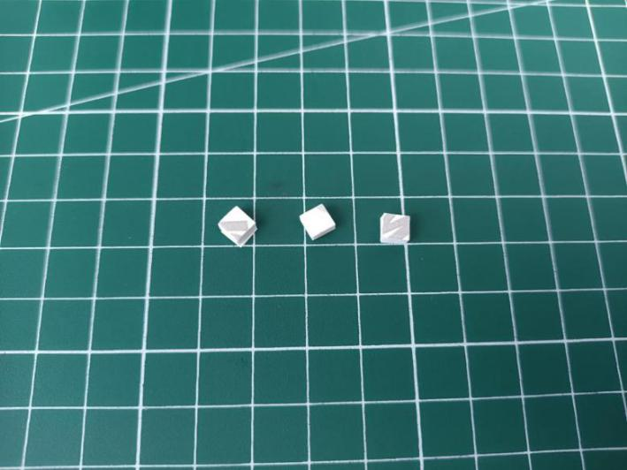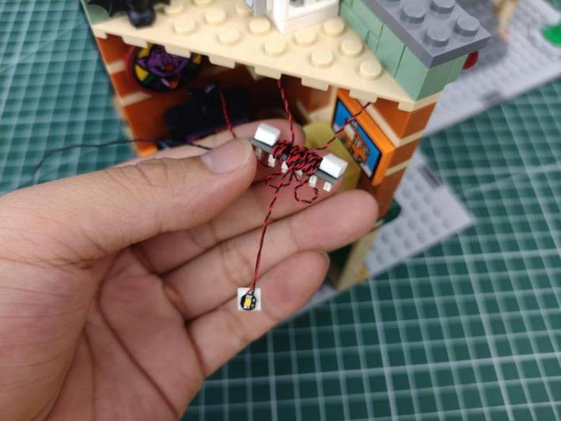

Stick them to the following places.
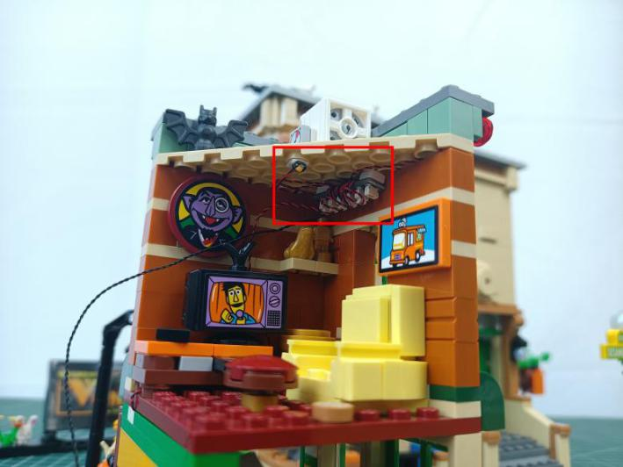

Create a gap at the corner of the wall.
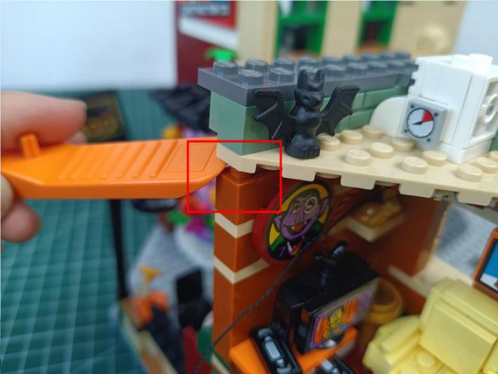

Place the cable from the expansion board at the gap as per below.
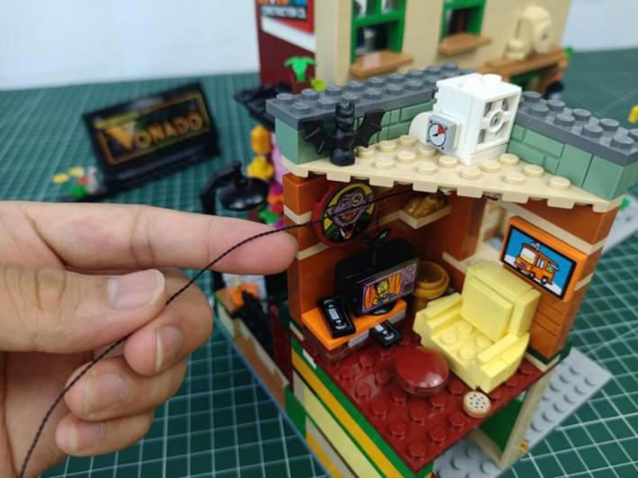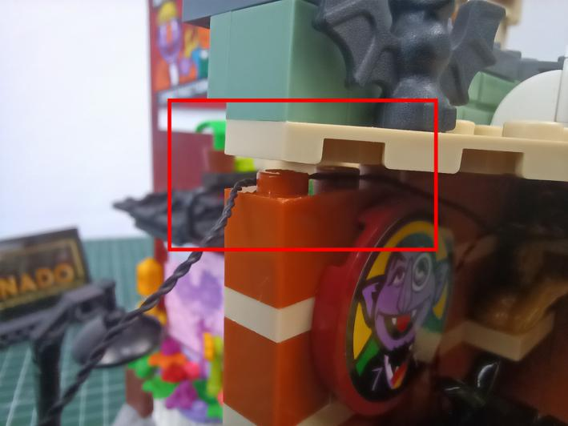

Close the gap.
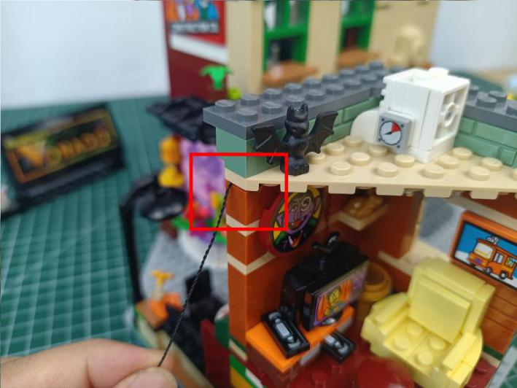

Turn to the side.
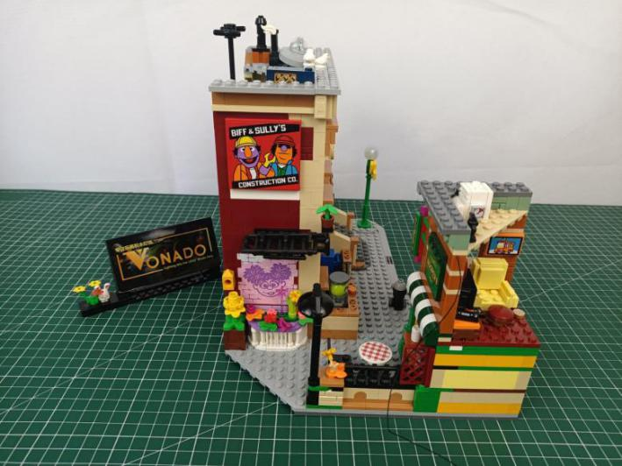

Remove the streetlight.
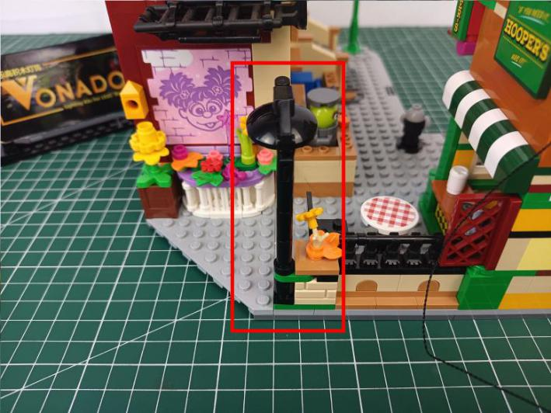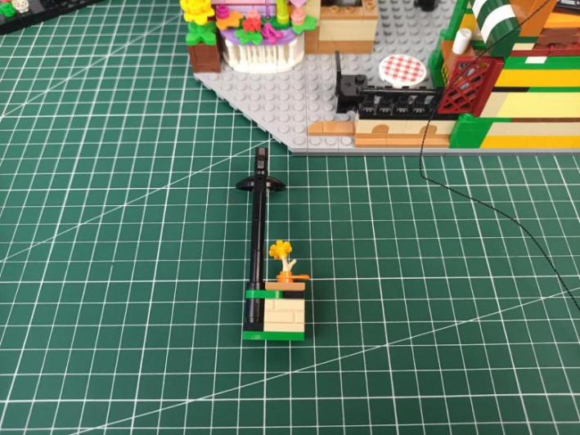

Disassemble it.
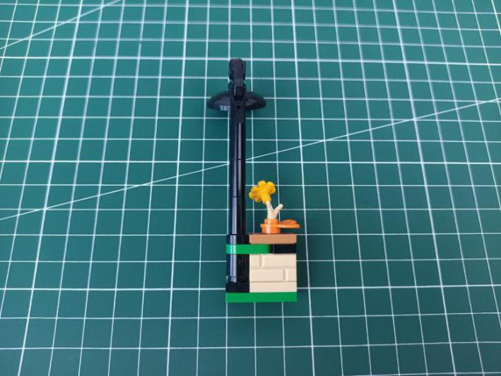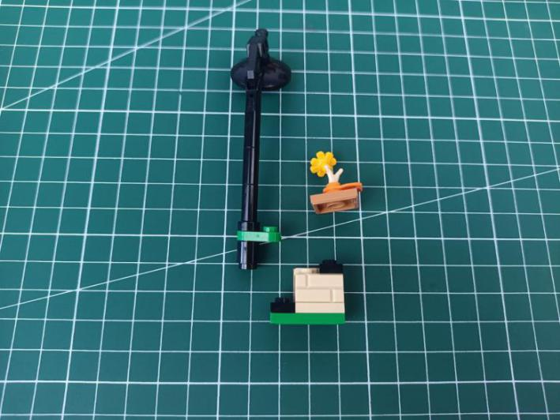

Take a 15cm pink dot light, split the cable as per below.
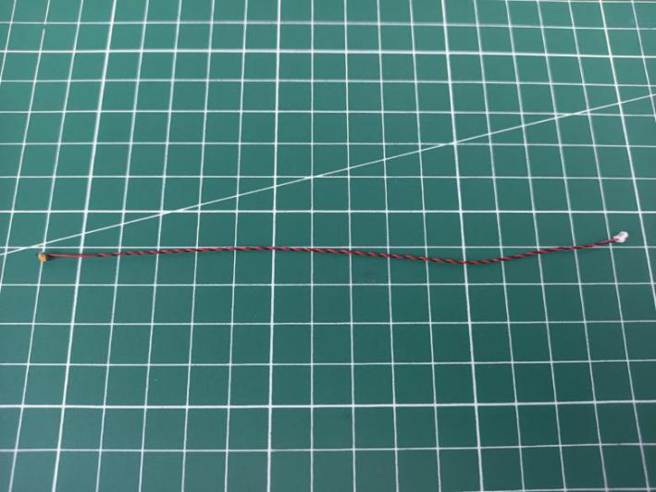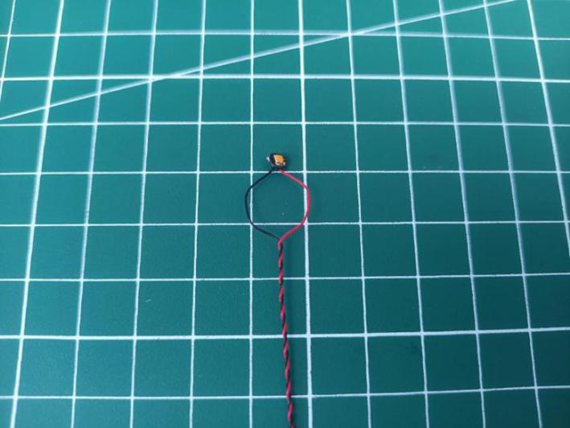

Noose the light as per below, then tighten the cable.
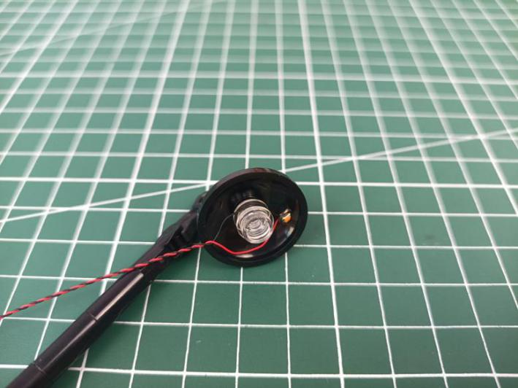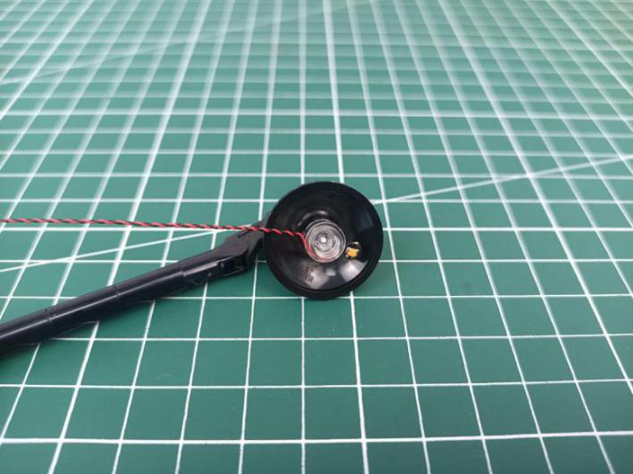

Thread the cable through the following space, and tighten it up.
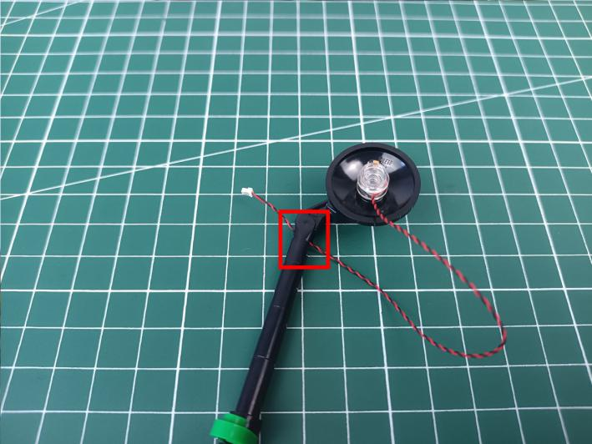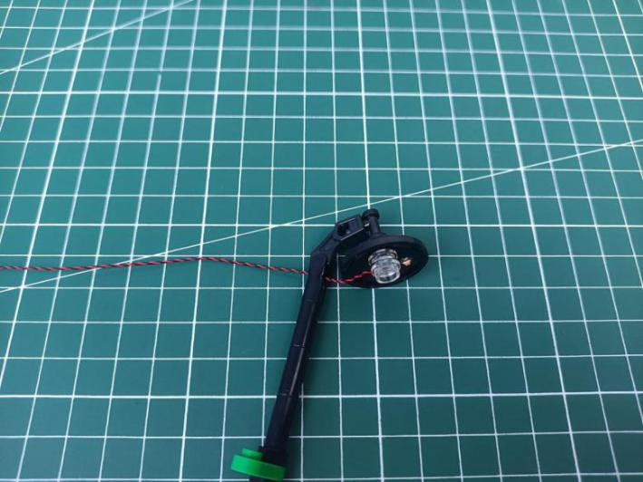

Pull the cable down, and wind it as per before tying it at the following place.
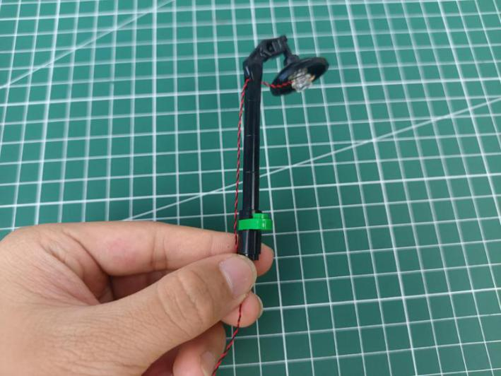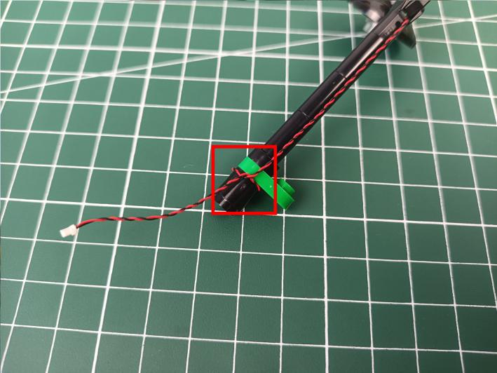

Reconnect the other pieces.
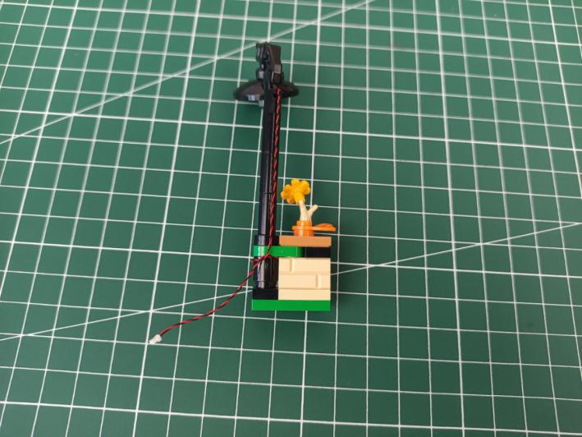

Reconnect the streetlight.
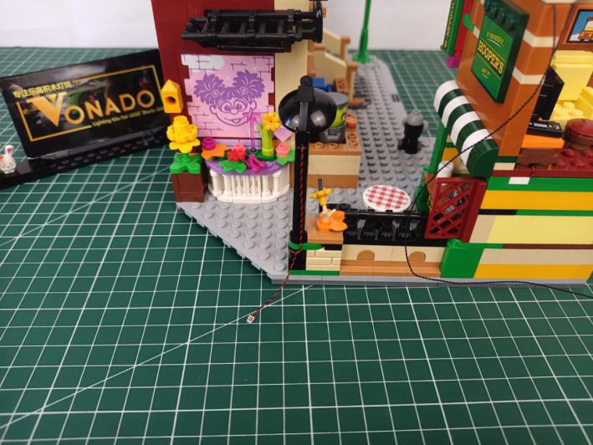

Turn to the front.
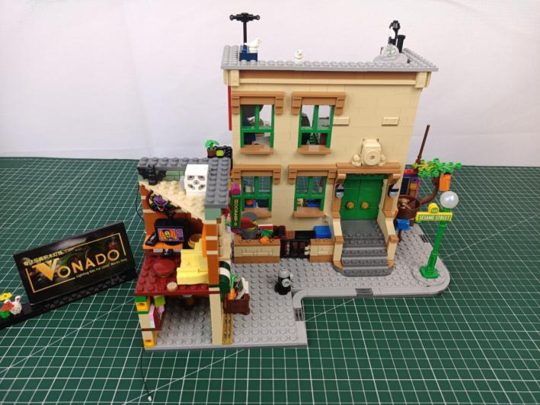

Disconnect the hydrant.
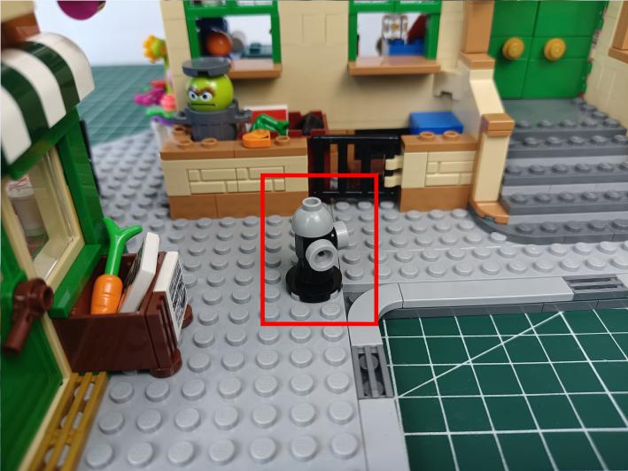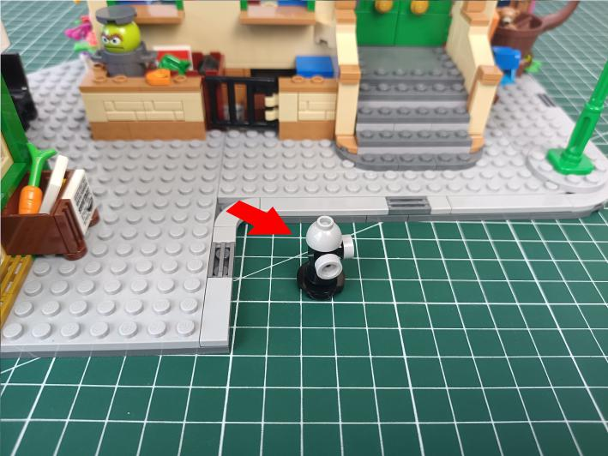

Take a blue 30cm dot light, a trans blue round plate.
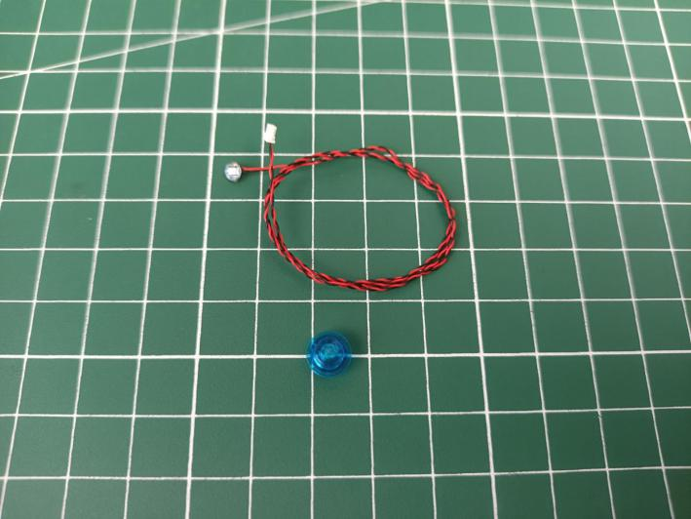

With lighting part facing down, place the light inside the round plate, stuck the cable at the opening.
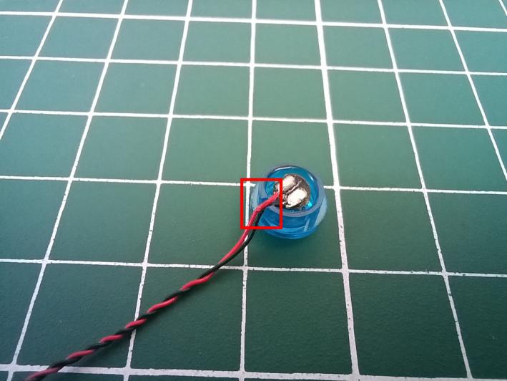

Connect the round plate over the hydrant, place the cable as per below.
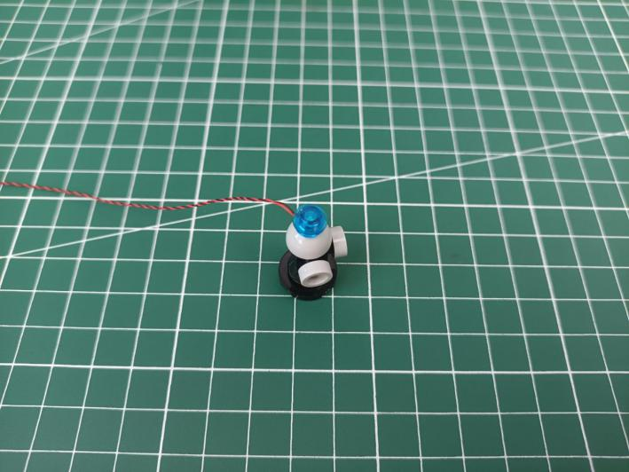

Place the cable as per below.
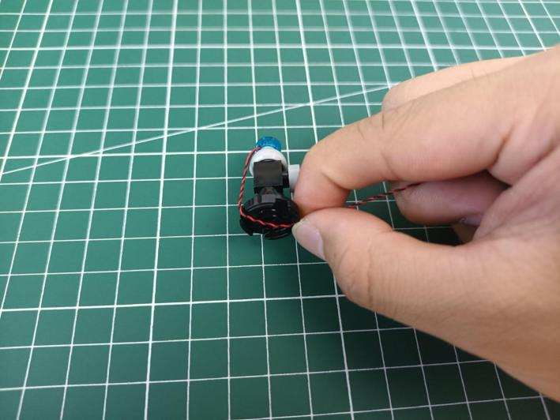

Reconnect the hydrant.
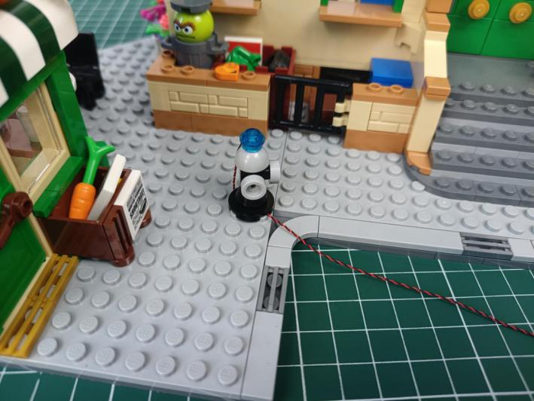

Remove the following piece.
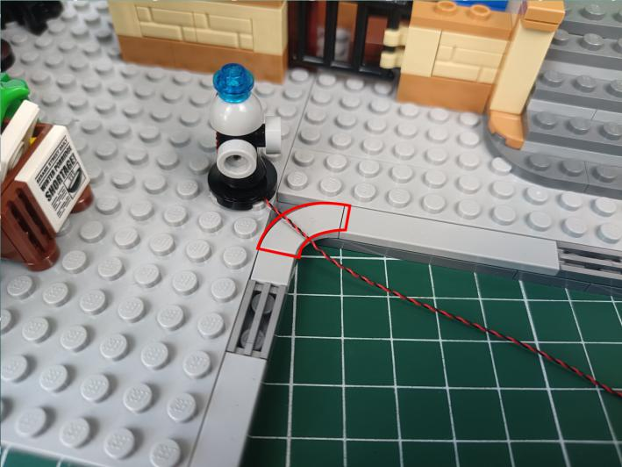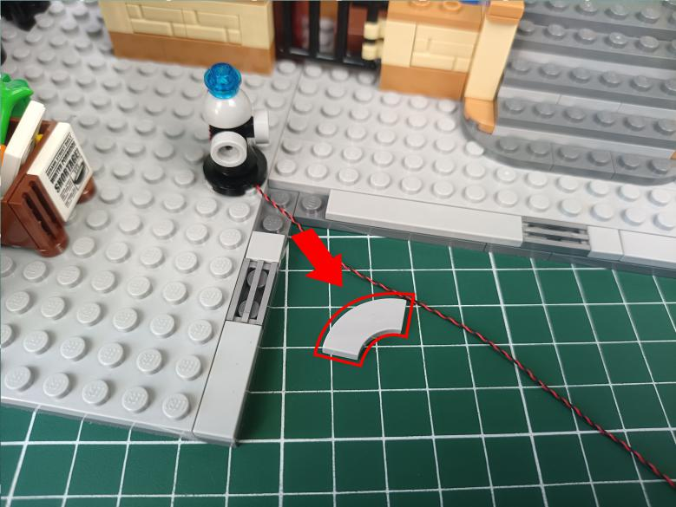

Press the cable underneath as per below.
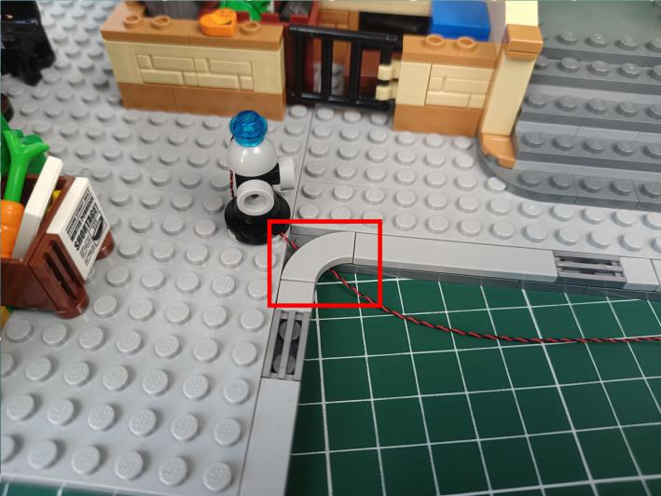

Press the cable underneath the floor and pull it to the side.
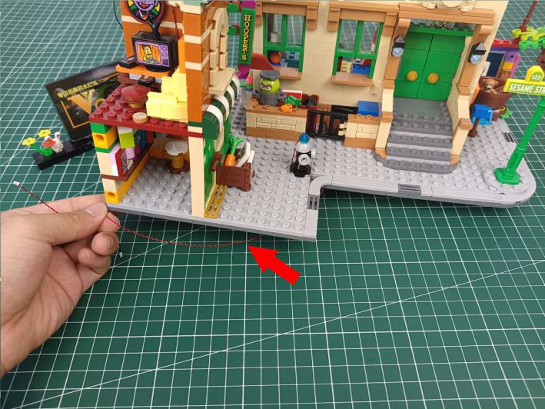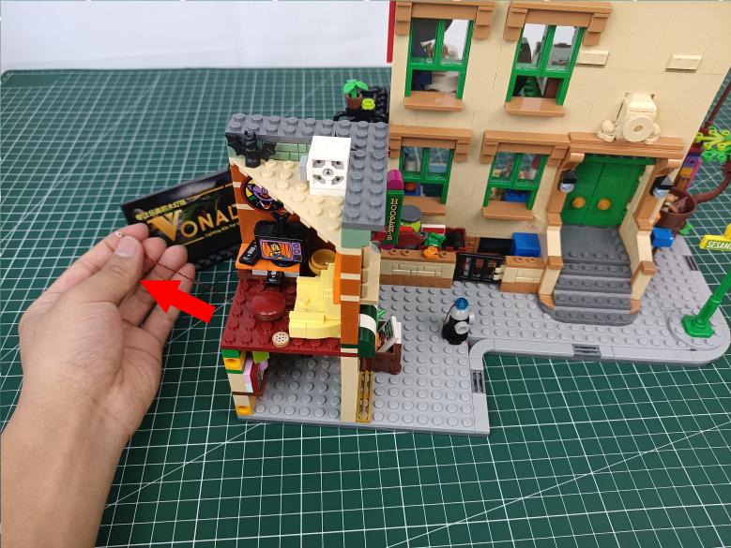

Turn to the side.
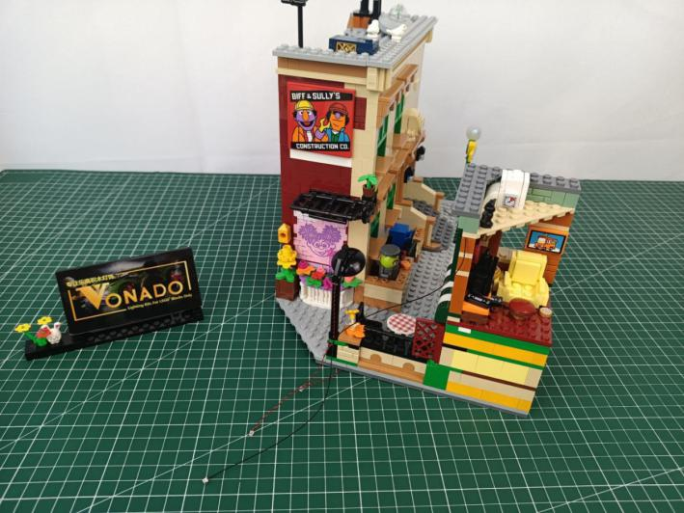

Take a 30cm connecting cable, a 4-port expansion board, assemble them as per below.
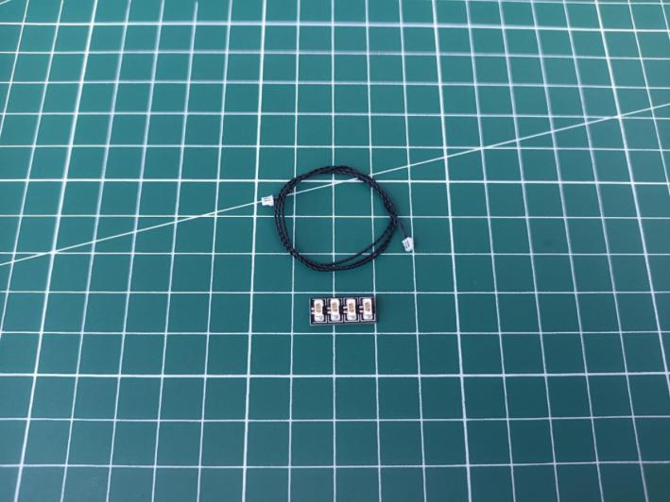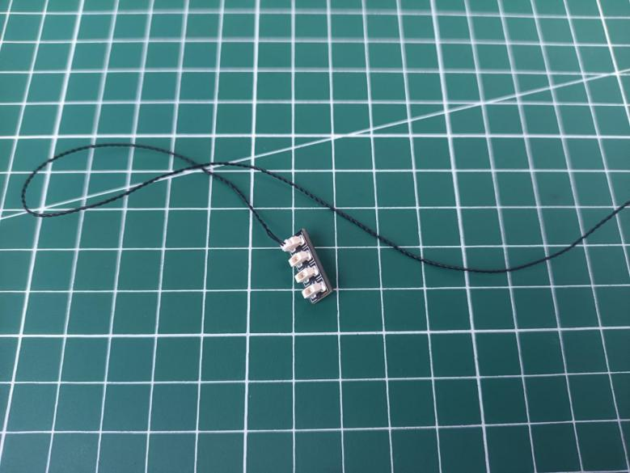

Connect all the cables from the side to the expansion board, and tuck excess cables around the expansion board.
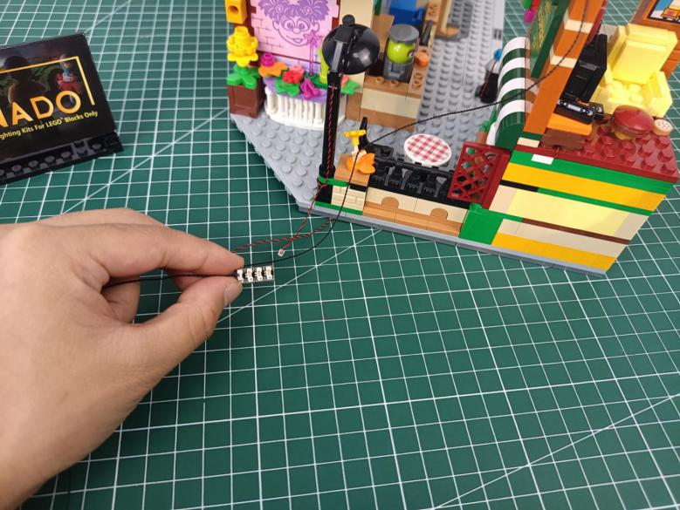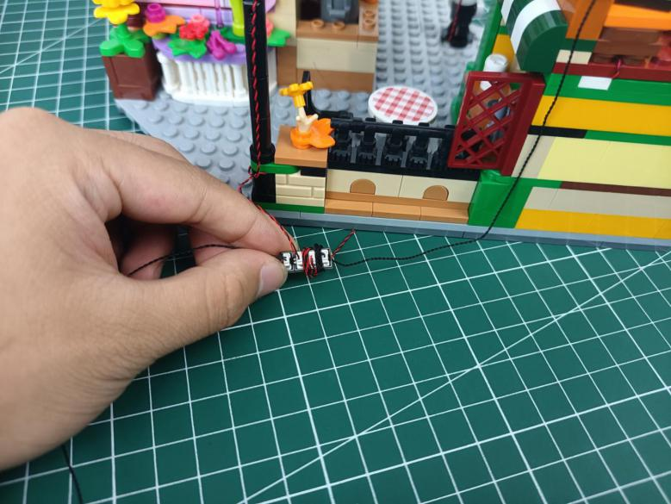

Take 3 adhesive squares, stick 2 of them to the back of the expansion board.
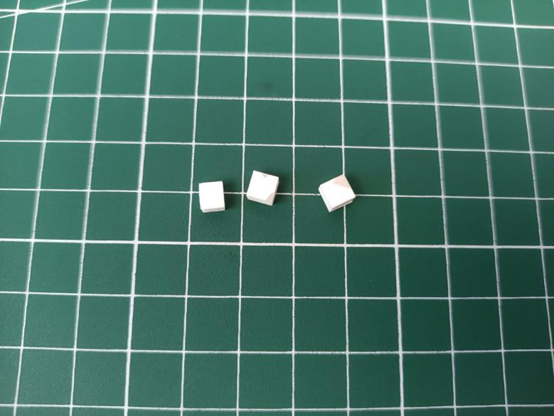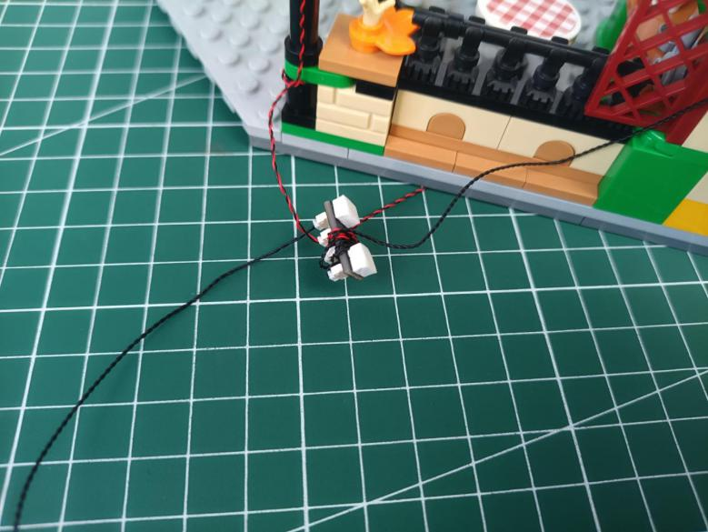

Stick the expansion board to the following place.
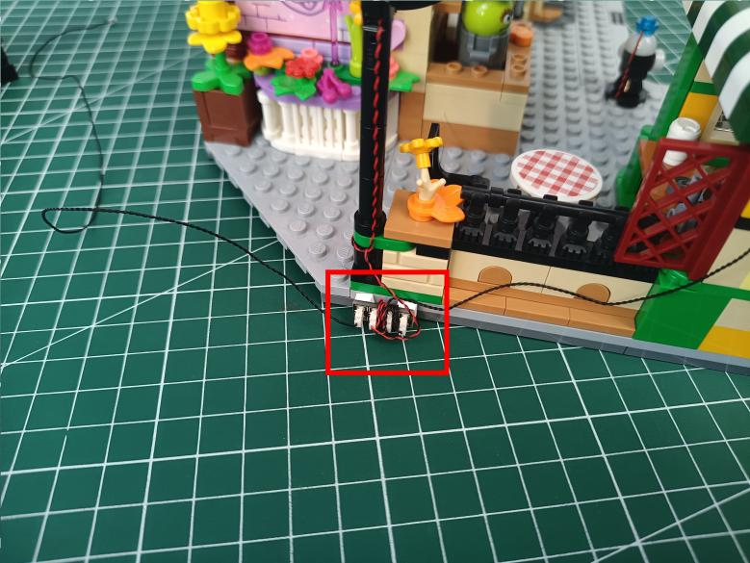

Secure the cable with the other adhesive square.
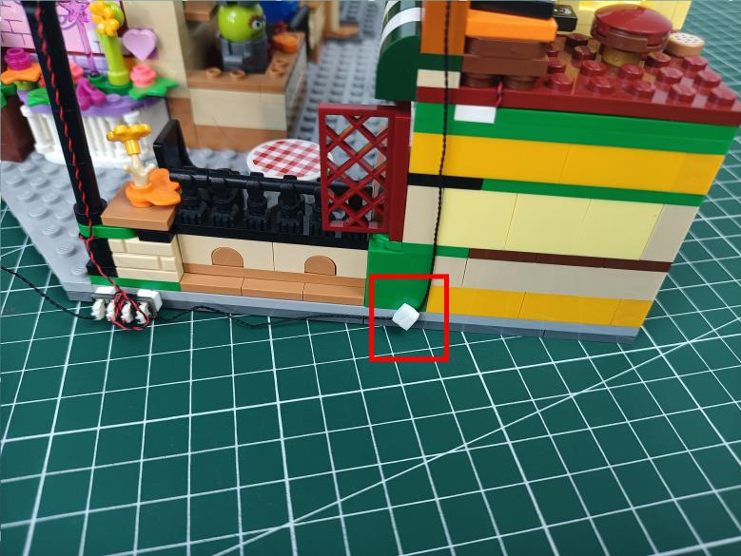

Remove the following gray piece from the roof.
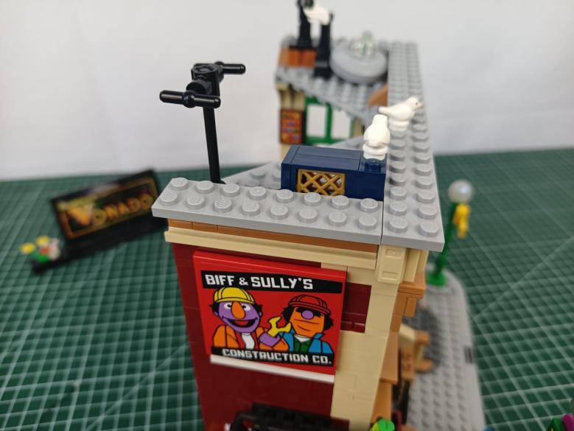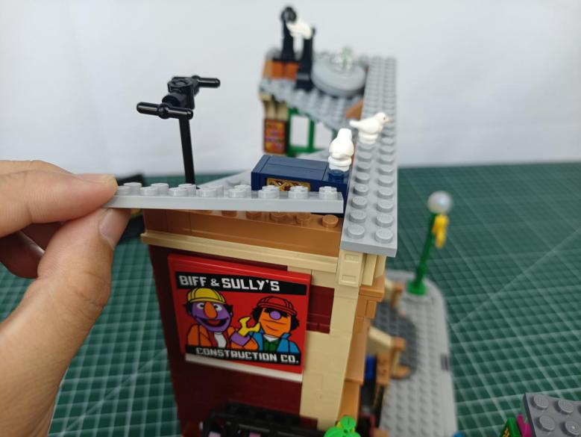

Take a blue 15cm strip light (7).
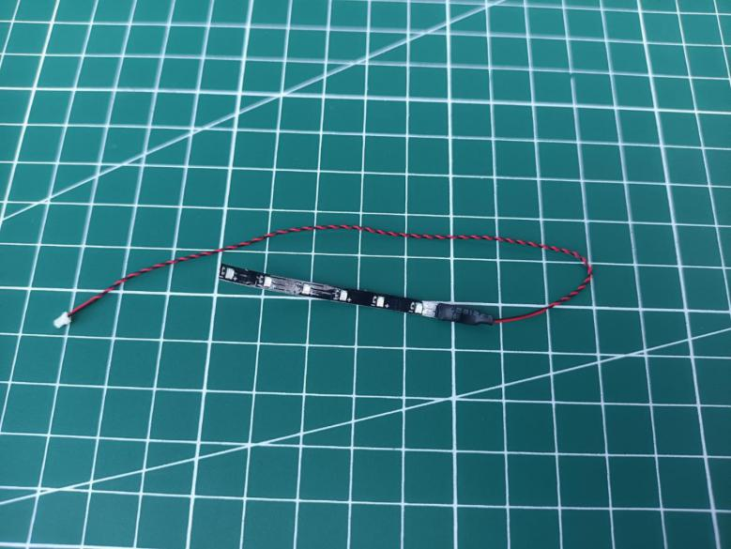

Stick the strip light underneath the gray piece, place the cable as per below.
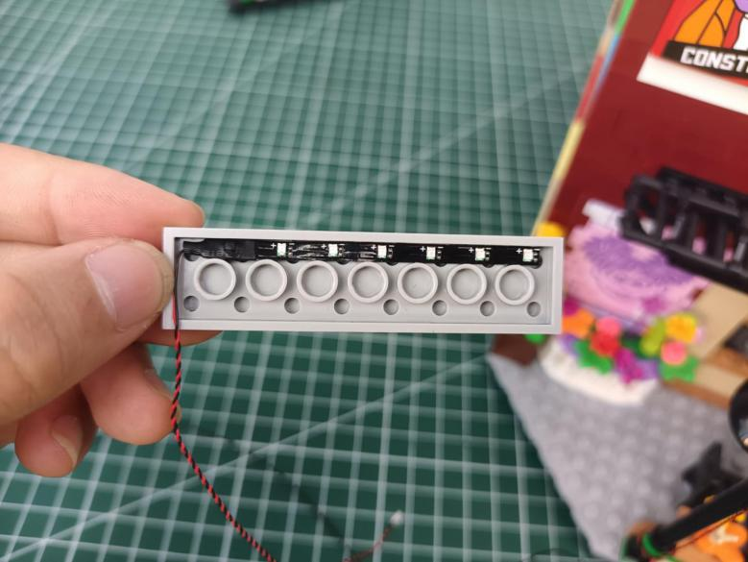

Stuck the cable at the following place, reconnect the gray piece.
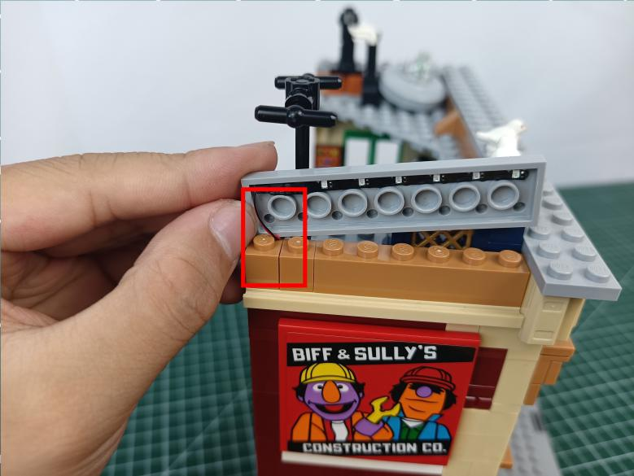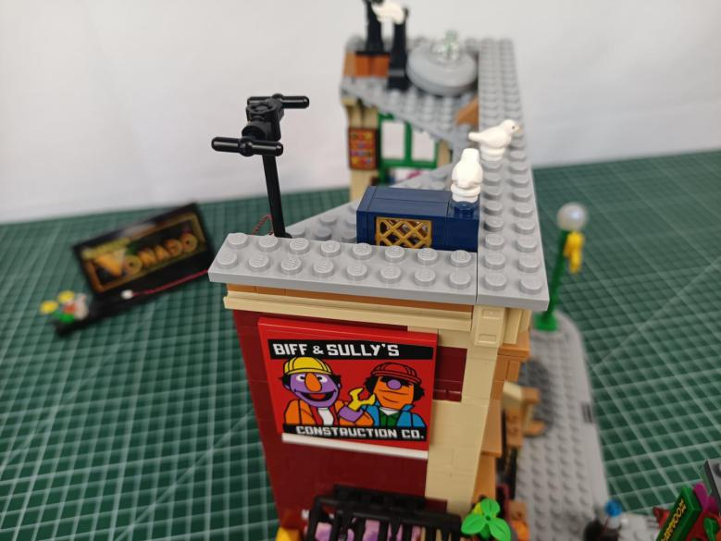

Turn to the front.
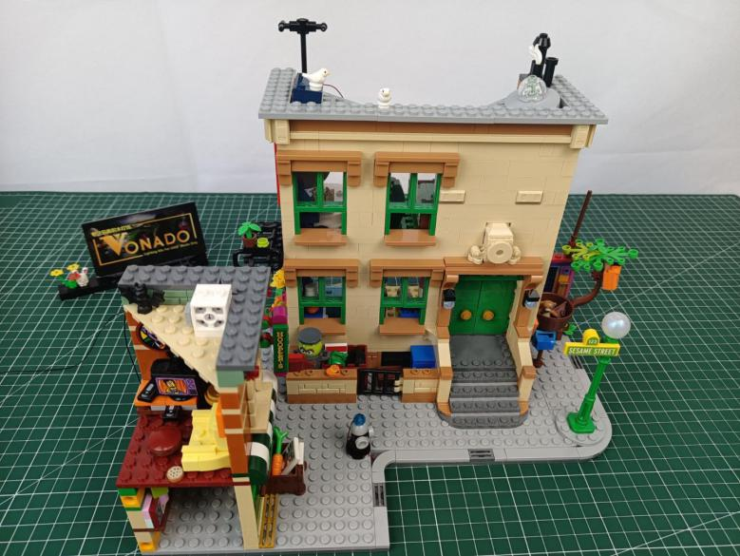

Remove the following round piece.
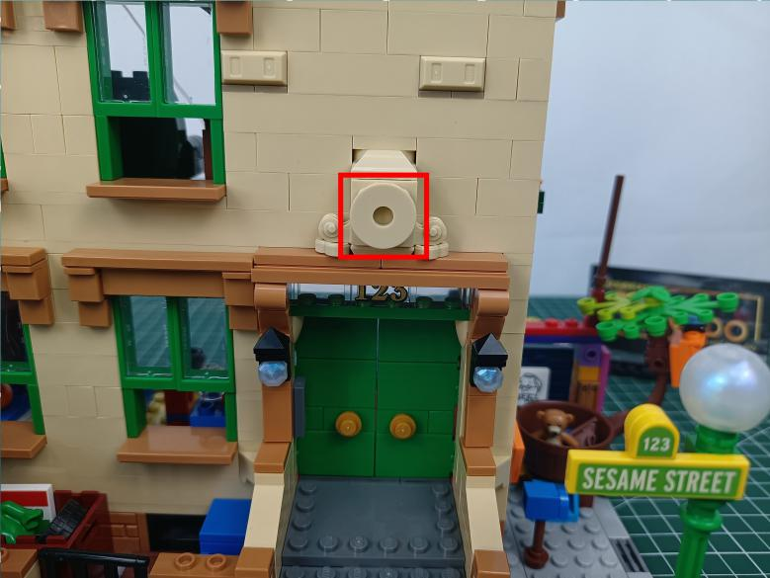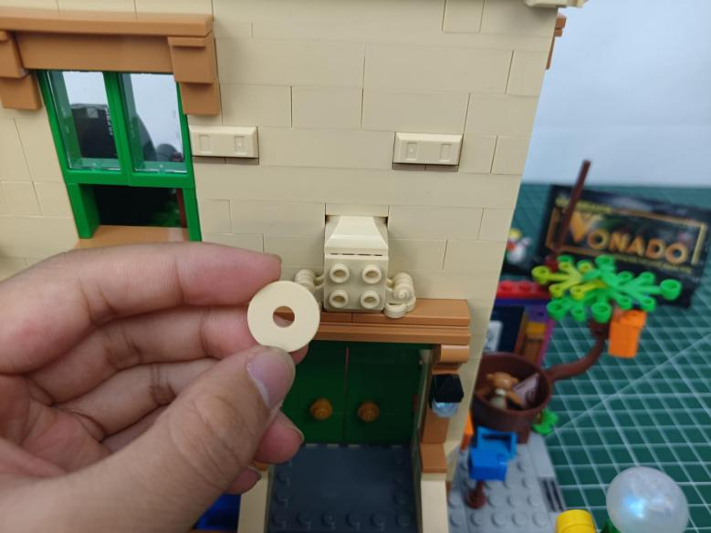

Take a red 15cm dot light.
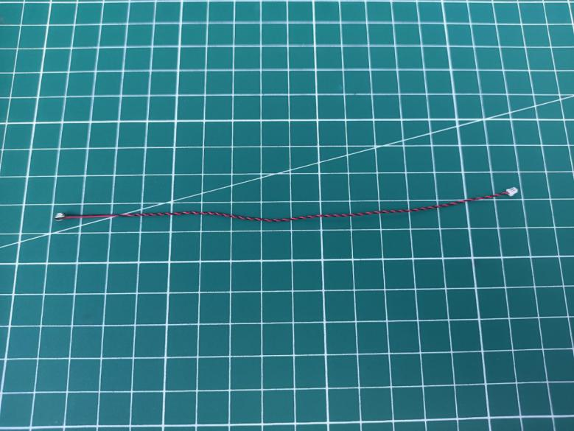

With lighting part facing outside, place the light as per below, connect the round piece over.
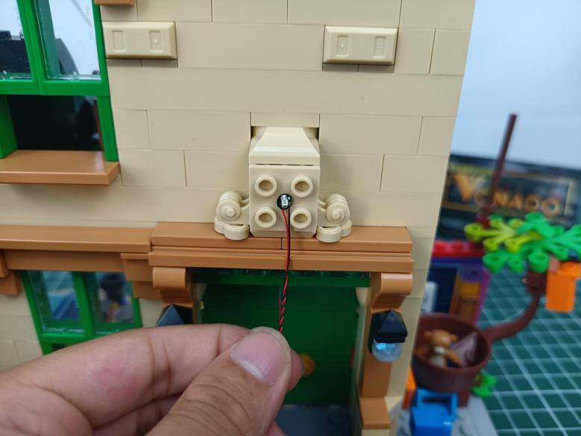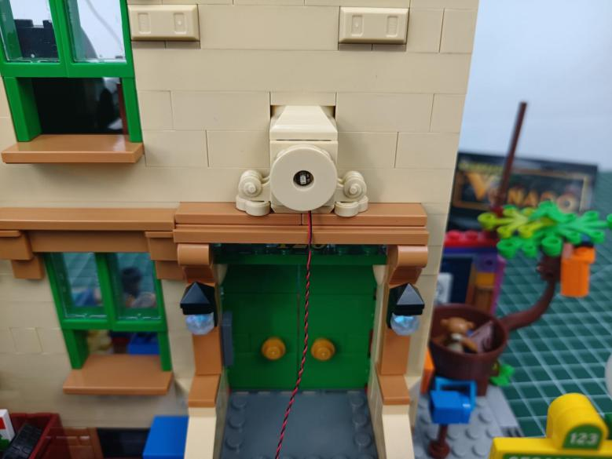

Stuck the cable in between pieces as per below.
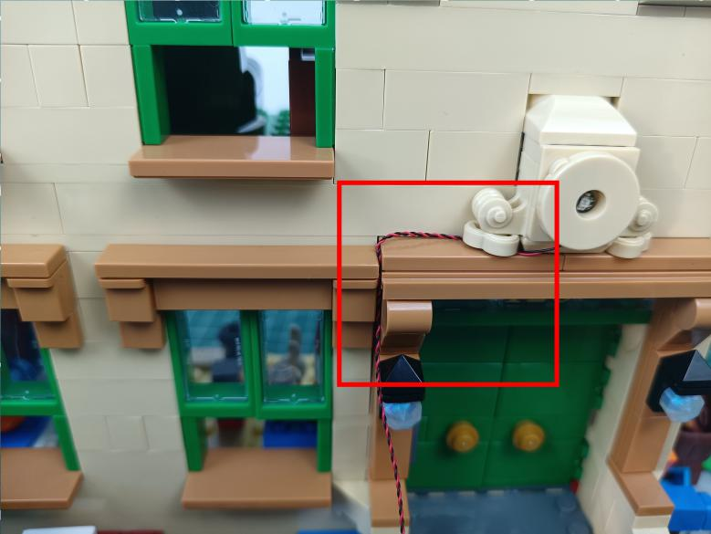

Remove the wall lamps.
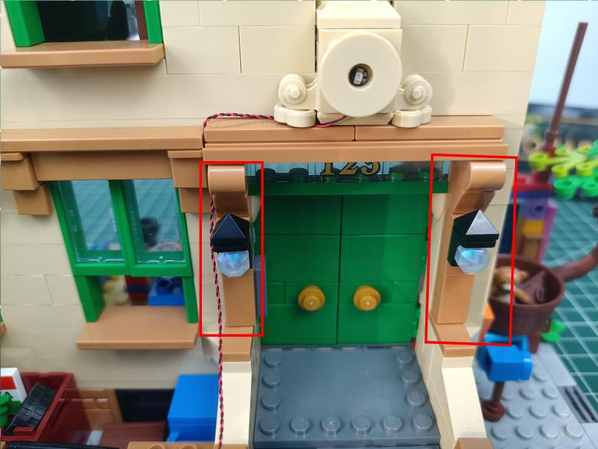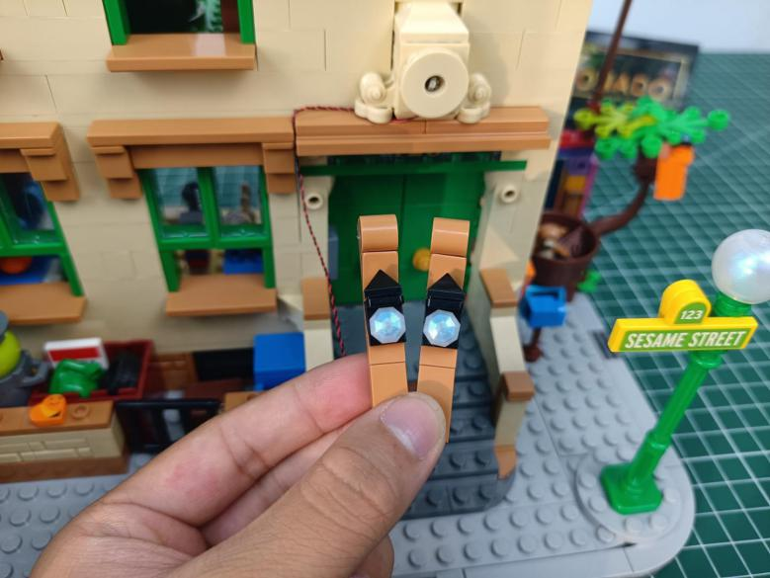

Disconnect the lampshades.
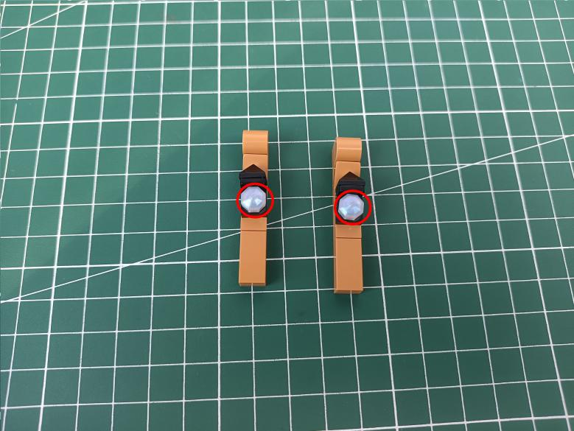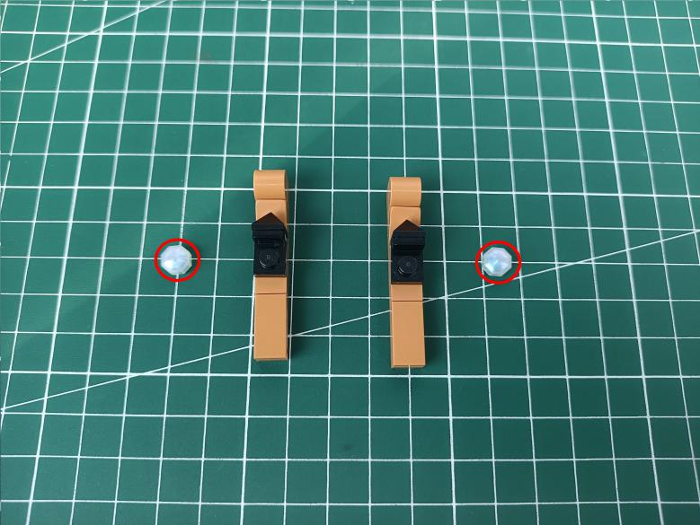

Take 2 flashing multi colour 15cm dot lights.
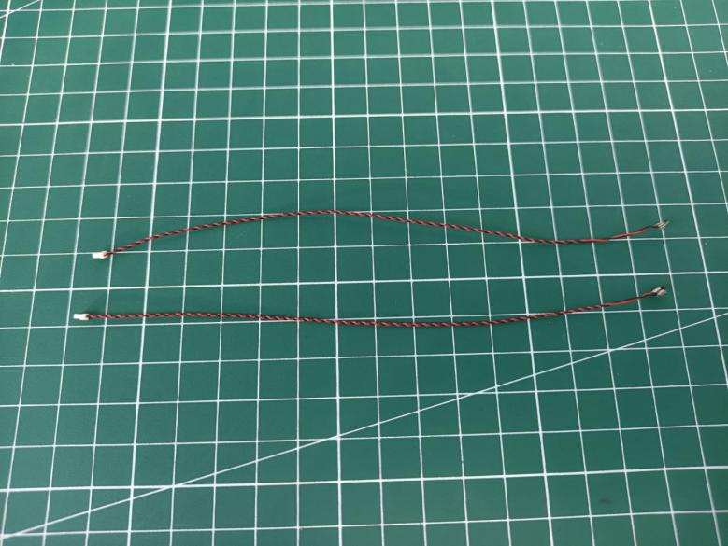

With lighting part facing up, place the light at the following place, place the cable as per below.
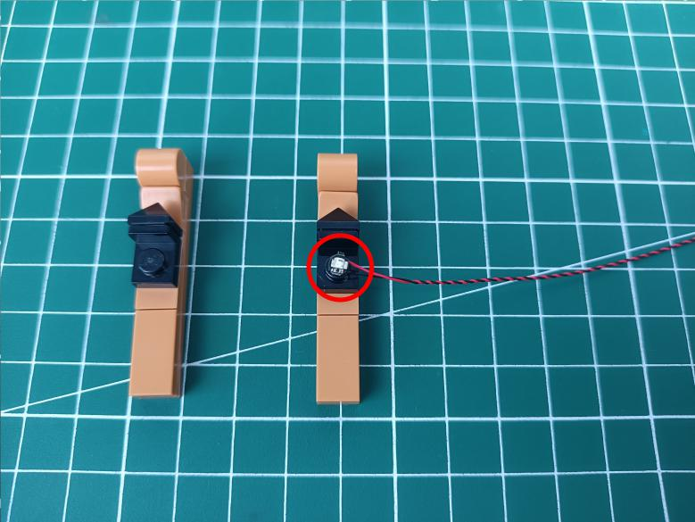

Reconnect the lampshade.
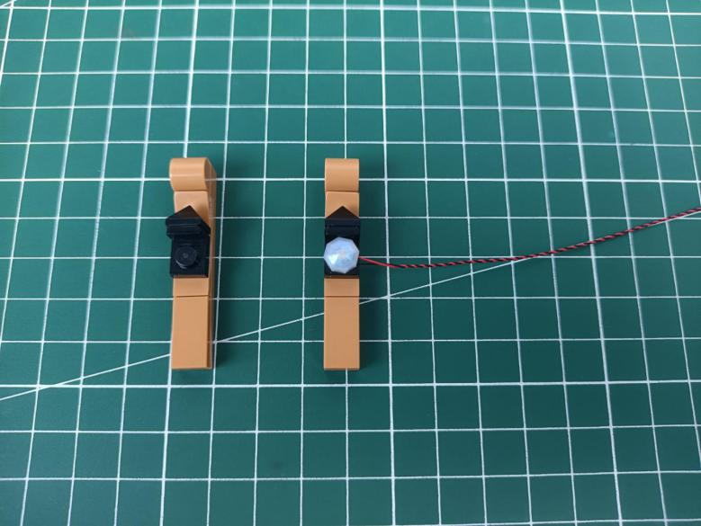

Install the other light in the same way.
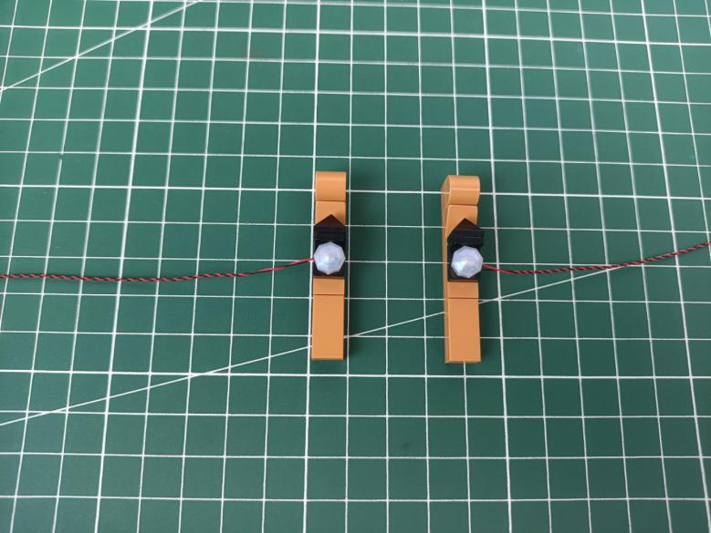

Take the following piece, pull the cable leftward.
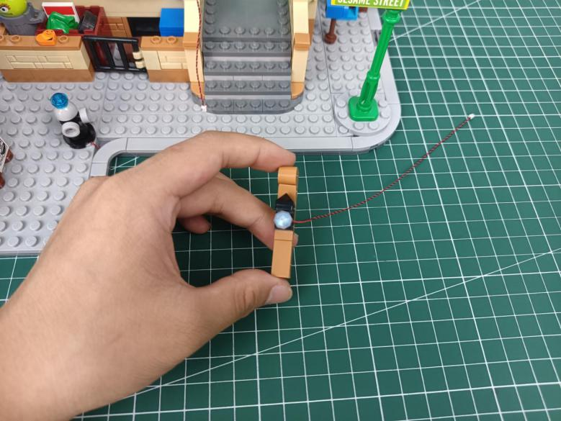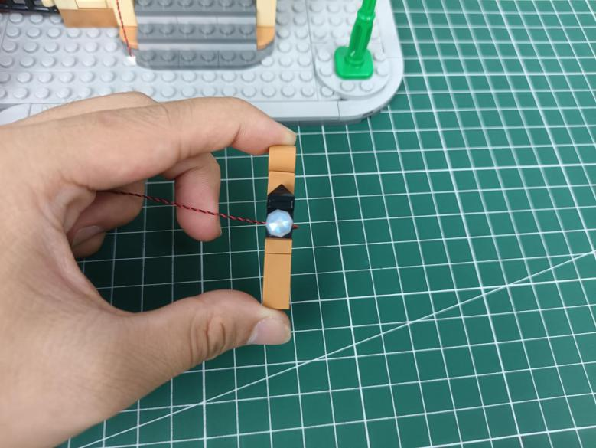

Reconnect the piece, press the cable underneath.
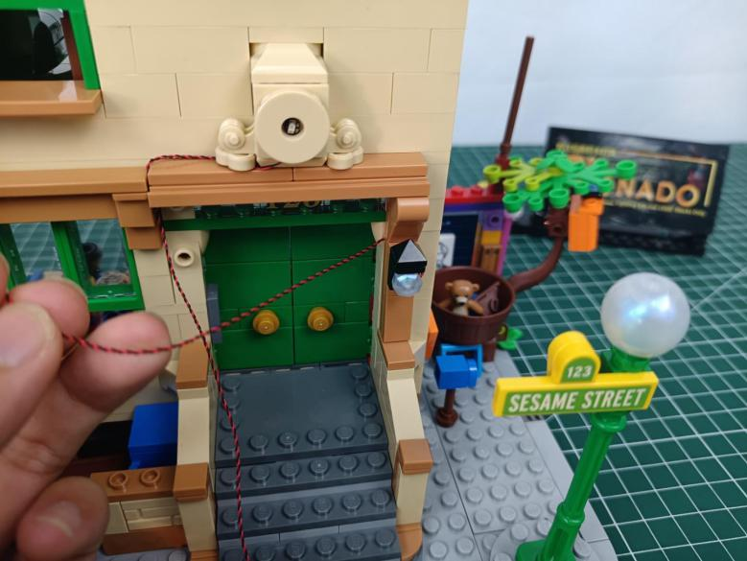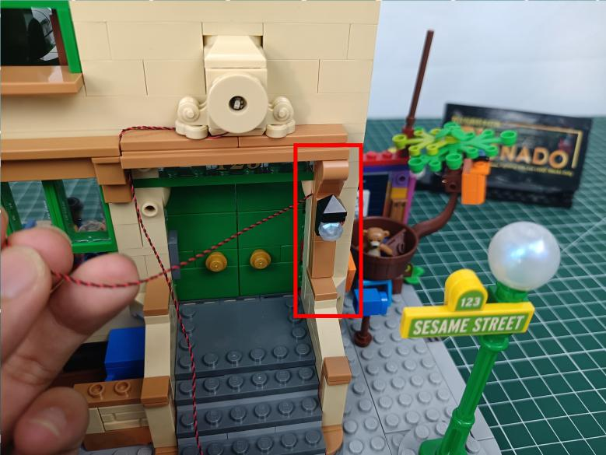

Take the other piece, pull the cable rightward.
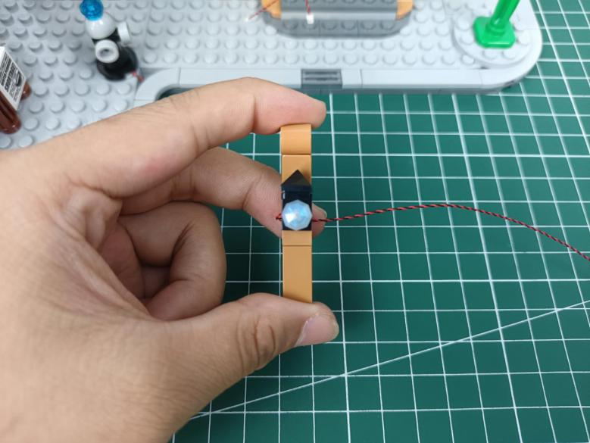

Place the cable as per below.
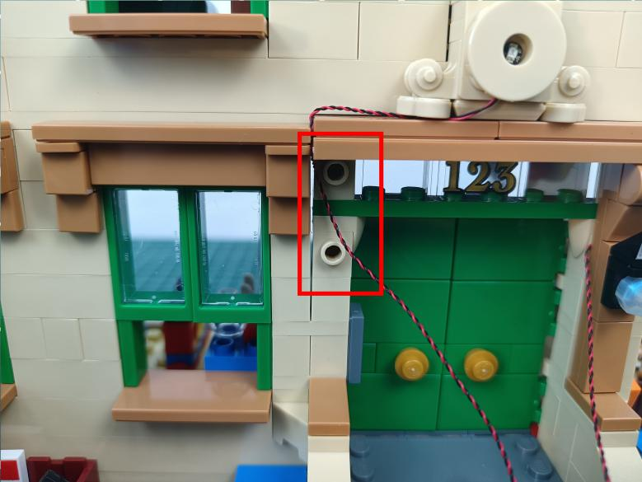

Reconnect the wall lamp, press the cable underneath.
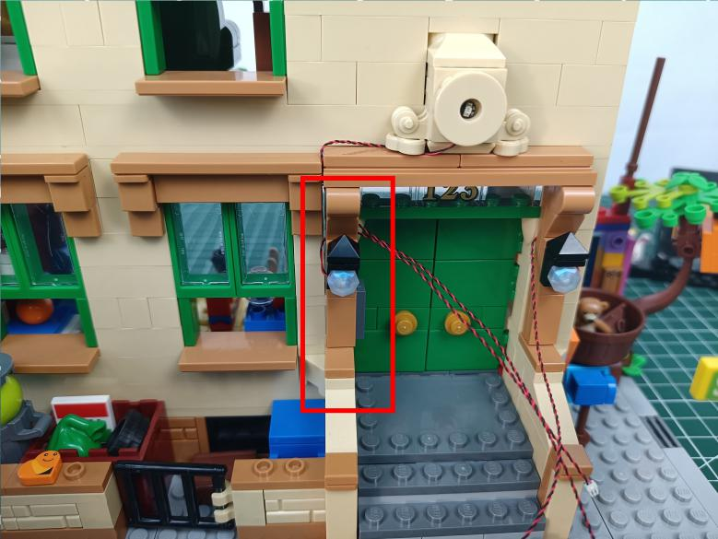

Open the door.
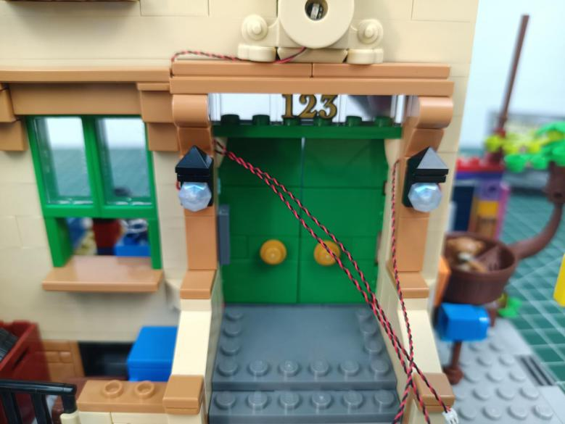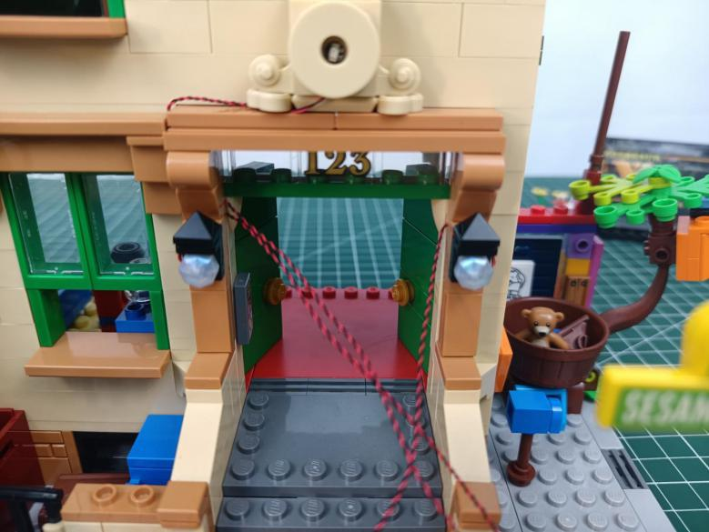

Pull the cable to the back, close the door.
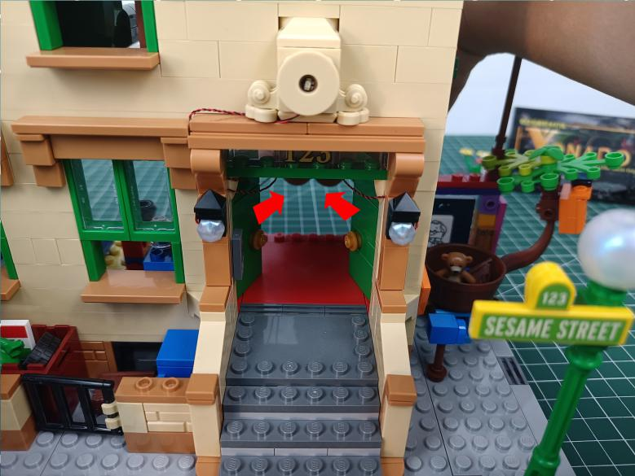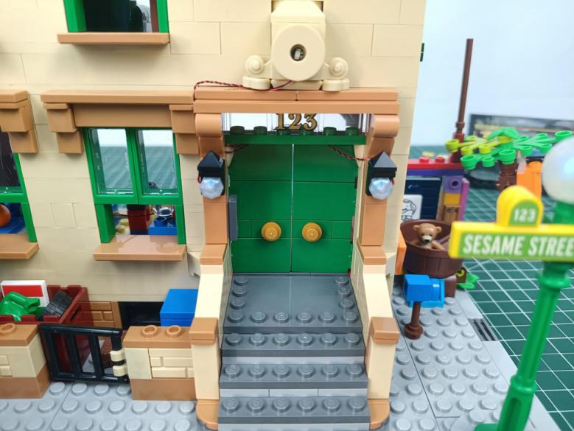
Remove the following streetlight.
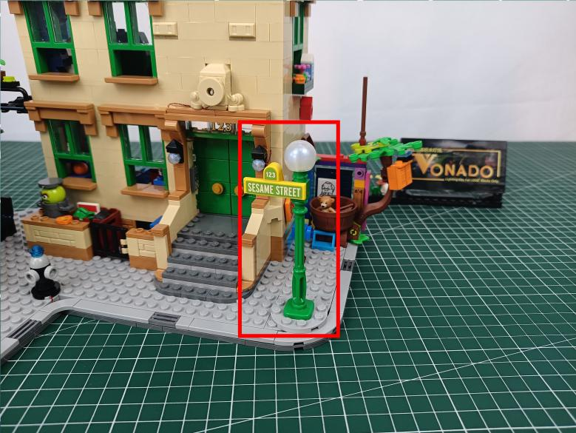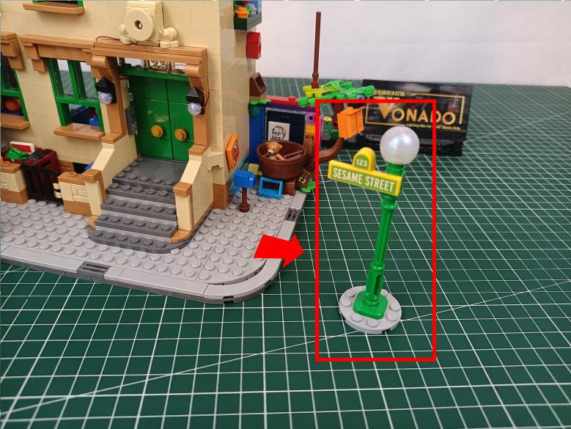

Disassemble it.
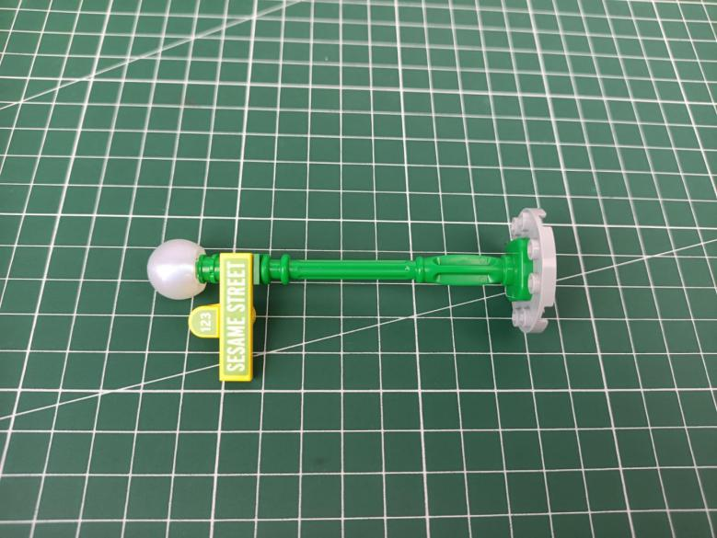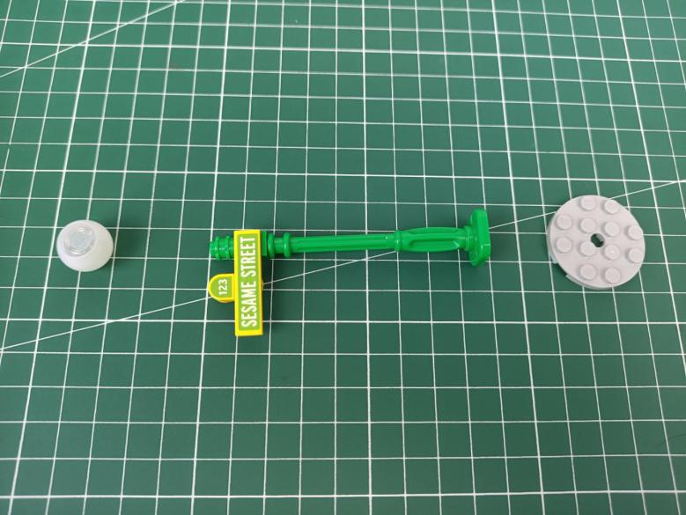

Take a warm white 30cm dot light.
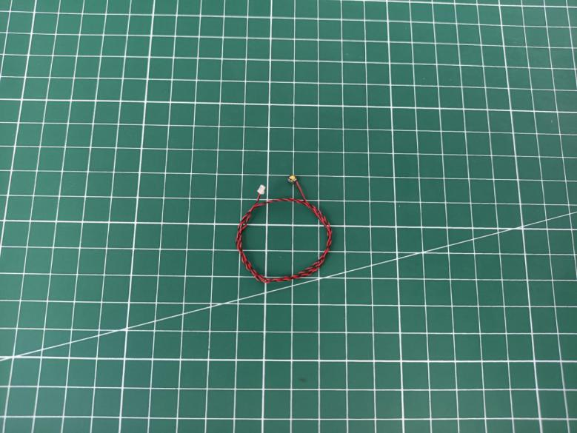

With lighting part facing outside, place the light as per below, reconnect the lampshade.
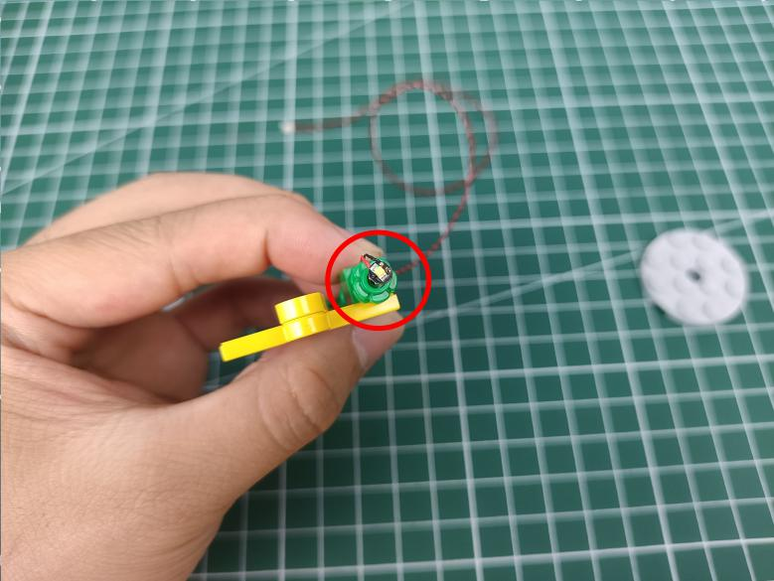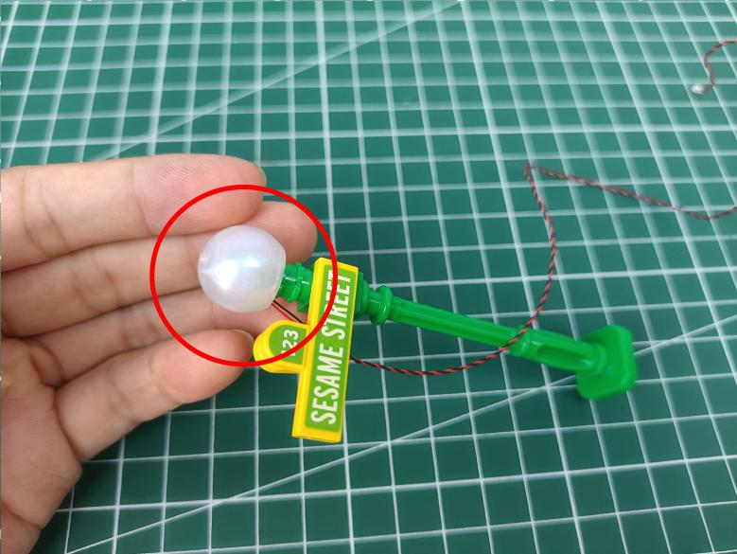

Thread the cable through the base and reconnect the base.
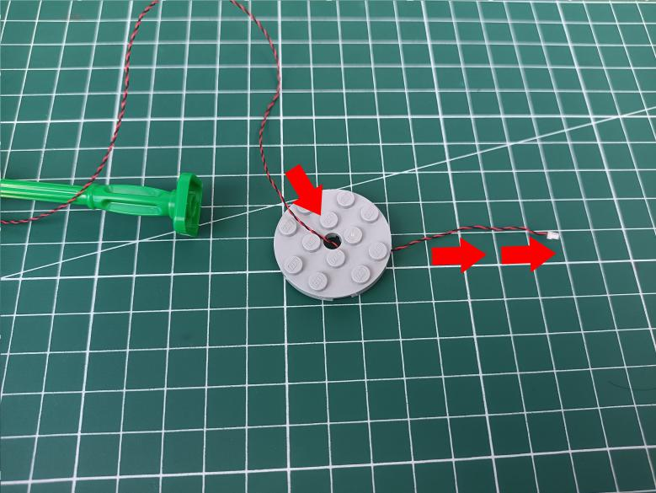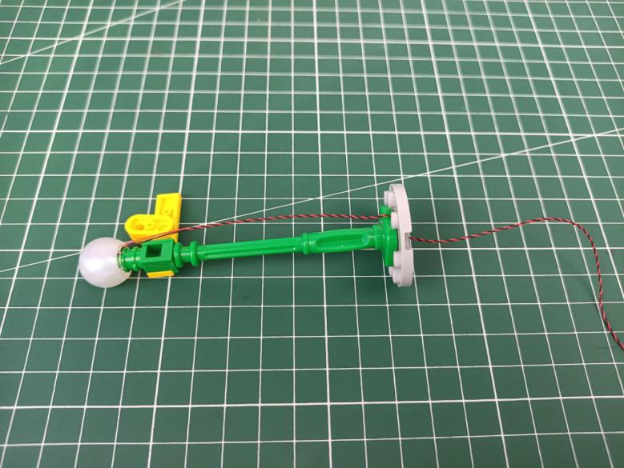

Reconnect streetlight, press the cable underneath.
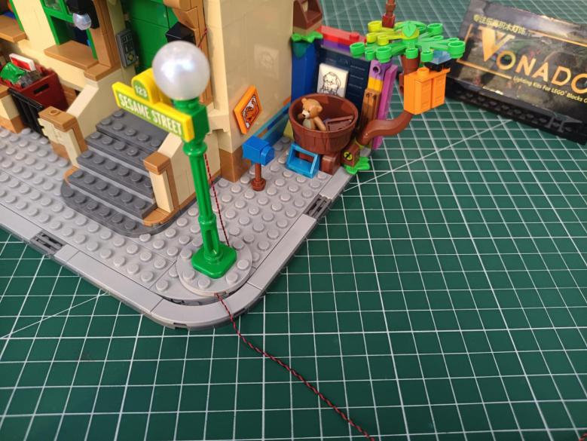

Remove the following pieces.
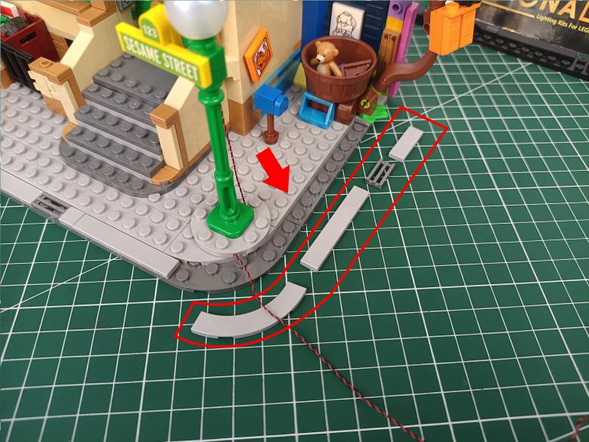

Place the cable as per below, reconnect the pieces.
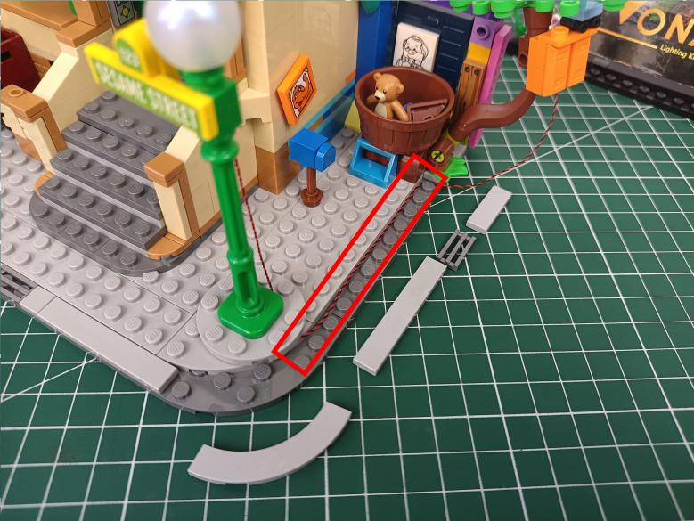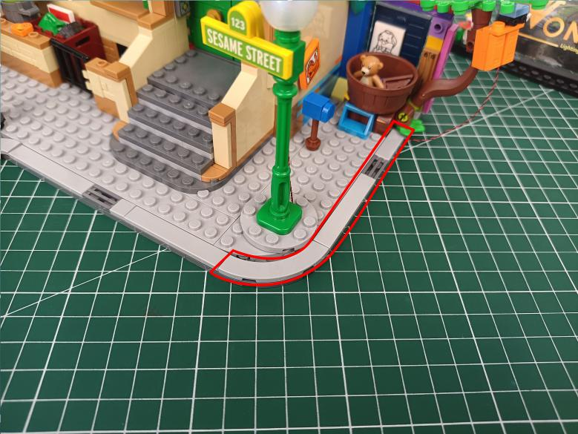

Take a blue 15cm strip light (21).
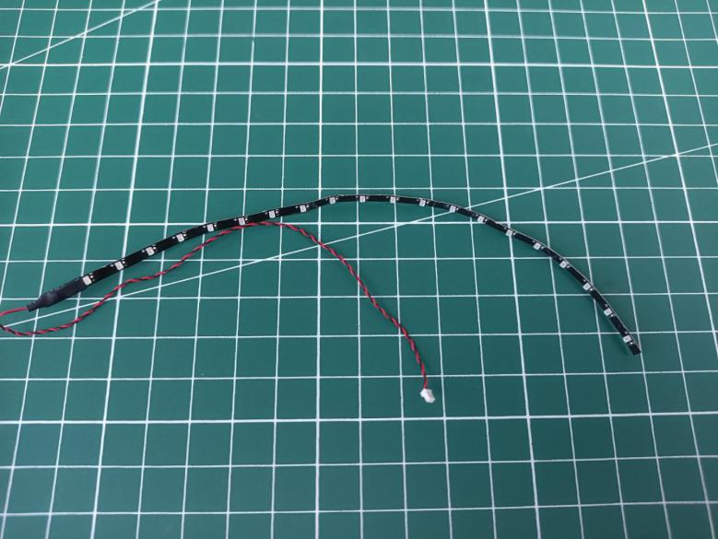

Stick it underneath the eave, place the cable as per below.
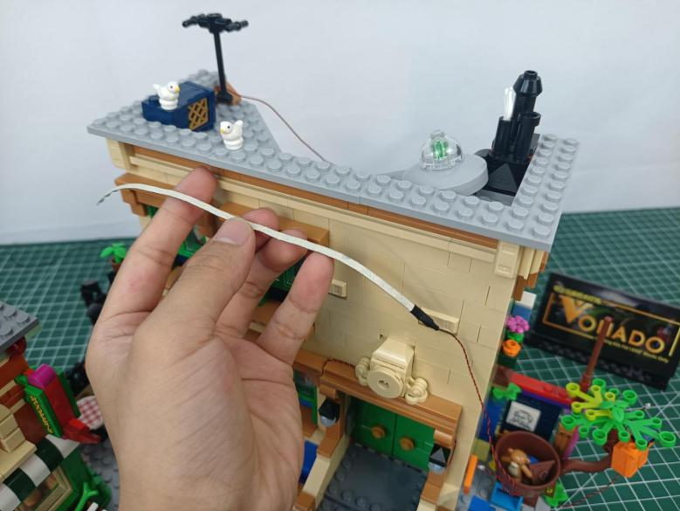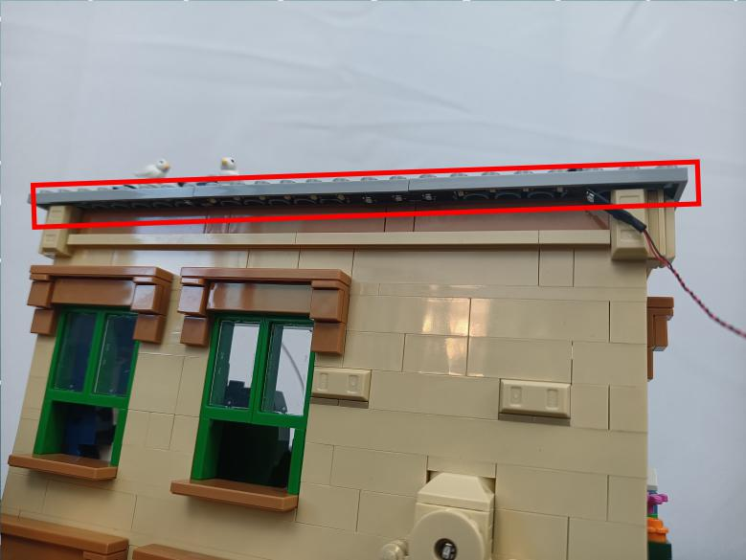

Open the following piece at the right, press the strip light underneath.
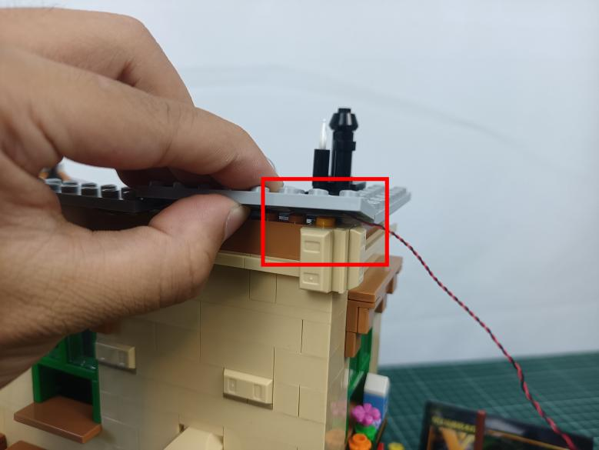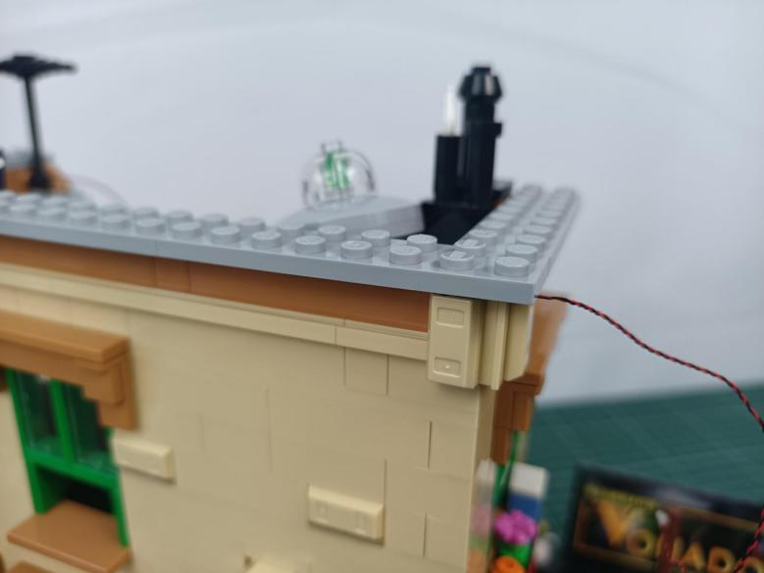

Turn to the side.
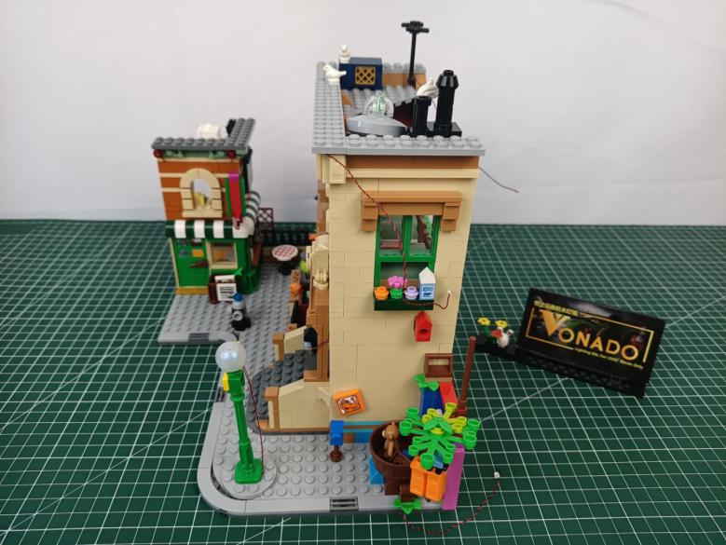

Disconnect the following gray piece.
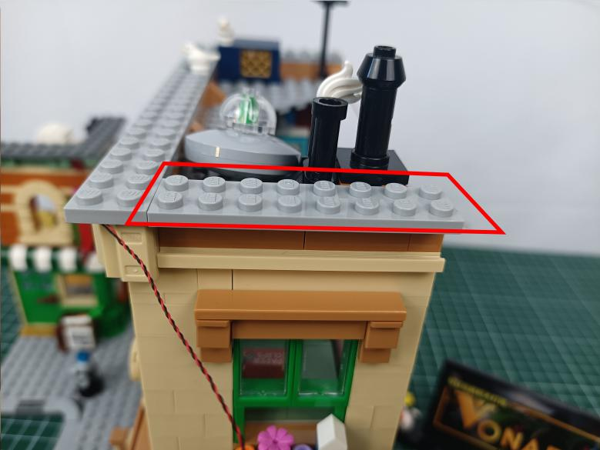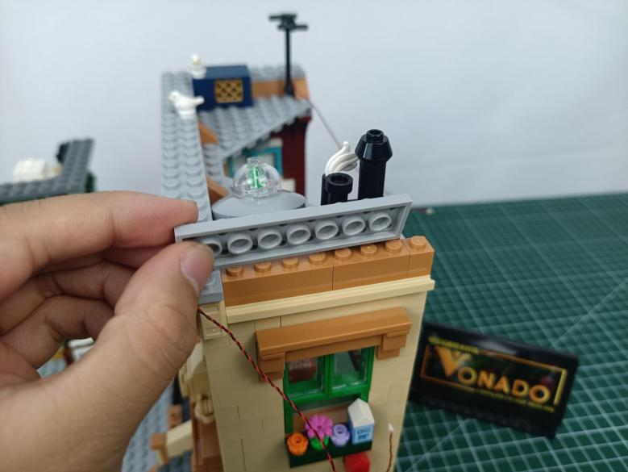

Take a blue 15cm strip light (7).
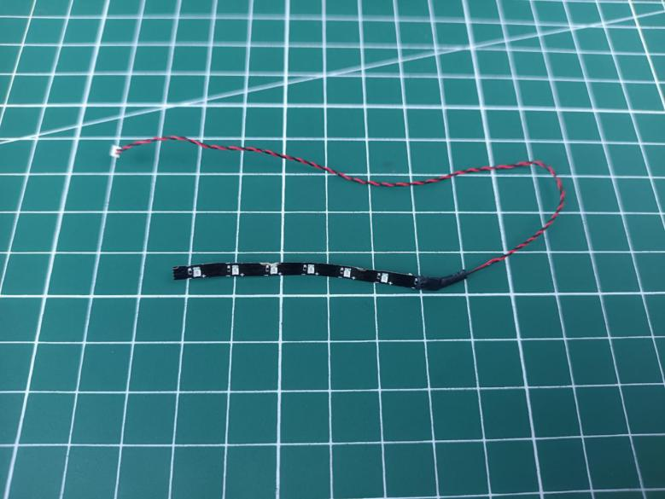

Stick the strip light underneath the gray piece, place the cable as per below.
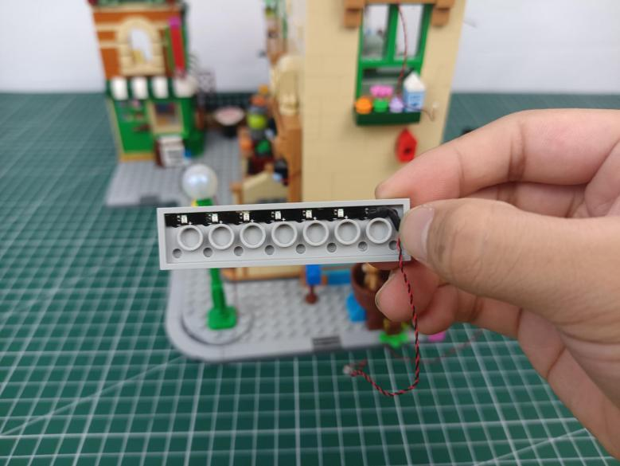

Stuck the cables at the following place, reconnect the gray piece.
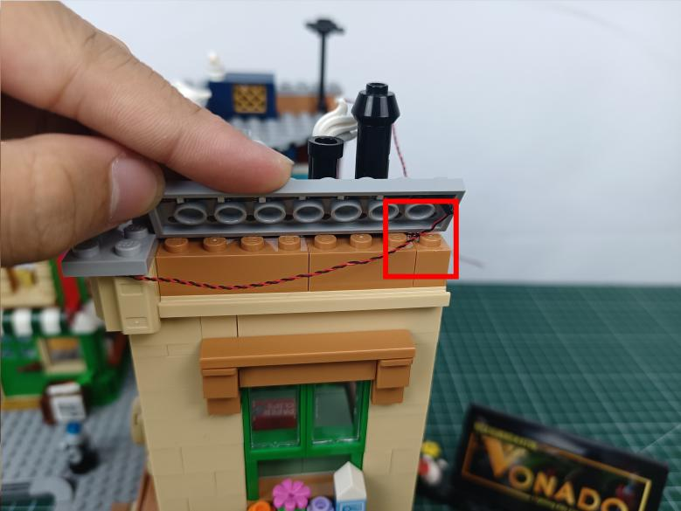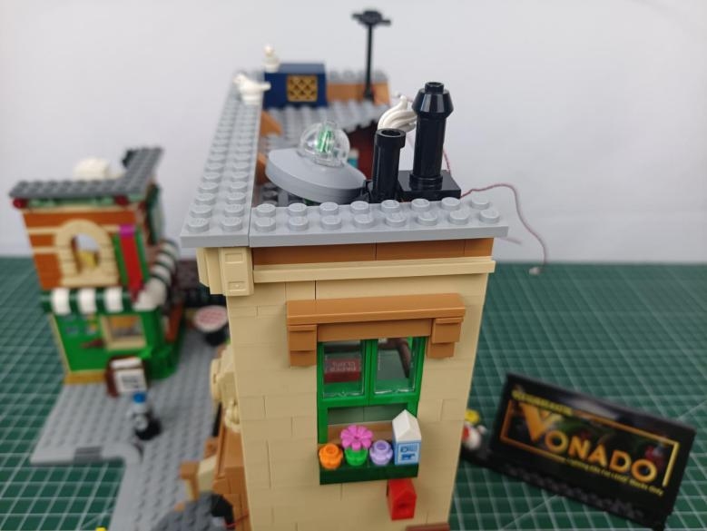

Remove the following piece.
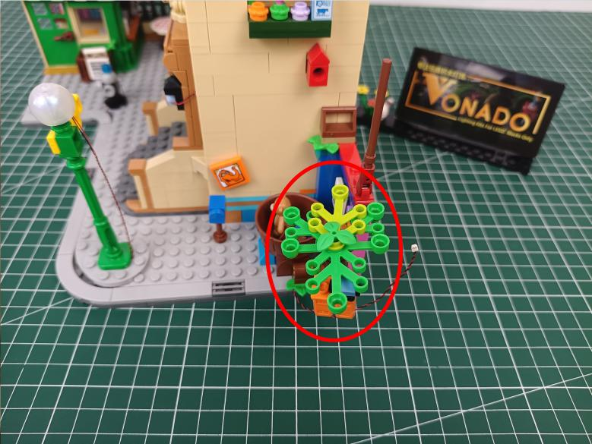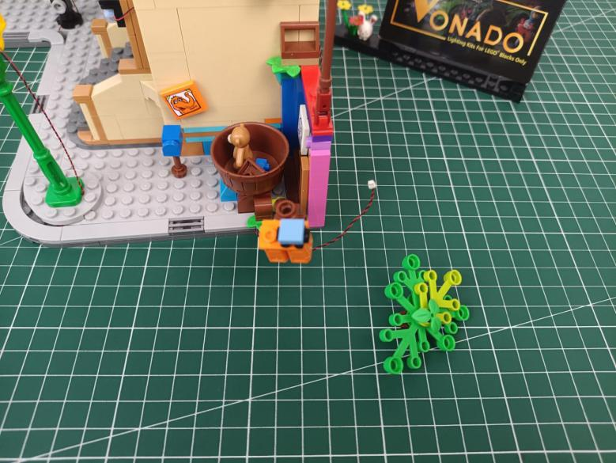

Take a 15cm green dot light, split the cable as per below.
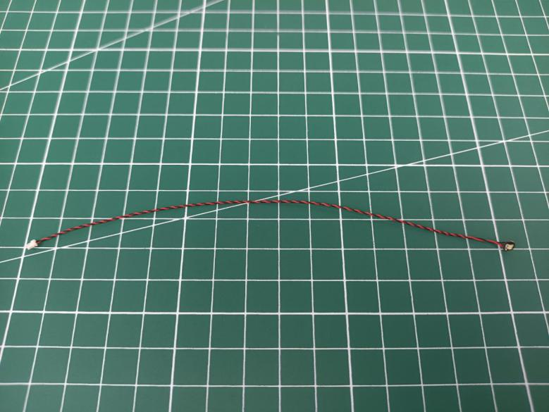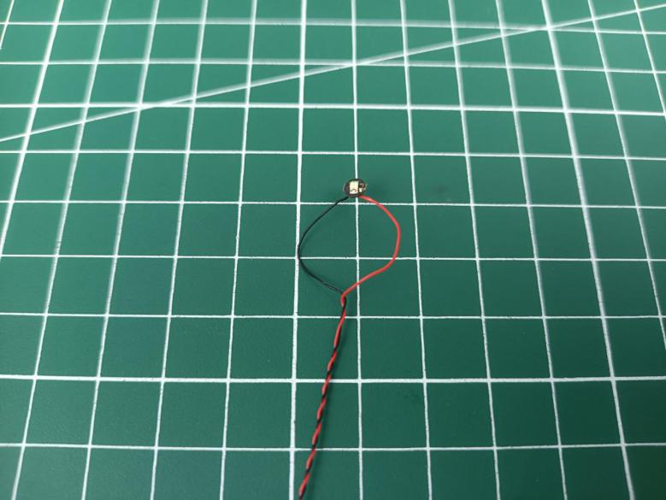

Noose the light at the following place, tighten the cable up as pre below.
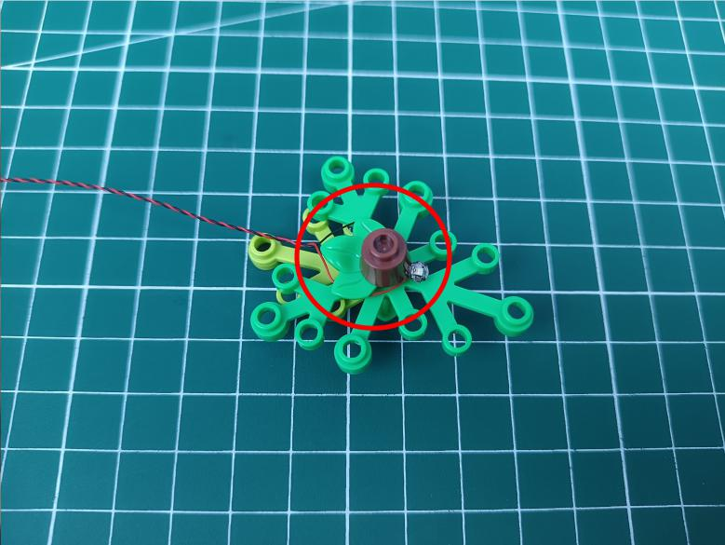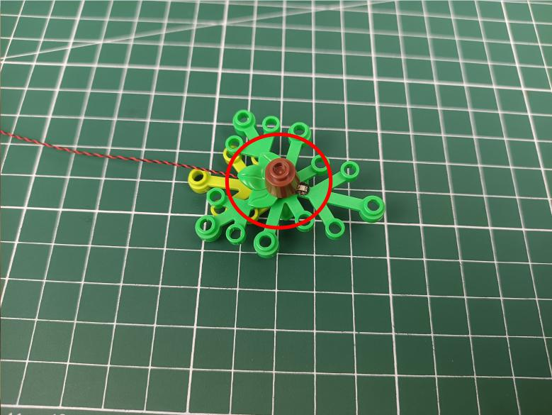

Reconnect the piece.
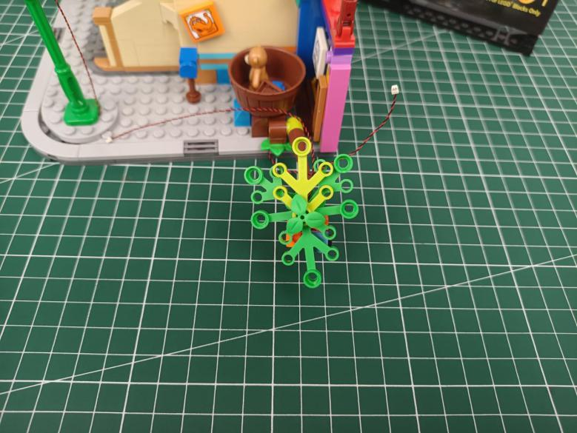

Take a 30cm connecting cable, a 4-port expansion board, assemble them as per below.
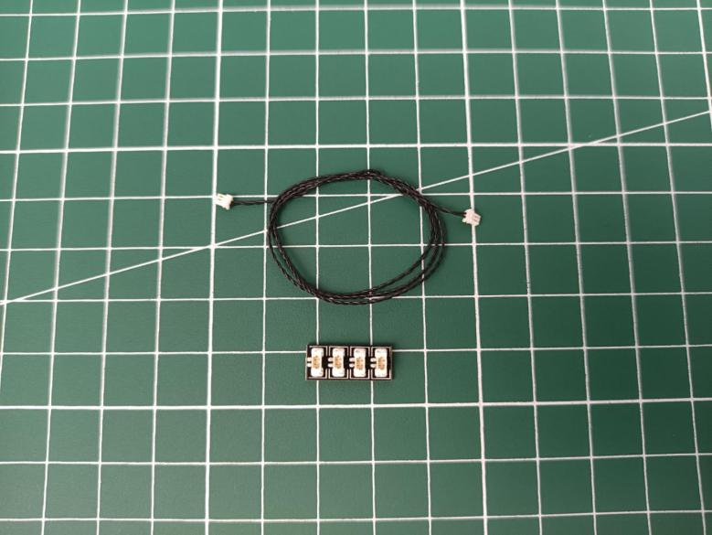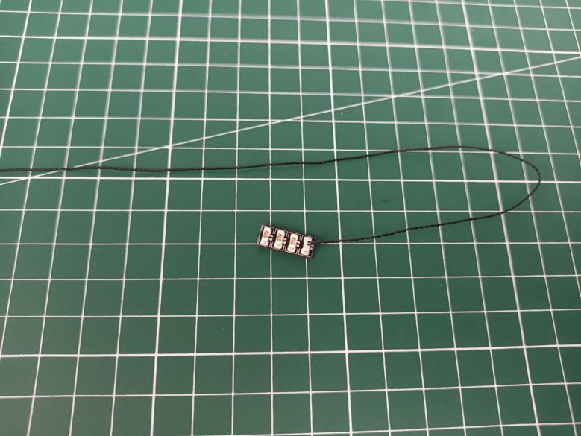

Connect the following cable of the light to the expansion board.
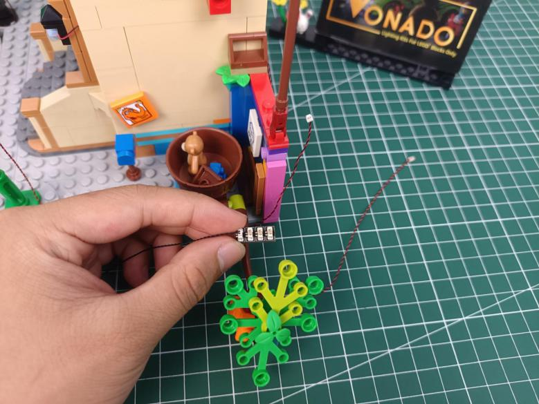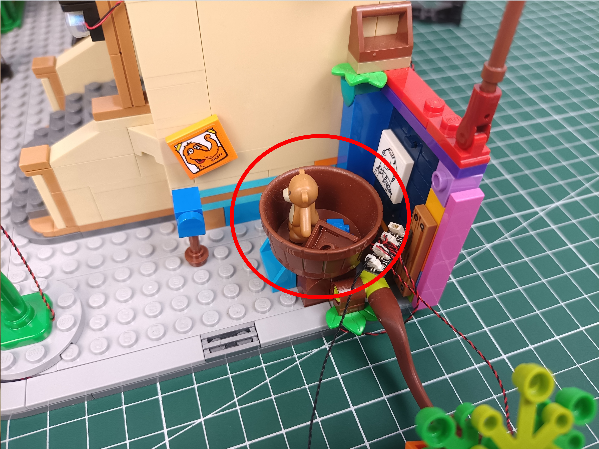

Remove the following piece.
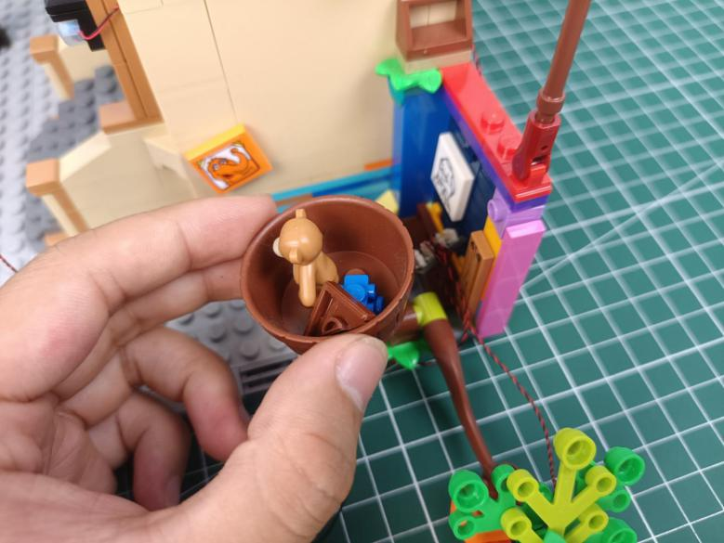

Take 2 adhesive squares, stick them to the back of the expansion board.
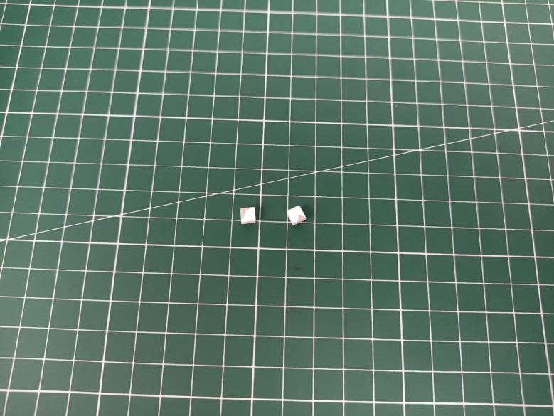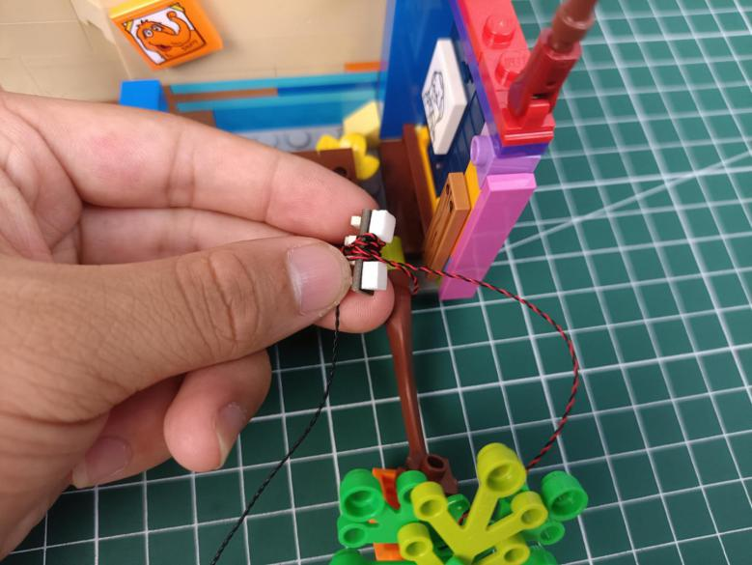

Stick the expansion board to the following place.
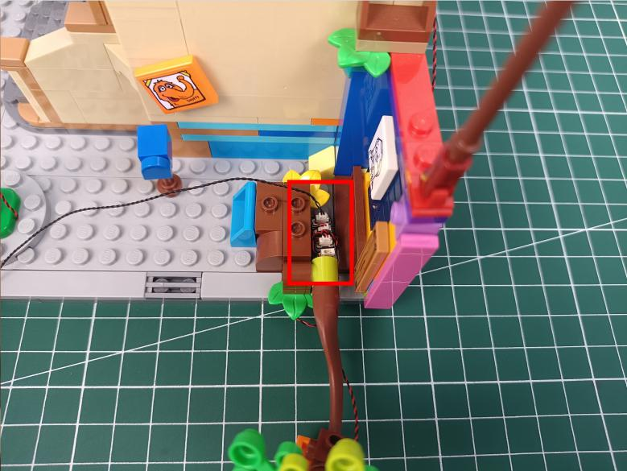

Thread the cable through the following space to the back.
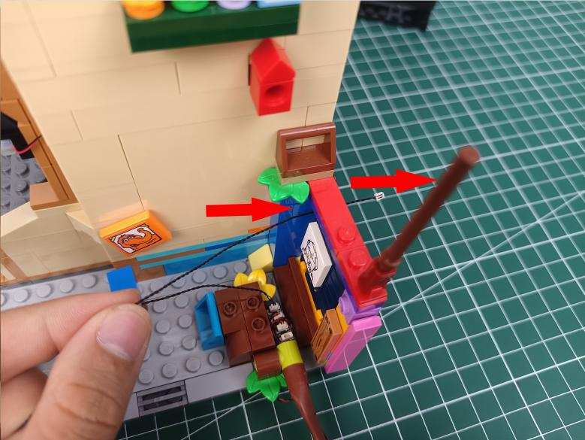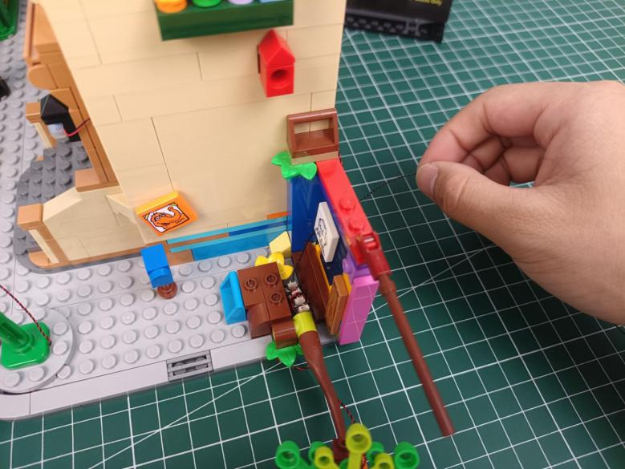

Reconnect the piece.
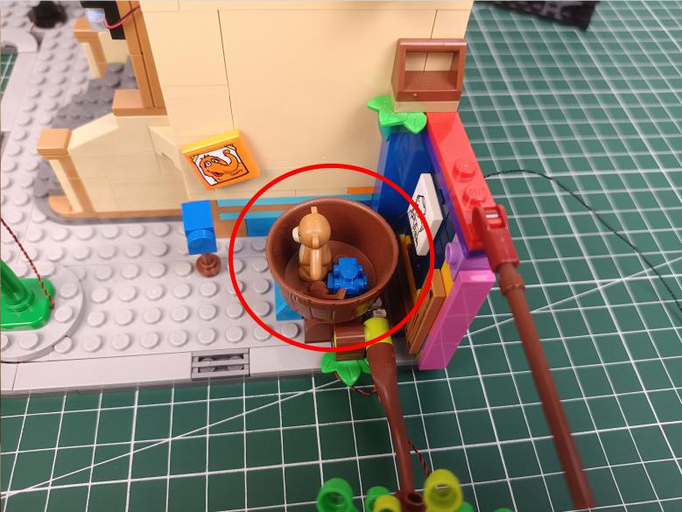

Turn to the back.
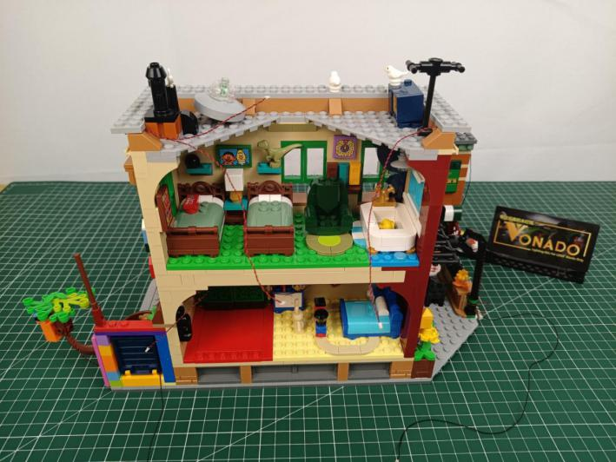

Remove the following black piece from the right roof.
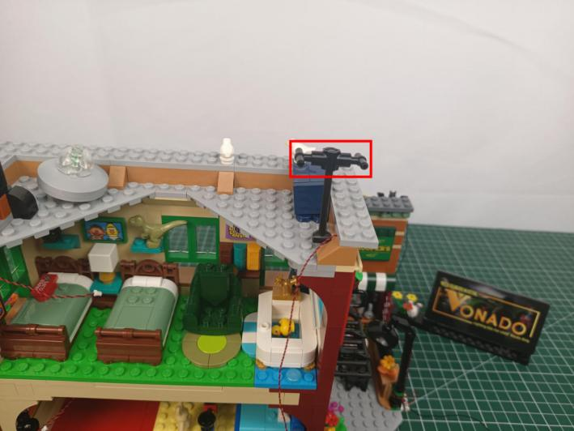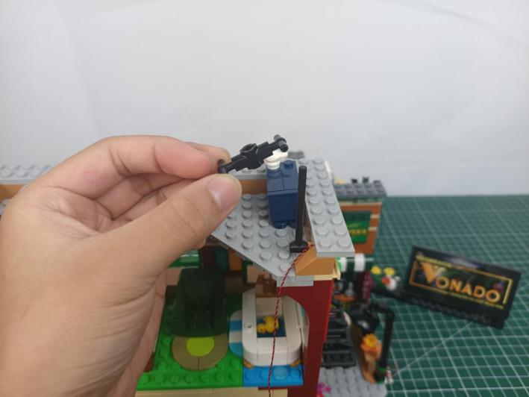

Take a flashing red 15cm dot light.
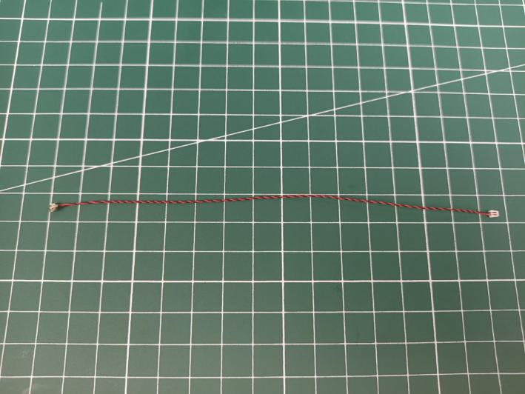

With lighting part facing outside, bend the cable to 90º.
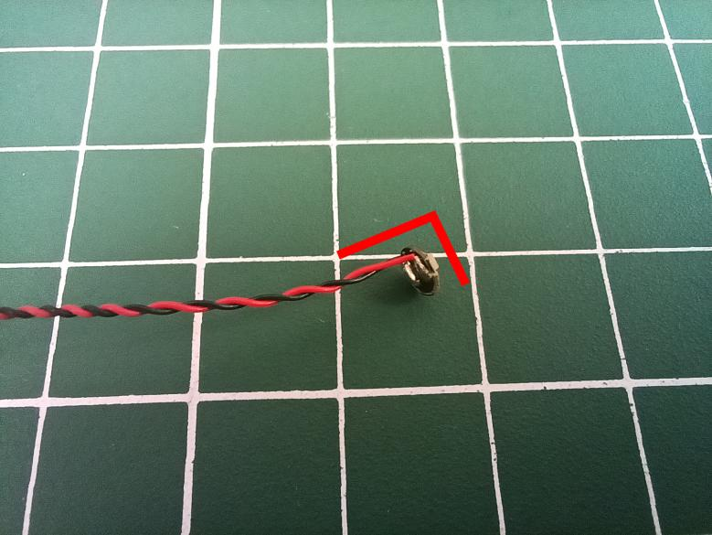

Thread the cable through the black piece and tighten it up.
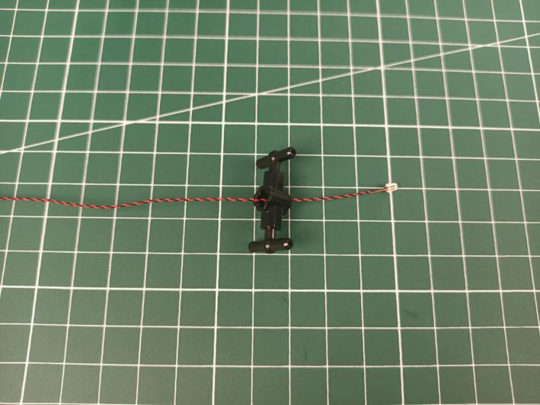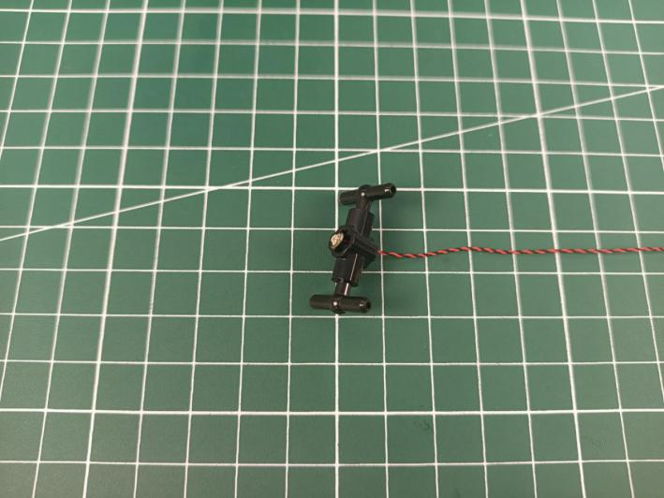

Reconnect the black piece.
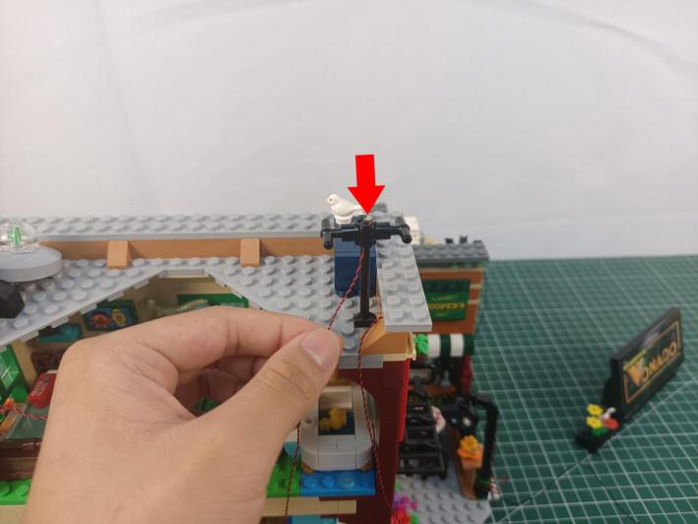

Wind the cable around the following piece twice.
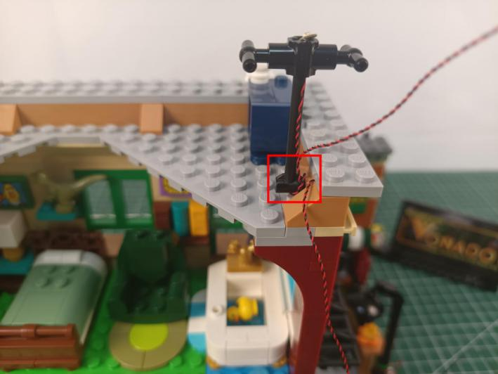

Open the right roof as per below.
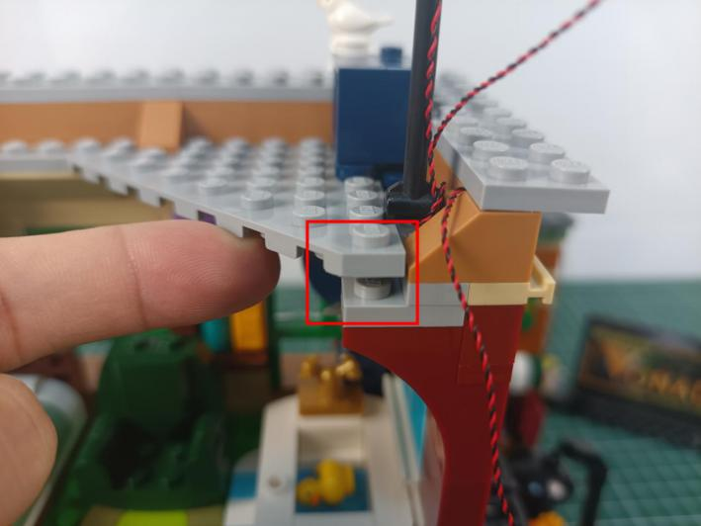

Stuck the 2 cables as per below.
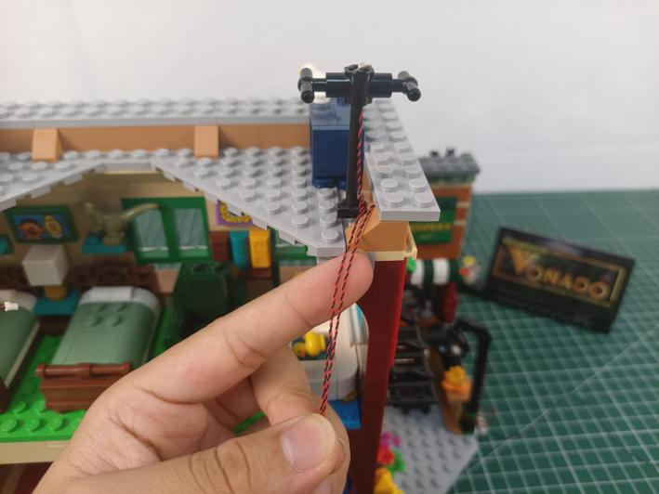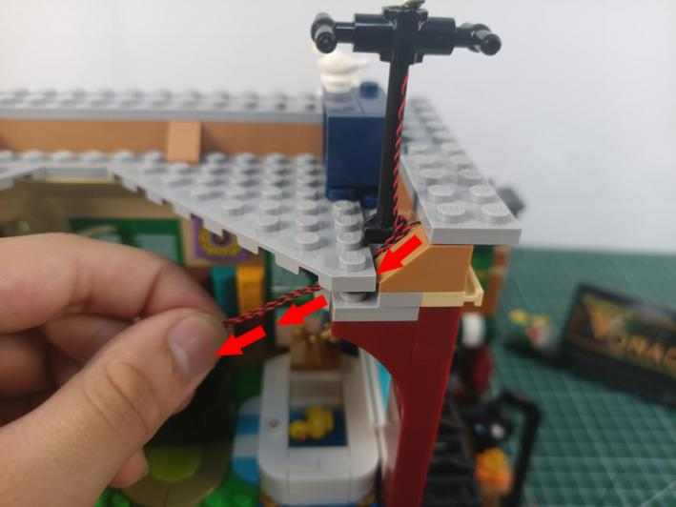

Close the gap.
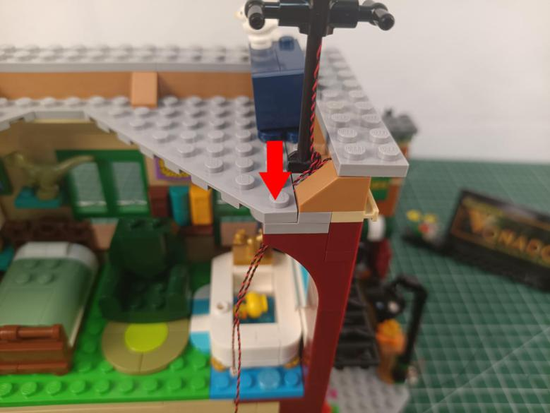

Remove the shower from the room at the second floor.
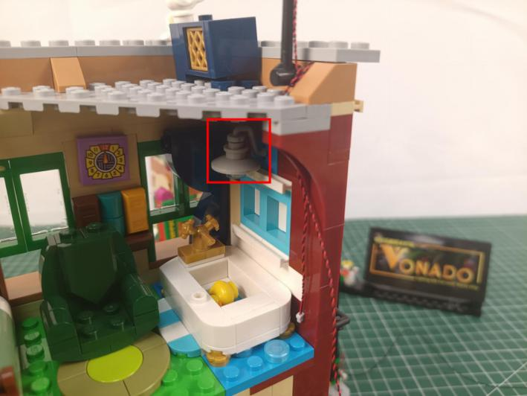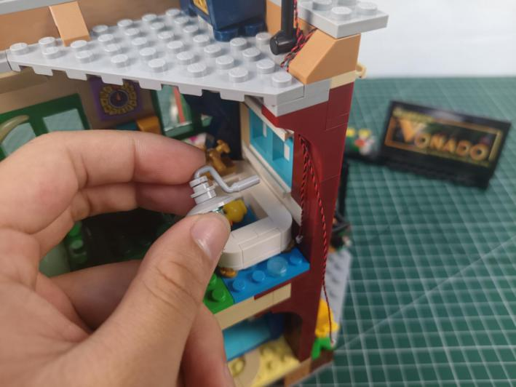

Take a blue 15cm dot light.
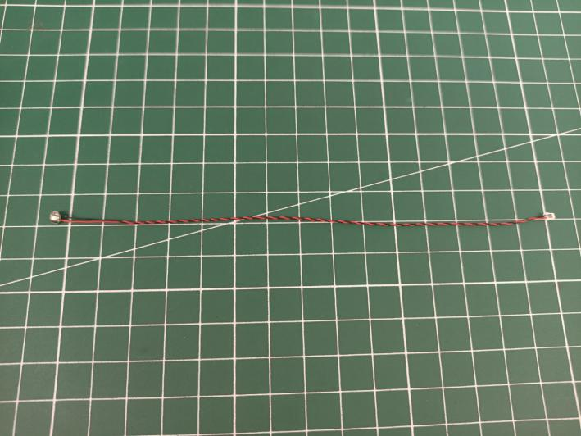

Split the cable as per below.
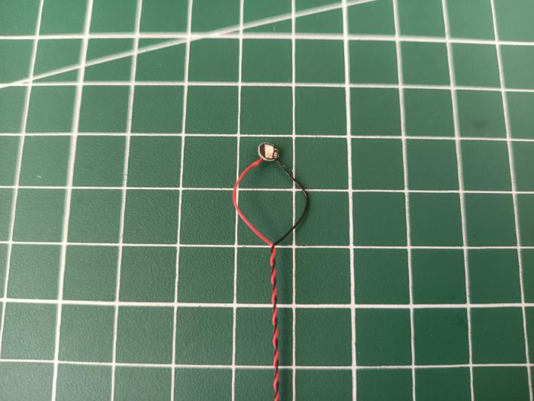

Noose the light as per below, tighten the cable up.
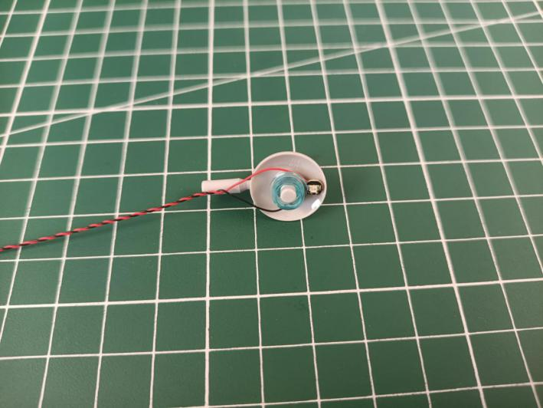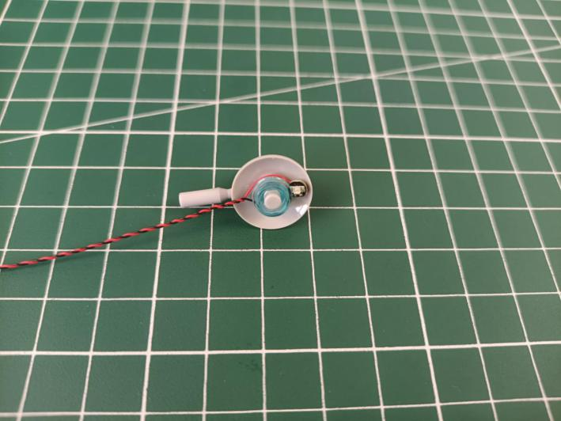

Reconnect the shower.
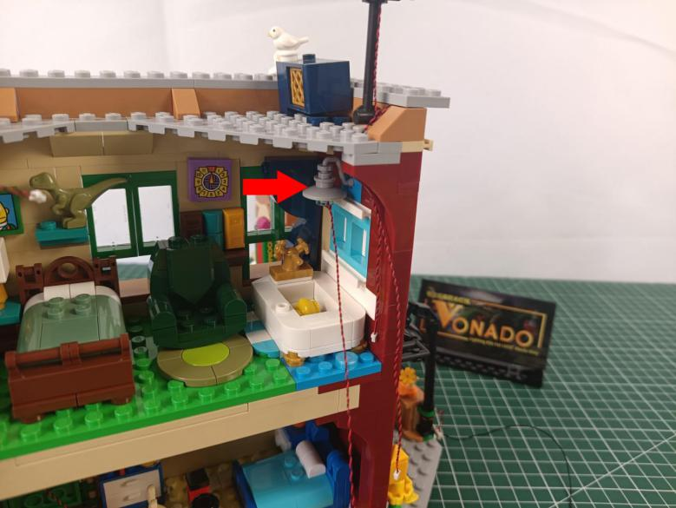

Take a 15cm connecting cable, a 4-port expansion board, assemble them as per below.
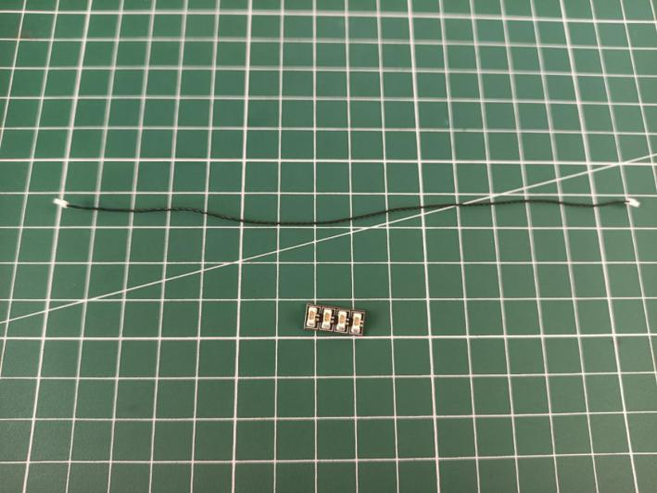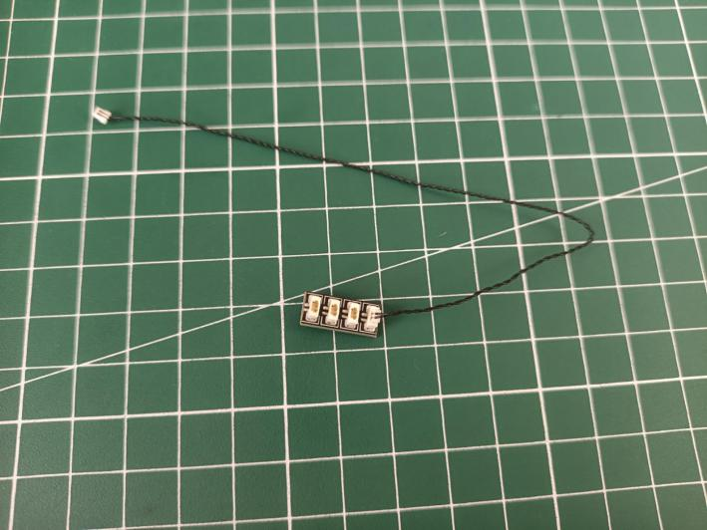

Connect all the cables from the right to the expansion board, and tuck excess cable around the expansion board.
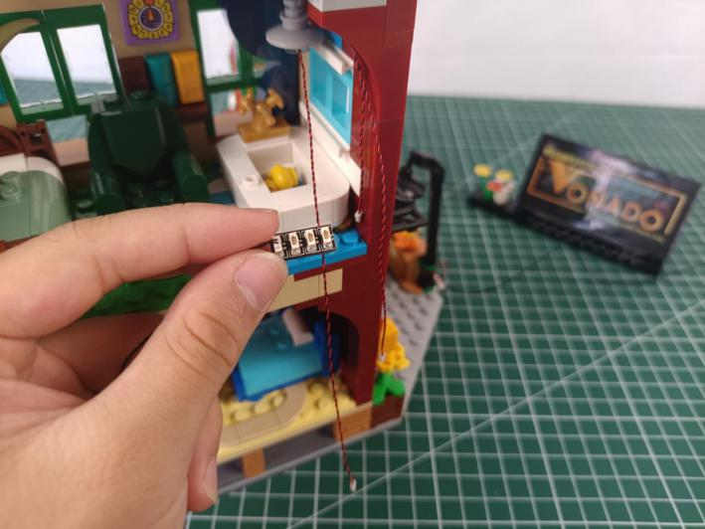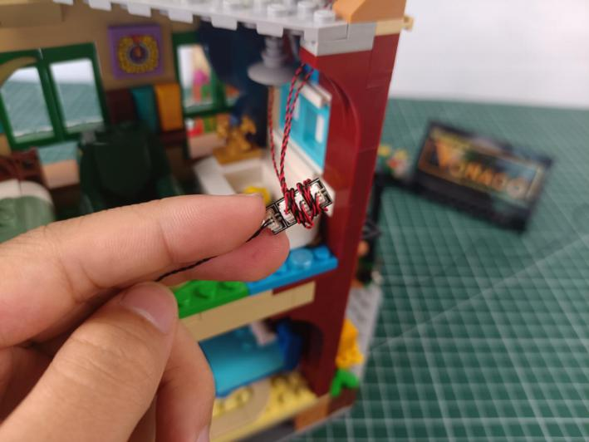

Take 2 adhesive squares.
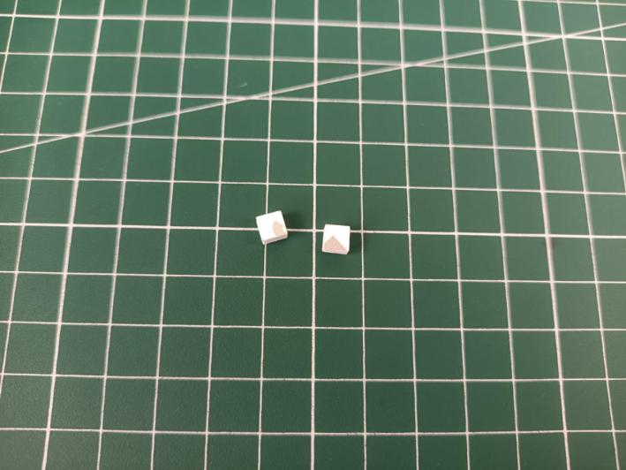

Stick them to the back of the expansion board, and stick the expansion board to the following place.
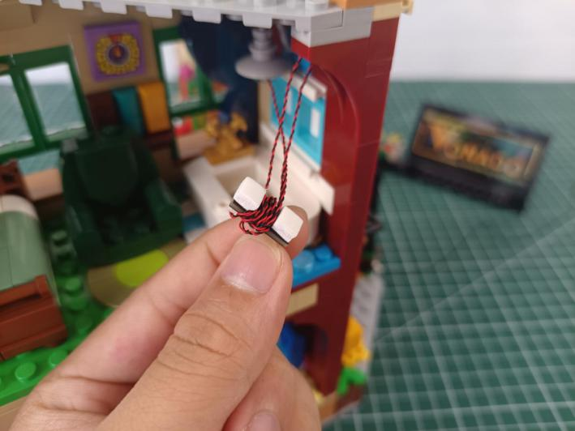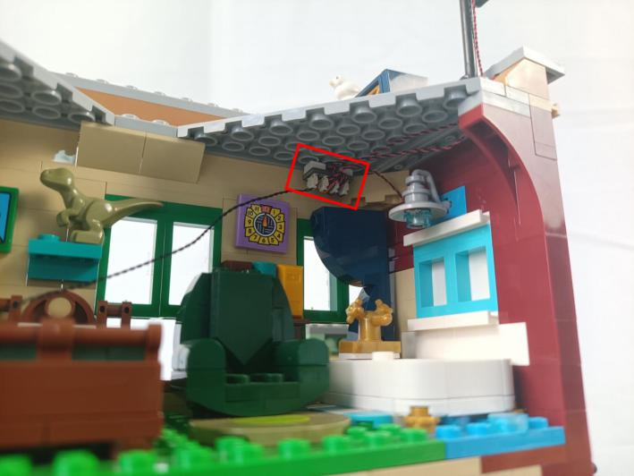

Remove the following gray piece.
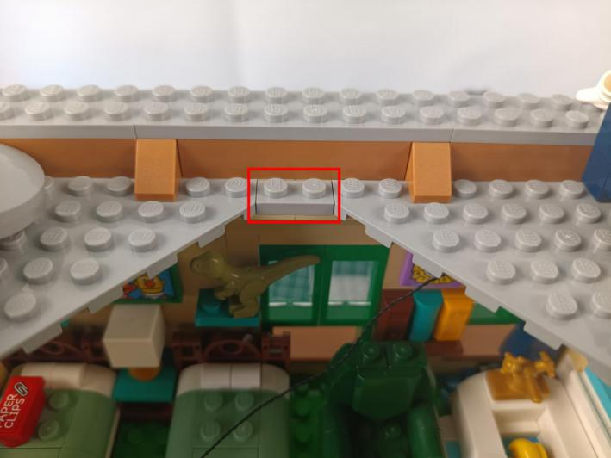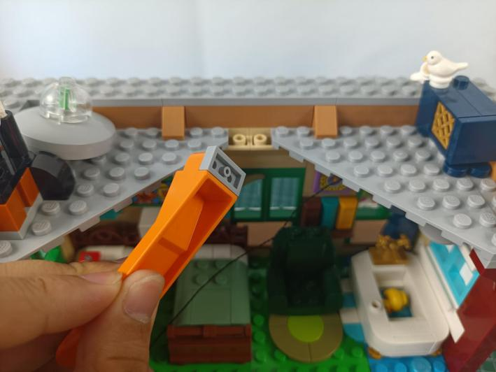

Prise off both sides of the roof with the tool.
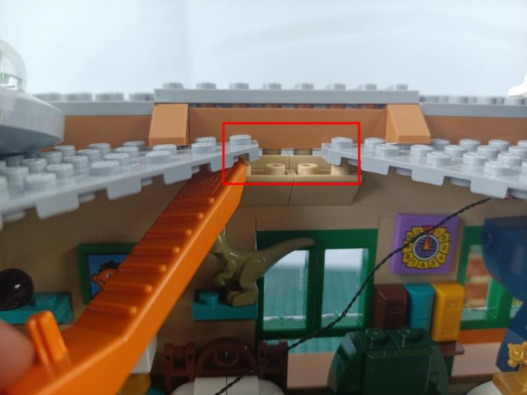

Place the cable as per below.
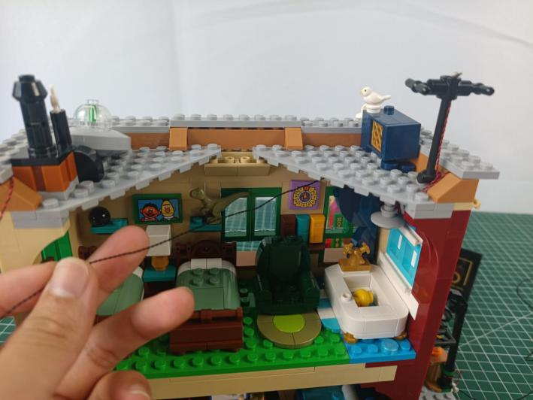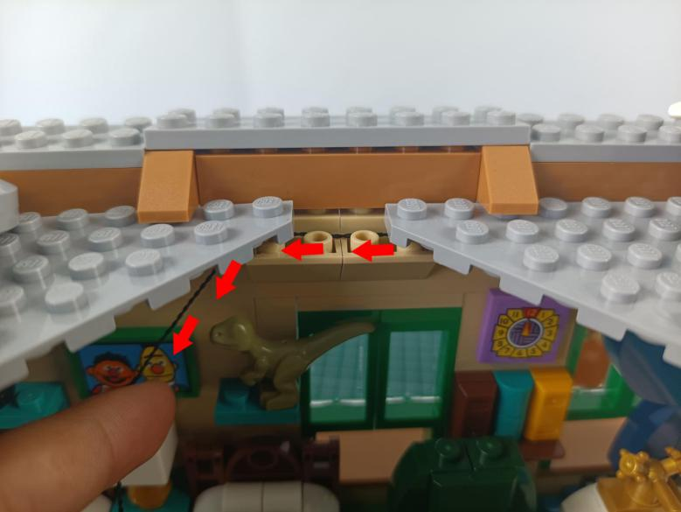

Reconnect the gray piece and close the gaps.
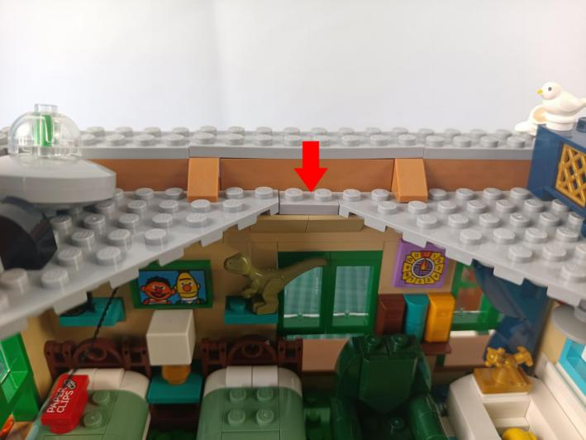

Take a warm white 15cm dot light, a 6-port expansion board.
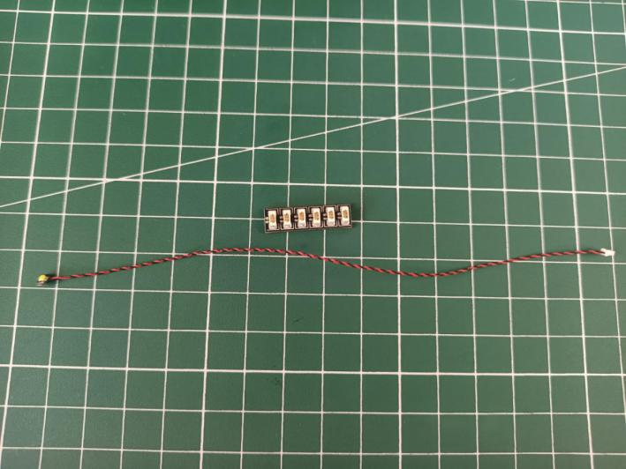

Save some length before connecting the cable to the expansion board, and tuck excess cable around the expansion board.
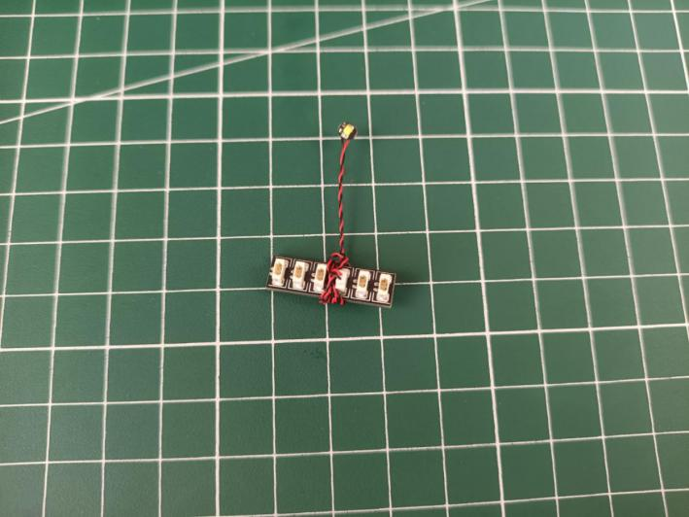

Connect all the cables from the left to the expansion board, and tuck excess cable around the expansion board.
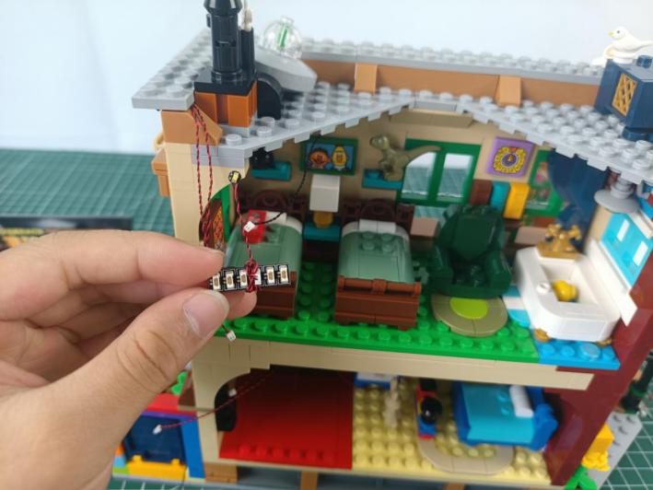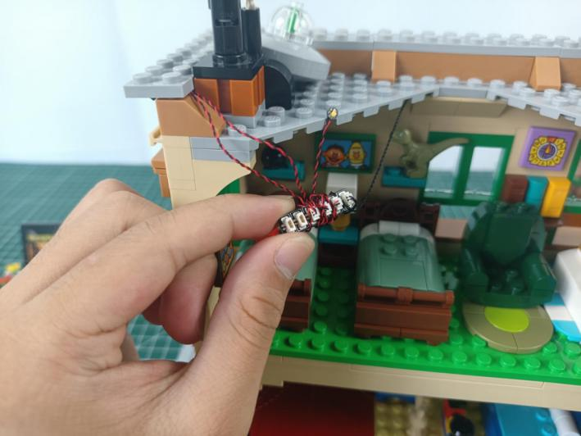

Take a 30cm connecting cable, 3 adhesive squares.
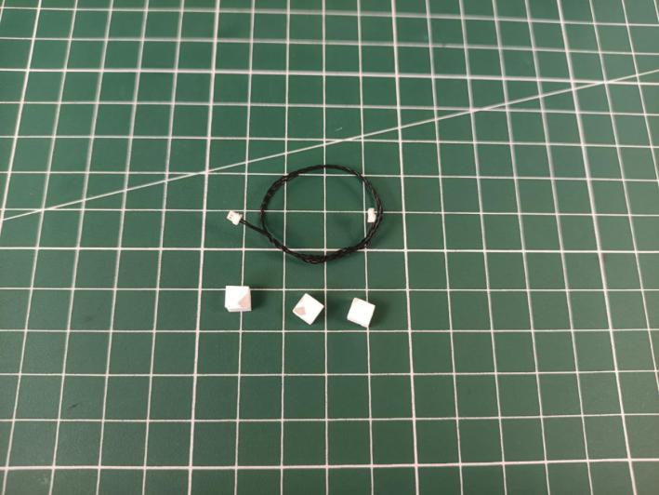

Connect the connecting cable to the expansion board.
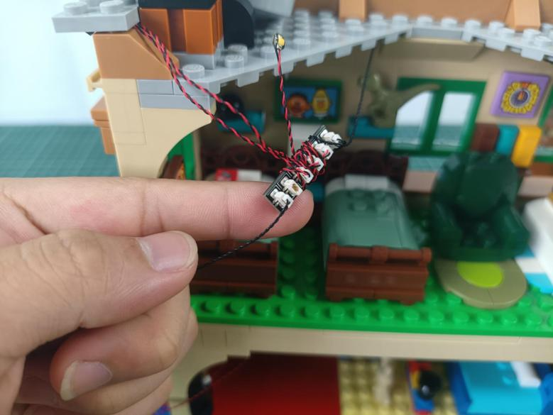

Stick 2 adhesive squares to the back of the expansion board, and stick the other adhesive square to the back of the light.
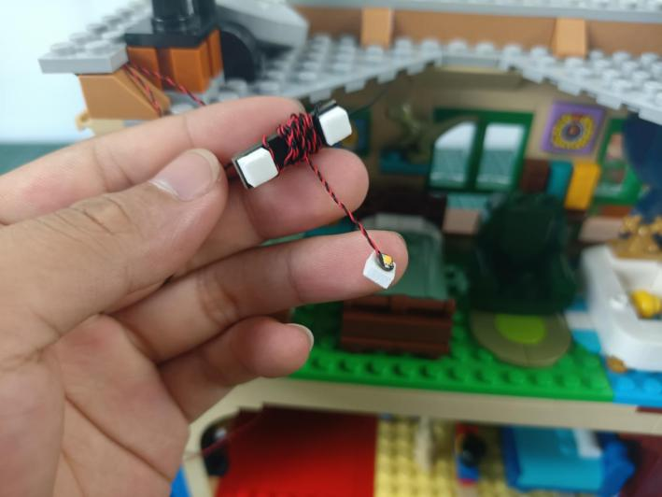

Stick them to the left roof of the second floor as per below.
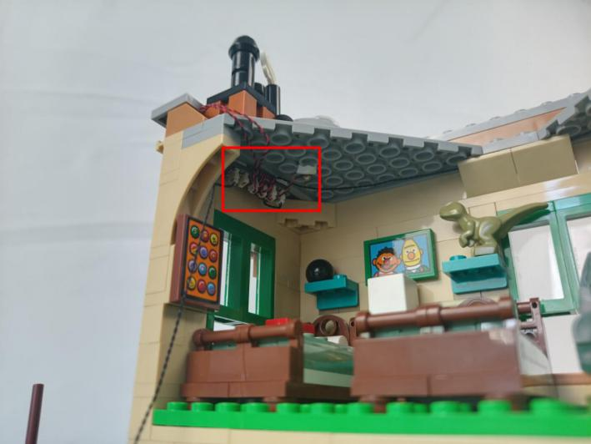

Create a gap at the floor as per below.
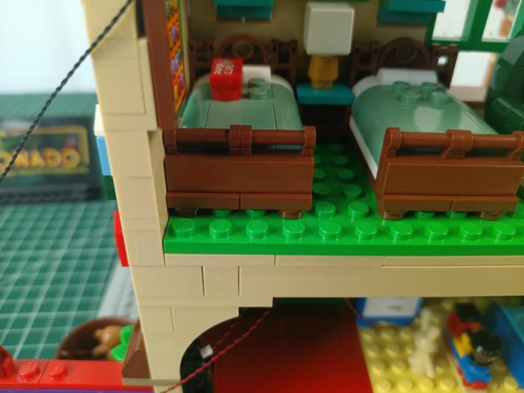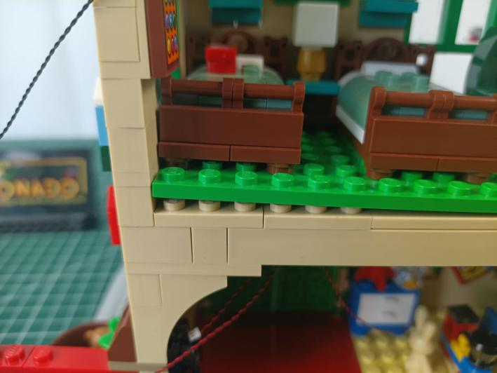

Thread the cable through the gap and pull it out from the bottom.
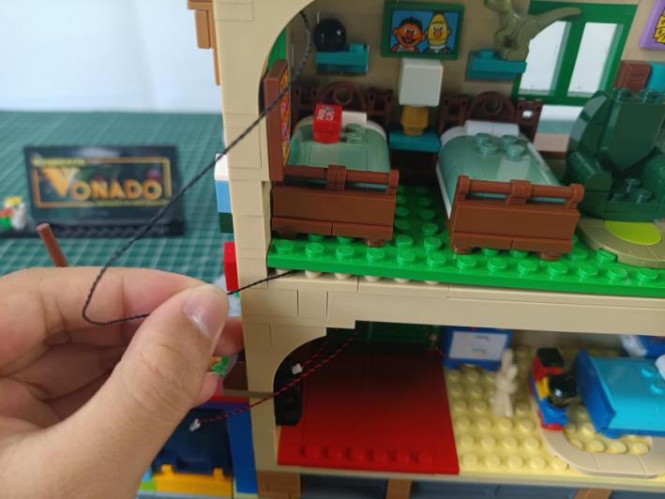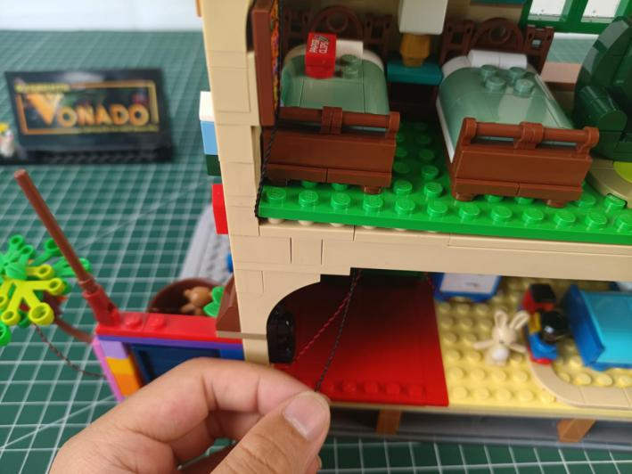

Close the gap.
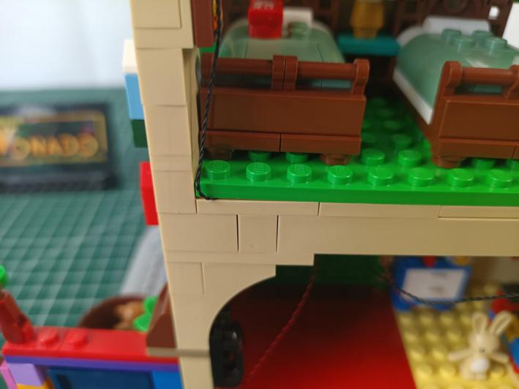

Remove the frame.
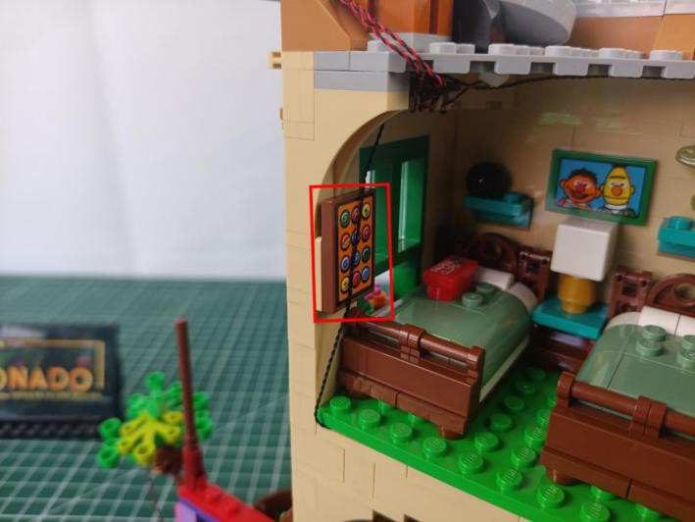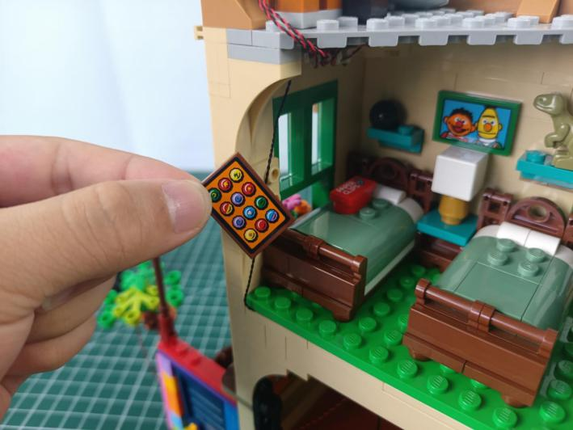

Press the cable behind the album, reconnect the frame.
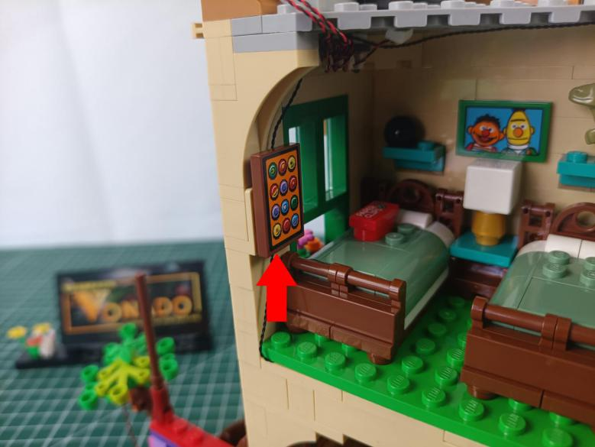

Turn to the first floor.
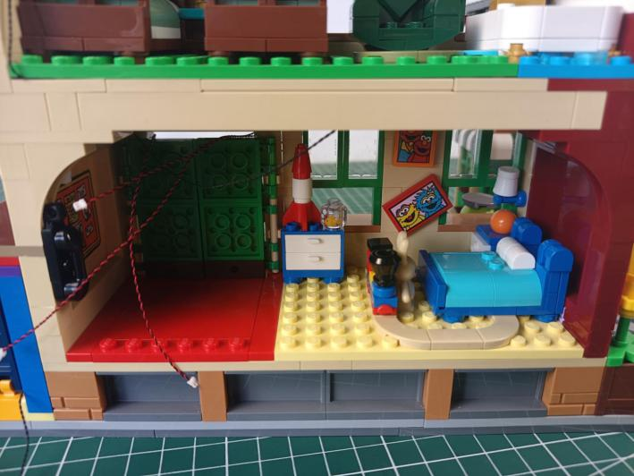

Remove the following piece.
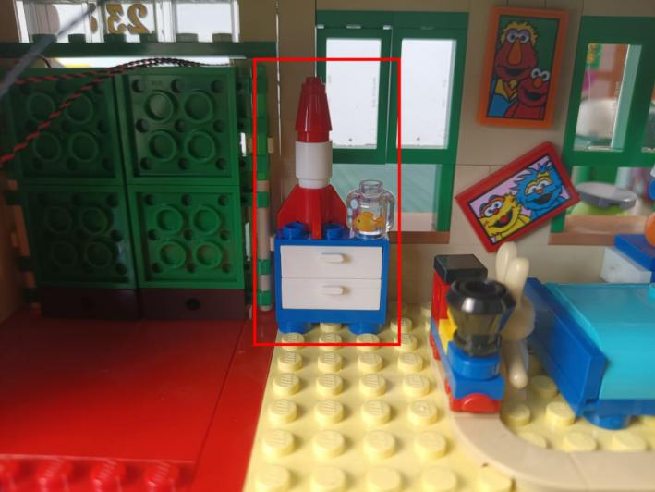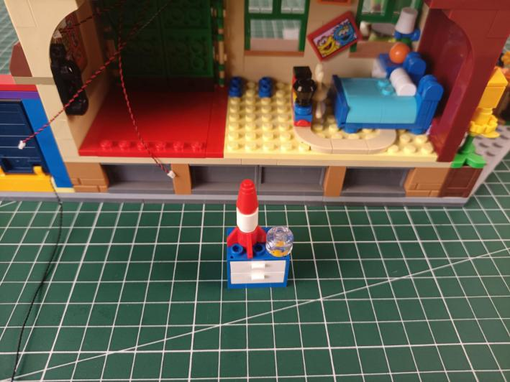

Disassemble it as per below.
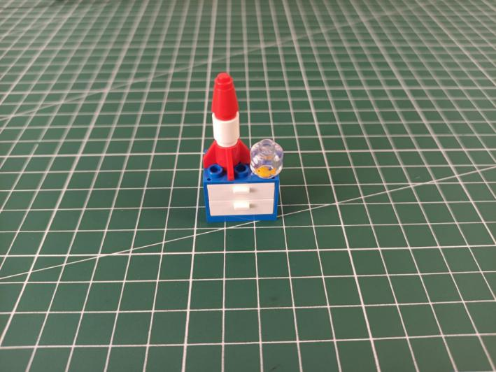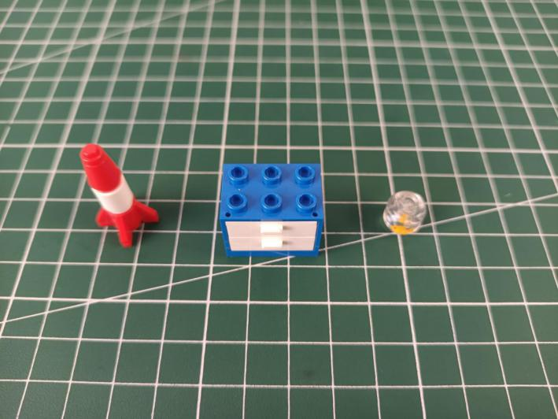

Take a blue 15cm dot light.
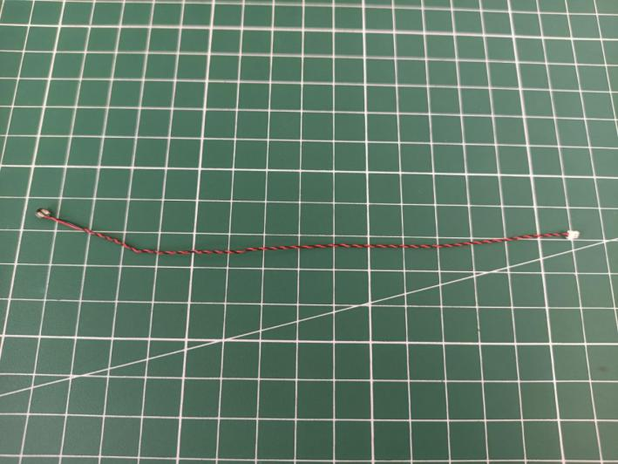

With lighting part facing up, reconnect the fish tank (place the cable as per below).
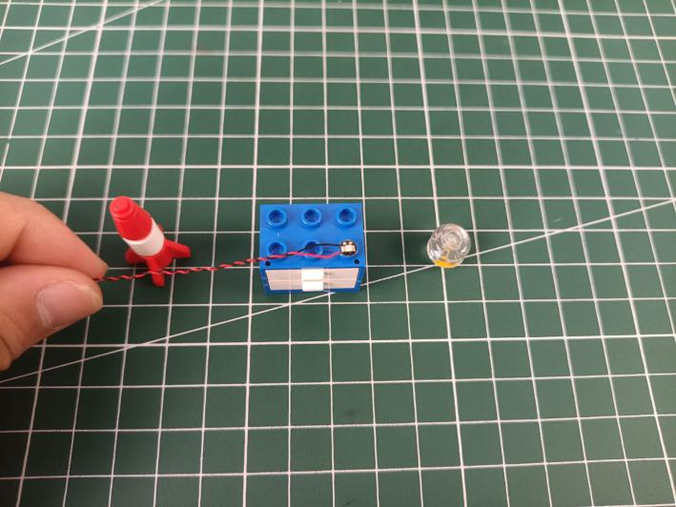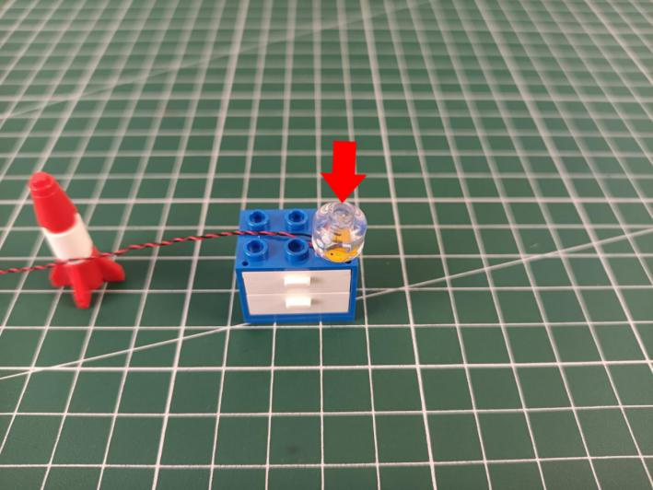

Reconnect the rocket.
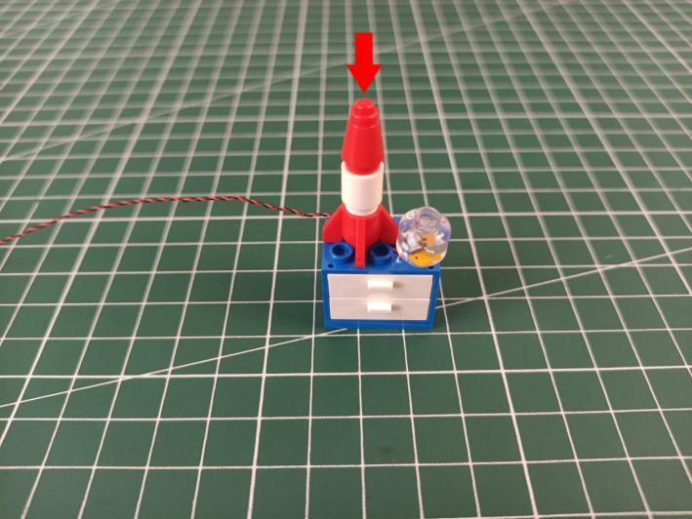

Reconnect the piece.
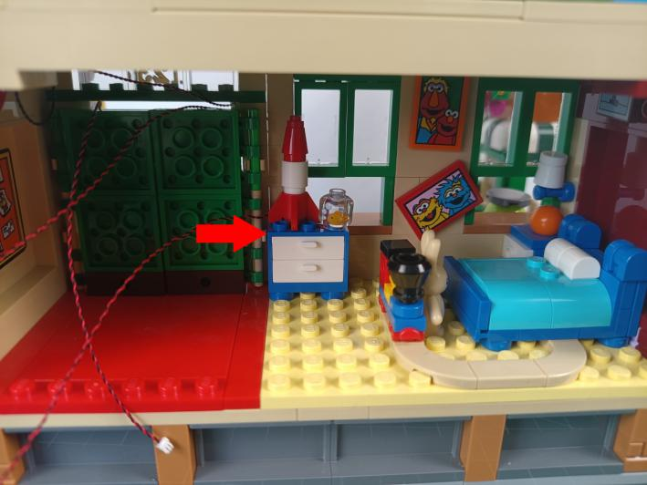

Take a USB cable, a 12-port expansion board, assemble them as per below.
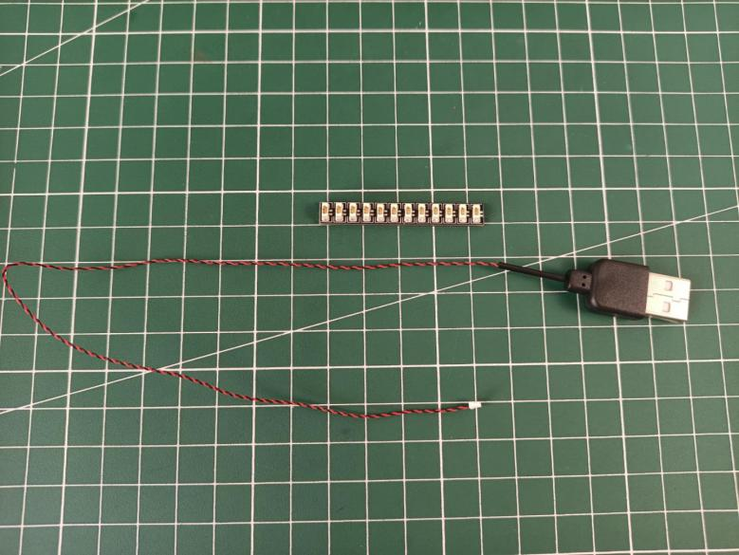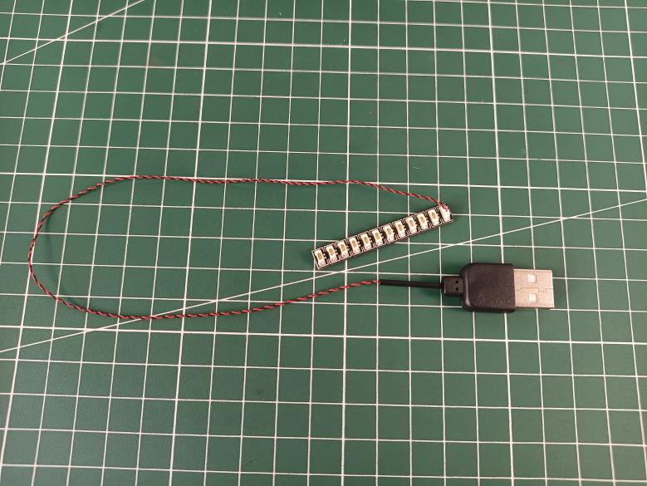

Take a 15cm head light, wind it around the expansion board, and connect it to the expansion board.
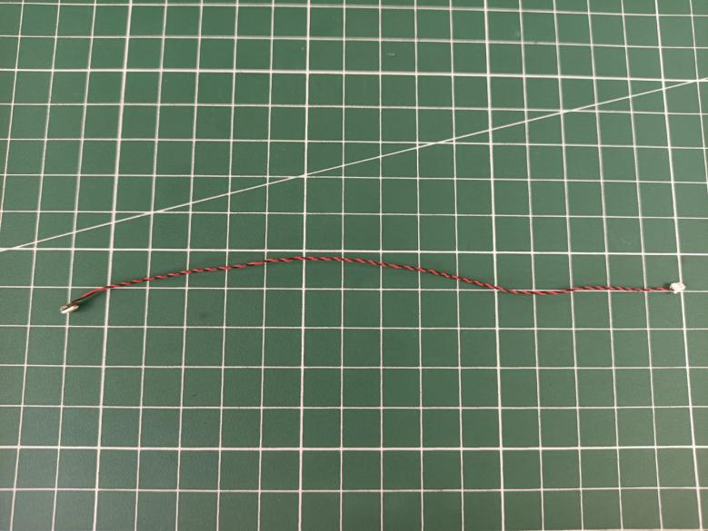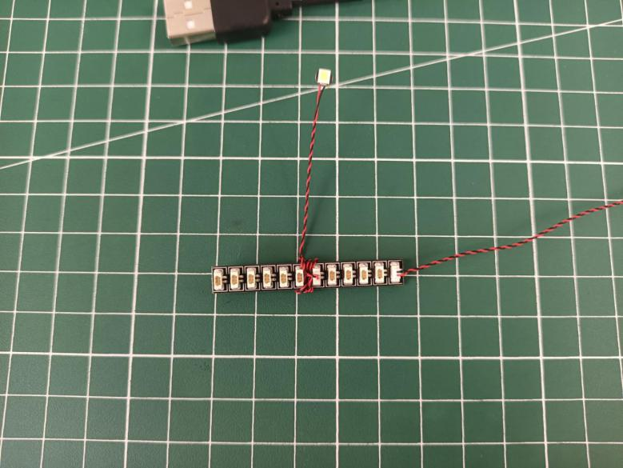

Connect all the cables from the first floor to the expansion board, and tuck excess cables around the expansion board.
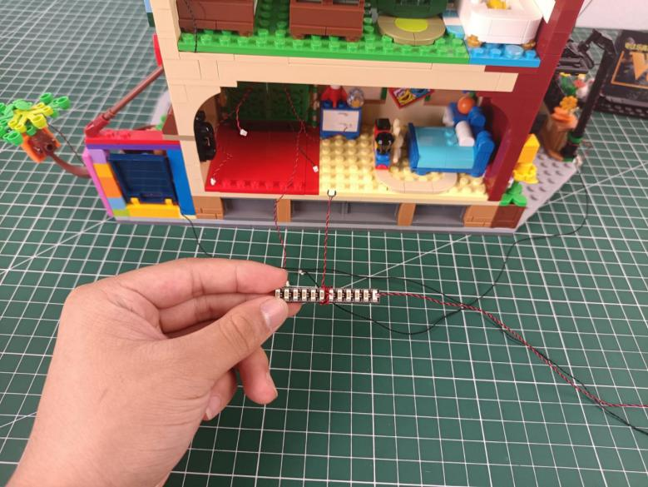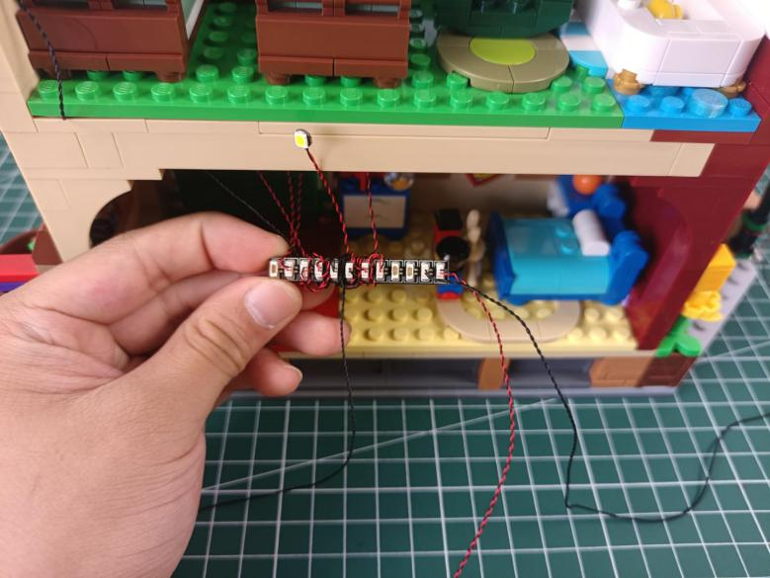

Take 3 adhesive squares, stick them to the backs of the expansion board and the head light.
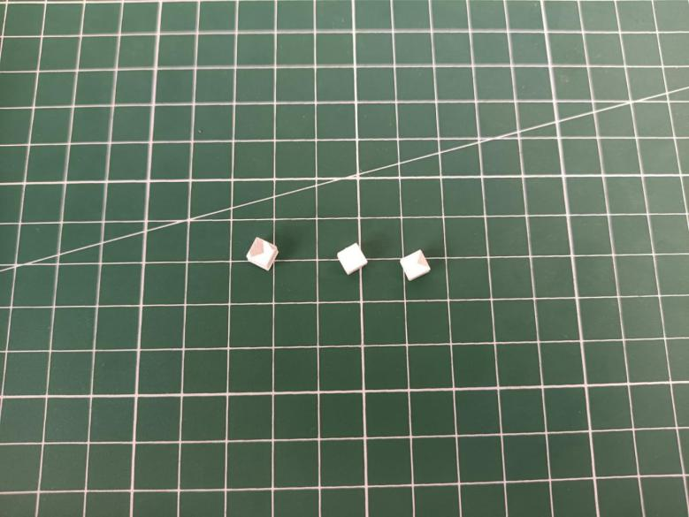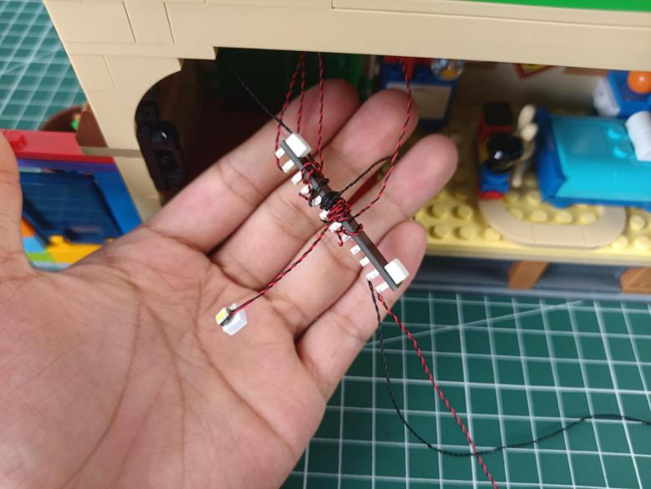

Stick them to the roof of the first floor as per below.
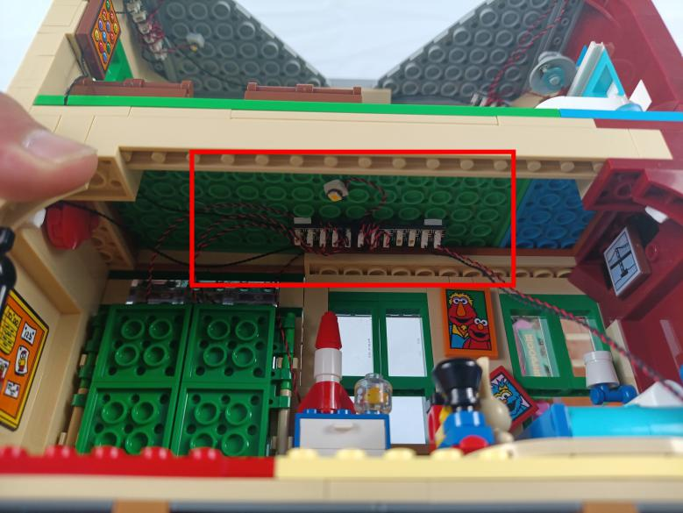

You can stick excess cables at the wall corner.
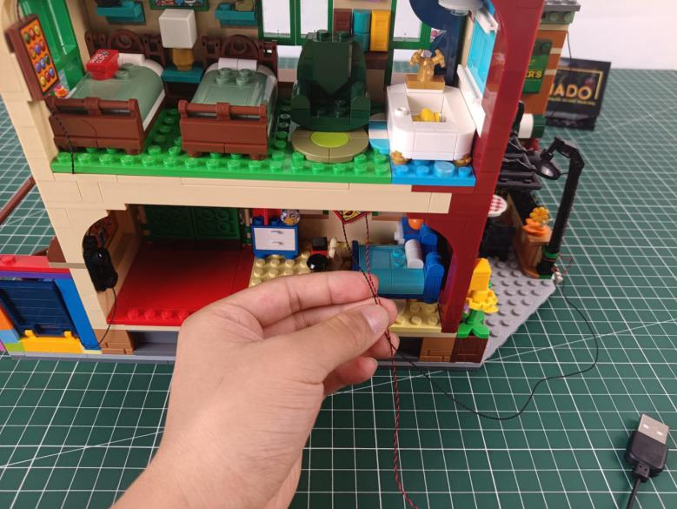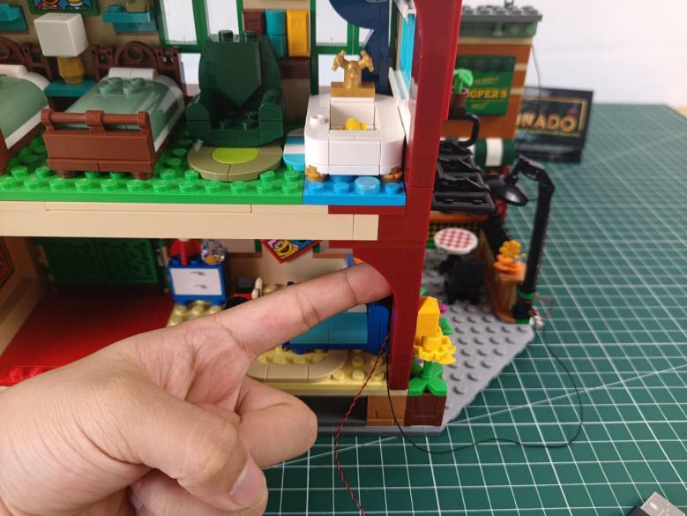

This completes installation of this LED Lighting Kit. ENJOY!

The above are ideas and instructions provided by our designers. Please move on:
1: Do you have any suggestions about the material and quality of our products?
2: Do you have any suggestions on the installation instructions and the degree of difficulty of the installation?
3: If you have better installation method and ideas, please contact us in time.

