**Lighting Kit LEGO 42095**

Thank you for choosing our lighting products. We are committed to LEGO product study and lighting development, we're always trying our best to provide LEGO fans with the best products and the best installation ideas.

Must be careful observation, imagination can be infinite.

We provide basic parts to support your imagination.

DO IT YOURSELF .that's what LEGO is .

As always, Lego has been adhering to the DIY philosophy from product selection, research and development to sales. Consumers buy the parts, you will assemble them by yourself, and you can experience every step from picking up the first piece to installing the last one. Besides, LEGO has different answers for the installation form and method of each part. Vonado lighting also does not want to kill your unlimited creativity, we will try our best to make products with high variability, high playability and unlimited play. If you have any dissatisfaction or your own ideas on the parts such as the color of the lights, the length of the cables, the installation position of the product, and the final effects of each module, you can make your own arrangement, and we will cooperate with you to replace or repurchase.

LETS MOVE!

#### **Package contents：**

* 3 x 15cm White Dot Lights
* 1 x 15cm Warm White Dot Light
* 2 x 15cm Red Dot Lights
* 2 x 15cm Blue Dot Lights
* 1 x 12-port Expansion Board
* 1 x Flat Coin Cell Battery Pack

Extra pieces

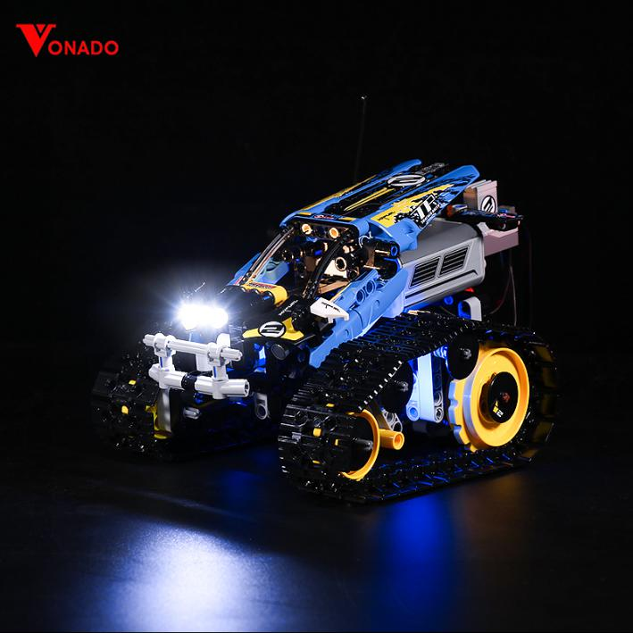

**Note:**

**Place wires on the surface or under the building blocks.**

**The wire can be place between the building blocks or under the block, but they should be placed between the studs correctly.**

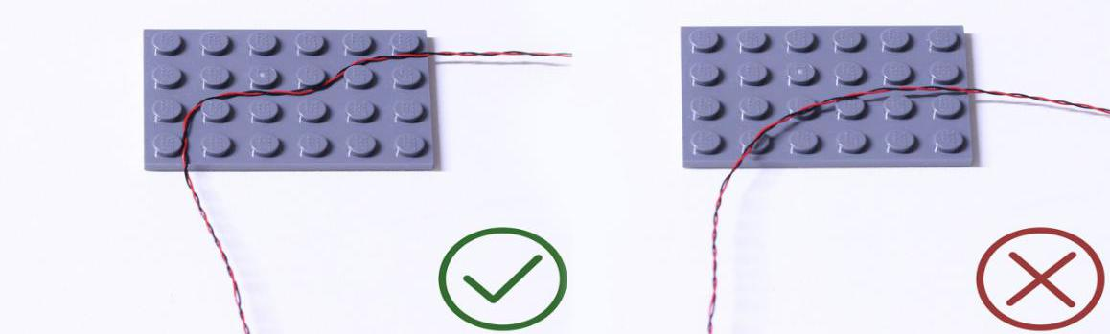

**Insert the connectors to the ports.**

**Be careful when you are operating, there’s only one correct way to insert, make sure the expansion board is upward, find the soldered “=” sign on the left of the port. When you are inserting, the side which the wires can be seen should be faced to the “=” sign and if you feel hard to insert, please stop, and don’t force it, for that may result in bent pins inside the port or overheating of the expansion board.**

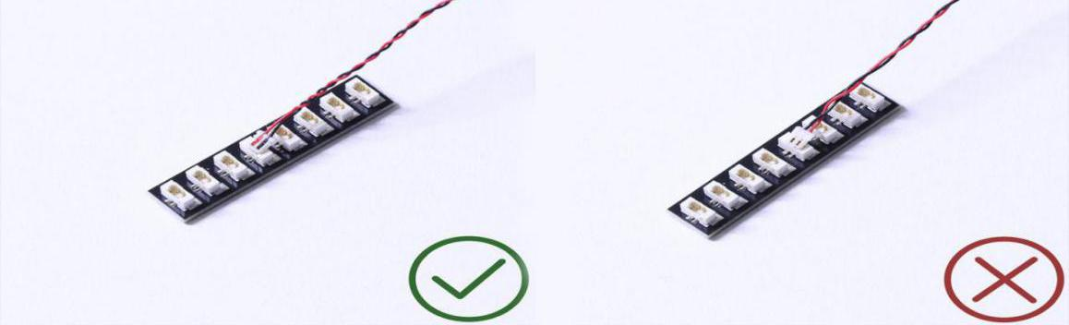

**At this point, use the tweezers to straighten the bent pins.**

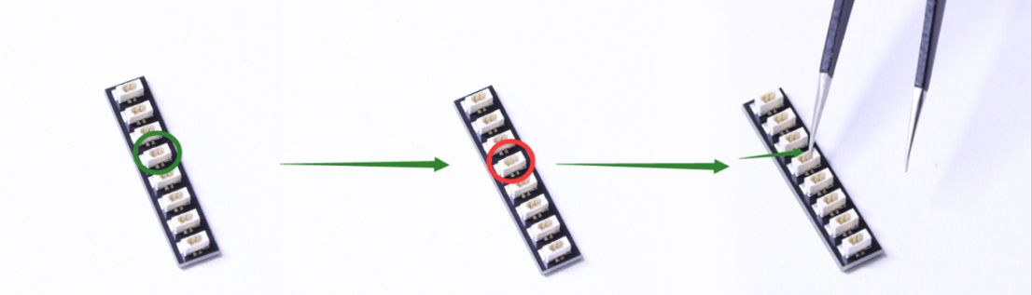

**When installing dot lights, make sure they are correctly placed (Yellow LED package is exposed). You can put they either on the top of the studs or between studs.**

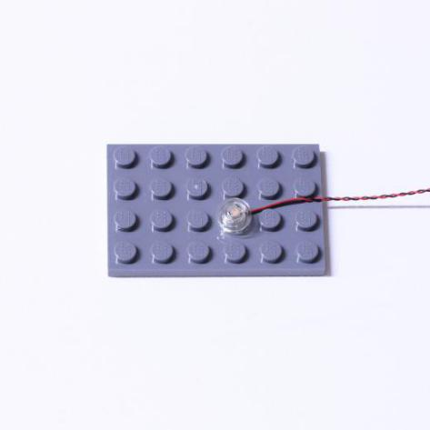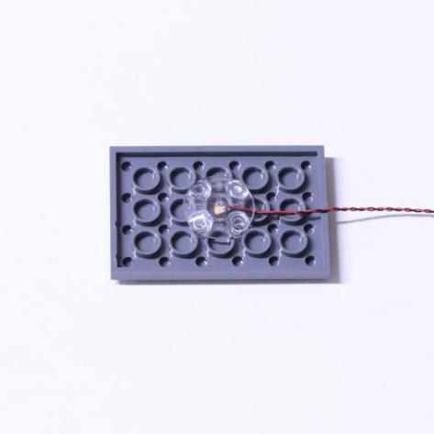

**Connecting cable connectors to Strip Lights**

**Take extra care when inserting connectors to ports on the Strip Lights. Connectors can be inserted only one way. With the Strip Light facing up, ensure the side of the connector with the wires exposed is facing down. If a plug won’t fit easily into a port connector, don’t force it. Doing so will damage the plug and the connector.**

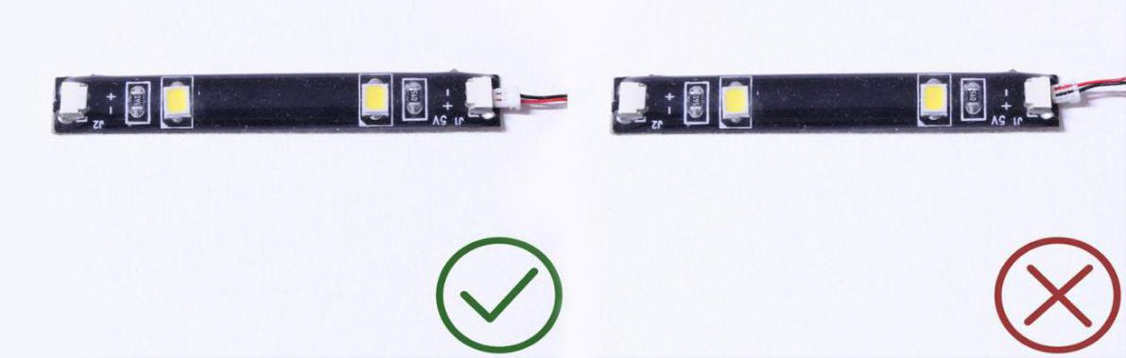

**Finally, please pay attention to the positive and negative terminals of the battery when installing the battery case.**

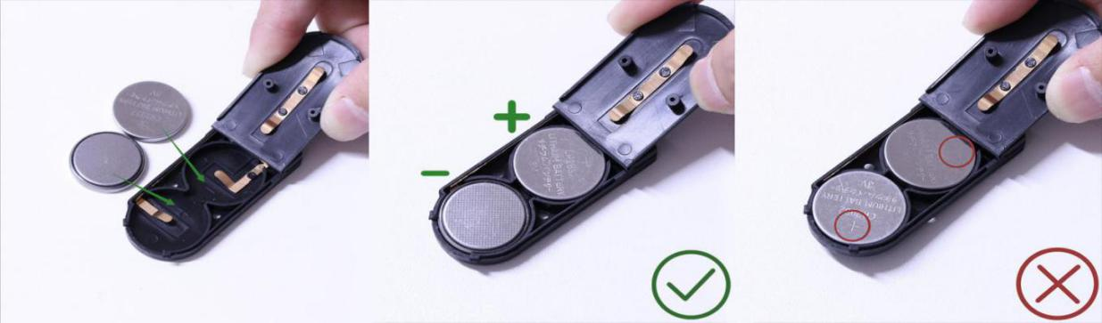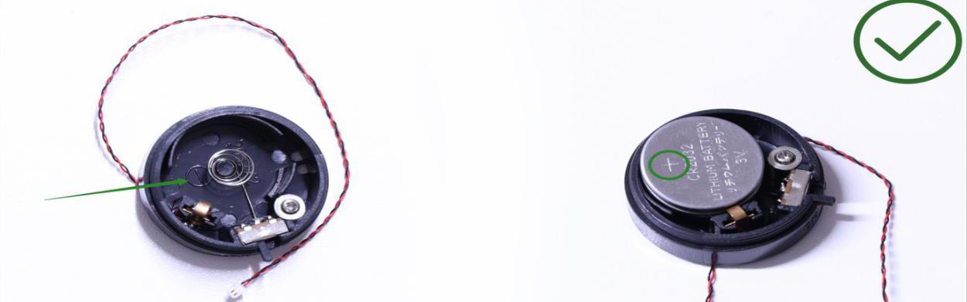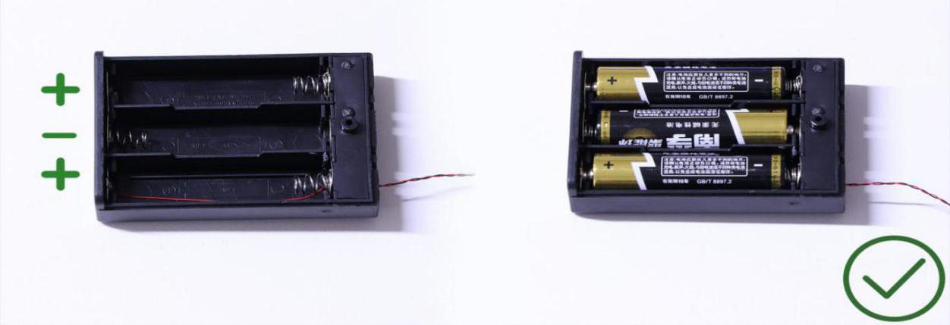

****Instructions for installing this kit：****

**Remote Control Stunt Truck,** **Classic Version, Lighting Kit, 7 bags in total，6 bags with labels，1 bag without label，as per below:**

**Power supply：Flat Coin Cell Battery Pack（self-contained battery）.**

Firstly, take the battery pack, connect it to the expansion board to verify all the lights one by one.

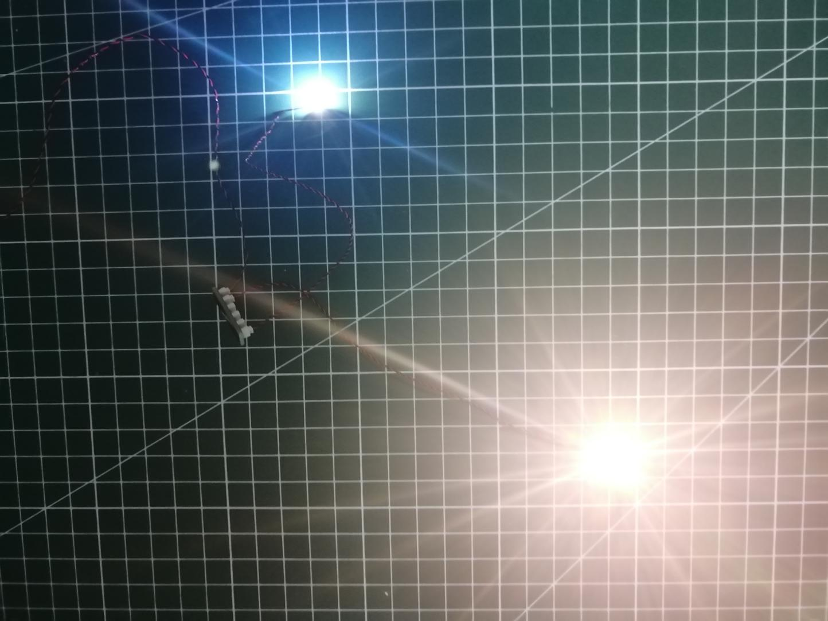

After the verification, disconnect the lights and put them back to the bags.

（note: put the lights back to the bags when verification of the lights from the same bag is done, then, continue to verify the lights in another bag.）

OK, Let’s Begin! （you can use the tweezer if necessary.）

（Tips: the tweezer is sharp, you should be careful when using it, do not hurt yourself or scratch the pieces; be gentle and do not wear the cables.）

****Instructions for installing this kit：****

Take the truck.

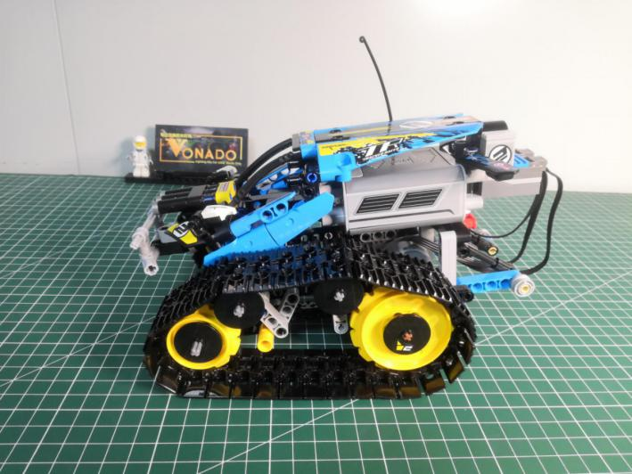

Turn to the front.

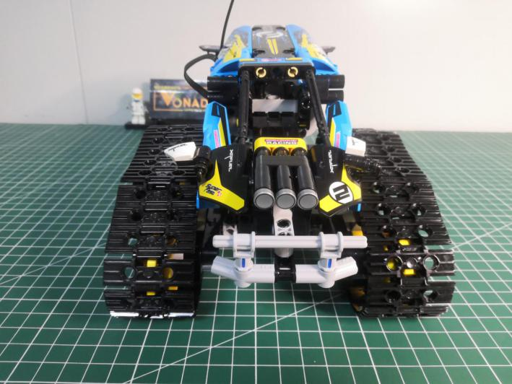

Remove the following 3 pieces.

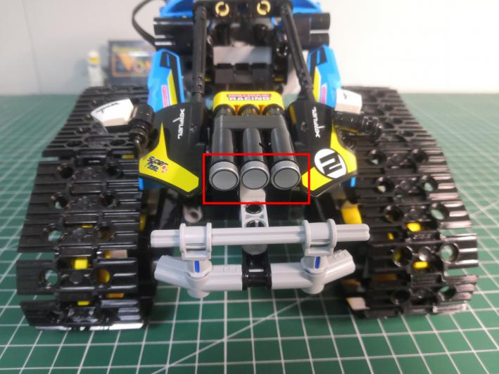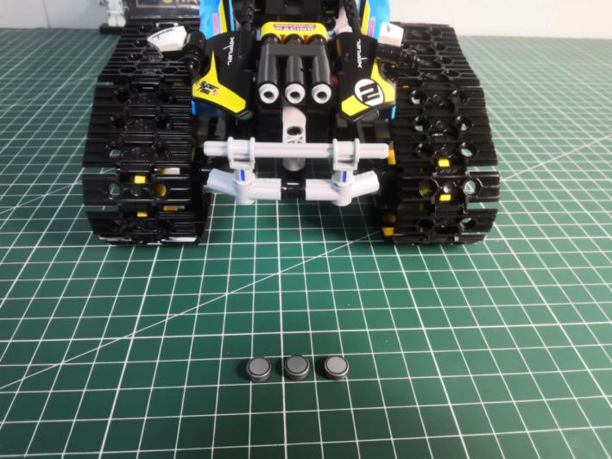

Take 3 white 15cm dot lights, 3 trans white 1x1 round plates.

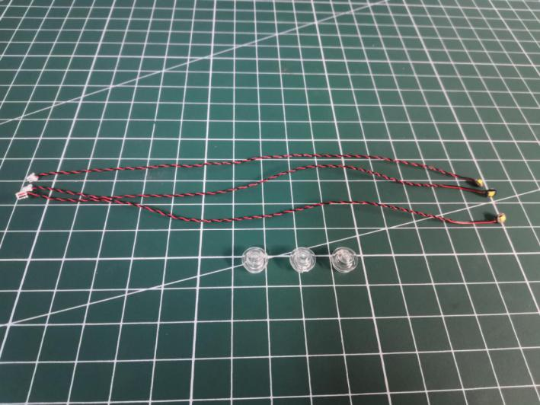

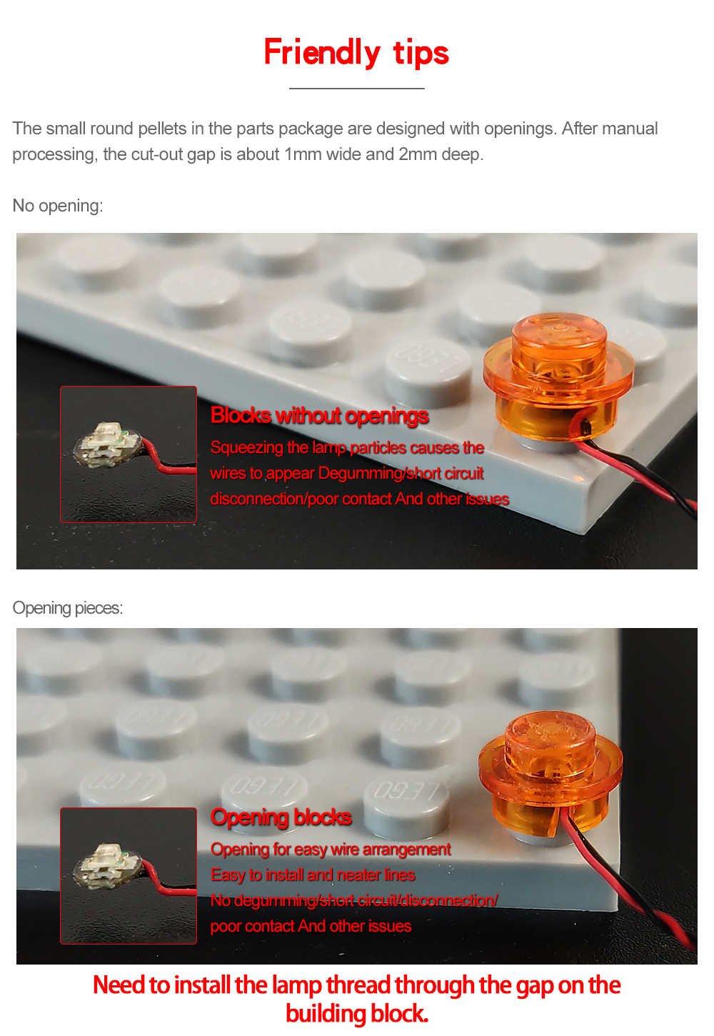

With lighting part facing up, connect the trans white round plate over to secure the light.

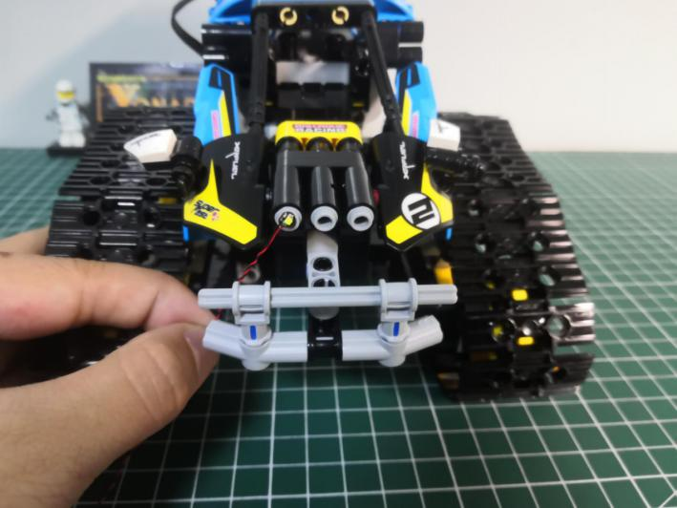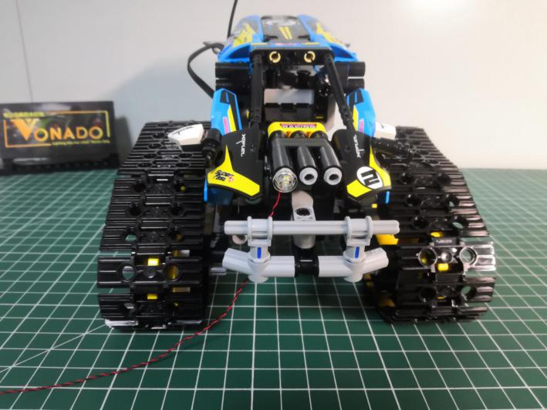

Install the other 2 lights in the same way.

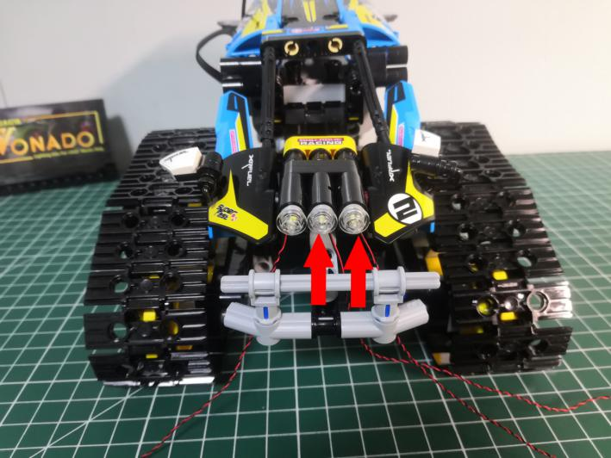

Turn to the side.

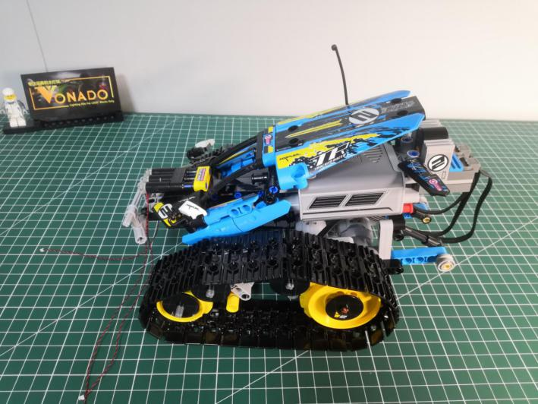

Take a warm white 15cm dot light, an adhesive square.

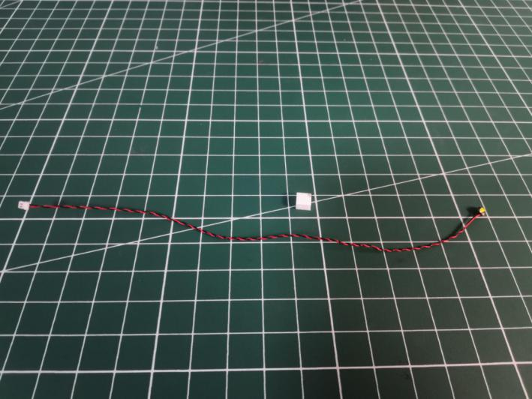

Stick the adhesive square to the back of the light, stick the light to the following place.

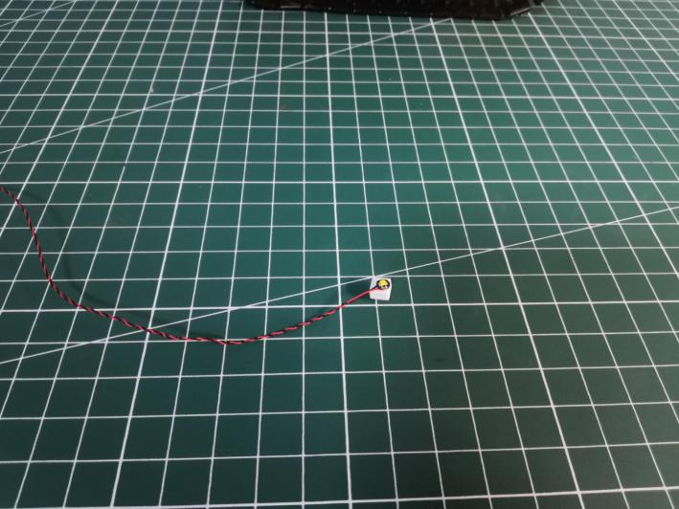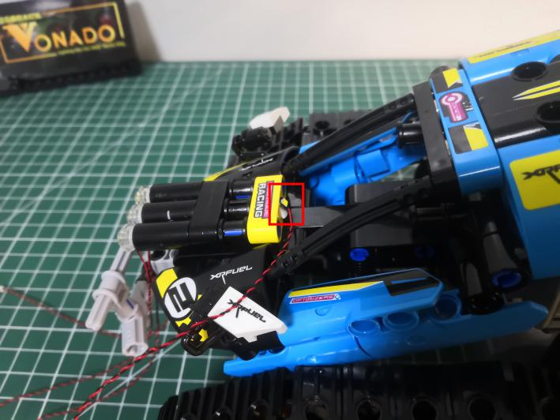

Take the following cables, tuck them underneath the truck.

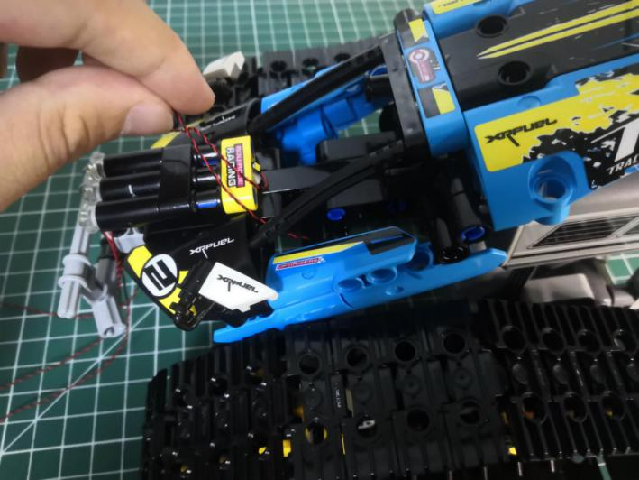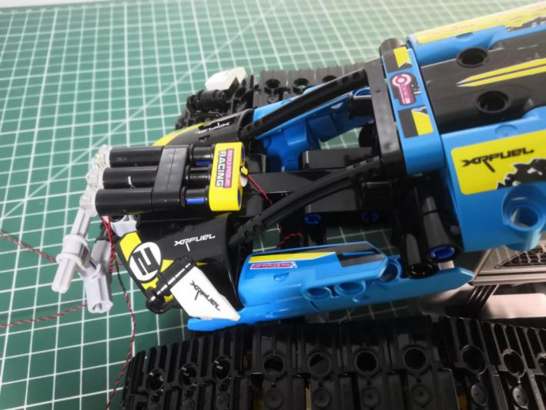

Turn to the tail.

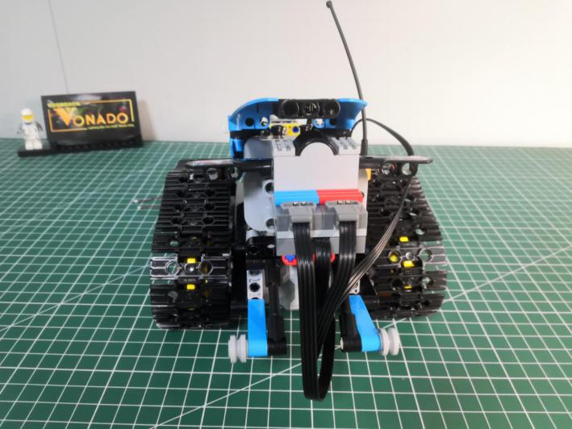

Take 2 red 15cm dot lights, 2 light gray half bolts

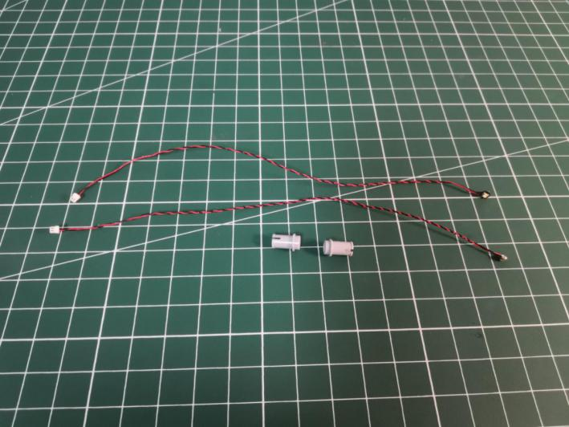

With lighting part facing up, thread the cable through the half bolt, and pull the cable out.

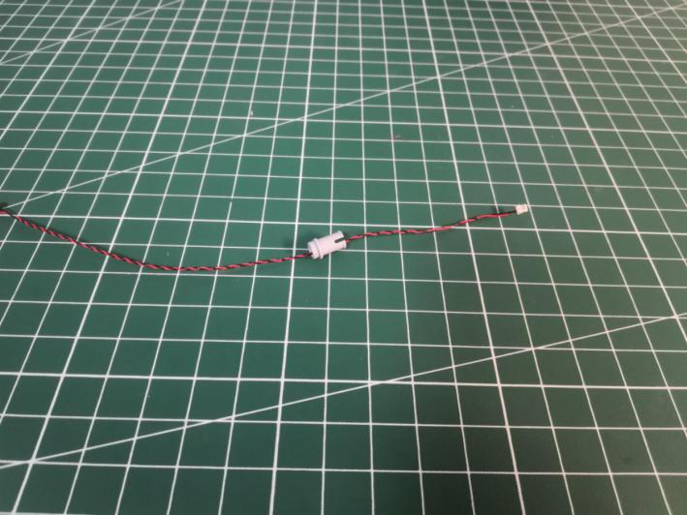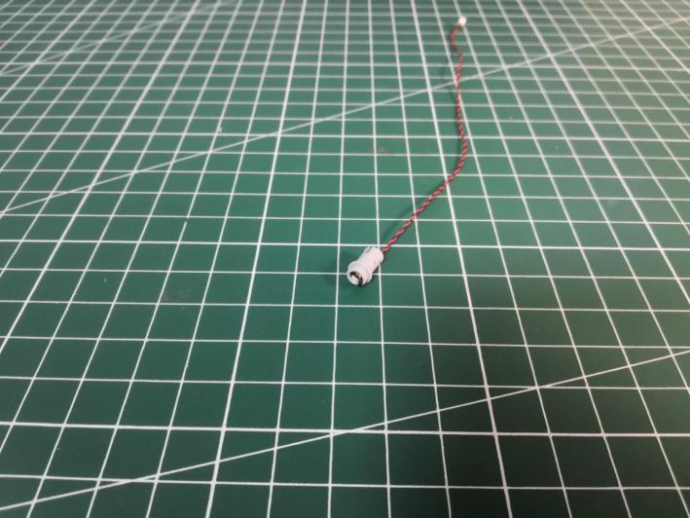

Install the other light in the same way.

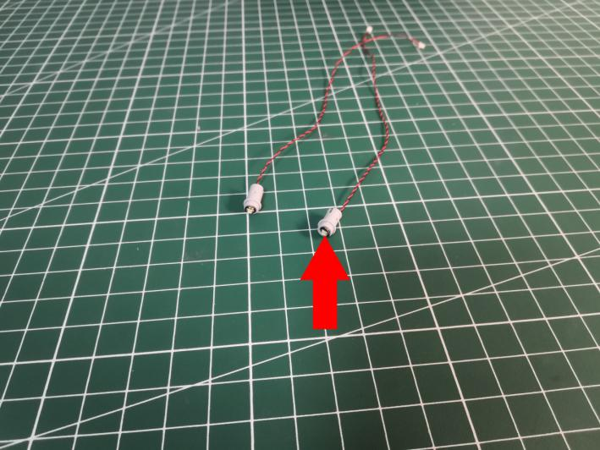

Turn to the left, thread the cable through the following hole, tighten the cable up to secure the light.

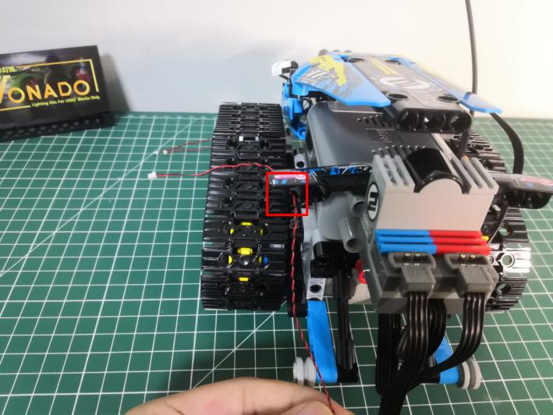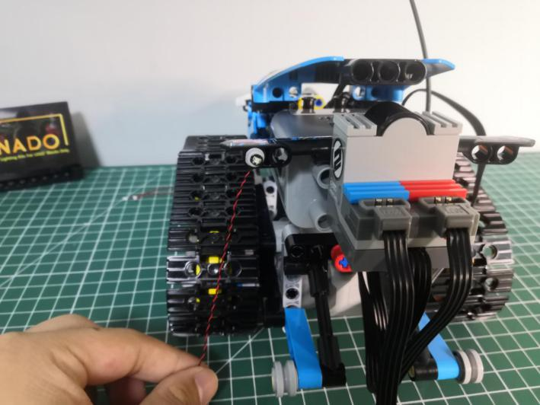

Install the light for the right side in the same way.

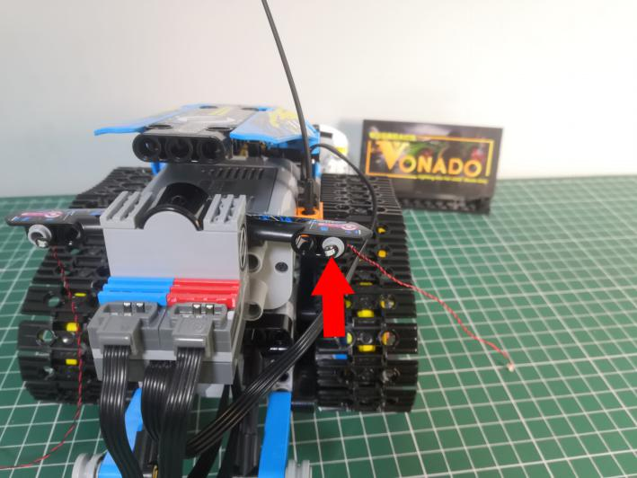

Turn to the side.

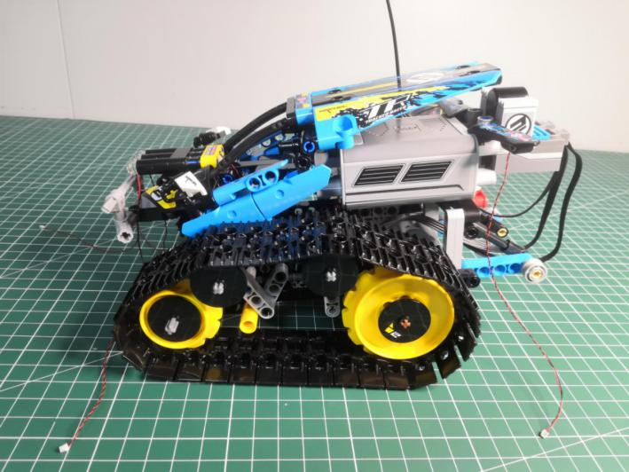

Take a blue 15cm dot light, an adhesive square.

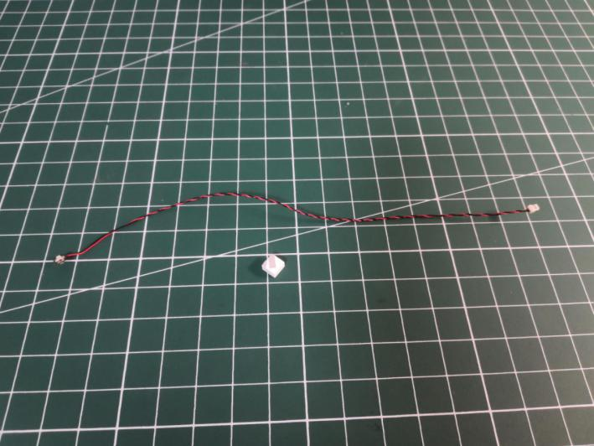

Stick the adhesive square to the back of the light.

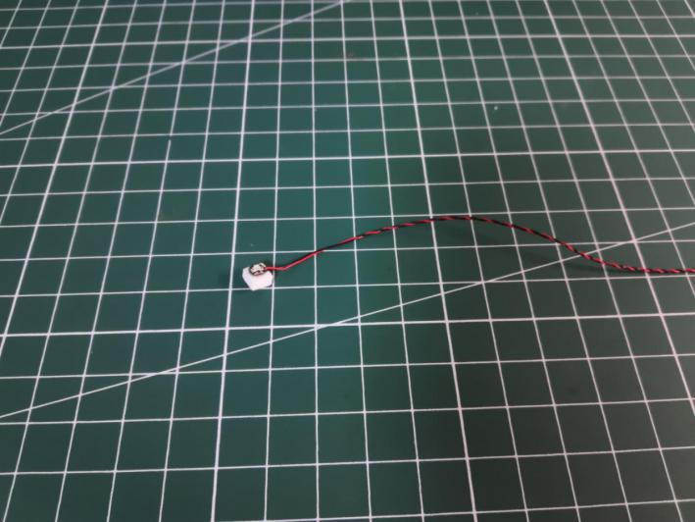

Tuck the cable underneath the tuck, and secure the light as per below.

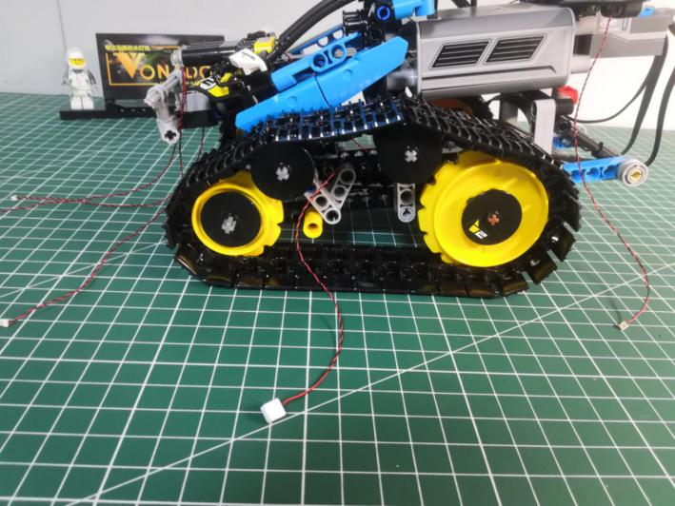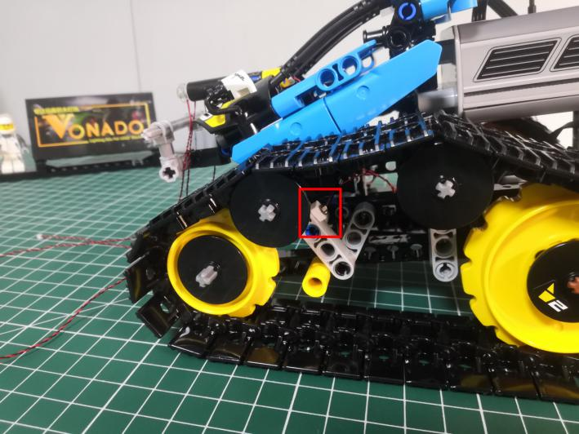

Turn to the other side.

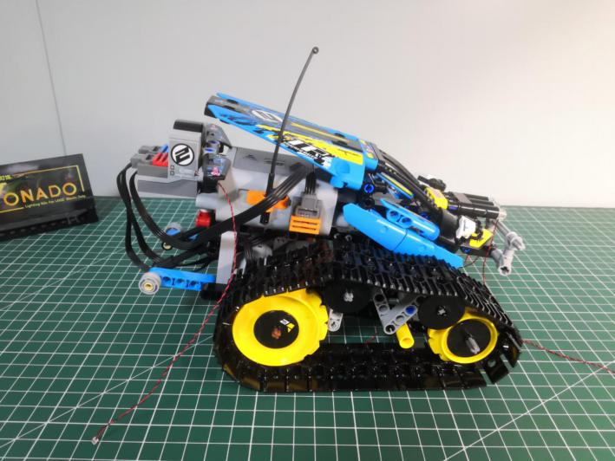

Take a blue 15cm dot light, an adhesive square.

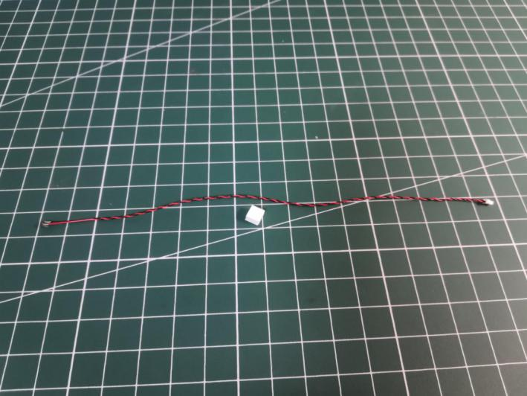

Stick the adhesive square to the back of the light.

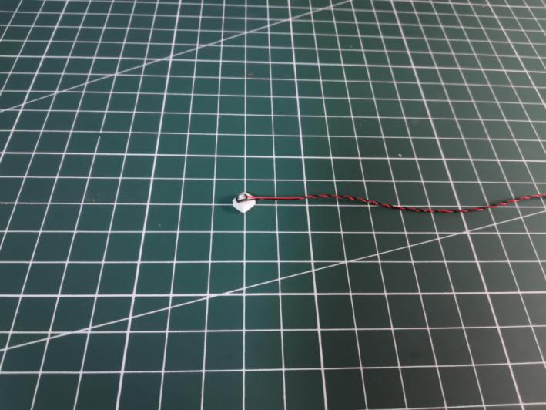

Tuck the cable underneath the tuck, and secure the light as per below.

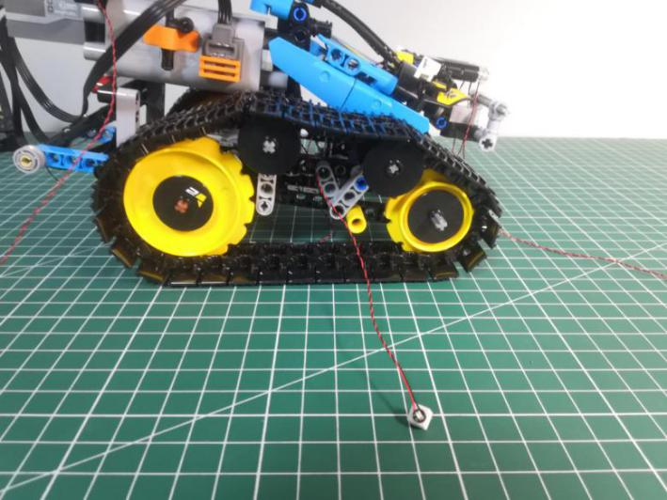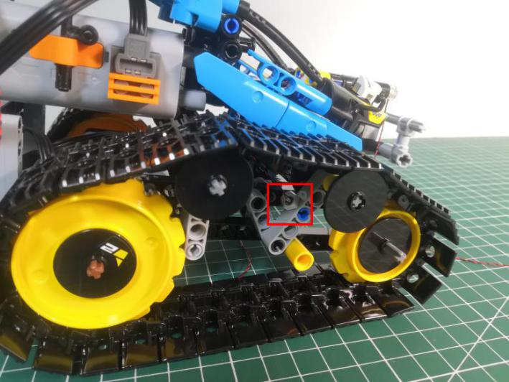

Open the roof as per below.

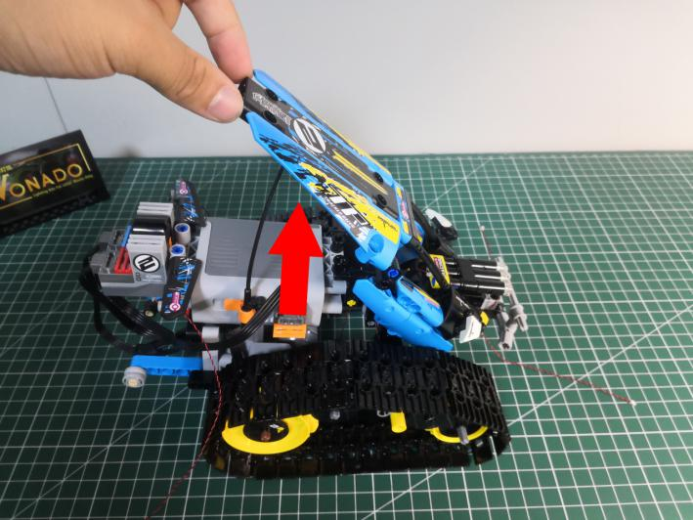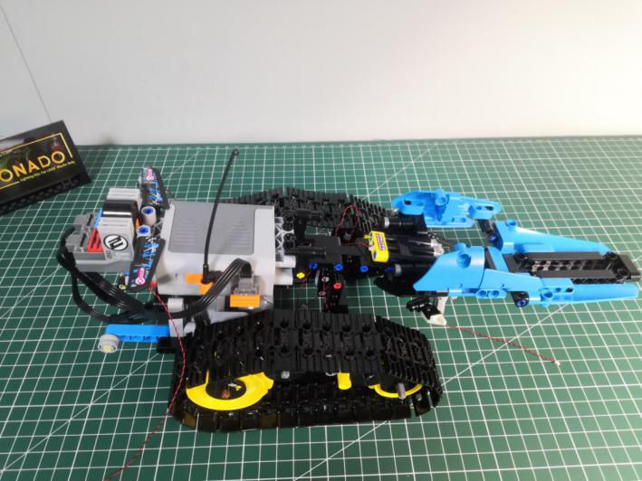

Pull the following red piece out.

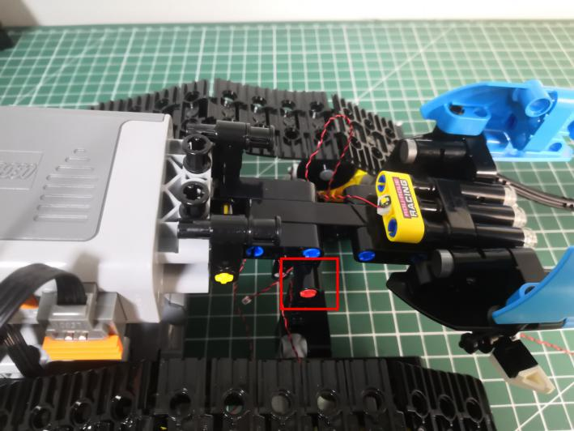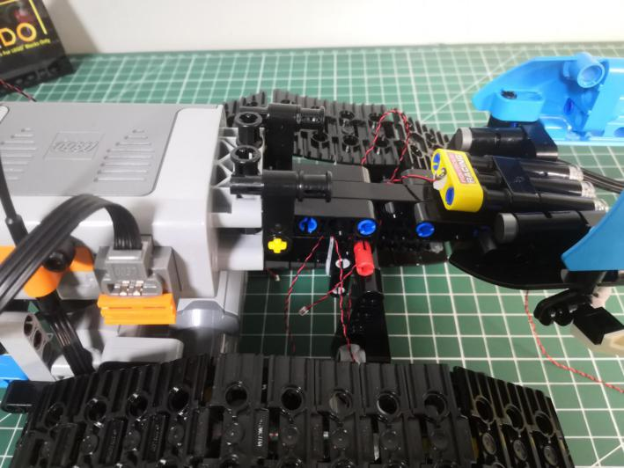

Remove the body.

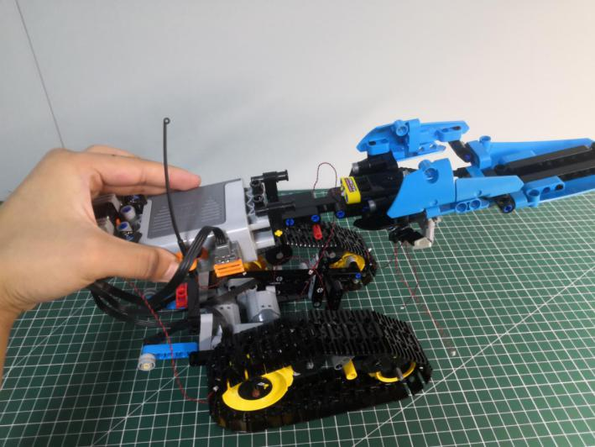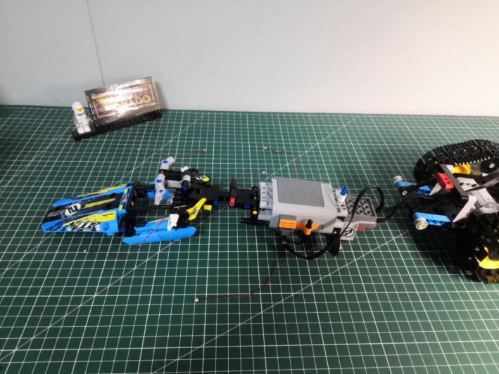

Take a 12-port Expansion Board.

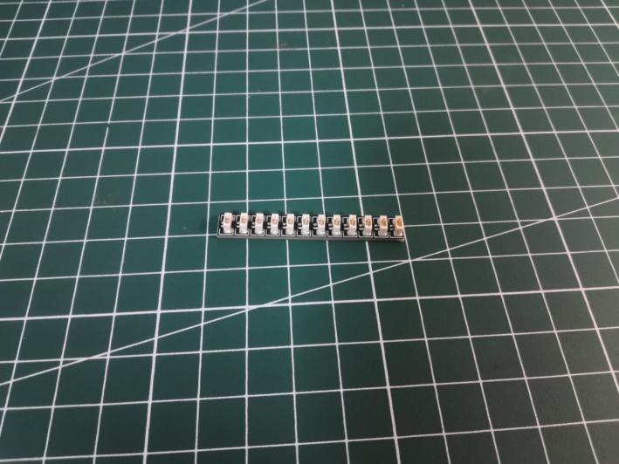

Take the following cable, thread it through the bottom as per below.

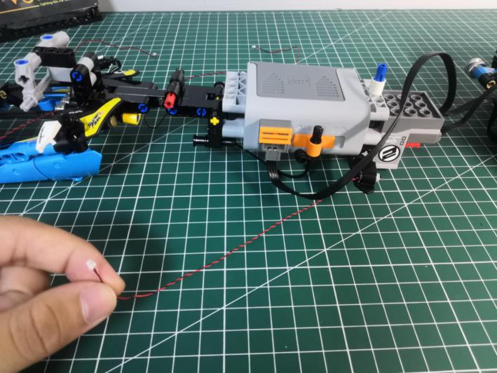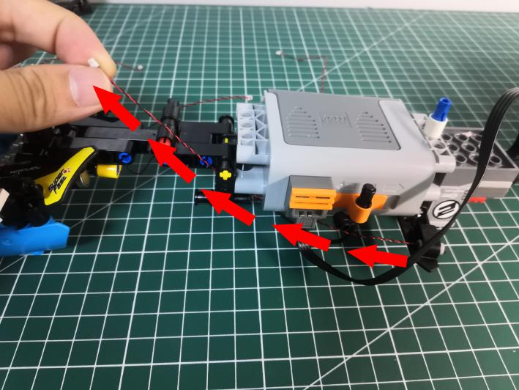

Wind the cable around the following black piece, and connect it to the expansion board.

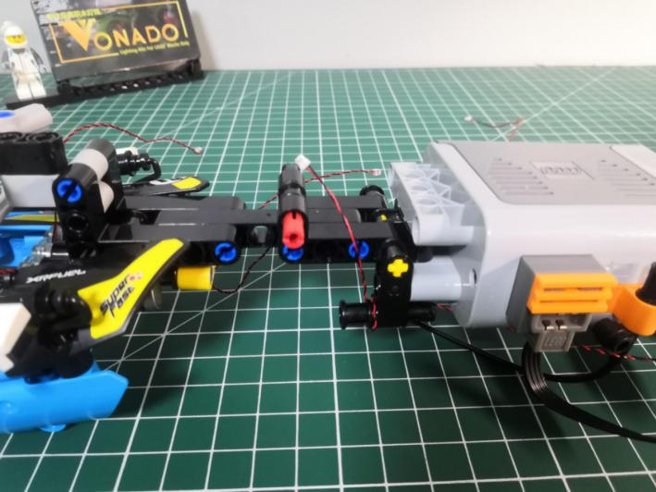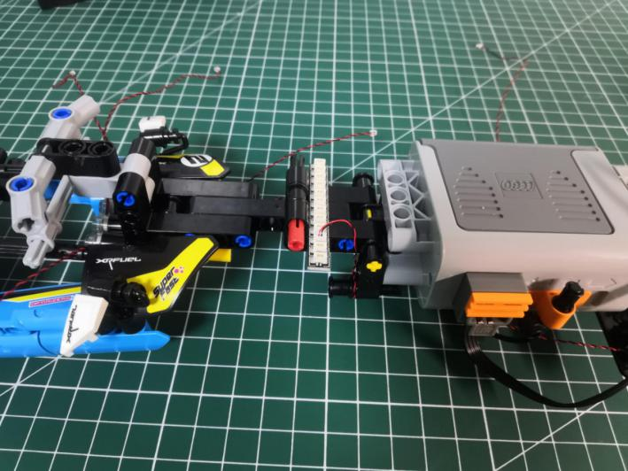

Place the cable at the other side in the same way.

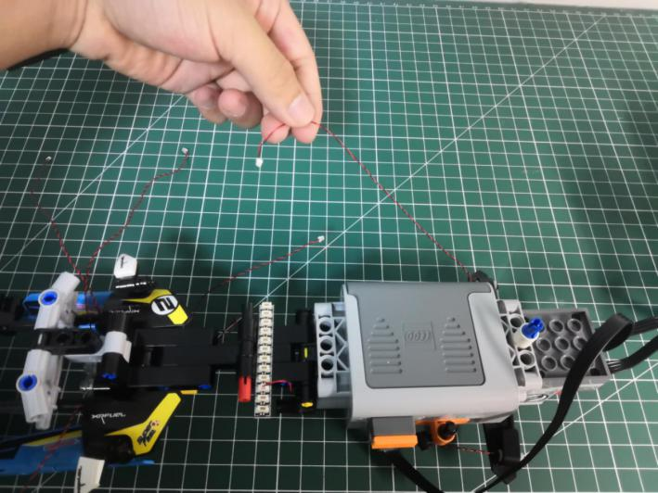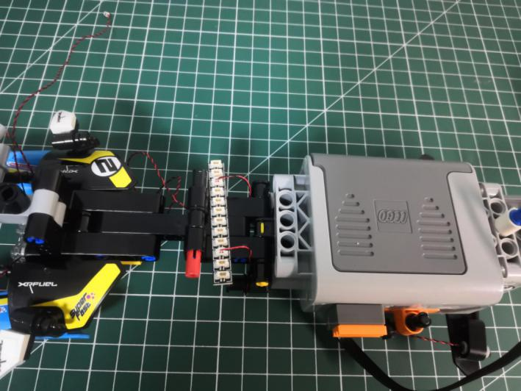

Take the following cable, wind it around the black piece several times before connecting it to the expansion board.

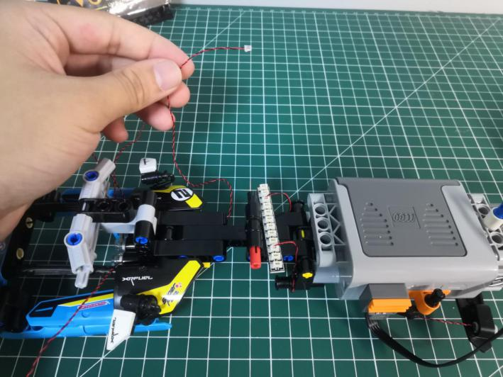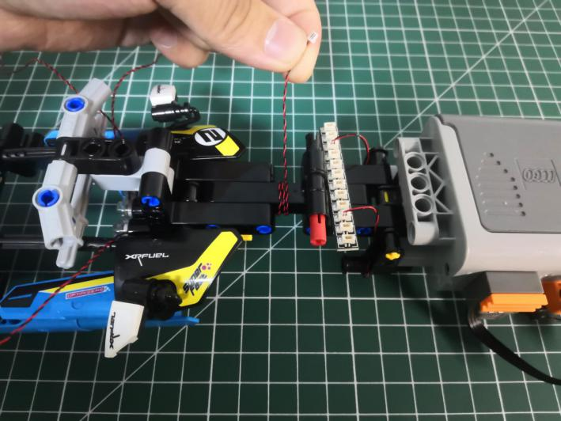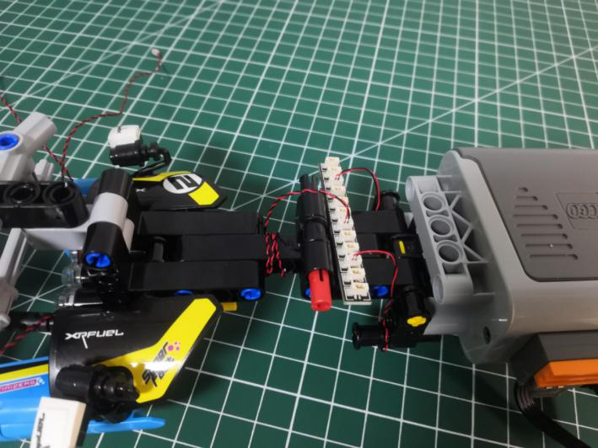

Take the following 3 cables from the head, thread them through the following space.

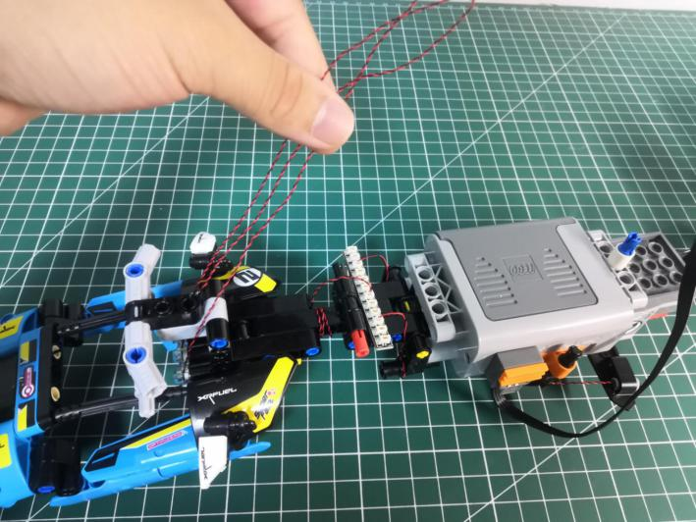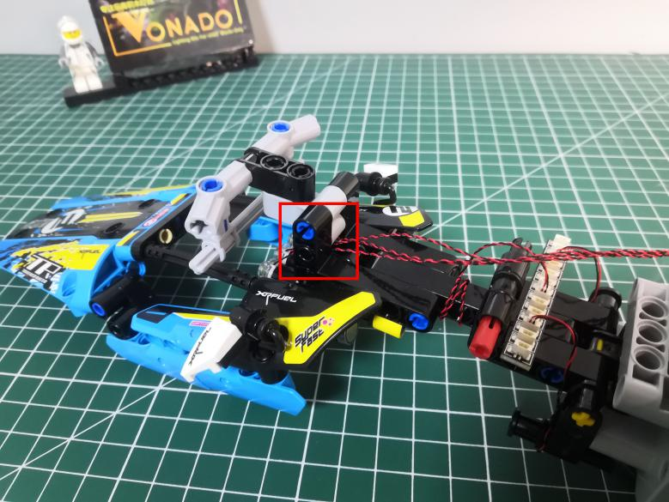

Wind them around the black piece several times before connecting them to the expansion board.

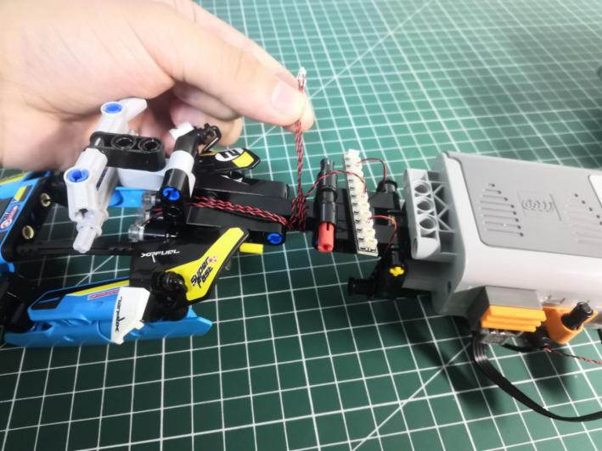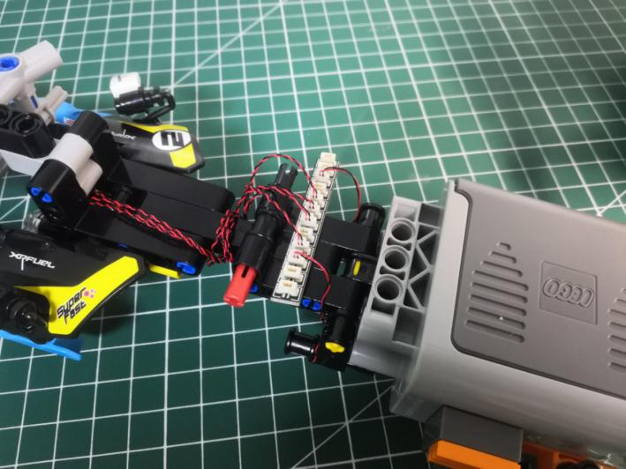

Take a Flat Coin Cell Battery Pack, 4 adhesive squares.

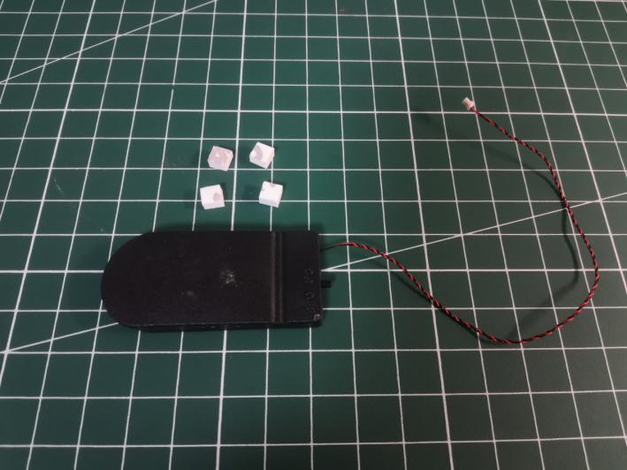

Connect the cable from the battery pack to the expansion board.

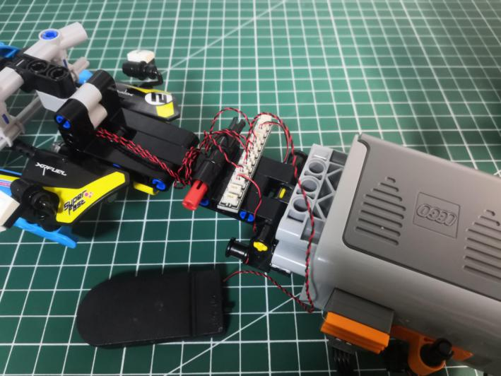

Stick the adhesive squares to the back of the battery pack, stick the battery pack to the following place.

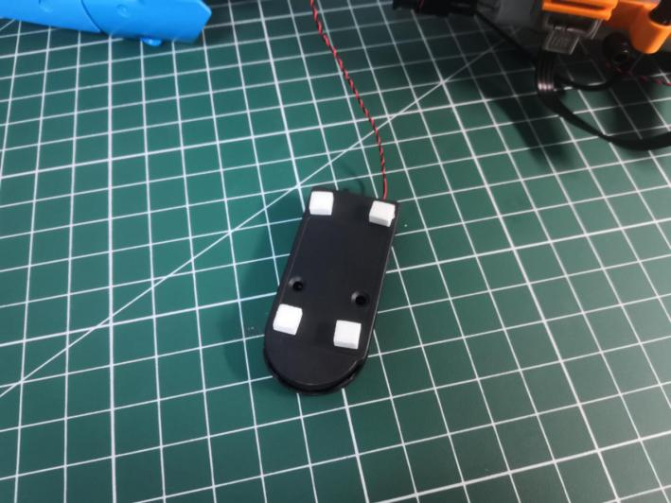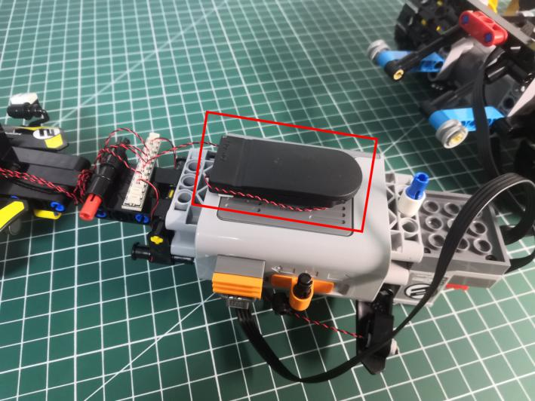

Take 2 adhesive squares.

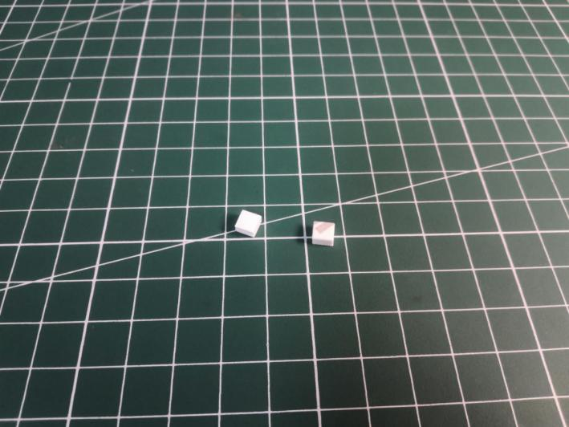

Stick the adhesive squares to the following place, and stick the expansion board to them.

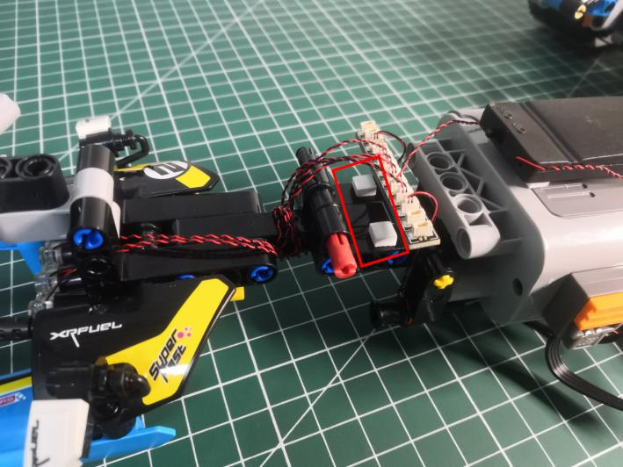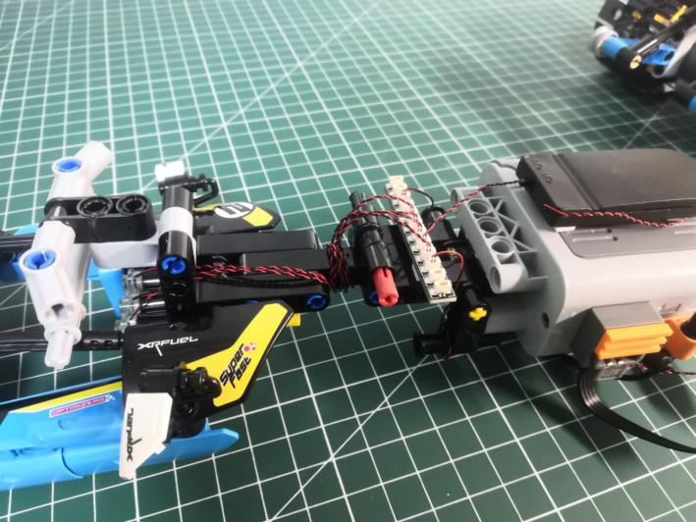

Take the following 2 cables, wind them around the black piece.

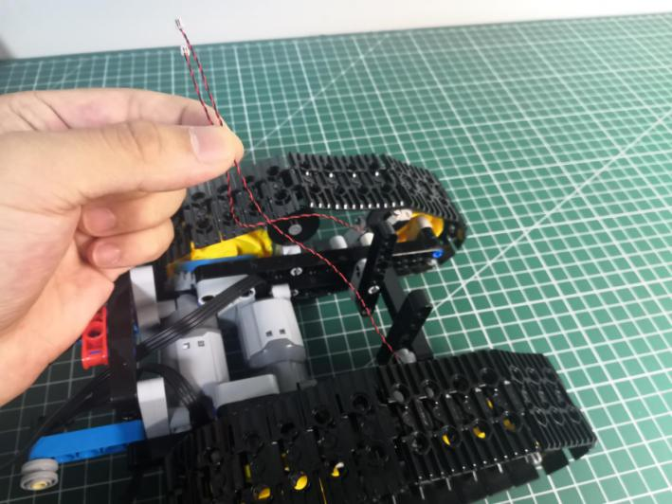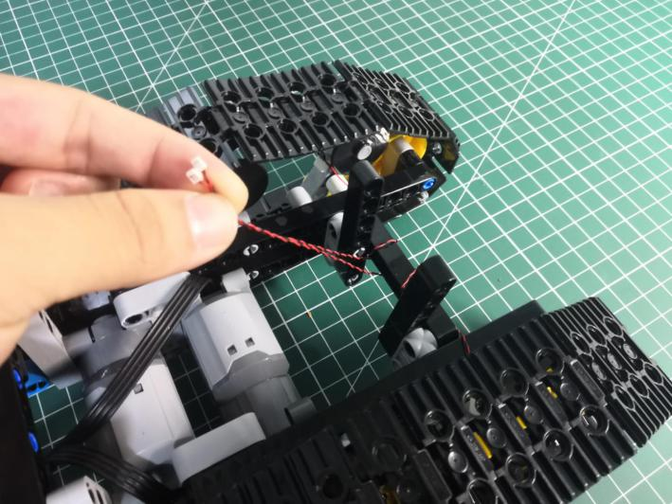

Lift the car and connect the 2 cables to the expansion board as per below.

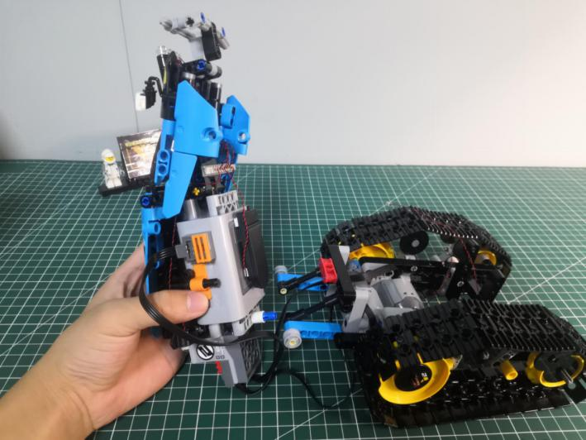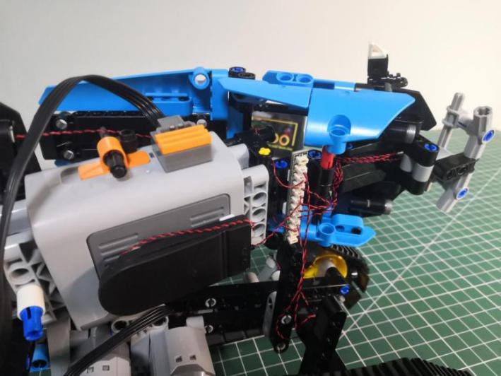

Reconnect the body, open the roof.

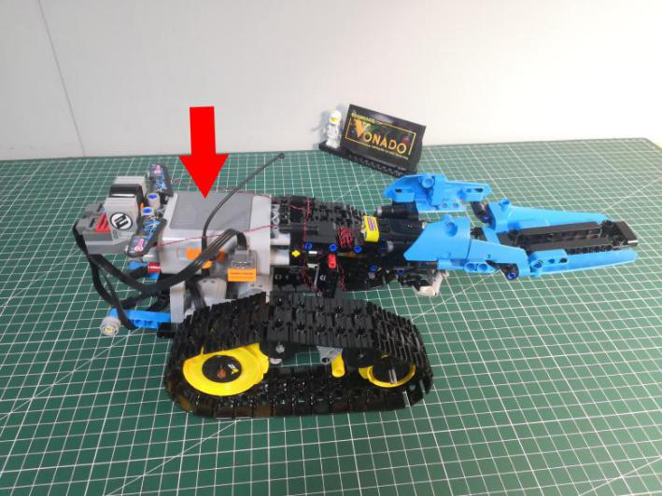

Reconnect the red piece and the roof.

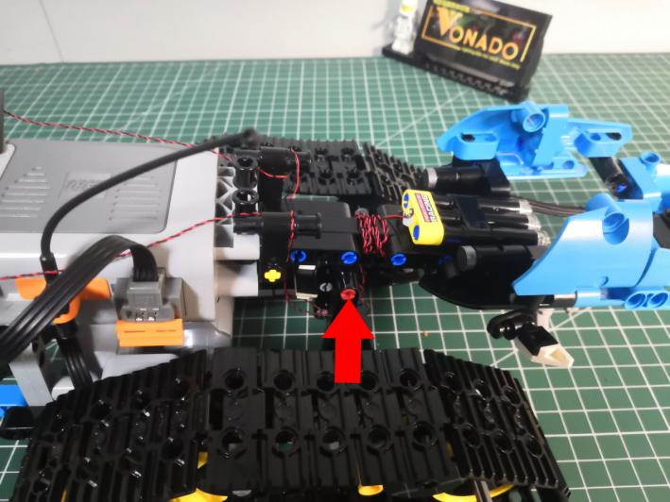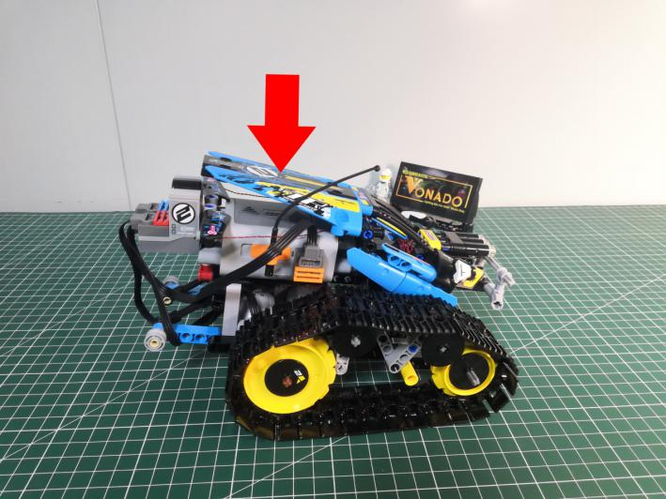

This completes installation of this LED Lighting Kit. ENJOY!



The above are ideas and instructions provided by our designers. Please move on:

1: Do you have any suggestions about the material and quality of our products?

2: Do you have any suggestions on the installation instructions and the degree of difficulty of the installation?

3: If you have better installation method and ideas, please contact us in time.