Lighting Kit LEGO 75980

Thank you for choosing our lighting products. We are committed to LEGO product study and lighting development, we're always trying our best to provide LEGO fans with the best products and the best installation ideas.
Must be careful observation, imagination can be infinite.
We provide basic parts to support your imagination.
DO IT YOURSELF .that's what LEGO is .

As always, Lego has been adhering to the DIY philosophy from product selection, research and development to sales. Consumers buy the parts, you will assemble them by yourself, and you can experience every step from picking up the first piece to installing the last one. Besides, LEGO has different answers for the installation form and method of each part. Vonado lighting also does not want to kill your unlimited creativity, we will try our best to make products with high variability, high playability and unlimited play. If you have any dissatisfaction or your own ideas on the parts such as the color of the lights, the length of the cables, the installation position of the product, and the final effects of each module, you can make your own arrangement, and we will cooperate with you to replace or repurchase.
LETS MOVE!

Package contents：
- 1 x 30cm Flashing Warm White Dot Light
- 2 x 15cm White Dot Lights
- 4 x 15cm Warm White Dot Lights
- 1 x 15cm Pink Dot Light
- 2 x 15cm Red Dot Lights
- 1 x 30cm Head Light
- 5 x 15cm White Strip Lights（with 7 lights）
- 1 x 6-port Expansion Boards
- 5 x 4-port Expansion Boards
- 3 x 30cm Connecting Cables
- 2 x 15cm Connecting Cable
- 1 x 5cm Connecting Cable
- 1 x USB Cable
- 1 x Remote Control Switch Board
Extra pieces
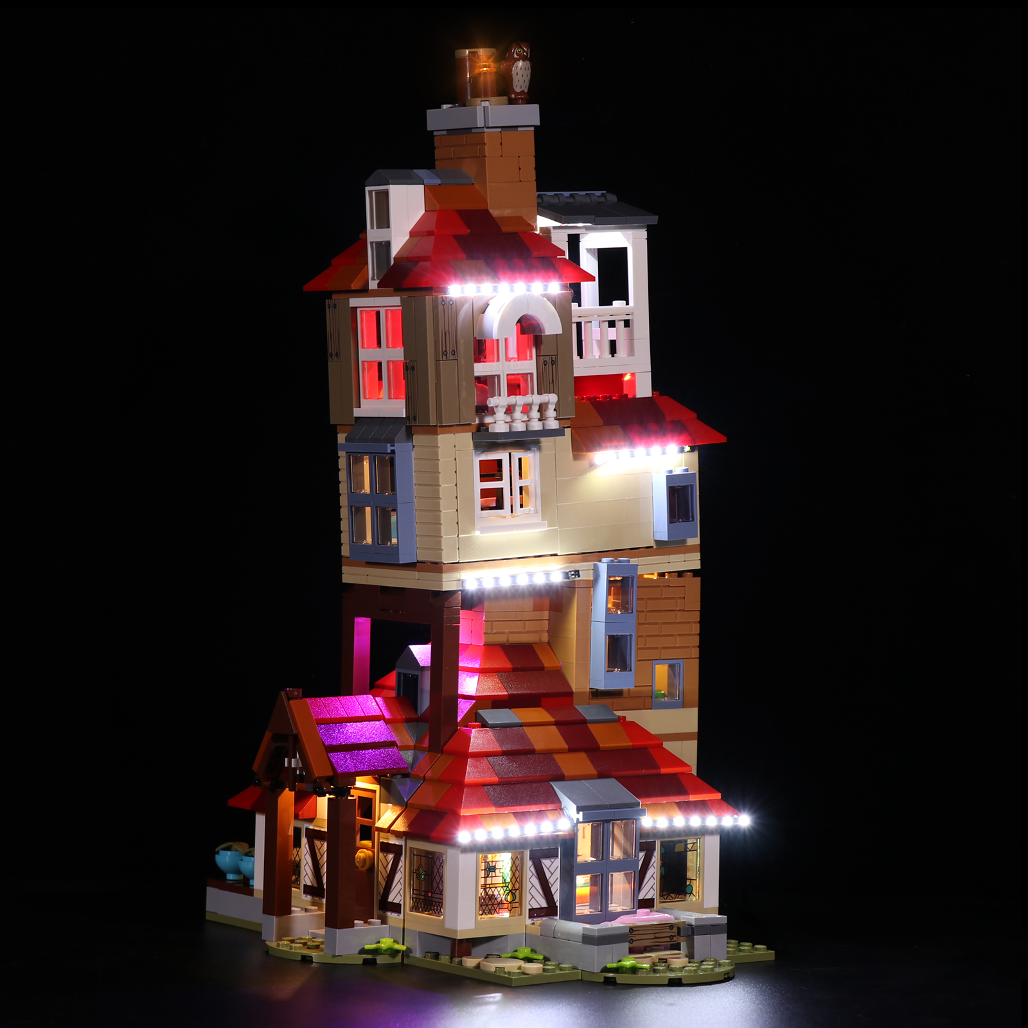
Note:
Place wires on the surface or under the building blocks.
The wire can be place between the building blocks or under the block, but they should be placed between the studs correctly.

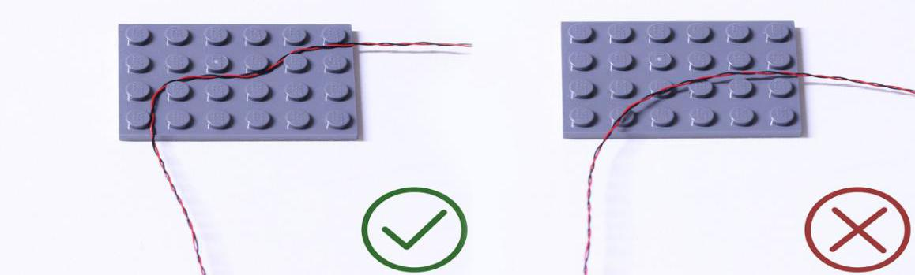

Insert the connectors to the ports.

Be careful when you are operating, there’s only one correct way to insert, make sure the expansion board is upward, find the soldered “=” sign on the left of the port. When you are inserting, the side which the wires can be seen should be faced to the “=” sign and if you feel hard to insert, please stop, and don’t force it, for that may result in bent pins inside the port or overheating of the expansion board.

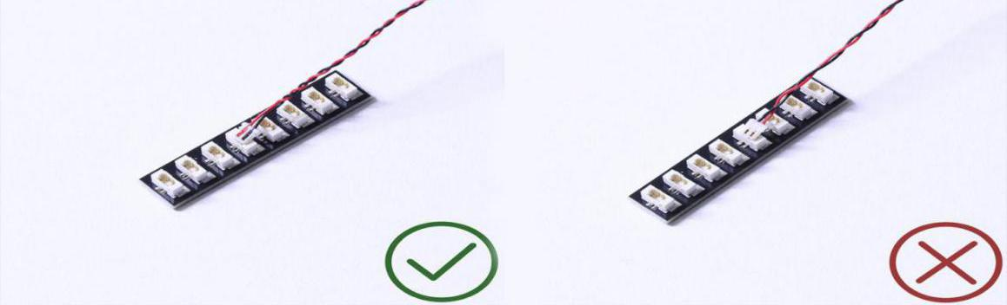

At this point, use the tweezers to straighten the bent pins.

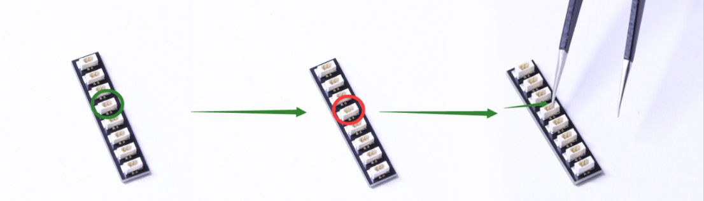

When installing dot lights, make sure they are correctly placed (Yellow LED package is exposed). You can put they either on the top of the studs or between studs.

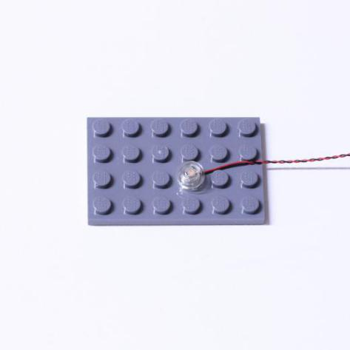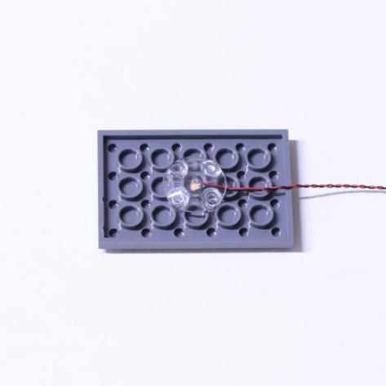

Connecting cable connectors to Strip Lights

Take extra care when inserting connectors to ports on the Strip Lights. Connectors can be inserted only one way. With the Strip Light facing up, ensure the side of the connector with the wires exposed is facing down. If a plug won’t fit easily into a port connector, don’t force it. Doing so will damage the plug and the connector.

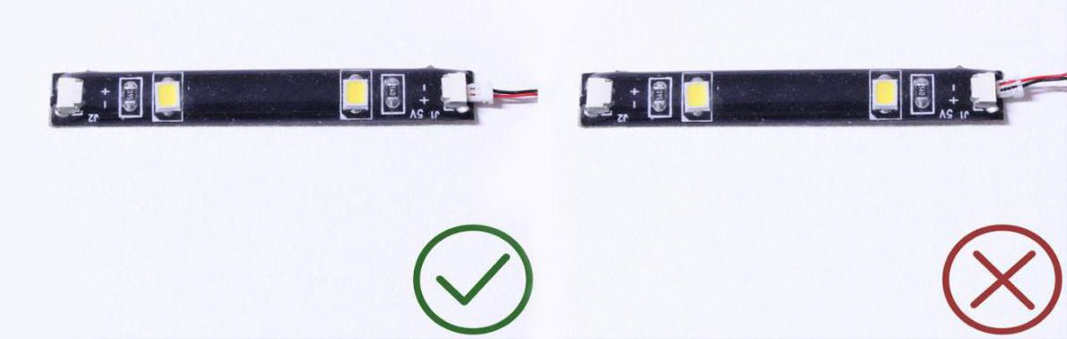

Finally, please pay attention to the positive and negative terminals of the battery when installing the battery case.

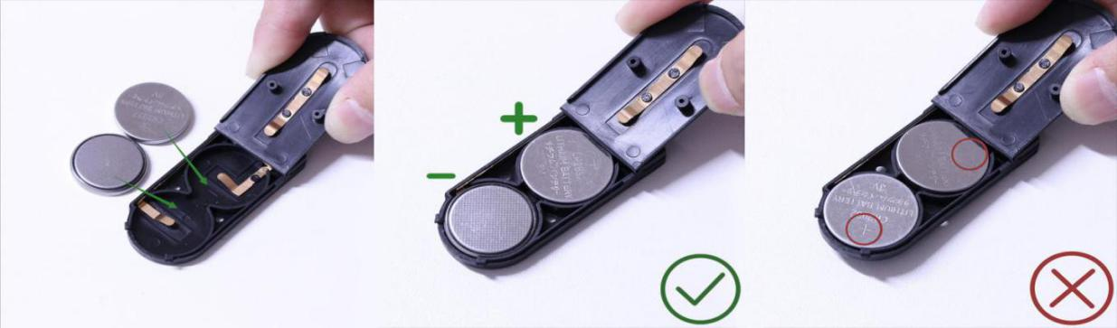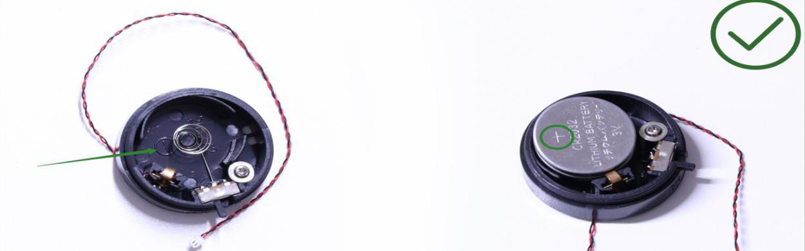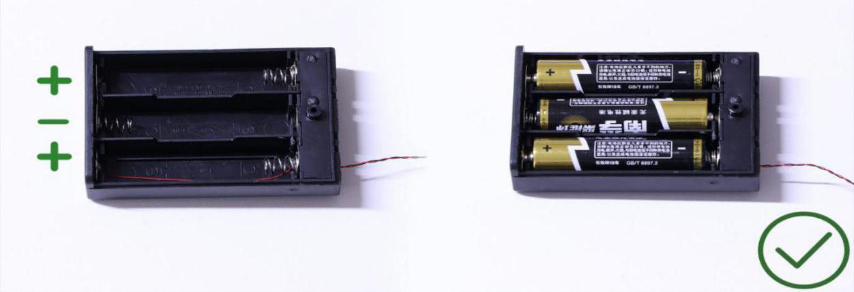
Instructions for installing this kit：
Attack on The Burrow Deluxe Remote Control Version Lighting Kit, 14 bags in total，13 bags with labels，1 bag without label，as per below:
Power supply： USB cable (self-contained power bank or mobile phone charger).
Firstly, take the power source (power bank or mobile phone charger), connect it to the USB cable, connect the other end of the USB cable to the expansion board to verify all the lights one by one.
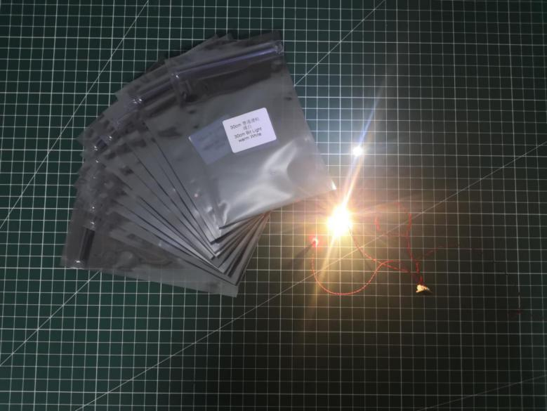

After the verification, disconnect the lights and put them back to the bags.
（note: put the lights back to the bags when verification of the lights from the same bag is done, then, continue to verify the lights in another bag.）
OK, Let’s Begin! （you can use the tweezer if necessary.）
（Tips: the tweezer is sharp, you should be careful when using it, do not hurt yourself or scratch the pieces; be gentle and do not wear the cables.）
Instructions for installing this kit：
Take the house firstly.
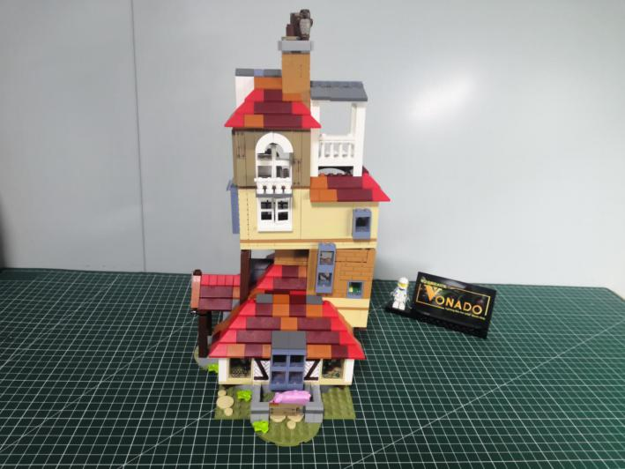

Turn to the back.
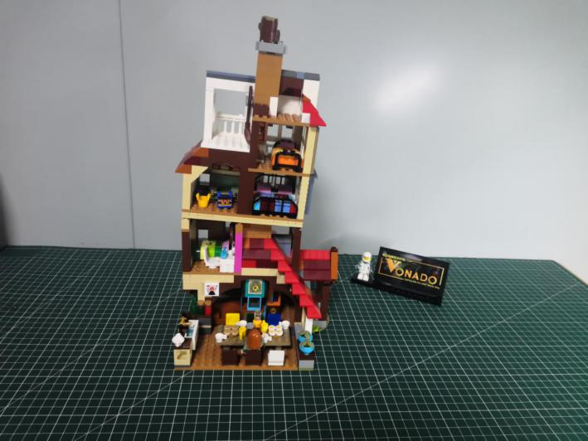

Turn to the following place, remove the following piece.
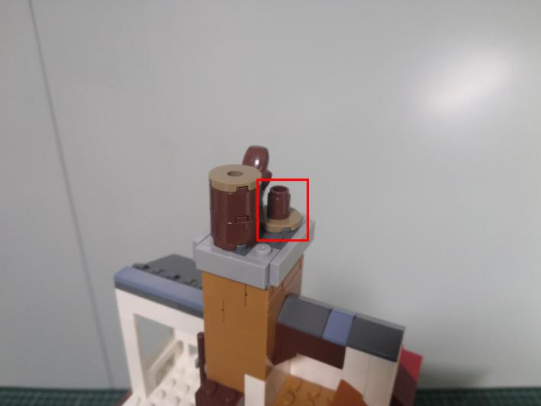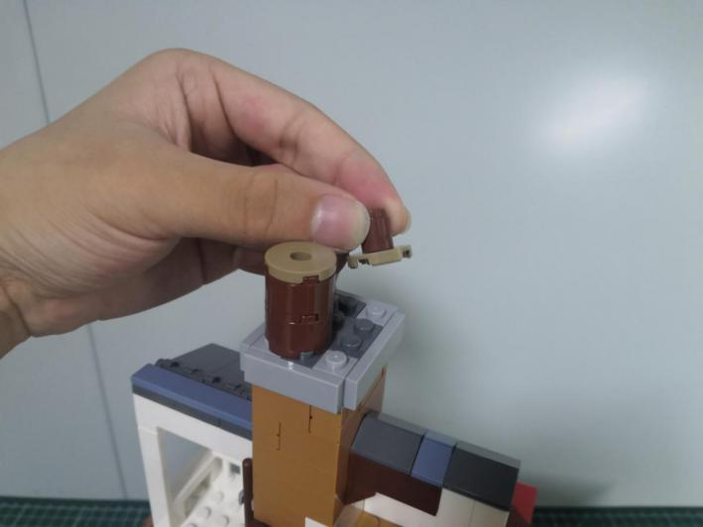

Take a flashing warm white 30cm dot light, a trans orange 1x1 round plate.
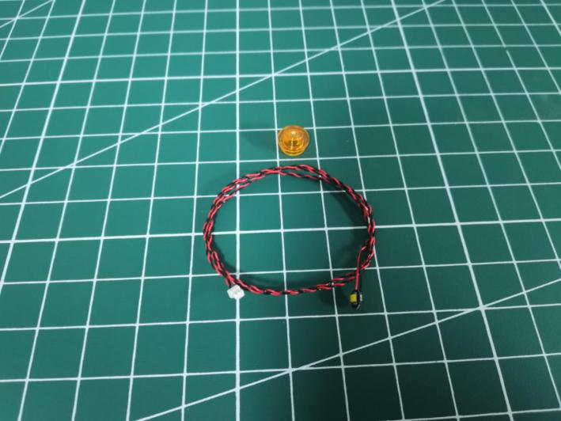

Take the piece we removed before, thread the cable through it as per below.
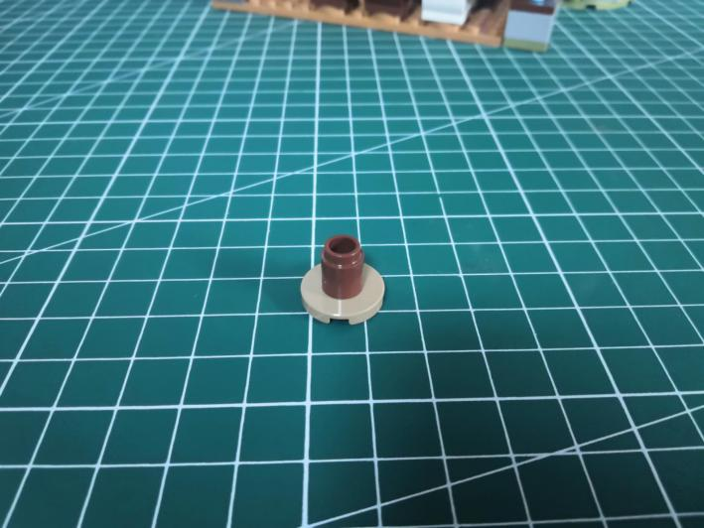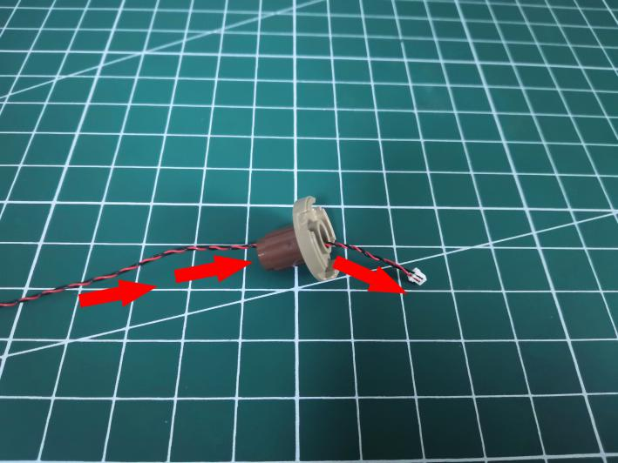

Tighten the cable up, connect the trans orange round plate over.
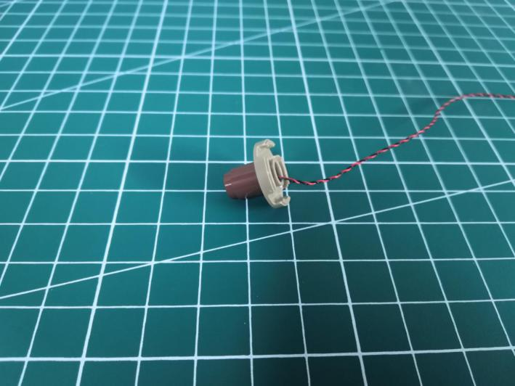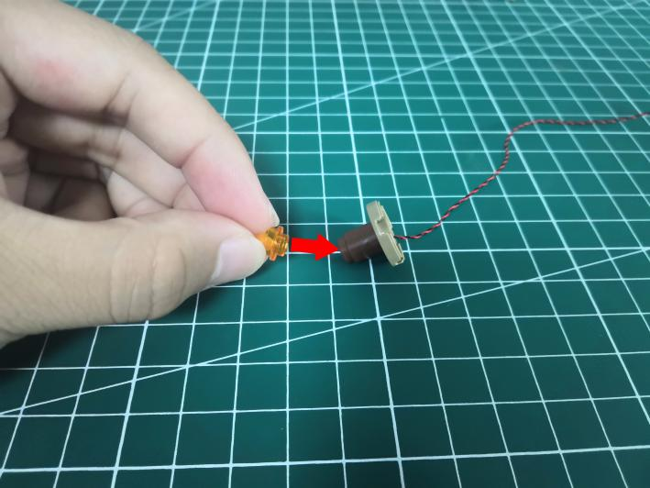

As per below.
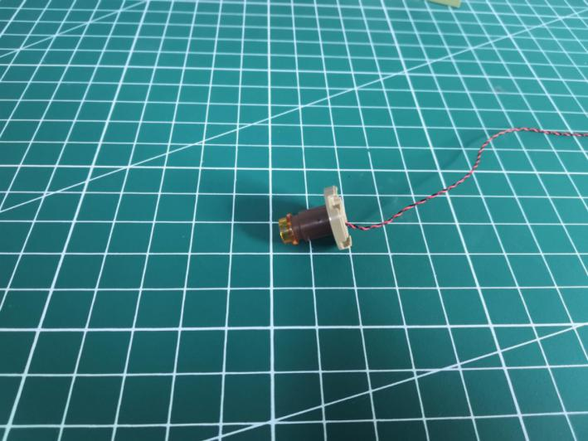

Reconnect the following piece.
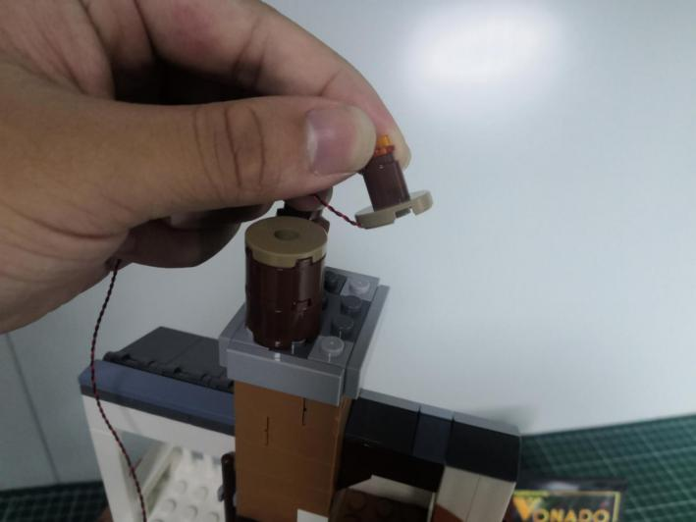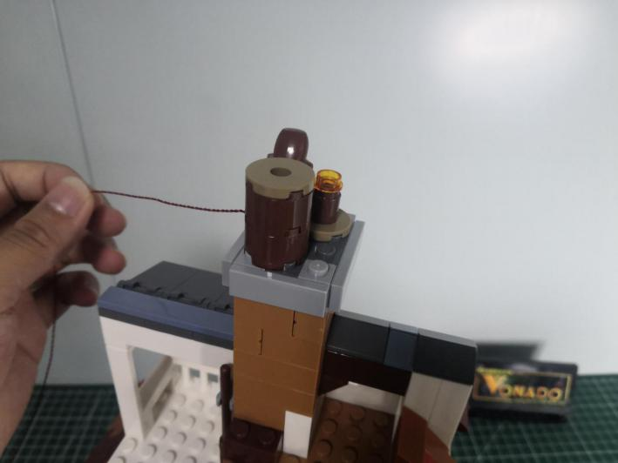

Turn to the following place, remove the gray plate.
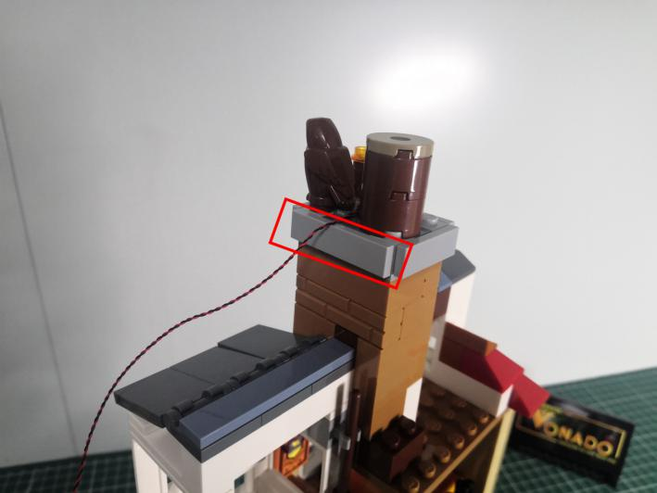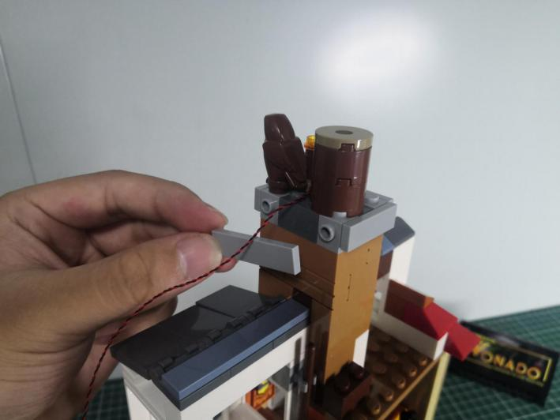

Place the cable as per below.
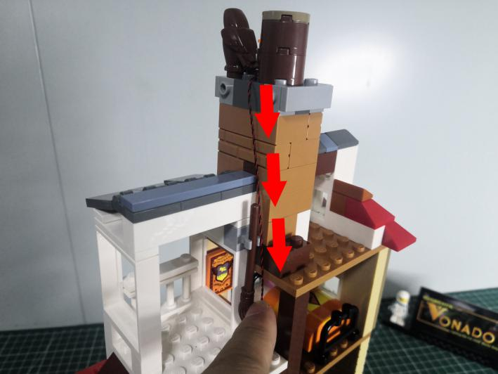

Reconnect the following gray plate.
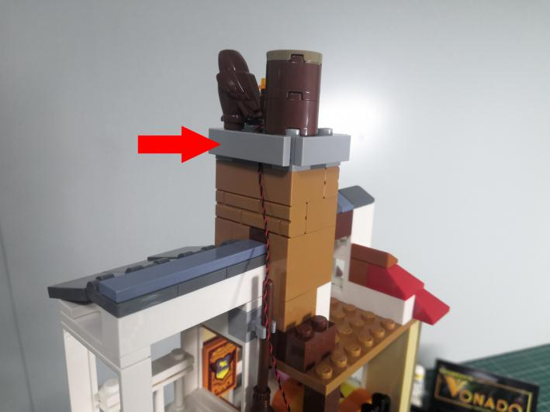

Take the cable and thread it through the right room as per below.
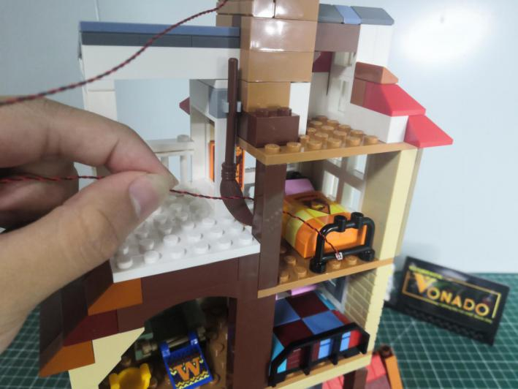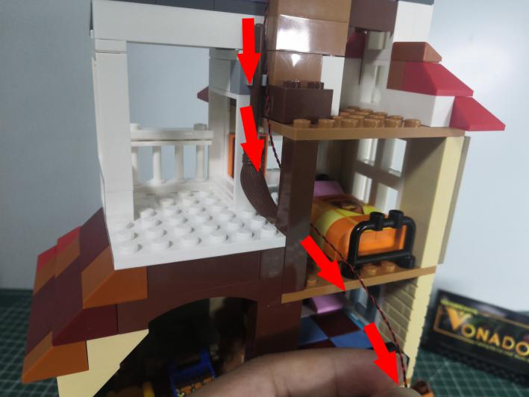

Continue to thread it through the room at the left lower.
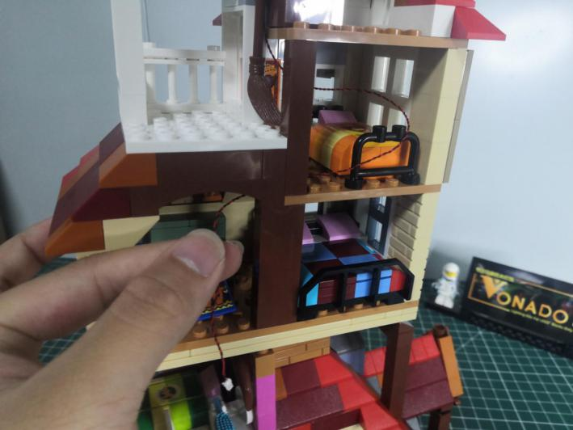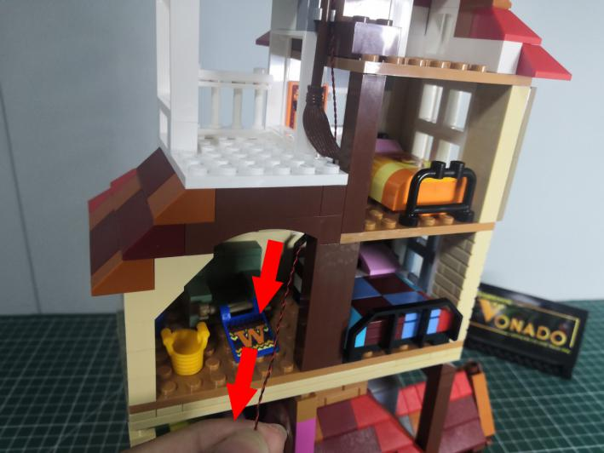

Take a white 15cm dot light, an adhesive square.
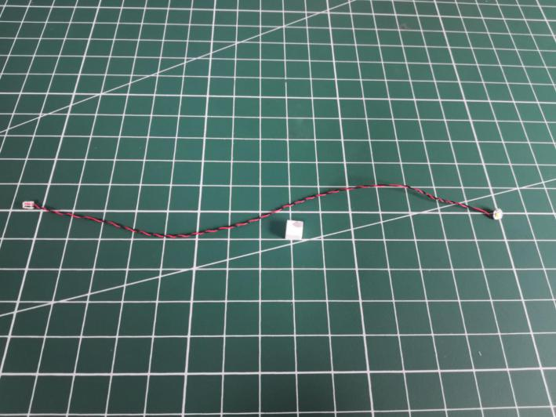

Stick the adhesive square to the back of the light.
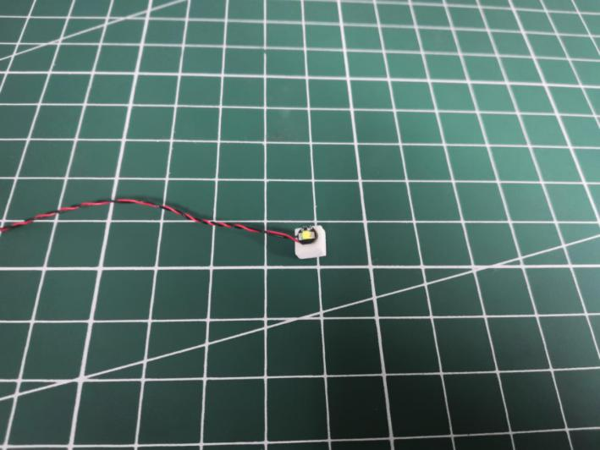

Turn to the white attic, stick the light to the following place.
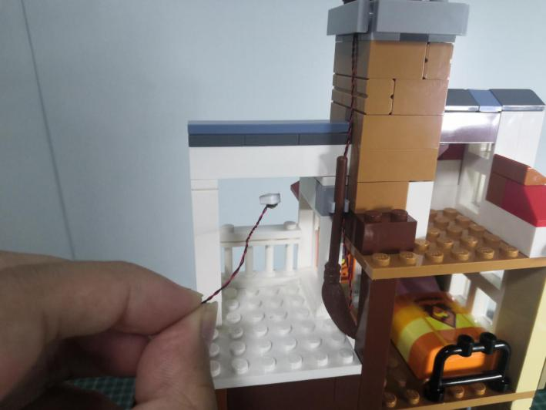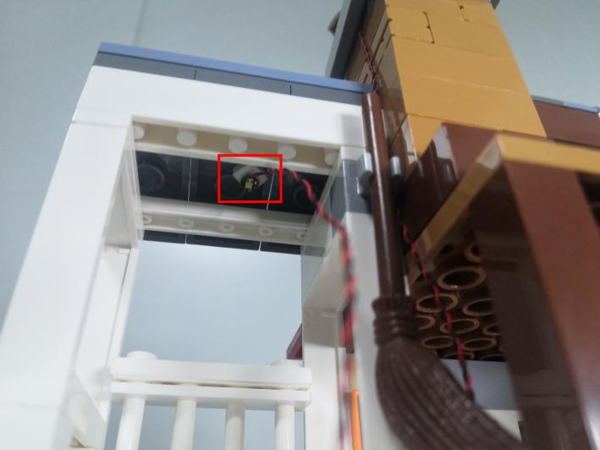

Turn to the following place， stuck the light as per below.
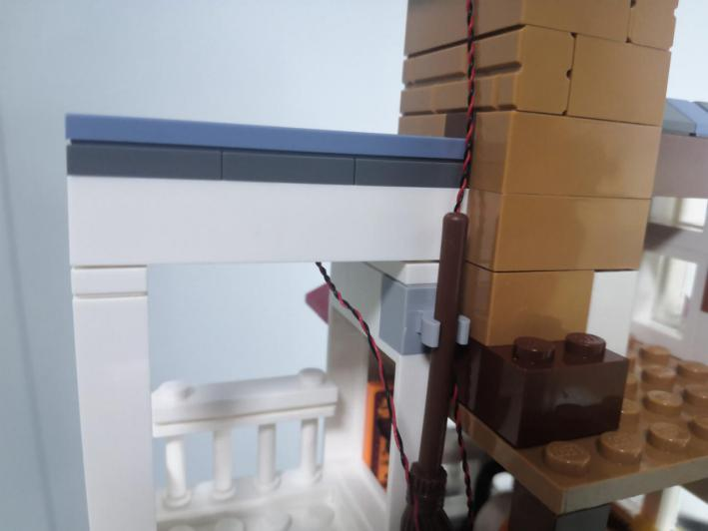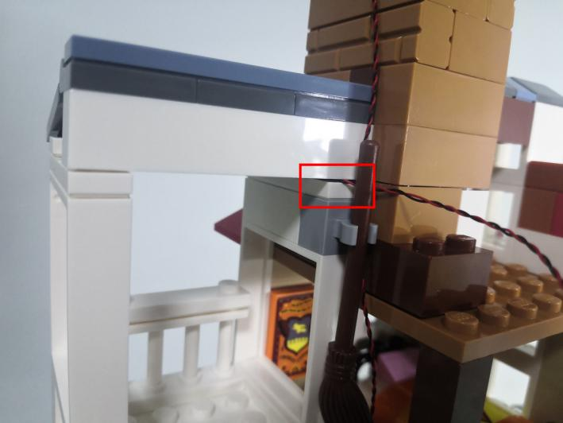

Take the cable and thread it through the right room as per below.
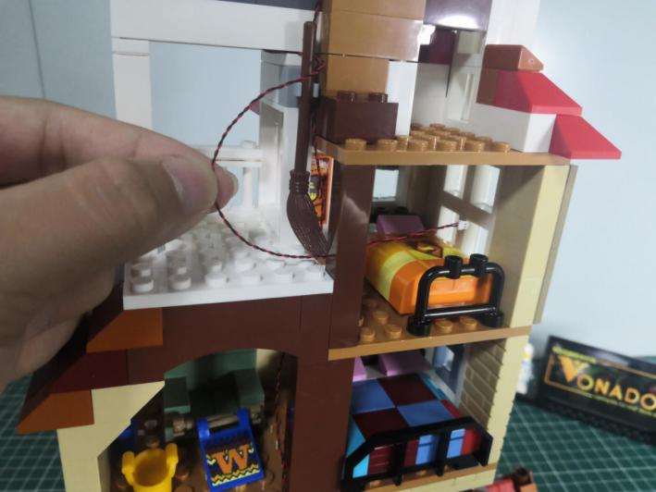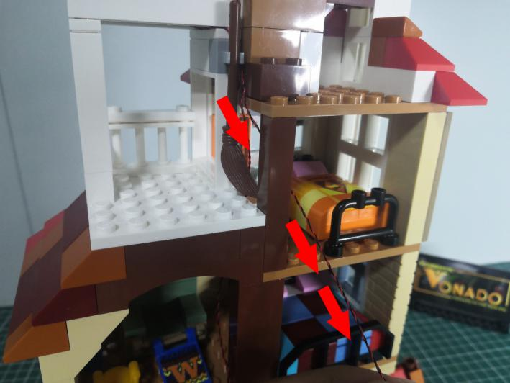

Continue to thread it through the room at the left lower as per below.
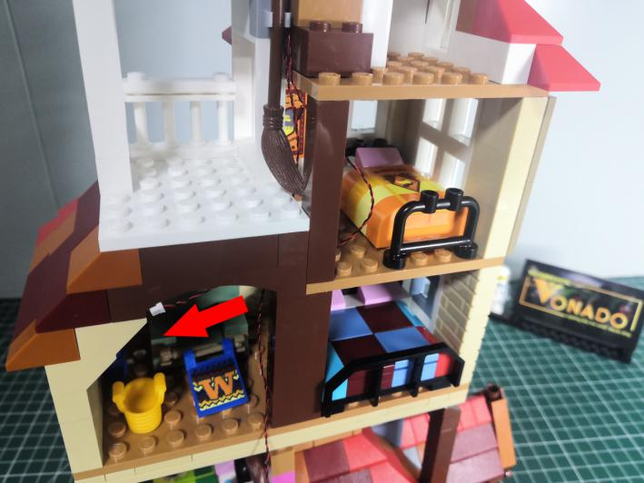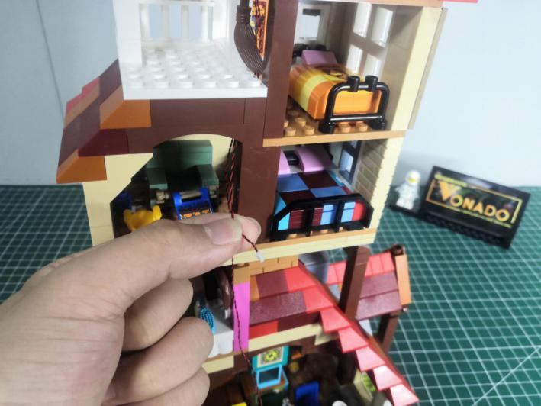

Take a red 15cm dot light, an adhesive square.
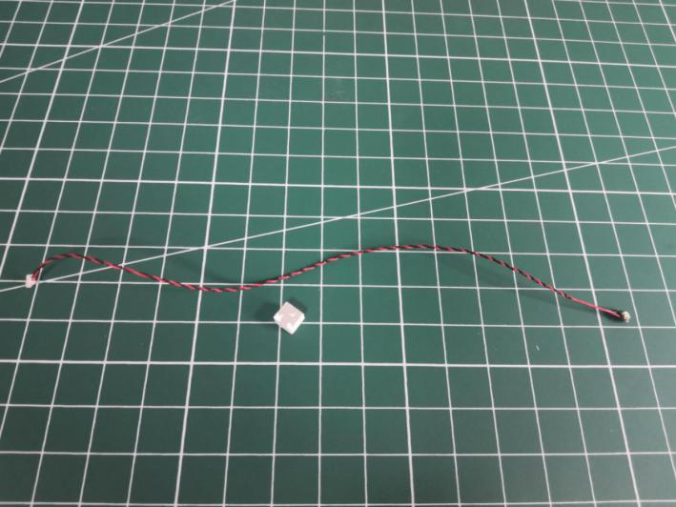

Stick the adhesive square to the back of the light.
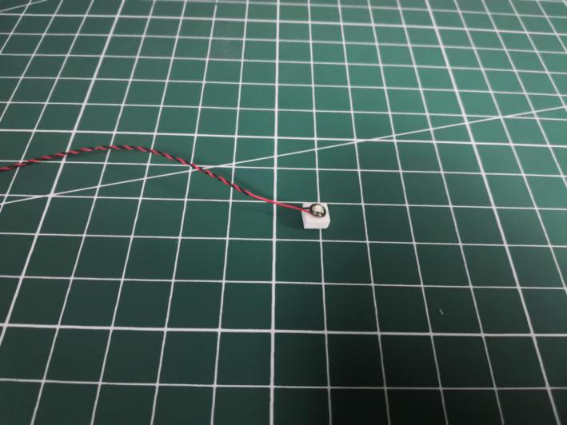

Turn to the room, stick the light to the following place.
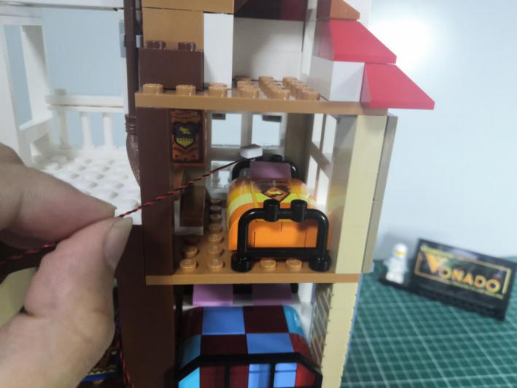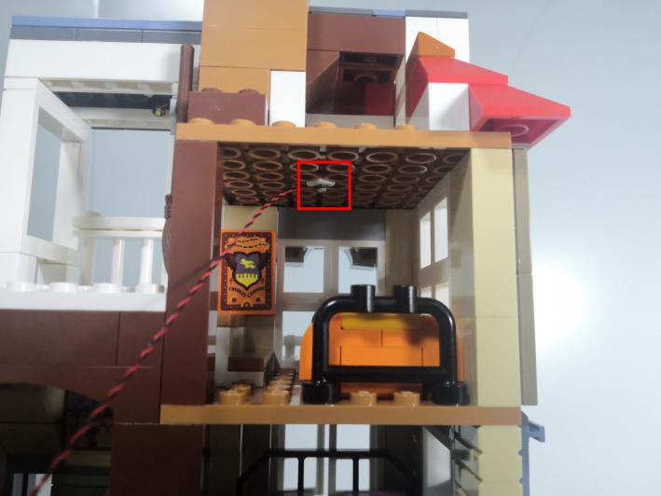

Create a gap at the following place, stuck the cable to the space as per below.
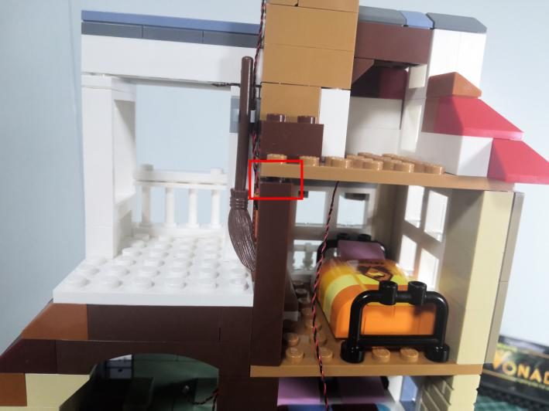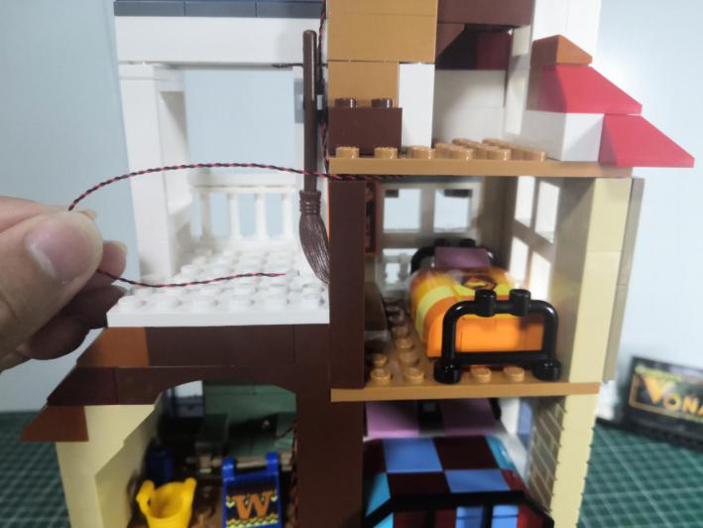

Thread the cable out, close the gap as per below.
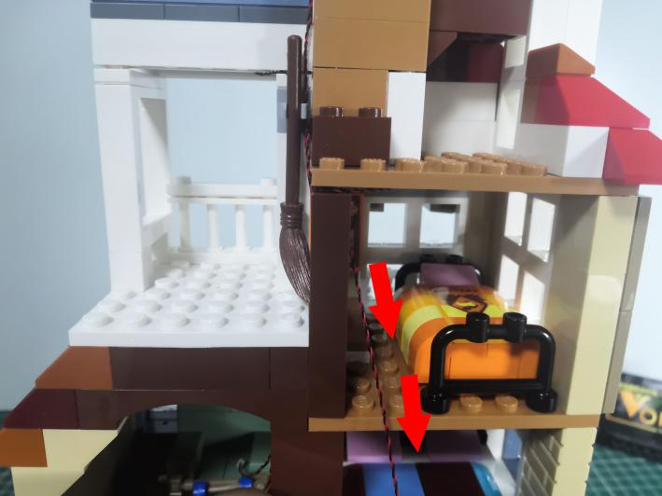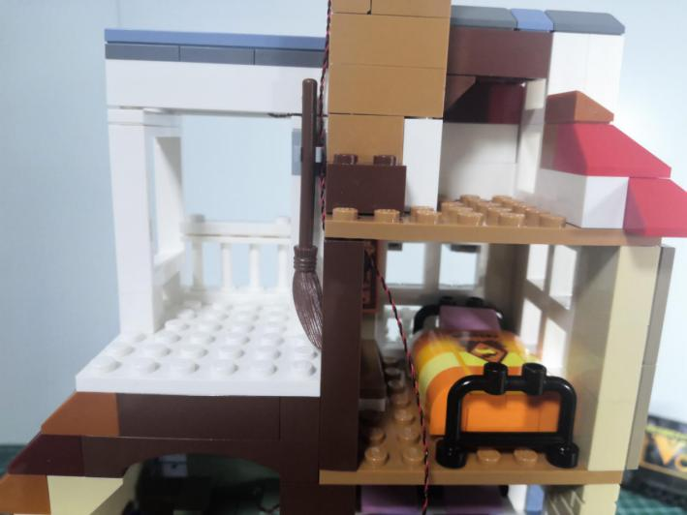

Take the cable and thread it through the room at the left lower as per below.
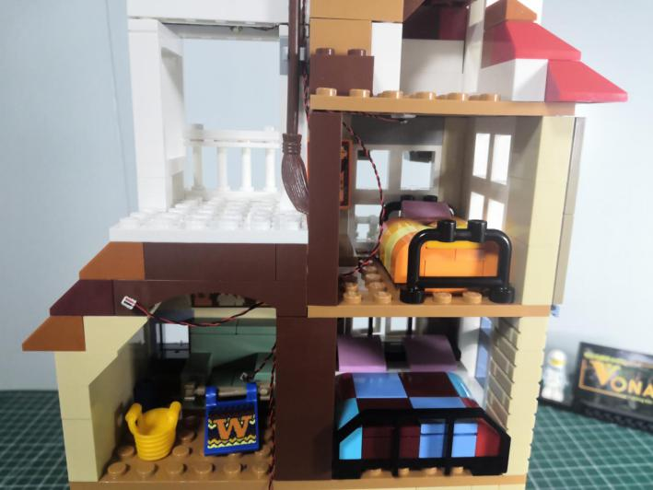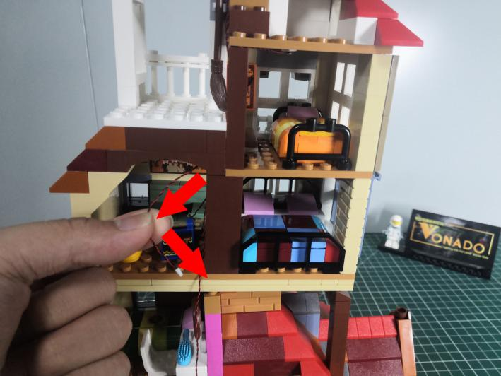

Take a red 15cm dot light, an adhesive square.
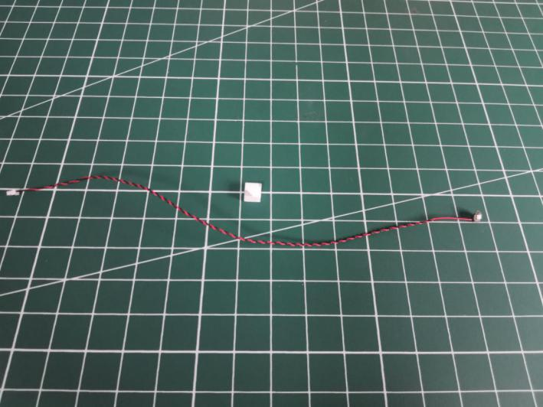

Stick the adhesive square to the back of the light.
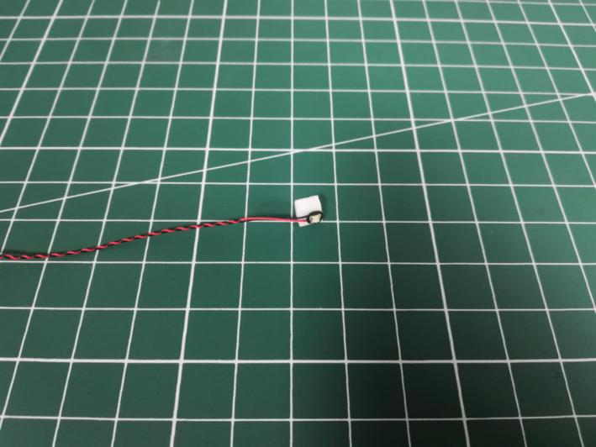

Turn to the room, stick the light to the following place.
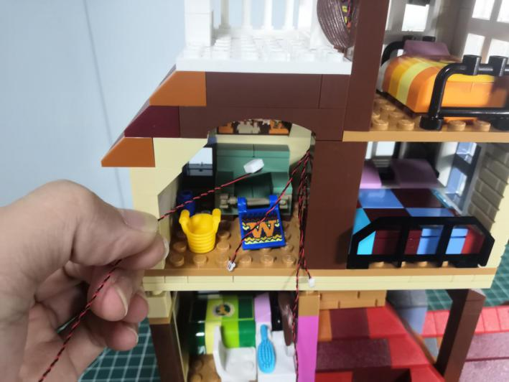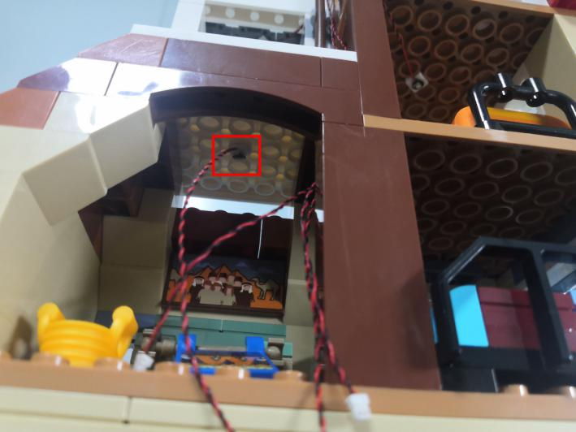

Take a warm white 15cm dot light, an adhesive square.
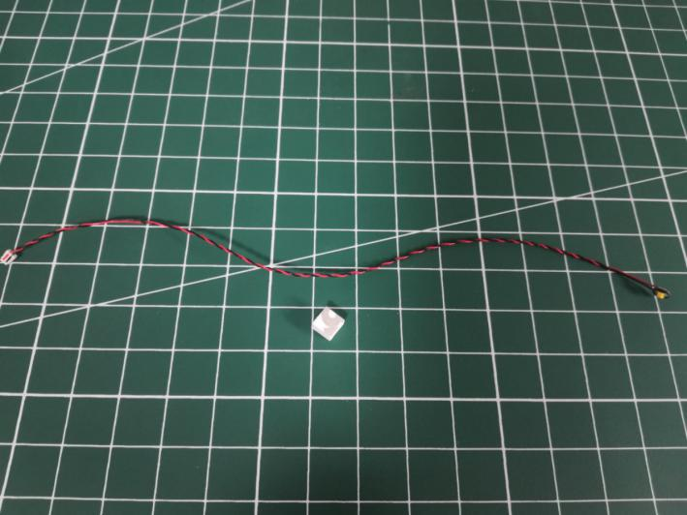

Stick the adhesive square to the back of the light.
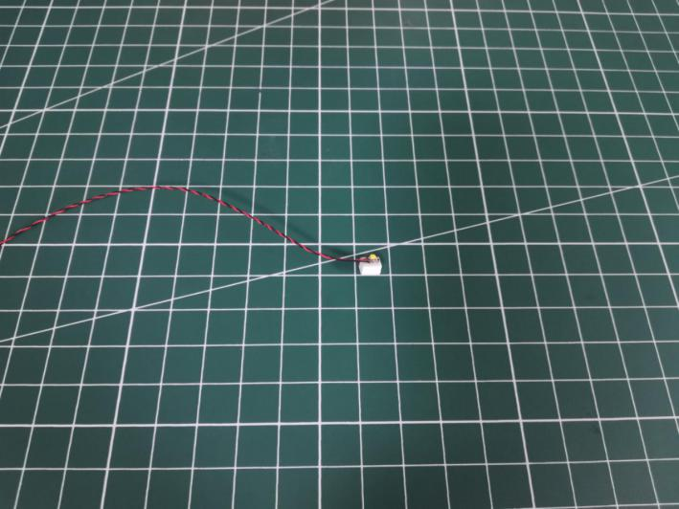

Turn to the room, stick the light to the following place.
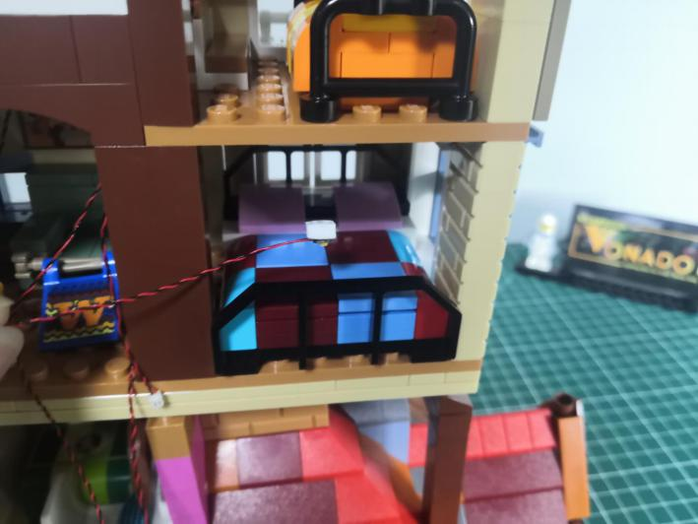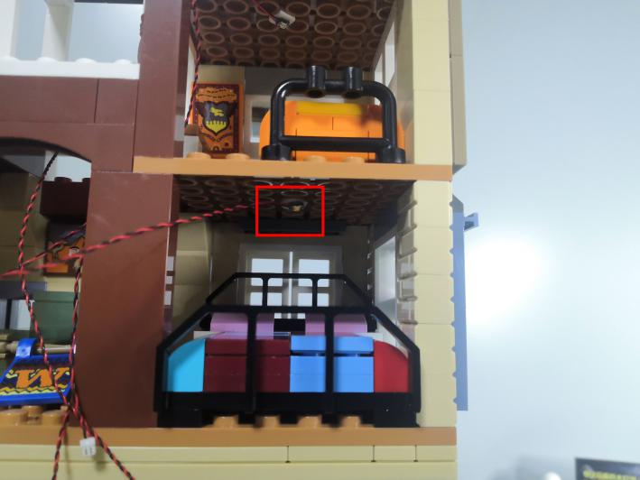

Thread the cable through the left room as per below.
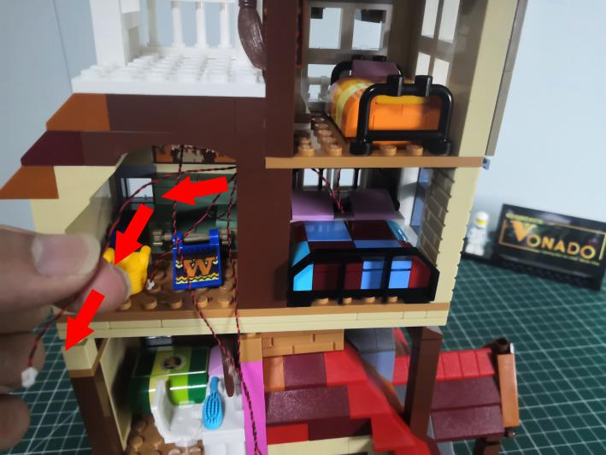

Take a 30cm connecting cable, a 6-port expansion board, assemble them as per below.
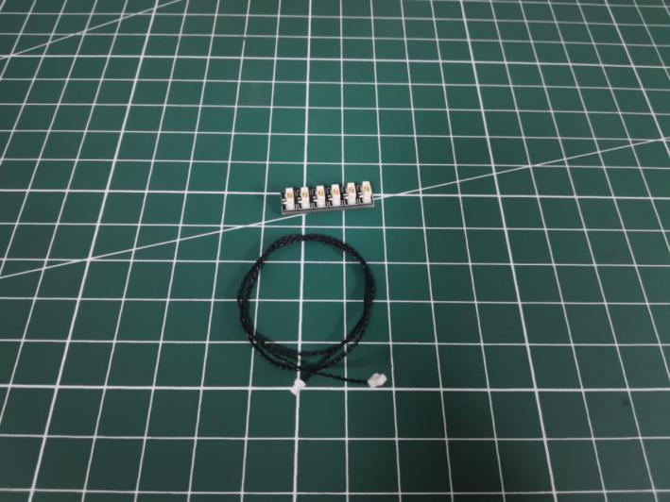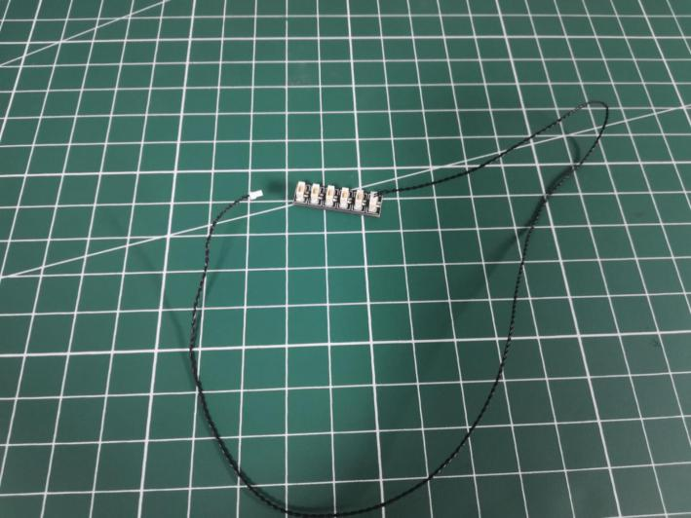

Turn to the following place.
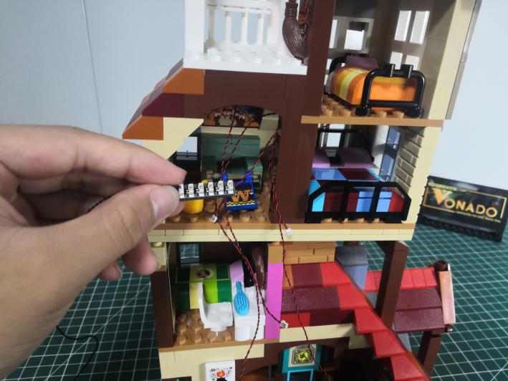

Connect all the cables to the expansion board, and tuck excess cable around it.
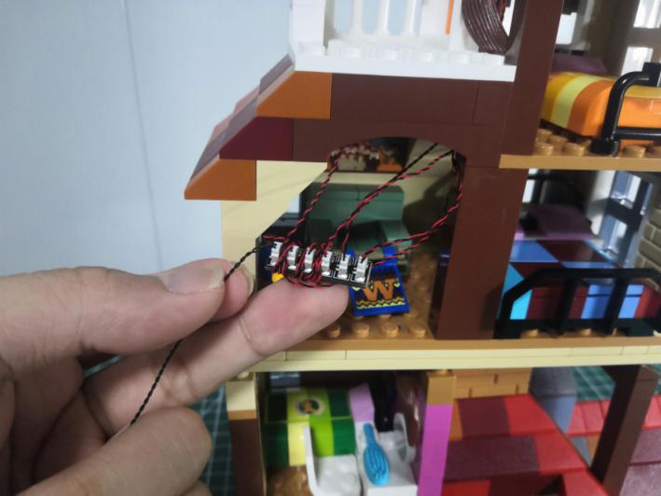

Take 2 adhesive squares.
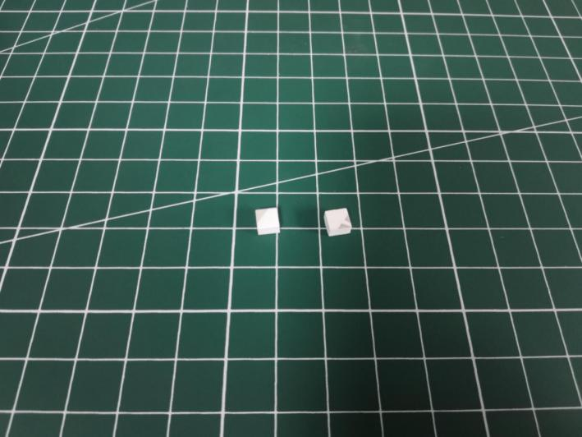

Stick the adhesive squares to the back of the expansion board, stick the expansion board to the following place.
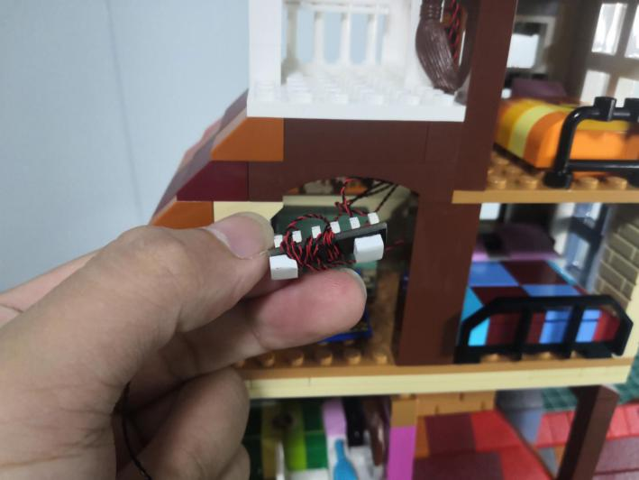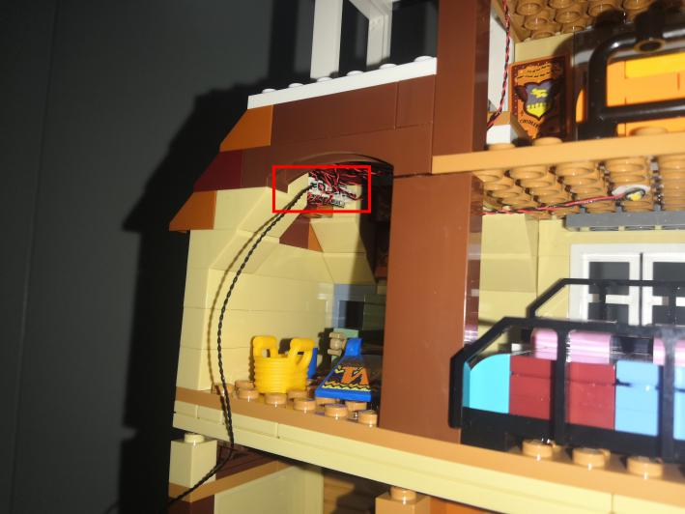

Turn to the following place, create a gap at the following place on the wall.
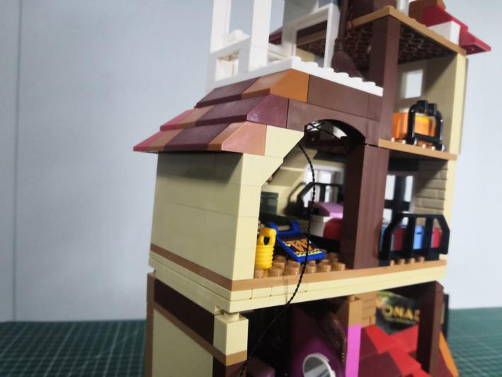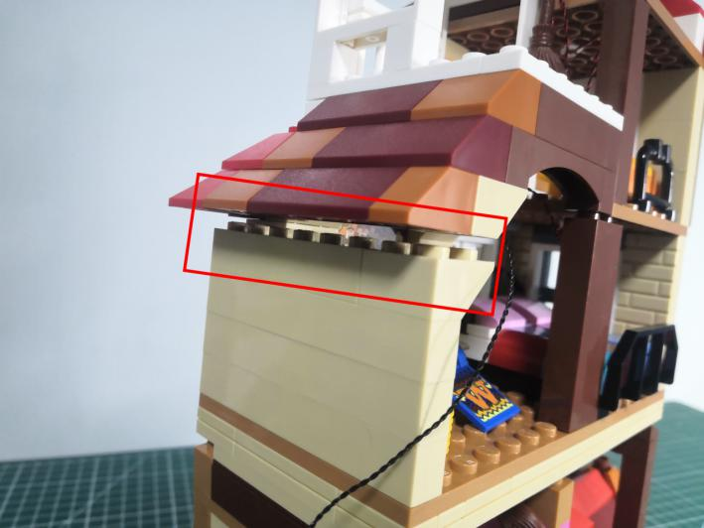

Thread the cable through the gap, close the gap.
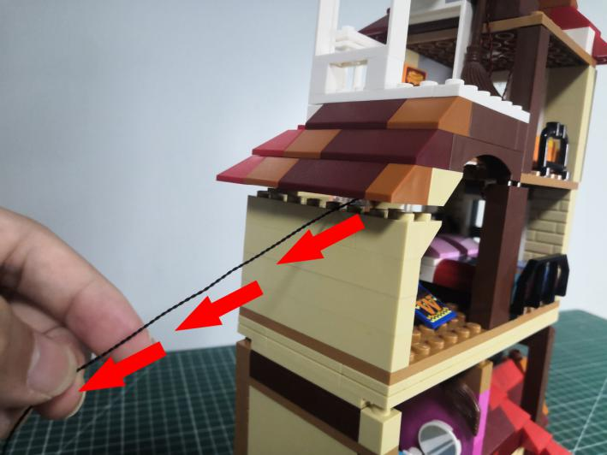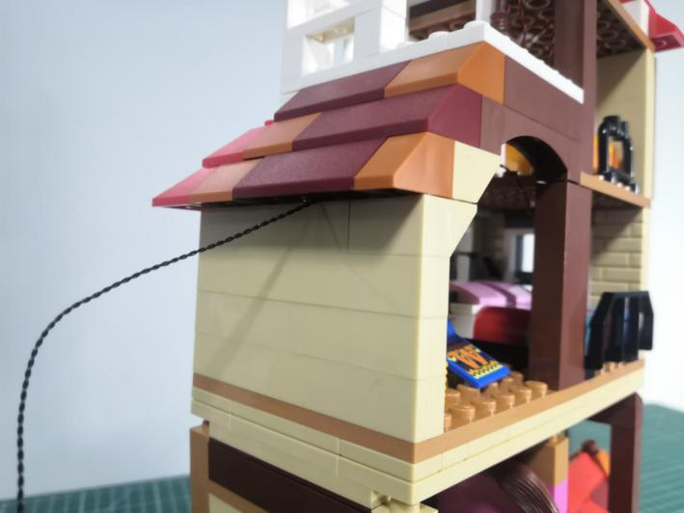

Take a warm white 15cm dot light, an adhesive square.
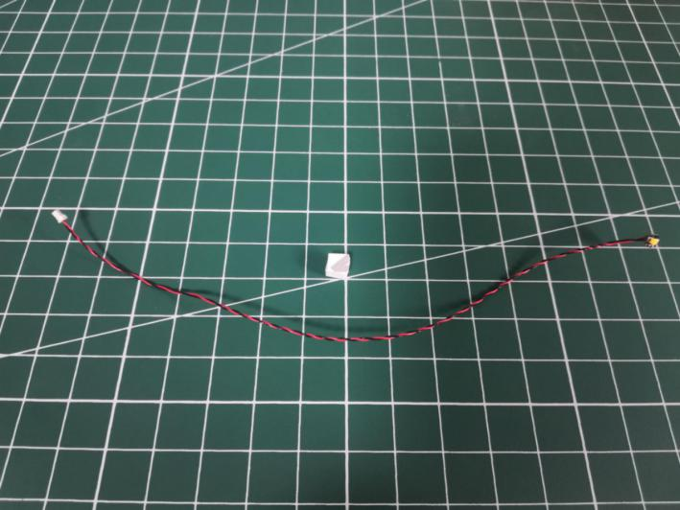

Stick the adhesive square to the back of the light.
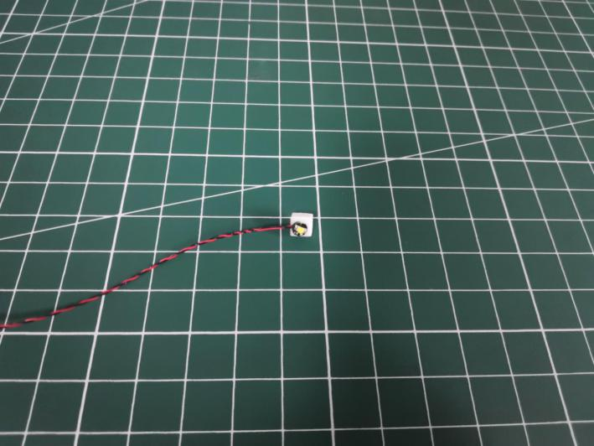

Turn to the room, stick the light to the following place.
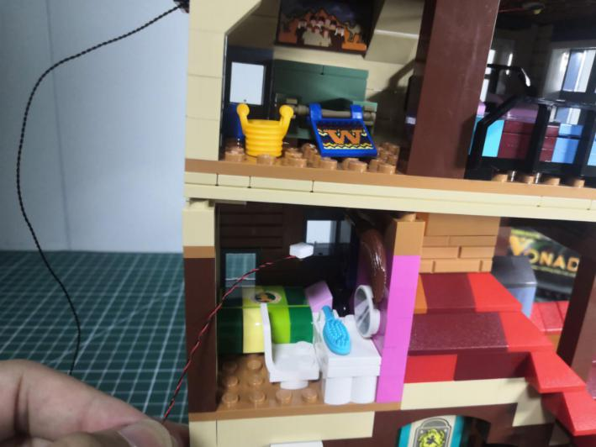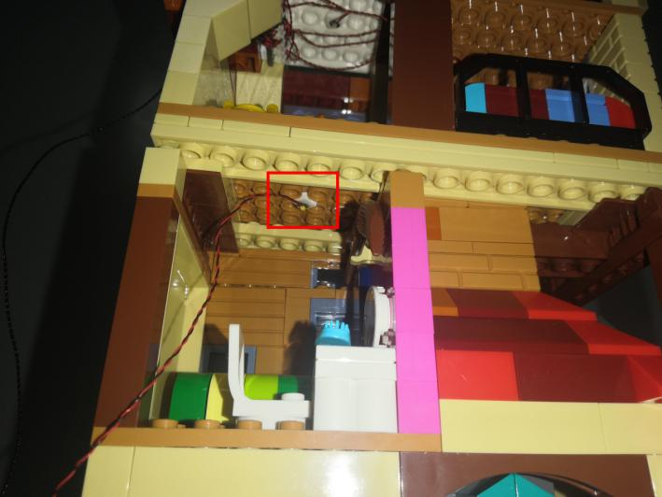

Take a pink 15cm dot light, an adhesive square.
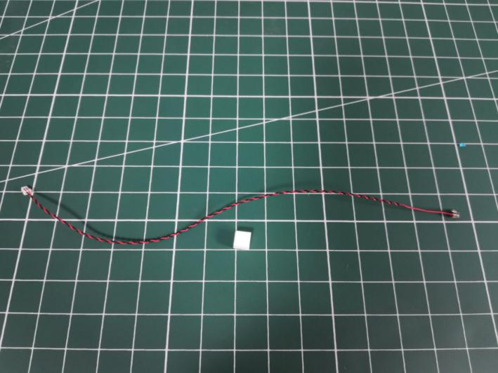
Stick the adhesive square to the back of the light.
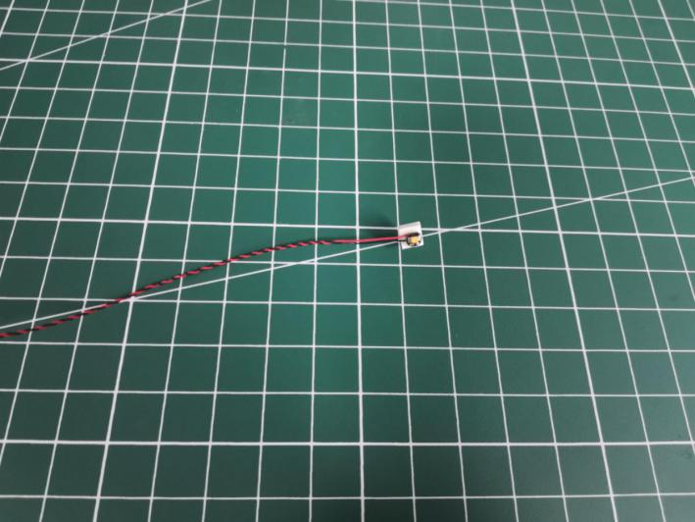

Turn to the following place, stick the light as per below.
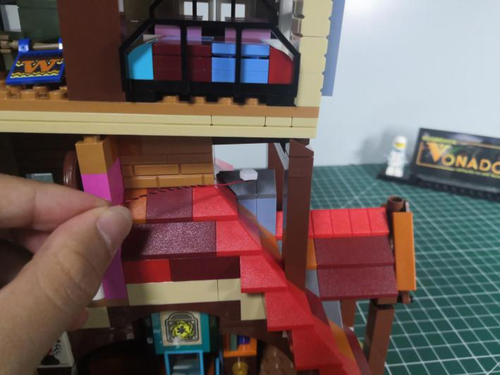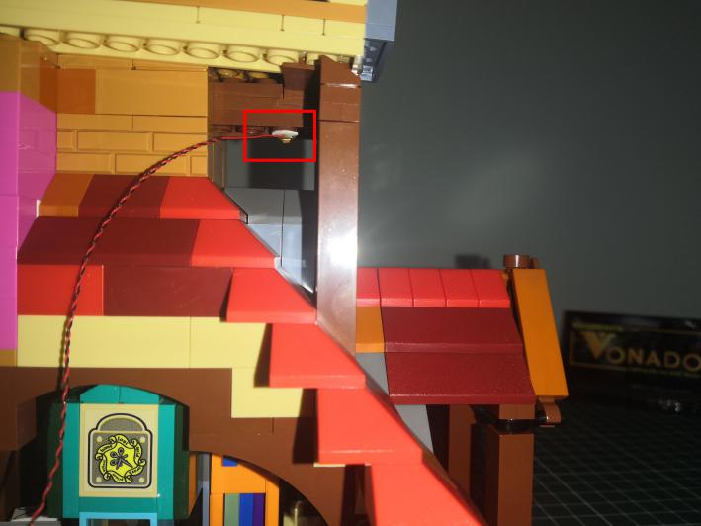

Place the cable as per below.
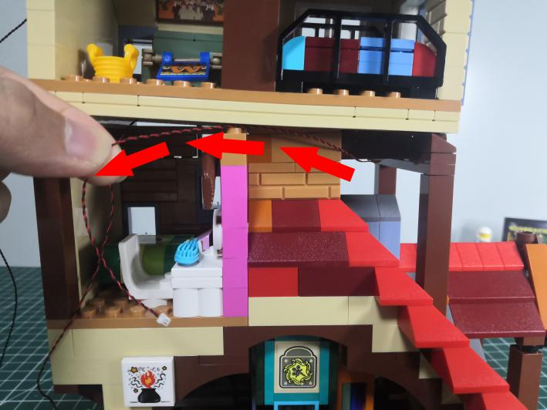

Take a 30cm connecting cable, a 4-port expansion board, assemble them as per below.
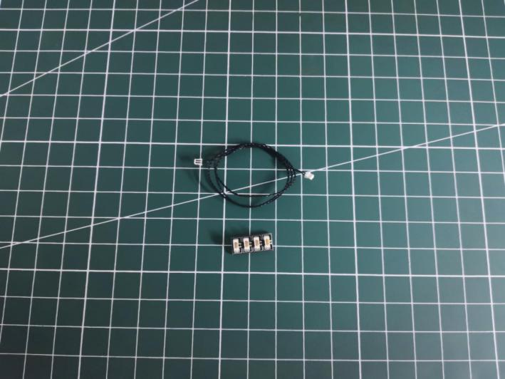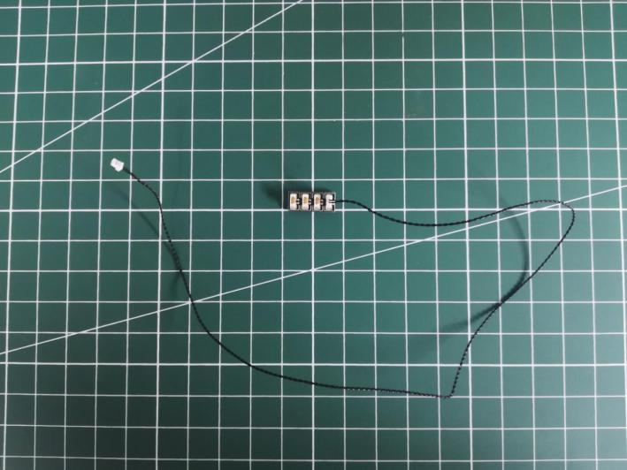

Turn to the following place, connect the 2 cables to the expansion board.
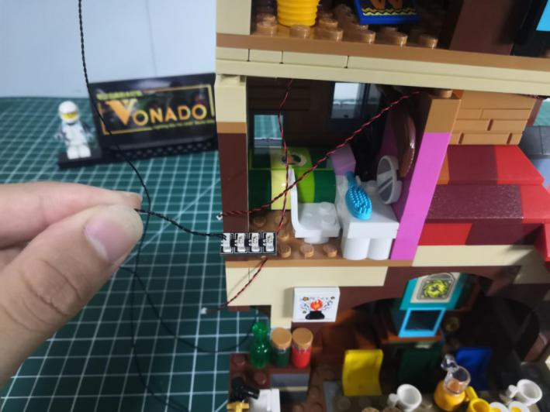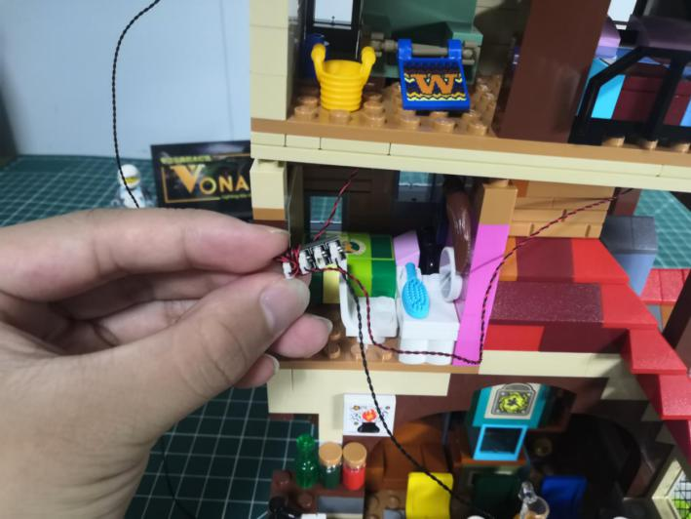

Take 2 adhesive squares.
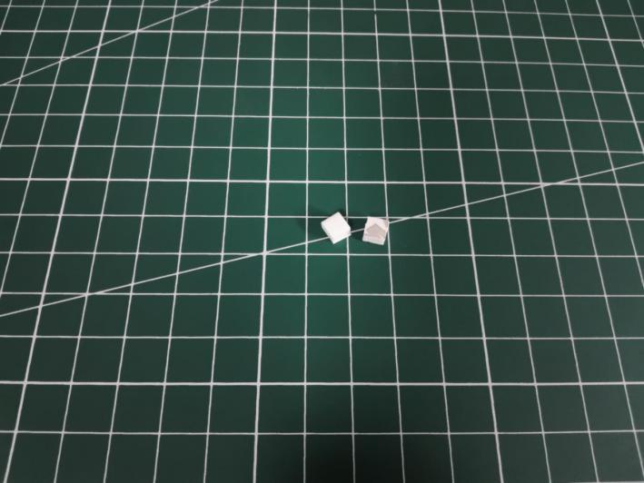

Stick the adhesive squares to the back of the expansion board, stick the expansion board to the following place.
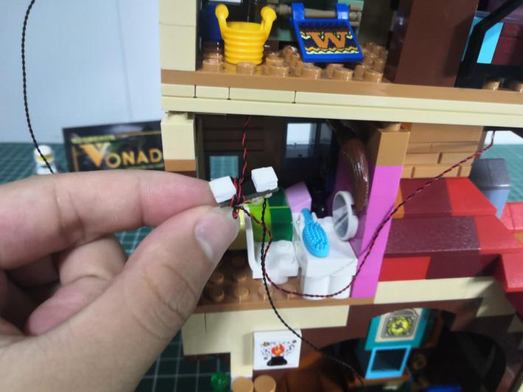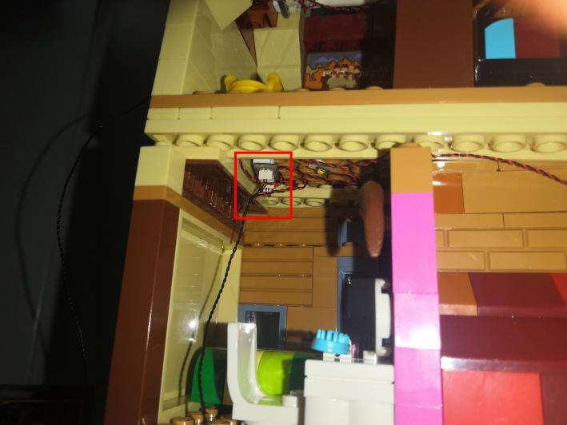

Turn to the left behind.
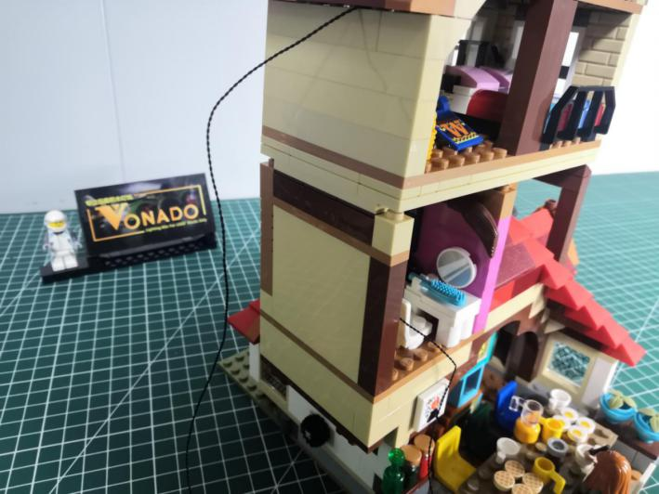

Create a gap at the following place on the wall with the tool.
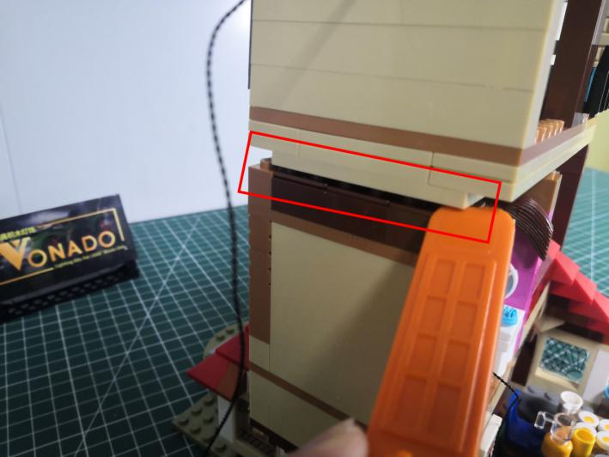

Take the following cable, thread it through the wall.
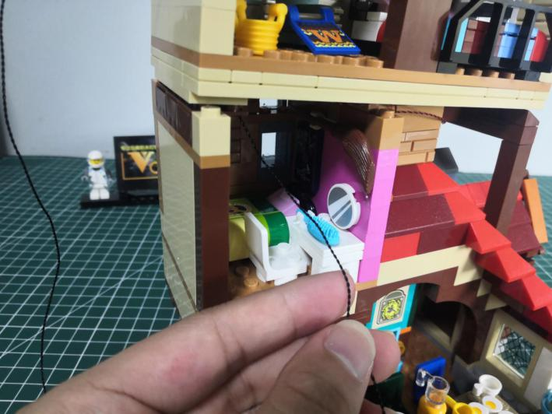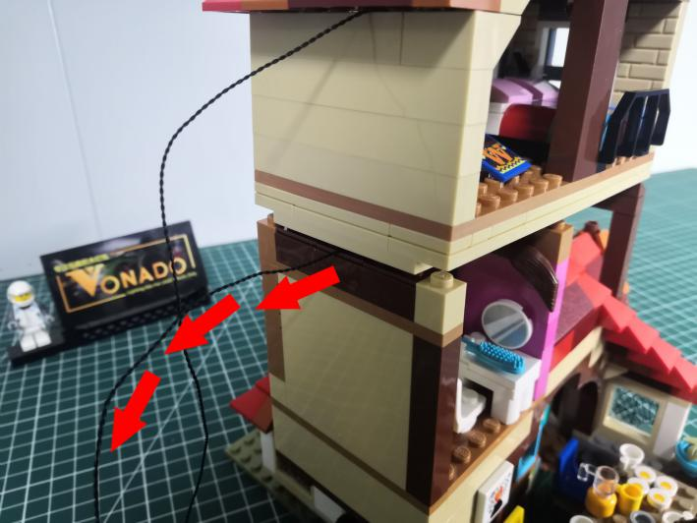

Reconnect the wall to secure the cable.
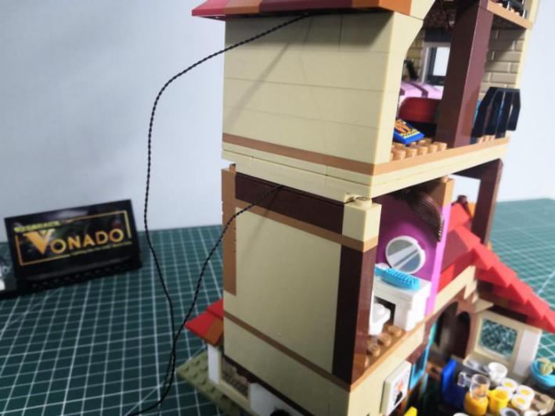

Turn to the following place.
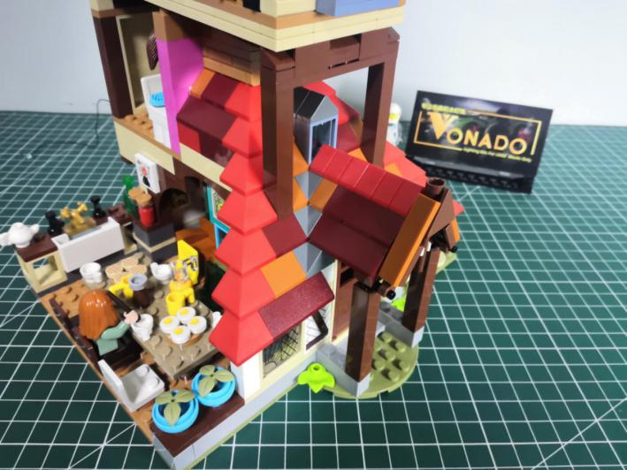

Remove the roof piece.

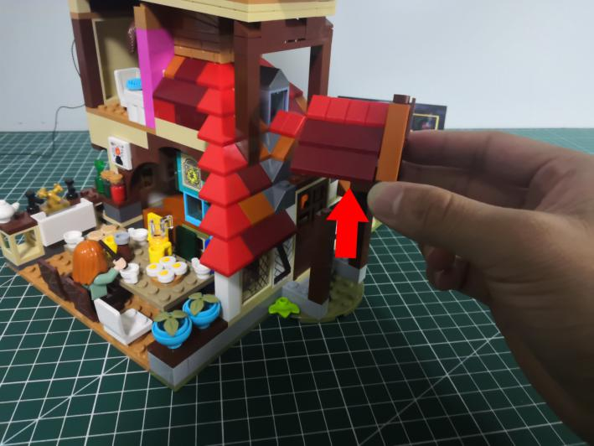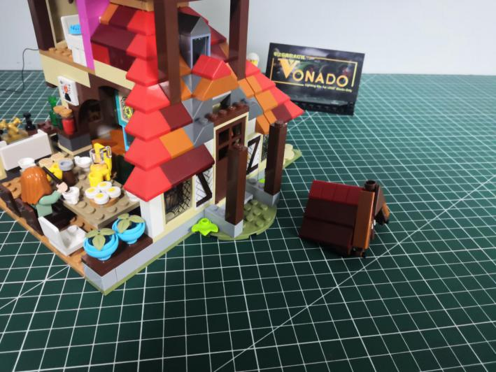

Take a warm white 15cm dot light, an adhesive square.
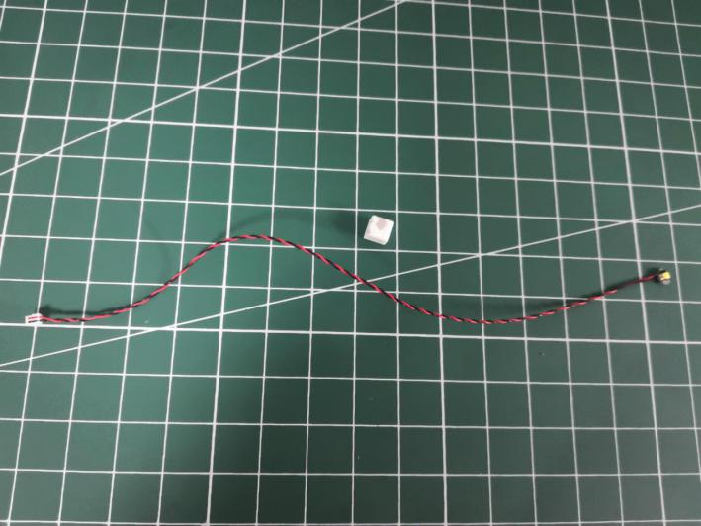

Stick the adhesive square to the back of the light.
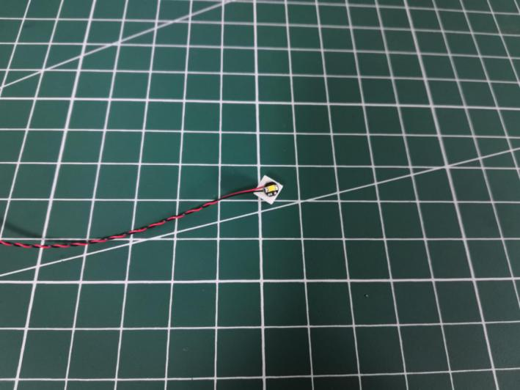

Turn to the back of the roof.
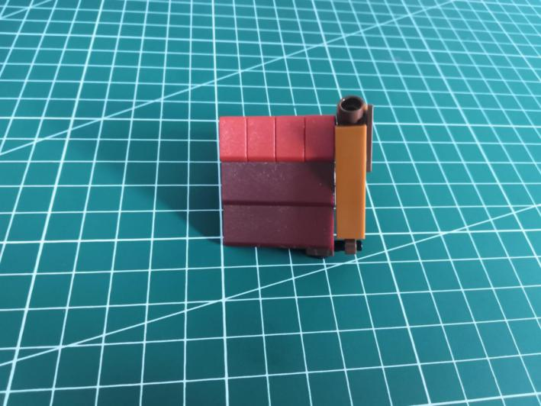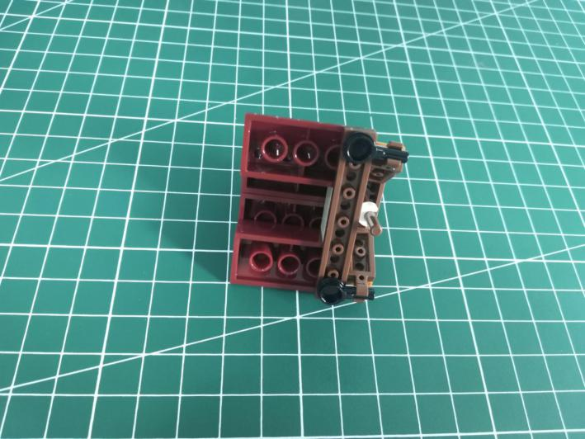

Stick the light to the following place.
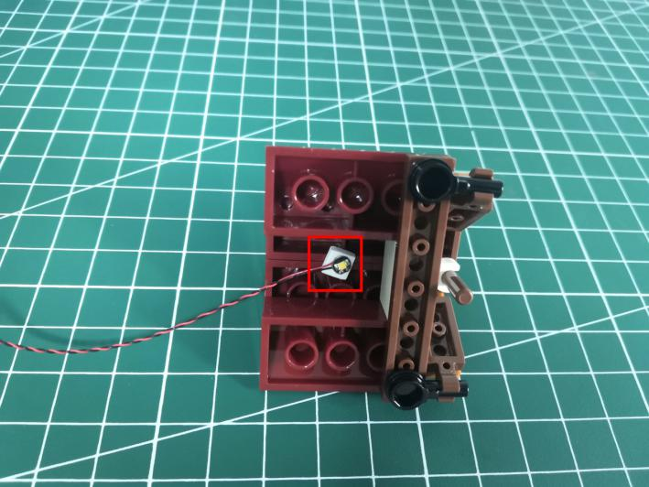

Thread the cable through the hole, reconnect the roof as per below.
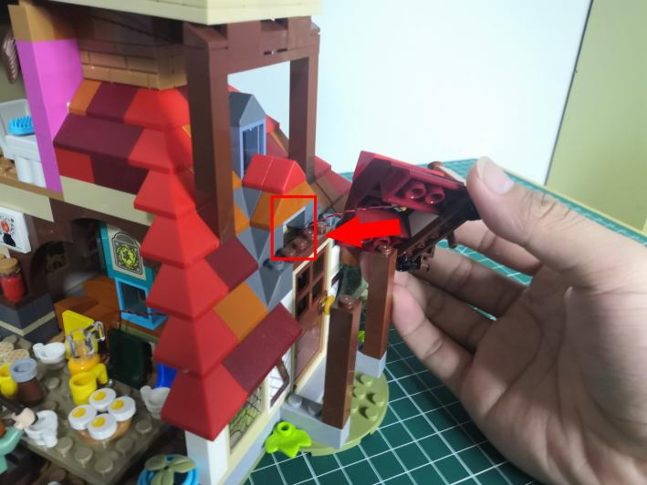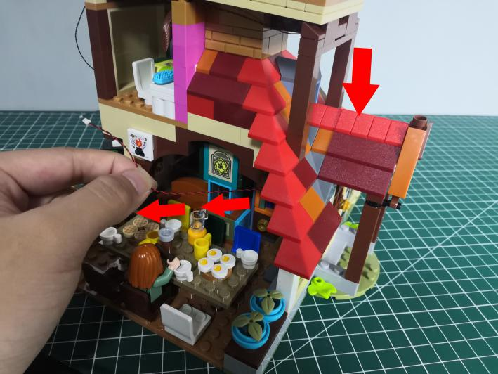

Take a warm white 15cm dot light, an adhesive square.
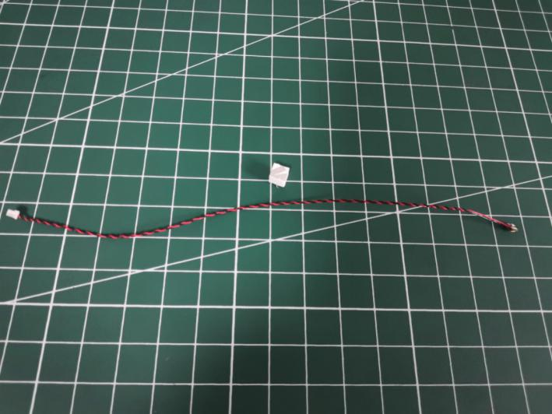

Stick the adhesive square to the back of the light.
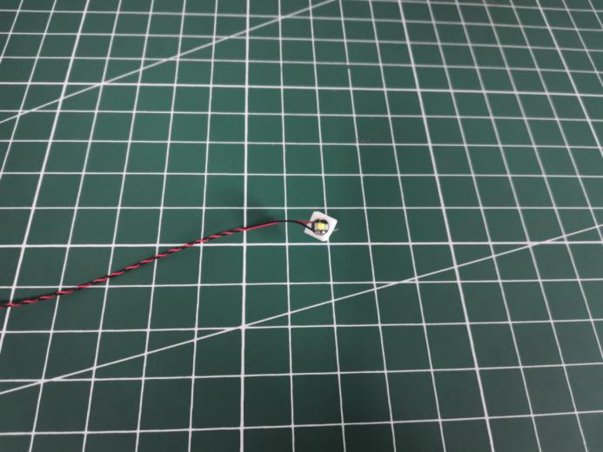

Turn to the following room.
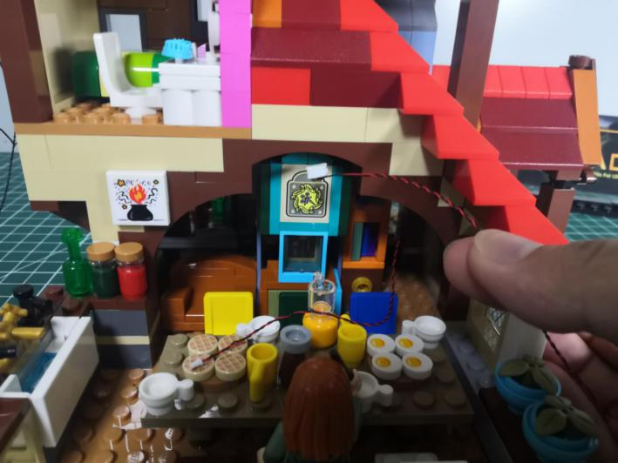

Stick the light to the following place indoor.
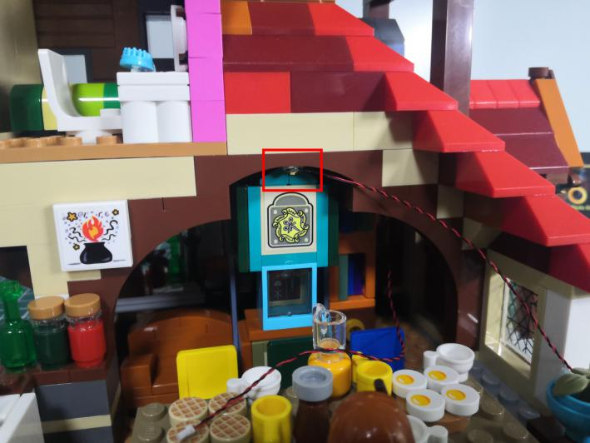

Turn to the front.
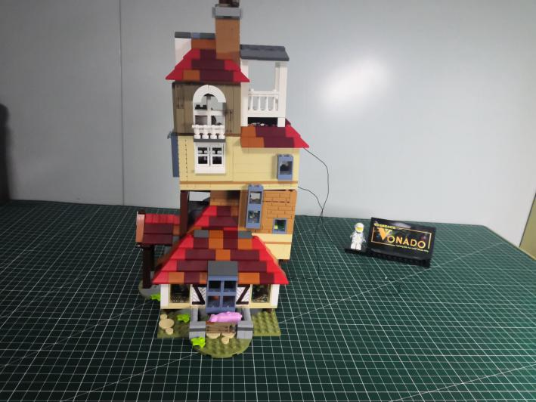

Open the following room.
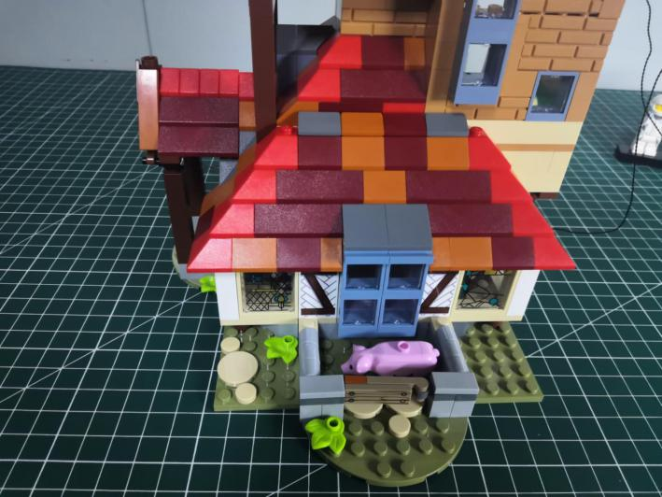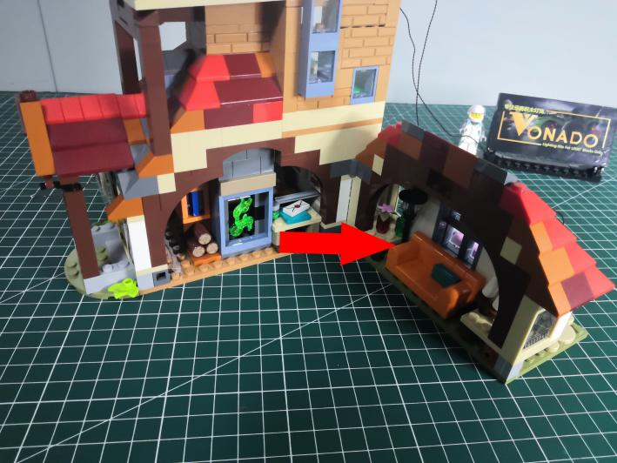

Take a white 15cm dot light, an adhesive square.
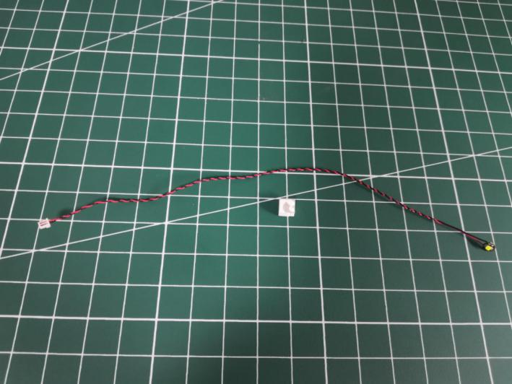

Stick the adhesive square to the back of the light.
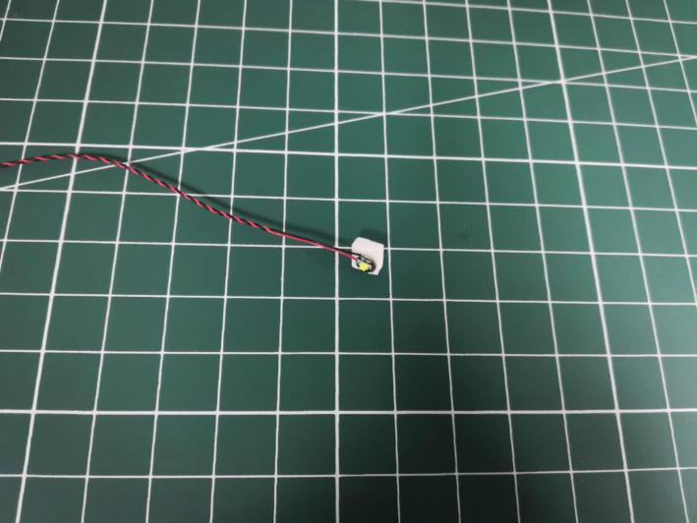

Take the cable, and thread it through the following hole.
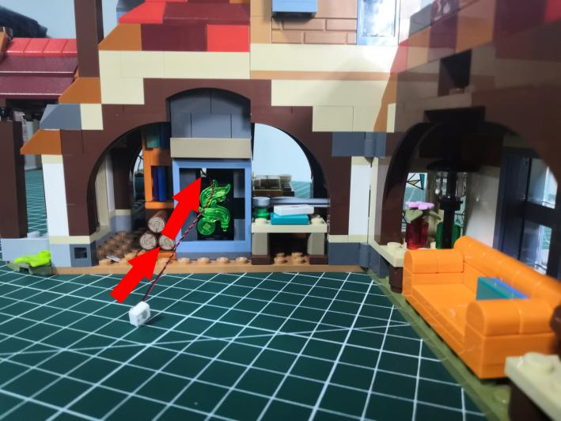

Stick the light to the following place.
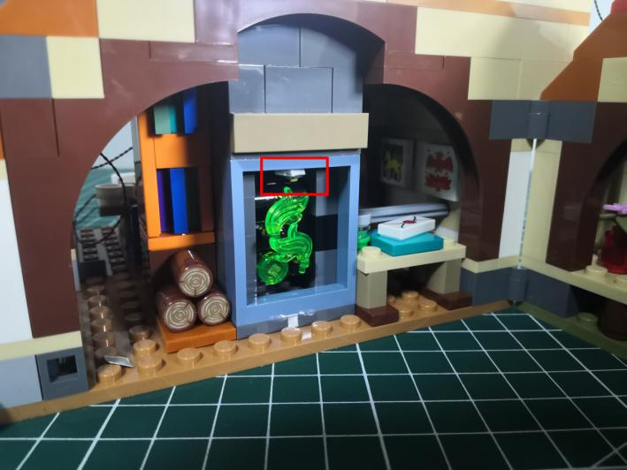

Take a 30cm head light, an adhesive square.
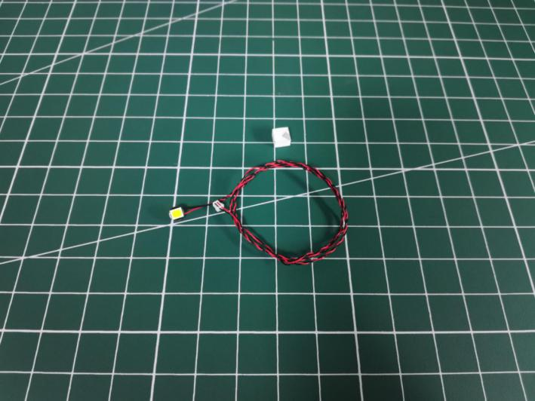

Stick the adhesive square to the back of the light.
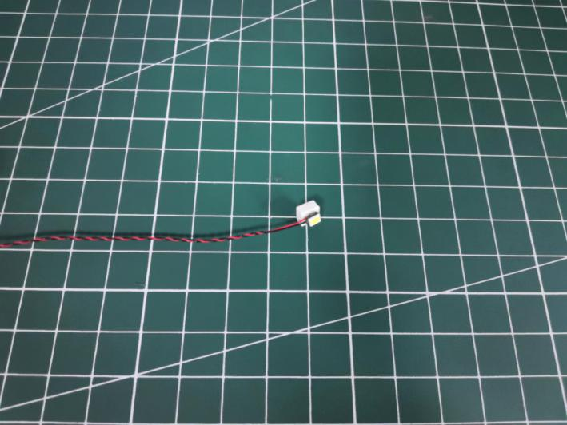

Turn to the following place, stick the light as per below.
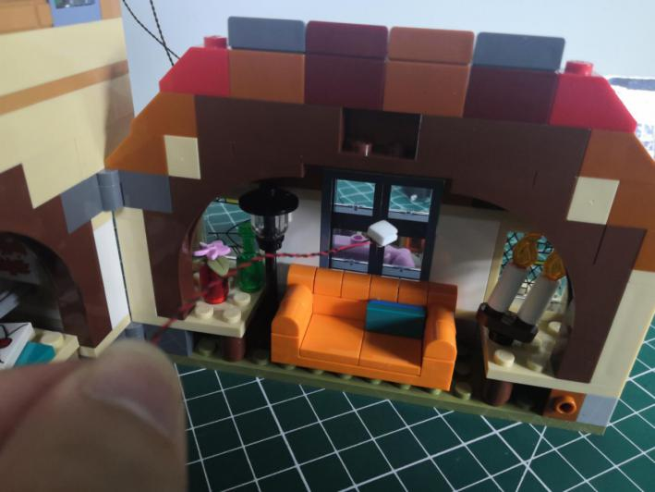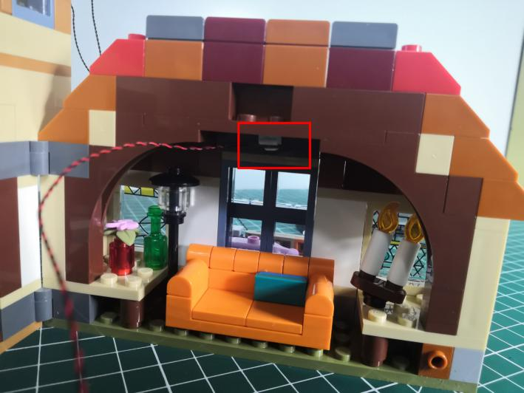

Turn to the following 3 red pieces from the roof.
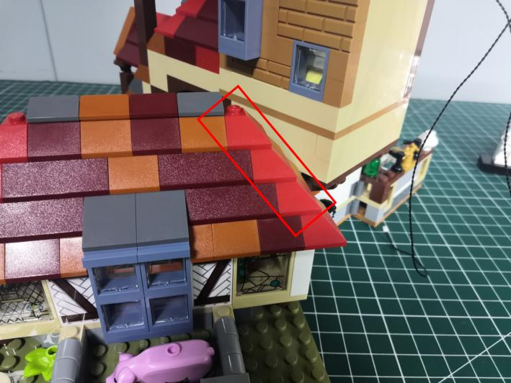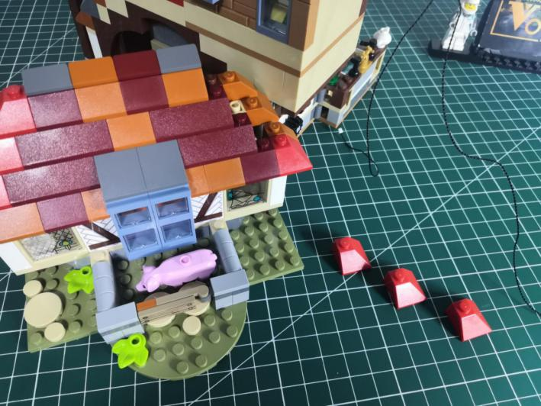

Continue to remove the following 2 yellow pieces.
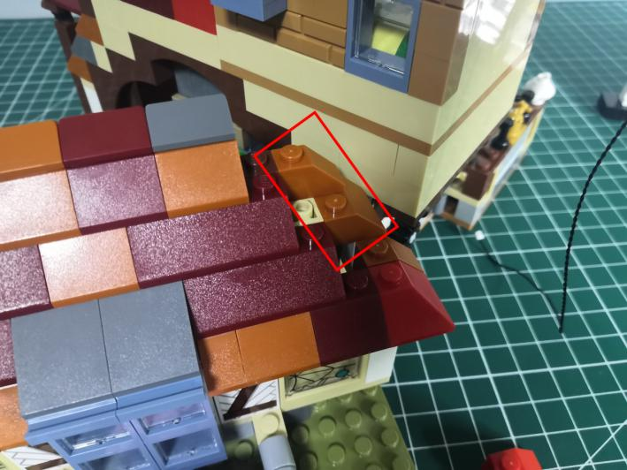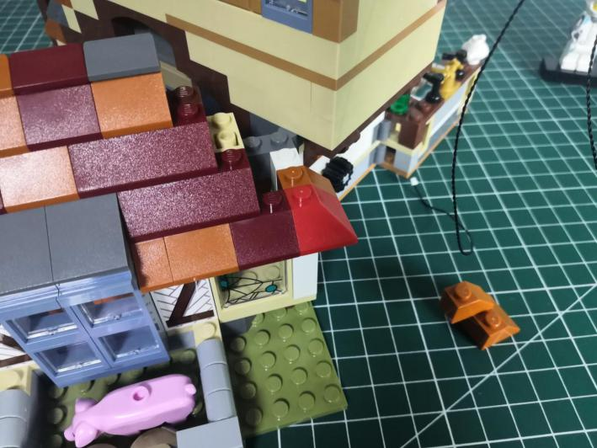

Turn to the room, thread the cable through the following space and pull it out.
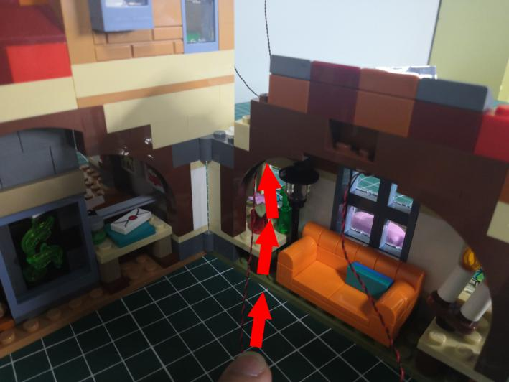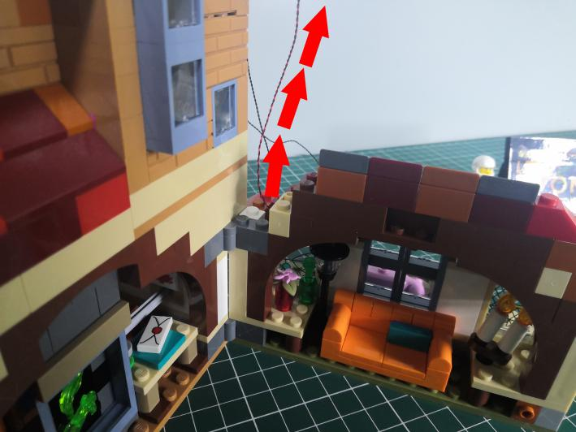

Turn to the front, place the cable as per below.
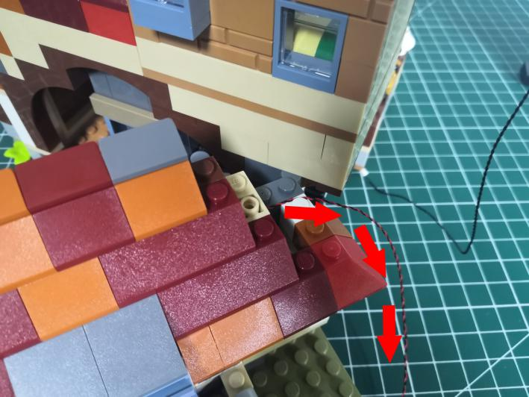

Reconnect the yellow piece and the red piece.
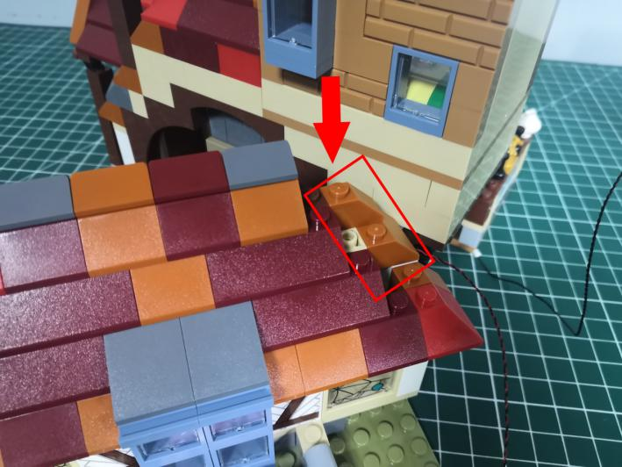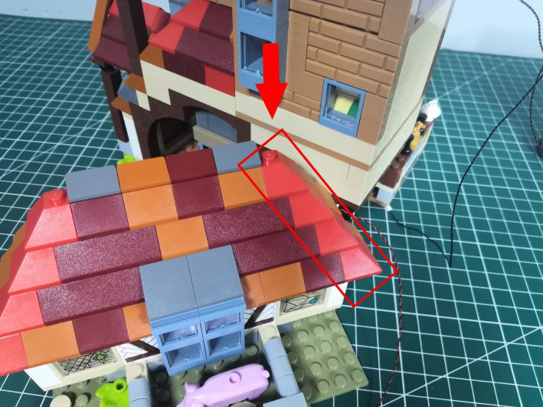

Close the room, thread the cable through and pull it out from the back.
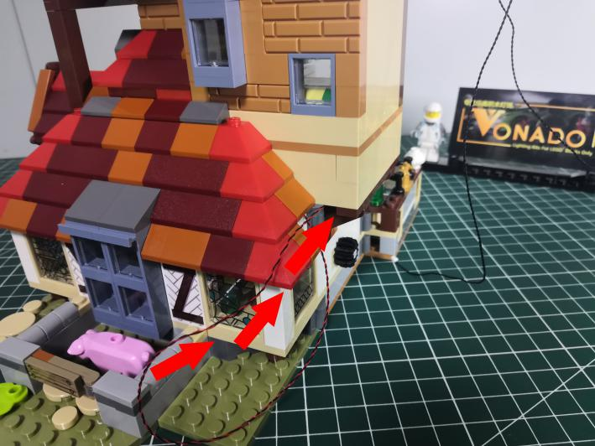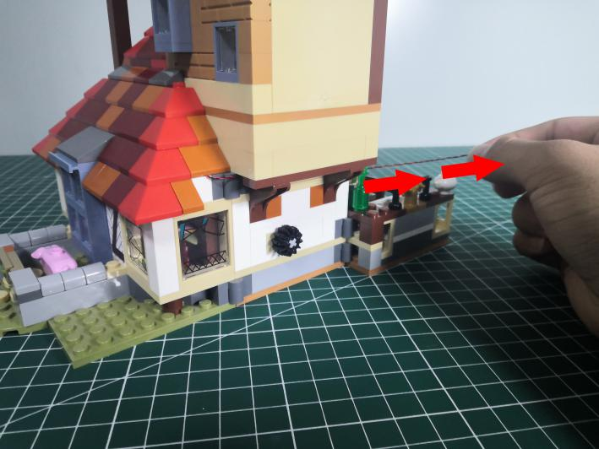

Turn to the side, take 2 connecting cables, thread them through the following place, and pull the cables out from the back.
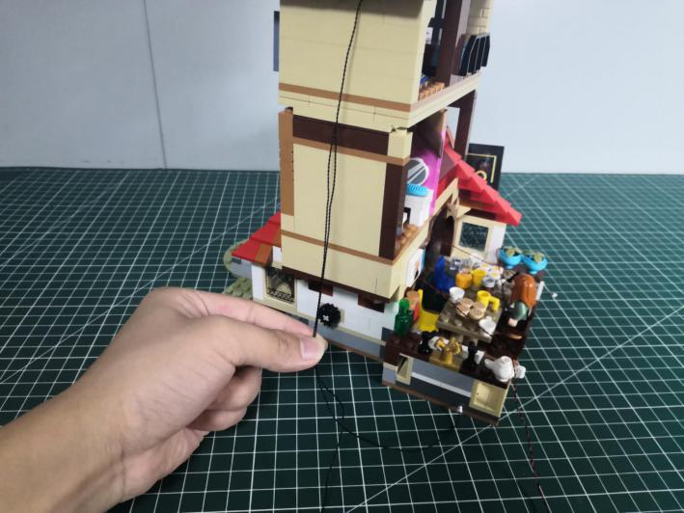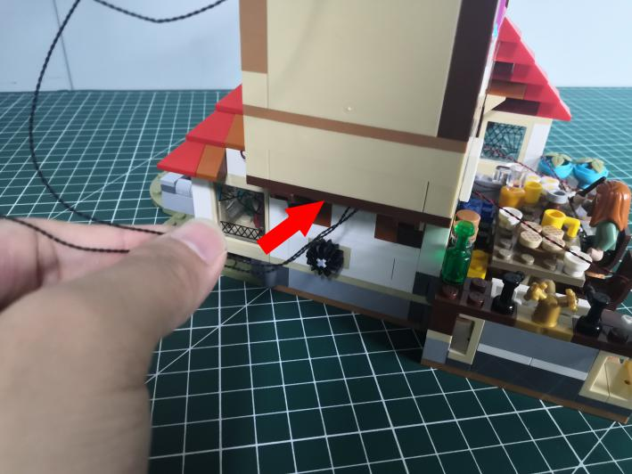
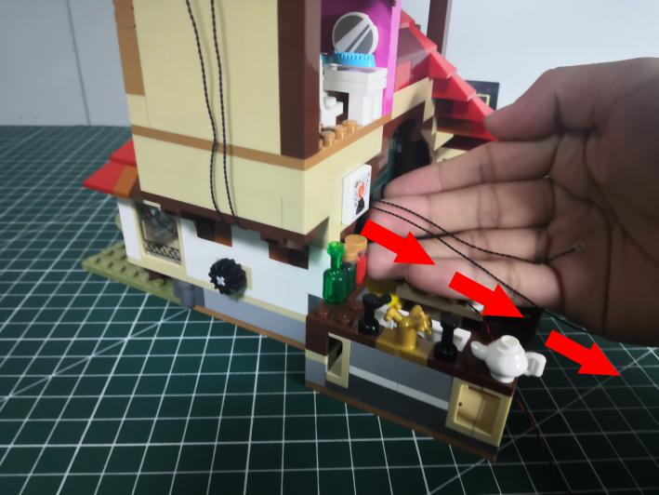

Turn to the front.
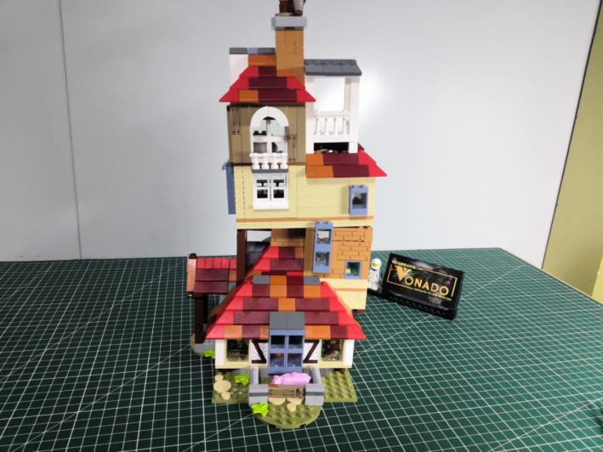

Take a white 15cm strip light.
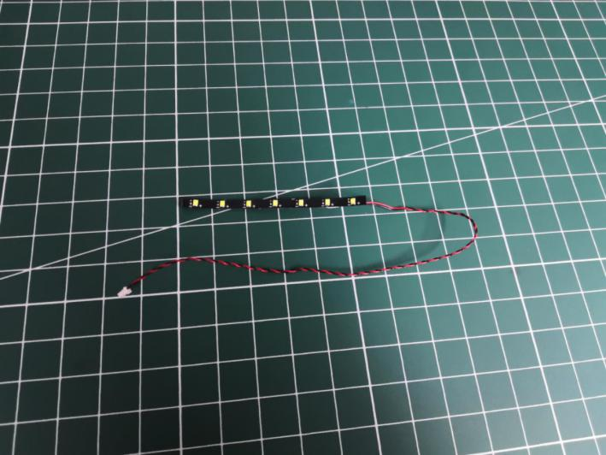

Stick it to the following place.
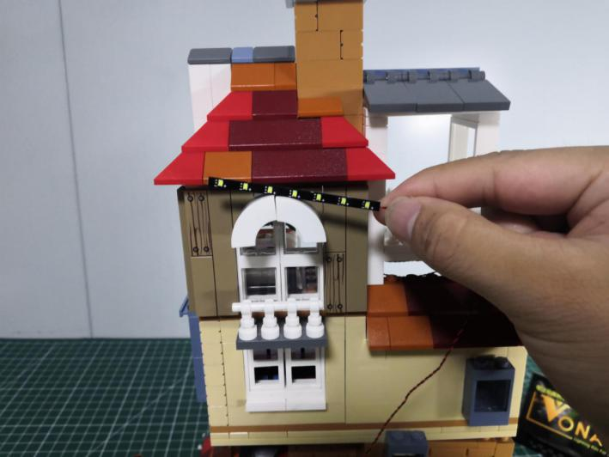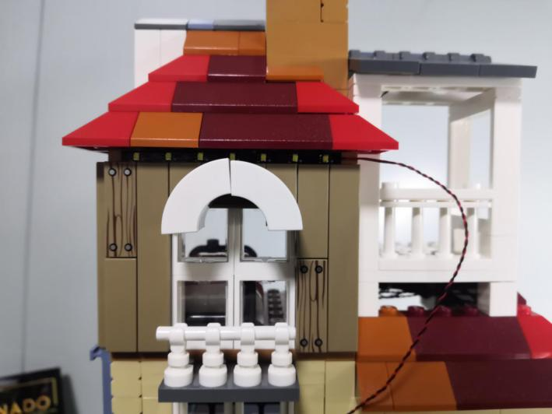

Take the cable, thread it through the following space and pull it out from the back.
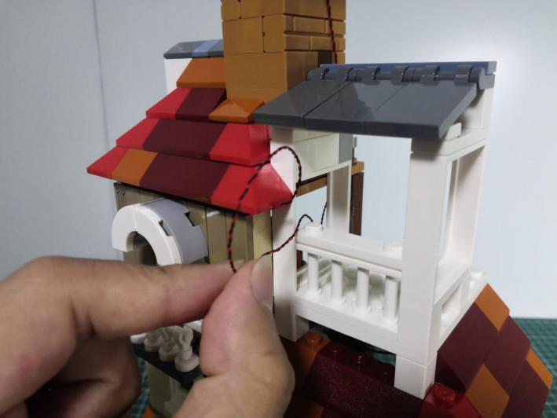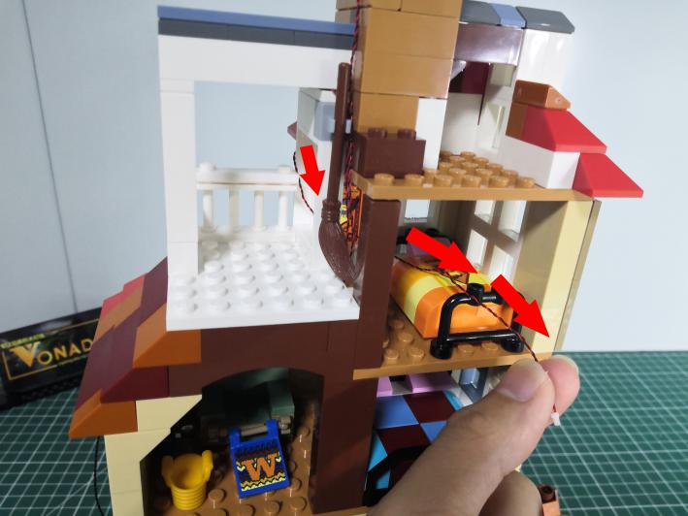

Continue to thread it through the room at the left-lower corner and pull it out as per below.
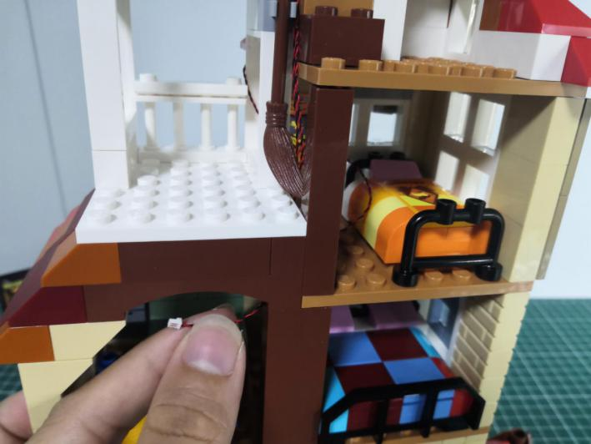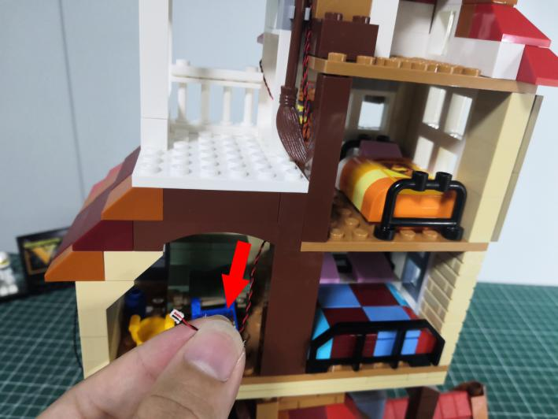

Turn to the front.
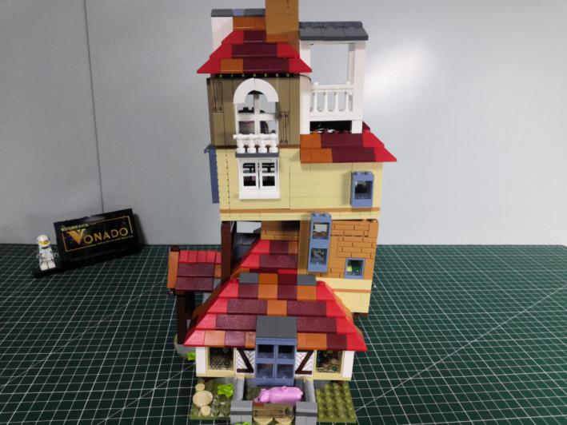

Take a white 15cm strip light.
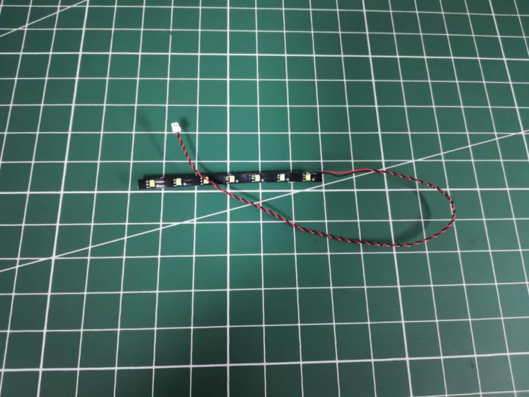

Stick the strip light to the following place.
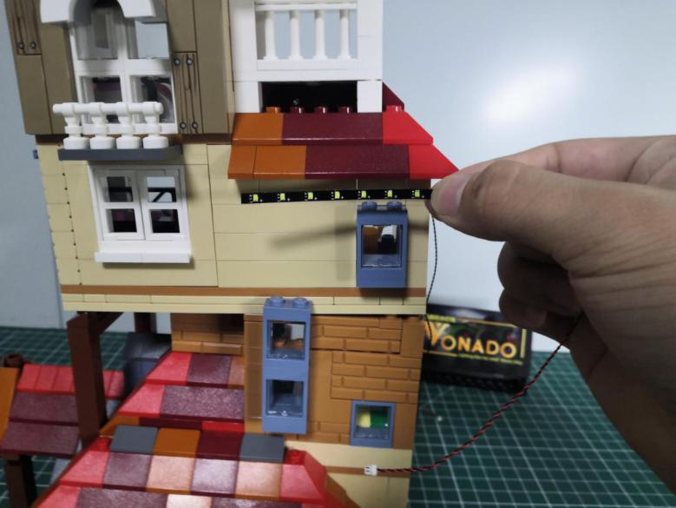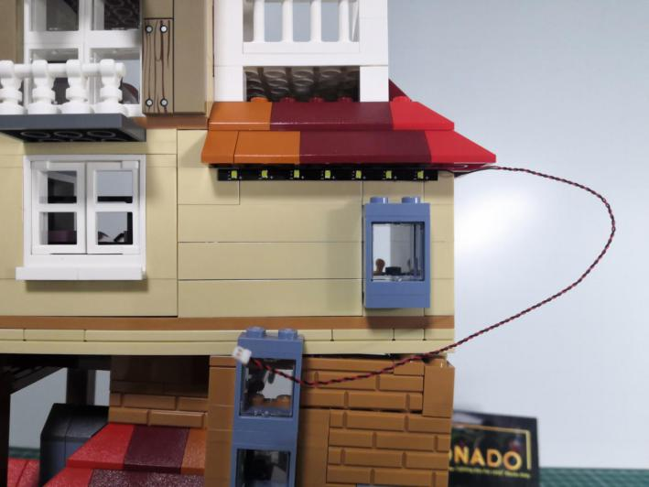

Thread the cable through the following space and pull it out from the back.
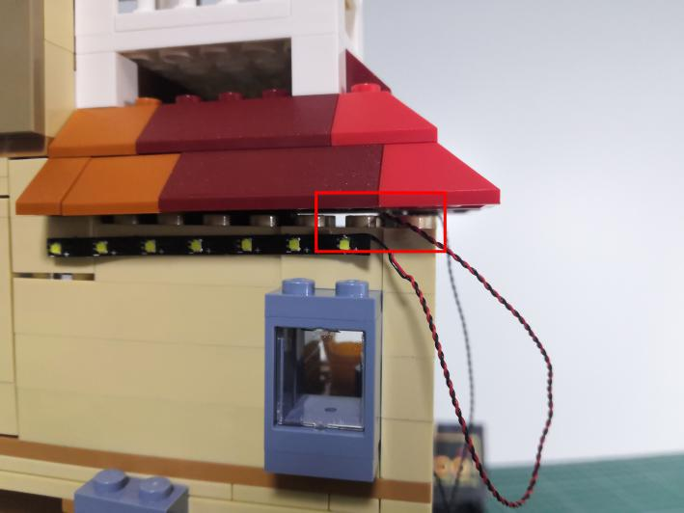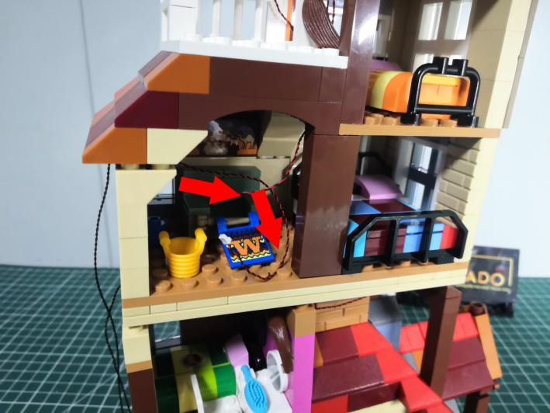

Take a white 15cm strip light.

Turn to the front, stick the strip light to the following place.
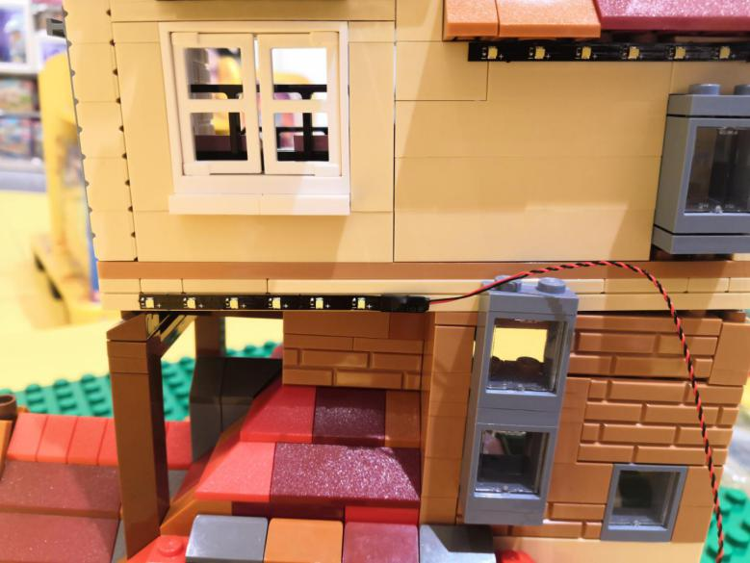

Create a gap at the following place with the tool.
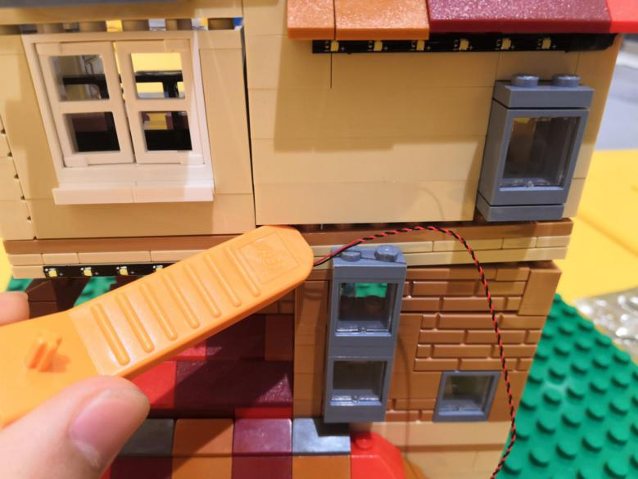

Thread the cable to the inside.
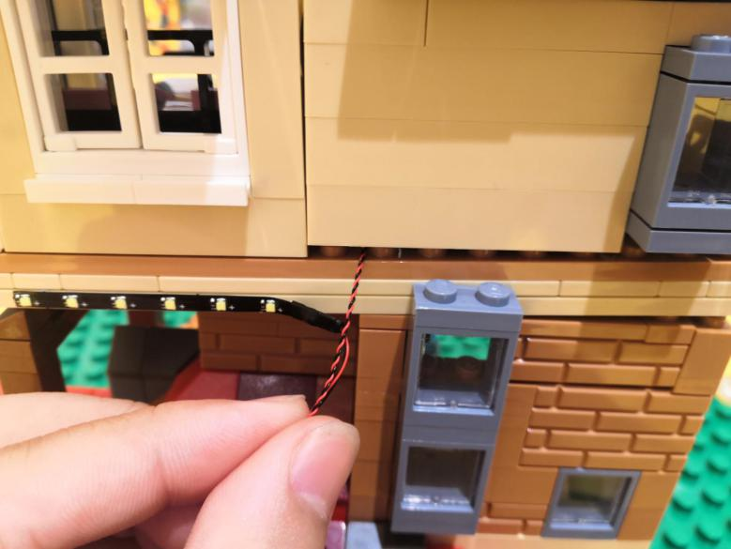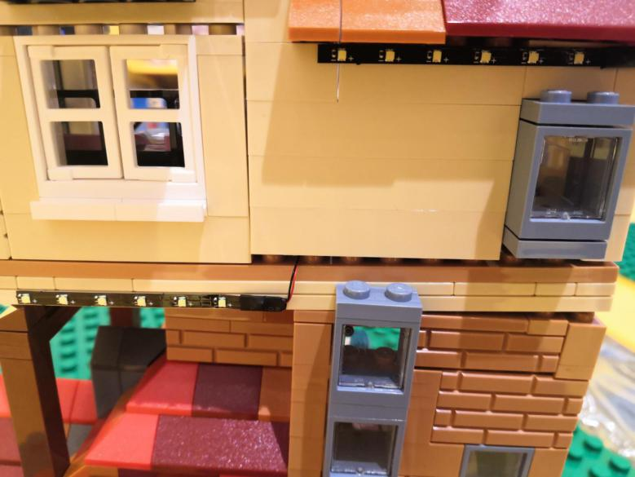

Close the gap.
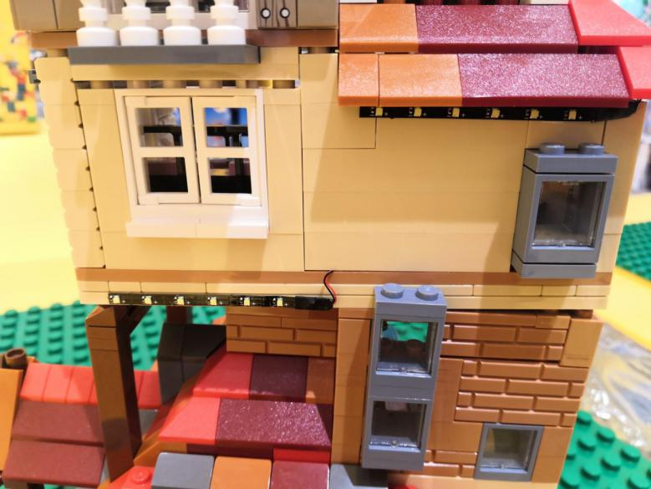

Take a 30cm connecting cable, a 4-port expansion board, assemble them as per below.
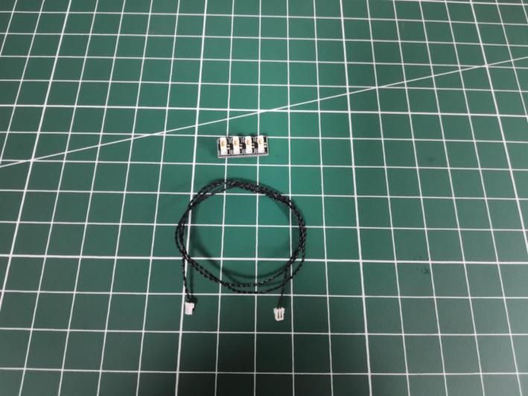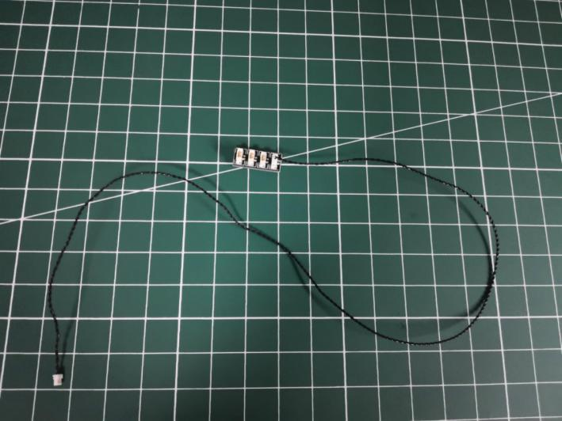

Turn to the following room, connect the cable to the expansion board, tuck excess cable around the expansion board.
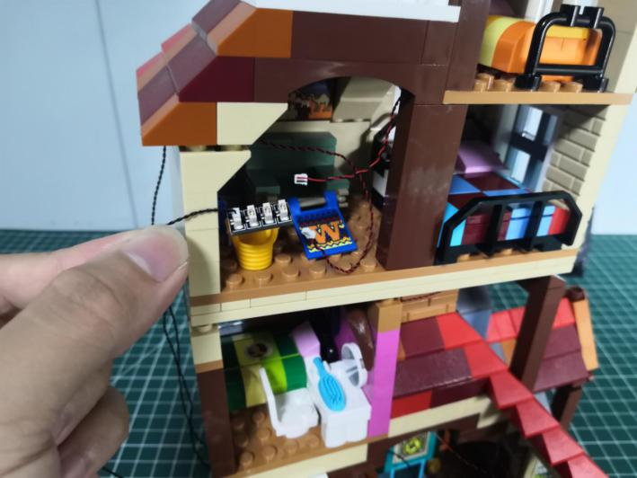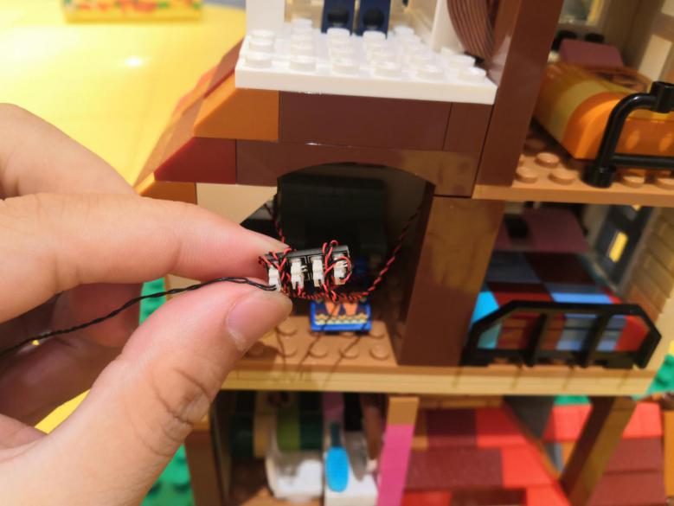

Take 2 adhesive squares.
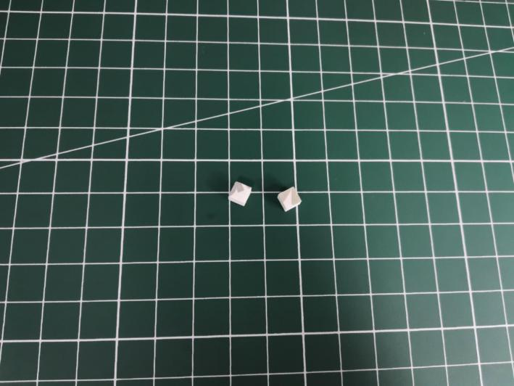

Stick them to the back of the expansion board, stick the expansion board to the following place.
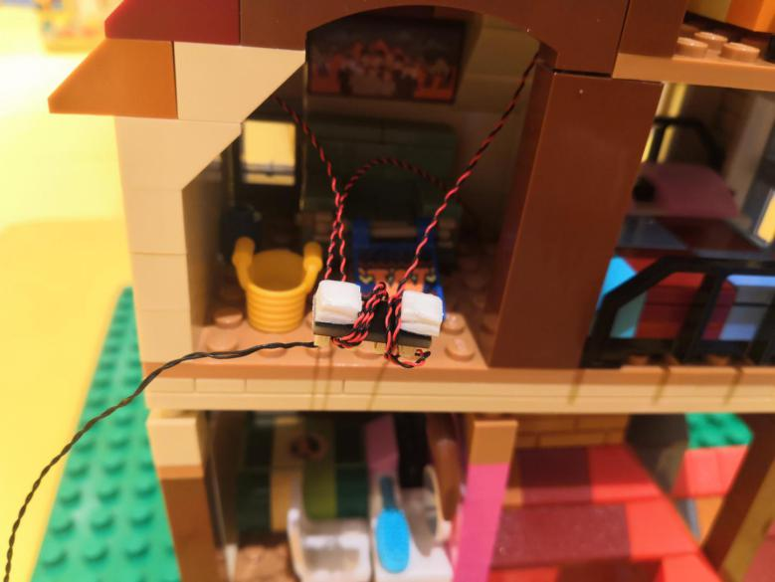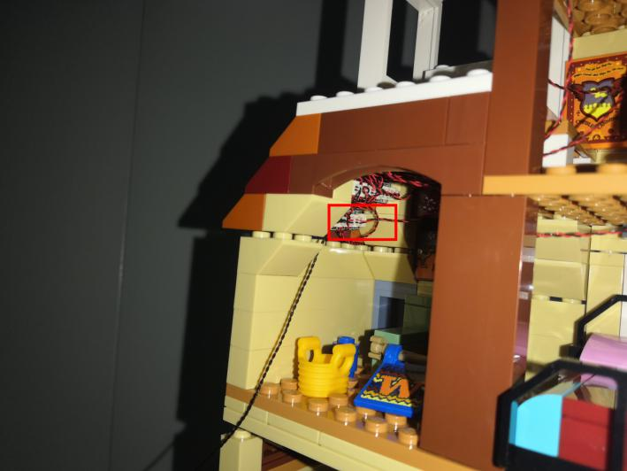

Take the following cable, wind it around the left wall as per below.
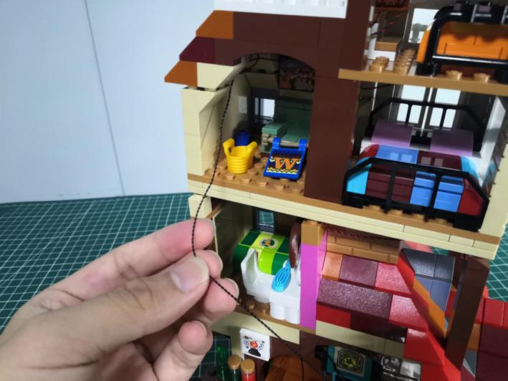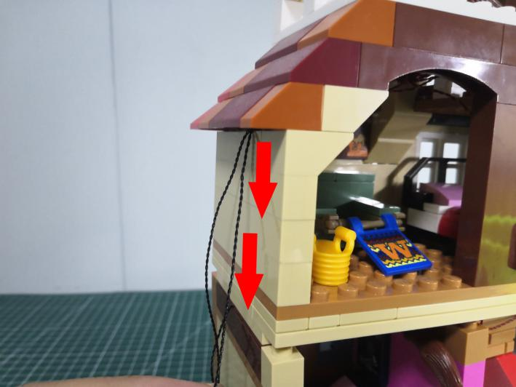

Turn to the front.
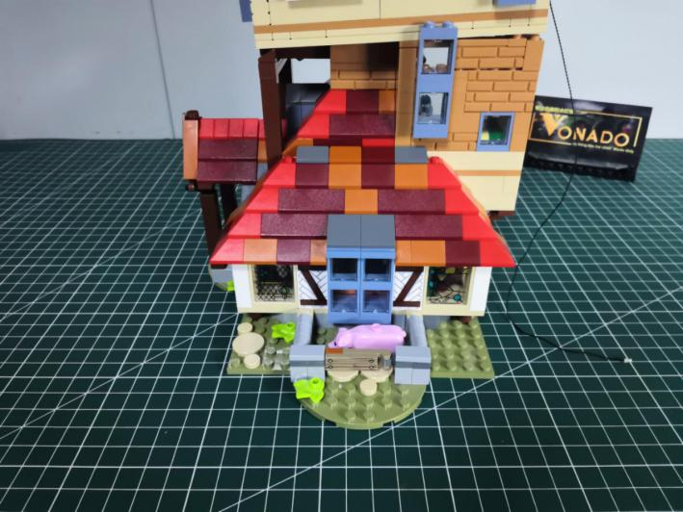

Take 2 white 15cm strip lights.
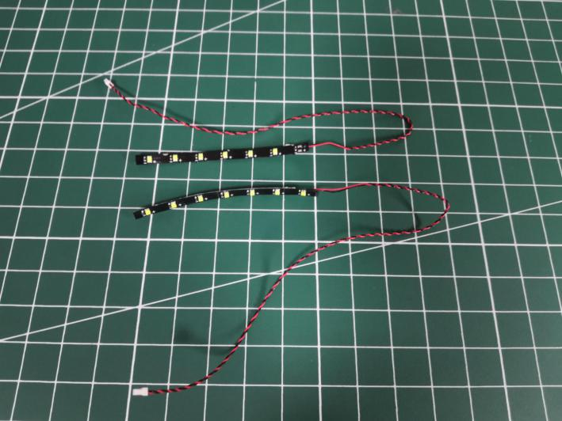

Stick them to the following places at both sides.
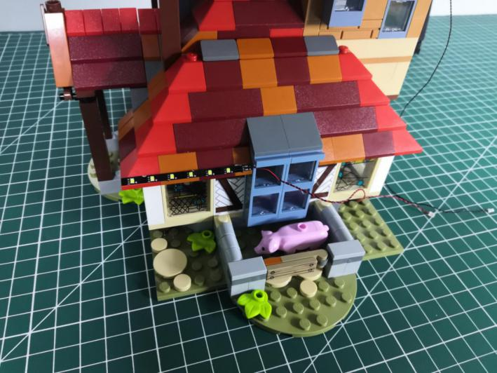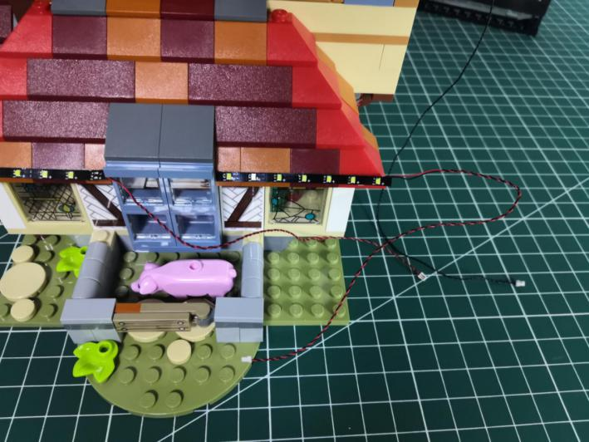

Turn to the right.
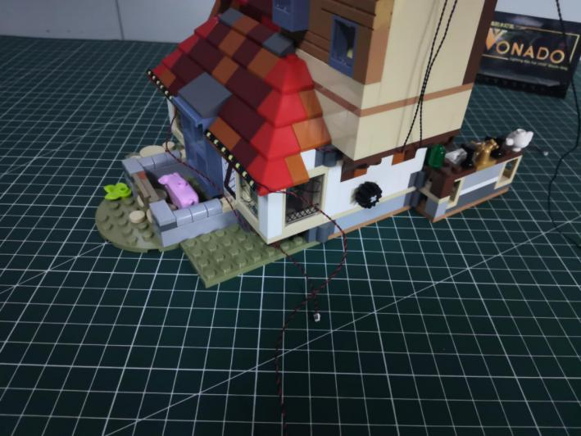

Take a 15cm connecting cable, a 4-port expansion board, assemble them as per below.
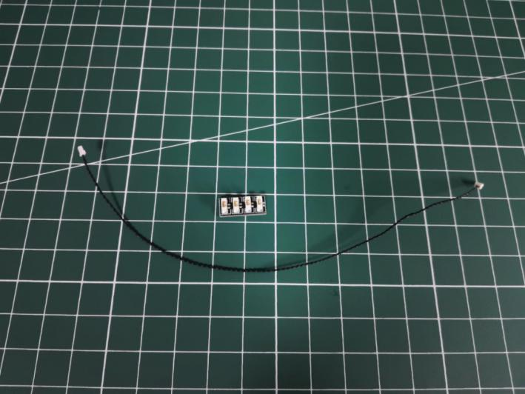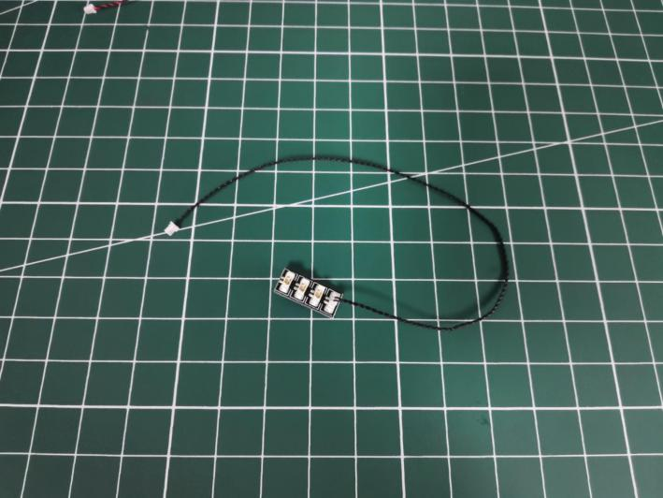

Connect the following 2 cables to the expansion board.
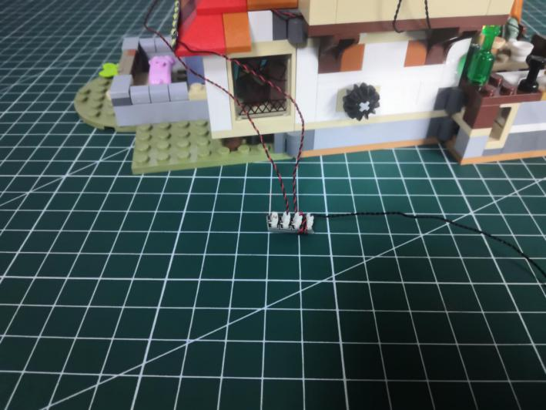

Take the following cable, connect it to the expansion board.
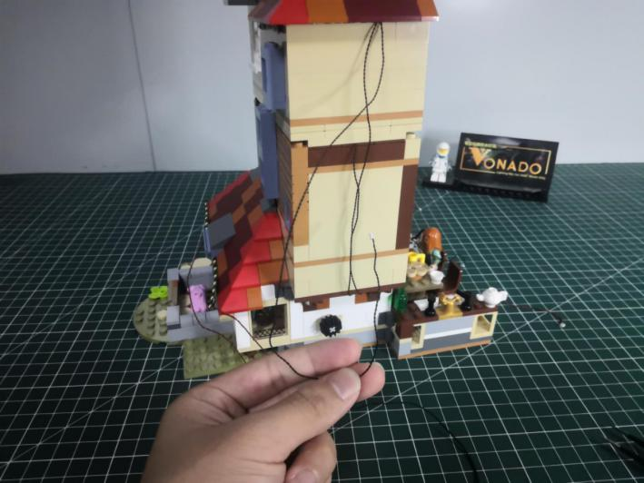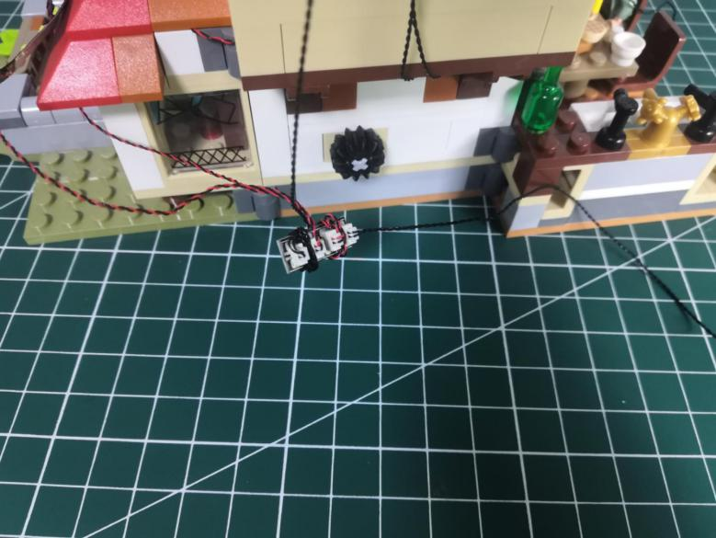

Take 2 adhesive squares.
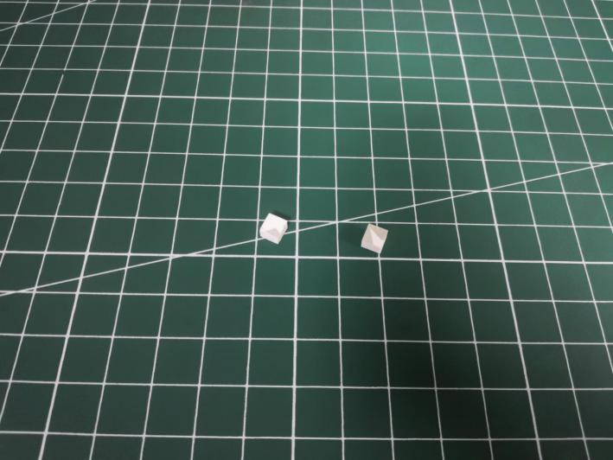

Stick them to the back of the expansion board, stick the expansion board to the following place.
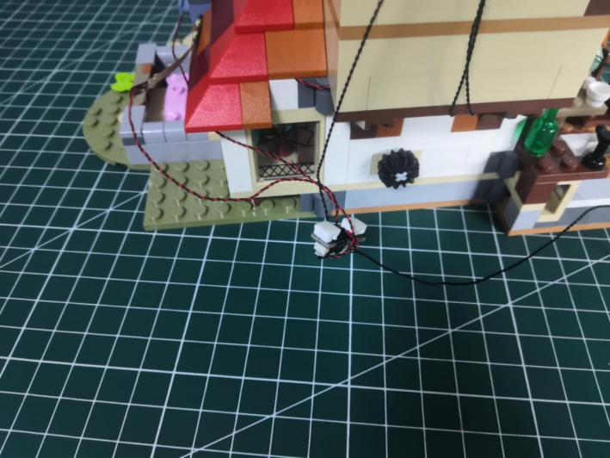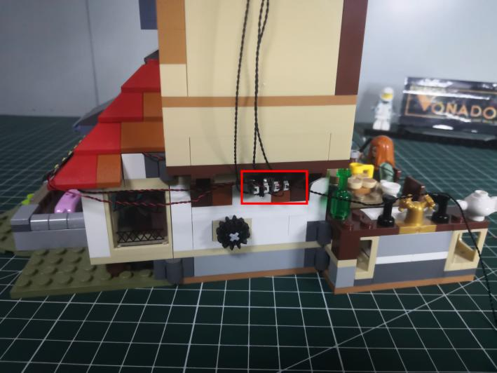

Take the following cable, thread it through the following space and pull it out from the back.
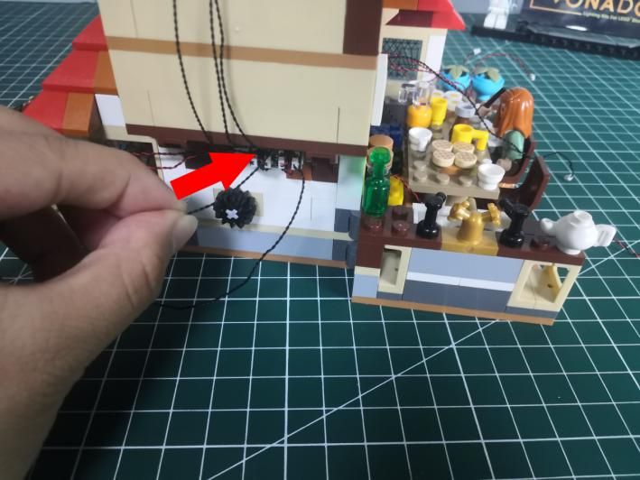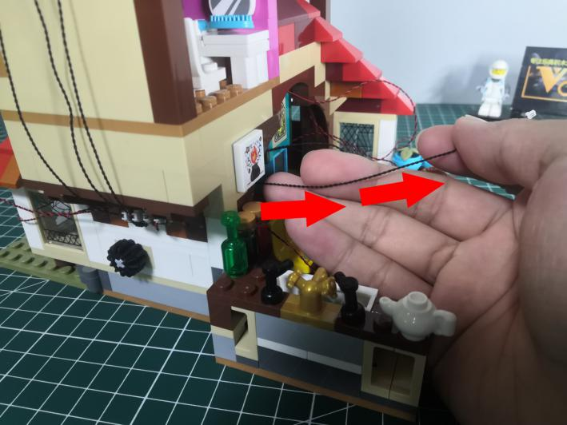

Turn to the back.
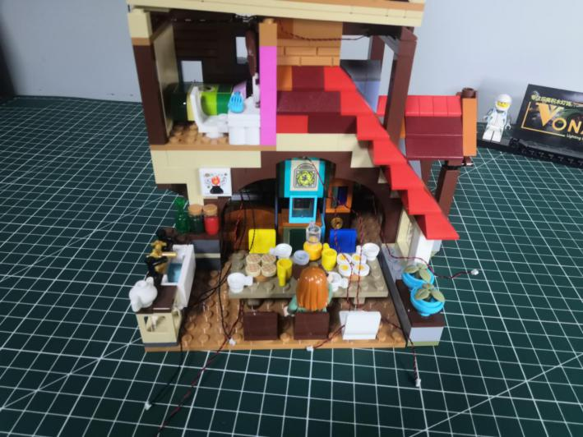

Take a 15cm connecting cable, a 4-port expansion board, assemble them as per below.
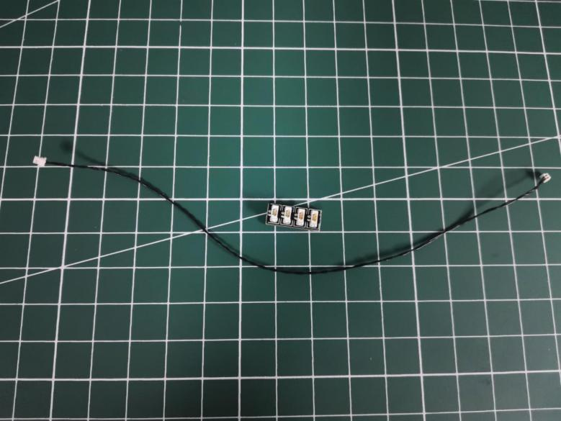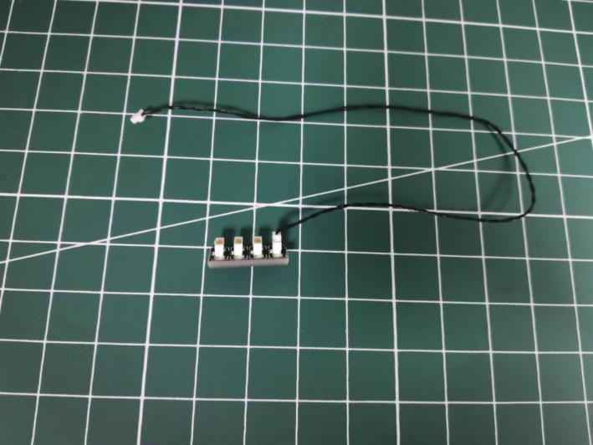

Turn to the following place, connect the 3 cables to the expansion board.
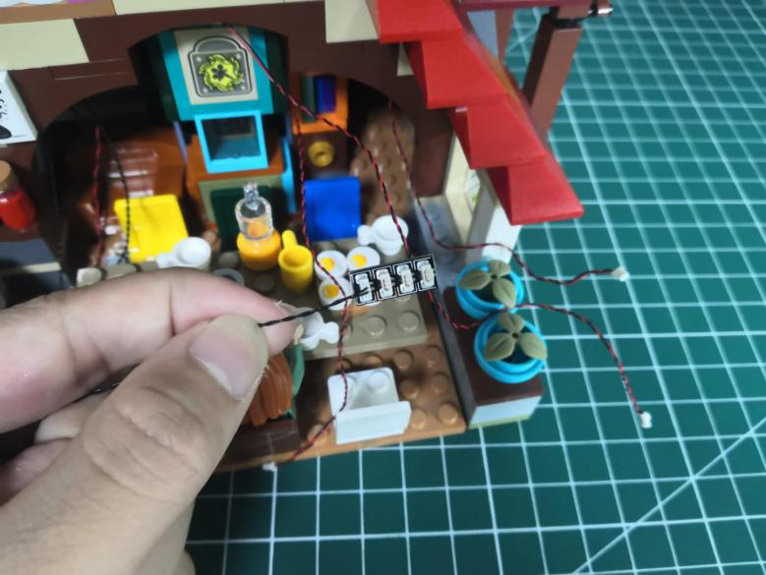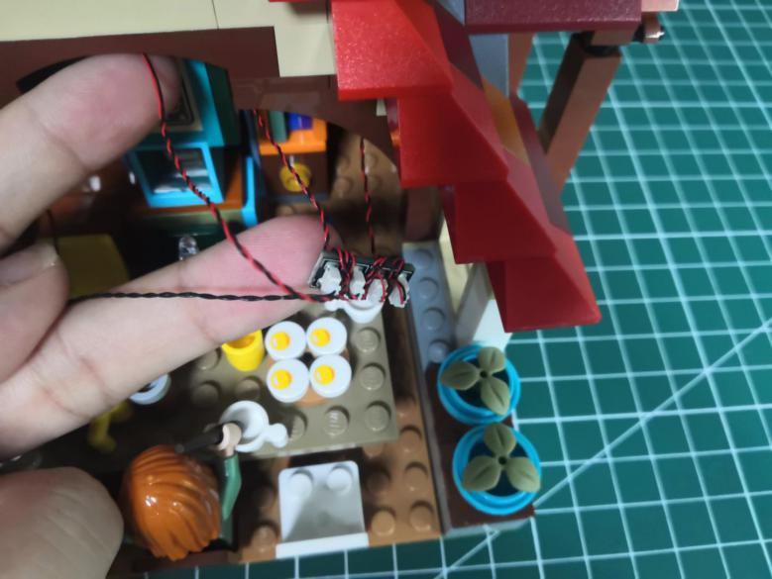

Take 2 adhesive squares.
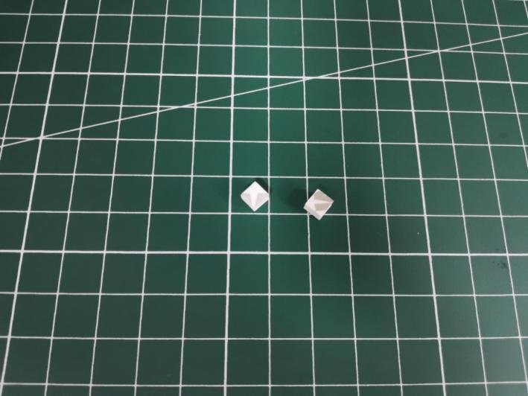

Stick them to the back of the expansion board, stick the expansion board to the following place.
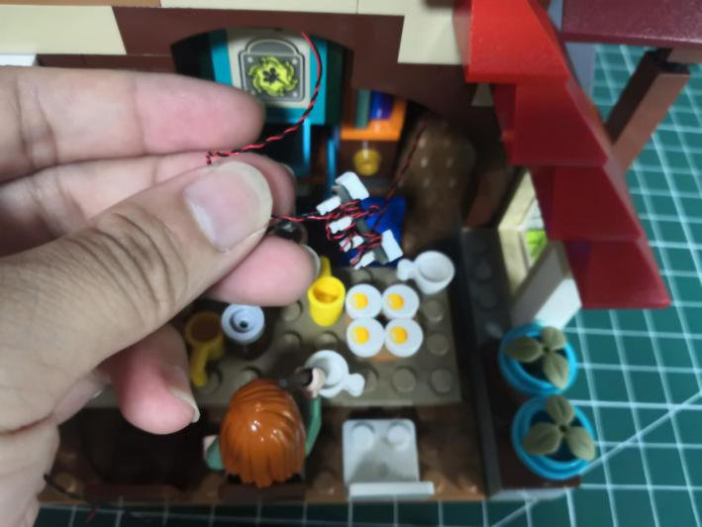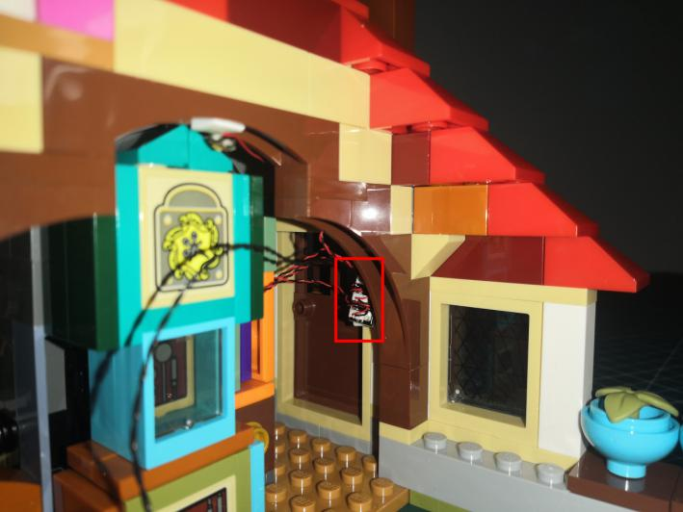

Turn to the back.
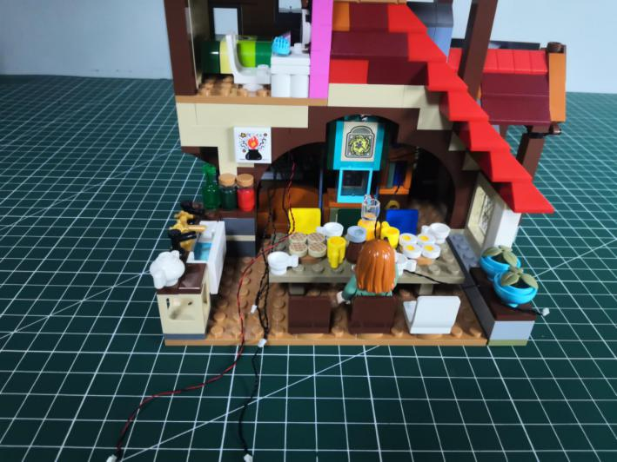

Take a 5cm connecting cable, a 4-port expansion board, assemble them as per below.
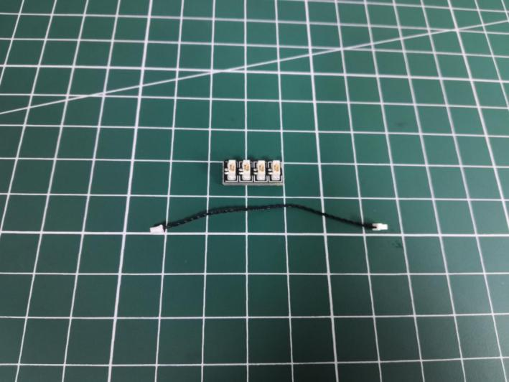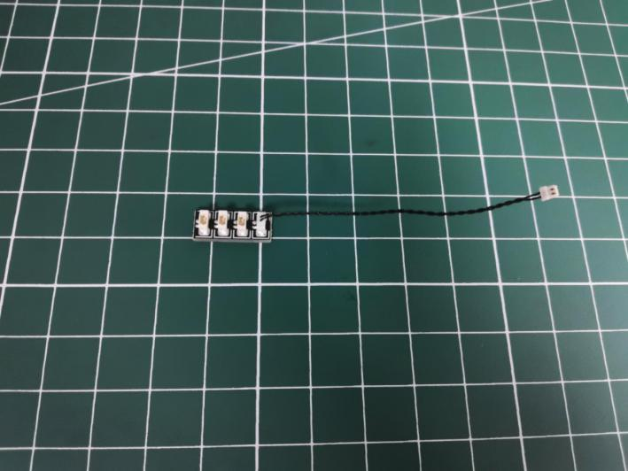

Take the following cable, connect it the to the expansion board, tuck excess cable around the expansion board.
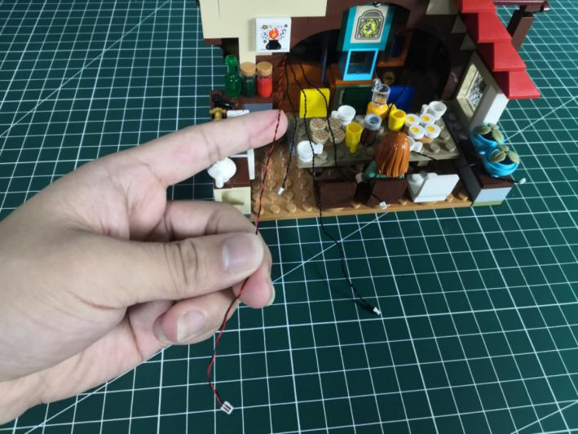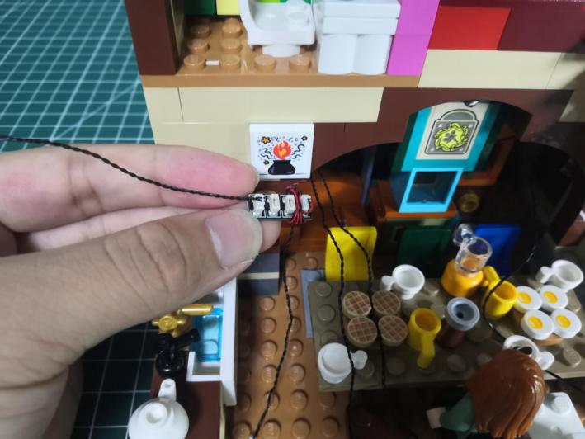

Take the following 3 cables (A、B、C).
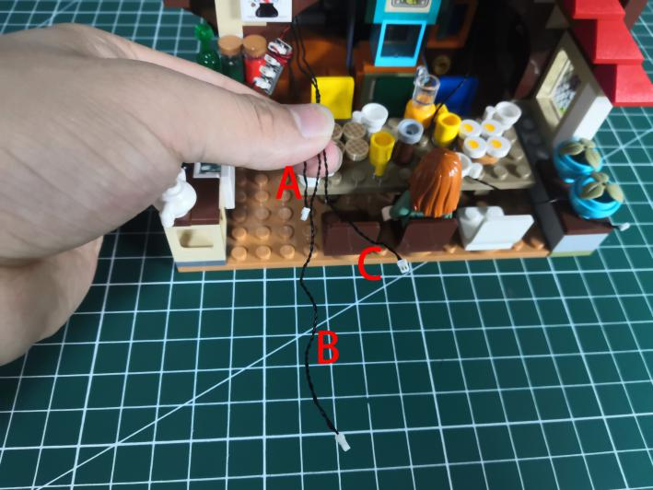

Connect the C cable to the expansion board, and tuck excess cable around the expansion board.
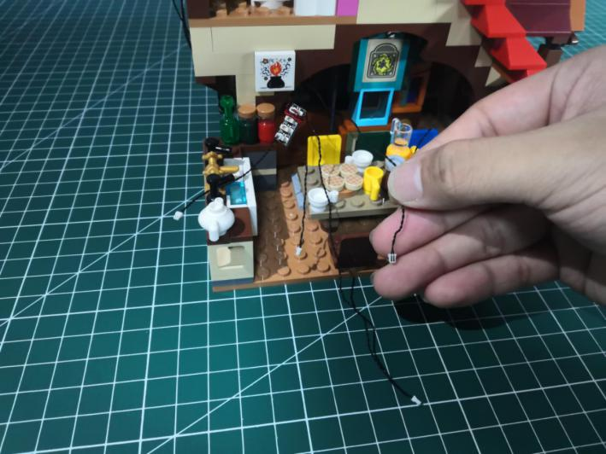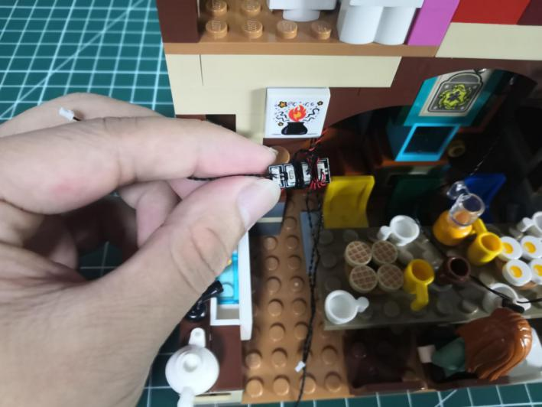

Take a Remote Control Switch Board.
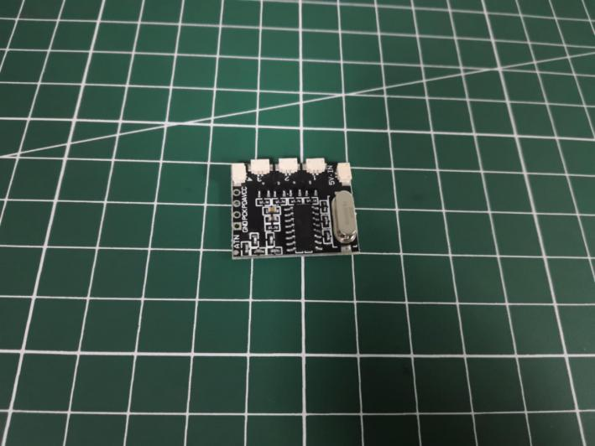
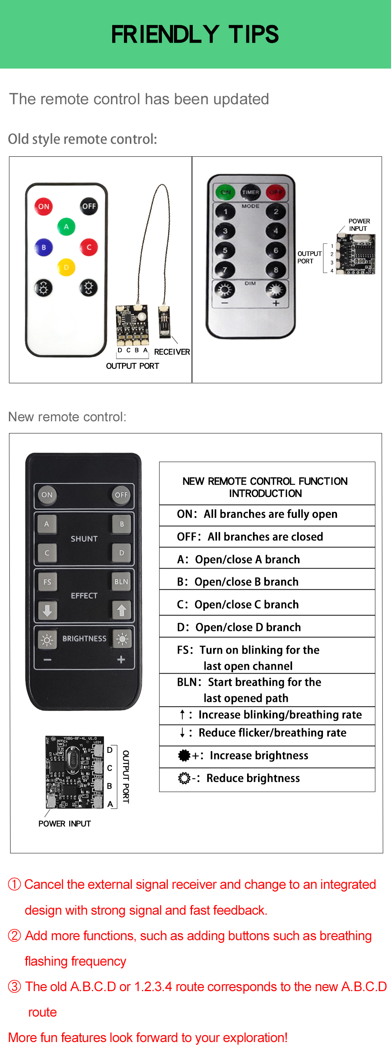

Connect the A cable to the 1 port.
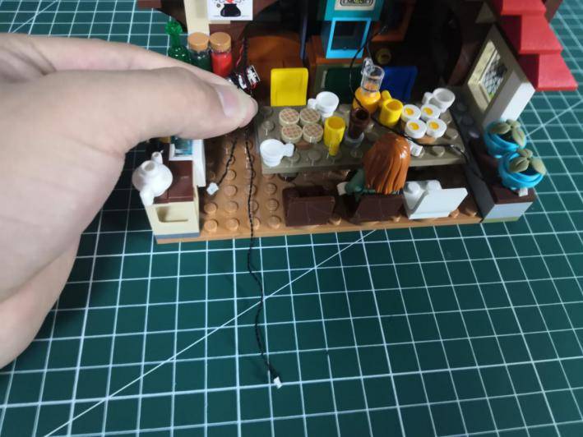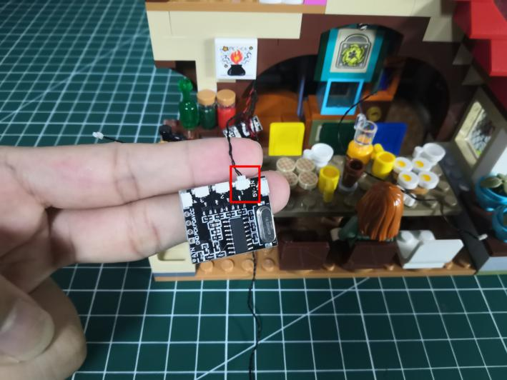

Connect the B cable to the 2 port.
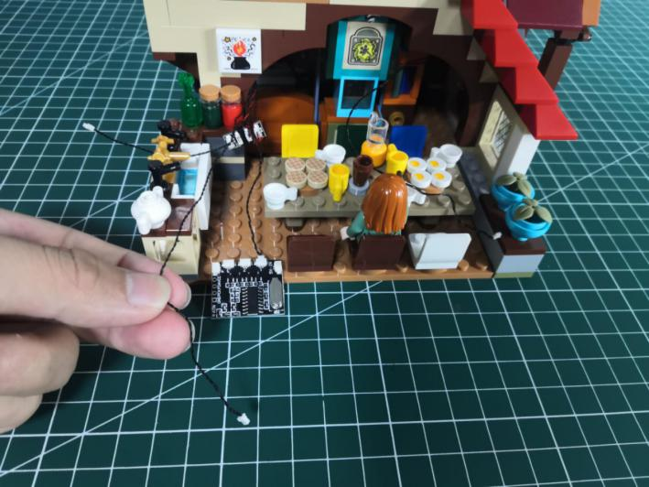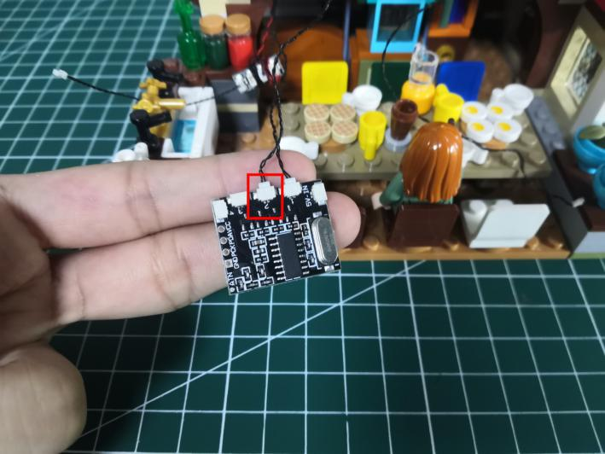

Turn to the right, connect the following cable to the 3 port.
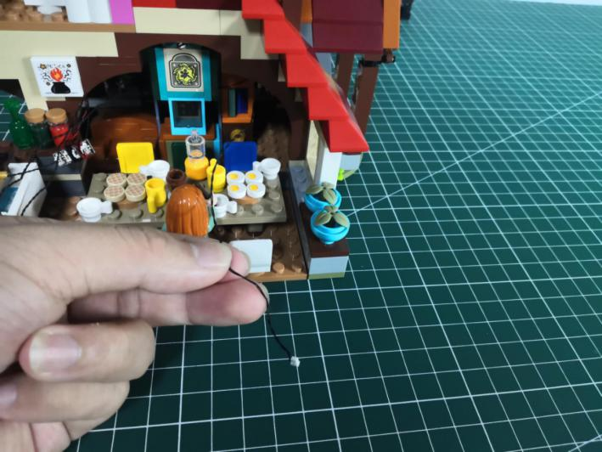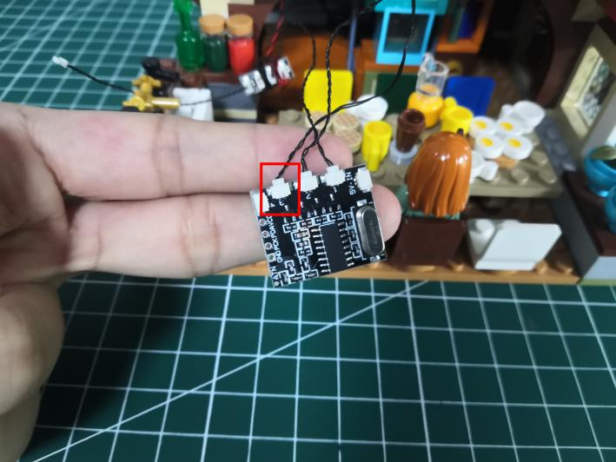

Turn to the left, connect the following cable to the 4 port.
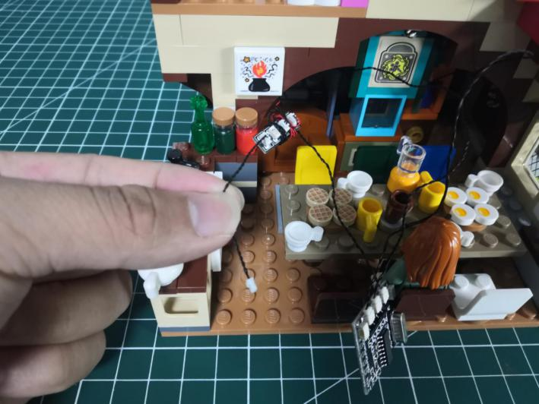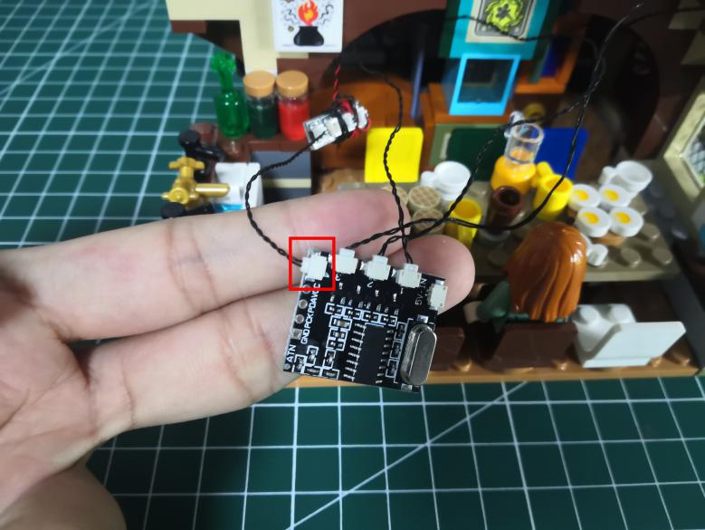

Take a USB cable.
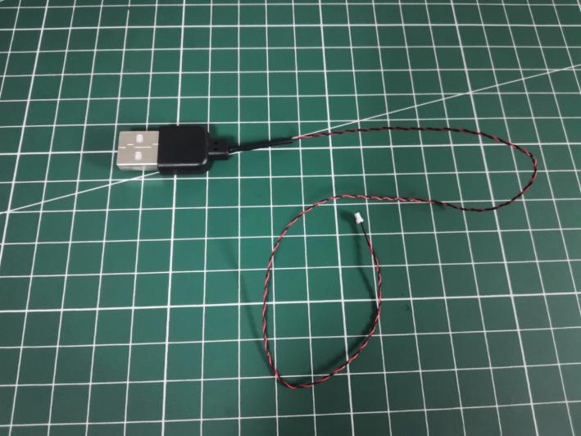

Thread the USB cable through the following space on the side wall, and pull it out from the back.
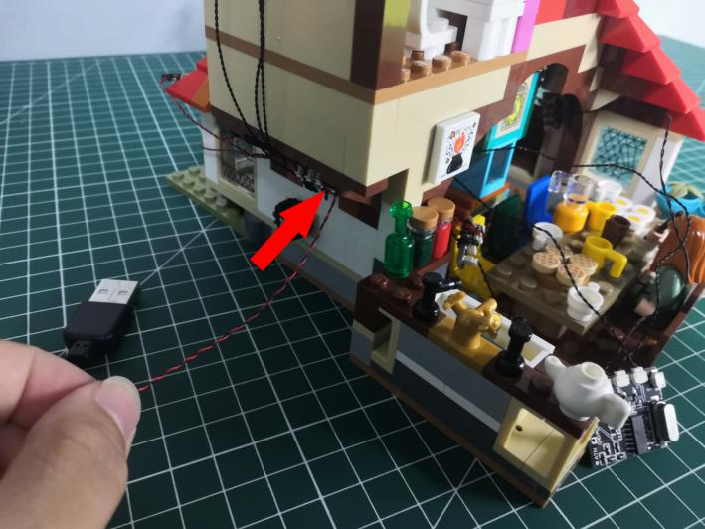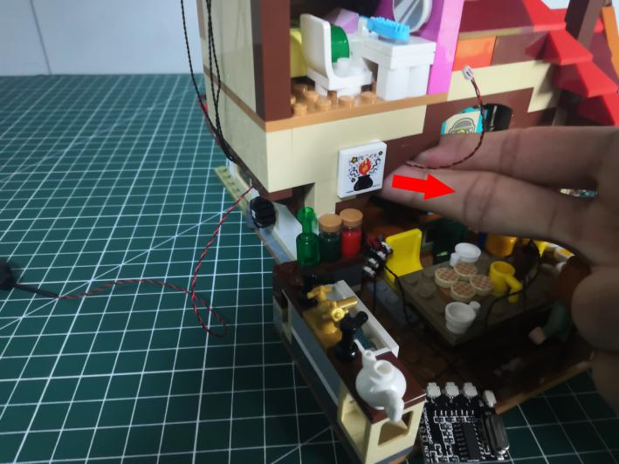

Connect the USB cable to the IN port.
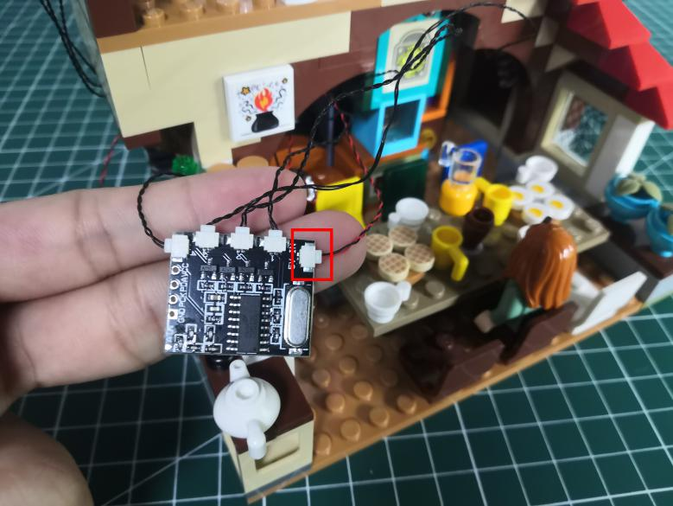

Take 6 adhesive squares.
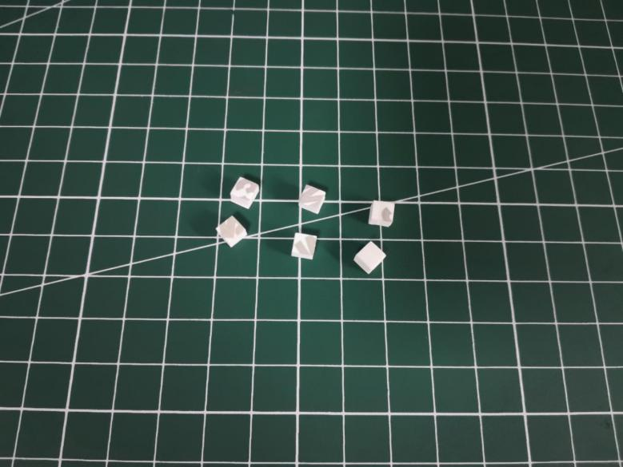

Stick 2 adhesive squares to the back of the expansion board.
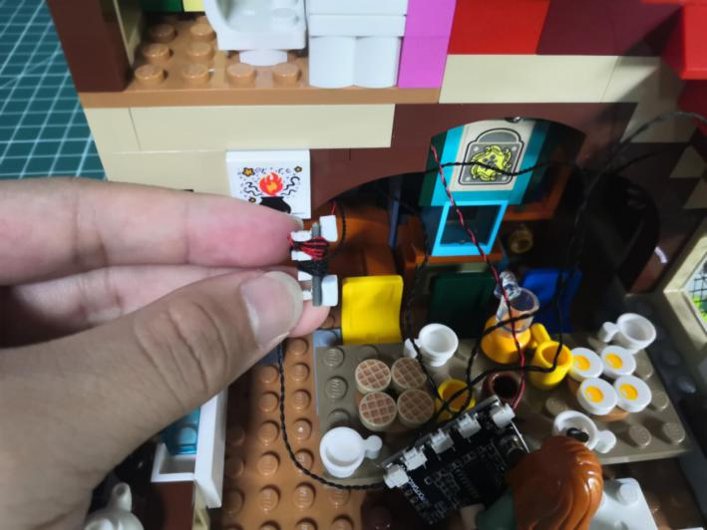

Stick 4 adhesive squares to the back of the Remote Control Switch Board.
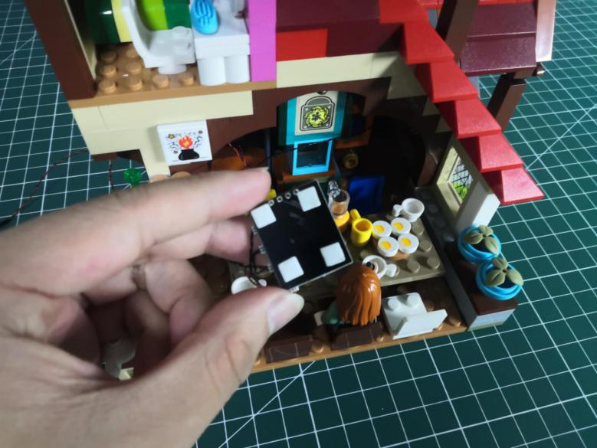

Stick them to the following places.
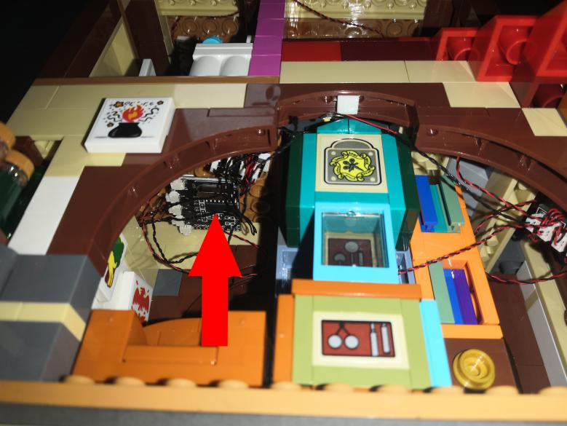

This completes installation of this LED Lighting Kit. ENJOY! （1 port： lights from the 3rd and 4th floors；2 port：lights from the 2nd floor ；3 port： lights from the 1st floor；4 port： lights at the front.）

The above are ideas and instructions provided by our designers. Please move on:
1: Do you have any suggestions about the material and quality of our products?
2: Do you have any suggestions on the installation instructions and the degree of difficulty of the installation?
3: If you have better installation method and ideas, please contact us in time.

