Lighting Kit LEGO 76898

Thank you for choosing our lighting products. We are committed to LEGO product study and lighting development, we're always trying our best to provide LEGO fans with the best products and the best installation ideas.
Must be careful observation, imagination can be infinite.
We provide basic parts to support your imagination.
DO IT YOURSELF .that's what LEGO is .

As always, Lego has been adhering to the DIY philosophy from product selection, research and development to sales. Consumers buy the parts, you will assemble them by yourself, and you can experience every step from picking up the first piece to installing the last one. Besides, LEGO has different answers for the installation form and method of each part. Vonado lighting also does not want to kill your unlimited creativity, we will try our best to make products with high variability, high playability and unlimited play. If you have any dissatisfaction or your own ideas on the parts such as the color of the lights, the length of the cables, the installation position of the product, and the final effects of each module, you can make your own arrangement, and we will cooperate with you to replace or repurchase.
LETS MOVE!
Package contents：
- 7 x 15cm White Dot Lights
- 3 x 15cm Red Dot Lights
- 2 x 15cm Yellow Dot Light
- 1 x 15cm Head Light
- 1 x 4-port Expansion Board
- 2 x 6-port Expansion Boards
- 3 x Flat Coin Cell Battery Pack
Extra pieces
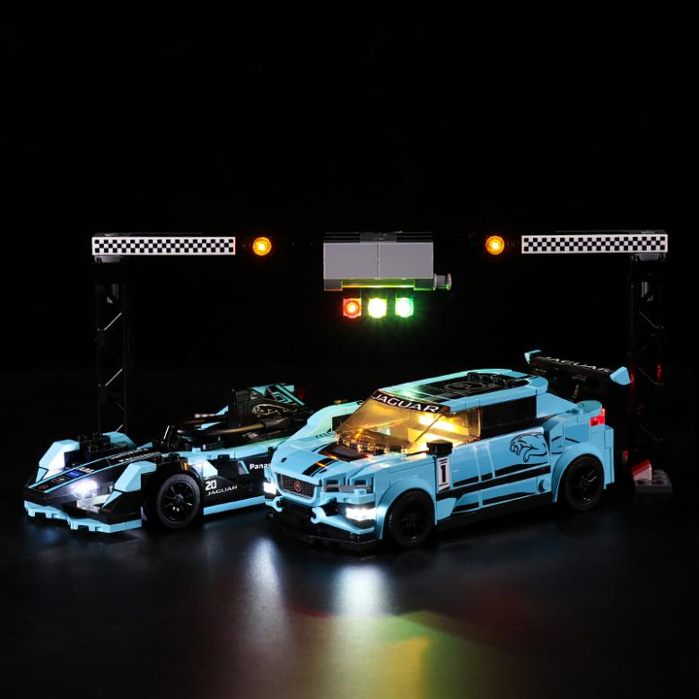
Note:
Place wires on the surface or under the building blocks.
The wire can be place between the building blocks or under the block, but they should be placed between the studs correctly.

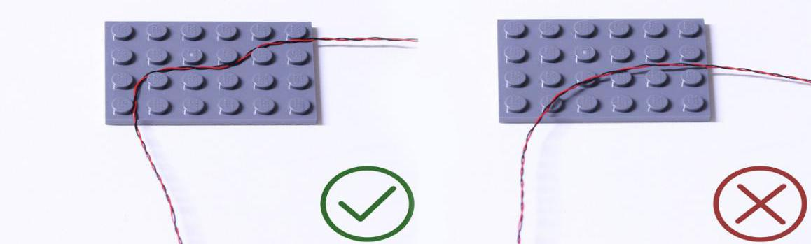

Insert the connectors to the ports.

Be careful when you are operating, there’s only one correct way to insert, make sure the expansion board is upward, find the soldered “=” sign on the left of the port. When you are inserting, the side which the wires can be seen should be faced to the “=” sign and if you feel hard to insert, please stop, and don’t force it, for that may result in bent pins inside the port or overheating of the expansion board.

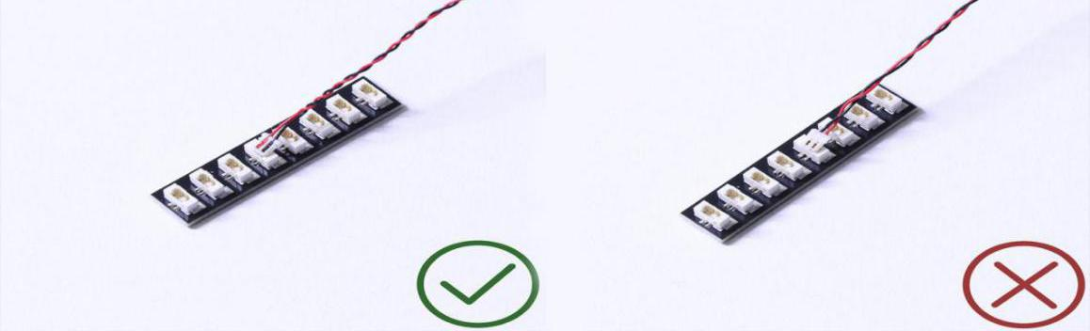

At this point, use the tweezers to straighten the bent pins.

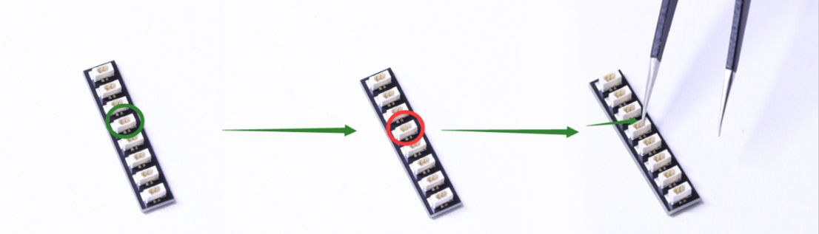

When installing dot lights, make sure they are correctly placed (Yellow LED package is exposed). You can put they either on the top of the studs or between studs.

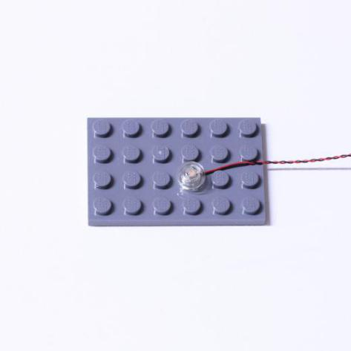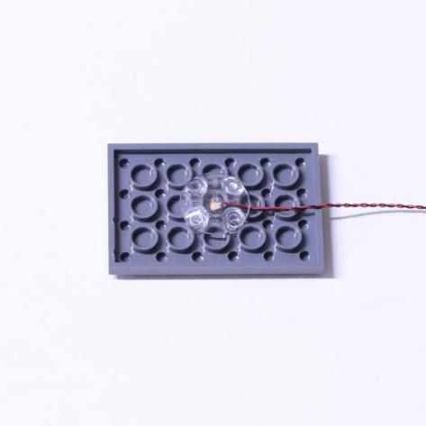

Connecting cable connectors to Strip Lights

Take extra care when inserting connectors to ports on the Strip Lights. Connectors can be inserted only one way. With the Strip Light facing up, ensure the side of the connector with the wires exposed is facing down. If a plug won’t fit easily into a port connector, don’t force it. Doing so will damage the plug and the connector.

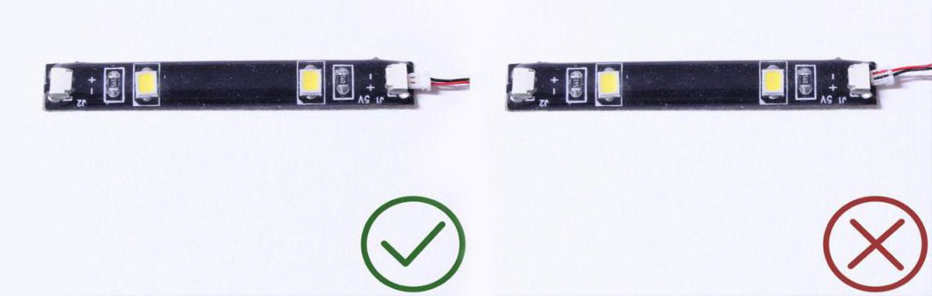

Finally, please pay attention to the positive and negative terminals of the battery when installing the battery case.

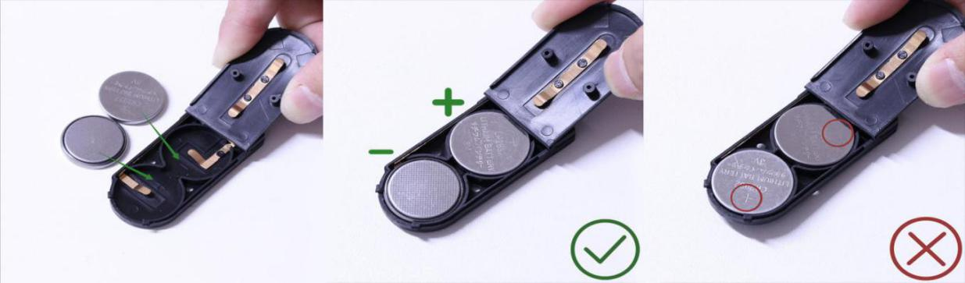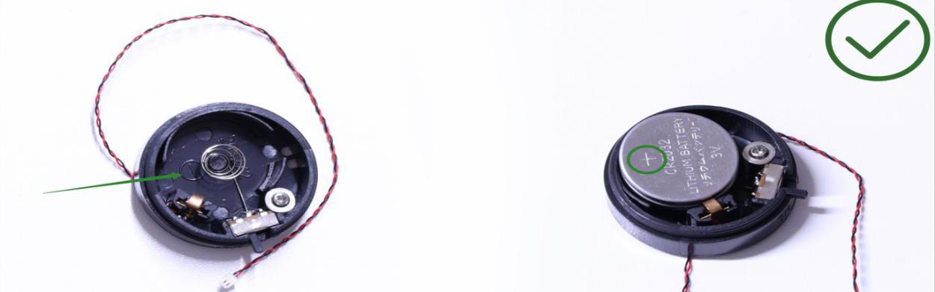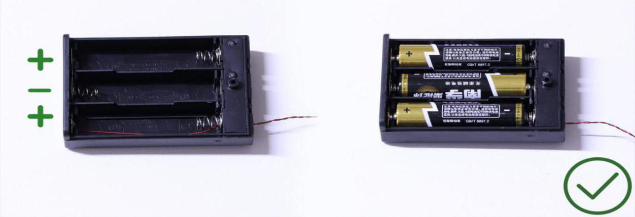
Instructions for installing this kit：
Supercar Series, Panasonic Jaguar Racing, Lighting Kit, 7 bags in total，6 bags with labels，1 bag without label，as per below:
Power supply：Flat Coin Cell Battery Pack（self-contained battery）.
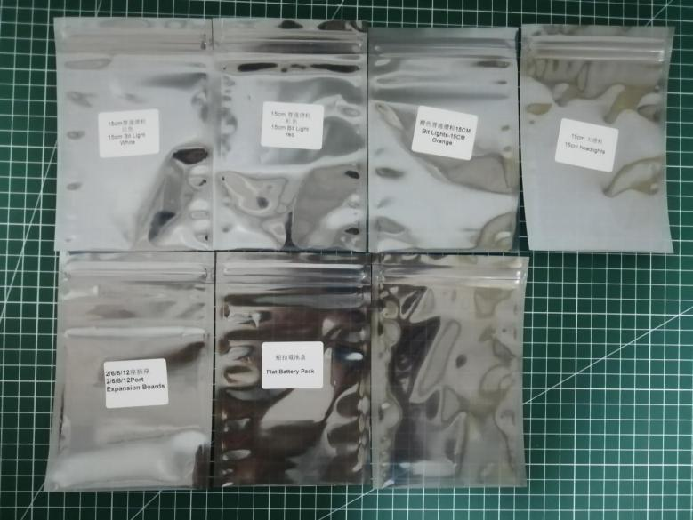

Firstly, take the battery pack, connect it to the expansion board to verify all the lights one by one.
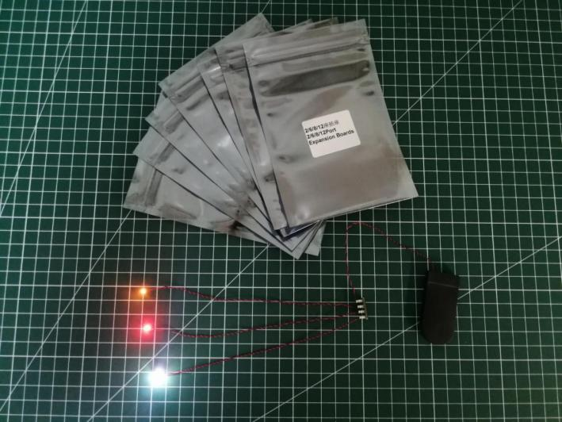
After the verification, disconnect the lights and put them back to the bags.
（note: put the lights back to the bags when verification of the lights from the same bag is done, then, continue to verify the lights in another bag.）
OK, Let’s Begin! （you can use the tweezer if necessary.）
（Tips: the tweezer is sharp, you should be careful when using it, do not hurt yourself or scratch the pieces; be gentle and do not wear the cables.）
Instructions for installing this kit：
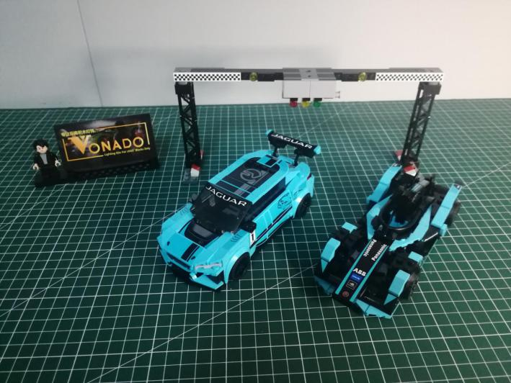

Take the first car.
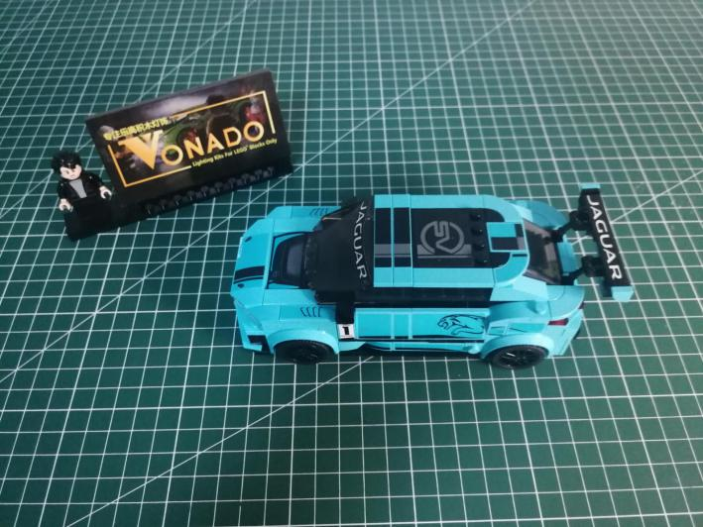

Remove the following piece from the head.
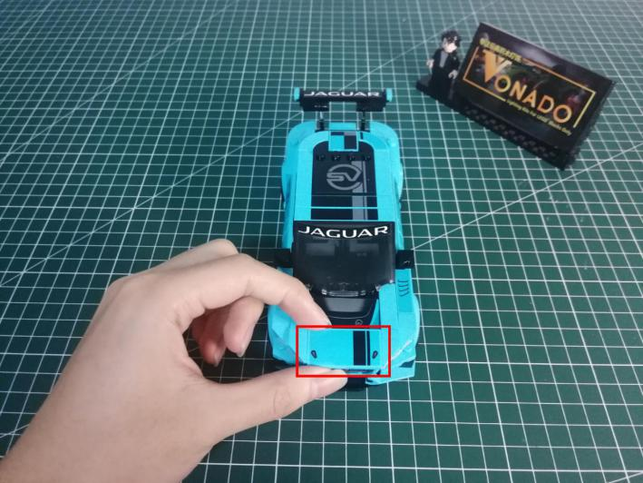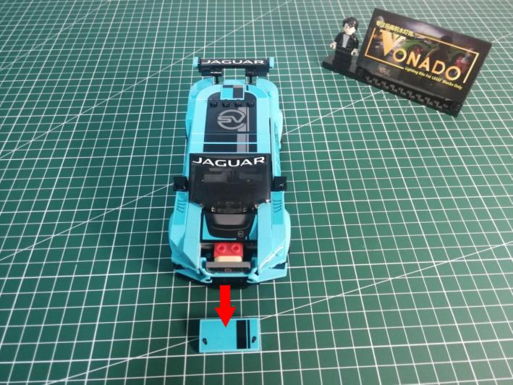

Continue to remove the following piece.
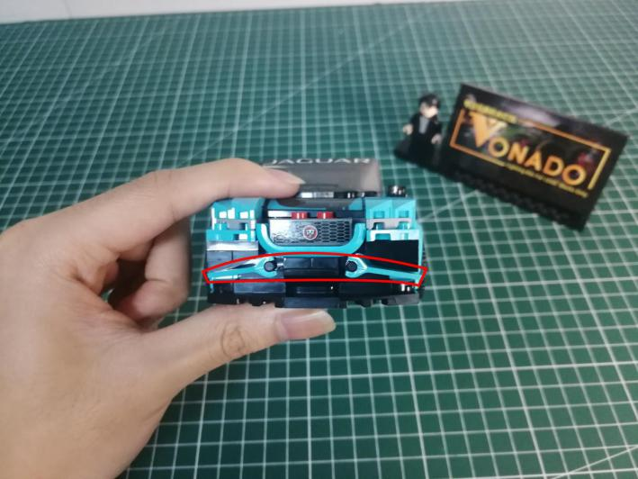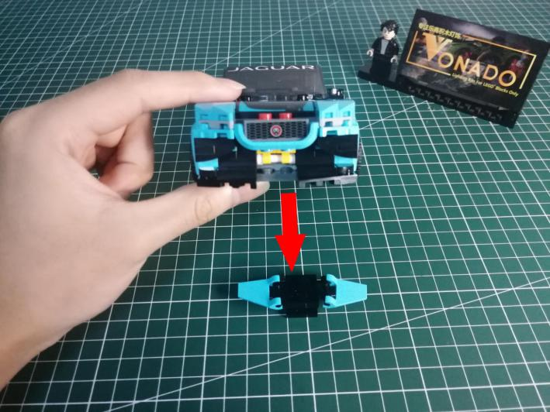

Remove the following piece.
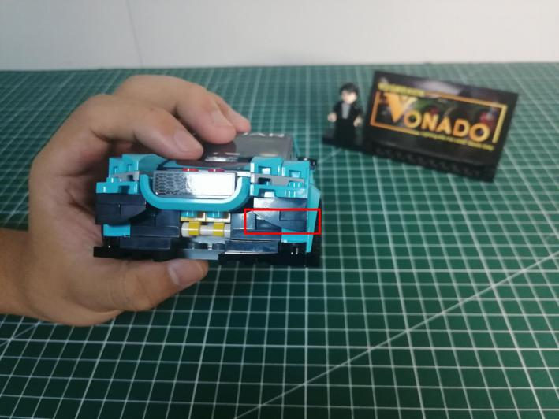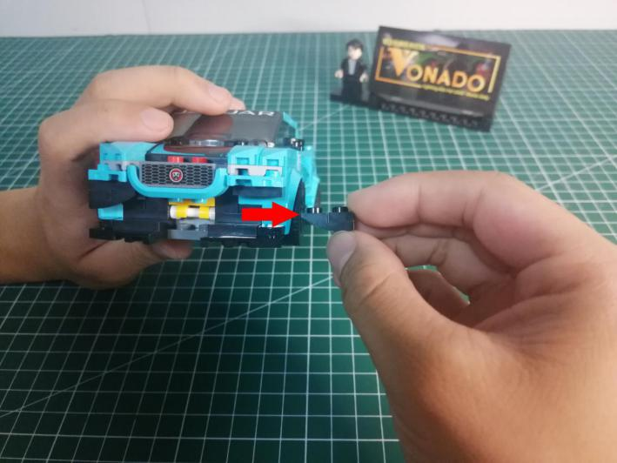

Remove the piece at the other side.
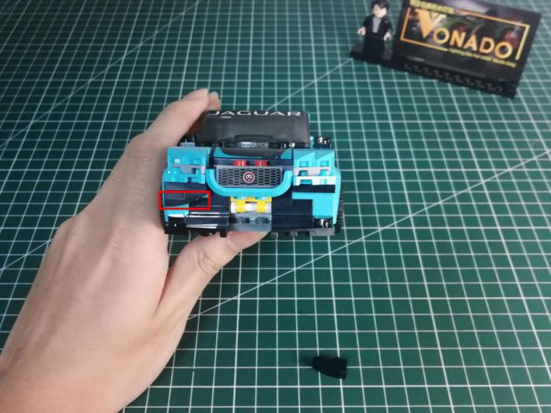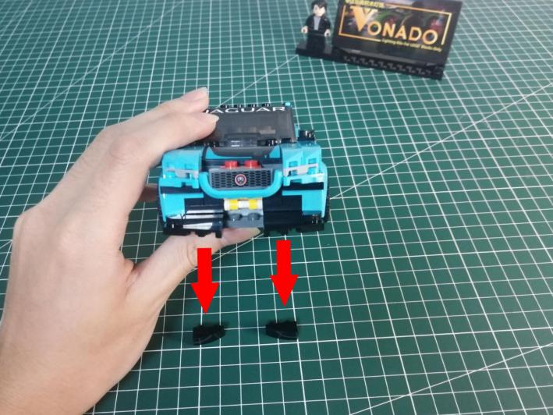

Disassemble the 2 black pieces.
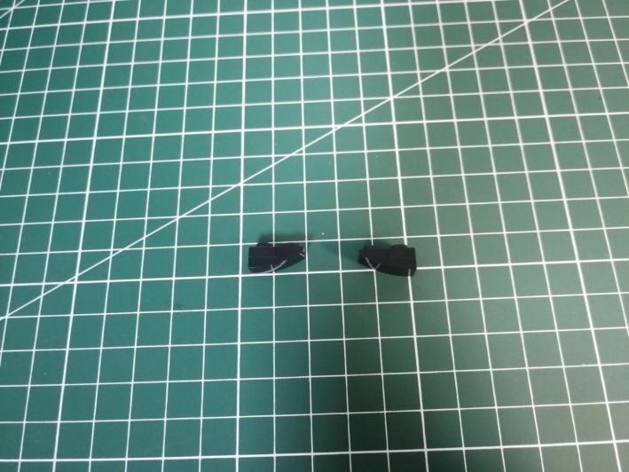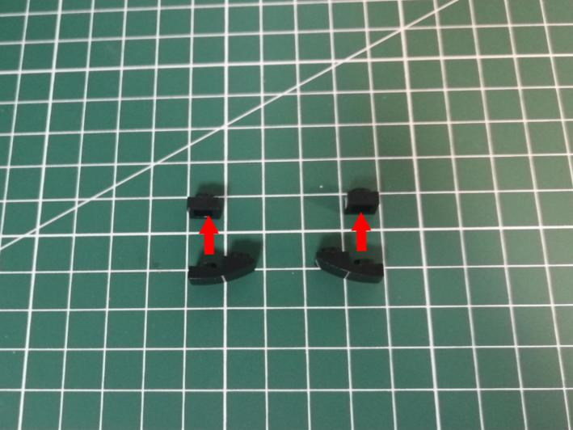

Take 2 white 15cm dot lights, 2 trans white 1x1 slope bricks.
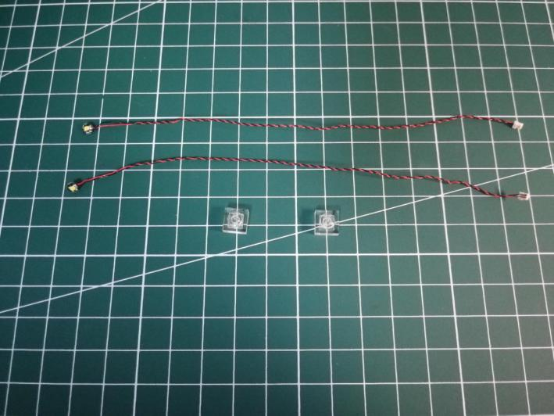

With lighting part facing up, place the light as per below.
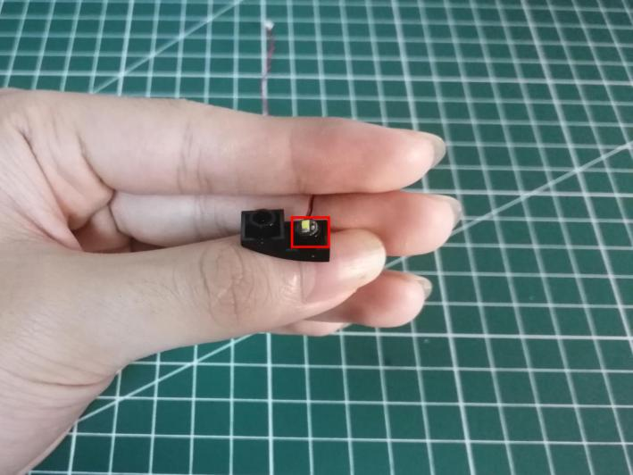

Connect the brick over.
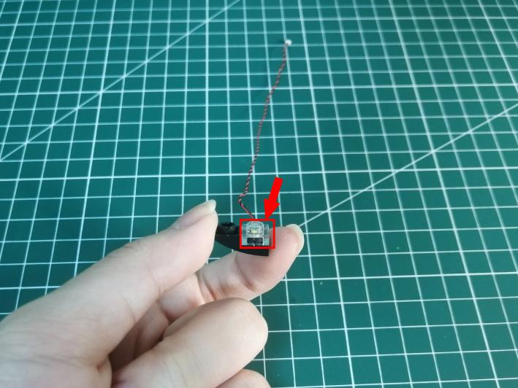

Install the light for the black piece at the other side in the same way.
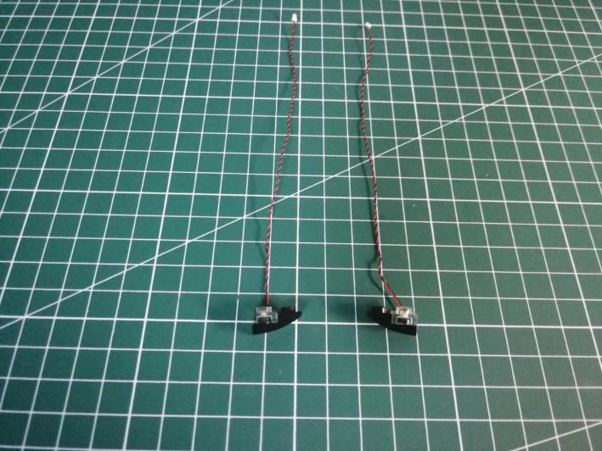

Thread the cable through the following space.
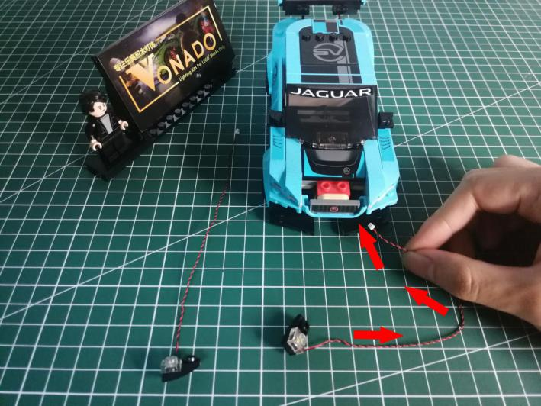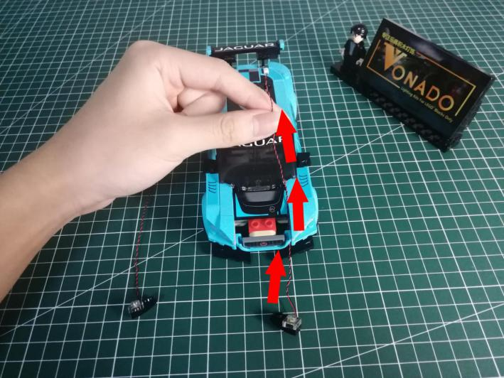

Tighten the cable up, reconnect the piece.
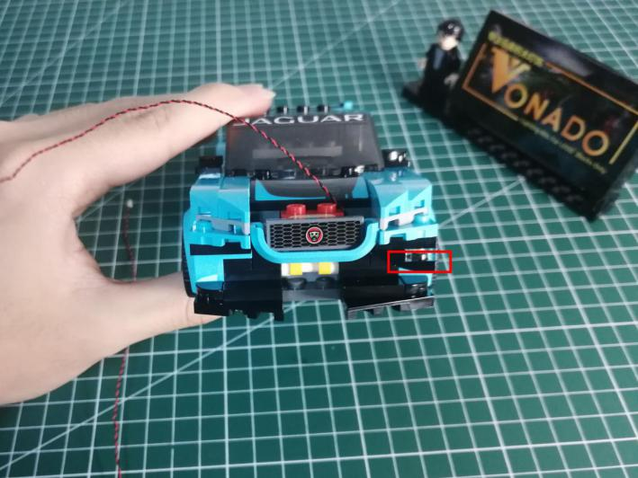

Thread the other cable through and reconnect the pieces as per below.
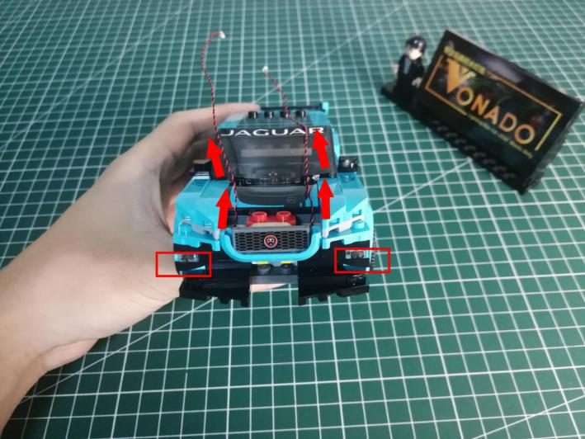

Remove the roof.
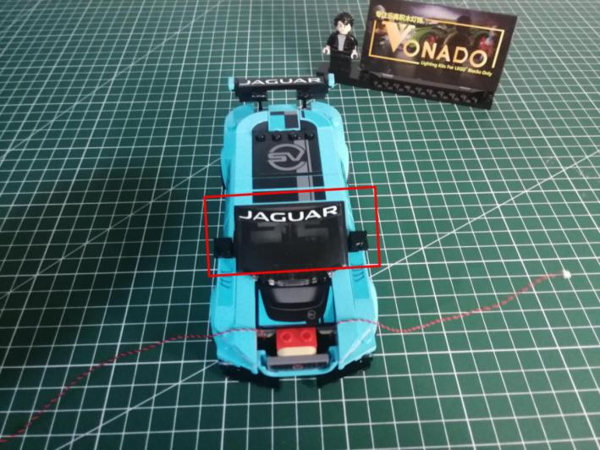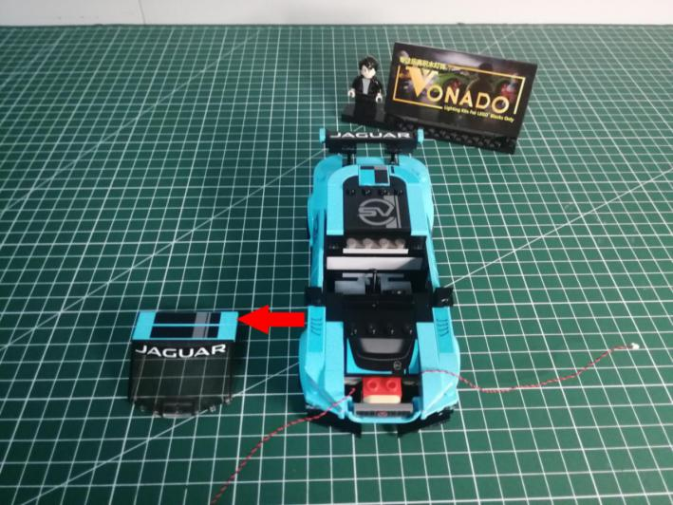

Continue to remove the following pieces.
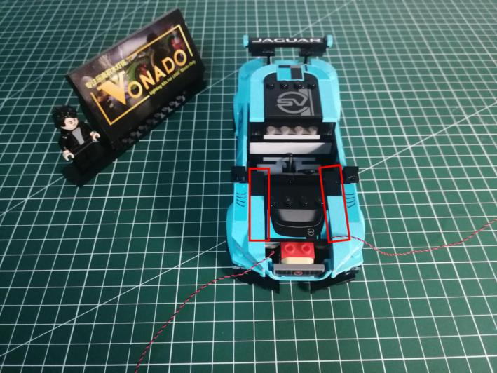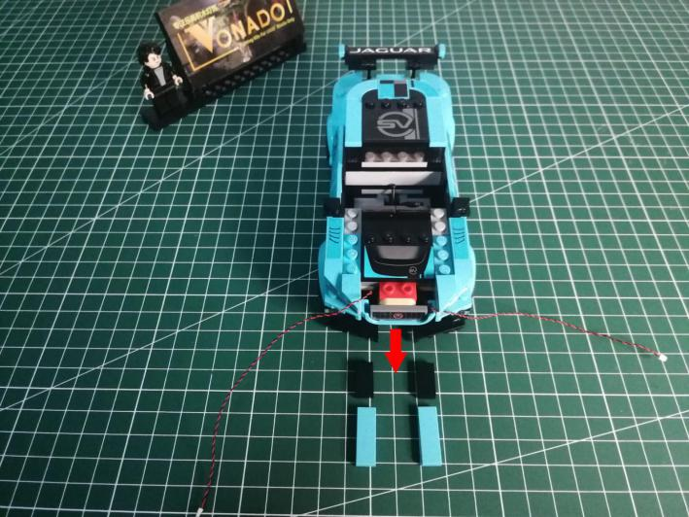

Place the cable alongside the studs as per below,
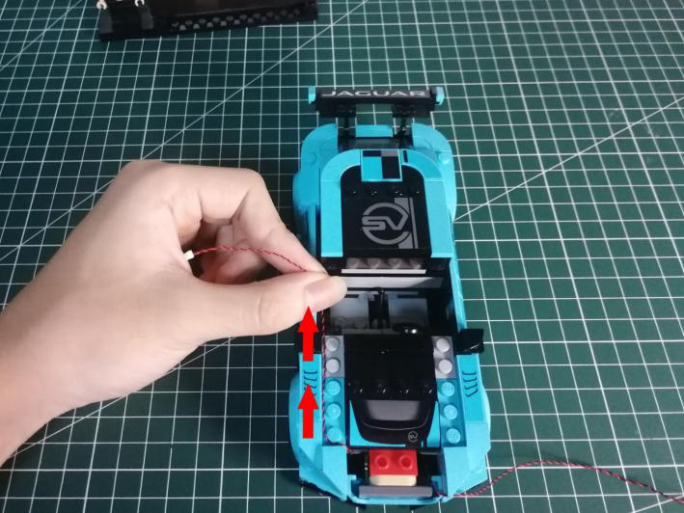

Reconnect the piece we removed before to secure the cable.
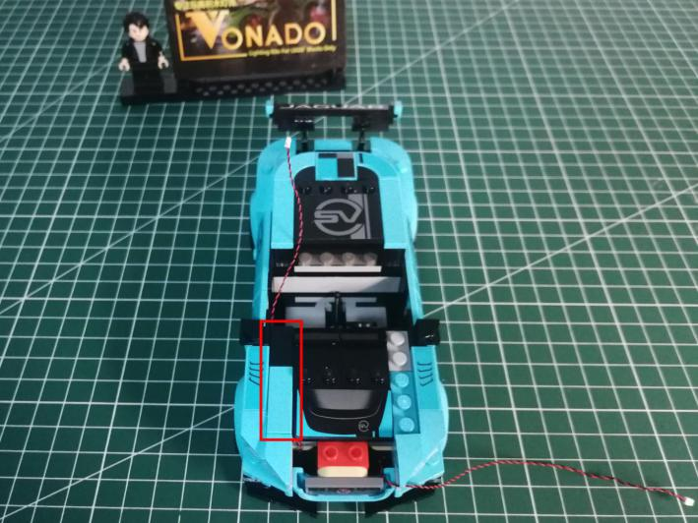

Place the cable at the other side in the same way.
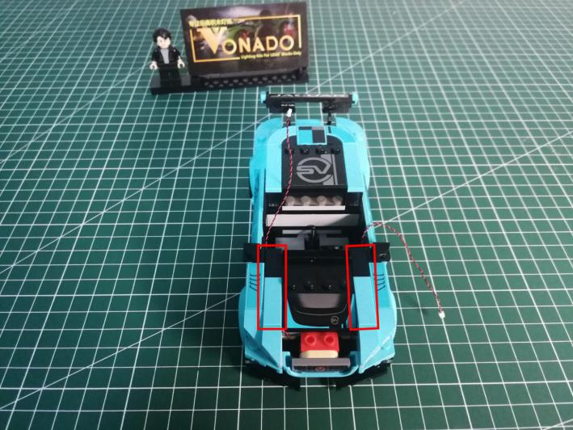

Reconnect the blue piece.
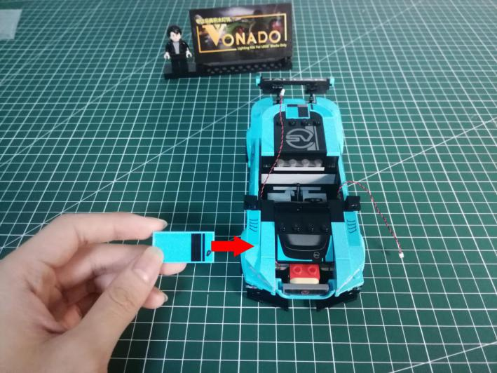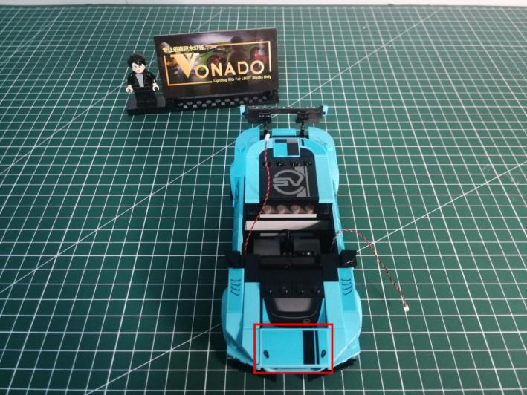

Reconnect the following piece.
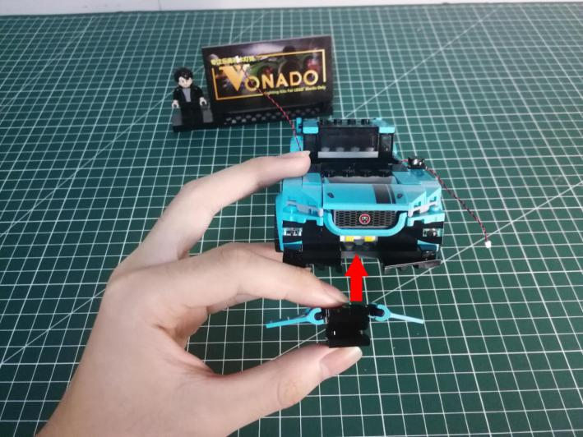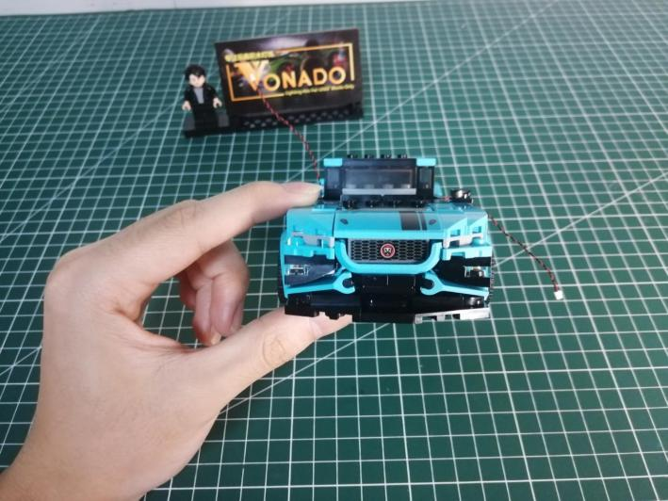

Turn to the back, remove the following piece.
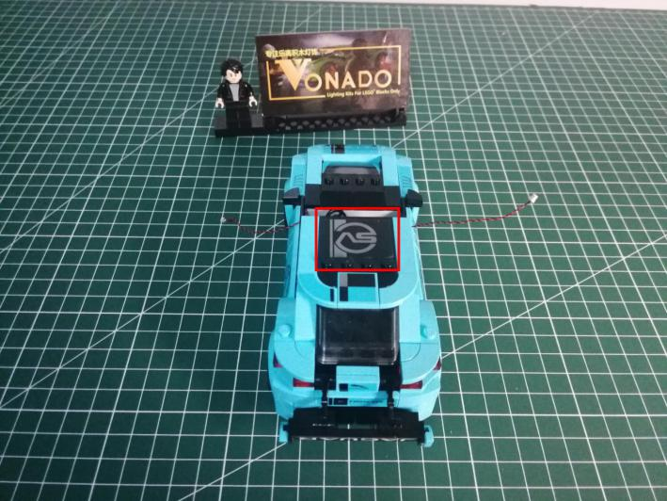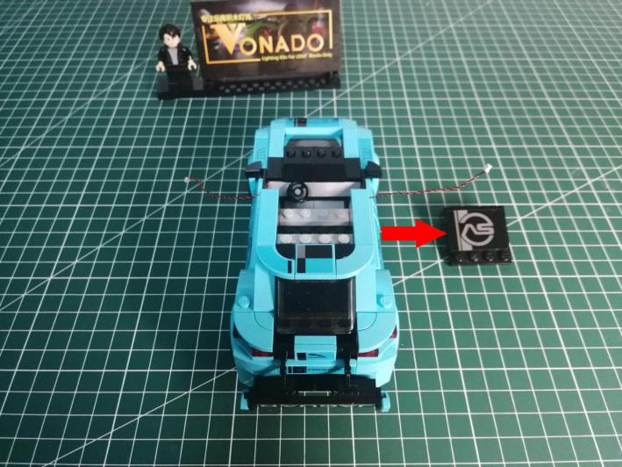

Remove the following pieces.
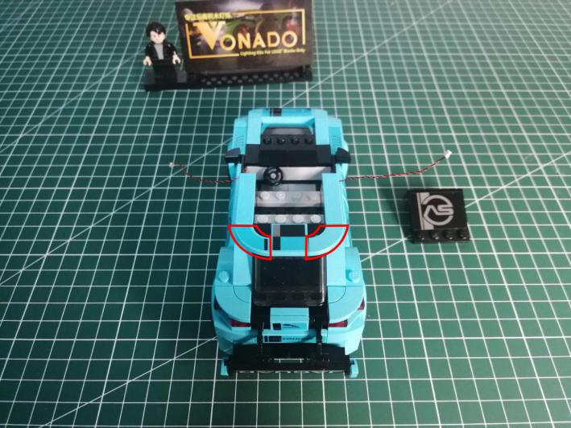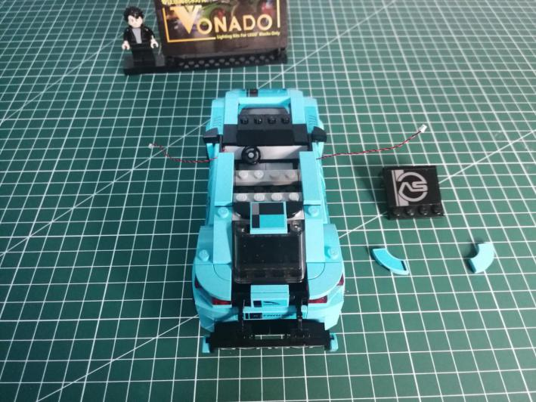

Remove the following whole gray piece.
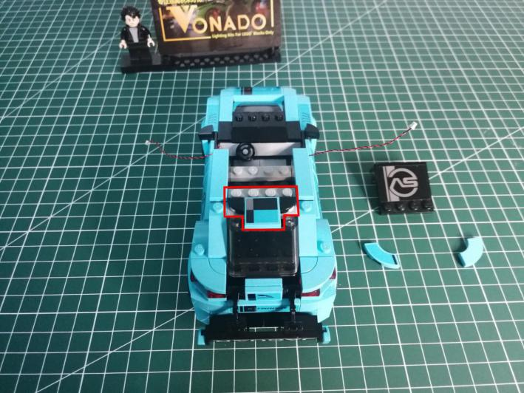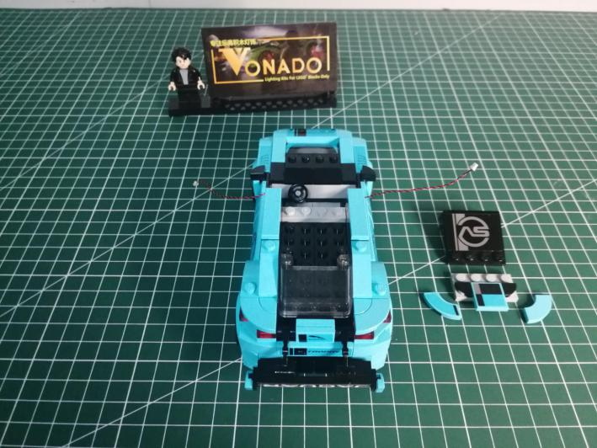

Disconnect the window shield.
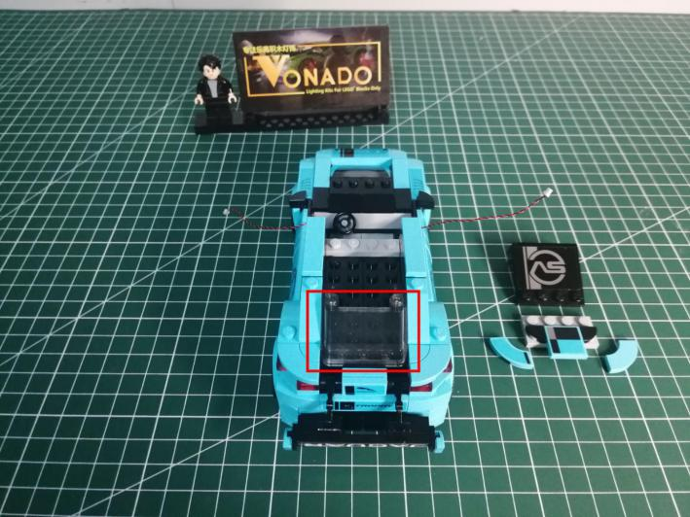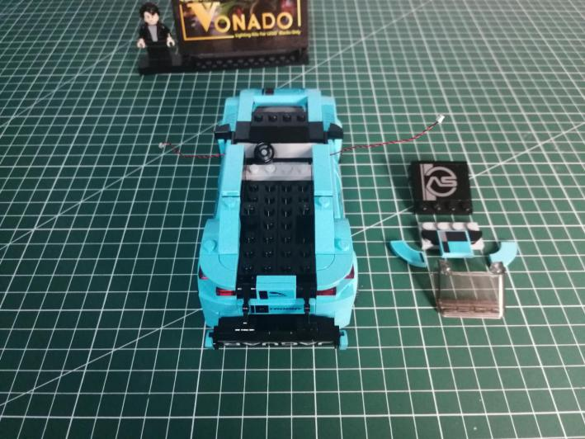

Remove the following pieces.
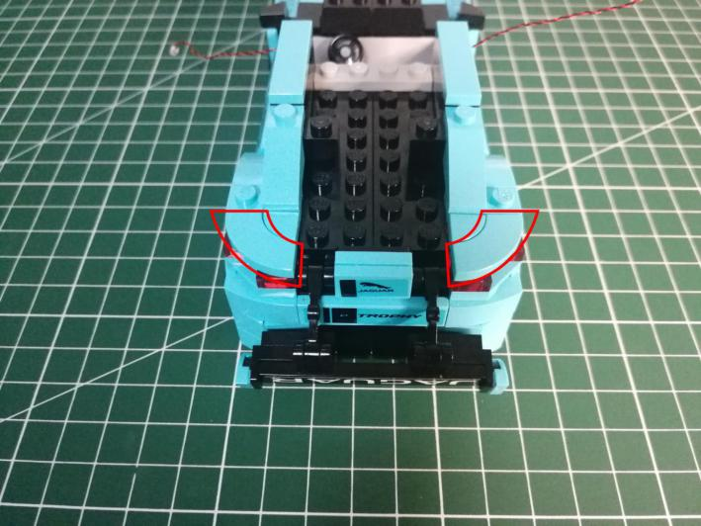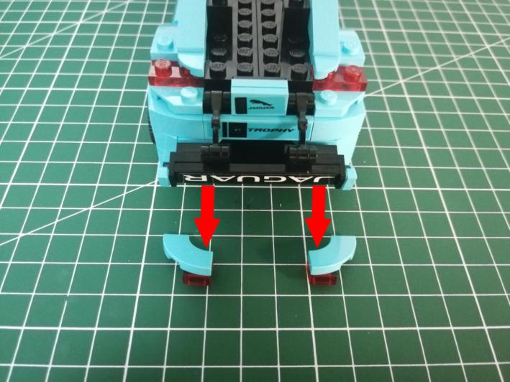

Take 2 red 15cm dot lights.
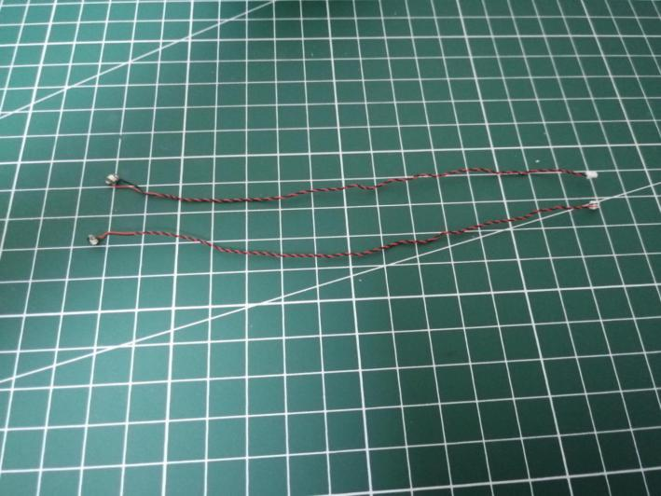

With lighting part facing up, place the light at the tail as per below.
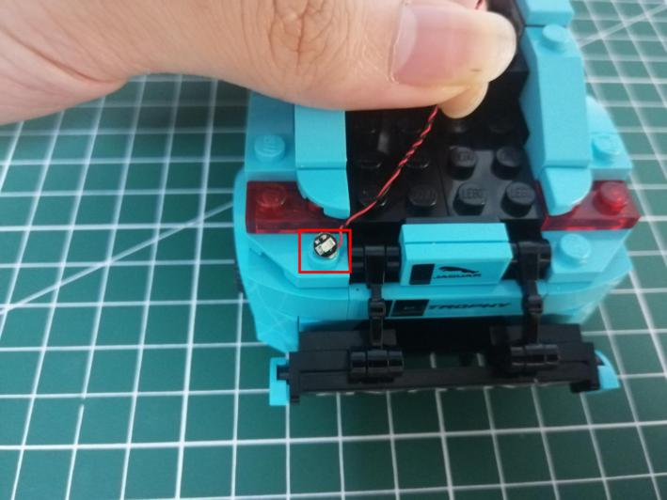

Reconnect the following piece.
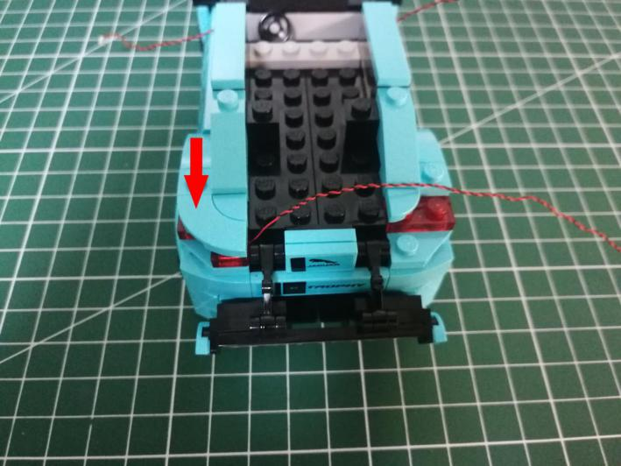

Install the light for the other side in the same way.
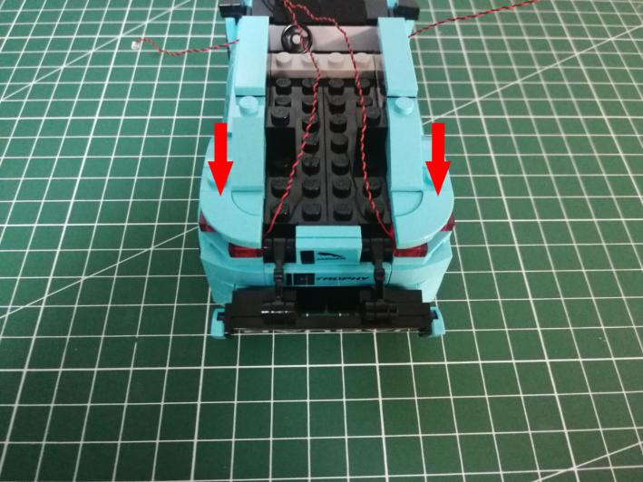

Remove the following black square piece.
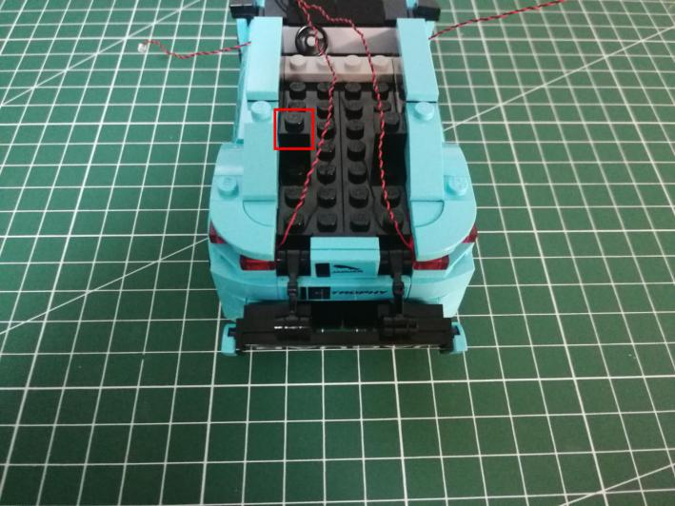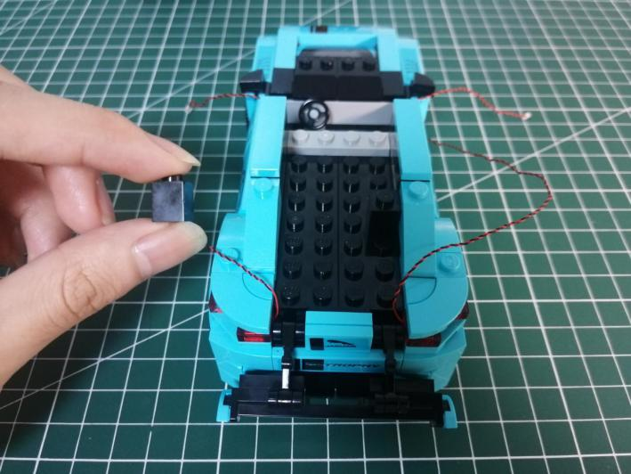

Place the cable alongside the studs.
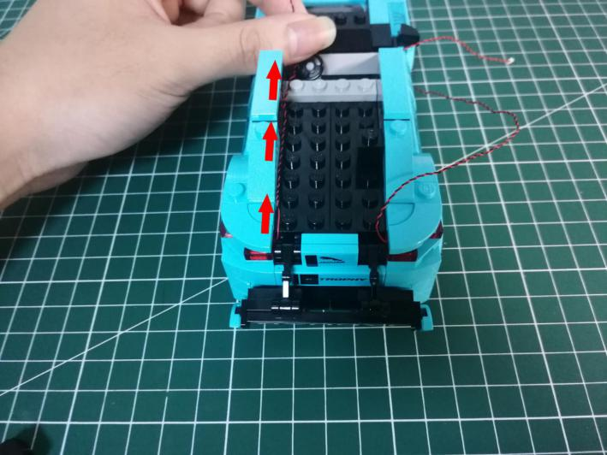

Reconnect the following black piece to secure the cable.
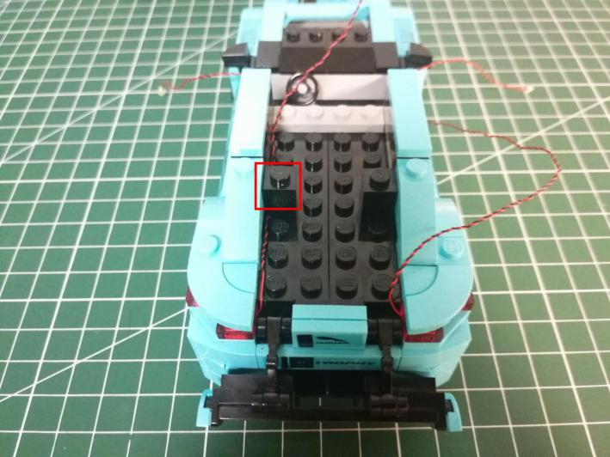

Secure the cable at the other side in the same way.
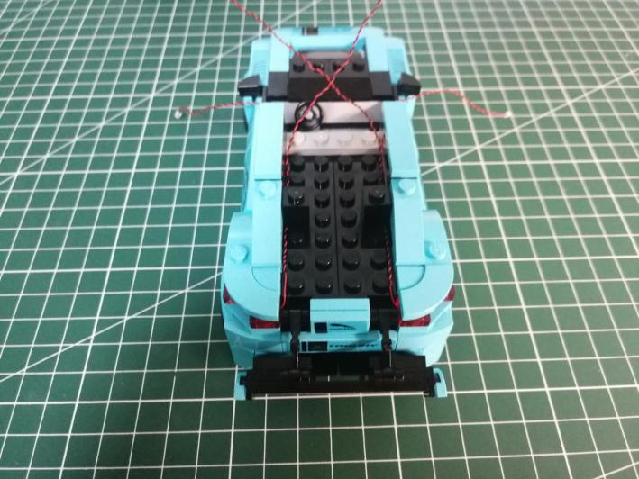

Disconnect the door.
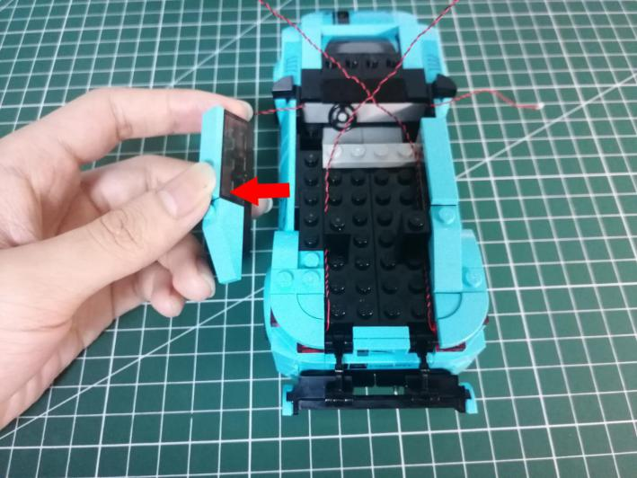

Pull the cable to the back.
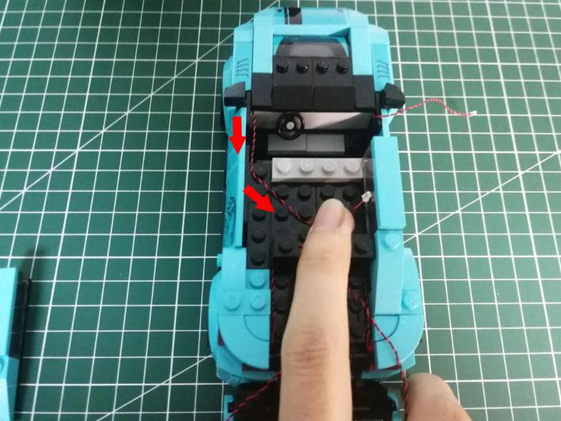

Reconnect the door to secure the cable.
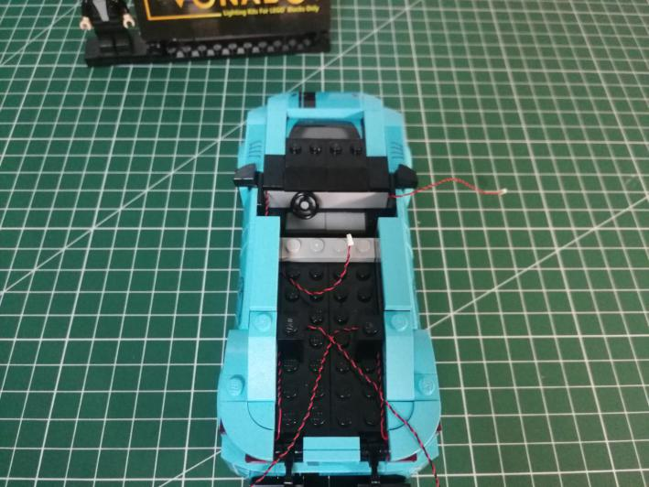

Place the other cable and secure it similarly.
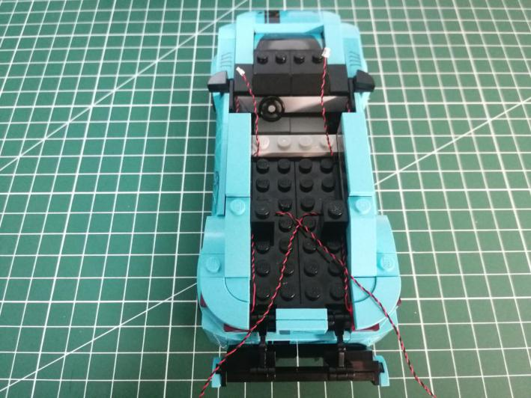

Take the window shield.
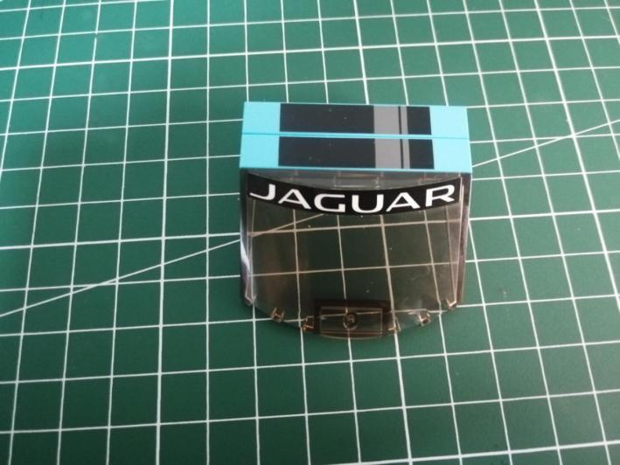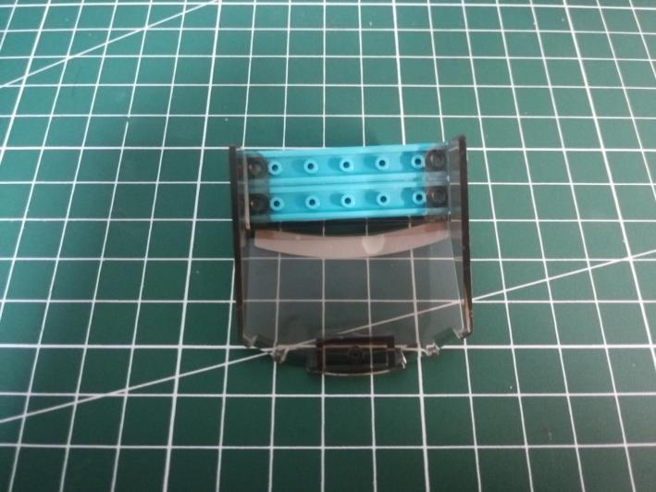

Take a 15cm head light, an adhesive square.
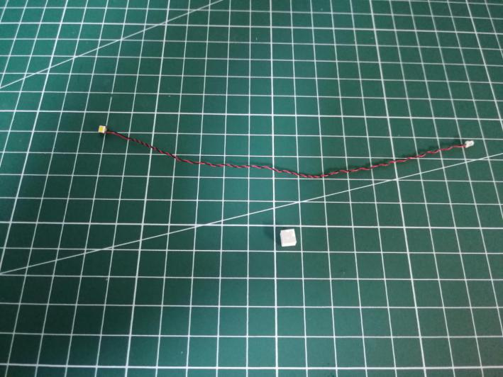

Stick it to the following place.
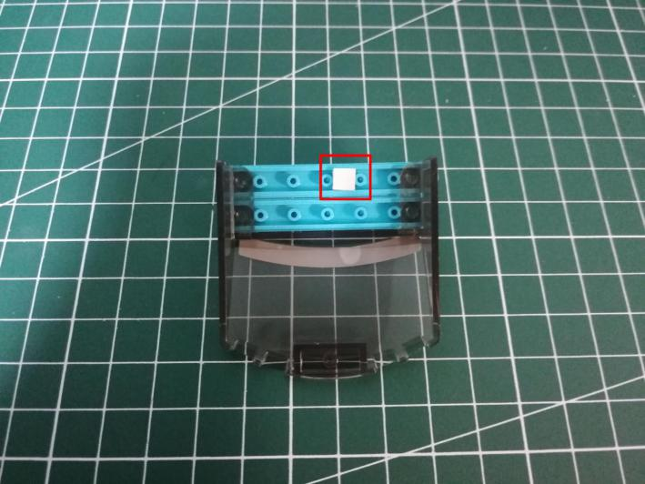

With lighting part facing up, stick the light on the adhesive square.
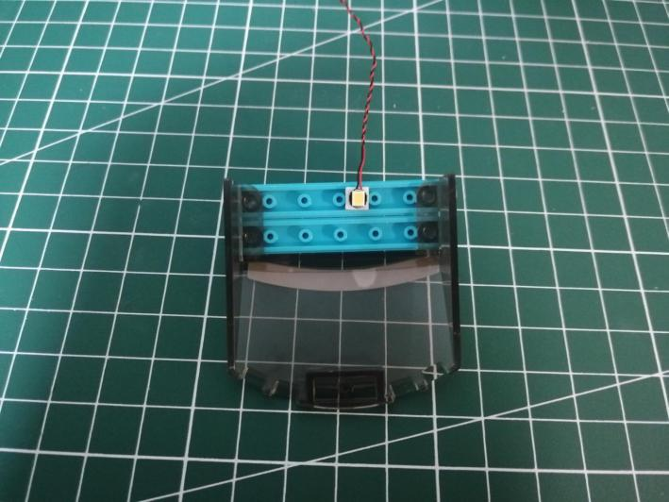

Reconnect the window.
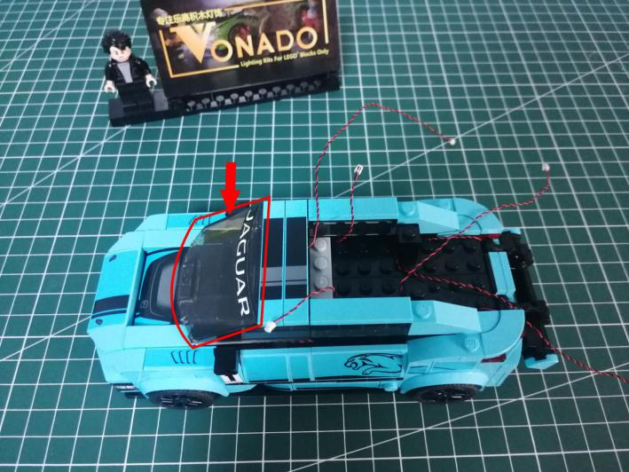

Pull the cable back and straighten it.
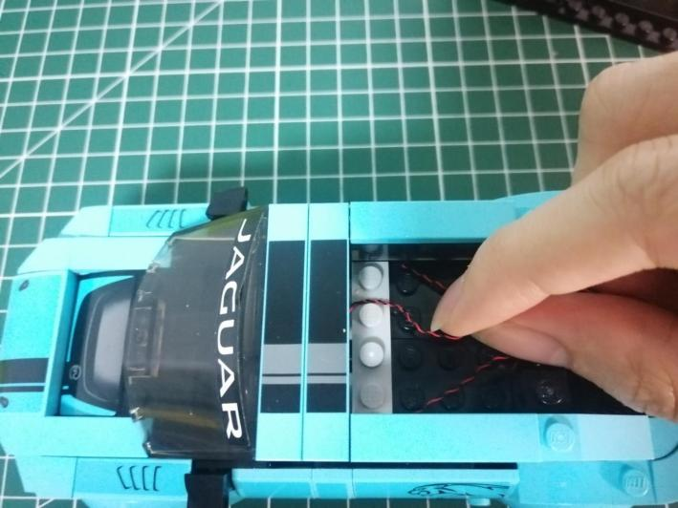

Reconnect the roof.
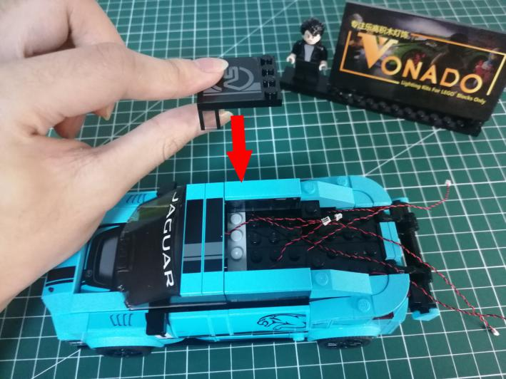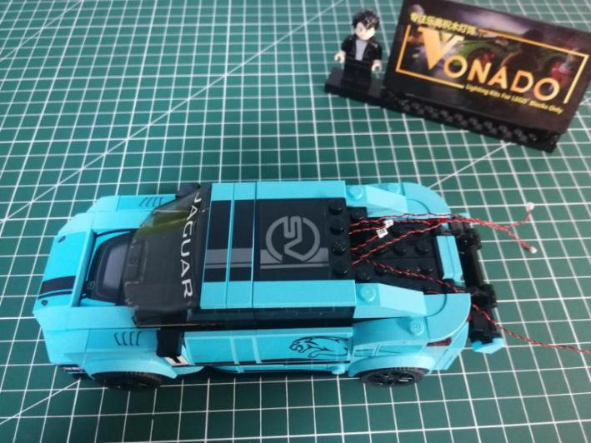

Continue to remove the following roof piece.
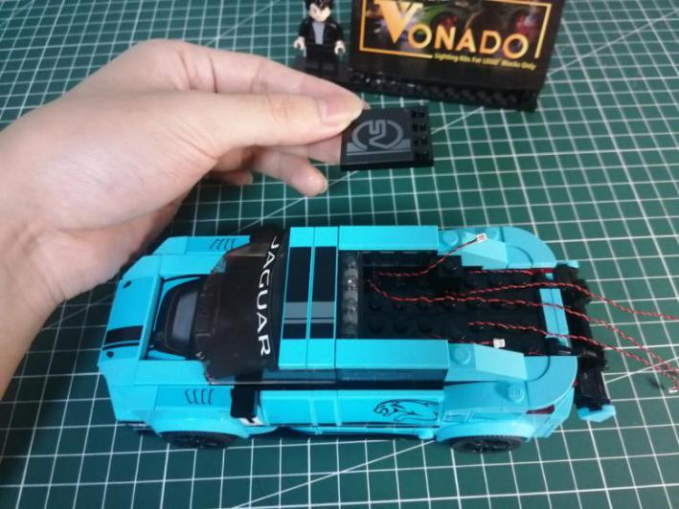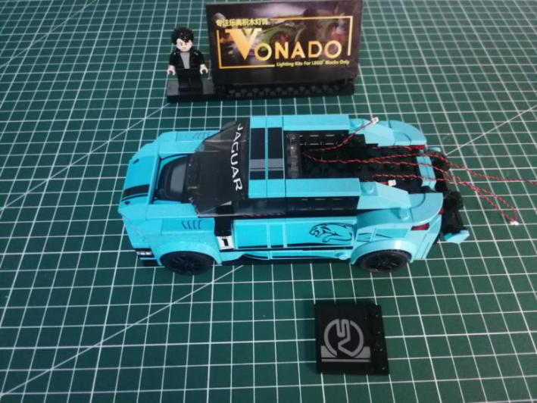

Take a Flat Coin Cell Battery Pack, a 6-port Expansion Board, assemble them as per below.
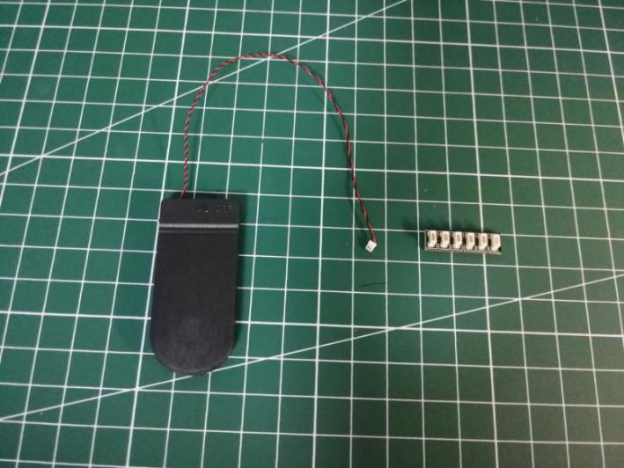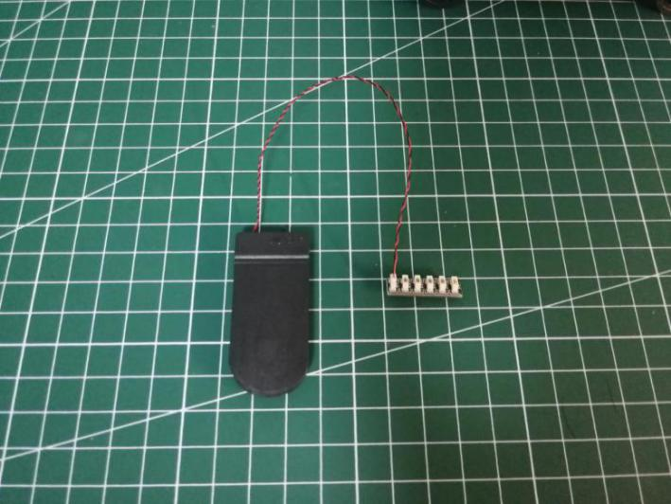

Connect the cables to the expansion board.
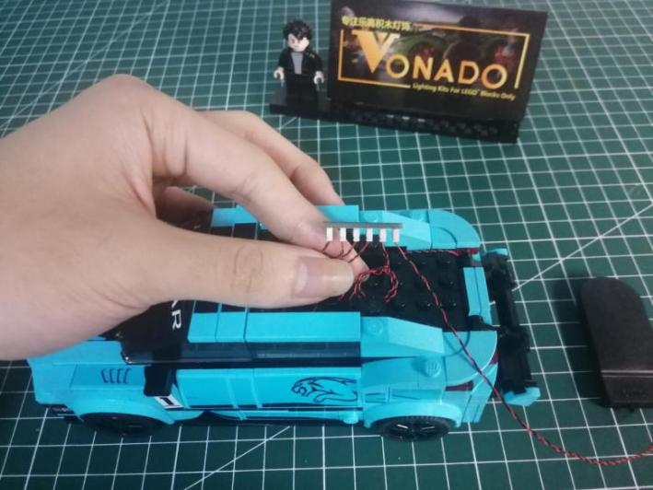

Take 2 adhesive squares.
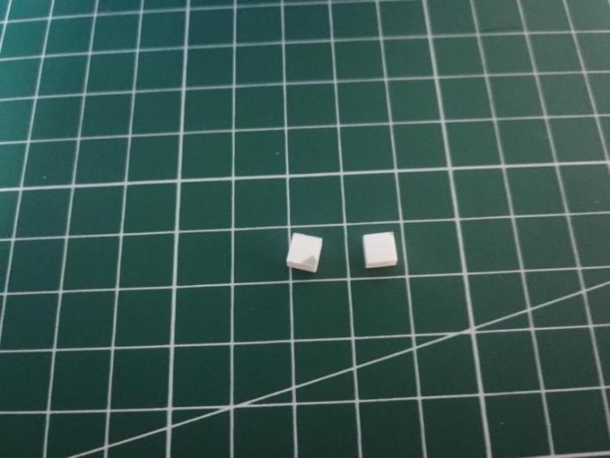

Stick them to the back of the expansion board.
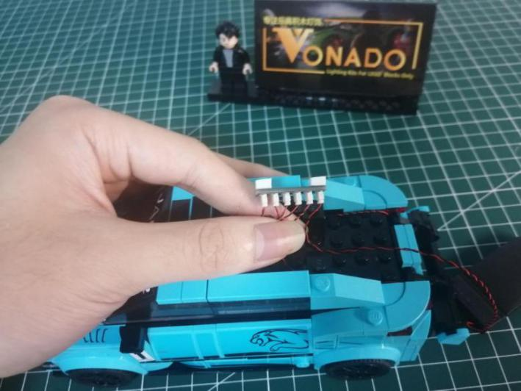

Stick the expansion board to the following place.
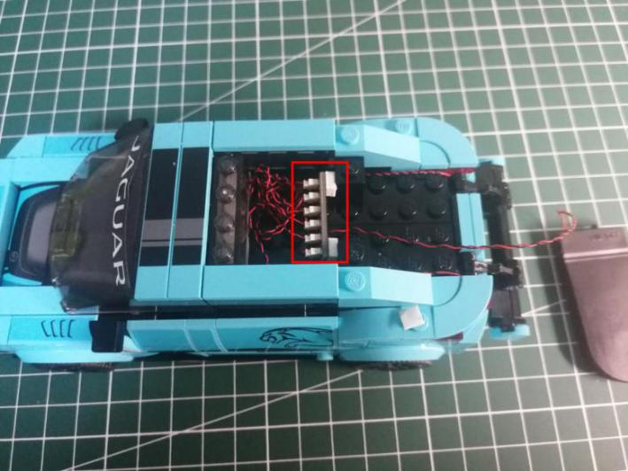

Reconnect the following piece.
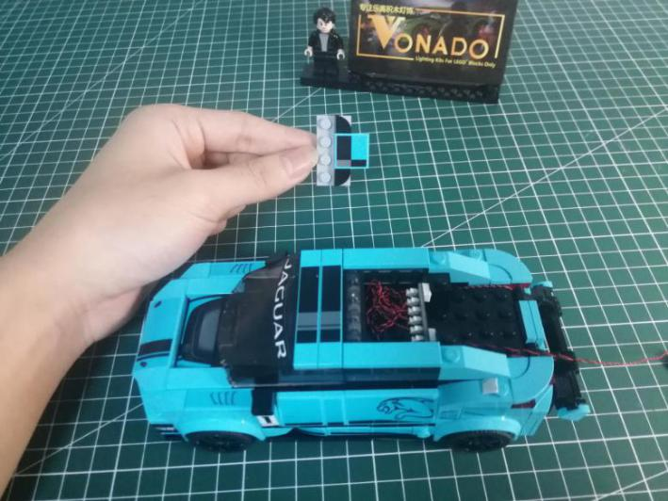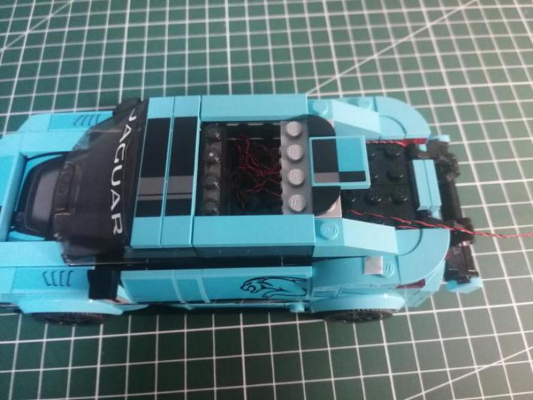

Reconnect the roof.
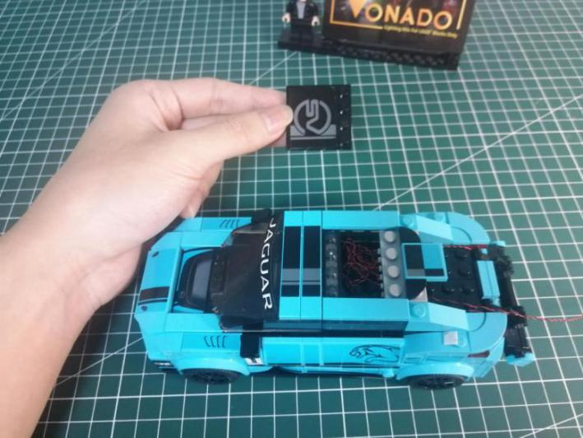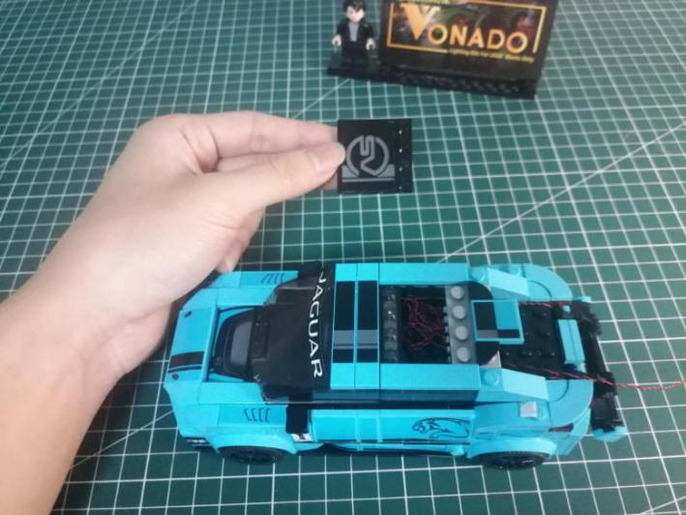

Place the cable of the battery pack as per below.
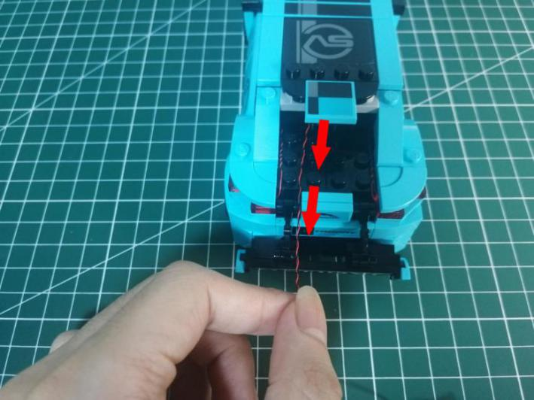

Reconnect the window shield to the tail.
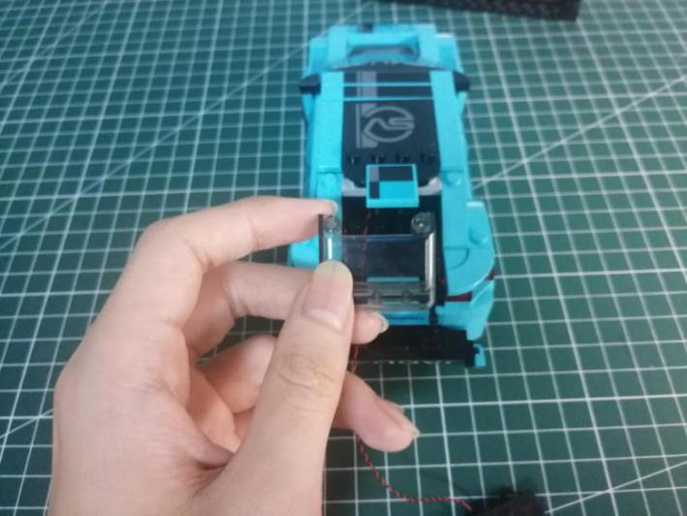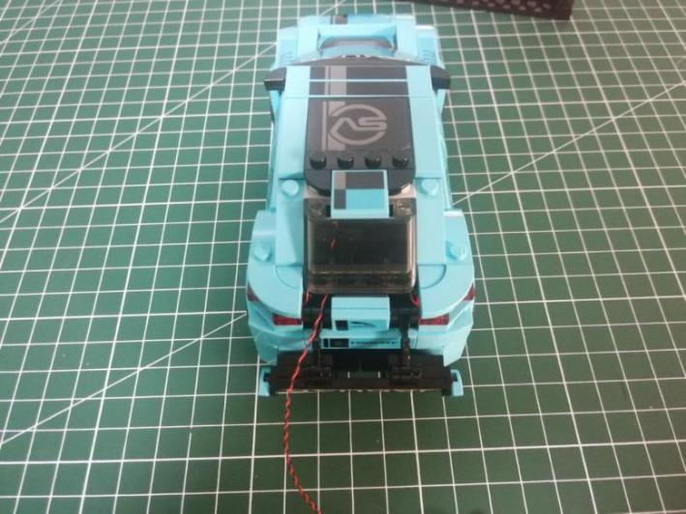

Continue to reconnect the following pieces.
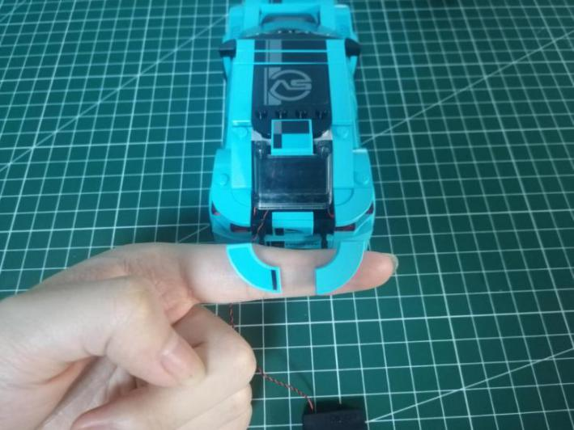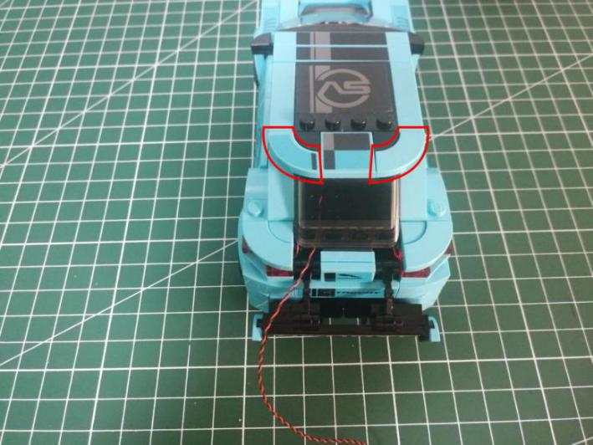

This completes installation of this car, put the bar at the tail up.
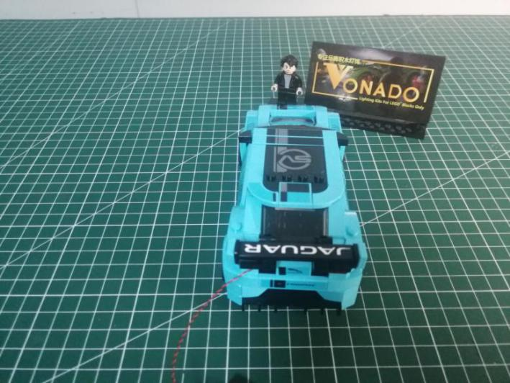

Take the second car.
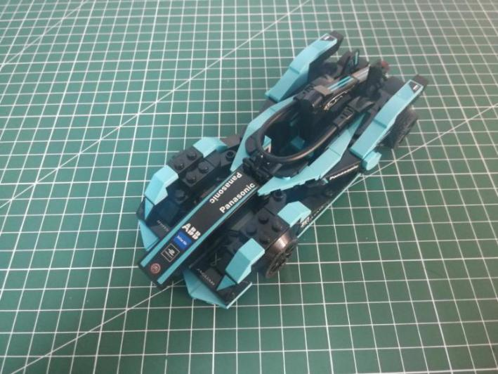

Turn to the front, disconnect the pieces from both sides.
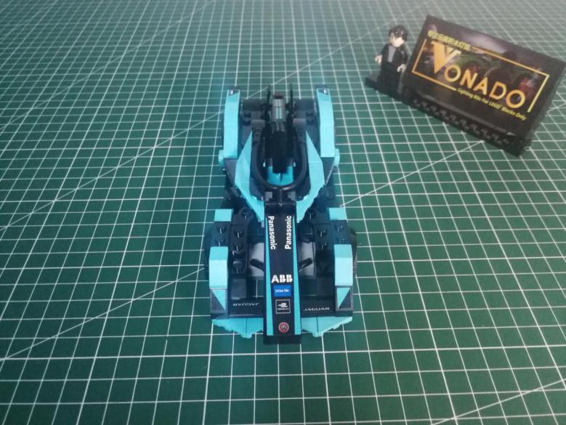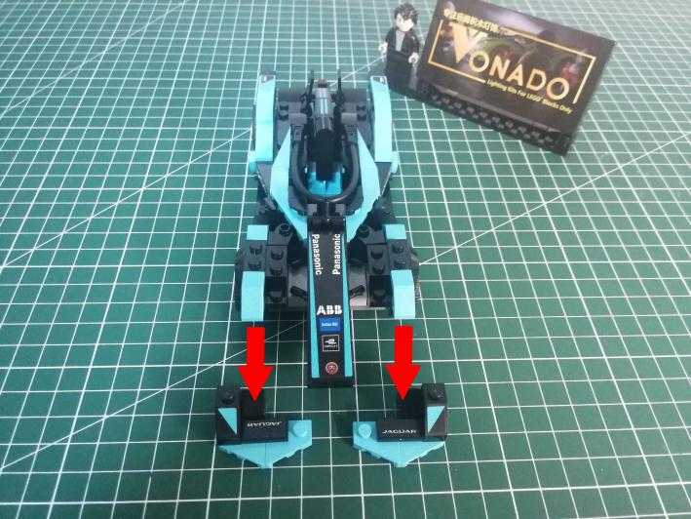

Remove the following 2 black pieces.
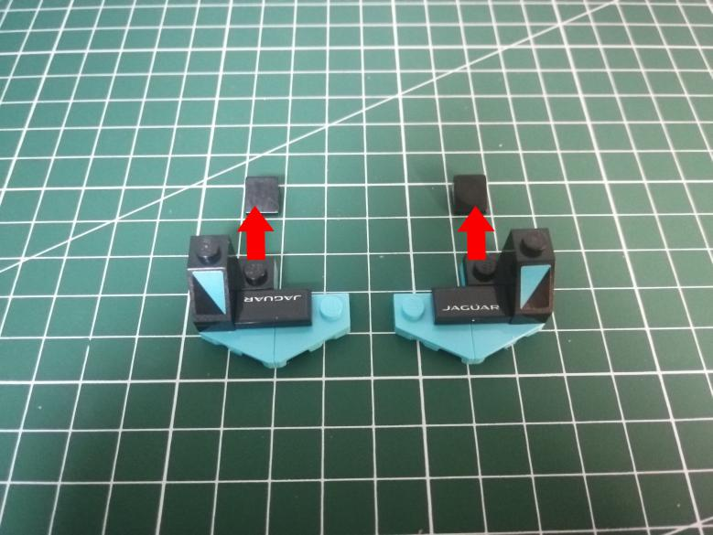

Take 2 white 15cm dot lights, 2 trans white 1x1 bricks.
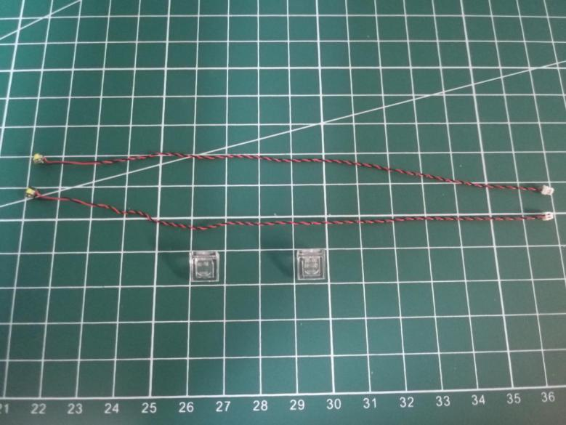

With lighting part facing up, connect the trans white brick over.
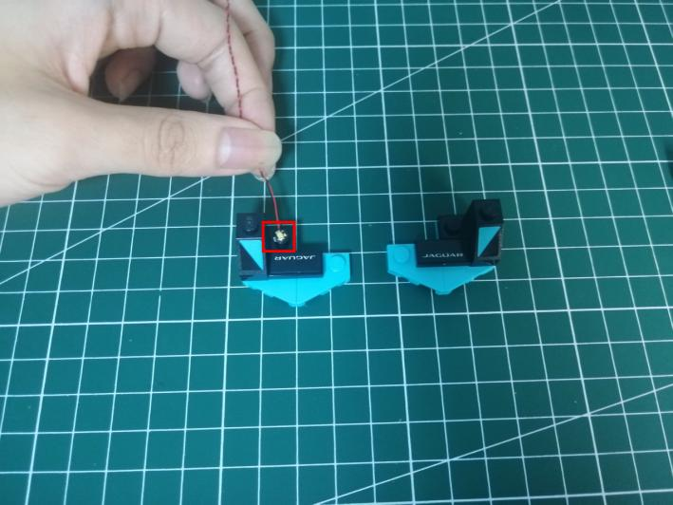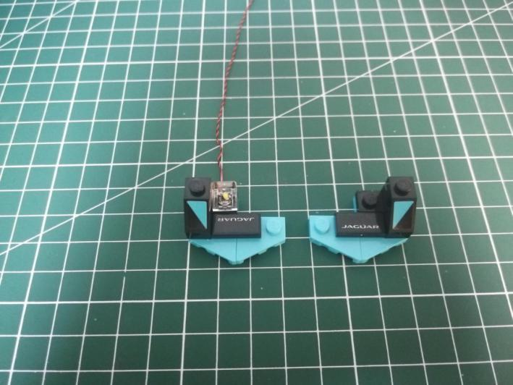

Install the light to the right side similarly.
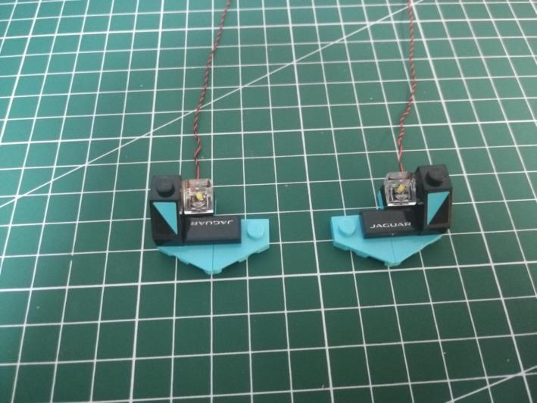

Reconnect the pieces at both sides.
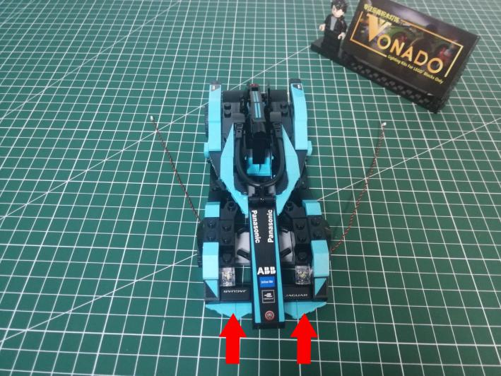

Turn the car over.
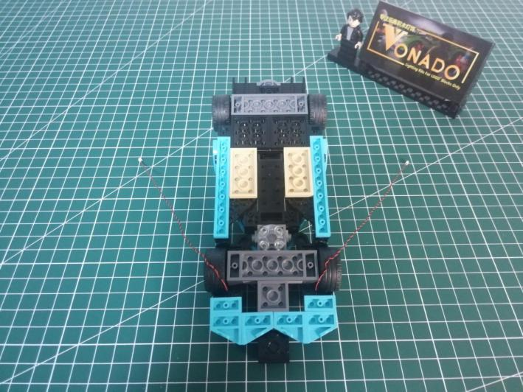

Disconnect the following trans white round plate.
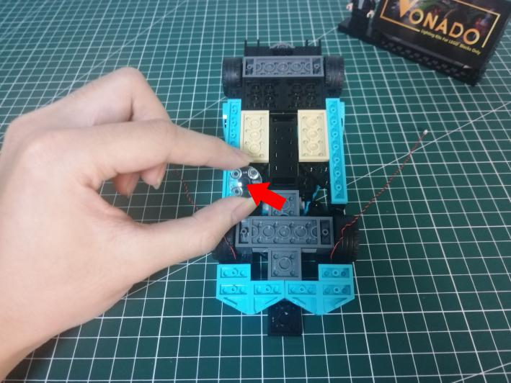

Take the following cable, secure it with the round plate.
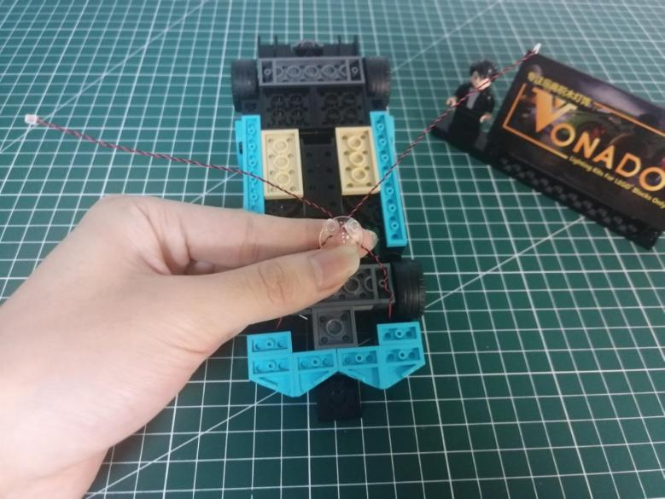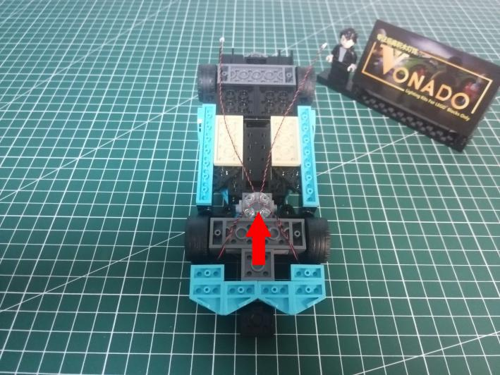

Turn to the tail.
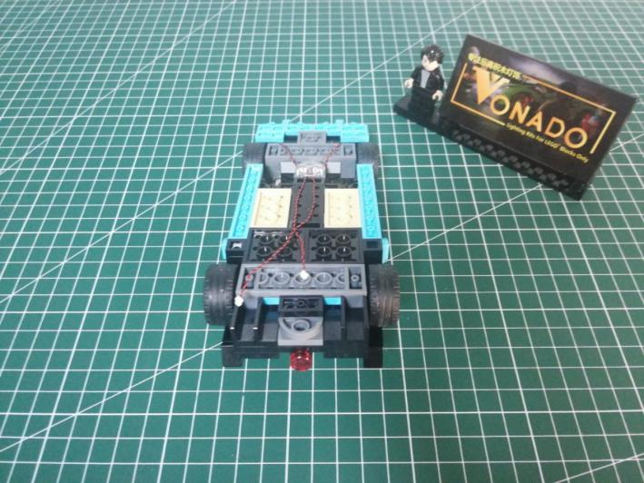

Remove the taillight.
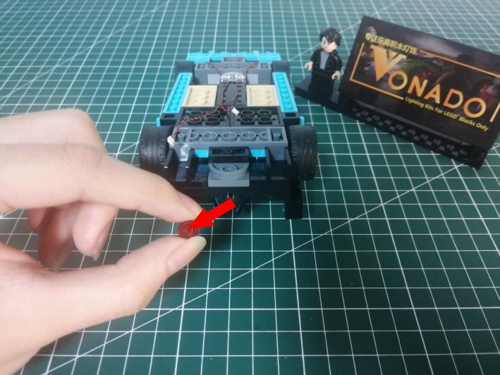

Take a red 15cm dot light, a trans red 1x1 round plate.
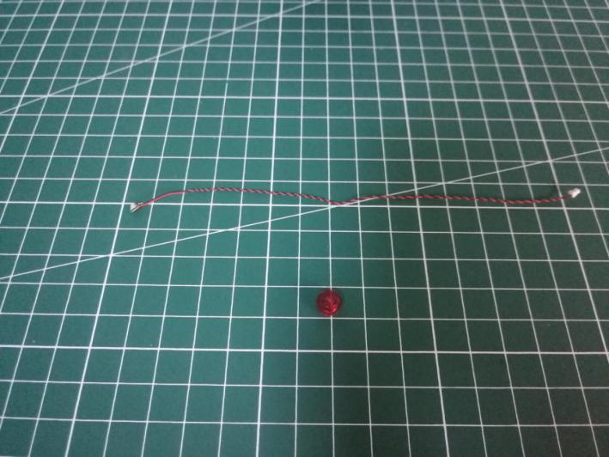
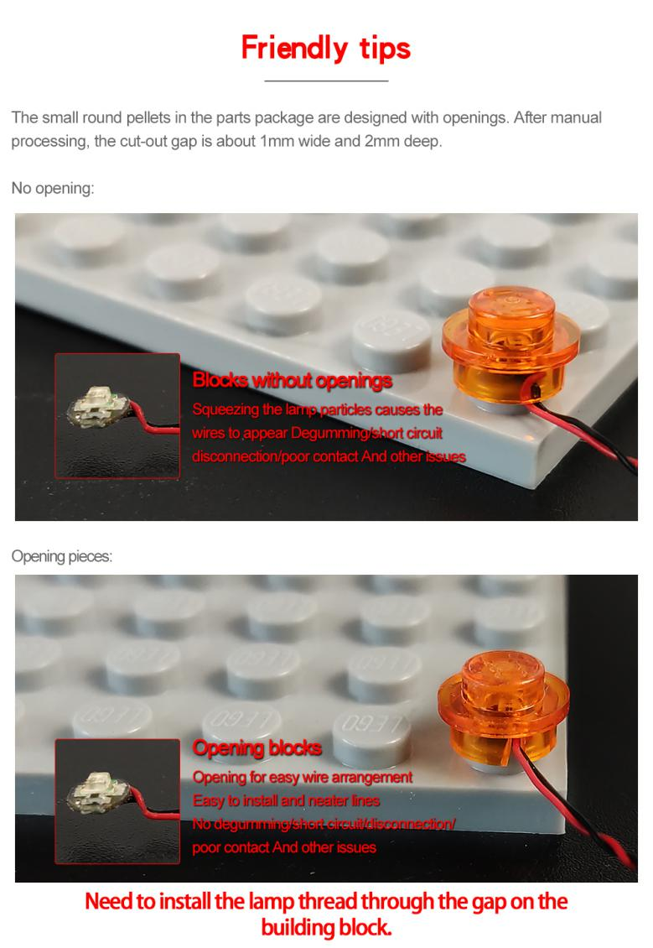

With lighting part facing up, connect the trans red round plate over.
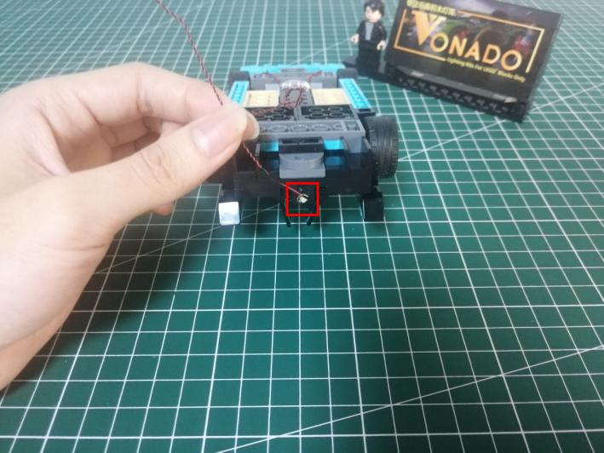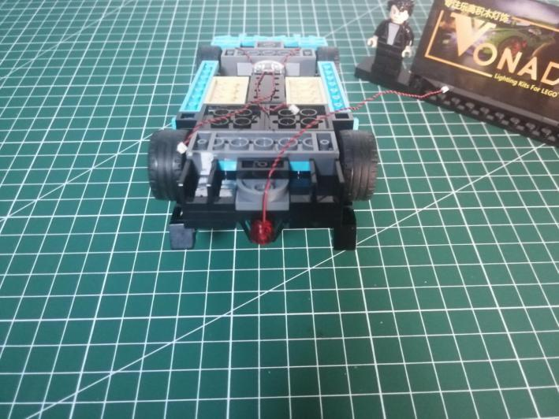

Turn to the side.
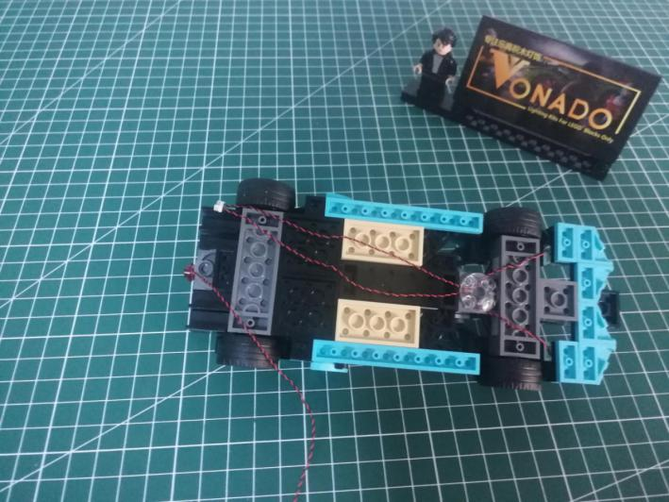

Take an adhesive square.
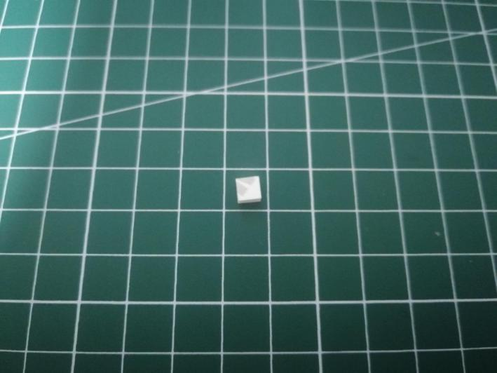

Secure the cable at the following place with the adhesive square.
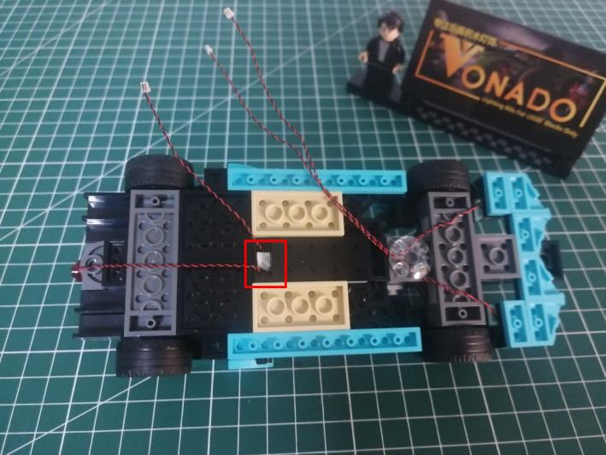

Take a Flat Coin Cell Battery Pack, a 4-port Expansion Board.
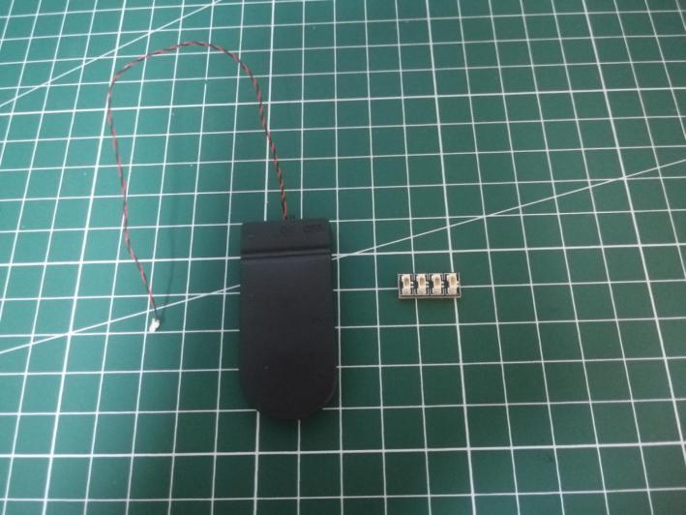

Connect all the cables to the expansion board.
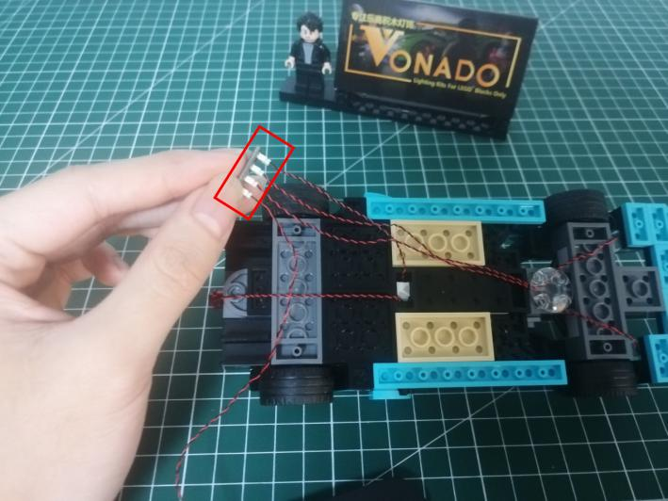

Take 2 adhesive squares.
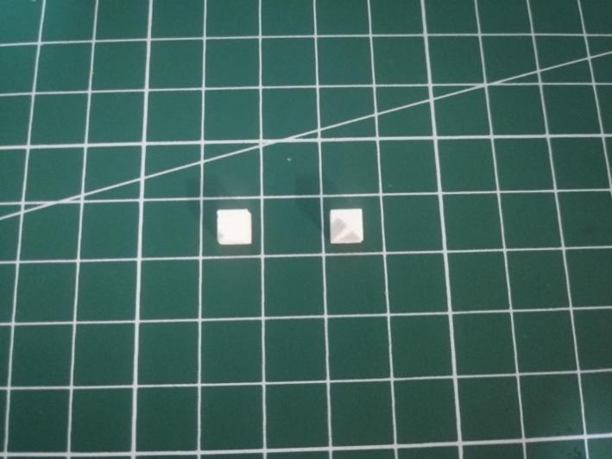

Stick them to the back of the expansion board, and stick the expansion board to the following place.
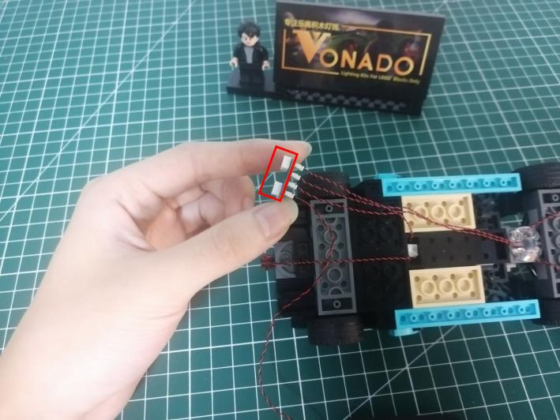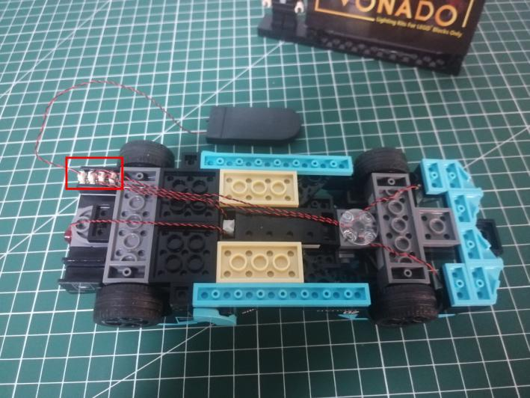

Take an adhesive square.
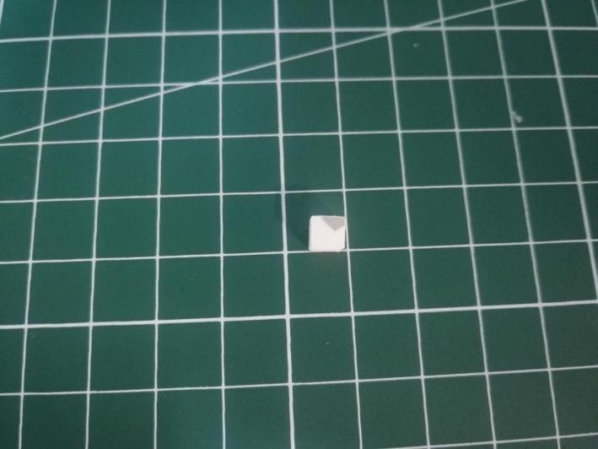

Secure the cable with the adhesive square as per below.
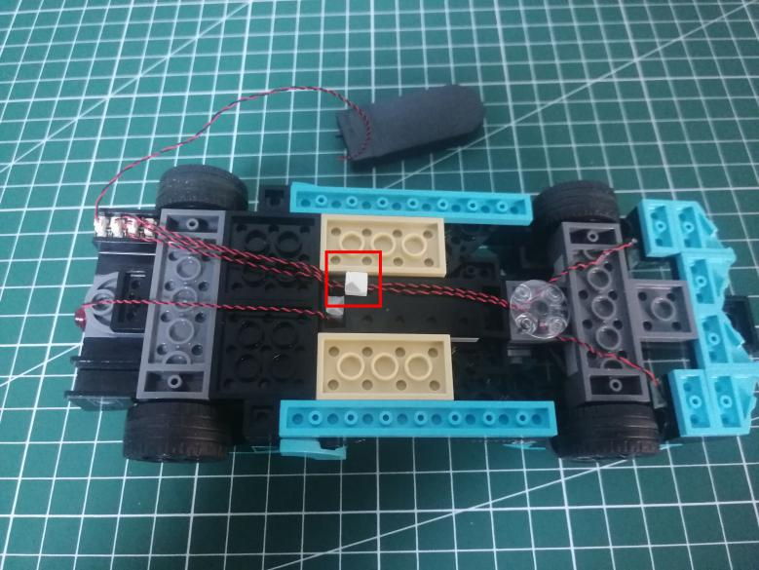

Turn to the front. This completes installation of this car.
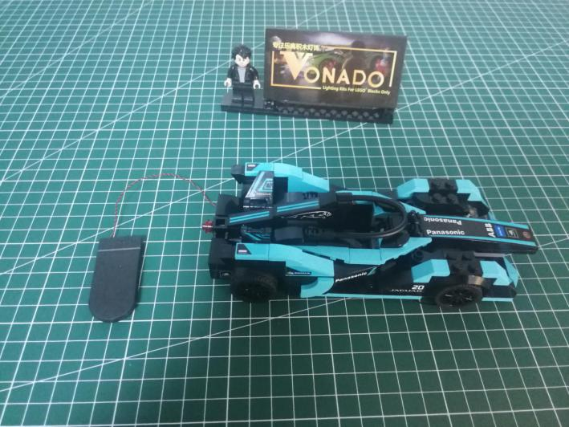

Take the frame.
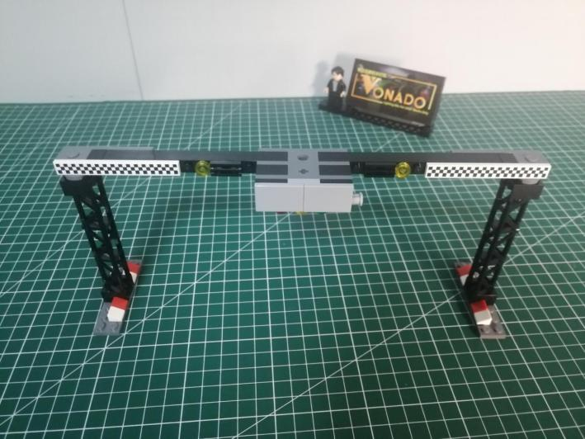

Remove the following pieces from both sides.
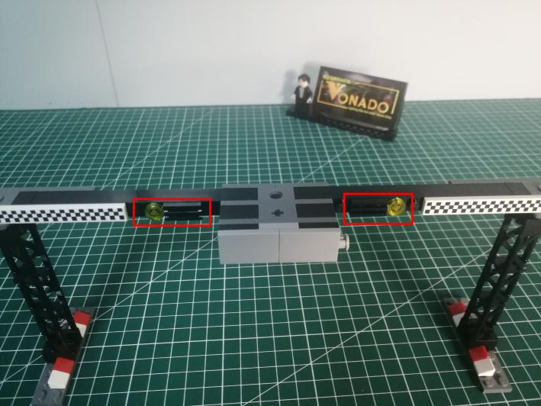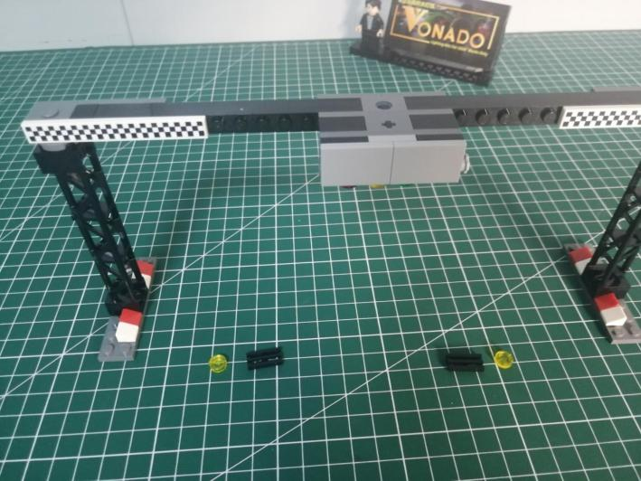

Take 2 yellow 15cm dot lights, 2 trans yellow 1x1 round plates.
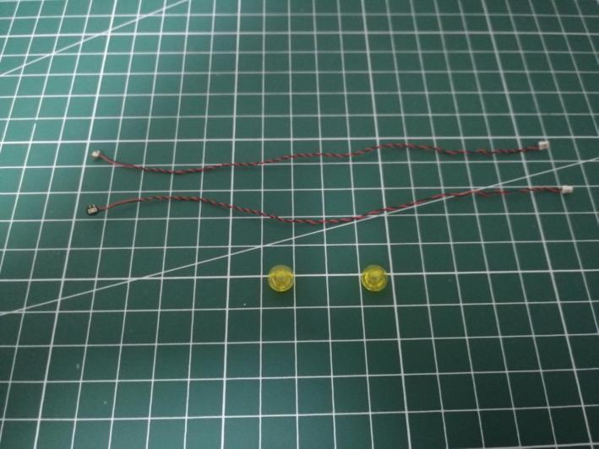

Turn to the right, with lighting part facing up, connect the trans yellow round plate over.
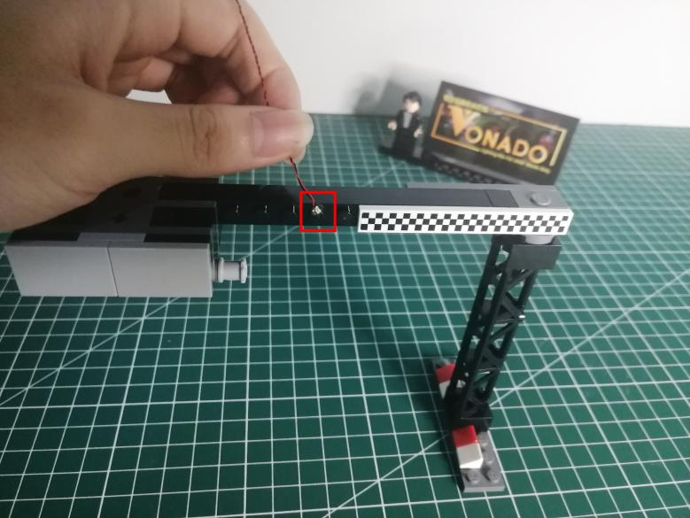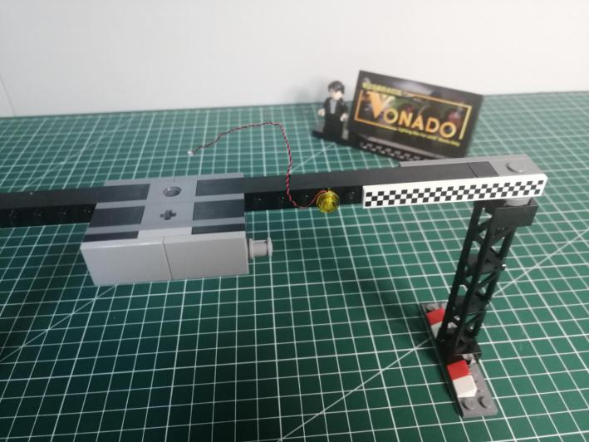

Reconnect the following black piece.
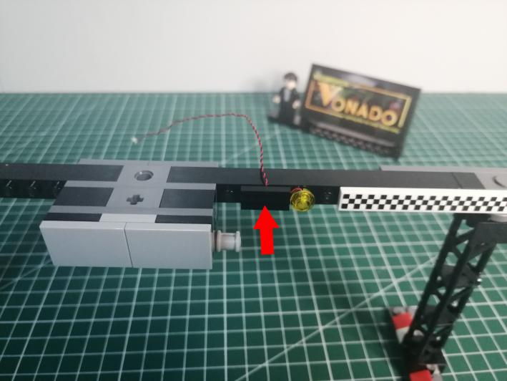

Install the light at the left side in the same way.
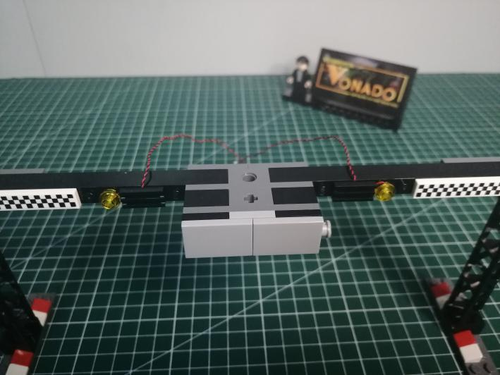

Turn to the back and roll the frame over.
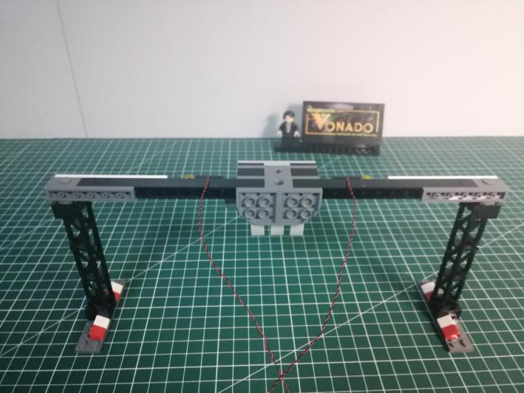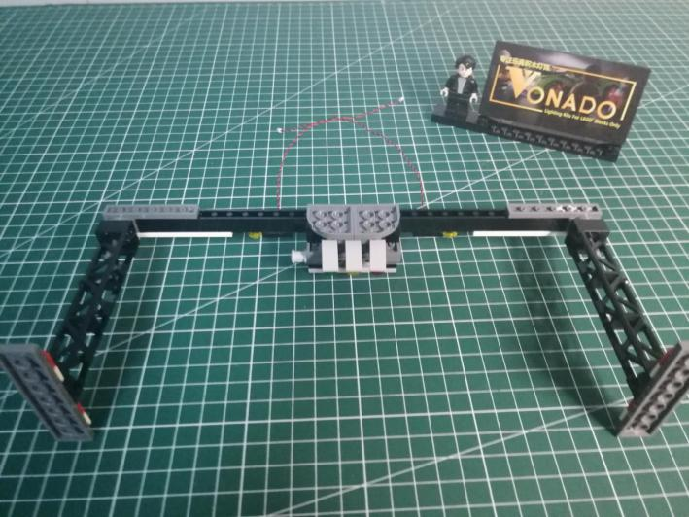

Disconnect the following 2 gray pieces.
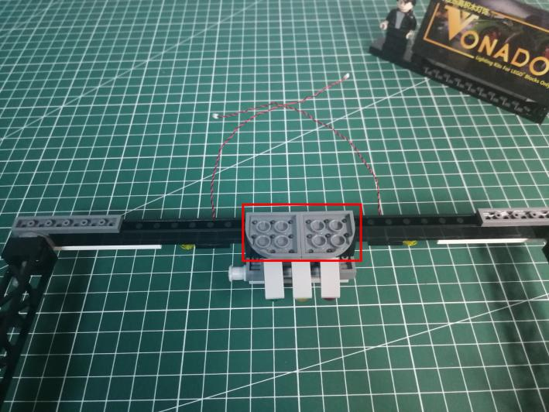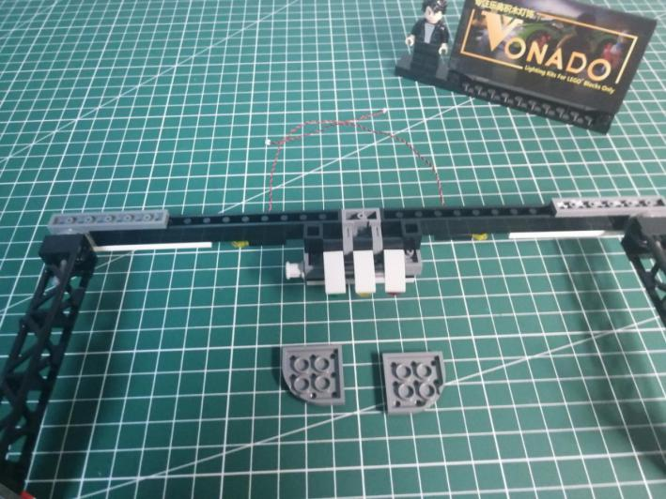

Remove the following traffic lights.
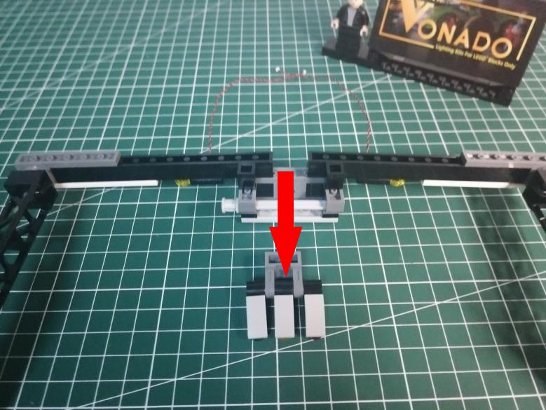

Turn the traffic lights to the front.
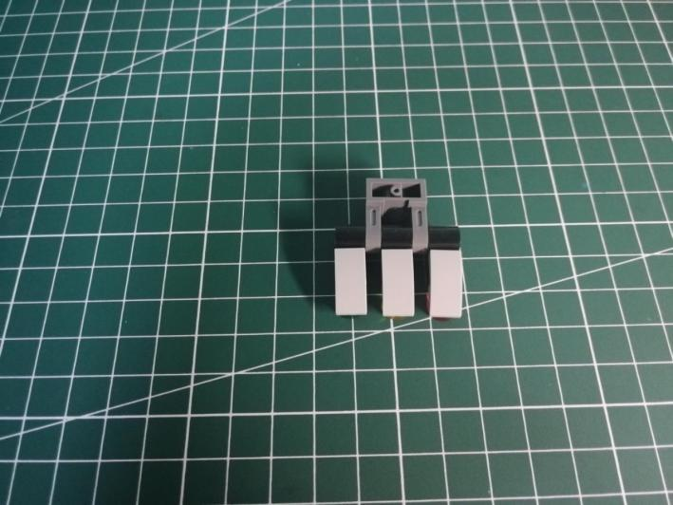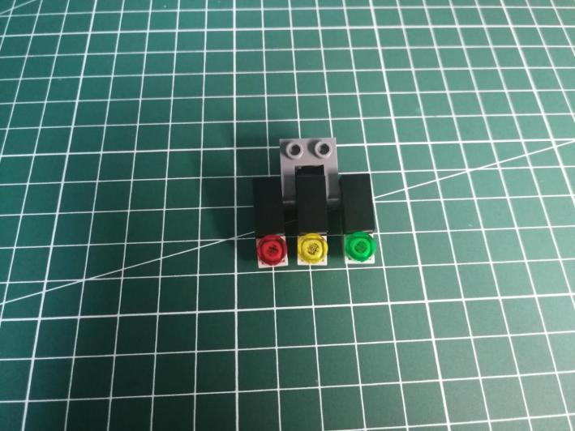

Remove the following pieces from the traffic lights.
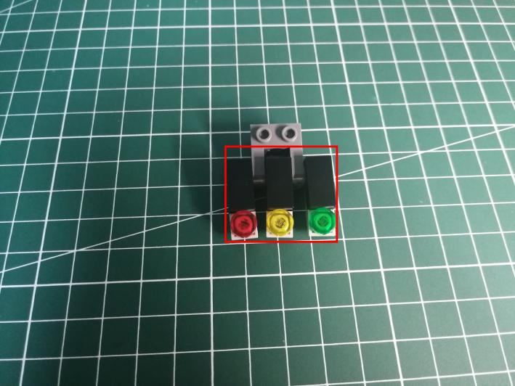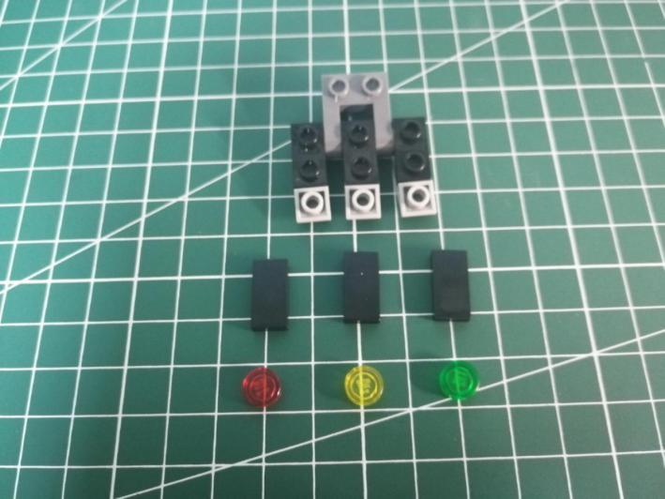

Take 3 white 15cm dot lights, a trans red 1x1 round plate, a trans yellow 1x1 round plate, a trans green 1x1 round plate.
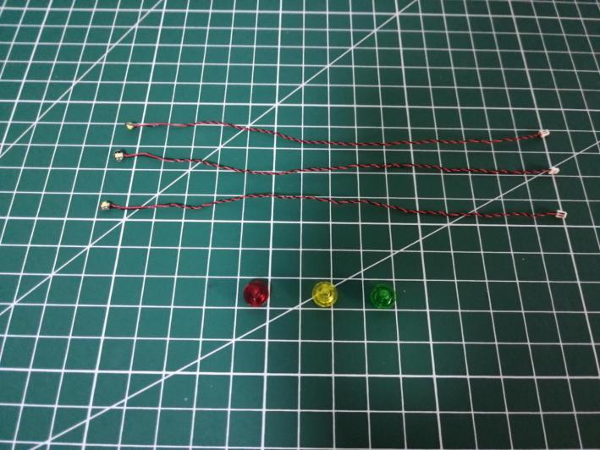

With lighting part facing up, connect the trans red round plate over.
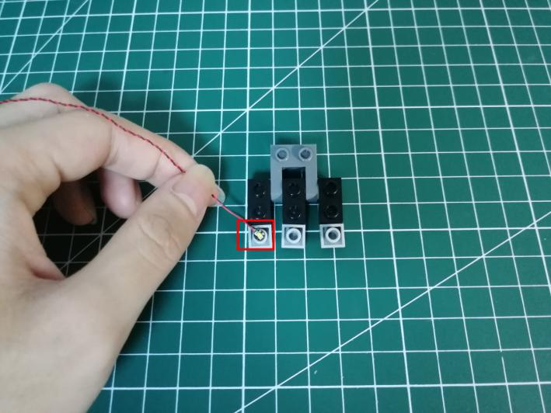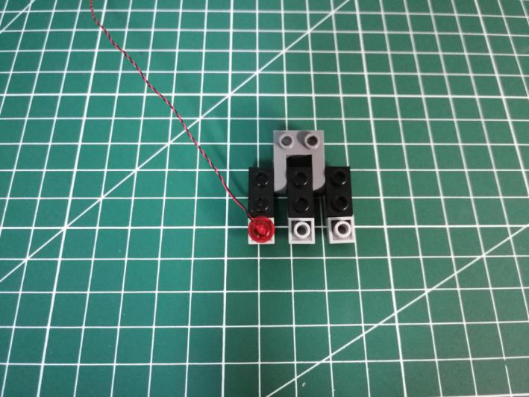

Install the other 2 lights in the same way.
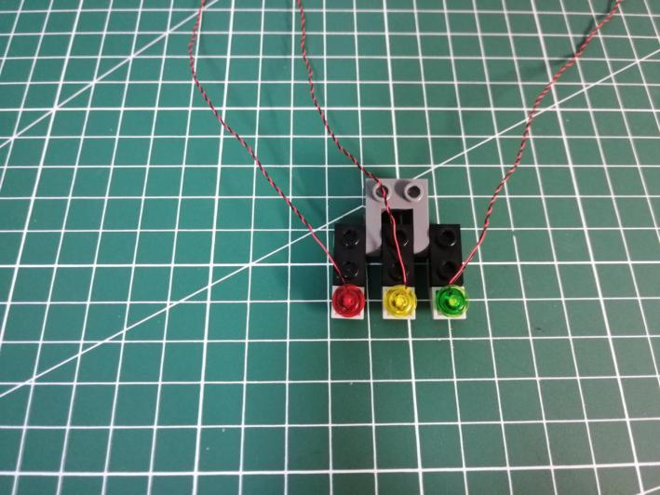

Place the cable as per below, reconnect the black piece to secure the cable.
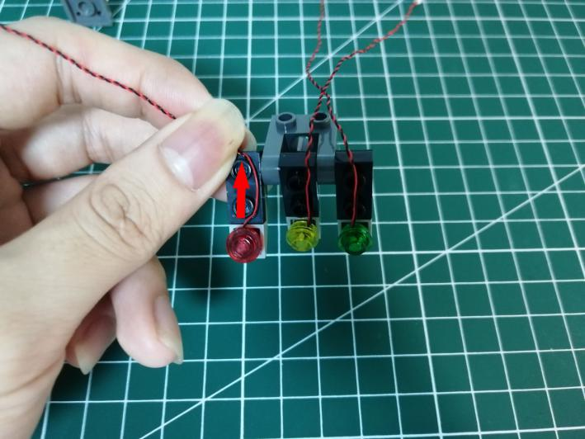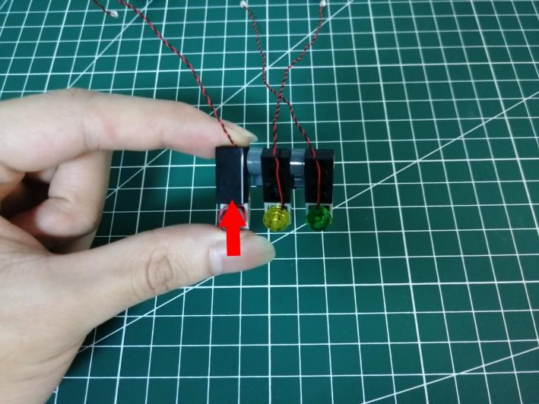

Place the other 2 cables similarly.
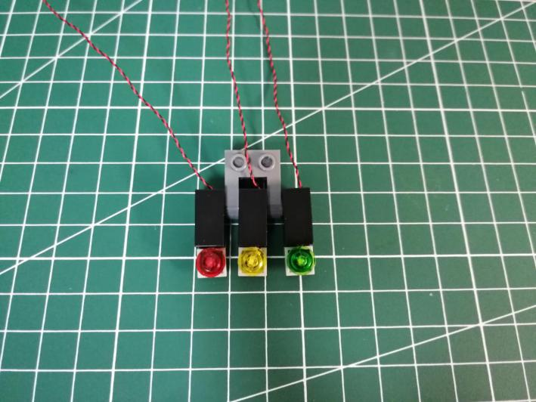

Turn to the back.
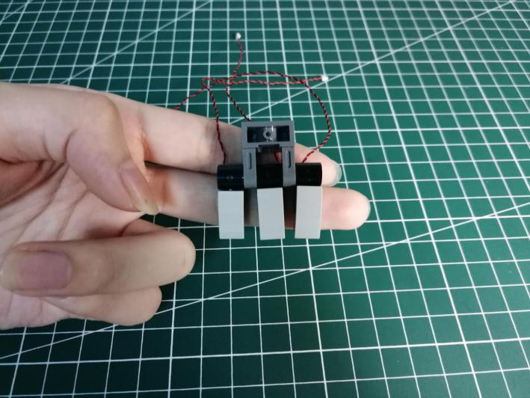

Thread the 3 cables through the following hole, pull them out.
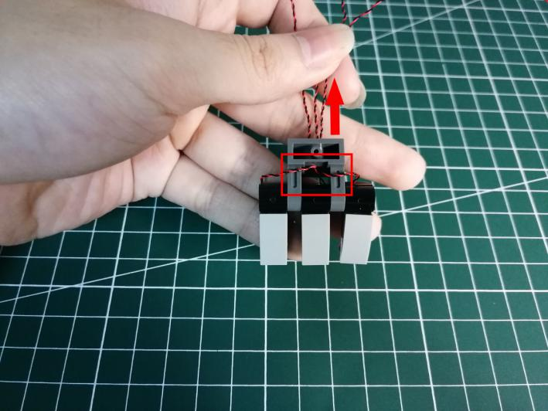

Group all the cables together.
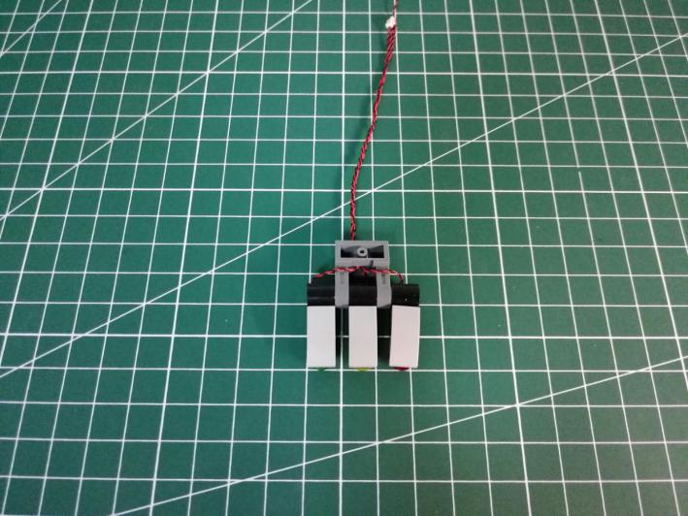

Reconnect the traffic lights.
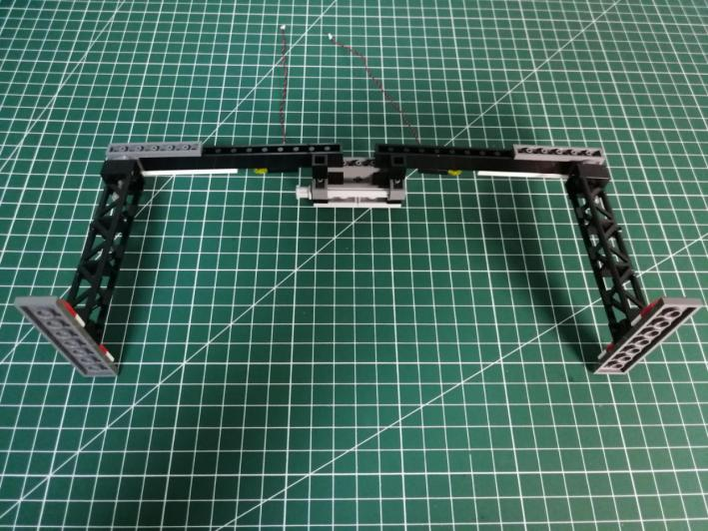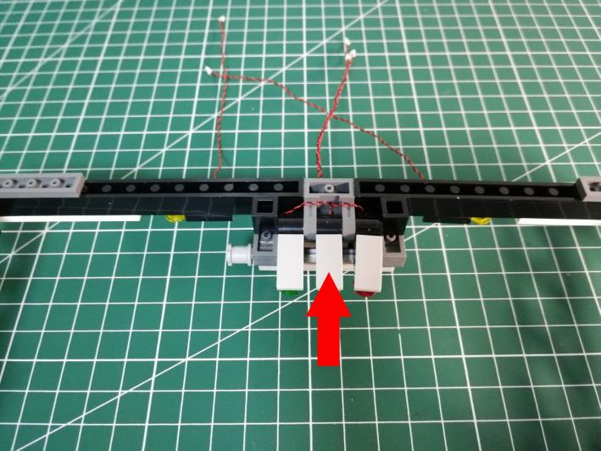

Reconnect the gray pieces.
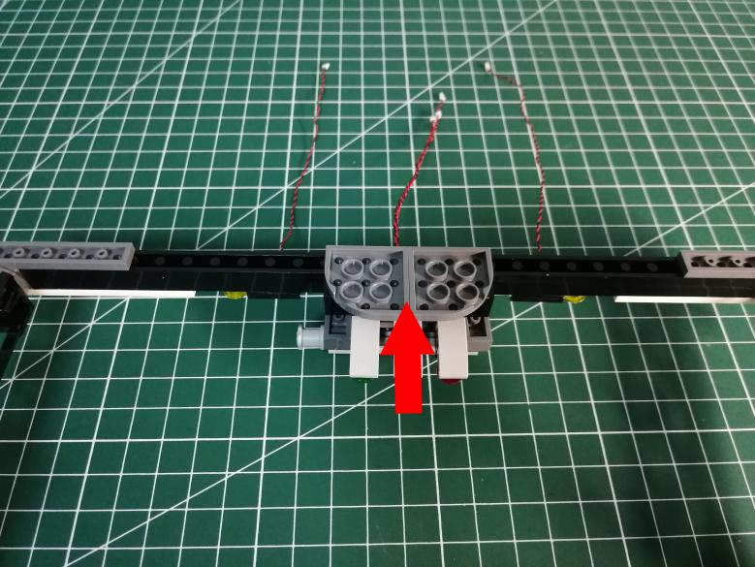

Take 2 adhesive squares.
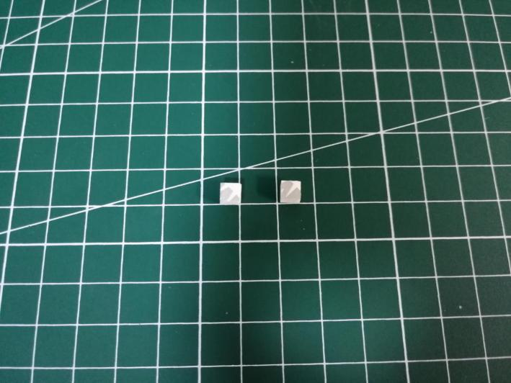

Secure the cables at the following places with the adhesive squares.
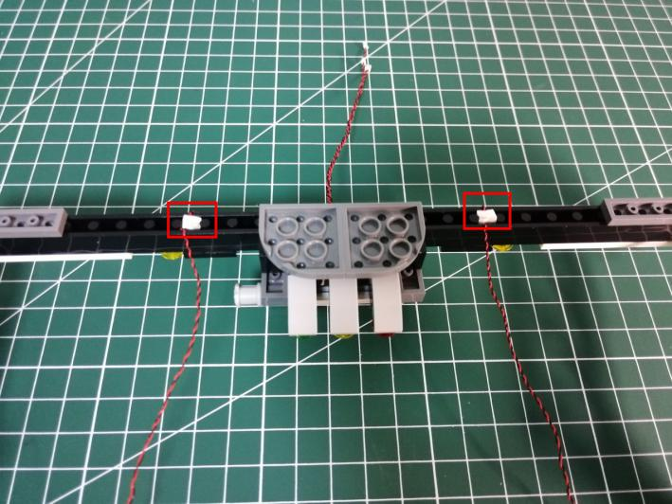

Take a Flat Coin Cell Battery Pack, a 6-port Expansion Board, assemble them as per below.
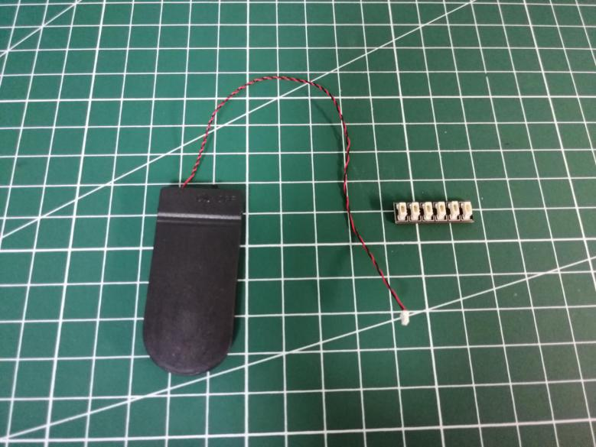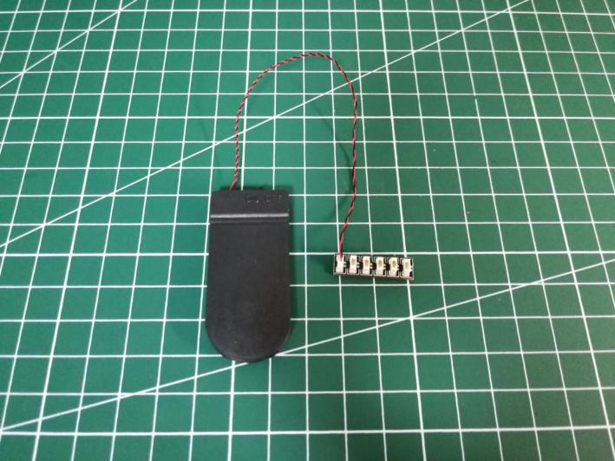

Connect all the cables from the frame to the expansion board, tuck excess cables around the expansion board.
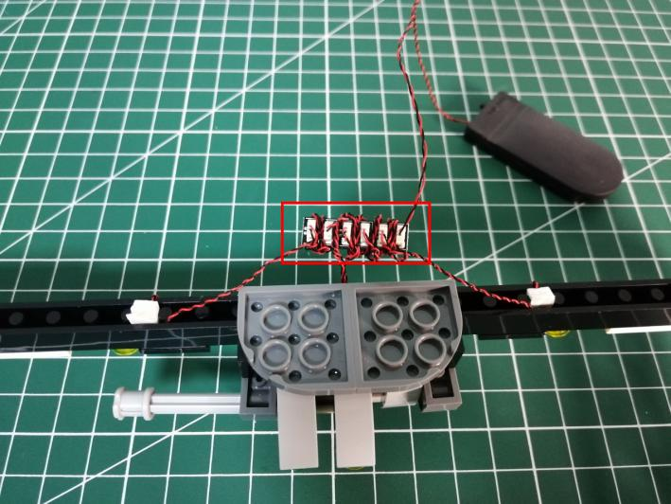

Take 2 adhesive squares.
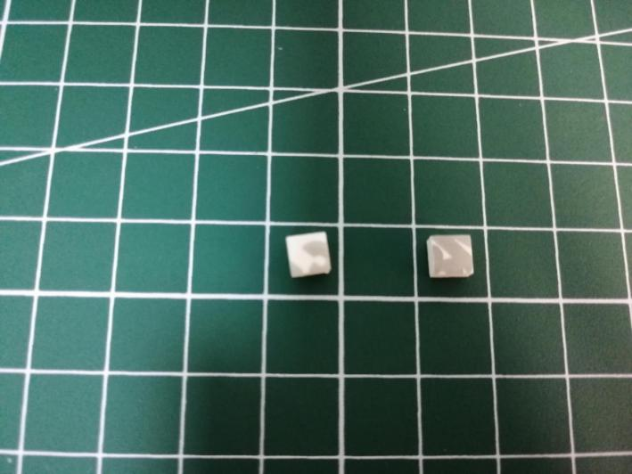
Stick them to the back of the expansion board, and stick the expansion board to the following place.
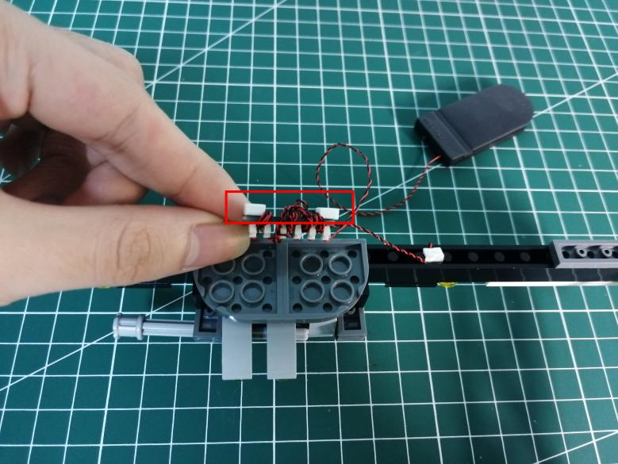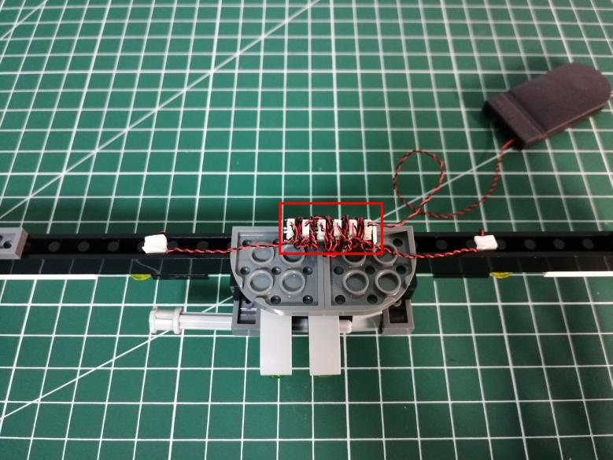

Turn the frame to the front.
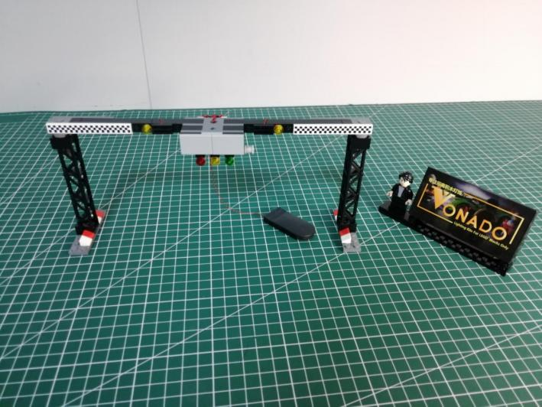

This completes installation of this LED Lighting Kit. ENJOY!
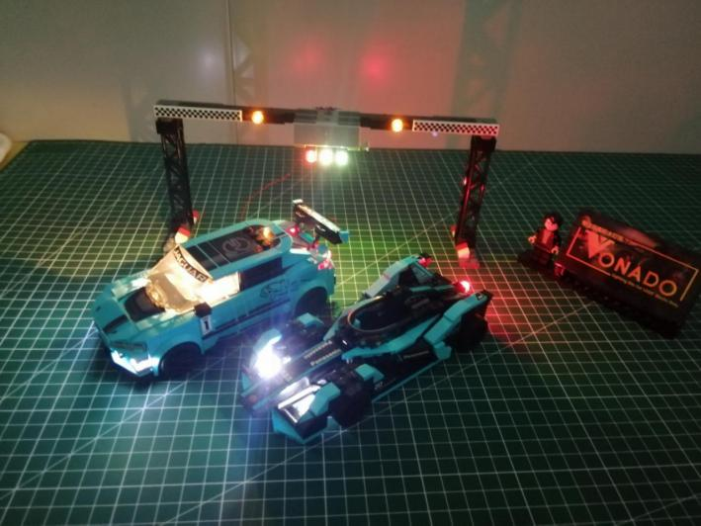

The above are ideas and instructions provided by our designers. Please move on:
1: Do you have any suggestions about the material and quality of our products?
2: Do you have any suggestions on the installation instructions and the degree of difficulty of the installation?
3: If you have better installation method and ideas, please contact us in time.

