Lighting Kit

Package contents：
- 10 x 15cm Warm White Dot Lights
- 2 x 15cm Red Dot Lights
- 4 x 15cm Head lights
- 1 x Warm White Strip Light
- 4 x Blue Strip Lights
- 3 x 8-port Expansion Boards
- 3 x 5cm Connecting Cables
- 1 x 15cm Connecting Cable
- 4 x 30cm Connecting Cables
- 1 x 50cm Connecting Cable
- 1 x Flicker Effects Board
- 1 x AAA Battery Pack
- 1 x Remote Control Switch Board
Extra pieces

Important things to note:
When installing dot lights
Make sure they are correctly placed (Yellow LED package is exposed). You can put they either on the top of the studs or between studs.
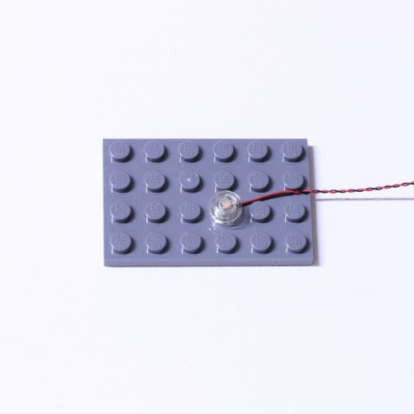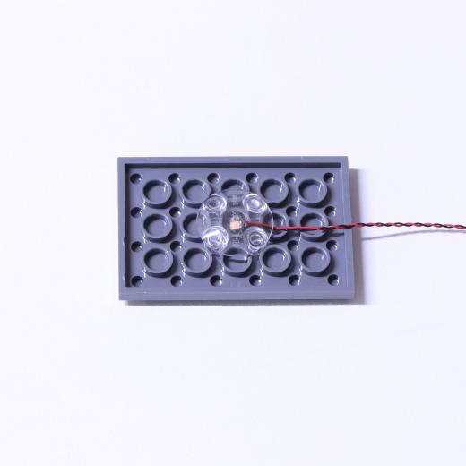
Place wires on the surface or under the building blocks.
The wire can be place between the building blocks or under the block, but they should be placed between the studs correctly.
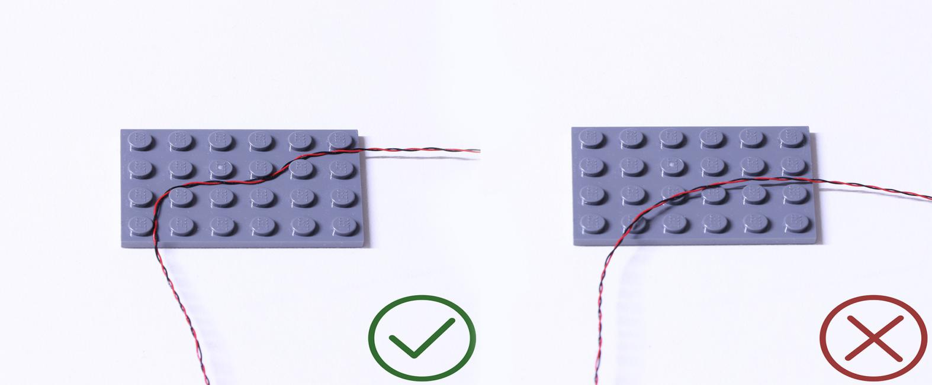

Be careful when insering the micro connector to the micro expansion board. With connecting cable side facing down, conenct the connector to the board as per below. In case of damaging the pieces, do ont force to connect the pieces.
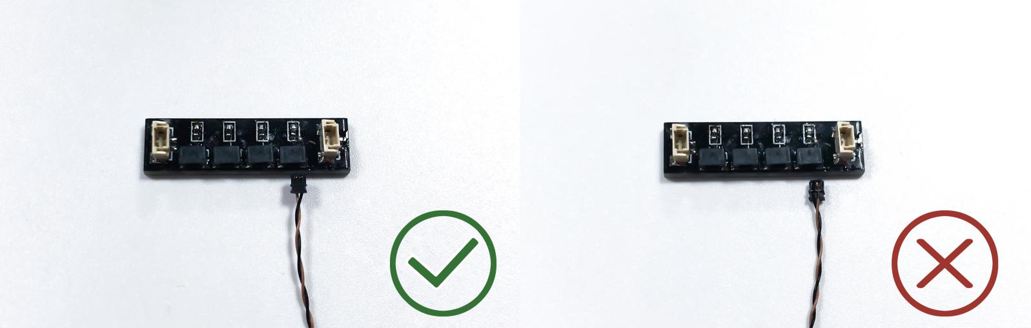

Insert the connectors to the ports.
Be careful when you are operating, there’s only one correct way to insert, make sure the expansion board is upward, find the soldered “=” sign on the left of the port. When you are inserting, the side which the wires can be seen should be faced to the “=” sign and if you feel hard to insert, please stop, and don’t force it, for that may result in bent pins inside the port or overheating of the expansion board.
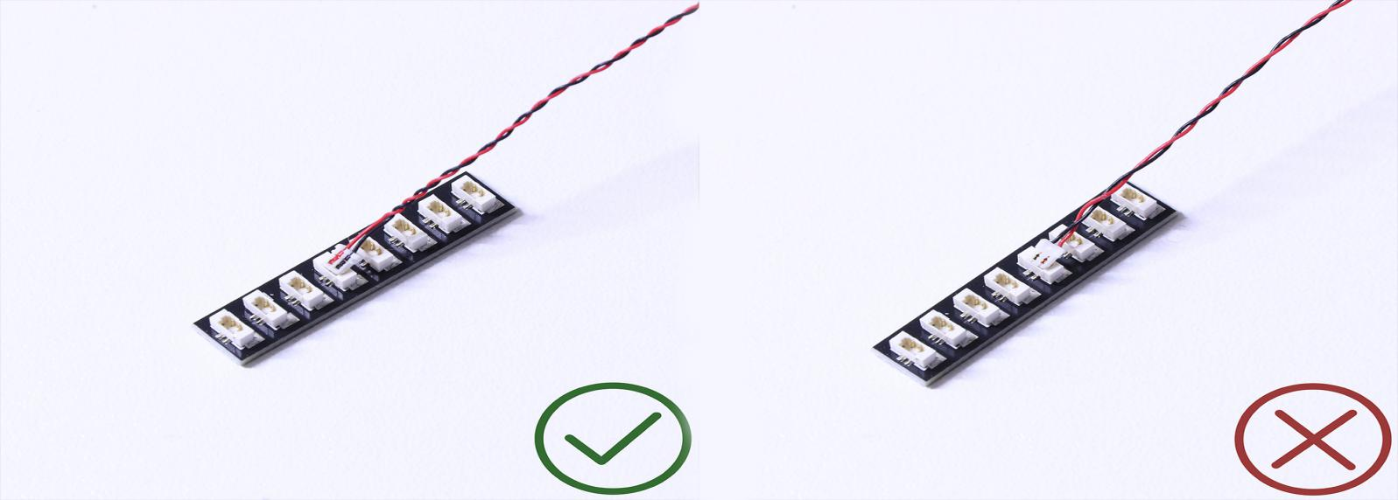
At this point, use the tweezers to straighten the bent pins.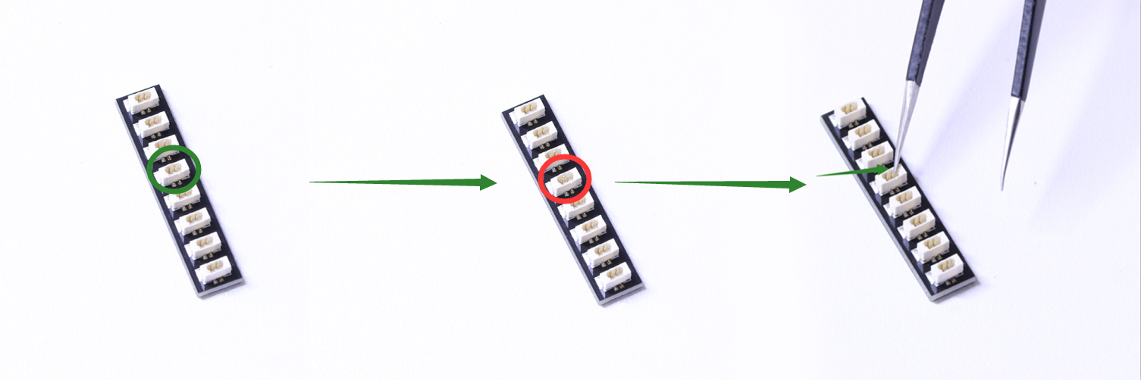

Connecting cable connectors to Strip Lights
Take extra care when inserting connectors to ports on the Strip Lights. Connectors can be inserted only one way. With the Strip Light facing up, ensure the side of the connector with the wires exposed is facing down. If a plug won’t fit easily into a port connector, don’t force it. Doing so will damage the plug and the connector.
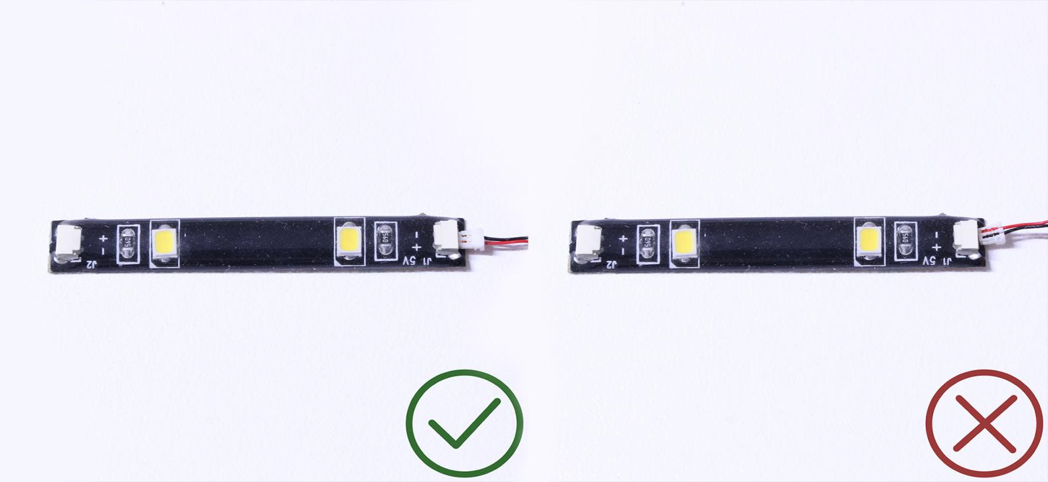
Finally, please pay attention to the positive and negative terminals of the battery when installing the battery case.
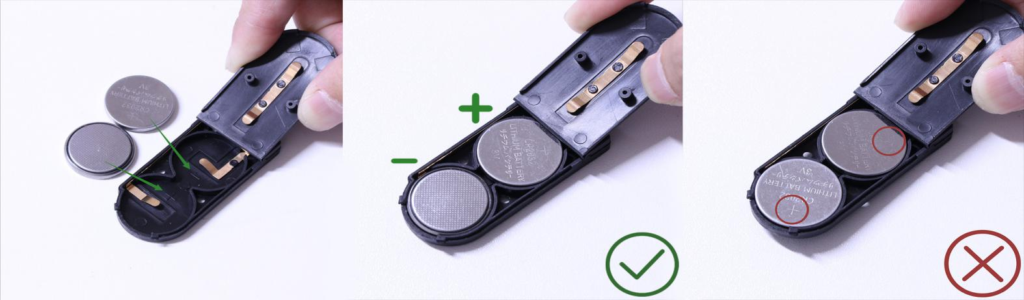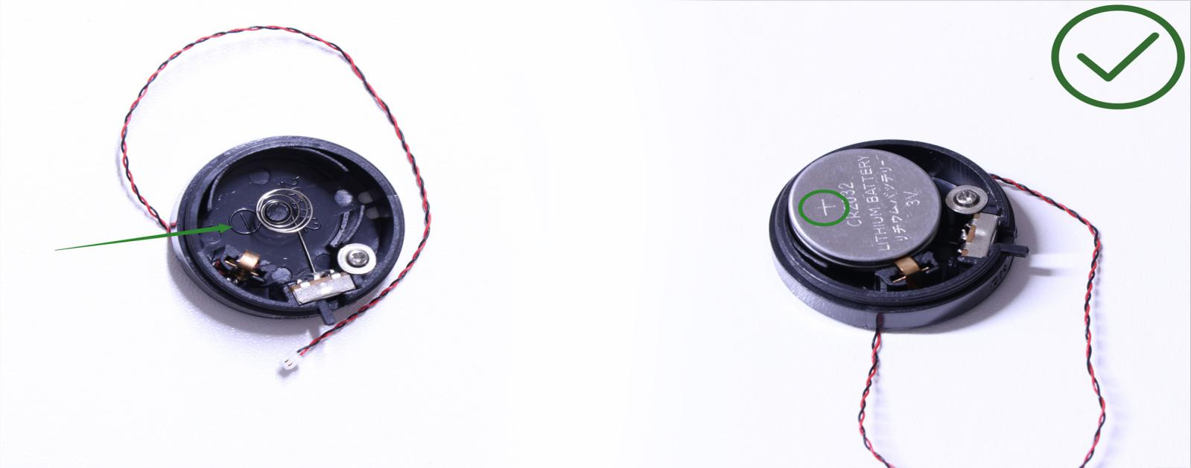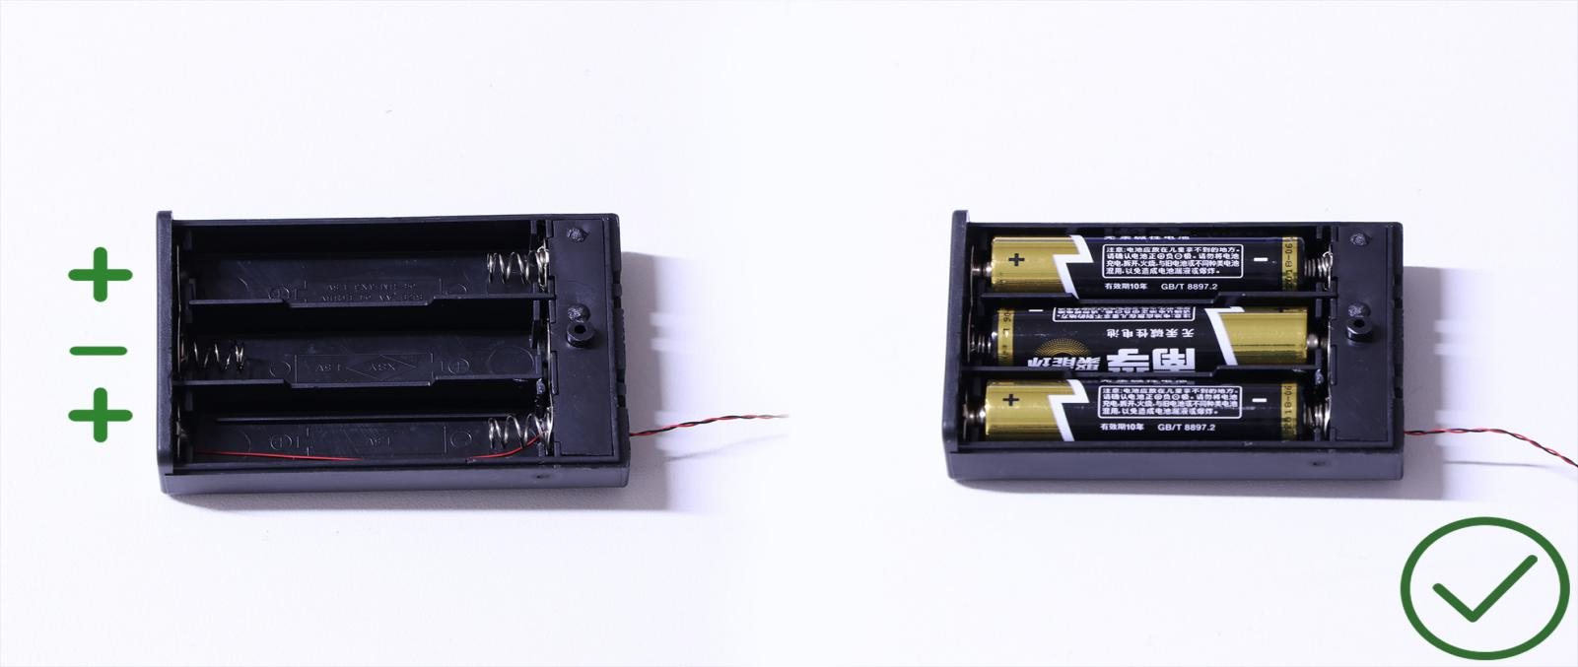

Instructions for installing this kit：
OK, Let’s Begin!
Start from installing the headlights.
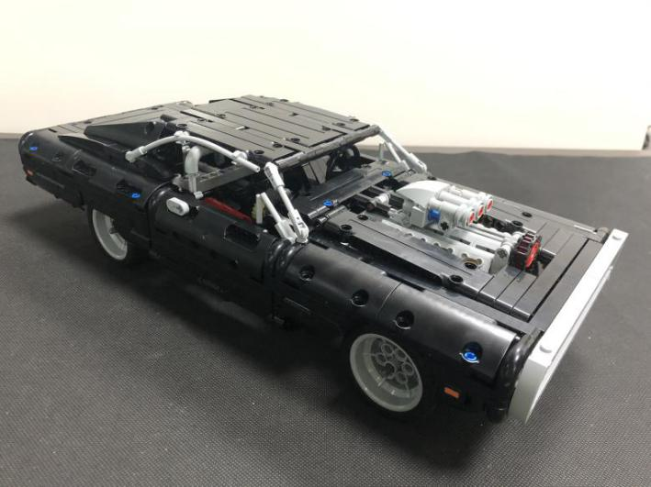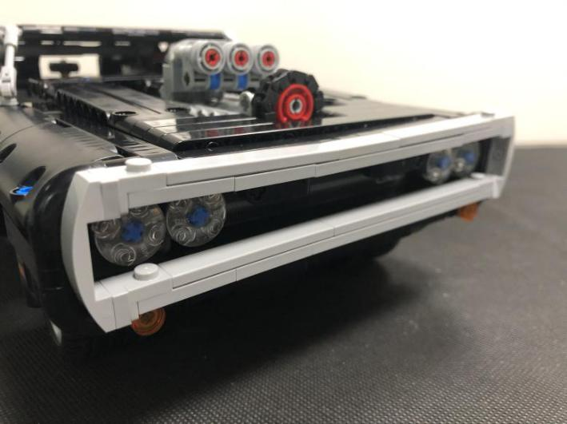
Remove the following gray piece.
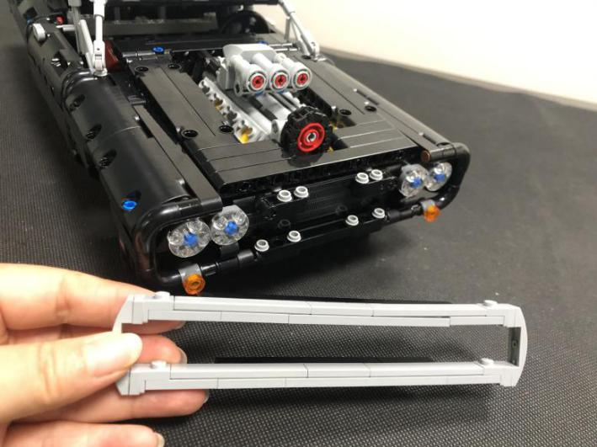
Remove the orange light, and disassemble it.
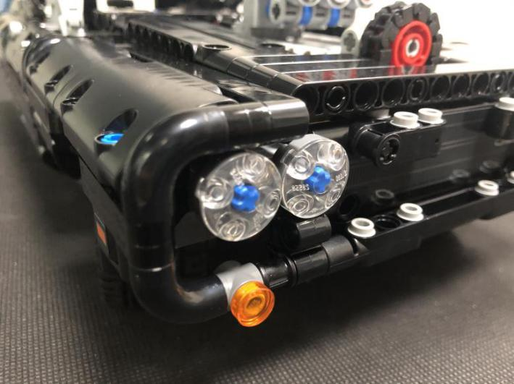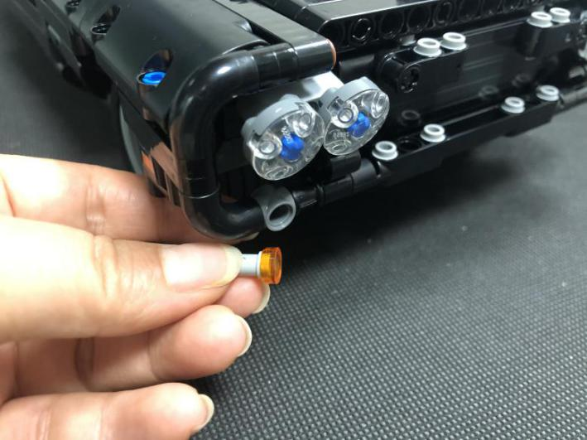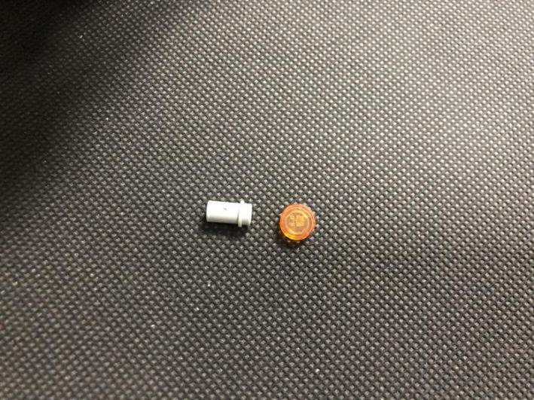
Take a 15cm warm white dot light, a trans orange 1x1 round plate, thread the cable through the gray pin, pull the cable out till the light is placed inside.
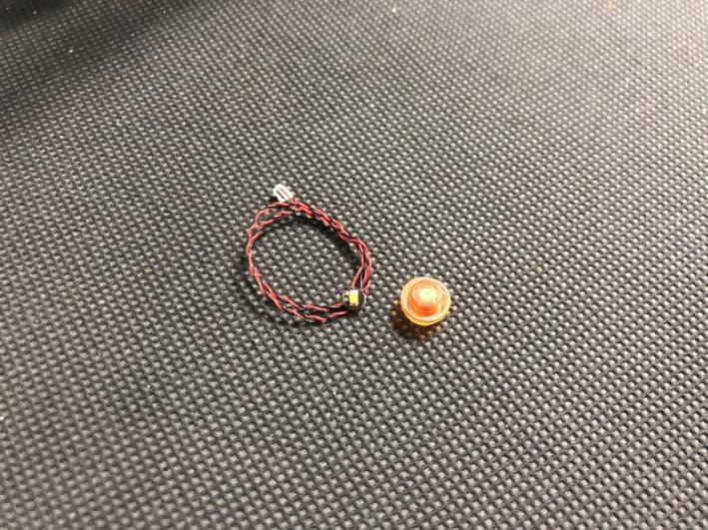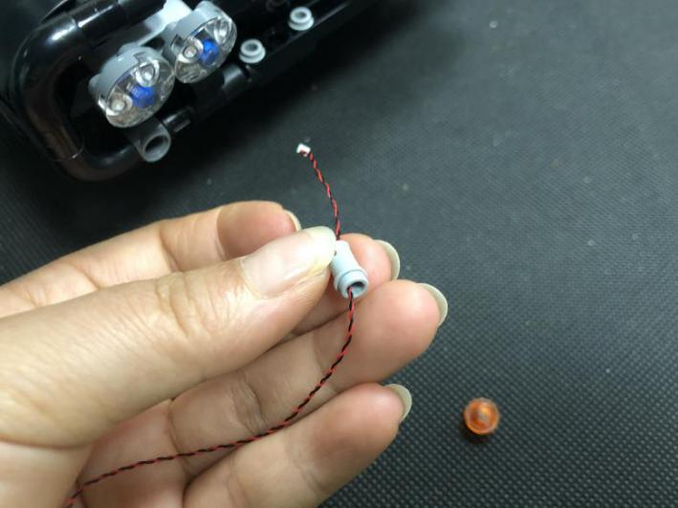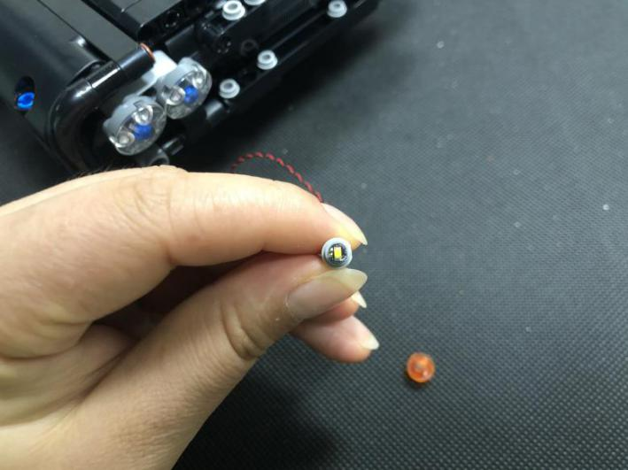
Secure the light with the trans orange plate.
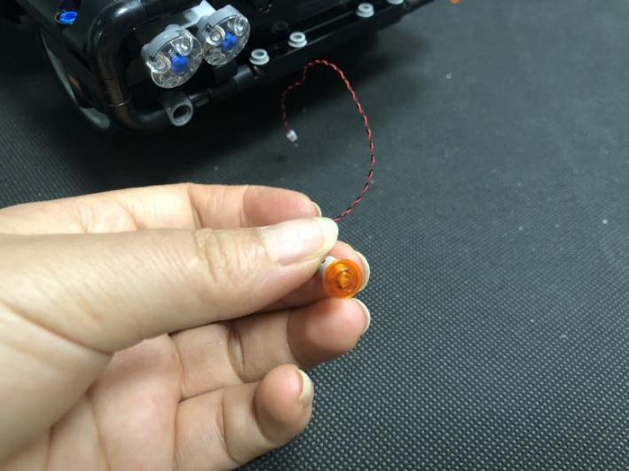
Thread the cable through the following hole, reconnect the light.
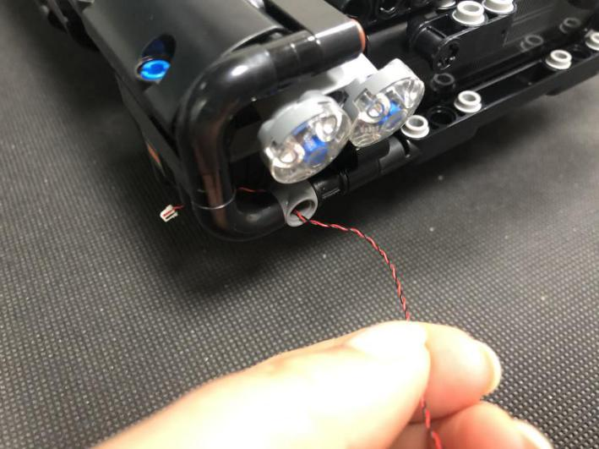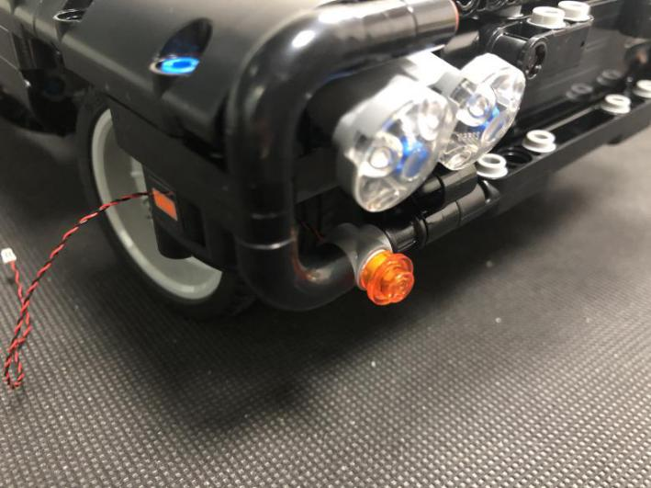
Turn the car over to its side, thread the cable through the following space.
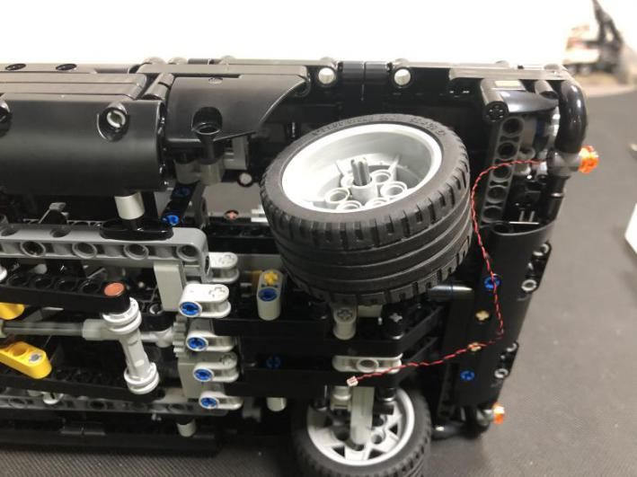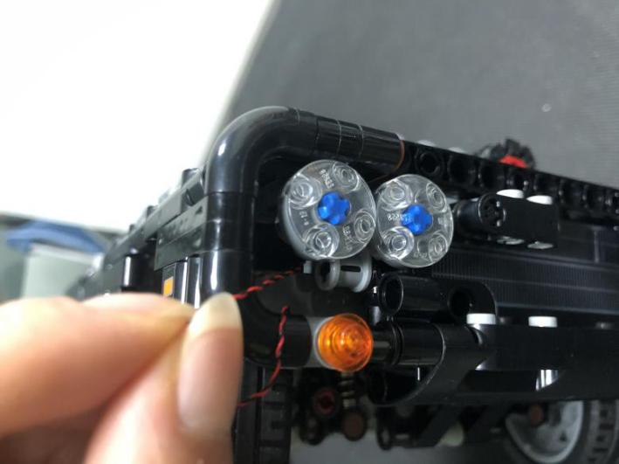
Open the lid, pull the cable out.
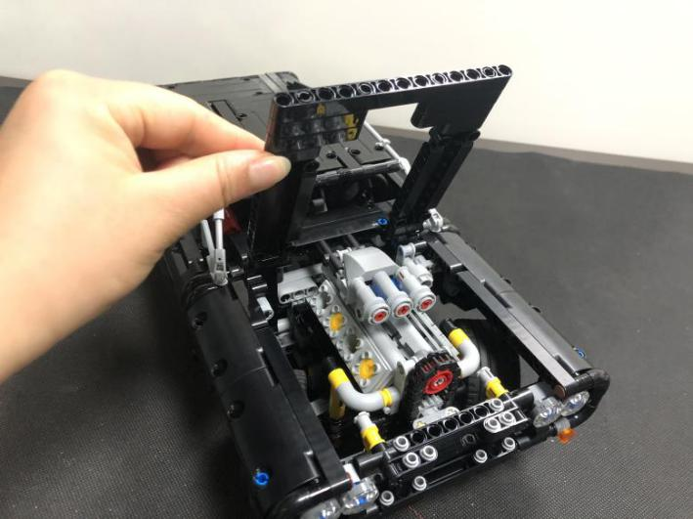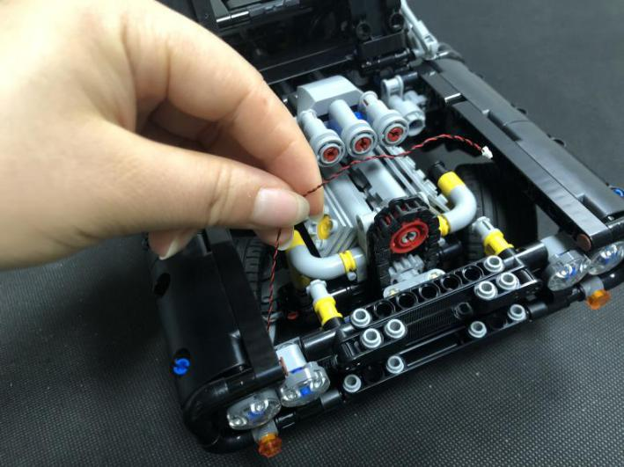
Take an 8-port expansion board, connect the cable to it.
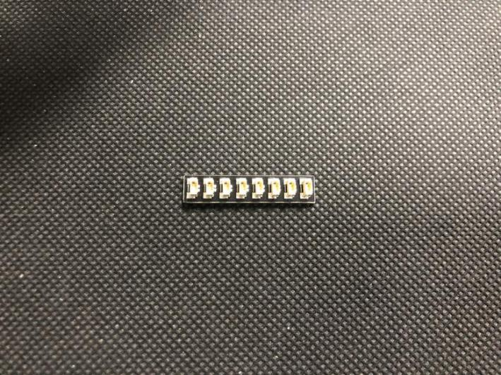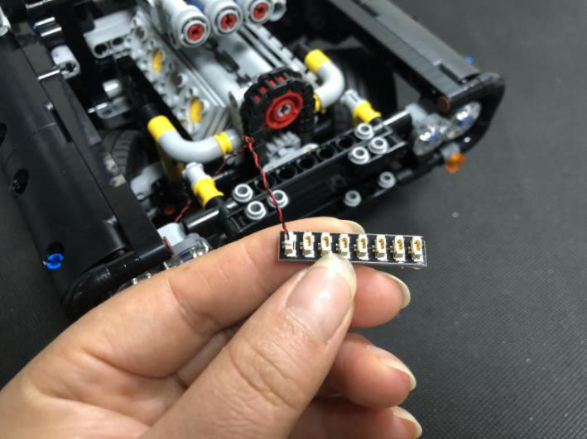
Tuck excess cable, stick the expansion board to the following place with adhesive squares.
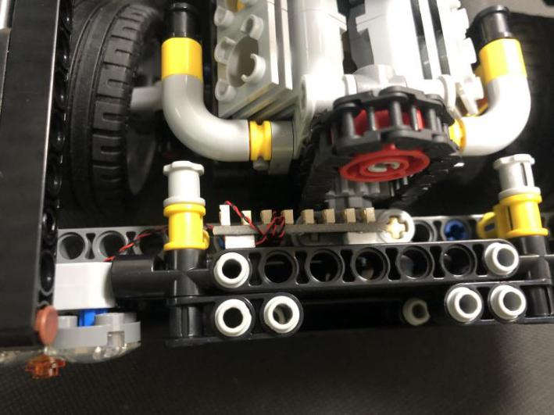
Continue to install the 2 headlights. Remove the lights and disassemble them as per below.
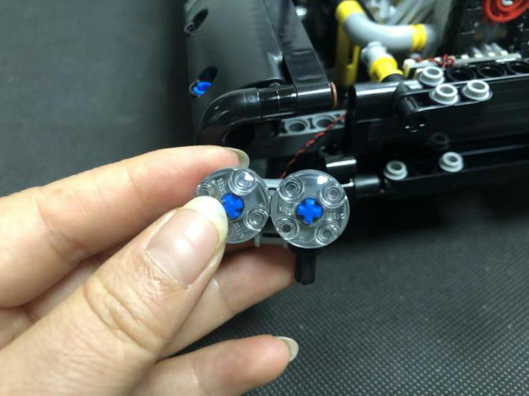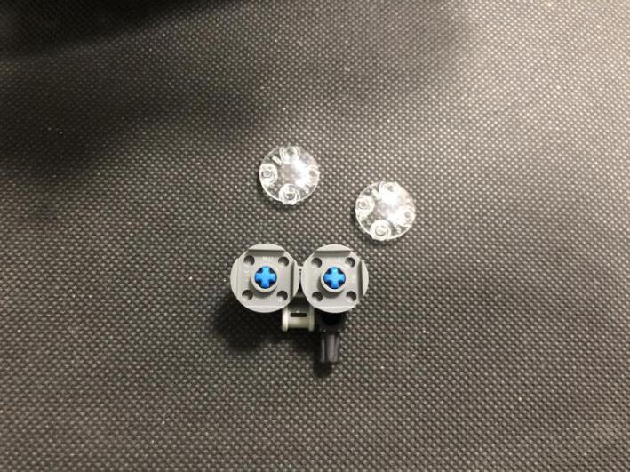
Take two 15cm headlights, take one light, place it to the following blue cross piece as per below.
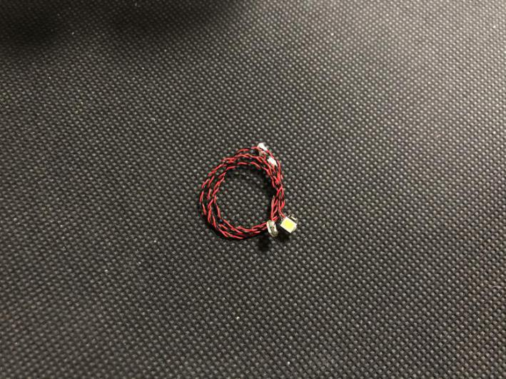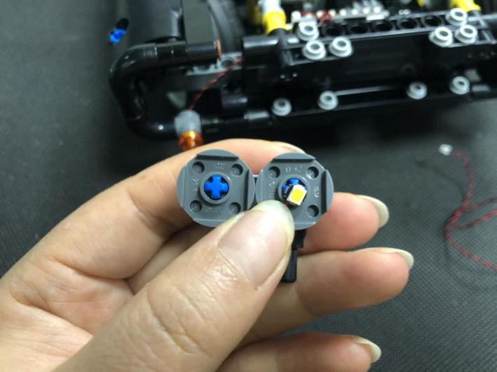
Secure the light with trans 2x2 round plate, pull the cable out from the back.
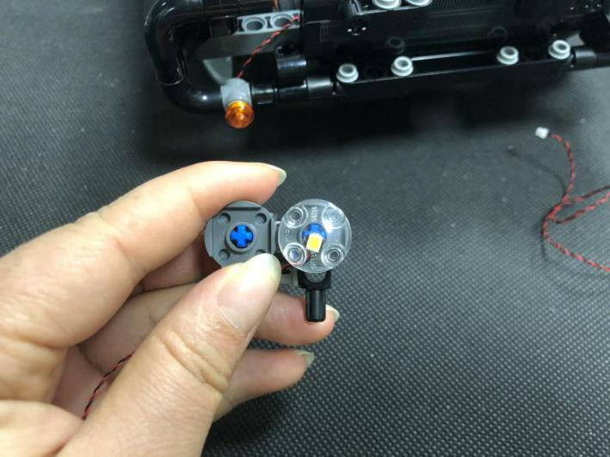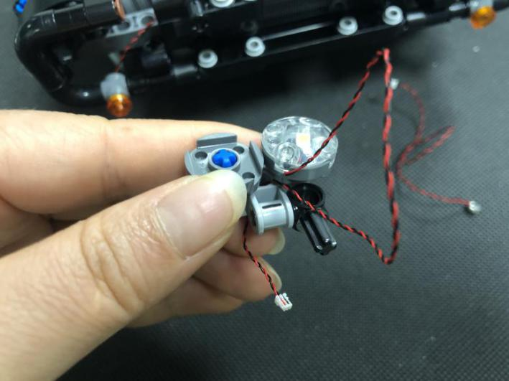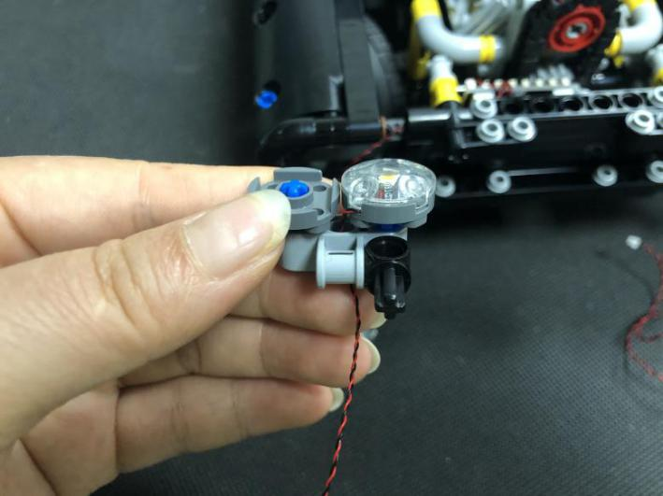
Repeat the steps above to install the other headlight.
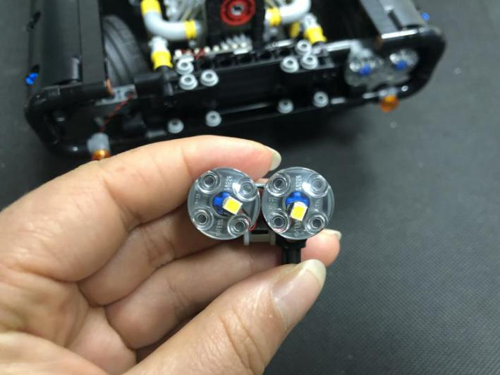
Group the 2 cables together, reconnect the headlights.
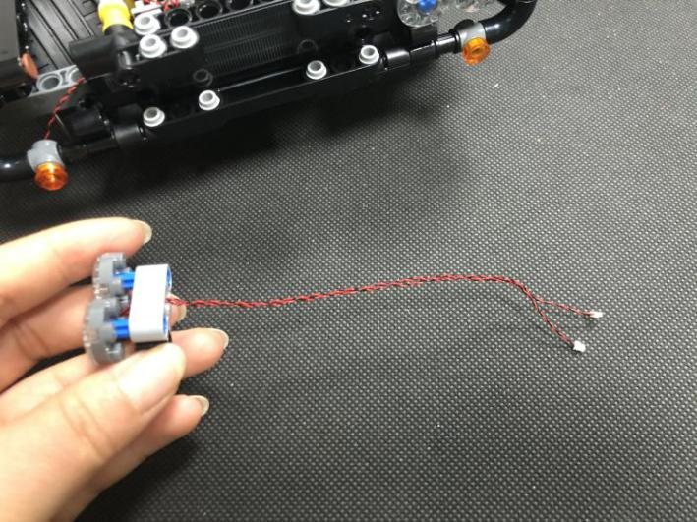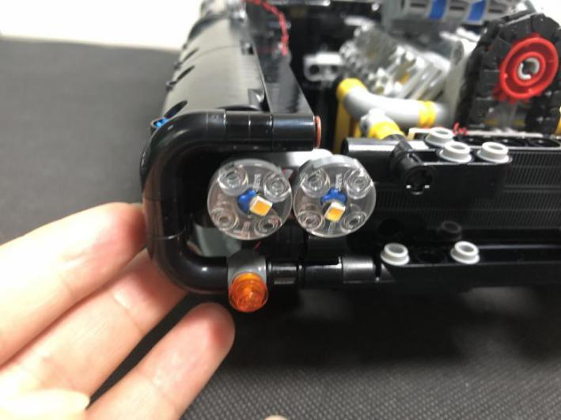
Tuck excess cables around the expansion board before connect the cables to the expansion board.
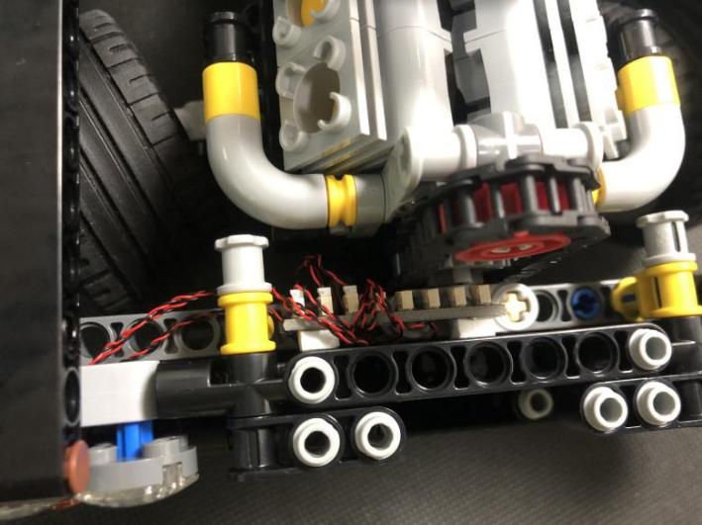
Take a warm white 15cm dot light, two 15cm headlights, a trans orange 1x1 round plate, repeat the previous steps to install the other 2 headlights.
Take a 50cm connecting cable, connect it to the expansion board.
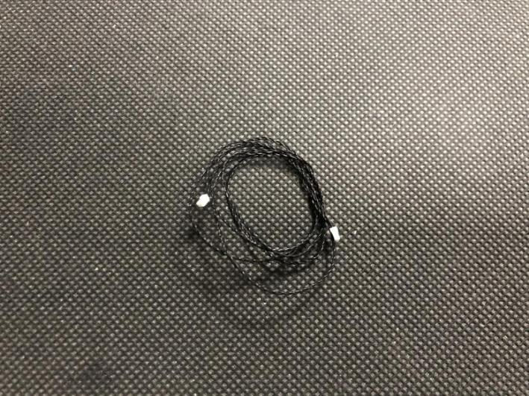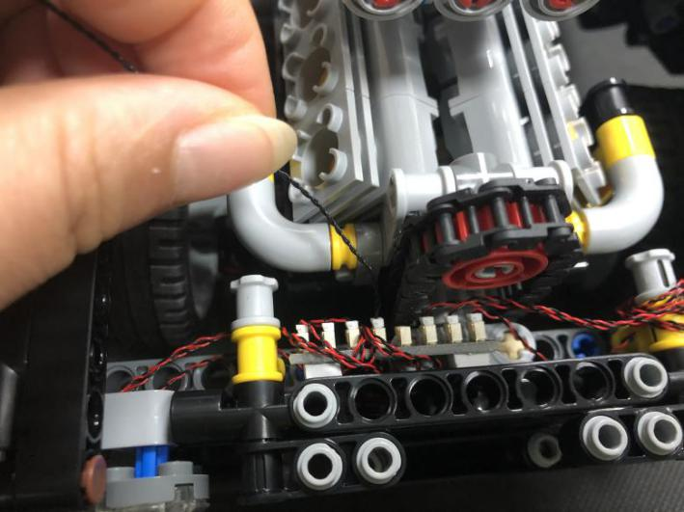
Thread the connecting cable to the bottom, thread the cable through the following space.
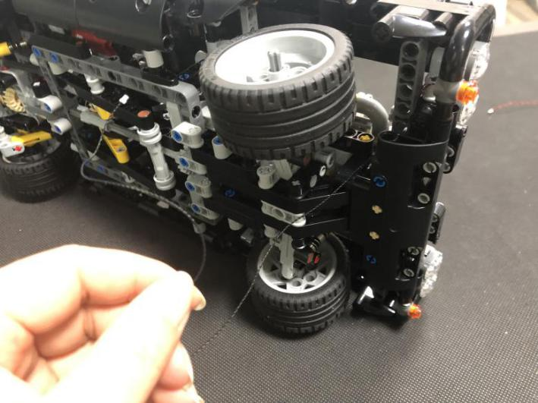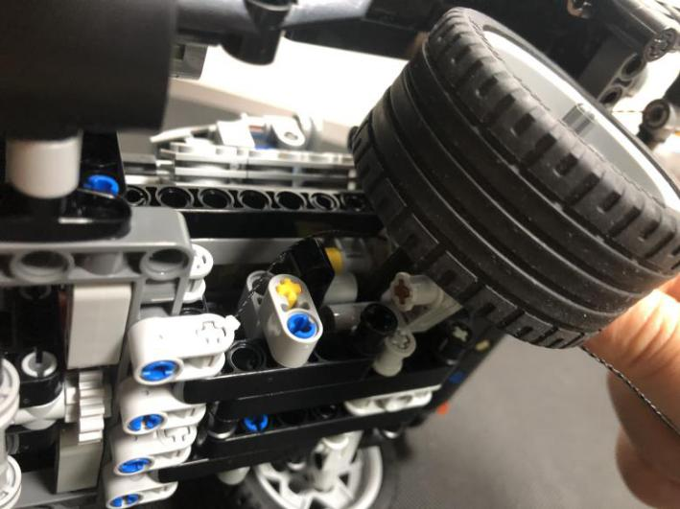
Pull the cable backward.
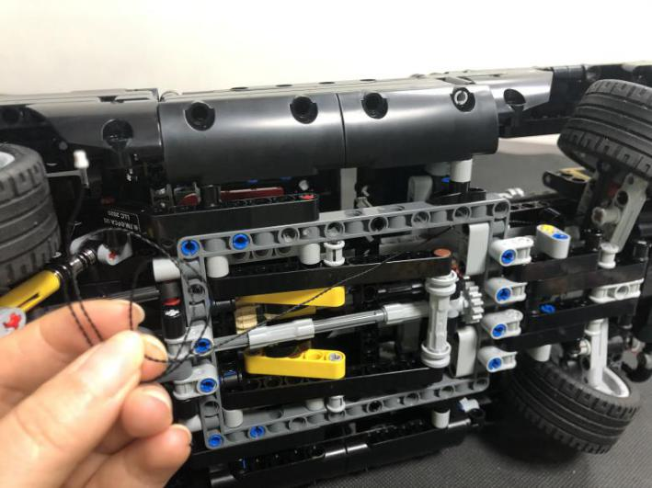
Tuck excess cable around the following piece.
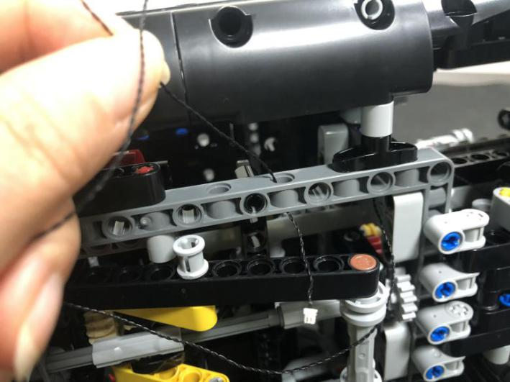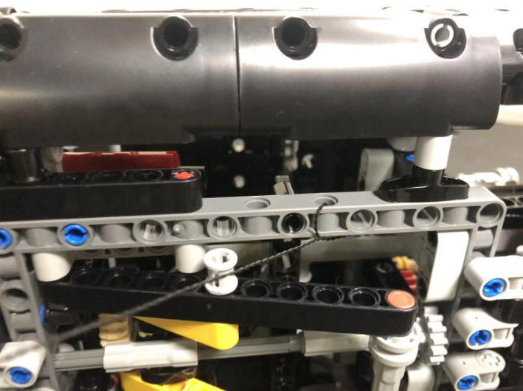
Wind the cable around the following piece at the back of the tire.
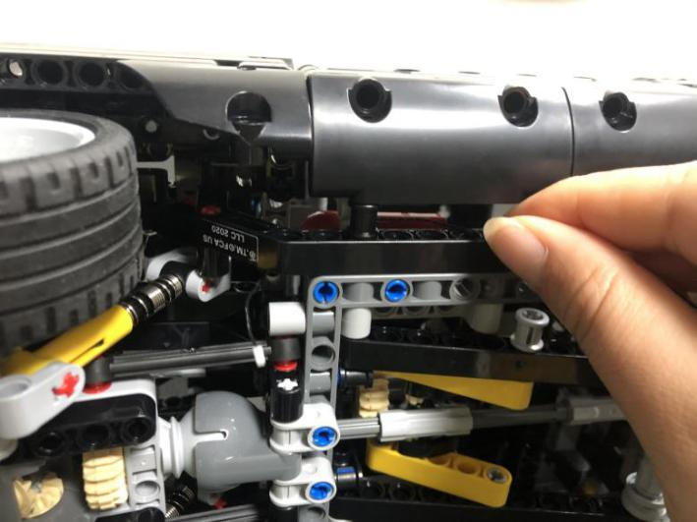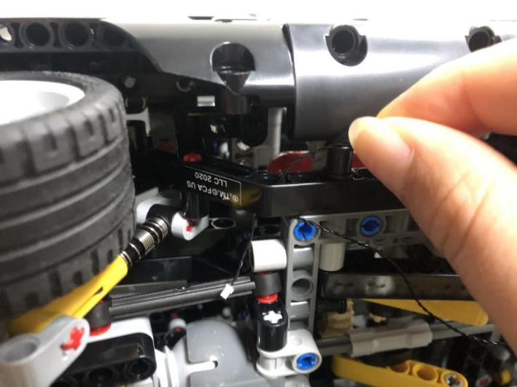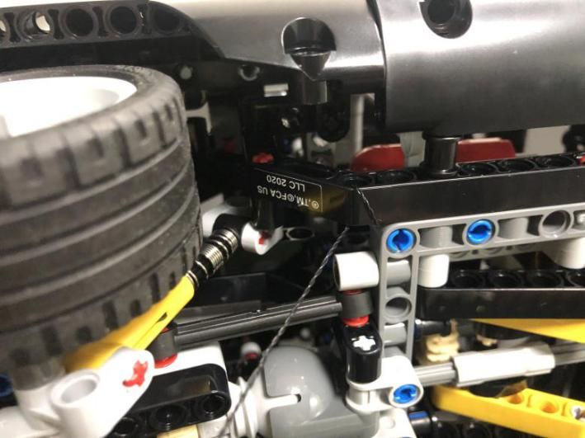
Remove the tire, thread the cable trough the following space.
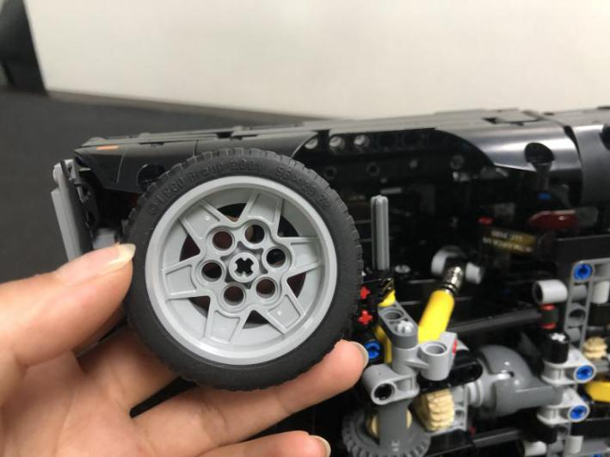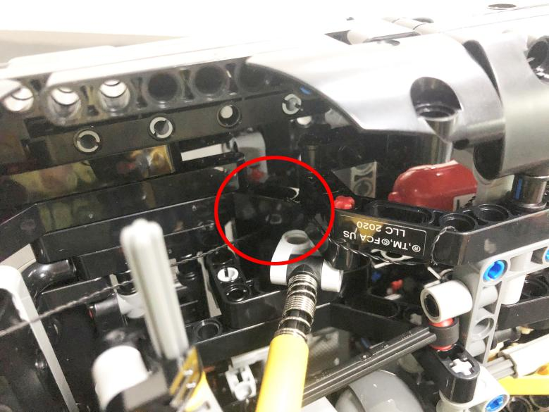
Open the lid of the trunk.
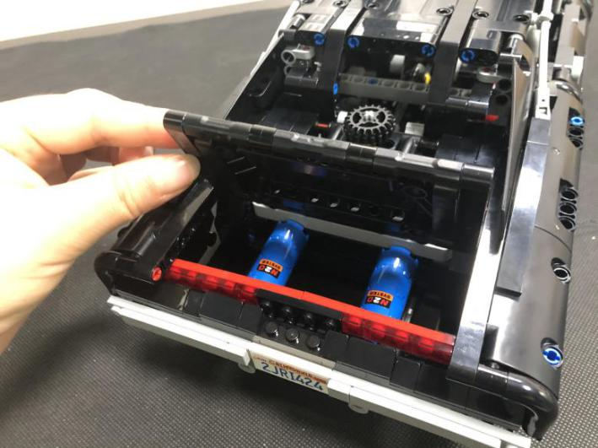
Thread the cable trough the following space, pull the cable out from the trunk.
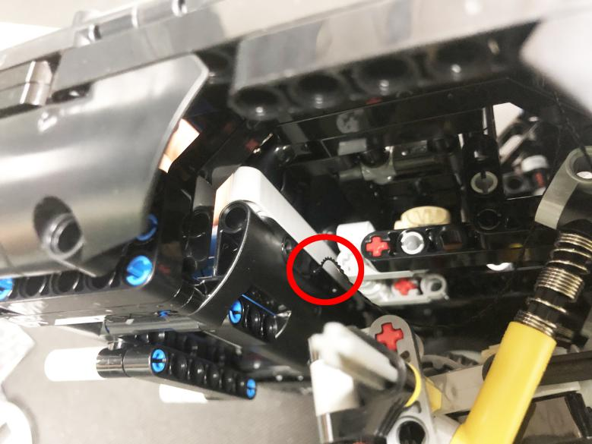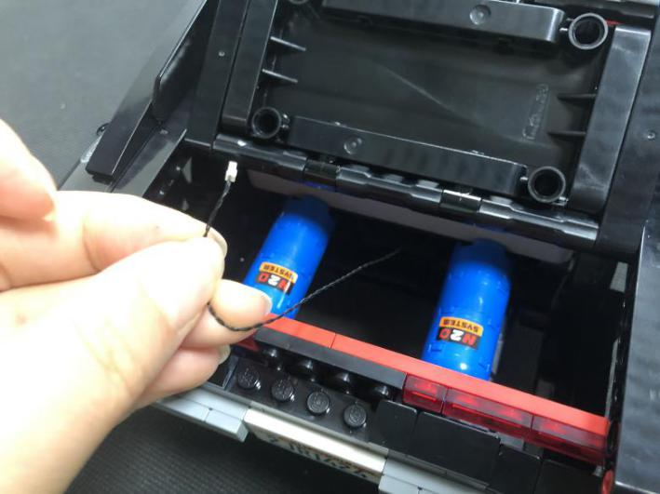
Take an 8-port expansion board, connect the connecting cable to it.
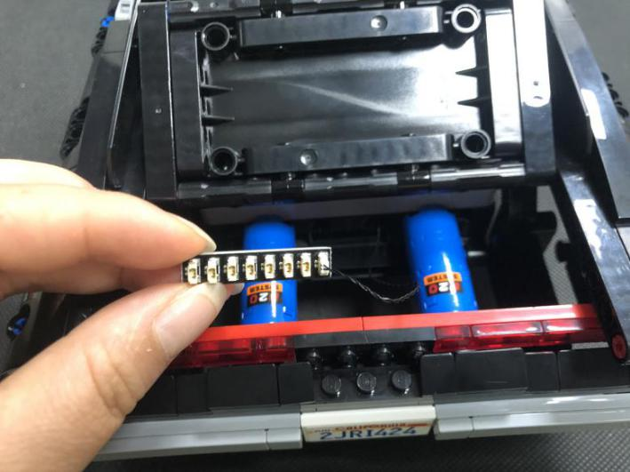
Stick the expansion board to the following place with adhesive squares, reconnect the tire, and the gray piece we removed before.
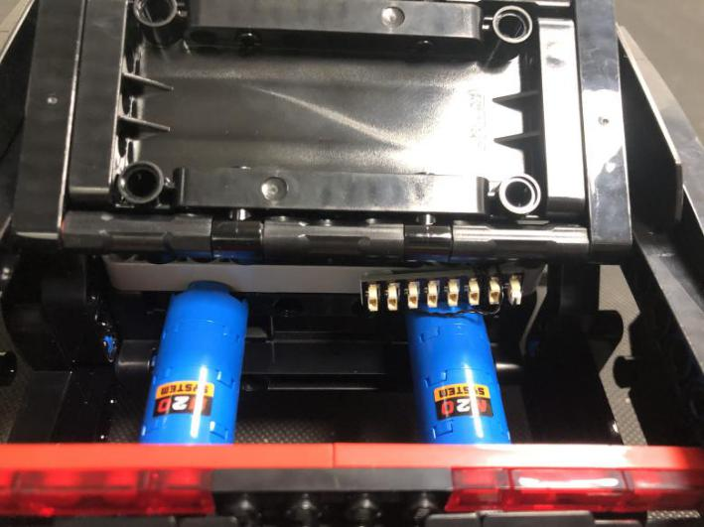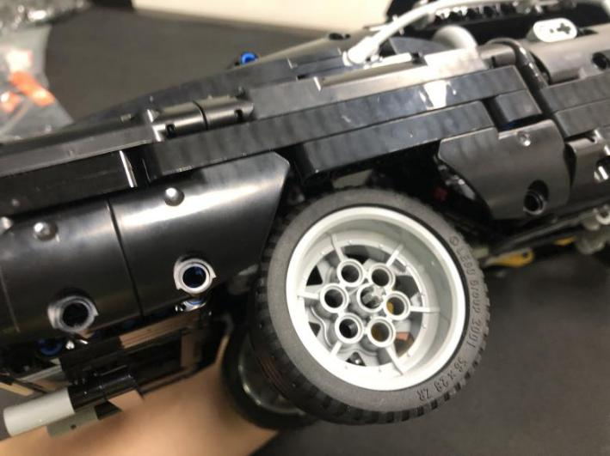
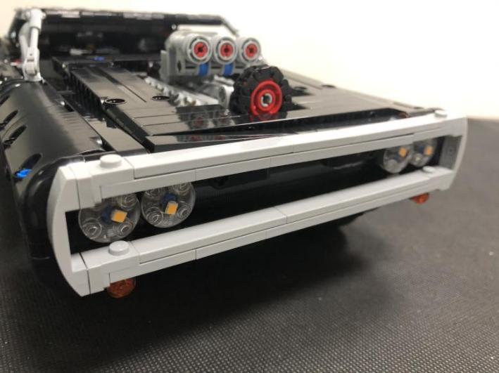
Take a warm white strip light, a 30cm connecting cable connect the connecting cable to the strip light.
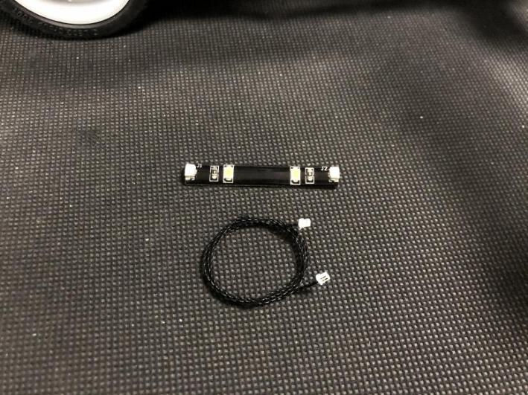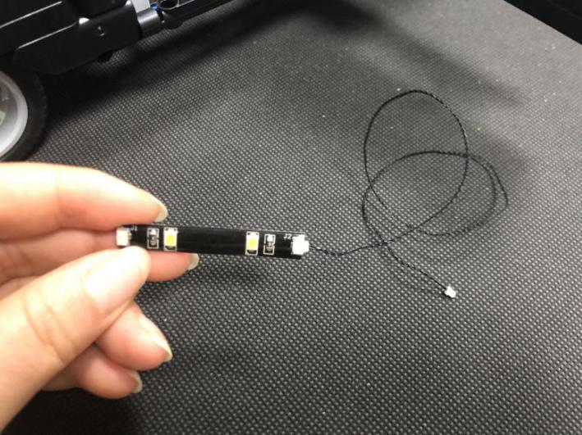
Stick the strip light to the roof of the control room. 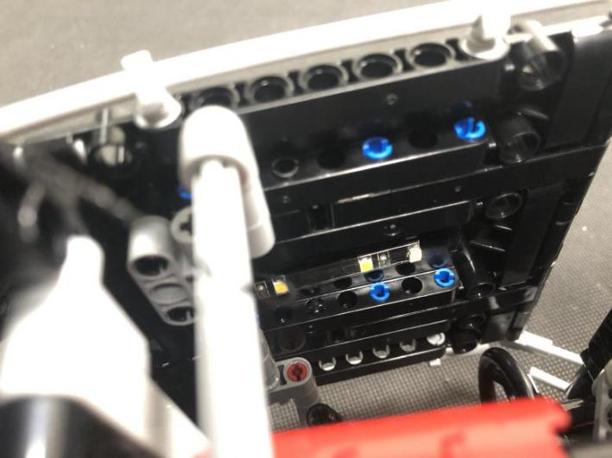
Thread the cable from the strip light through the following space, pull it out from the back.
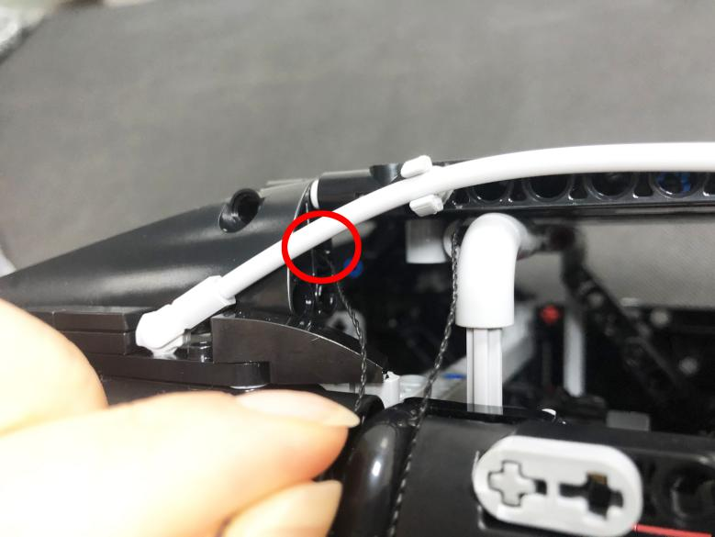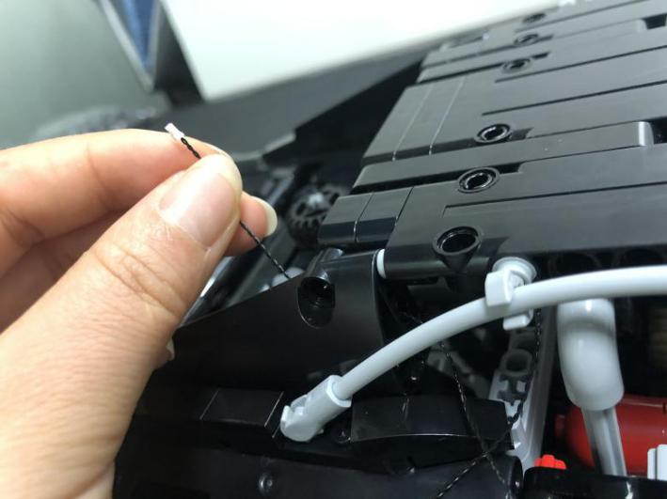
Thread the cable through the following space to the bottom of the car.
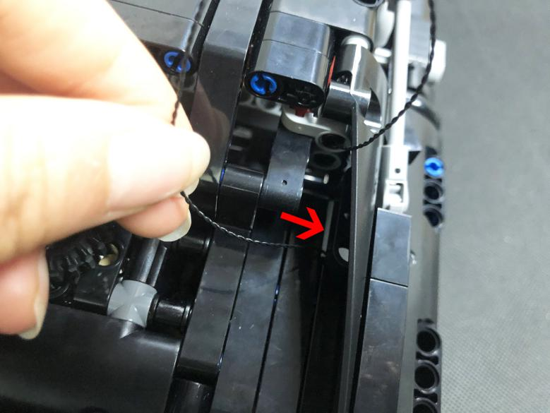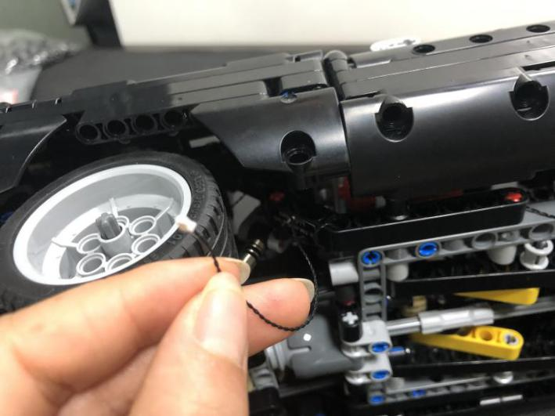
Thread the cable through the following space to the expansion board at the back.
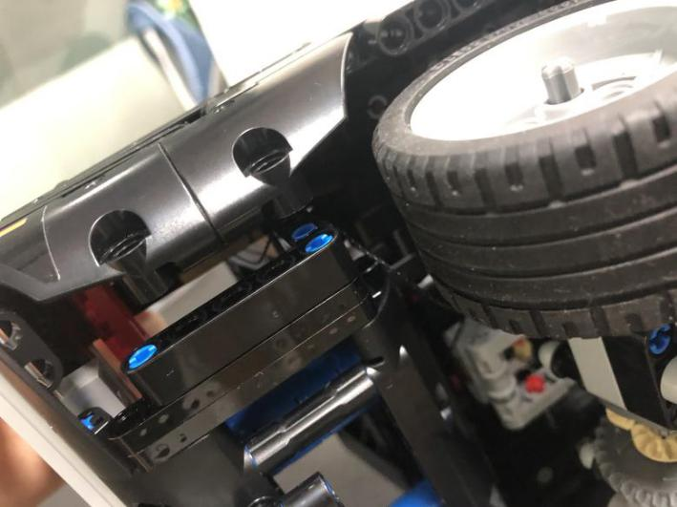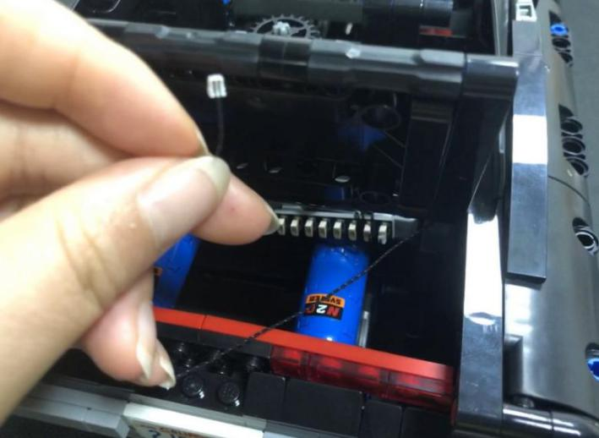
Tuck excess cable before connect the connecting cable to the expansion board.
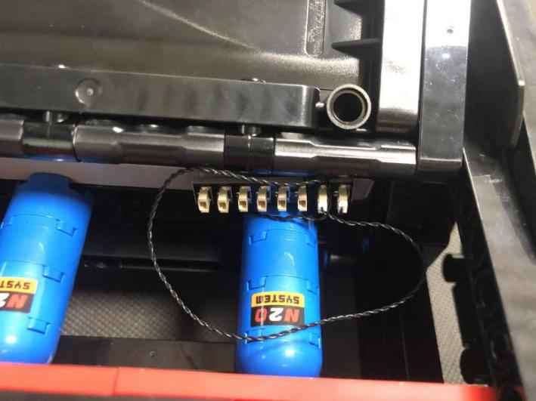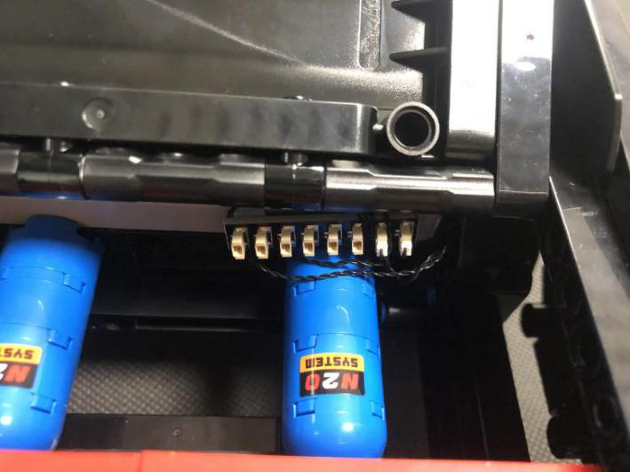
Move onto installing lights for the red taillights, remove the left part and disassemble it as per below.
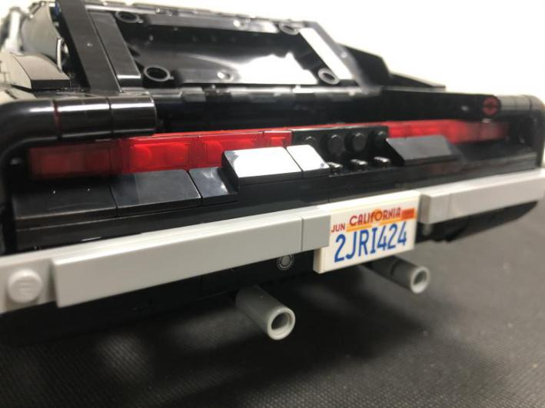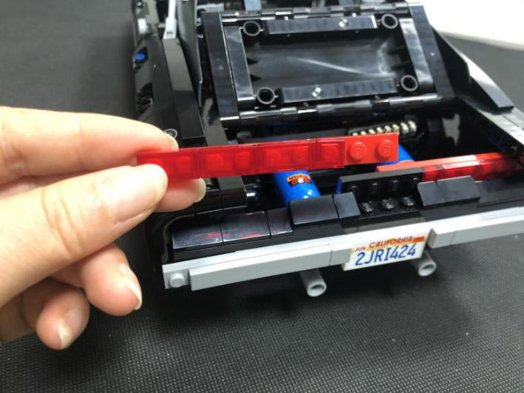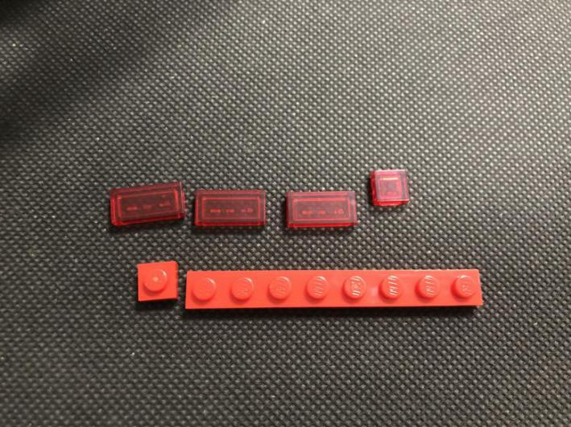
Take 4 warm white 15cm dot lights, a trans red 1x1 plate.
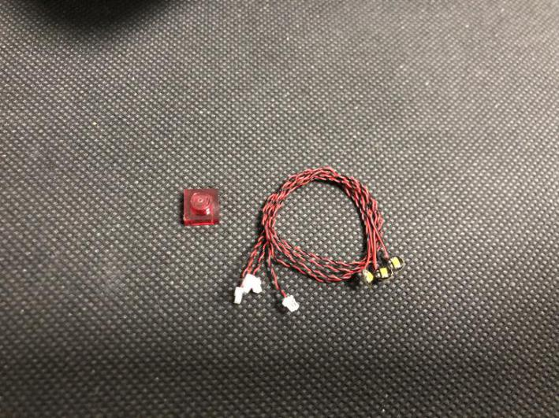
Place one of the lights to the following place, secure the light with the 1x2 trans red plate.
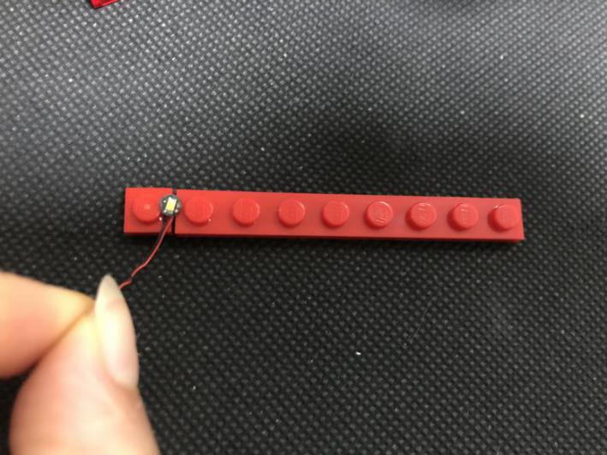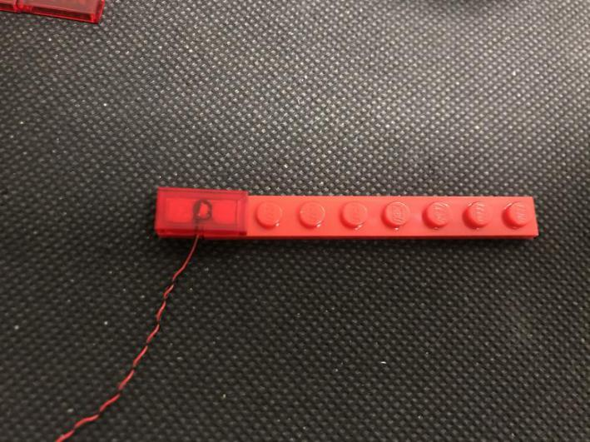
Repeat the steps above to install the next 2 lights.
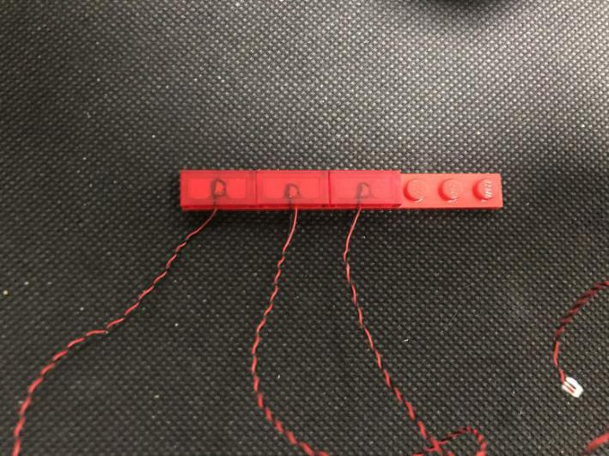
Place the last light on the stud, secure the light with the trans red 1x1 plate.
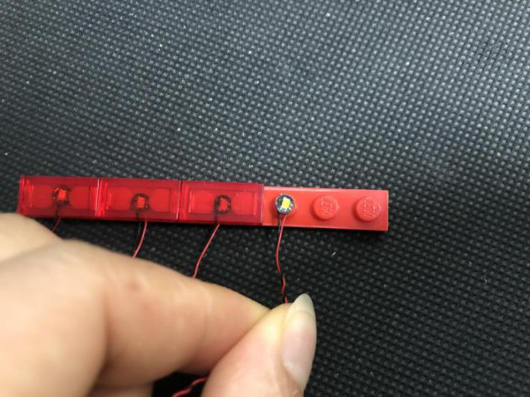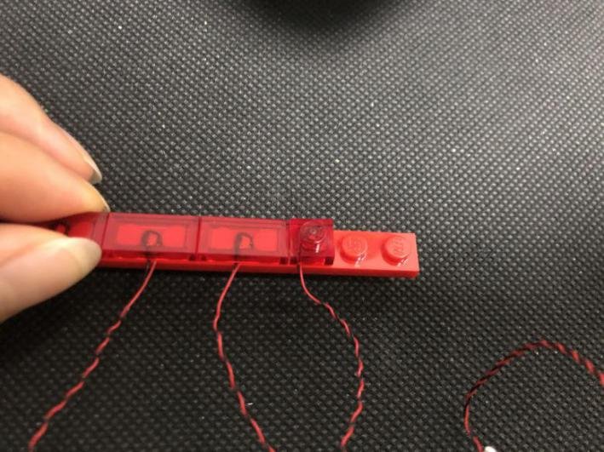
Group the cables together before reconnect the lights.
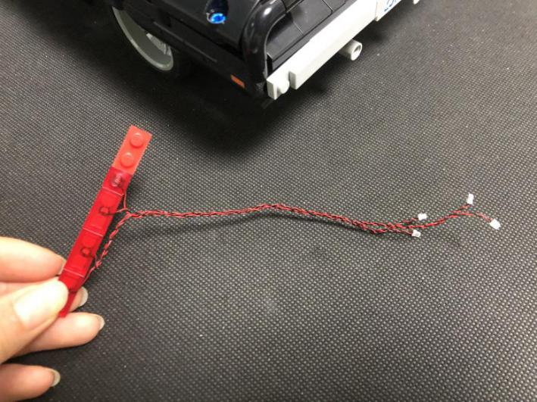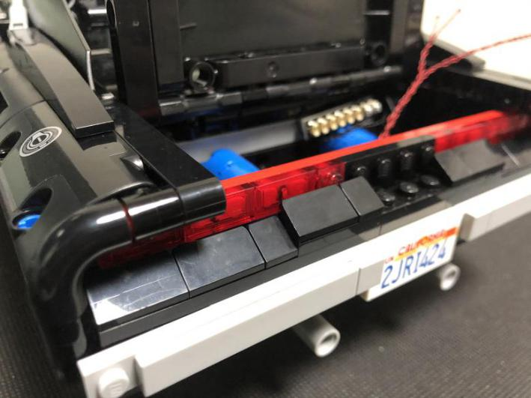
Connect the cables of the lights to the expansion board.
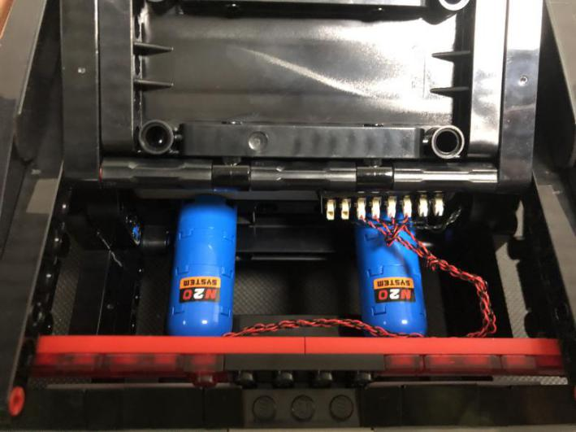
Take an 8-port expansion board, a 5cm connecting cable, connect the connecting cable to the expansion board.
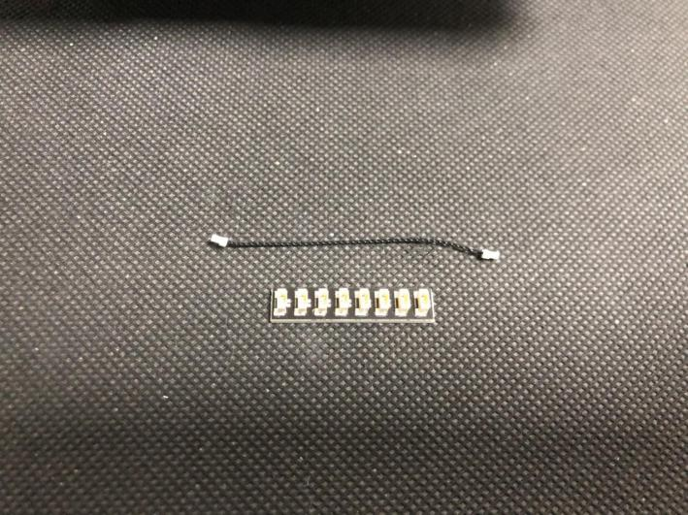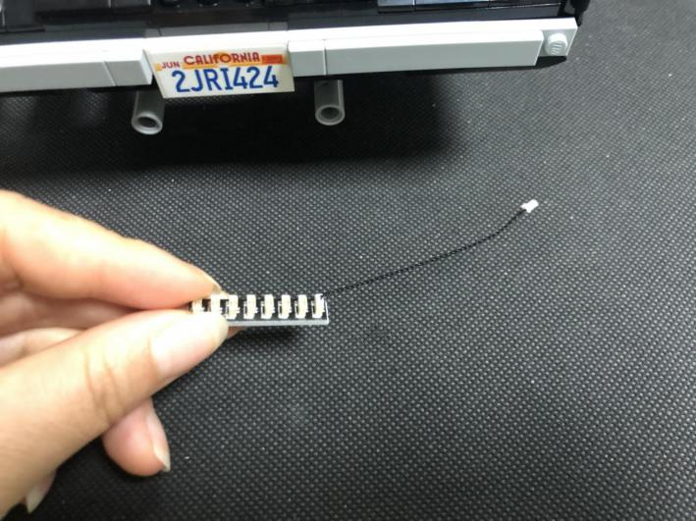
Connect the other end of the connecting cable to another expansion board, stick the expansion board to the following place with adhesive squares.
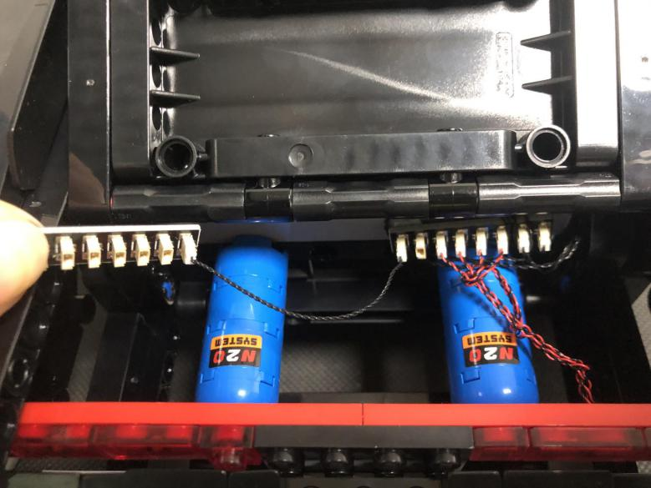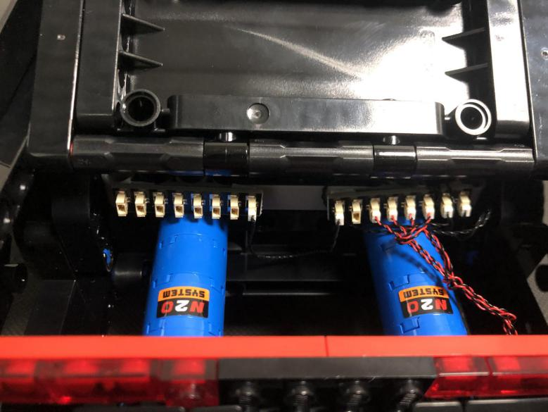
Remove the right part of the taillights.
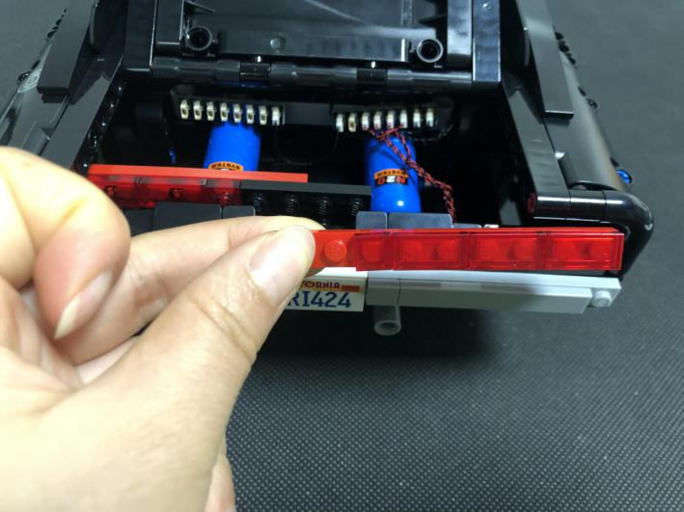
Take 4 more warm white 15cm dot lights, a trans red 1x1 plate, repeat the steps above to install the lights for the right part.
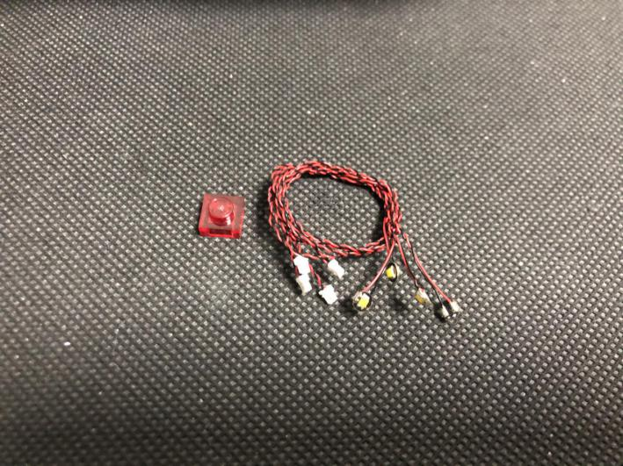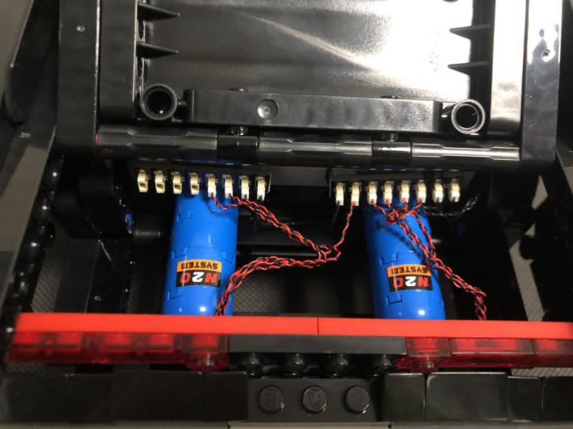
Now, we’ll install lights for the pipes. Turn the car over to its side.
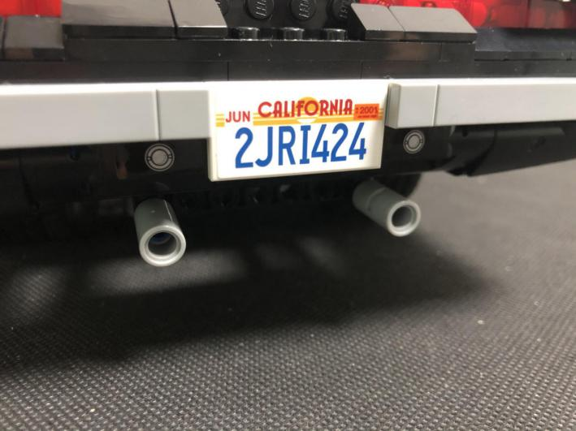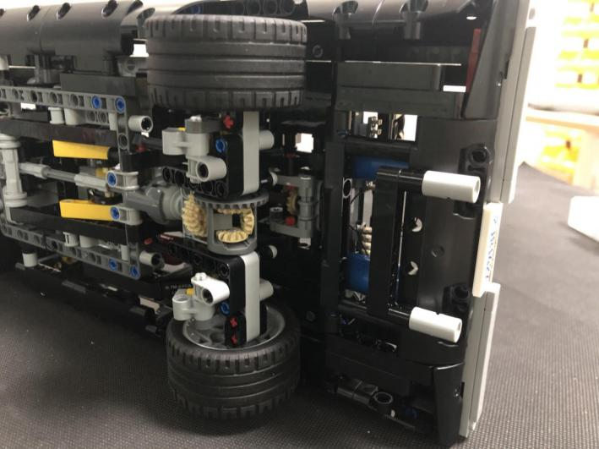
Remove one of the pipes.
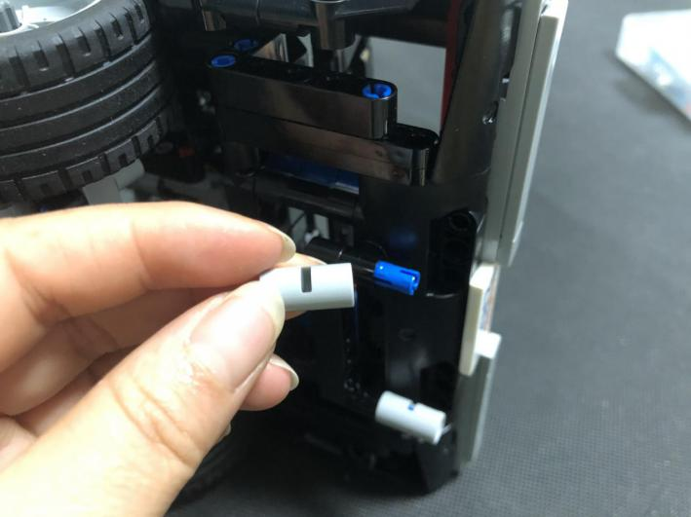
Take a red 15cm dot light, place the light on the blue pin, reconnect the gray pipe.
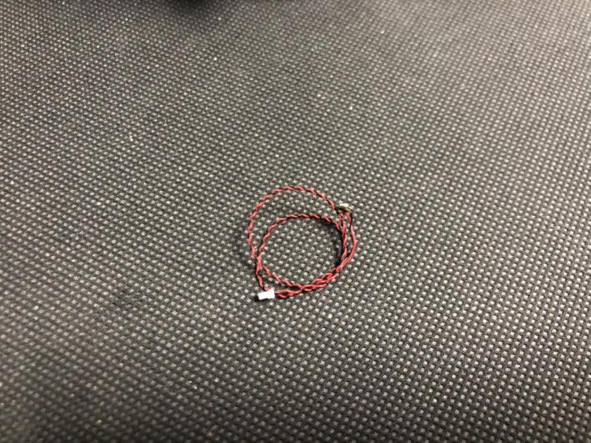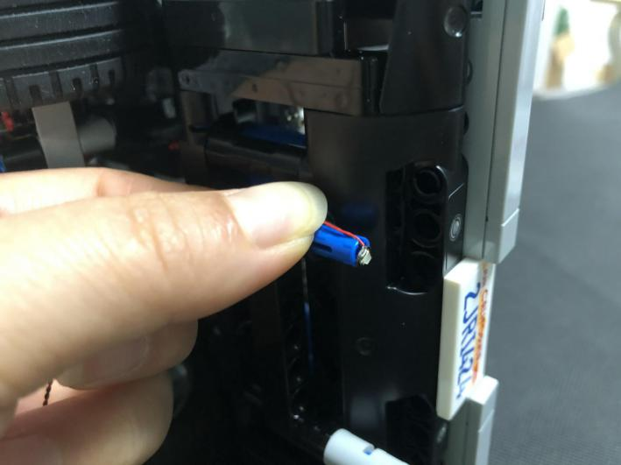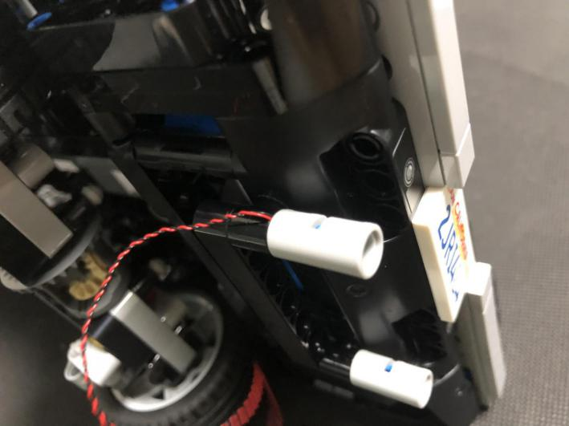
Take the Flicker Effects Board, connect the cable of the light to the Flicker Effects Board (note: do not connect it to the power port), as per below.
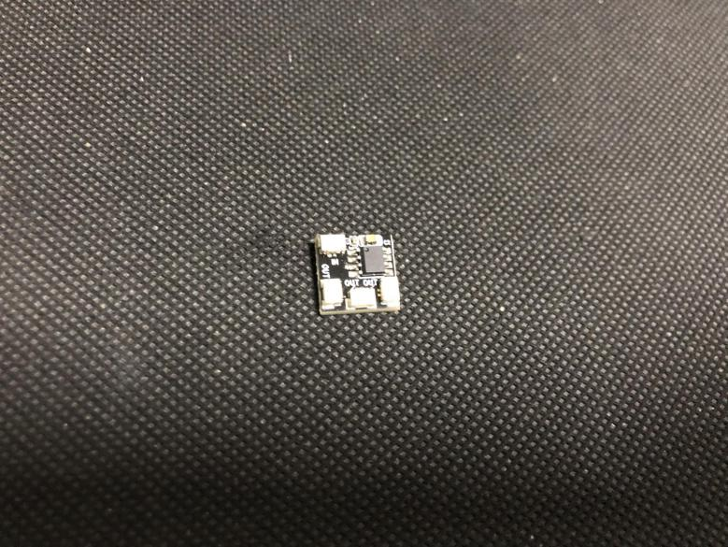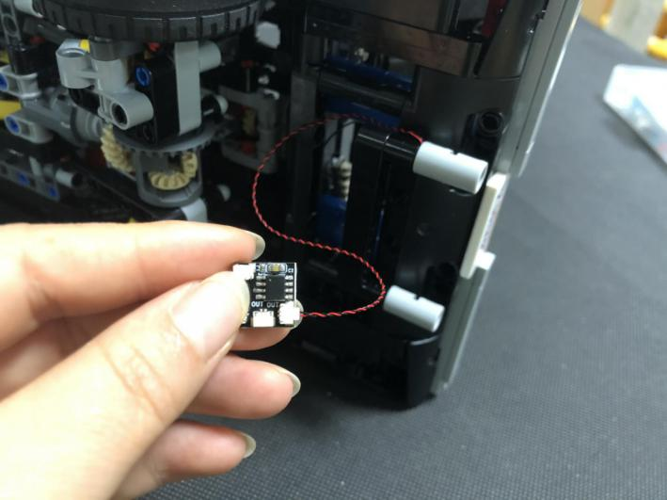
Take a red 15cm dot light, repeat the previous steps to install light for the other pipe, also connect the cable of the light to the Flicker Effects Board.
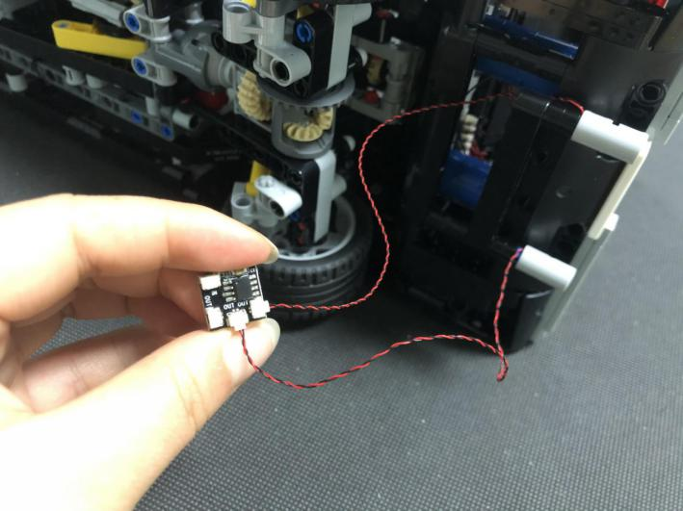
Pull the Flicker Effects Board out, tuck excess cable.
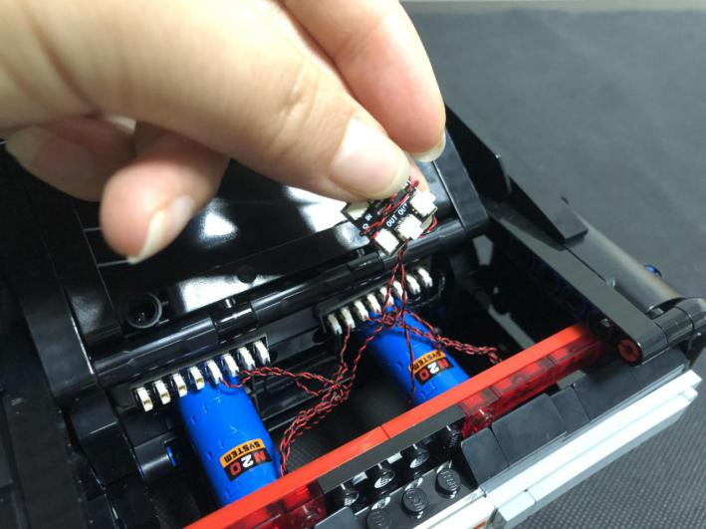
Take a 5cm connecting cable, connect it to the power port on the Flicker Effects Board.
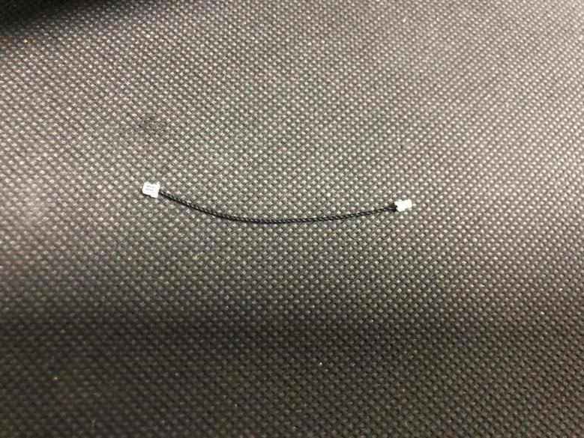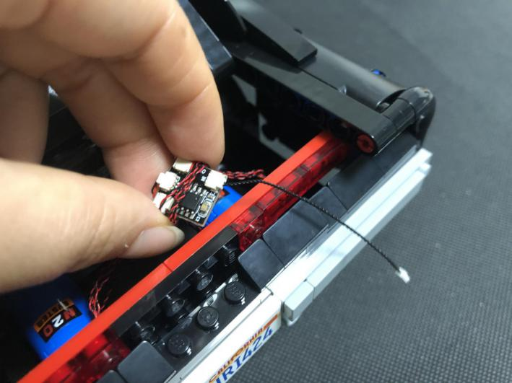
Stick the Flicker Effects Board to the following place, connect the cables on the Flicker Effects Board to the expansion board.
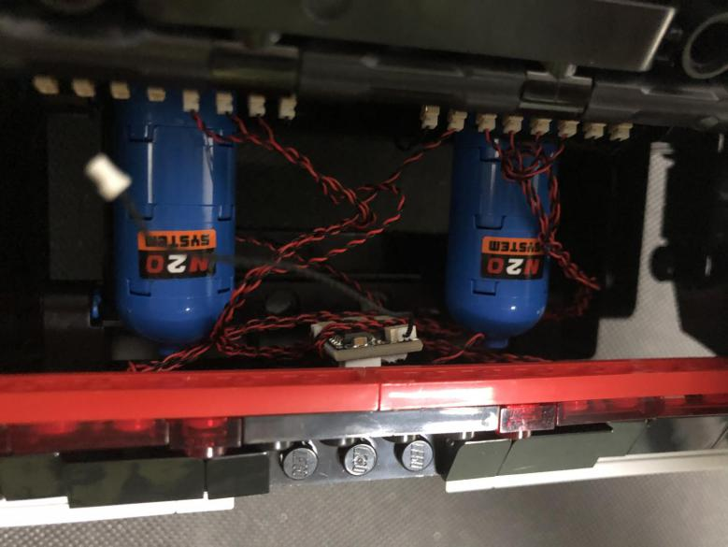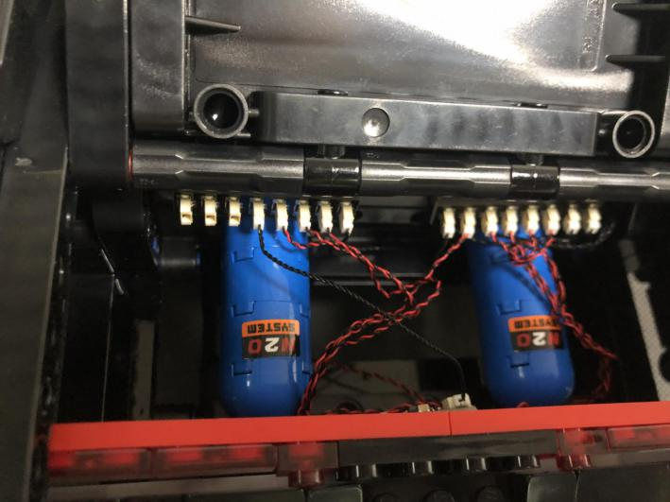

Take a blue strip light, a 30cm connecting cable, connect the connecting cable to the strip light.
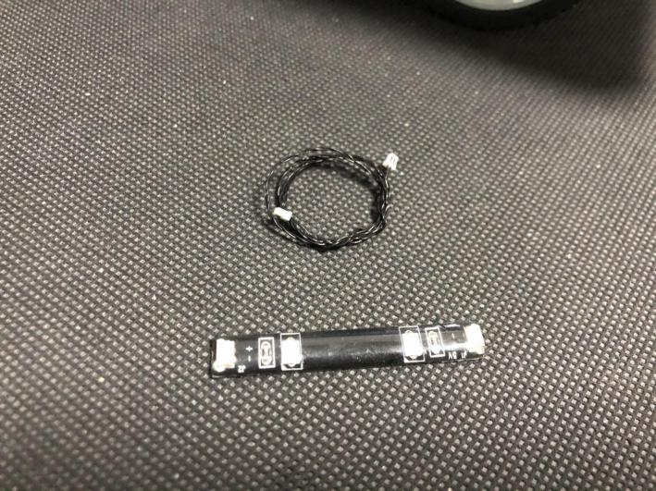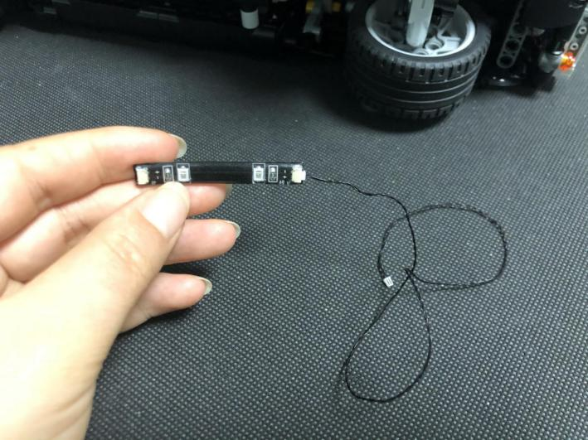
Stick the strip light to the following place over the front wheel. Thread the cable through the following space.
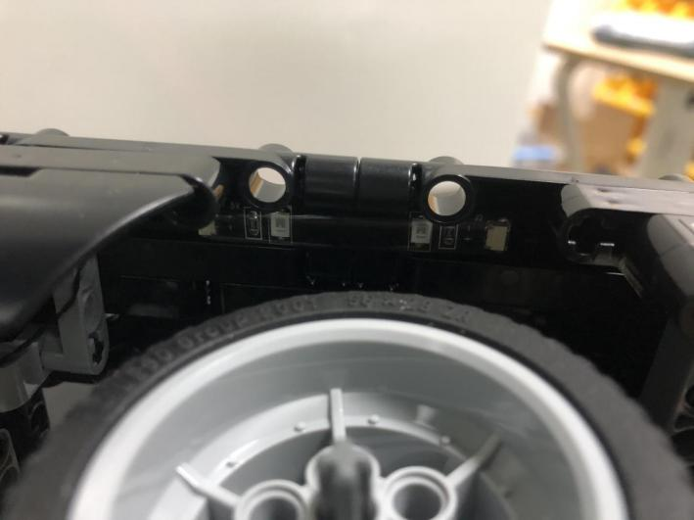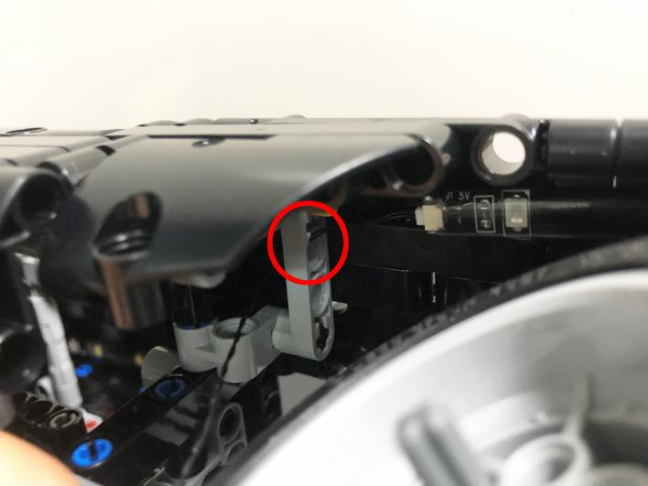
Thread the cable through the following spaces (note: you can thread the cable through any hole), and pull it backward.
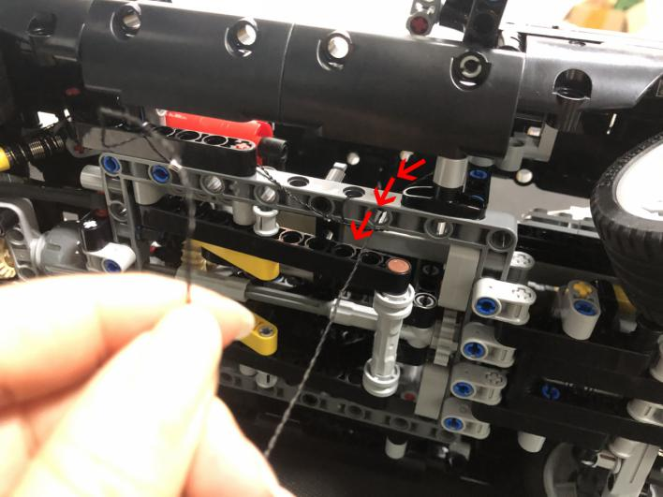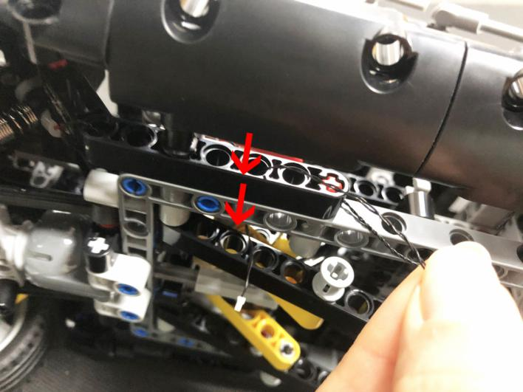
Tuck excess cable, and continue to place the cable.
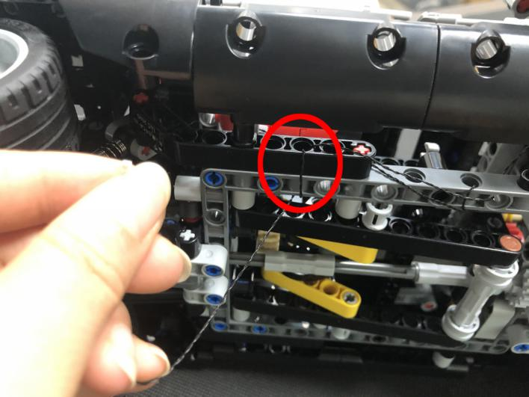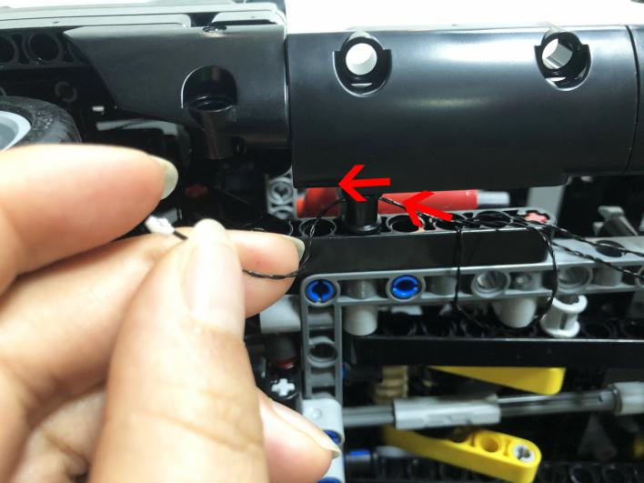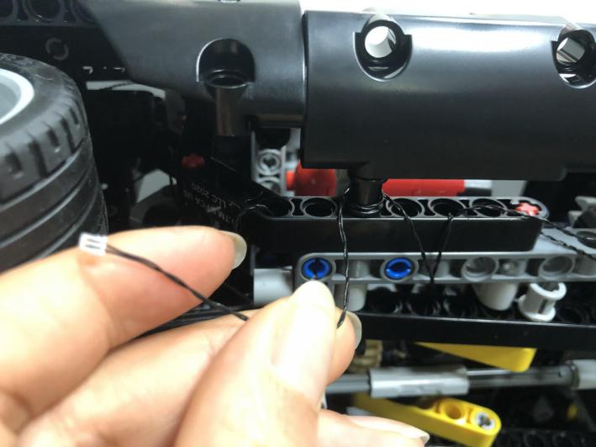
Take a blue strip light, connect the connecting cable to it.
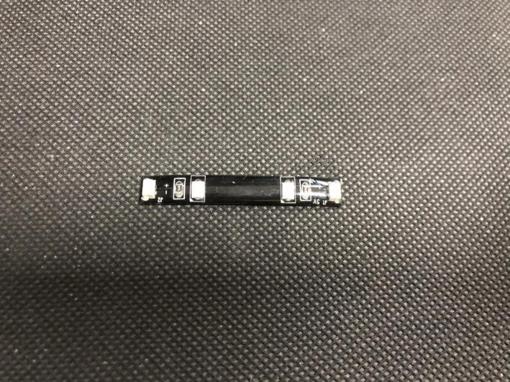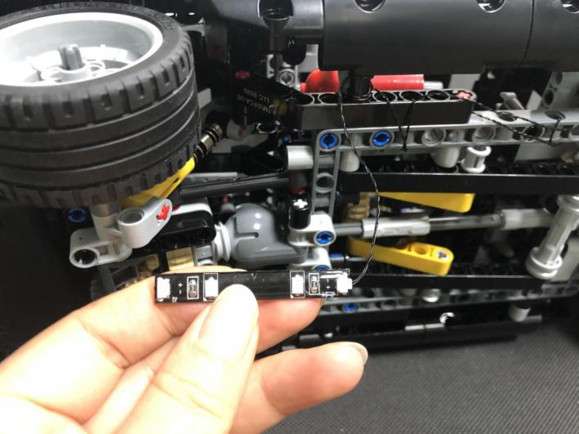
Stick the strip light to the following place over the back wheel.
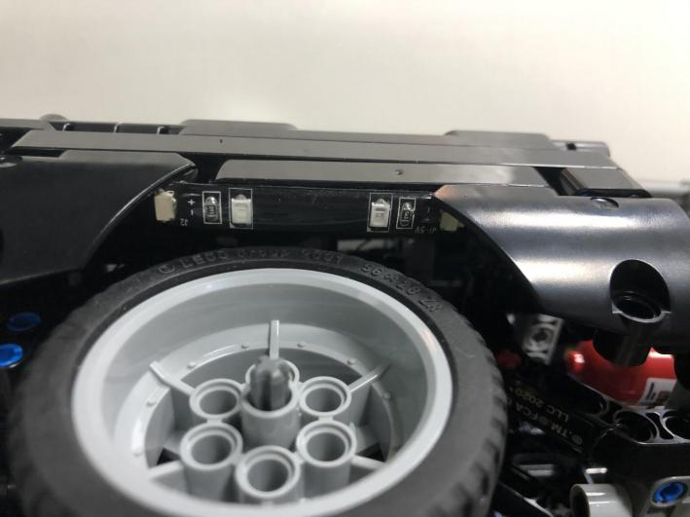
Take a 30cm connecting cable, connect it to the strip light over the back wheel.
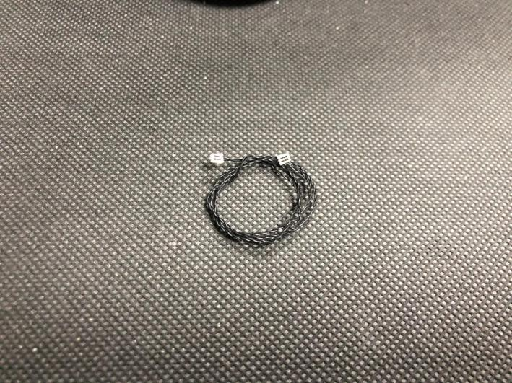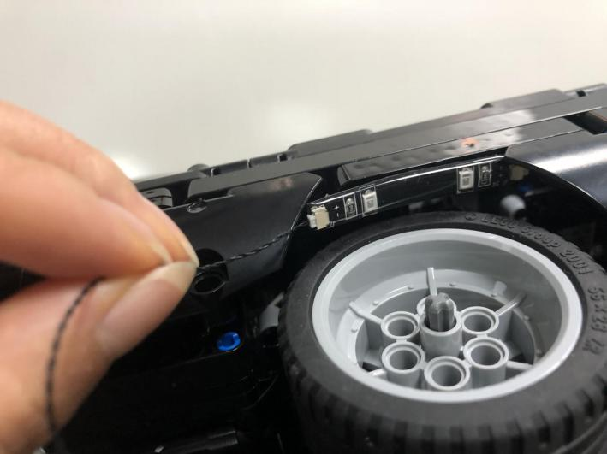
Turn the car over, thread the cable through the following space to the other side of the car, tuck excess cable as per below.
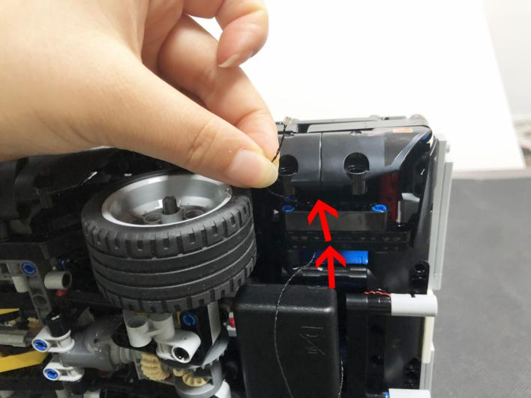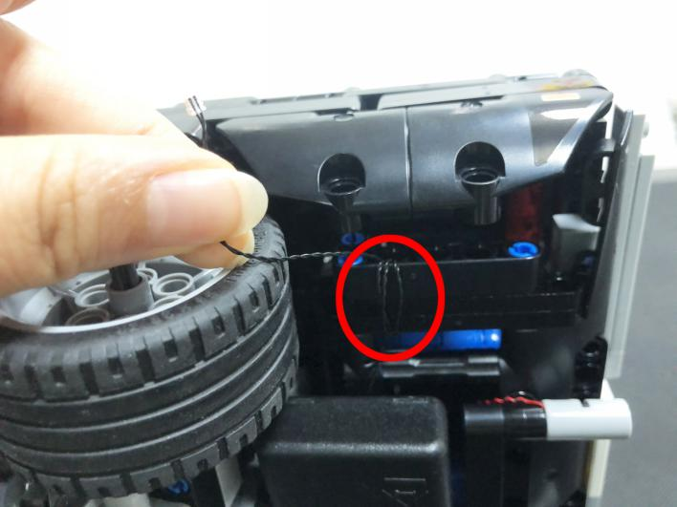
Take a blue strip light, connect the connecting cable to it.
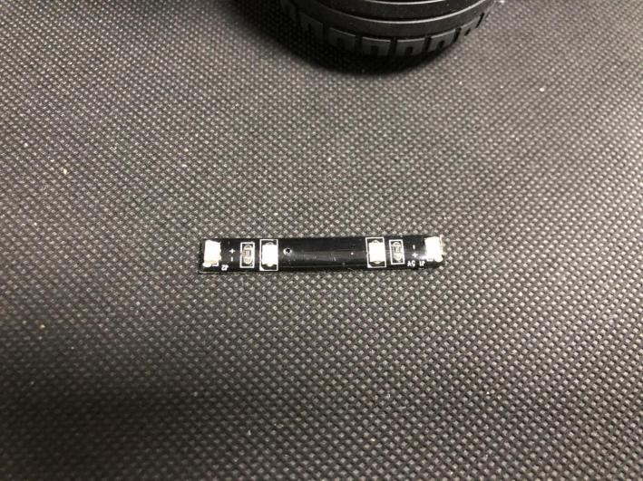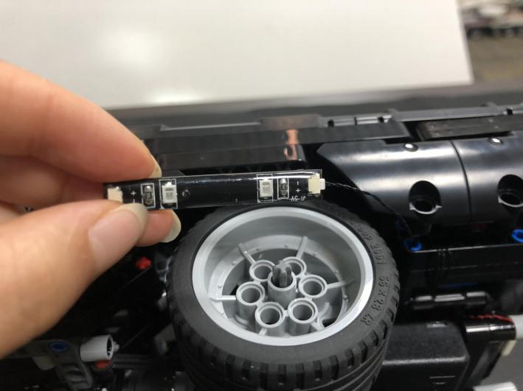
Take a 30cm connecting cable, connect it to the strip light.
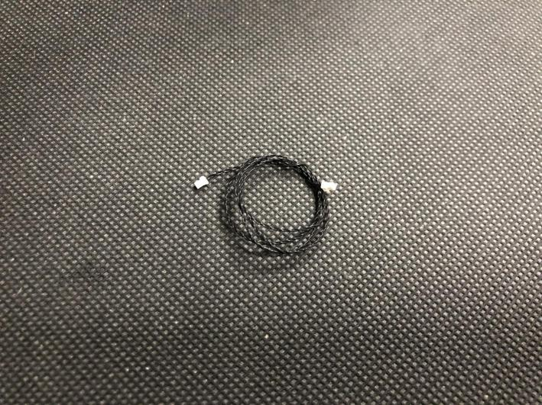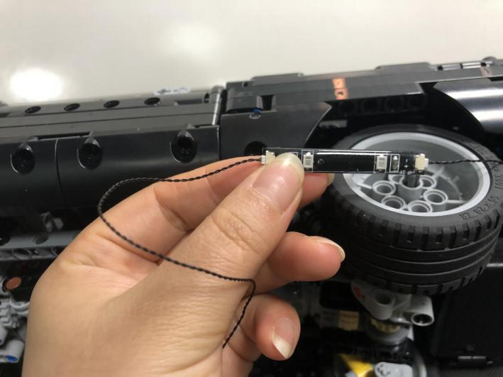
Stick the strip light to the place over the back wheel, thread the cable through the following hole.
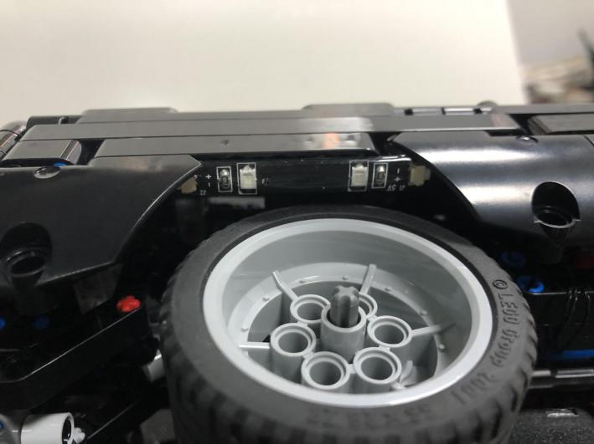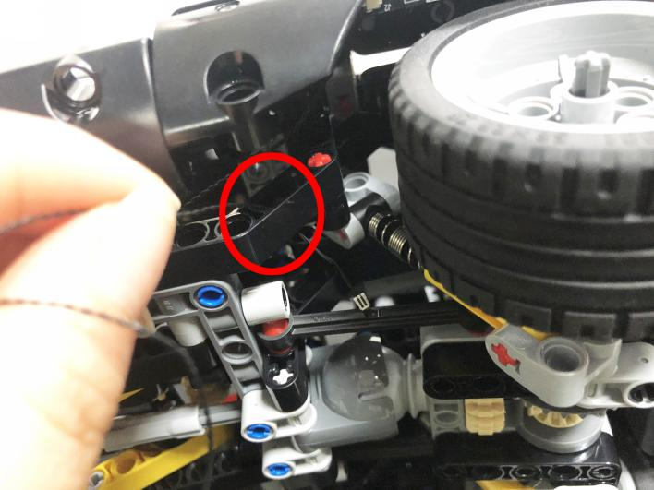
Tuck excess cable as per below.
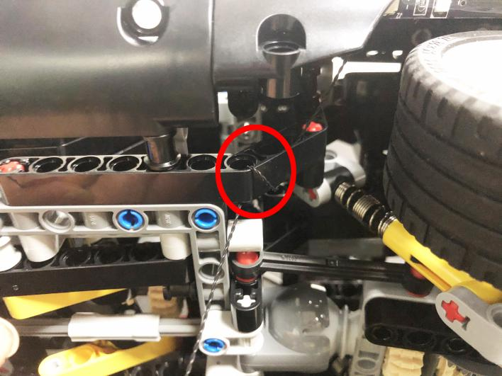
Thread the connecting cable through the spaces inside (you can thread it through any hole), tuck excess cable as per below.
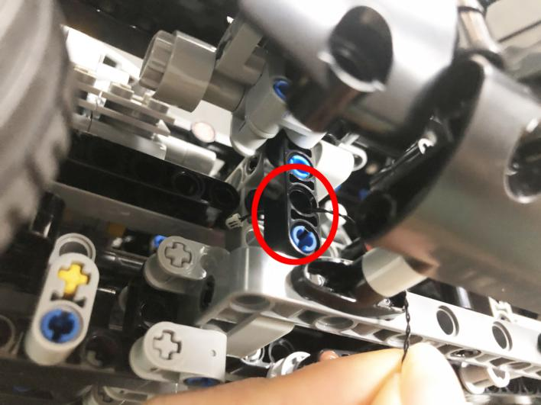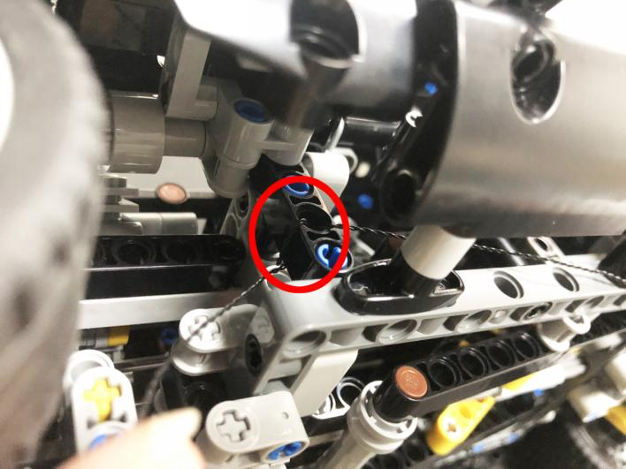
Remove the front tire, thread the cable through the following space.
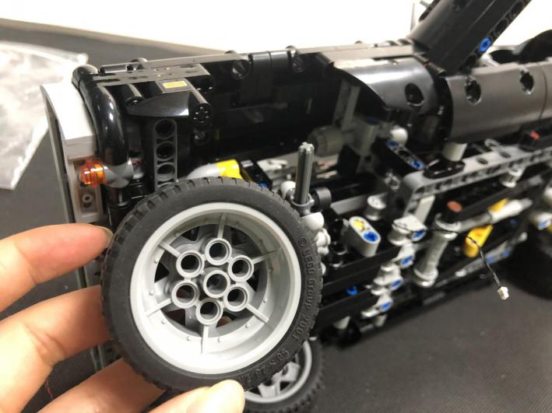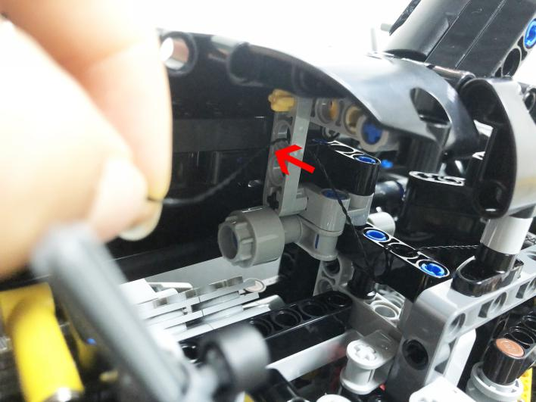
Take a blue strip light, connect the connecting cable to it.
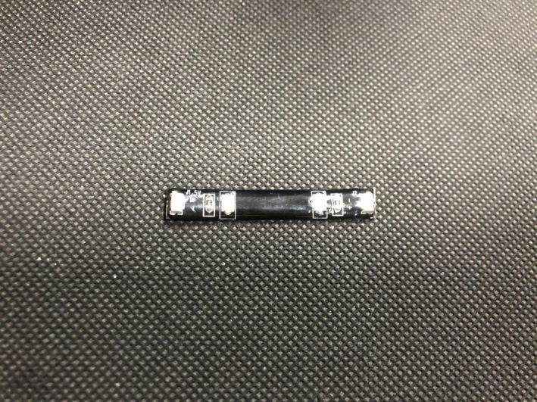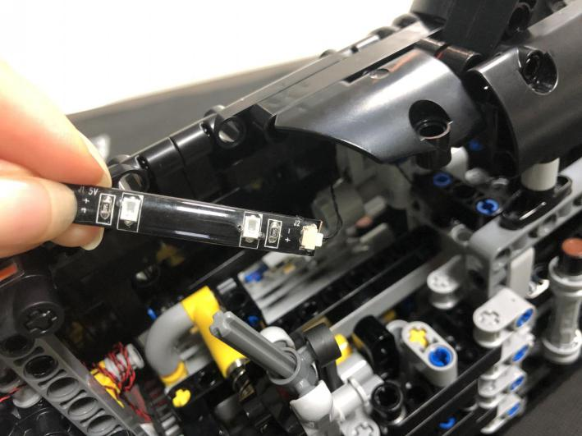
Take a 15cm connecting cable, connect it to the other end of the strip light.
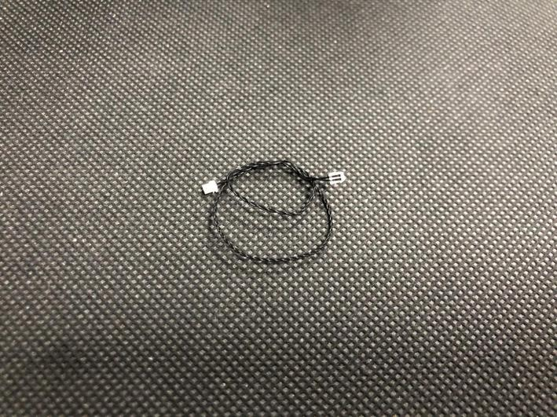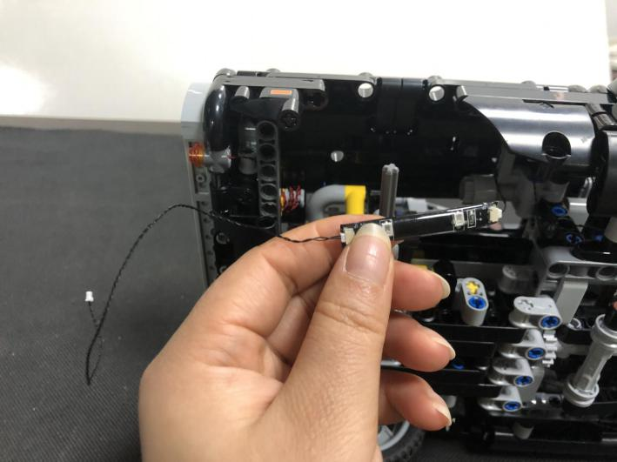
Stick the strip light to the following place, turn the car back, pull the cable out from the front trunk, as per below.
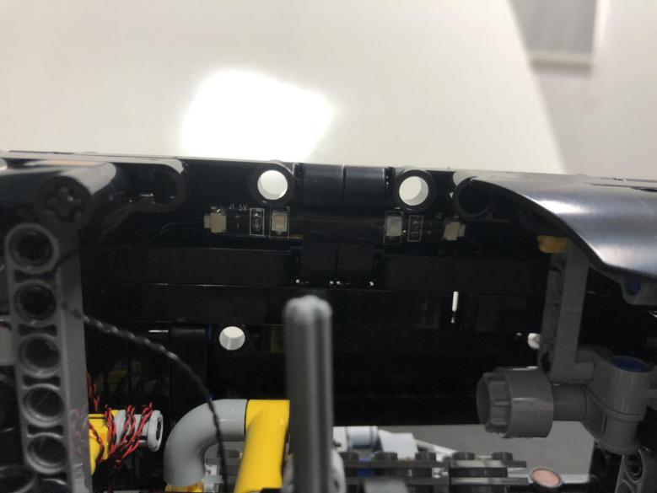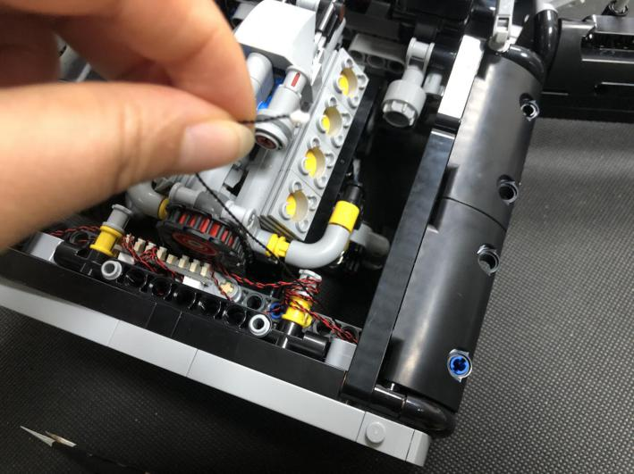
Thread the connecting cable through the following spaces, tuck excess cable as per below.
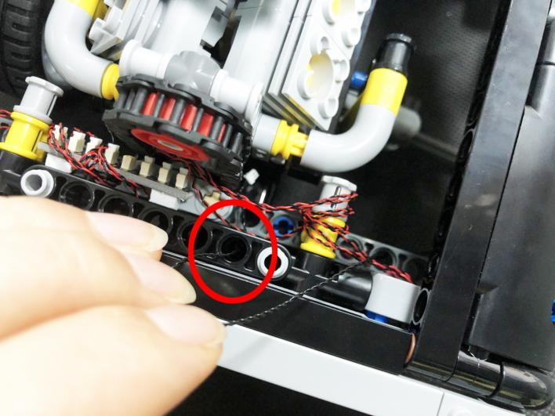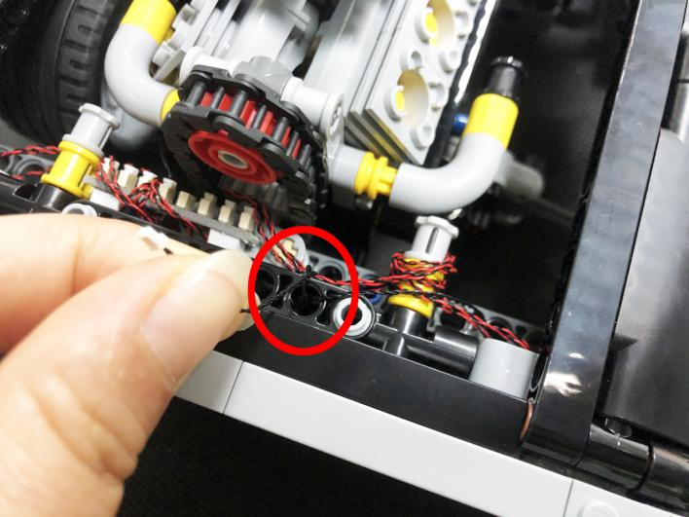
Connect it to the expansion board as per below.
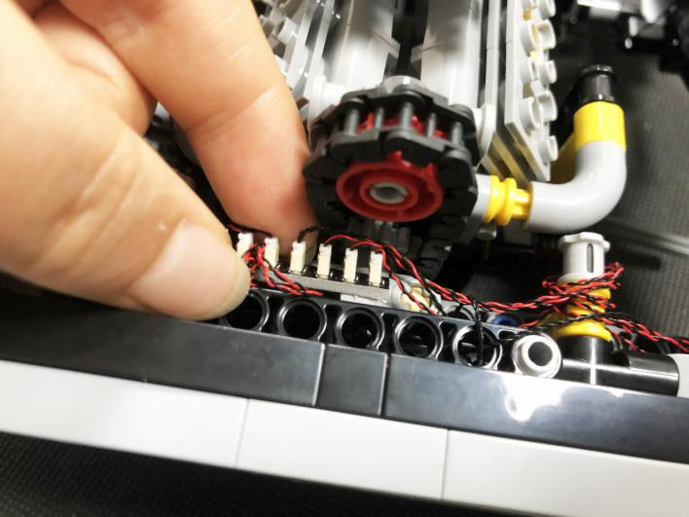
Reconnect the tire.
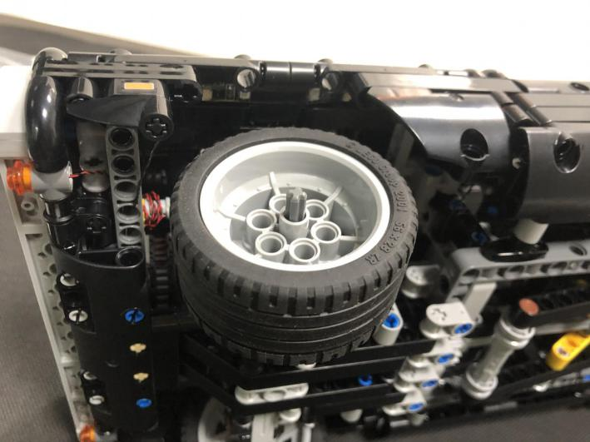
Take the Remote Control Switch Board,
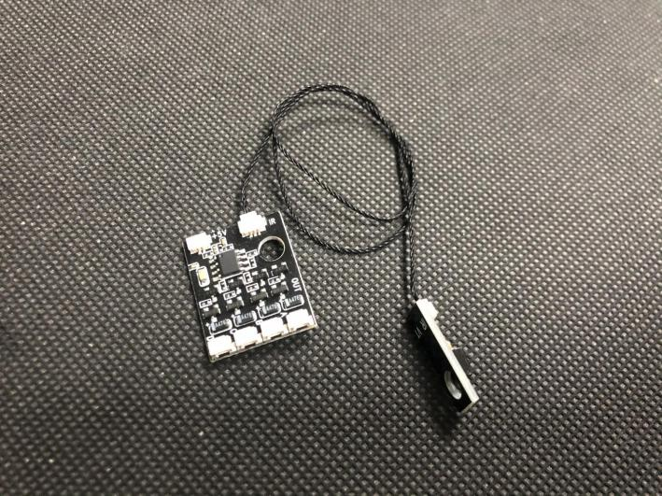
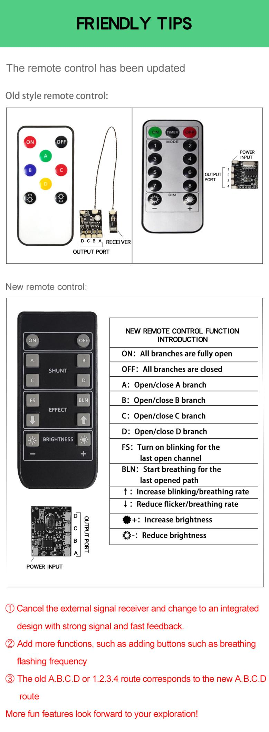

a 5cm connecting cable.
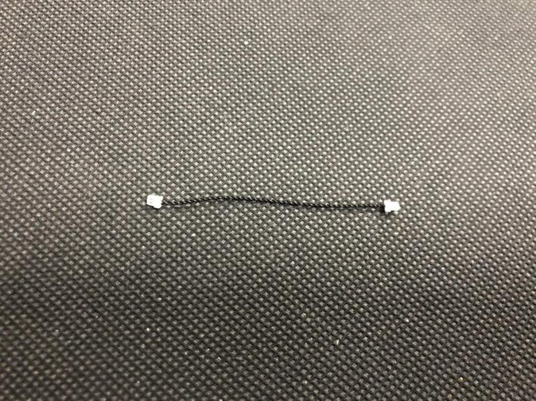
Connect the connecting cable to the following port on the board, connect the other end of the cable to the expansion board in the trunk.
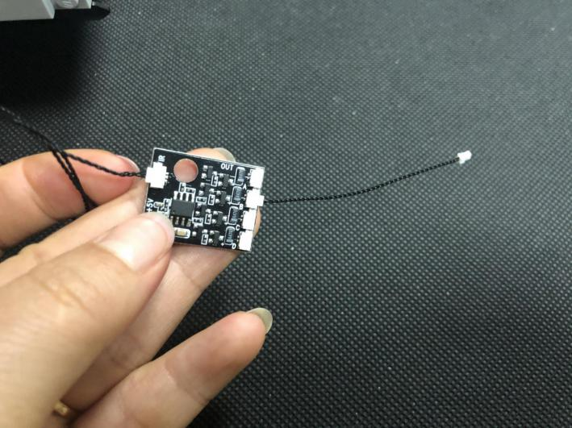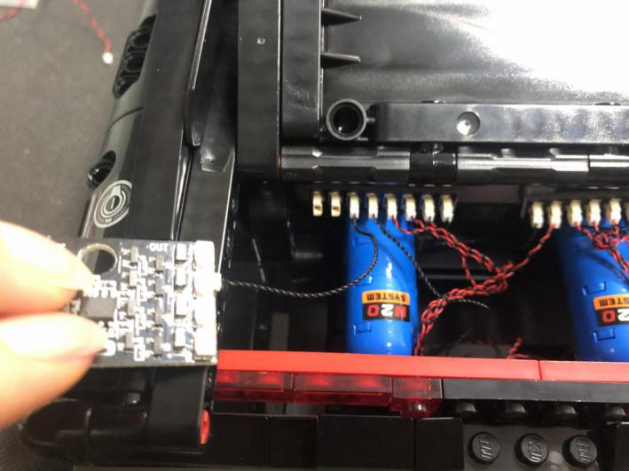
Take the AAA Battery Pack.
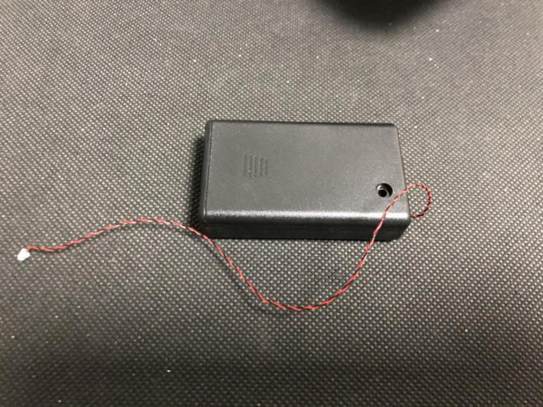
Thread the cable from the battery pack through the following space, stick the battery pack to the following place with adhesive squares.
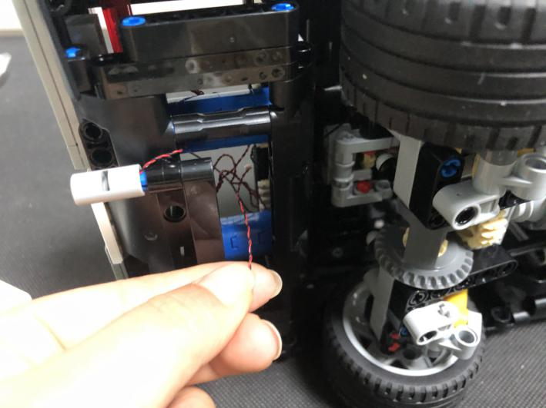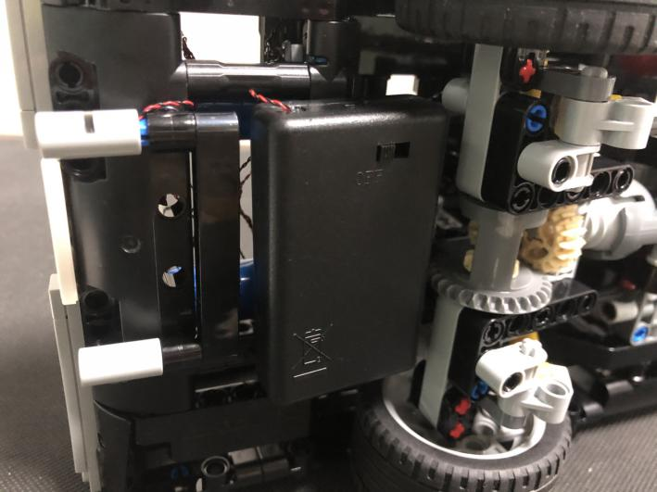
Connect the cable from the battery pack to the power port on the Remote Control Switch Board.
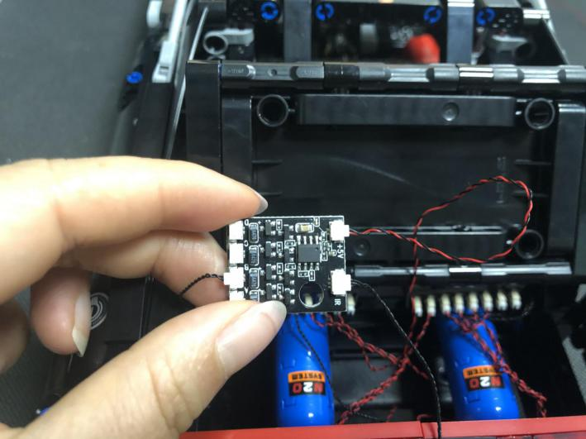
Stick the Remote Control Switch Board to the place next to the Flicker Effects Board, close the lid.
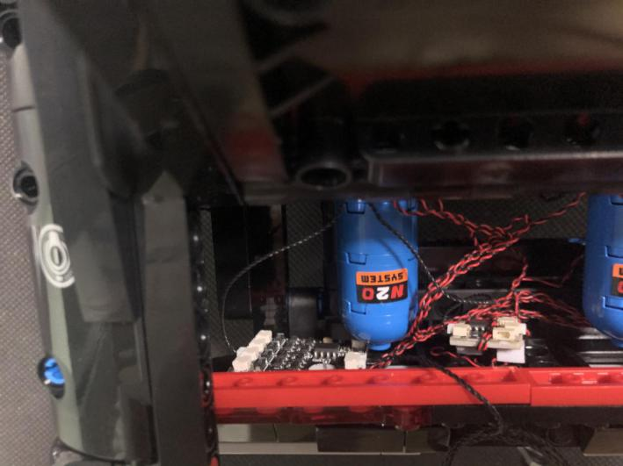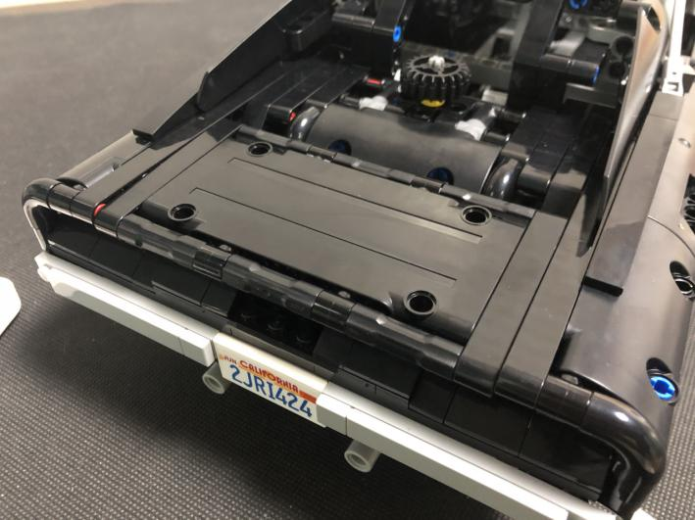
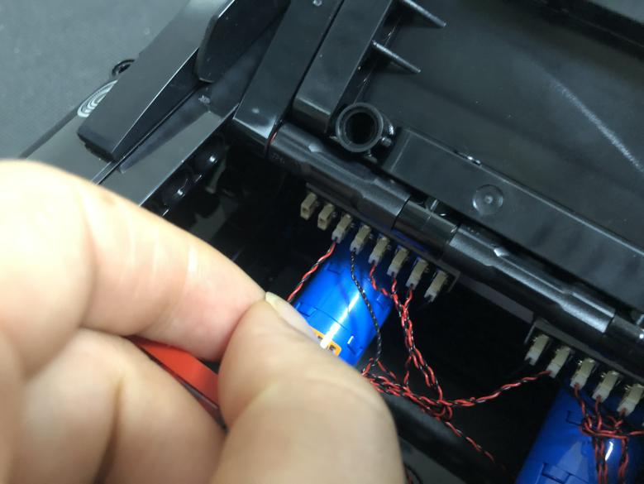
This completes installation of this LED Lighting Kit.
There’s enough space inside the car, you can place the cables as you wish. ENJOY!
