Lighting Kit LEGO 10267

Thank you for choosing our lighting products. We are committed to LEGO product study and lighting development, we're always trying our best to provide LEGO fans with the best products and the best installation ideas.
Must be careful observation, imagination can be infinite.
We provide basic parts to support your imagination.
DO IT YOURSELF .that's what LEGO is .

As always, Lego has been adhering to the DIY philosophy from product selection, research and development to sales. Consumers buy the parts, you will assemble them by yourself, and you can experience every step from picking up the first piece to installing the last one. Besides, LEGO has different answers for the installation form and method of each part. Vonado lighting also does not want to kill your unlimited creativity, we will try our best to make products with high variability, high playability and unlimited play. If you have any dissatisfaction or your own ideas on the parts such as the color of the lights, the length of the cables, the installation position of the product, and the final effects of each module, you can make your own arrangement, and we will cooperate with you to replace or repurchase.
LETS MOVE!

Package contents：
- 2 x 30cm Multi Colour Flashing Lights
- 4 x 15cm Multi Colour Flashing Lights
- 2 x 15cm Warm White Dot Lights
- 1 x 30cm Warm White Dot Light
- 3 x 15cm Warm White Strip Lights（with 7 lights）
- 2 x 15cm Pink Dot Lights
- 1 x 30cm Pink Dot Light
- 1 x 15cm Multi Colour Light String
- 2 x 15cm Flashing Warm White Dot Lights
- 2 x 15cm Flashing Red Dot Lights
- 4 x 15cm Head Lights
- 1 x USB Cable
- 2 x 8-port Expansion Board
- 1 x 4-port Expansion Boards
- 3 x 6-port Expansion Boards
- 3 x 30cm Connecting Cables
- 2 x 5cm Connecting Cables
Extra pieces
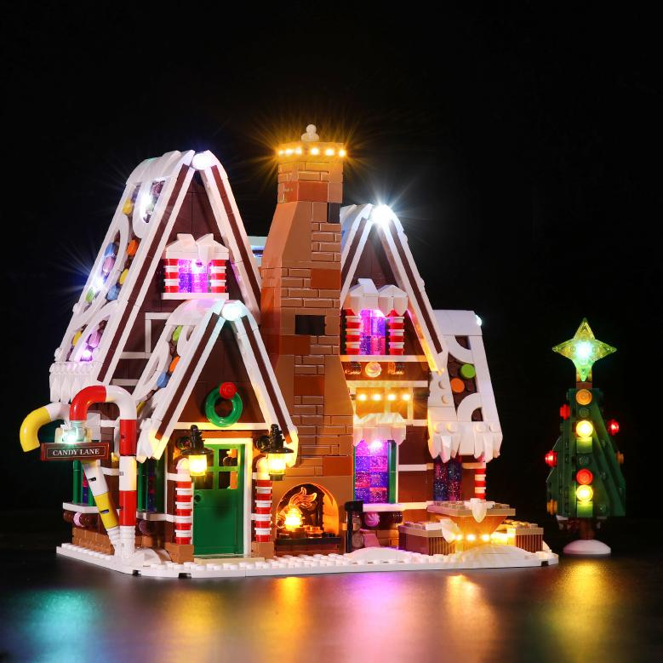
Note:
Place wires on the surface or under the building blocks.
The wire can be place between the building blocks or under the block, but they should be placed between the studs correctly.

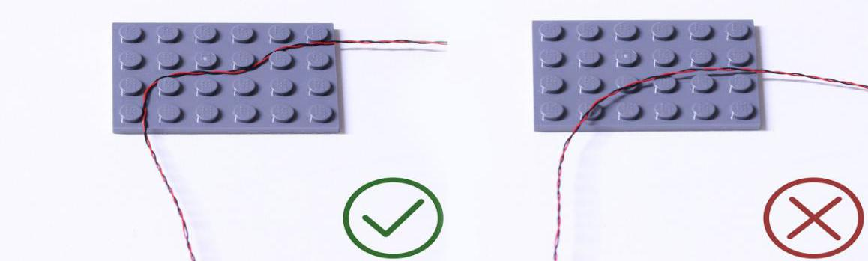

Insert the connectors to the ports.

Be careful when you are operating, there’s only one correct way to insert, make sure the expansion board is upward, find the soldered “=” sign on the left of the port. When you are inserting, the side which the wires can be seen should be faced to the “=” sign and if you feel hard to insert, please stop, and don’t force it, for that may result in bent pins inside the port or overheating of the expansion board.

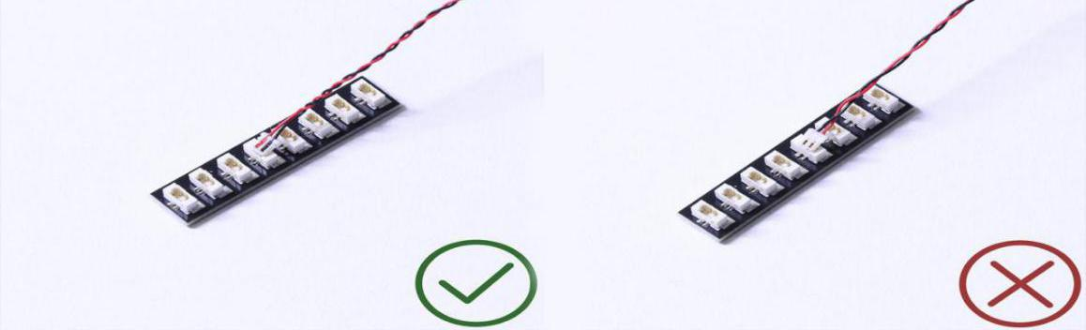

At this point, use the tweezers to straighten the bent pins.

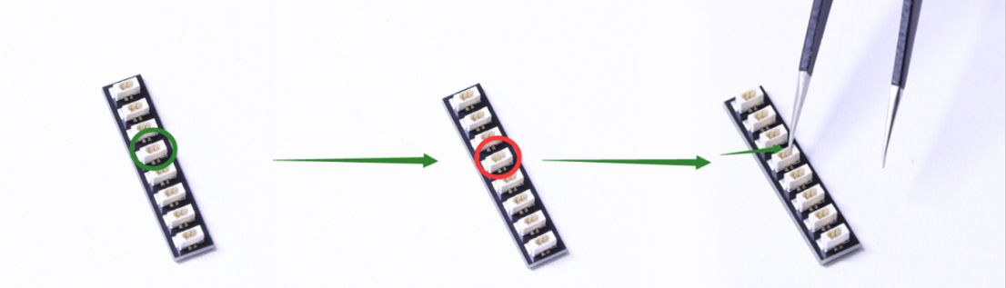

When installing dot lights, make sure they are correctly placed (Yellow LED package is exposed). You can put they either on the top of the studs or between studs.

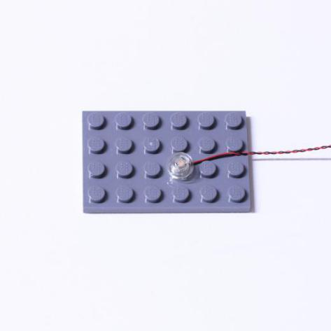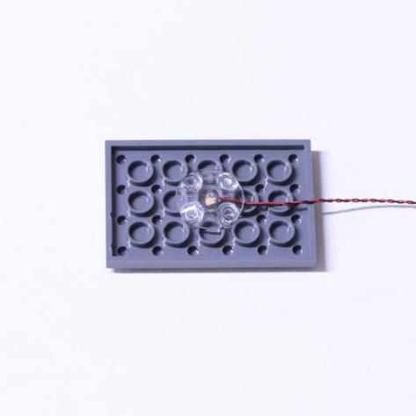

Connecting cable connectors to Strip Lights

Take extra care when inserting connectors to ports on the Strip Lights. Connectors can be inserted only one way. With the Strip Light facing up, ensure the side of the connector with the wires exposed is facing down. If a plug won’t fit easily into a port connector, don’t force it. Doing so will damage the plug and the connector.

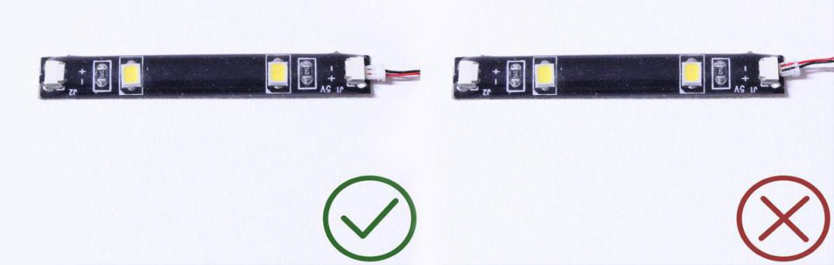

Finally, please pay attention to the positive and negative terminals of the battery when installing the battery case.

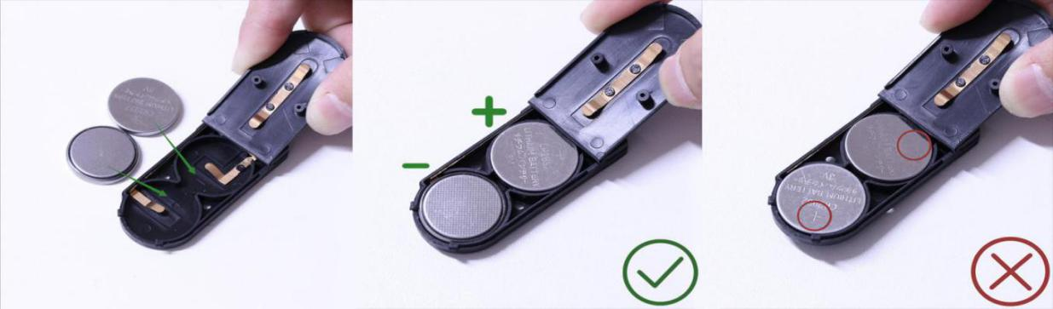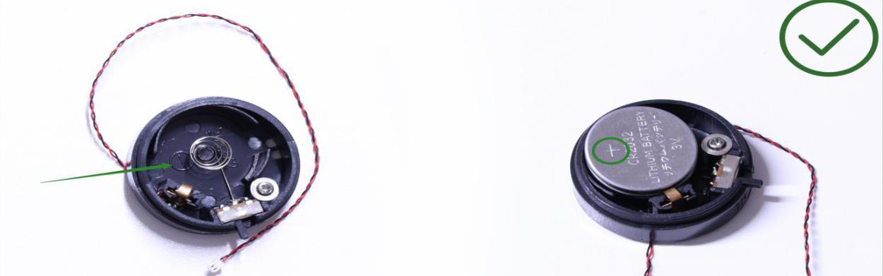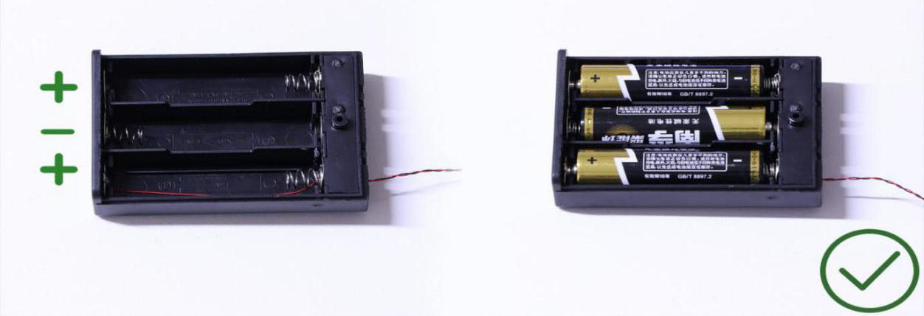
Instructions for installing this kit：
Gingerbread House， Deluxe Version, Lighting Kit, 16 bags in total.
Power supply： USB cable (self-contained power bank or mobile phone charger).
Firstly, take the power source (power bank or mobile phone charger), connect it to the USB cable, connect the other end of the USB cable to the expansion board to verify all the lights.
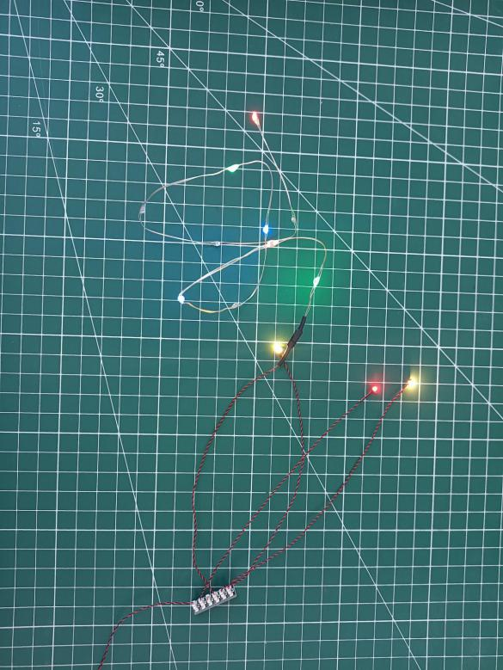
After the verification, disconnect the lights and put them back to the bags.
（note: put the lights back to the bags when verification of the lights from the same bag is done, then, continue to verify the lights in another bag.）
OK, Let’s Begin! （you can use the tweezer if necessary.）
（Tips: the tweezer is sharp, you should be careful when using it, do not hurt yourself or scratch the pieces; be gentle and do not wear the cables.）
Instructions for installing this kit：
Take the Gingerbread House.
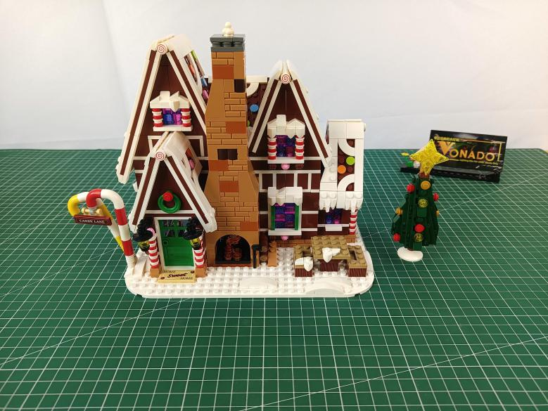

Start from installing lights for the Christmas tree, remove the leaf.
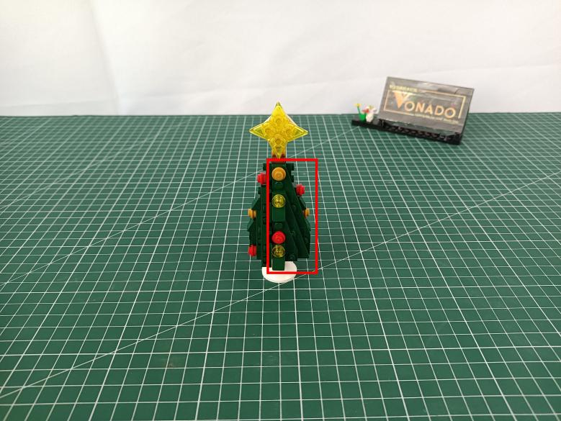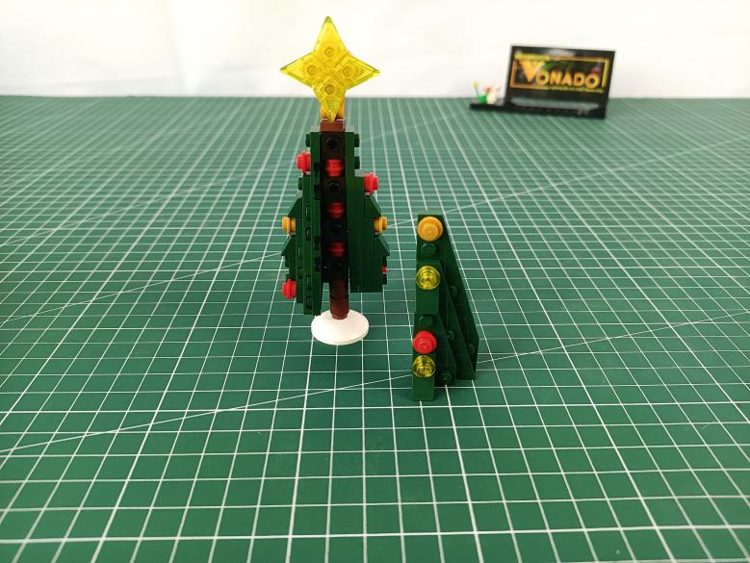

Disconnect the 2 yellow round plates from the leaf.
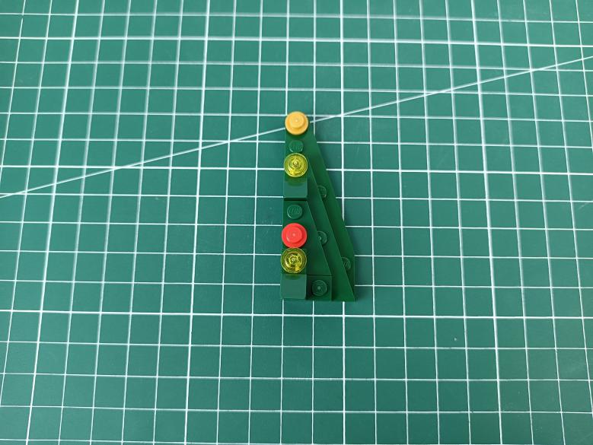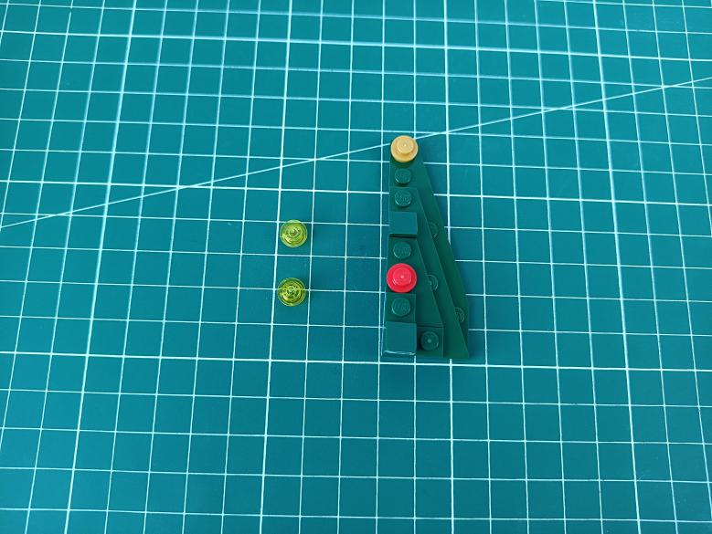

Take 2 flashing warm white 15cm dot lights.
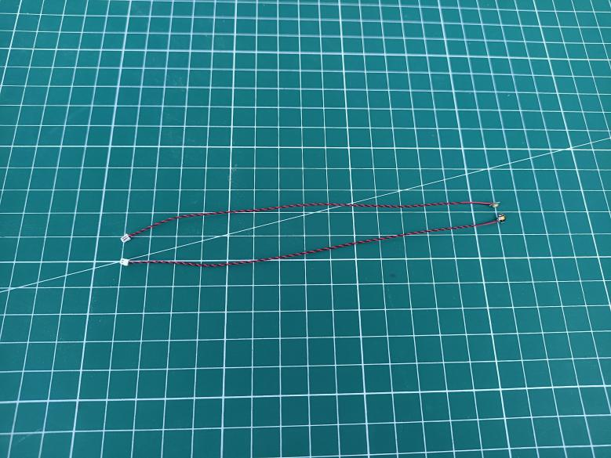

With lighting part facing up, reconnect the round plate.
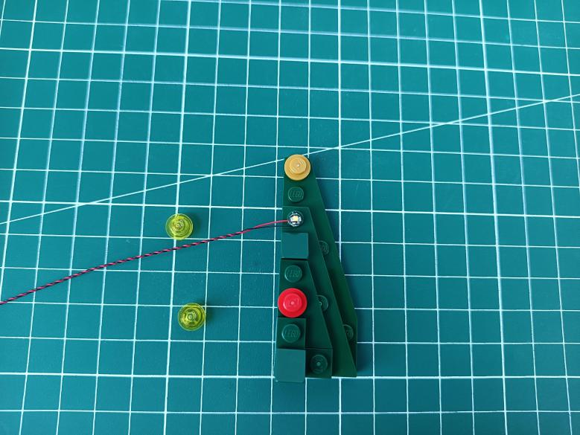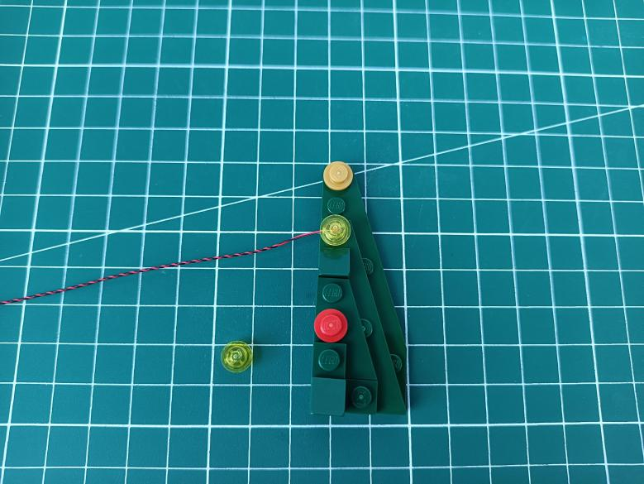

Install the other light in the same way.
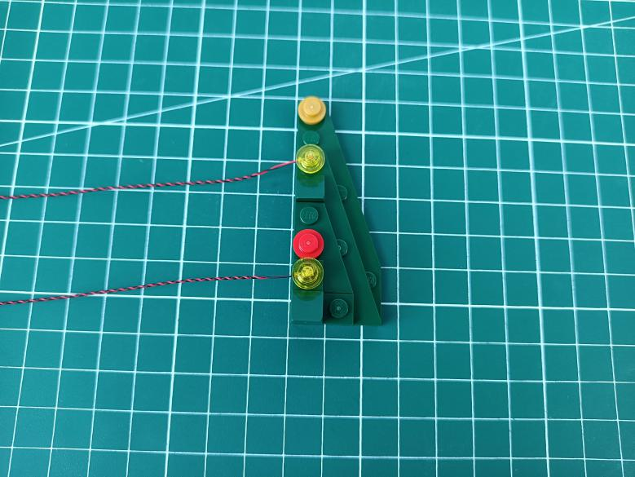

Place the cable as per below, reconnect the leaf.
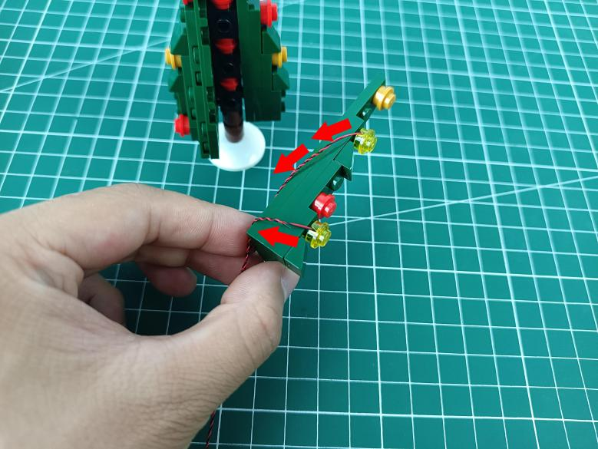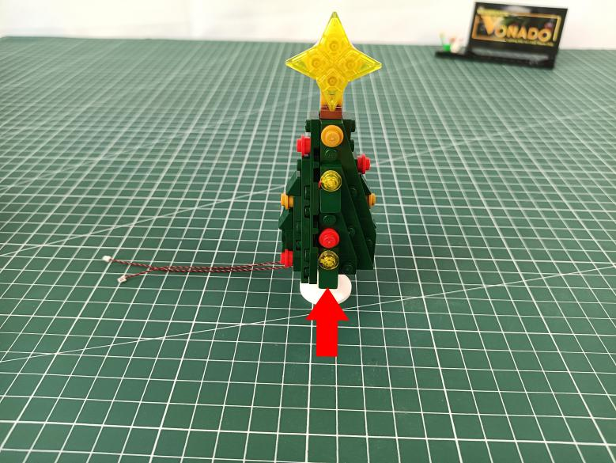

Turn to the left, remove the following leaf.
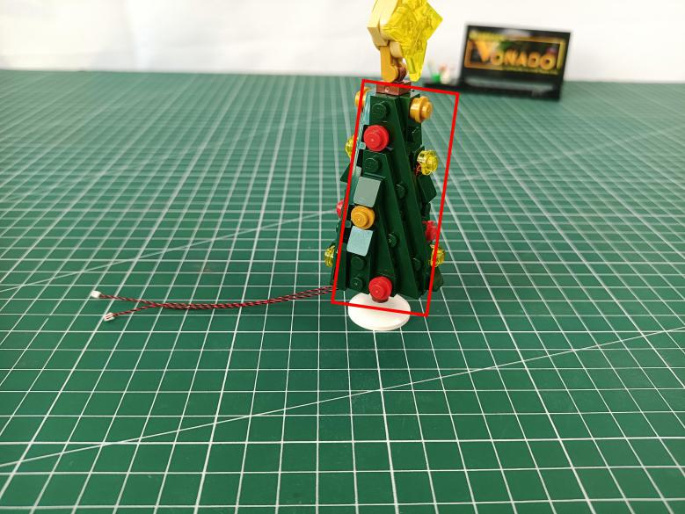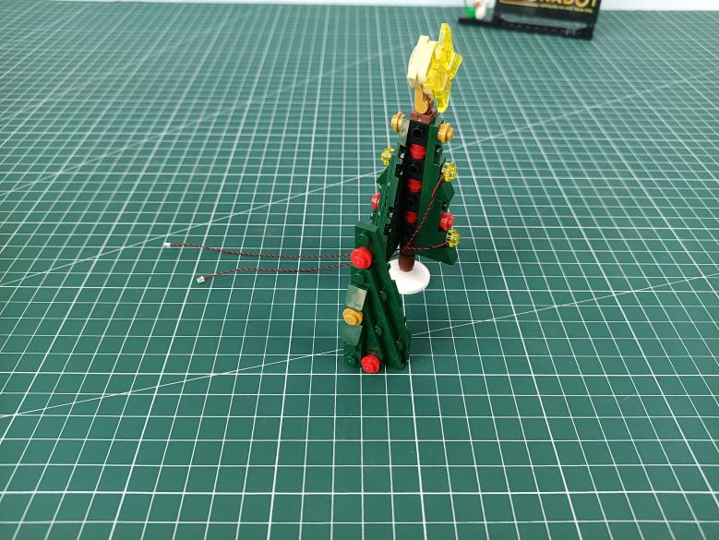

Disconnect the red round plate and the yellow round plate from the leaf.
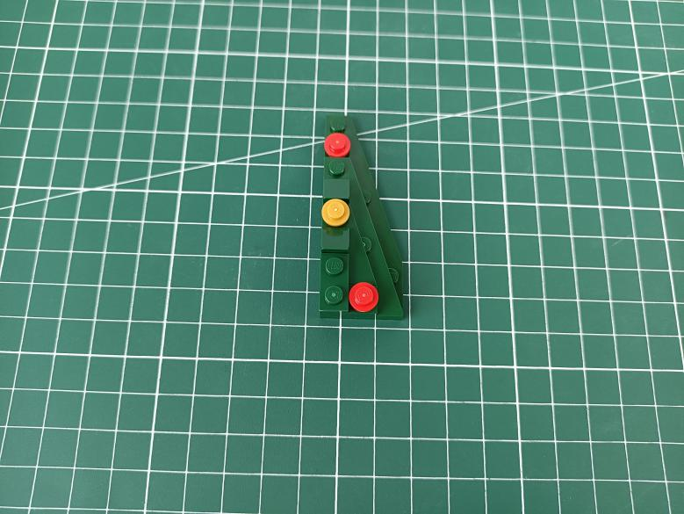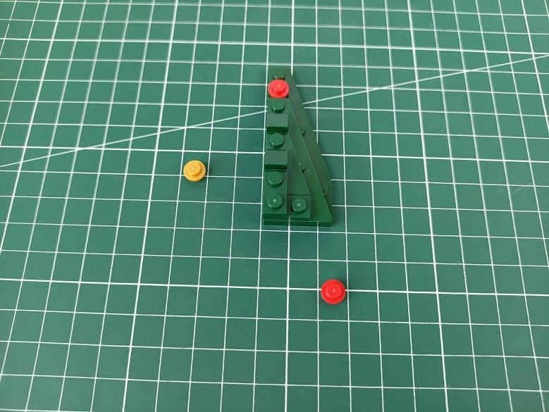

Connect the yellow round plate at the following place.
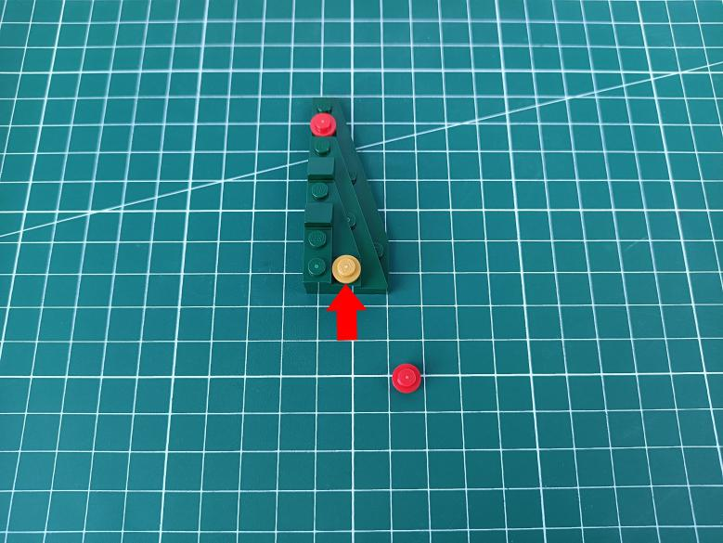

Take a flashing red 15cm dot light, a trans red 1x1 round plate.
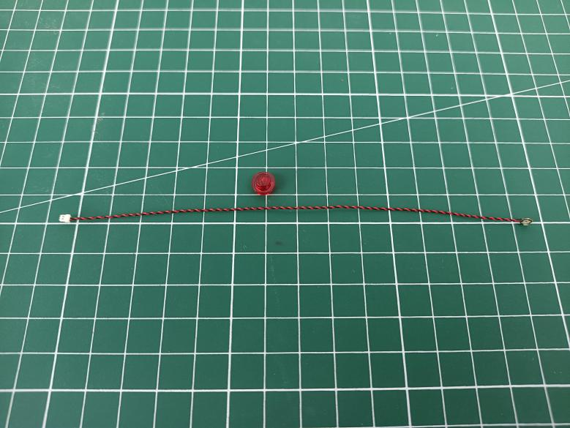
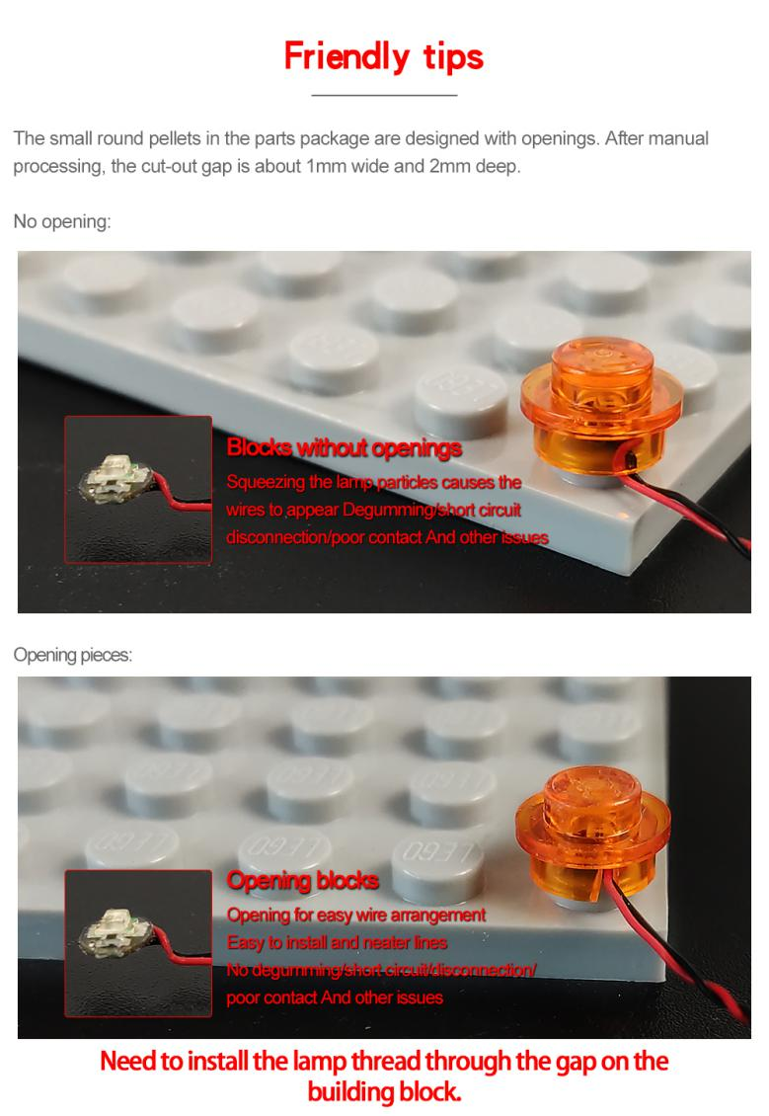

With lighting part facing up, connect the red round plate over.
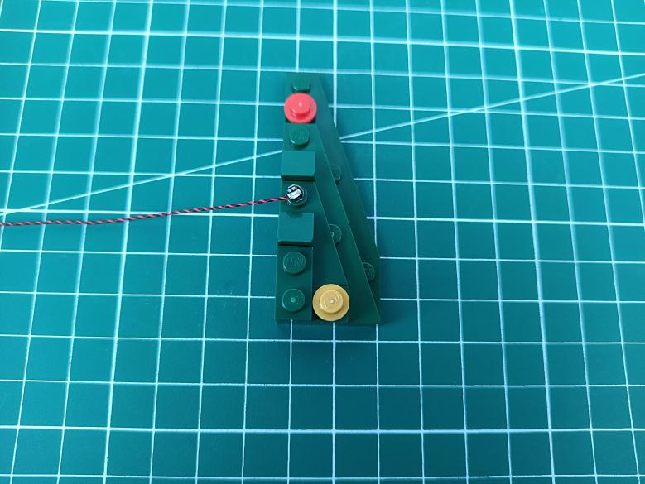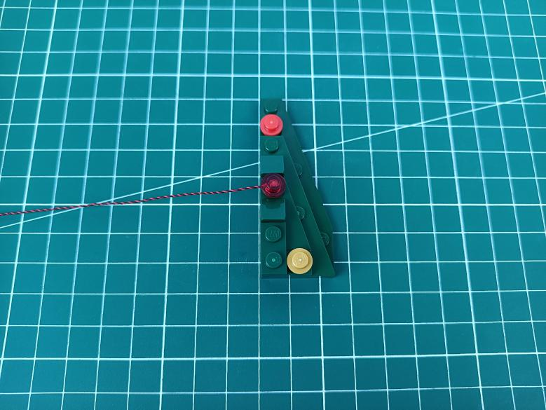

Place the cable as per below, reconnect the leaf.
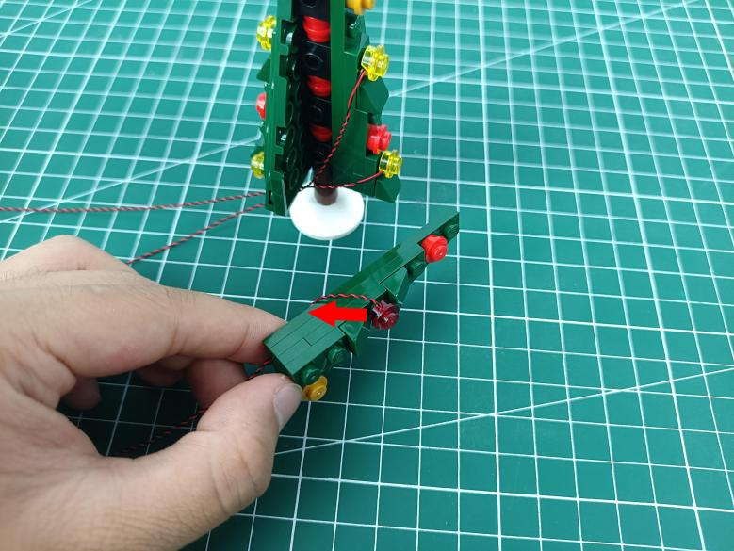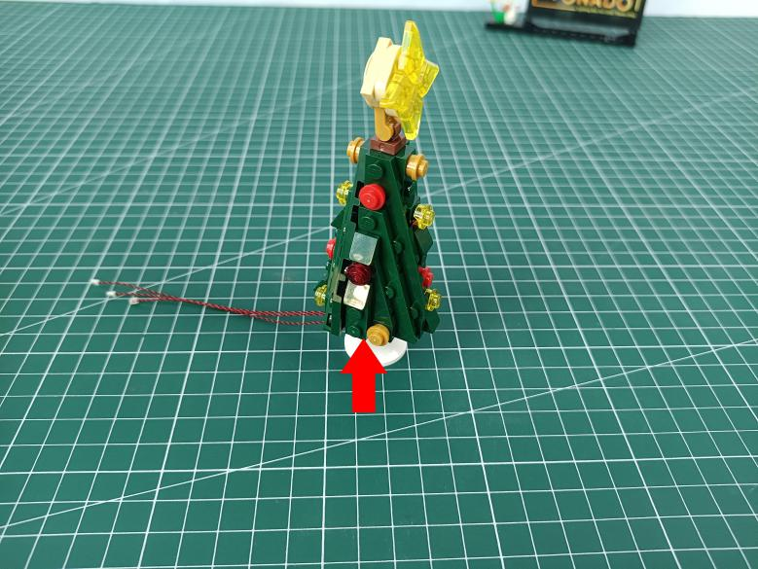

Turn to the right, remove the following leaf.
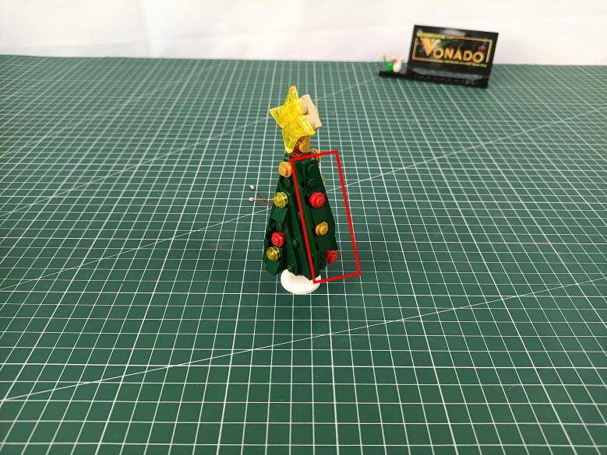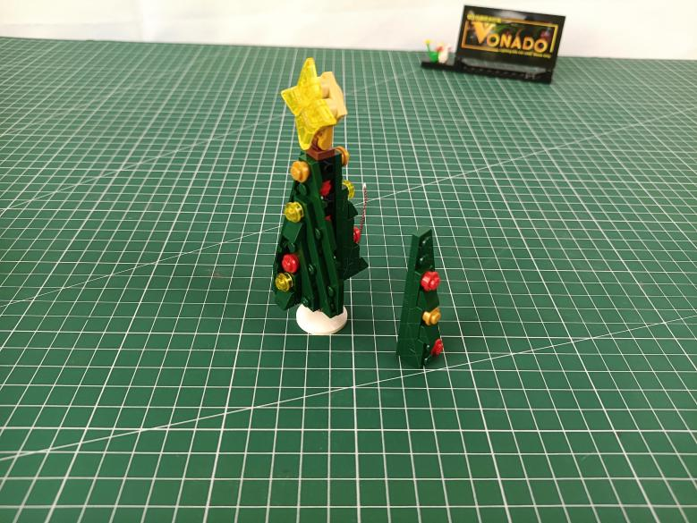

Disconnect the red round plate from the leaf.
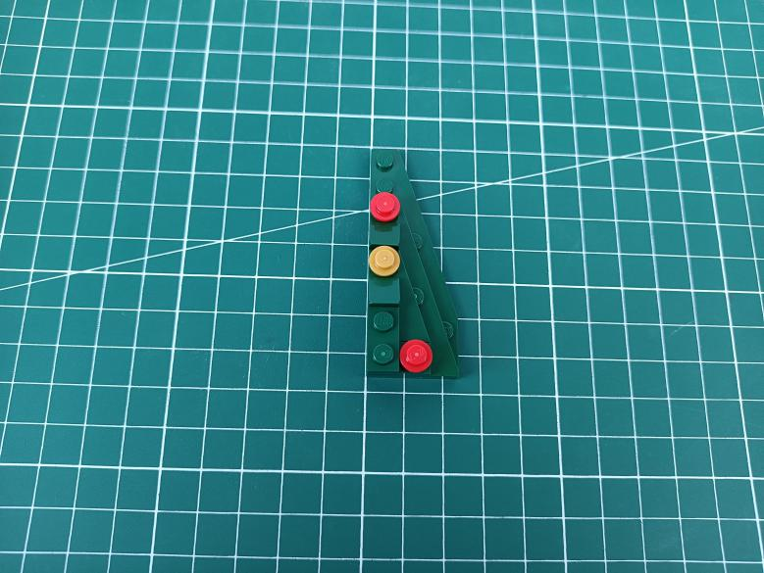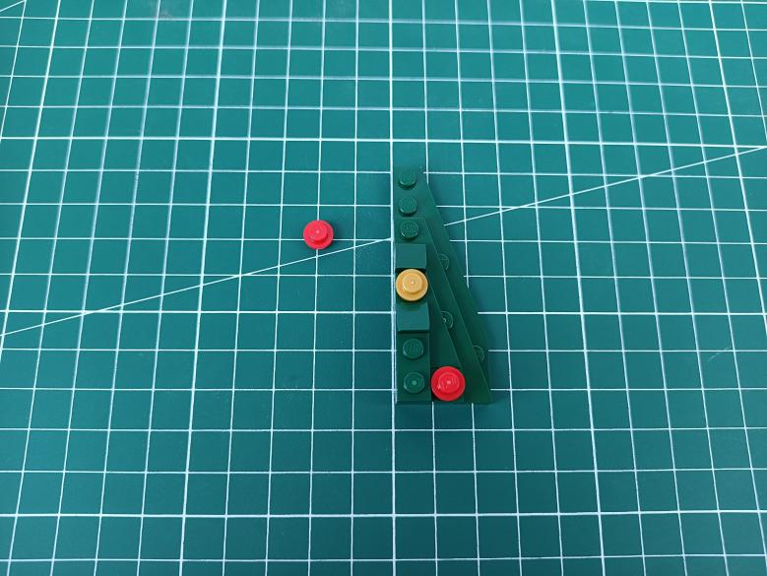

Take a flashing red 15cm dot light, a trans red 1x1 round plate.
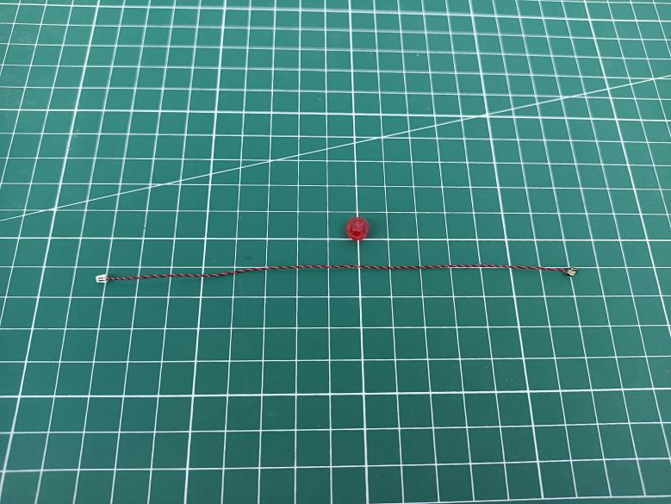

With lighting part facing up, connect the red round plate over.
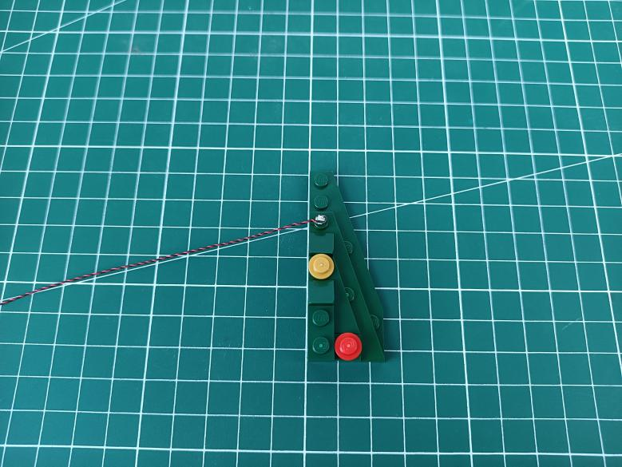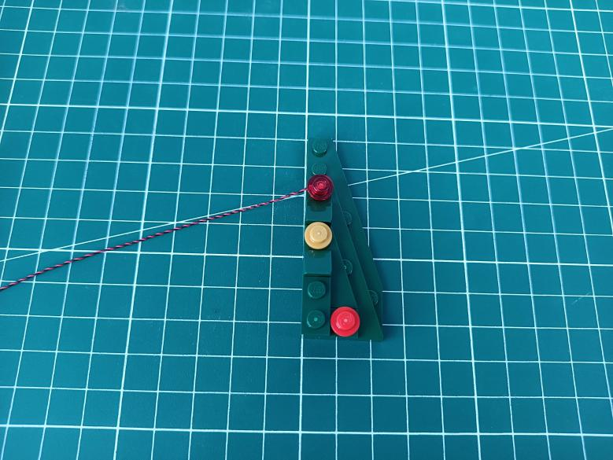

Place the cable as per below, reconnect the leaf.
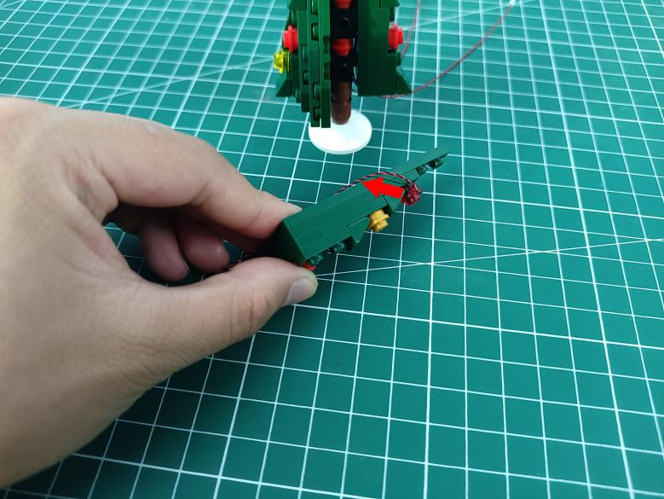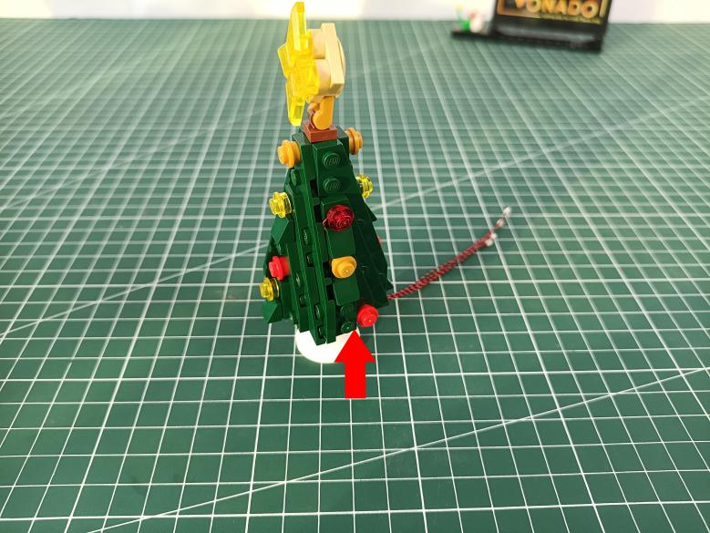

Disconnect the following piece from the tree.
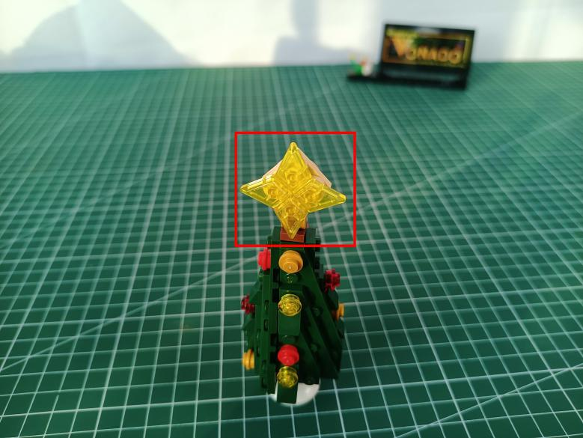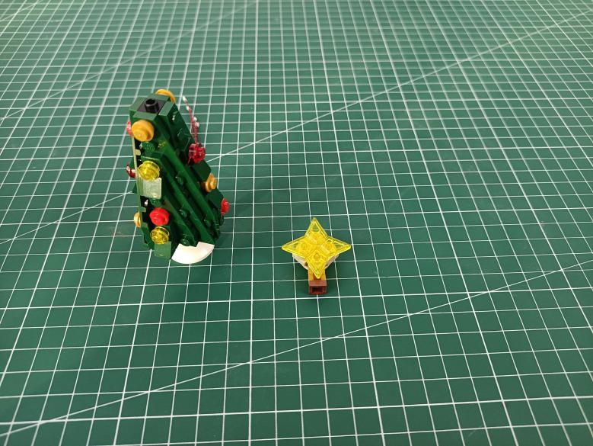

Disconnect the 2 yellow pieces.r
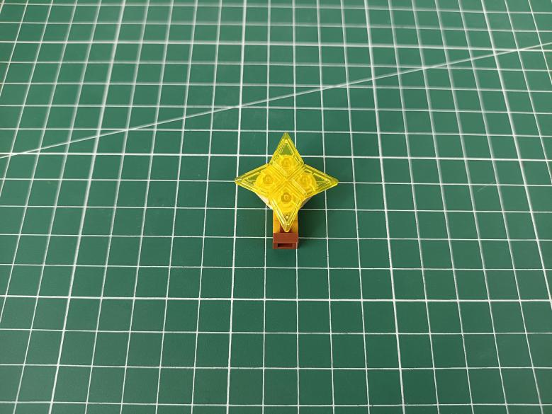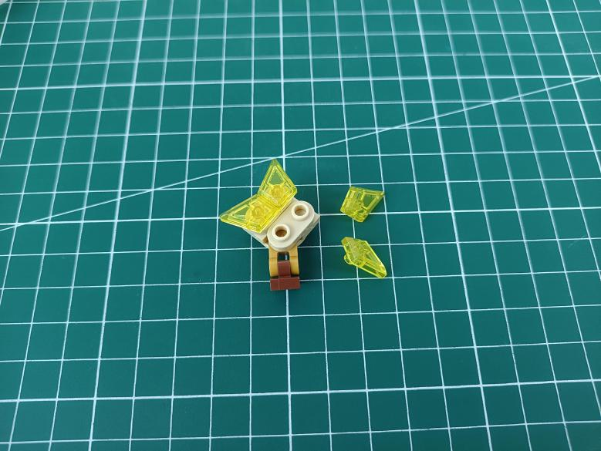

Take a 15cm Multi Colour Flashing Light.
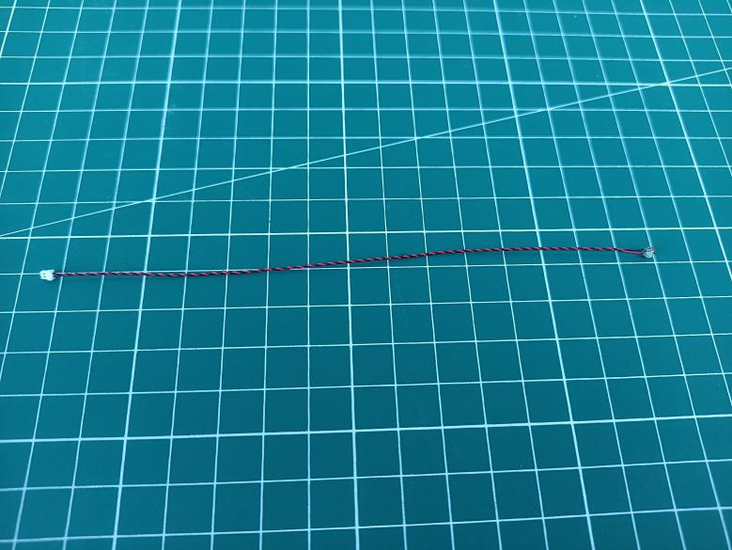

With lighting part facing up, stuck the light at the following place.
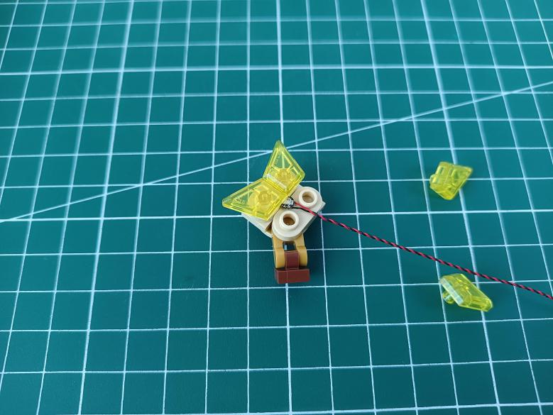

Reconnect the yellow pieces to secure the light.
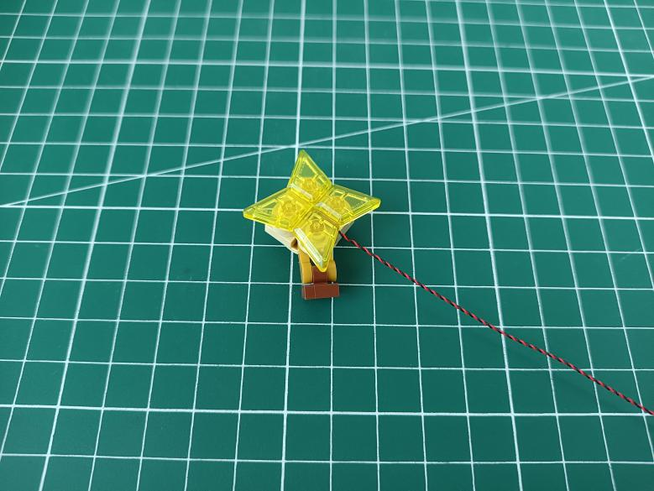

Thread the cable through the following gap to the back.
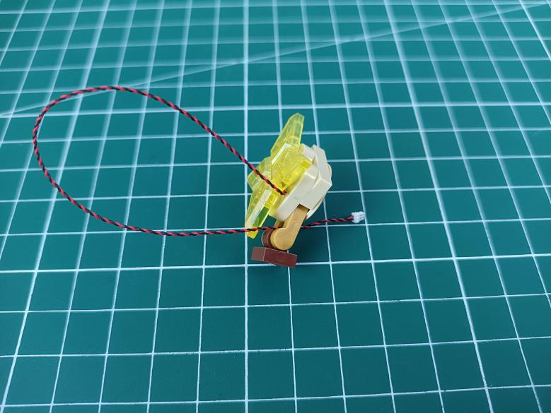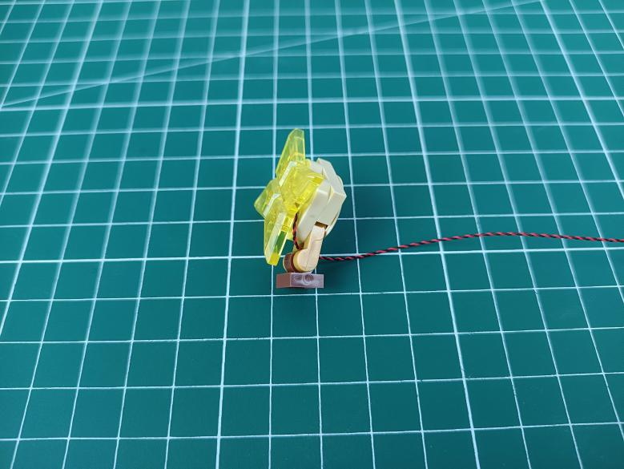

Reconnect the piece.
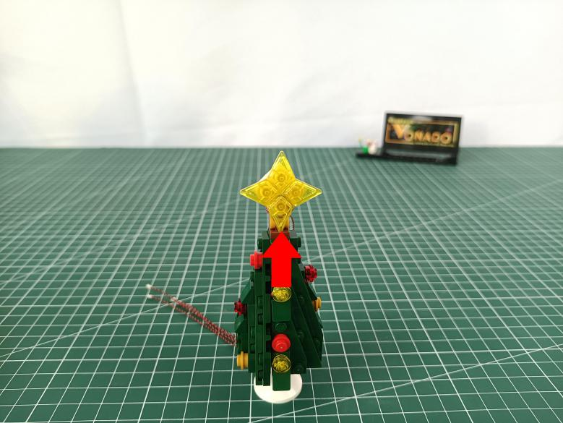

Turn to the back, remove the following leaf.
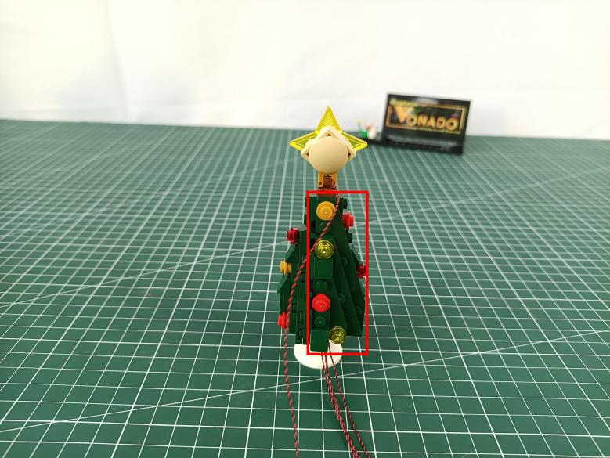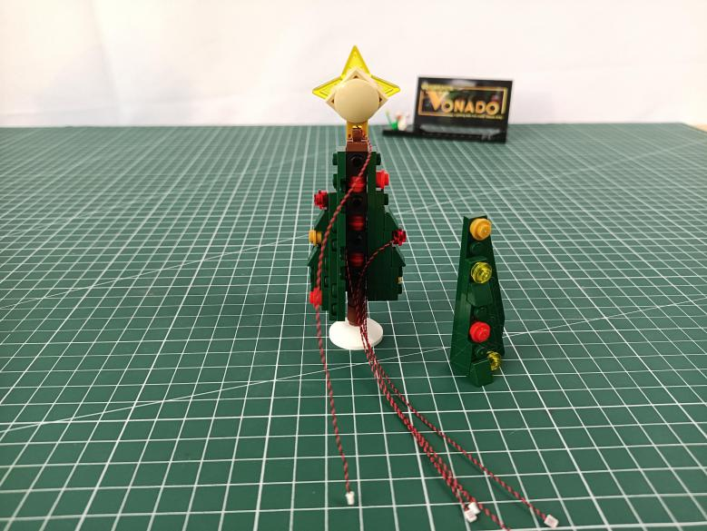

Place the cable inside, reconnect the leaf.
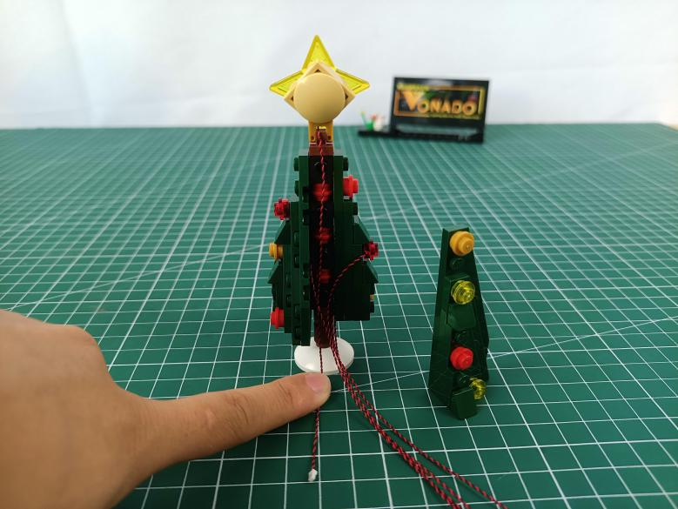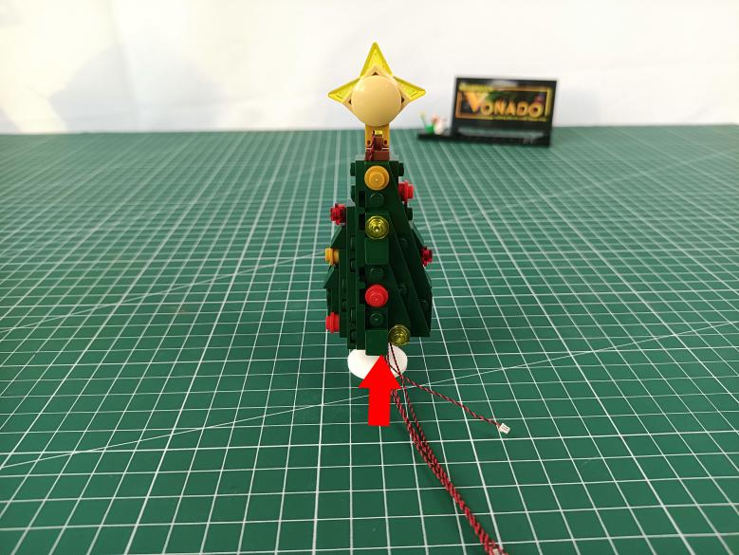

Take a 30cm connecting cable, a 6-port expansion board, assemble them as per below.
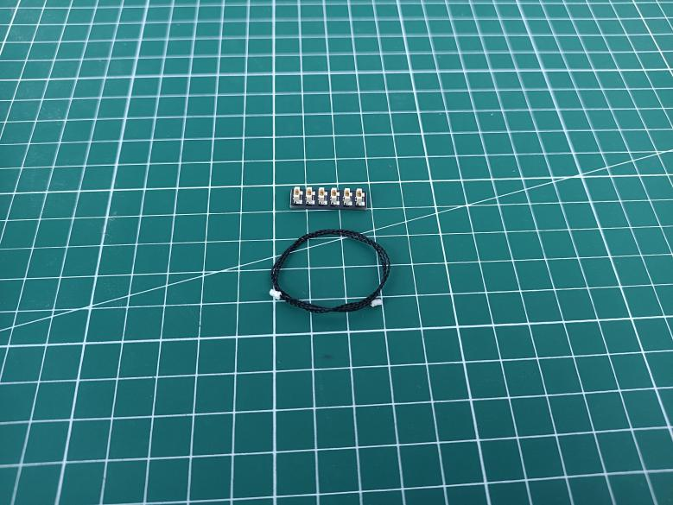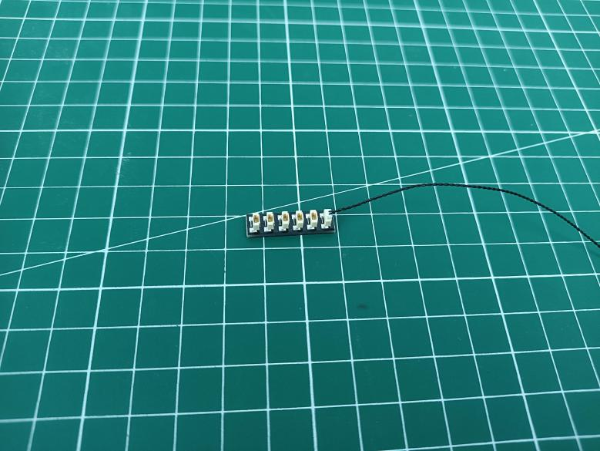

Connect all the cables from the Christmas tree to the expansion board, tuck excess cables around the expansion board.
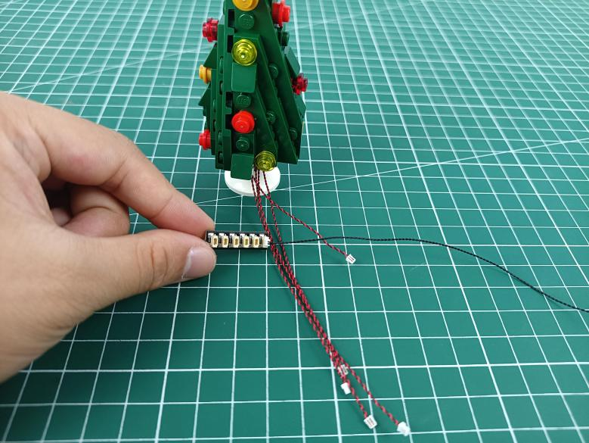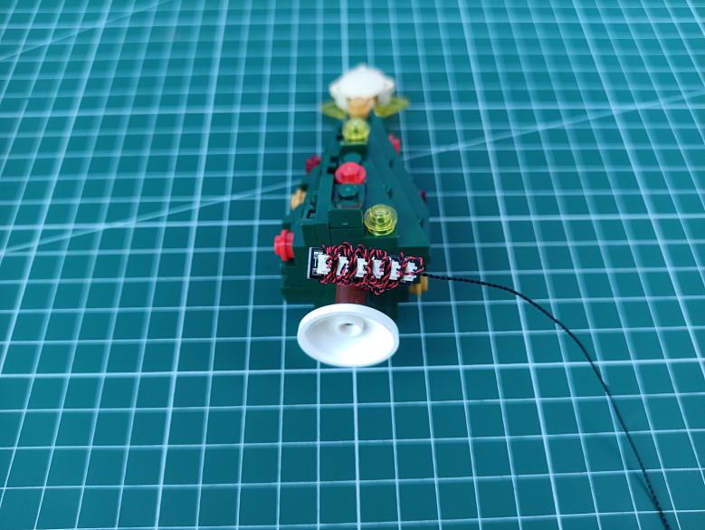

Take 2 adhesive squares.
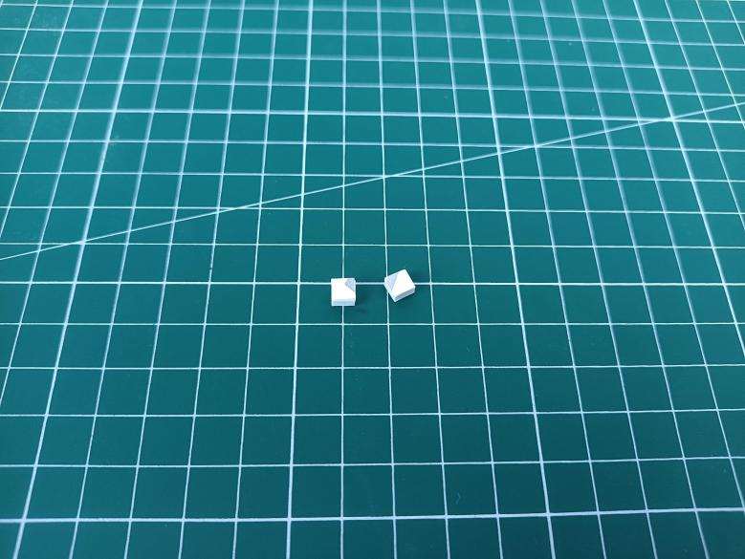

Stick them to the back of the expansion board, and stick the expansion board to the following place.
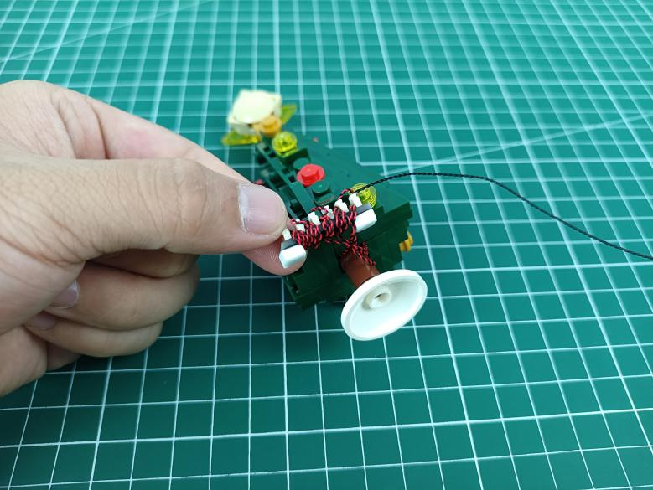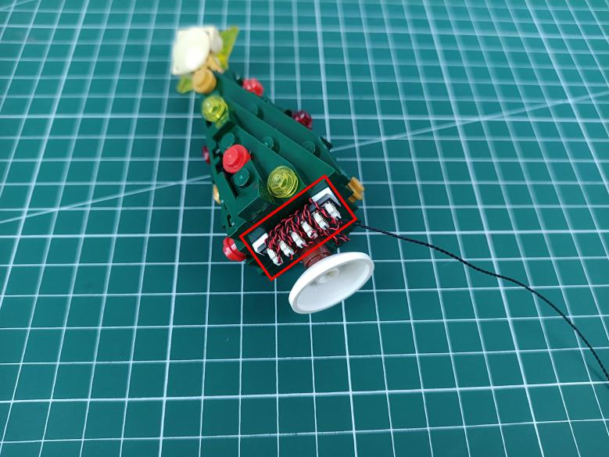

Continue to install lights for the house.
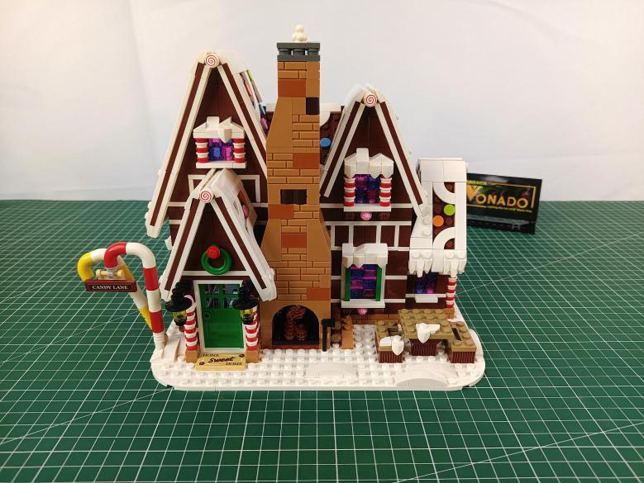

Remove the wall lamps.
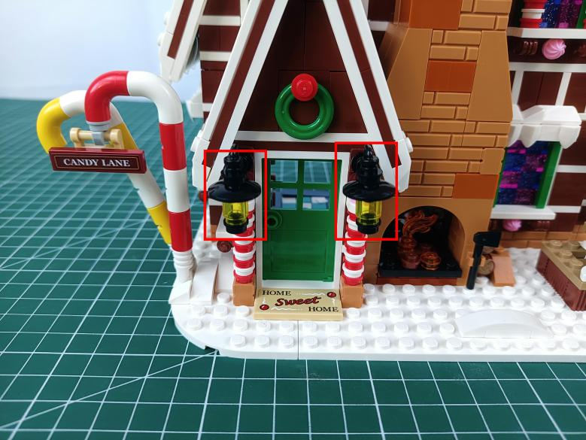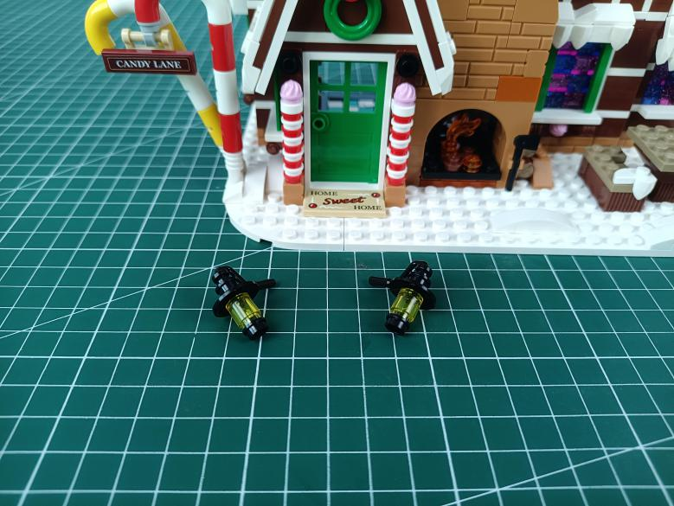

Disconnect the 2 black round plates from the lamps.
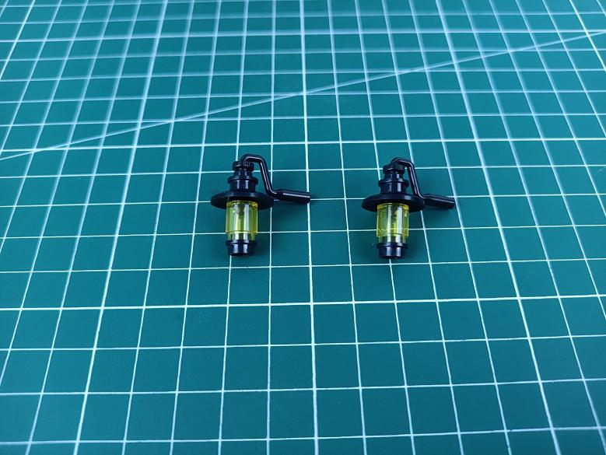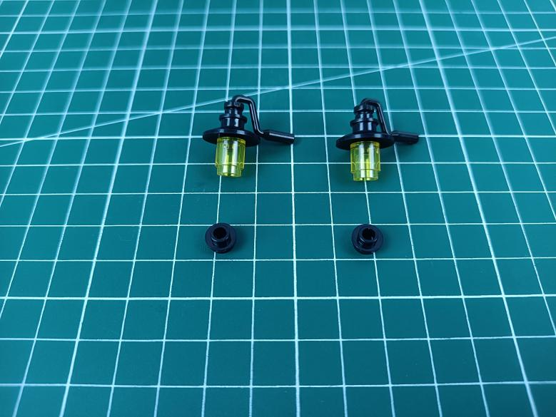

Take 2 warm white 15cm dot lights.
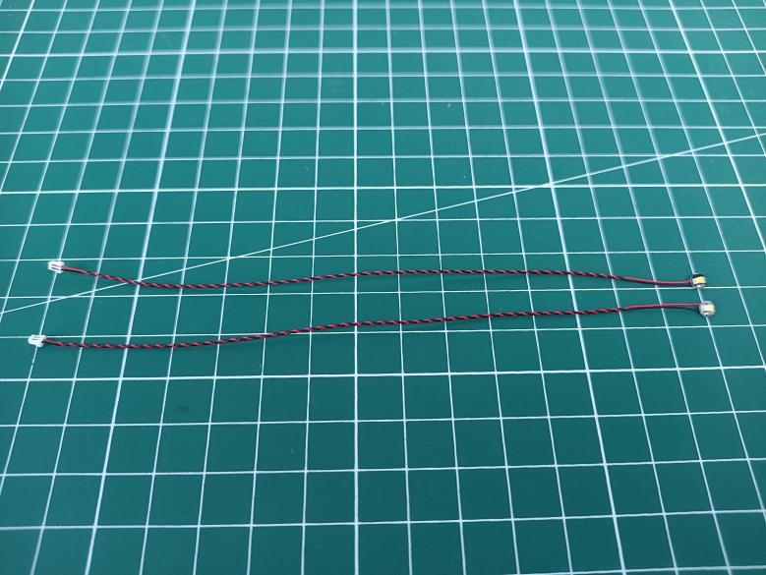

With lighting part facing up, thread the cable through the black round plate and tighten the cable up.
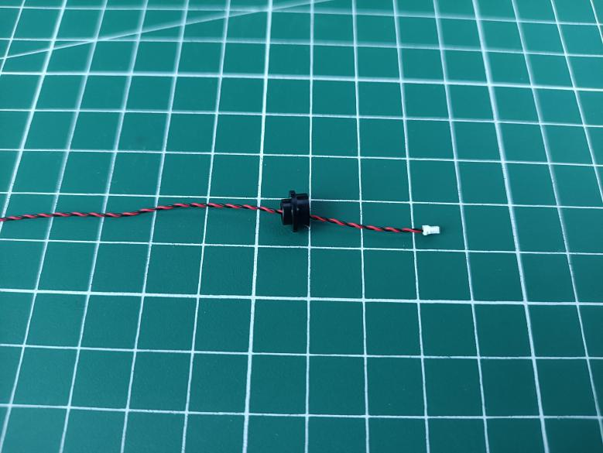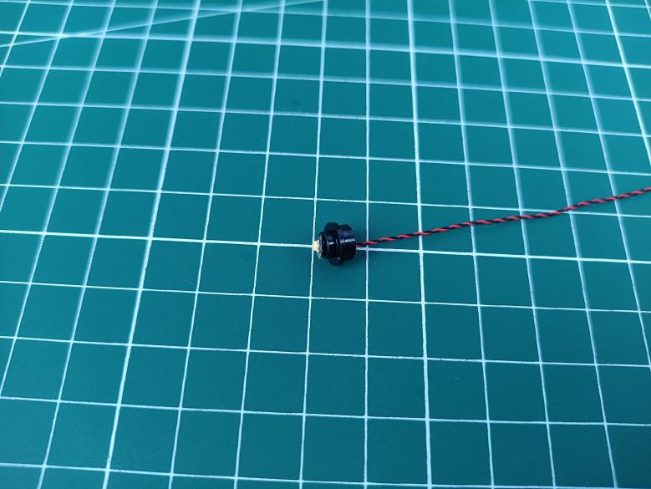

Reconnect the piece to the lamp, and wind the cable as per below.
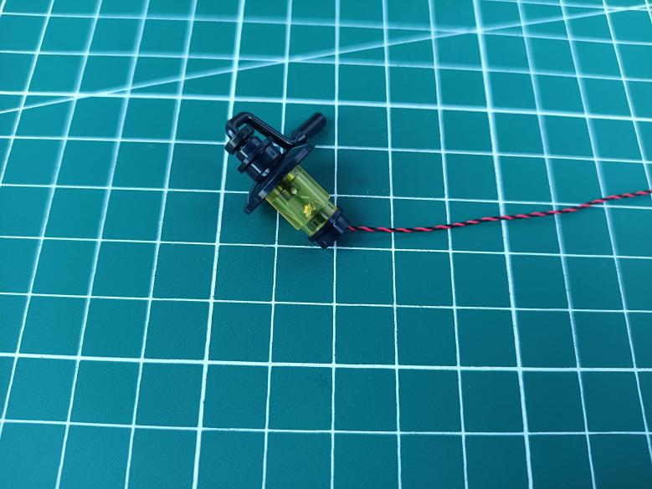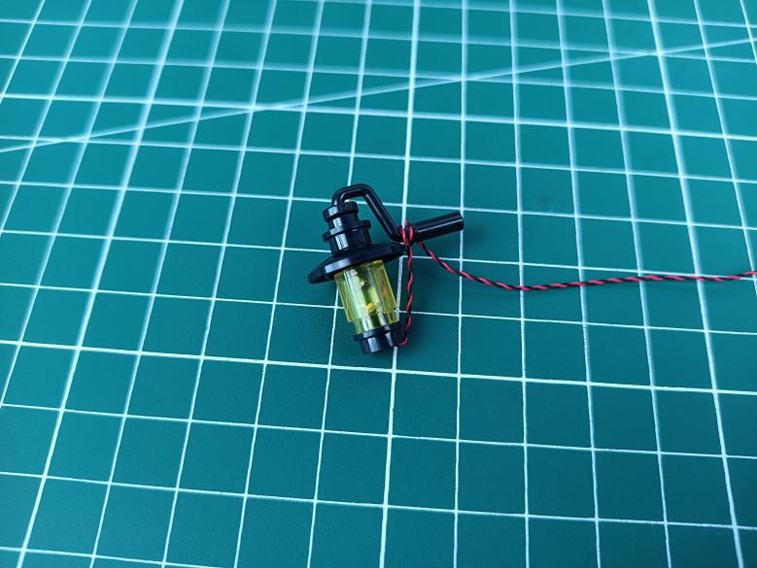

Install the other light in the same way.
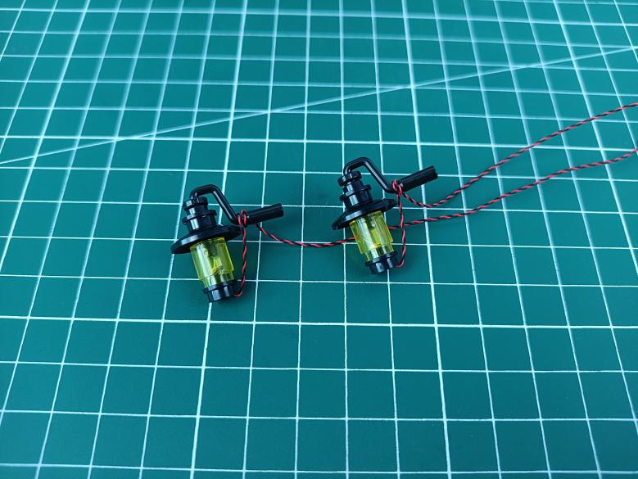

Reconnect the wall lamps.
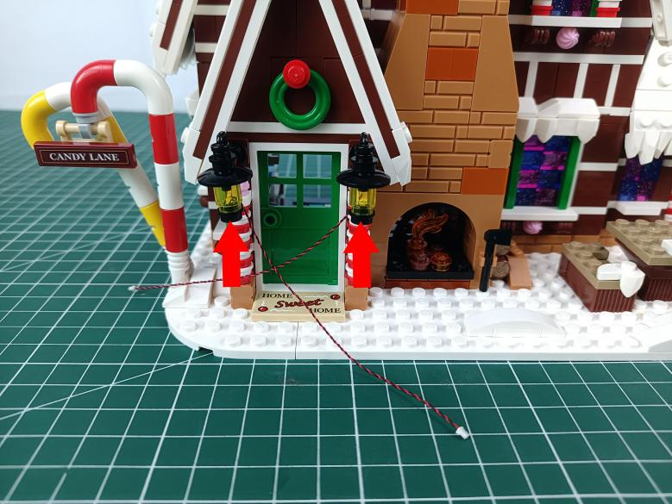

Open the door, place the cables behind the door.
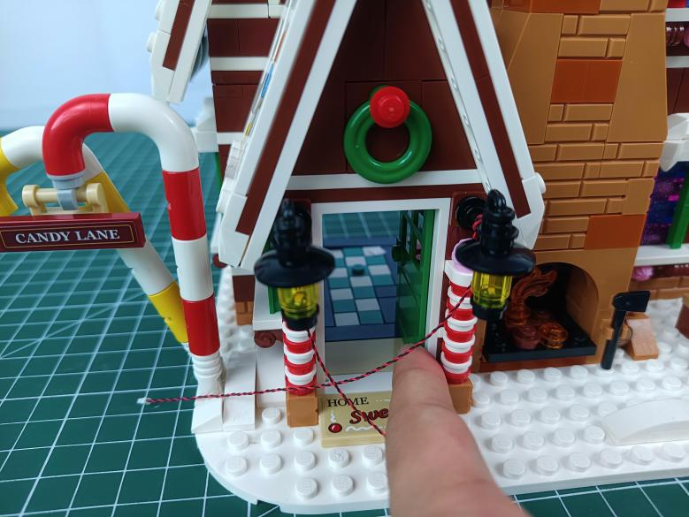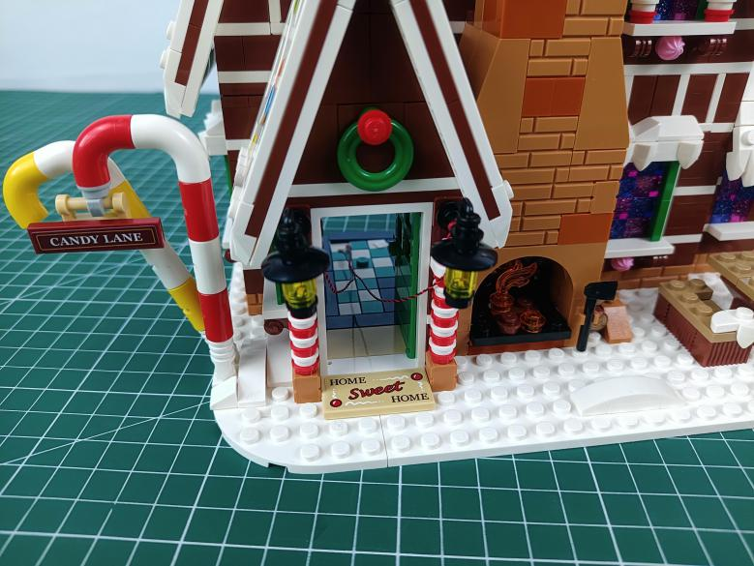

Remove the following piece.
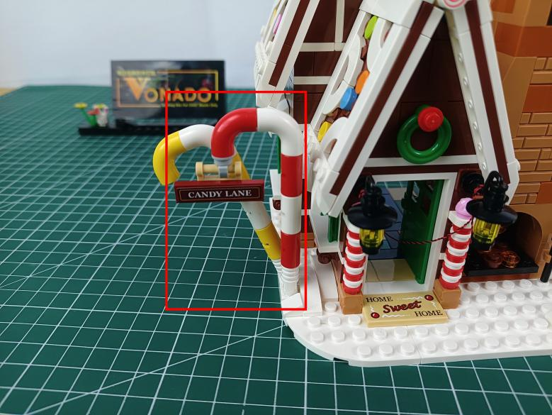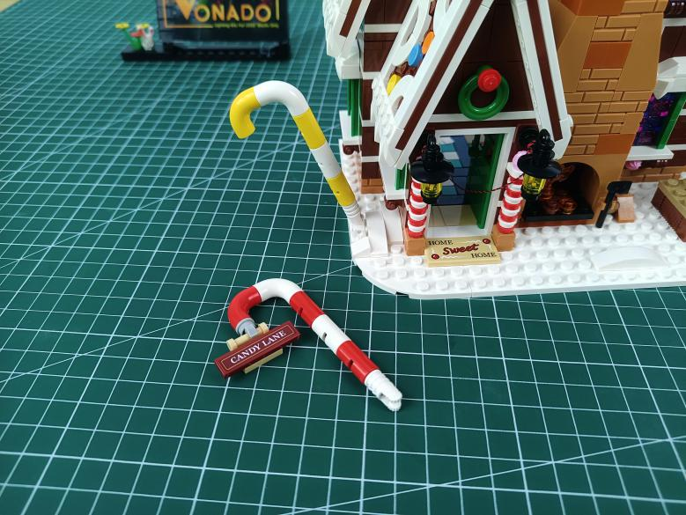

Disconnect the brown signboard.
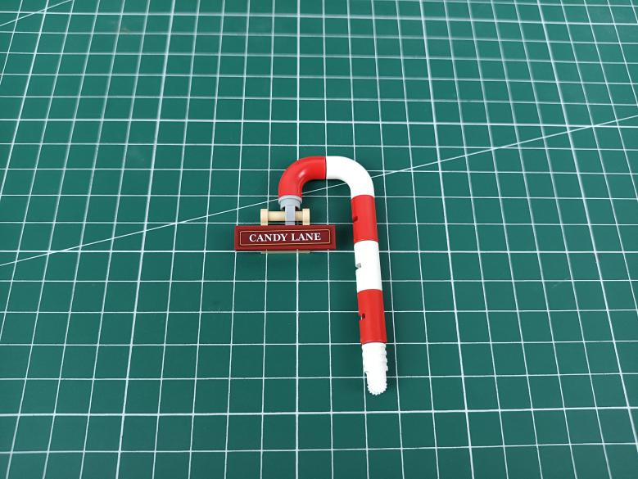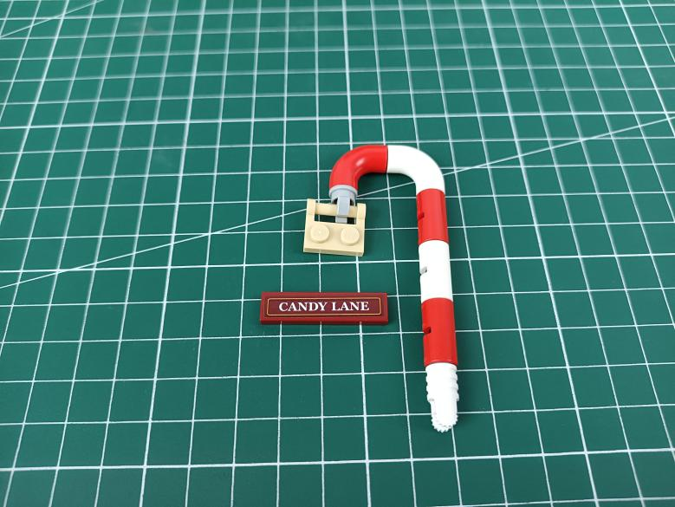

take a 30cm Multi Colour Flashing Light.
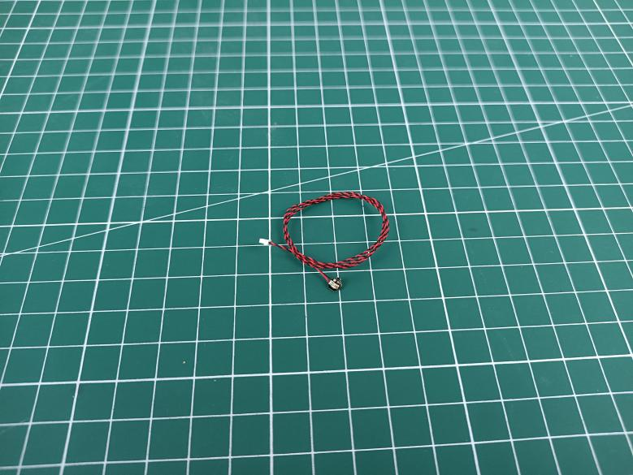

With lighting part facing up, place the light as per below.
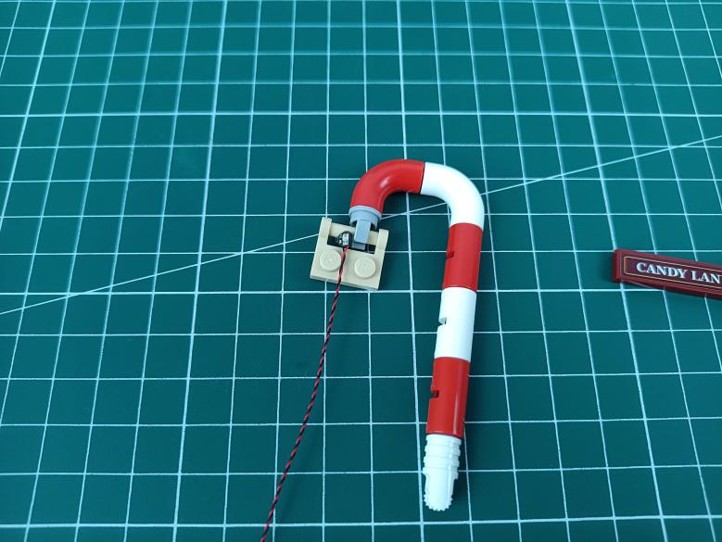

Reconnect the brown signboard to secure the light.
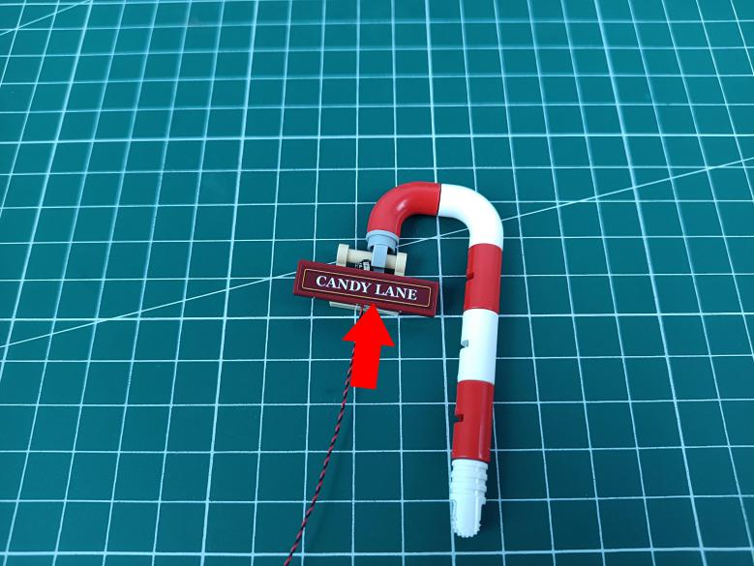

Create a gap at the following place.
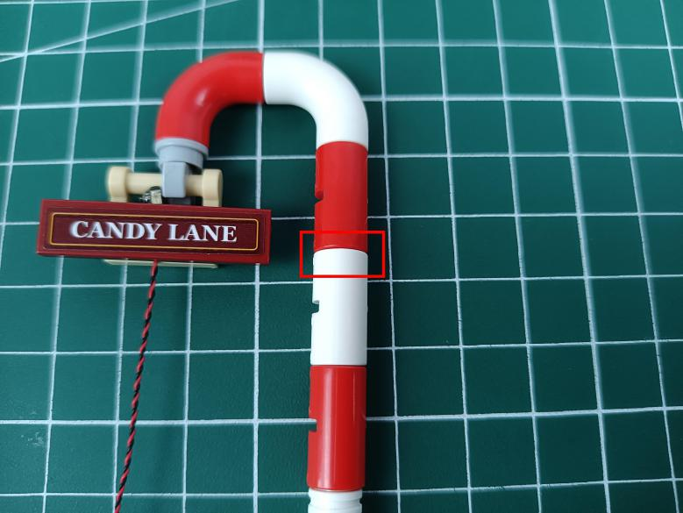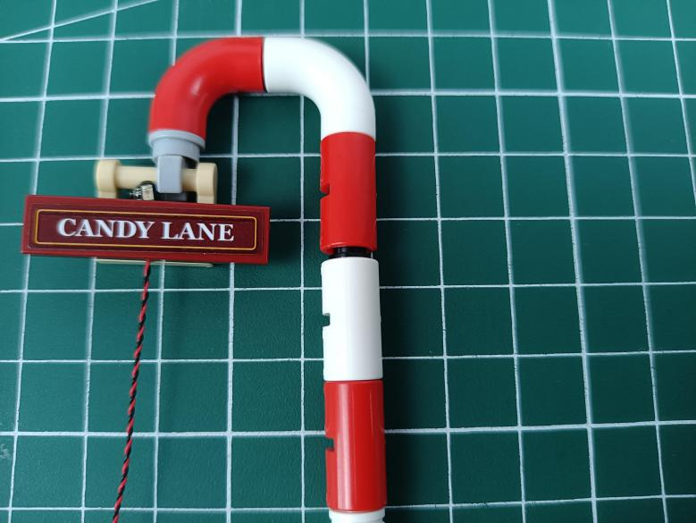

Wind the cable as per below, close the gap to secure the cable.
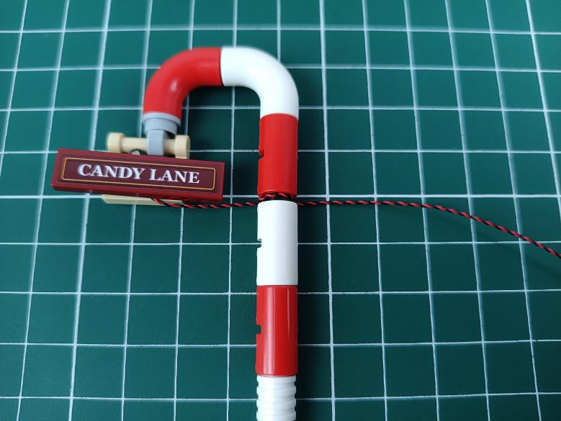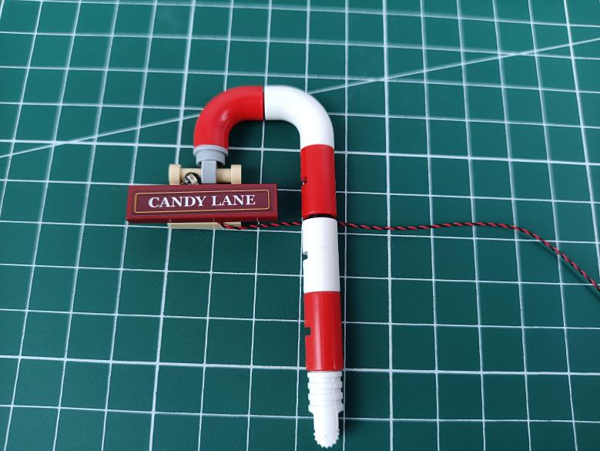

Reconnect the piece.
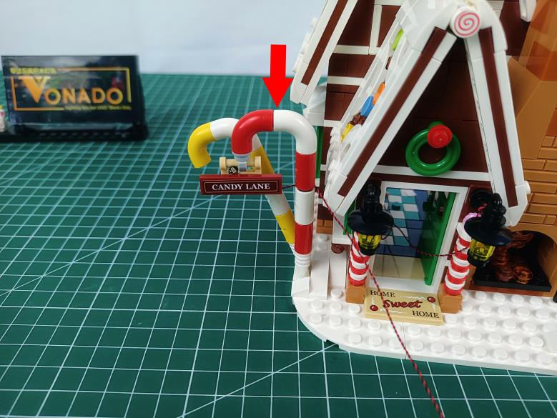

Place the back to the back of the door.
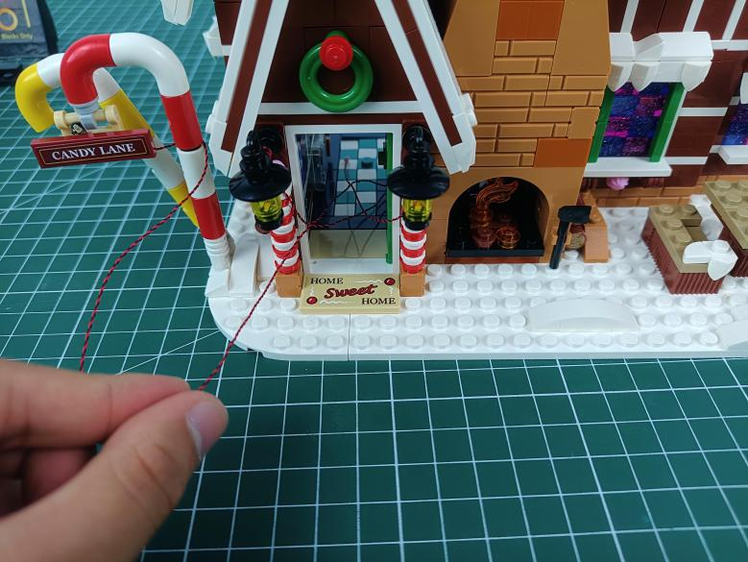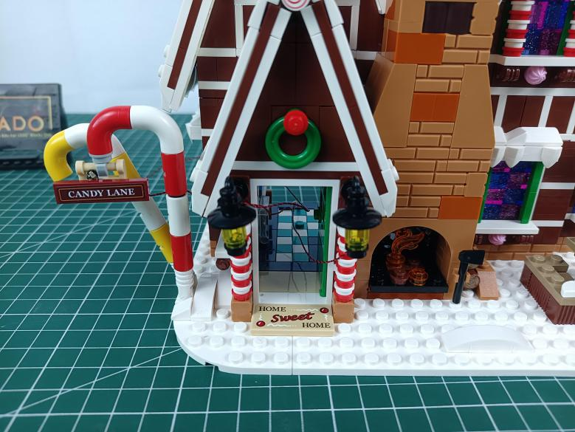

Remove the following piece.
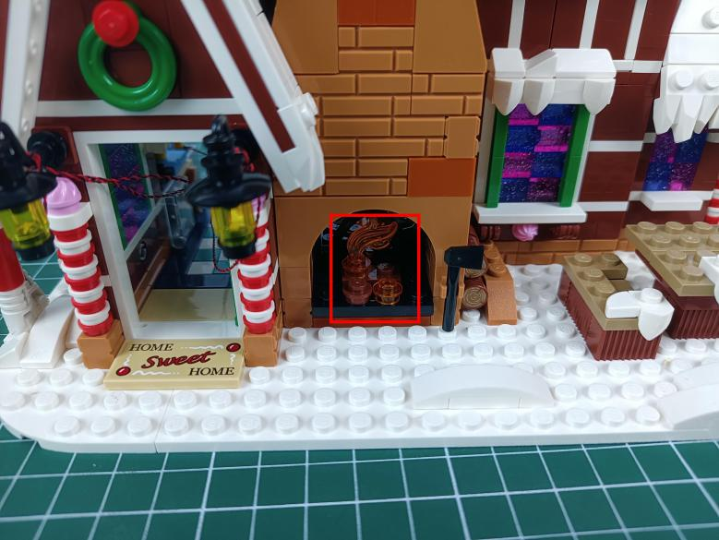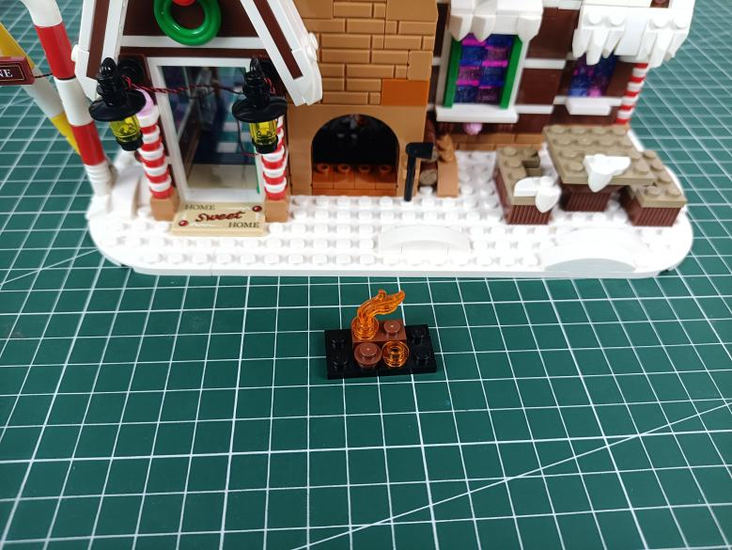

Disconnect the flame.
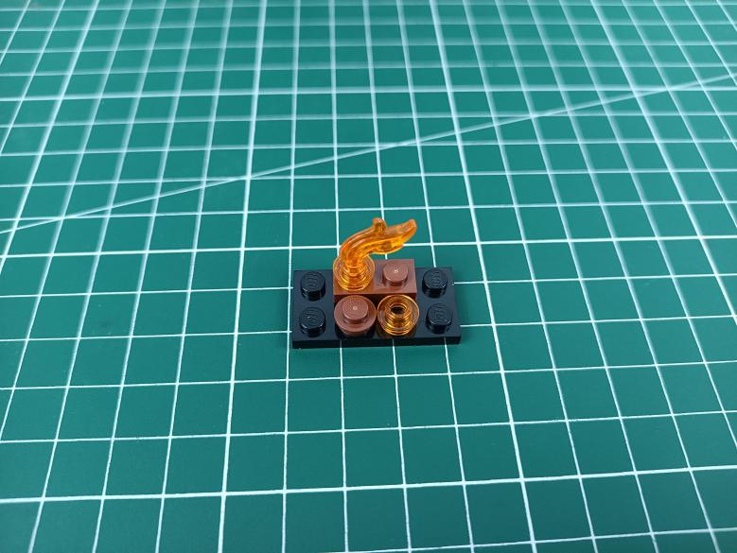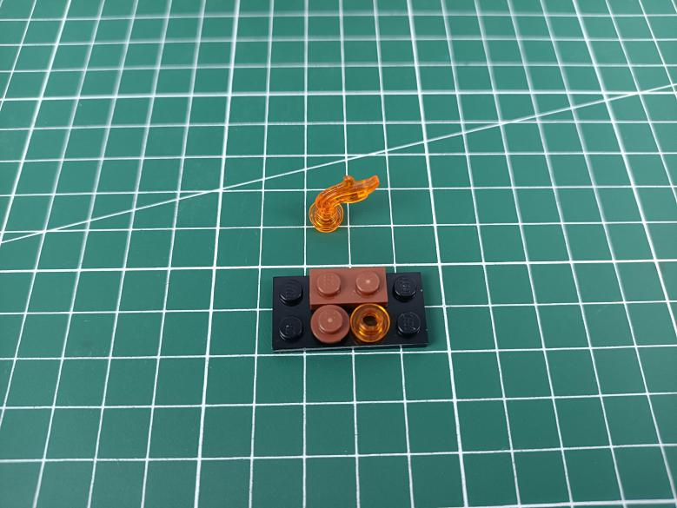

Take a 30cm warm white dot light, a trans orange 1x1 round plate.
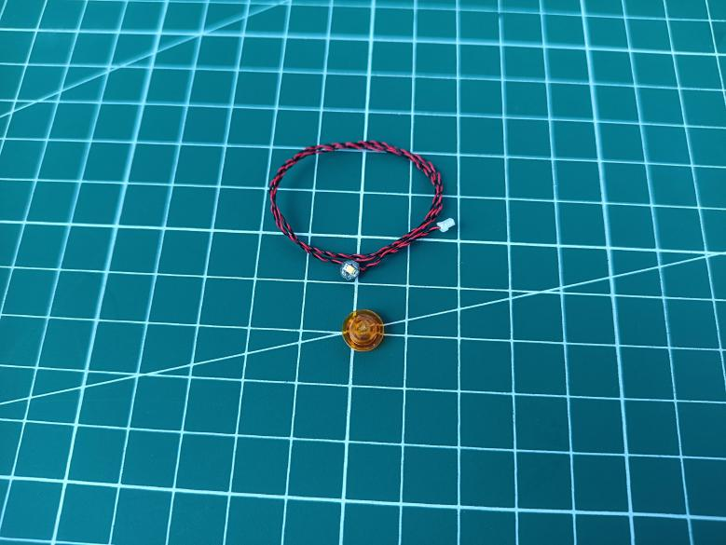

With lighting part facing up, connect the orange round plate over.
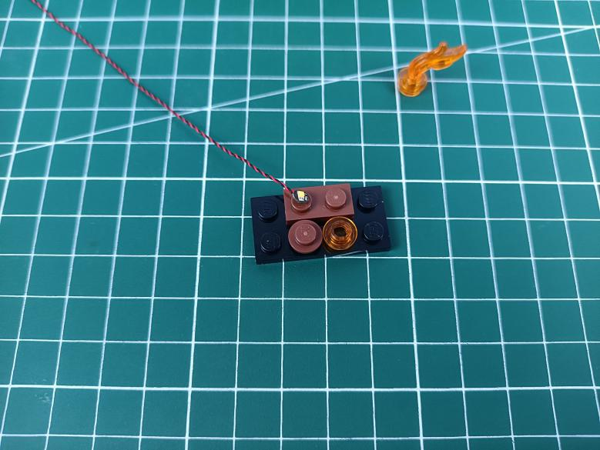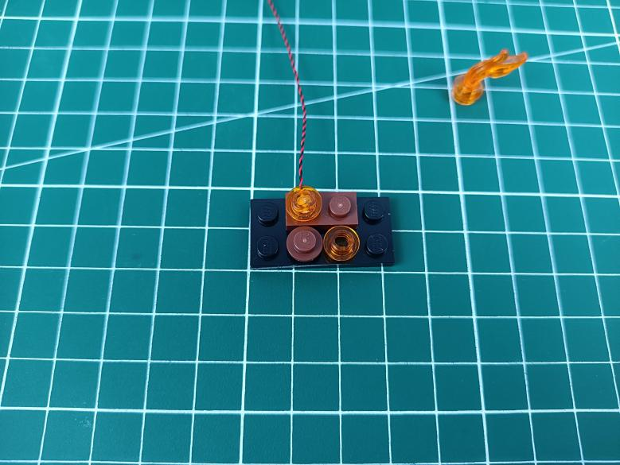

Reconnect the flame.
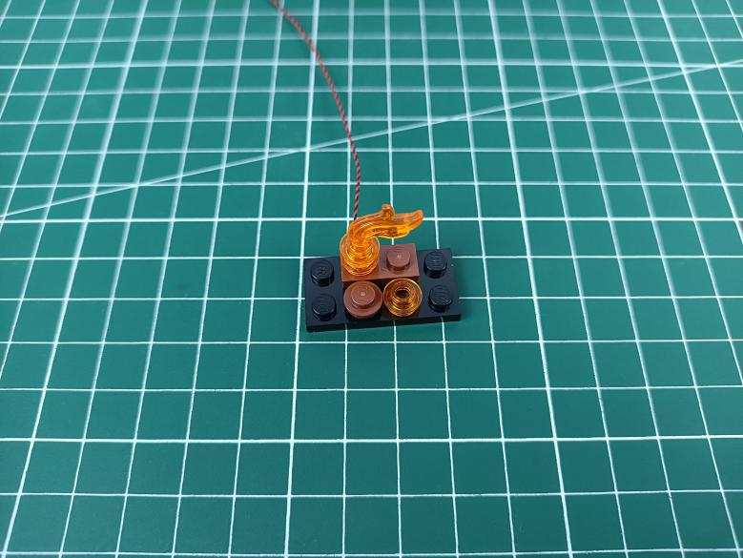

Reconnect the pieces.
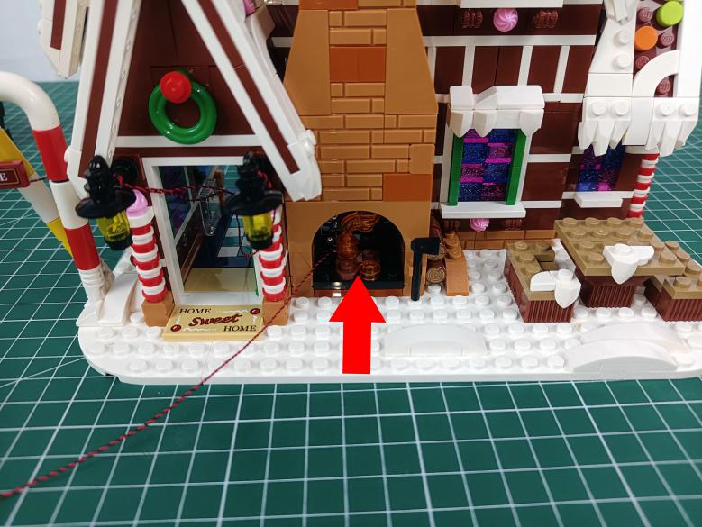

Stuck the cable at the following space, and pull it to the back of the chimney.
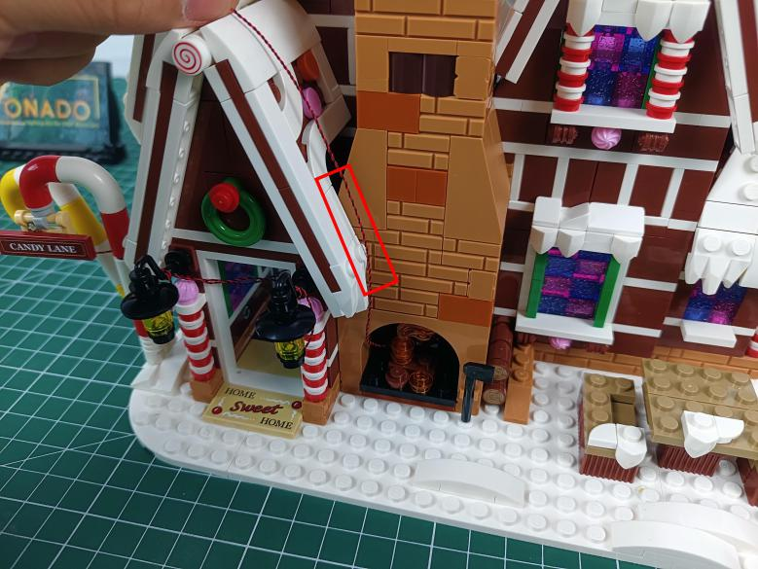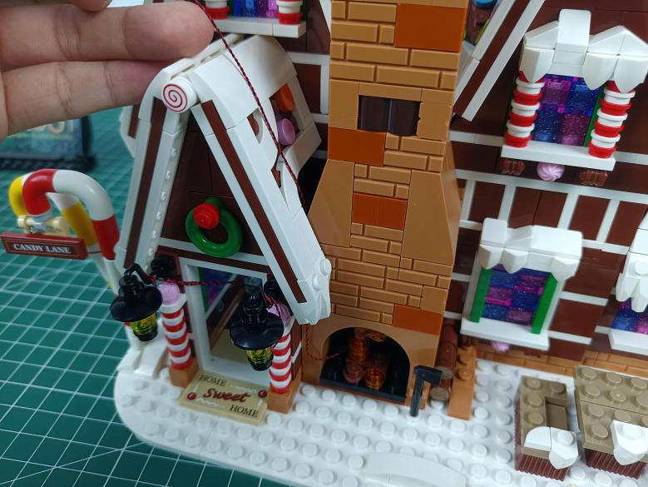
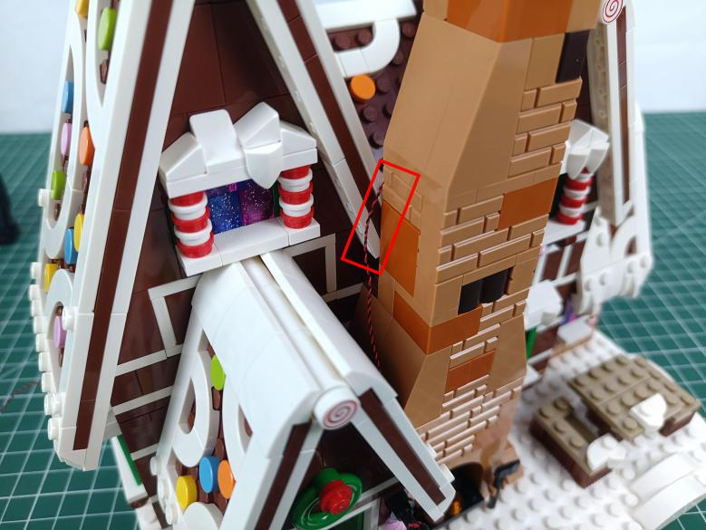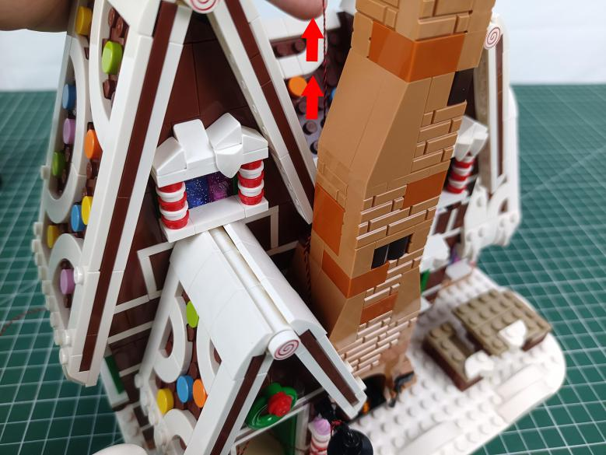

Turn to the roof, remove the following white round piece.
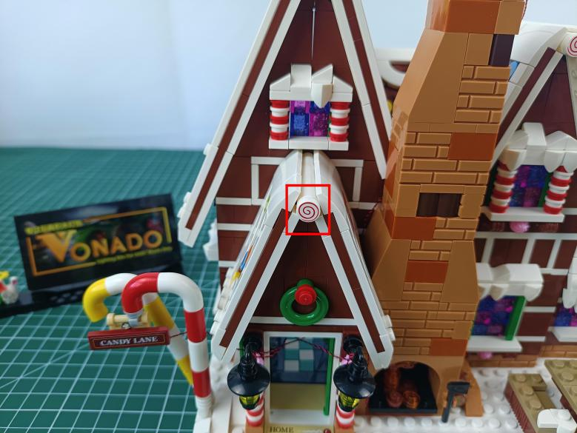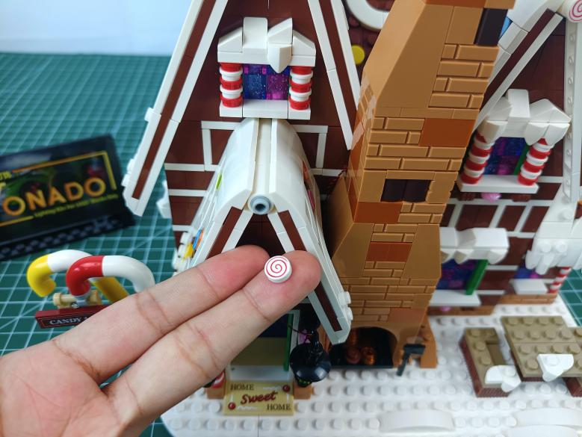

Continue to remove the following 3 white pieces.
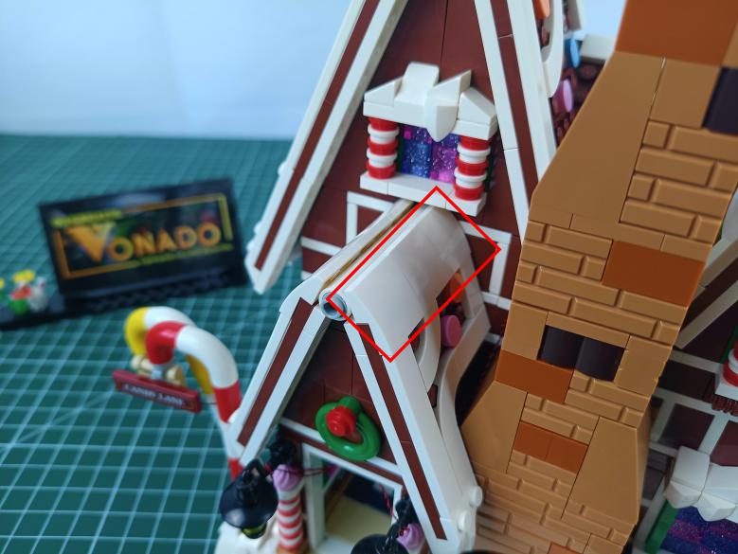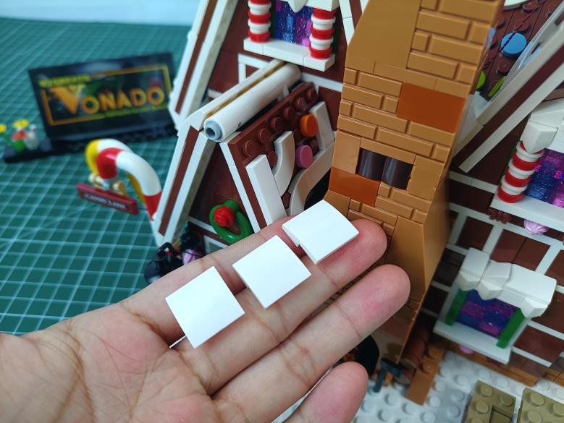

Remove the following white piece from the roof.
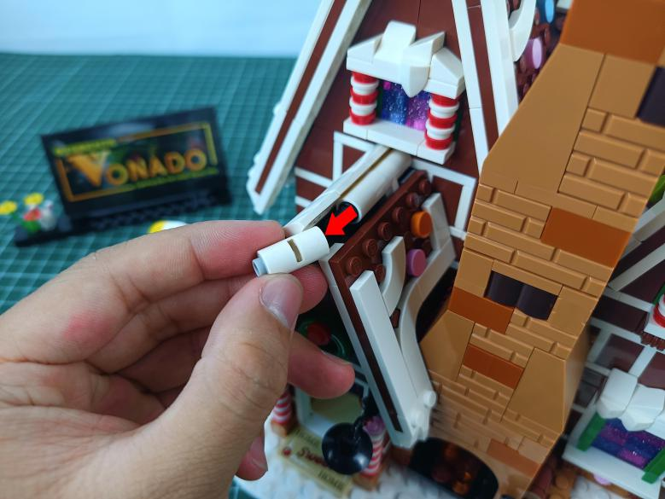

Take a 15cm Multi Colour Flashing Light, a trans white 1x1 round plate.
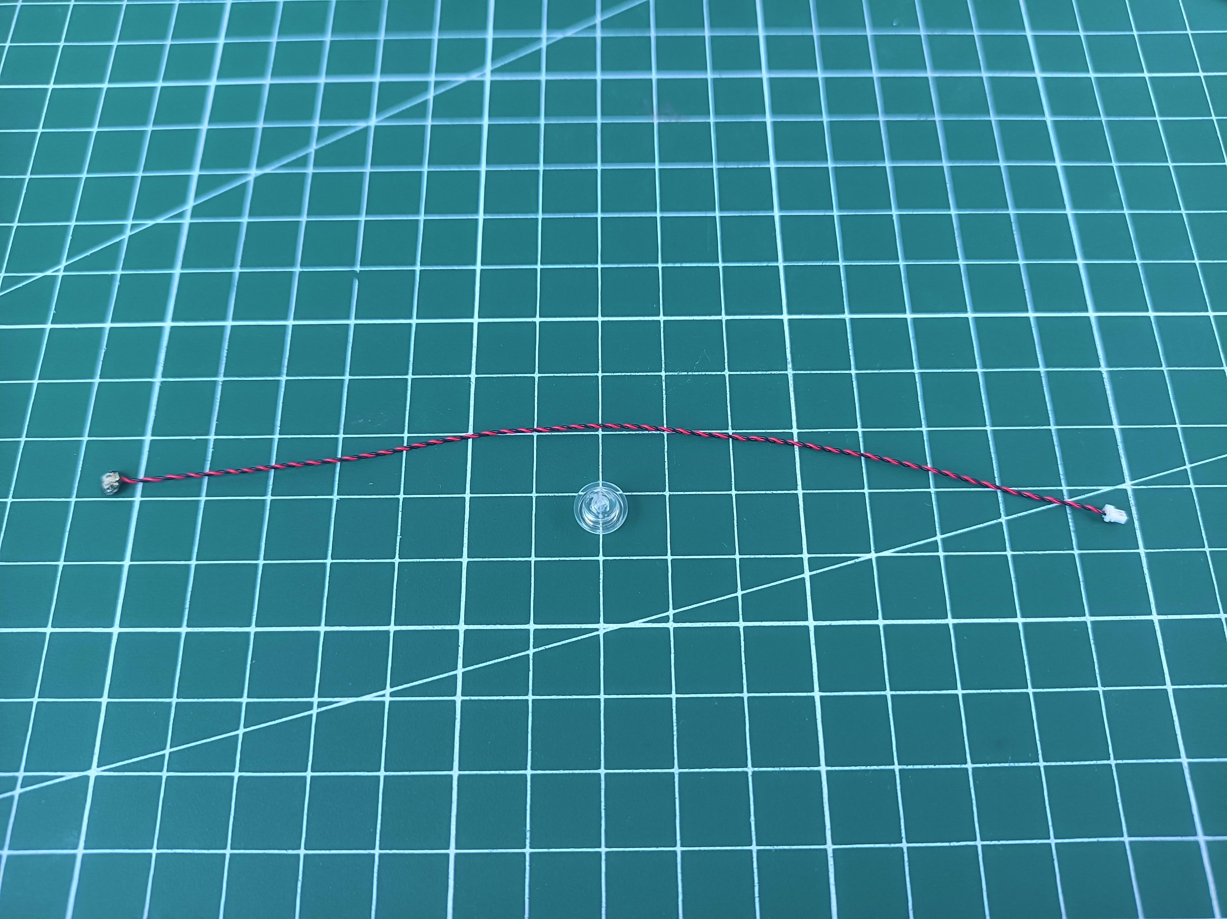

With lighting part facing up, thread the cable through the white piece and tighten the cable up.
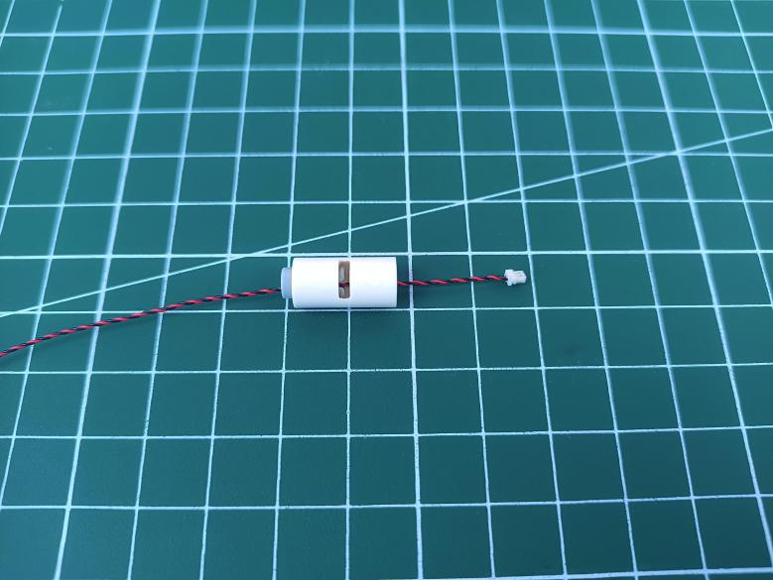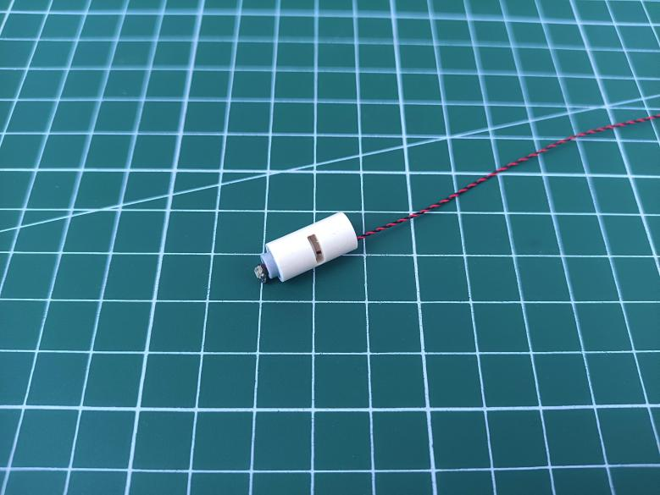

Connect the trans white round plate over.
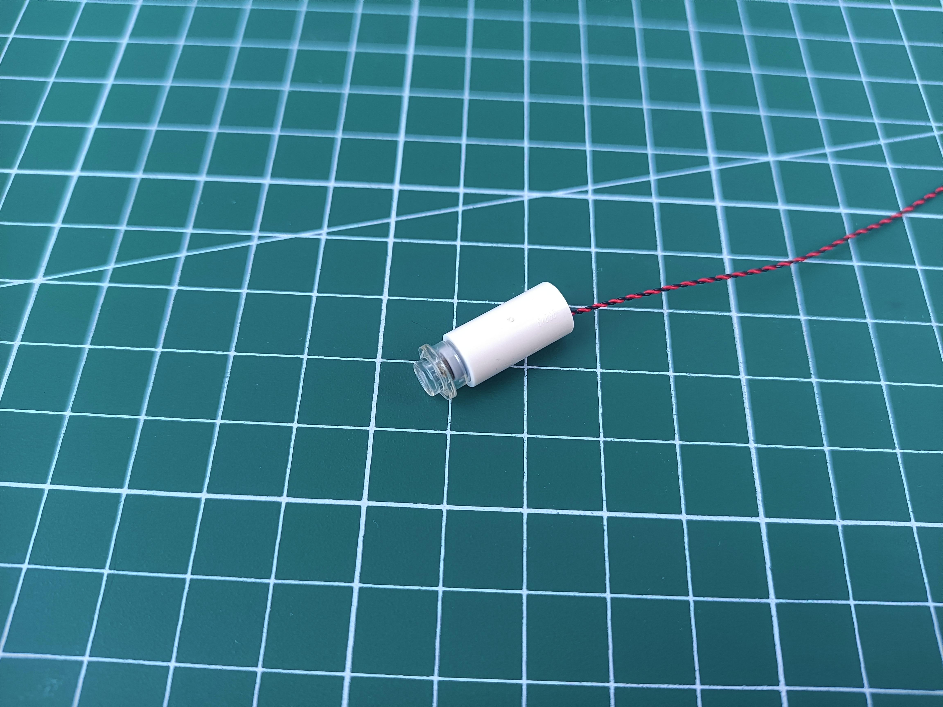

Reconnect the white piece with light installed.
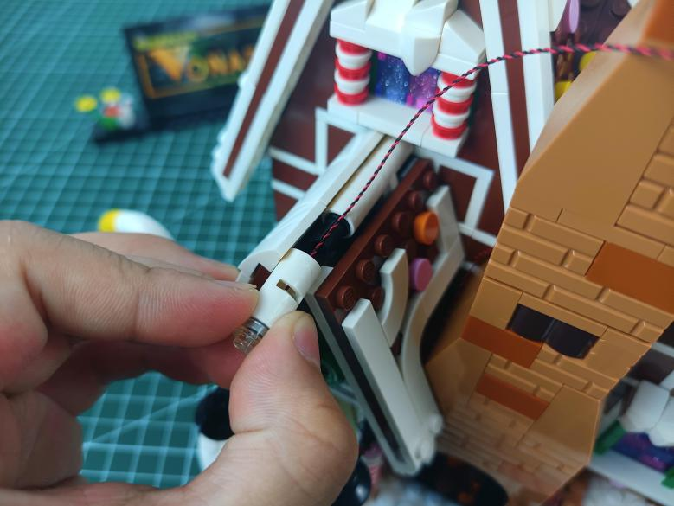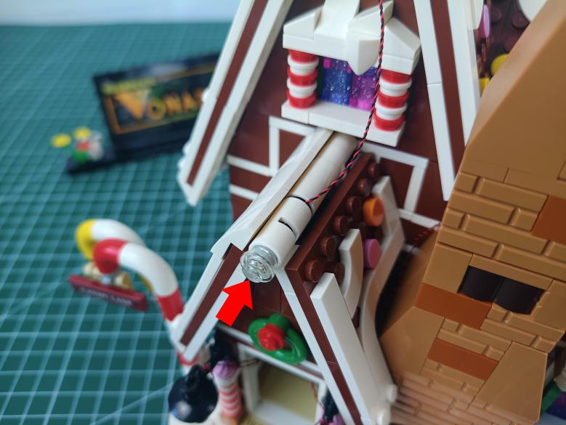

Place the cable as per below, reconnect the white pieces.
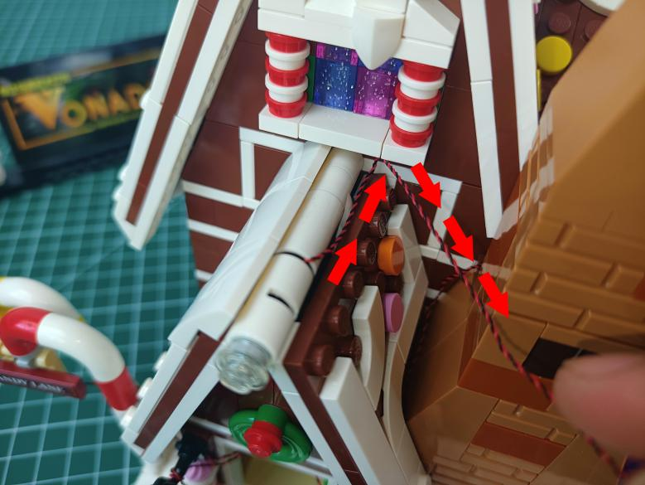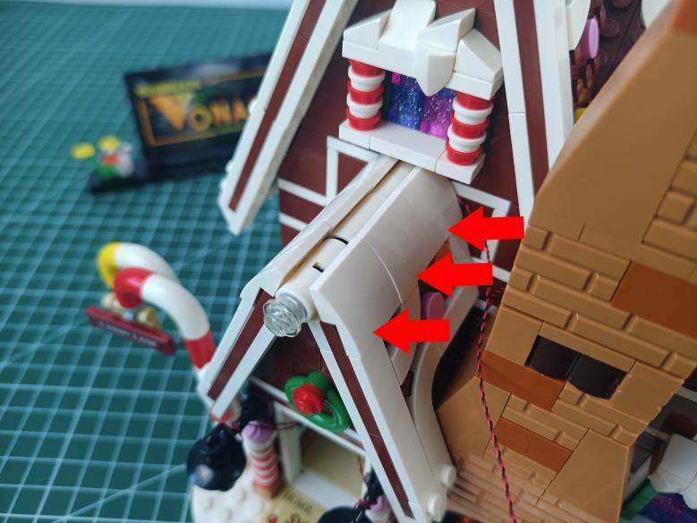

Stuck the cable as per below, pull it to the back of the chimney.
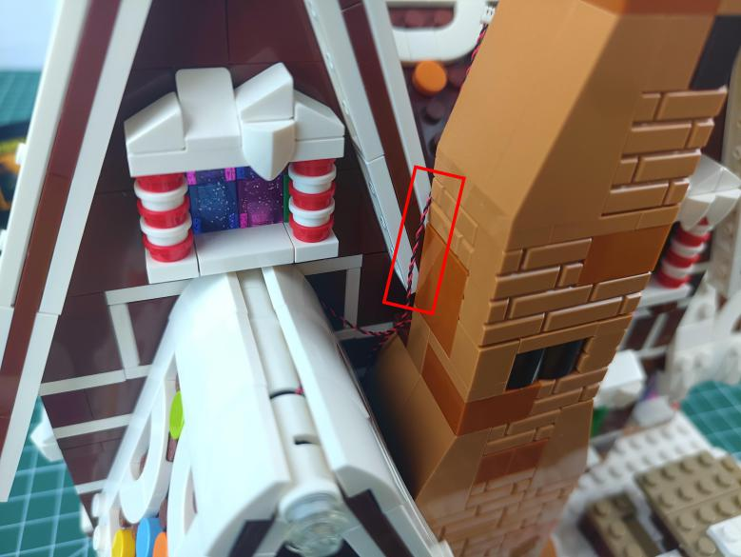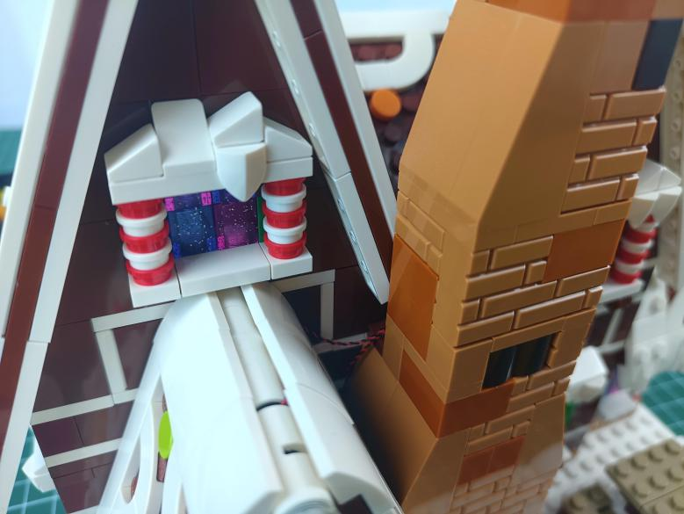

Turn to the following roof, remove the white round plate and the white piece.
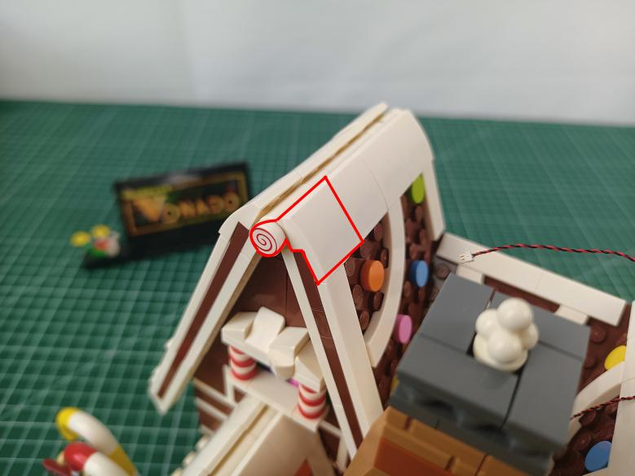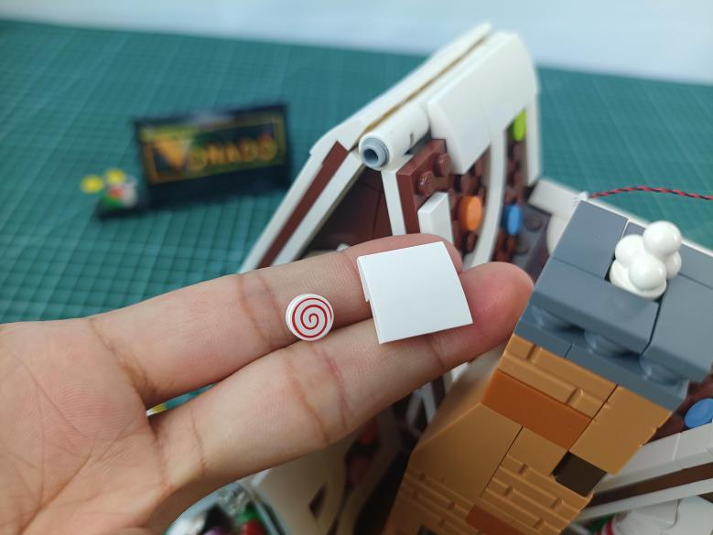

Continue to remove the following white piece.
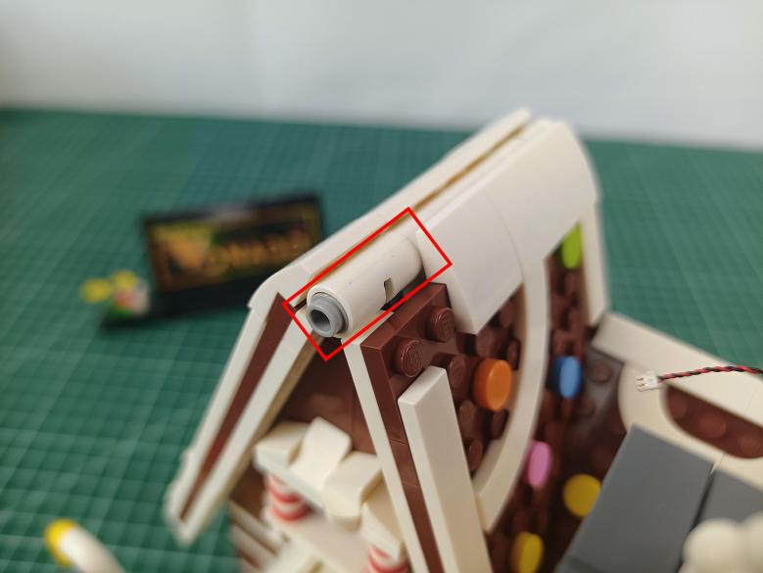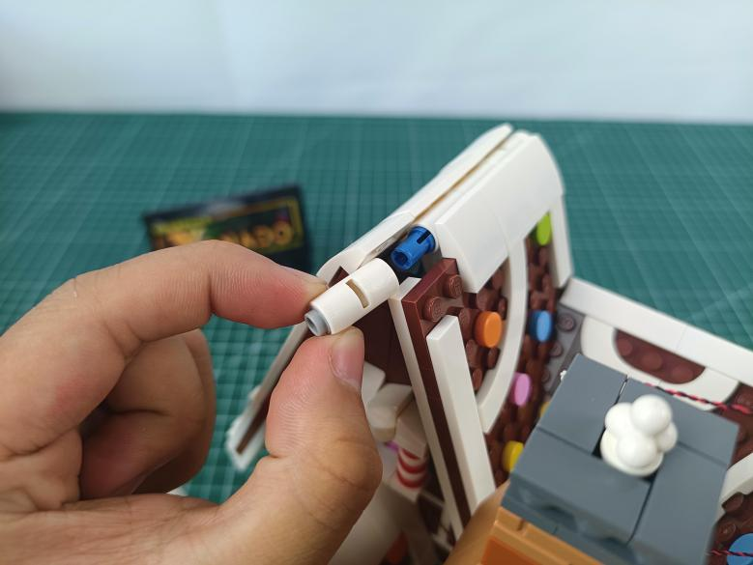

Take a 15cm Multi Colour Flashing Light, a trans white 1x1 round plate.

With lighting part facing up, thread the cable through the white piece and tighten the cable up.
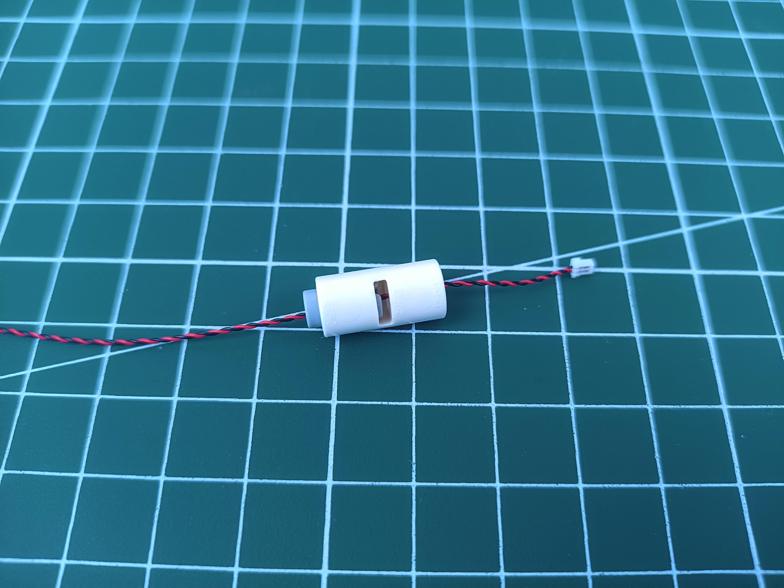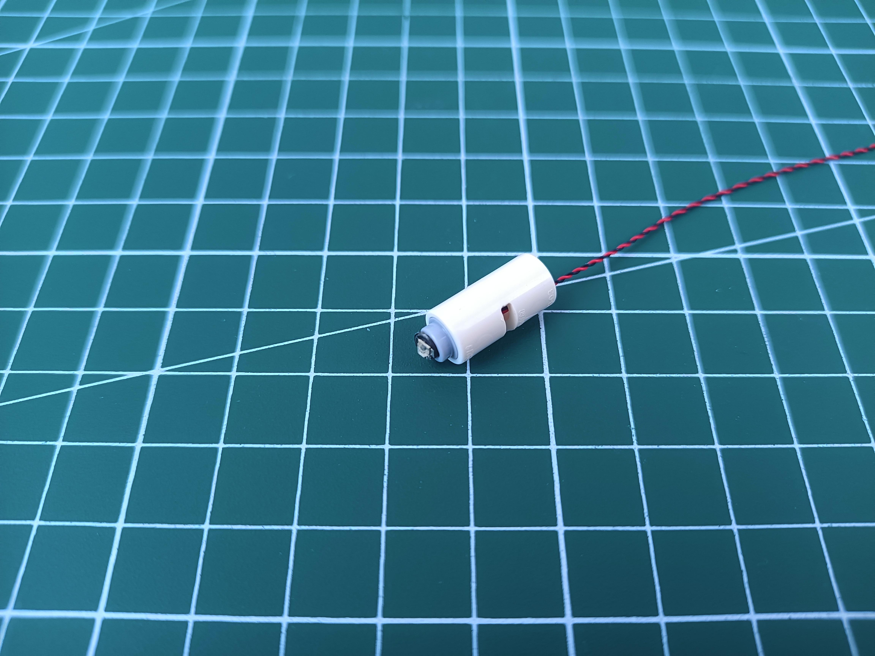

Connect the trans white round plate over.

Reconnect the white piece with light installed.
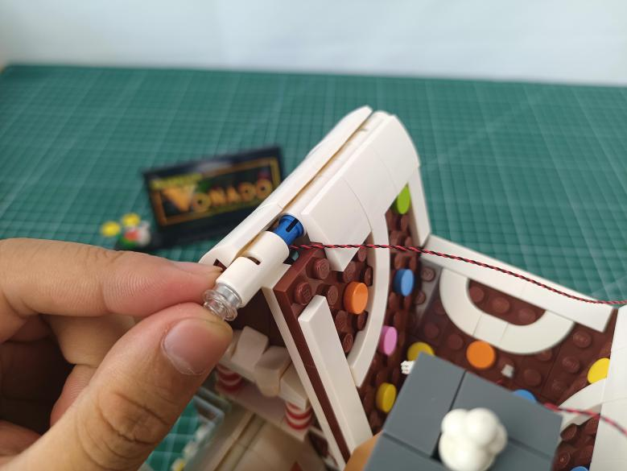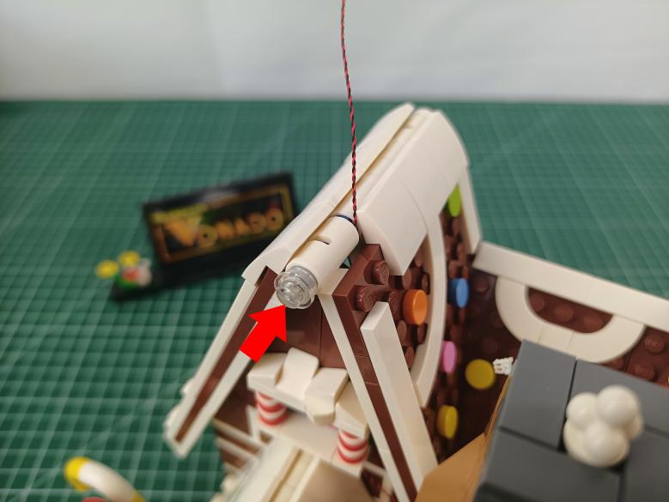

Reconnect the white piece.
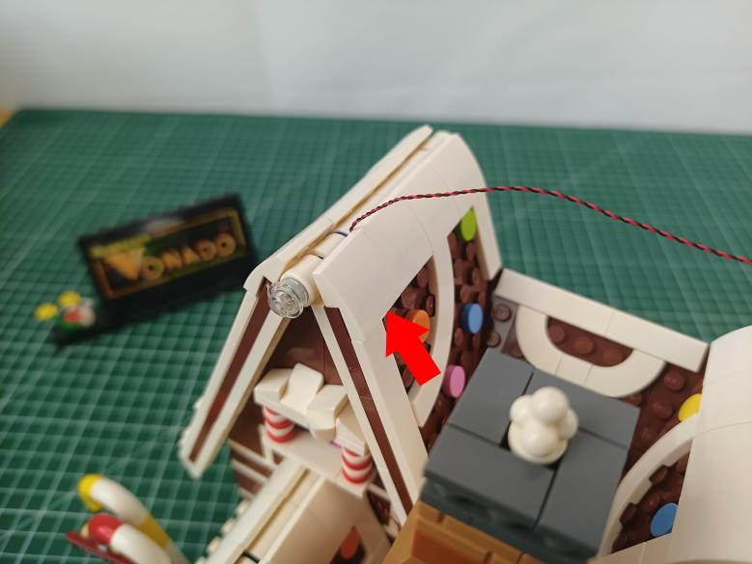

Turn to the following roof, remove the white round plate and the white piece.
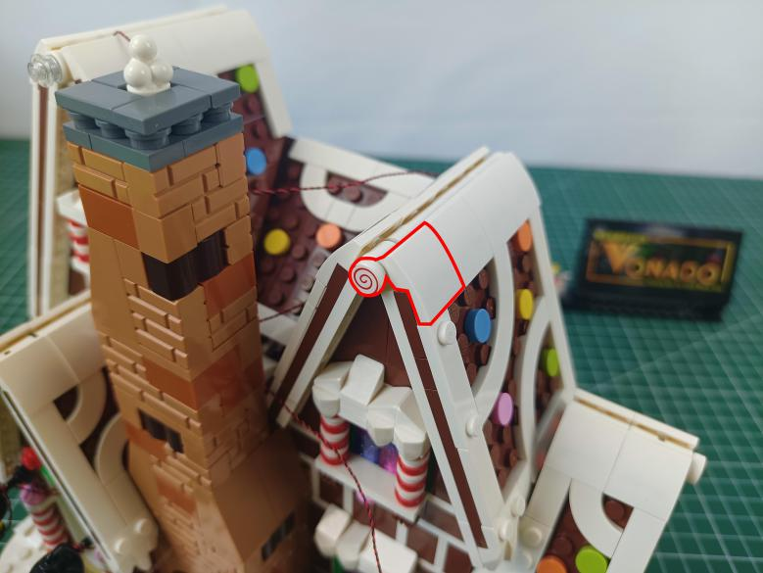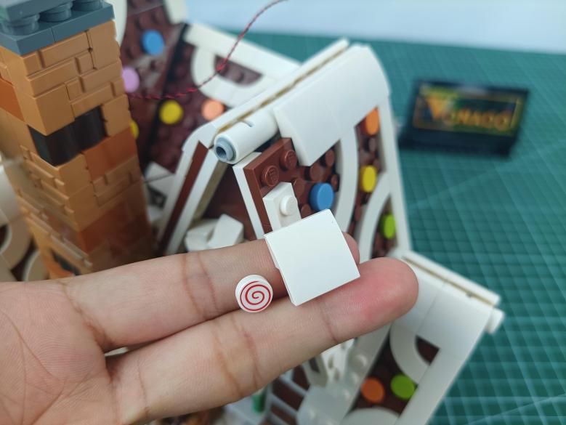

Continue to remove the following white piece.
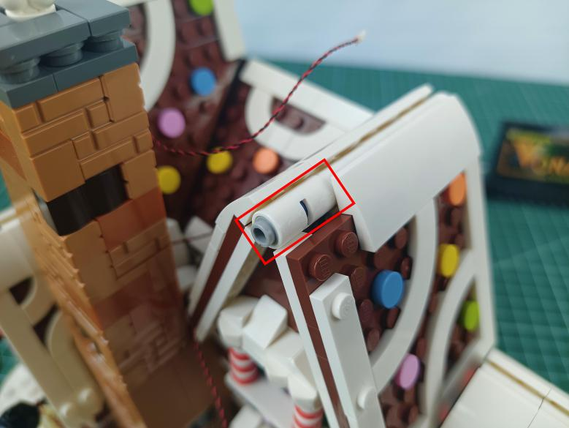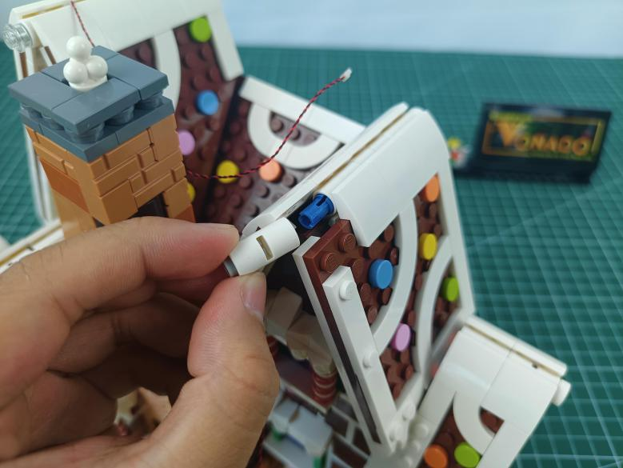

Take a 15cm Multi Colour Flashing Light, a trans white 1x1 round plate.

With lighting part facing up, thread the cable through the white piece and tighten the cable up.

Connect the trans white round plate over.

Reconnect the white piece with light installed.
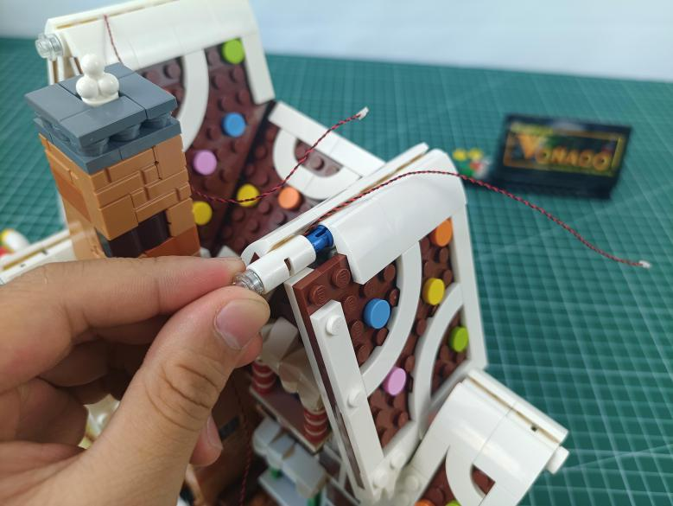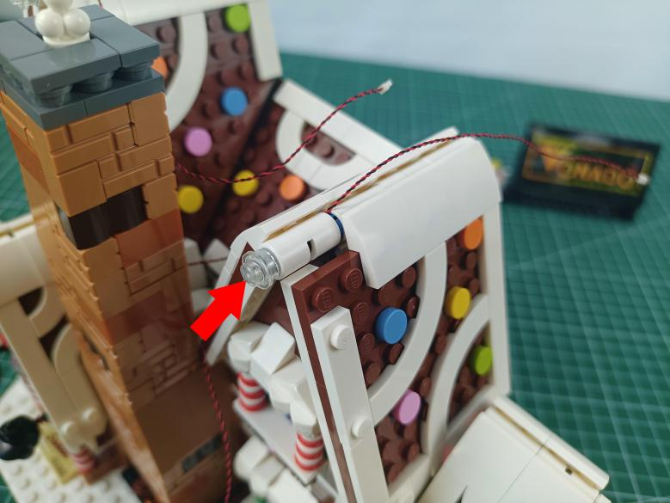

Continue to reconnect the white piece.
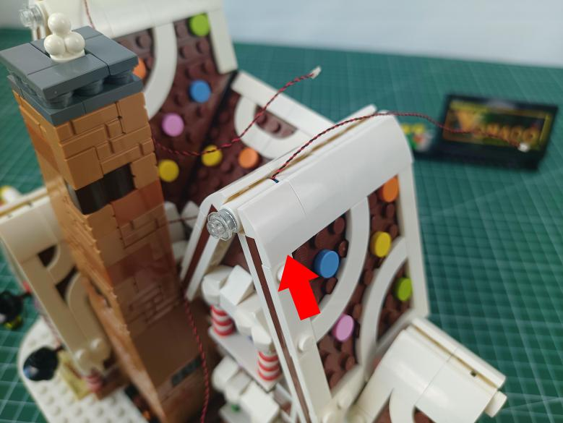

Turn to the following roof, remove the white round plate and the white piece.
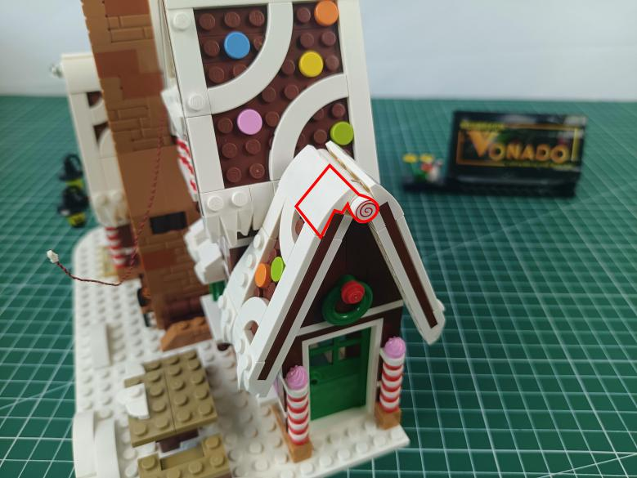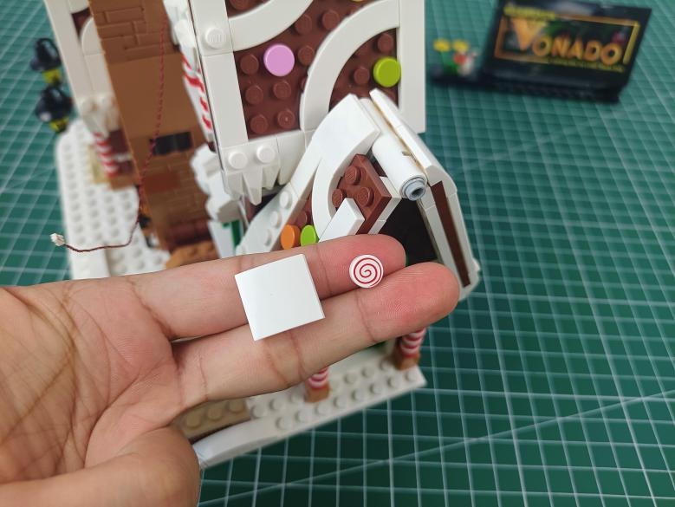

Continue to remove the following white piece.
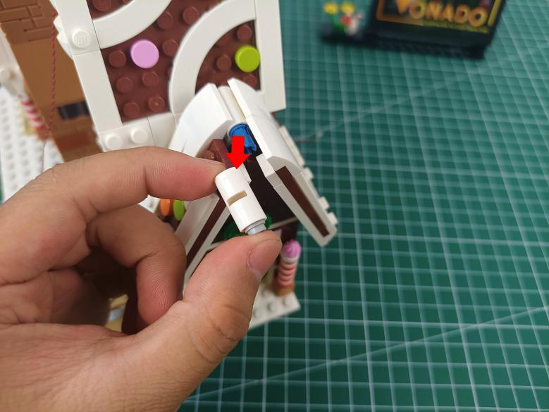

Take a 30cm Multi Colour Flashing Light, a trans white 1x1 round plate.
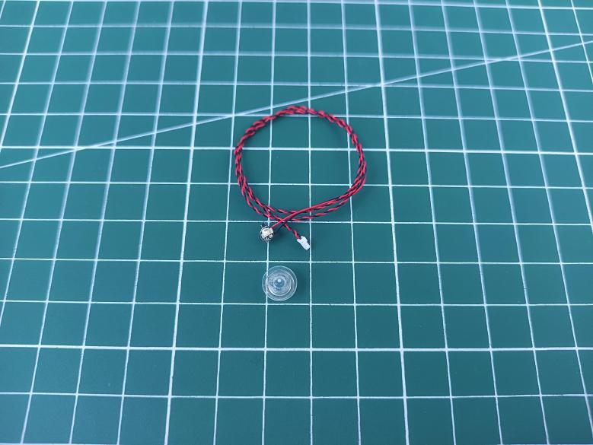

With lighting part facing up, thread the cable through the white piece and tighten the cable up.
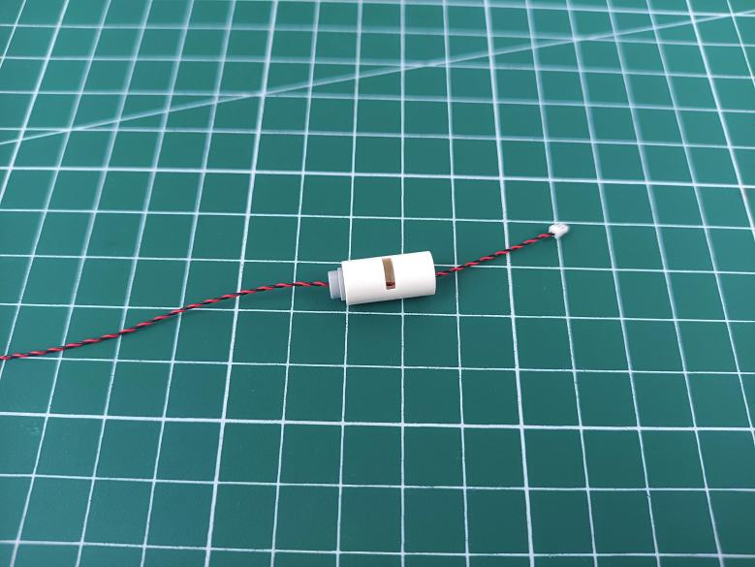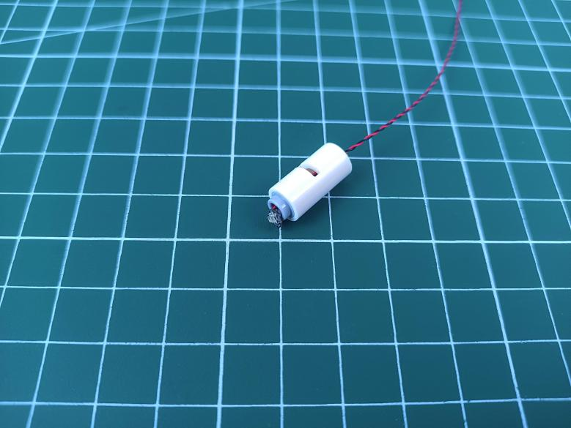

Connect the trans white round plate over.

Reconnect the white piece with light installed.
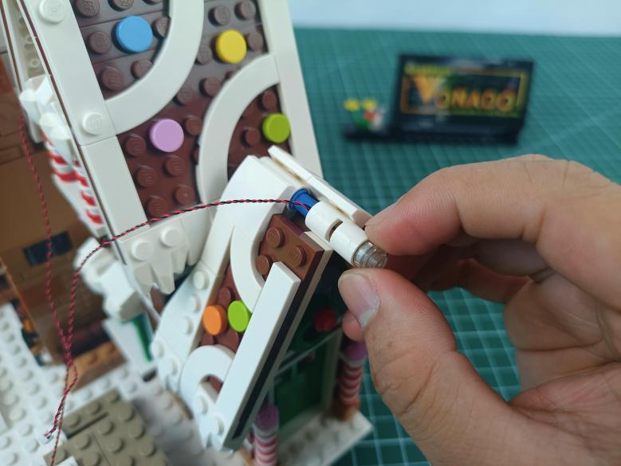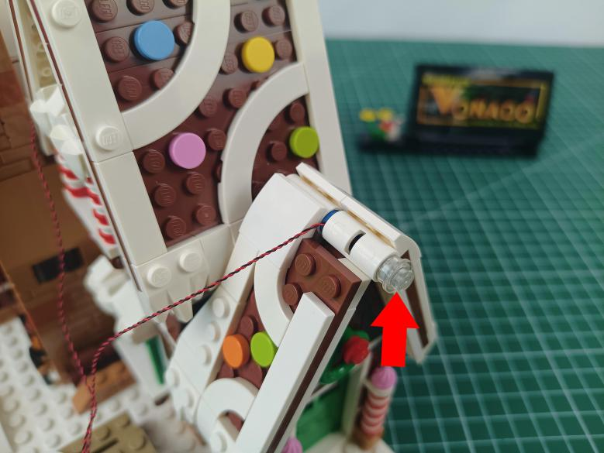

Continue to reconnect the white piece.
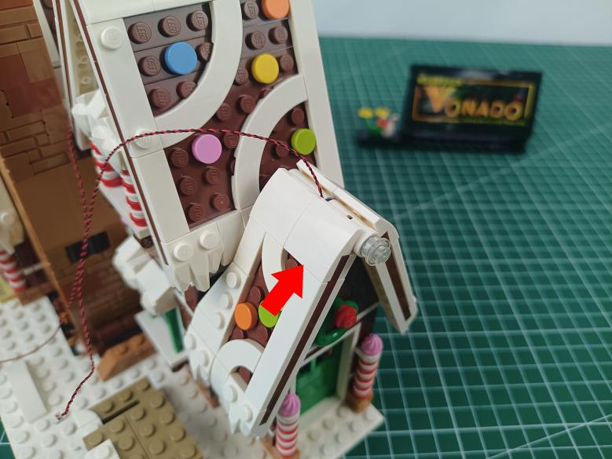

Stuck the cable at the roof as per below.
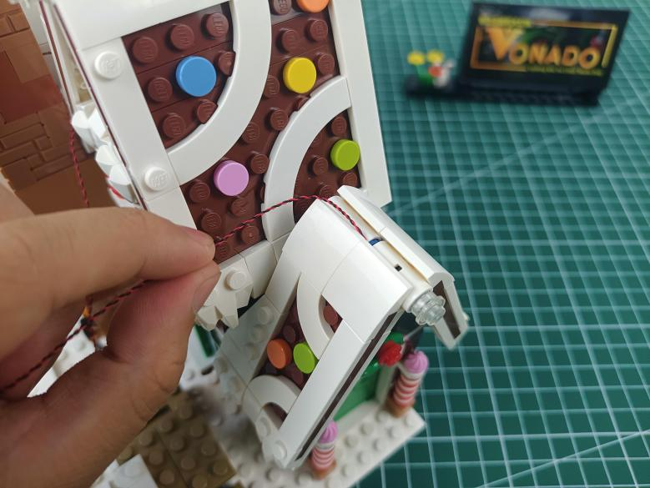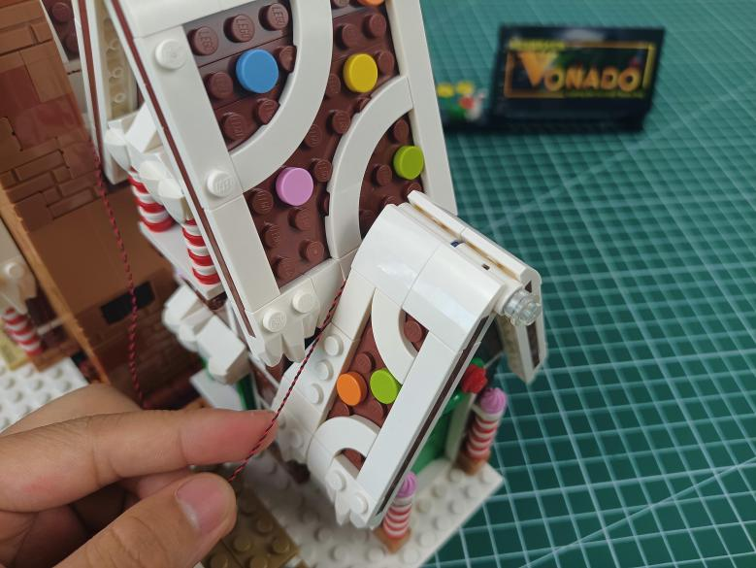

Pull the cable to leftward.
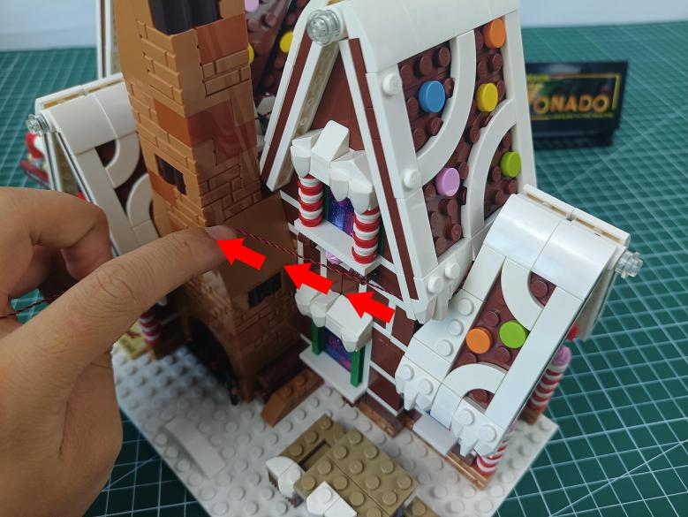

Stuck the cable at the following place and pull it to the back of the chimney.
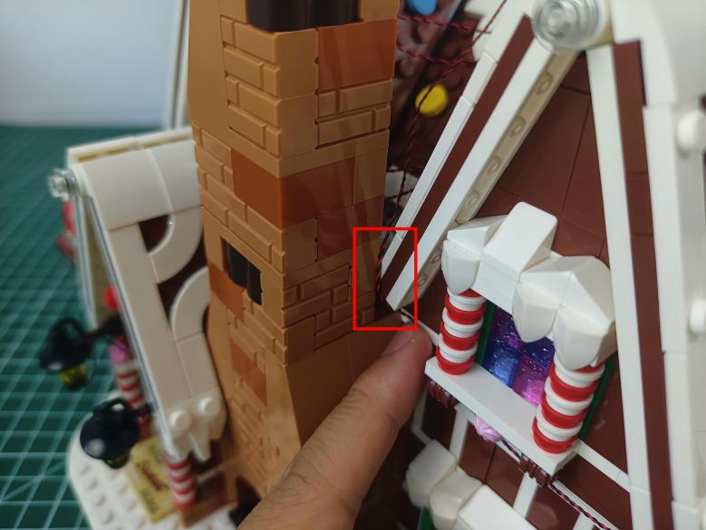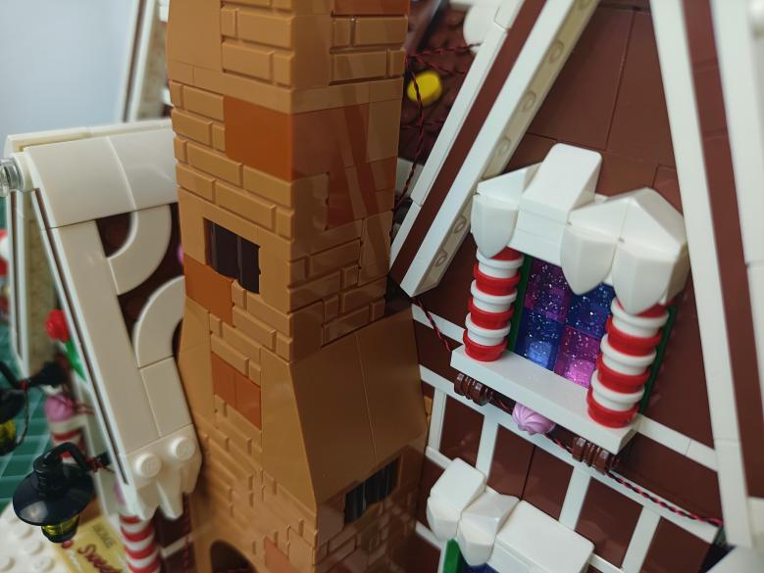

Turn to the left, remove the following pieces from the window.
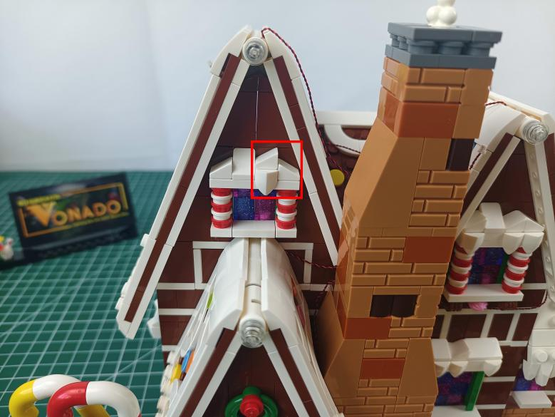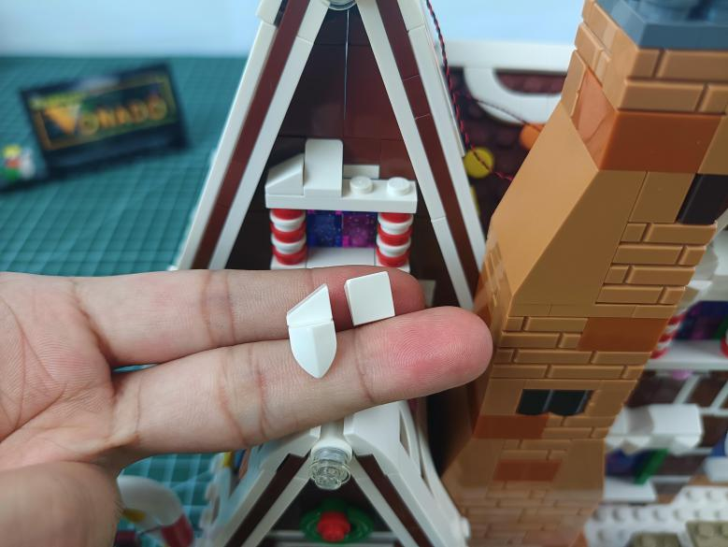

Take a 30cm pink dot light, an adhesive square.
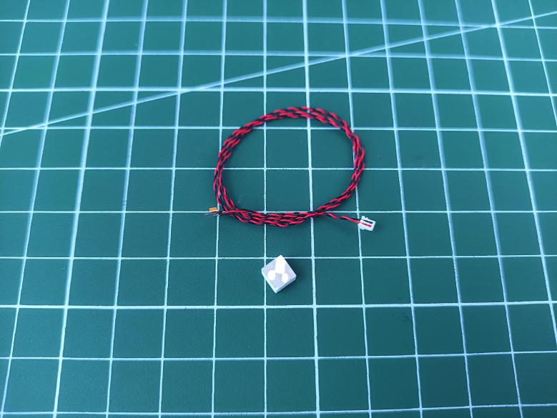

Stick the adhesive square to the back of the light.
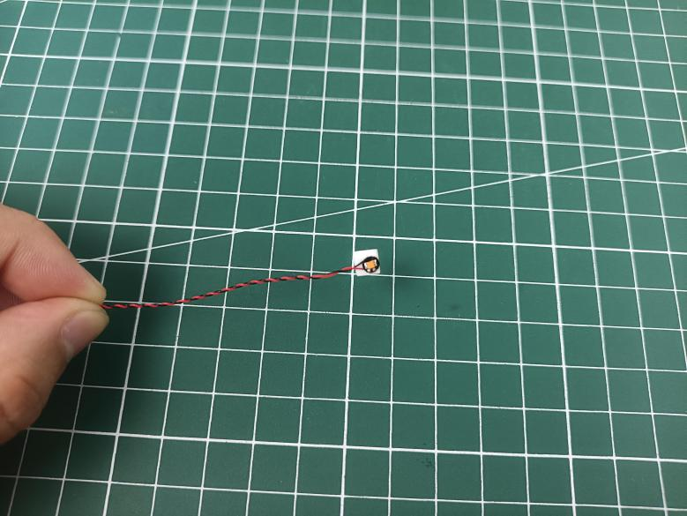

Stick the light underneath the windowsill as per below.
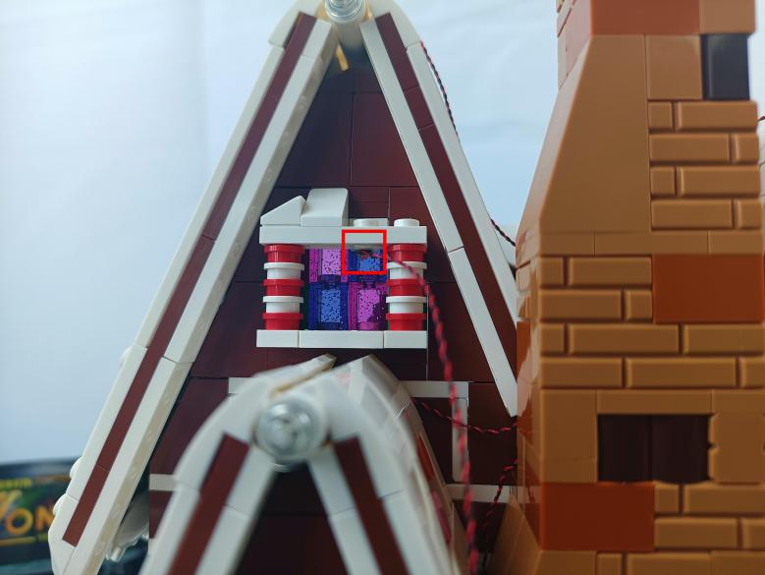

Place the cable as per below, reconnect the following pieces.
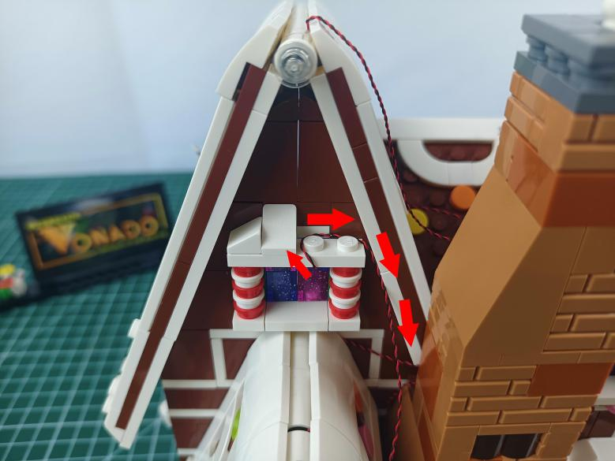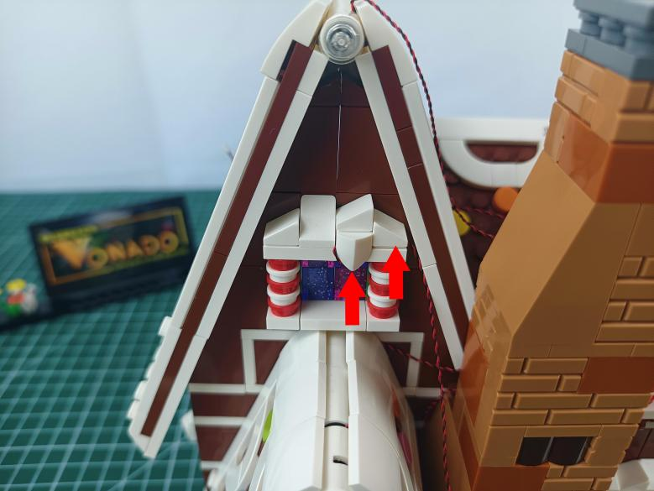

Pull the cable down.
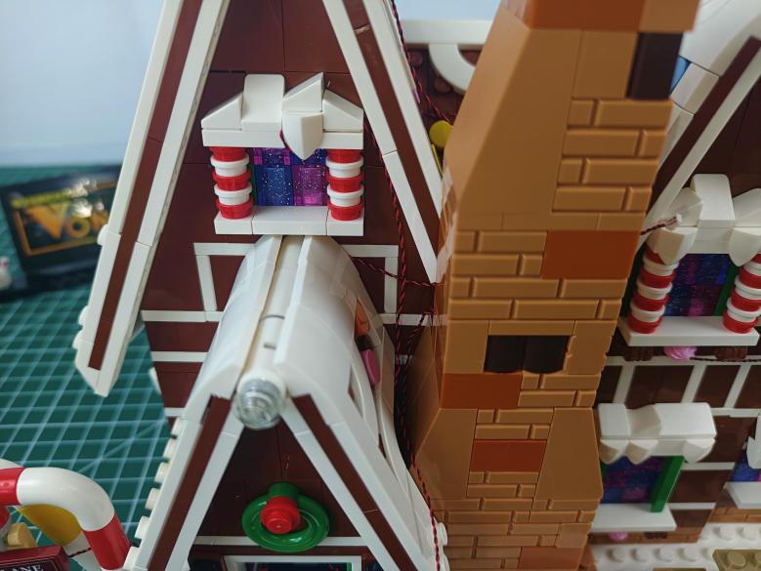

Stuck it at the following place.
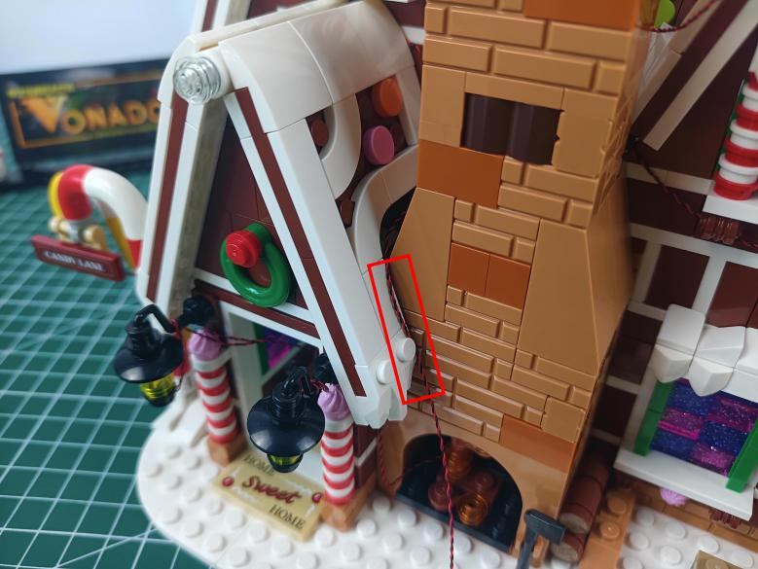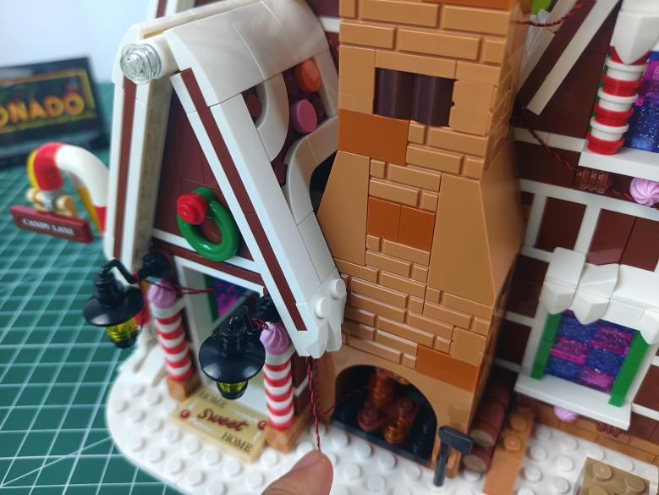

Thread the cable through the door to the back.
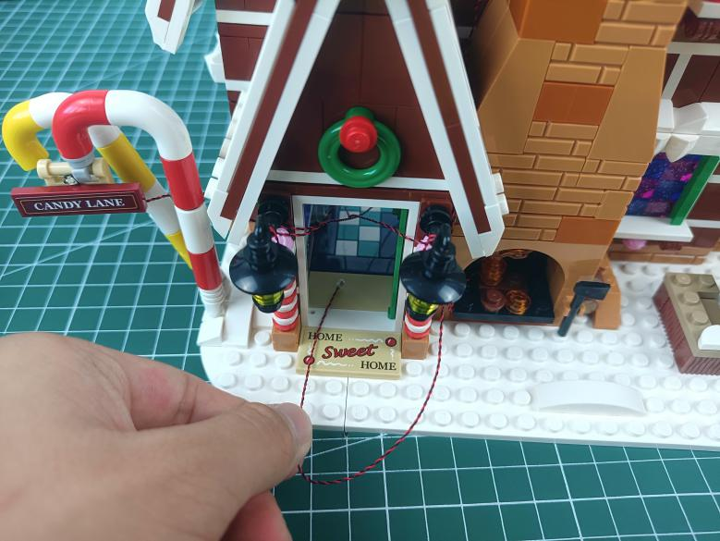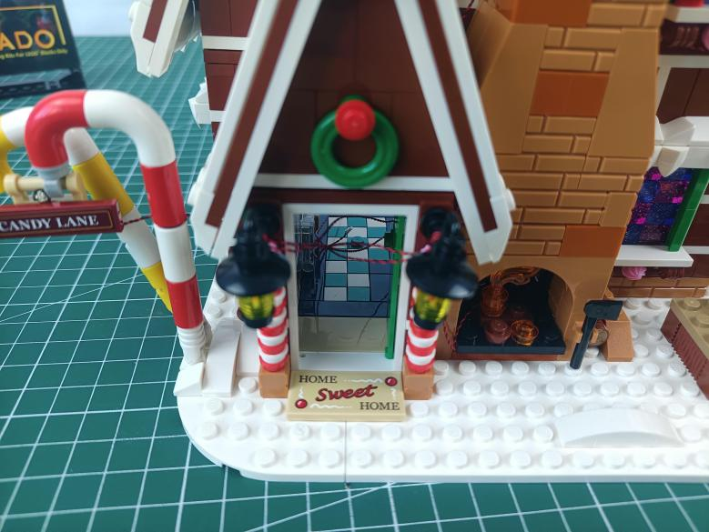

Turn to the right, remove the following pieces from the window.
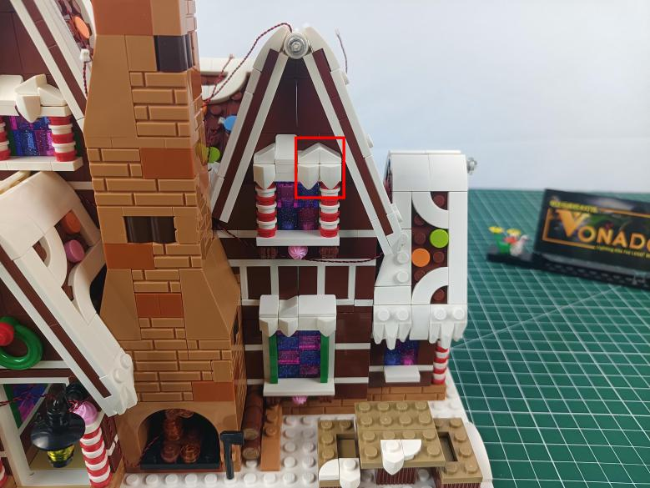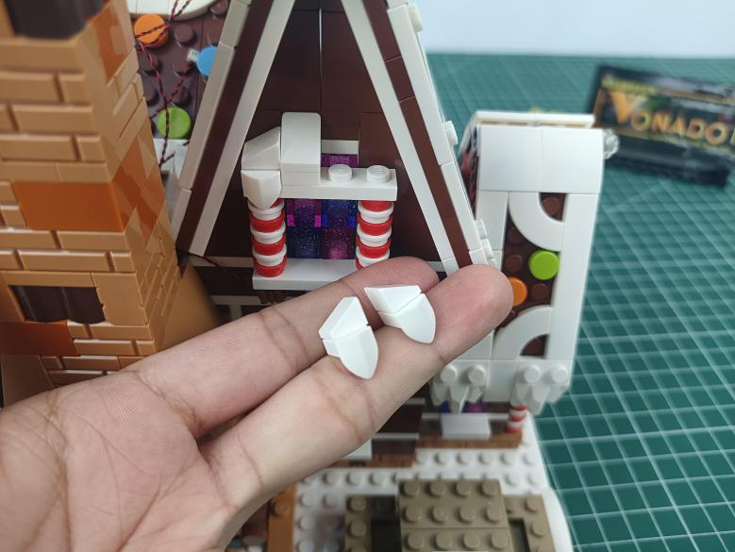

Take a 15cm pink dot light, an adhesive square.
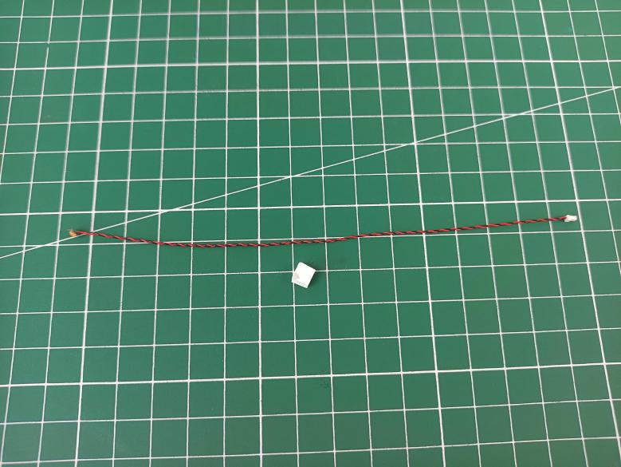

Stick the adhesive square to the back of the light.
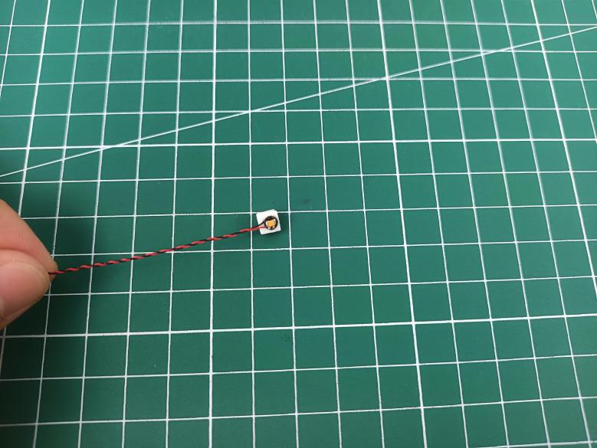

Stick the light underneath the windowsill as per below.
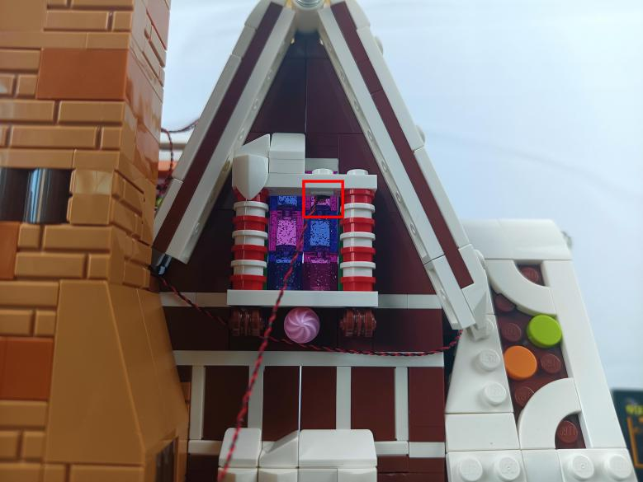

Place the cable as per below, reconnect the following pieces.
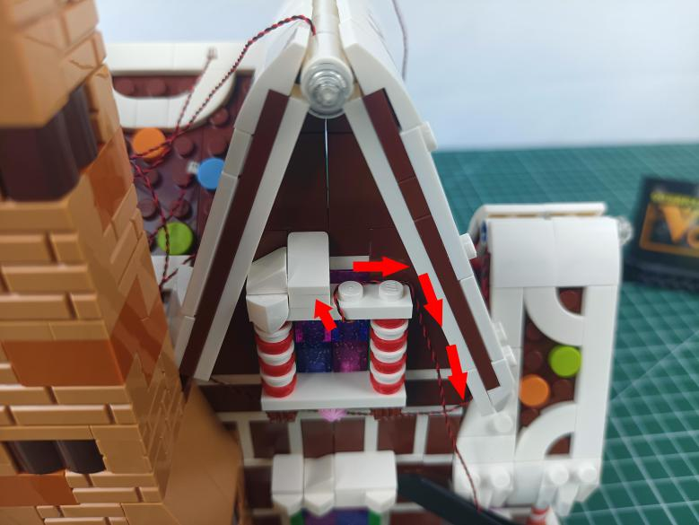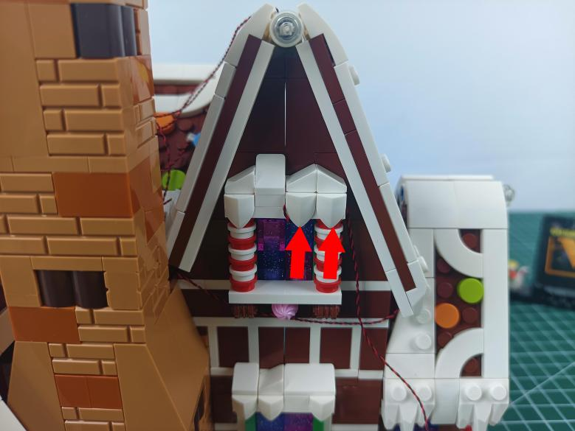

Thread the cable through the following space and tighten it up.
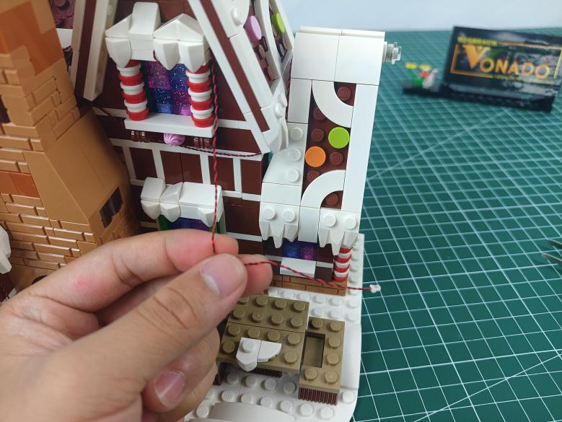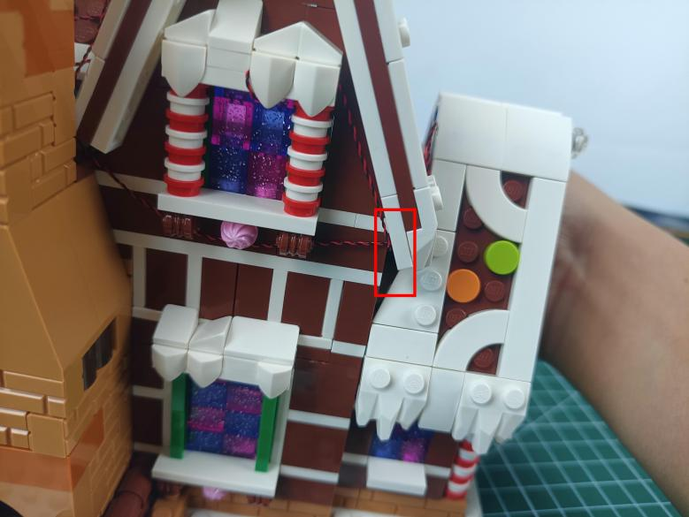

Remove the following piece from the window.
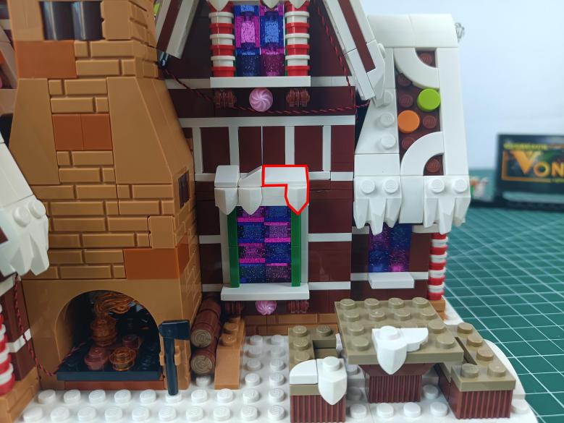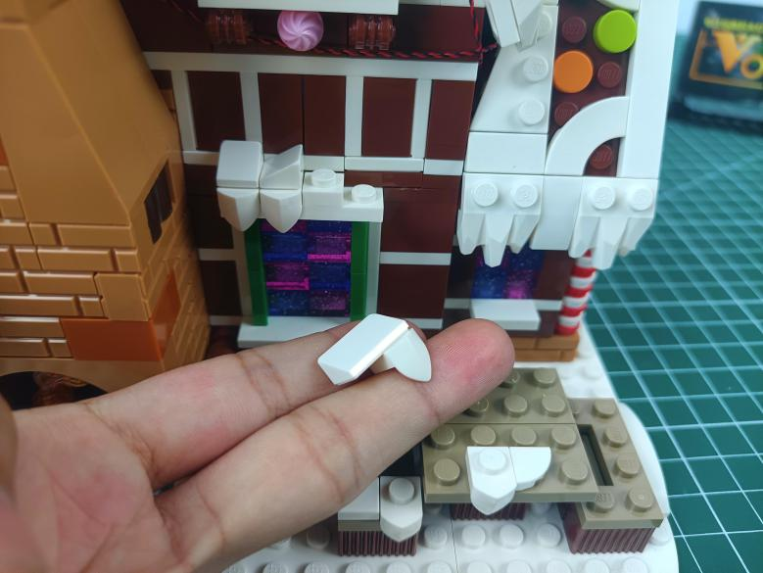

Take a 15cm pink dot light, an adhesive square.
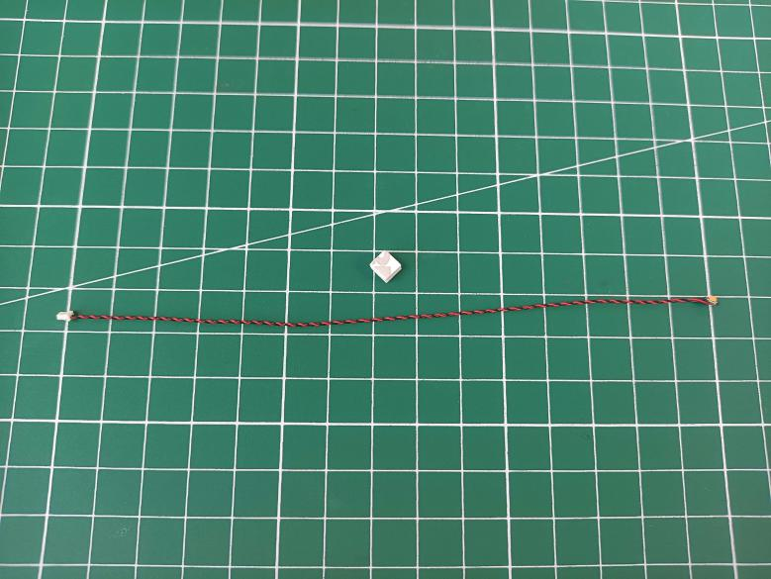

Stick the adhesive square to the back of the light.
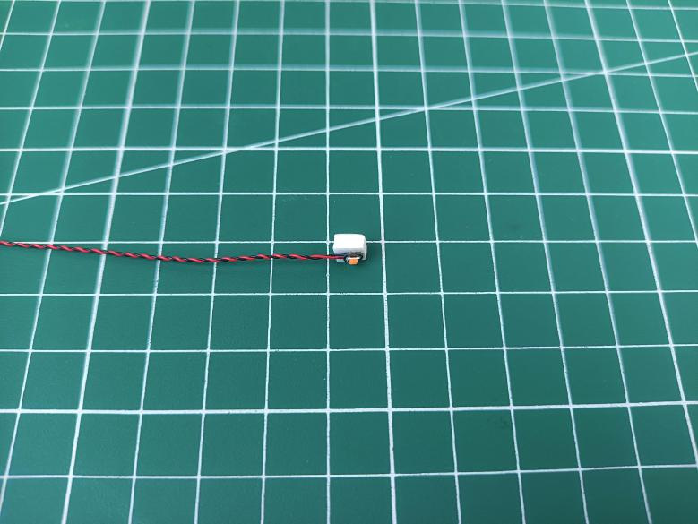

Stick the light underneath the windowsill as per below.
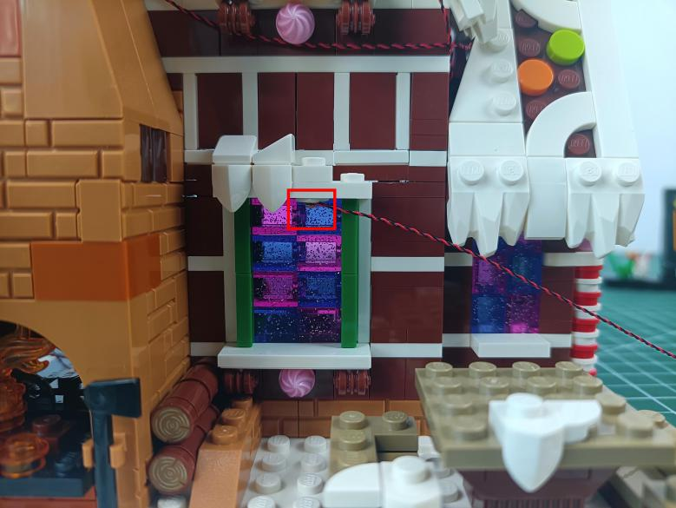

Place the cable as per below, reconnect the following piece.
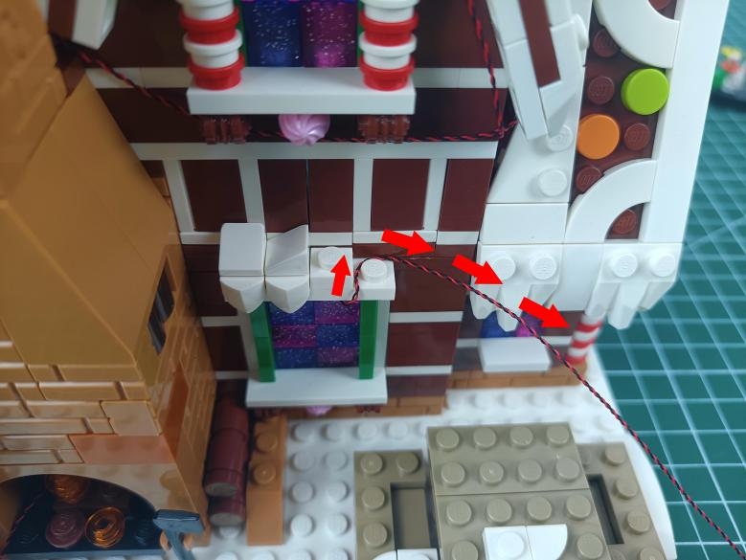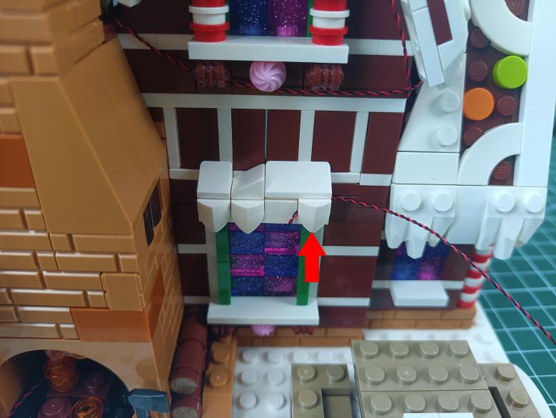

Thread the cable through the following space and tighten it up.
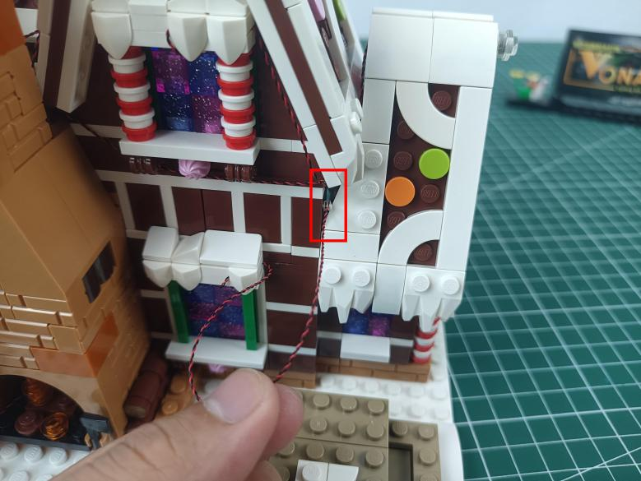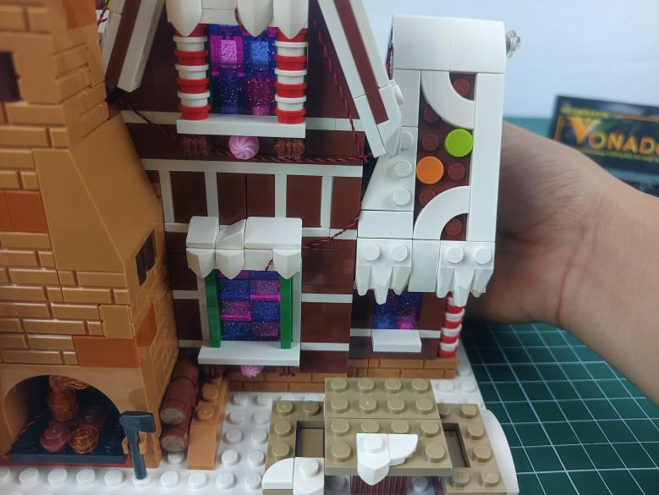

Remove the following desk.
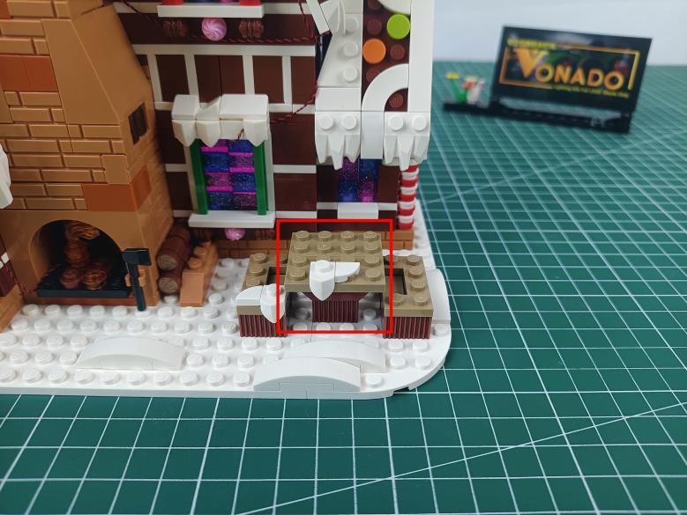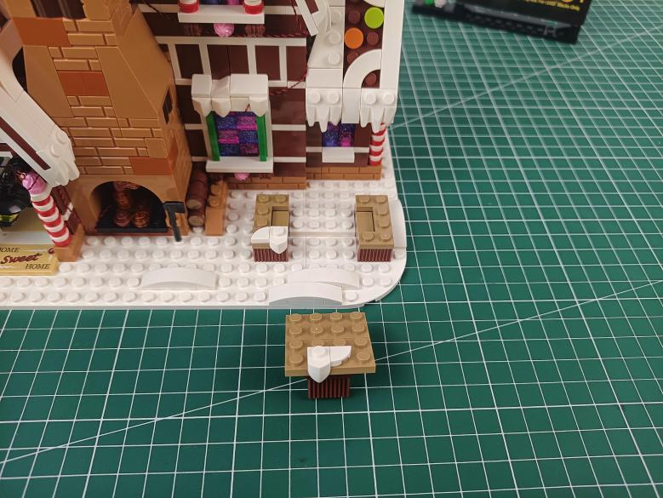

Take a warm white 15cm strip light (with 7 lights).
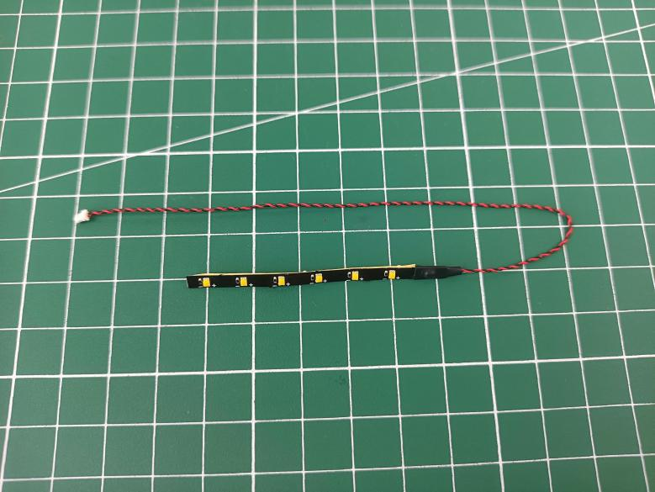

Stick the strip light to the leg of the desk.
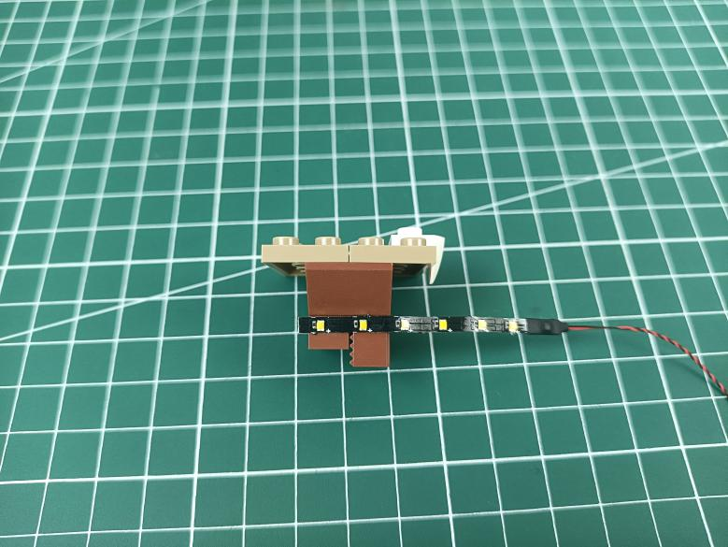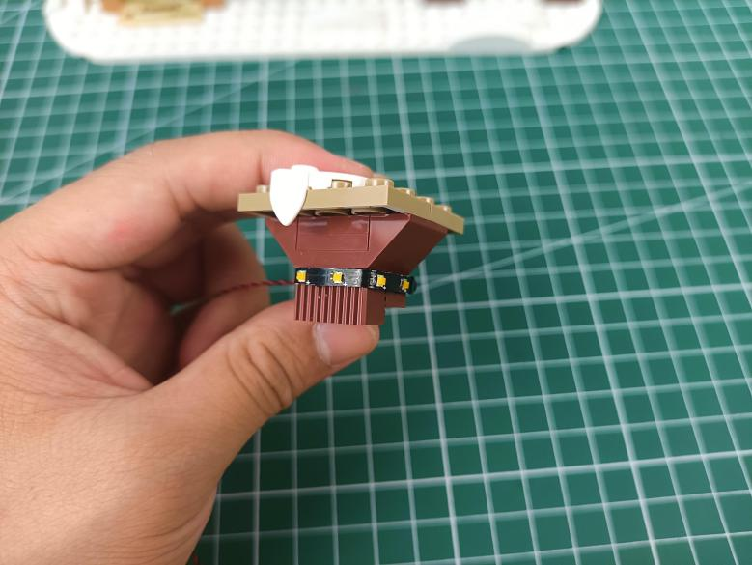

Reconnect the desk.
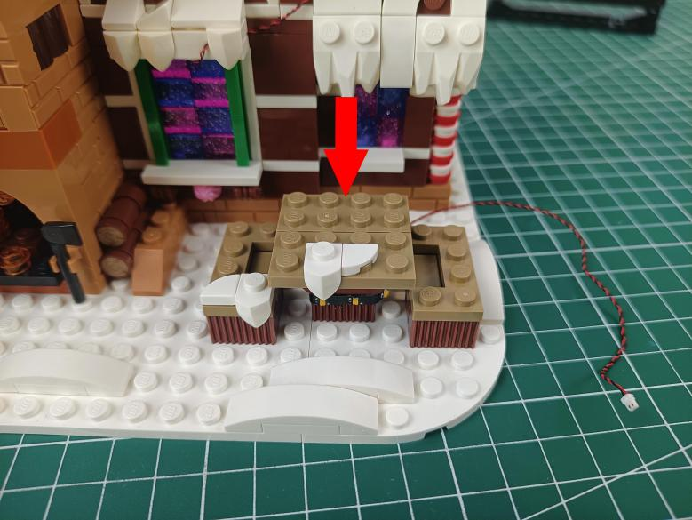

Thread the cable through the following space and tighten it up.
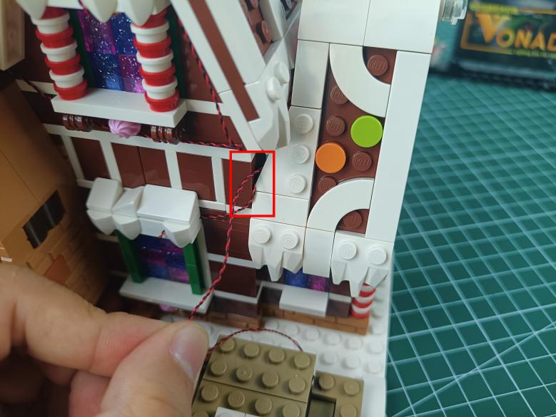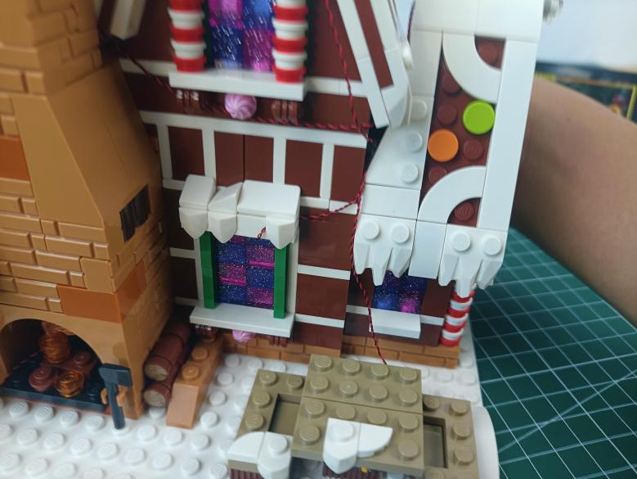

Take an adhesive square.
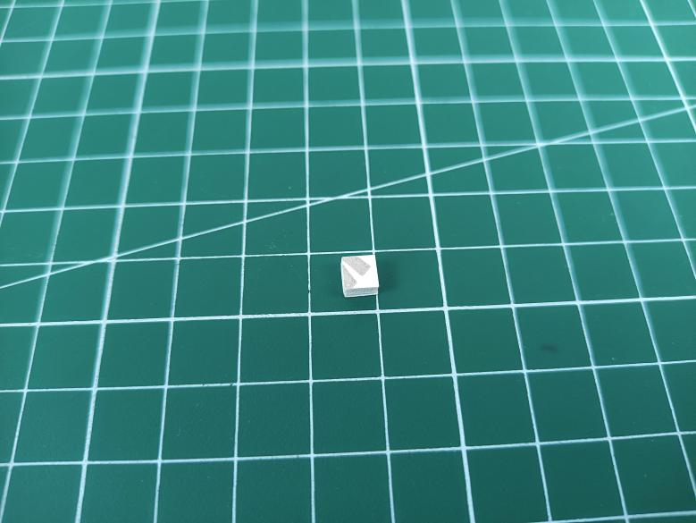

Stick the adhesive square to the following place to secure the cable.
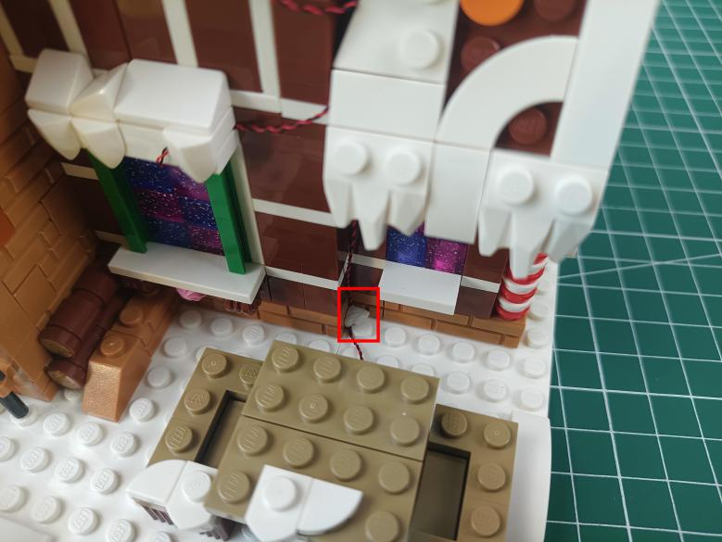

Take a warm white 15cm strip light (with 7 lights).
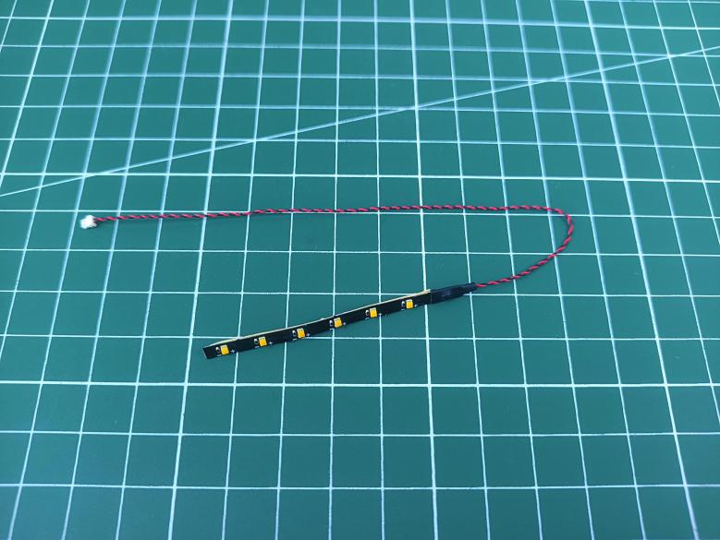

Stick the strip light to the following place.
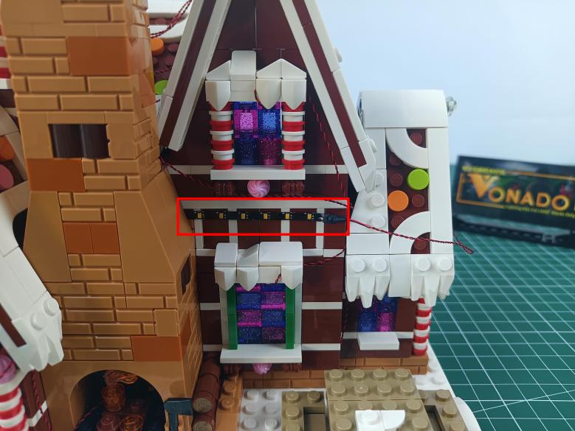

Thread the cable through the following space and tighten it up.
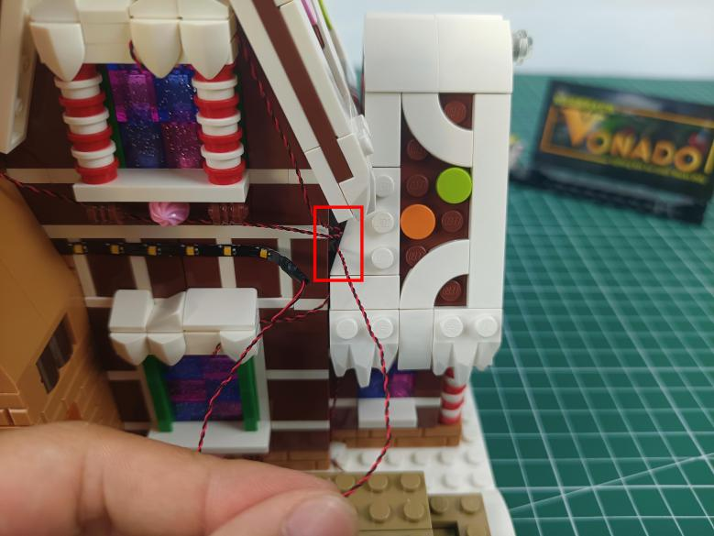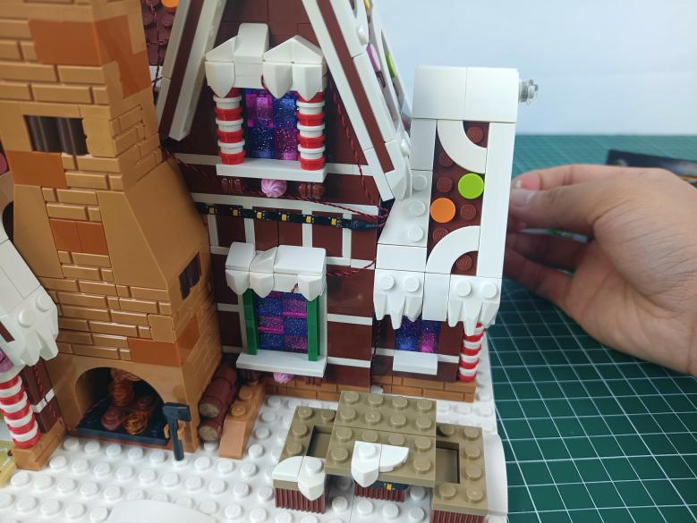

Take a warm white 15cm strip light (with 7 lights).
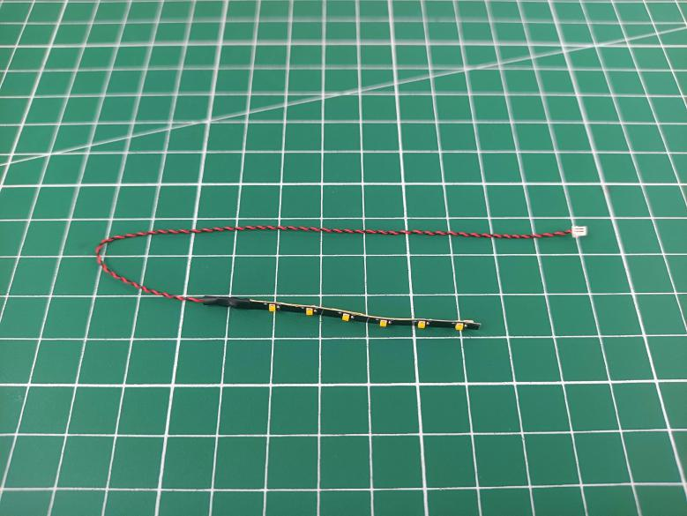

Turn to the top of the chimney.
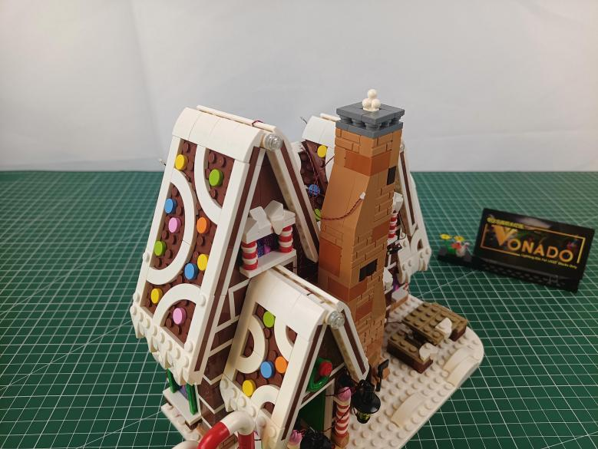

Stick the strip light to the edge of the chimney.
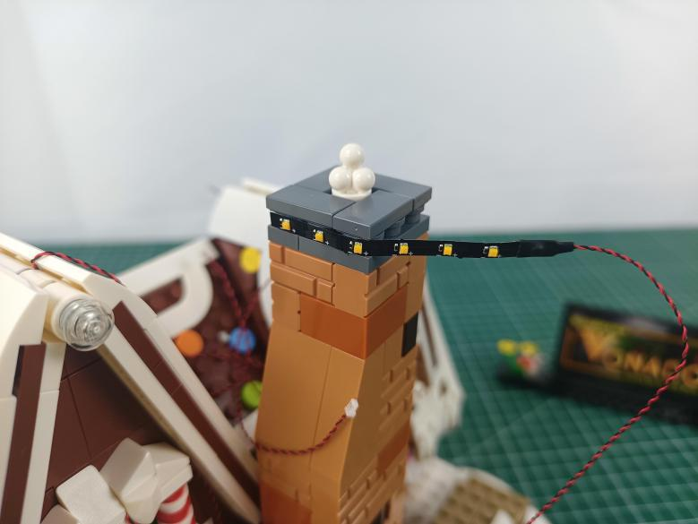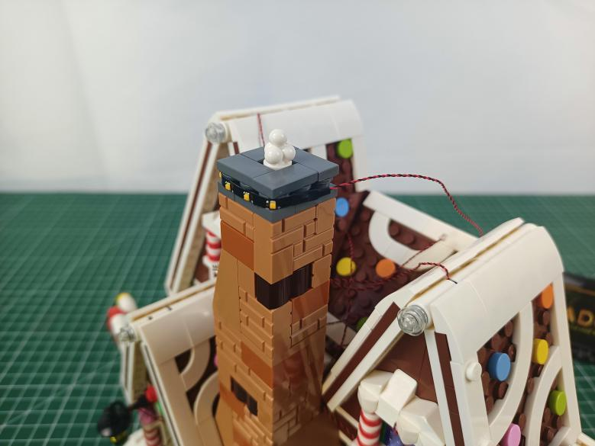

Remove the following gray piece.
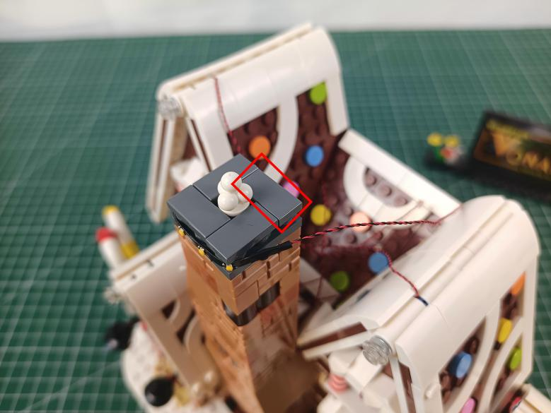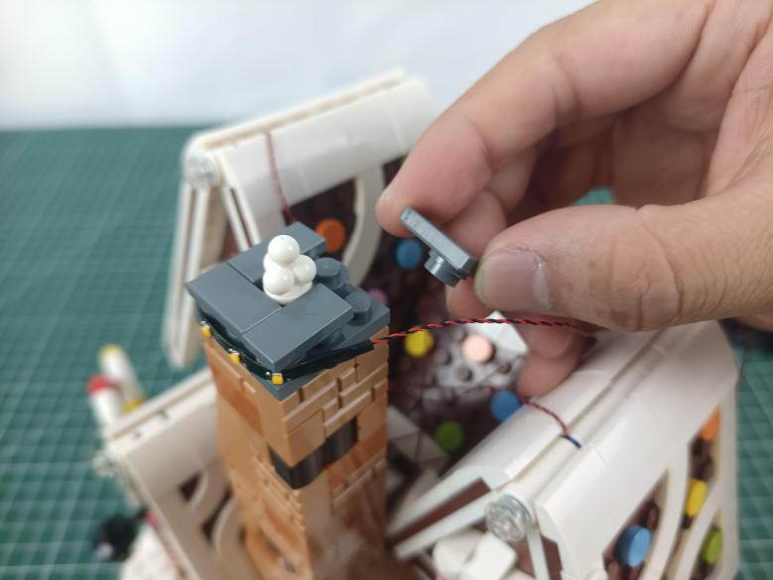

Place the cable as per below, reconnect the gray piece.
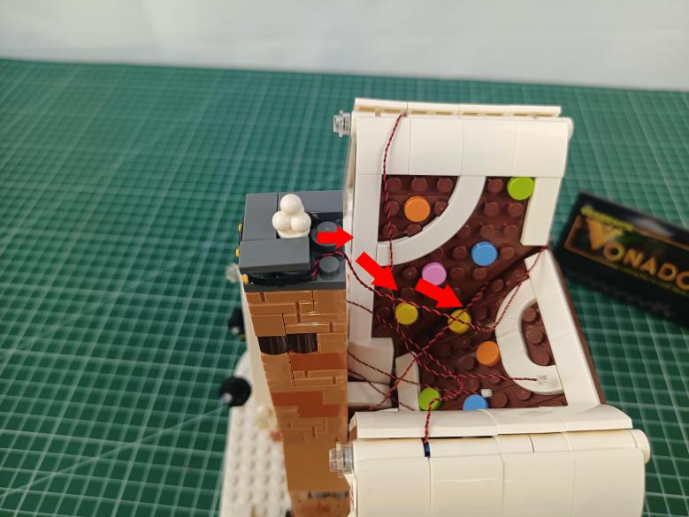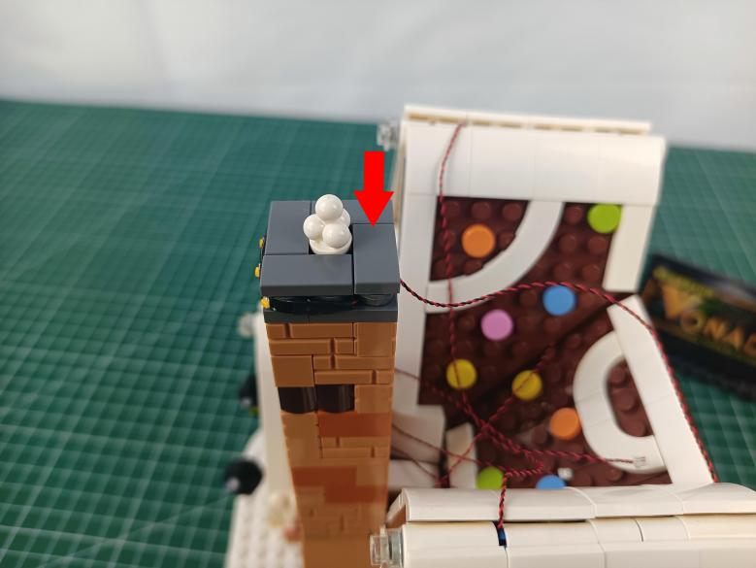

Turn to the left.
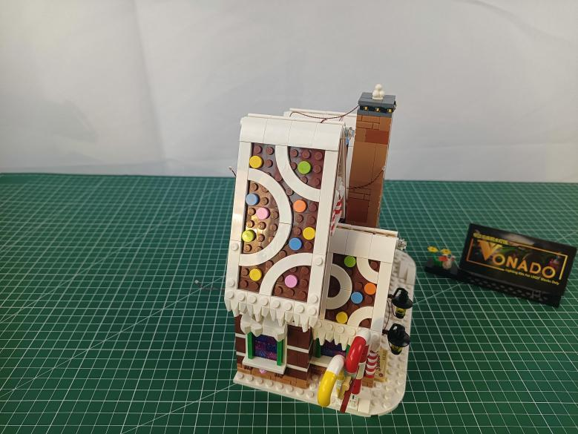

Take a Multi Colour Light String.
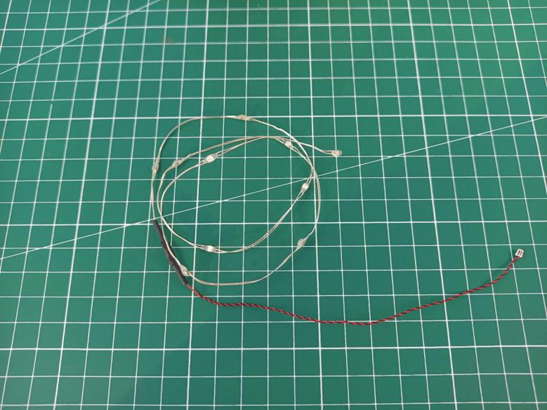

Remove the following piece.
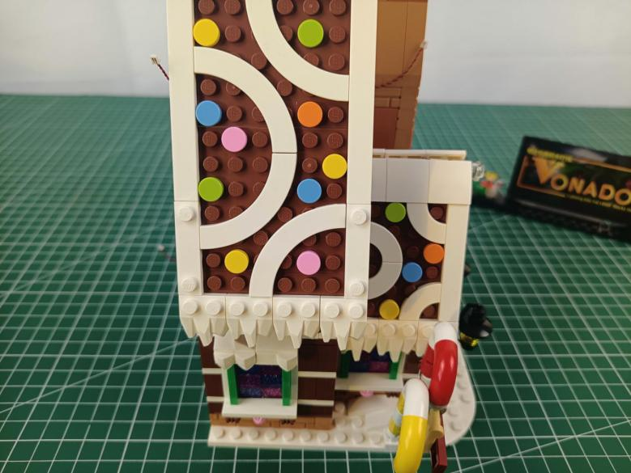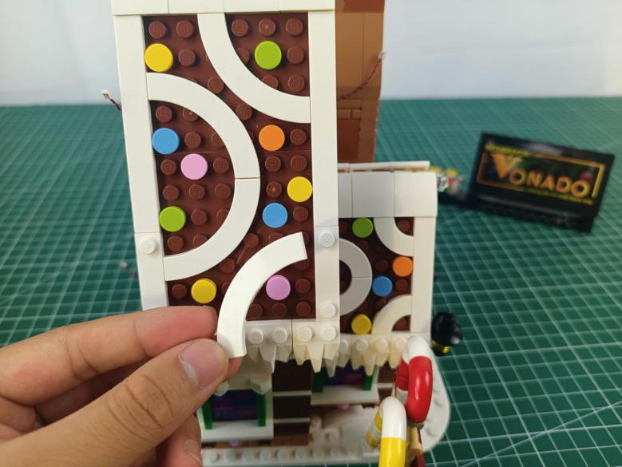

Place the light string as per below, reconnect the piece we removed before.
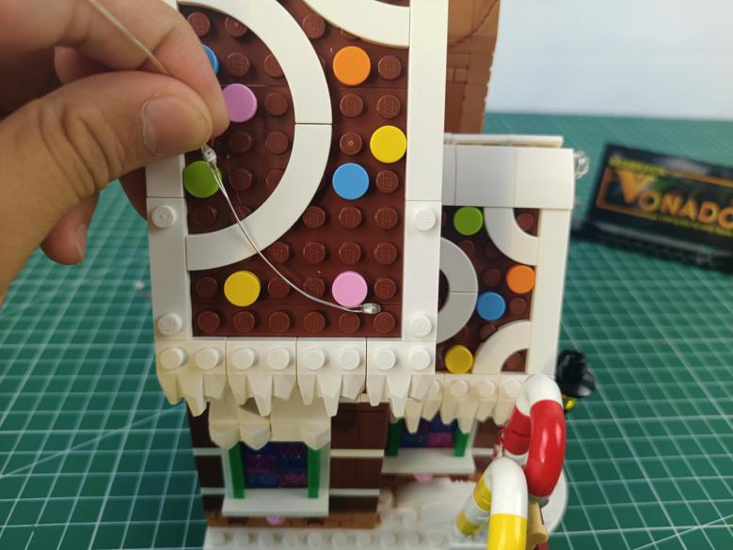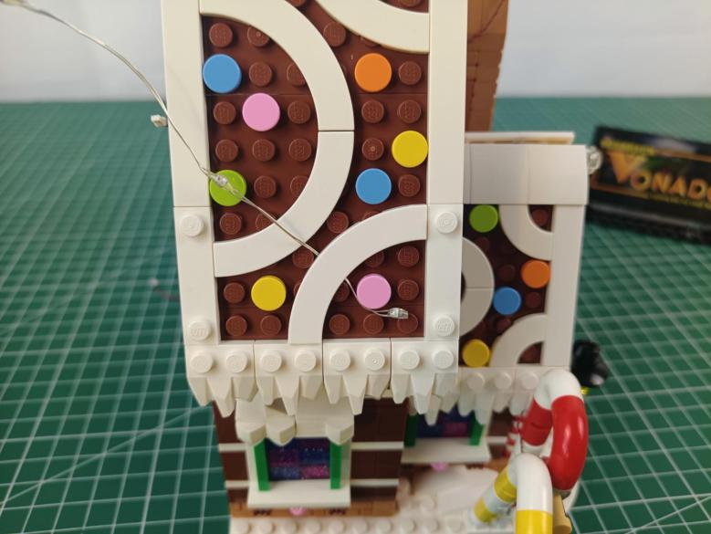

Remove the following white piece and press the light string underneath.
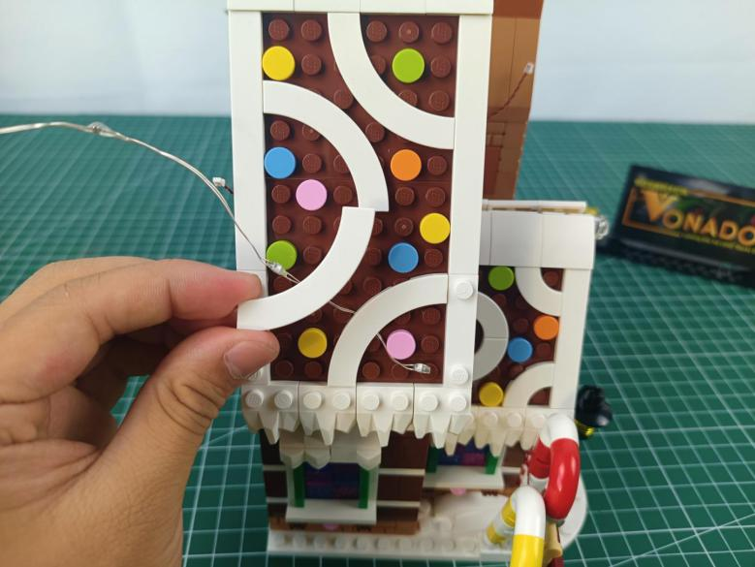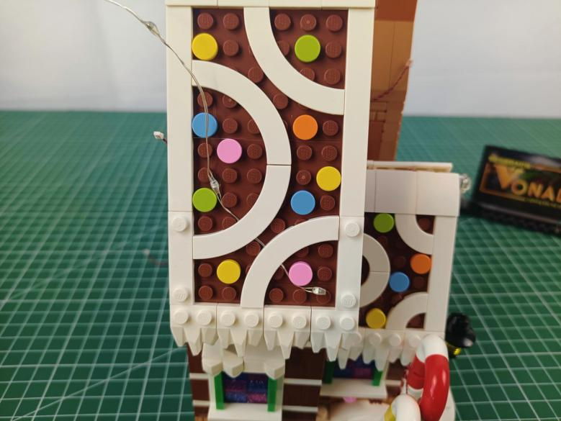

Press the light string underneath the following white piece in the same way.
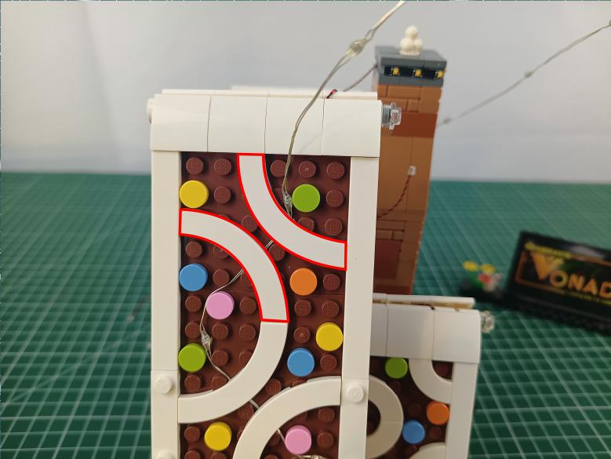

Disconnect the following white piece from the roof.
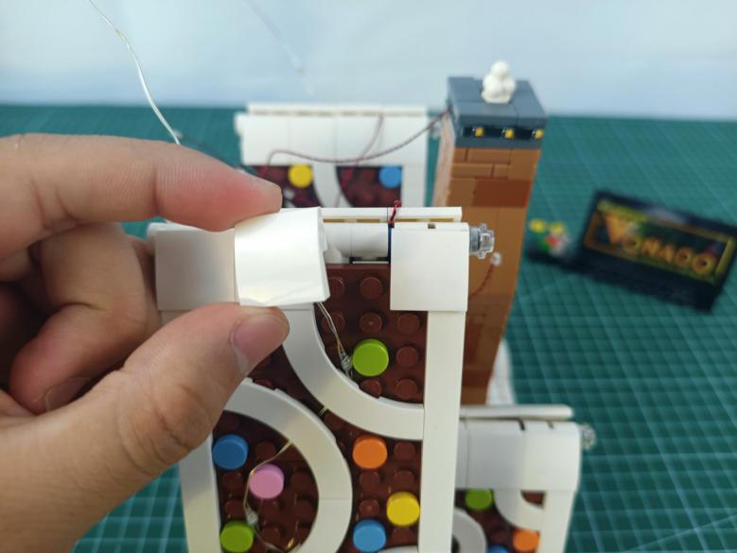

Place the light string as per below, reconnect the white piece.
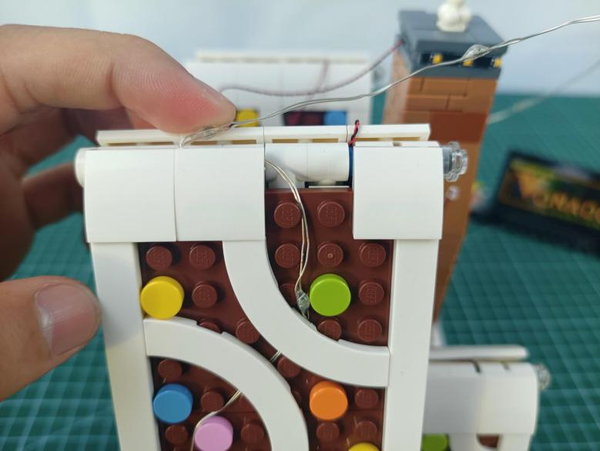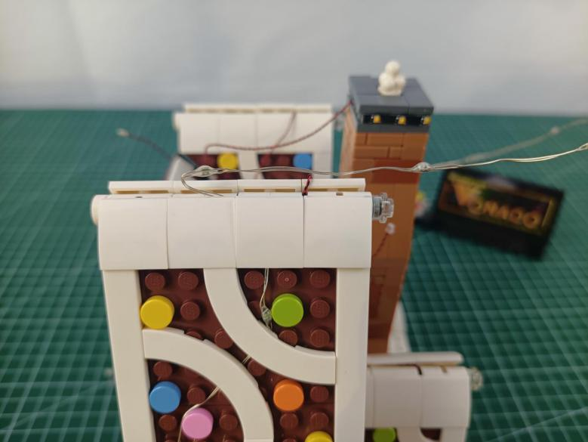

Turn to the other side.
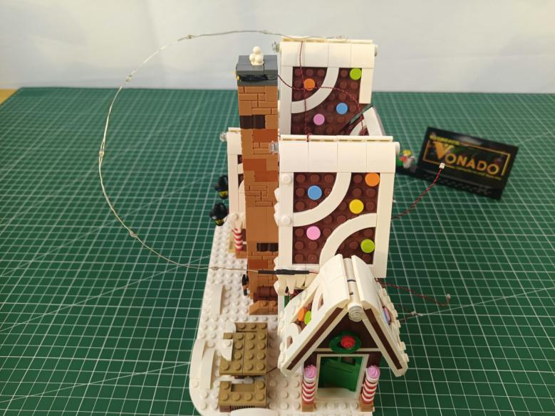

Disconnect the following white piece from the roof.
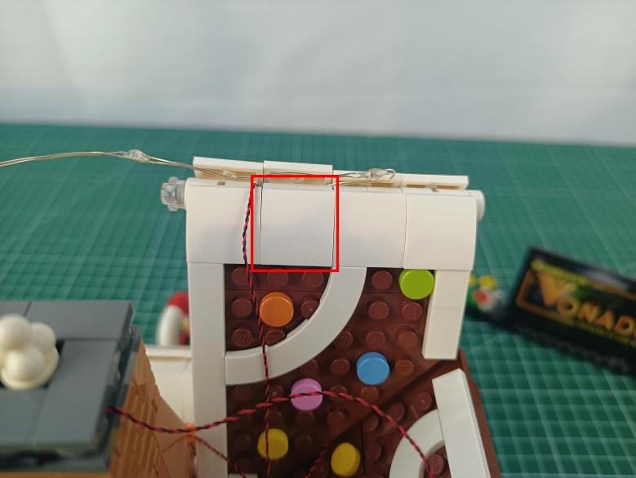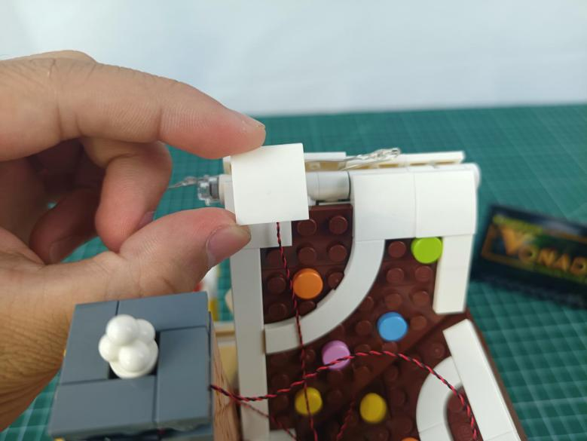

Press the light string underneath.
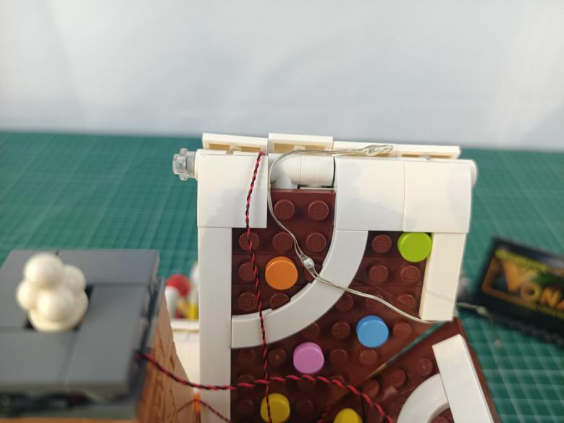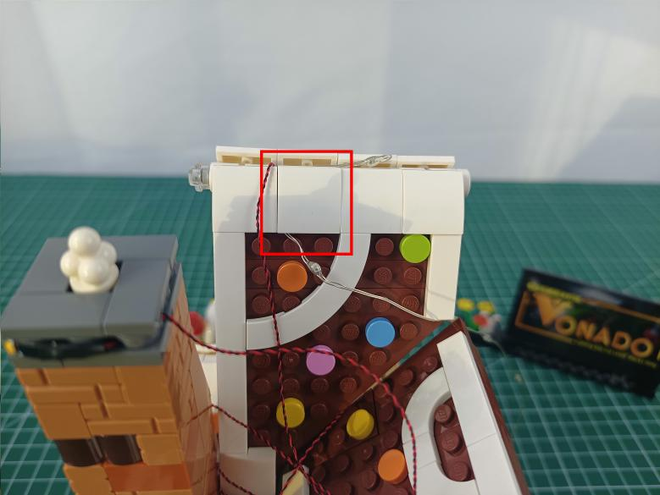

Remove the following white piece and press the light string underneath.
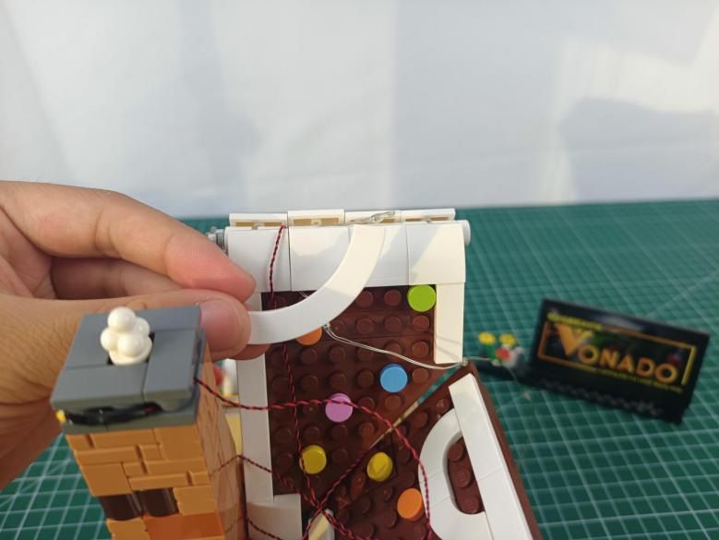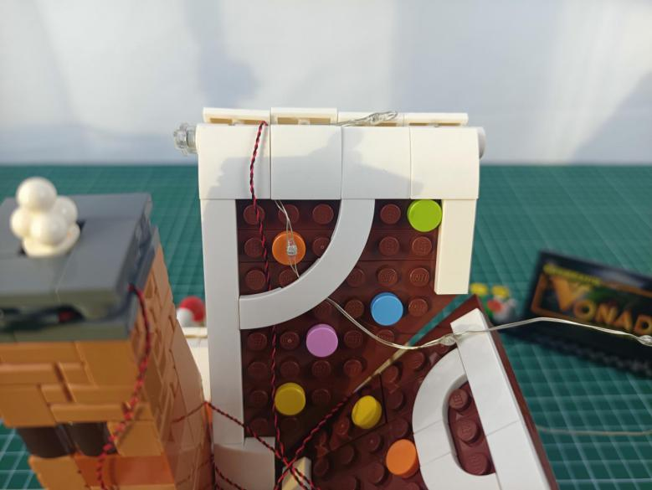

Turn to the front.
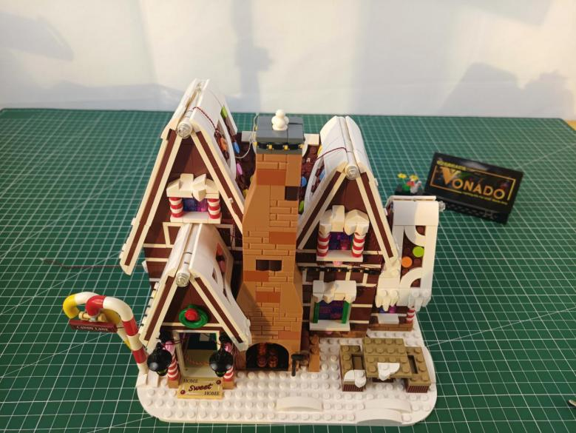

Disconnect the following 2 pieces from the roof.
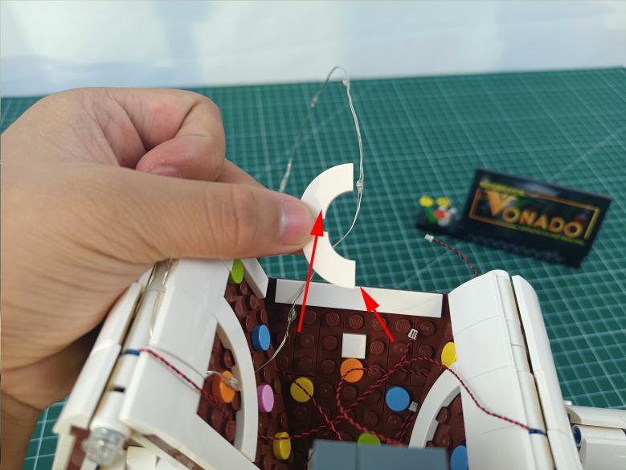

And press the light string underneath.
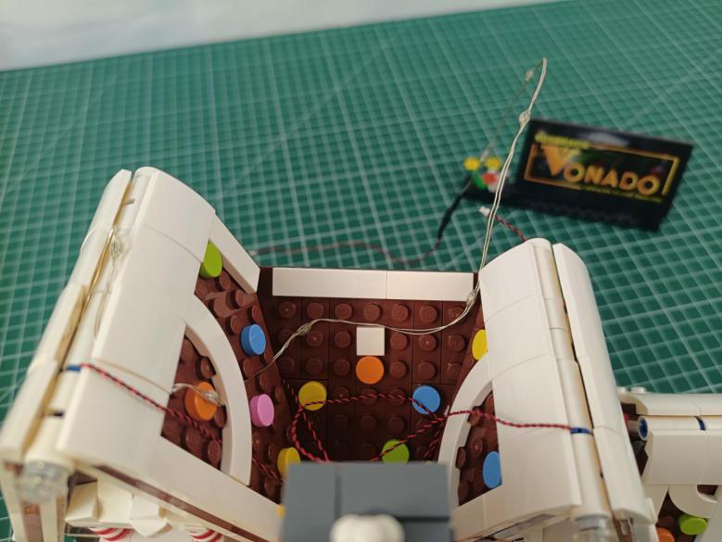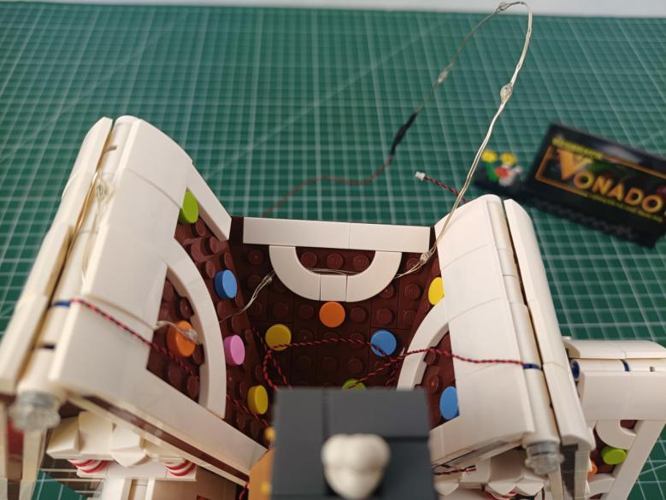

Turn to the right.
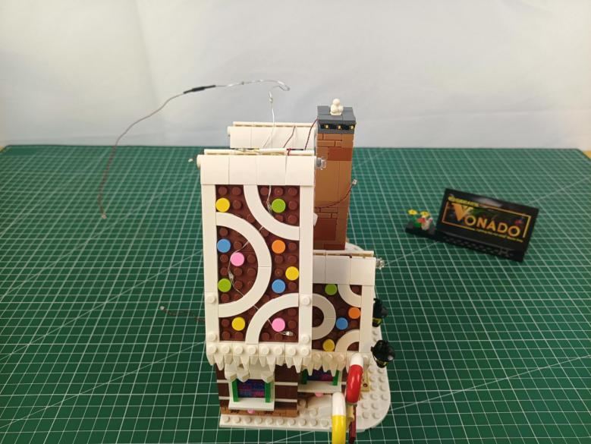

Disconnect the following piece.
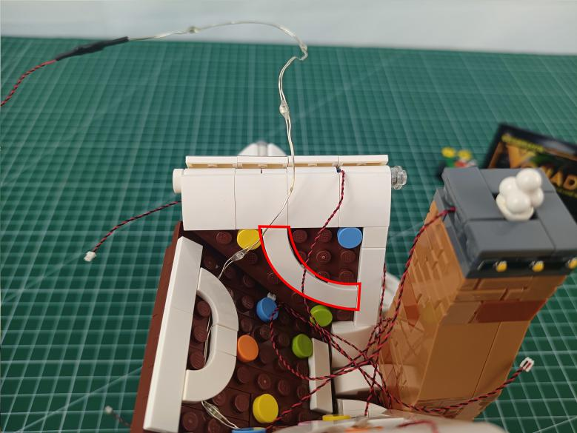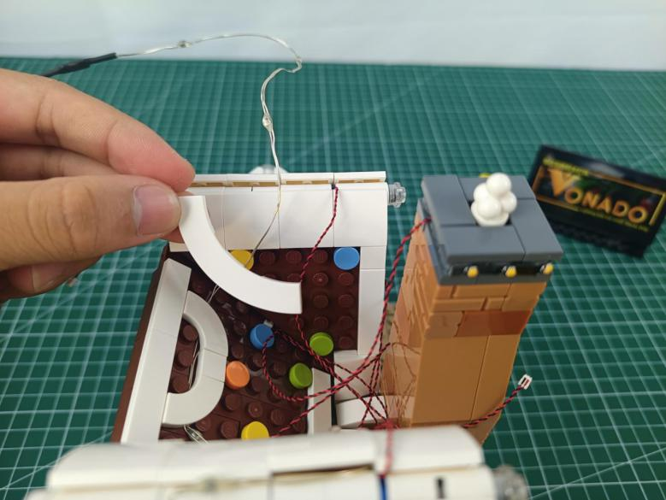

And press the light string underneath.
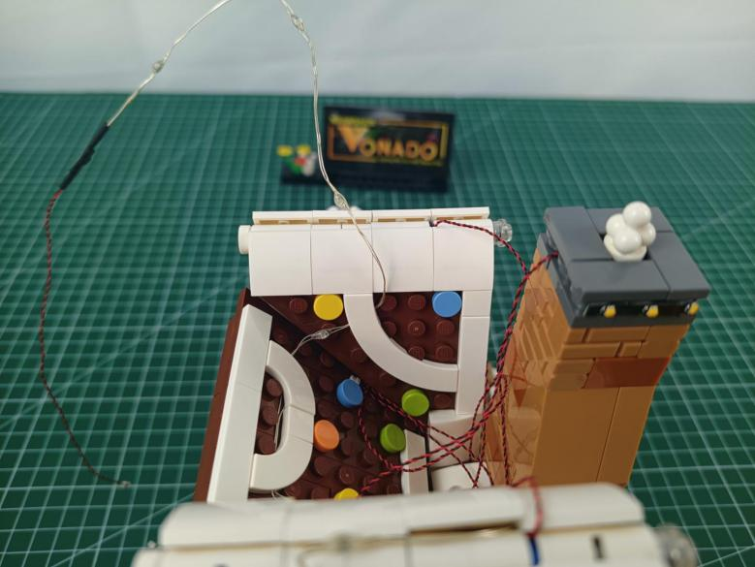

Place the light string as per below.
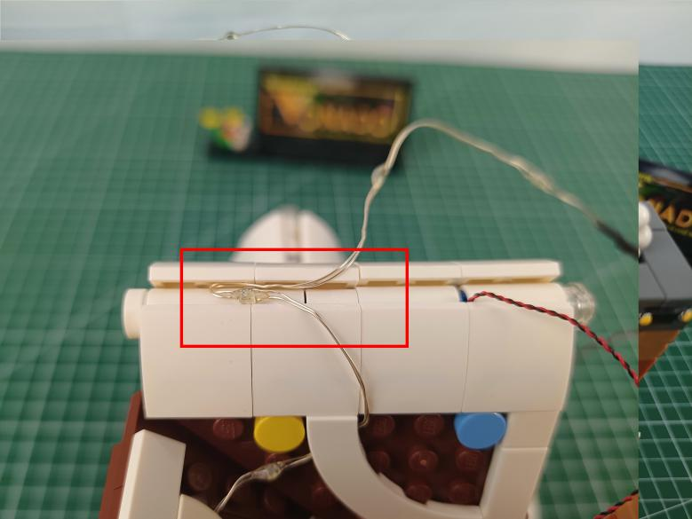

Turn to the right.
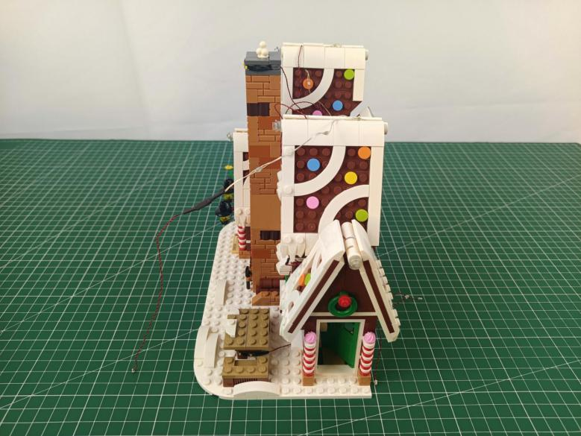

Remove the following piece from the roof.
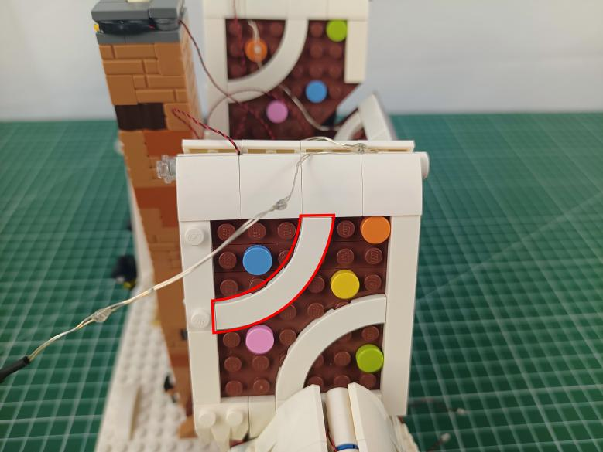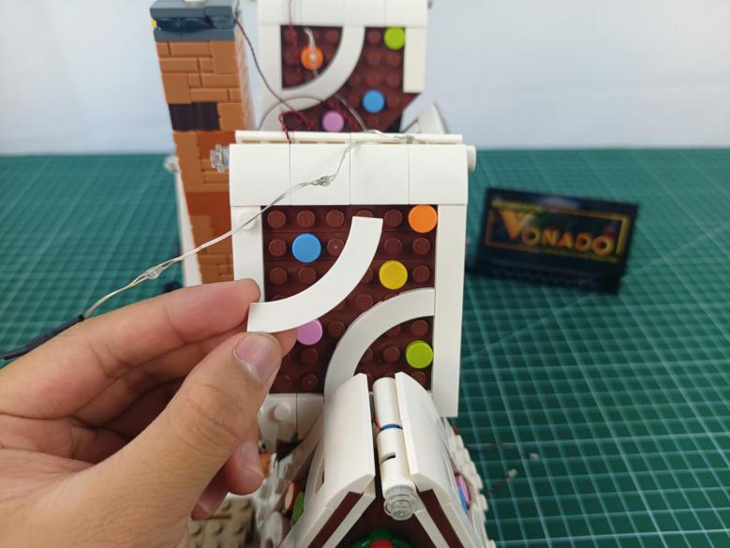

And press the light string underneath.
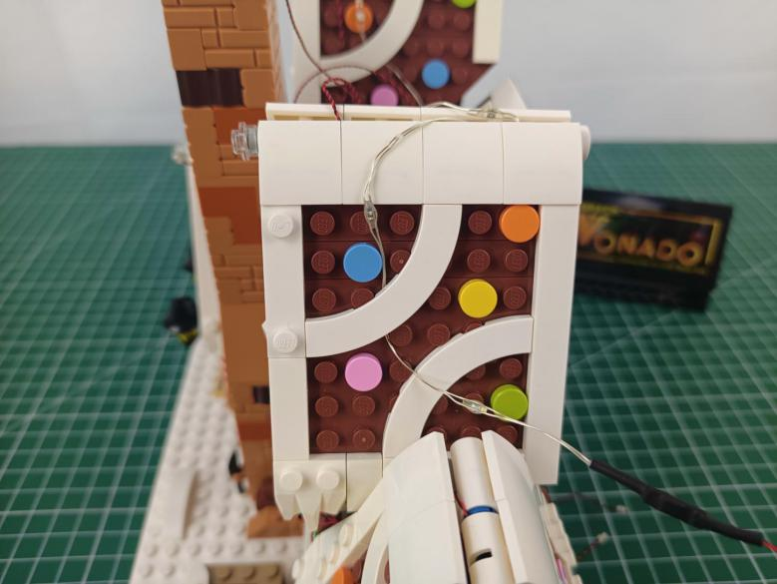

Continue to disconnect the following piece.
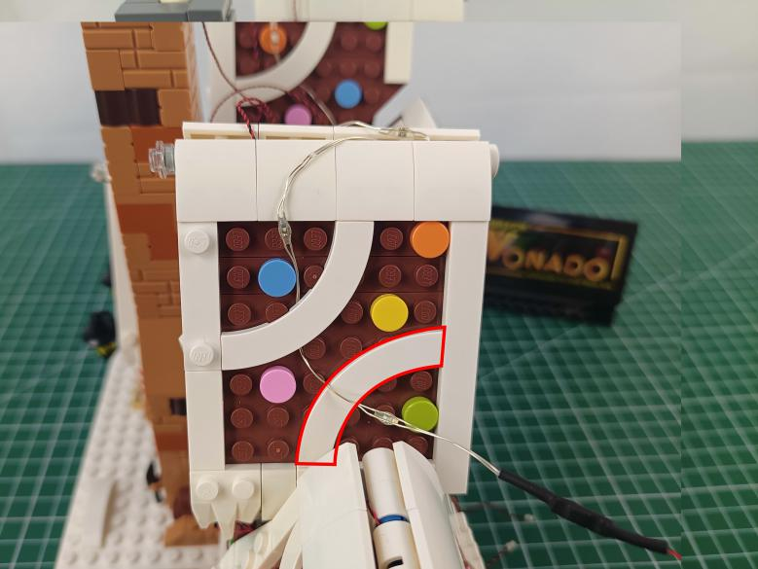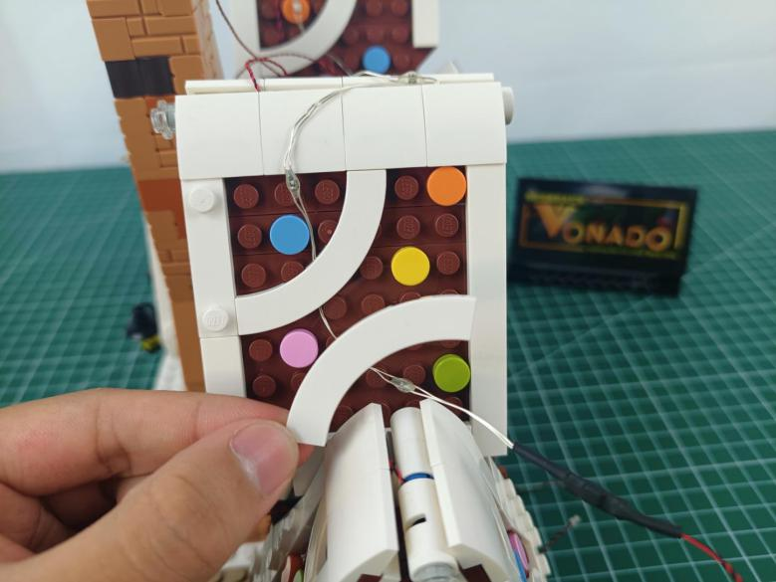

And press the light string underneath.
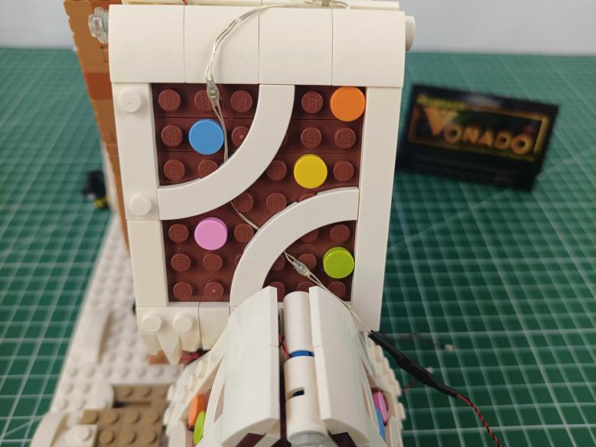

Turn to the rear side.
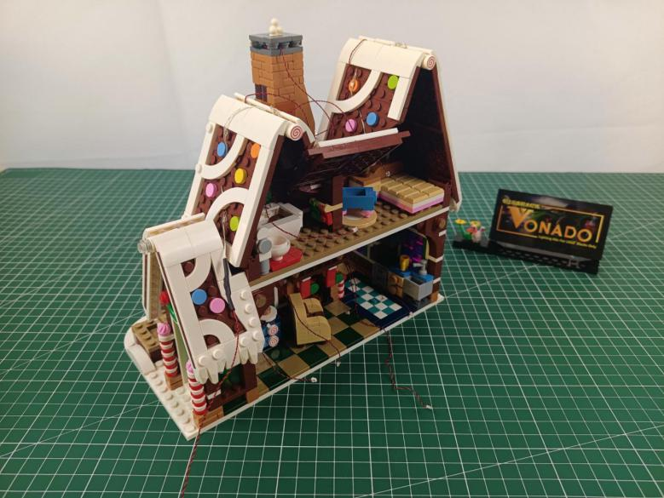

Thread the string light through the following space to the first floor.
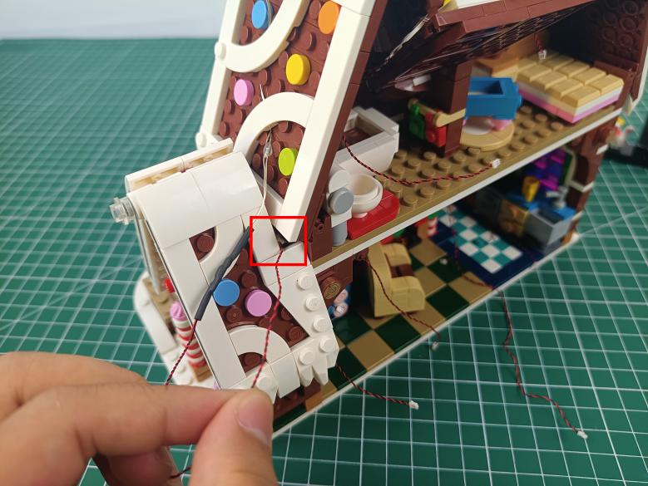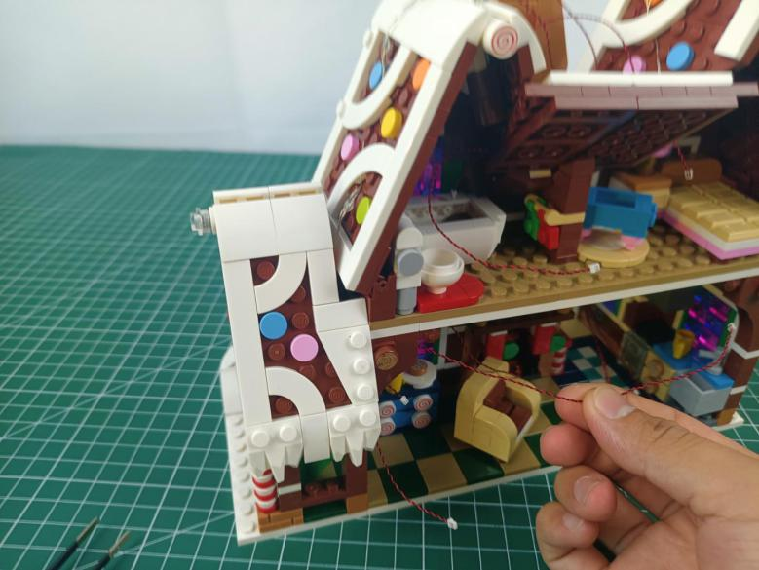

Take an 8-port expansion board, a 30cm connecting cable.
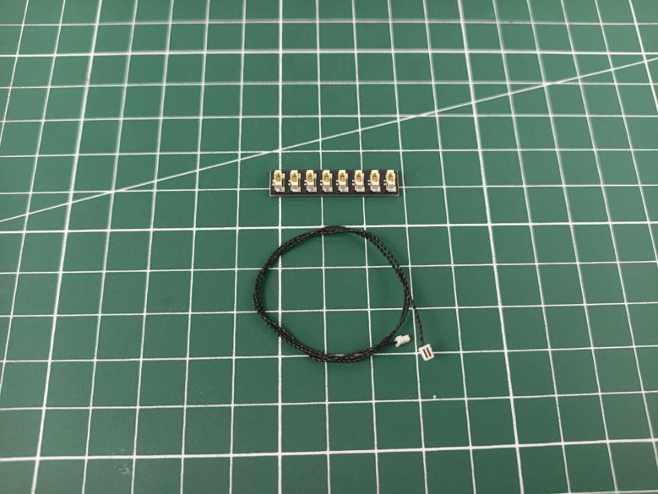

Assemble them as per below.
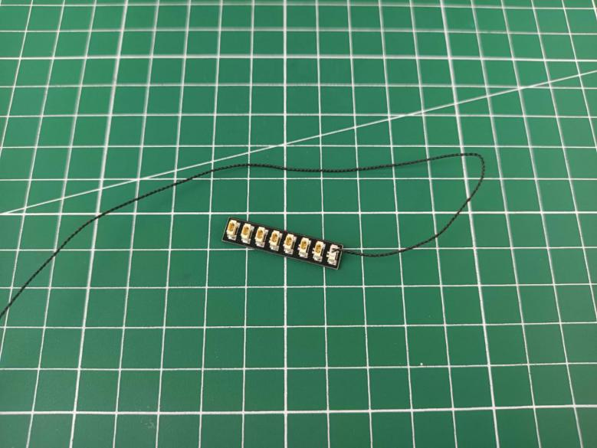

Connect the cables from the roof to the 8-port expansion board.
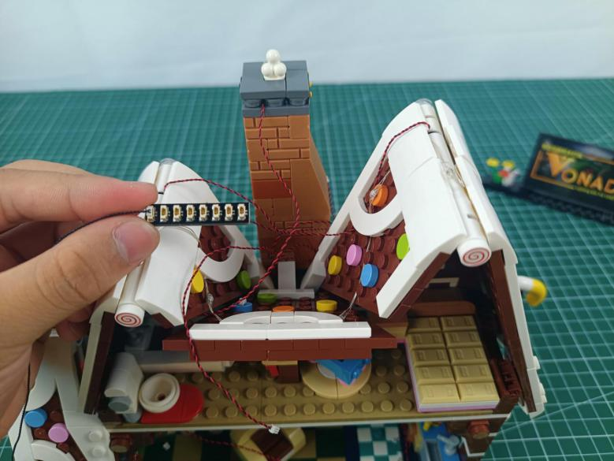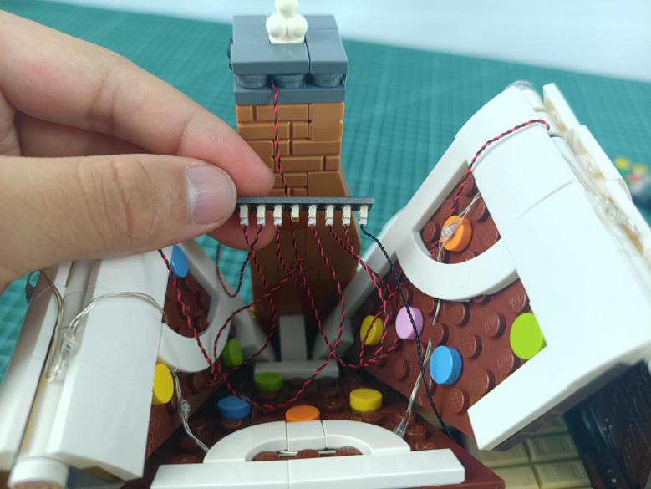

Take 2 adhesive squares.
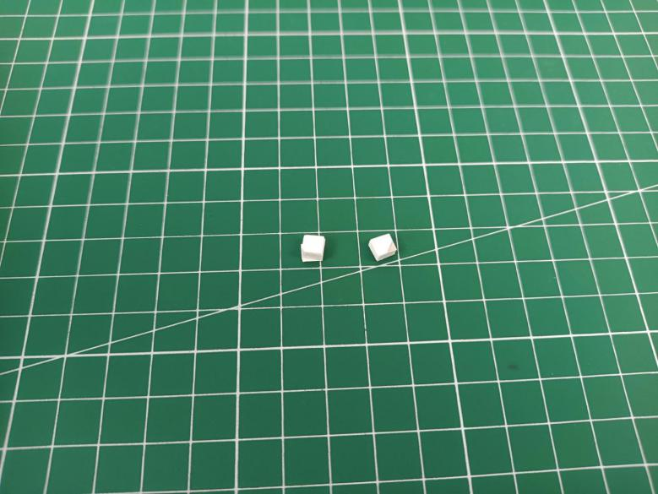

Stick the adhesive squares to the back of the expansion board.
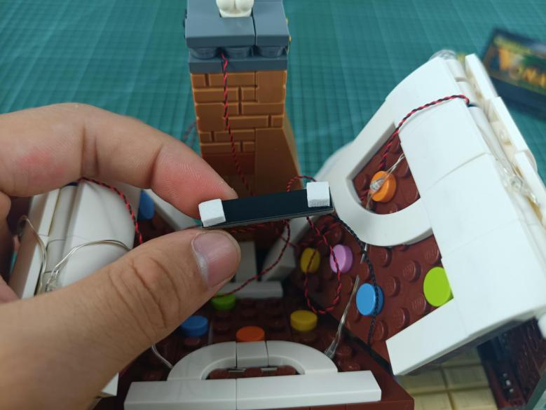

Stick the expansion board to the following place.
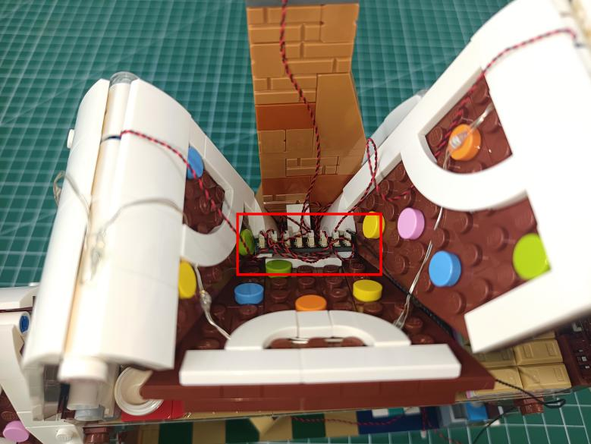

Tuck excess cables inside the following space with the tweezer.
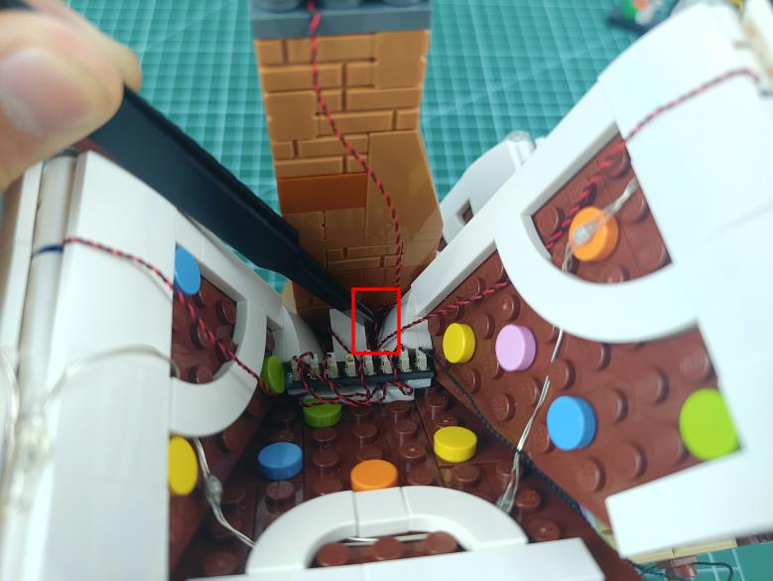

Thread the connecting cable from the 8-port expansion board through the following space to the second floor.
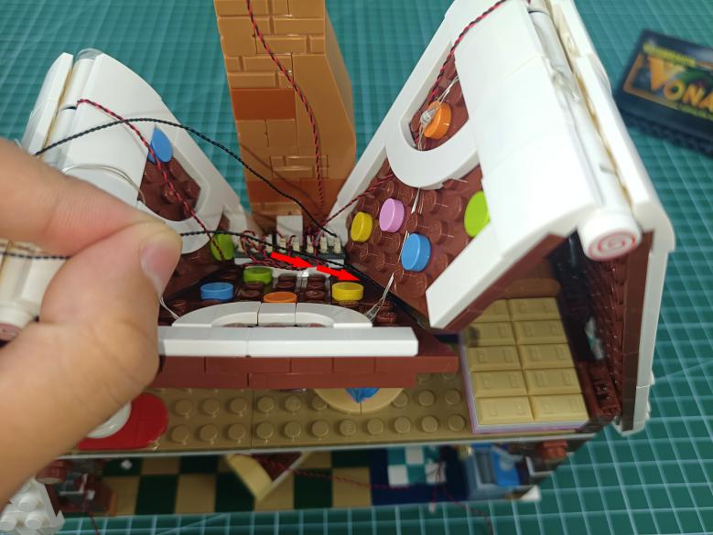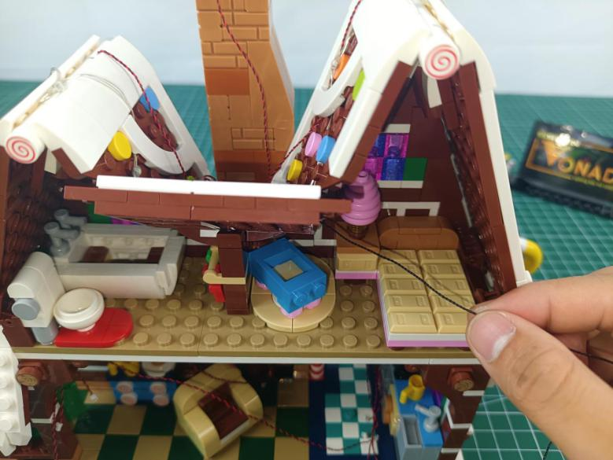

Continue to thread it through the following space at the right side to the first floor.
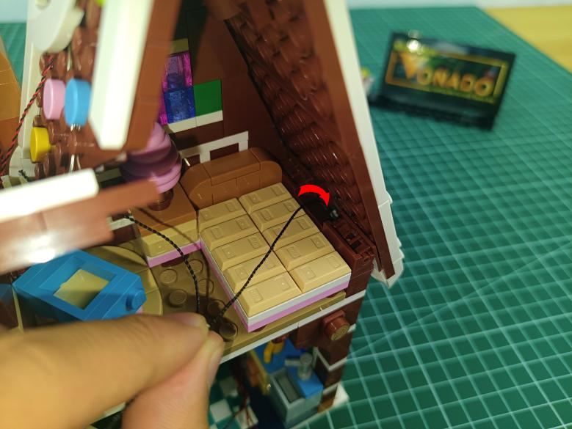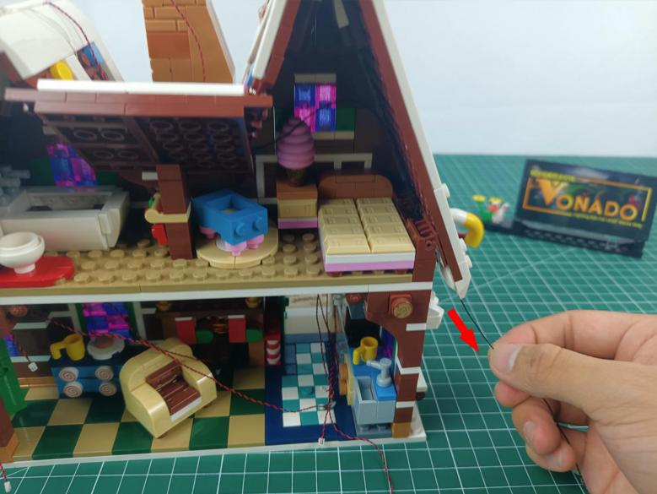

Take a 15cm head light, a 4-port expansion board, a 30cm connecting cable.
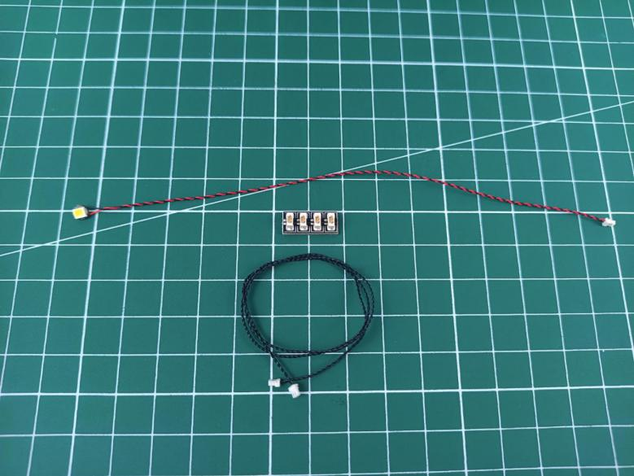

Connect them to the expansion board.
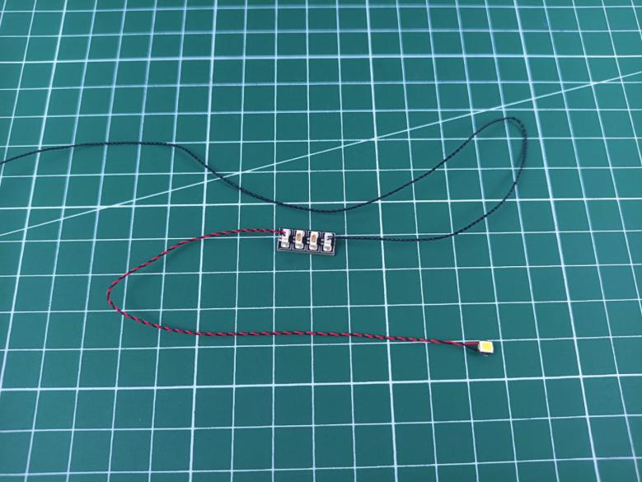

Take a 15cm head light.
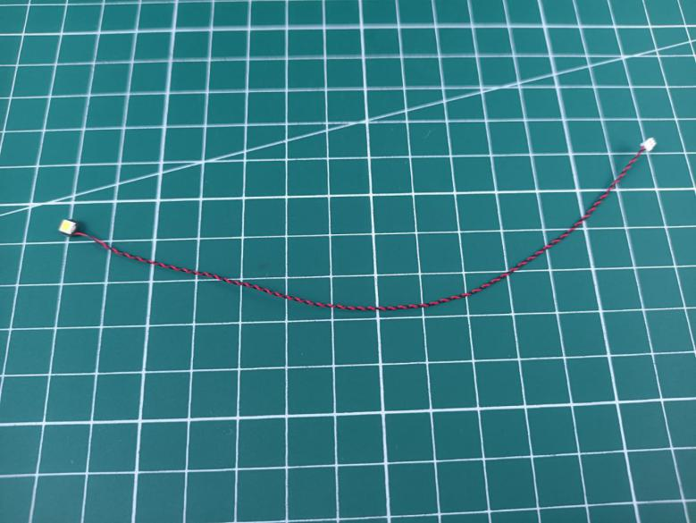

Wind it around the expansion board before connect it to the expansion board.
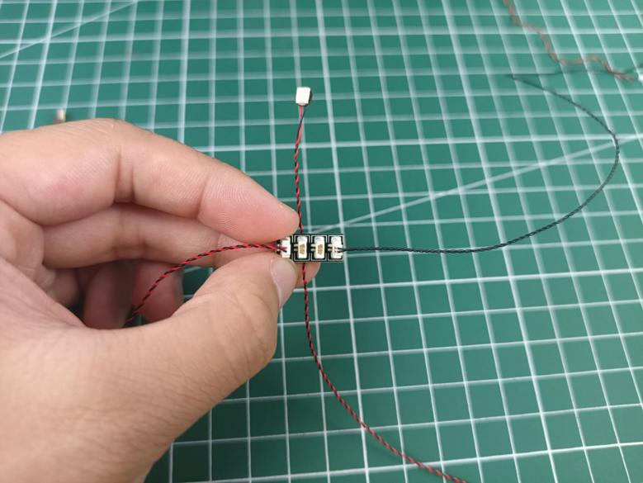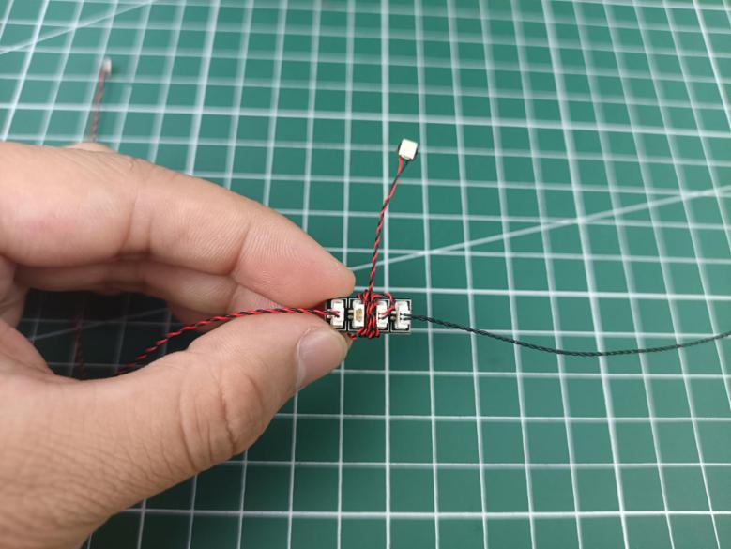

Take 3 adhesive squares, stick them to the backs of the expansion board and the head light.
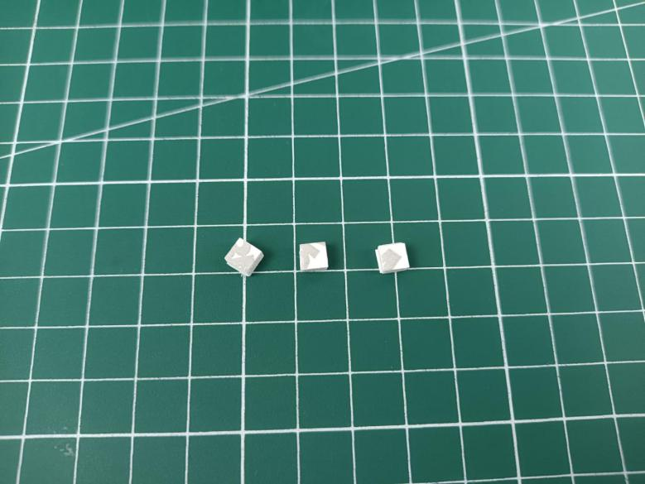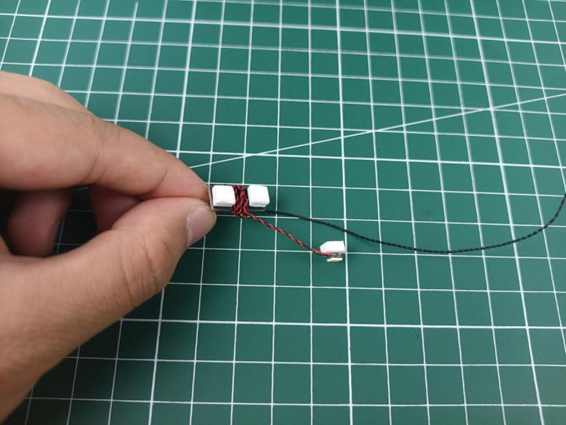

And stick them to the right roof of the second floor.
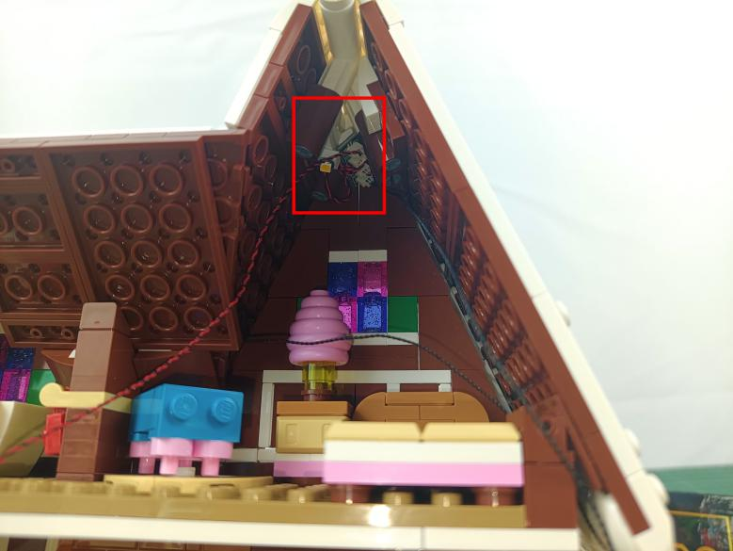

Take the connecting cable from the expansion board.
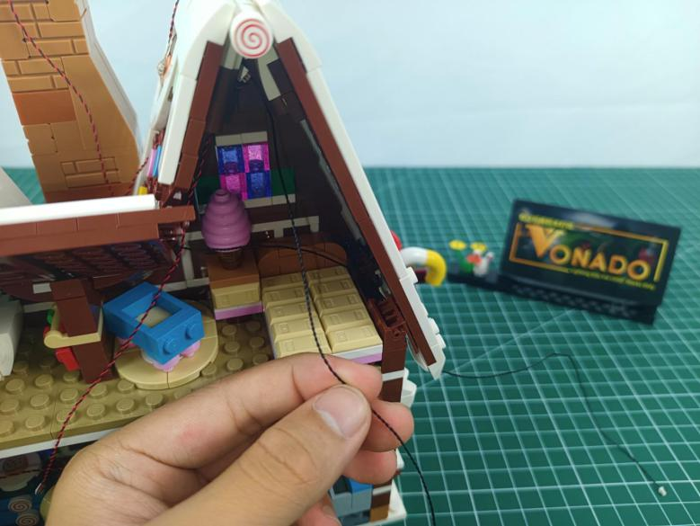

Thread through the gap at the right side to the first floor.
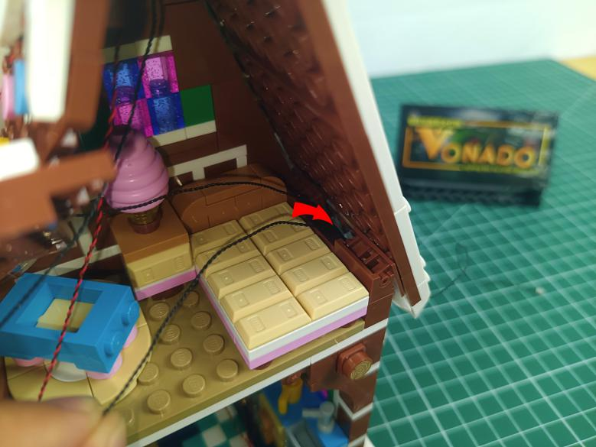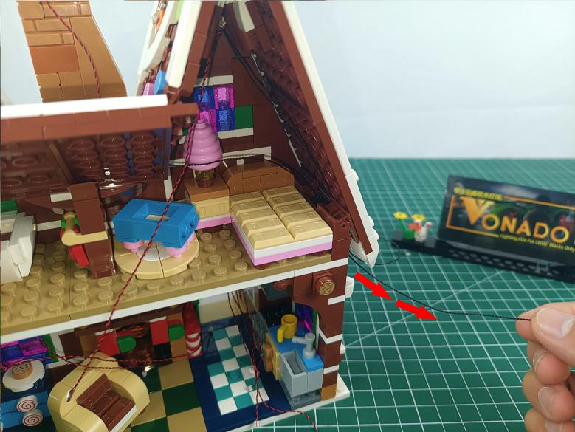

Connect the cable from the head light.
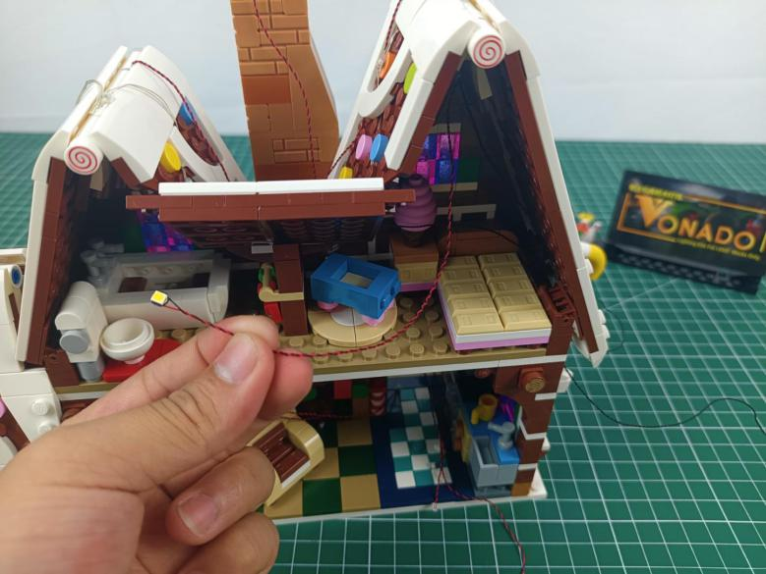

Thread it through the following space to the roof.
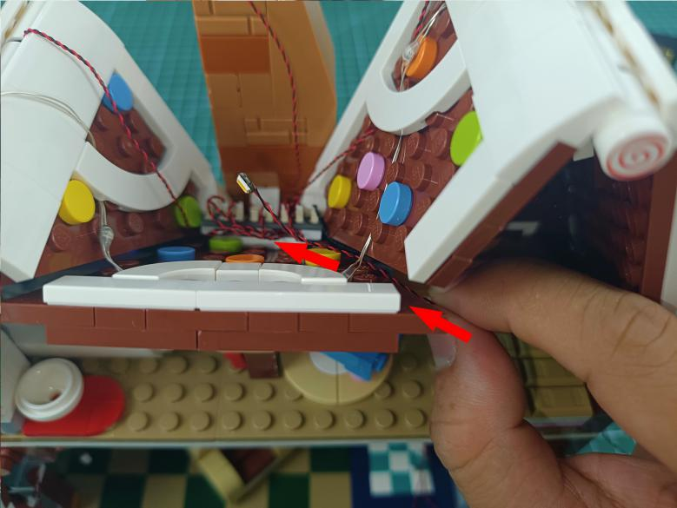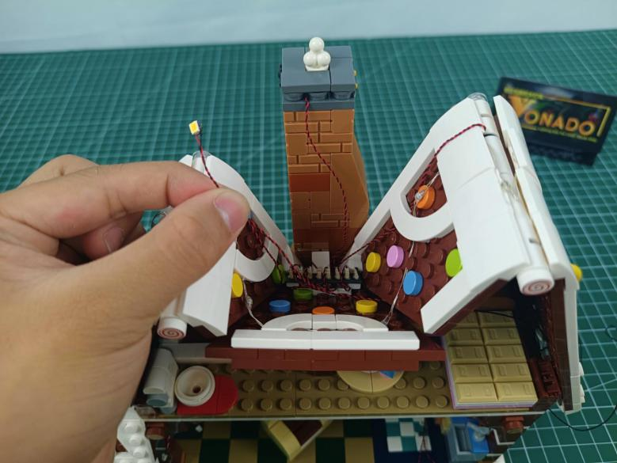

Continue to thread it to the room at the left.
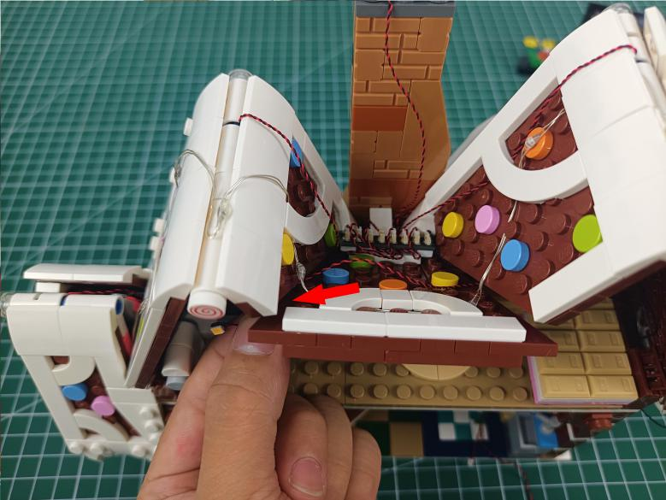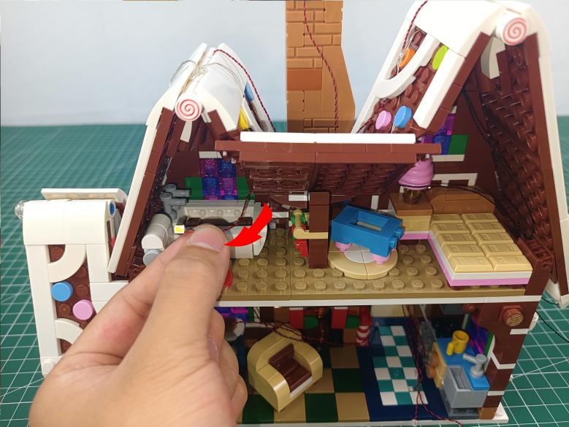

Take an adhesive square, stick it to the back of the head light.
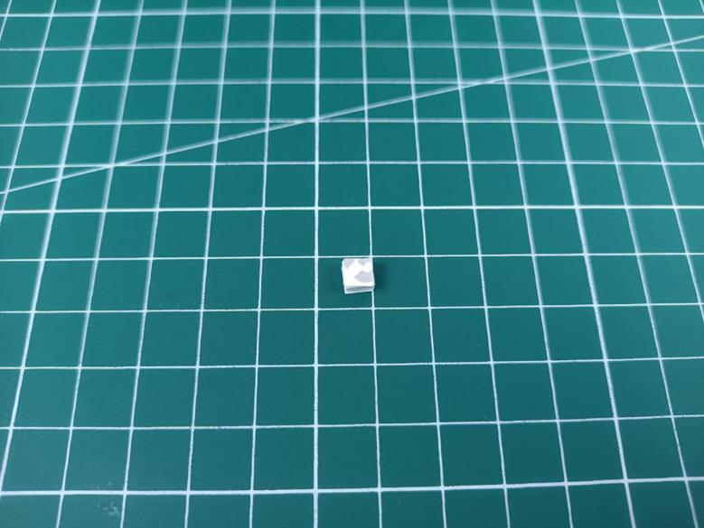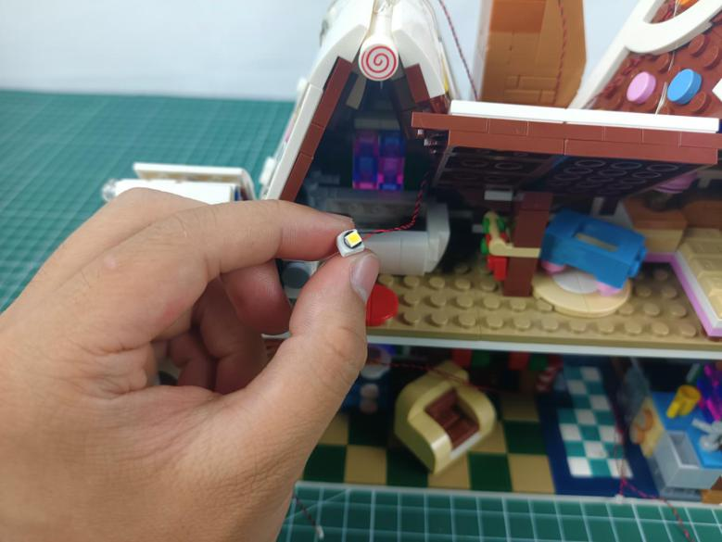

Stick it to the left room at the second floor with the tweezer.
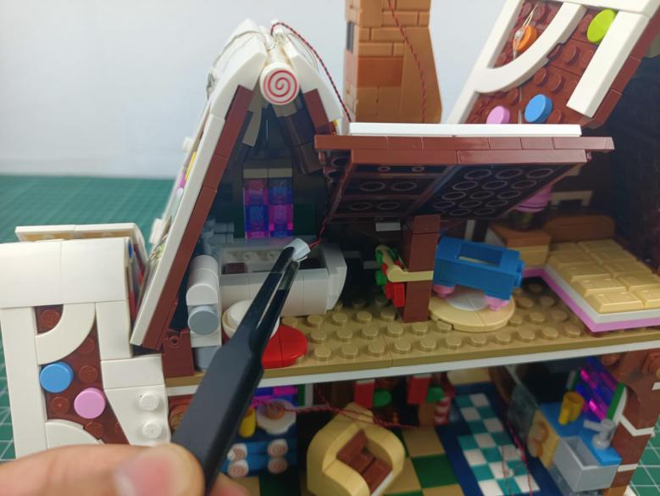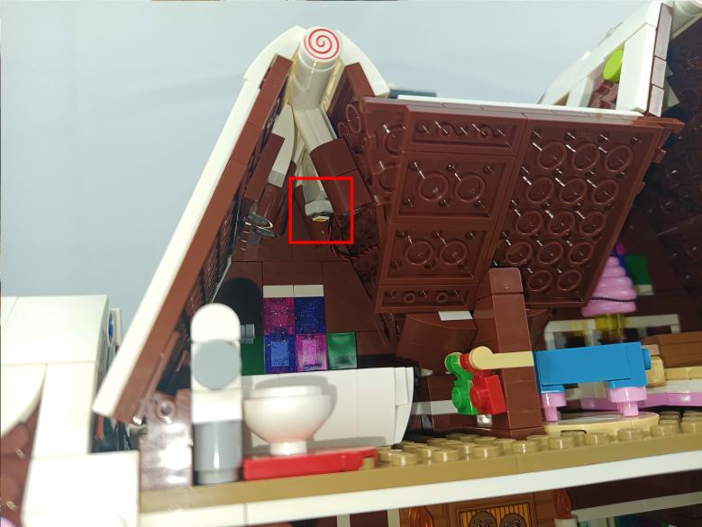

Turn to the room at the right, tuck excess cables with the tweezer as per below.
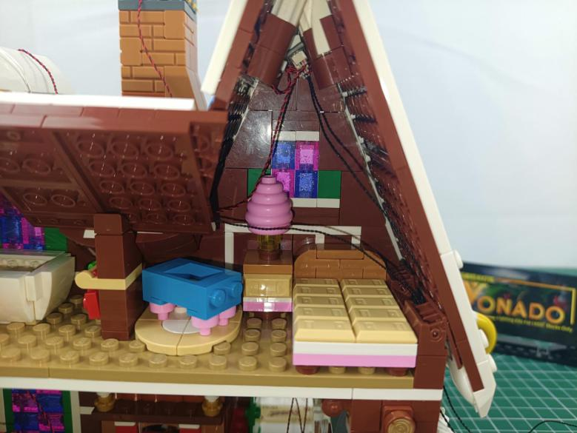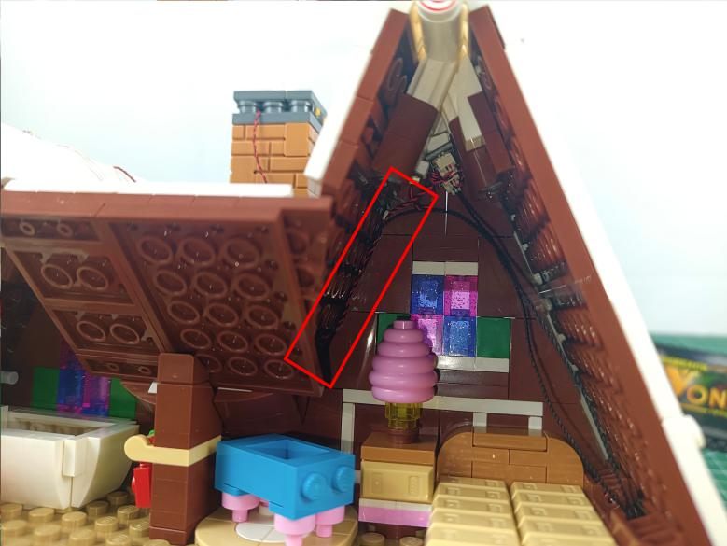

Take a 6-port expansion board, a 5cm connecting cable, assemble them as per below.
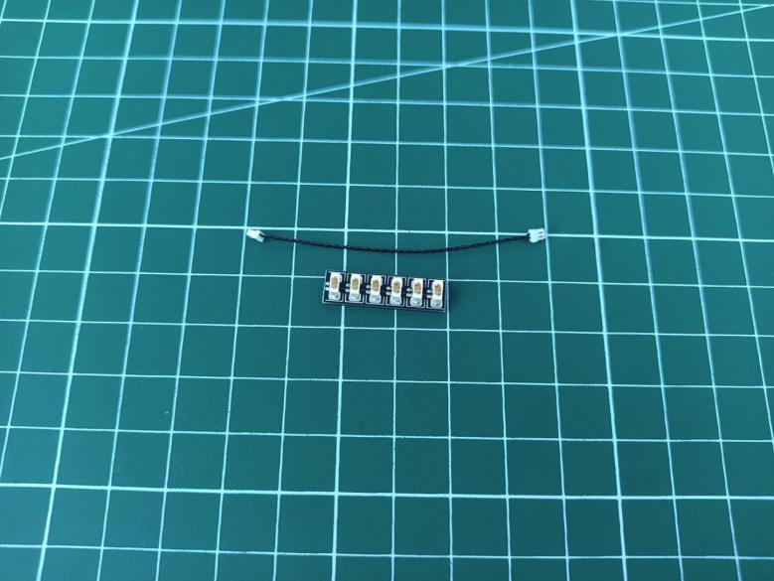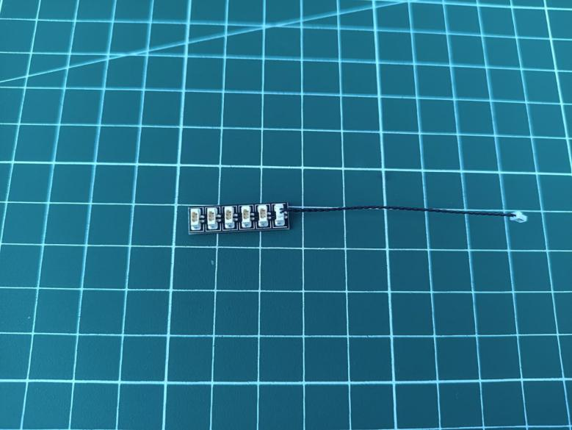

Connect the 5 cables from the left to the expansion board, you can tuck excess cable around the expansion board.
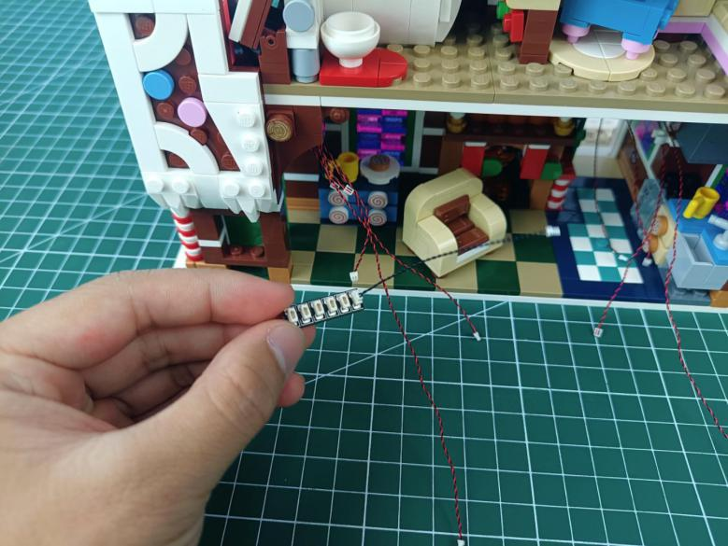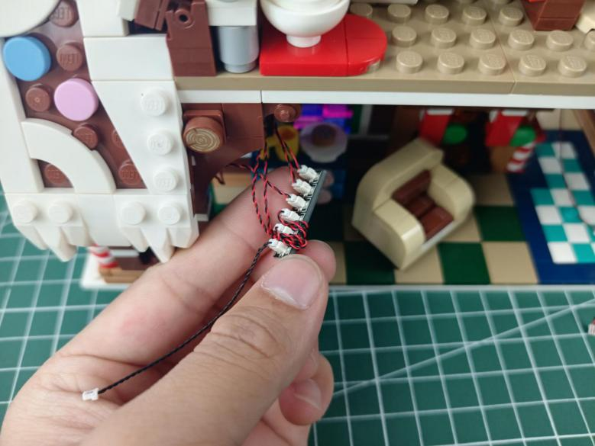

Take a 6-port expansion board, a 5cm connecting cable, assemble them as per below.
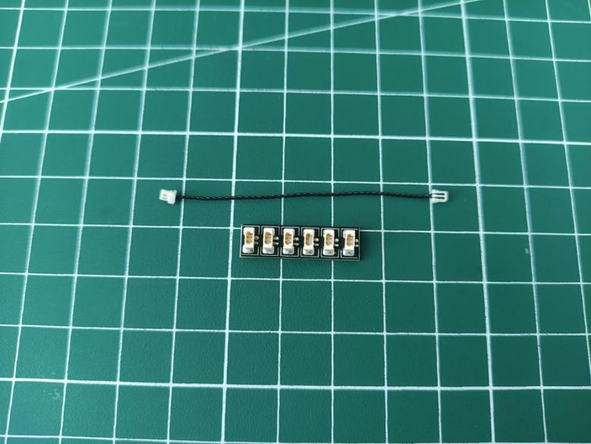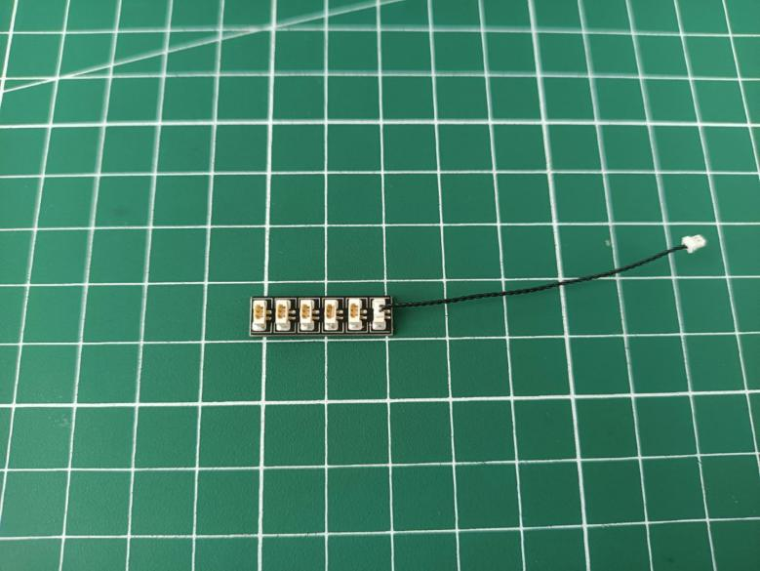

Connect the 4 cables from the right to the expansion board, you can tuck excess cable around the expansion board.
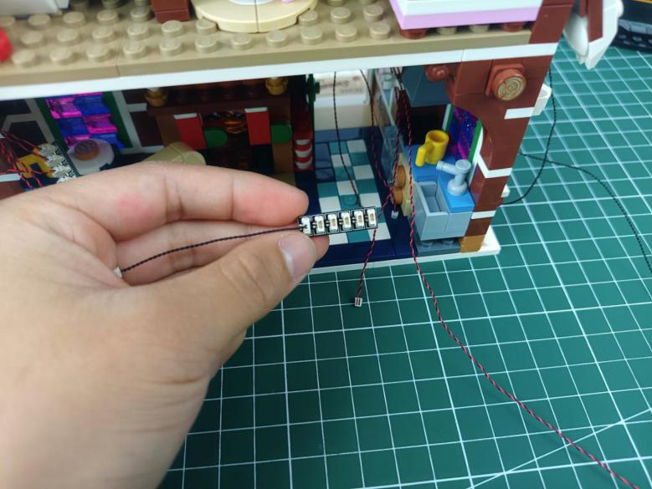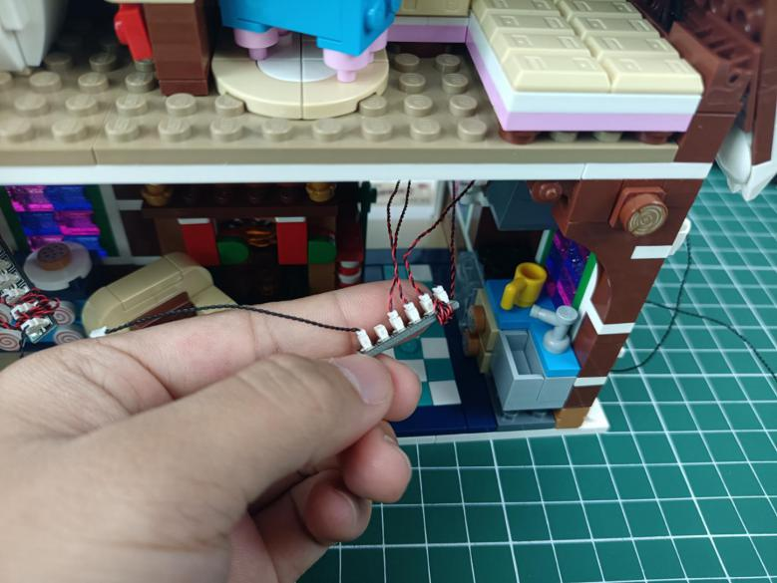

Take an 8-port expansion board, two 15cm head lights.
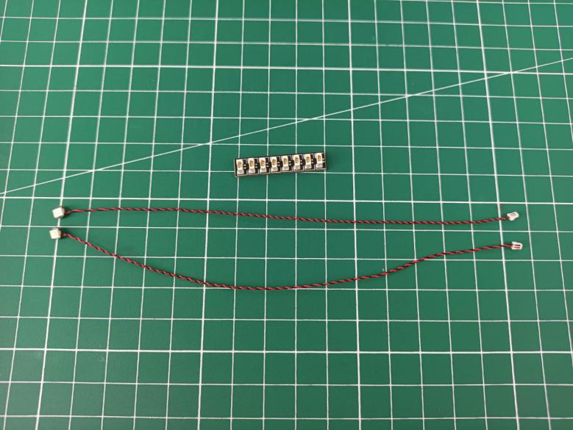

Wind the cables of the head lights around the expansion board before connecting them to the expansion board.
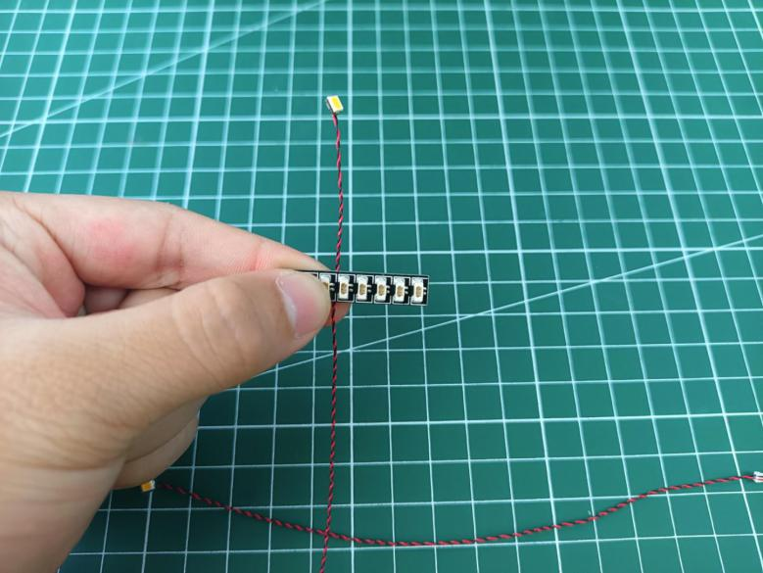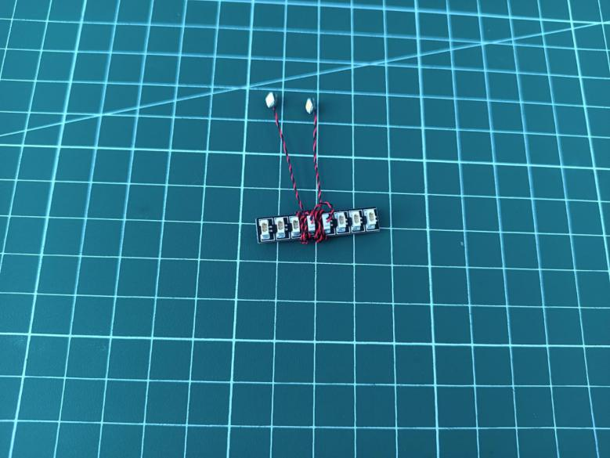

Take a USB cable.
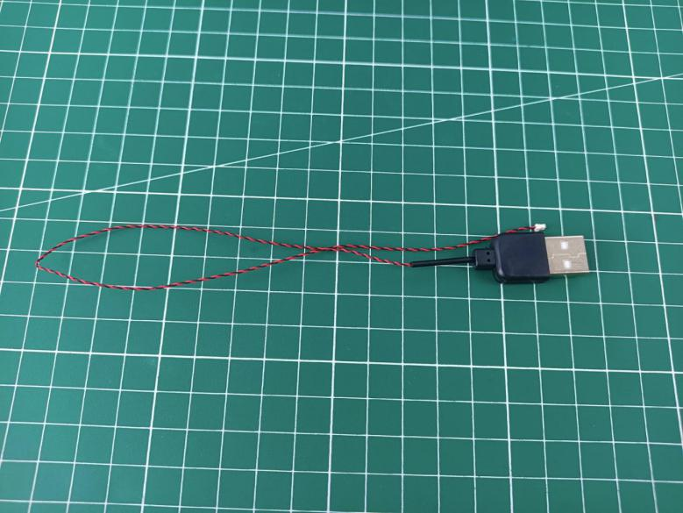

Connect it to the expansion board.
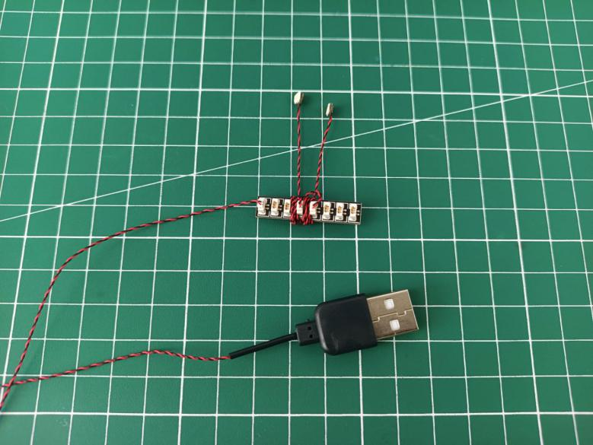

Connect the other cables from the house to the 8-port expansion board.
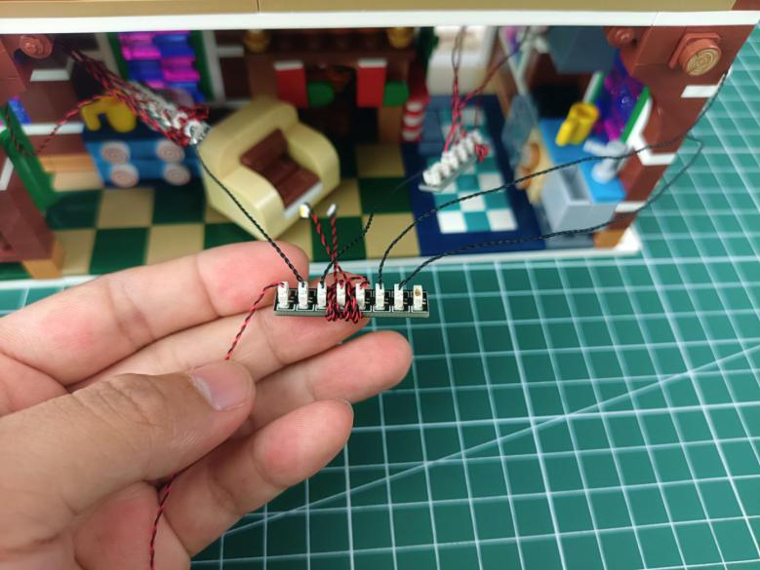

Take the Christmas tree.
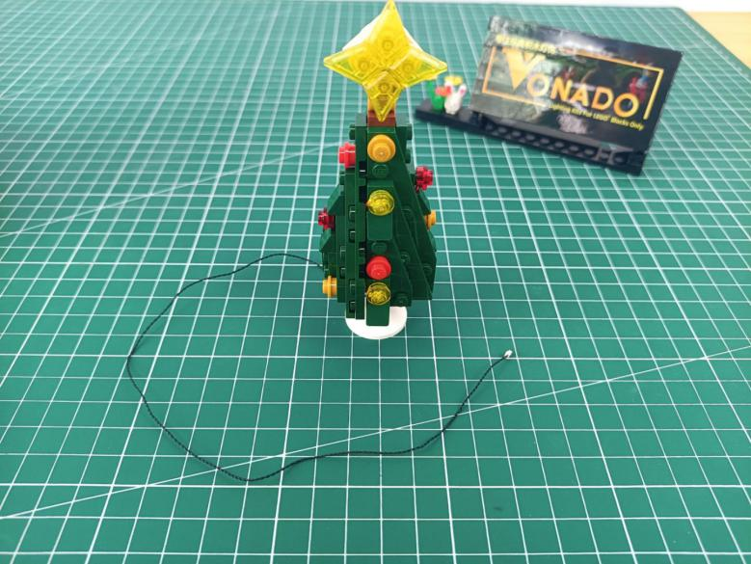

Connect the cable from the tree to the 8-port expansion board.
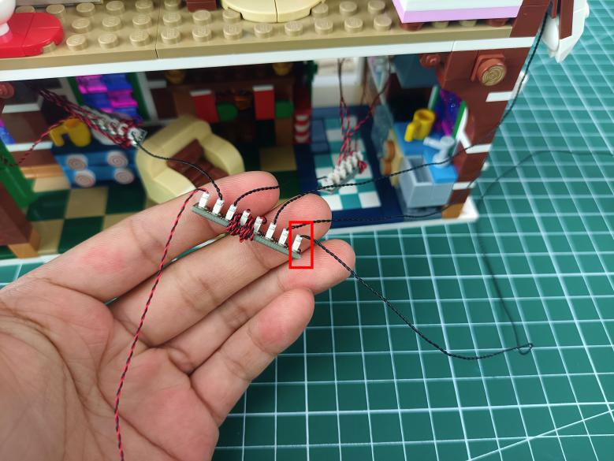

Take 8 adhesive squares.
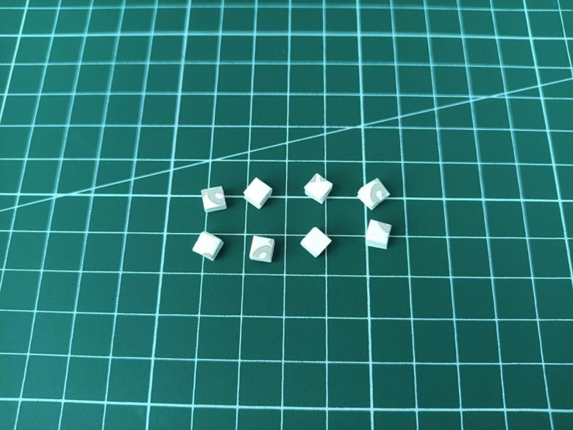

Stick them to the backs of the expansion board and the head lights.
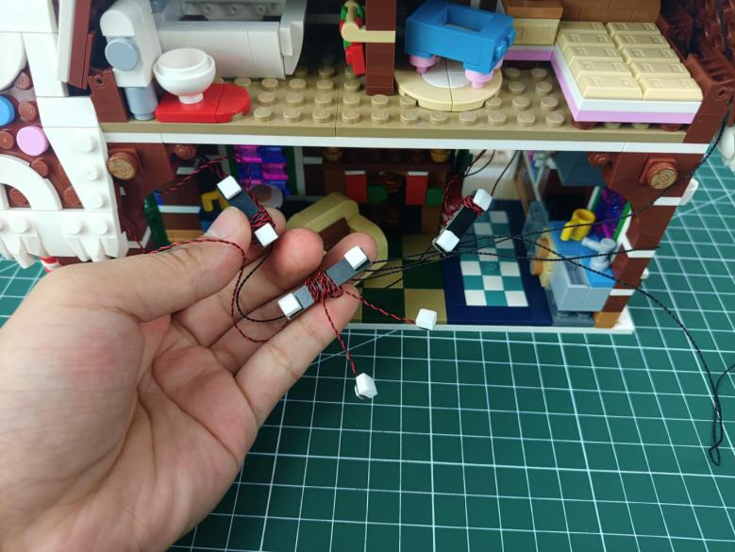

Stick them to the following places.
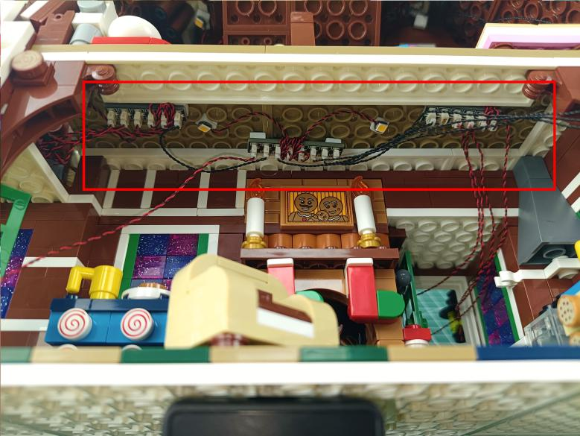

This completes installation of this LED Lighting Kit. ENJOY!

The above are ideas and instructions provided by our designers. Please move on:
1: Do you have any suggestions about the material and quality of our products?
2: Do you have any suggestions on the installation instructions and the degree of difficulty of the installation?
3: If you have better installation method and ideas, please contact us in time.

