Lighting Kit

Package contents：
- 2 x 15cm Warm White Dot Lights
- 2 x 15cm Blue Dot Lights
- 4 x 15cm Red Dot Lights
- 1 x 30cm Warm White Light
- 3 x 30cm Blue Dot Lights
- 2 x 30cm Red Dot Lights
- 2 x 5cm Connecting Cables
- 1 x 15cm Connecting Cable
- 2 x 6-port Expansion Boards
- 1 x 8-port Expansion Board
- 1 x Flicker Effects Board
- 1 x USB Cable

Note:
Place wires on the surface or under the building blocks.
The wire can be place between the building blocks or under the block, but they should be placed between the studs correctly.
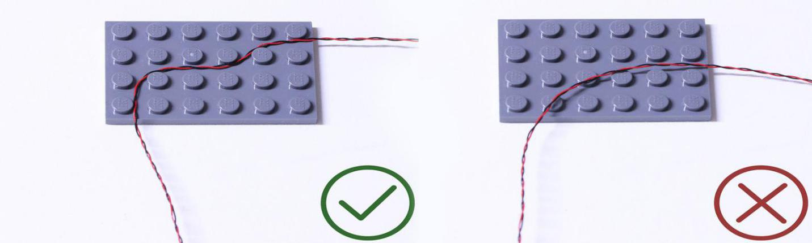
Insert the connectors to the ports.
Be careful when you are operating, there’s only one correct way to insert, make sure the expansion board is upward, find the soldered “=” sign on the left of the port. When you are inserting, the side which the wires can be seen should be faced to the “=” sign and if you feel hard to insert, please stop, and don’t force it, for that may result in bent pins inside the port or overheating of the expansion board.
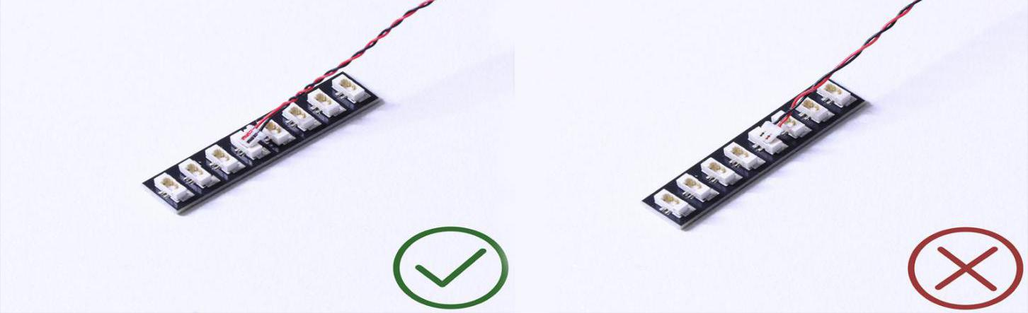
At this point, use the tweezers to straighten the bent
pins.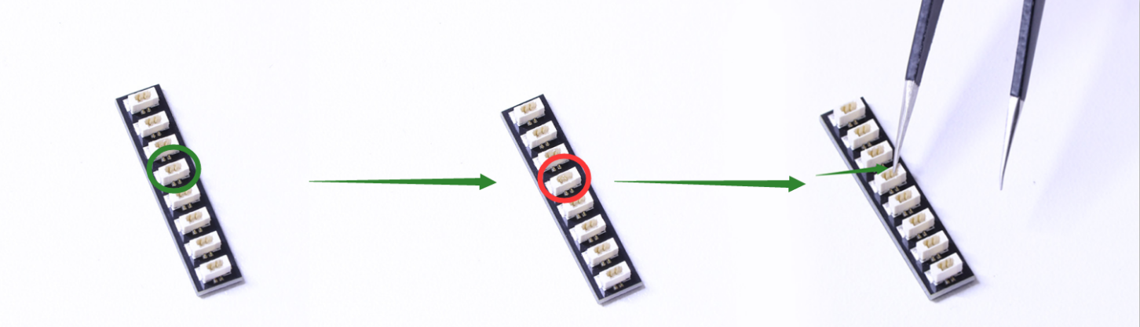
When installing dot lights, make sure they are correctly placed (Yellow LED package is exposed). You can put they either on the top of the studs or between studs.
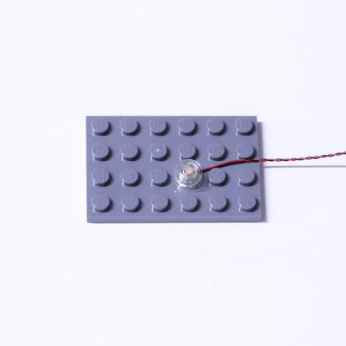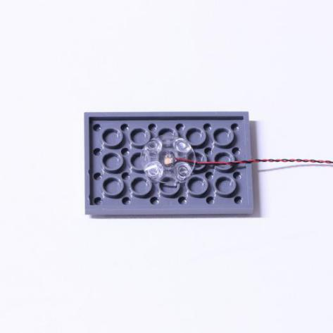

Connecting cable connectors to Strip Lights

Take extra care when inserting connectors to ports on the Strip Lights. Connectors can be inserted only one way. With the Strip Light facing up, ensure the side of the connector with the wires exposed is facing down. If a plug won’t fit easily into a port connector, don’t force it. Doing so will damage the plug and the connector.
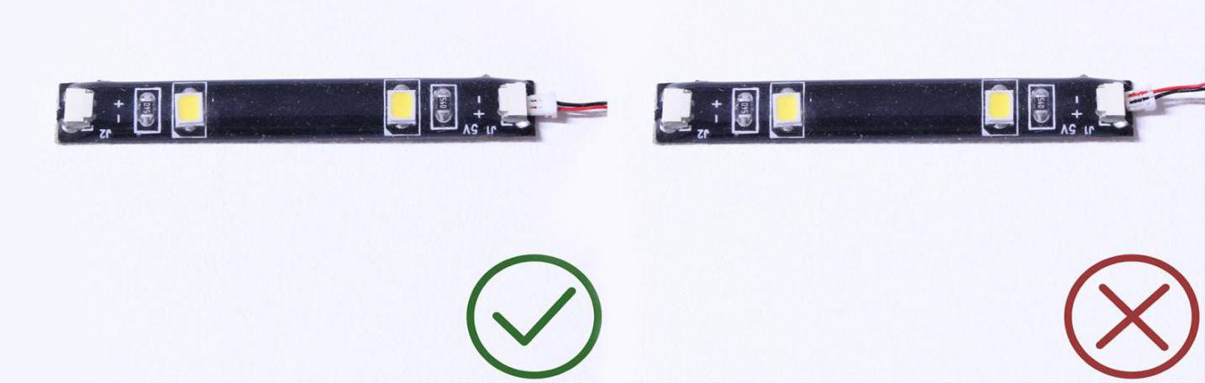
Finally, please pay attention to the positive and negative terminals of the battery when installing the battery case.
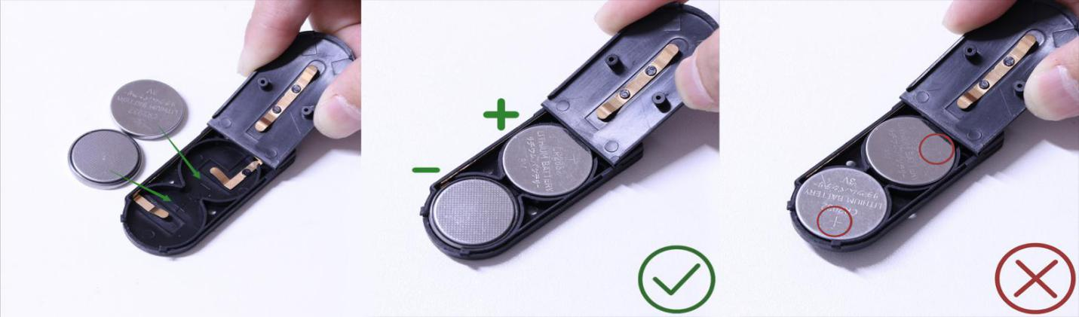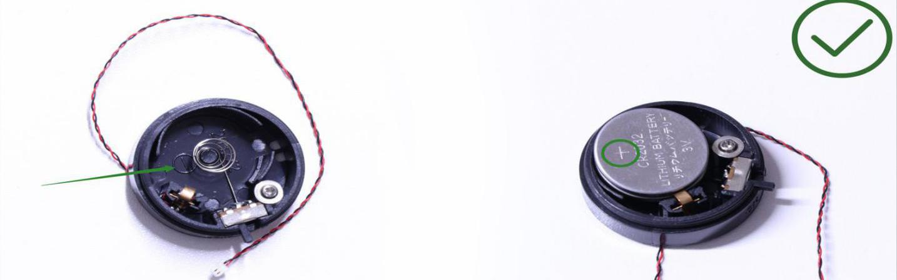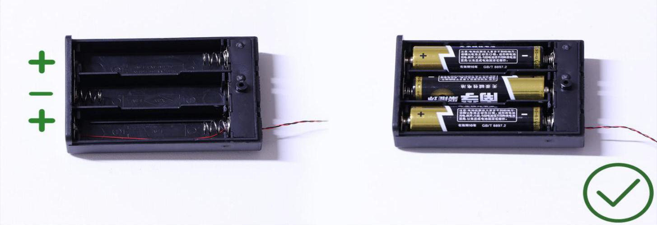

Instructions for installing this kit：
OK, Let’s Begin!
Start from installing the headlights for the motorcycle
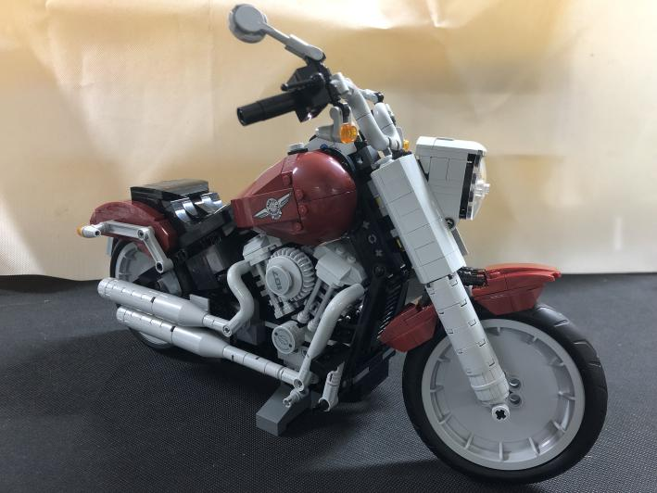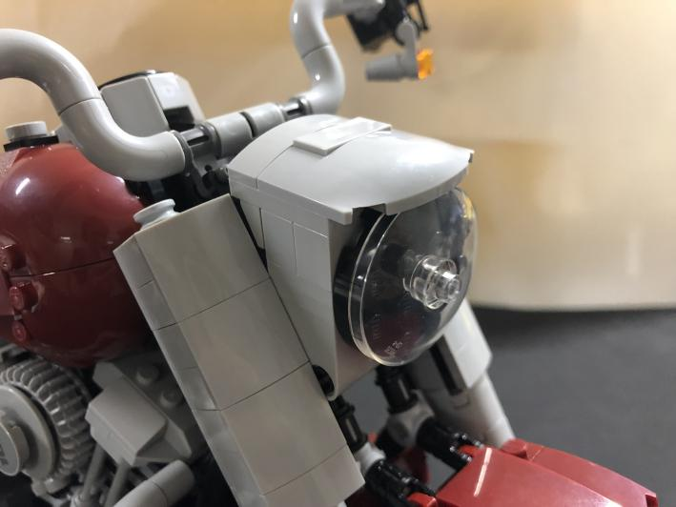
Remove the lights as per below
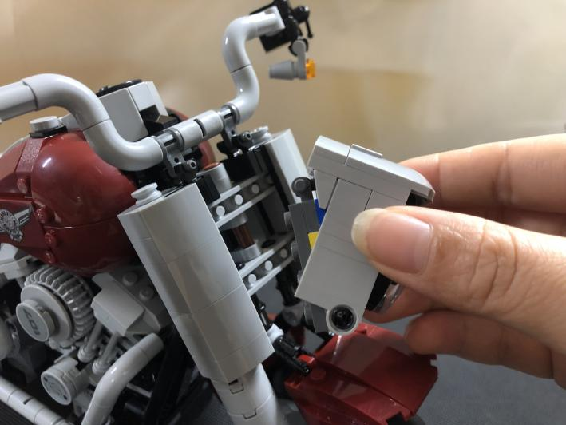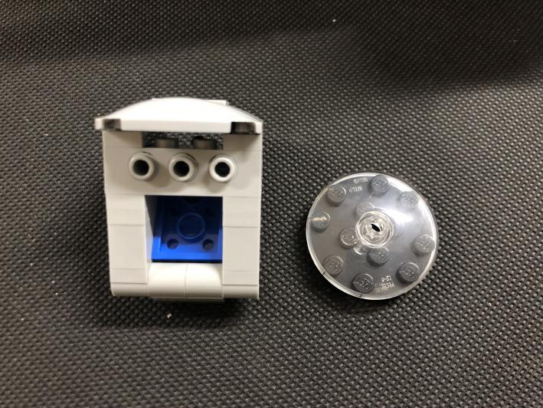
Take a warm white 30cm light, with the lighting part facing the trans piece, place the light at the center of the following round black piece
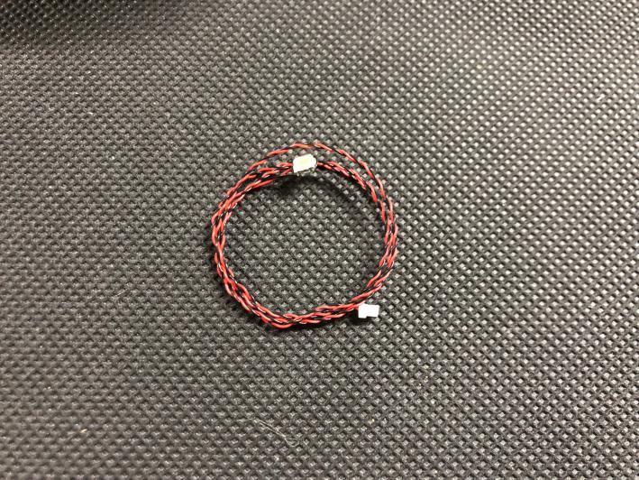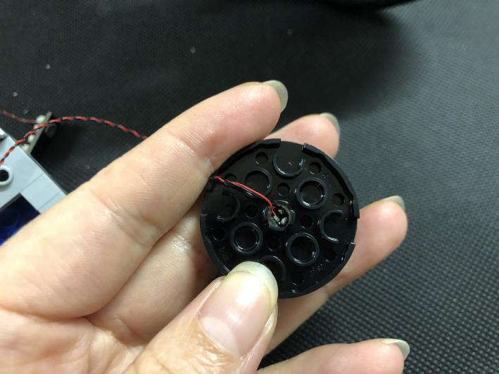
Open the upper part of the arm with clips
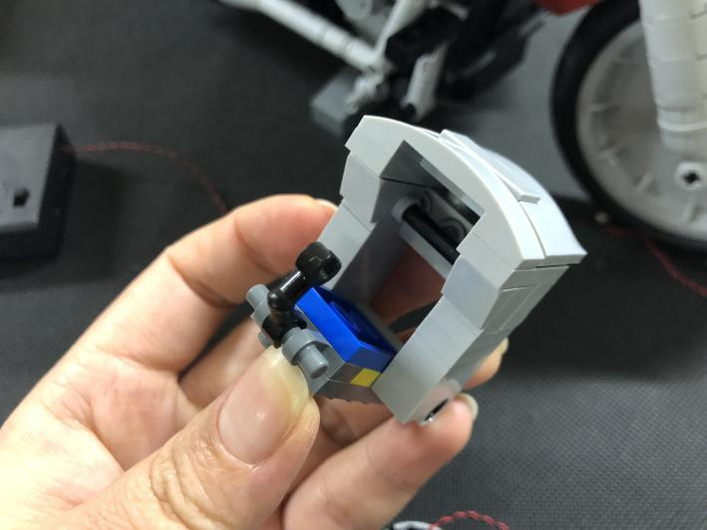
Thread the cable of the light through the hole on the gray piece, reconnect the round black piece, reconnect the arm
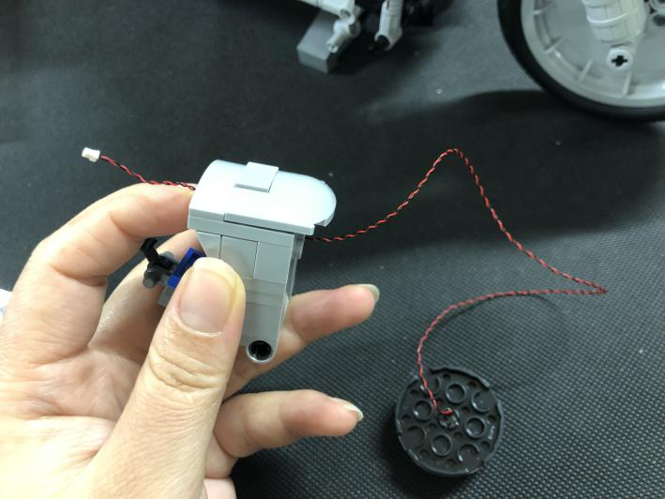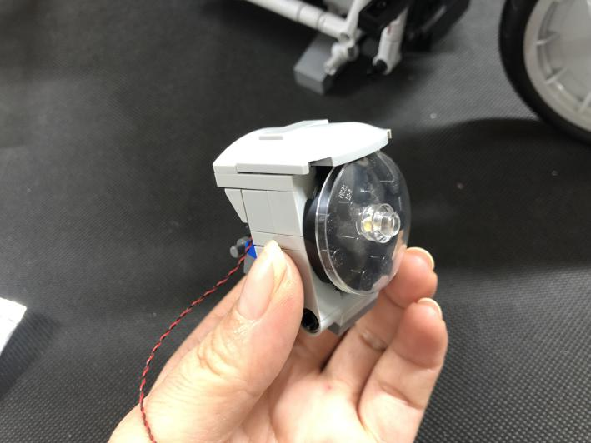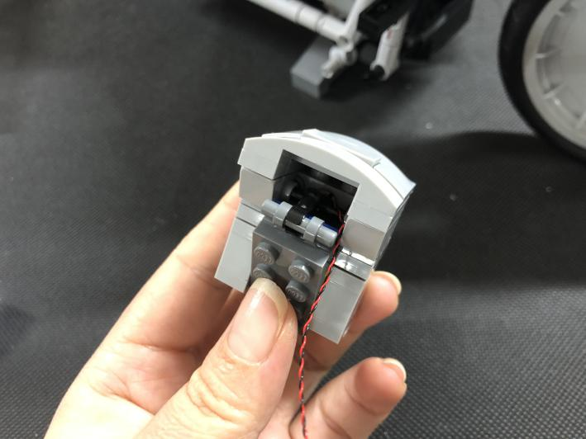
Reconnect the light back to the motorcycle
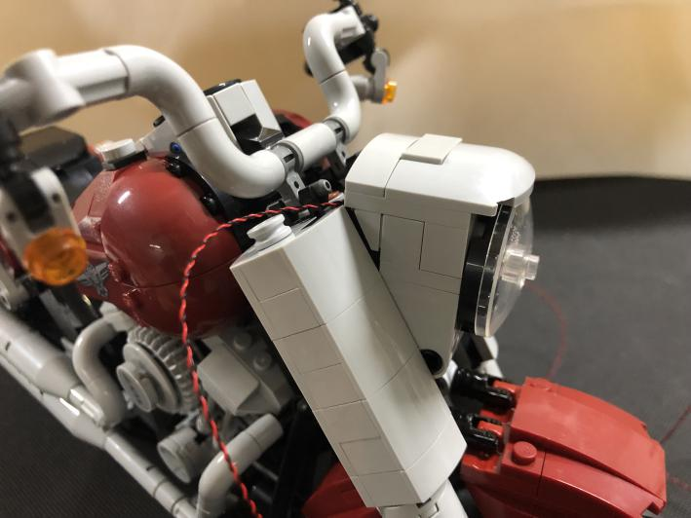
Thread the cable of the light through the following piece
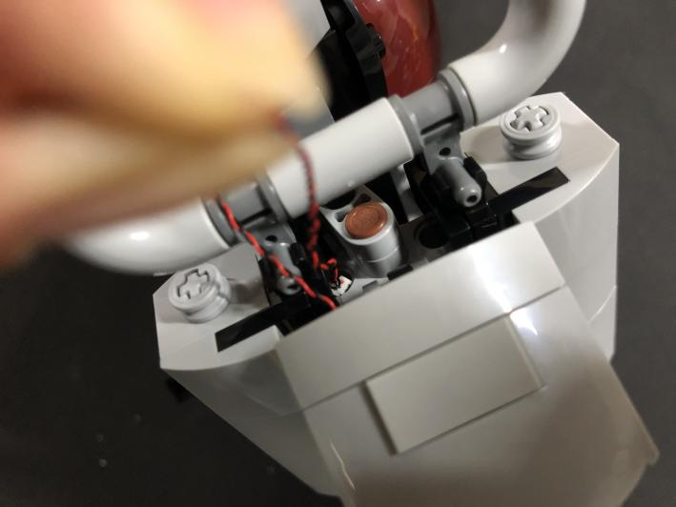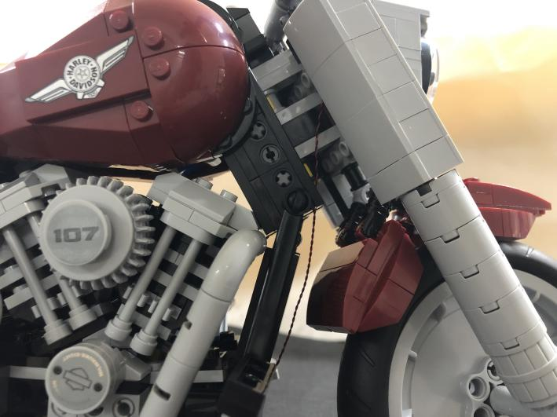
Continue to thread the cable through the following space and pull it out from the bottom
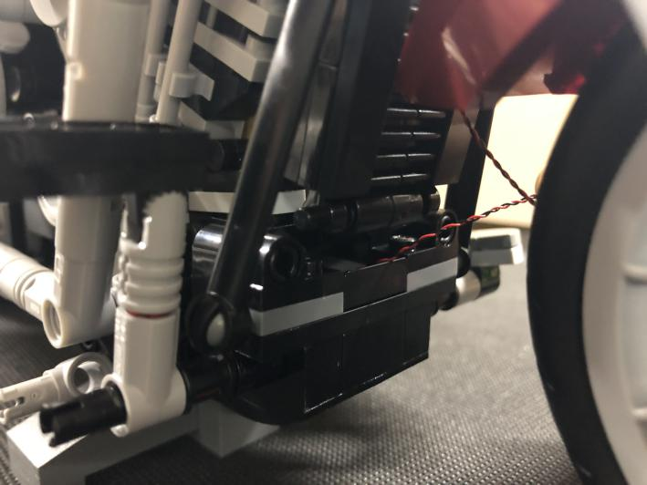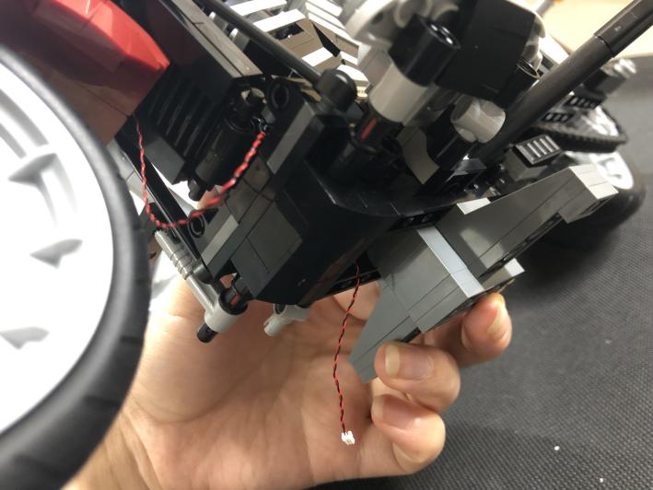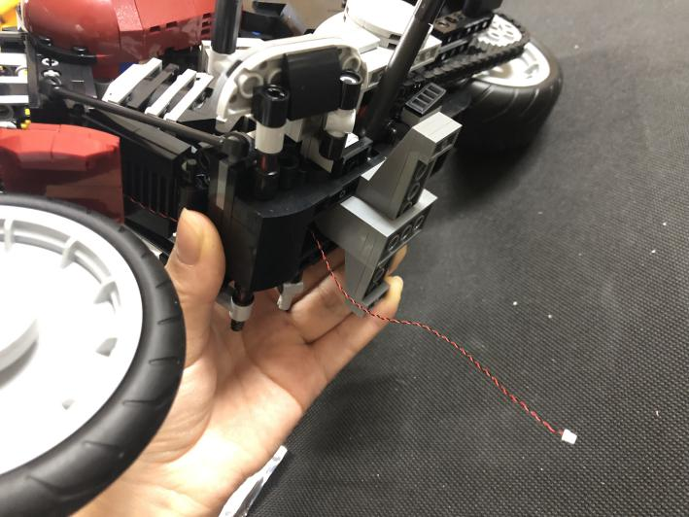
Move onto installing light for the fender. remove the fender
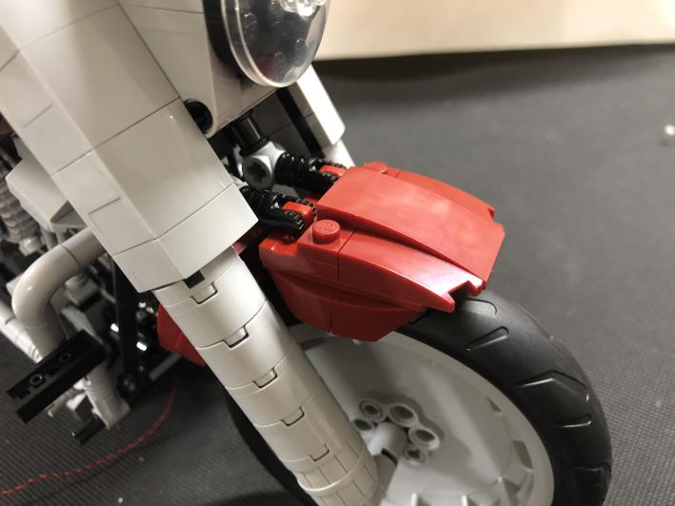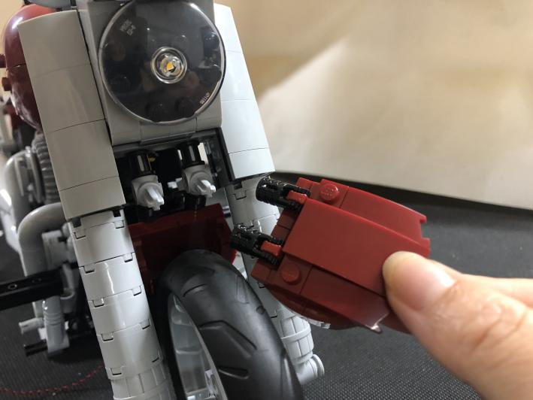
Take 2 blue 30cm dot lights, stick the lights underneath the fender with adhesive squares as per below
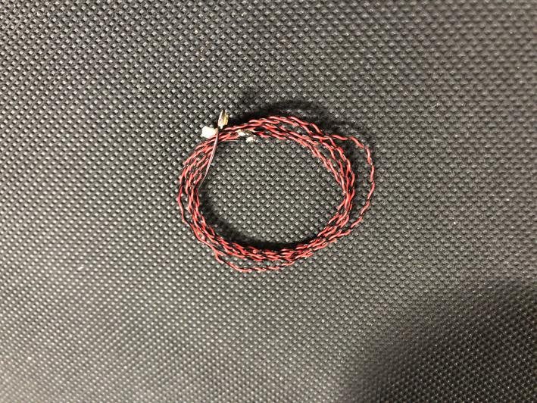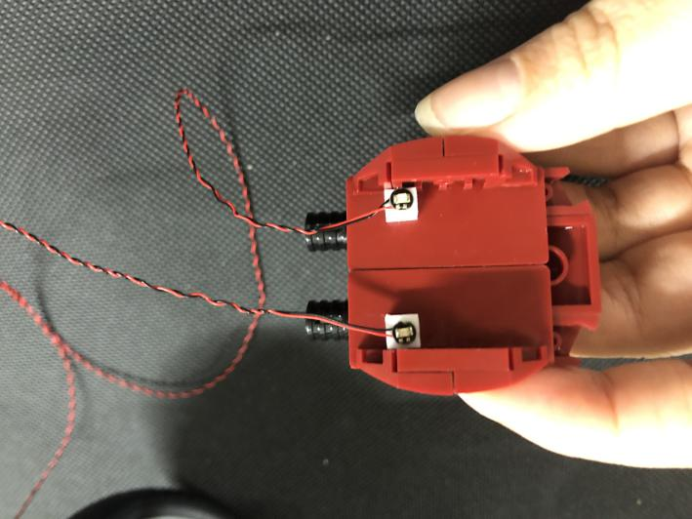
Group the 2 cables together, reconnect the fender
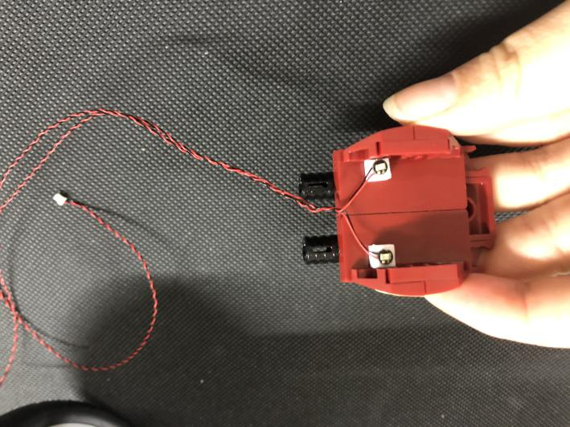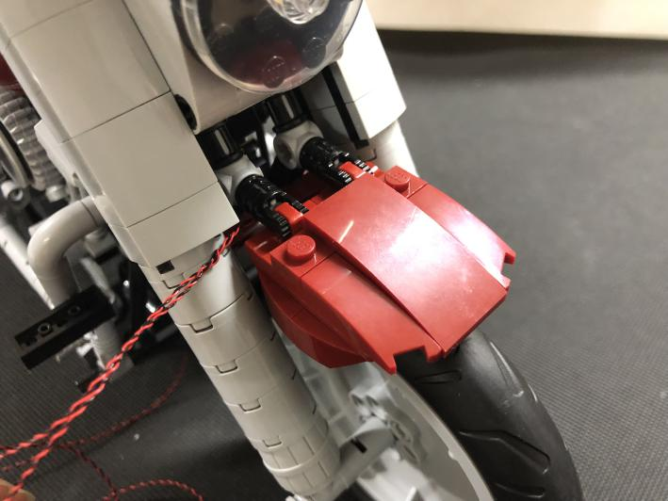
Pull the cables to the back and thread them through the following space
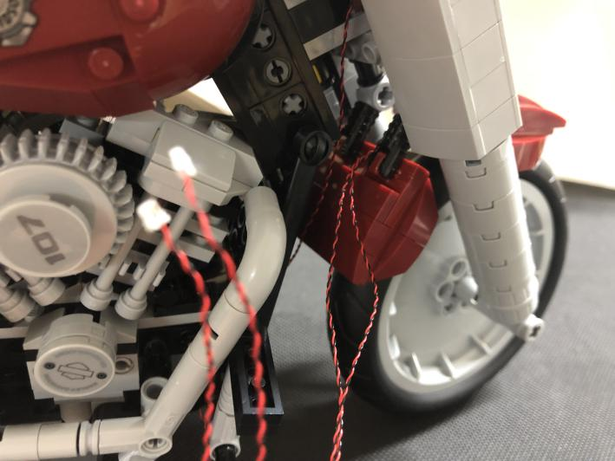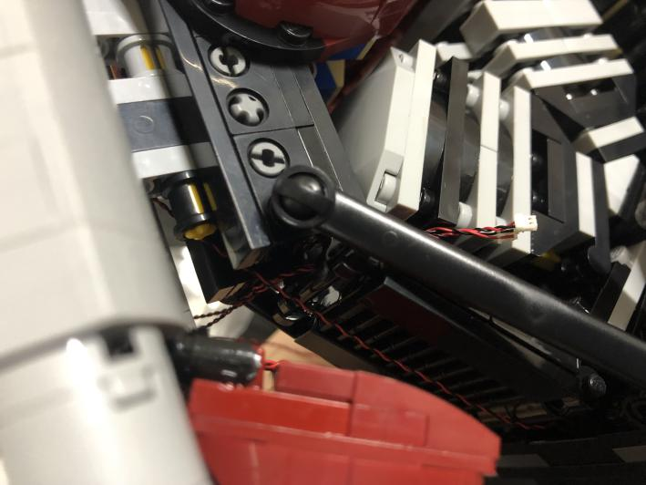
Continue to place the cables as per below, then, pull them out from the bottom of the motorcycle
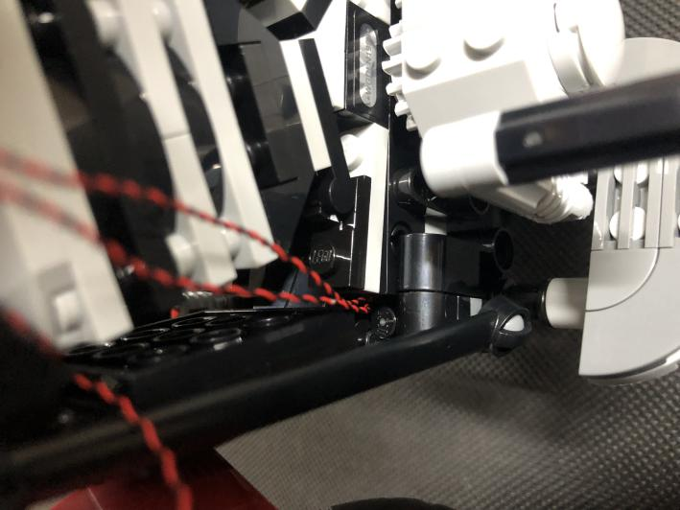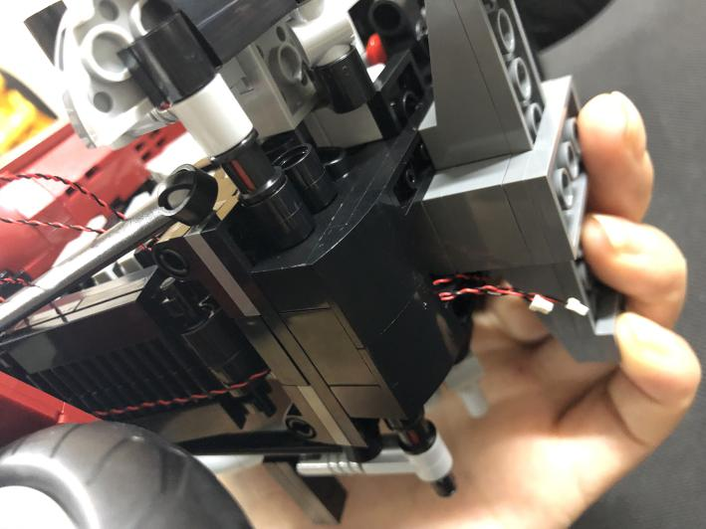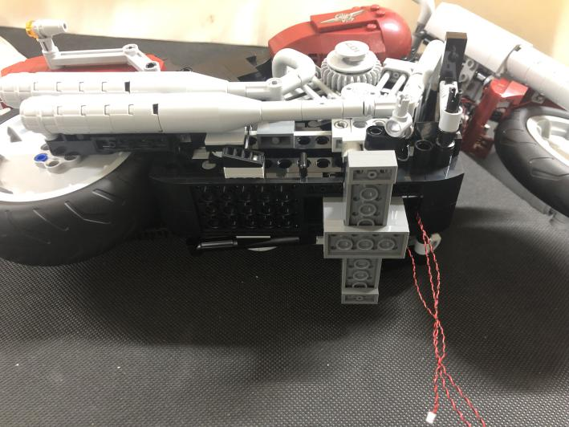
Secure the cables with the gray cross piece underneath the motorcycle
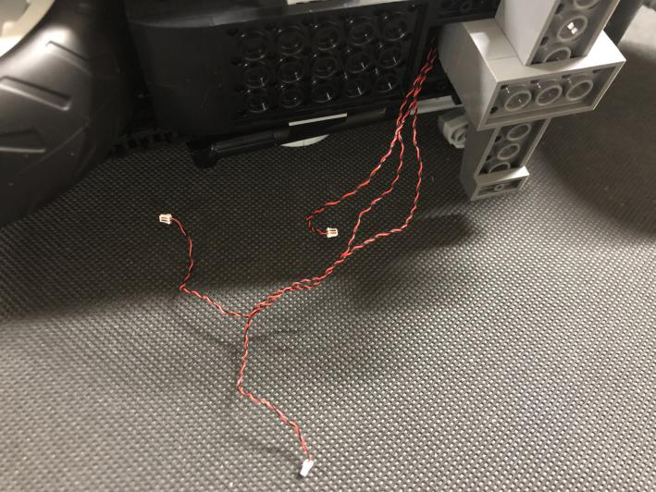
Take an 8-port expansion board, connect the 3 cables to it. Tuck excess cables as per below before sticking the expansion board to the bottom of the motorcycle
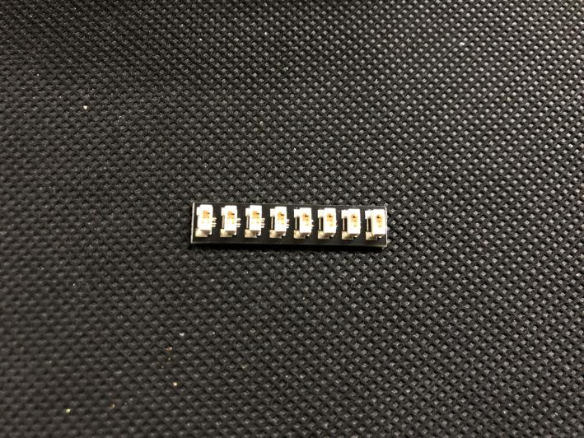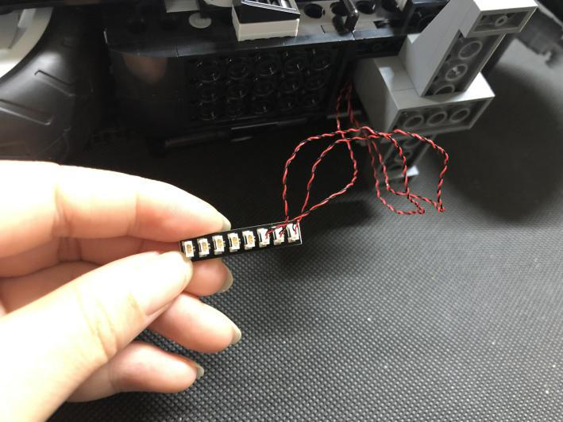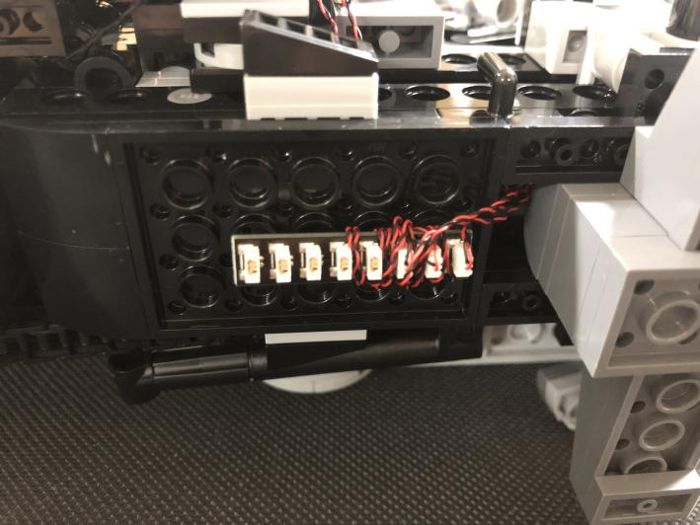
We’ll continue to install lights for the engine, remove the following piece
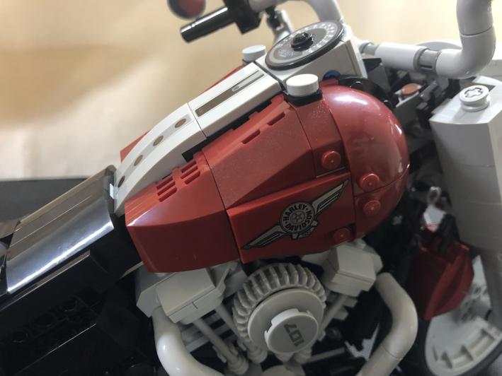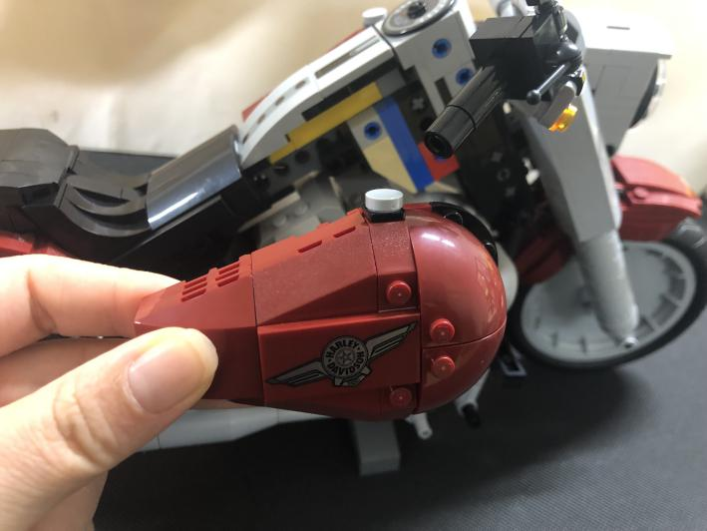
Take a blue 30cm dot light, stick it to the following place with an adhesive square
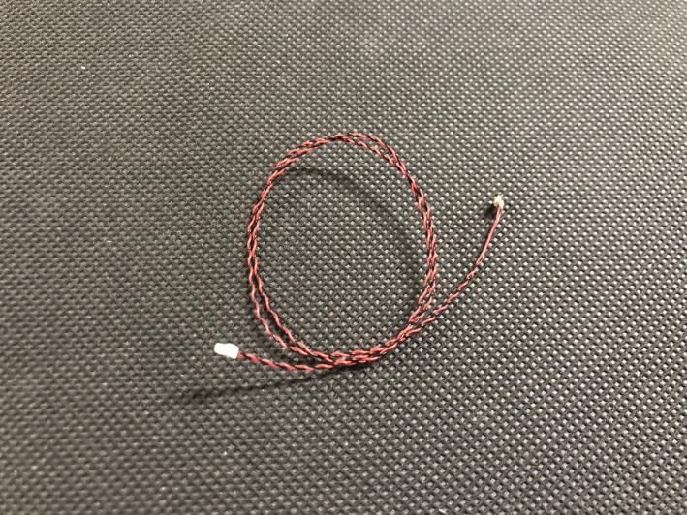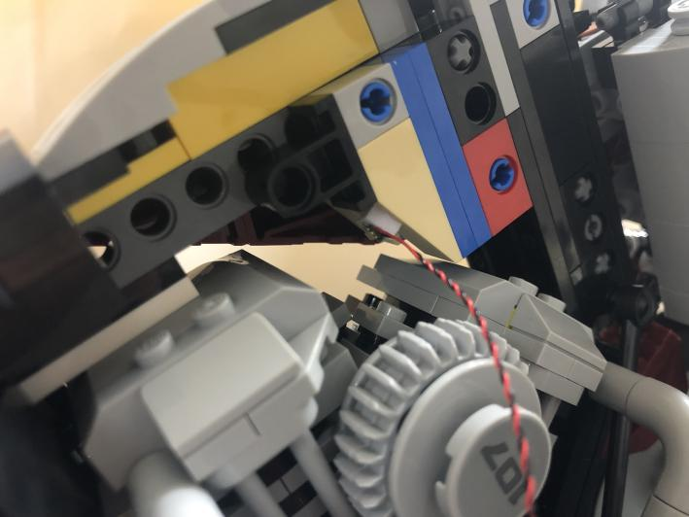
Thread the cable through the gap behind the gray wheel
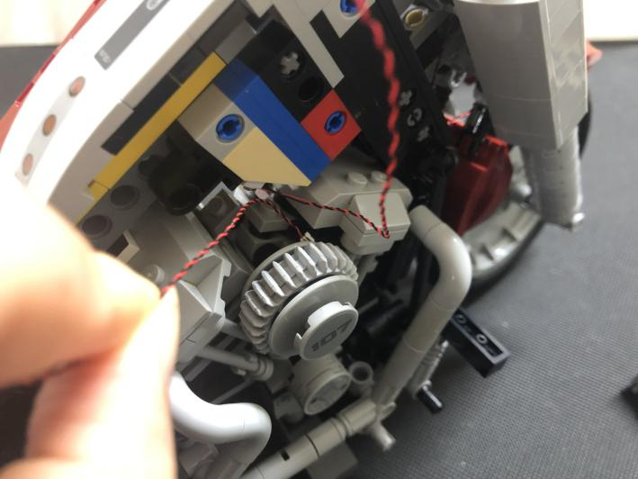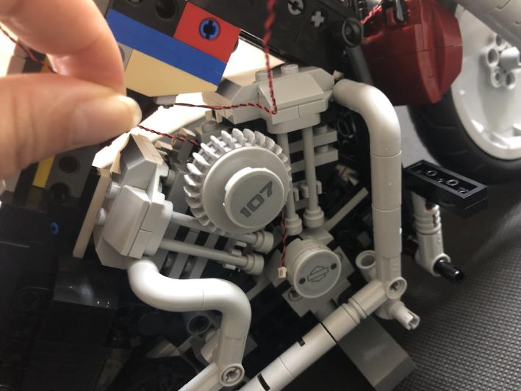
Continue to thread it through the following space and pull it out from the bottom
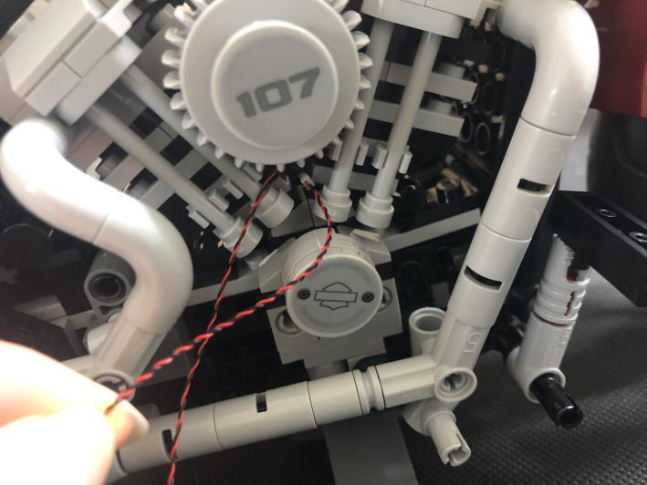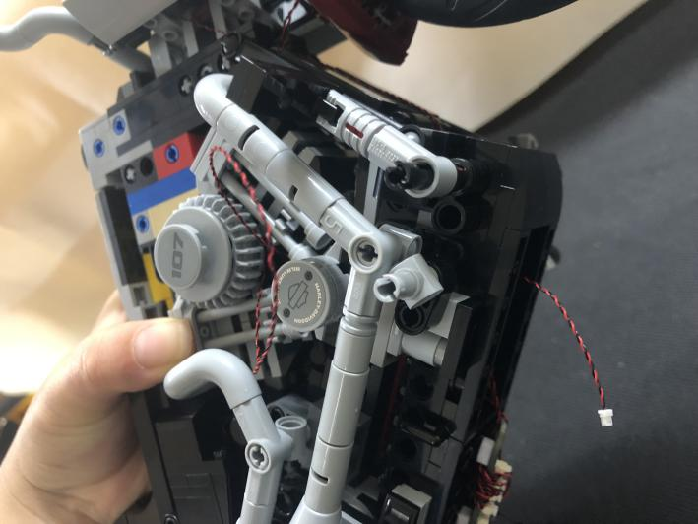
Connect the light to the expansion board underneath, tuck excess cable as per below
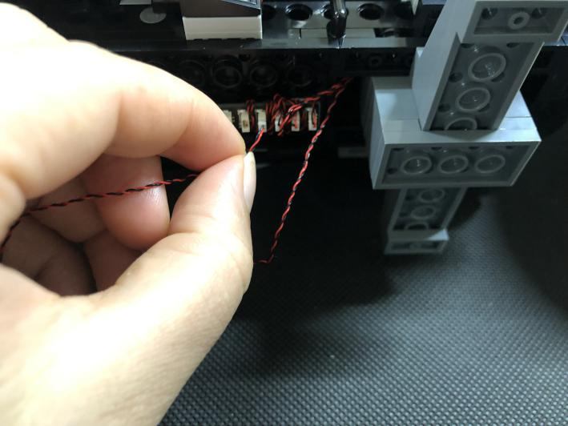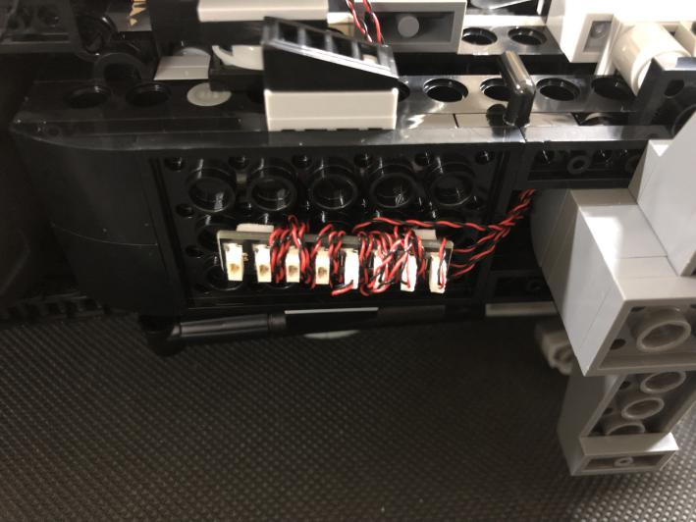
Remove a vent pipe.
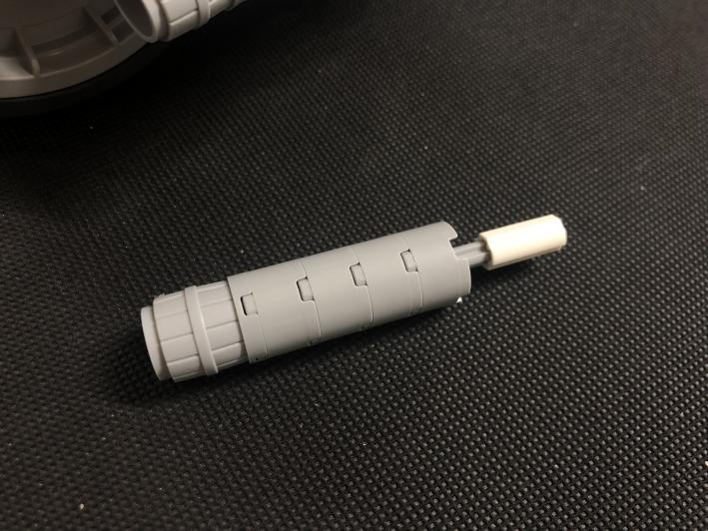
Take a red 30cm dot light
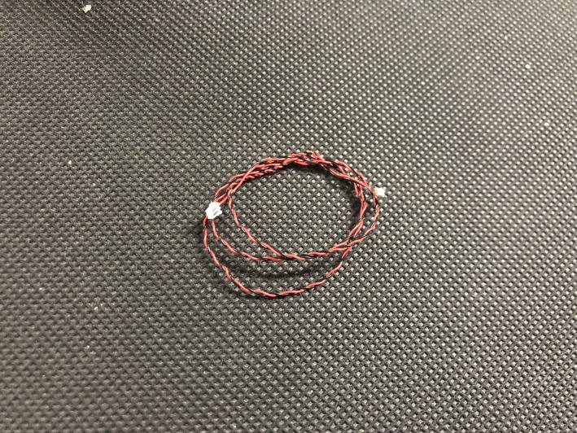
Disconnect the vent pipe.
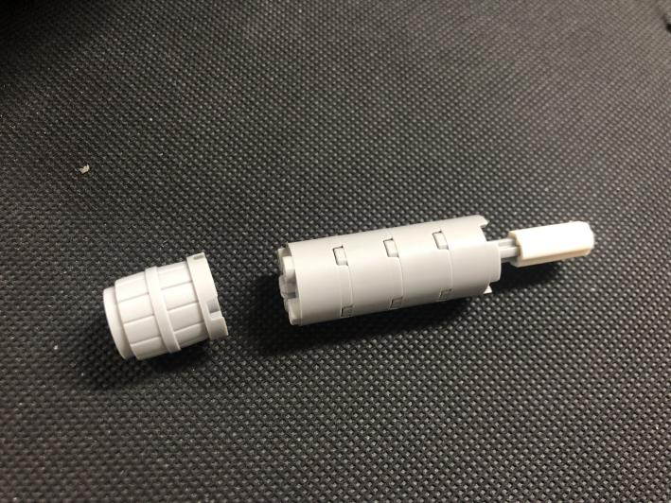
With lighting part facing the vent. Thread the light through the following piece
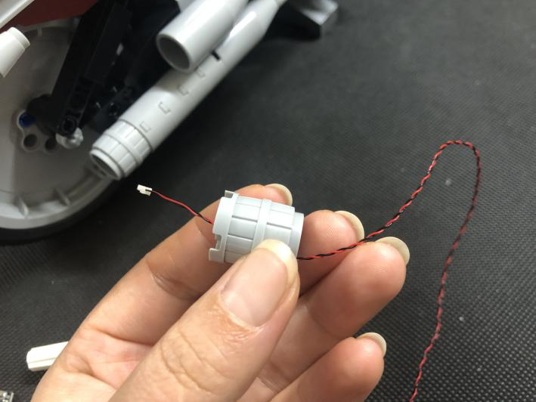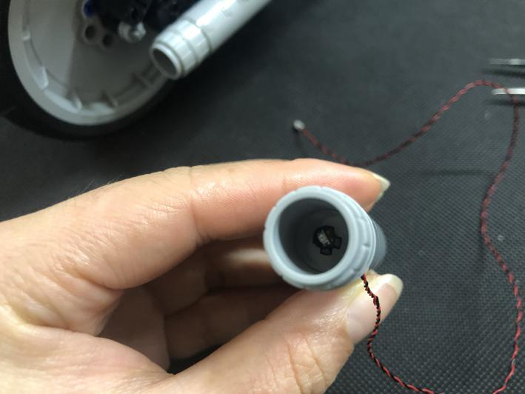
Reconnect the vent pipe
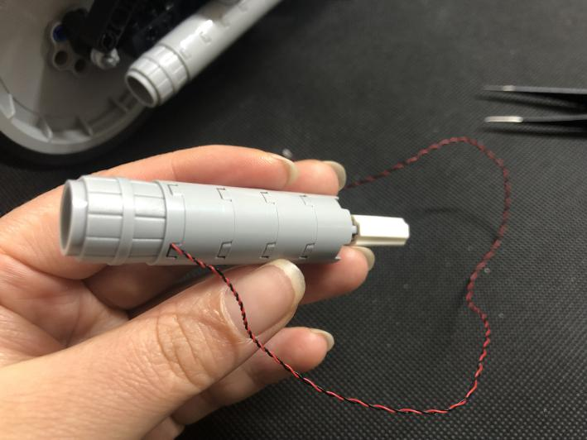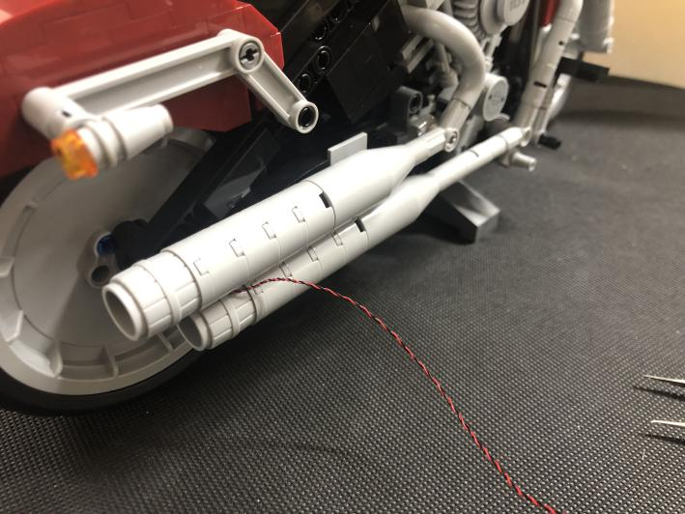
Turn the motorcycle to its side, thread the cable as per below
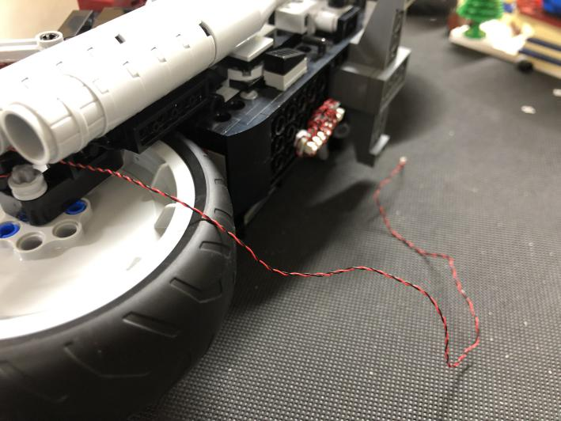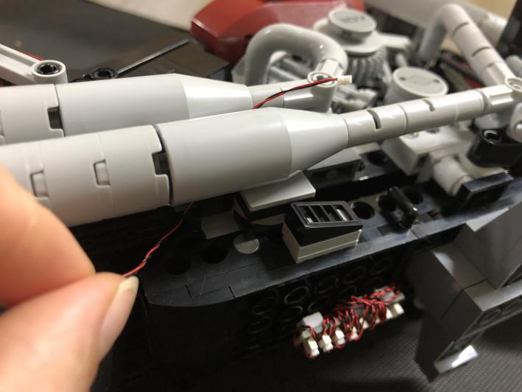
Thread the cable through the following hole, pull it out from the bottom
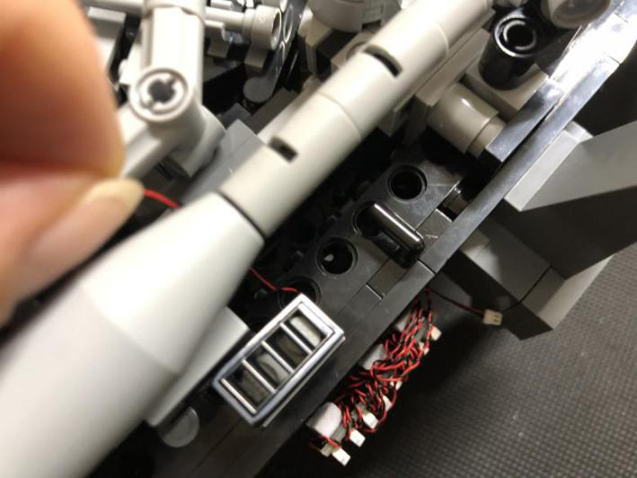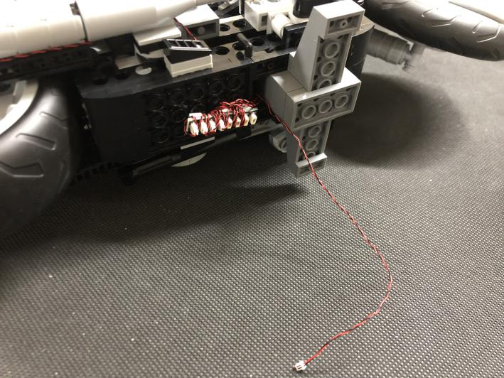
Take a red 30cm dot light, repeat the steps above to install light for another vent pipe
Take a Flicker Effects Board, a 5cm connecting cable.
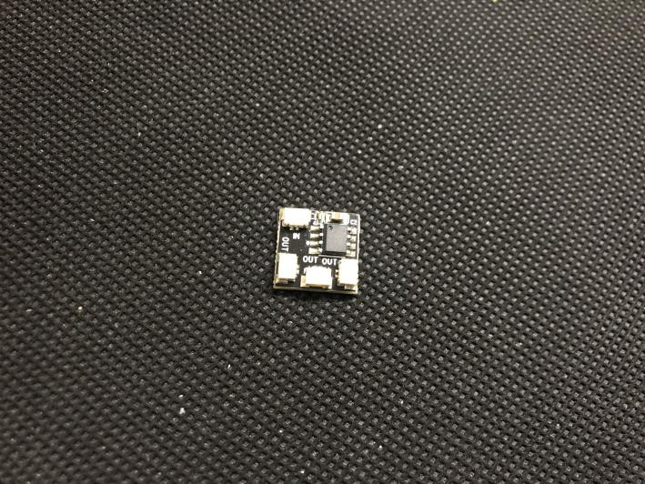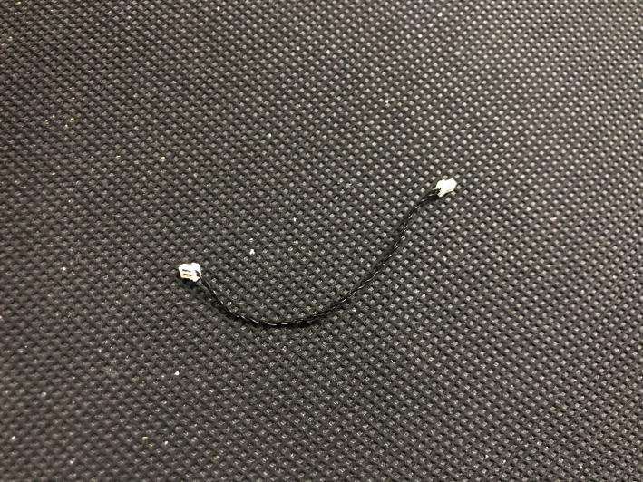
Connect the 2 cables of the vent pipe lights to the Flicker Effects Board
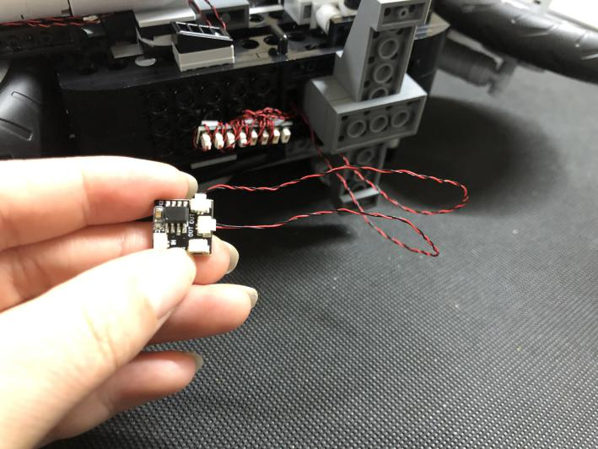
Connect the 5cm connecting cable to the Flicker Effects Board. Tuck excess cables as per below
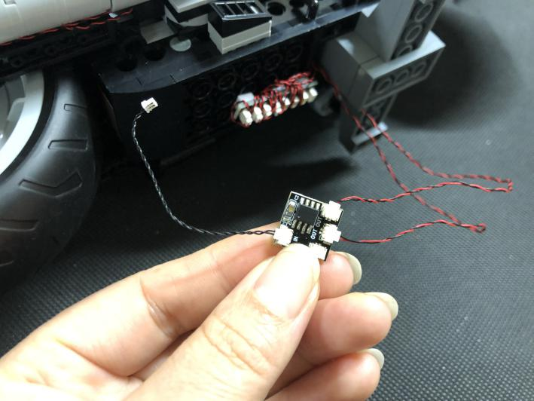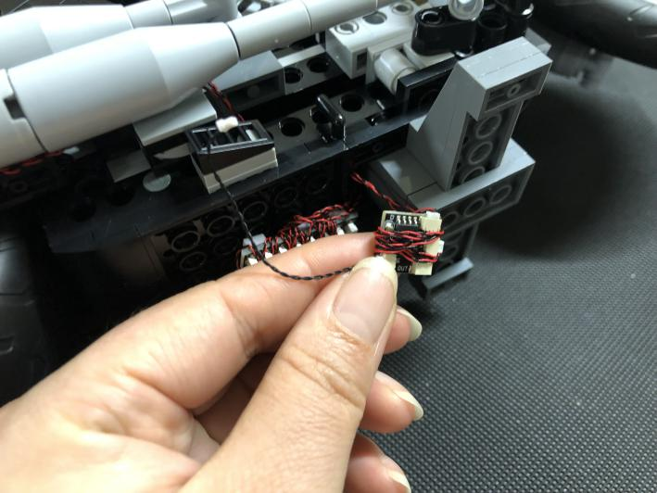
Connect cables from the Flicker Effects Board to the expansion board underneath. Hide the Flicker Effects Board as per below
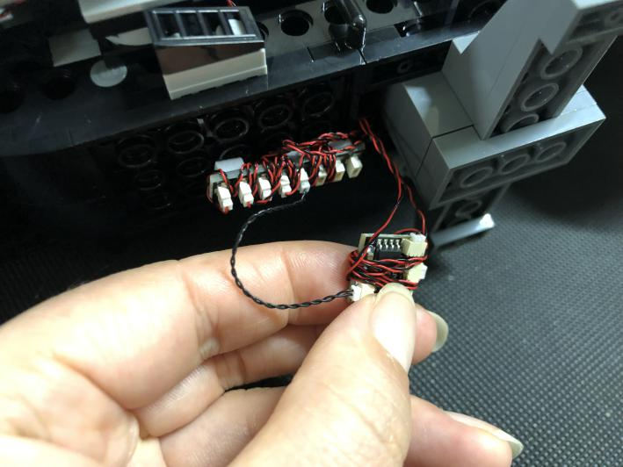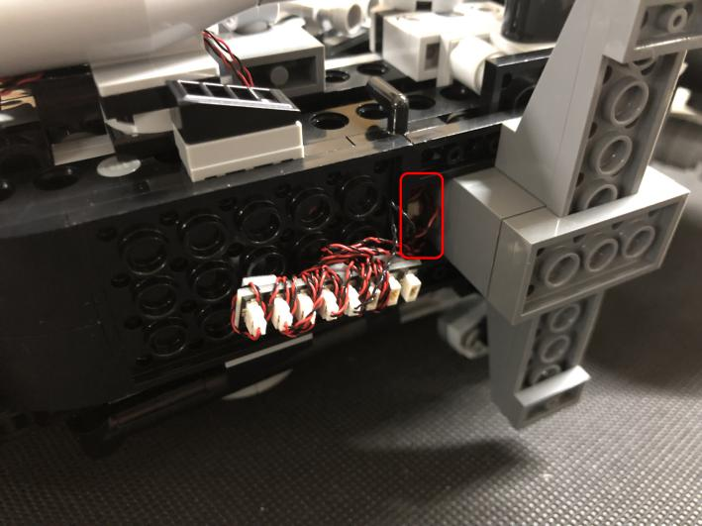
Turn the car to its back, we’ll install the turn signals now, remove one of the lights as per below
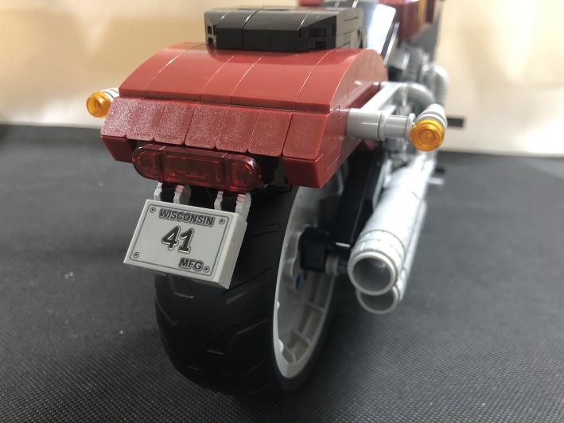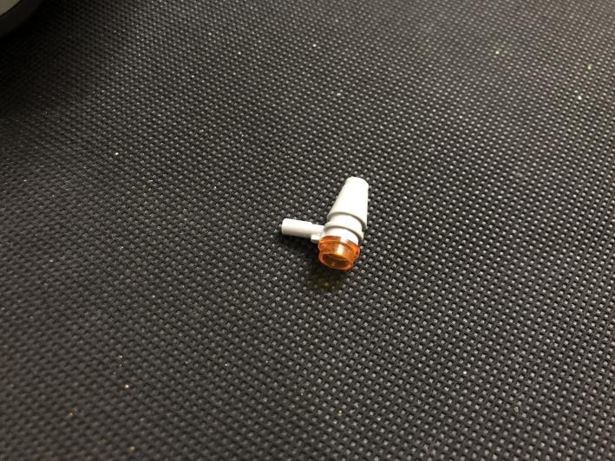
Take a warm white 15cm dot light, disconnect the turn signal as per below
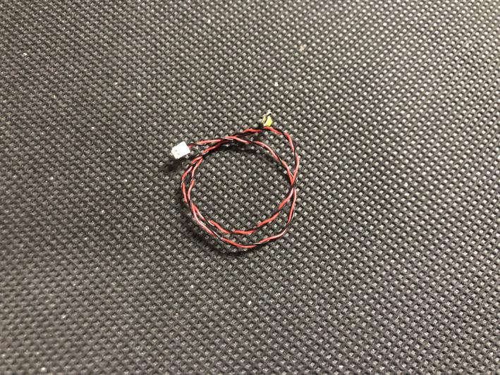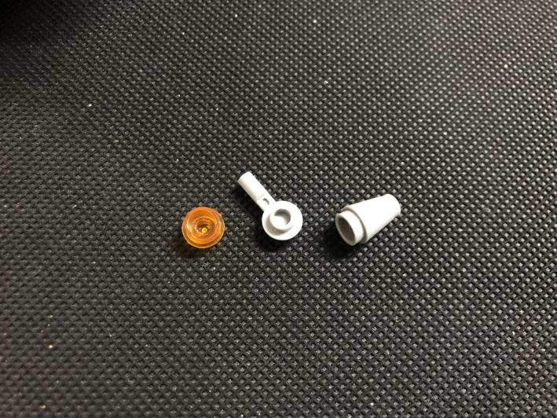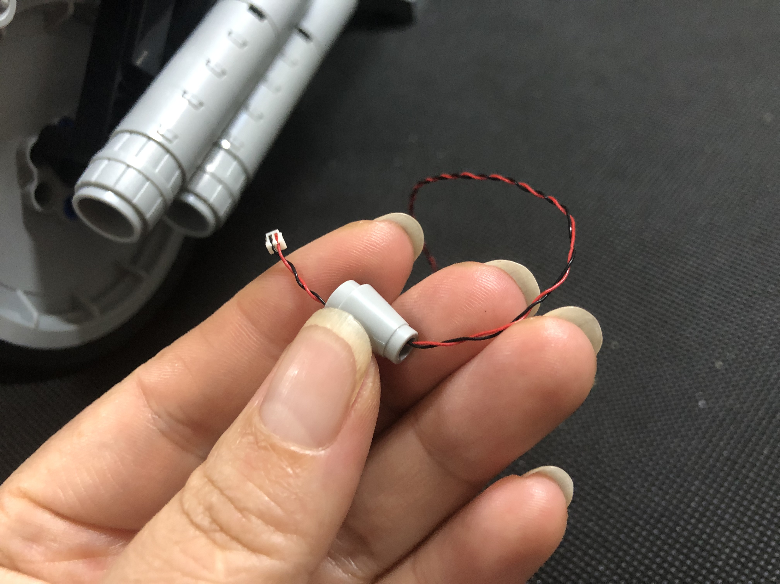
Thread the light through the gray piece, secure the light with a trans orange 1x1 piece
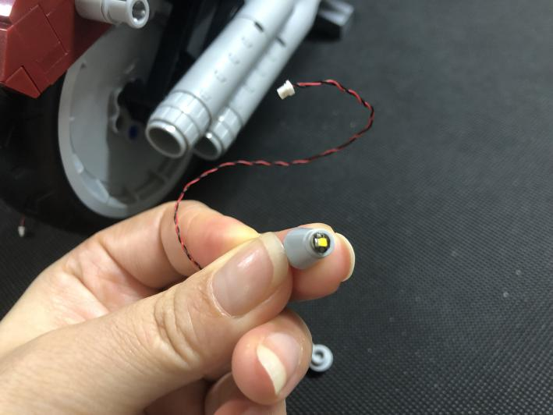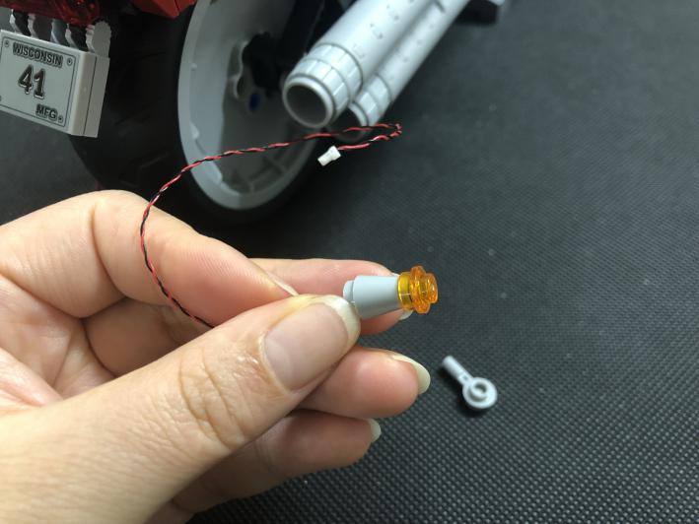
Reconnect the turn signal
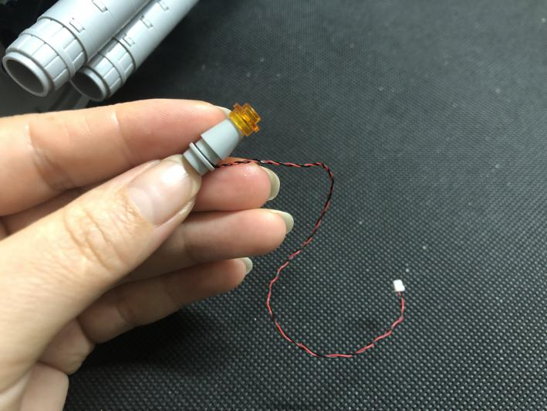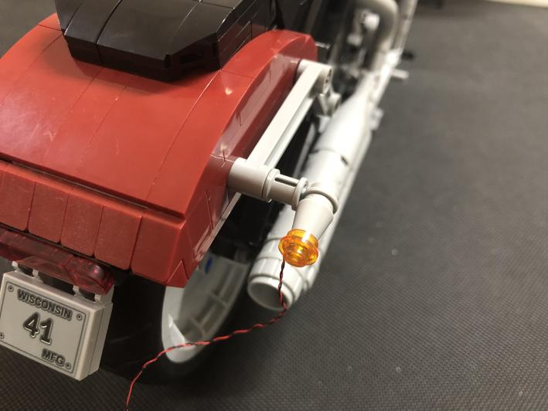
Lift the following piece and place the cable as per below. Reconnect the piece
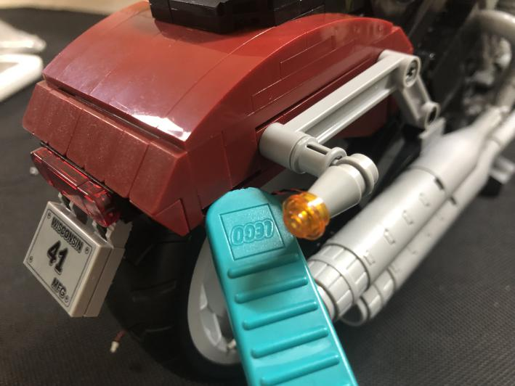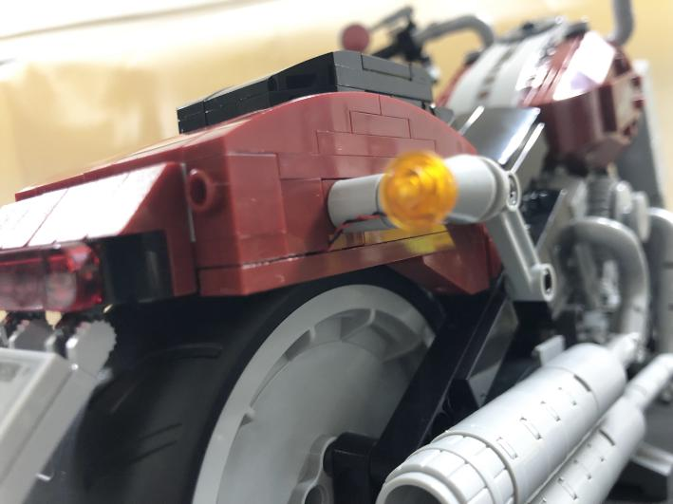
Remove the cushion to allow the cable thread through
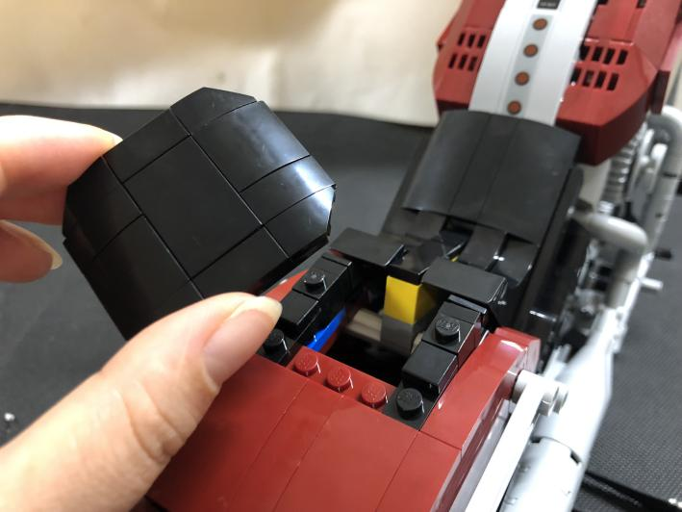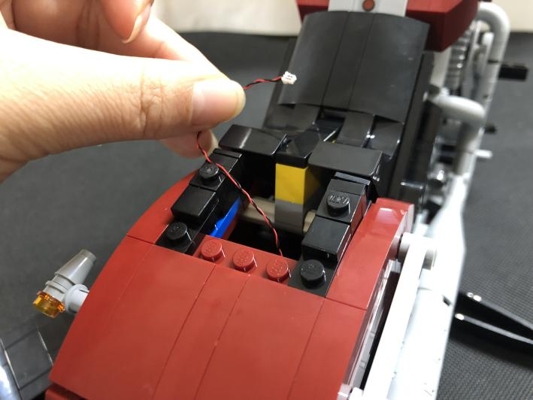
Take a warm white 15cm dot light, repeat the previous steps to install another turn signal.
Take a 6-port expansion board, connect the cables of the lights to it
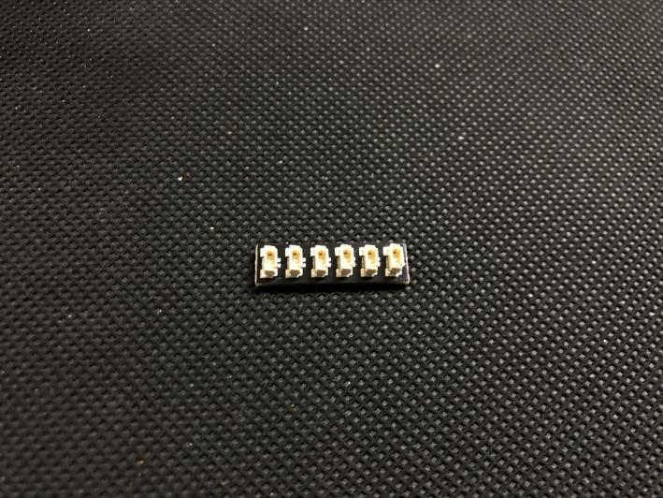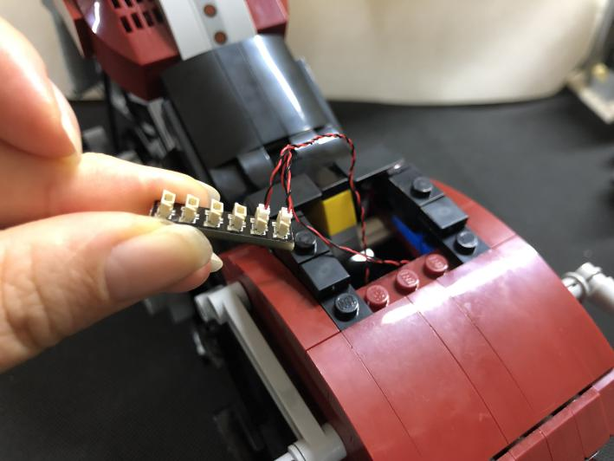
Continue to install the taillights. Remove the taillights part
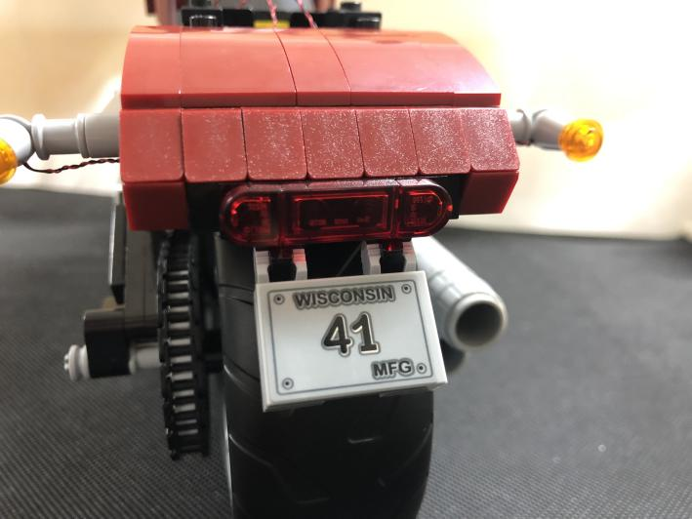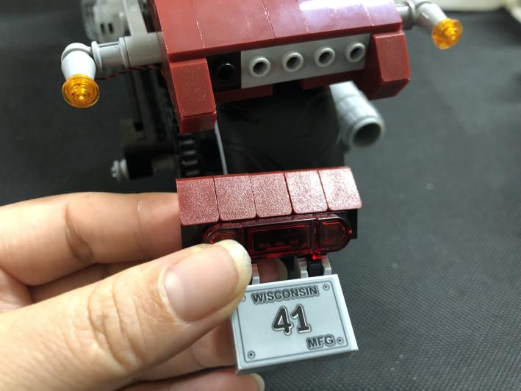
Remove the following trans red piece
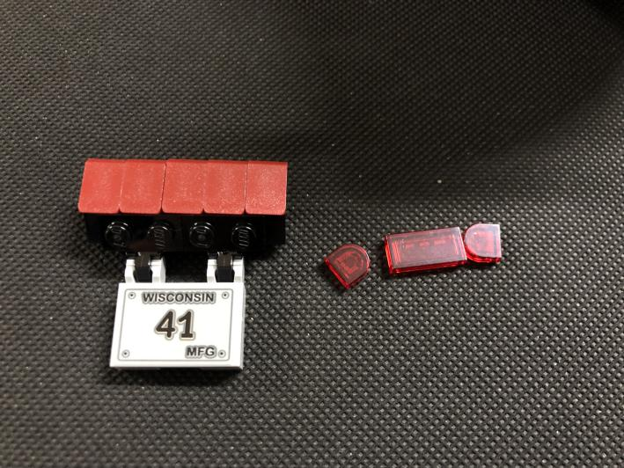
Take a red 15cm dot light, a trans red 1x1 piece, with lighting part facing up, secure the light with the trans red piece
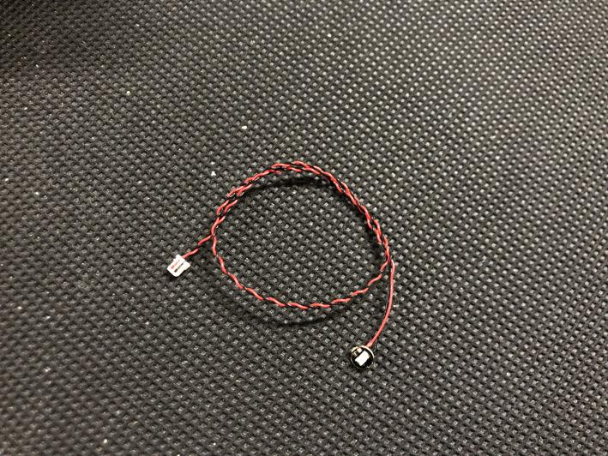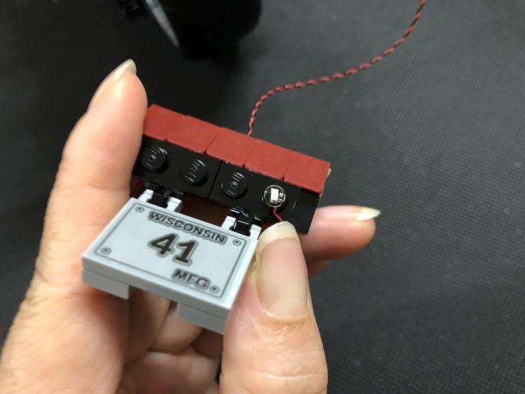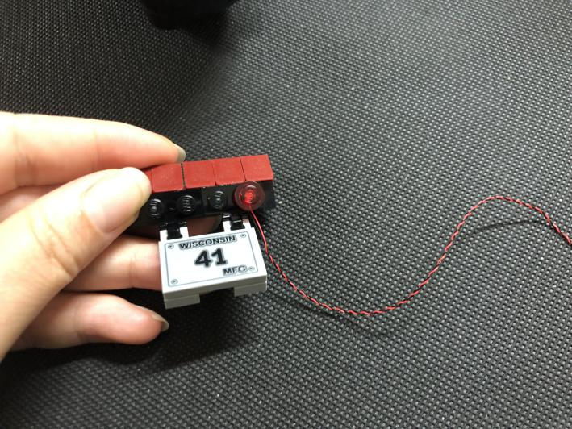
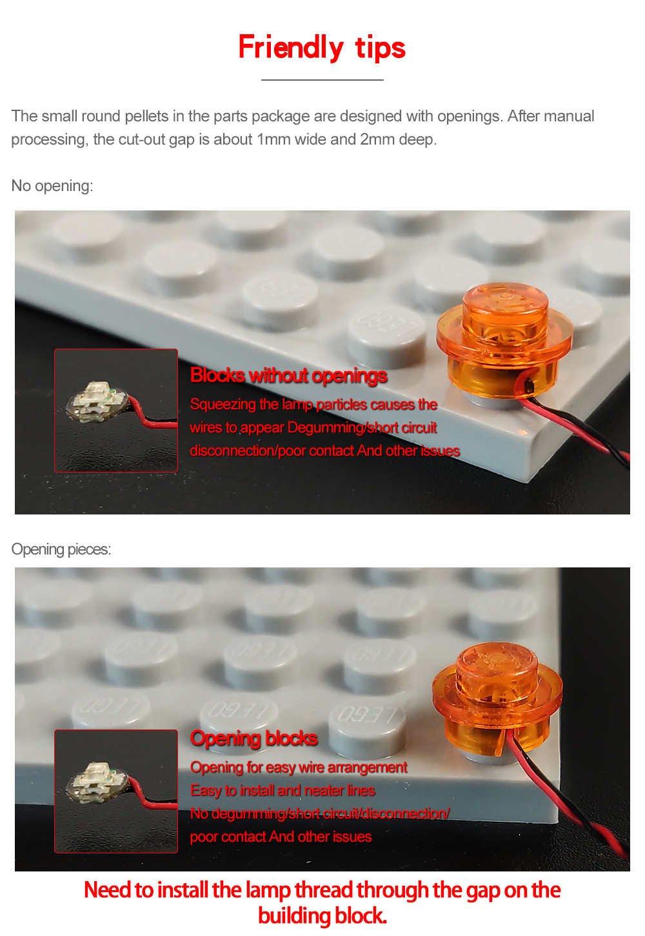
Take 3 red 15cm dot lights, 3 trans red 1x1 pieces. Repeat the steps above to install the last 3 lights
Group all the cable together
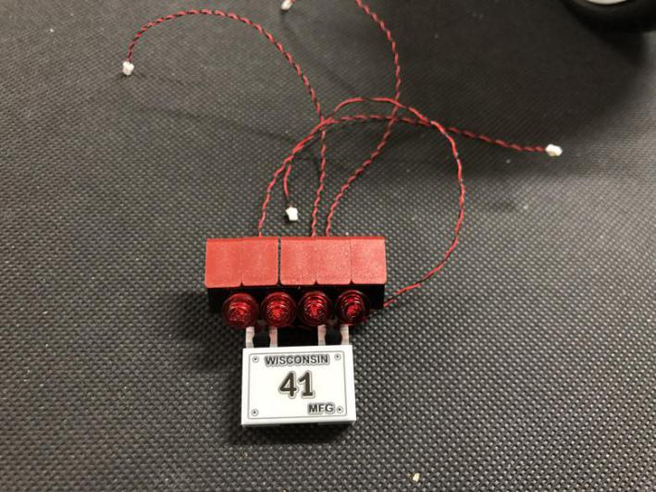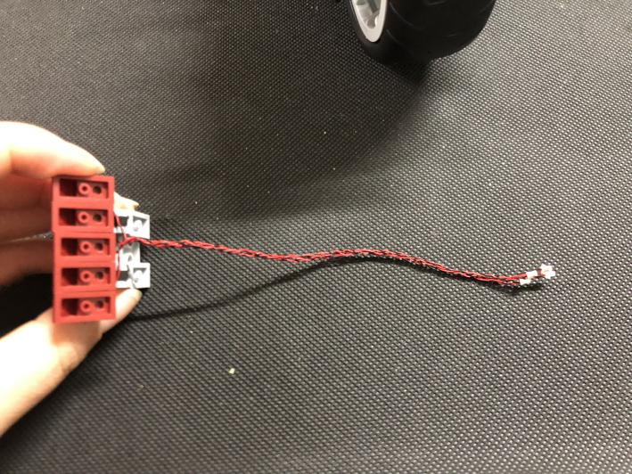
Pull the cables out from the cushion, reconnect the taillight part
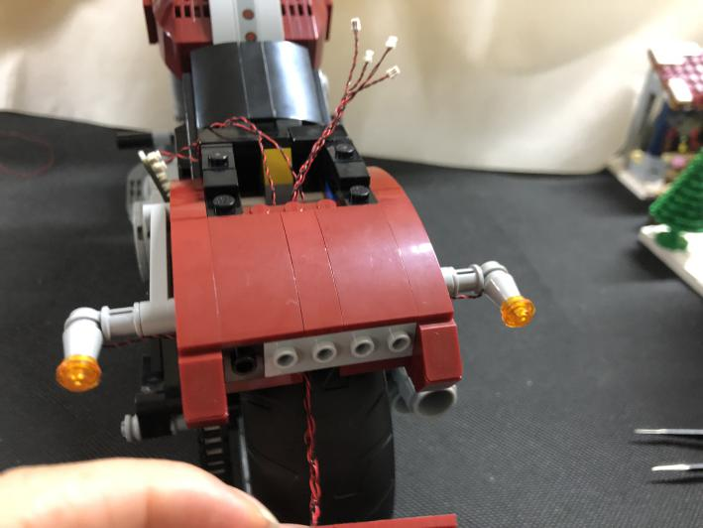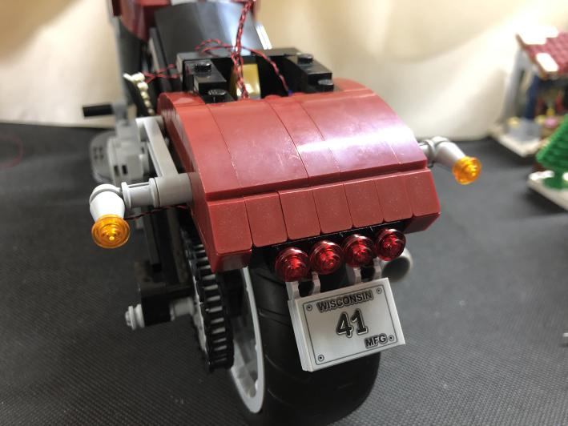
Take a 6-port expansion board, connect the 4 taillights to it
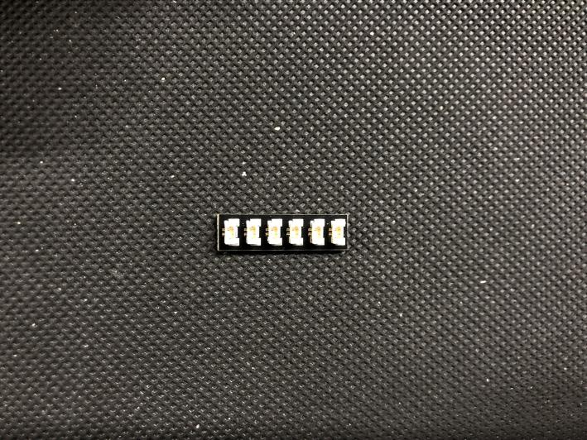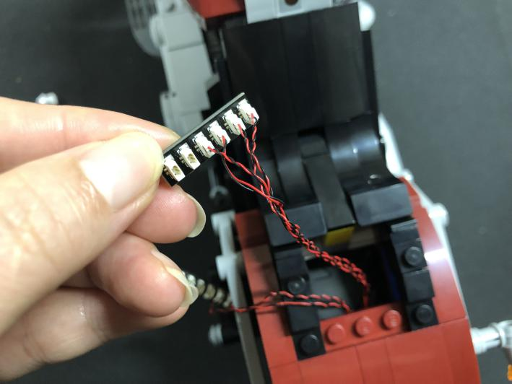
Take a 5cm connecting cable, connect it to the expansion board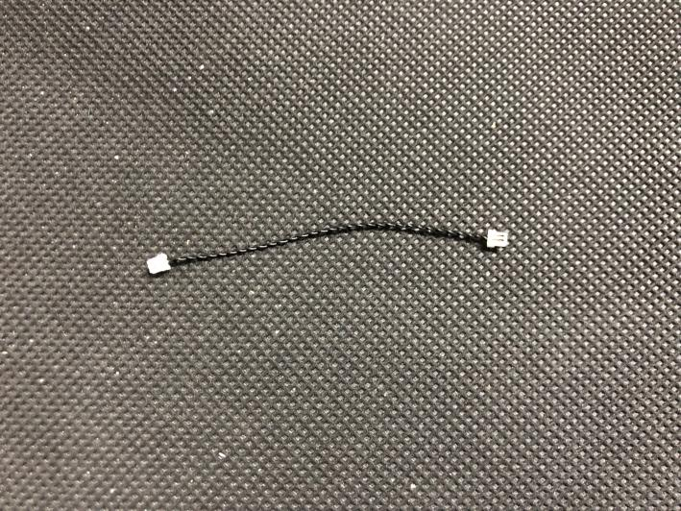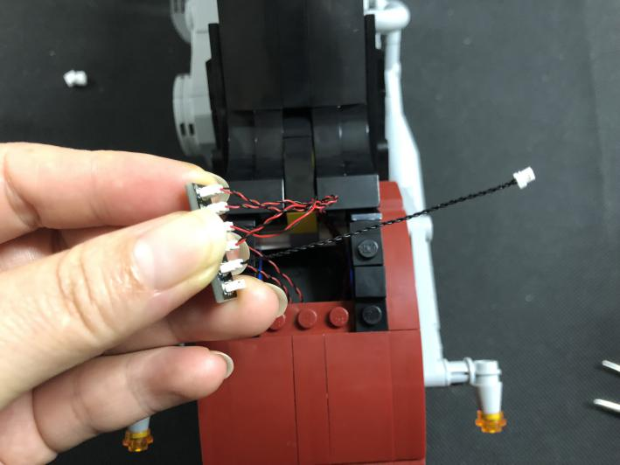
Connect the other end of the cable to another expansion board as per below
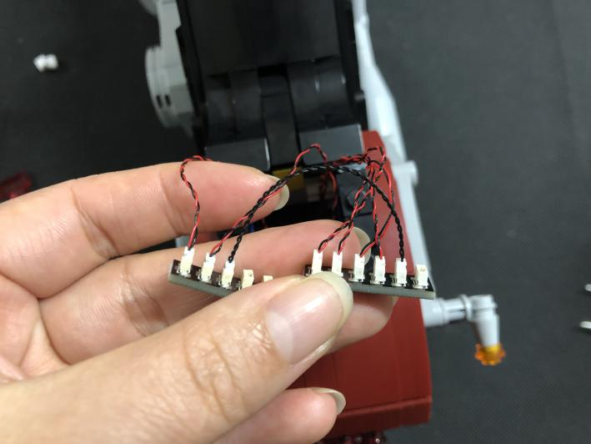
Turn the motorcycle to its side, we will install lights for the fenders at both sides
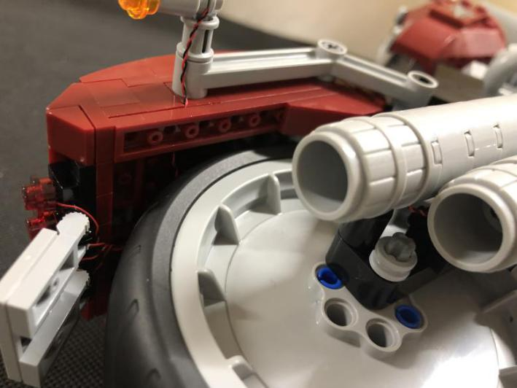
Take a blue 15cm dot light, stick it to the following place with adhesive square
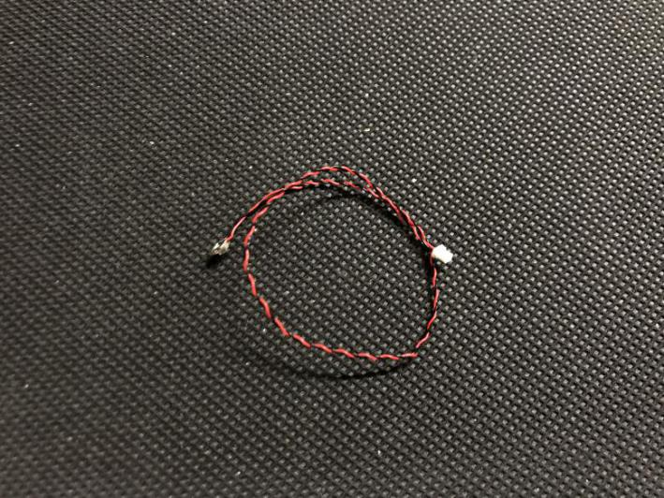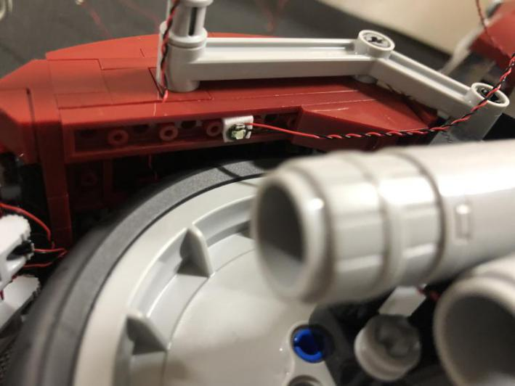
Pull the cable out from the cushion, and connect it to a expansion board
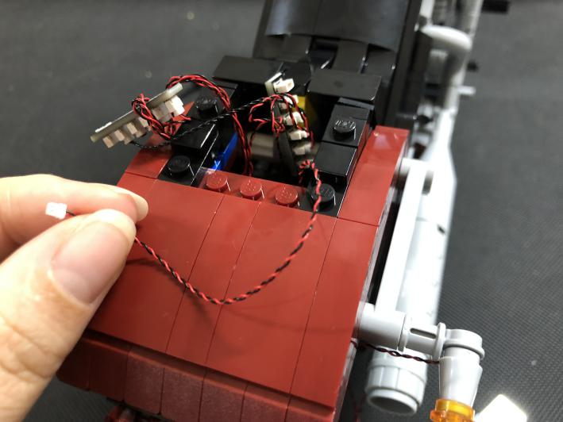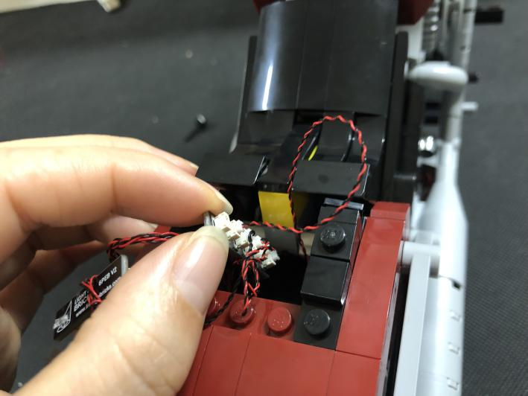
Take a blue 15cm dot light, repeat the steps above to install the other light
Take a 15cm connecting cable, connect the cables to the expansion board
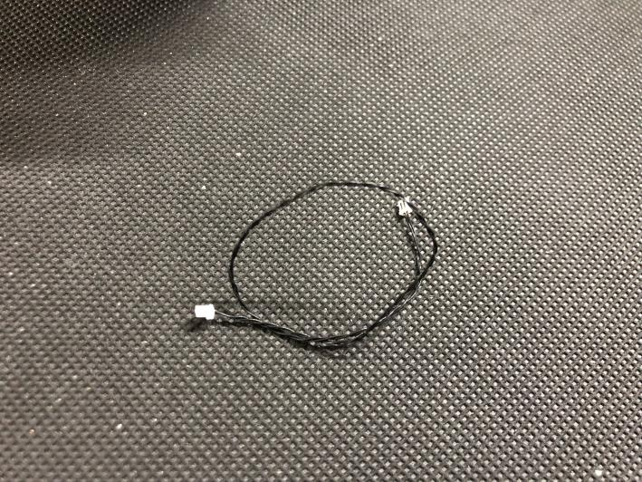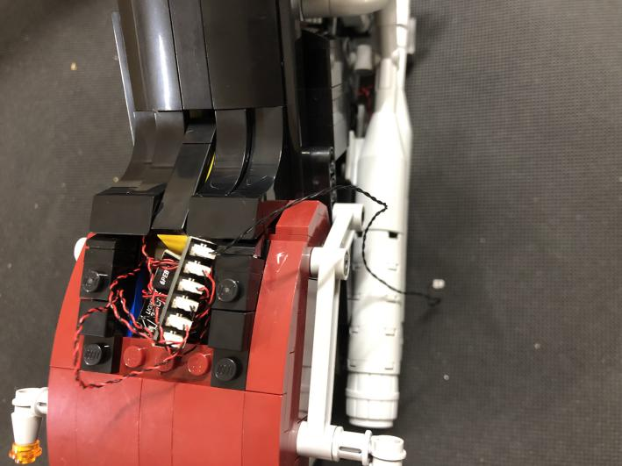
Thread the other end of the connecting cable down through the cushion, pull it out from the bottom
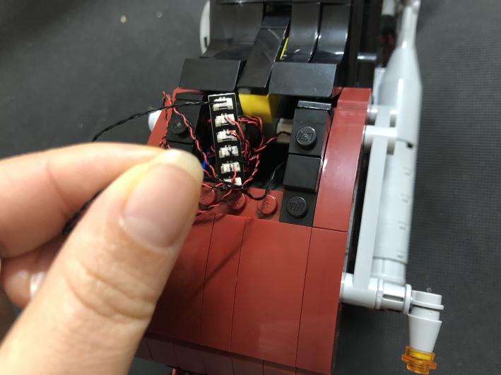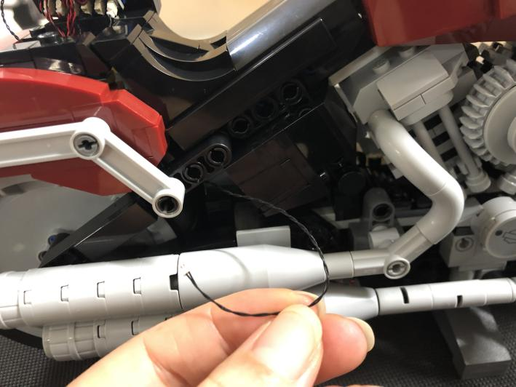
Place the cable as per below
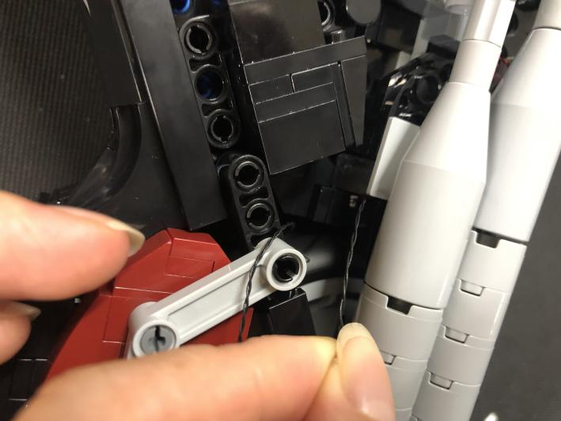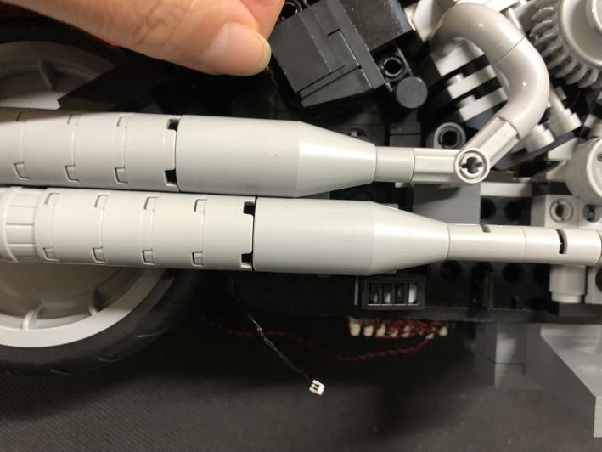
Connect the cable to the expansion board underneath
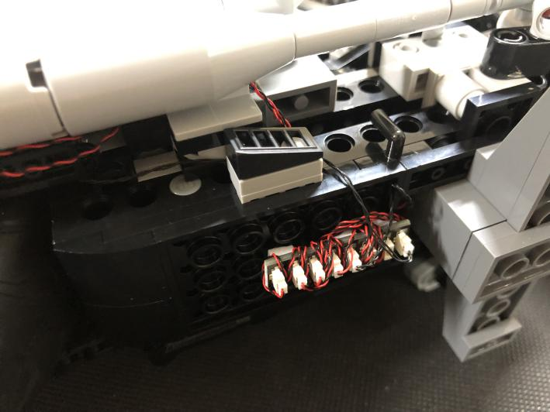
Take a USB cable, connect it to the expansion board
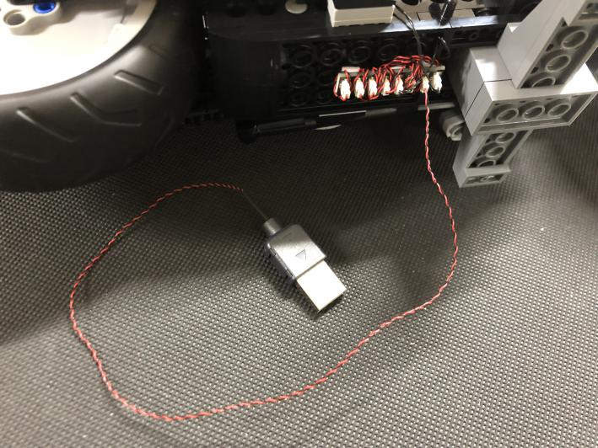
Place the 2 expansion boards underneath the cushion, reconnect the cushion
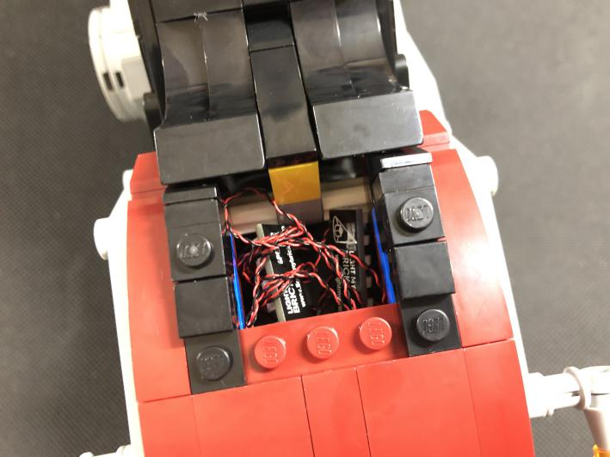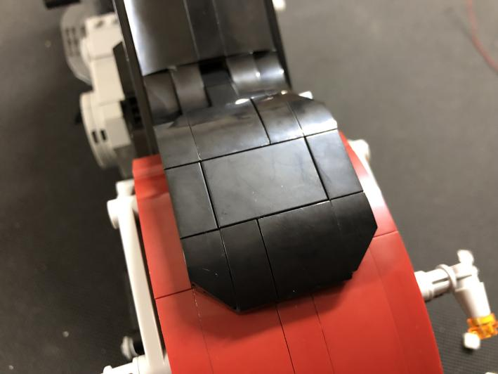

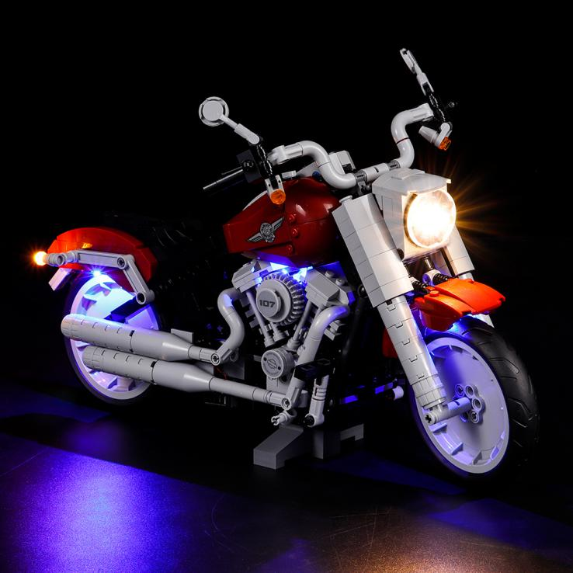
This completes installation of this LED Lighting Kit. ENJOY!

