Winter Village Cottage 10229 Lighting Kit

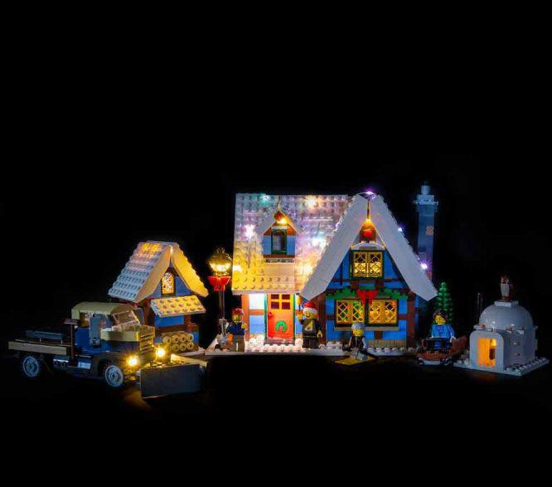

The following page is the instructions for the Winter Village Cottage (10229) LED light kit.

If you run into any issues, please refer to the online troubleshooting guide.

To ensure a trouble-free installation of your light kit, please read and follow each step carefully.

Package Contents:

5x White 30cm Bit Lights 12x White 15cm Bit Lights 3x White Strip Lights
1x Multi Colour Light String 4x 6-Port Expansion Board 1x 8-Port Expansion Boards 1x Flicker Effects Board
2x 5cm Connecting Cable 2x 15cm Connecting Cables 3x 30cm Connecting Cables
1x AA Battery Pack (requires 3x AA Batteries)
1x Flat Battery Pack (requires 2x CR2032 Batteries) 8x Adhesive Squares

Pieces:

2x Trans Clear Round Plate 1×1 1x Trans Orange Round Plate 1×1 5x White Plate 1×4
2x Plate 1×6 (any colour)

Note:
Place wires on the surface or under the building blocks.
The wire can be place between the building blocks or under the block, but they should be placed between the studs correctly.
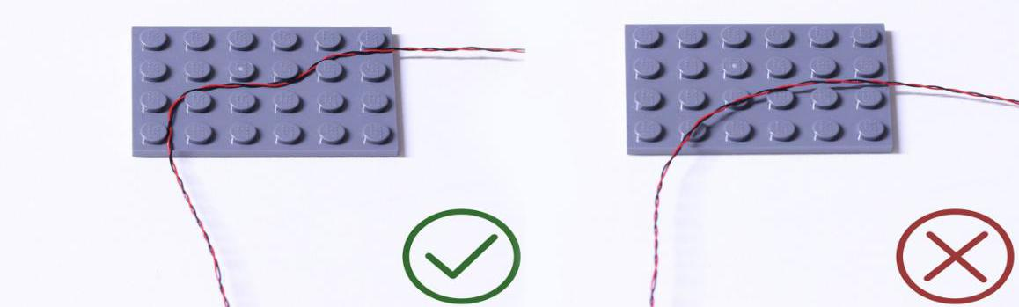
Insert the connectors to the ports.

Be careful when you are operating, there’s only one correct way to insert, make sure the expansion board is upward, find the soldered “=” sign on the left of the port. When you are inserting, the side which the wires can be seen should be faced to the “=” sign and if you feel hard to insert, please stop, and don’t force it, for that may result in bent pins inside the port or overheating of the expansion board.
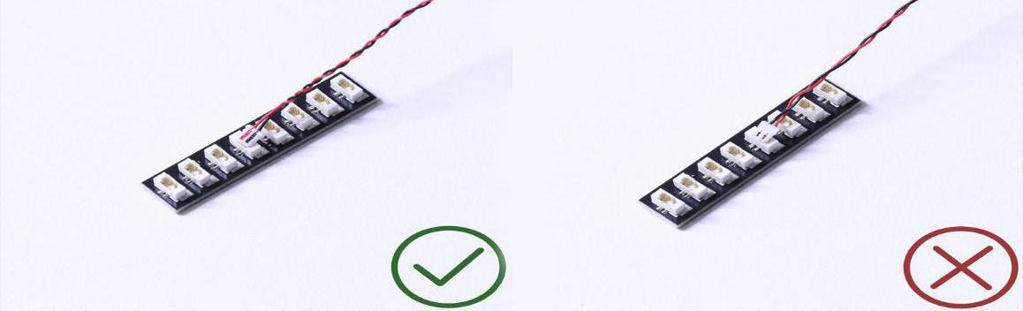

At this point, use the tweezers to straighten the bent pins.

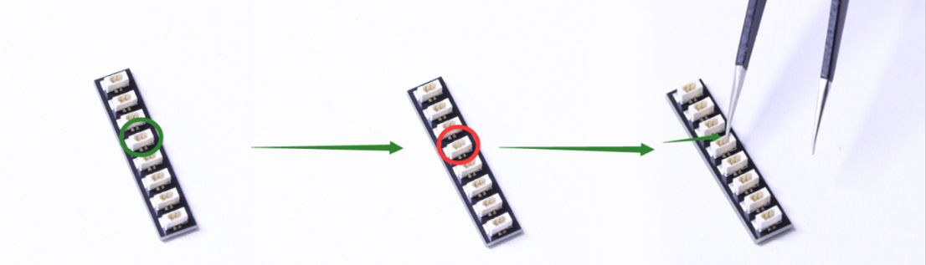

When installing dot lights, make sure they are correctly placed (Yellow LED package is exposed). You can put they either on the top of the studs or between studs.

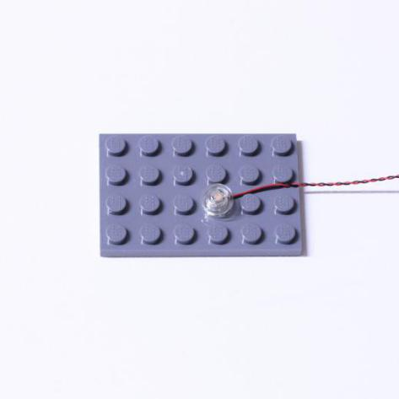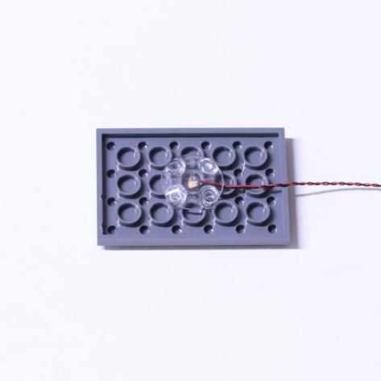

Connecting cable connectors to Strip Lights

Take extra care when inserting connectors to ports on the Strip Lights. Connectors can be inserted only one way. With the Strip Light facing up, ensure the side of the connector with the wires exposed is facing down. If a plug won’t fit easily into a port connector, don’t force it. Doing so will damage the plug and the connector.
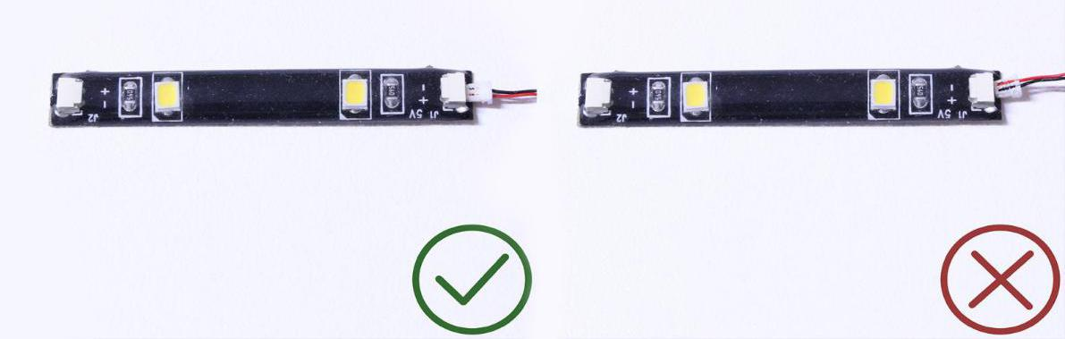

Finally, please pay attention to the positive and negative terminals of the battery when installing the battery case.

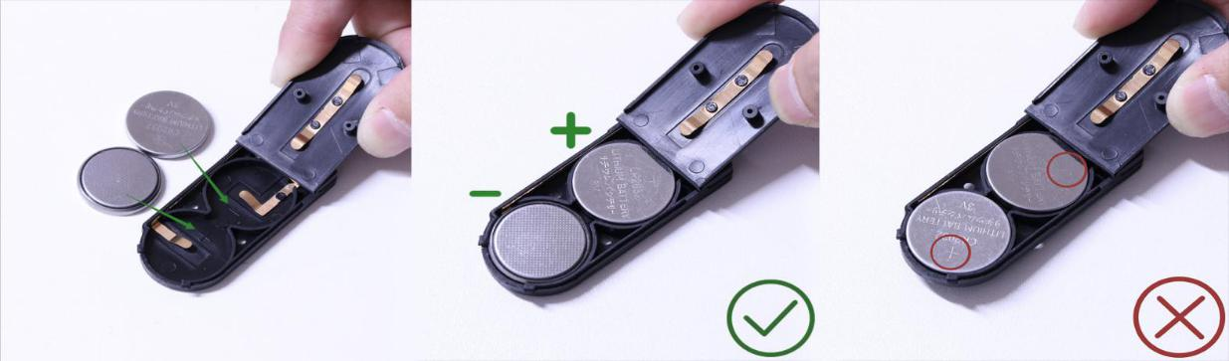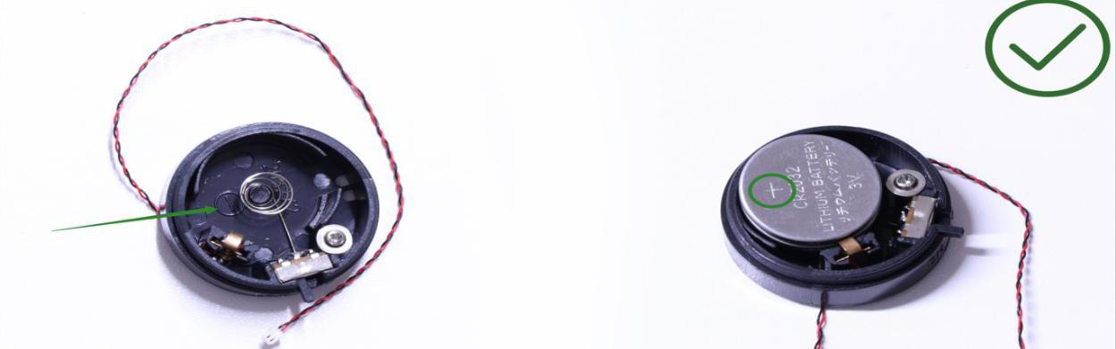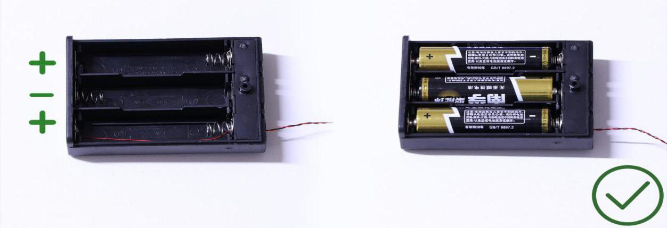
OK, Let’s Begin!

Installing lights to the Snow Truck

1.) We will first install head lights to the Snow Truck. First disconnect the headlight section from the front, then remove the trans clear round tiles.

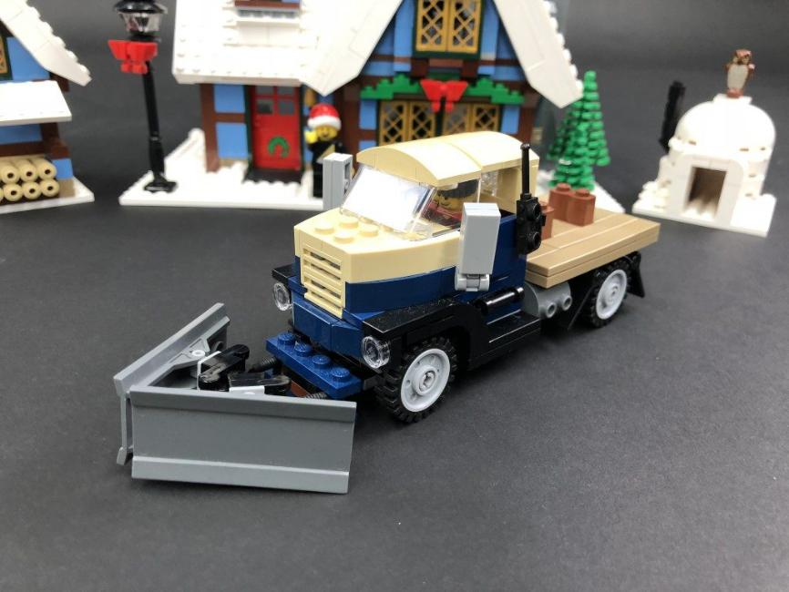

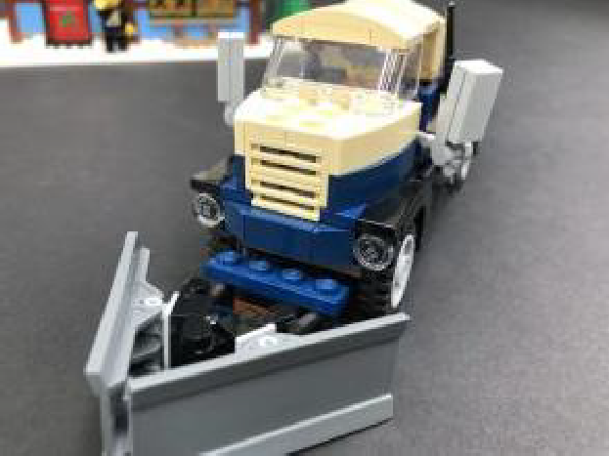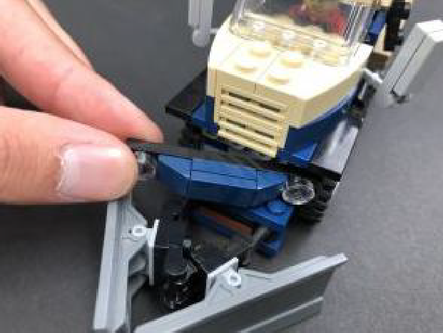

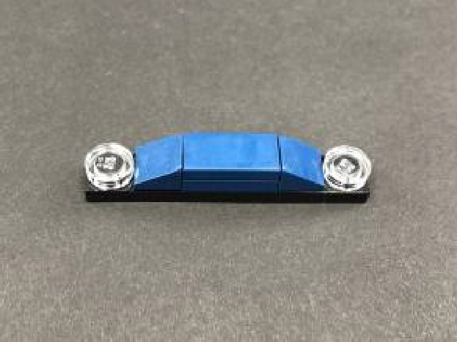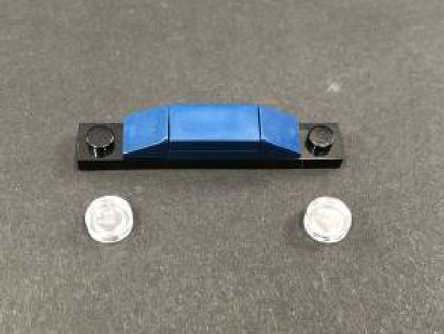

Take a White 15cm Bit Light and with the cable facing down, place it over the top of the left black stud. Secure the Bit Light in place by connecting a provided Trans Clear Round Plate 1×1 over the top.
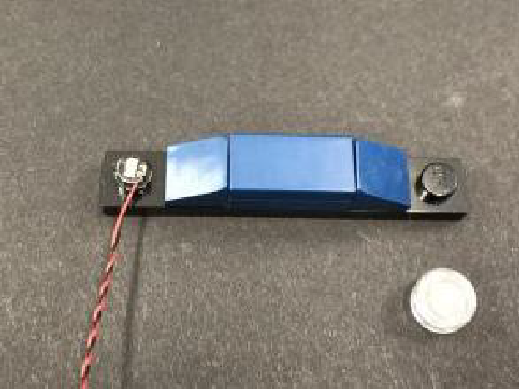
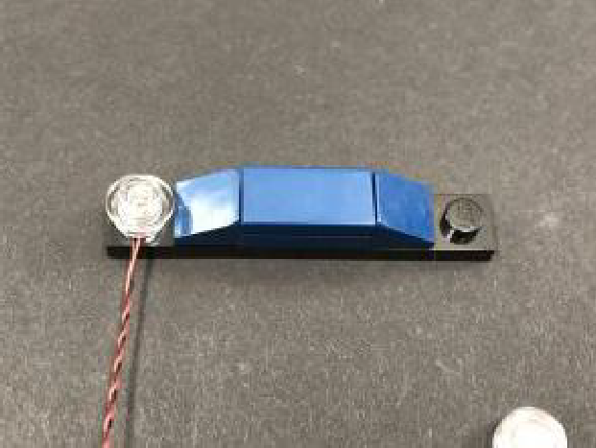

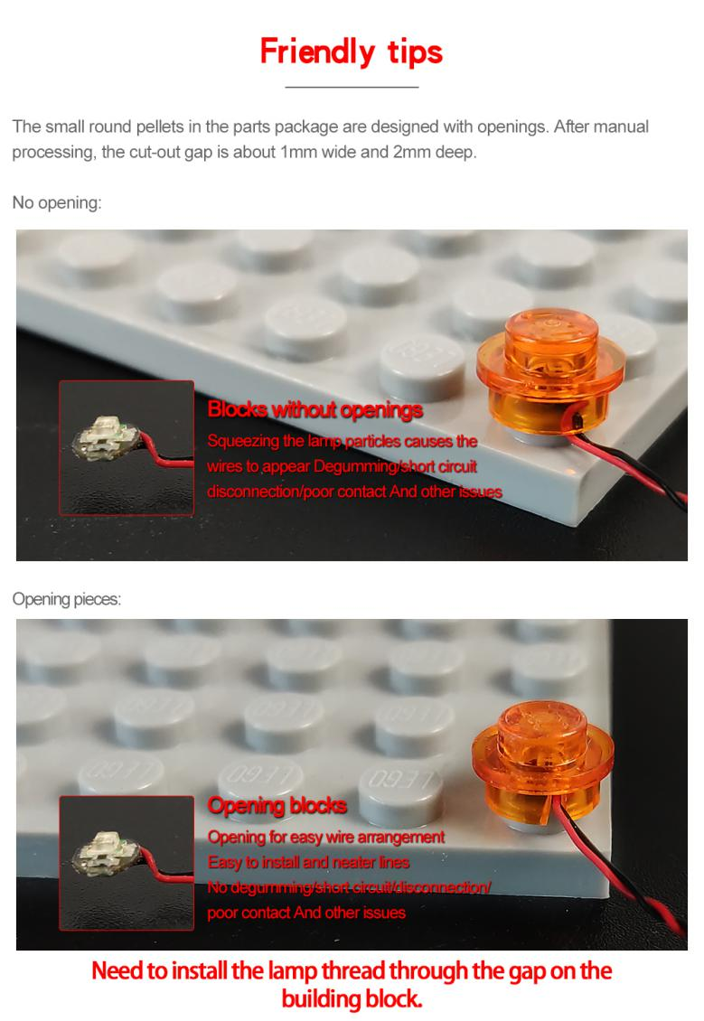2.) Repeat previous step to install another White 15cm Bit Light to the other side using another Trans Clear Round Plate 1×1 to secure it in place, then reconnect this section back to the front of the truck.
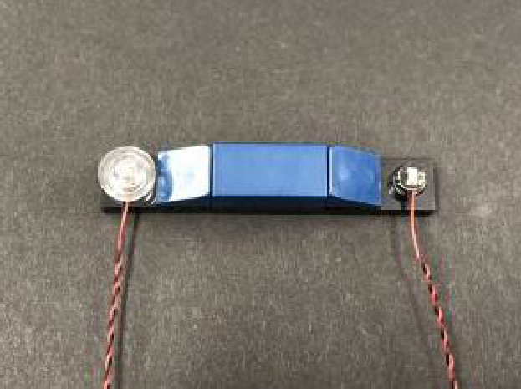
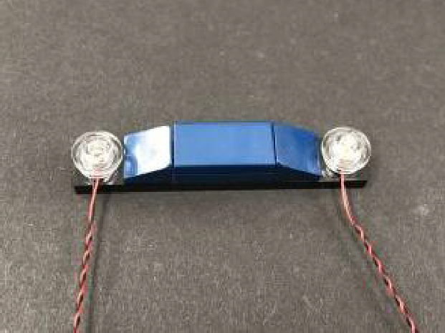

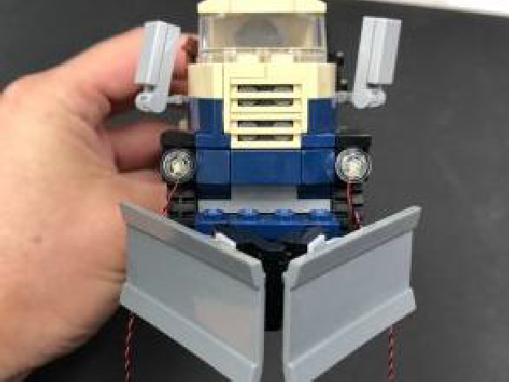

3.) Turn the truck onto it’s side, then pull each cable behind the front wheel. Repeat this step to pull the cable on the other side over the wheel.
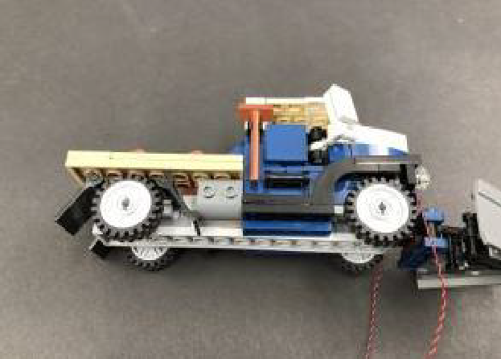
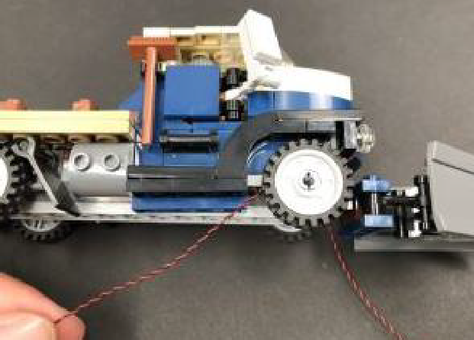

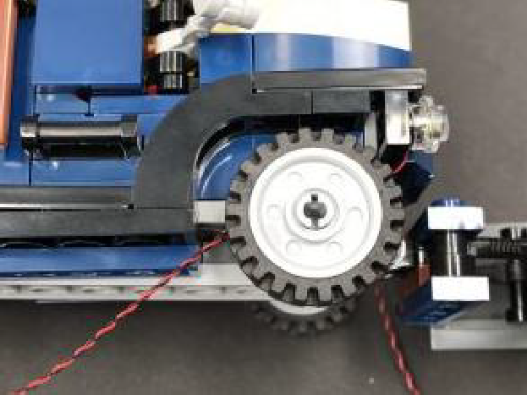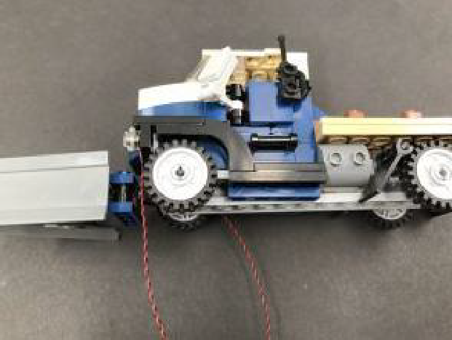

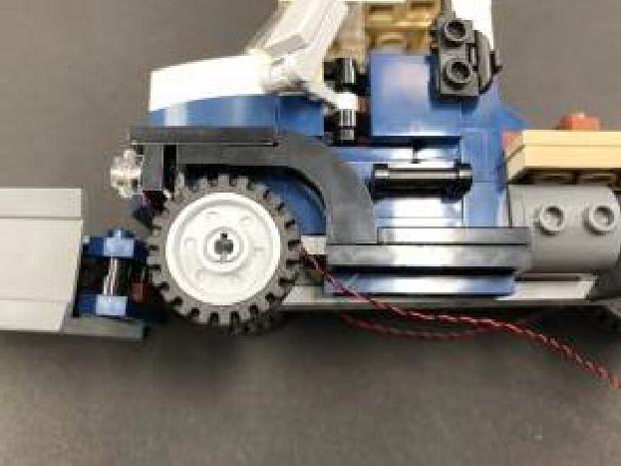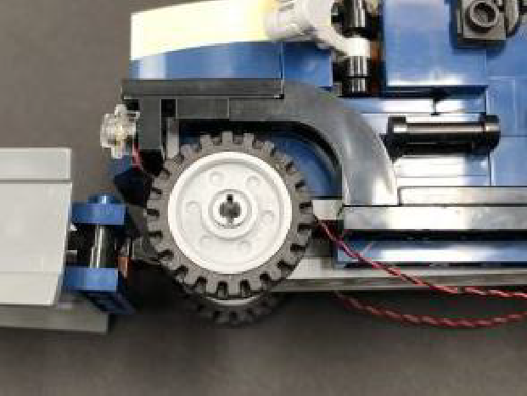

4.) Flip the truck over and bring each cable toward the back and secure them underneath the dark blue 1×4 plate on each side. Ensure the cables are laid in between studs underneath each dark blue plate.
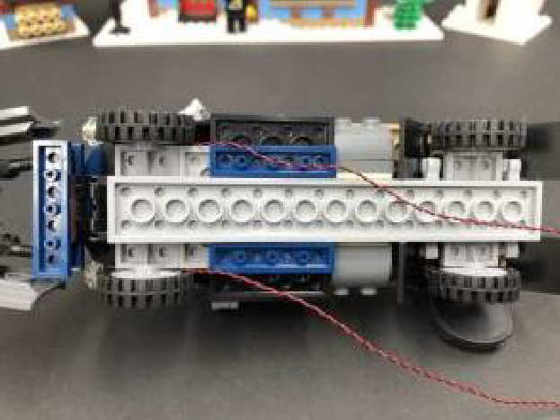
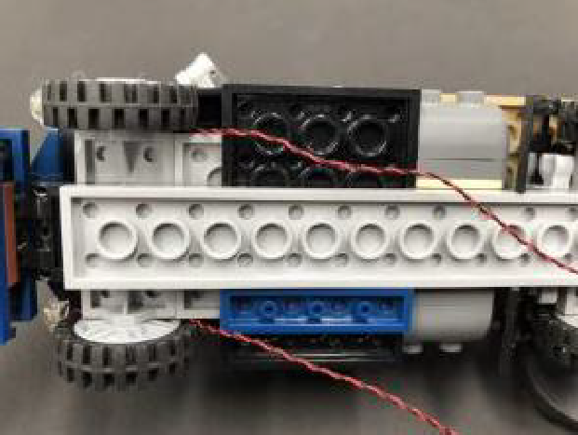

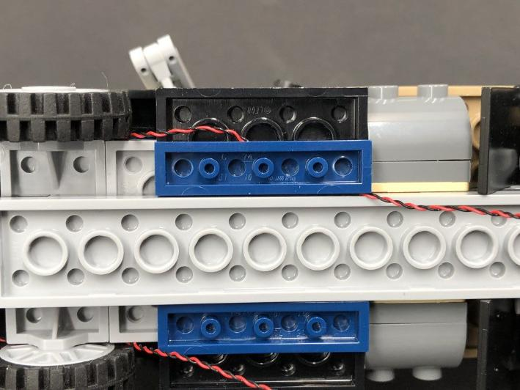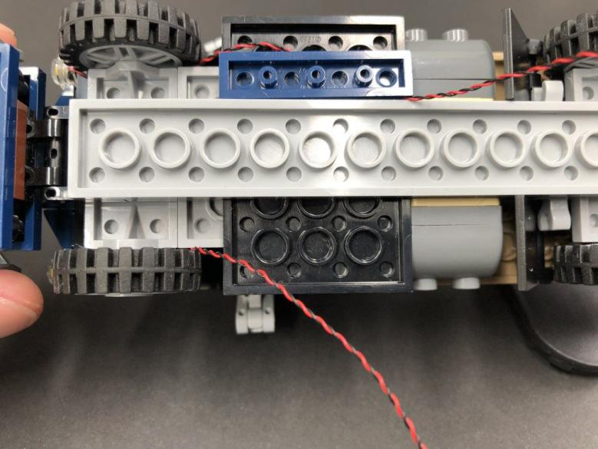

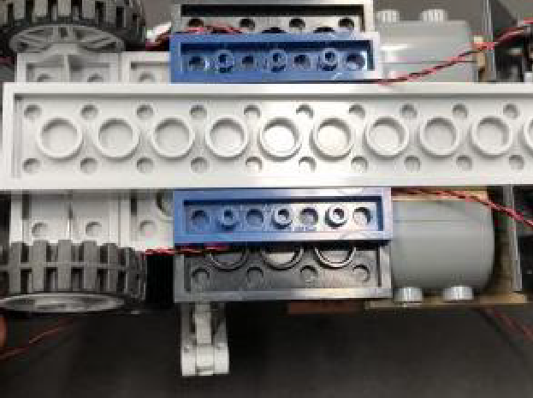

5.) Take out a 6-Port Expansion Board and connect both Bit Light cables to it, then take the Flat Battery Pack and insert 2x CR2032 Batteries to it. Connect the Battery Pack cable to the expansion board and turn ON to verify the headlights are working OK.
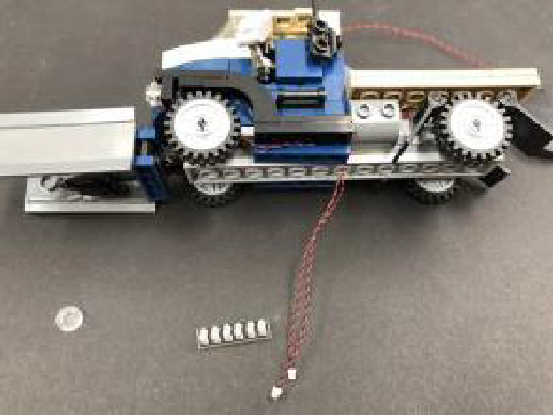
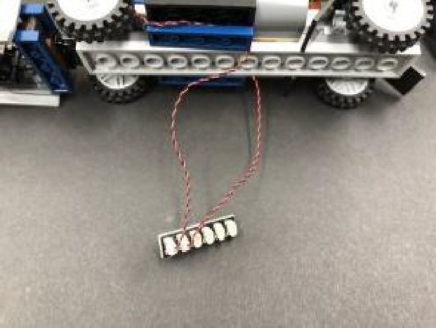

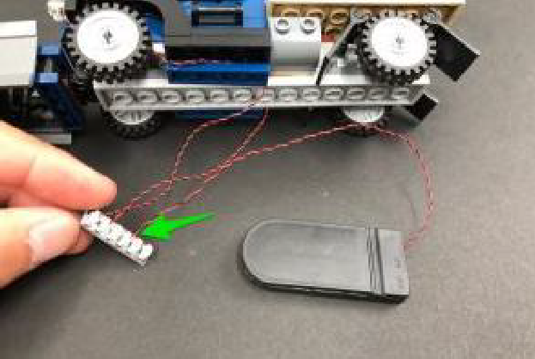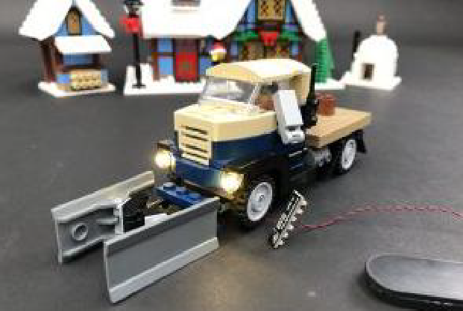
6.) With the truck flipped onto it’s right side, disconnect the rear left wheel.

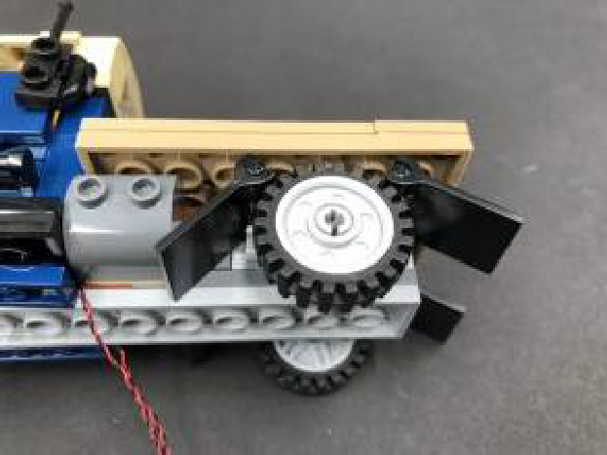
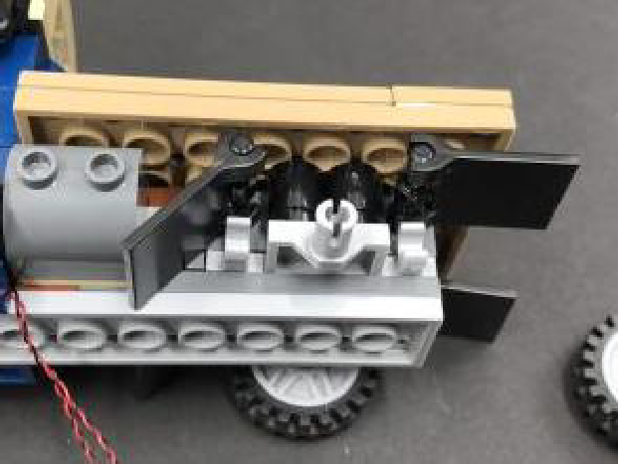

Stick 2x Adhesive Squares onto the back of the expansion board, then mount it on the side behind the wheel. Reconnect the wheel as shown below:
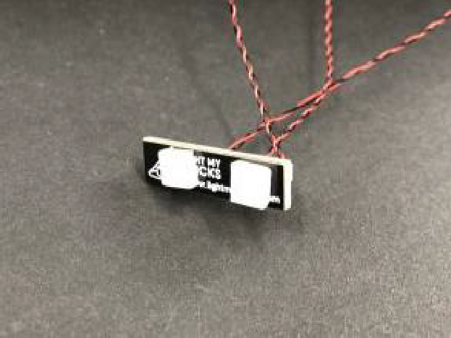
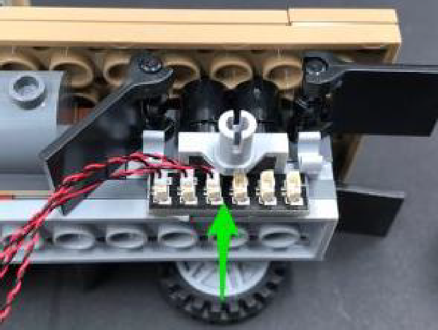

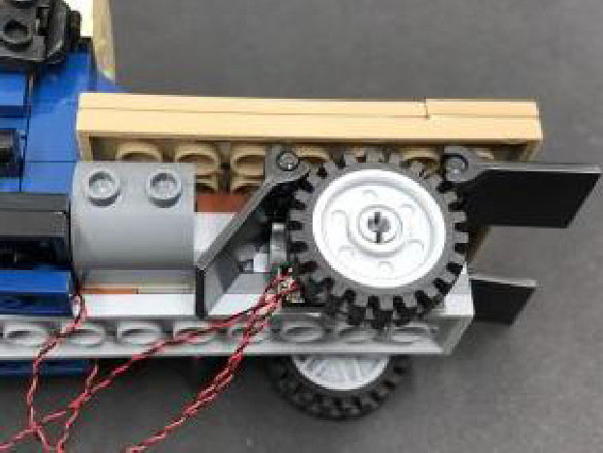
7.) Turn the truck back over and disconnect the two brown bricks on the trailer. Take 2x Adhesive Squares and stick them to the below positions, then disconnect the tan 1×6 tile just below.
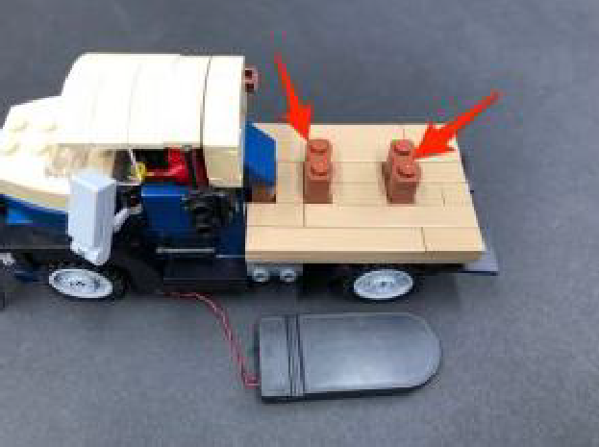
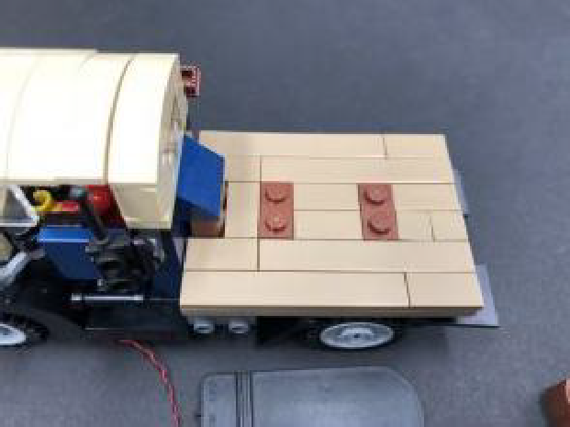

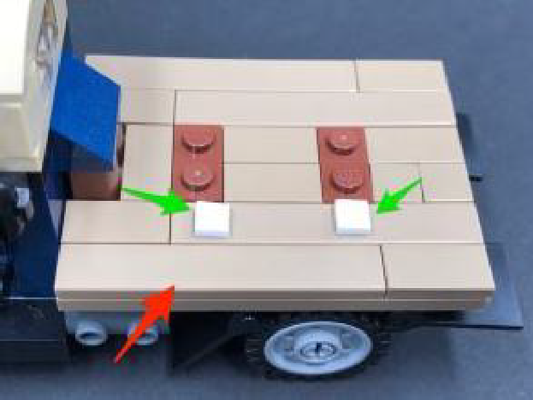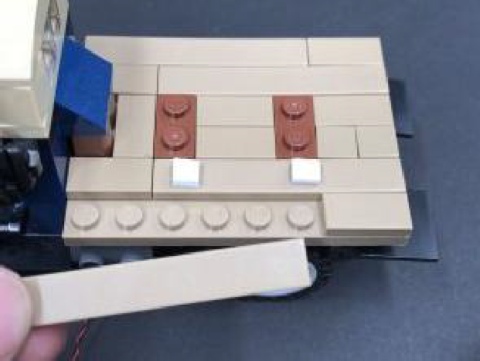

Stick the Flat Battery Pack onto the back of the truck, ensuring the switch is at the back, then lay the battery pack cable in between studs before reconnecting the tan 1×6 tile over the top.
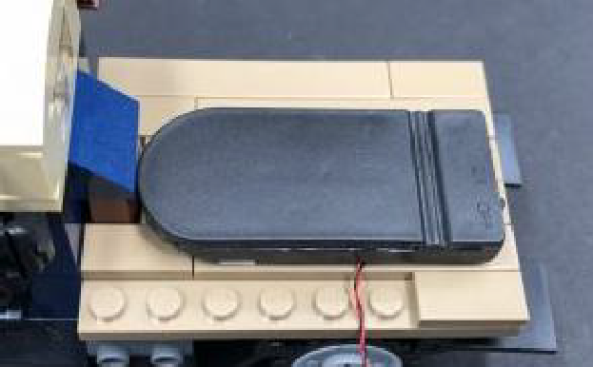
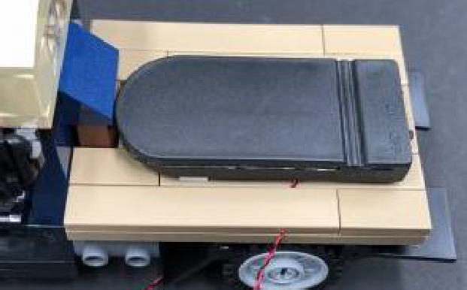


8.) Bring the Battery Pack cable down the side of the trailer, then disconnect the light grey brick and lay the cable underneath in between studs before reconnecting the brick over the top.
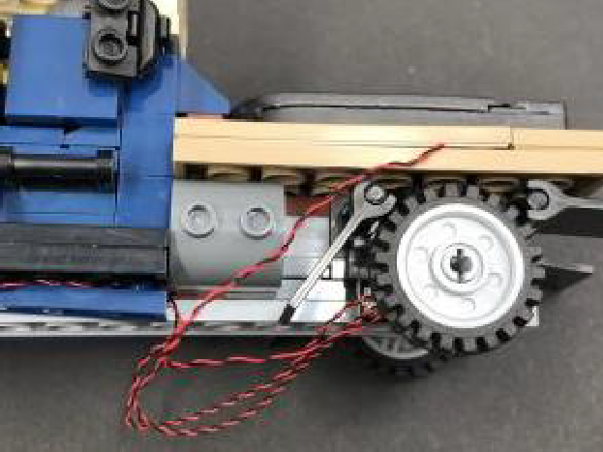
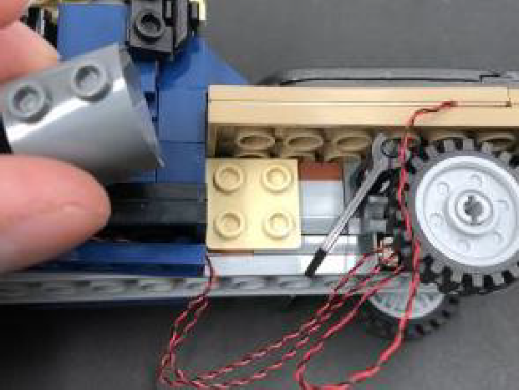

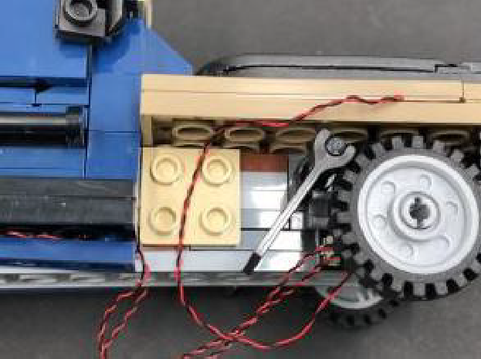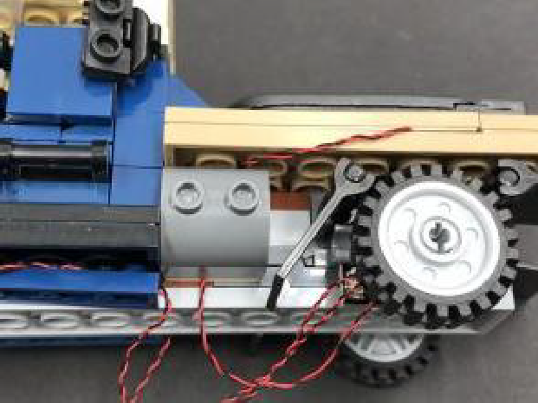

9.) Clean up any excess cables underneath the truck by laying them underneath the dark blue plates as shown below:
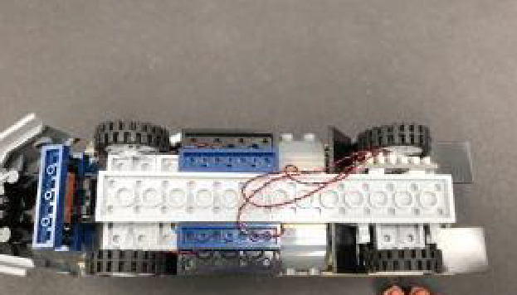
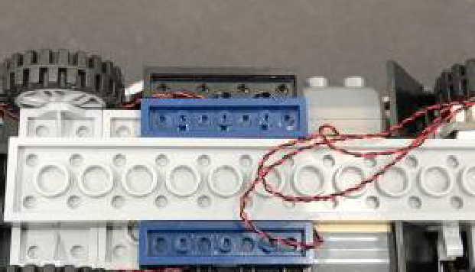
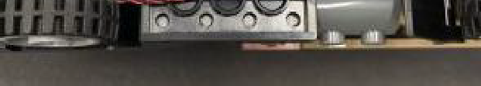

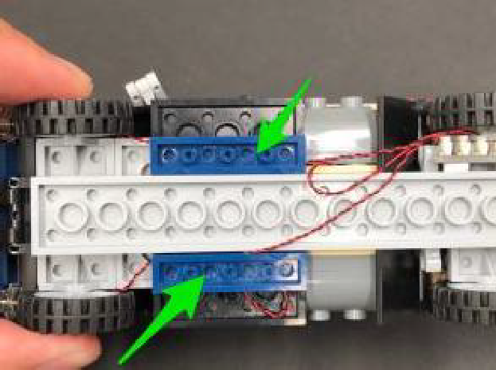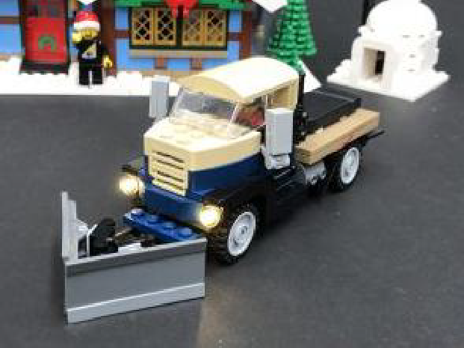

This completes installation of the lights for the winter village cottage truck.

Installing Lights to the Fire Station and external sections.

1.) We will first install a light to the igloo. First take this section and remove the roof, then disconnect the back left corner wall sections as shown below:
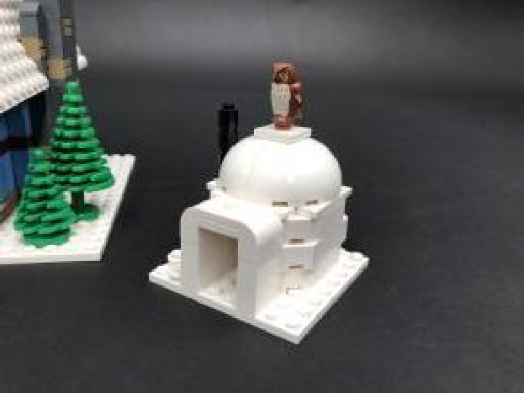
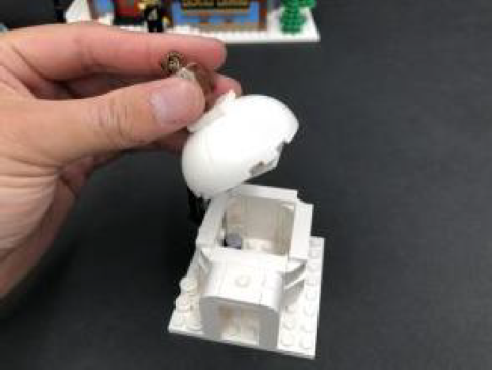

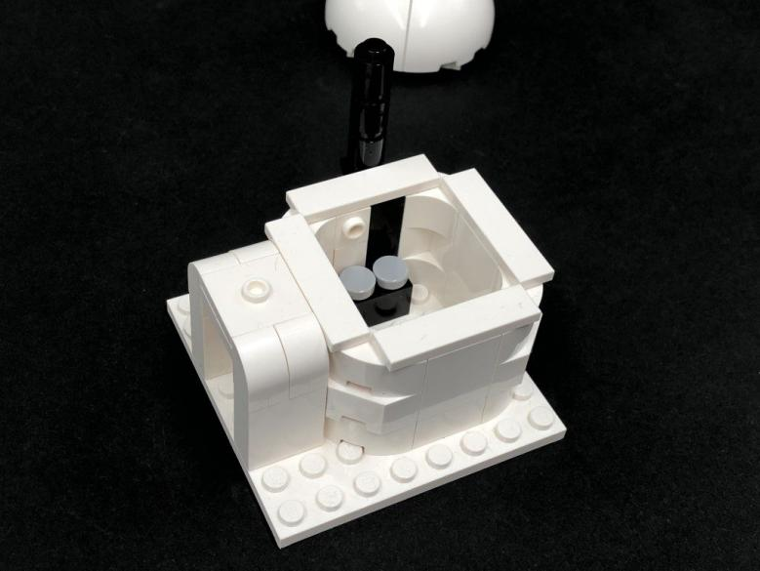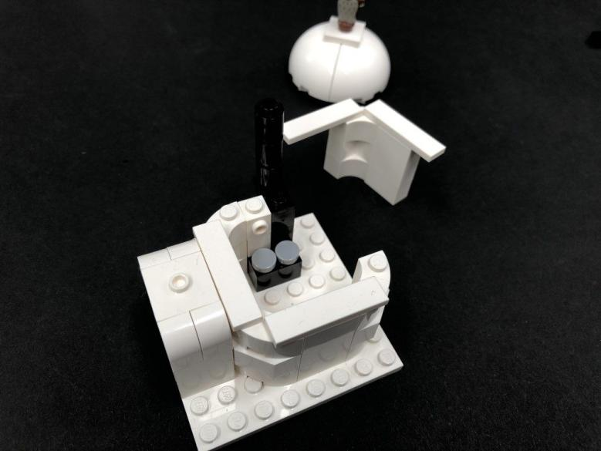

2.) Disconnect one of the light grey tiles from the stove then, take a White 30cm Bit Light and place if over the top of the black stud. Secure the Bit Light in place by connecting a provided Trans Orange Round Plate 1×1 over the top.
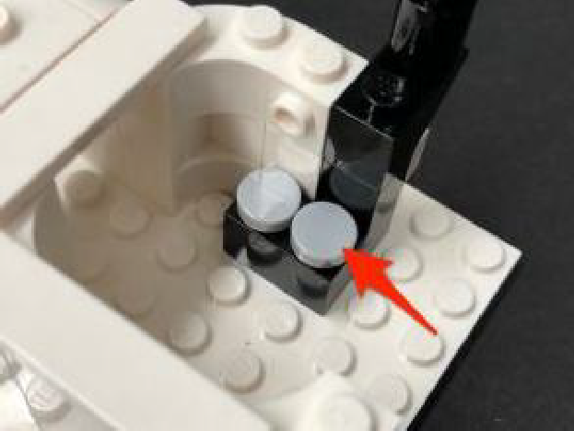
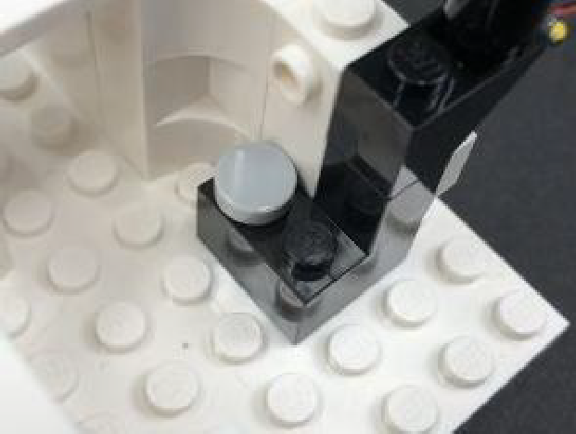

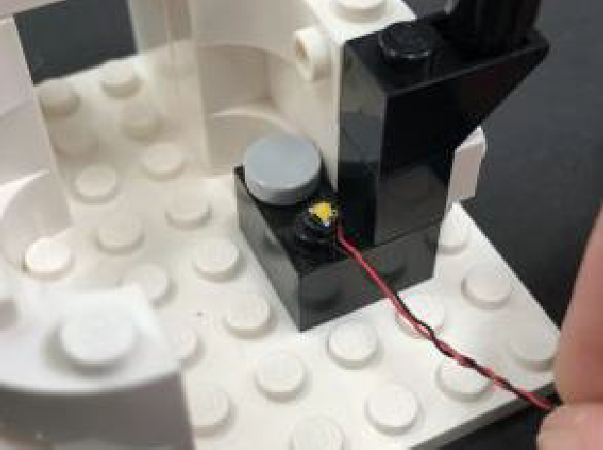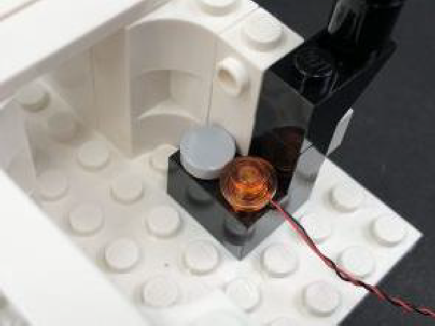

Ensure the cable is laid down in between studs before reconnecting wall sections over the top, then reconnect the roof and place aside as we will connect this to the cottage at a later stage.
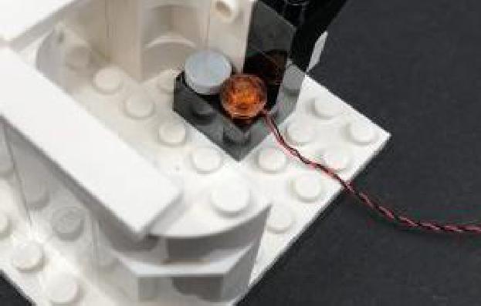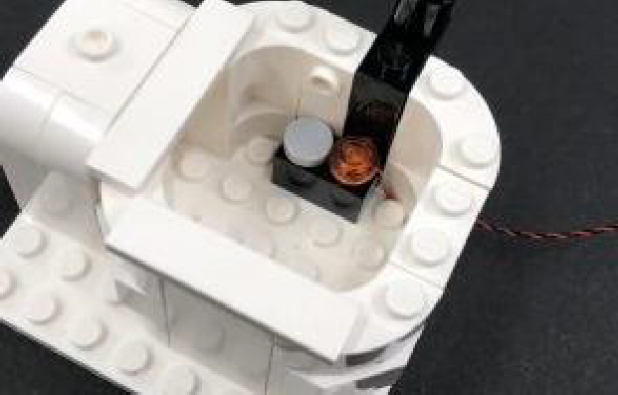

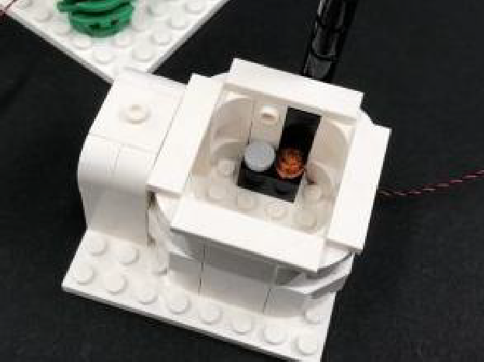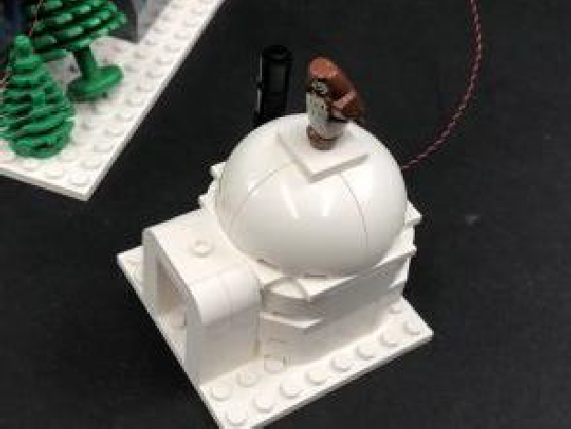

3.) We will now install a strip light to the tool cabin. First take this section and lift up the roof sections. Take a White Strip Light and using it’s adhesive backing, stick it to the base of a provided Plate 1×6.
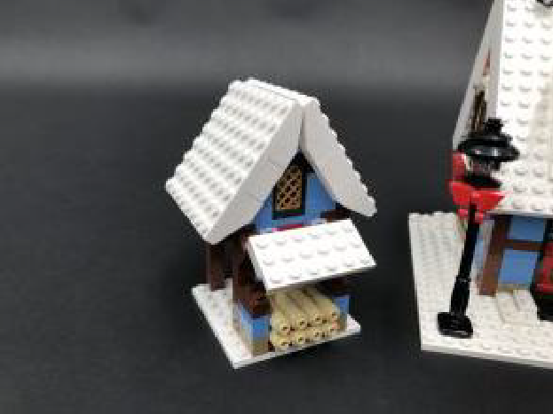
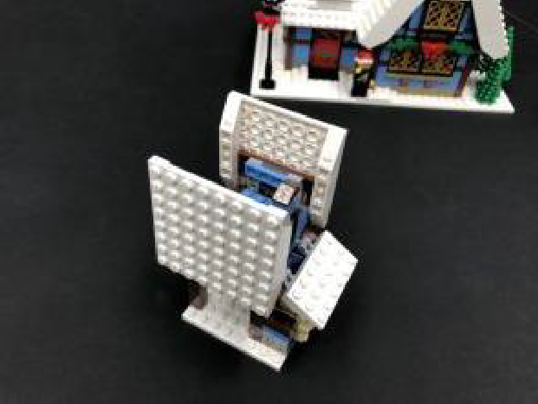

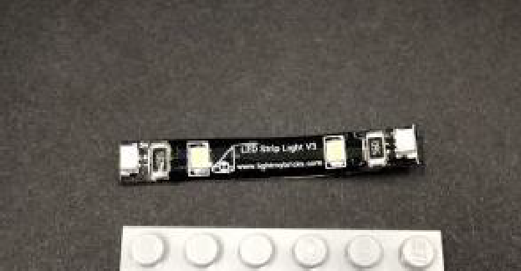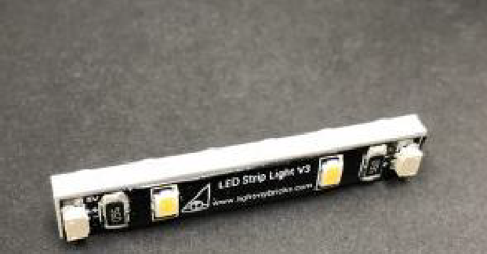
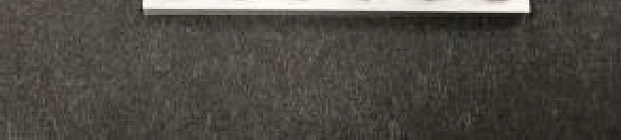

Take a 30cm Connecting Cable and connect it to the Strip Light’s left port, then with the cable facing the back, mount the strip light to the right roof section as shown below:
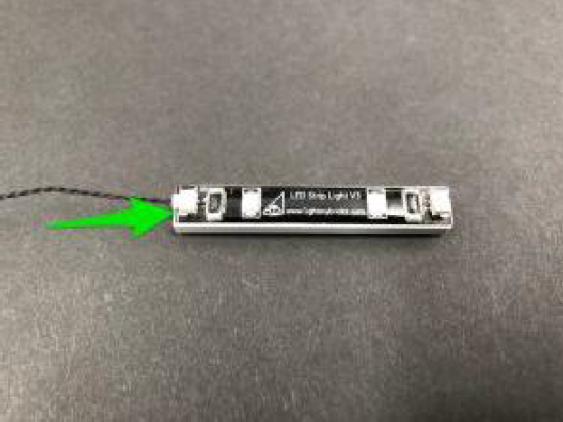
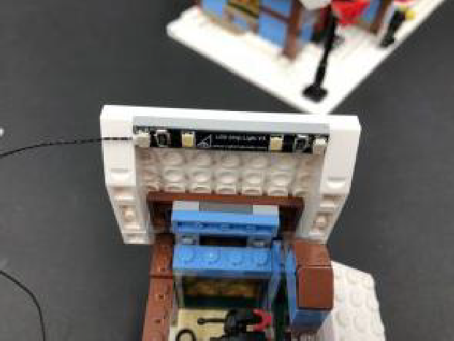
Secure the cable underneath the following brick then place the cabin on the
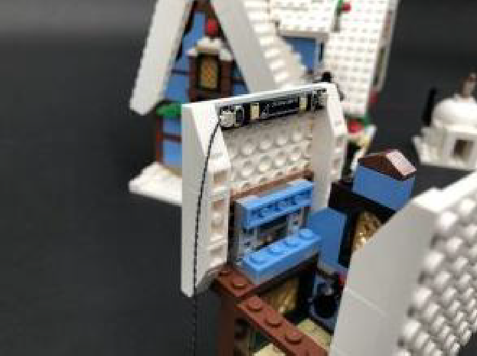
left side of the cottage. We will connect up the cable at a later stage.
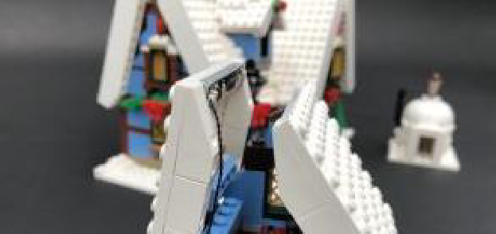
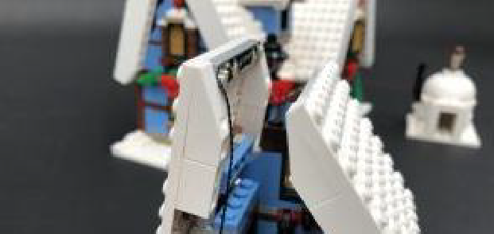
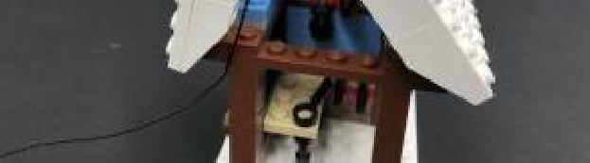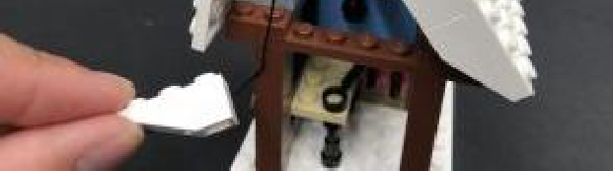

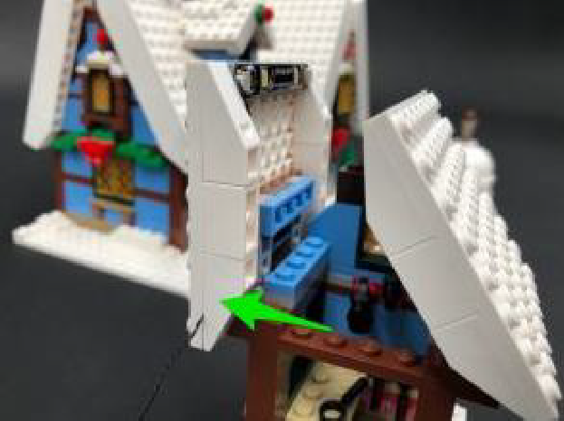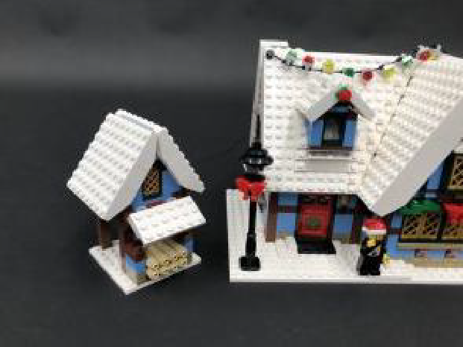

4.) We will now light up the cottage starting with the lamp post. First disconnect the lamp post, then disconnect and disassemble to the top section.
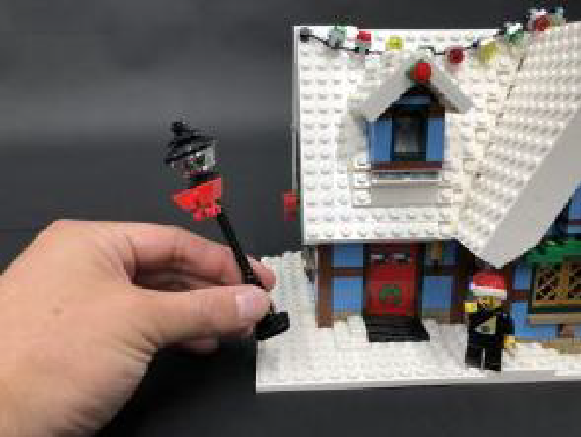
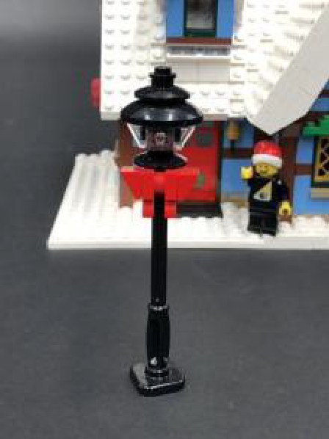

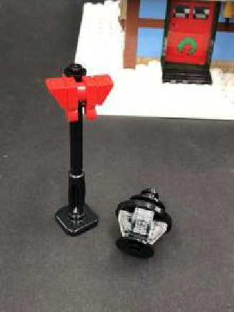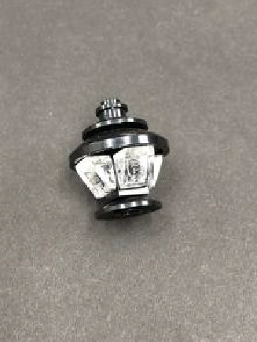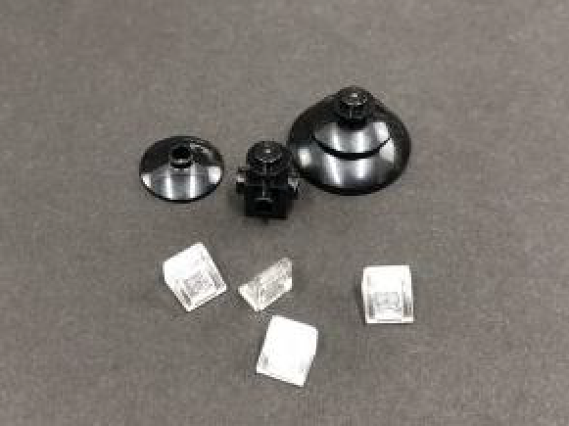
5.) Take a White 30cm Bit Light and thread the connector end of the cable through one of the side holes of the black brick, then out the bottom as shown below:
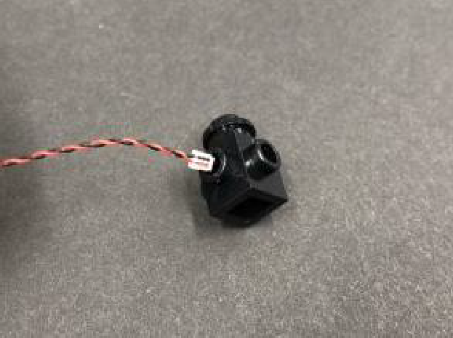
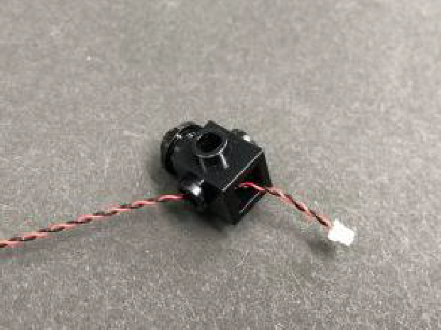
Thread the Bit Light all the way through, then carefully push the bit light so that it sits flat against the edge of the hole. Secure the Bit Light in place by reconnecting the trans clear triangular piece over the top.
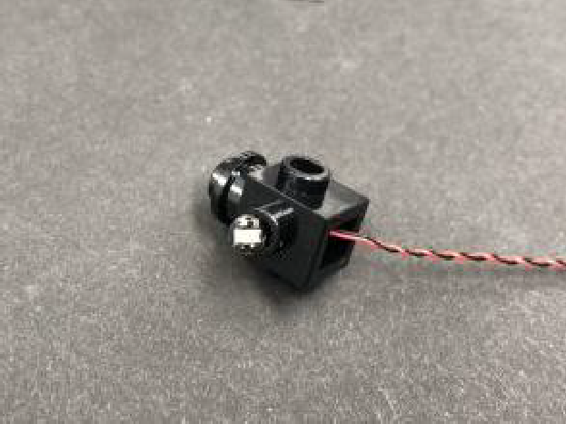
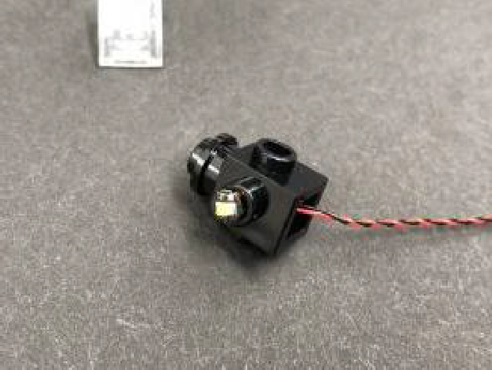

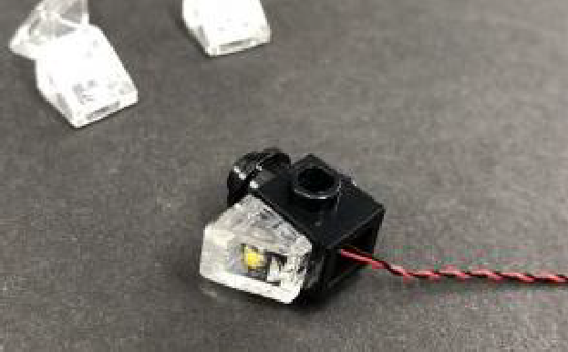


6.) Take another White 30cm Bit Light and bend the cable in a ‘hook’ shape, then thread it through hole on the opposite side of the black brick and out the bottom. Flatten the bit light against the edge of the hole then reconnect the trans clear triangular piece over the top.
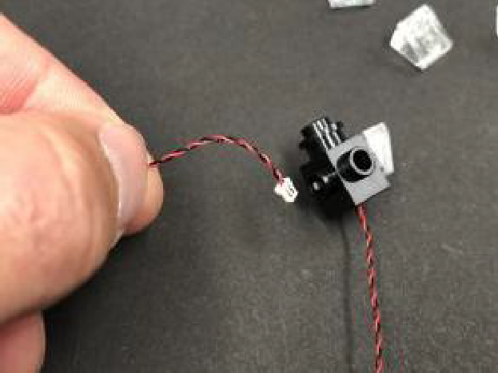
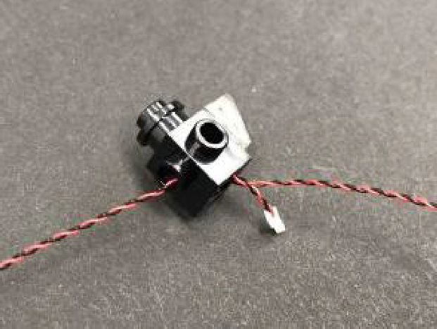

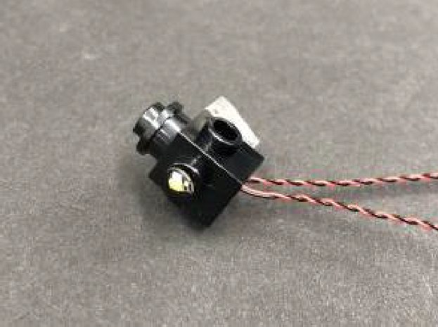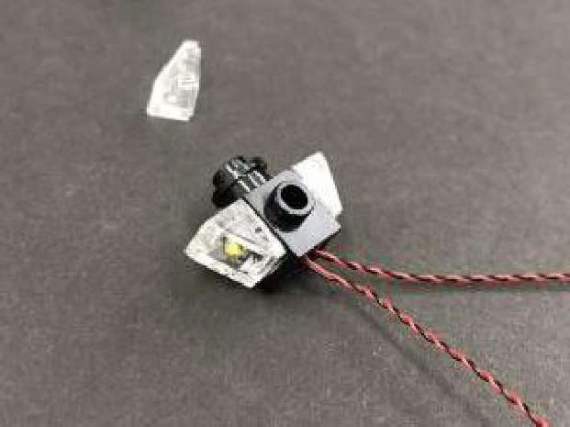
Repeat the same process to install one more White 30cm Bit Light to the middle hold of this section.
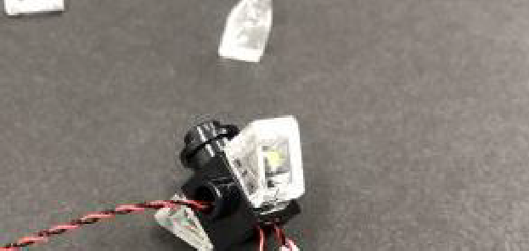
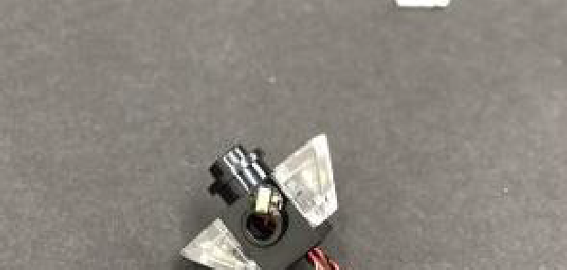
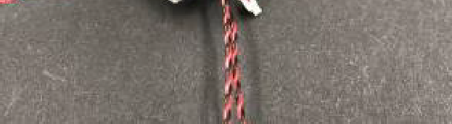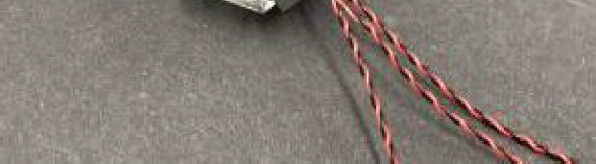

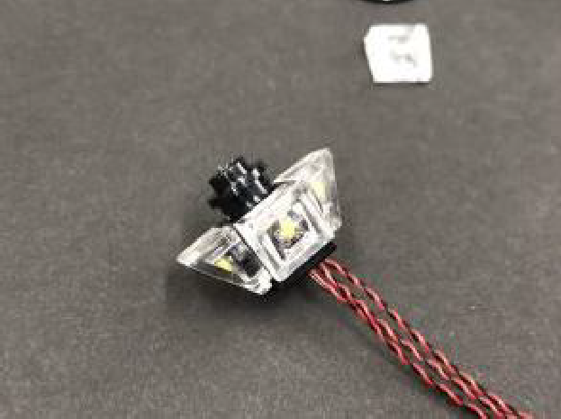

Turn this section to the back and reconnect the remaining trans clear piece (without light underneath). The reason we are not installing another light to the back of this lamp post is to reduce the amount of visible cables that will be wound around the lamp post later.
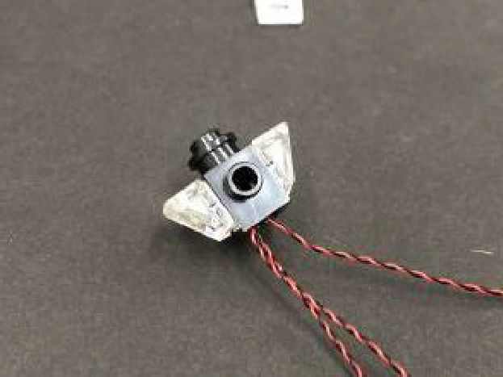
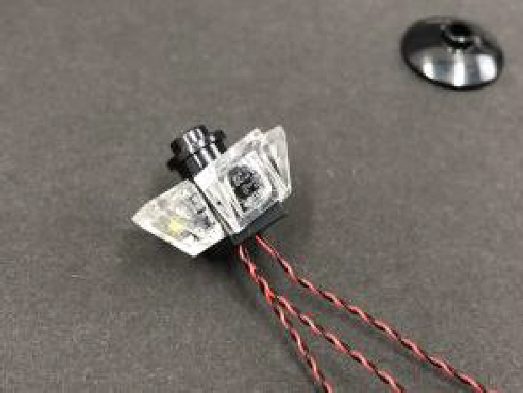

7.) Take all three cables and thread each end through the top of the black dish piece one at a time, then reconnect this dish to the bottom of the light section. Reconnect the top of the lamp post.
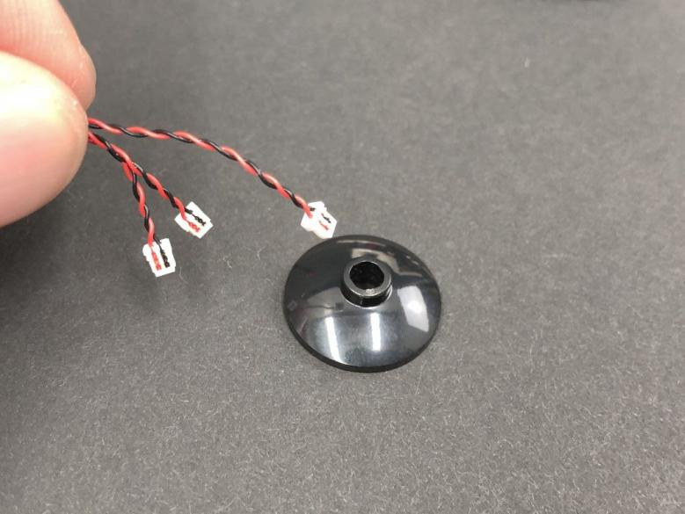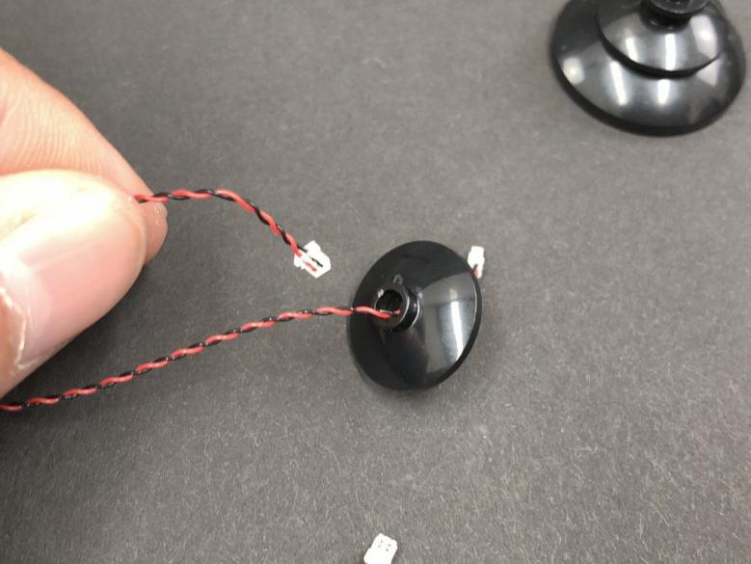

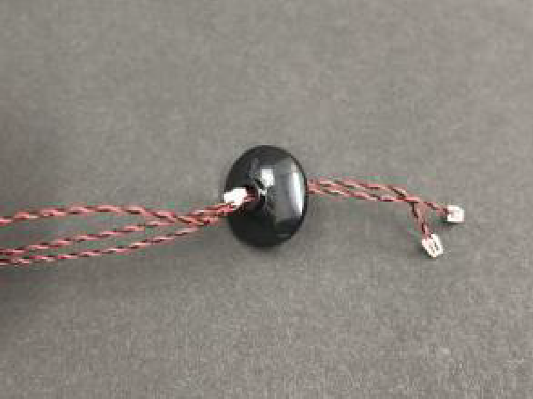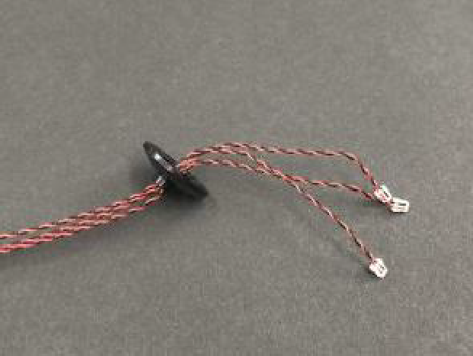

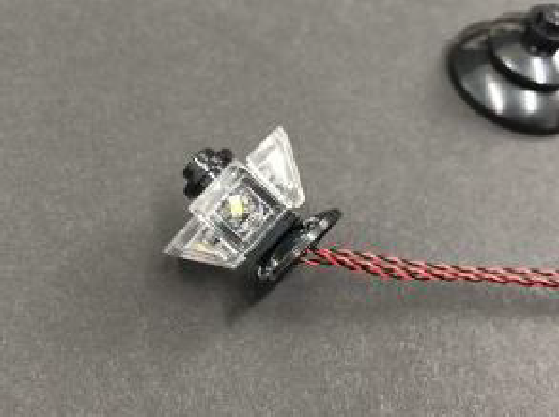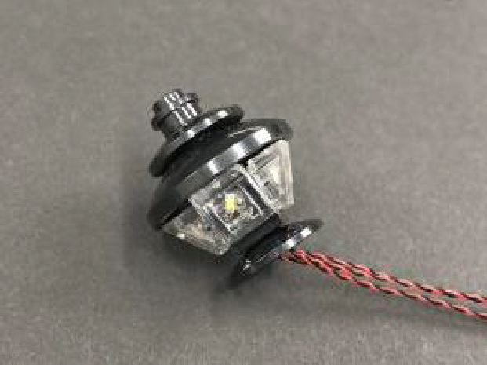

8.) Reconnect the lamp back on top of the lamp post ensuring the cables are facing the back, then twist/wind the cables around each other starting from the top, all the way to the end so they all come together forming one larger cable.
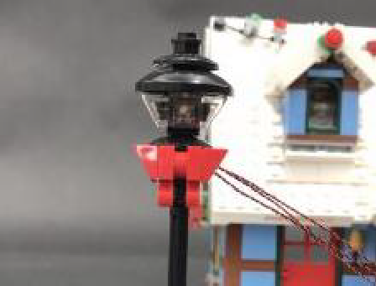
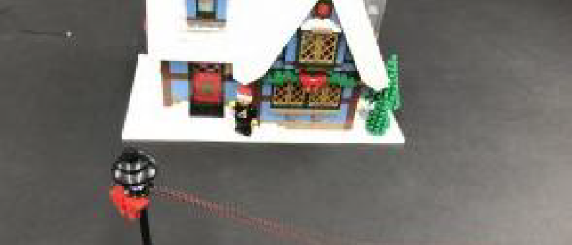
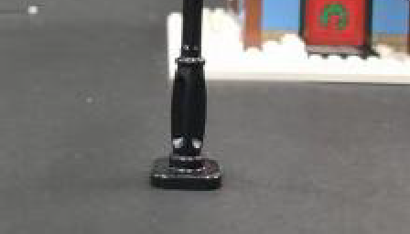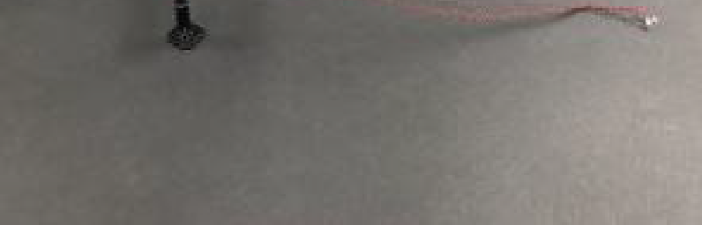

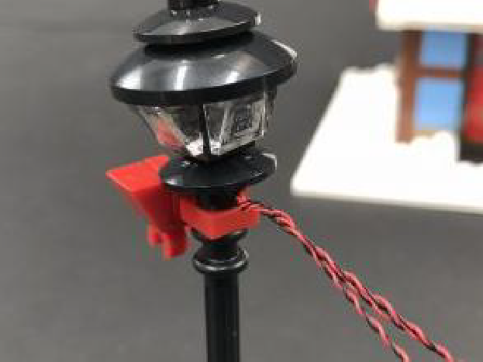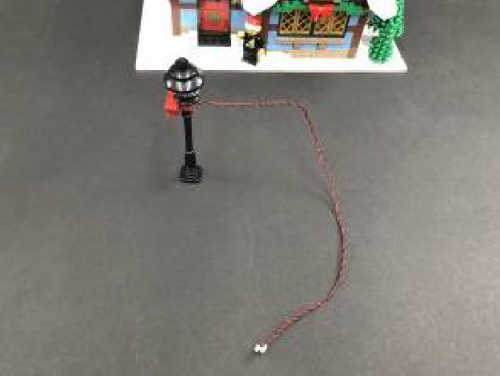

9.) Wind the cable around the left side of the lamp post, then down toward the bottom right. Tuck the cable underneath the lamp post and lay in between studs toward the back before reconnecting the lamp post over top.
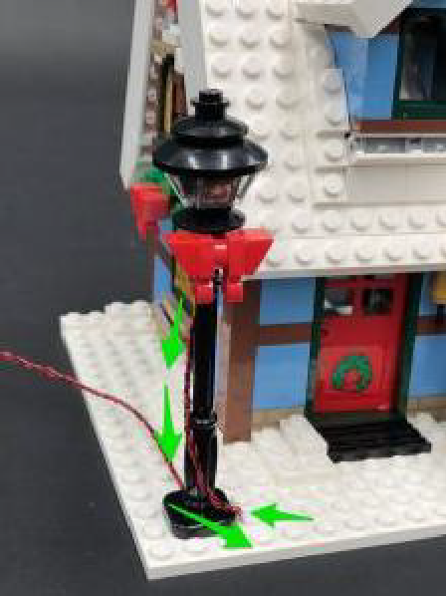
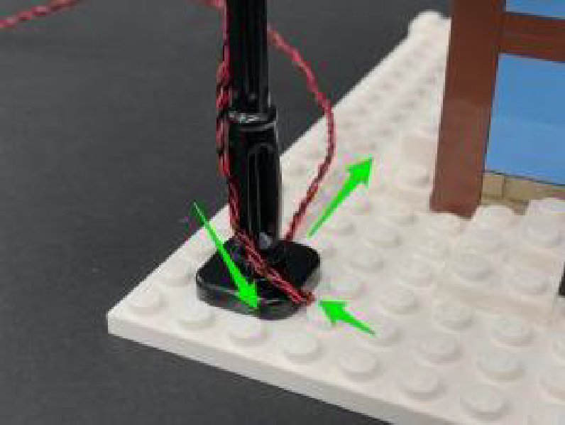

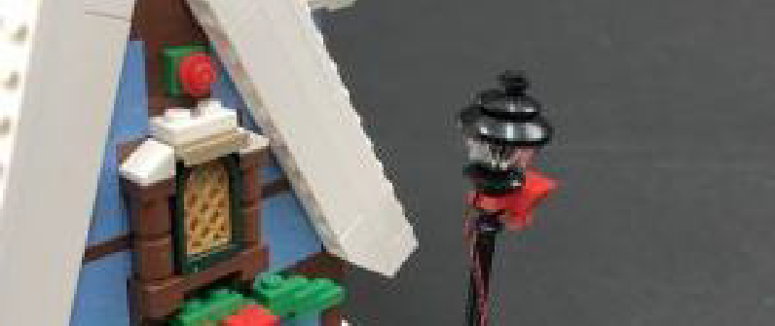
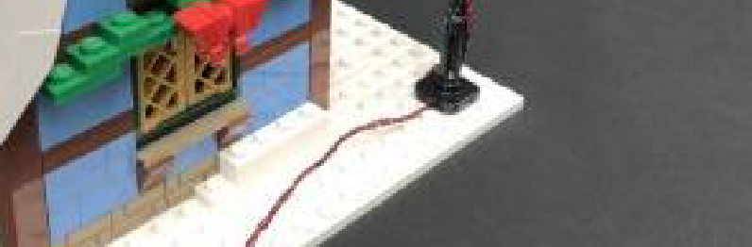

Bring the cable towards the back of the cottage and lay underneath the white bricks to secure the cable in place.
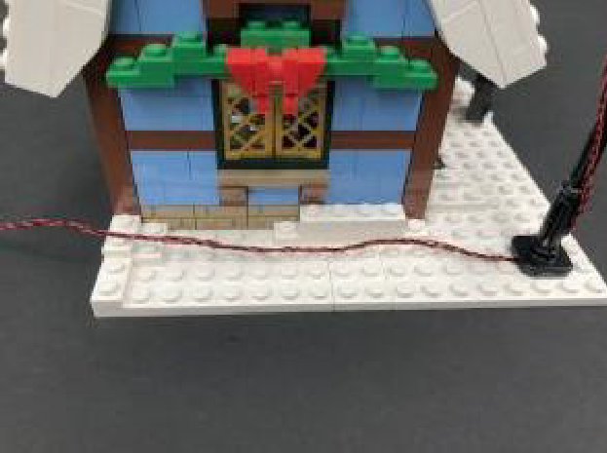
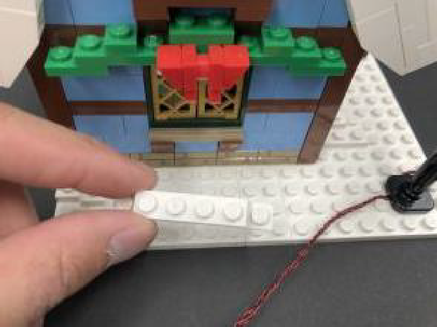

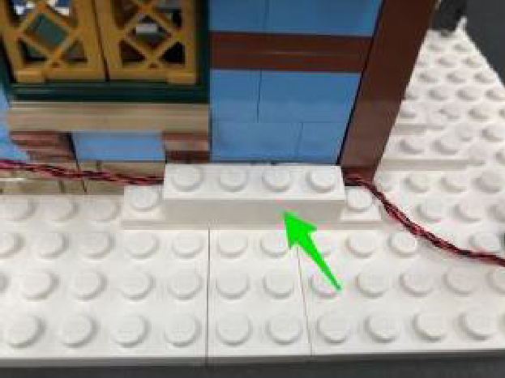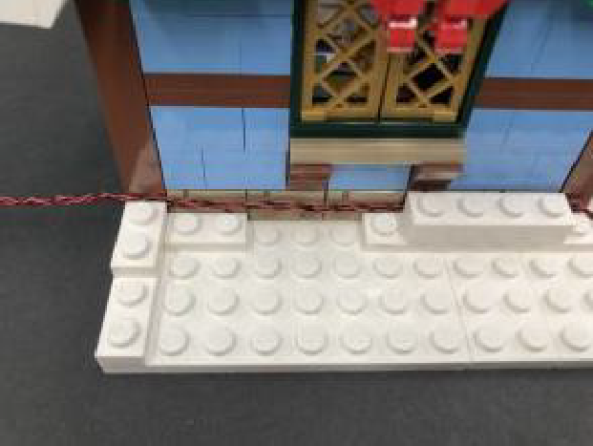

10.) Turn the cottage around to the back and take a 6-Port Expansion Board and connect the three bit light cables from the lamp post to it. Take the AA Battery Pack and insert 3x AA Batteries to it. Connect the battery pack cable to the expansion board, then turn it ON to test the lamp post lights are working OK.
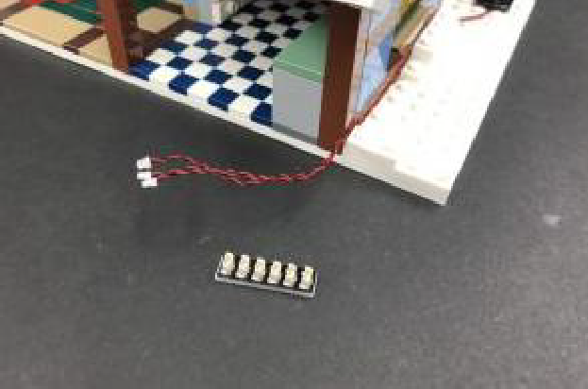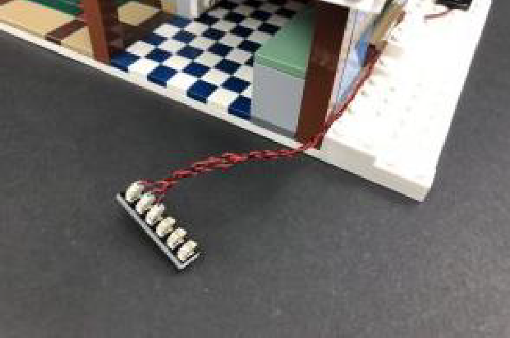

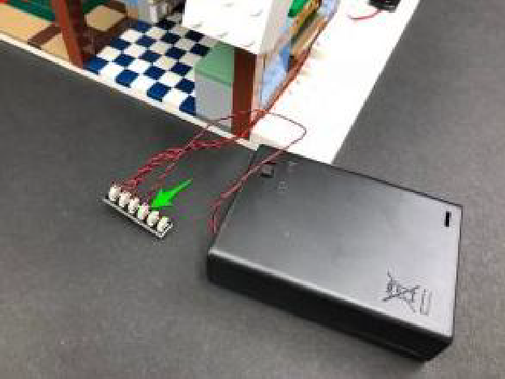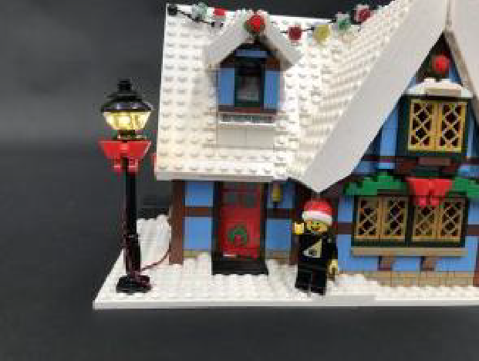

11.) We will now install lights to the cottage. First disconnect the christmas roof lights followed by the front left roof section.
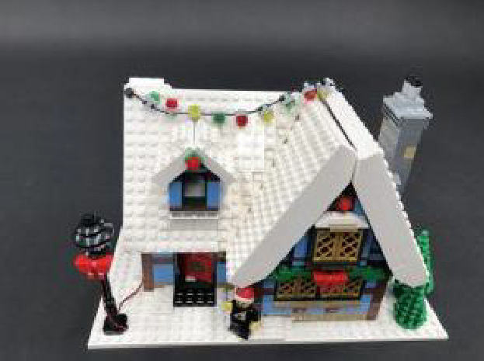
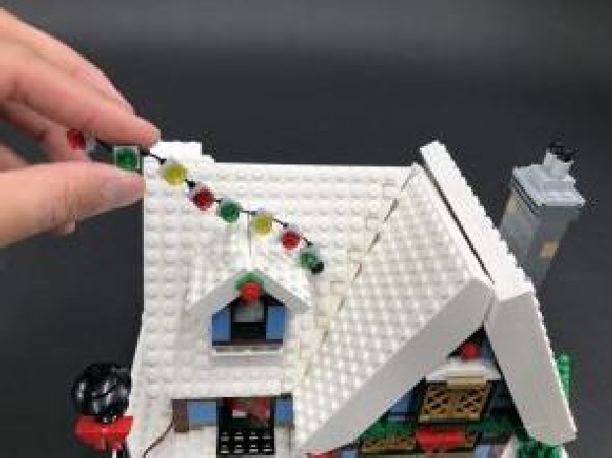

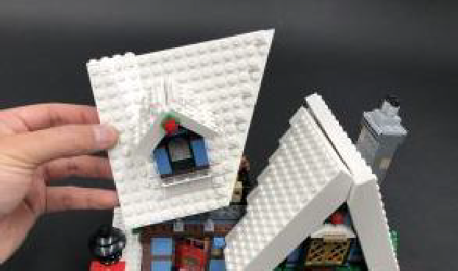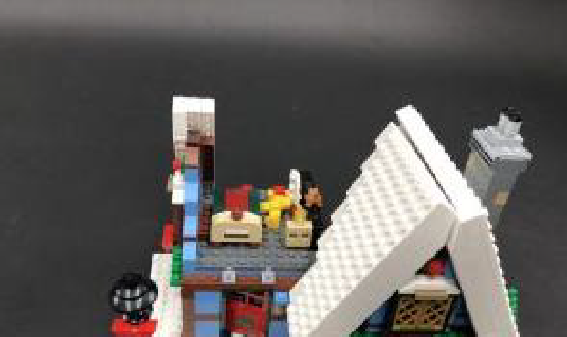

Disconnect the window section from the left roof section, then disconnect the left side of the window.
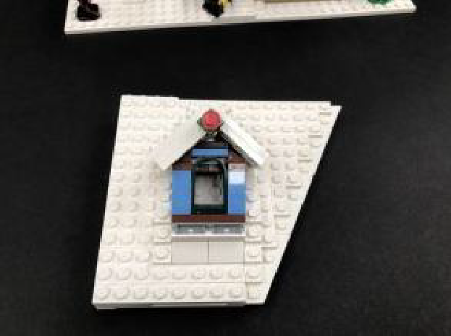
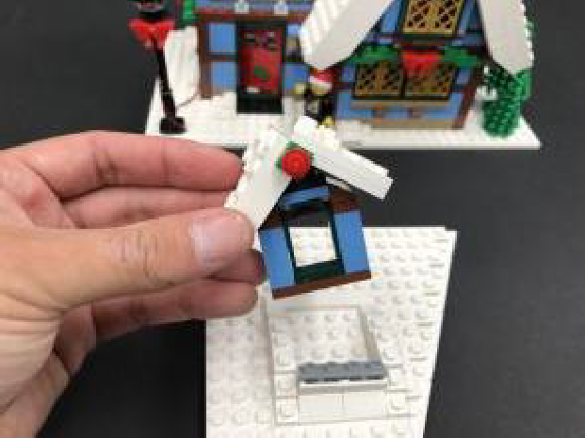

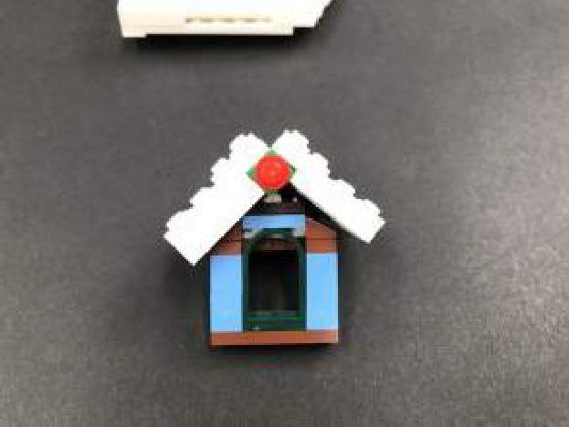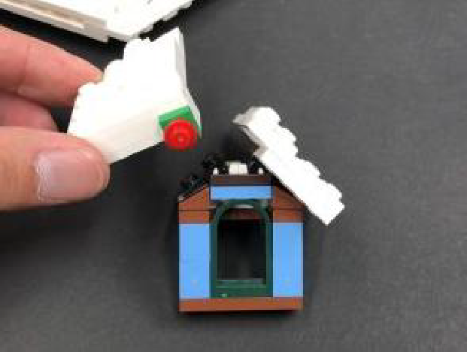
12.) Turn this section over then take a White 30cm Bit Light and stick it onto an Adhesive Square. Stick the light underneath this section with cable facing back as shown below:
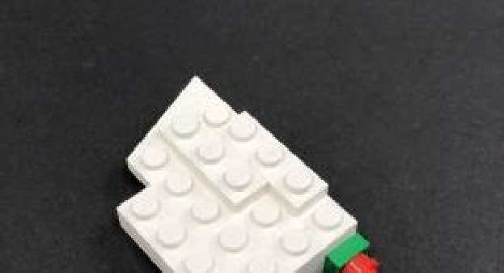
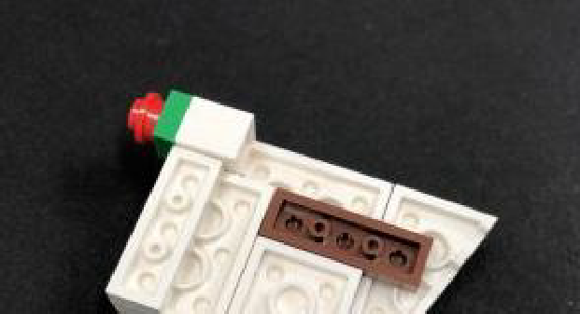


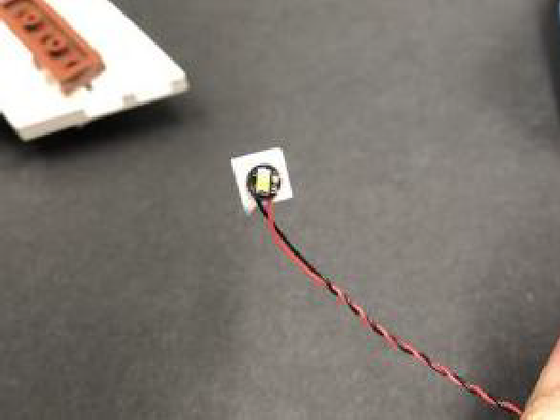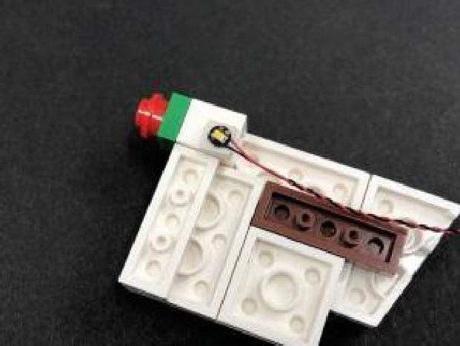

Reconnect this section back to the window, then reconnect the window back to the roof ensuring the cable is facing up.
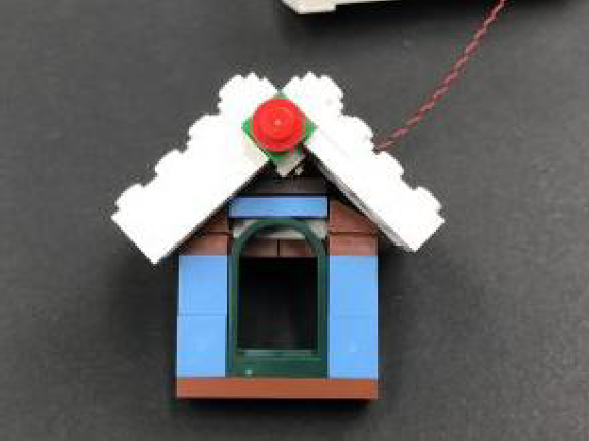
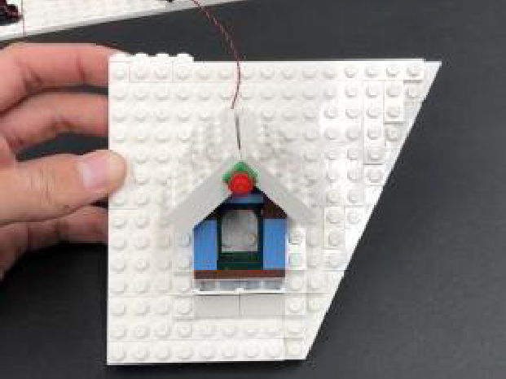

13.) Flip the roof section over and then upside down. Pull the cable up from underneath and secure it underneath the white 2×8 plate as well as the dark grey plate (disconnect plate, lay cable underneath, then reconnect plate over the top).

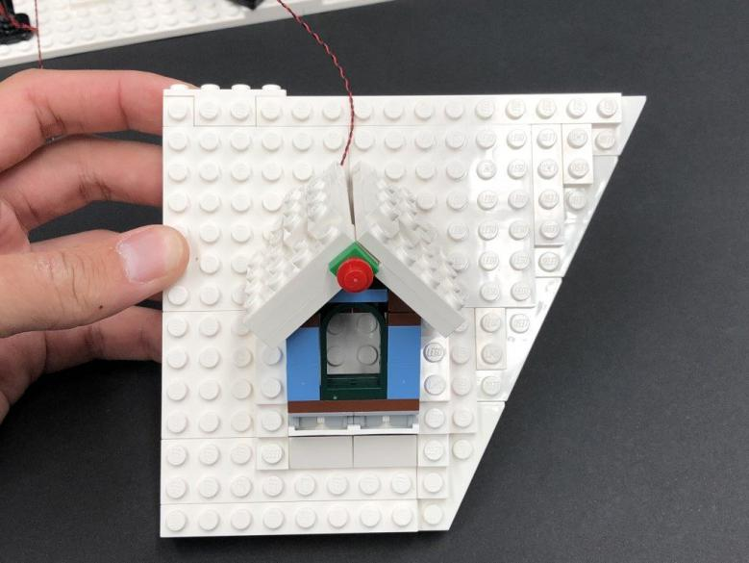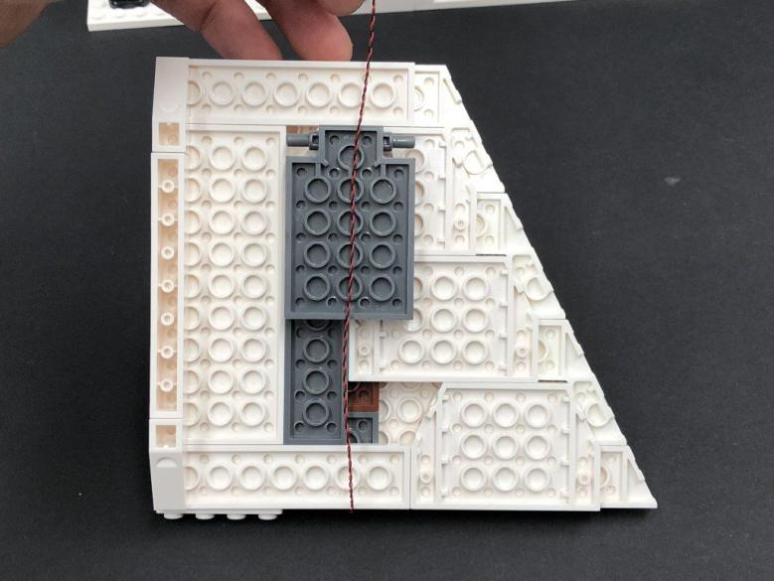

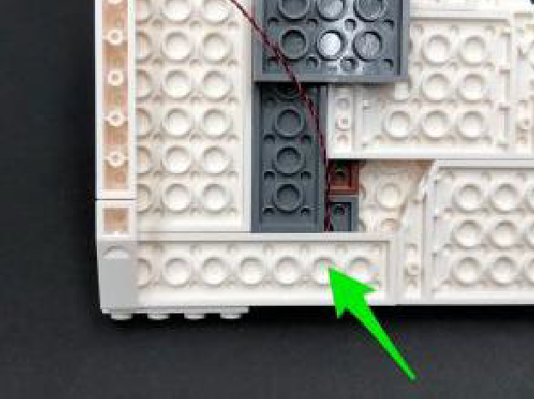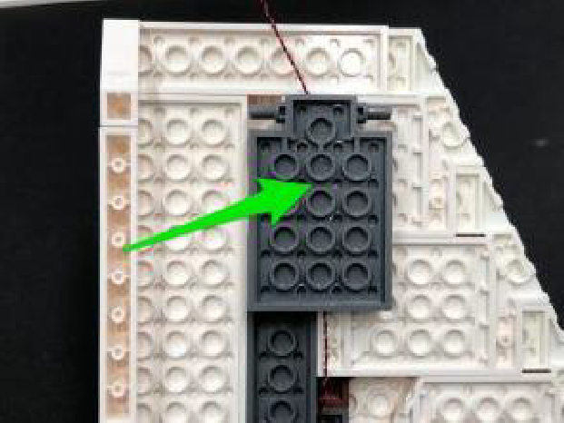

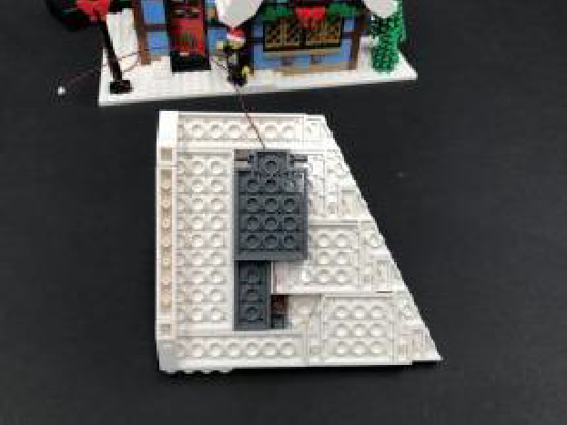

Take a White Strip Light and connect 5cm Connecting Cable to the right port. Take a 15cm Connecting Cable and connect it to the left port.
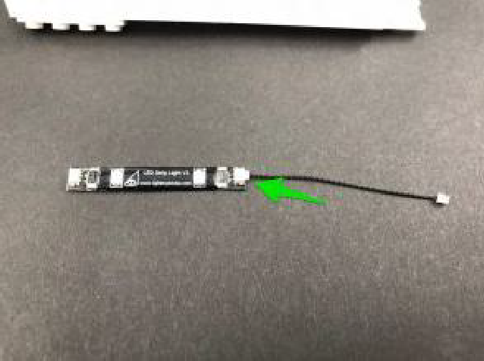
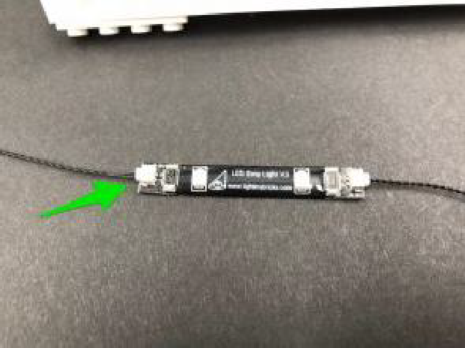
Using it’s adhesive backing, stick the strip light to the back side of this roof section in the below position. Ensure the 5cm connecting cable is facing the right side then connect it along with the Bit Light cable from the window to a new 6-Port Expansion Board.
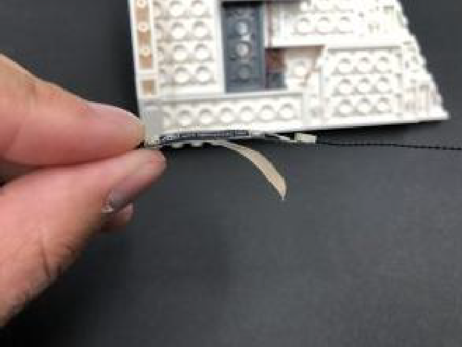
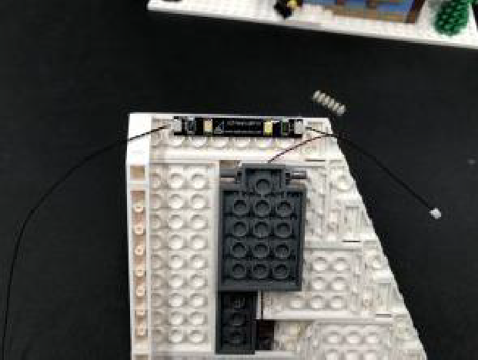

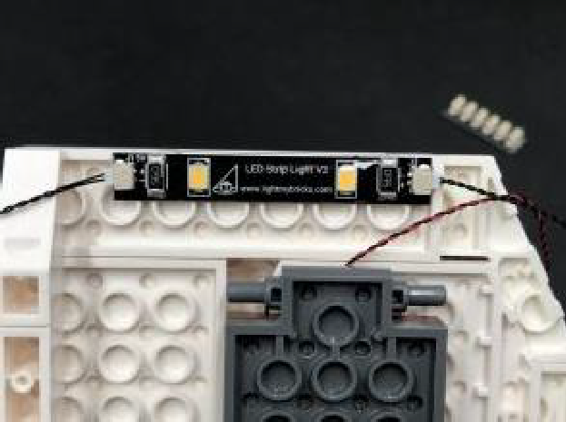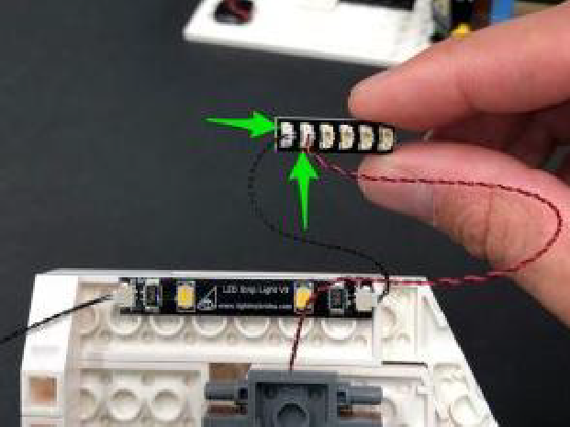

14.) From the back of the cottage, push your finger up underneath the second floor to disconnect the left plate with the bedside table on it.
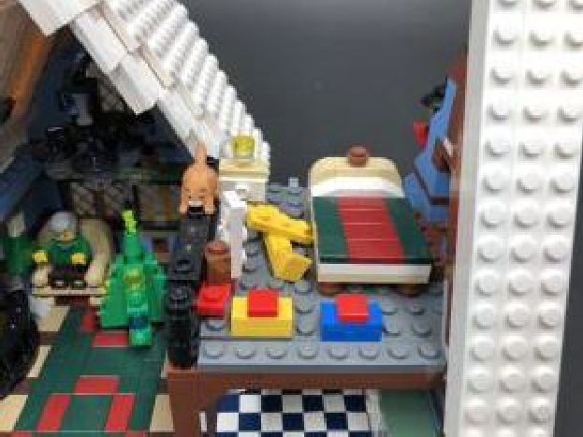
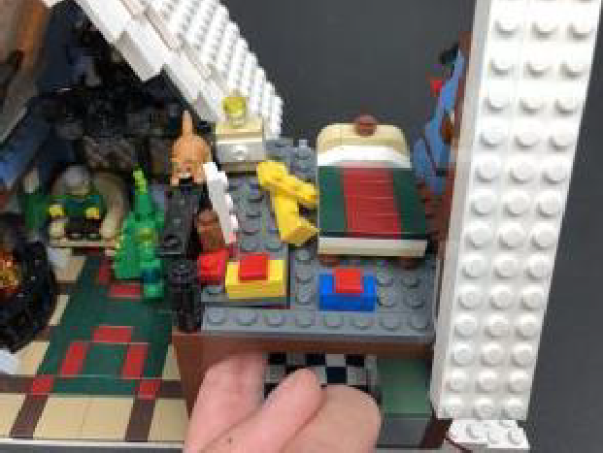

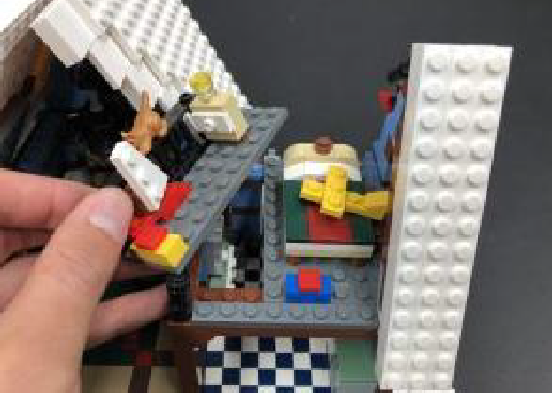

Disconnect the trans clear round plates (bedside lamp) from the bedside table then take a White 15cm Bit Light and with the cable facing behind, place it over the top of the stud. Secure it in place by reconnecting the trans clear round plates over the top, then from the back of the bedside table, press the cable down the back as shown below:
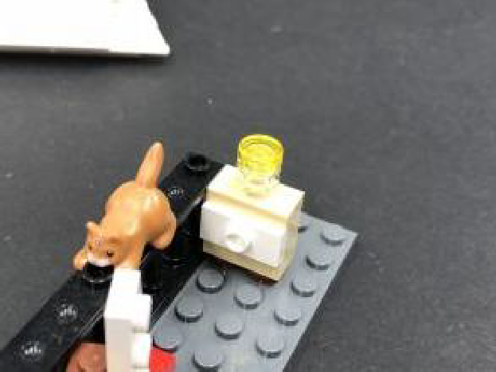
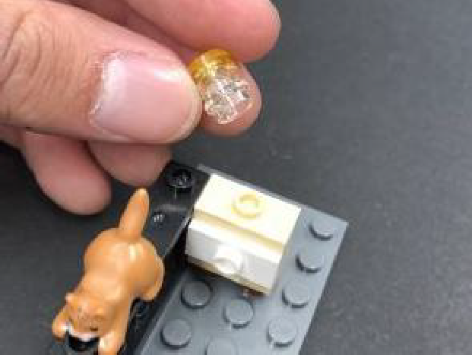

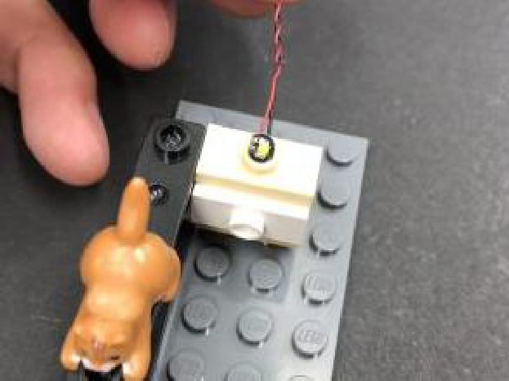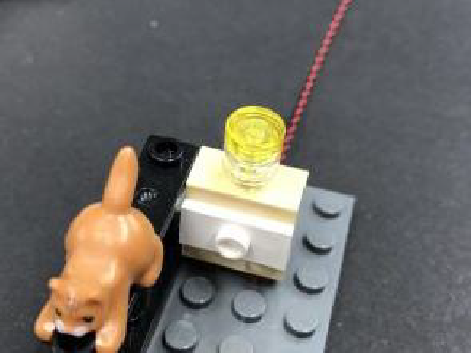

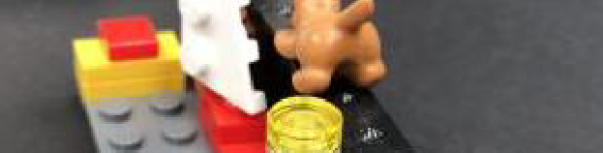
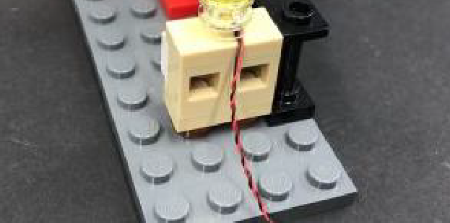

15.) Reconnect the left roof section to the cottage ensuring you first thread the other end of the 15cm Connecting Cable from the Strip Light as well as the 6- port expansion board down through to the inside.
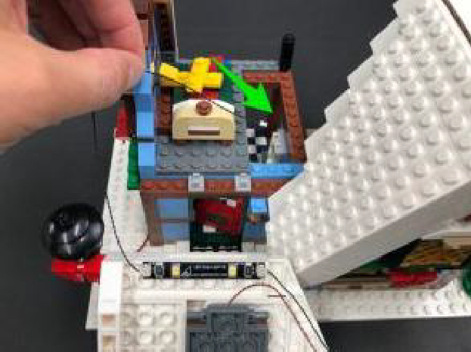
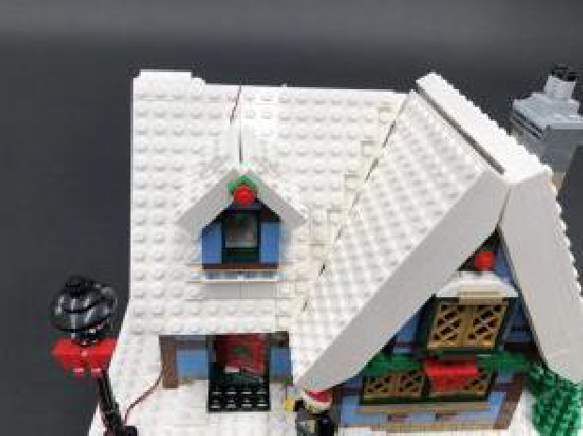
From the inside of the cottage, thread the 15cm connecting cable down through to the inside of the ground floor and then pull it all the way out from the bottom.
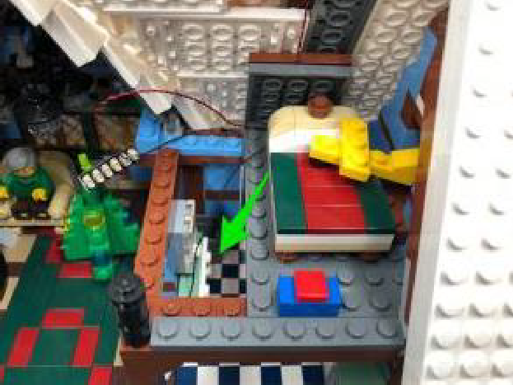
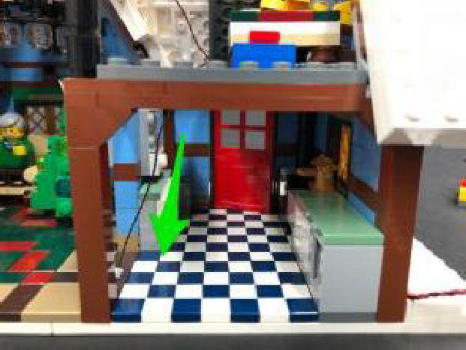
16.) Take a White Strip Light and using it’s adhesive backing, stick it to the base f a provided Plate 1×6. Connect the 15cm Connecting Cable from above the ground floor to the right port. Take a 30cm Connecting Cable and connect it to the strip light’s left port.
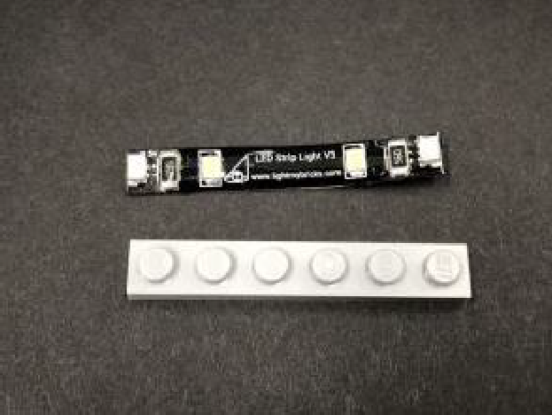
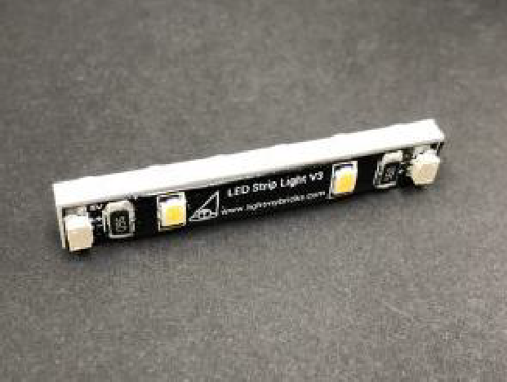

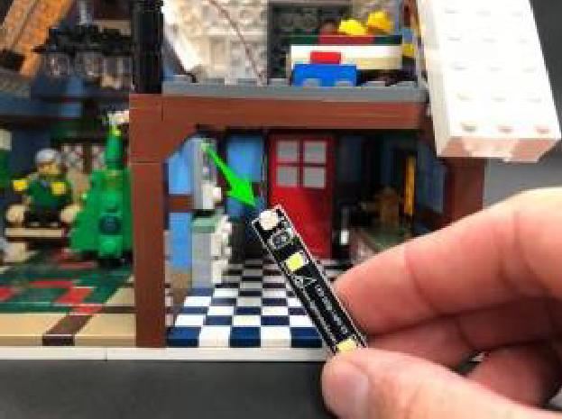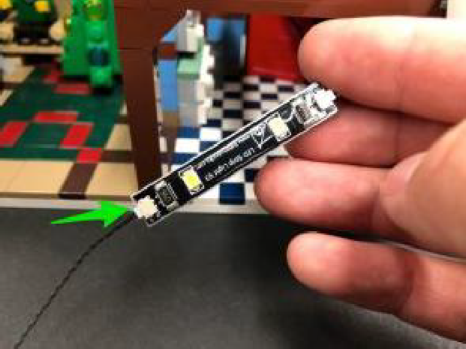

Mount the Strip Light to the ceiling above the ground floor in the below position ensuring the 30cm connecting cable is on the left side.
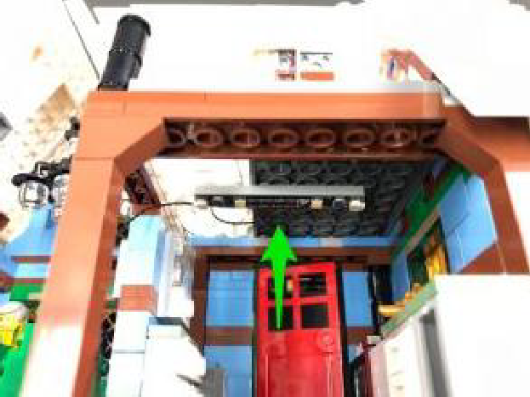
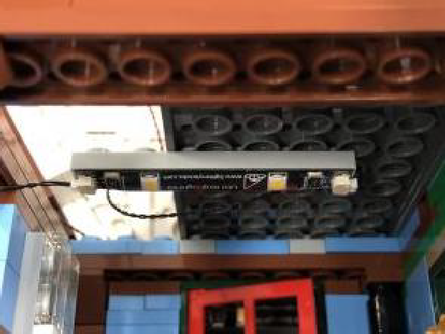
Ensuring the 30cm Cable is in between studs, reconnect the plate with the bedside table, then connect the Bit Light cable from the bedside lamp to the 6- port expansion board.
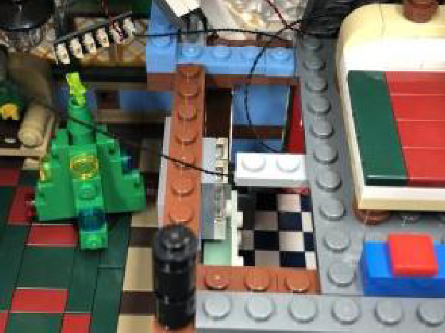
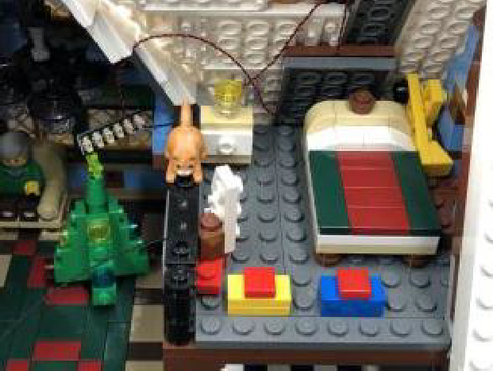

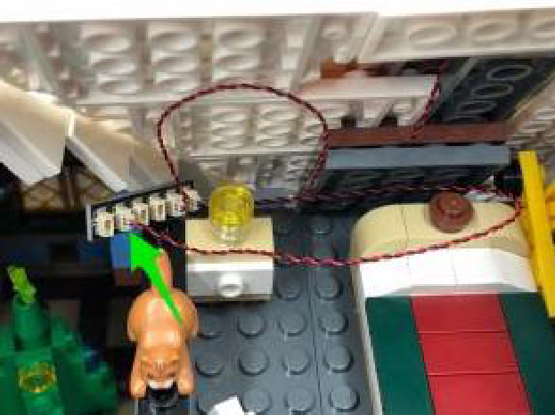

17.) Take a 30cm Connecting Cable and connect it to the 6-port Expansion Board then disconnect the right roof section. Bring the 30cm cable behind the bedside table and bed, then down the right side of the room and secure it down underneath the bed. Connect the cable to the 6-port expansion board at the bottom right side of the cottage.
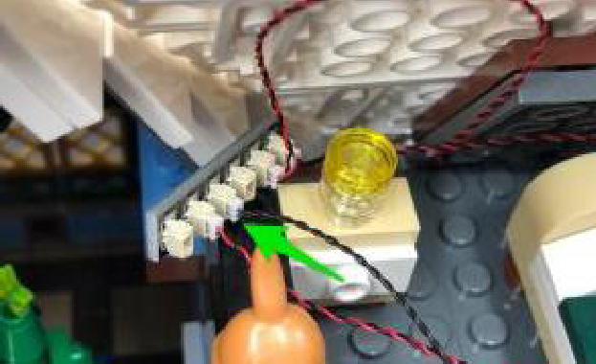
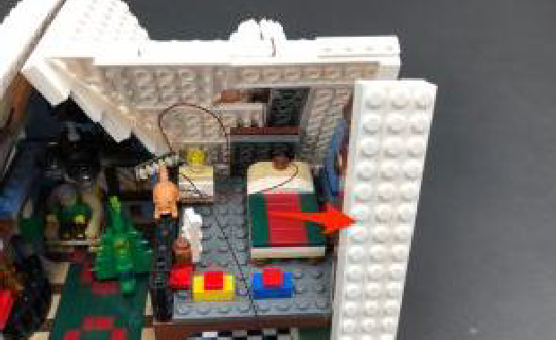

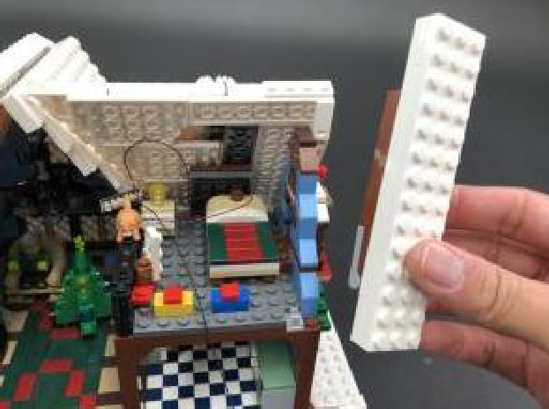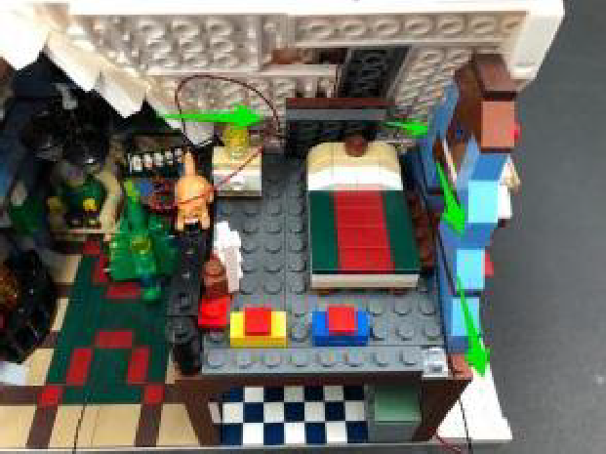

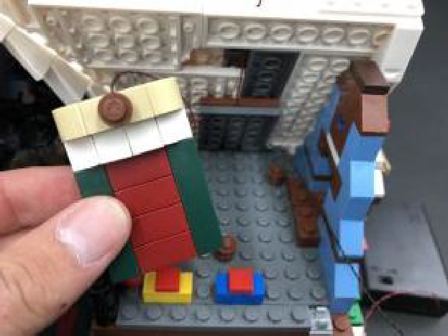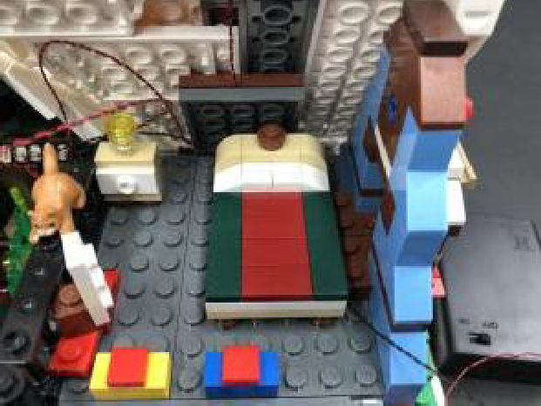

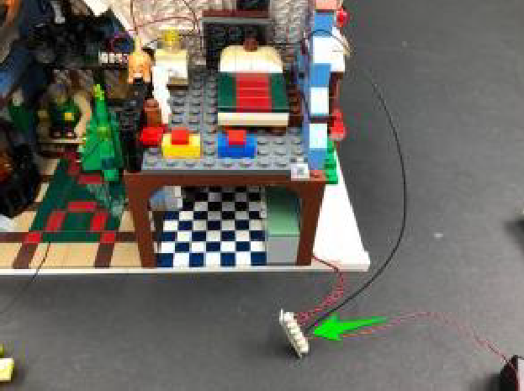

Turn the AA Battery Pack ON to verify all lights installed so far to the cottage are working OK.
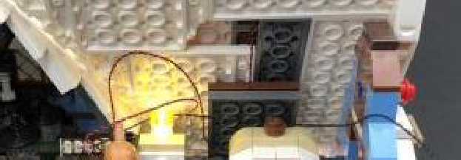
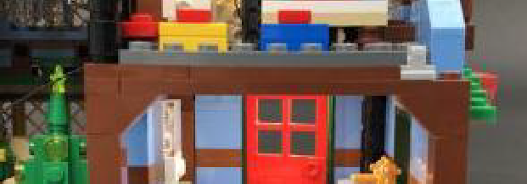
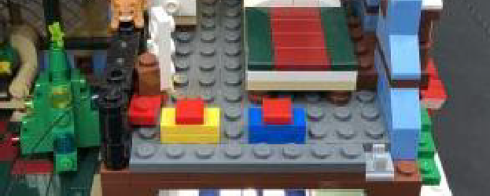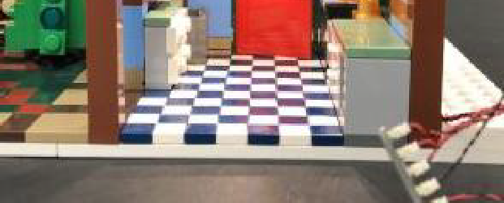

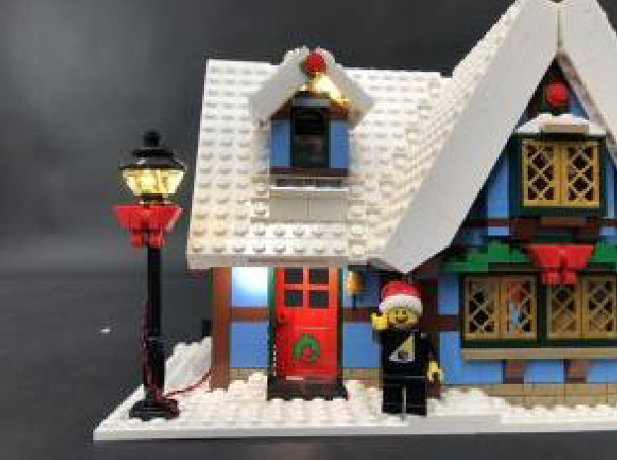

18.) Disconnect the following section above the side window then take a White 15cm Bit Light and split apart the red and black wires as shown below:
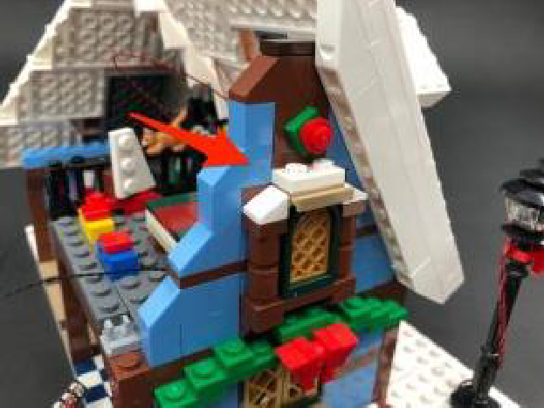
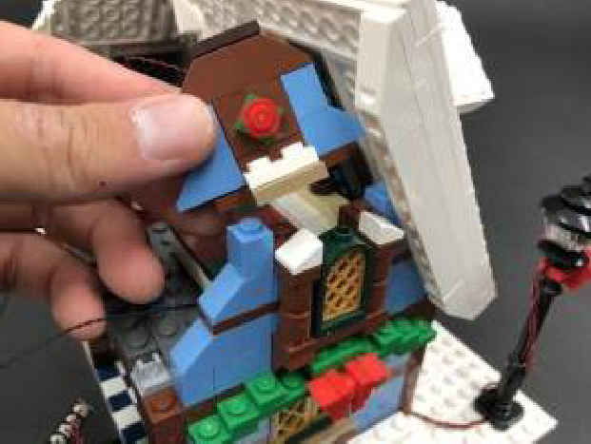

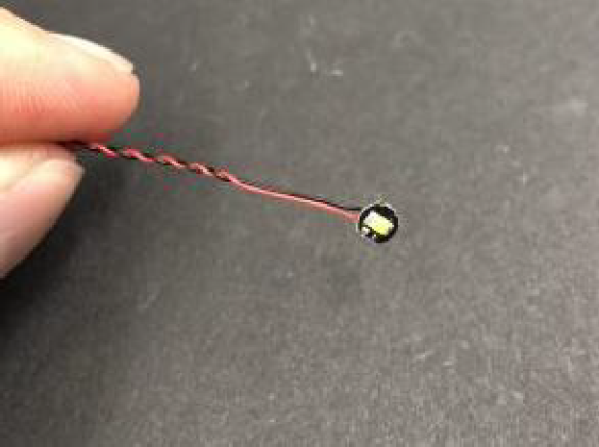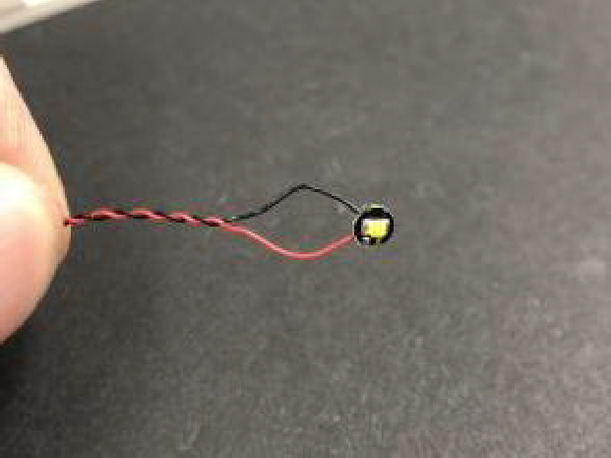
Turn the Bit Light upside down and then place it over the green stud directly above the window. Secure the Bit Light in place by reconnecting the section above. If you look from below the window, the Bit Light should be slightly peaking out above the window to shine down.
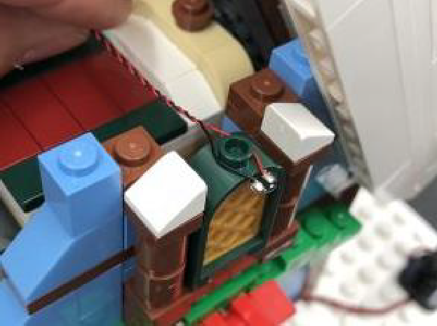
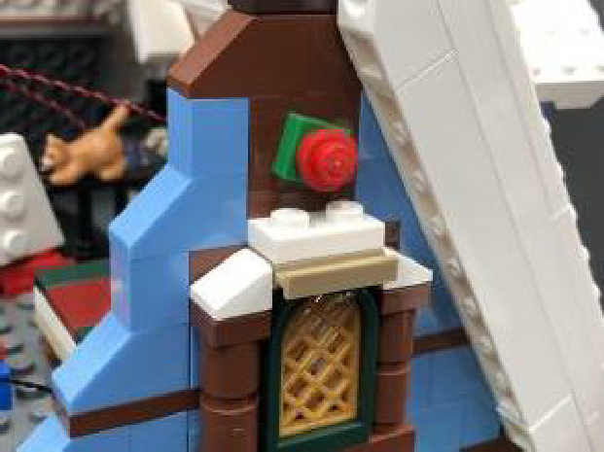

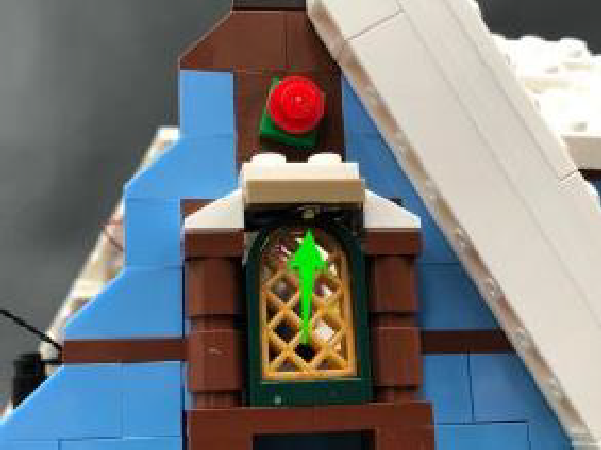
19.) Connect the White 15cm Bit Light to the 6-port Expansion board behind the bedside table then lay the cable up the right side and then across behind the bed as shown below:
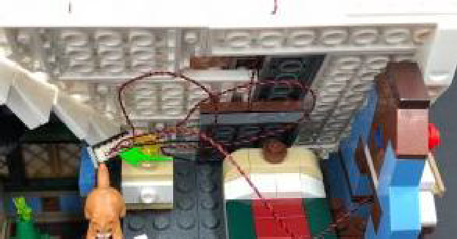
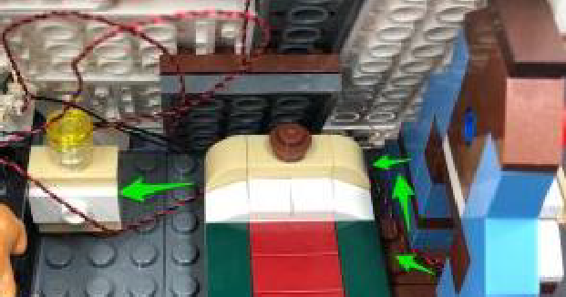
Neaten up cables by grouping them altogether and winding/twisting/folding them around each other, then the tuck cables and expansion board down behind the bedside table.
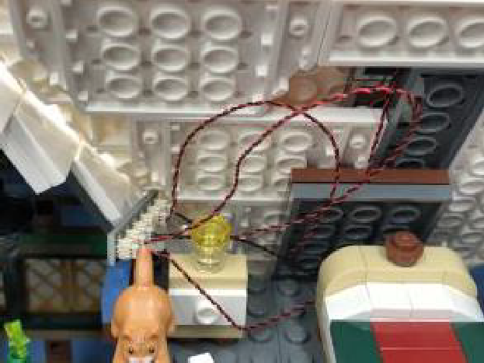
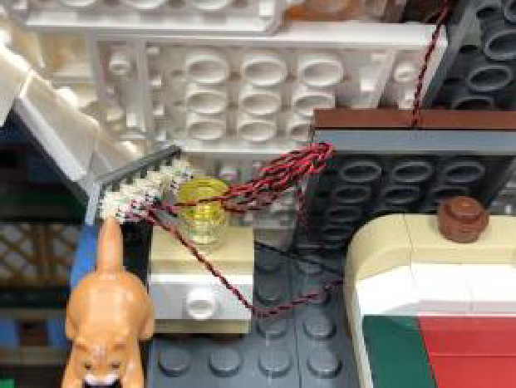

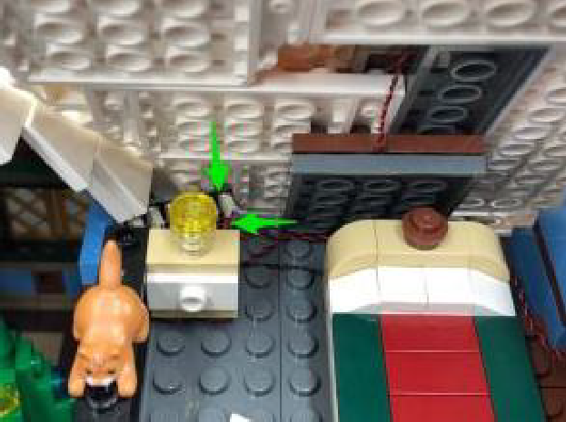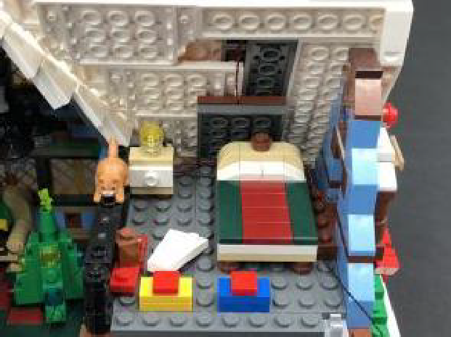

Eliminate excess cable from the 30cm connecting cable on the right side by pulling some of it up, then twisting/folding it around each other. Tuck the bunched up cable in above the light grey clip before reconnecting the side roof section over the top.
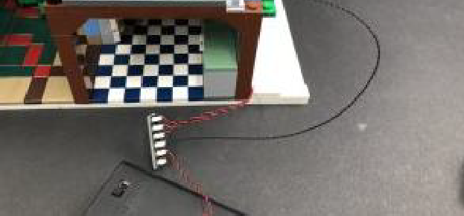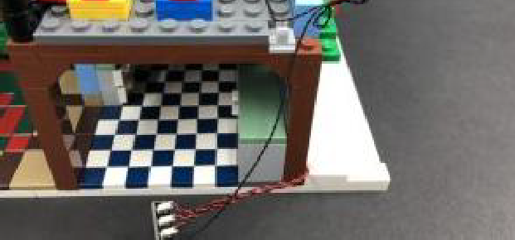

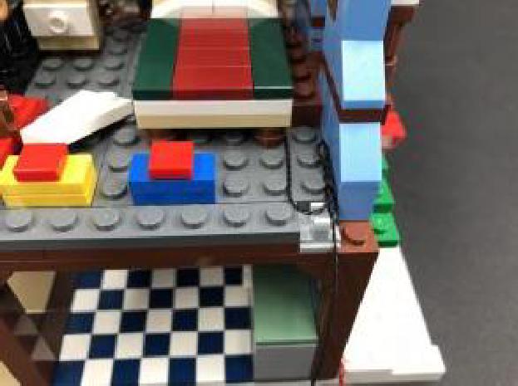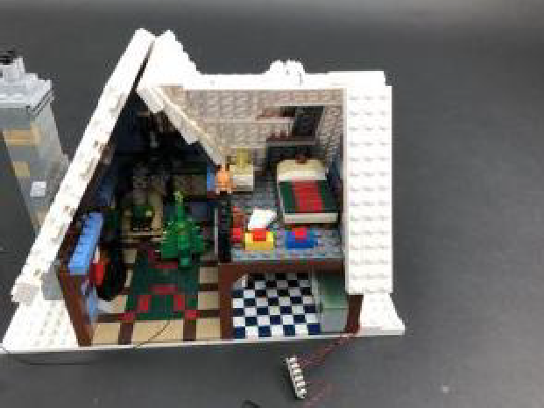

Turn ON the battery pack to test the window light is working OK.
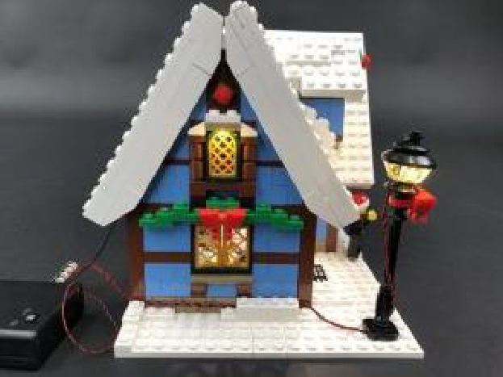
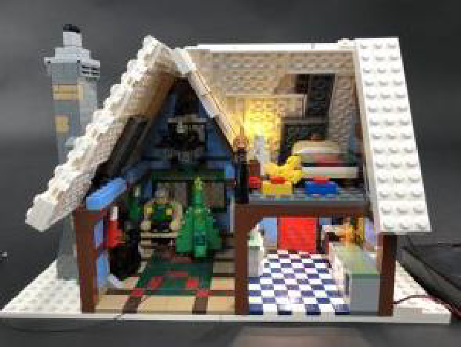
20.) From the front of the cottage, disconnect the left and right sections from the right roof, then from the inside, disconnect section with the four lights.

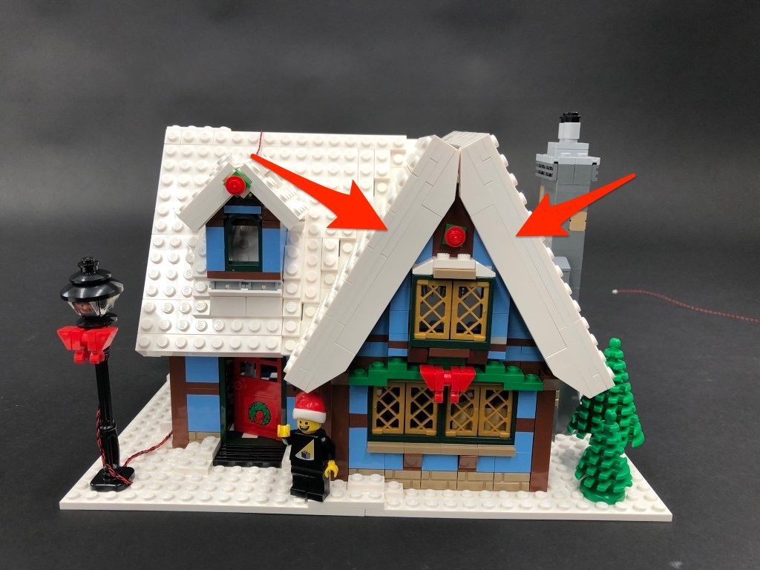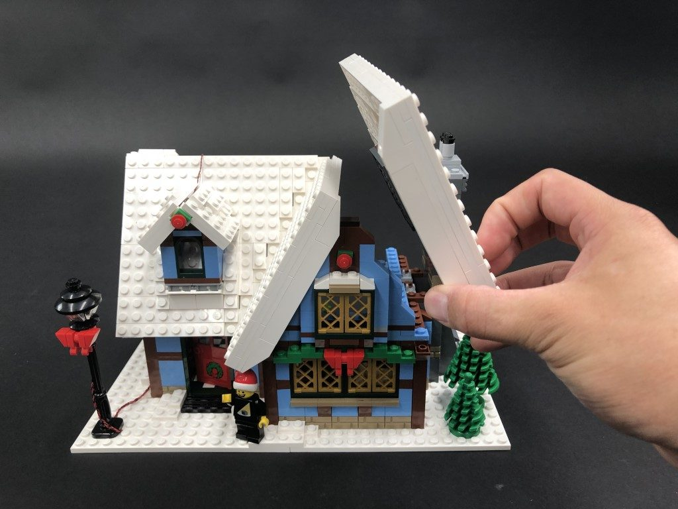

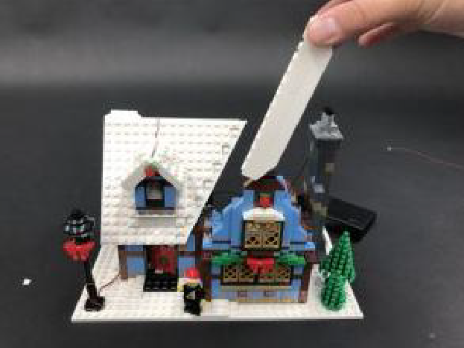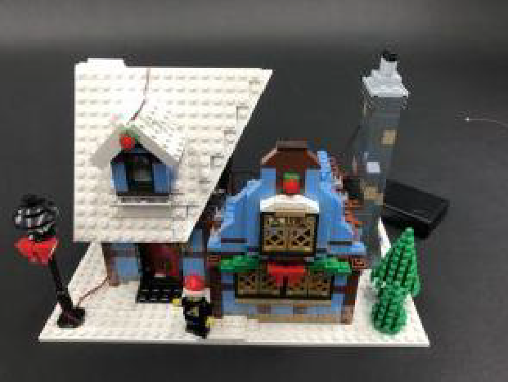

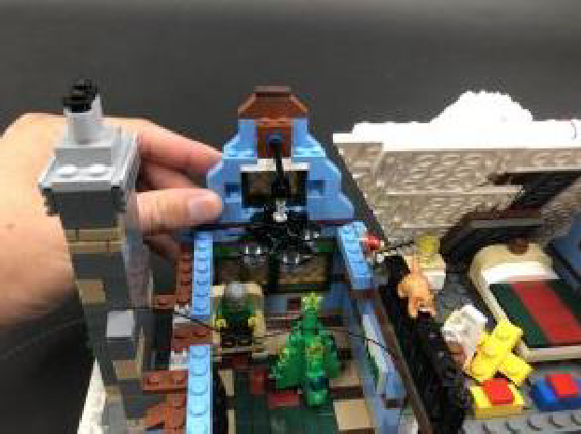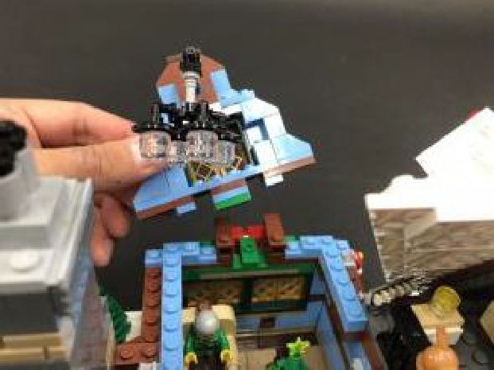

21.) Bring the 30cm Connecting Cable from the right side over towards the left section and thread it in between studs on top of the light blue plates on the right side, then reconnect the section with four lights over the top. Bring the cable further across to the left and secure in between studs underneath the light blue 1×6 plate as shown below.
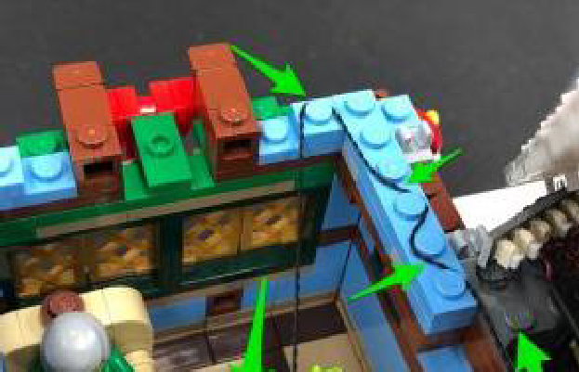
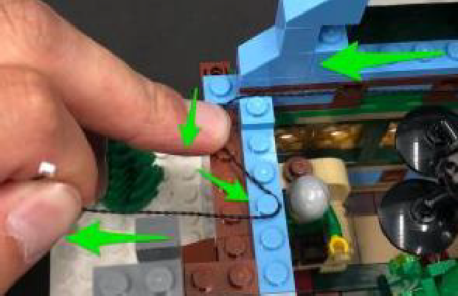
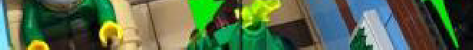

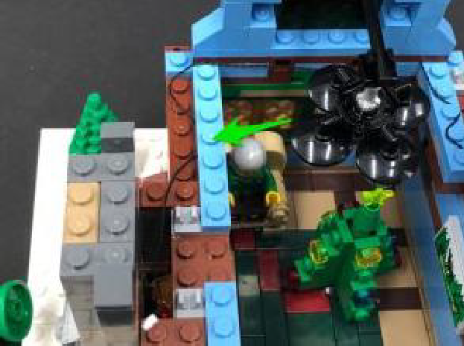
22.) Disconnect the light section from the top of the floor, then disassemble it as per below:
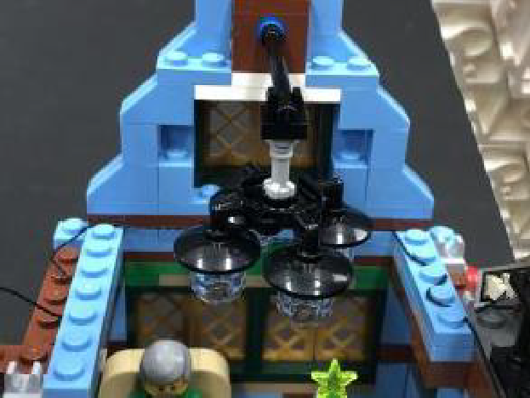
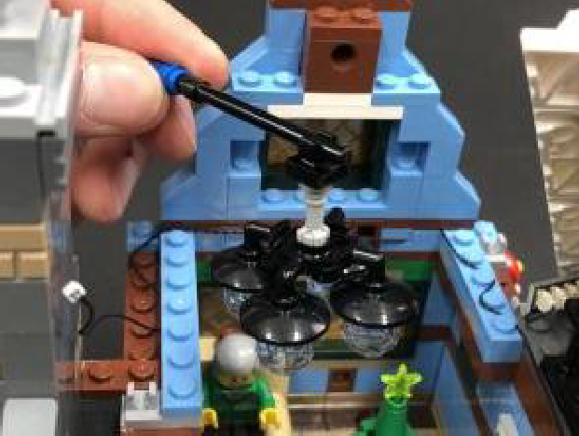
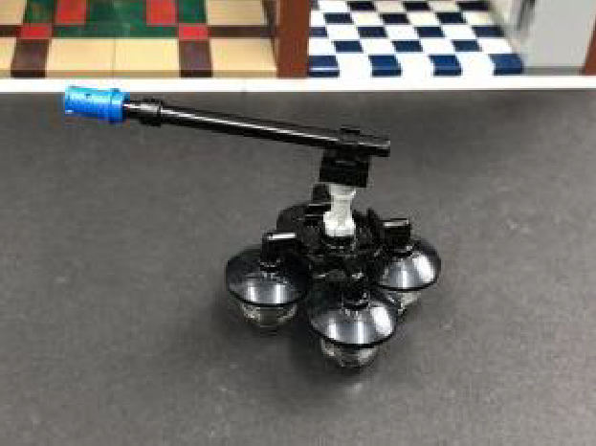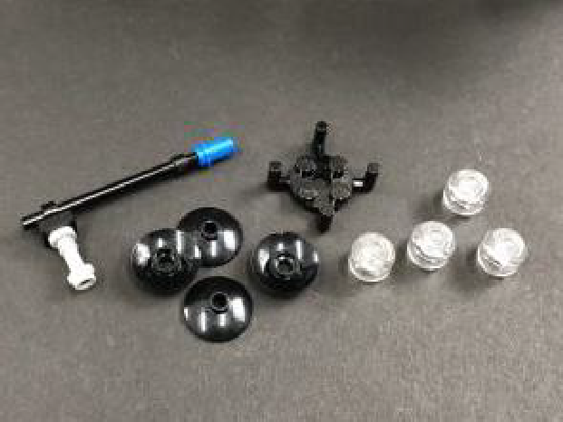

Take a White 15cm Bit Light and thread the connector end of the cable through the bottom of one of the black dish pieces. Thread it all the way
through and then reconnect the trans clear minifig head piece to the bottom of the dish. The Bit Light should be neatly secured inside the stud of the trans clear piece.
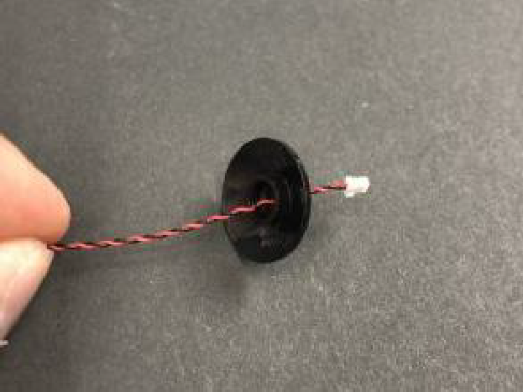
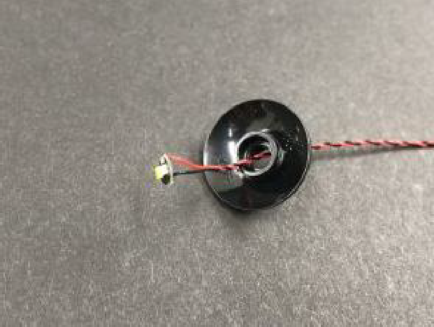

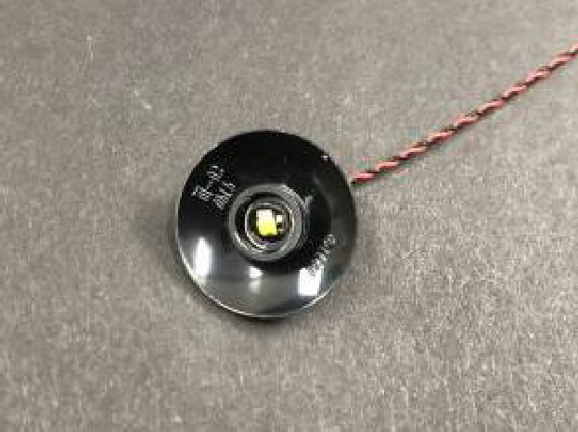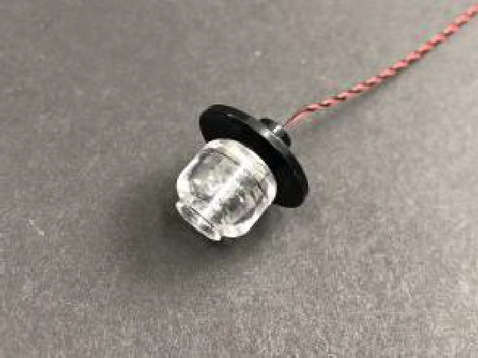

23.) Repeat previous step to install another 3x White 15cm Bit Lights to the remaining three light pieces.
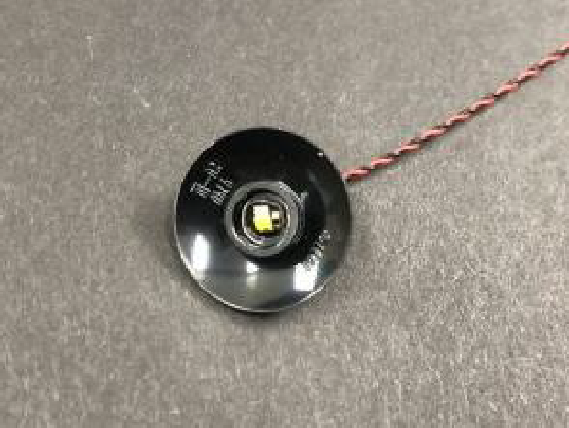

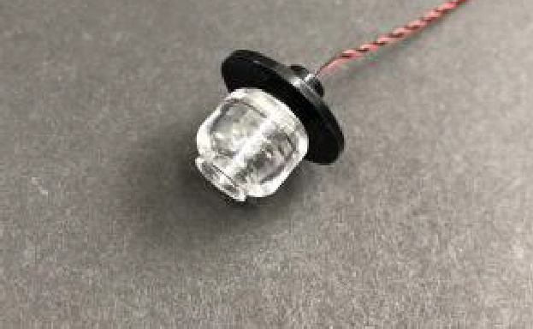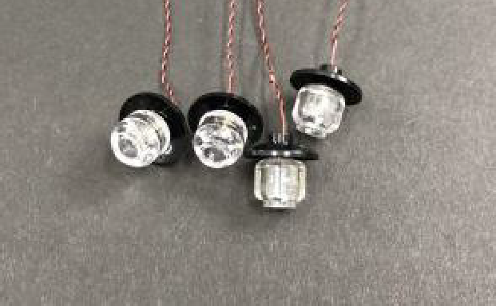

24.) Reconnect the four lights back to the light bracket then group all four cables and twist and wind them around each other all the way to the ends so they all come together to form one larger cable.
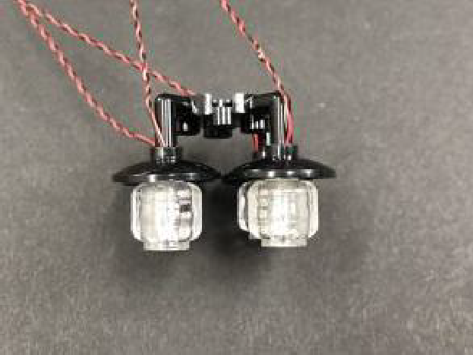
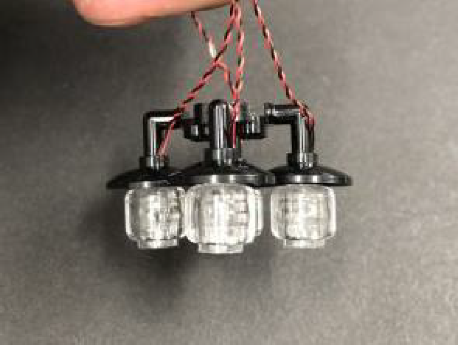

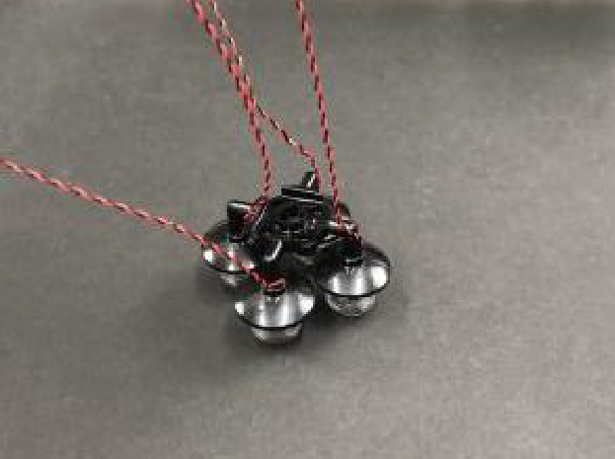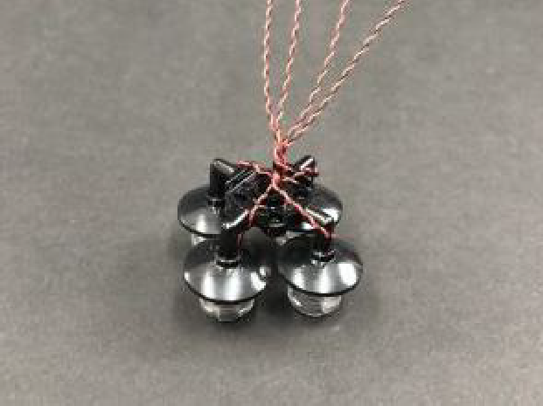

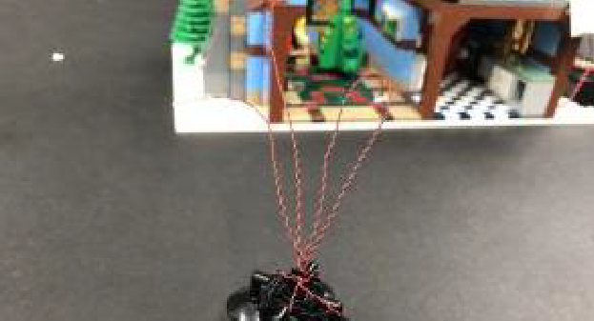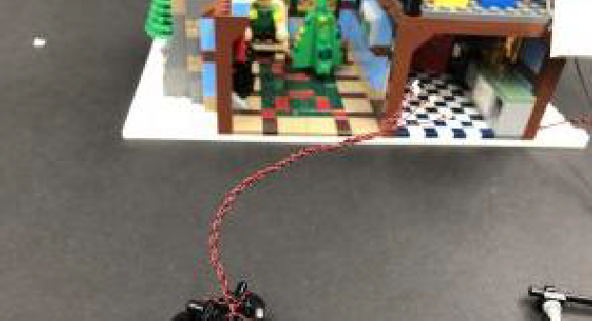
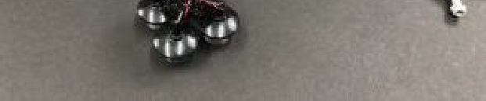
Reconnect this section back to the horizontal bar then reconnect it back to the top of the cottage.
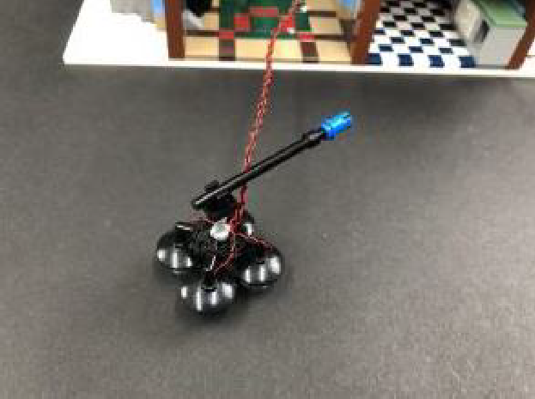
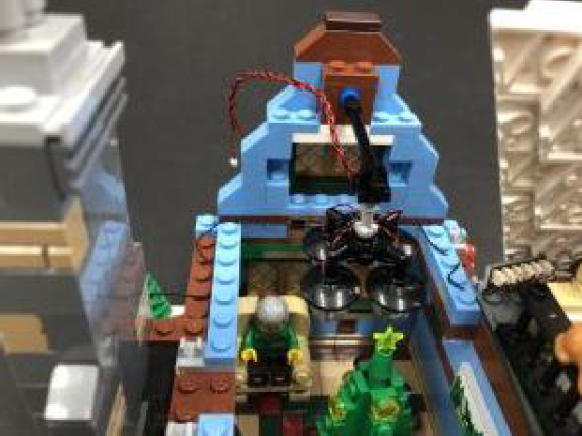

Connect the four bit light cables to an 8-Port Expansion Board then connect the other end of the 30cm Connecting Cable pulled over from the right side to it. Turn your AA Battery Pack ON to test the lights are working OK.
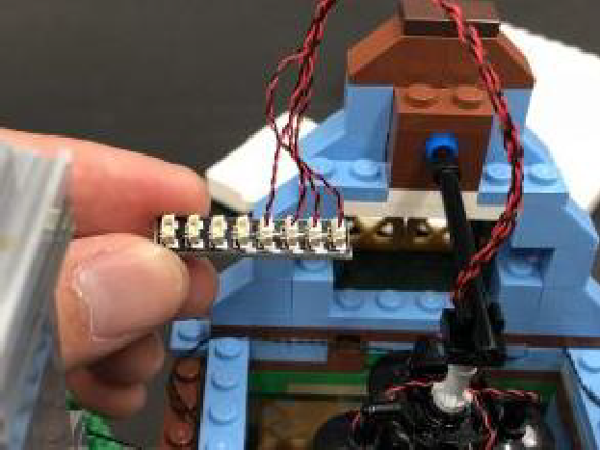
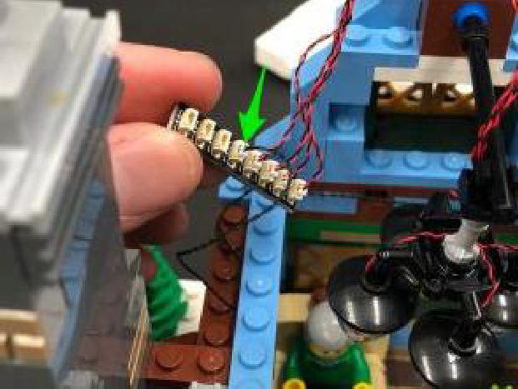

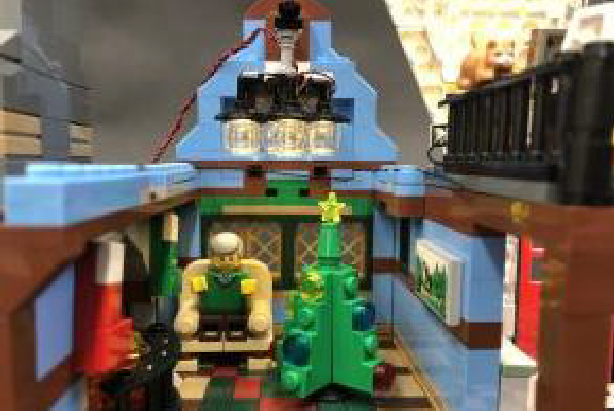

25.) Take a new 15cm Connecting Cable and connect one end to a spare port on the 8-port Expansion Board. Leave the other end of the cable unplugged for now, then from the front of the cottage, remove the dark brown 1×2 tile from the top.
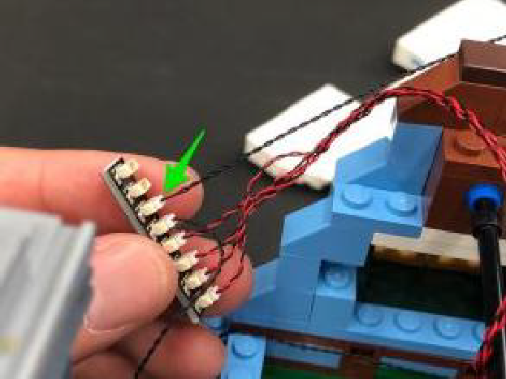
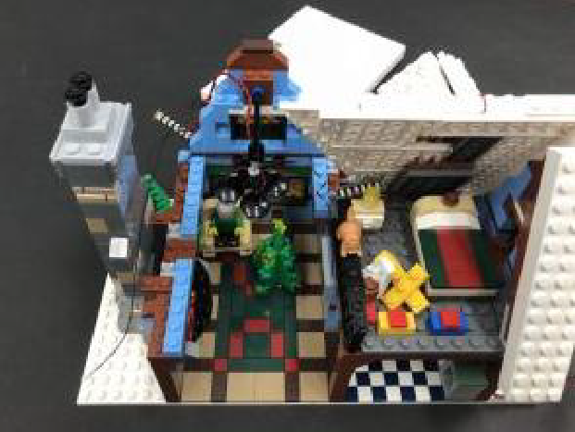

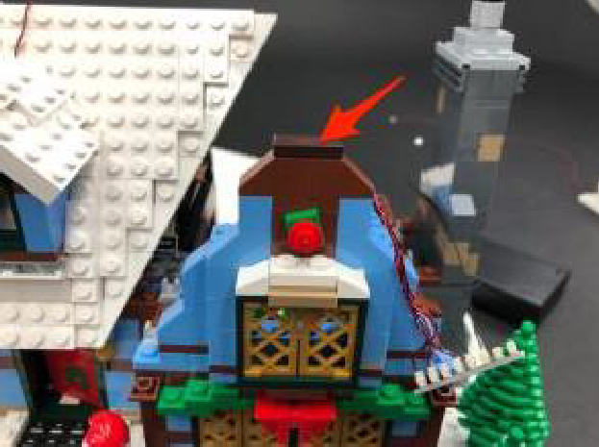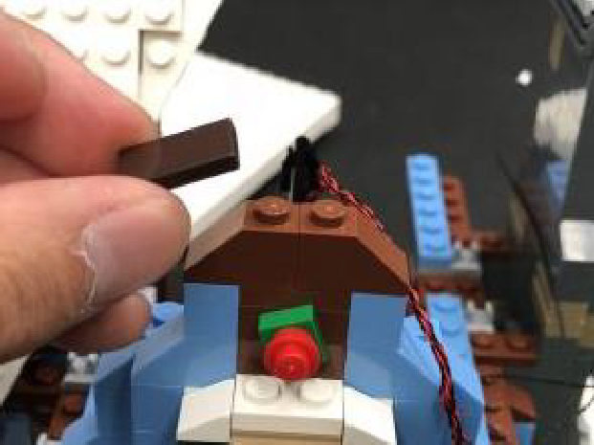
Take a White 15cm Bit Light and with the cable facing behind, place it upside down in between brown studs. Secure it in place by reconnecting the dark brown 1×2 tile over the top. The Bit Light should be slightly peaking out above the window to shine down.

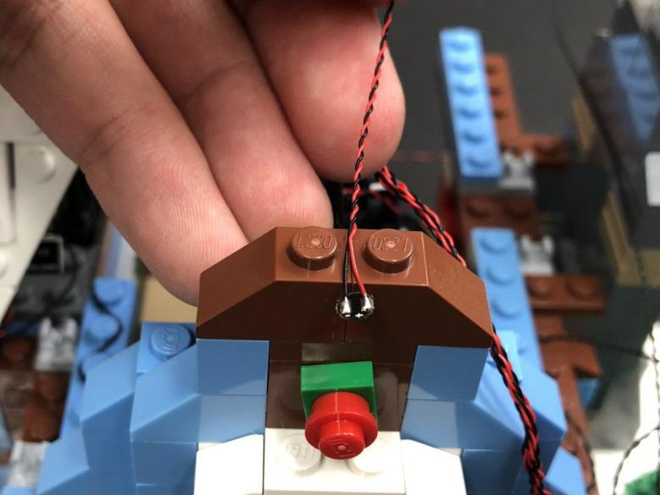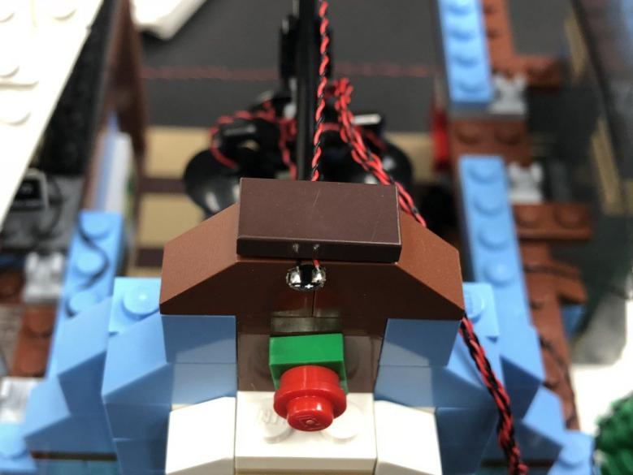
Connect the Bit Light to the 8-port expansion board then turn the Battery Pack ON to verify all lights are working OK.
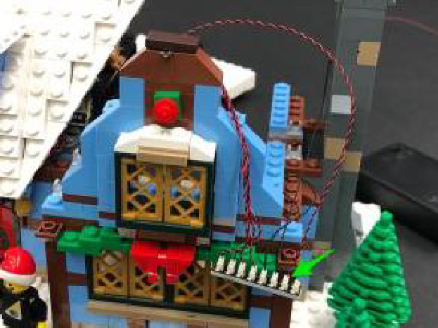
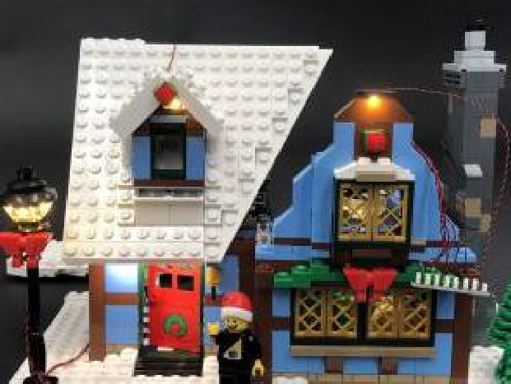

26.) Take a Multi-Colour Light String and connect it to the remaining port on the 8-port expansion board. Leave this out for now as we will connect it to the roof towards the end.
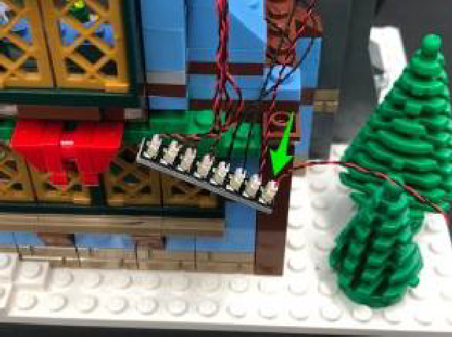
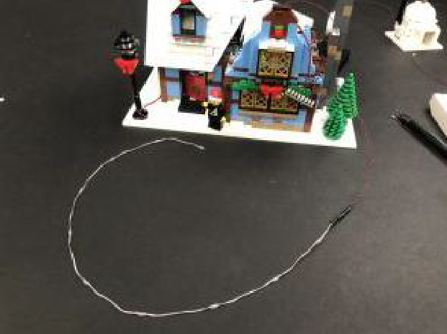

27.) From the inside of the cottage disconnect the fire place front grill as well as
the flame section from the fire place. Disconnect the trans orange pieces from the brown plates.
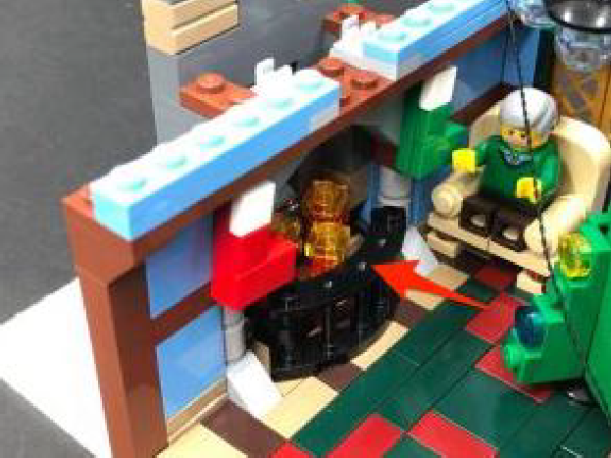
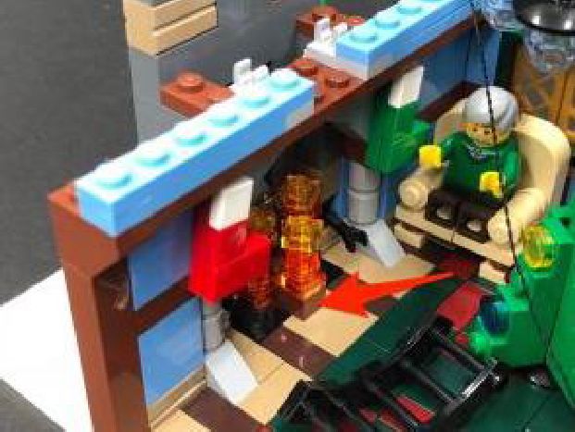

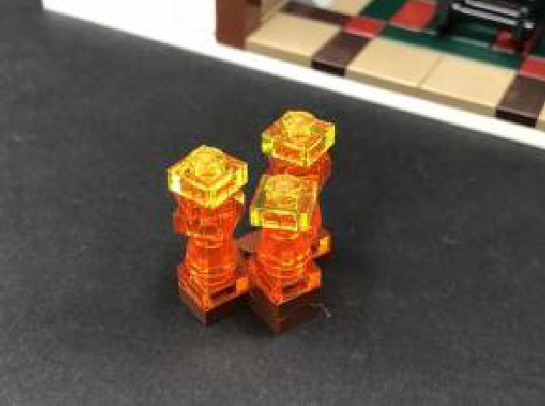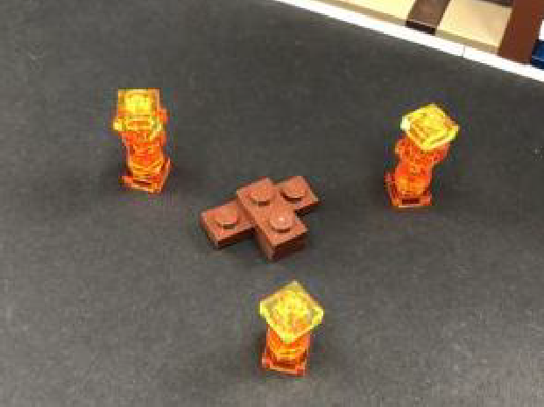

Take a White 15cm Bit Light and with the cable facing behind, place it over the top of the left brown stud. Secure the Bit Light in place by reconnecting one of the trans orange fire pieces over the top.
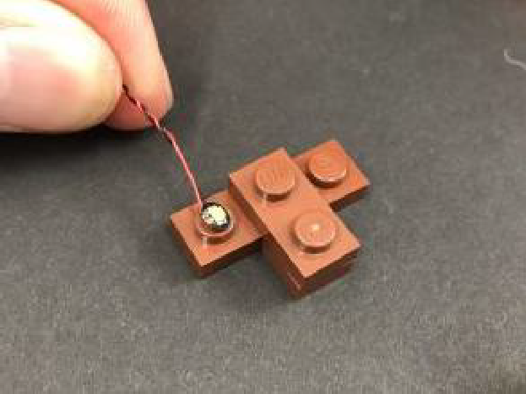
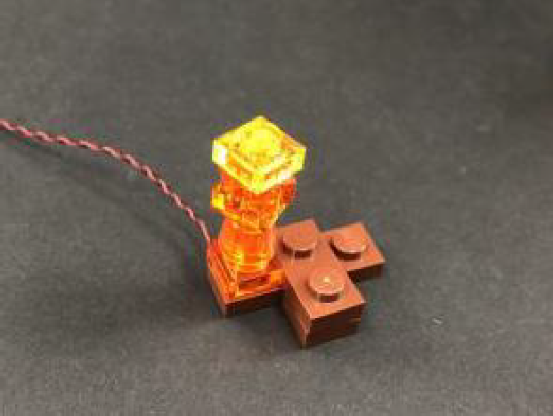
Repeat this process to install another 2x White 15cm Bit Lights to the right and middle flame sections.
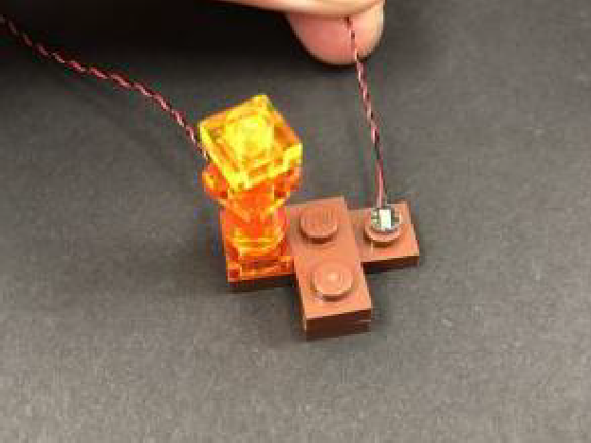
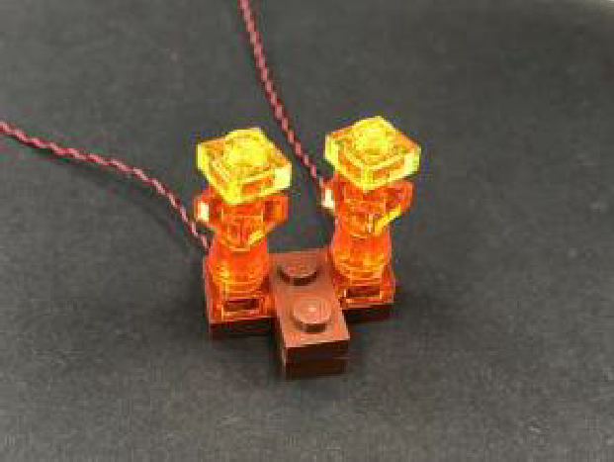

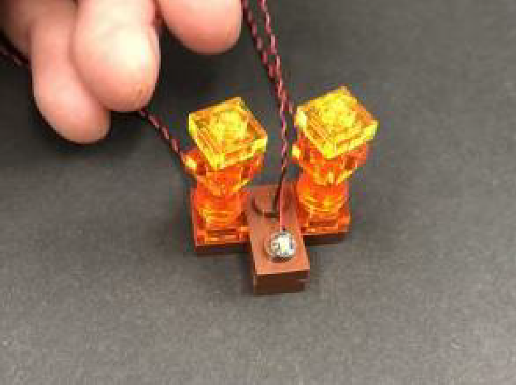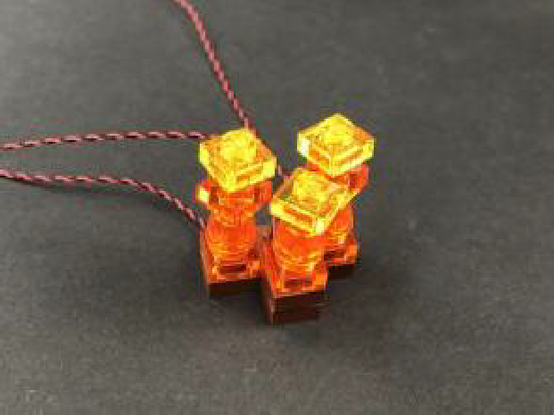

28.) From the back of the fire section, twist/wind the cables around each other all the way to the ends so they come together to form one larger cable.
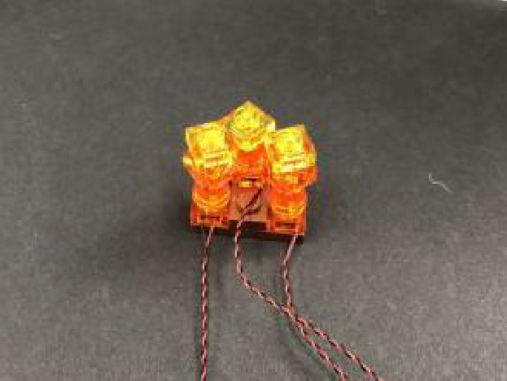
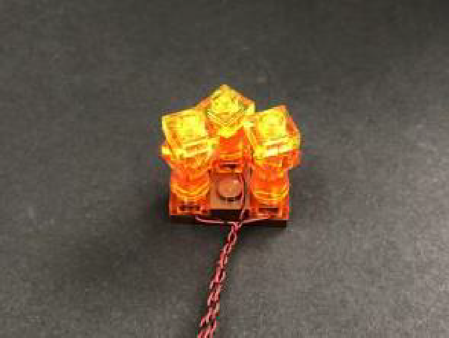

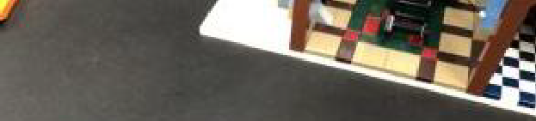
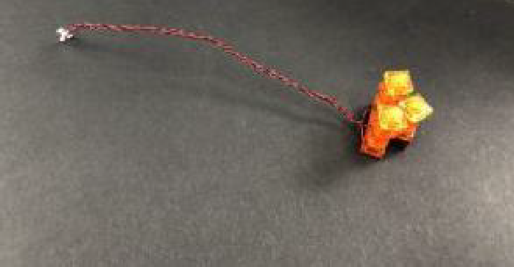

Thread the cable up underneath the top of the fire place and pull it out from above before reconnecting the fire section as well as the front grill.
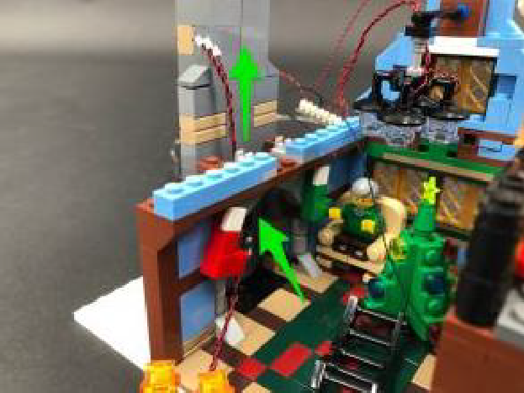
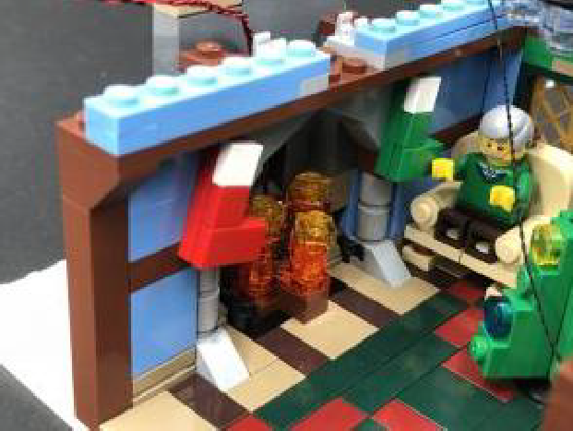

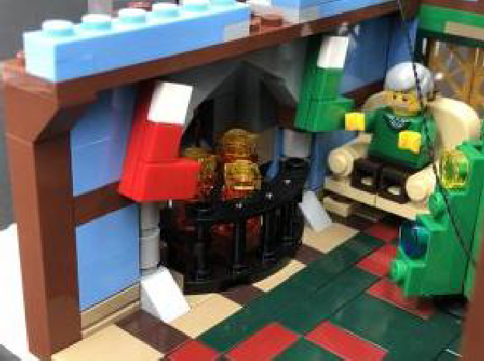

29.) Take out a 6-Port Expansion Board, 5cm Connecting Cable, and a Flicker Effects Board. Connect one end of the 5cm Connecting Cable to the expansion board and connect the other end to one of the OUT ports on the Flicker Effects Board.
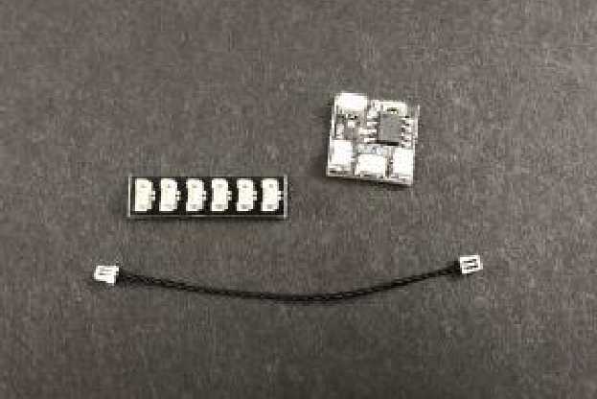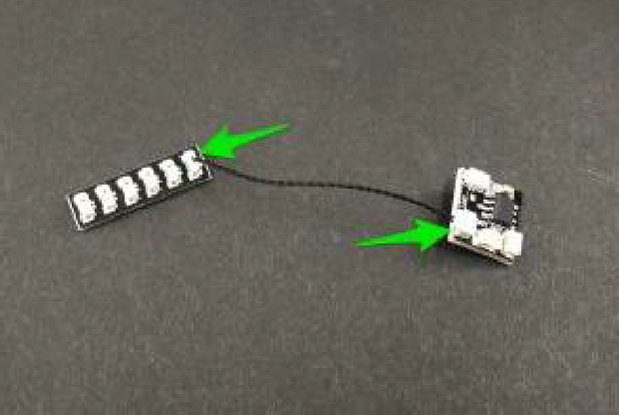

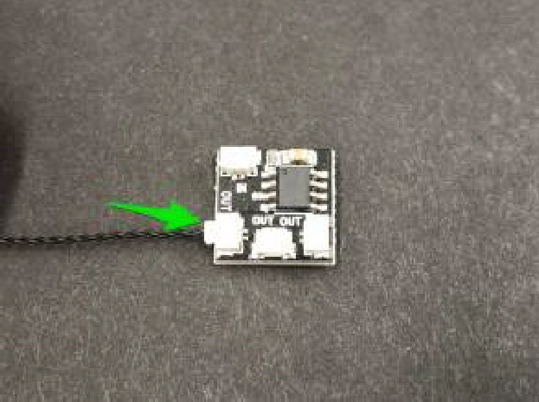

Take the other end of the 15cm Connecting Cable from step 25 and connect it to the IN port on the Flicker Effects Board.

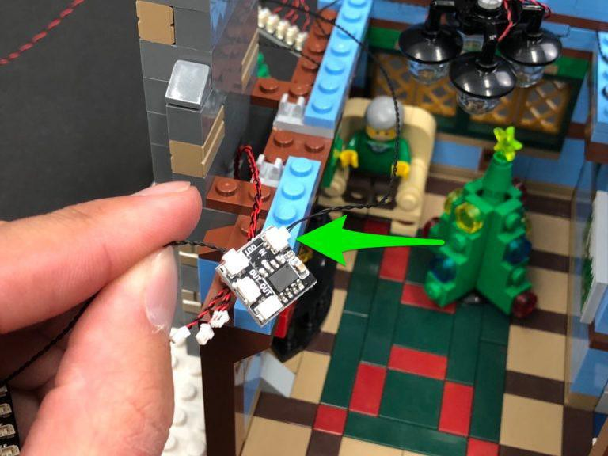

Connect two out of the three Bit Light cables from the fireplace to the remaining two OUT ports on the Flicker Effects Board, then connect the third Bit Light cable to the 6-port expansion board.
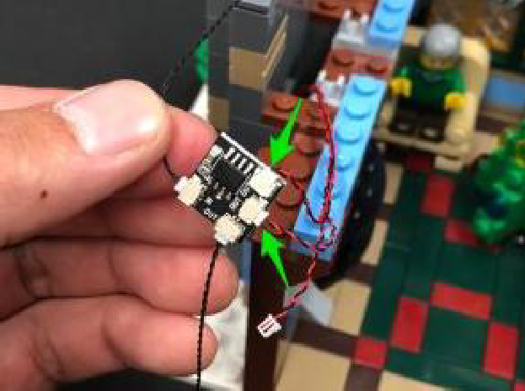
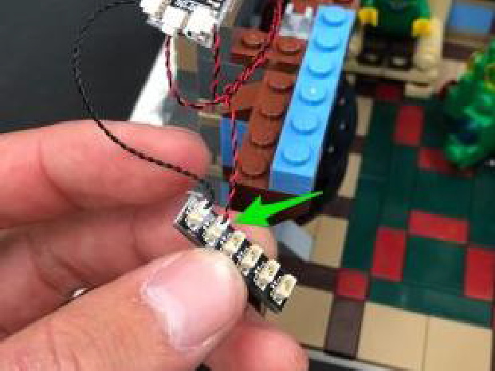

30.) Bring the Igloo over to the right side of the cottage and connect it’s Bit Light cable to the 6-port Expansion Board (as this will also utilise the flicker effect).
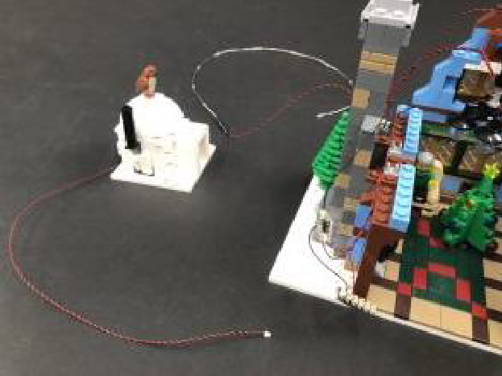
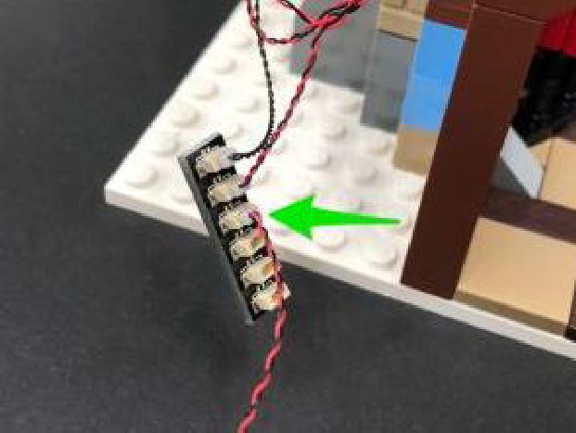

Stick 2x Adhesive Squares to the back of the 6-port Expansion Board and another Adhesive Square to the back of the flicker effects board. Mount both boards to the side of the chimney in the below positions as shown below:
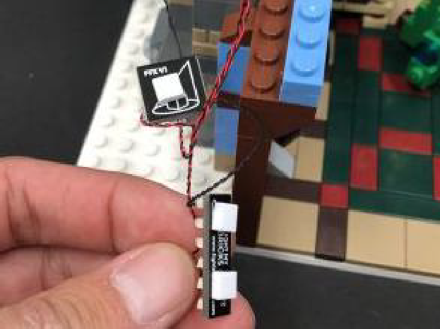
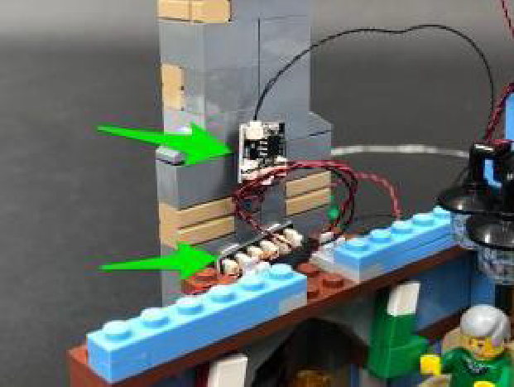

Neaten up cabling in between boards by twisting/folding the cables around each other, then tuck them down inside.

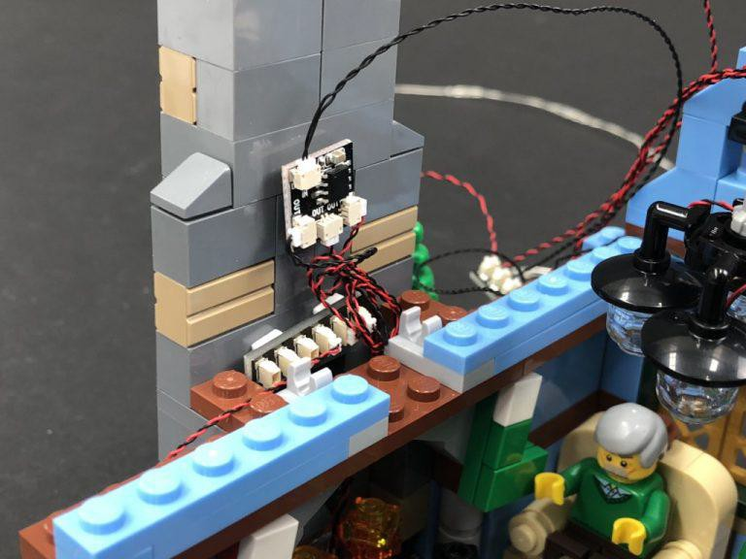

31.) Neaten up cabling from the 8-Port Expansion Board above by twisting and folding the cables around each other before reconnecting the left and right roof section. Neatly tuck the 8-port expansion board and cables inside in between gaps of the roof as shown below:
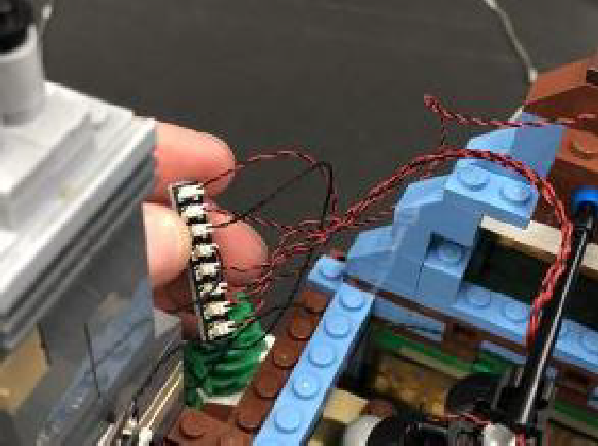
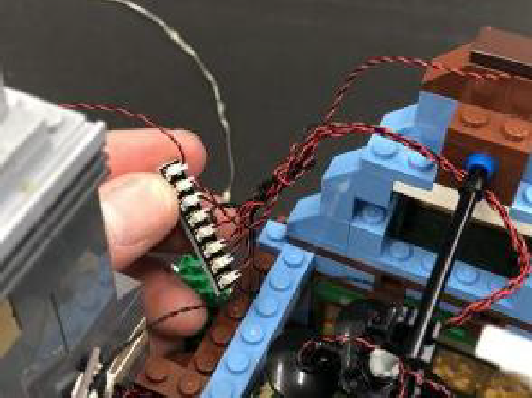

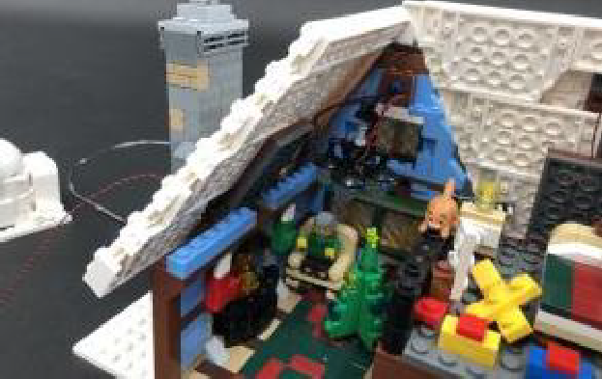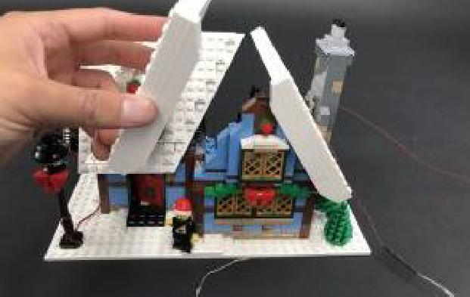

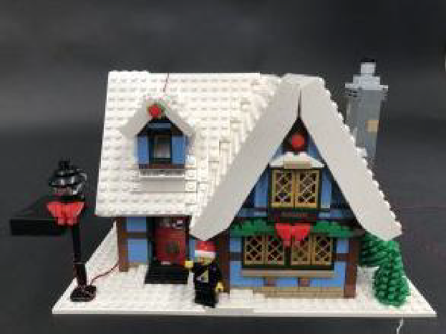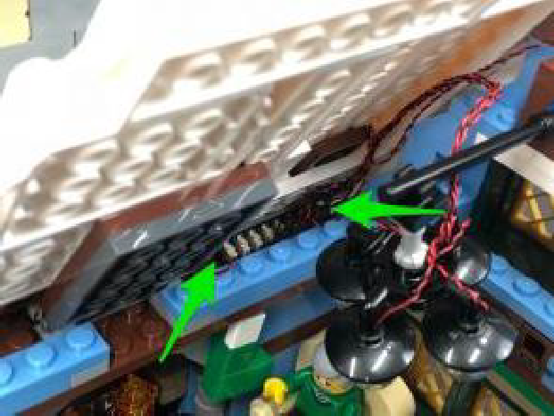

Turn the Battery Pack ON to test all lights are working including the flicker effect for the fire place and igloo fire stove.
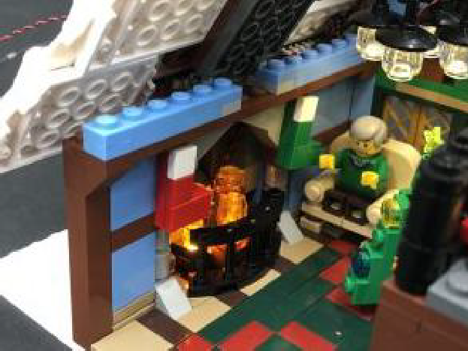
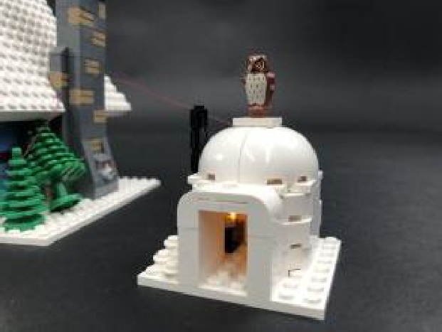

32.) From the front of the cottage, bring the Multi Colour Light string behind in between roof and chimney, then wind it around the right side and lay it up the right roof as shown below. Secure this part of the light string down by connecting a provided White Plate 1×4 over the top ensuring the light string is

in between studs.

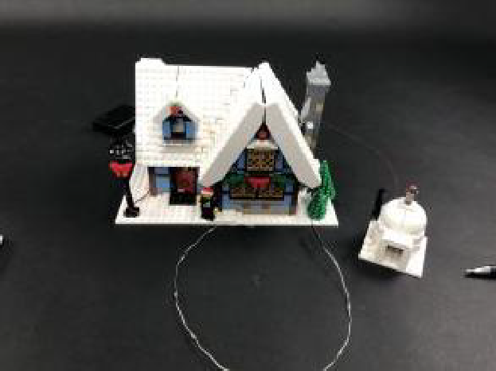
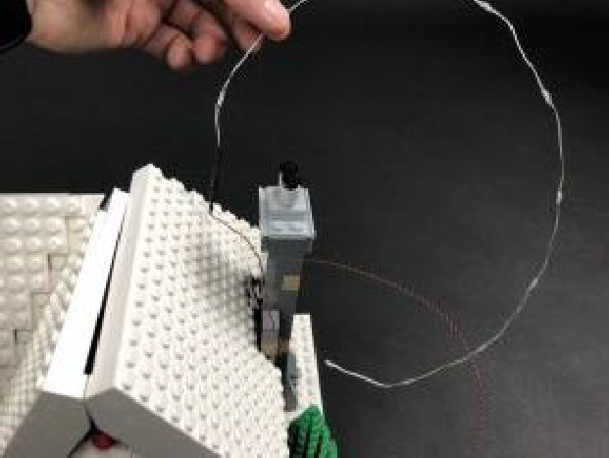

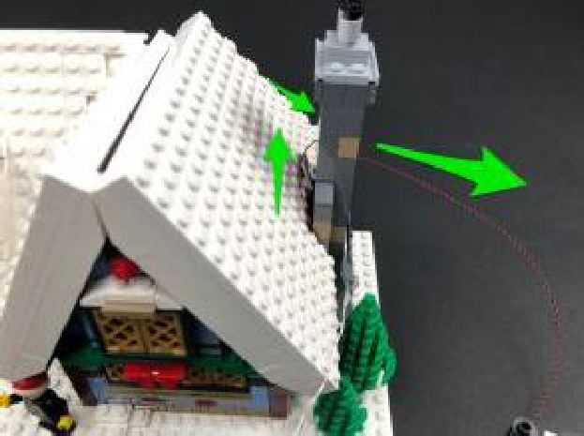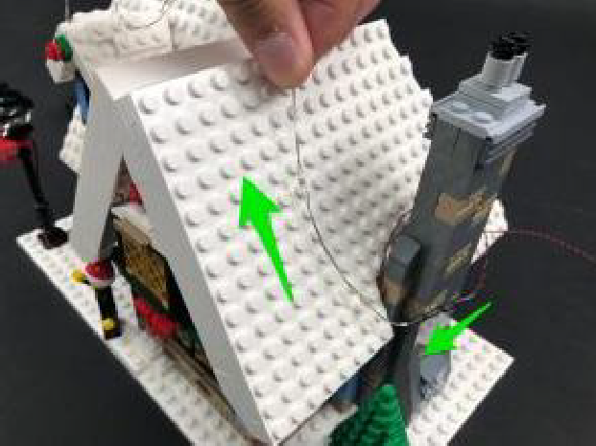

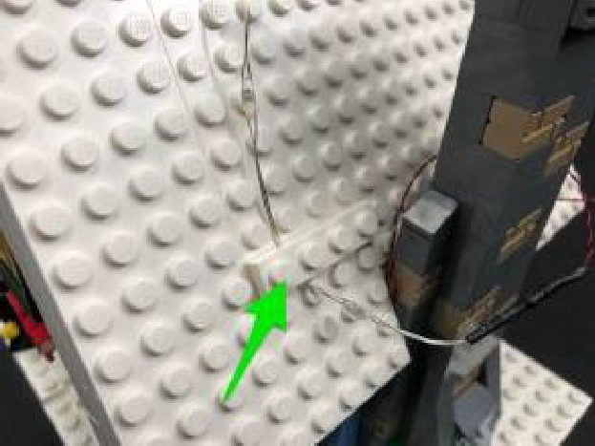

Bring the cable up and over the roof to the left side then secure it down using another provided White Plate 1×4.

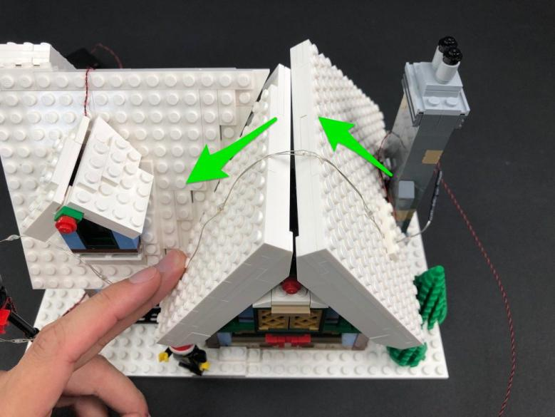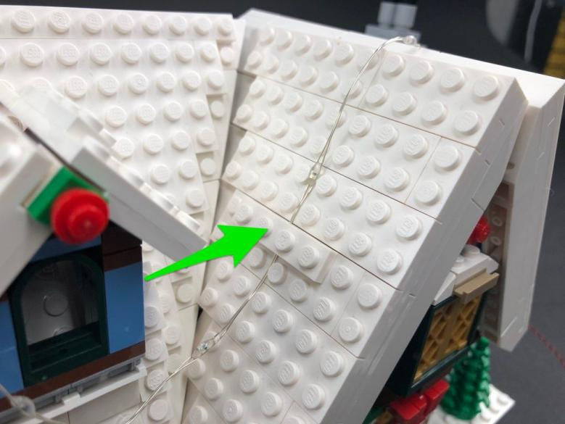

33.) Follow the below images to continue laying the Multi-Colour Light String across the roof, securing it in place using another 3x White Plates 1×4.
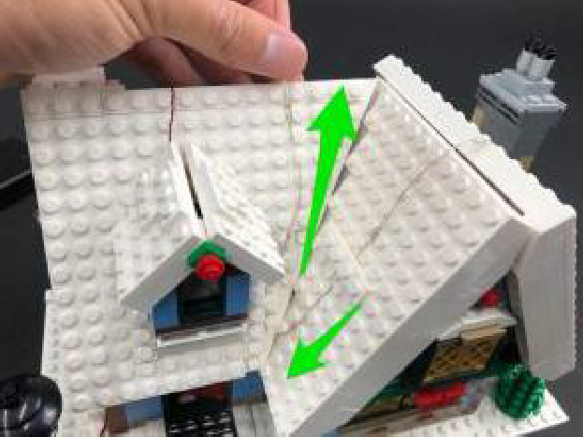
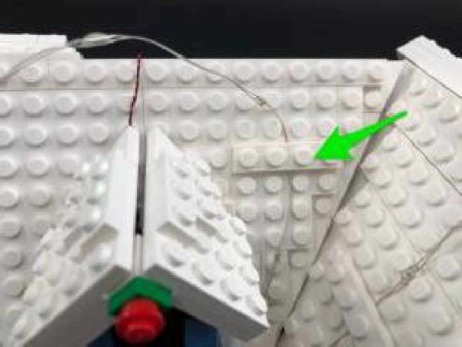

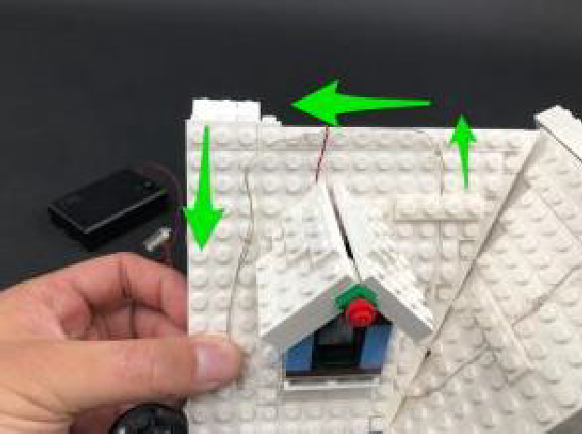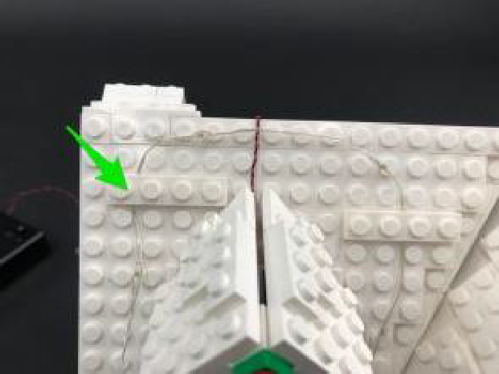

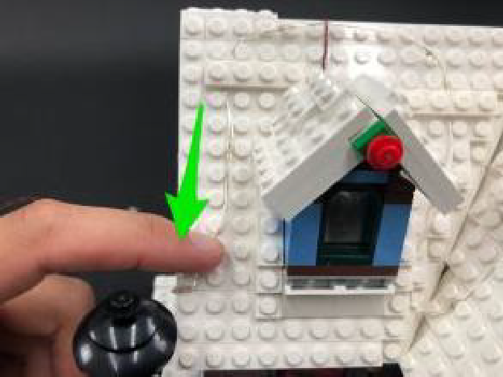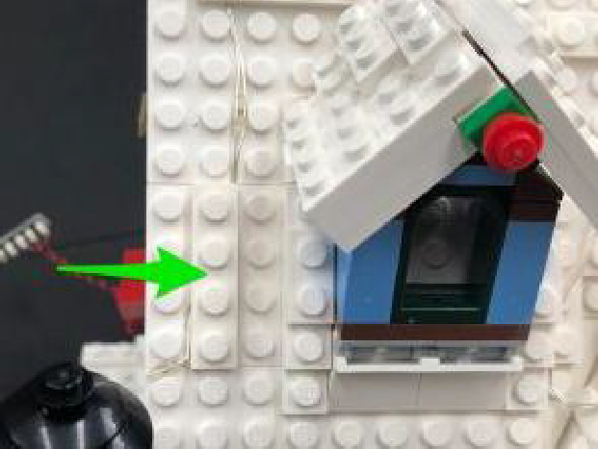
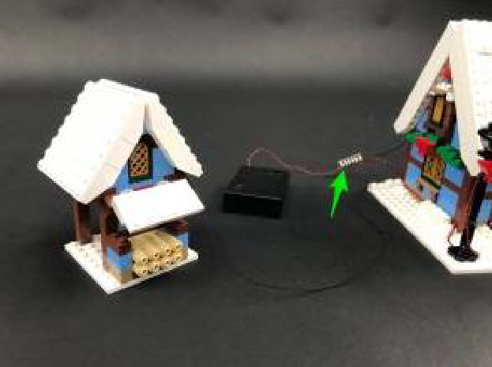
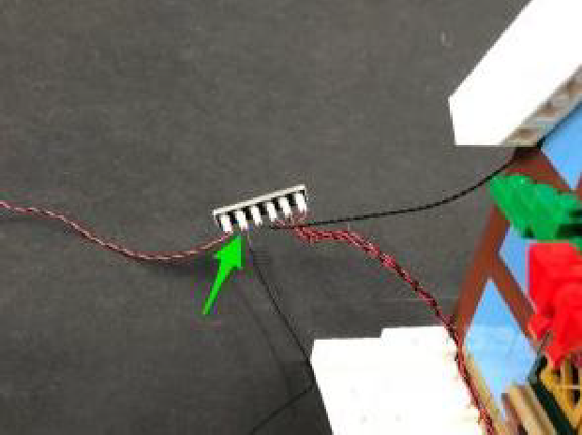
34.) Place the tool cabin on the left of the cottage and connect the 30cm Connecting Cable from the strip light to the 6-Port Expansion Board on the left side of the cottage.
"
From the back of the cottage, neaten up all the components by tucking them underneath the Battery Pack as shown below:
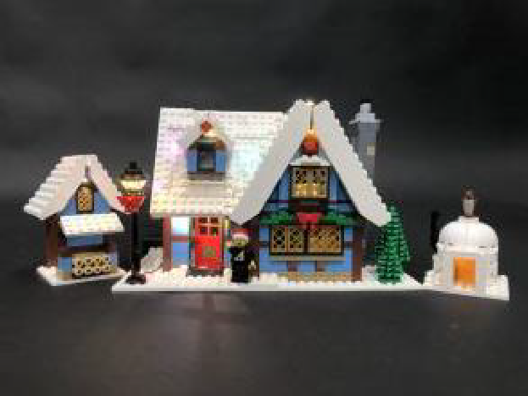
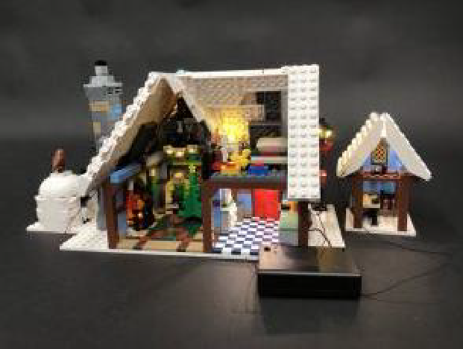

This finally completes installation of the Light My Bricks Winter Village Cottage Light Kit.

We hope you enjoy and we thank you for purchasing this product.
