Disney_Castle_71040 LED Lighting Kit
Package contents:
- 21x White 30cm Dot Lights
- 7x White 15cm Dot Lights
- 6x LED Strip Lights
- 2x Multi-Colour Changing Strip Lights
- 1x Multi-Colour Changing Light String
- 20x Adhesive Squares
- 3x 12-Port Expansion Boards
- 1x 6-Port Expansion Board
- 1x USB Power Cable (30cm)
- Connecting Cables
- 3x 5cm Connecting Cables
- 5x 15cm Connecting Cables
- 3x 30cm Connecting Cables
- 2x 50cm Connecting Cables
Extra pieces
- 11x Trans Orange Round Plate 1x1
- 5x Plates 1x6
- 4x Plates 1x2
- 1x Green Flower 1x1
- 2x Plate 2x6
- 4x Plate, Modified 1x2 with Stud (jumper)
- 2x Dish 3x3 Inverted (Radar)
- 2x Plate, Modified 1x2 with handle on End—Close Ends
- 2x Tile, Modified 1x1 with Clip
- Eßects Boards option 1 (retired)2x Multi-EGects Board
- 1x 6-port Expansion Board
- 1x 5cm Connecting Cable
- OrEßects Boards option 2
- 2x Flicker EGects Boards (FFX)

Note:
Place wires on the surface or under the building blocks.
The wire can be place between the building blocks or under the block, but they should be placed between the studs correctly.
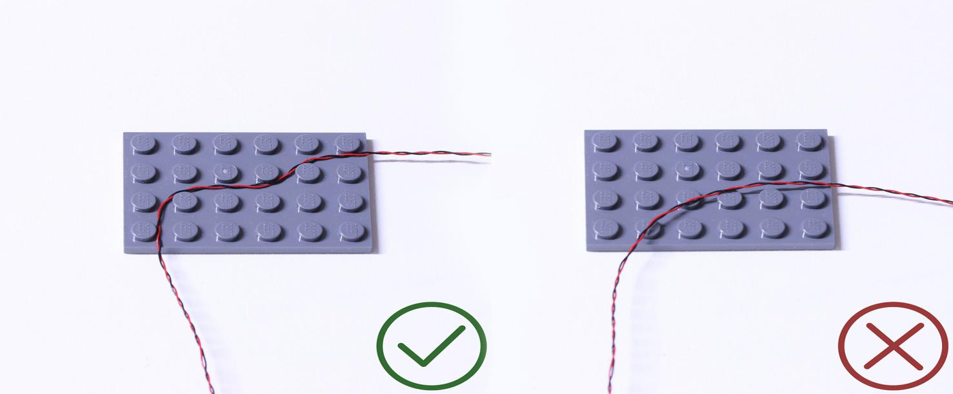
Insert the connectors to the ports.
Be careful when you are operating, there’s only one correct way to insert, make sure the expansion board is upward, find the soldered “=” sign on the left of the port. When you are inserting, the side which the wires can be seen should be faced to the “=” sign and if you feel hard to insert, please stop, and don’t force it, for that may result in bent pins inside the port or overheating of the expansion board.
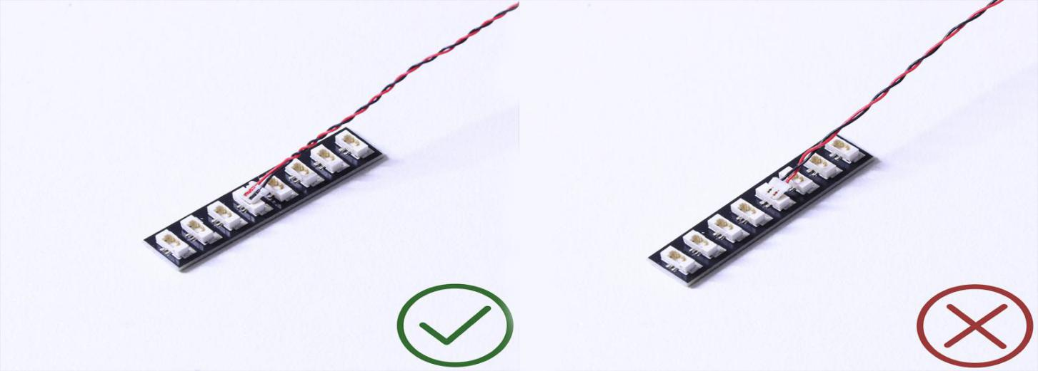

At this point, use the tweezers to straighten the bentpins.

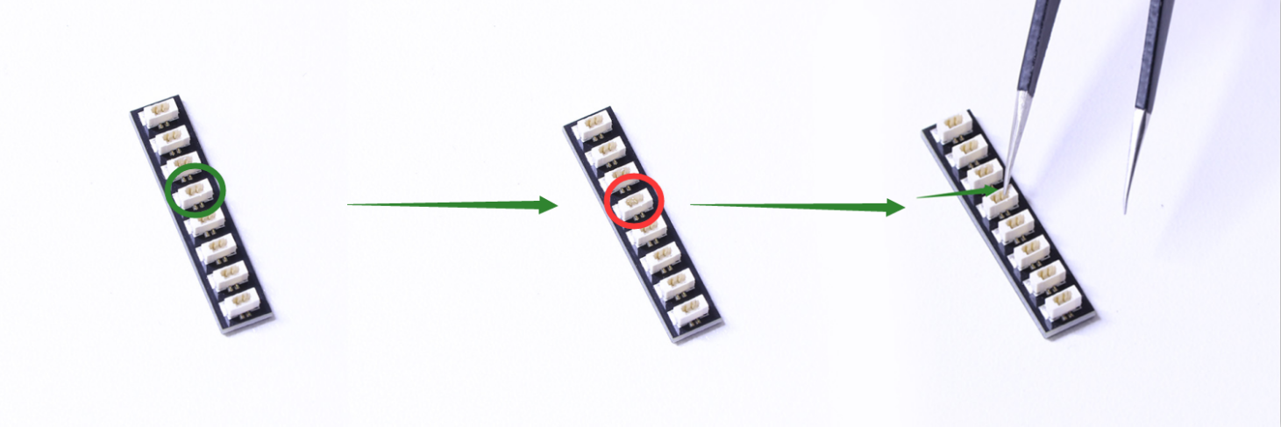

When installing dot lights, make sure they are correctly placed (Yellow LED package is exposed). You can put they either on the top of the studs or between studs.

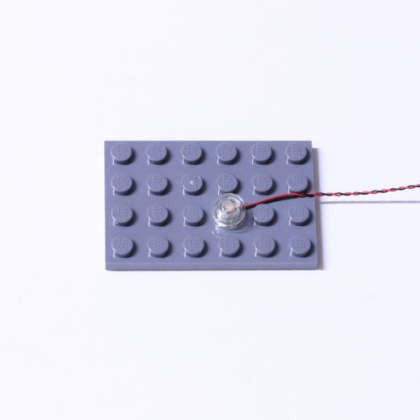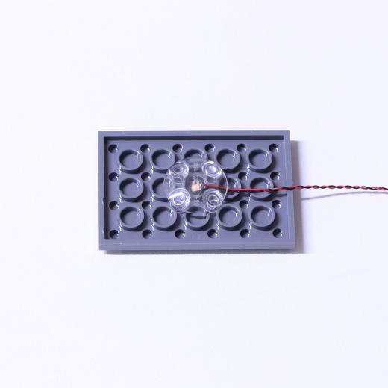

Connecting cable connectors to Strip Lights

Take extra care when inserting connectors to ports on the Strip Lights. Connectors can be inserted only one way. With the Strip Light facing up, ensure the side of the connector with the wires exposed is facing down. If a plug won’t fit easily into a port connector, don’t force it. Doing so will damage the plug and the connector.
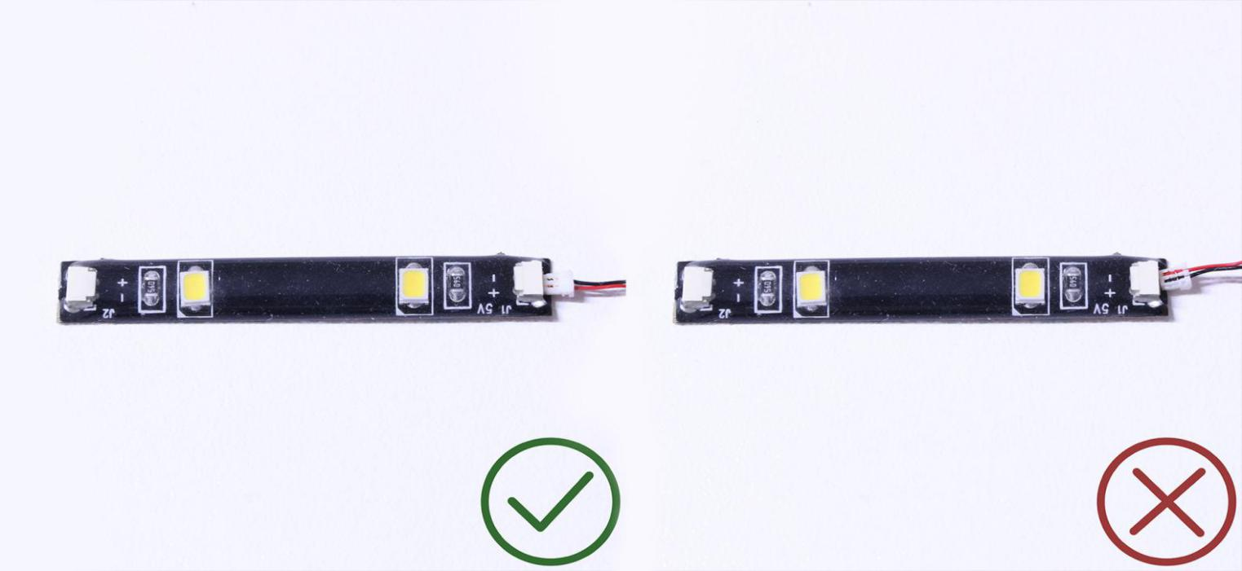
Finally, please pay attention to the positive and negative terminals of the battery when installing the battery case.
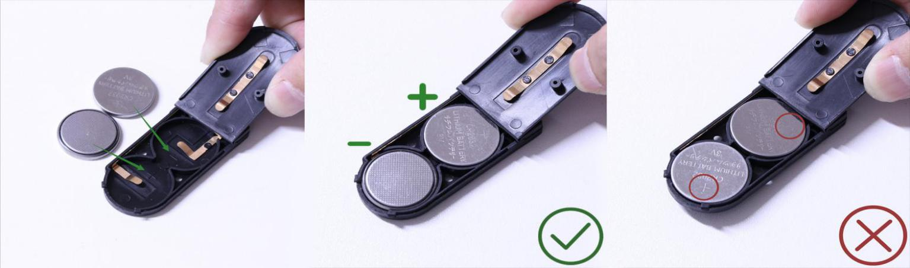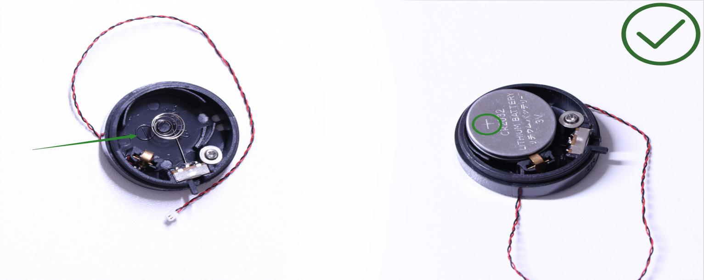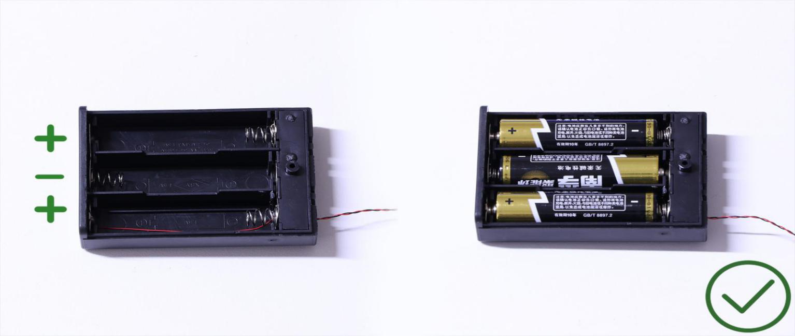
OK, Let’s Begin!
Instructions for installing this kit
1.) We will start by installing lights to the 2 lamps at the front door. Start by disconnecting the top sections of the castle so we can work with just the base. Remove the following lamp sections as per below.

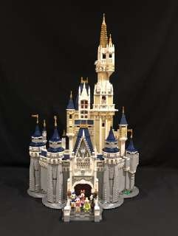
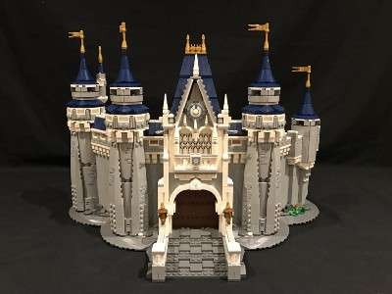
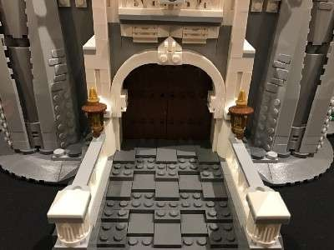
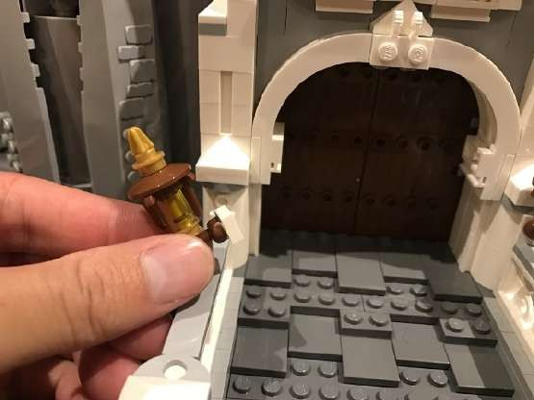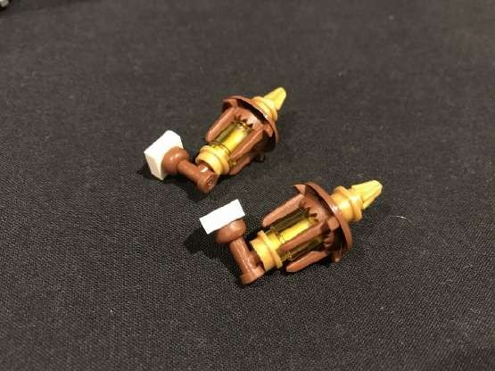

You will require a Removal Tool to assist you in removing sections and creating gaps where required.

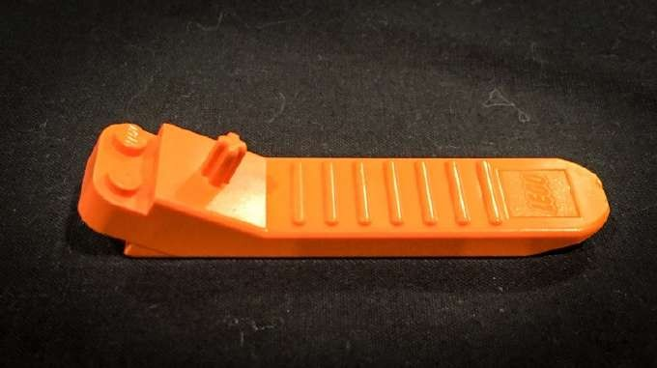

2.) Use the Removal Tool to lift and create a gap at the following position on the right side of the front door.
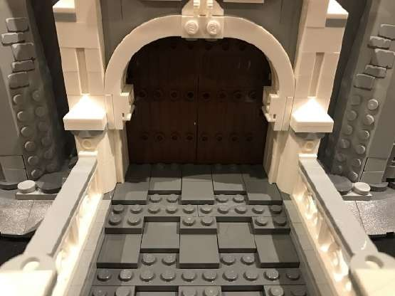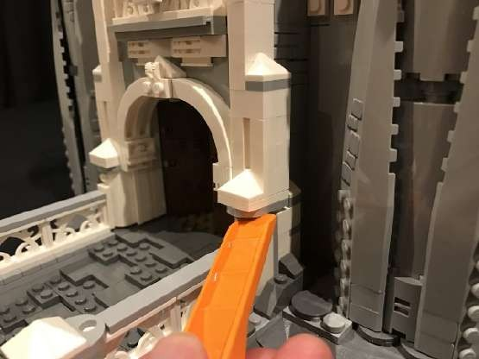
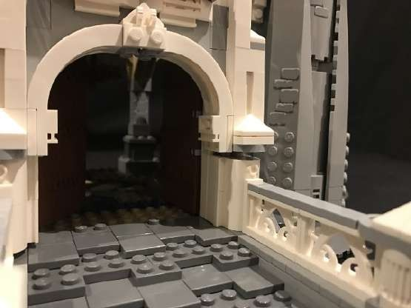
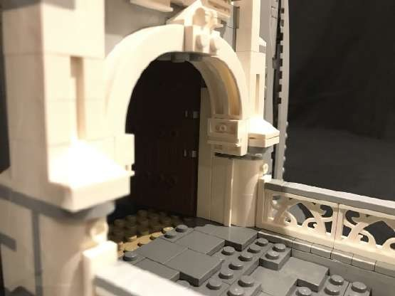

Remove the following sections

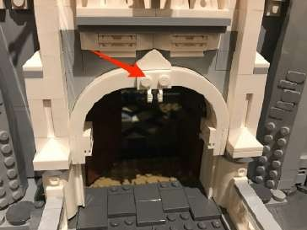
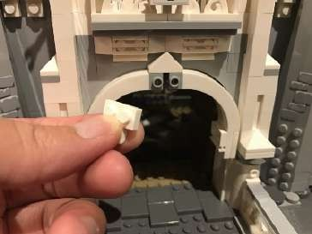
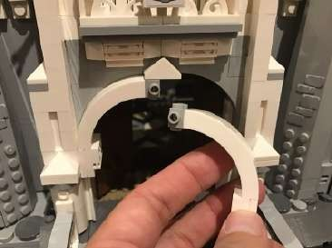

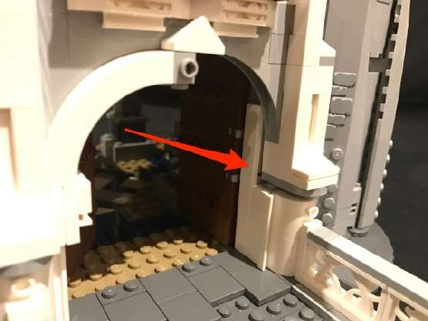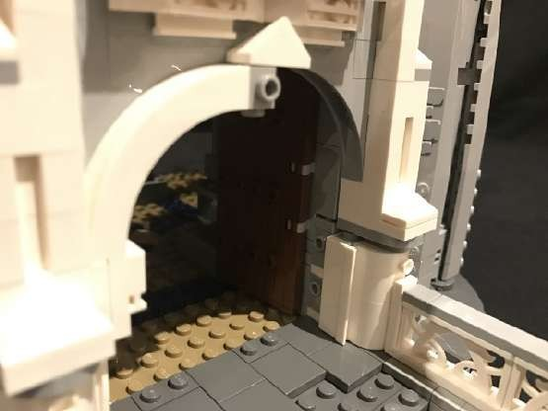

3.) Take one of the lamp sections and disassemble as per below

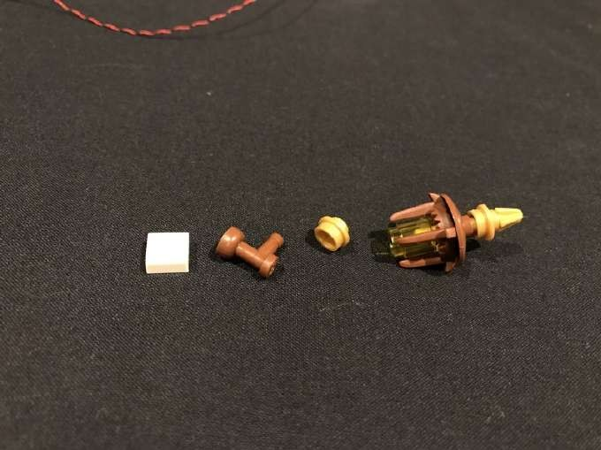

Take a White 30cm Dot Light and thread the connector side through the top (smaller hole) of the pearl gold round plate. Thread all the way through until the LED component of the Dot Light is right up against the bottom of the plate.

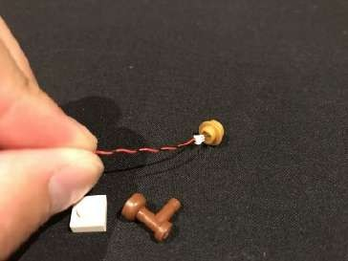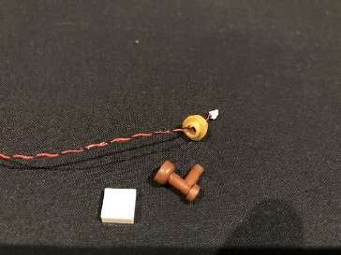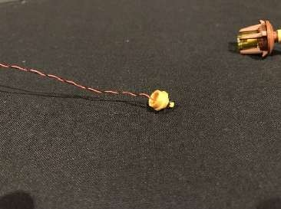

Reconnect the pearl gold plate back to the rest of the lamp ensuring the LED Component is clearly visible, then reconnect the remaining pieces to the lamp.

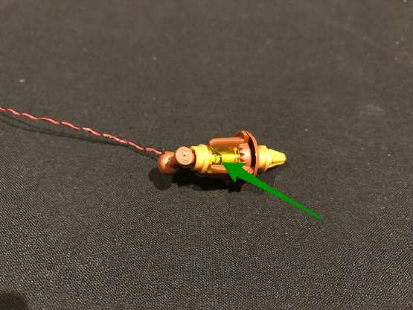
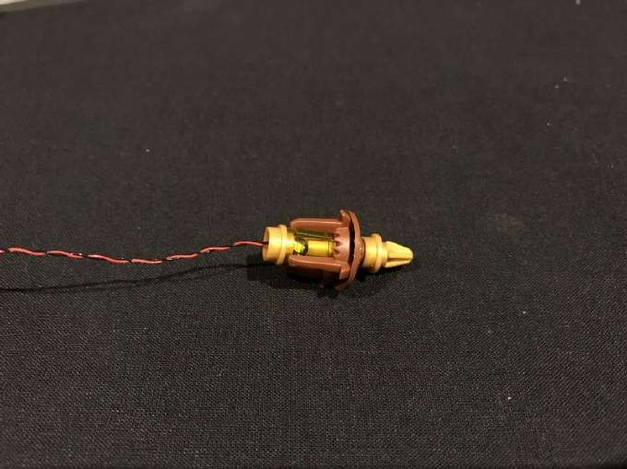
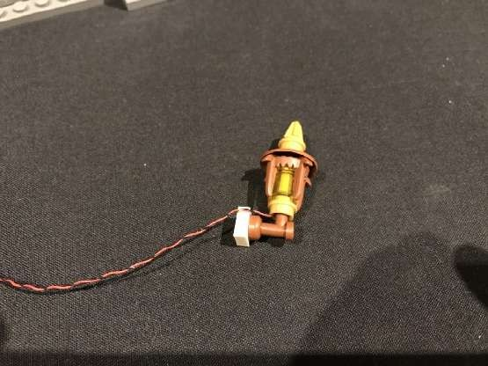
early visible from the front of the lamp

Reconnect the lamp with Dot Light installed back to the castle and then remove the right door.

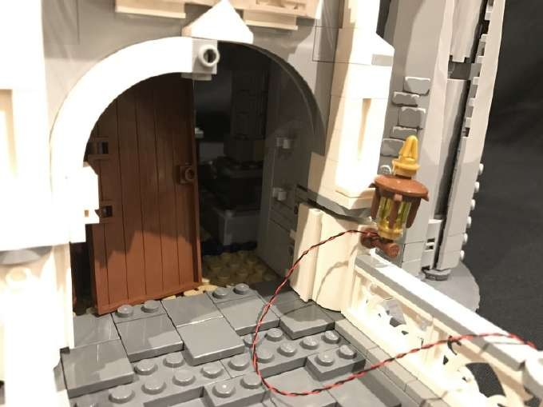

4.) Thread the other end of the cable through to the inside of the castle and then lay the cable neatly underneath the gap we created.
Reconnect the door to secure the cable in place.

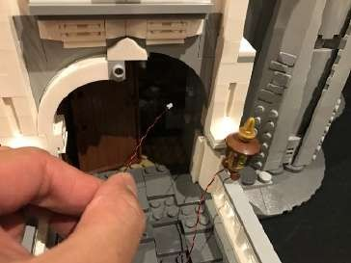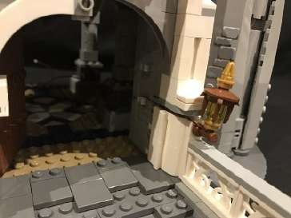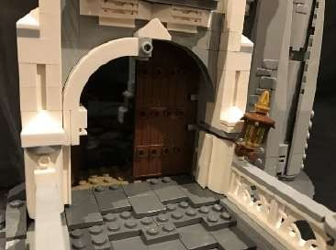

Reconnect pieces we removed earlier and then close the gap by pushing down pieces together.

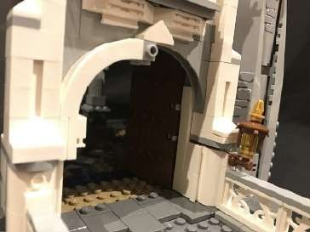
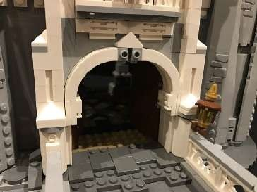
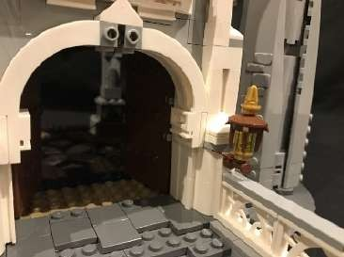

5.) Repeat step 2 to remove pieces and create another gap to the left side of the door.

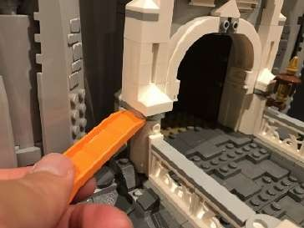
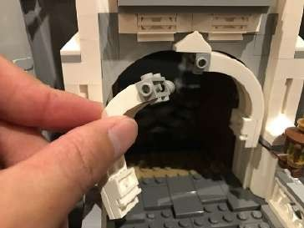
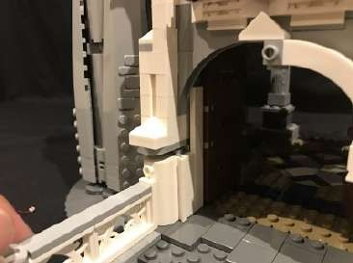

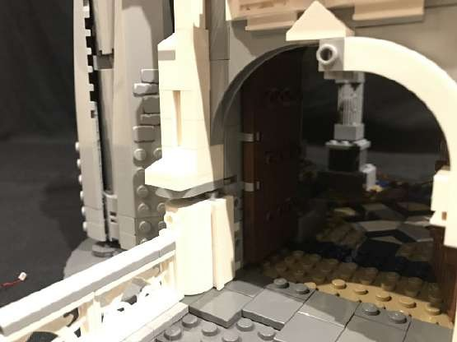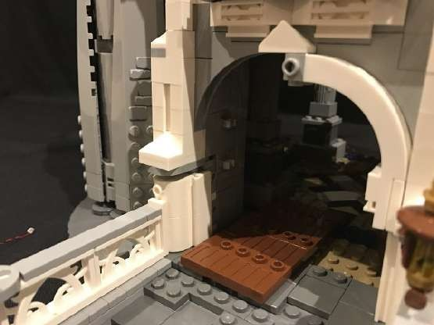

6.) Repeat steps 3 and 4 to install another White 30cm Dot Light to the lamp on the right, then reconnect sections and push down on bricks to close up the gap.
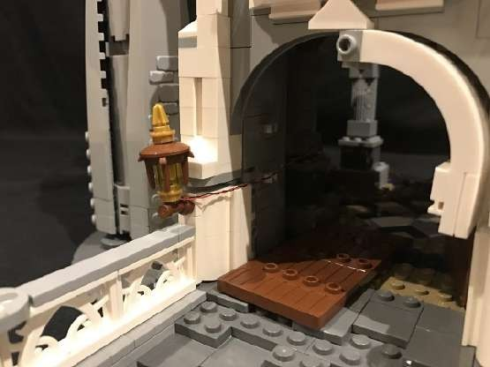
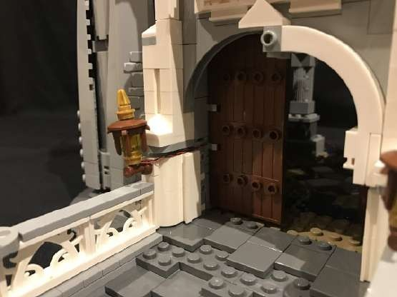
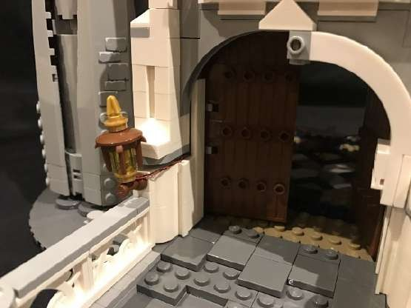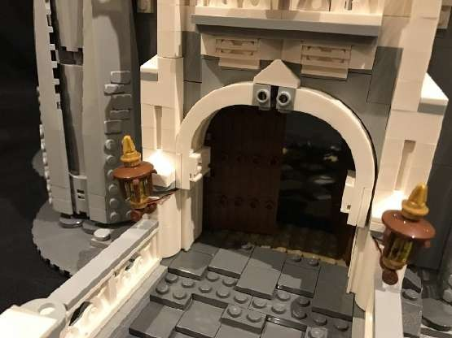

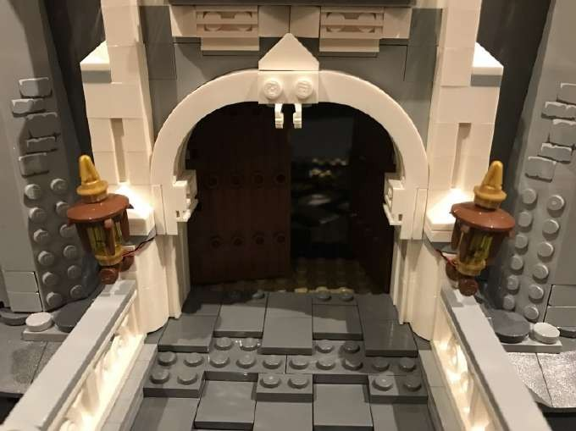

7.) Turn the castle around so that we can access the inside and then pull the cables right through from the doorway.
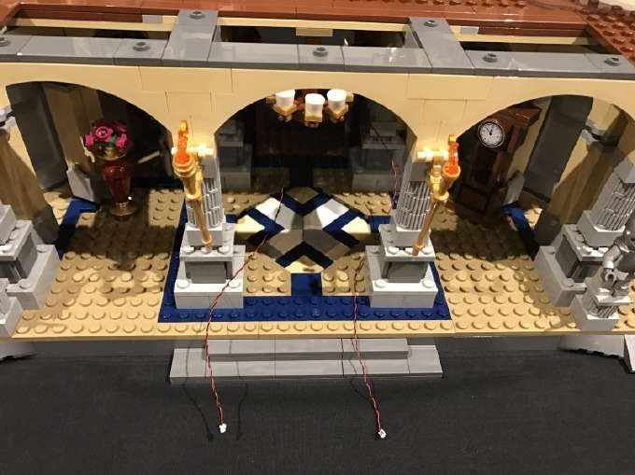
Remove the following tiles from the base of the second koor and then remove the 6x8 plate from the middle, followed by the 2x10 plate behind.
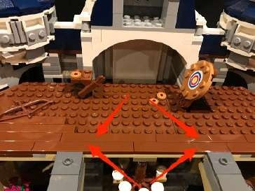
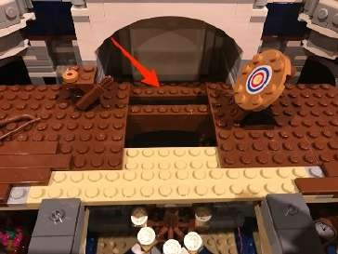
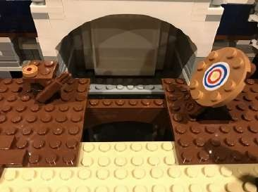

Thread the 2 cables from front door up this space we have created and then set aside.
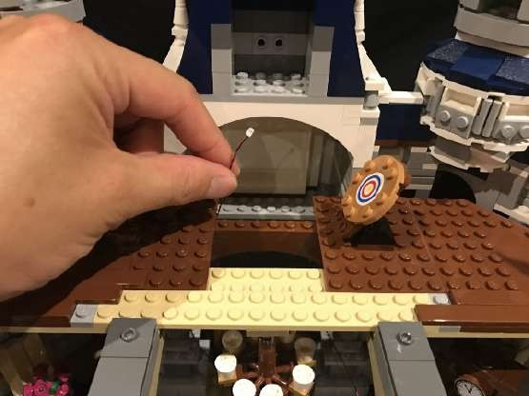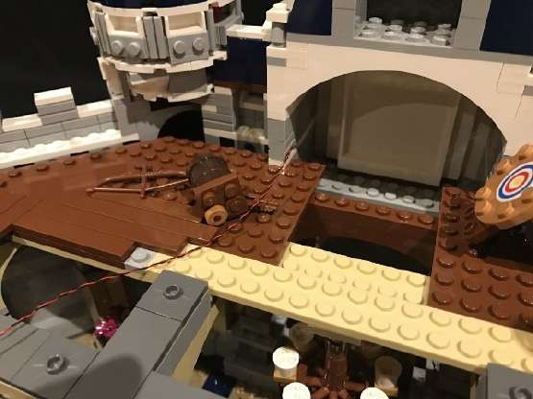

8.) Use the removal tool to lift and remove the middle section as per below.
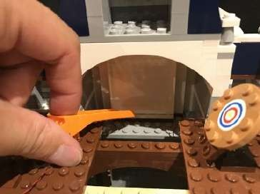
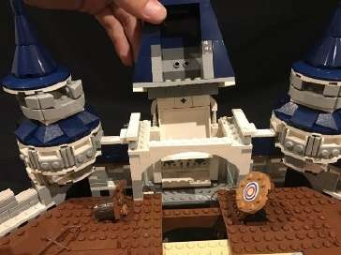
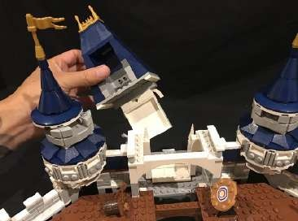

Take a Strip Light and connect a 15cm connecting cable on each port (total 2x connecting cables). Since we are using several strip lights in this lighting kit, we will identify this one as striplight#1
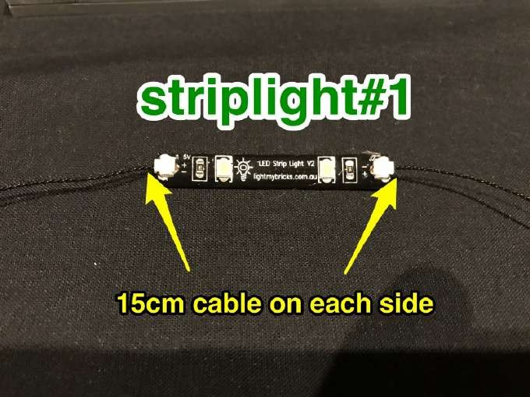

Peel ofl the adhesive backing paper and to allow us to stick it to the base of balcony as close as possible to the 1x6 plate

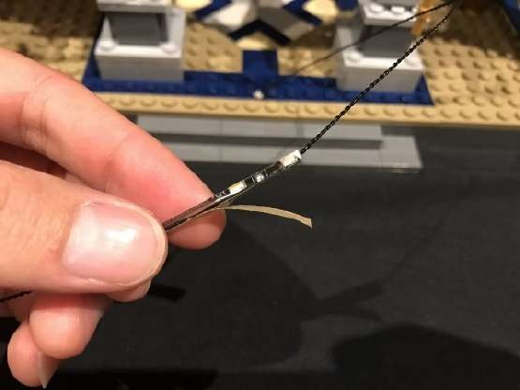
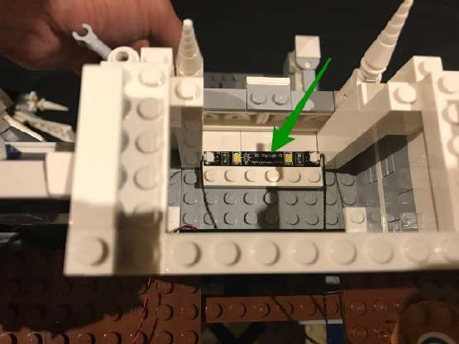

Pull the connecting cables over before reconnecting the 2x10 brown plate and middle section we removed earlier
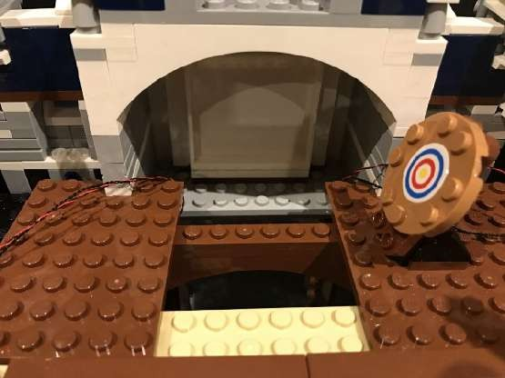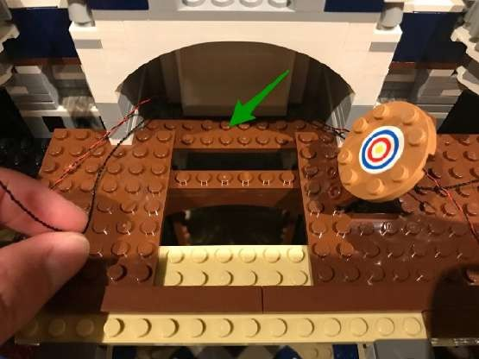

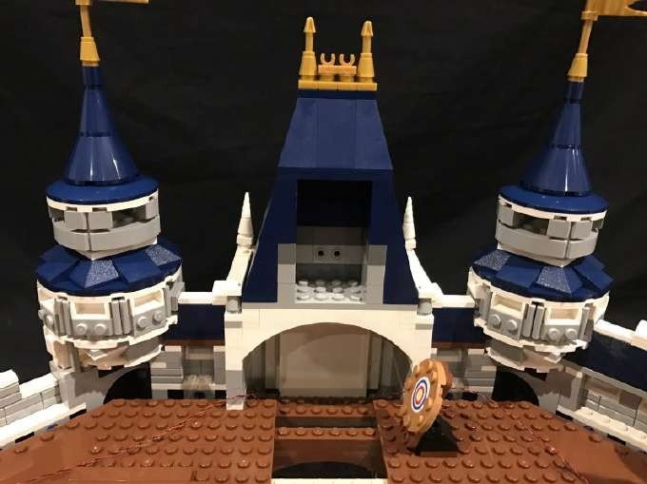

9.) Remove the following sections of the base of the second koor and then thread the connecting cable from the left port on striplight#1 underneath the 6x8 plate (but over the beam below) through to the left side.
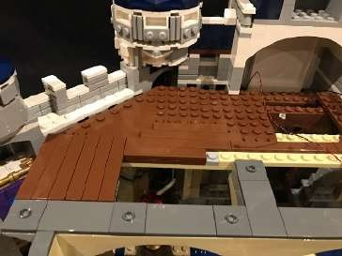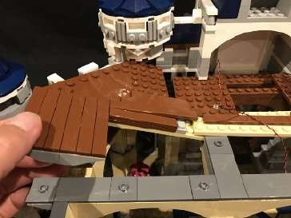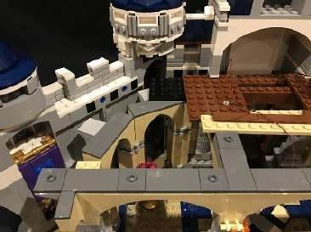
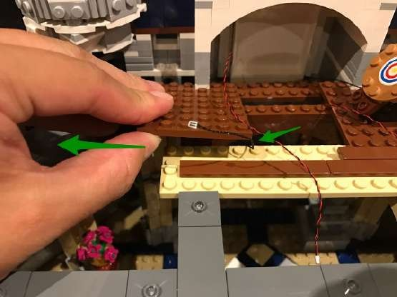
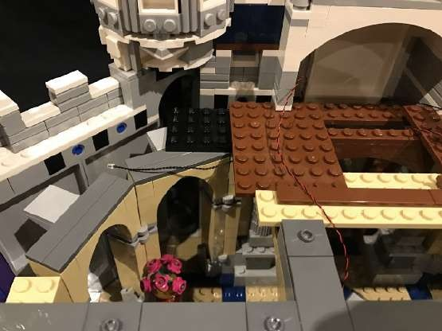

Repeat this process for the right section and cable from the right port on striplight#1.

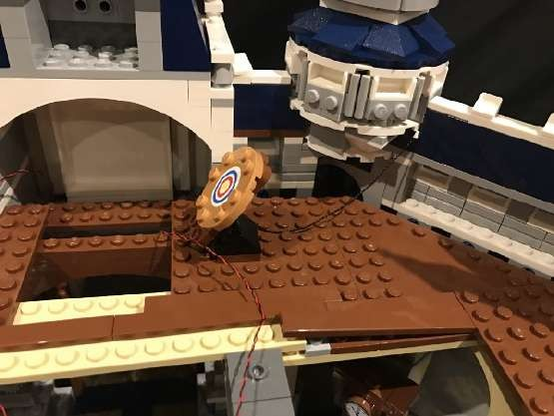
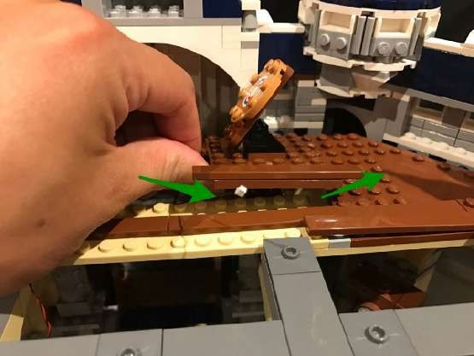
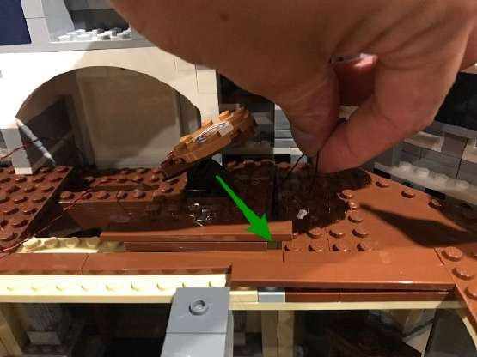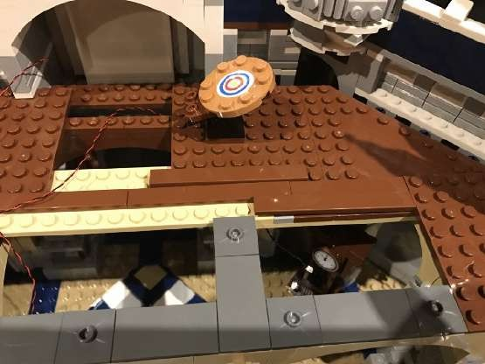

10.) We will now install lights to the chandelier. First remove this entire section at the 2x2 plate and then disassemble pieces as per below:

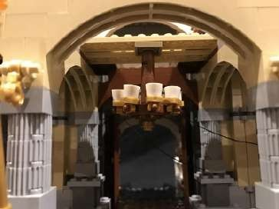
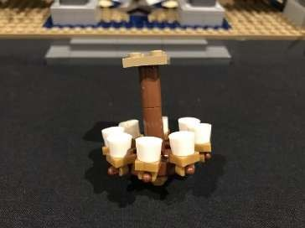
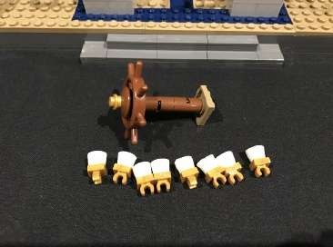

Take out 8 of the provided trans orange round plates which came in this set.

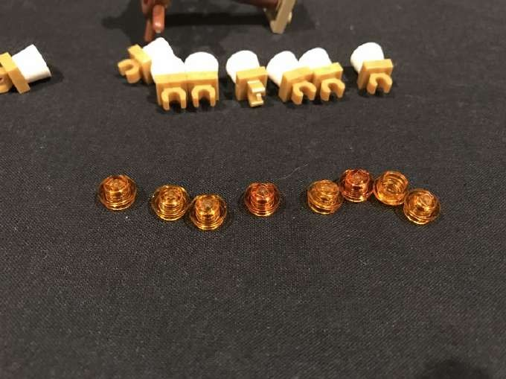

11.) Take a White 30cm Dot Light and then bend the LED component on a 90 degree angle with the component face up. Place the Dot Light inside one of the white round pieces and then secure by connecting a trans orange plate directly over it.

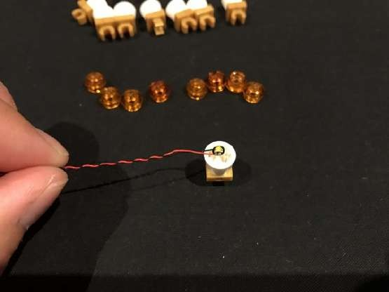
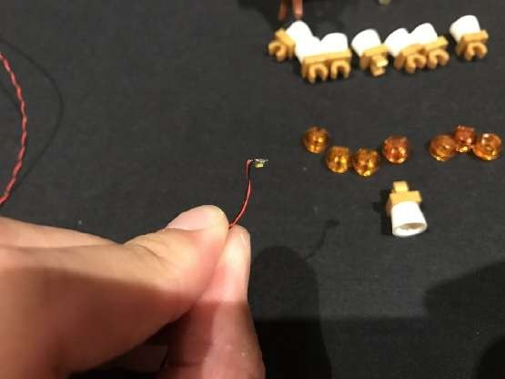

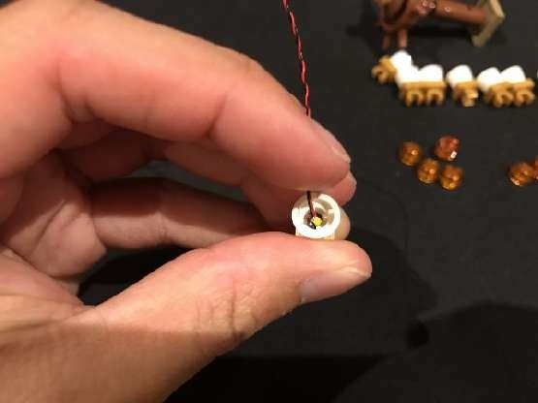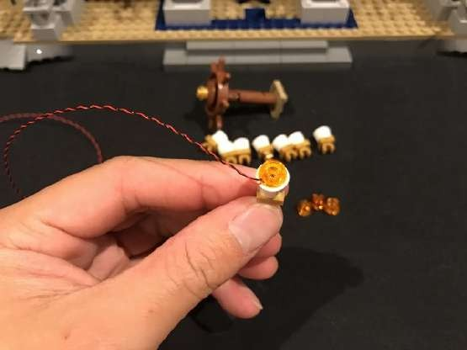
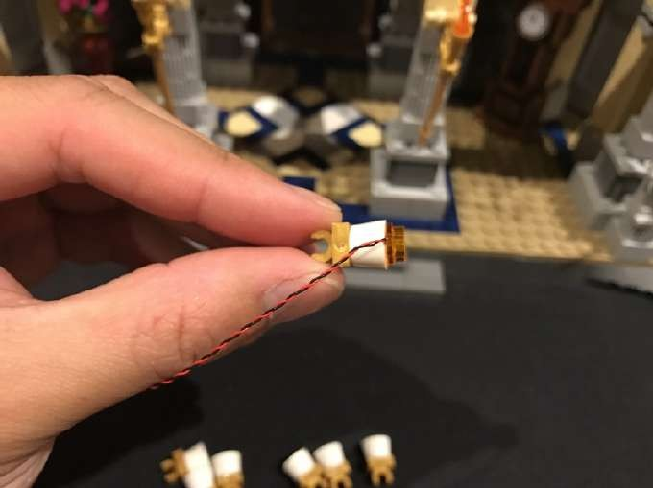

Repeat the above process to install another 7x White 30 Dot Lights
using provided trans orange round plates to secure.
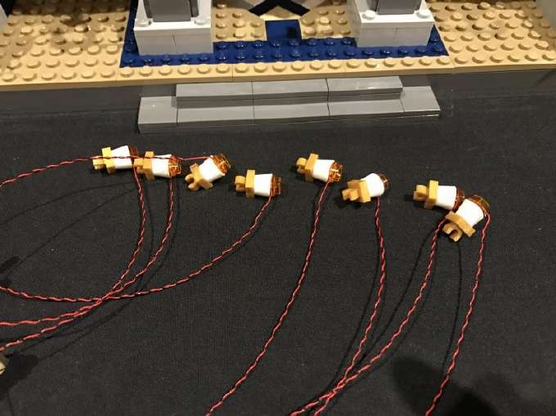

12.) Connect each light section back to the wheel ensuring each cable is facing toward the centre of the wheel.
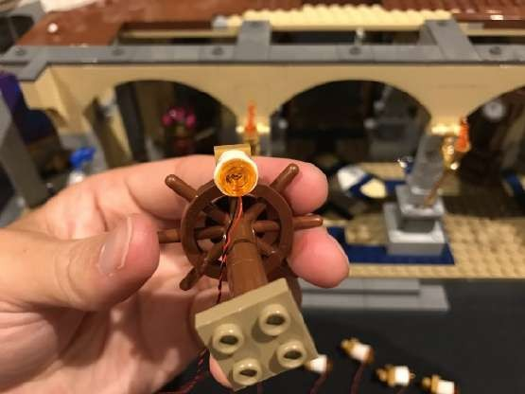
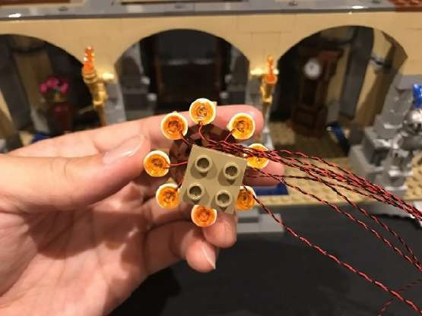
Group all the cables together and then twist/wind them around each other so that they all come together to form one large cable.
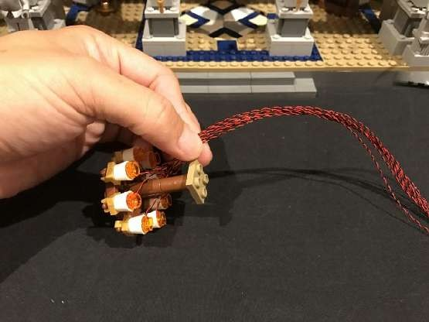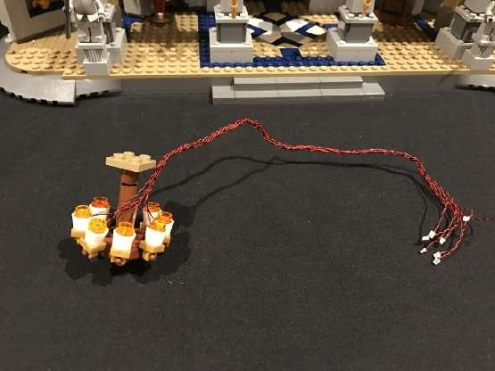

Reconnect this section back to the roof of the ground koor.
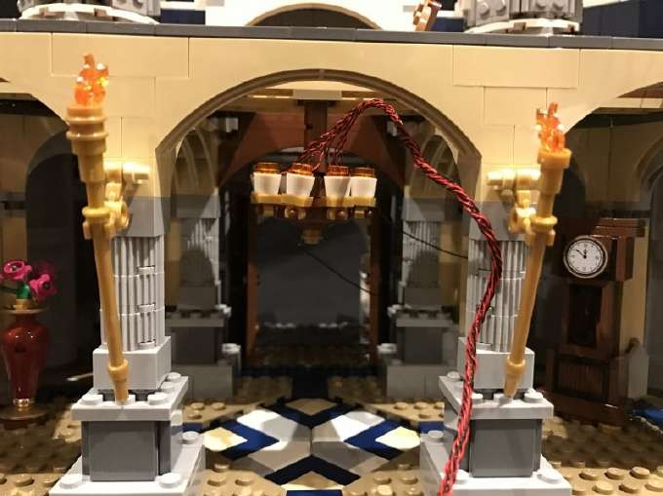

13.) Bring the cables of the chandelier toward the front of the castle and then thread the cables up the space which leads to the second level. Lay the cables in between studs of the first brown brick before reconnecting the middle 6x8 plate directly over the top as well as the brown tiles we removed earlier.
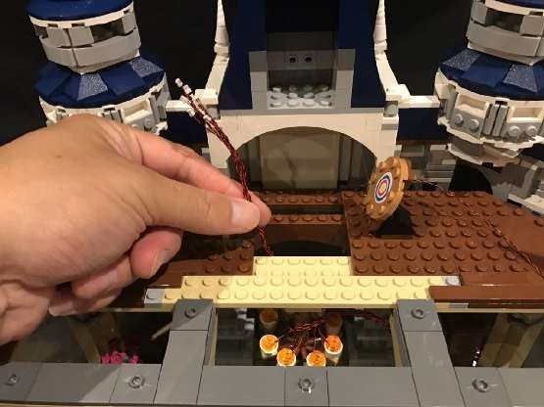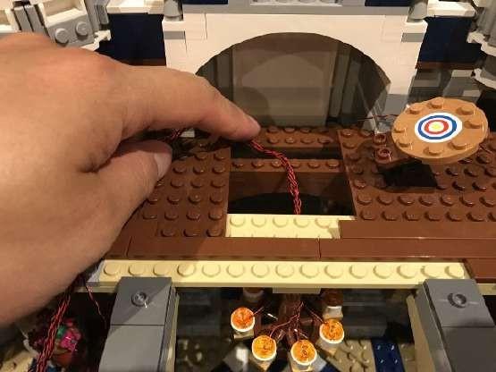
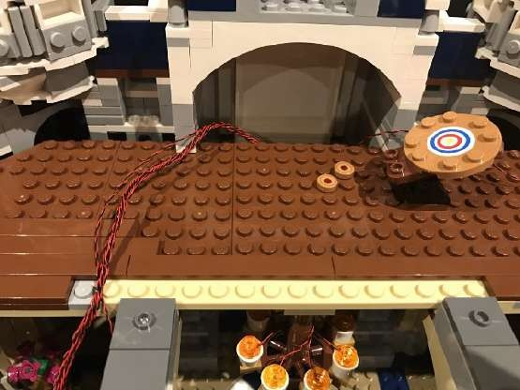
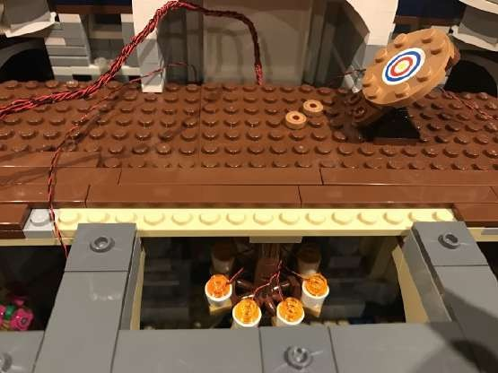

14.) Take a 12-Port Expansion Board and then connect all lights from the chandelier as well as the 2 front door lights we installed at the start into available ports of the expansion board.

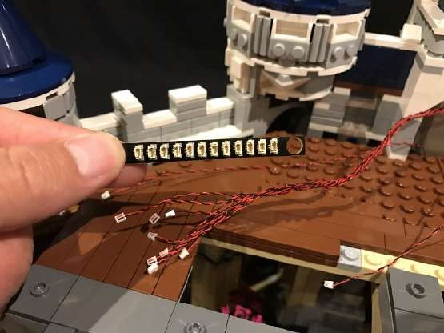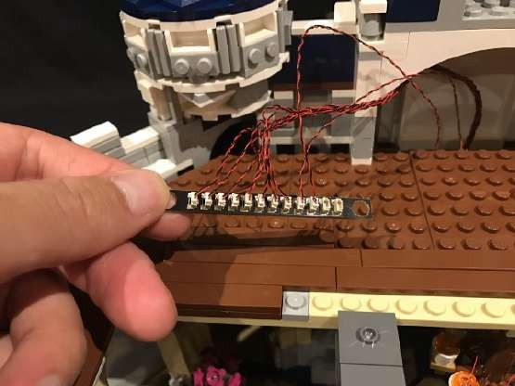

This is now a good time to test the lights we have installed so far. To do this take the USB Power Cable and connect it to your USB Power Bank. Connect the other end of the USB Power Cable into a spare port on the expansion board and turn on to confirm all the lights are working OK.

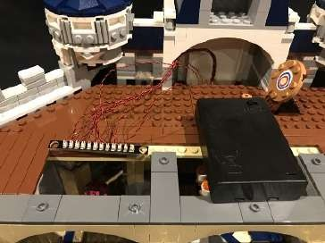
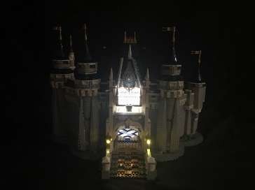
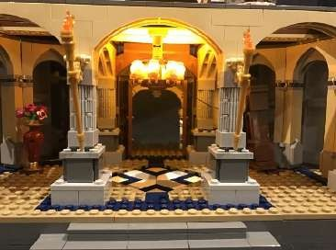

15.) Let’s move onto lighting the rest of the ground koor. Take a Strip Light (striplight#2) and then stick it onto a provided 1x6 plate.
Connect a 5cm connecting cable into one of the ports. Take this strip light and connect the loose 15cm cable hanging from the left side of the roof into the spare port and then mount to the roof in the below position. Ensure the 5cm connecting cable is facing the right.
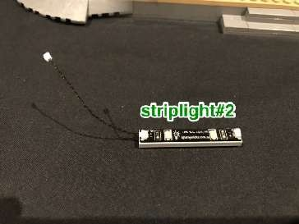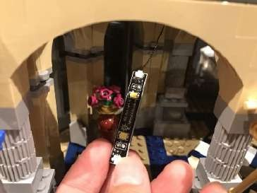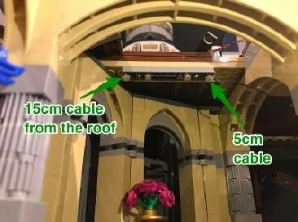

16.) Take another Strip Light (striplight#3) and stick to a 1x6 plate. Connect a 30cm connecting cable to one of the ports on the strip light. Take this strip light and connect the loose 15cm cable hanging from the right side of the roof into the spare port and mount to the roof in the below position. Ensure the 30cm connecting cable is facing the right.
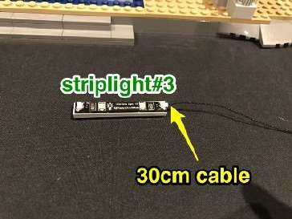
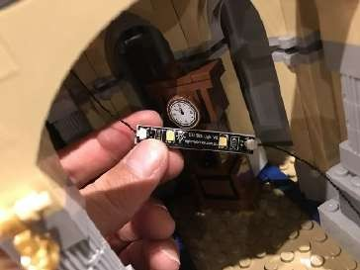
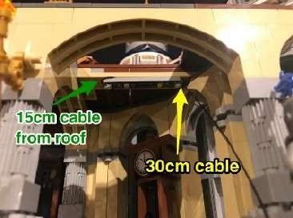
You can prevent the cable from hanging down by looping them behind the strip light like what I have done here

Thread the other end of the 30cm cable up behind the back wall which leads up to the level above. Pull up from underneath and then connect the cable into one of the spare ports on the 12-port expansion board.
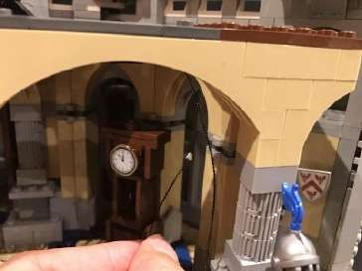
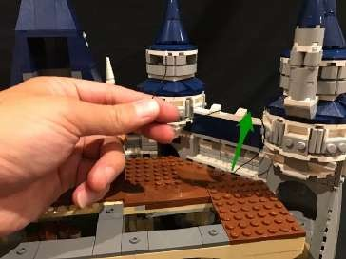
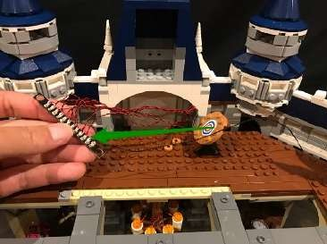
Take this time to test our lights we have installed so far by connecting back the USB Power Cable to the expansion board and verifying all is OK.

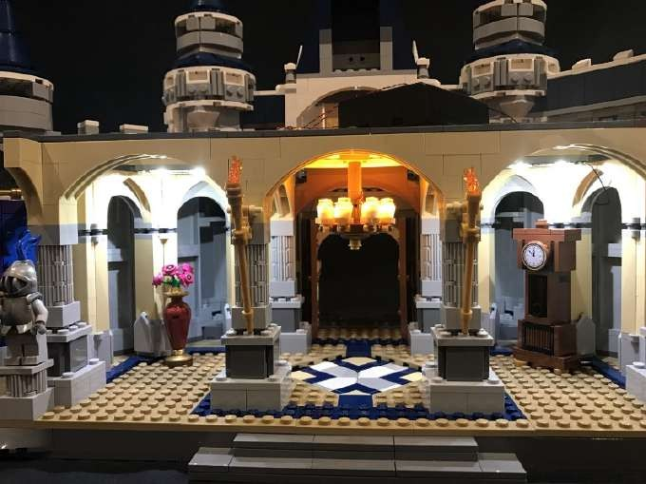

17.) We will now install lights to the 2 fire torches. First remove them and then disassemble pieces as per below:
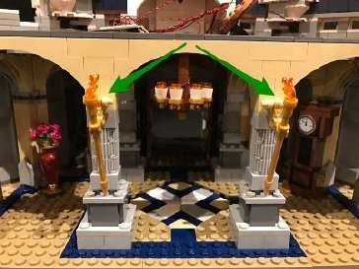
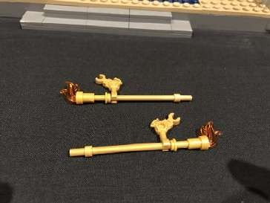
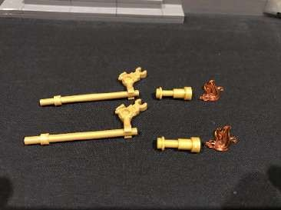
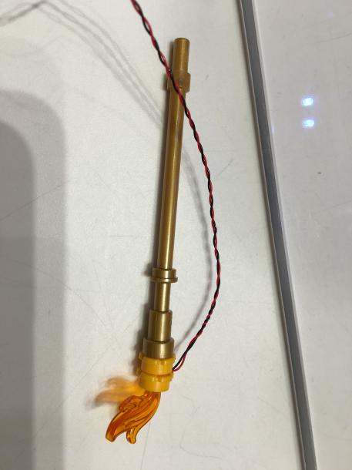

Reconnect these 2 sections back to the poles and then back to the pillars ensuring the cables are behind.
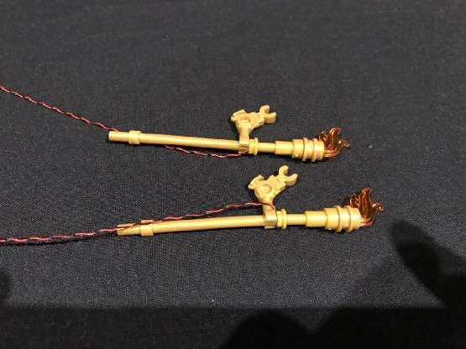
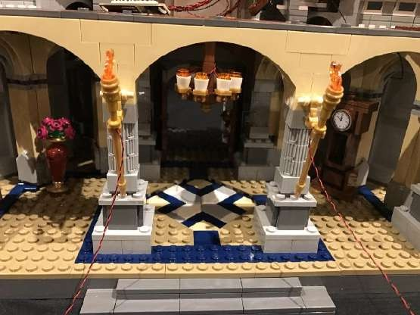

18.) We now need to thread the cable for each torch underneath the pillars at the below position.
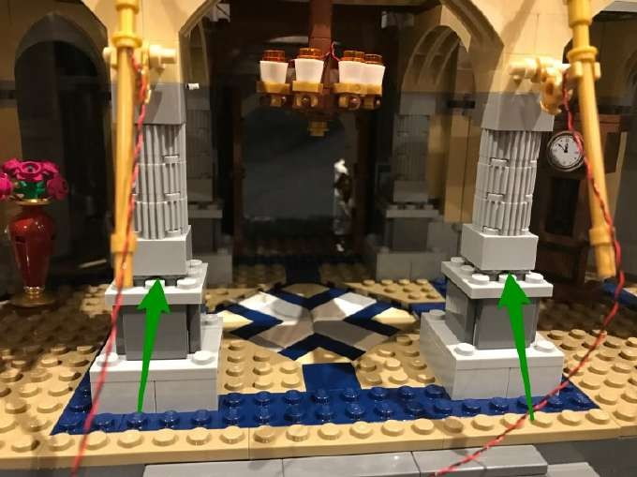

To do this, use your removal tool to lift and create a gap opening to allow you to thread the Dot Light cable through the middle in between studs. Once threaded through close up the gap by reconnecting down the pillars.
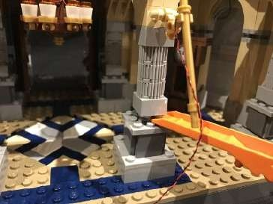
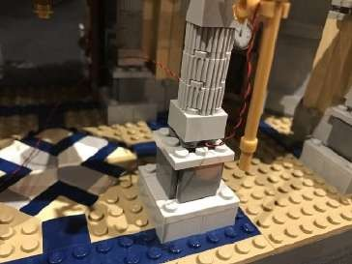
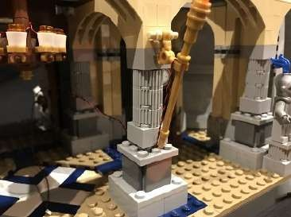
Repeat this process for the torch cable on the other side.
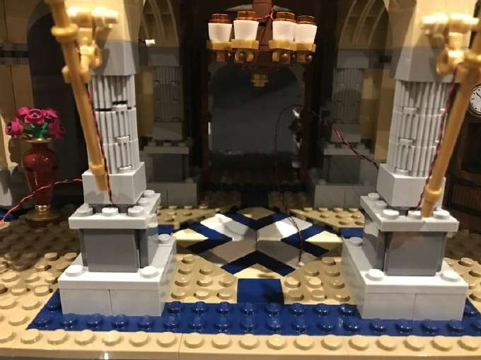

Before proceeding to the next steps, please take note of which eGects board option was included in your lighting kit:
Eßects Boards option 1 (This is now retired) : Steps 19–20

2x Multi-EGects Board

1x 6-port Expansion Board

1x 5cm Connecting Cable

or

Eßects Boards option 2: Steps 21–22

2x Flicker EGects Boards (FFX)

19.) If your lighting kit contains the EGects Board 1 option, then take out one of the Multi-EGects Boards and connect the torch cables into the 2 output ports as shown below:
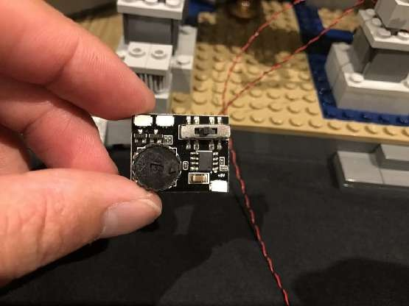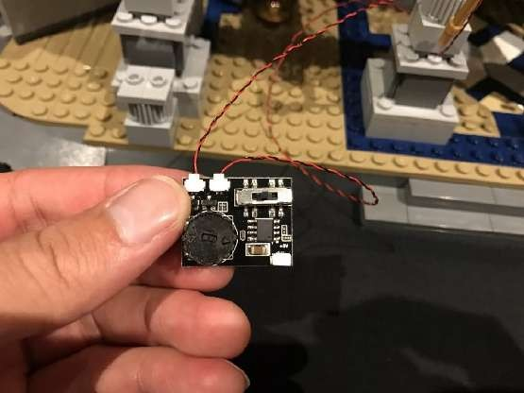

Take the battery pack cable and connect it to the input port at the bottom. Turn on the battery pack and you should see the torches light up with one of the 3 eflects. Switch to the “kicker” eflect on the far left and then adjust the speed of the eflect by turning the wheel as desired. The eflect used in the Vonado demo video is with the wheel turned all the way to the left.

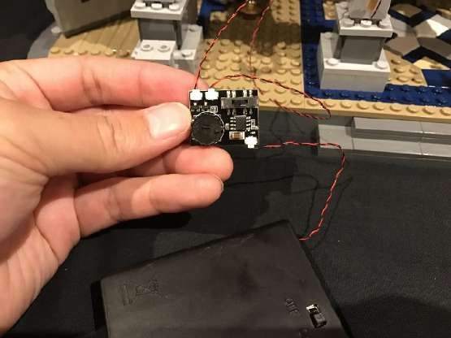
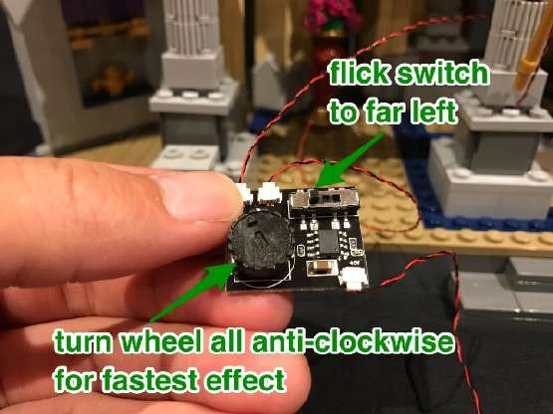

When you are satisfied with your eflect and speed, disconnect the battery pack and proceed to the next step.

20.) Locate the 5cm cable from striplight#2 hanging from the roof and connect this into the input port on the multi-eflects board. Use 2x provided Adhesive Squares to mount the eflects board to the top of the wall in the below position.
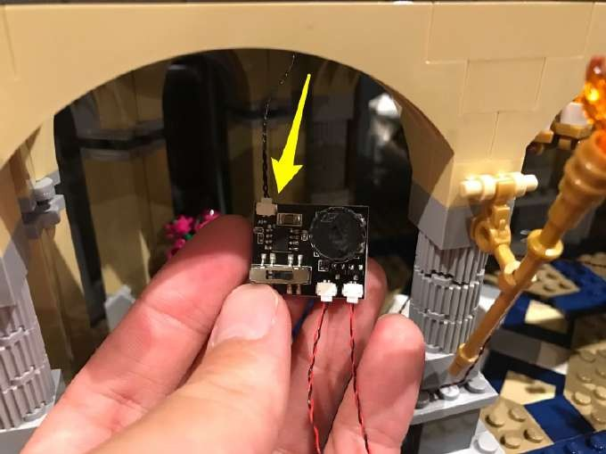

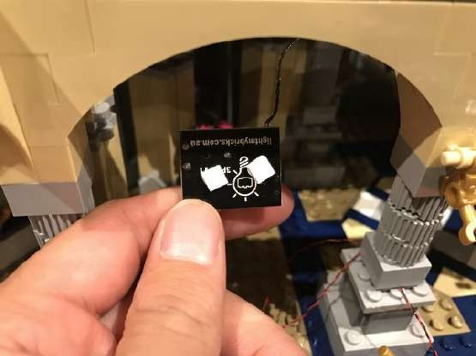
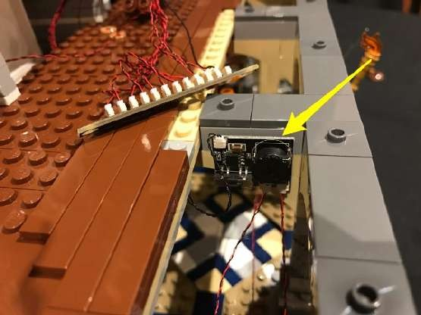

Proceed to step 23.

21.) If your lighting kit contains the EGects Board 2option, then take out one of the Flicker EGects Boards and connect the torch cables into the any 2 output ports as shown below:
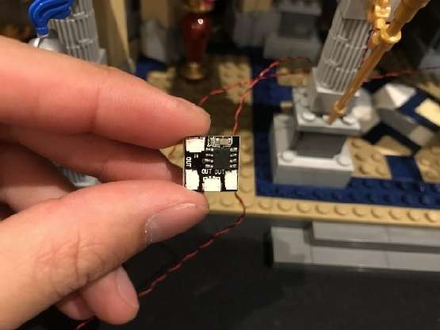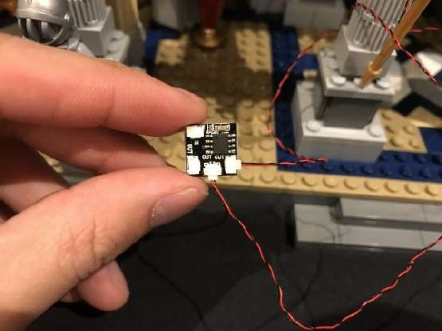

22.) Locate the 5cm cable from striplight#2 hanging from the roof and connect this into the input port on the kicker eflects board. Use 2x provided Adhesive Squares to mount the eflects board to the top of the wall in the below position.

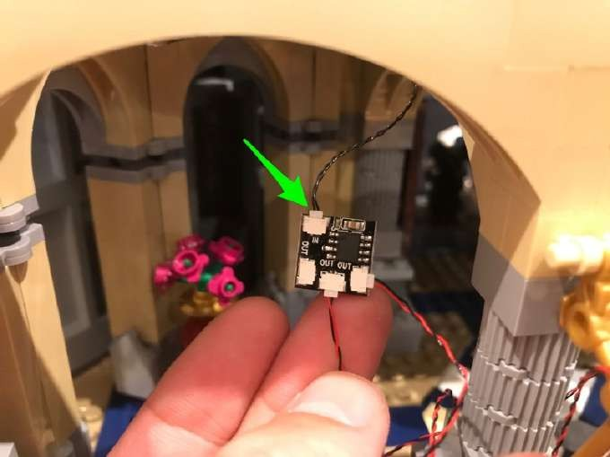
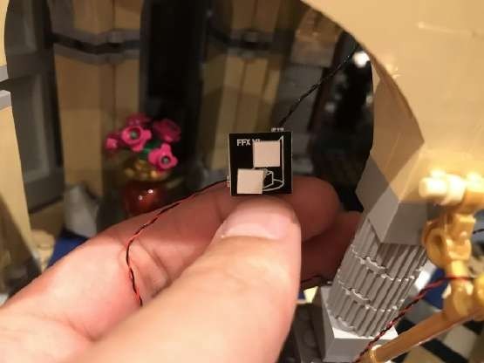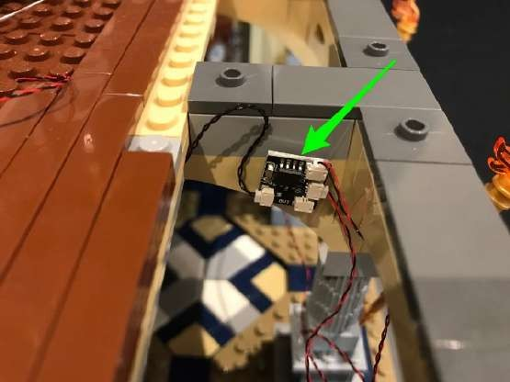

23.)We now need to eliminate excess cables from the 2 torches. To do this, bring the cables up and lay them underneath the grey tiles on the roof of the ground koor. You will need to first disconnect tiles, lay the cables in between studs, then reconnect the tiles over the top of them as shown below.

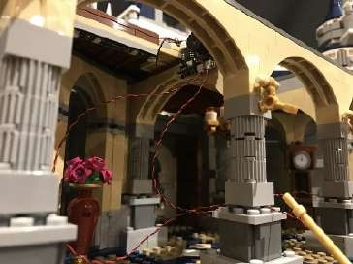
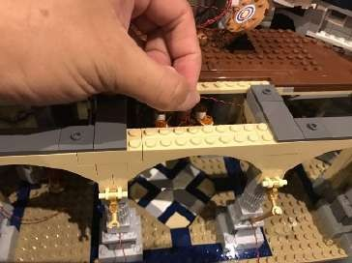
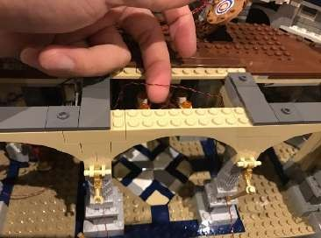
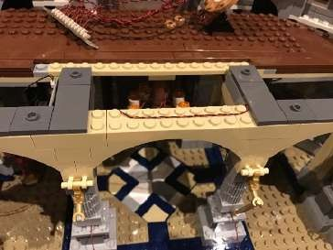
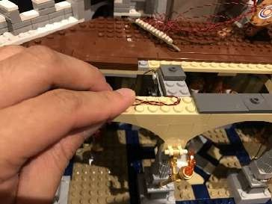
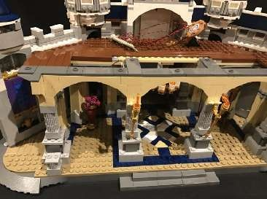

Test all the lights and eflects are working together by connecting the USB Power Cable to the expansion board above. Turn on and verify all is OK.
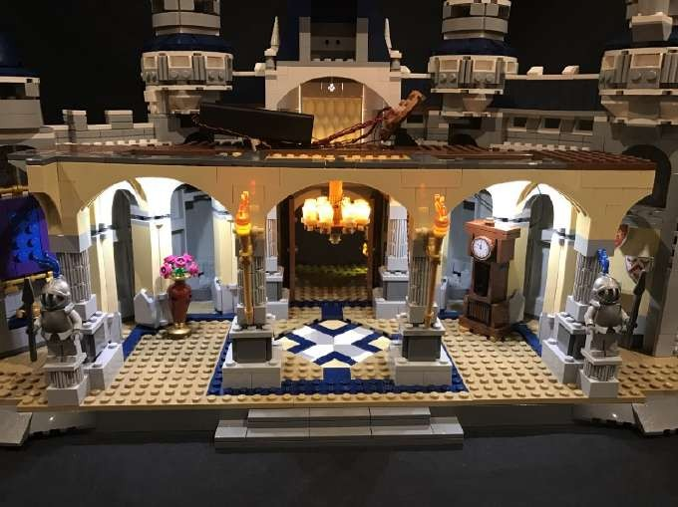

24.) We will now move onto installing lights to each of the towers on the first koor. Remove the roof ofl the far left tower from the round white base as per below. Take a White 30cm Dot Light and stick underneath the white round plate in the below position using an adhesive square.

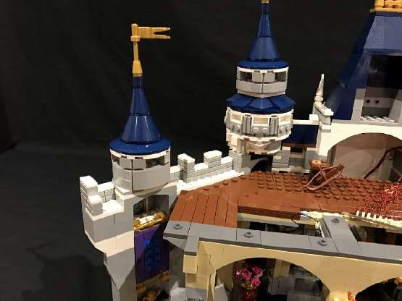
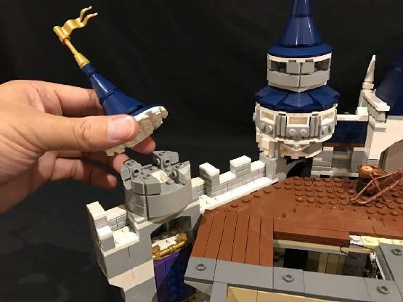

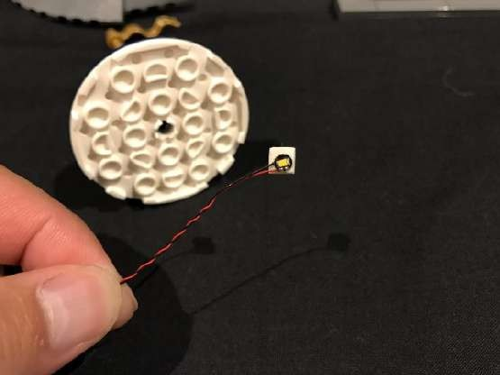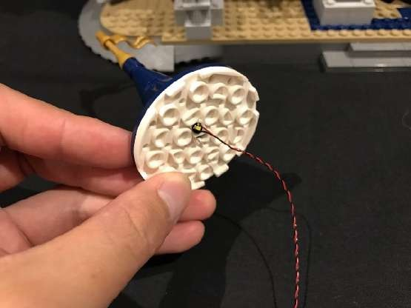

Reconnect this roof section back to the tower ensuring the cable for the Dot Light is laid over the grey bricks underneath toward the right.

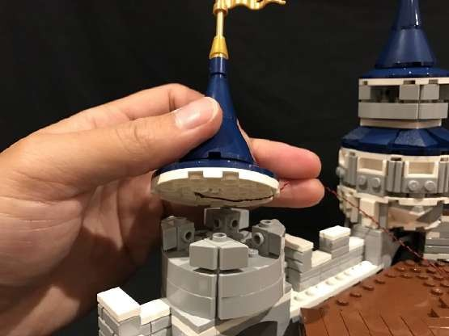
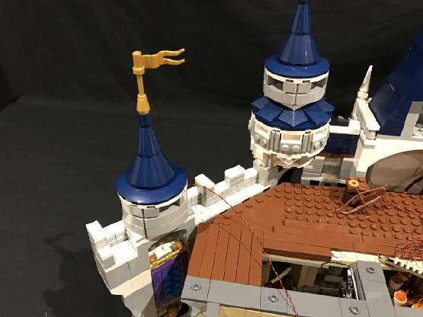
Remove the roof ofl the next tower along and install another White 30cm Dot Light underneath the white round base using an adhesive square. Reconnect roof with cable in between the white round plate and grey brick underneath facing toward the centre.
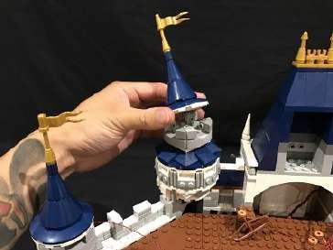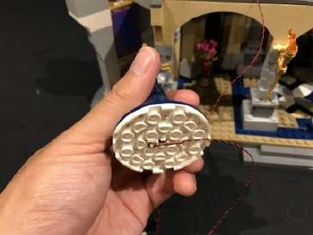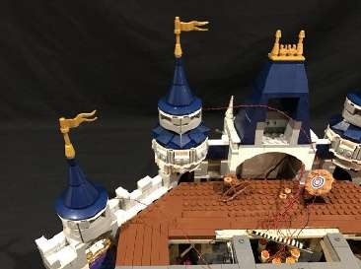

25.) Repeat previous steps to install another 2x White 30cm Dot Lights for the two towers on the right side using adhesive squares(one Dot Light each).

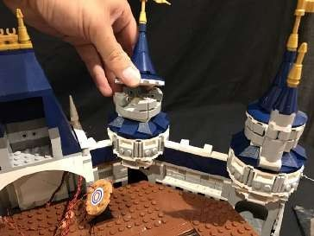
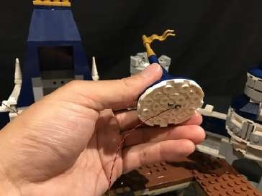
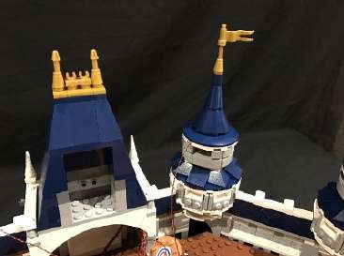
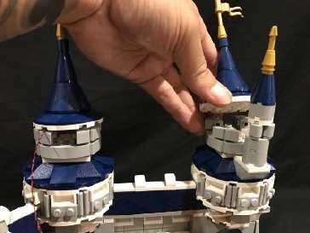
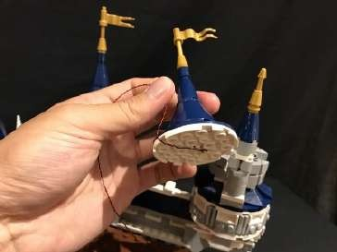
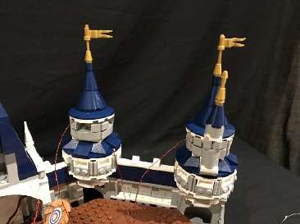

You can use tape to neaten up and secure the cables to the sides of the tower.
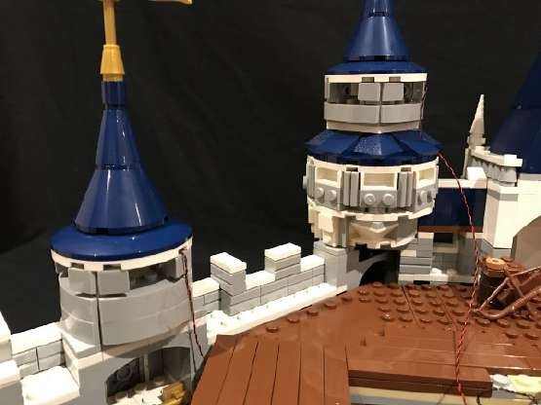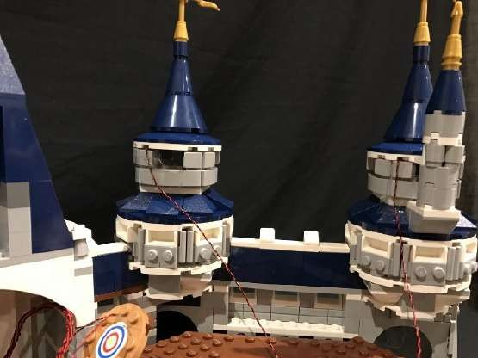

26.) We will now install a light to the clock on the front. First remove the sections on each side of the front of the tower as per below.

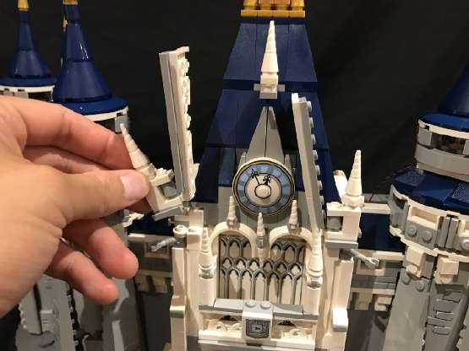
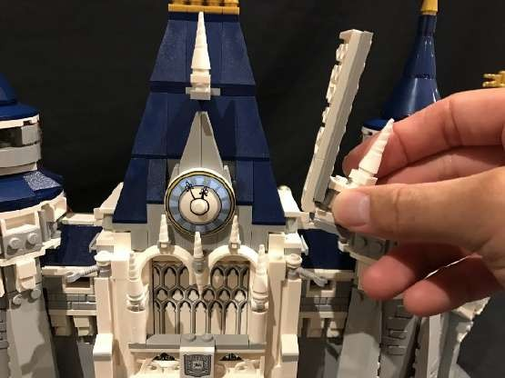

From the back of the castle, use the removal tool to lift this section ofl at the following position.
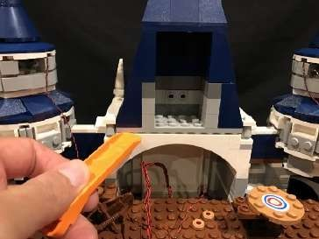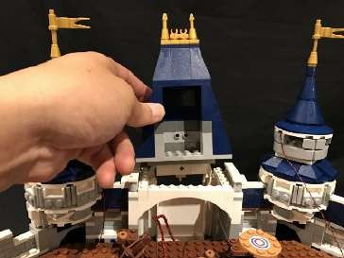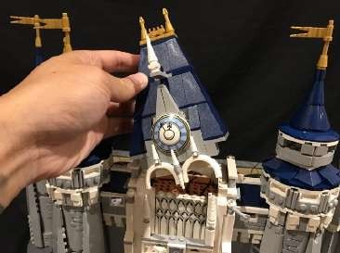

Remove the clock piece as well as following pieces from the front.

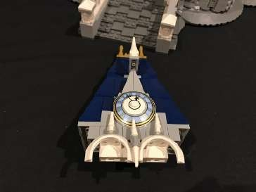
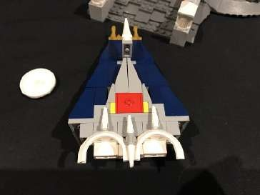
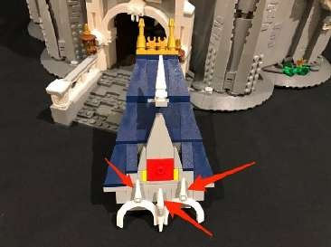
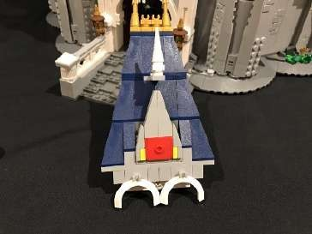
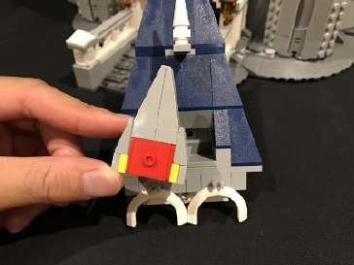
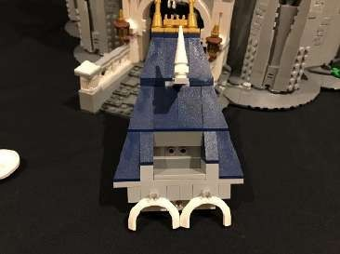

27.) Take a White 30cm Dot Light and thread the connector side through one of the holes of the grey holes behind. Thread all the way through until you have about 5cm cable left. Stick the Dot Light to the following position using an adhesive square.
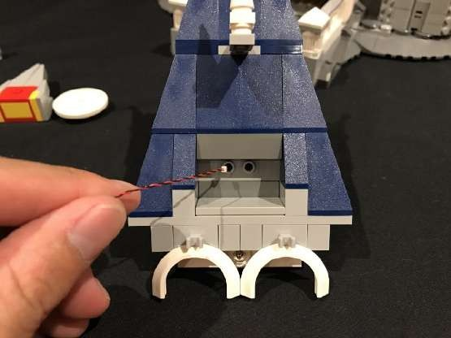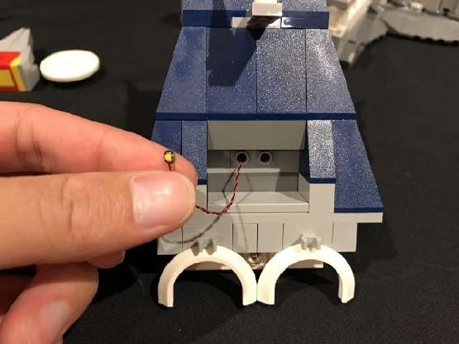
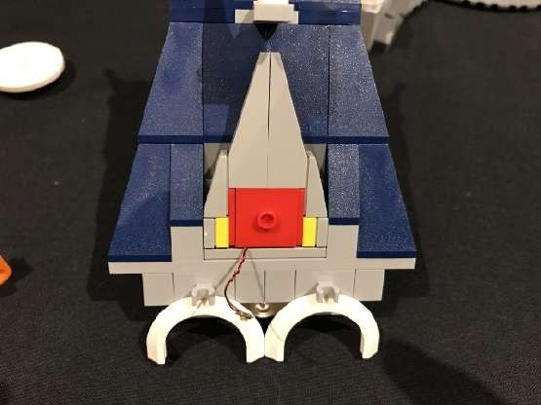
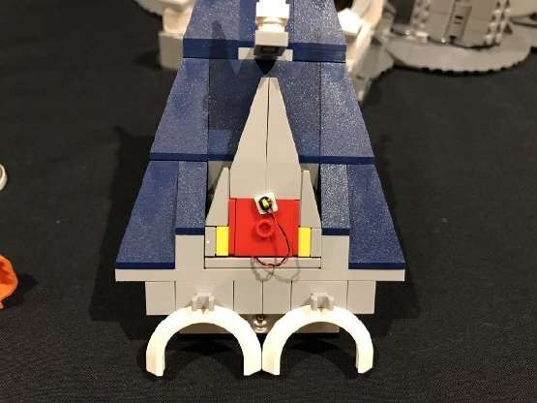

Reconnect the clock piece as well as other pieces we removed earlier.

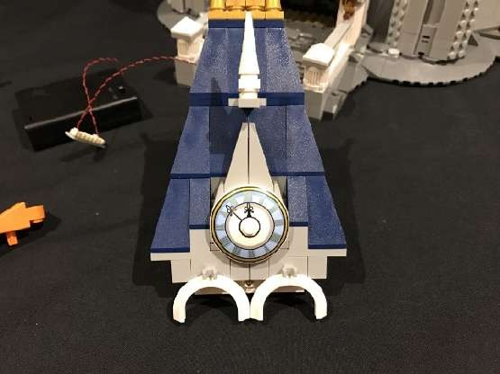
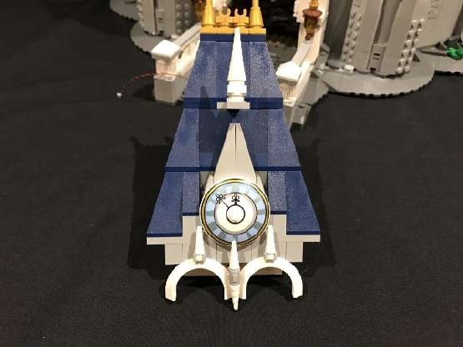

Reconnect this whole section back to the castle and then reconnect the two sections on each side of the top.

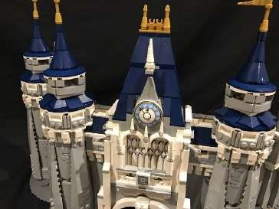
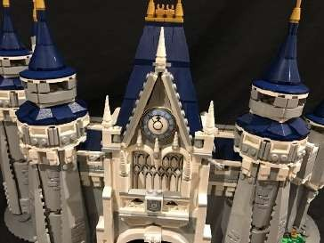
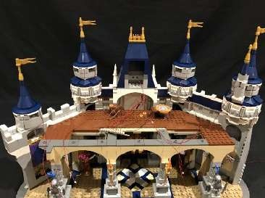

28.) Take another 12-Port Expansion Board and connect a 5cm connecting cable to the first port. Connect the other end of the cable to the remaining port on the first expansion board.

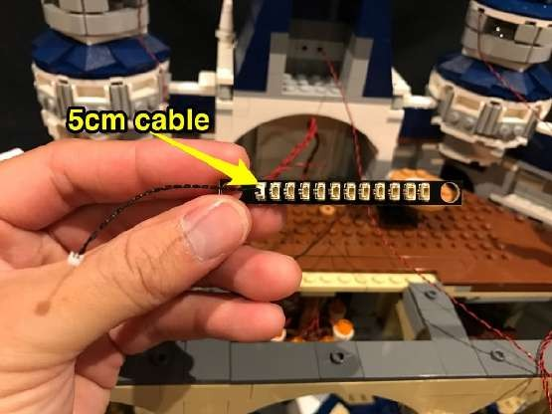
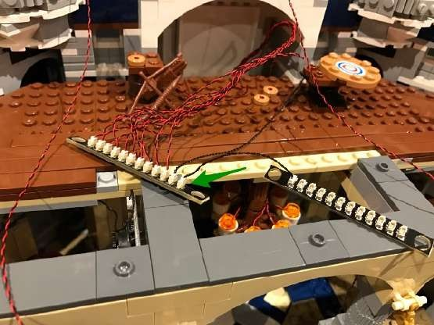

Connect the Dot Light cables from the 4 towers as well as the clock light to the ports on the other side of the second expansion board.
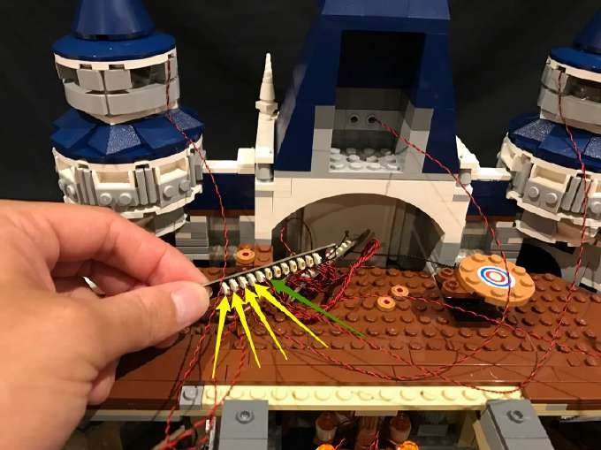

Neaten up cabling by laying them down in between the centre section and walls of the castle. Tuck the expansion boards into the middle section as per below.

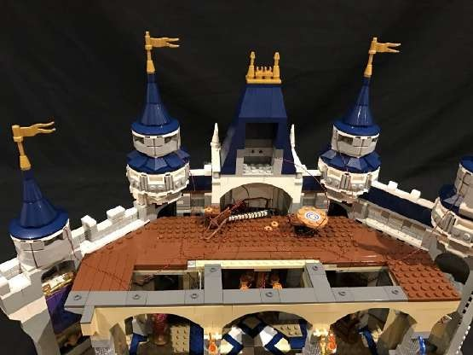
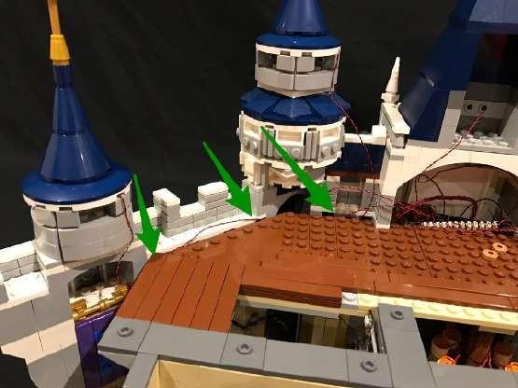
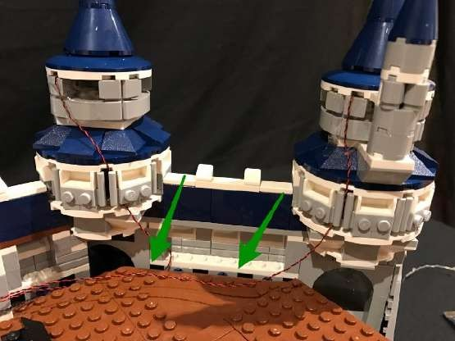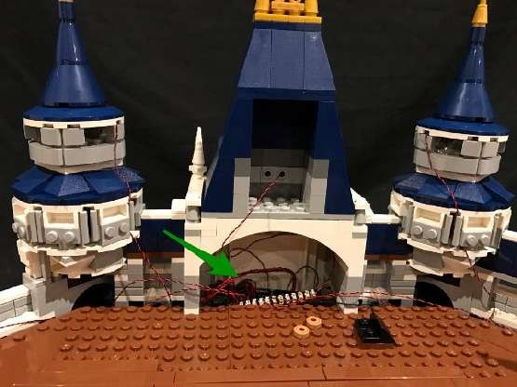

Test the lights we have installed again by connecting the USB Power Cable to the expansion board. Turn on to verify all is OK

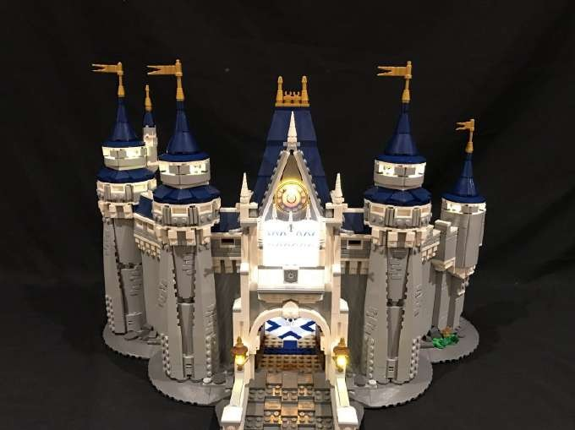

29.) Take the Multi-Colour Changing Light String and connect it to the next spare port on the far right of the 12-port expansion board.
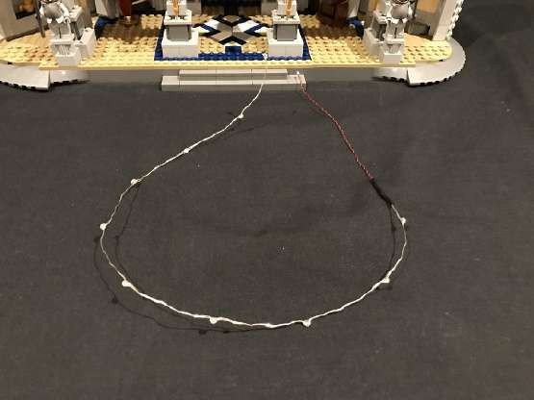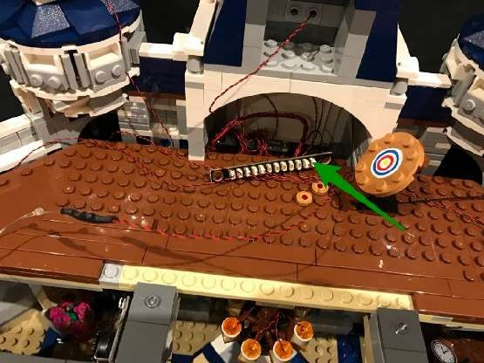

Lay the light string across the base of the second koor. Use 2x provided 1x2 plates to secure down at each side and do your best to ensure each of the 10 individual LEDs are facing up as we want them to shine as much as possible onto the front of the second level walls.

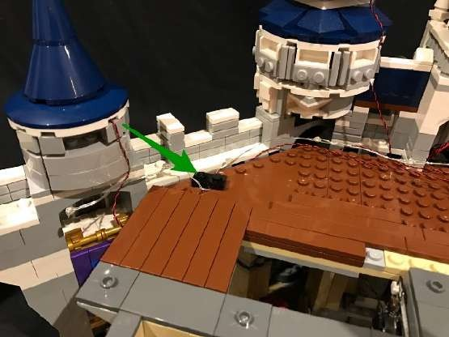
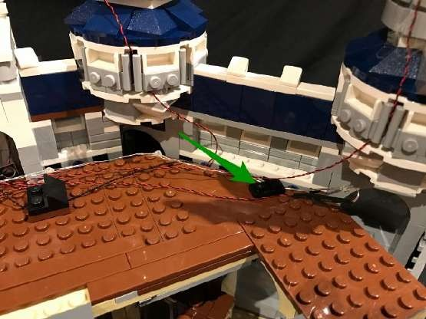
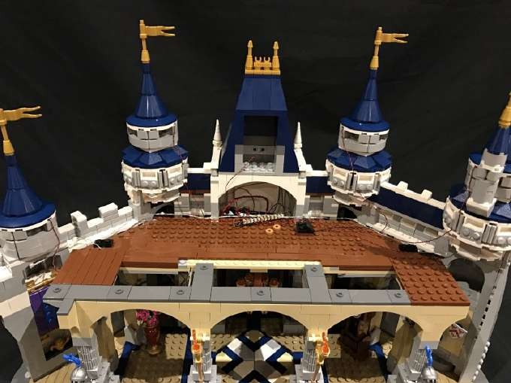

30.) Take a 30cm Connecting Cable as well as 2x 50cm Connecting Cables and connect them all into spare ports of the expansion board.

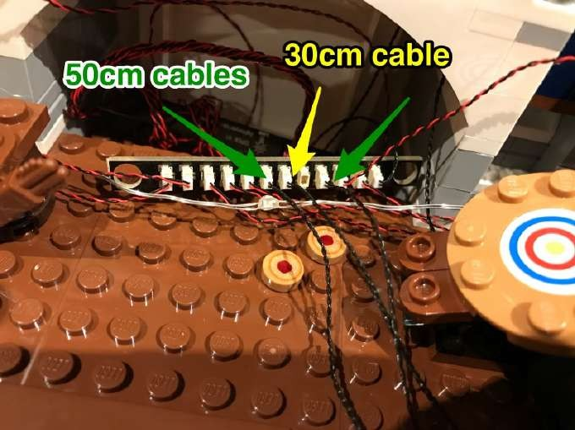

The 30cm connecting cable will be used to connect to lights on the second level of the tower. The 2x 50cm connecting cables will be used for the spot lights at the front of the castle which will shine on the front walls. Take the 50cm connecting cable connected to the left and neatly thread it toward the left side of the castle. Do the same for the other 50cm connecting cable, but thread it to the right side of the castle.
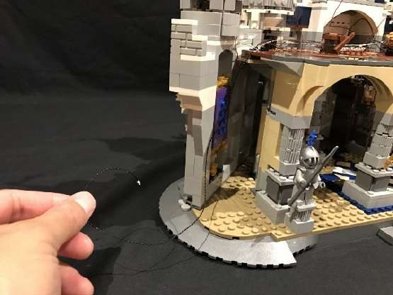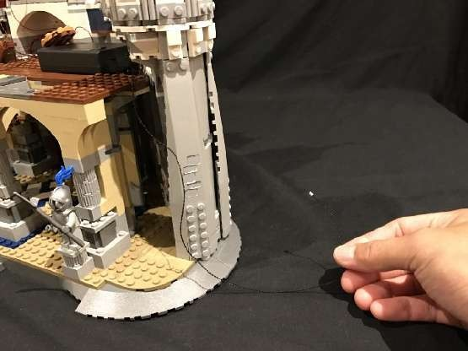

31.) Locate the following pieces which were provided in this kit and assemble them as per below to build 2x spotlights.

2x Black Plate 2x6

4x Plate, Modified 1x2 with Stud (jumper)

2x Dish 3x3 Inverted (Radar)

2x Plate, Modified 1x2 with handle on End—Close Ends

2x Tile, Modified 1x1 with Clip
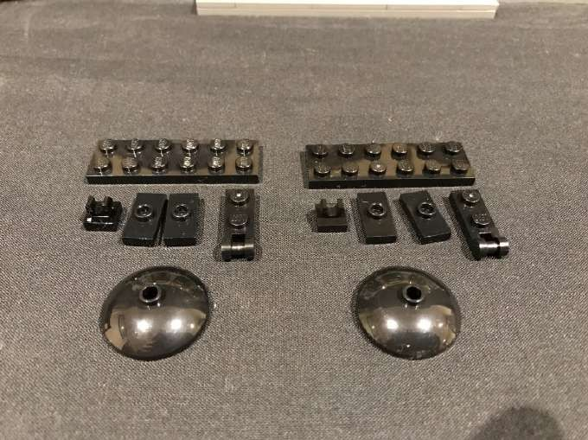

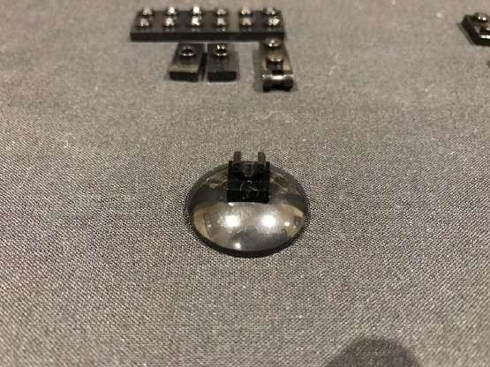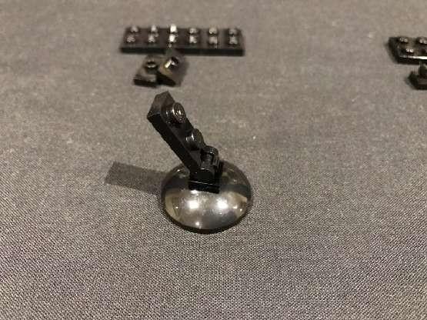
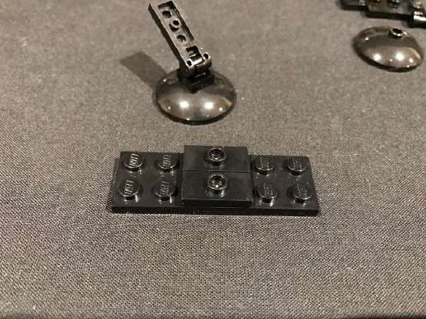
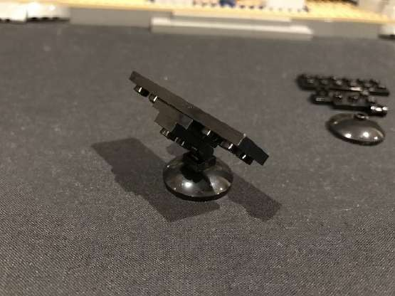

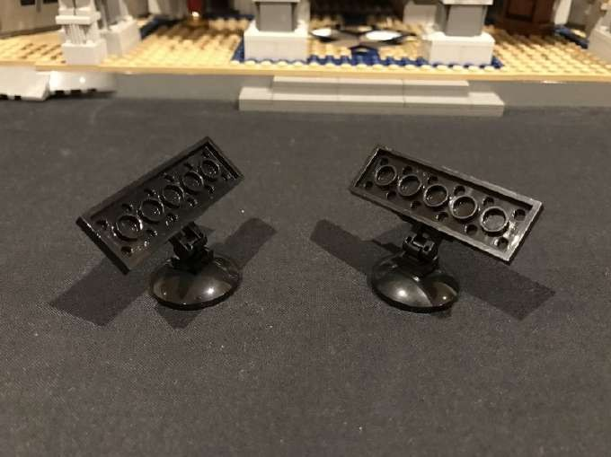

Take the two Multi-Coloured Strip Lights and peel ofl the adhesive backing paper to stick on to the base of each 2x6 plate.

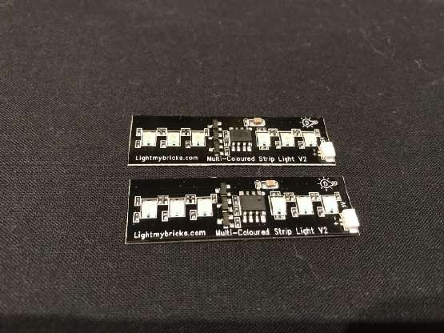
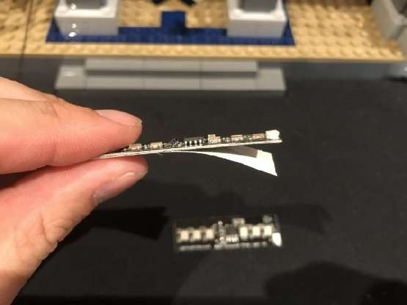

Stick one of the strip lights the correct way up (for the spot light on the left side) and stick the other strip light upside down (for the spot light on the right side)

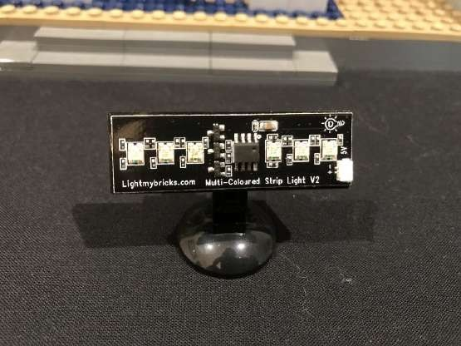
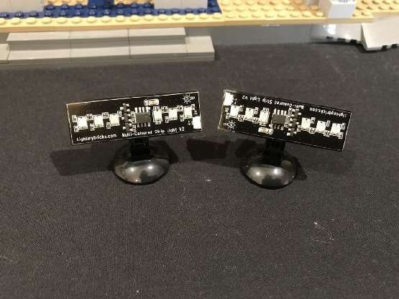

Connect the other end of the 50cm cable from each side into the input port on the strip lights.

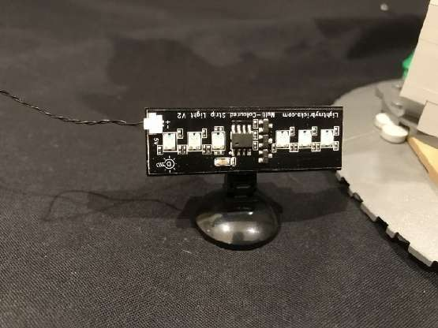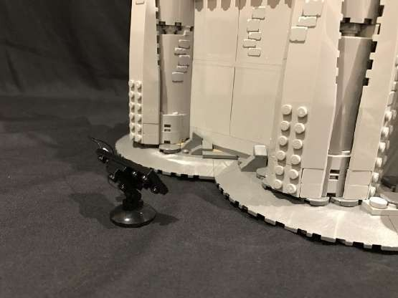
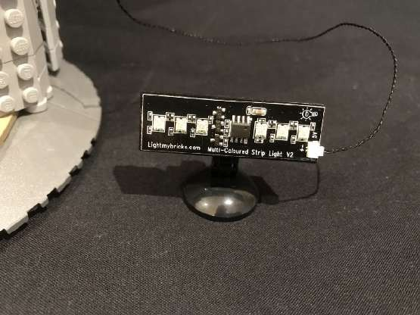
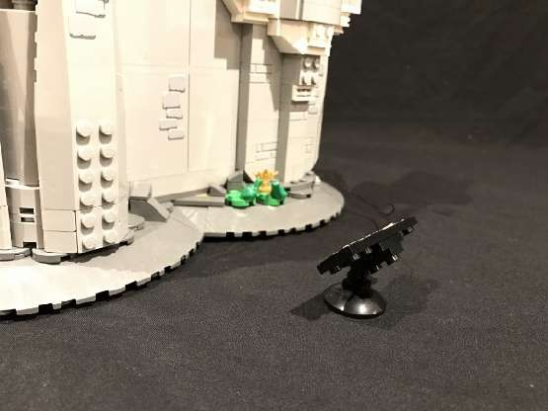

We can position the spot light at each side of the castle and adjust so that the light is shining on the walls. You can also take this time to connect the USB power bank and test.
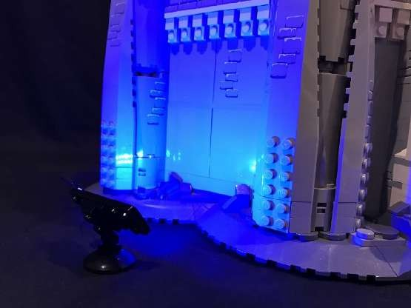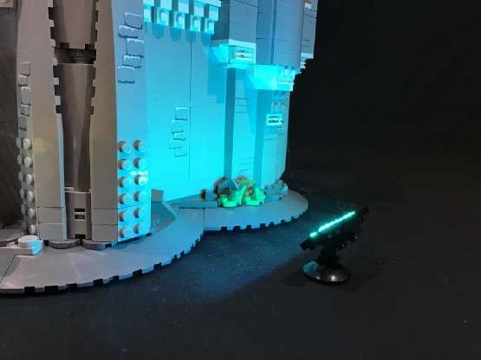
The Multi-Coloured Strip Lights will automatically cycle through diGerent colours

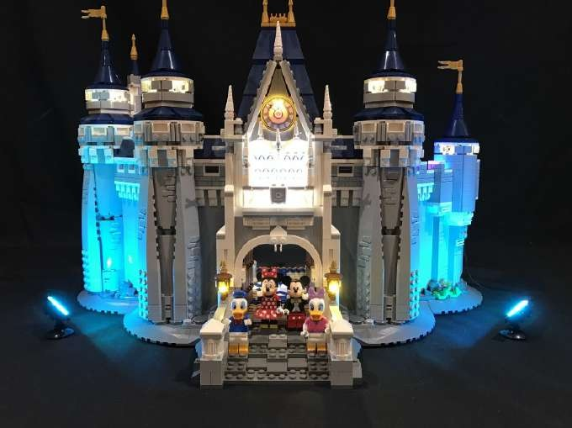

32.) Take the USB Power Cable and USB Power Bank and place it on the base of the second koor as per below. Connect the cable into a spare port on the 12-port expansion board.
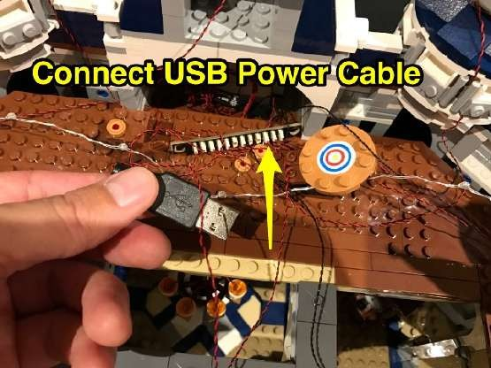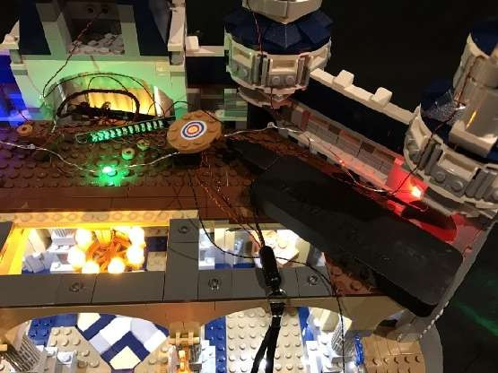

As the USB Power Cable and Power Bank are now in their permanent position, you can test the connected lights at any stage of this user guide.

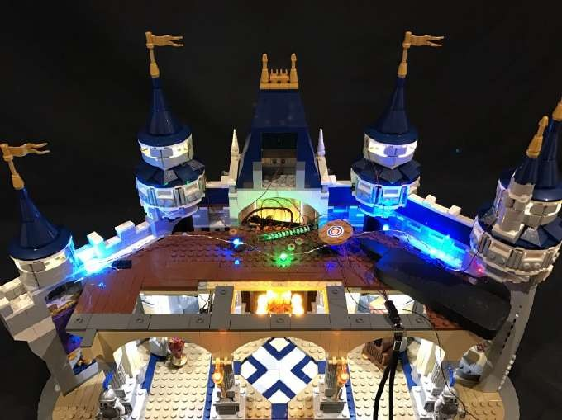

33.) We will now move onto lighting the next levels of the castle. Take the middle section and turn it to its back. Use the removal tool to remove the middle section of the roof, followed by some blue tiles which make up the roof.
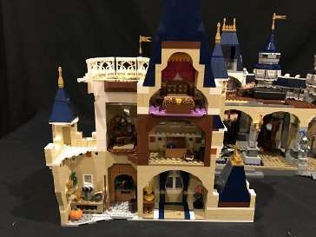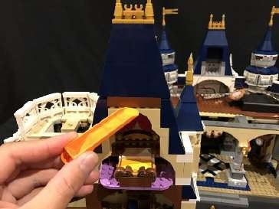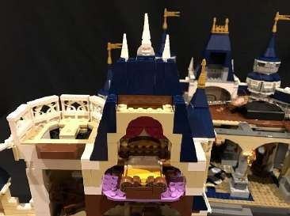
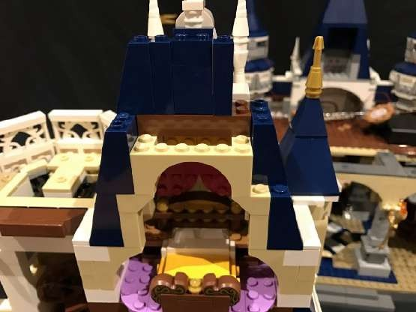
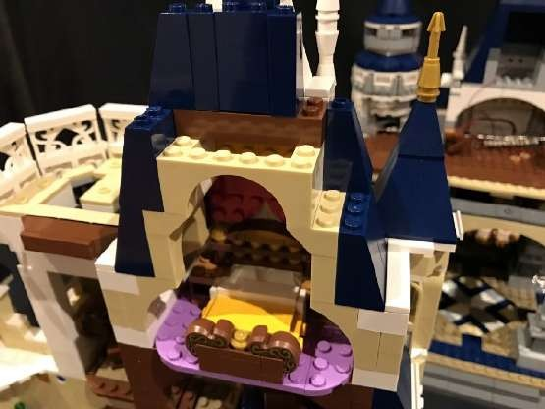
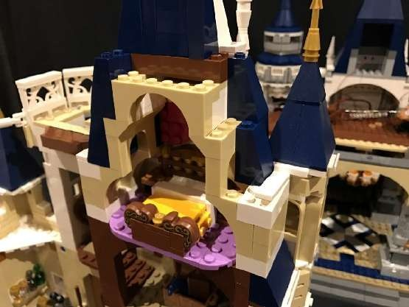
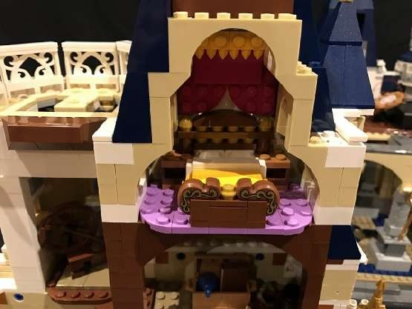

34.) Take the middle roof section and install a White 30cm Dot Light underneath it using an adhesive square. Reconnect this middle roof section back to the top ensuring the cable is facing toward the right then reconnect the roof pieces following the below order. Ensure you thread the Dot Light cable through to the inside as you go.
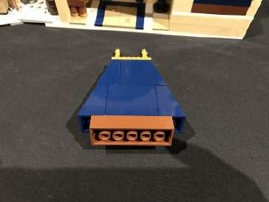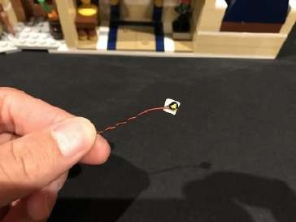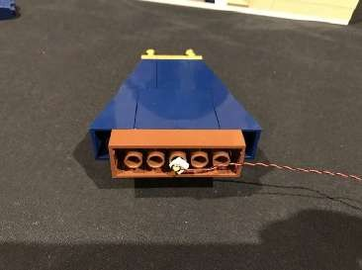
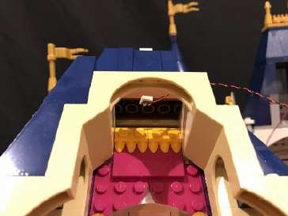
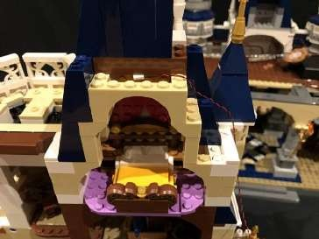
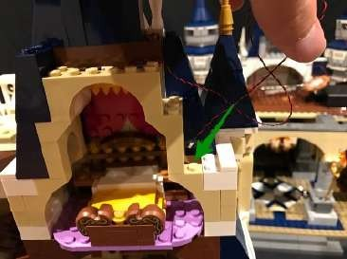
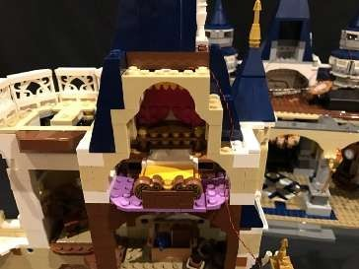
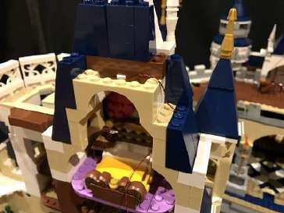
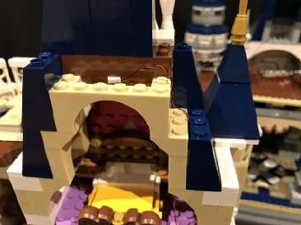
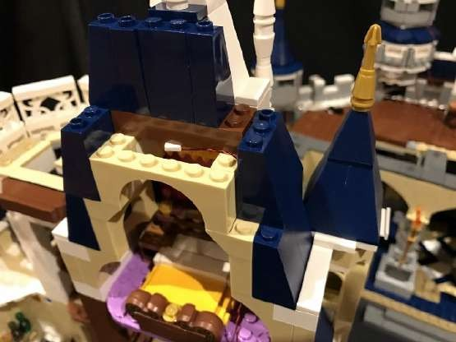
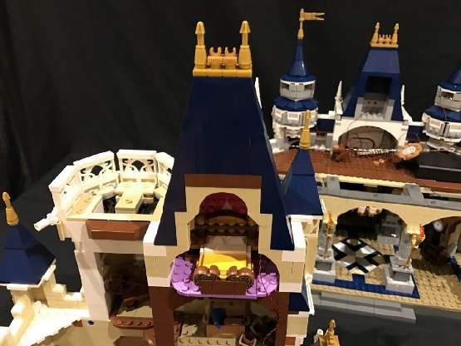

35.) Remove section and pieces as per below.
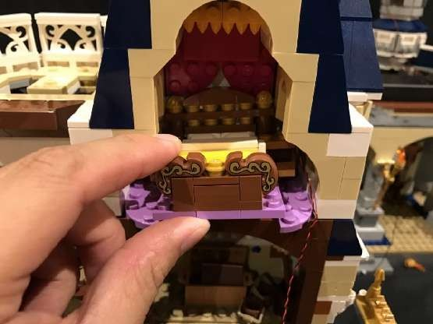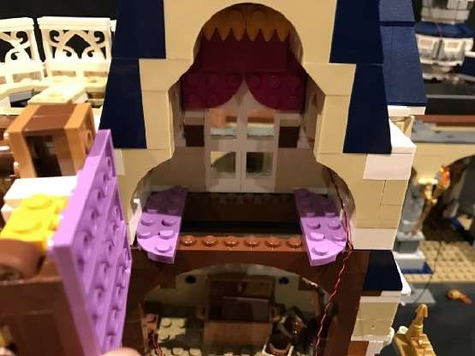
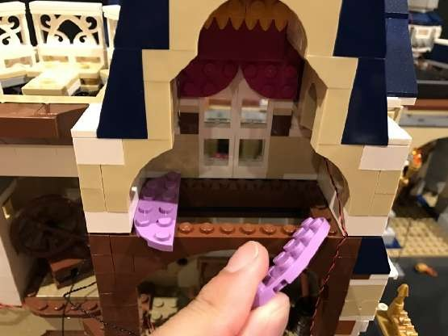
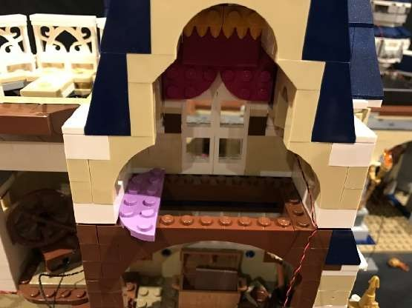

36.) From the front of the castle, remove the following sections around the top of the window as well as the window section itself.

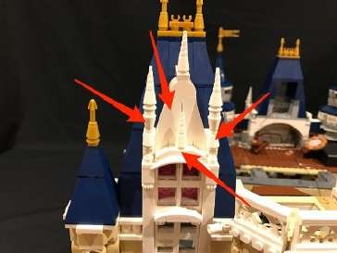
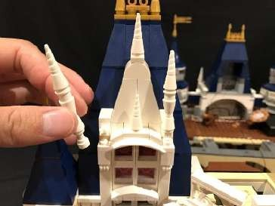
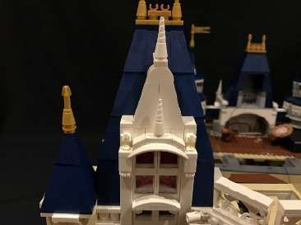

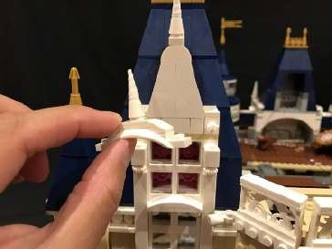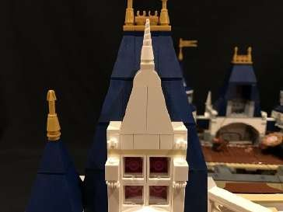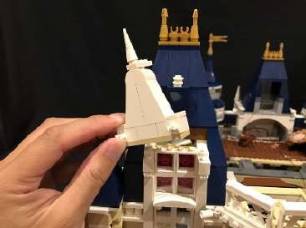
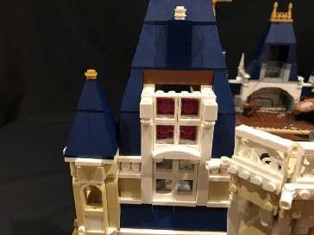
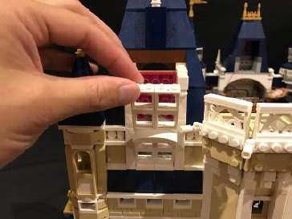
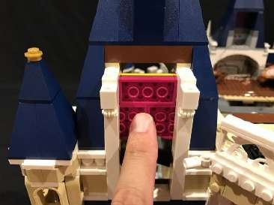

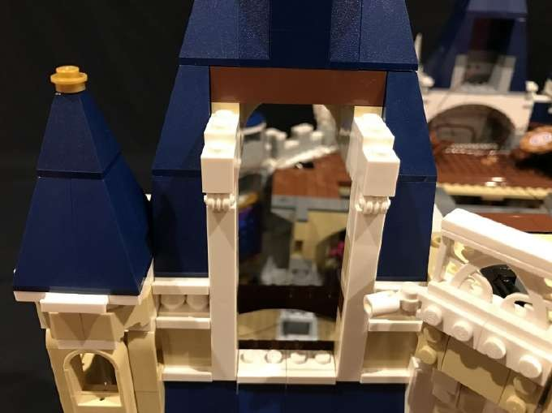
Disassemble pieces of the window as per below.
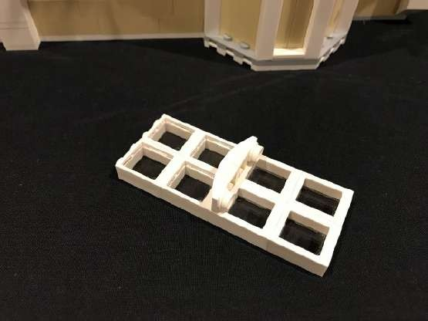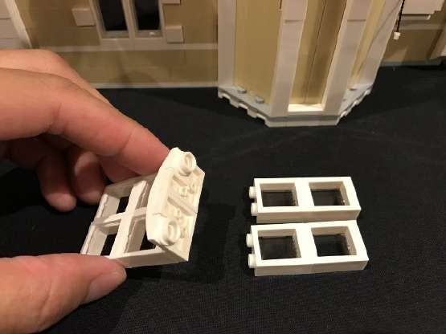

37.) Take a White 15cm Dot Light and place it underneath the top half of the window in below position. Hold the Dot Light in place with your finger before reconnecting window pieces, securing it in place. Ensure the LED component of the Dot Light is facing downward.

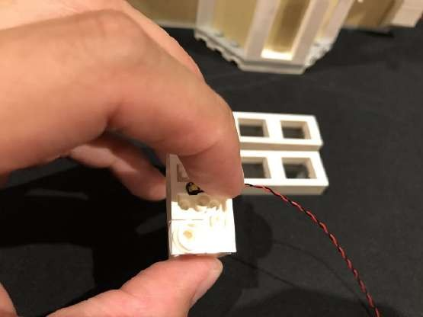
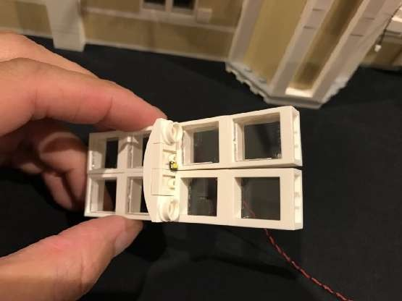
If you look from below up, you should be able to see the LED component peaking out

Reconnect the window section ensuring you first thread the cable through to the inside of the castle.

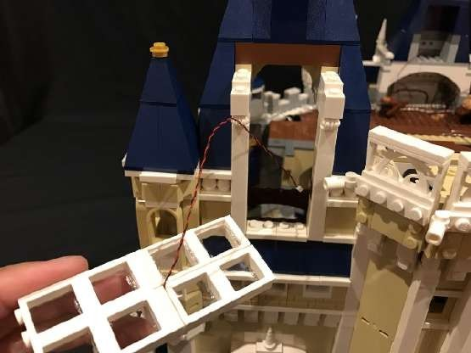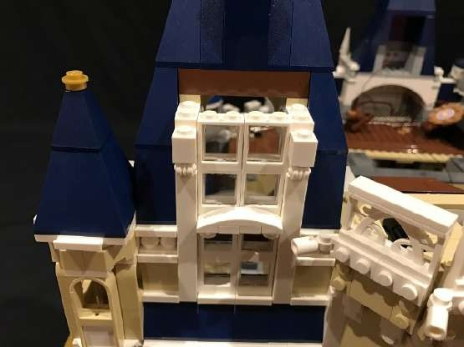

38.) Before you reconnect the top of the window section, install another White 15cm Dot Light by sticking it underneath using an adhesive square.
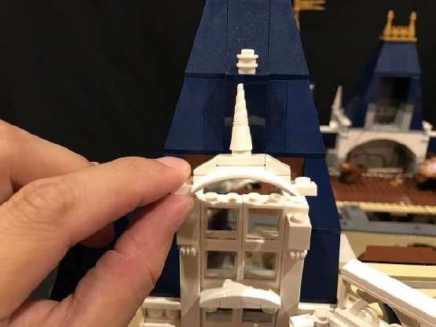
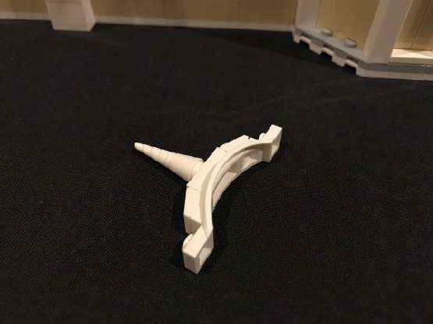
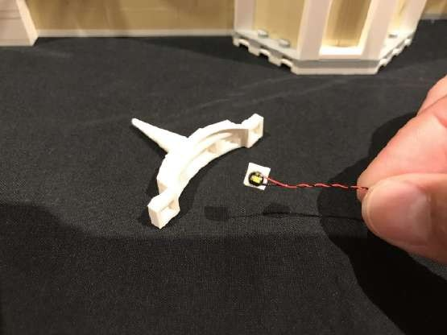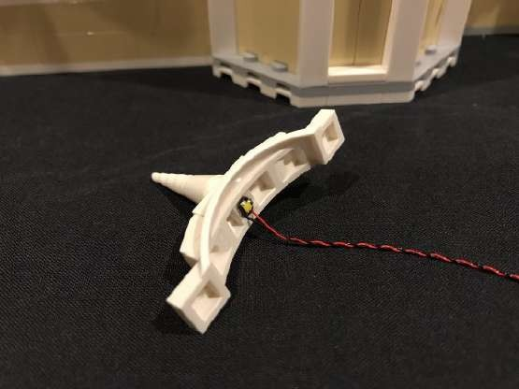

Reconnect this section back on top of the window ensuring you first thread the cable through to the inside of the castle, then reconnect all the pieces/sections we removed earlier.

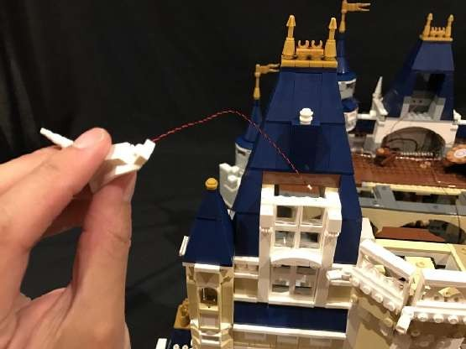
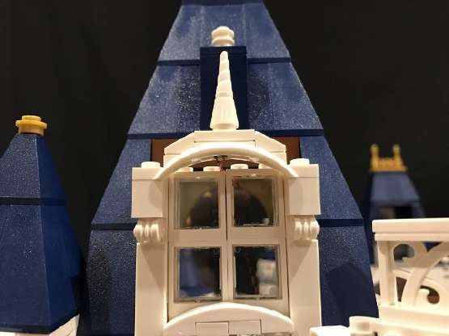
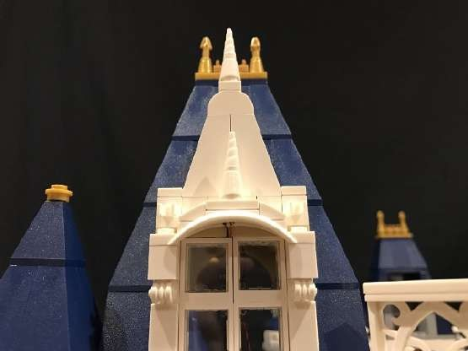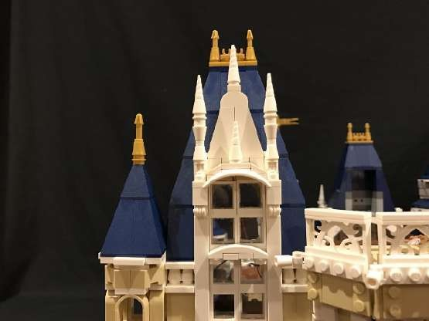

From the inside, reconnect the curtain section over the top of the cables ensuring the cables are neatly laid in the middle.

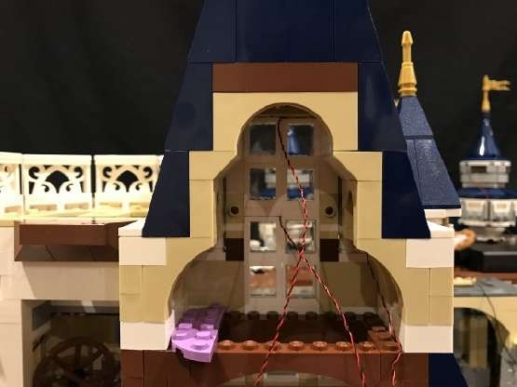
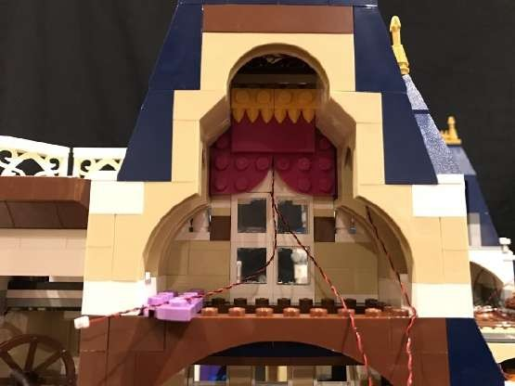

39.) We will now install a light to the tower closest to the bedroom. First remove the roof ofl this tower as well as the white tile near by.
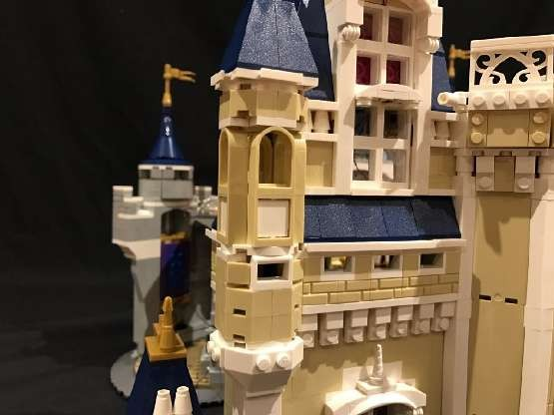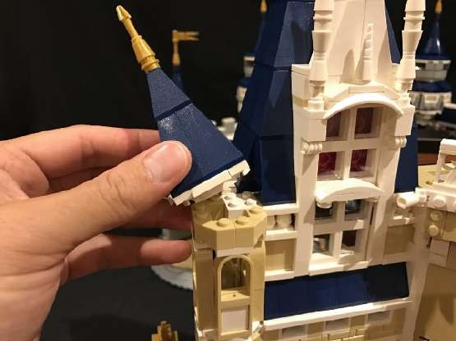
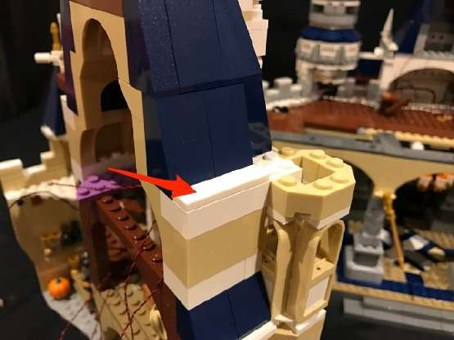
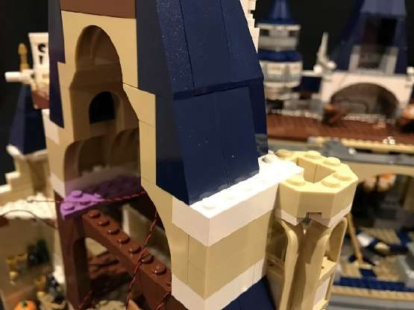

Use the removal to lift and create a gap at the following position

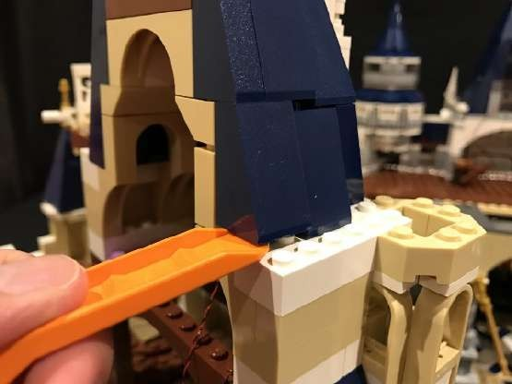
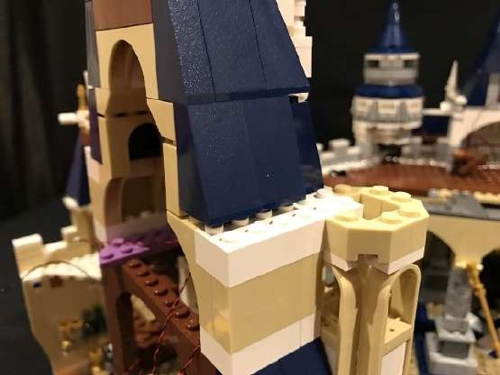

Take another White 15cm Dot Light and thread the connector end of the cable through from the top in through to the inside as per below. Stick the LED component part of the Dot Light to the roof of the tower using an Adhesive Square then reconnect the roof.
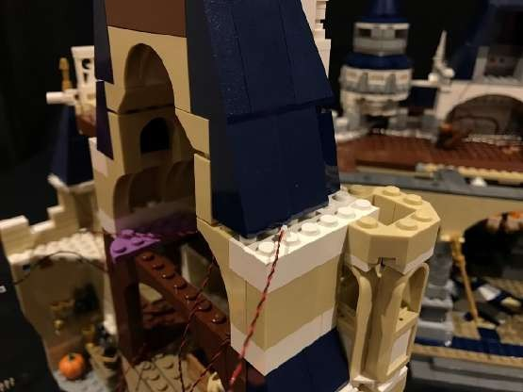
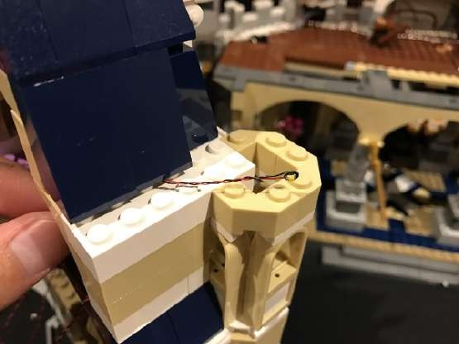
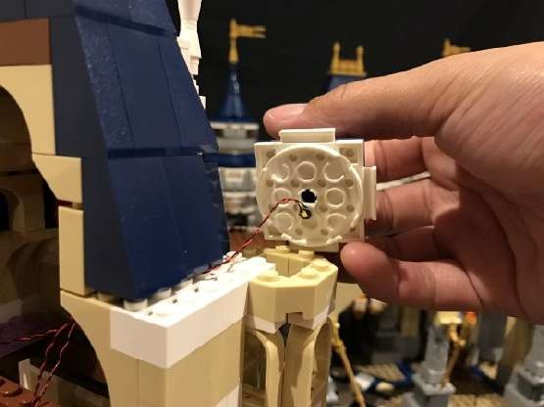
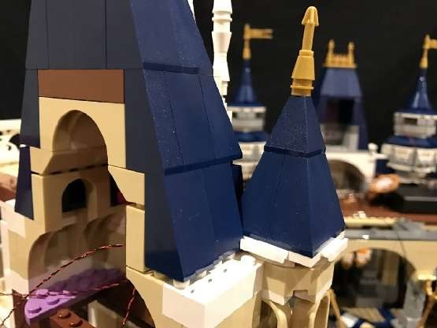
Reconnect the white tile we removed earlier
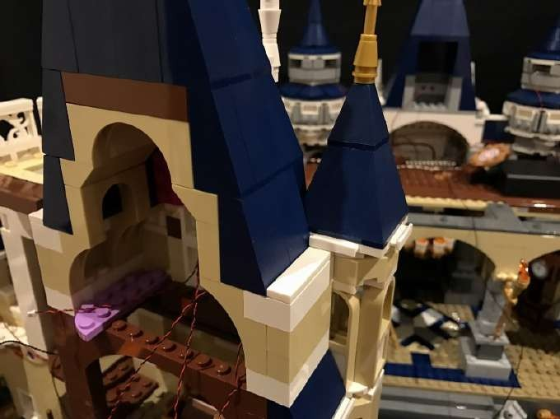
40.) Tuck all 4 cables in through the space which leads to the level below and then reconnect the 2 purple plates ensuring cables are neatly laid behind.
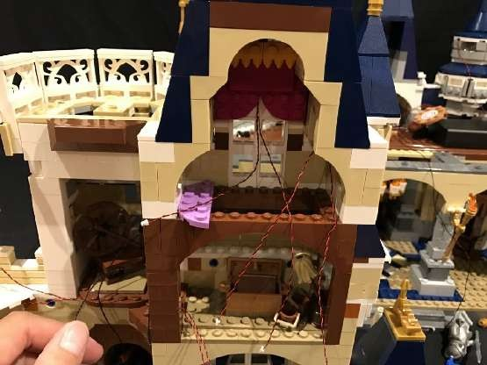
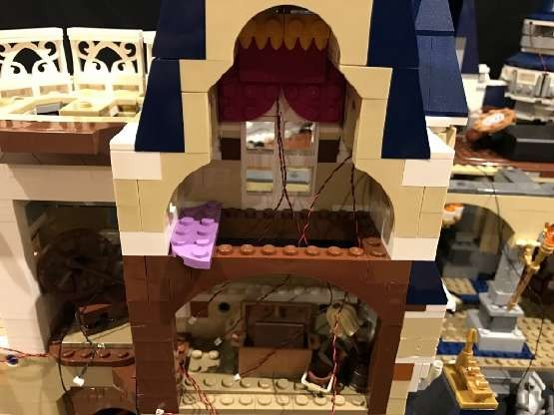
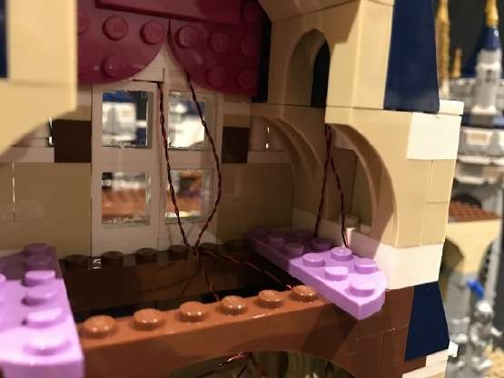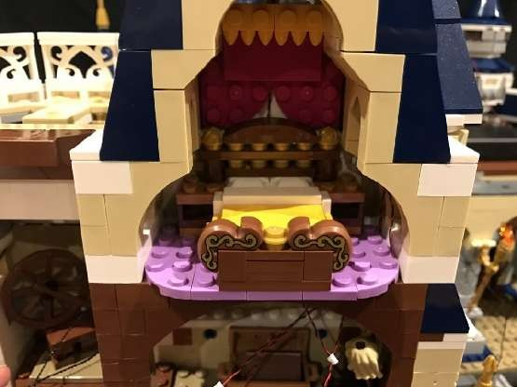

41.) We will now install a light to the tower on the left. First remove the roof of the tower at the white round plate and install a White 30cm Dot Light to the centre hole of the white round plate using a provided 1x2 plate to secure down. Ensure the Dot Light is facing downward then reconnect the roof section with the cable across to the right.

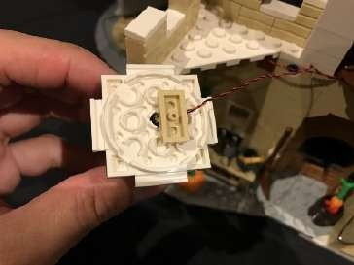
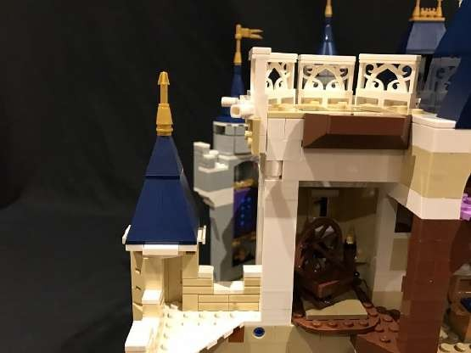
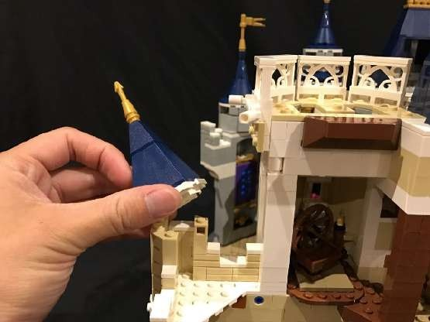
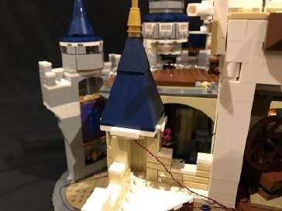
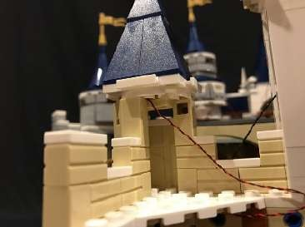

You should be able to see the LED component peaking out
42.) Take another White 30cm Dot Light and stick it to the roof corner on the level below using an adhesive square. Ensure the cable is facing toward the right.

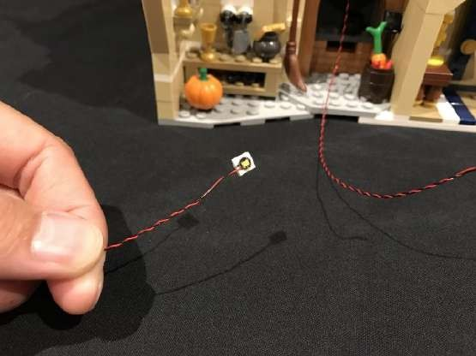
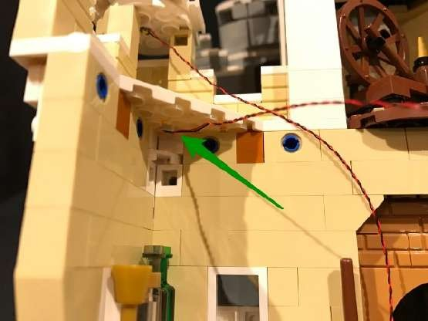

Take the two cables and then thread them across to the other side toward the right.

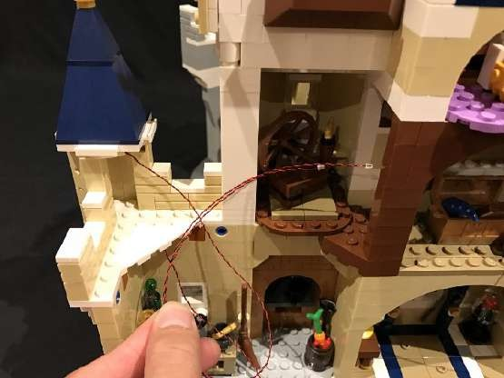
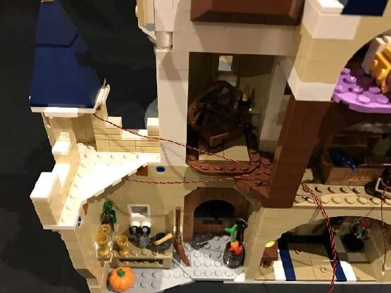

We need to hide these 2 cables underneath the brown plates in the next room. First remove the following sections.

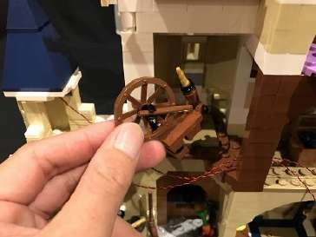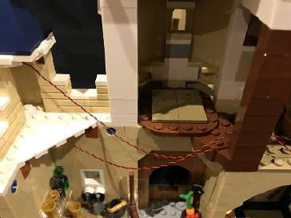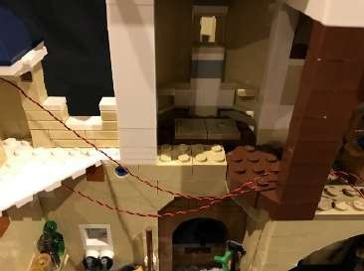

Neatly lay the two cables down in between the studs below before reconnecting brown plates back over the top, securing the cables in place. Then reconnect pieces we removed earlier

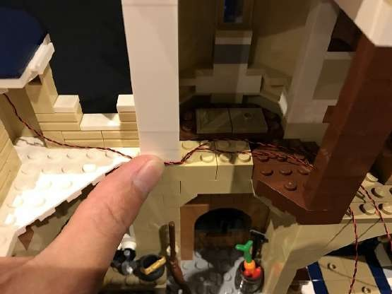
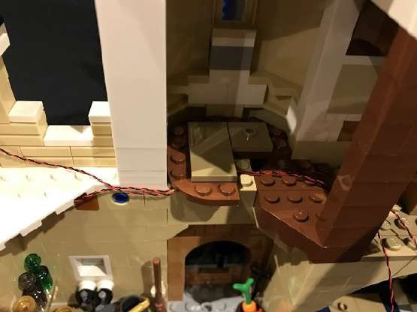
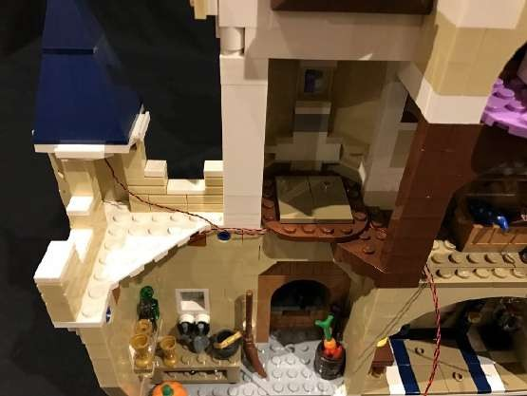
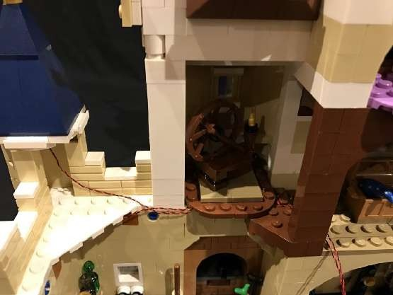

43.) Take another 12-Port Expansion Board and then connect the lights from the left tower we just lit as well as the light on the level below into the 2nd and 3rd port along the left (keep the first port on the left free).

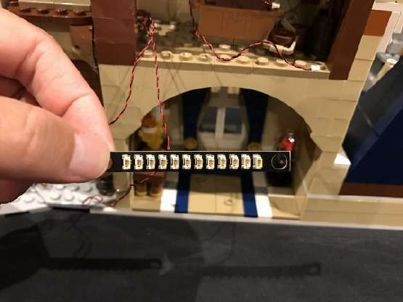
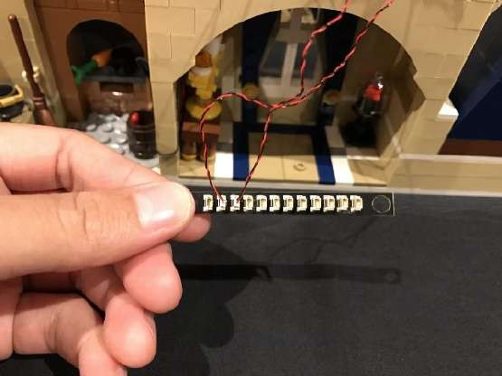

Wind the cables around the expansion board about 4–5 times before then connecting the Dot Light from above the bed to the next port along (30cm Dot Light) and then connect the three 15cm Dot Lights from the windows and right tower to ports on the right side of the expansion board.

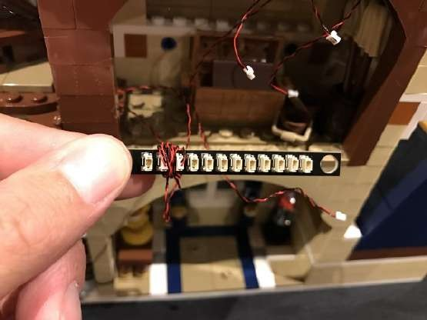
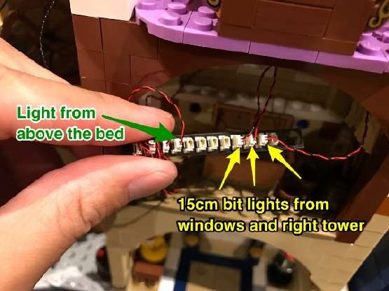

set aside the expansion board and cables for now and move onto the next step.

44.) We will now install lights to the candles (Lumière) on the level below. First remove this section as well as the table underneath and then disassemble pieces of the candle as per below.

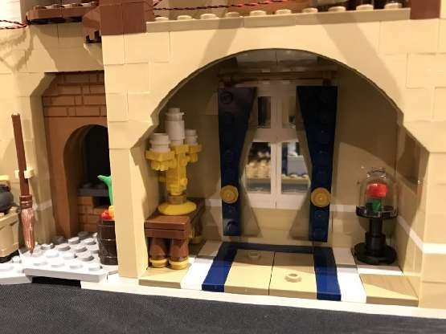
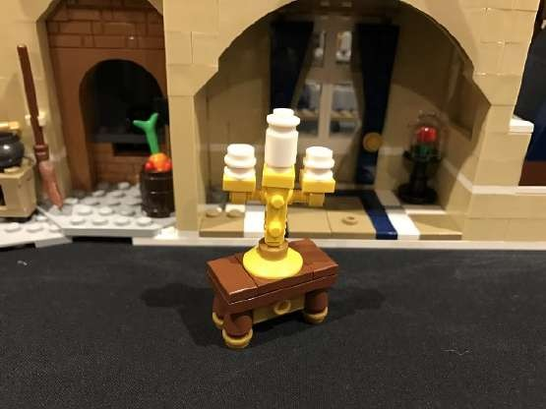
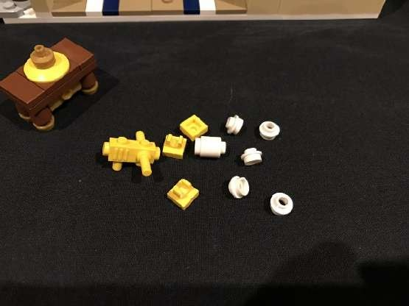
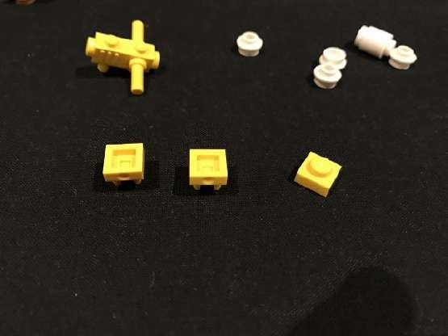

Take a White 15cm Dot Light and place the LED component directly over the plate with stud and ensure the Dot Light is facing up. Reconnect the round white brick over the top securing it in place and then connect one of the provided trans orange round plates on top.
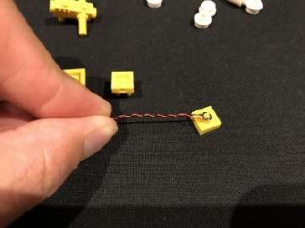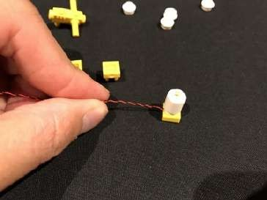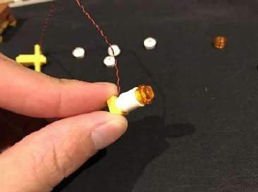

Take another White 15cm Dot Light and this time, place it inside the base one of the yellow plates with clip as shown below. Secure this in place by reconnecting one of the white round plates with hole and then connect another trans orange round plate on top. Repeat this process to install another White 15cm Dot Light to the other yellow plate with clip and connect another trans orange plate on top.

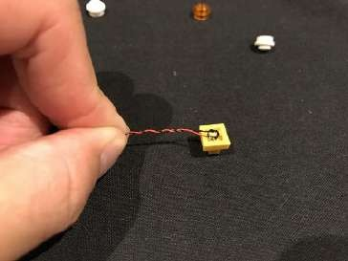
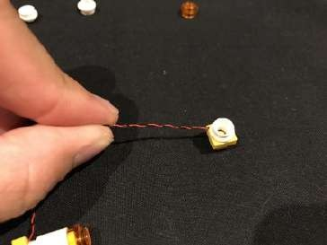
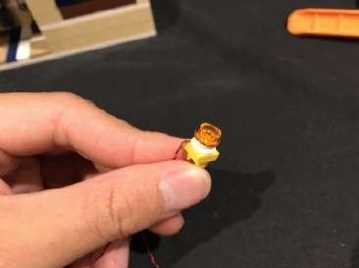

Reconnect the middle candle with Dot Light installed back to the “candle frame” piece followed by the 2 side candle sections ensuring the cables are all facing toward the back of the candles.
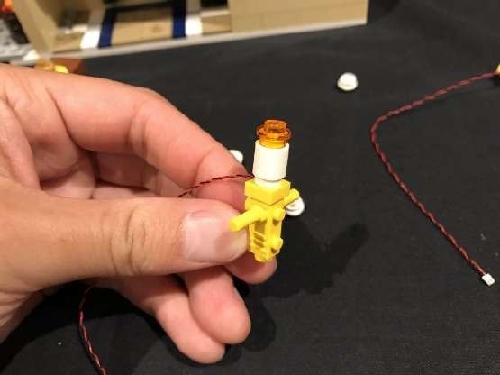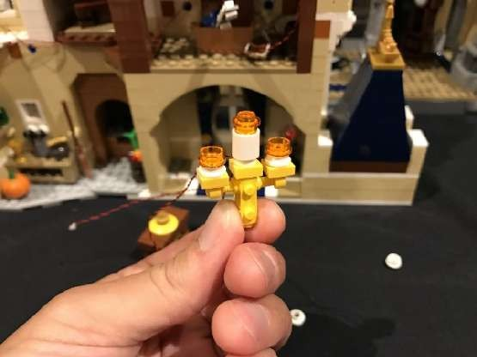

Take all 3 cables from the Dot Lights and twist them around each other so that they become one large cable then reconnect this section back to the table.

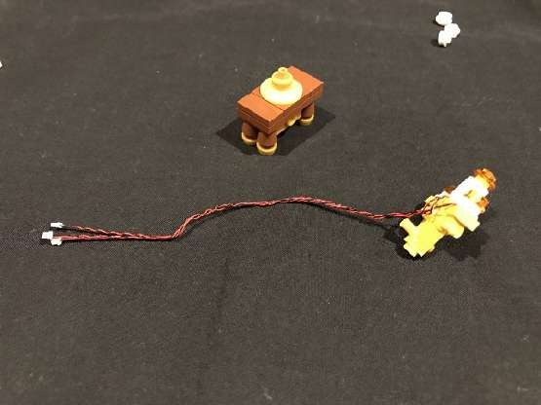
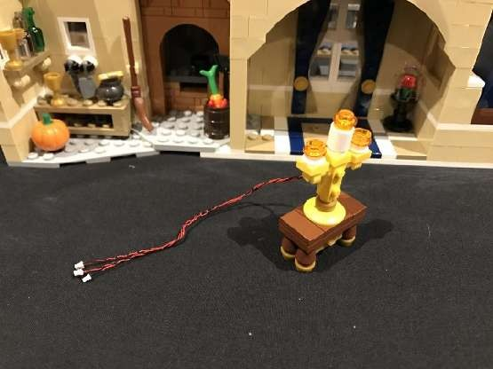

Before proceeding to the next steps, please take note of which eGects board option was included in your lighting kit:
Eßects Boards option 1: Steps 45–47

2x Multi-EGects Board

1x 6-port Expansion Board

1x 5cm Connecting Cable
or

Eßects Boards option 2: Steps 48–50

2x Flicker EGects Boards (FFX)

45.) If your light kit came with eflects board option 1 then take out the Multi-EGects Board and connect the 5cm Connecting Cable to one of the output ports (side with 2 ports). Connect the other end of the 5cm cable to the 6-Port Expansion Board. Connect all 3 light cables from the candle to the 6-port expansion board. The eflects board will be used to give the candles a realistic kame eflect. Flick the switch on the multi- eflects board all the way to the left for the ‘kicker’ eflect’ and then turn the wheel anti-clockwise all the way for the fastest speed of eflect.

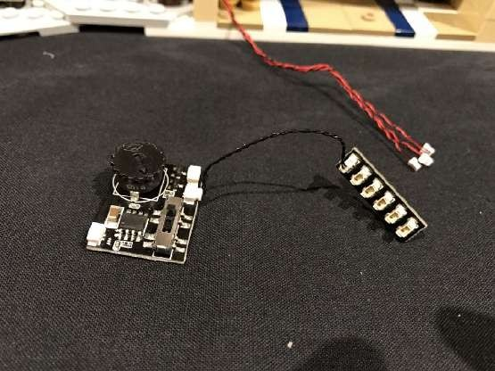
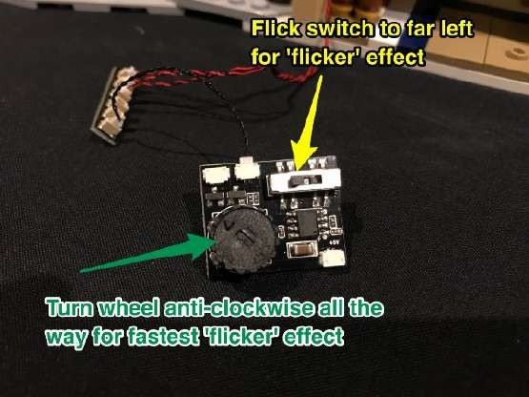

46.) Stick 2 adhesive squares to each board and then connect a 30cm connecting cable to the input port on the expansion board (side with 1 port).
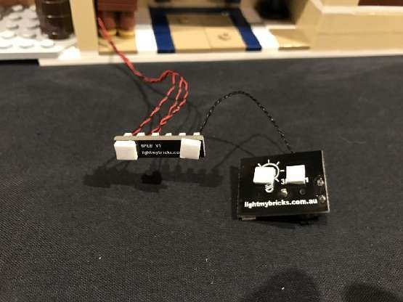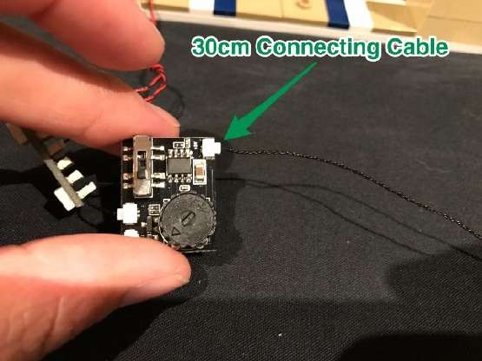

47.) Mount the expansion board and multi-eflects board to the roof in the following position and then tuck in cables of the candle before reconnecting the table back securing the cables and hiding them behind.

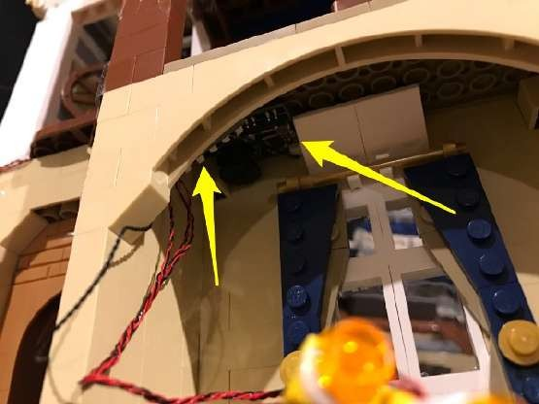
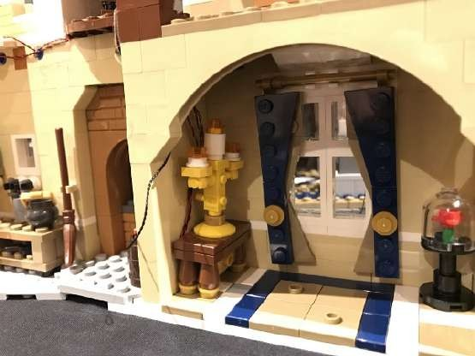
Skip the next steps and proceed to Step 51.
48.) If your light kit came with eflects board option 2 then take out the Flicker EGects Board and connect all 3 light cables from the candle to the output ports of the eflects board.
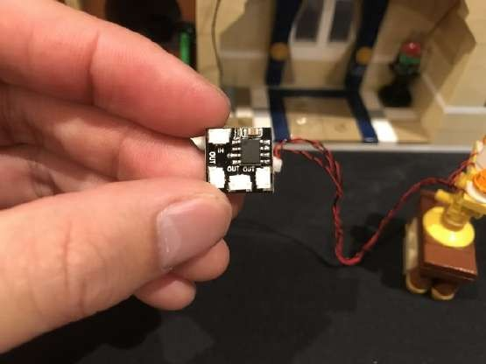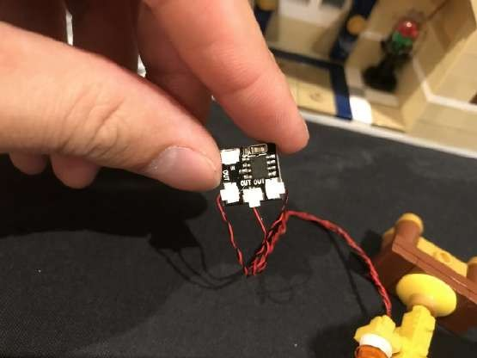

49.) Take a 30cm connecting cable and connect it to the input port of the eflects board then stick 2 adhesive squares to the back.

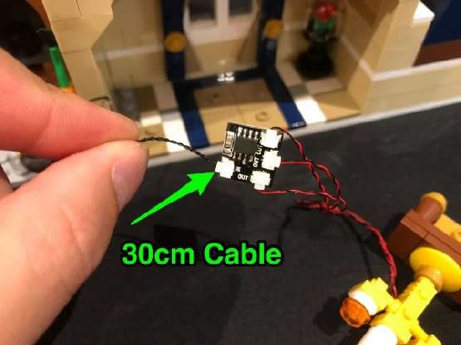
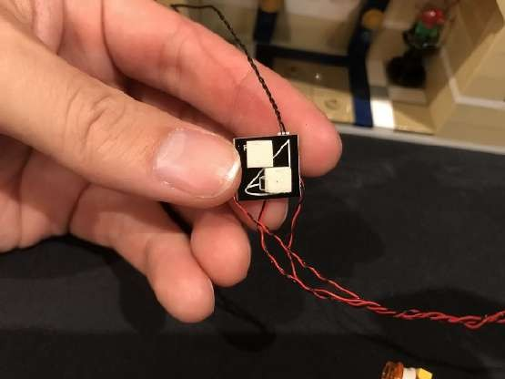

) Mount the kicker eflects board to the roof in the following position and then tuck in cables of the candle before reconnecting the table back securing the cables and hiding them behind.

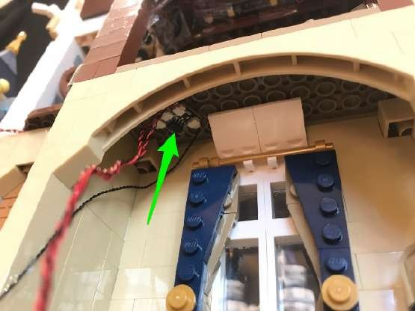

51.) Take the other end of the 30cm connecting cable and bring it all the way up to the room above and connect it to the far left port on the 12-port expansion board.

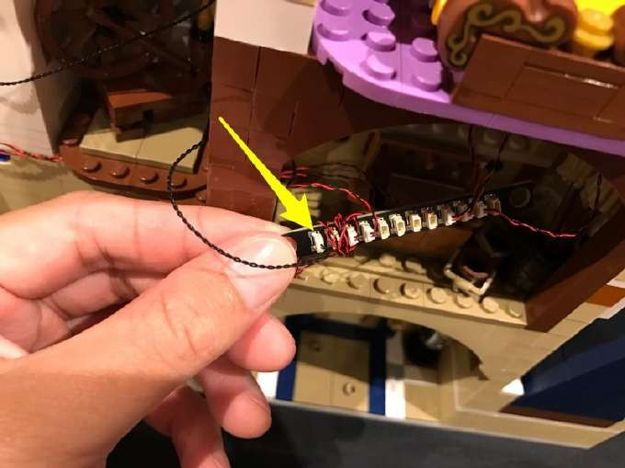

52.) We will now install a light to the Beauty and the Beast Rose. Remove this whole section and then disconnect the trans clear case and red kower piece as per below.

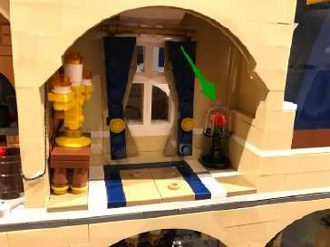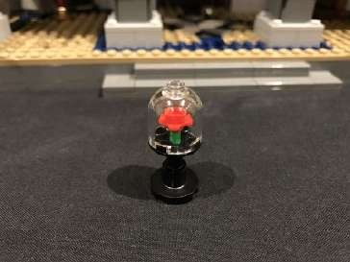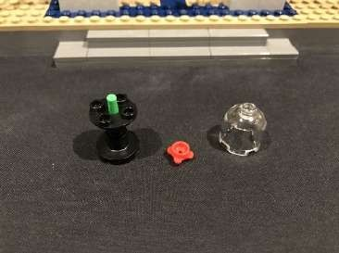

Take the Green Flower piece which came provided in this light kit and then connect this on top of the green “stem”.

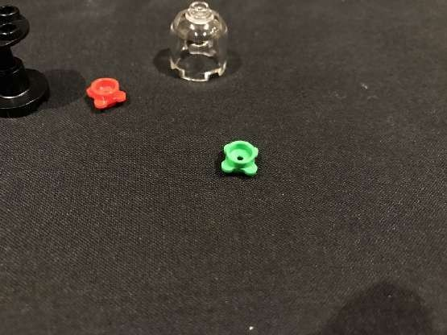
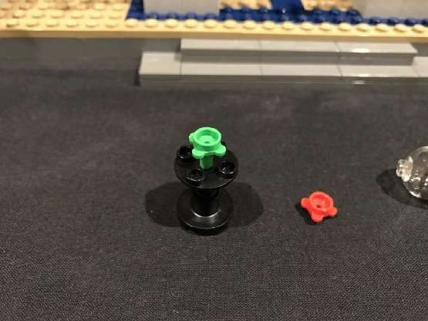

Take a White 30cm Dot Light and place the LED component in the centre of the green kower (facing up) and then reconnect the red kower piece over the top, securing the Dot Light in place. Reconnect the trans clear case.

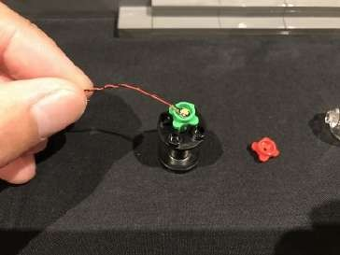
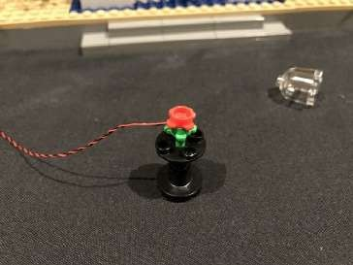
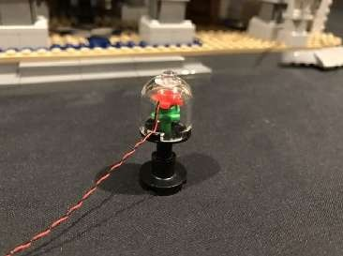

Thread the cable of the Dot Light outside the window before reconnecting the table back to original position.

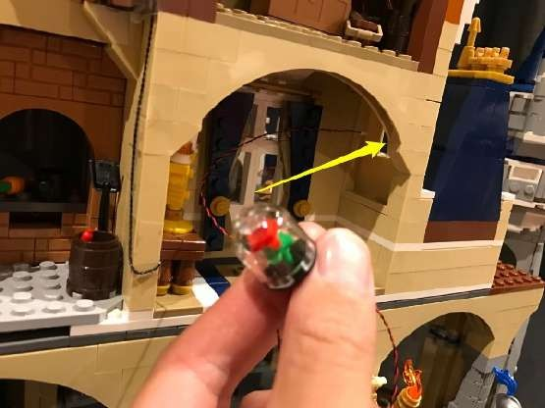
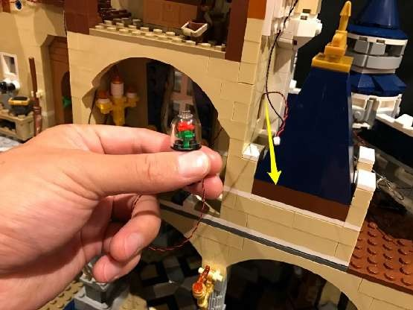

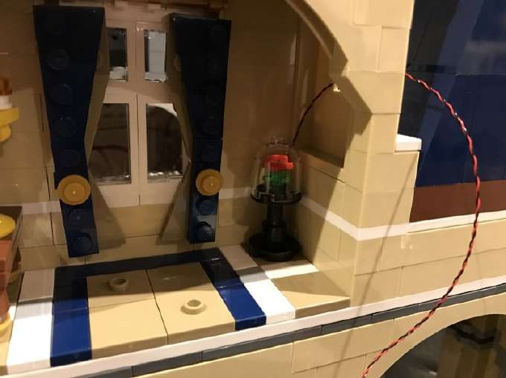

Bring the Dot Light cable up to the next level and then thread it back through the window above and then connect it to a spare port on the 12-port expansion board.

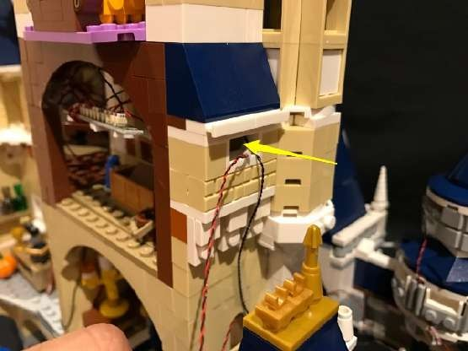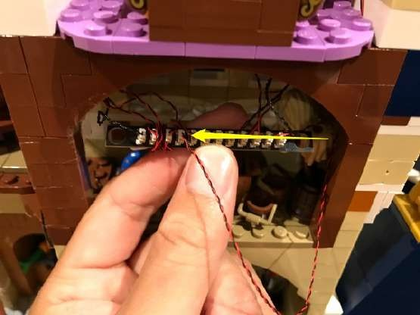

Leave the expansion board as is for now and move onto the next step.

53.) Take 2x Strip Lights and connect a 15cm Connecting Cable in between them (striplight#4 and striplight#5). Stick both strip lights onto provided 1x6 plates. Connect a 5cm Connecting Cable and connect it to the right port on striplight#5.

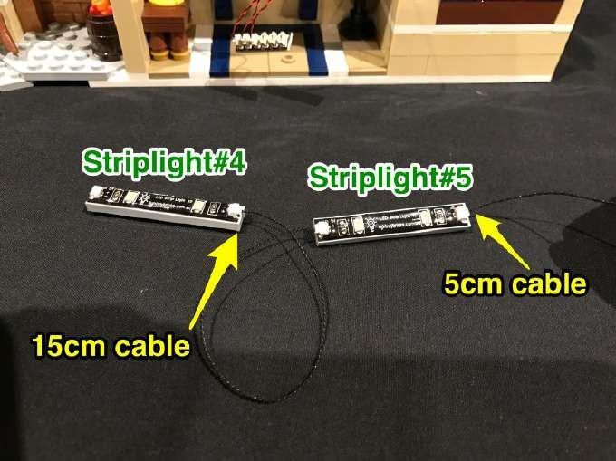

Connect another 15cm Connecting Cable to the left port on striplight#4

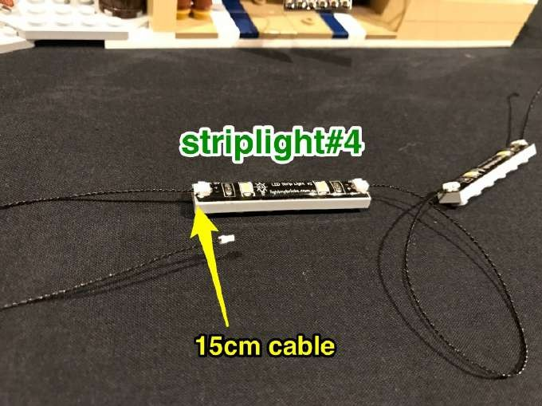

Mount striplight#4 to the following position above the spinning wheel and then thread the other end of the loose 15cm cable through the left window.

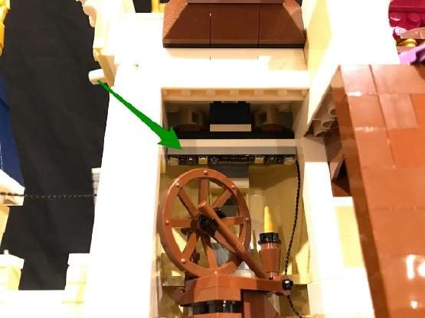
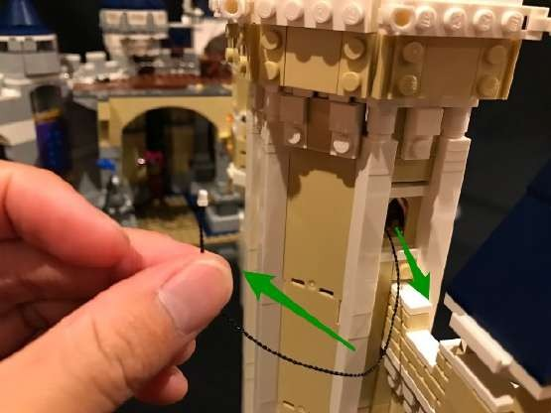

Take the 5cm connecting cable from striplight#5 and connect it to the next available port on the 12-port expansion board. Then mount the strip light to the following position above the treasure chest.

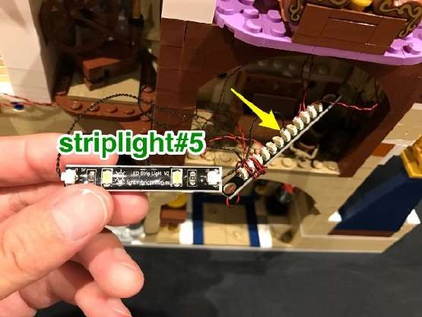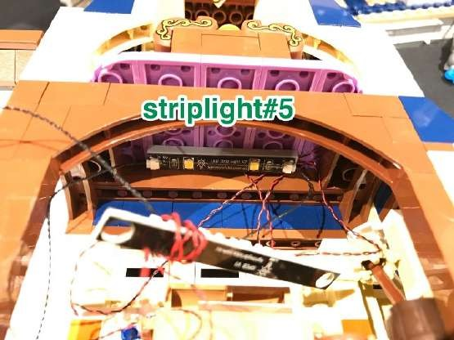

54.) Now take the entire middle section of the castle and securely connect it on top of the bottom section. Locate the other end of the 30cm connecting cable we had installed to an expansion board on lower koor (step 27) and thread this through the window to allow you to connect to a spare port on the 12-port expansion board.

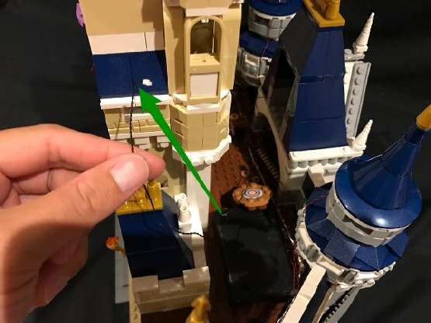
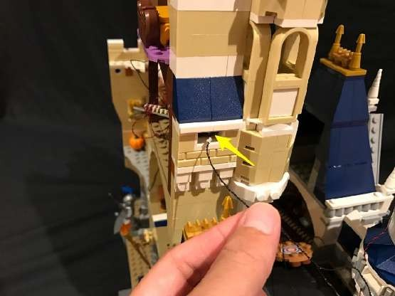
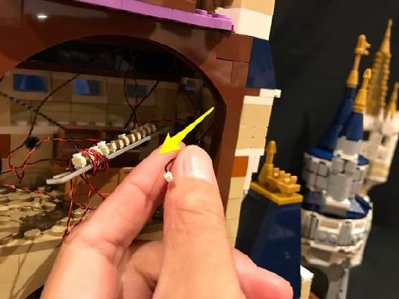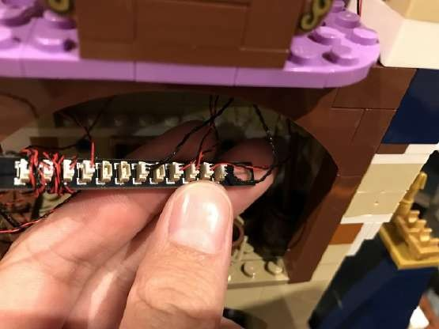

Now that we have connected the middle section of the castle to the bottom we can turn on the power bank to test the lights we have installed.

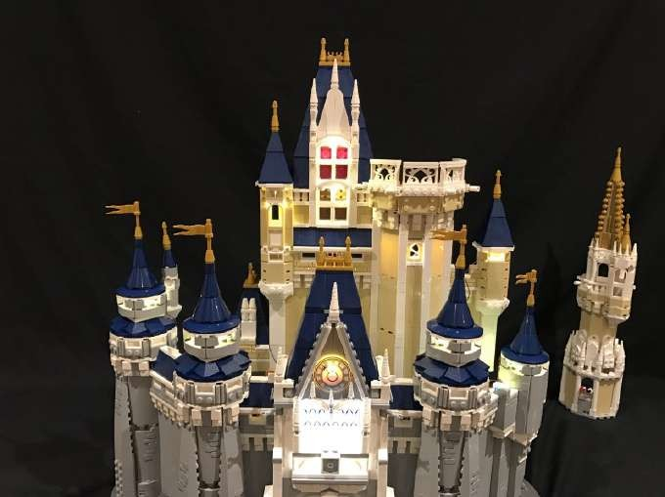

55.) Take 2 adhesive squares and stick it to the back of the 12-port expansion board and then mount the expansion board onto the inside of the brown arch on the top as per below.
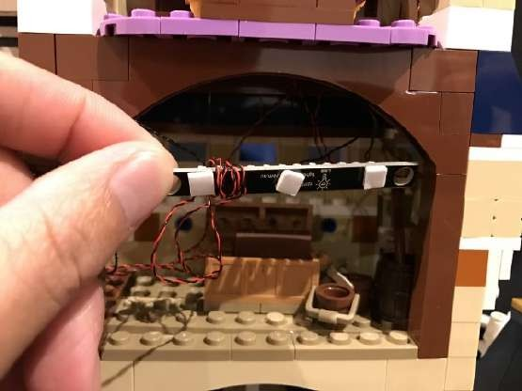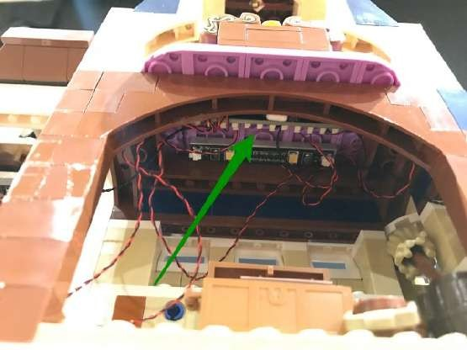

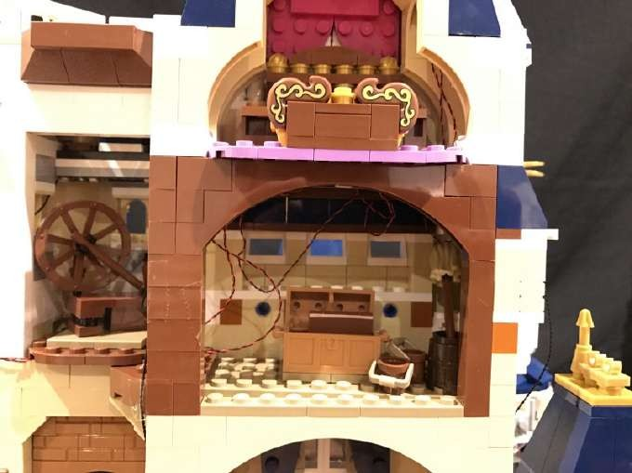

Do your best to prevent cables from being seen by neatening them up and using tape to secure them down (or up) to the building. See example images below.

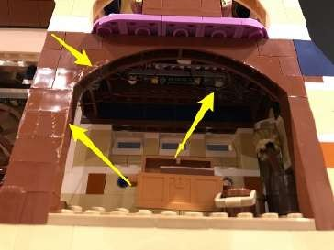
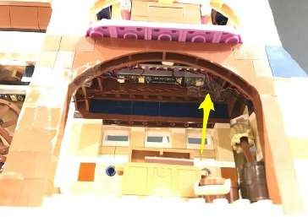
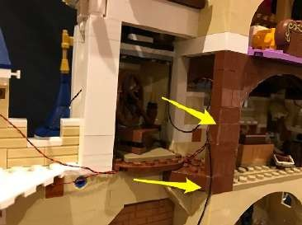
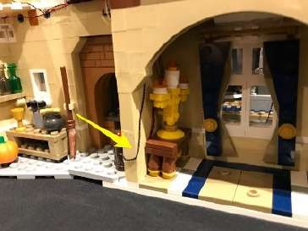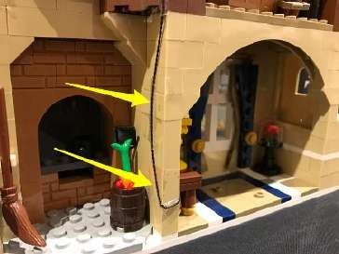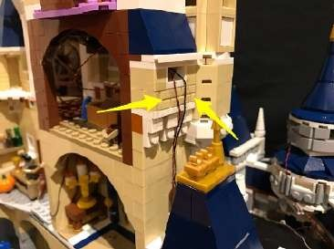

56.) We will now move onto lighting the top section of the castle. Turn the top section around so that we can light the inside of it. Start by removing the roof section ofl the top as well as the mirror section from the level below.

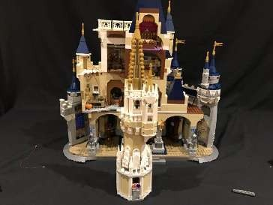
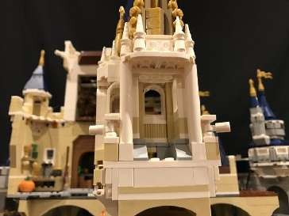
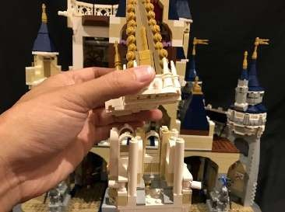
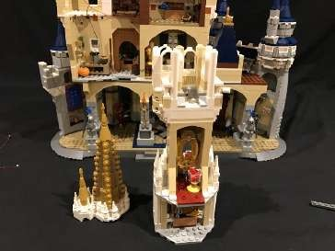
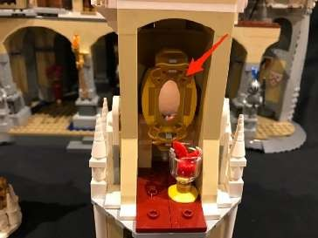
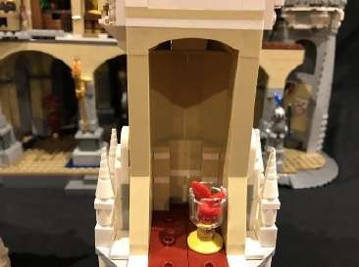

Take the top roof and then disconnect the following 1x2 plate from underneath.
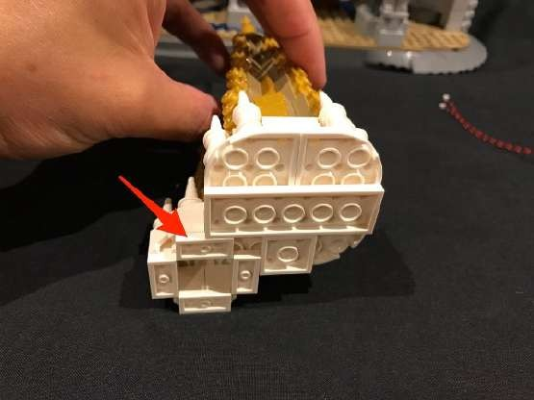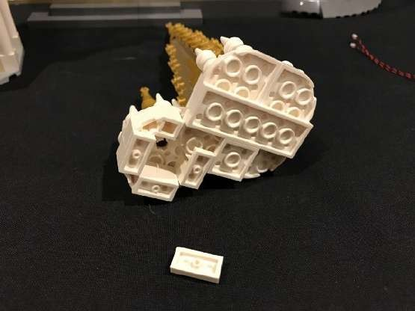

Take a White 30cm Dot Light and place it underneath in the middle (with Dot Light facing down) and then reconnect the 1x2 plate to secure the Dot Light in place.

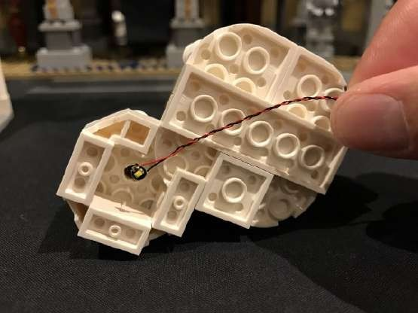
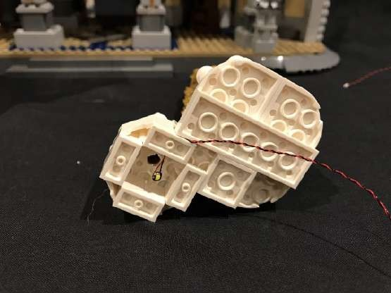
Take another White 30cm Dot Light and place it in the below position. Secure this down by connecting one of the provided 1x2 plates over the top ensuring the Dot Light is facing down.
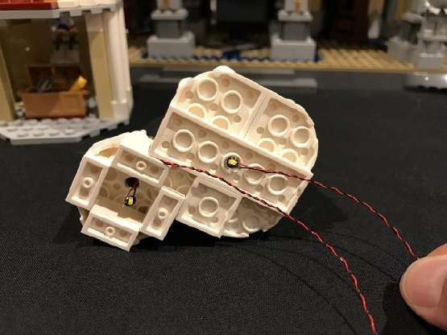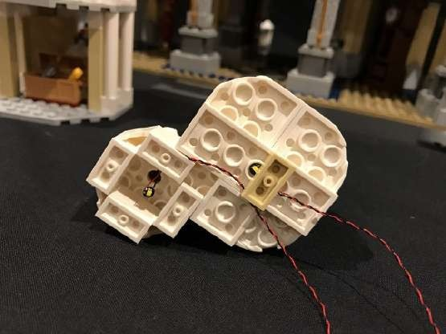

Reconnect this roof section back to the castle and then remove the following sections from the side.
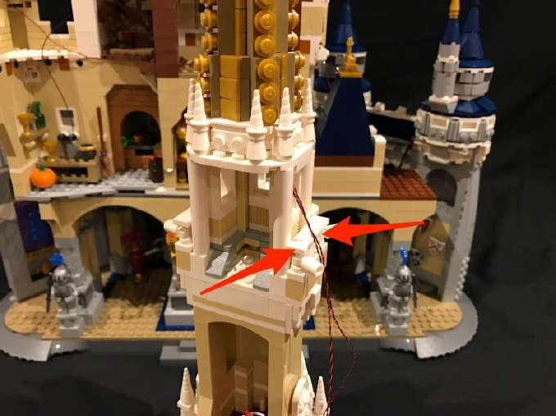

Remove the 1x1 brick in the corner and then lay both cables underneath before reconnecting the brick over the top followed by the sections we removed earlier.
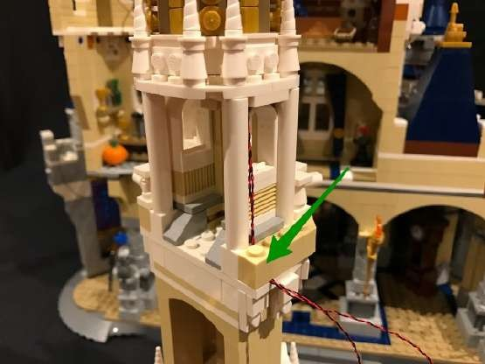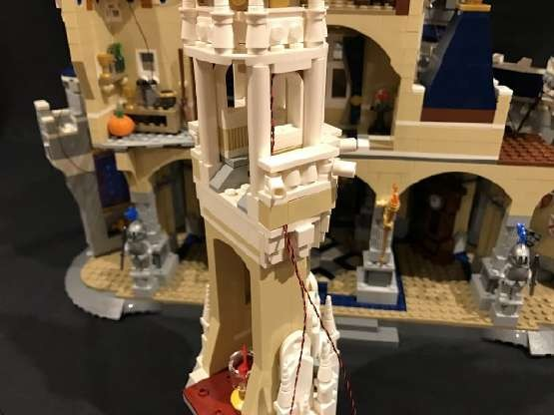

57.) We will be installing a light behind the mirror on the level below. Take a White 15cm Dot Light and stick it to an adhesive square. Mount this light to the wall as per below.

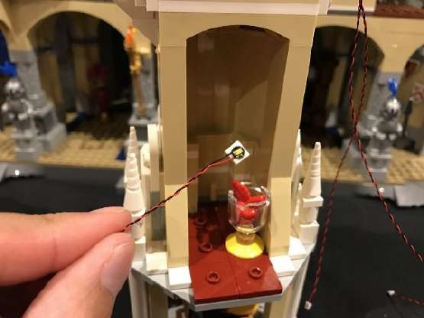
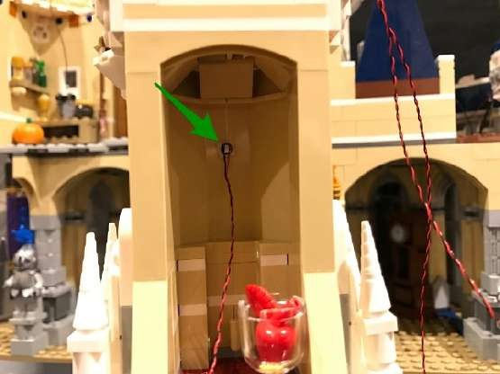

Take a 6-Port Expansion Board and then connect the Dot Light we just mounted into a spare port. Wind the cable around the port 2–3 times.

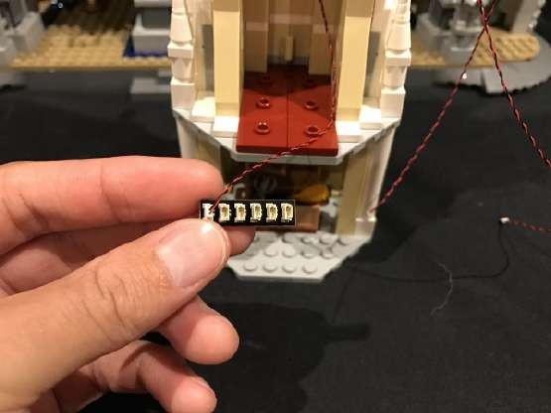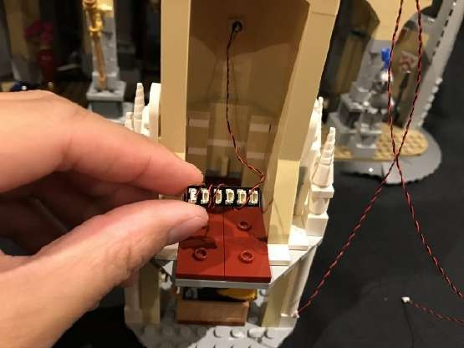

Take the 2 Dot Light cables from the level above as well as another 15cm Connecting Cable (which will be used to connect to the level below) and connect them to the next available ports on the expansion board.

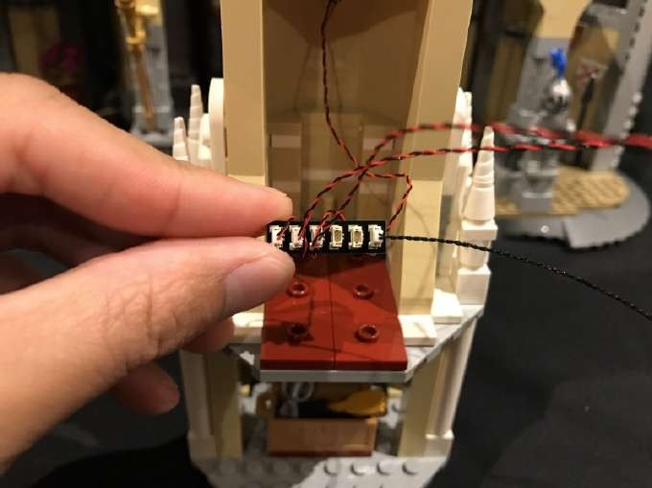

Mount the expansion board to the wall underneath the Dot Light using 2
adhesive squares.

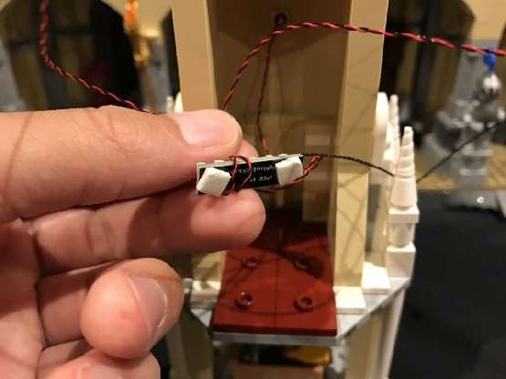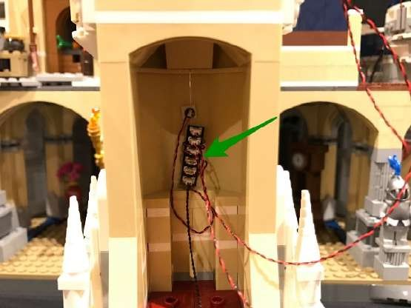

Bring the excess cables down and tuck them in behind before reconnecting the mirror section over the top. Neaten up cables and secure them down underneath the cup as per below.

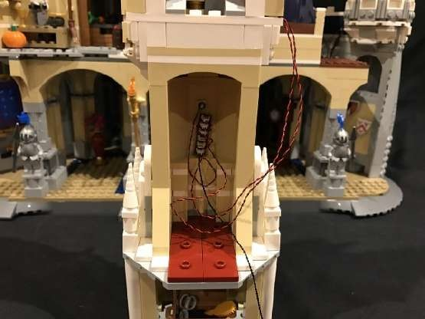
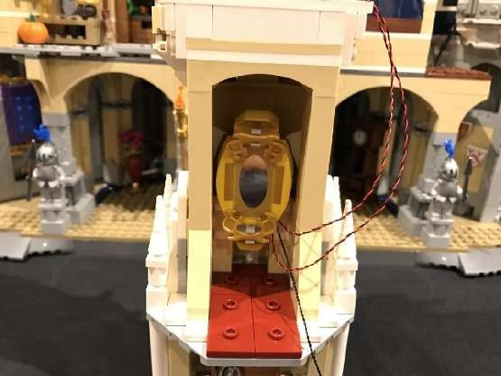
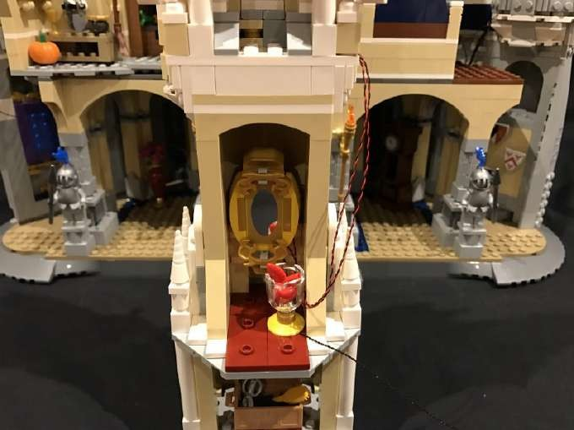
Use tape to secure the cables to the side of the castle.
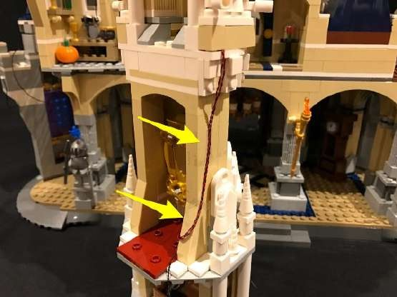
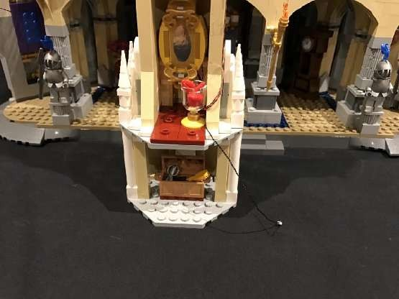

Take the 15cm cable from the expansion board and then loop it behind and then thread through the right side window as per below
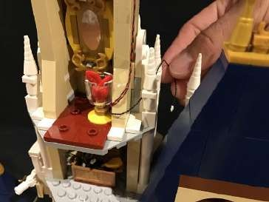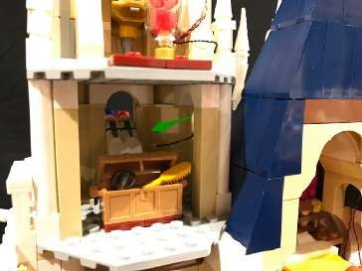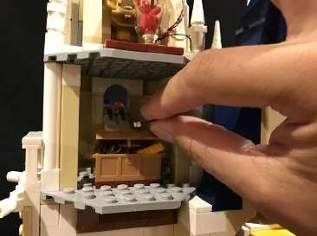

58.) Take the last Strip Light (striplight#6) and stick onto a 1x6 plate. Connect the other end of the 15cm connecting cable from above to the right port.
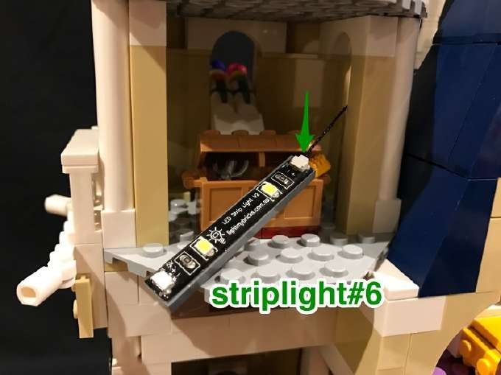

Before we secure this strip light, take this entire top section and securely reconnect it to the rest of the castle. Locate the 15cm cable from striplight#4 on the level below. Pull this cable up and then thread into the window before connecting it to the left port on striplight#6.
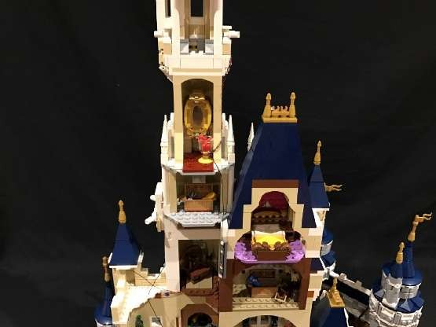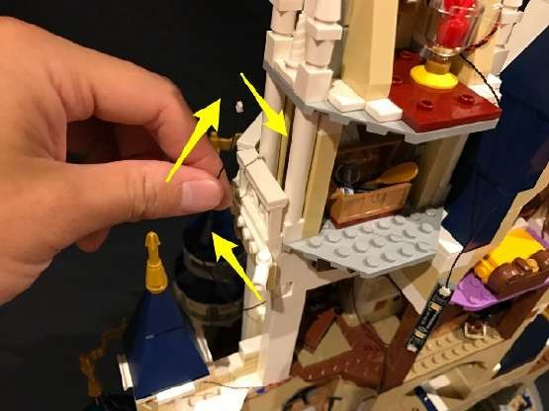
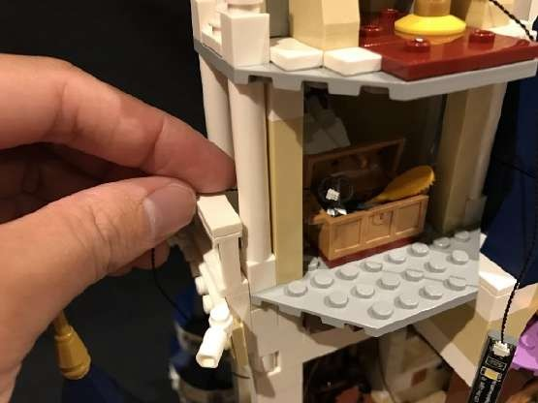
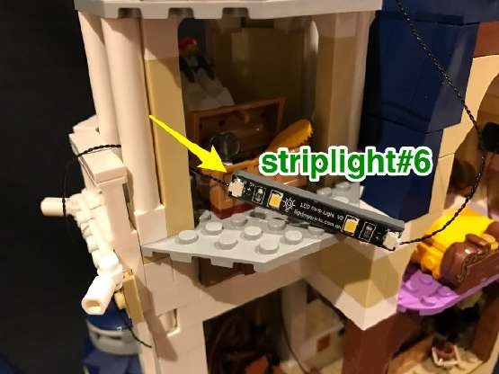

Mount striplight#6 to the top of this level in the following position as per below
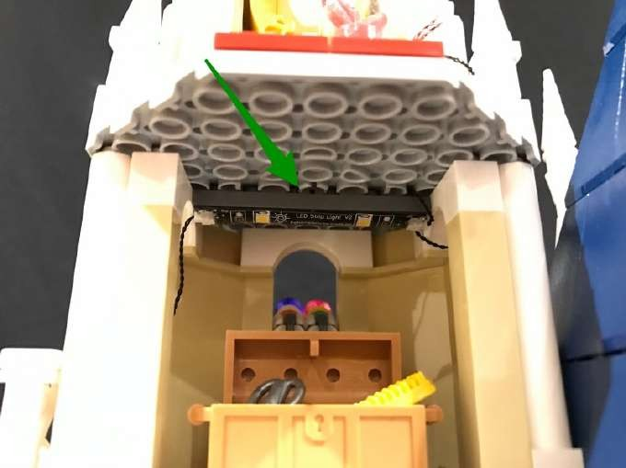

59.) Hide the following connecting cables behind sections by disconnecting and reconnecting them over the top as per below.

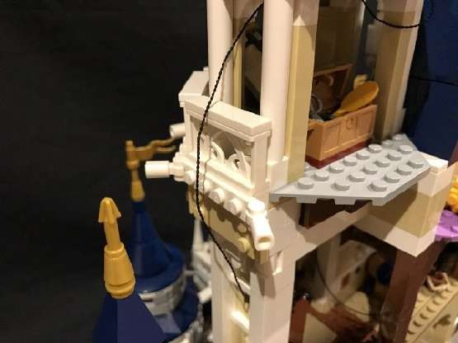
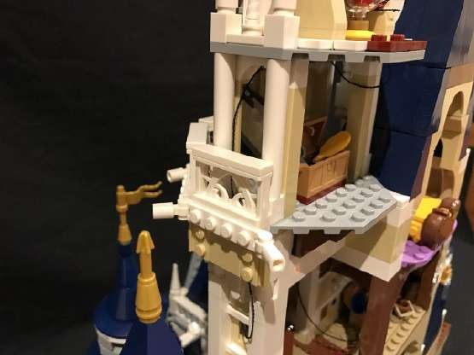

This now completes installation of the Disney Castle Lighting Kit. You can now finally turn ON using the USB Power Bank and ENJOY!

