## **[Star War Docking Bay](https://drive.google.com/open?id=1twoxg5VTcppPpBSRVWcmHvWjZIsADd47" \o "Lighting Kit for Lego Docking Bay 327 Build Guide For Minifigure Scale UCS Falcon) LED Lighting Kit**

#### Package contents：

* 1 x 30cm White Dot Light
* 1 x 15cm Flashing White Dot Light
* 7 x 30cm Flashing White Dot Lights
* 15x Warm White Strip Lights
* 7 x 50cm Connecting Cables
* 7 x 30cm Connecting Cables
* 2 x 15cm Connecting Cables
* 1 x 5cm Connecting Cable
* 1 x Multi Effects Board
* 3 x 6-port Expansion Boards
* 1 x AAA Battery Pack
* 1 x USB Connecting Cable
* 25 x Adhesive squares

**Note:**

**Place wires on the surface or under the building blocks.**

**The wire can be place between the building blocks or under the block, but they should be placed between the studs correctly.**

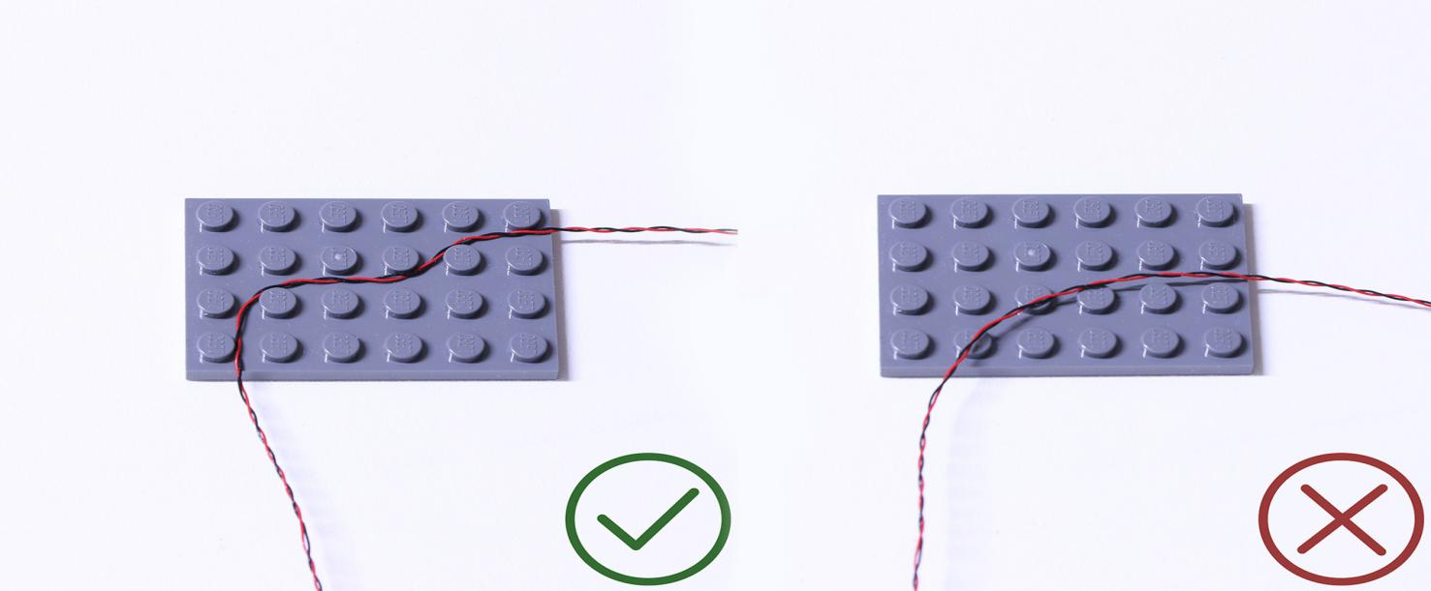

**Insert the connectors to the ports.**

**Be careful when you are operating, there’s only one correct way to insert, make sure the expansion board is upward, find the soldered “=” sign on the left of the port. When you are inserting, the side which the wires can be seen should be faced to the “=” sign and if you feel hard to insert, please stop, and don’t force it, for that may result in bent pins inside the port or overheating of the expansion board.**

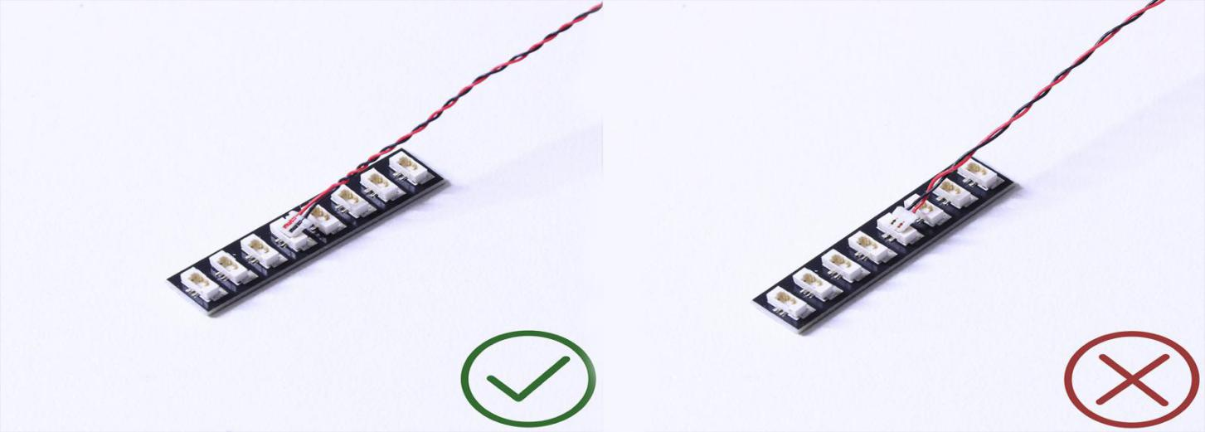

**At this point, use the tweezers to straighten the bentpins.**

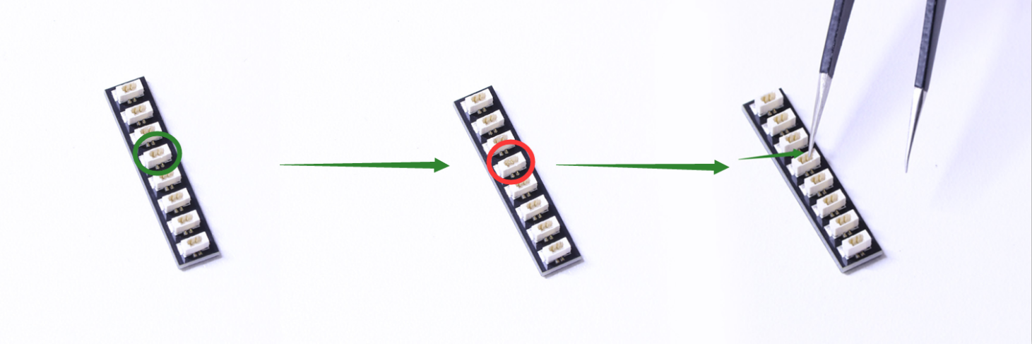

**When installing dot lights, make sure they are correctly placed (Yellow LED package is exposed). You can put they either on the top of the studs or between studs.**

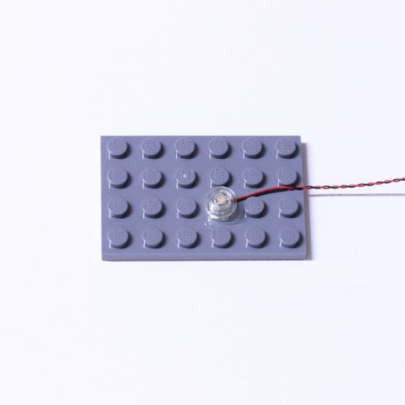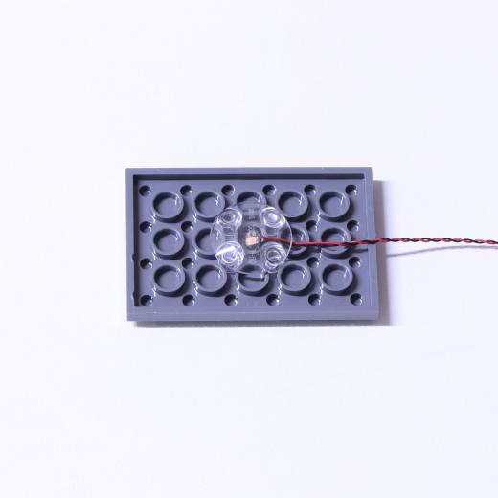

# Connecting cable connectors to Strip Lights

**Take extra care when inserting connectors to ports on the Strip Lights. Connectors can be inserted only one way. With the Strip Light facing up, ensure the side of the connector with the wires exposed is facing down. If a plug won’t fit easily into a port connector, don’t force it. Doing so will damage the plug and the connector.**

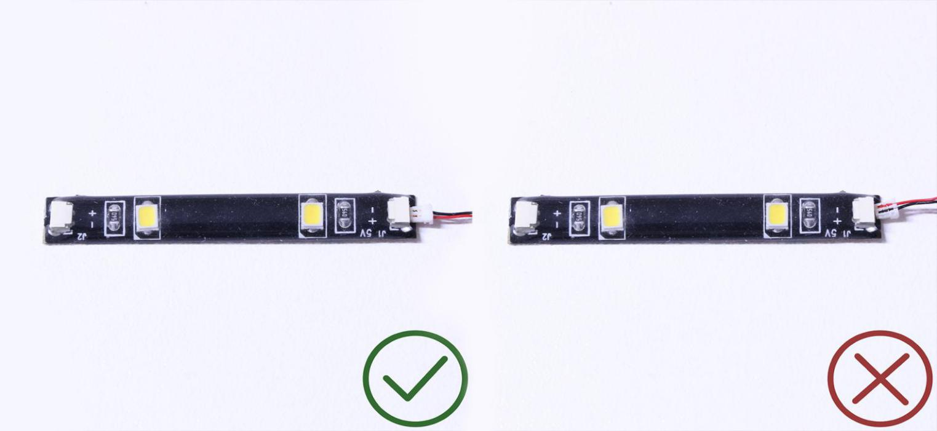

**Finally, please pay attention to the positive and negative terminals of the battery when installing the battery case.**

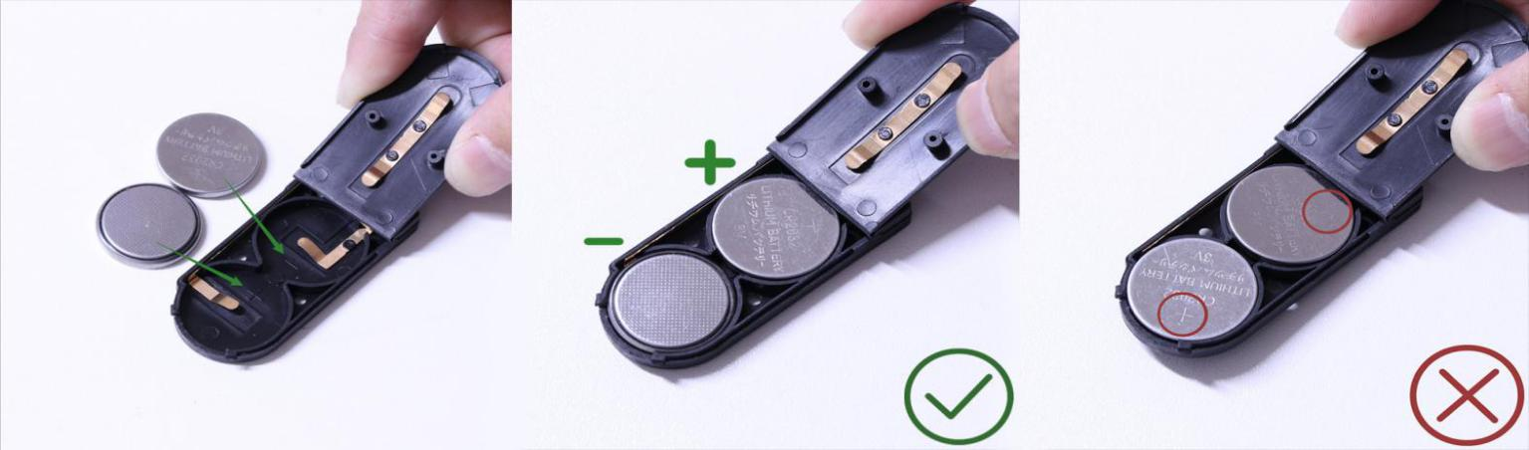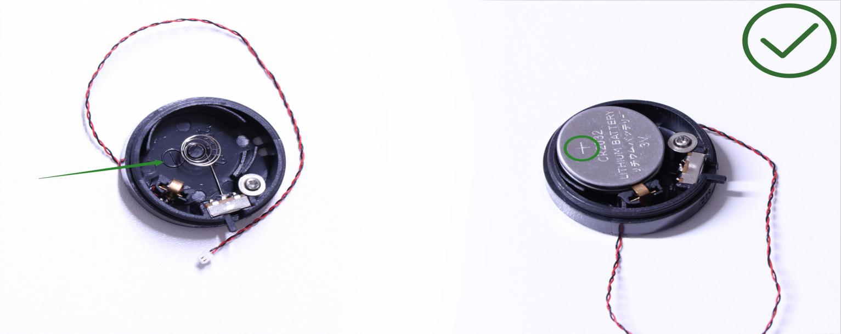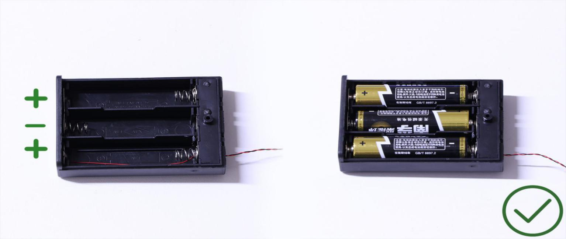

**OK, Let’s Begin!**

**Start from installing lights at the following side**

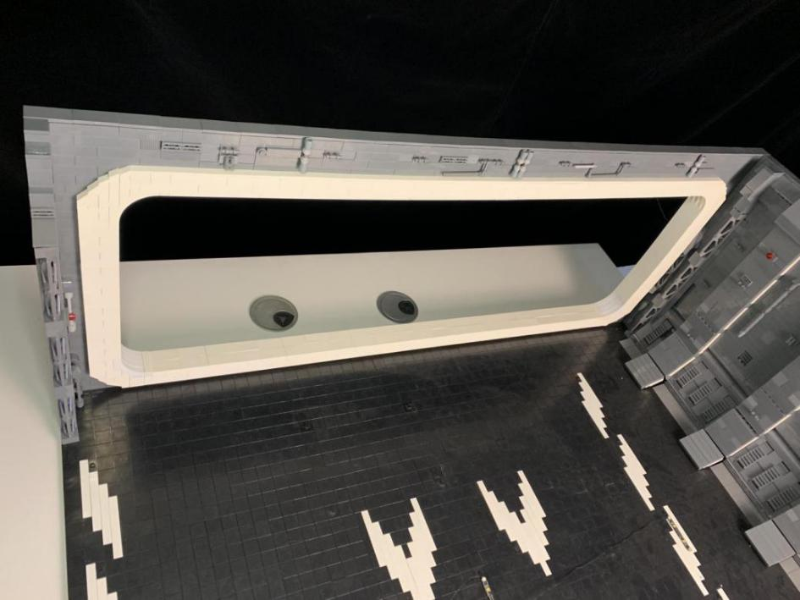

**Take a 30cm white Dot Light, remove the trans red piece and the 1x2 plate from the following place**

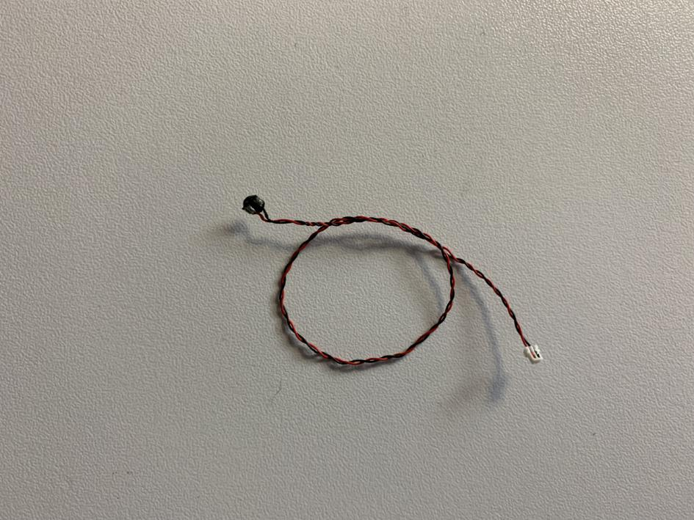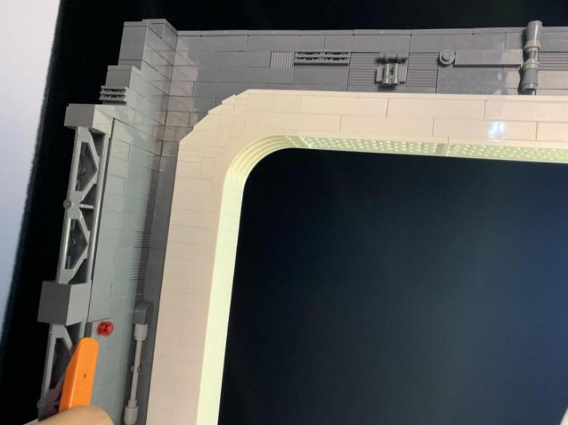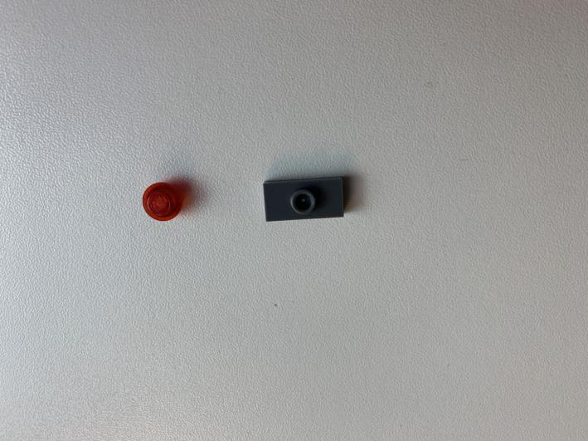

With lighting part facing up, assemble those pieces we taken together, reconnect it to the wall at the left

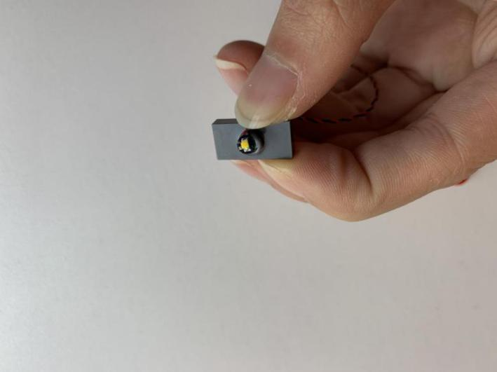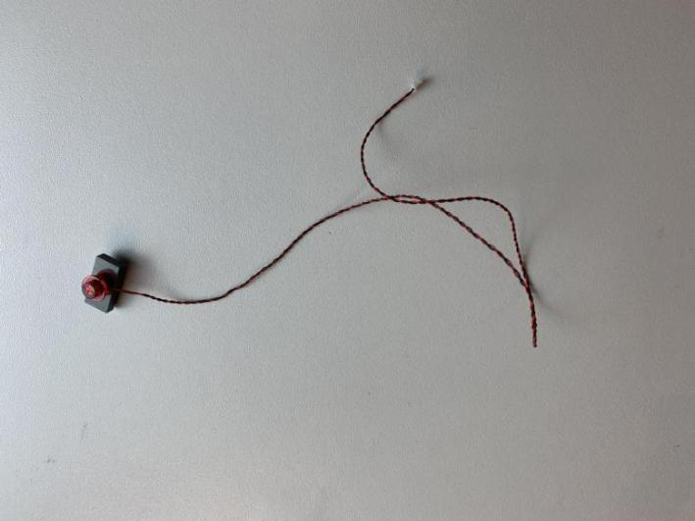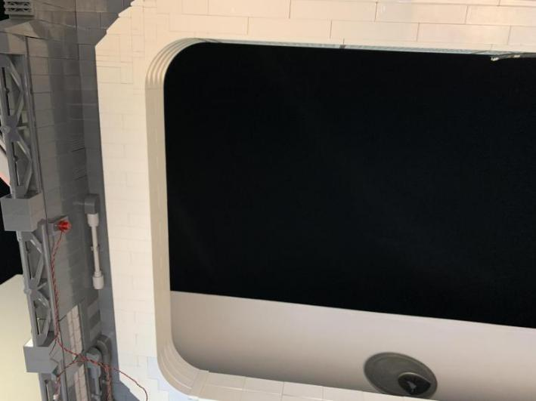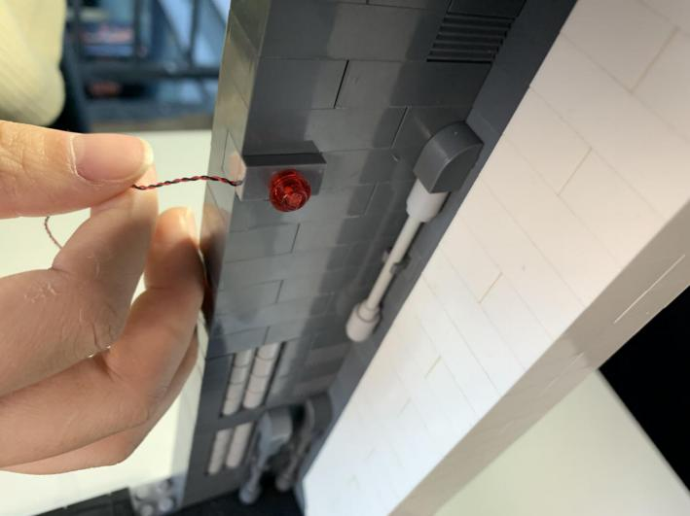

Remove the following pieces, and the 2x2 black plate next to it。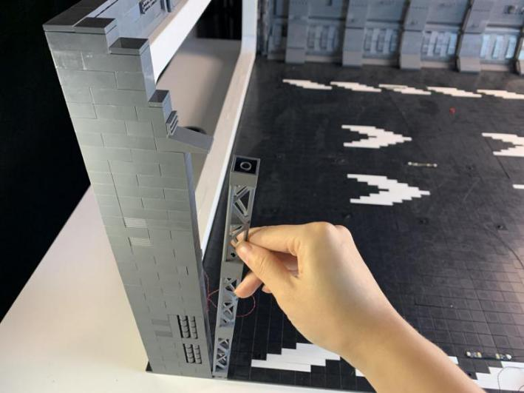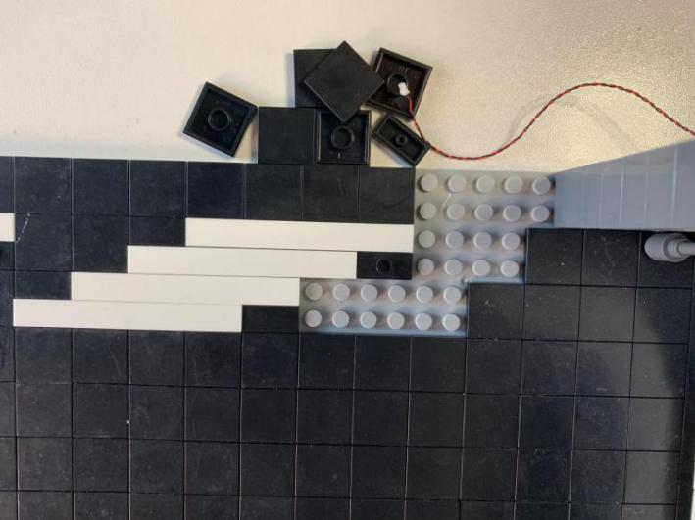

Place the cable underneath the gray piece before reconnecting it

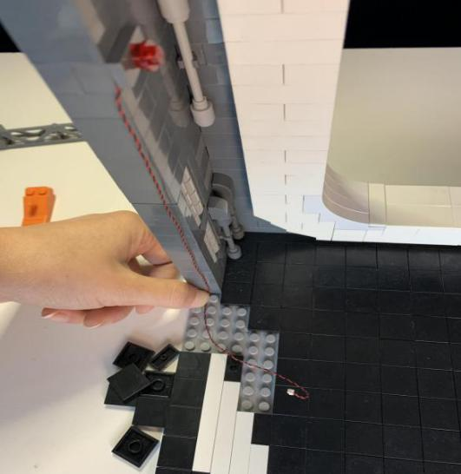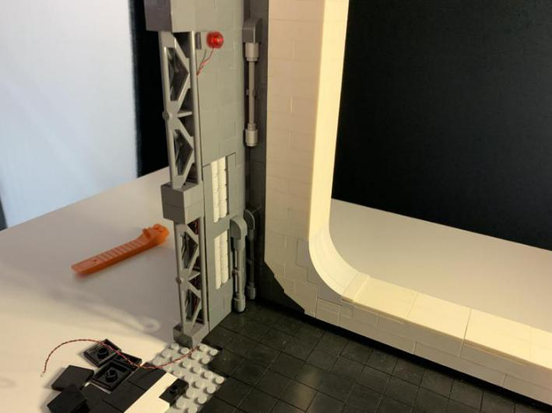

Take 6 warm white strip lights, three 50cm connecting cables, two 30cm connecting cables, assemble them as per below

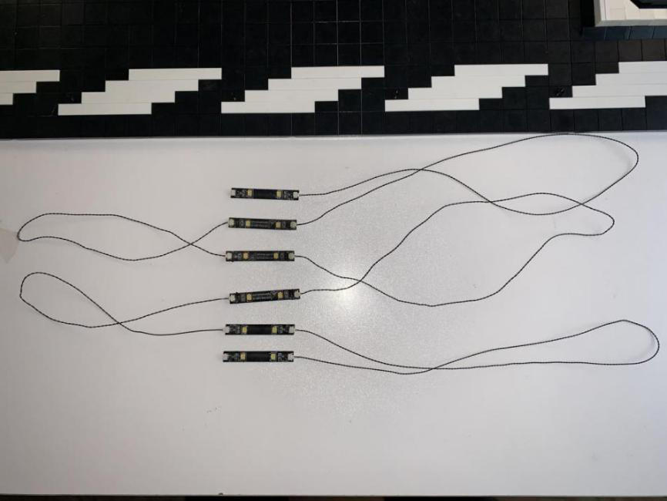

Connect the 30cm connecting cables we used at the first step to the strip 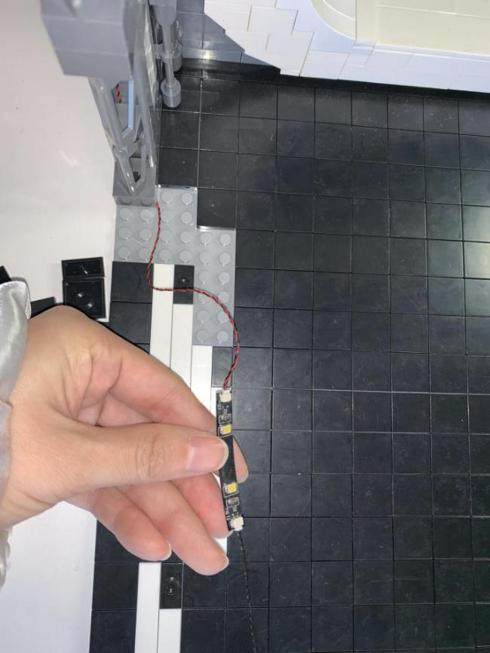

Stick the first strip to the following place

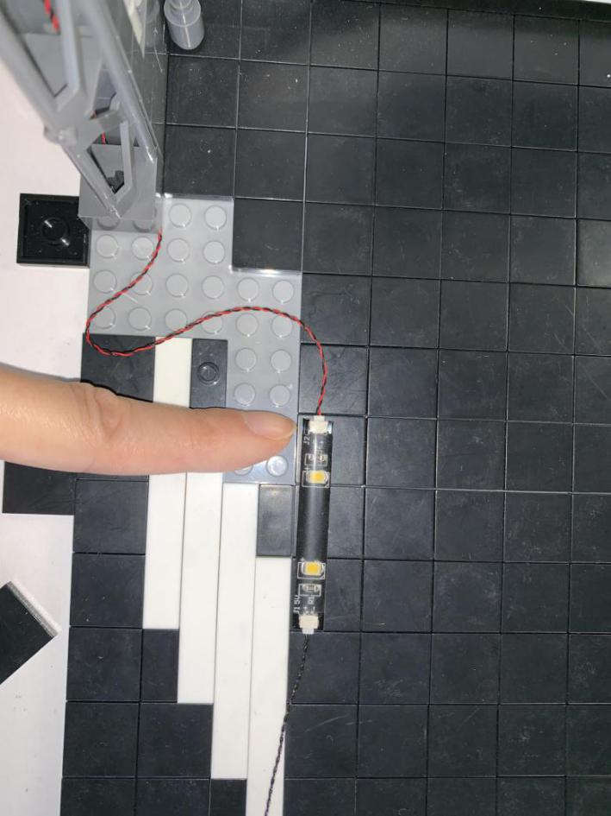

Reconnect the 2x2 black plate, place the cable underneath in between studs

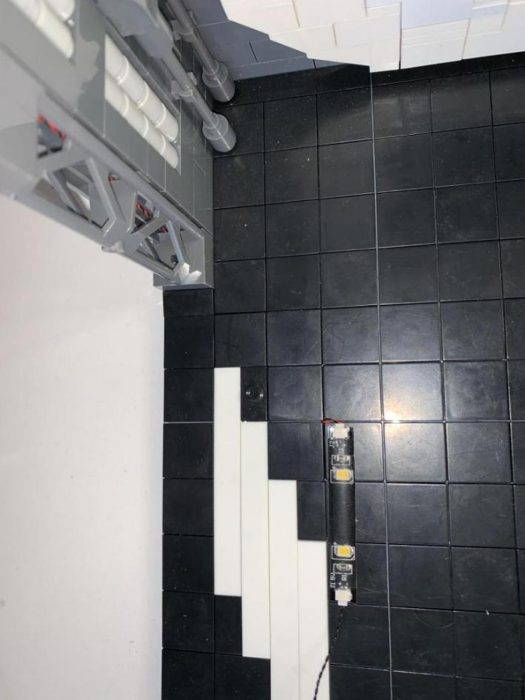

Follow the green arrows to stick strips to the places with red marks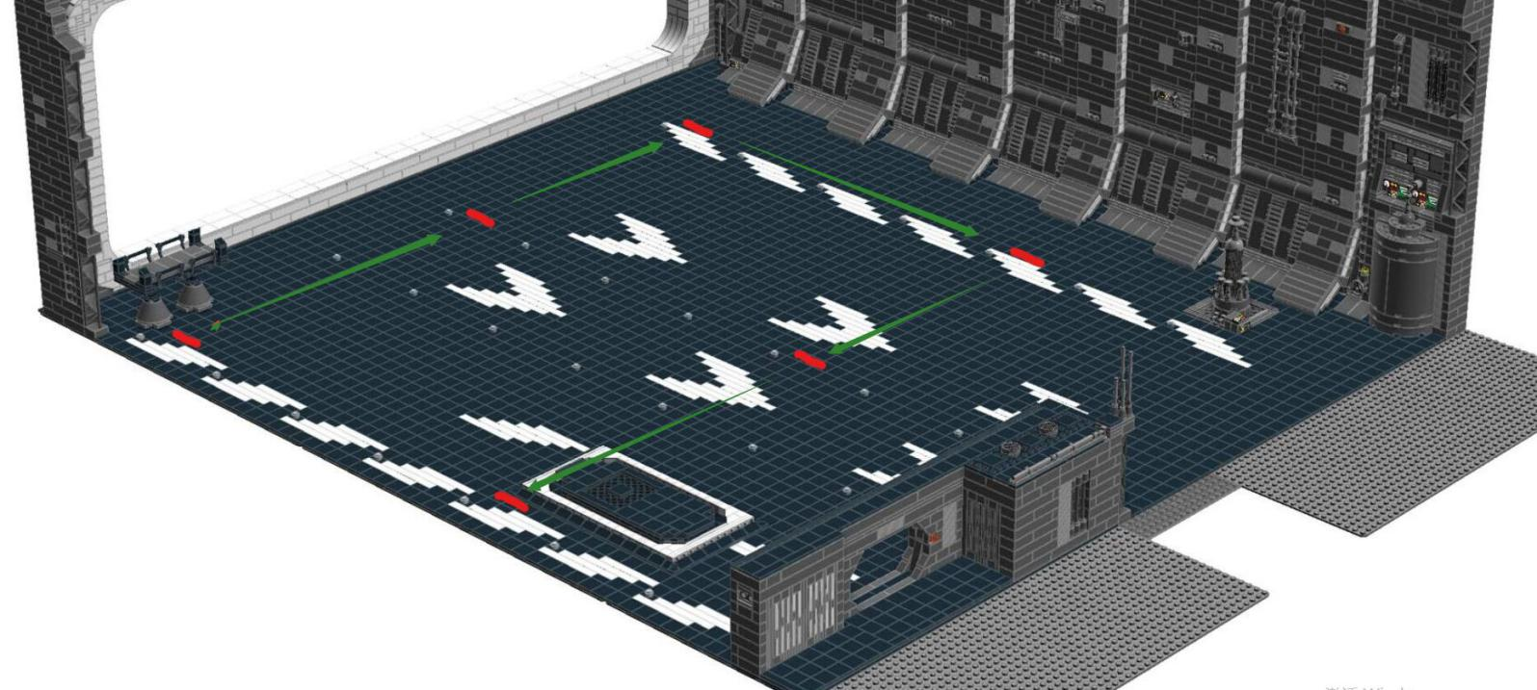

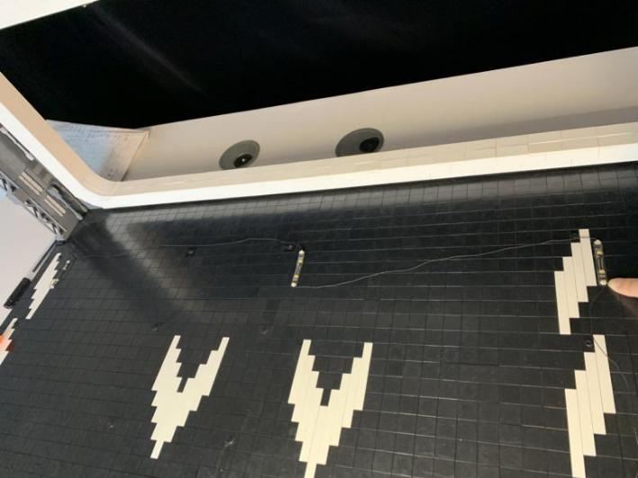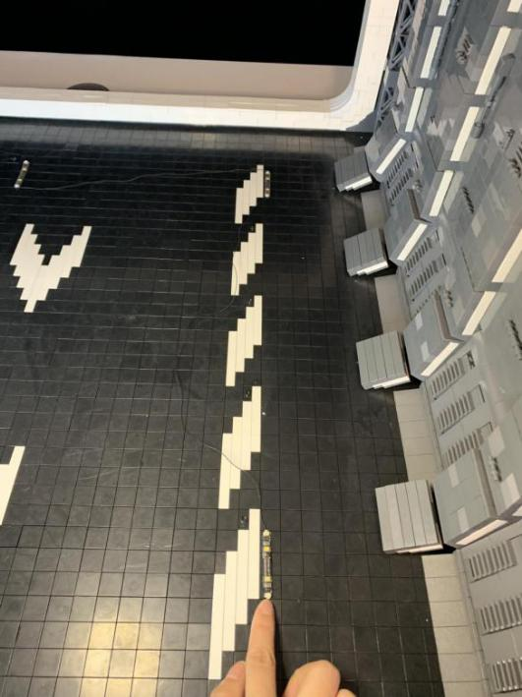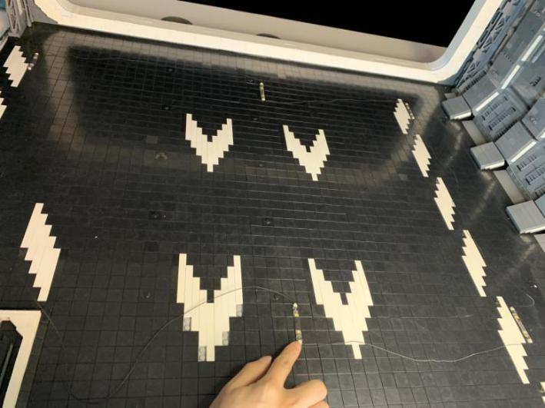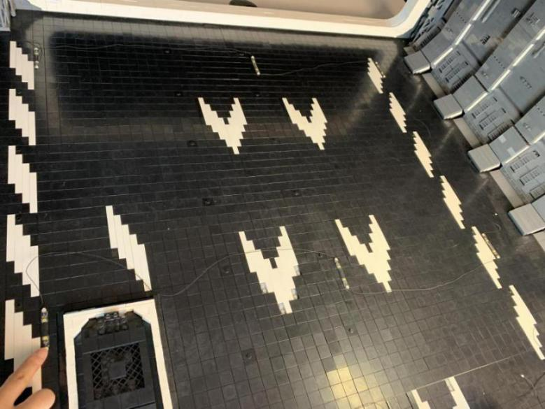

Take a 30cm connecting cable, connect it to the last strip. Remove the 2x2 black plate, place the cables underneath in between studs

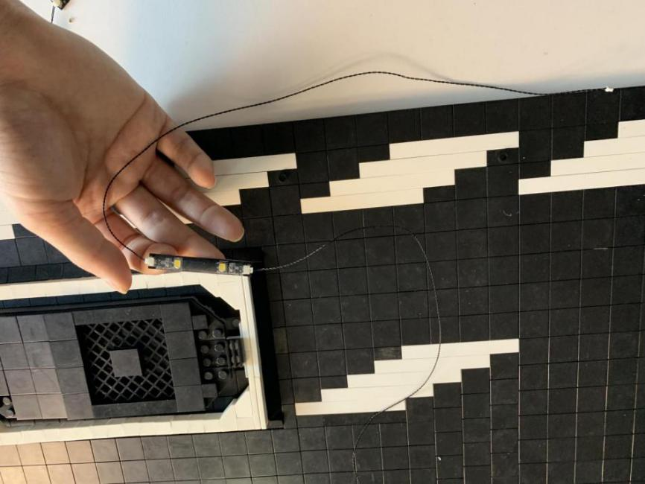

Take another 6 warm white strip lights, three 50cm connecting cable, and two 30cm connecting cables, assemble them together as per below

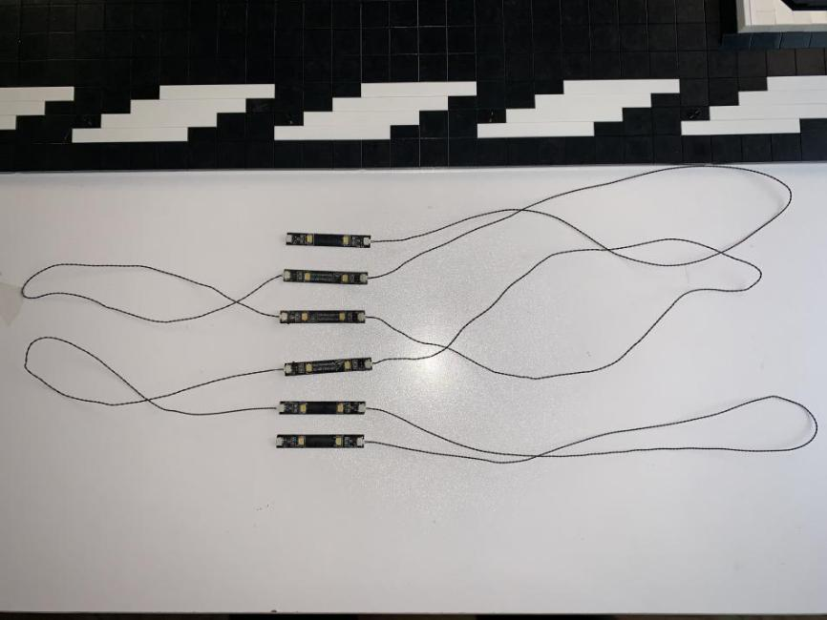

Stick the strip lights to the following positions with yellow marks

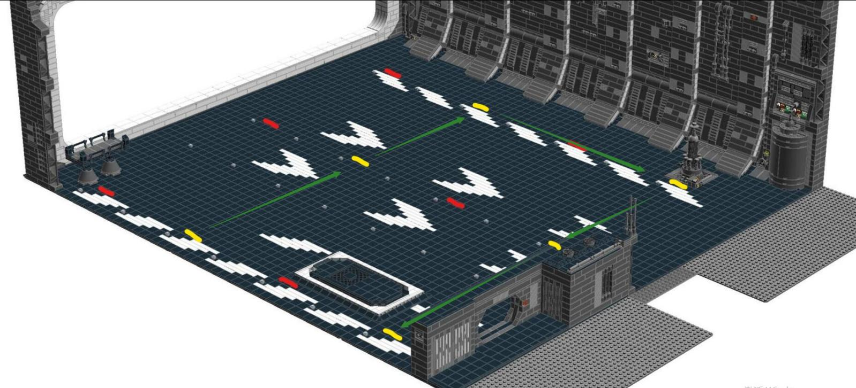

Take a 30cm connecting cables, connect it to the last strip

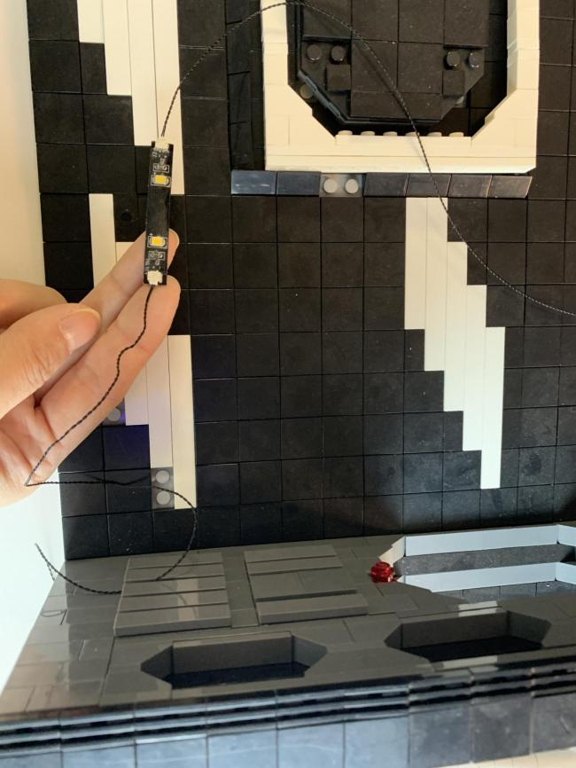

Now, we completes installation for the lights at the baseplate

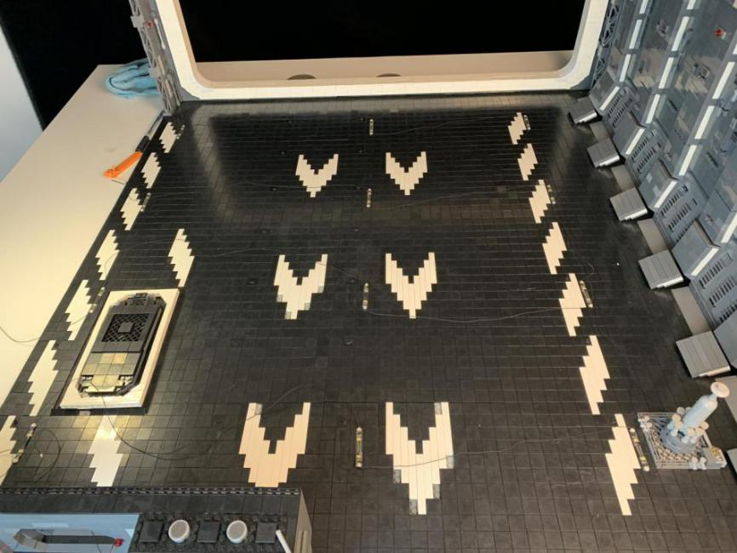

Take the Multi Effects Board, a 5cm connecting cable, connect the cables to the input port of the Multi Effects Board

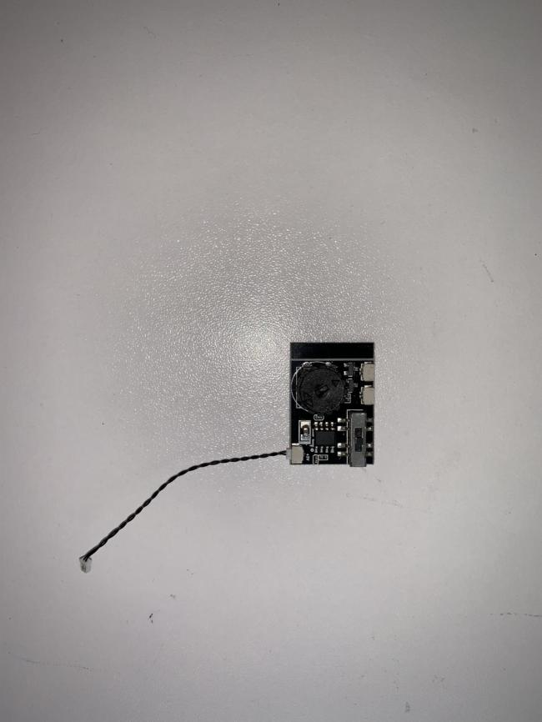

Connect the two 30cm cables from the last 2 strips to the Multi Effects Board, stick the Multi Effects Board to the following place by using the adhesive tapes

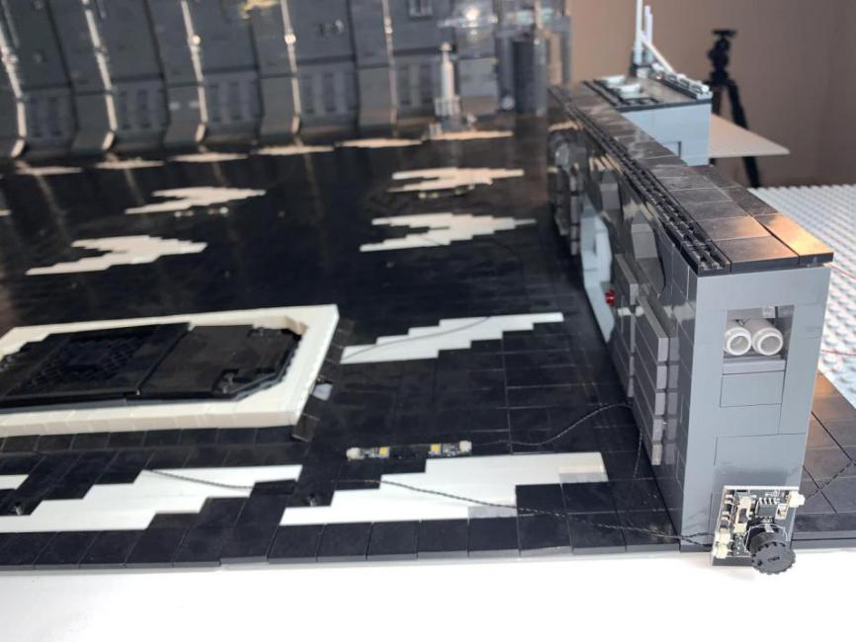

Take the USB connecting cable, a 6-port expansion boar, connect the cable to the expansion board

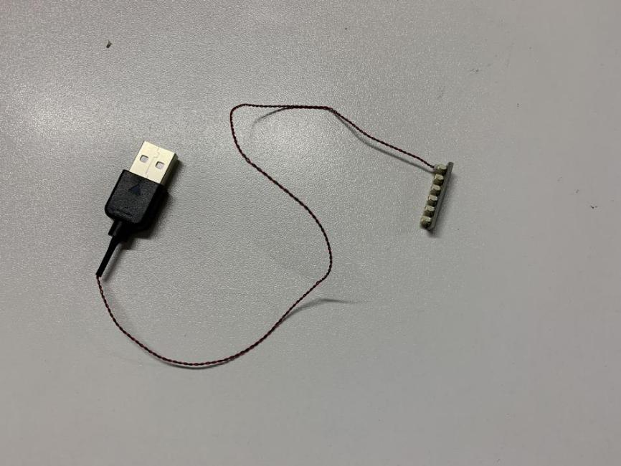

Connect the 5cm connecting cable from the Multi Effects Board to the 6-port expansion board, turn the power on to check if all lights are working OK.  
flick the switch to choose different effect, turn the wheel to adjust the speed of the effect.

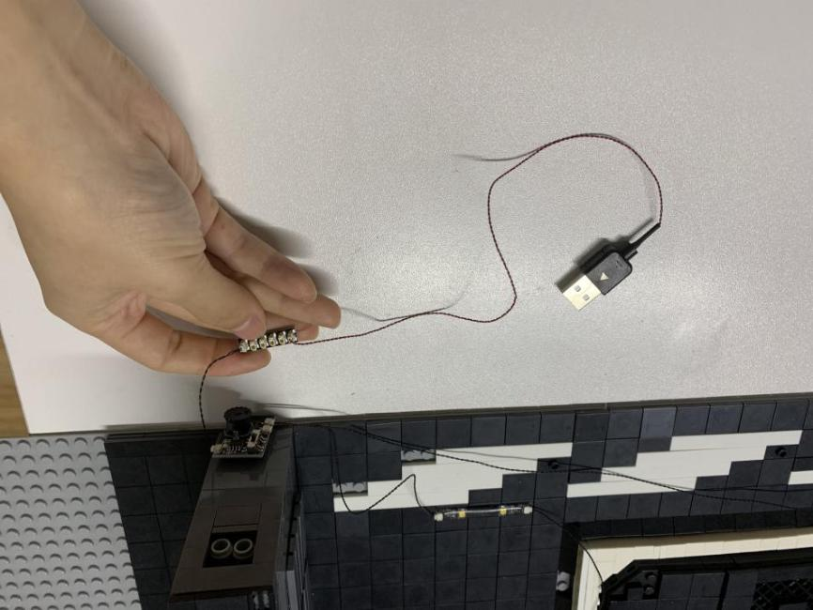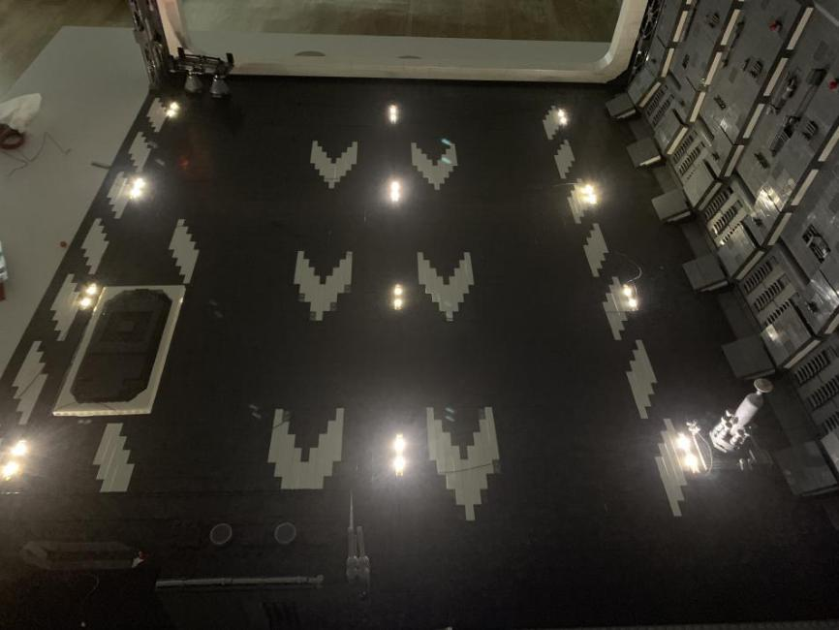

Now, we’ll continue to install lights to the following section

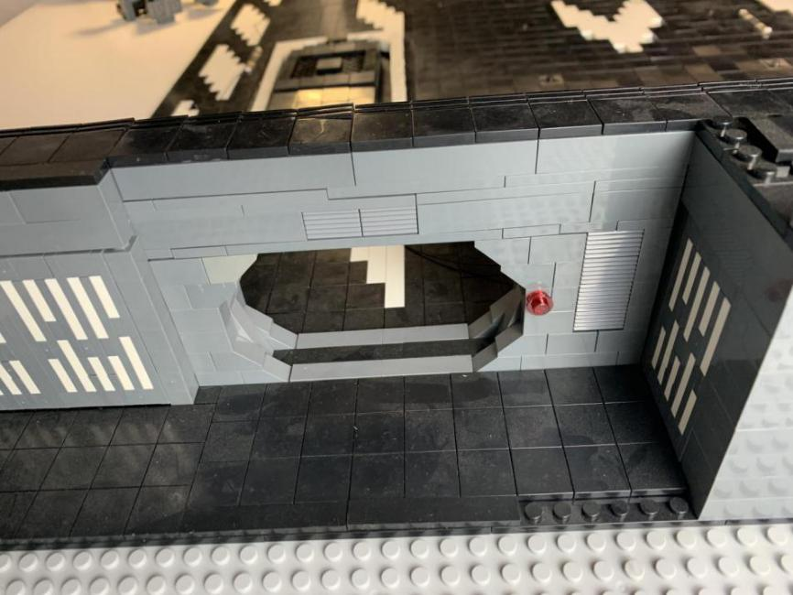

Remove the red round plate, remove the gray base plate and the black base plate under it. Lift the pieces above the red plate

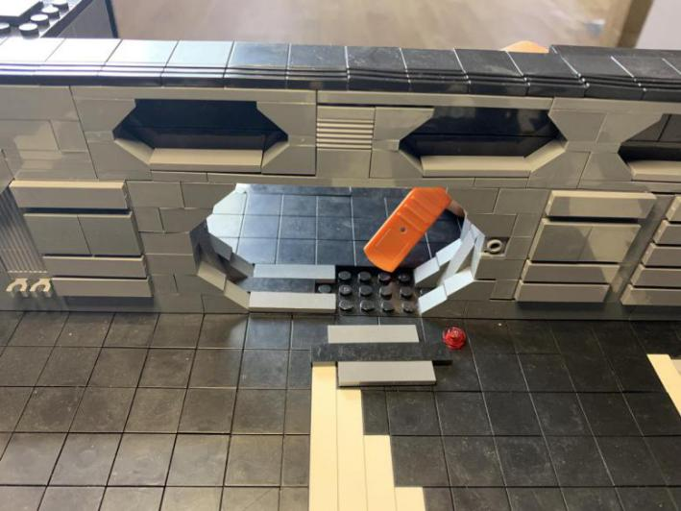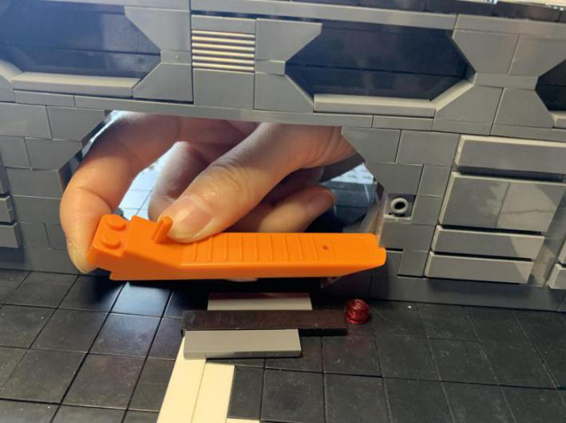

Take a 15cm flashing white Dot Light

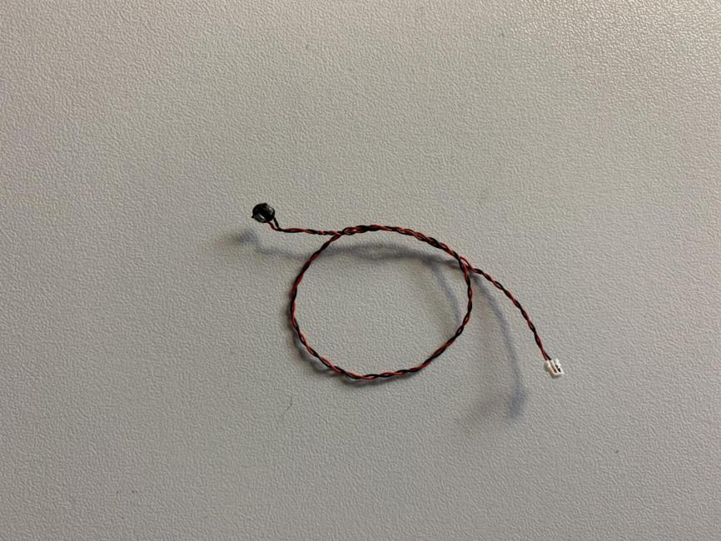

Secure it in the following place

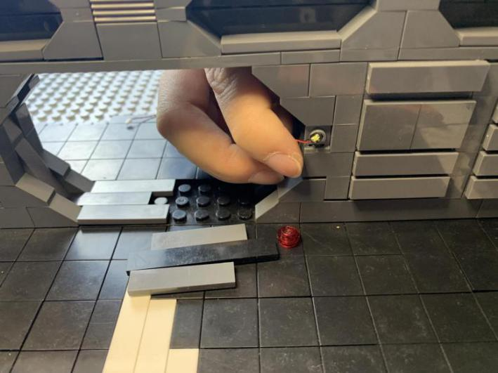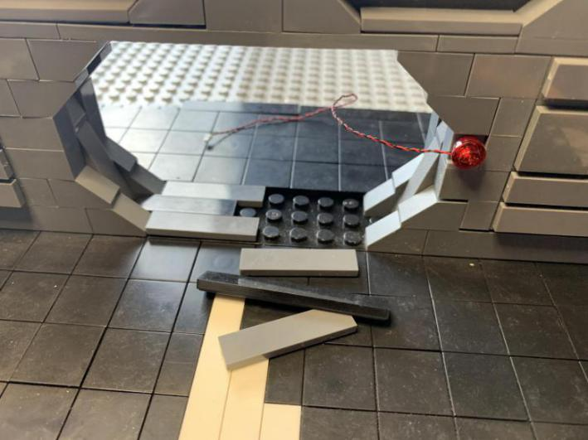

Remove the red round plate from the other side of the wall, take a 30cm flashing white Dot Light, install it there

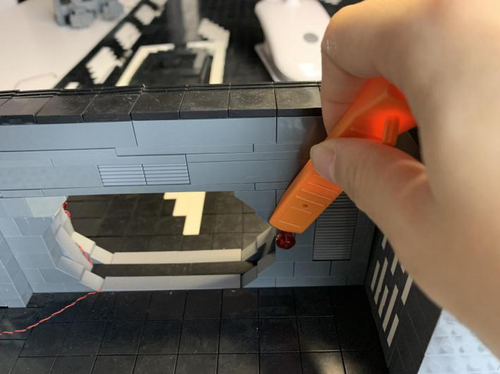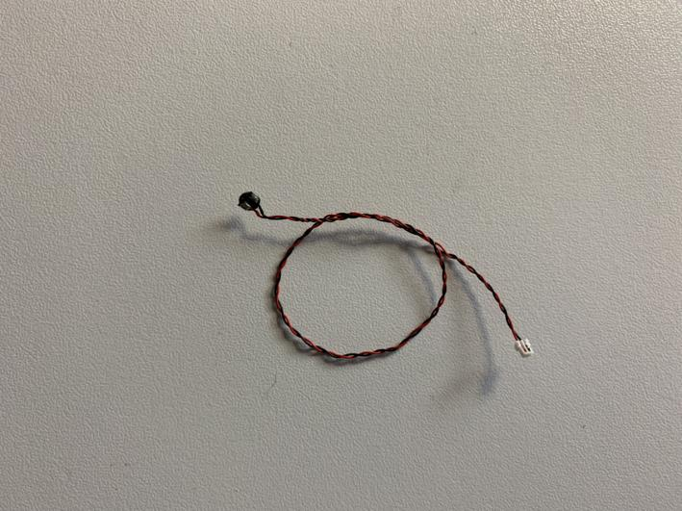

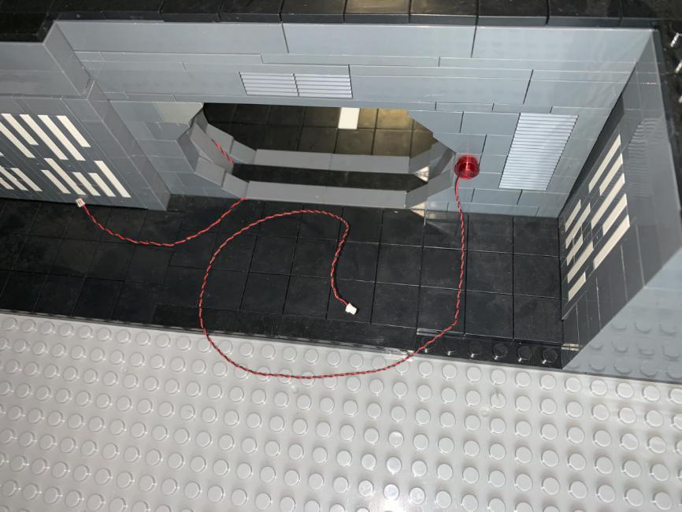

Remove the gray base plates.

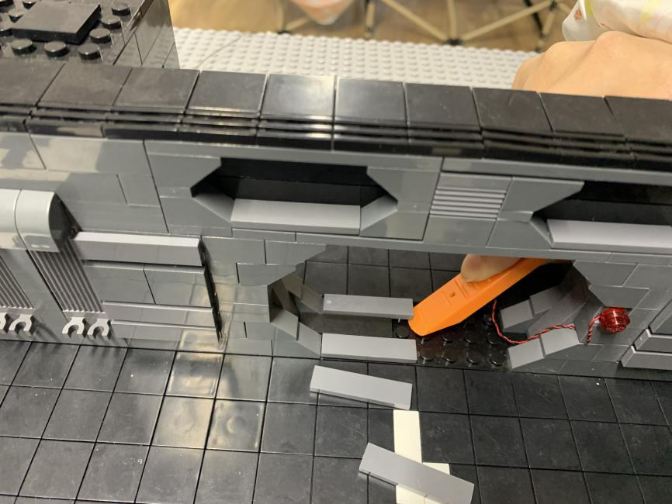

Place the cables underneath in between studs before reconnecting the plates

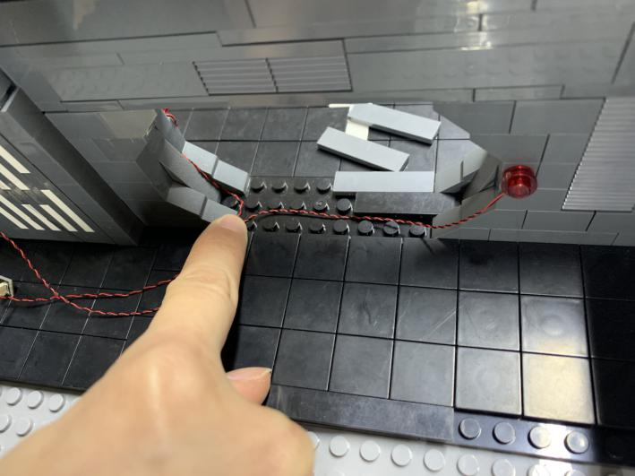

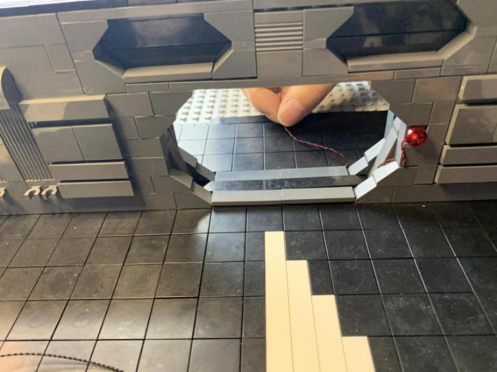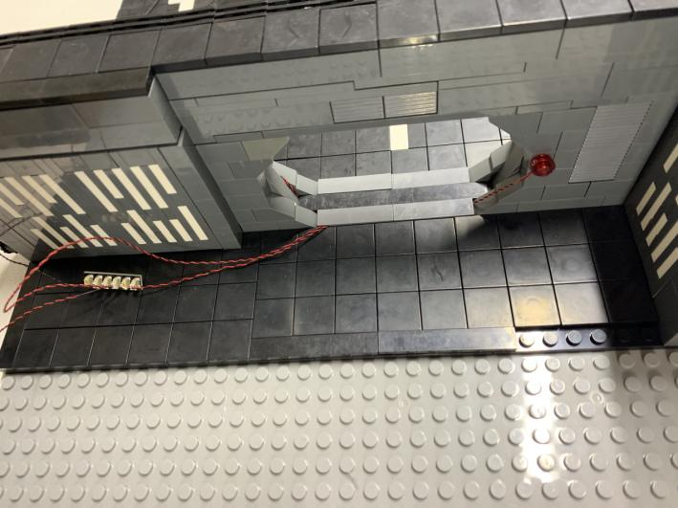

Connect the cables to the 6-port expansion board

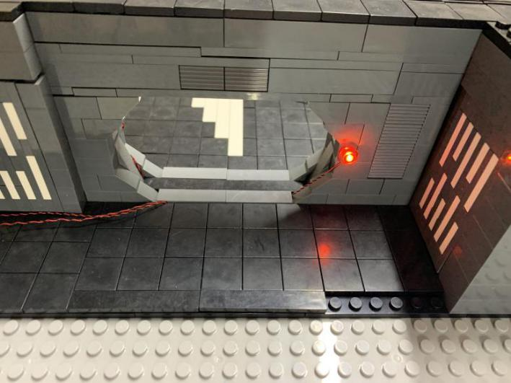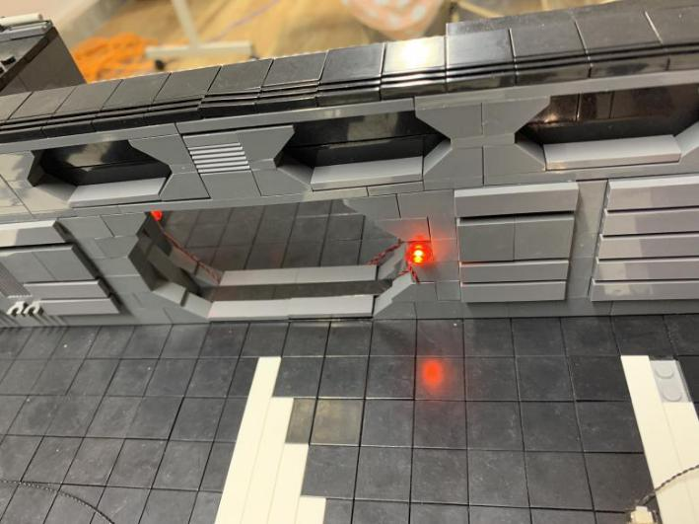

We’ll move onto installing lights to the wall

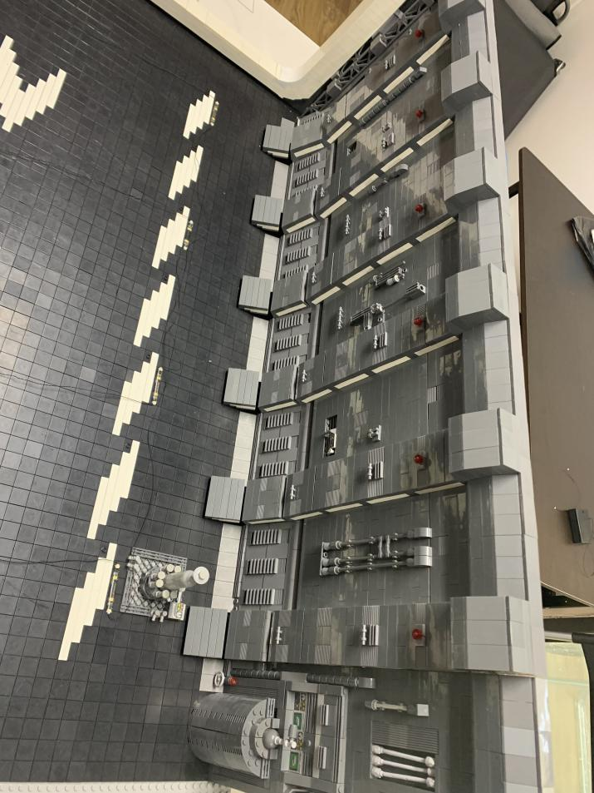

Take 6 flashing white 30cm Dot Lights, remove the red 1x2 round plates from the wall, connect them as per below

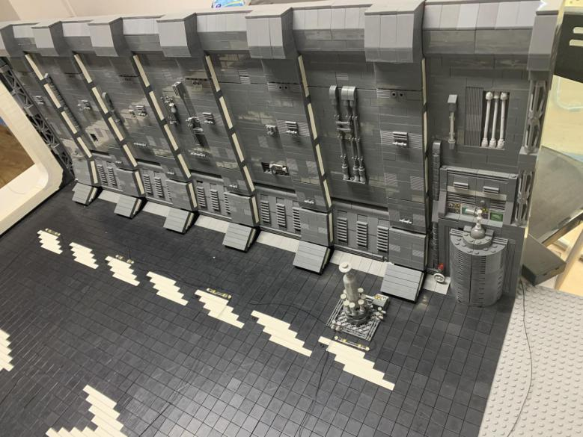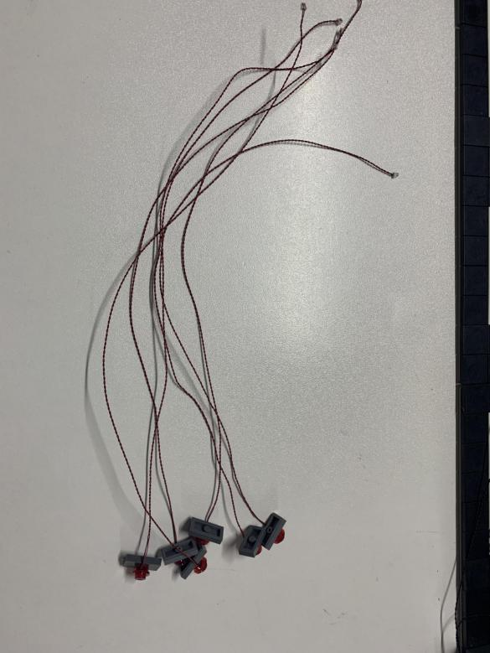

Life the piece over the red round piece to remove the piece. Reconnect the red round plate before threading the cable of the light though the wall. Reconnect the piece we removed

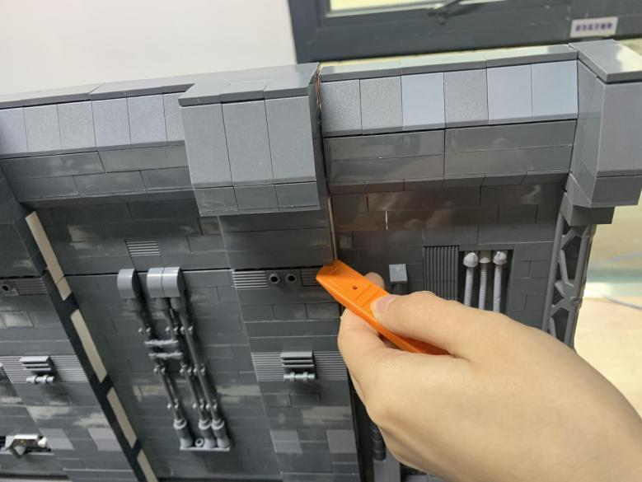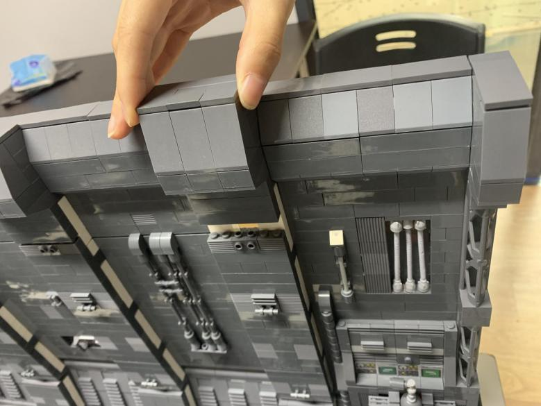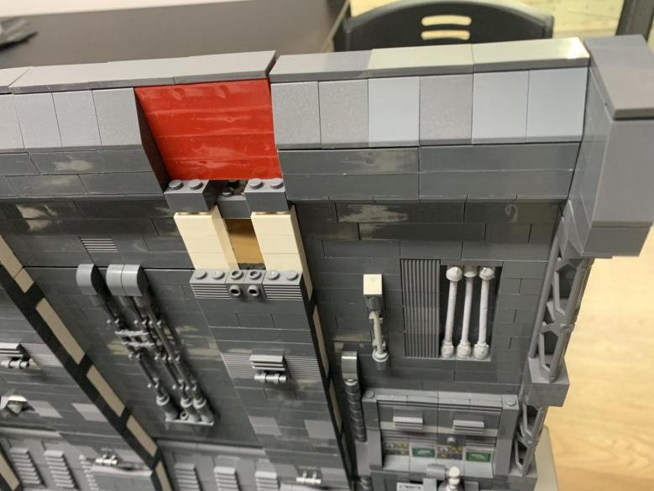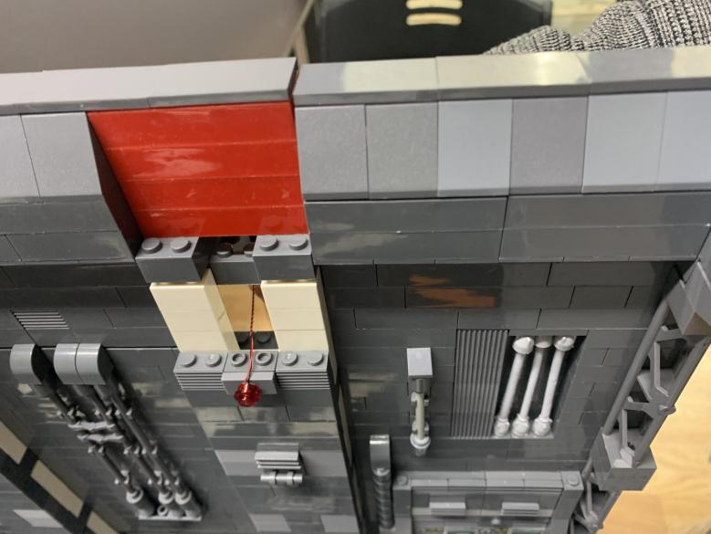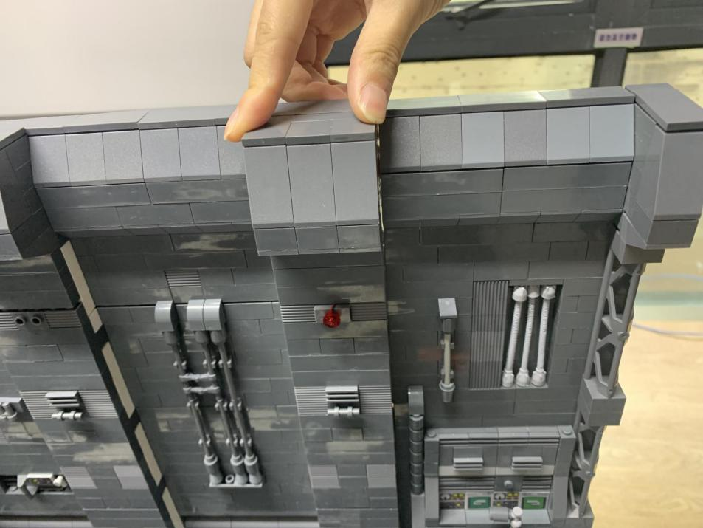

Repeat the steps above to install the other 5 lights

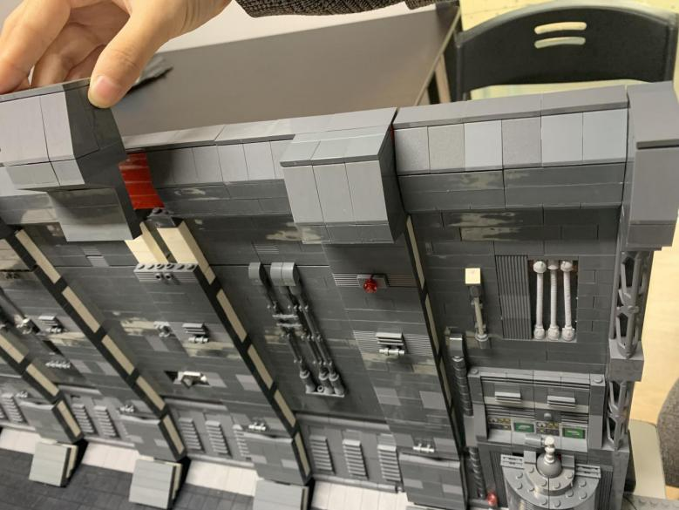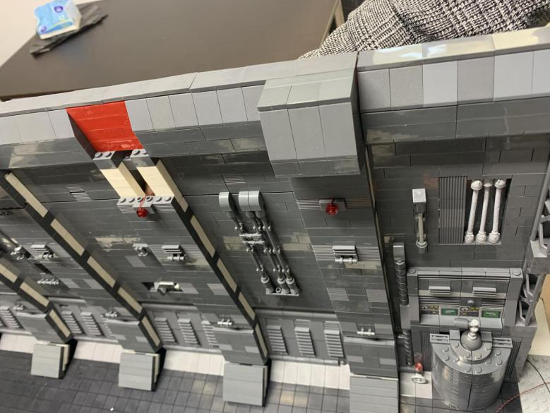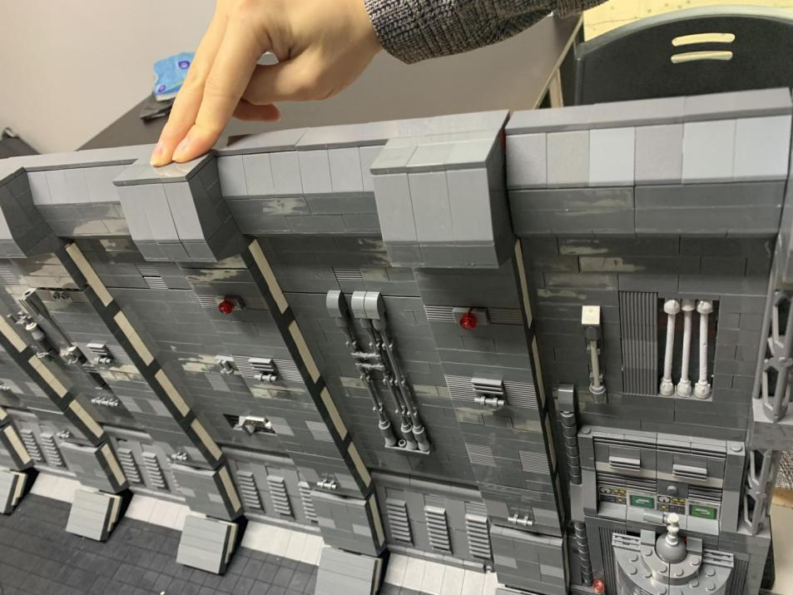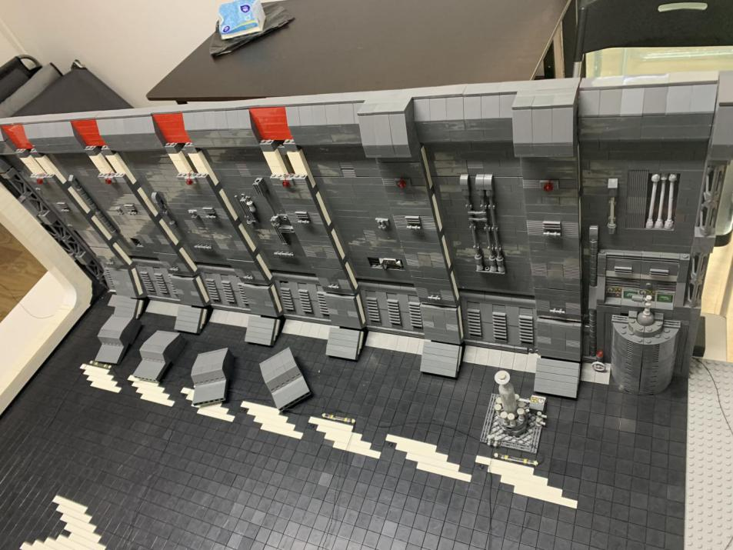

After installing all lights on the wall, we ‘ll tuck the cables of the lights

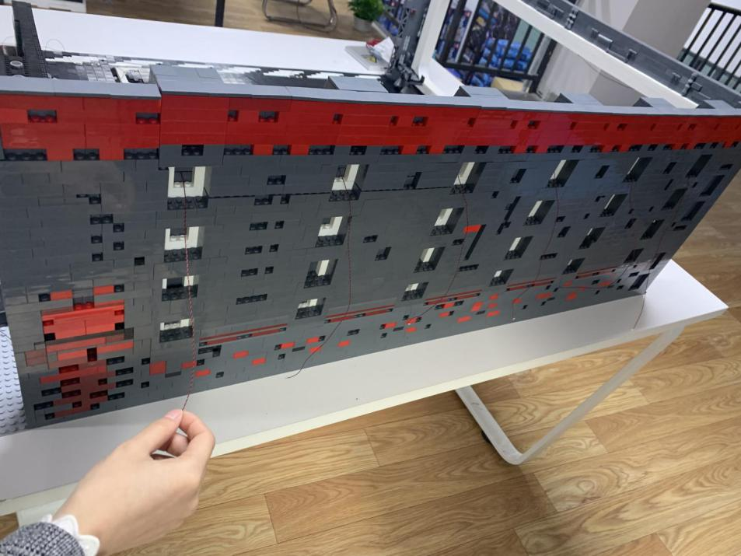

Life the wall at the right side of the first Dot Light, thread the cable through the gap all the way to the far right. Note: place the cable in between studs

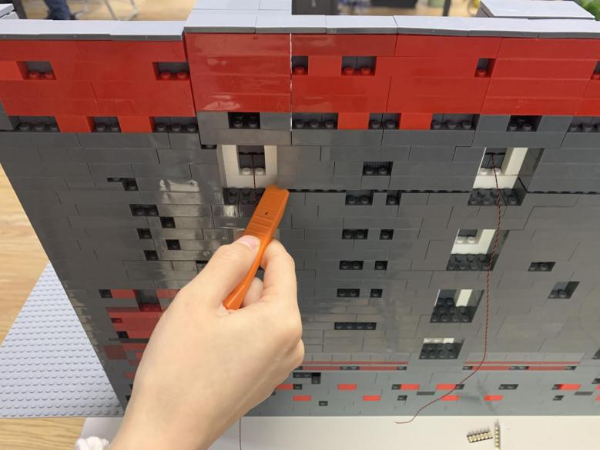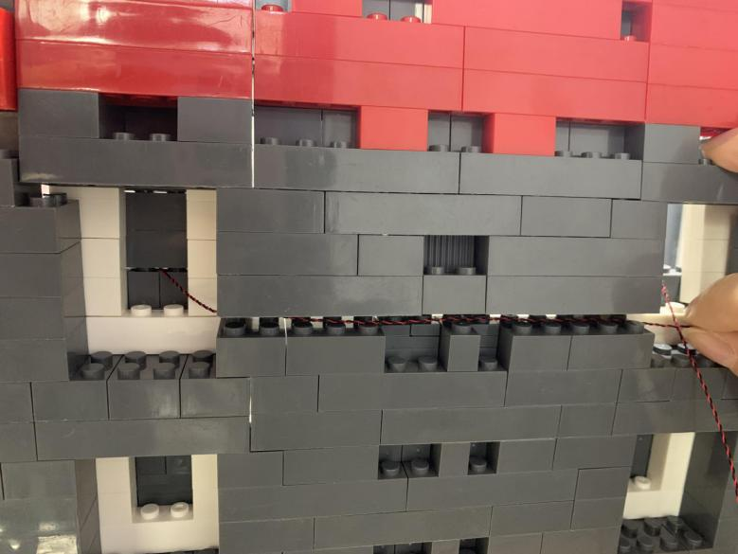

Repeat the steps above to pull the cable of the second light

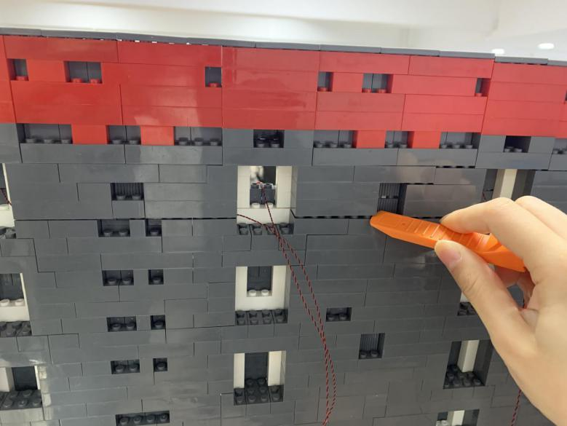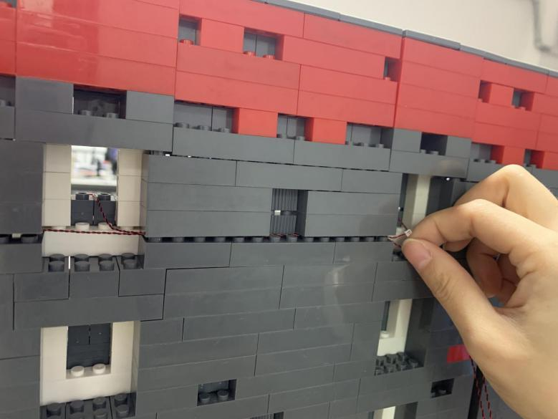

Move onto lift the wall at the right of the third light, pull the cable of the forth Dot Light to the third light

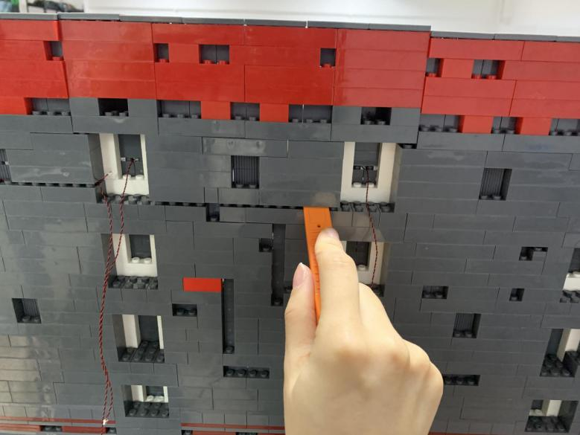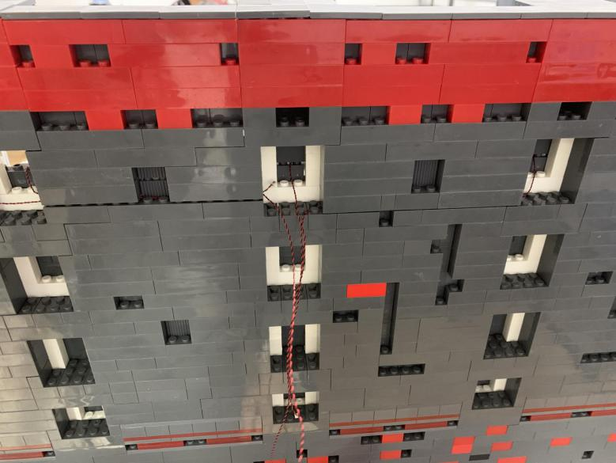

Take a 6-port expansion board, a 50cm connecting cable, stick tapes at both sides of the expansion board

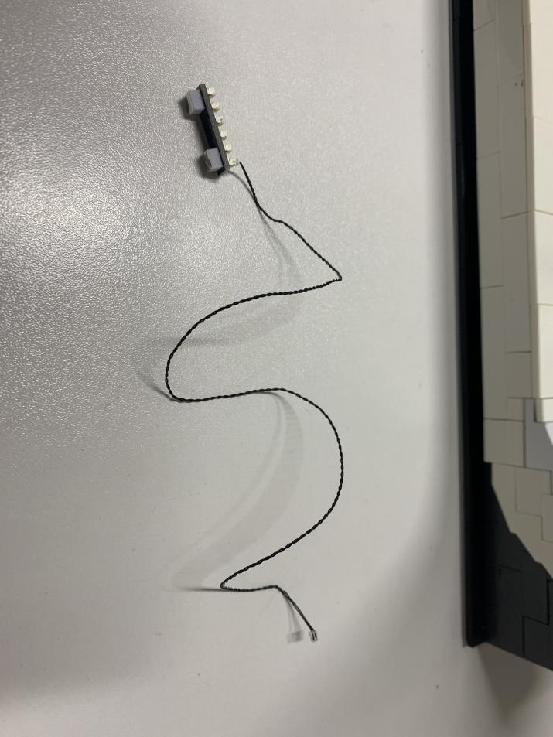

Connect the first 4 cables of the lights to the expansion board, tuck excess cables around the expansion board, connect the expansion board where the third light placed.

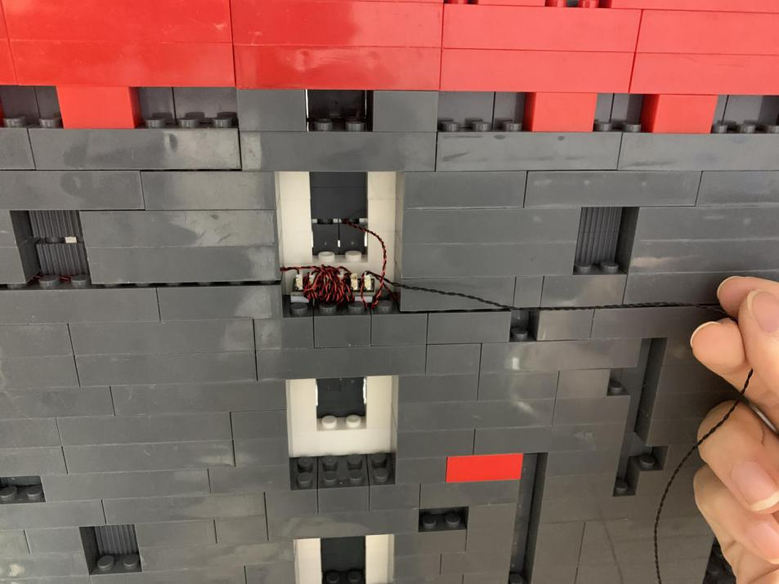

Continue to lift the wall at the right, thread the 50cm connecting cable to the fifth light, place the cable in between studs

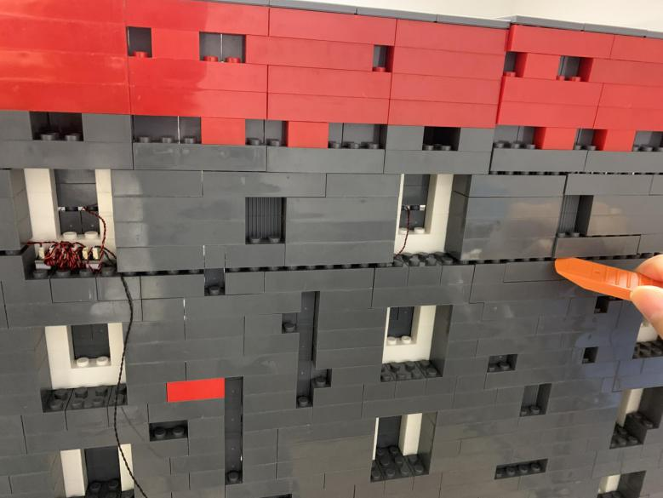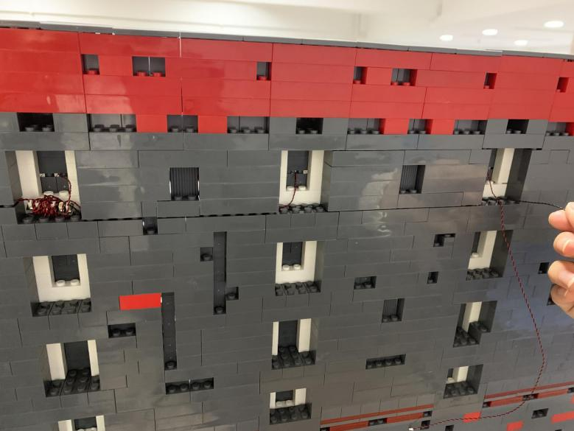

Lift the wall at the right side of the fifth light, pull the cable of the light and the 50cm connecting cable to the sixth light

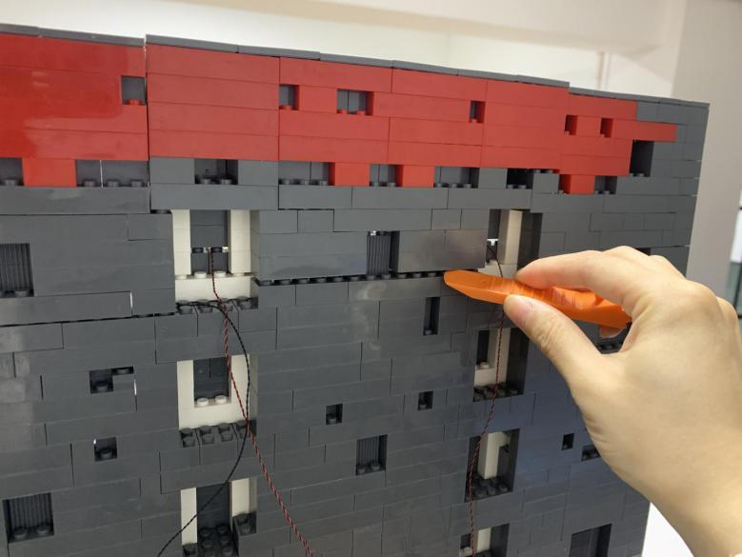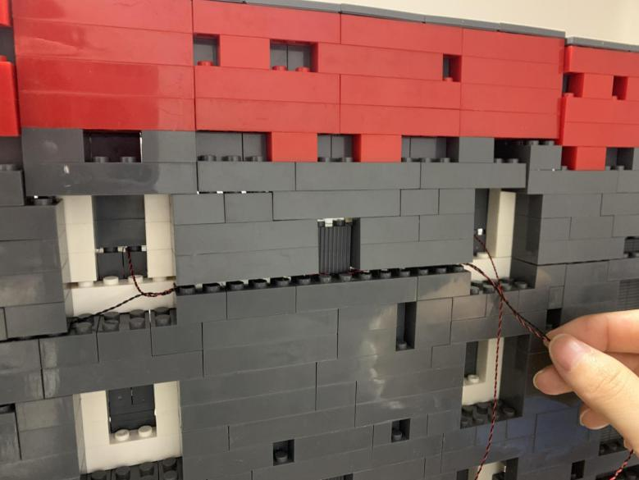

Take a 6-port expansion board, a 30cm connecting cable, connect the cable to it

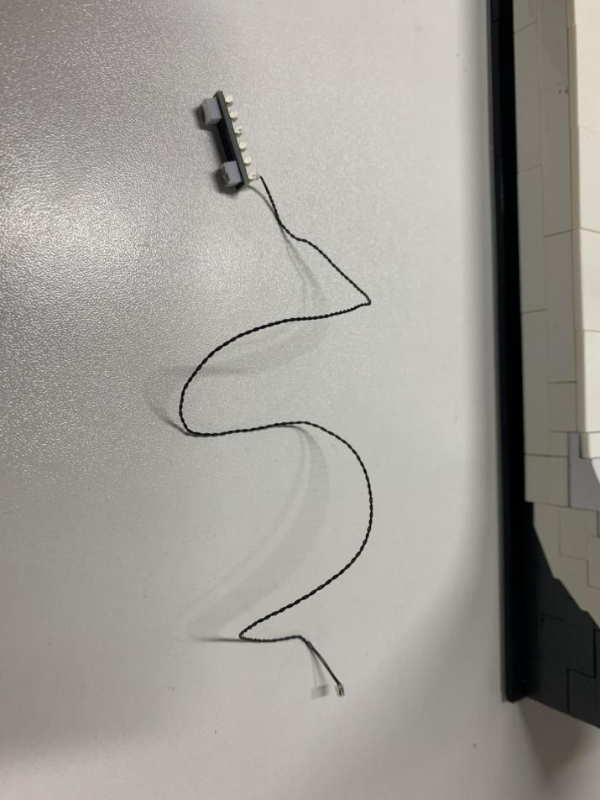

Connect the 2 cables to the expansion board, secure the expansion board where the sixth light placed

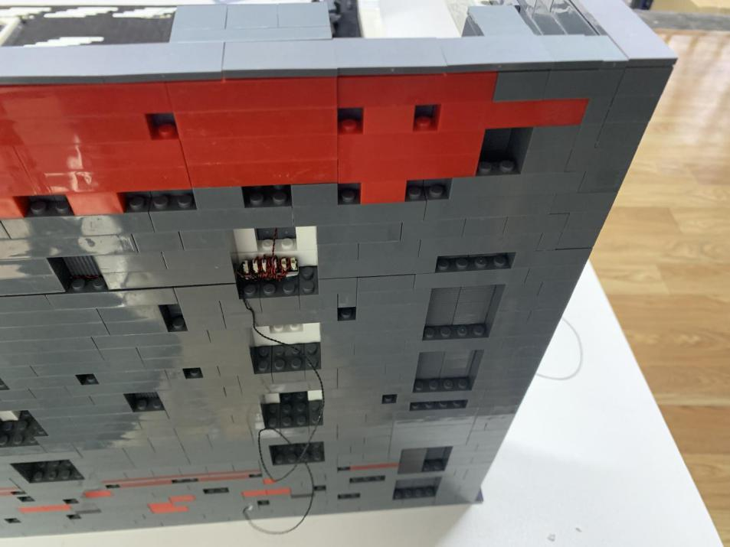

Take 3 warm white strip lights, two 15cm connecting cables, assemble them as per below

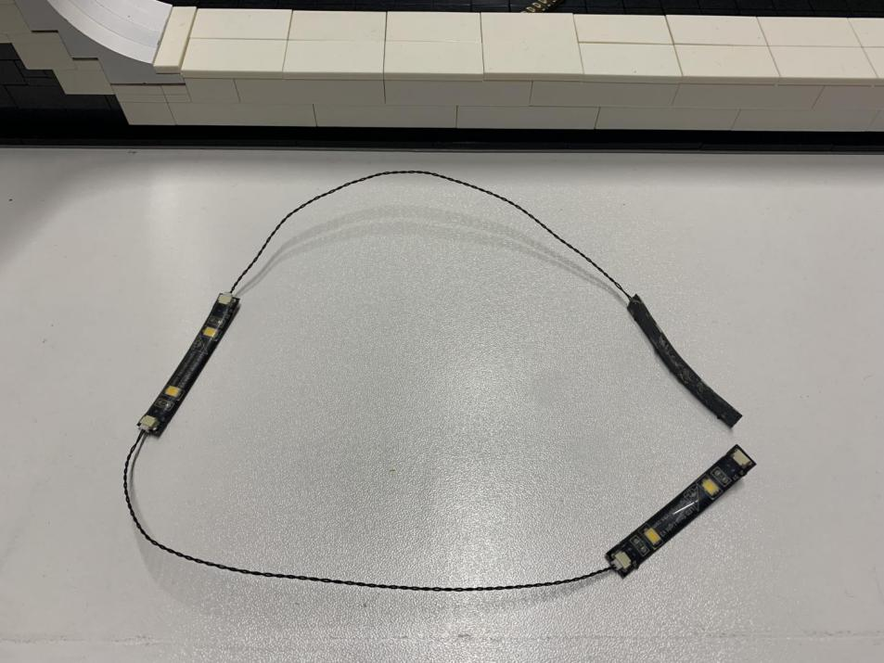

Connect the 30cm connecting cable to the strip light

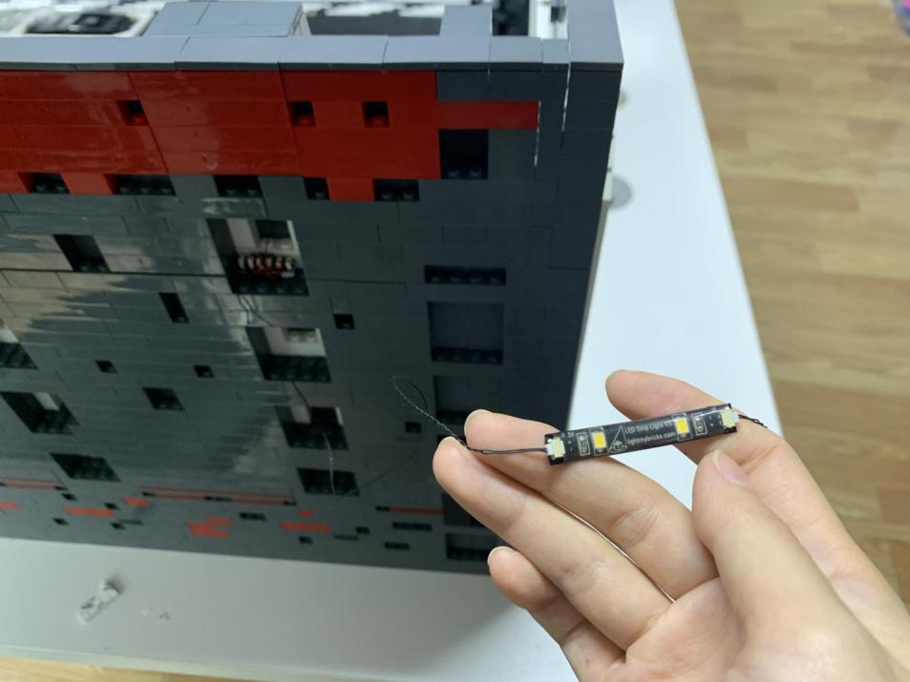

Pull the strip light to the white frame, stick it to the following place

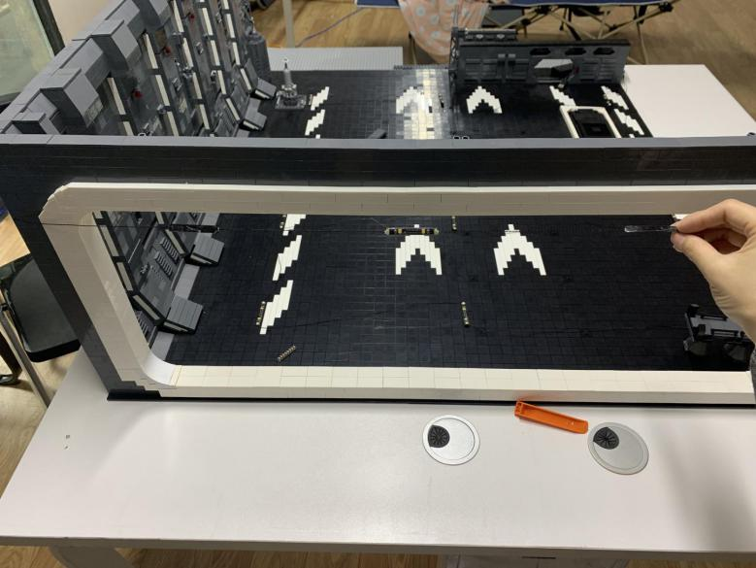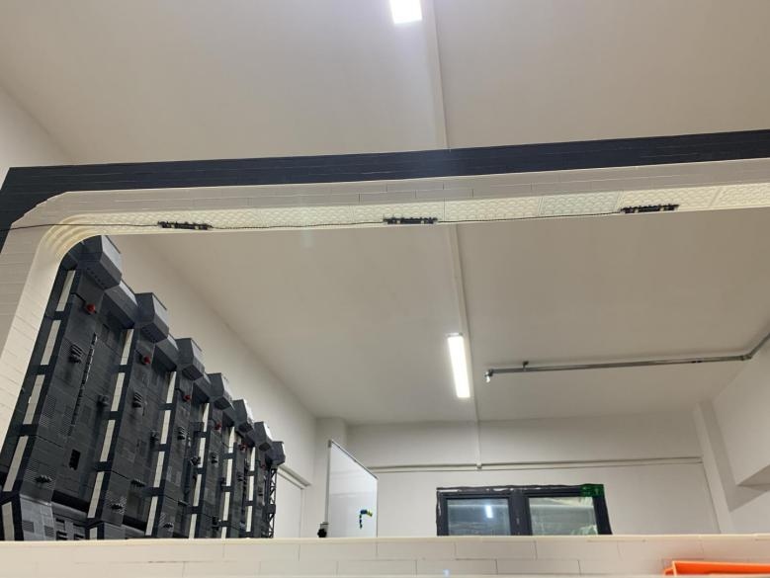

Take the AAA battery pack, inserted with batteries, stick tapes at its back. Connect its cable to the 6-port expansion board. Place the battery pack at the following position

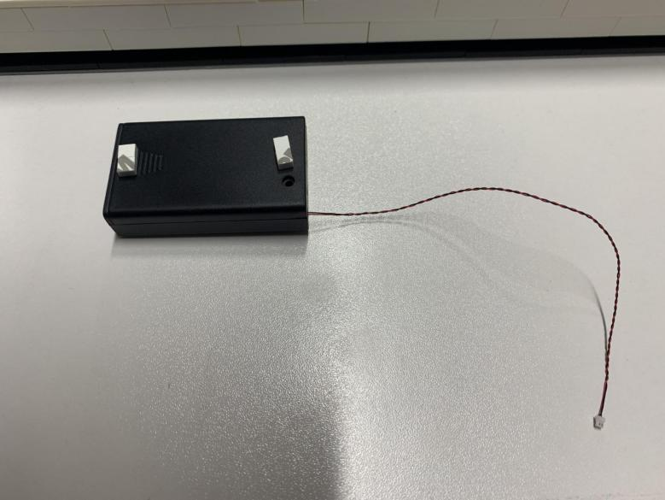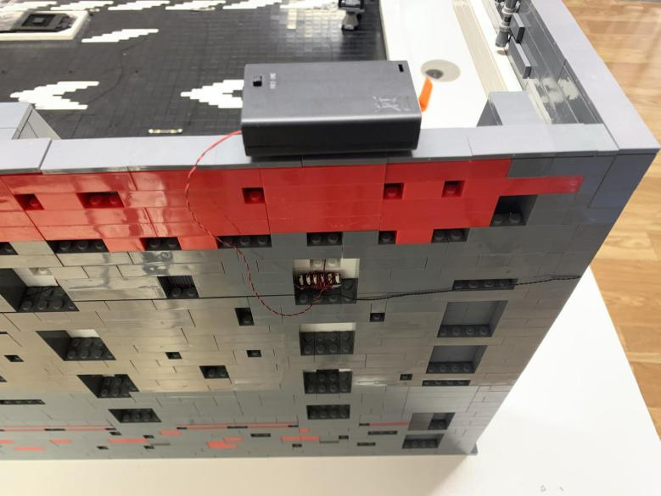

Turn the batter pack on and ENJOY！

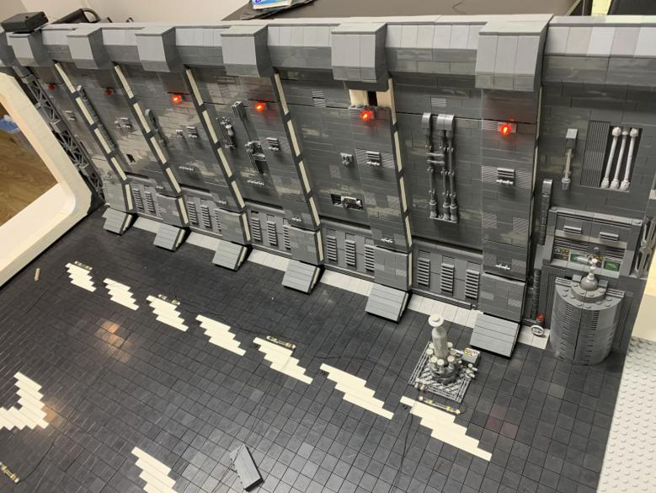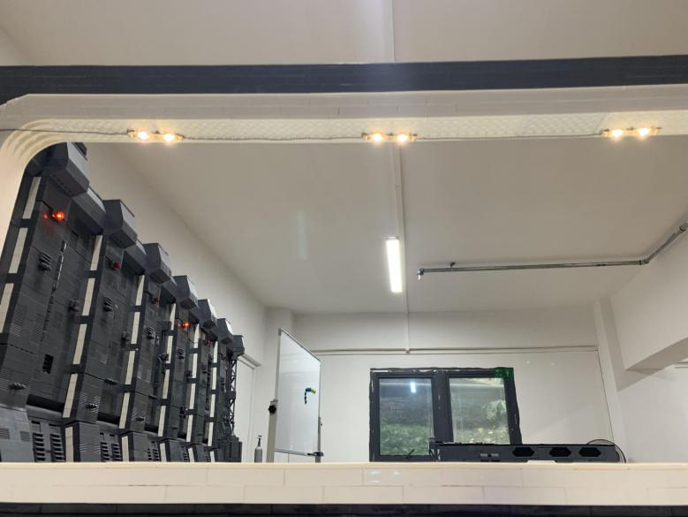

This completes installation of this LED Lighting Kit. 